St. Thomas/St. John/St. Croix Restaurants invited to compete in the 1st Annual MarlinFest
‘Chowder Championship’

What is MarlinFest?

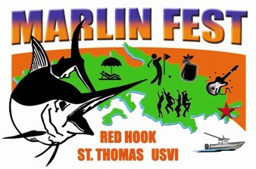
MarlinFest is a week of fun activities planned around the USVI Open/Atlantic Blue Marlin Tournament or better known as the “Boy Scout” Tournament. The week is packed with exciting daily events that will keep visitors and residents alike thrilled to be part of the festival! Proceeds from MarlinFest benefit the Marine Vocational Program (MVP), a program operated under the Boy Scouts of America.

Event Date:
Scheduled MarlinFest events include: Welcome Cocktail Party at Paradise Point, Music Concert at Reichhold Center; Red Hook ‘Jump Up’ Arts and Crafts and Food Festival; BVI Excursion; Wet & Wild Center Console Tournament; Mahogany Run Golf Tournament and a BBQ Beach Farewell Party!
MarlinFest’s Red Hook ‘Jump Up’ is scheduled around the full moon of August each year. This year’s date is Aug. 9, 2014.

Event Held: Red Hook Plaza parking lot in front of XO. Time: 5:30 p.m. – 9:00

See poster www.abmt.vi/pages/marlinfest_chowder.gif

How it Works: Restaurants may showcase up to three (3) of their chowder specialties. Items judged will be: Conch Chowder (any base), Clam Chowder (any base) and Seafood Chowder (any base), but seafood products may only include the choices of shrimp, lobster, scallops, dolphin, tuna or wahoo. Absolutely no local reef fish may be used! There will be prizes for the first, second and third place winners in each category. The restaurant judged to be the “Chowder Champion” will receive a $1000 cash prize. Customers will provide the restaurant operators with a “tasters” food ticket valued at $2.00 each ticket. The customer purchases these food tickets from MarlinFest booth located in the area. This is an opportunity to allow your establishment to shine! Winners will be announced in the Daily News, on the ABMT website and in ‘On The Edge’ magazine. Off-Island entries are accepted, provided they must be co-sponsored by a locally licensed restaurant owner.

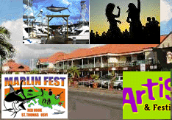
MarlinFest shall provide:
Booth space - Prizes and Promotion. MarlinFest will also provide chowder sampler cups.

Restaurants to Provide:
- Tent (max. 10'x10') if one is desired for rain protection.
- 8-foot skirted table cloth. Must cover to within 3” of the ground. No storage may be seen from the front of booth.
- Napkins. Bowls and spoons if selling bowls of chowder to customers.
- Please decorate your table and you may provide handout menus and business cards,
- You are responsible for the transportation and disposal of your booth trash.

Event Information:

- Parking is not provided for participants. See STSA pool shuttle information.
- Setup begins at 4:30 p.m. and product must be ready to serve by 5:30 p.m. Competition ends and winners are announced at 9 p.m. A MarlinFest drawing will take place at the same time.
- Festival patrons will purchase food and bar tickets from the MarlinFest cashier booth. Food tickets will be a two part ticket - the restaurant keeps one half and the customer retains the other half for the 9 p.m. “customer appreciation” prize drawing.

Entry Requirements:

- $50 fee for up to 3 chowder entries. Deadline to enter: 08/01/14.

Payment Options: Checks are made payable to: Boy Scouts of America. Credit Cards accepted: MC, Visa. Questions answered and for additional information contact the MarlinFest office: 340-775-9500. To register email us: loveto@islands.vi. Need Restaurant name, person in charge, telephone number.

