1. FAMILY
a)
- Europass – Curriculum vitae CV
- Importnant occasions in family life : Child birth
Birthdays
Anniverse
Church – priest, Registry Office - registe Wedding – ceremony ( bride, groom, Bride´s maid,
- reception Best man, guests)
Retirement

GREAT GRANDPARENTS
BROTHER-IN-LAW
SISTER-IN-LAW
PARENTS
AUNT AND UNCLE
SON AND DAUGHTER
SISTER AND BROTHER
GRANDPARENTS
GRANDCHILDREN
COUSIN

b)
- Family members

spouse= husband and wife, next of kin –najbližší príbuzný, engagement – zásnuby, fiancé

- Description - /tall, short, thin,fat, long, short hair,.../
- character /angry, happy,flexible, generous, bright, hardworking, polite,
hospitable,sensitive, sensible, tolerant, mean, violent,jealous./
- free time activities / hobbies and interests/
c)

Family relations: Nuclear family: 2 generations Parents – children
Extended family: 3 or more generations
Single parent families: reasons: divorce / pregnancy outside marriage/
death of one partner (widow(er))
Recunstructed families: Step-parents , half-brother/ sister, step brother/ sister
d)

My future family : marriage- get married until, live in cohabitation/household with, work abroad, have children

e)

Family and society : divorce rate –increasing / decreasing
Arranged/ inappropriate marriage- bcs of money, fame, age
problems of single parent families : social, economical

Family problems: violence, jealousy, adultory, abuse, gambling, drugs, alcohol, workoholism, generation gap problems, punishment/ corporal punishment (telesné tresty), raising children, to be the only child

ART
Fine arts
Literature
Fiction/ Non-fiction
Performing arts
Sculpture/ painting
Novels/ short stories/ biographies/drama/poetry
Dance, opera, cinema, ballet, concerts, rock/classical,
pop music
Architecture and ceramics
2. CULTURE AND ART

a)
possibilities TOWN - VILLAGE
theatre, performances, museums, galleries, exhibitions, concerts, operas, circus, discos, cinema
- in Brezno

b)
my favourite culture or art
Going to the cinema / theatre – like the scene/ plot/ cast/ actors, visiting museums, galleries
Performance- brilliant, good, bad, poor

Painters : DaVinci, Monet, Micelangello, Goya...
Poets: Ted Hughes, T.S. Eliot...
Musicians: Mozart, Beethowen...
Architects: Aldo Rossi...

Favourite groups, singers/ favourite film star, genre of music - rock/classical,
pop music- hip-hop...

c)
visiting of cultural event : buy tickets in advance/ at the place, clothes, behaviour,
standing ovations, applaus, atmosphere
THEATRE: box office clerk, costume designer, audience, newspaper crisics- drama review, stage crew, stage manager, director technician, theatre-goer

d)
Folklore festivals – Heľpa, Východná...
Folk music – rhytmical, traditional dancing, costumes, playing traditional instruments: acordeon, violin, contra bass, cello...

Orchestra – conductor,

e)
another kinds of art
painting/ folklore/ sculpture/ architecture/ The most famouse representatives

3. SPORT
Collective
Games/rules– football, tennis,
aerobics
Winter
Skiing, skating,
snowboarding
Summer
swimming, cycling, surfing, diving
Individual
Cycling, jogging, hitch-hiking
SPORT

a)
kinds of sport

b)
my favourite sport: active / passive
why : amateurs: to be healthy, to get rid of stress, to relax, for pleasure
professionals: for money, fame, success, to win medal, worldchampionship, olympic games

c)
Importance of sport

d)
Important sports events
World championship



Olympic games
Beginning in 776 B.C., the Olympic Games were held inOlympia in Greece. By about 650 B.C., the Ancient Games were held
over five days, involving running, wrestling, the pentathlon, horse riding and chariot racing ( preteky na kočoch).
393 A.D. Roman Emperor Theodosius I banned all pagan festivals (the Olympics celebrated the Greek god Zeus) and abolished them.

1894, French educator Baron Pierre de Coubertin renewed the idea of olympic games.
Modern olympic games: more than 10,000 athletes from 199 countries will take part in 300 events.
Summer / winter

e)
Negative aspects in sport
Doping – sefl esteem / to win / for money
Commitee / jura tests/ blood tests

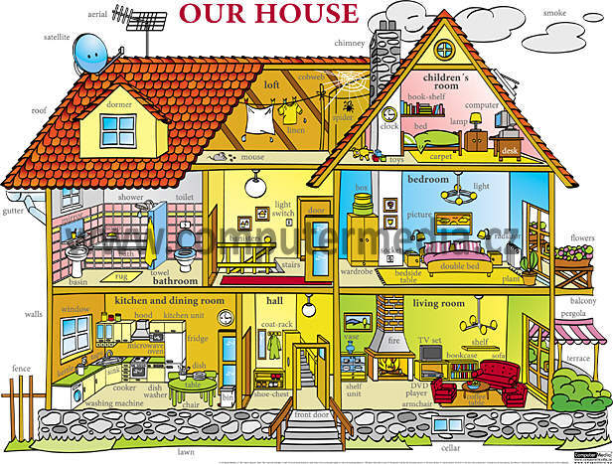
4 HOUSING
a)
My house
- description of a house/ flat
- there is/are

b)
Living in the town or village
Advantages / disadvantages
Town- adv.- job opportunities
- shopping facilities
- rich social life
Disadv. – higher pollution
- street crime
- peace and quite

Different kinds of houses
Flat (Apartment Am.E),block of flats / Slovakia
House – detached/ semi-detached, terrased, cottage, bungallow

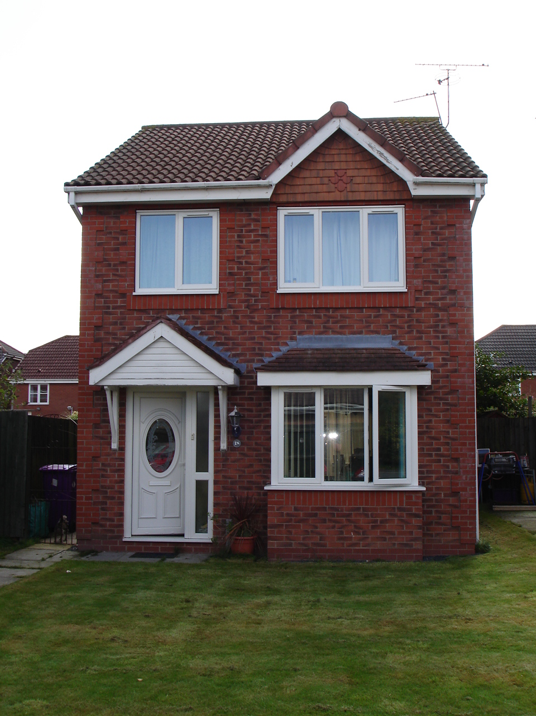
detached H./GB
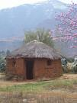



semi-detached H. terraced H./GB bungalow/A cottage hut
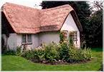

(samos.stojaci) (dvojdom) (radová výst.) one –storey h. trad. country h. shelter (prístrešok)
Garden wooden beams (priečky)
thatched roof(slamená strecha)

c)
Ideal dwelling (bývanie)

d)
HOME and its Importance in the life of people

Homeless people

e)
Dwelling problems of young people
Mortgage- hypotéka, tenanty flat- nájomný byt, service charges- poplatky za služby,water rates-polatky za vodu,

DIY – do it yourself, Who repairs things in your house?

5 SHOPPING AND SERVICES
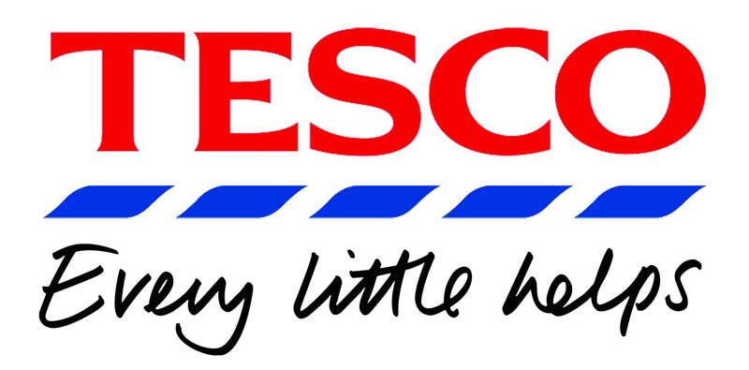

a)
Shopping facilities (shops, hypermarkets, markets)
Consumer society – material goods are very important

Two main kinds of shops:
Part of a chain, group: JEDNOTA…
Individual shops: florist/baker´s/butcher´s/confectioner´s (cukráreň) / greengrocer´s/ ironmonger´s/ jeweler´s/pet shop/ shoe shop/ stationer´s/ toy shop/ fishmonger´s/ grocery (potraviny)/ newsagent´s
Department store / shopping malls/ hypermarkets, supermarkets

What do you prefer, why ?
What can you buy there?

b)

Services (Banks, post, police, petrol station), optician, baby sitting, plumber, cleaner, hairdresser, launderette – samoobslužná práčovňa
Where can you find ? – local newspapers, classified ads.(inzeráty), Yellow pages
-order meal from the restaurant, find job, rent flat or house

What an attendant should be like: kind, helpful, tolerant, interested, talkative,

c)
Avdertisement and its influence on customers

WHERE - in the newspapers, magazines, on TV, on buses, trains, trams (električka)
WHY- to persuade customers to buy the product, to increase profit
HOW – rearranging goods, double packaging, special offers, bargains, free gift

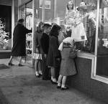
d)
Different kinds of shopping/ paying
Internet shopping, Window shopping, shopping around

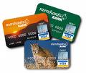
How to pay : cash, cheque, credit/ debit card, internet banking, Hire purchase = pay in weekly/ mounthly instalments – splátky, Why ?

Cash dispenser – bankomat

e)
Export of foreign goods, Foreign trade

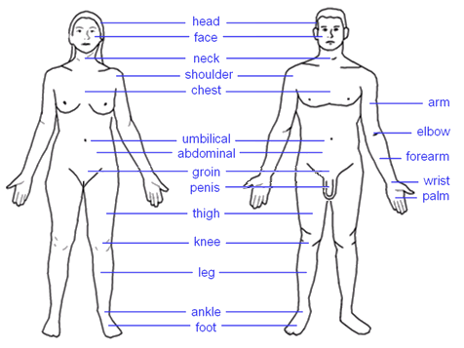
6 HEALTH CARE

a)
Human body
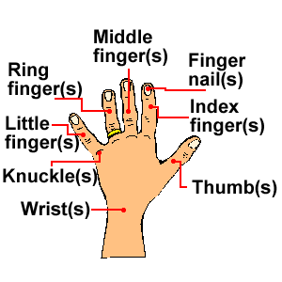
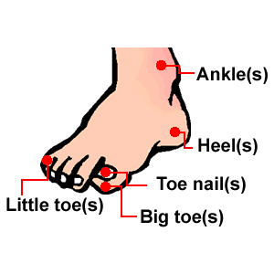

Heart, Brain, Kidney, Liver, Lungs, Skeleton, Spine
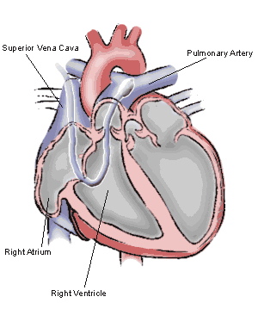
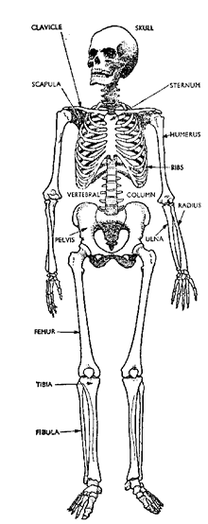
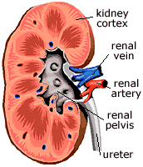
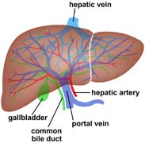
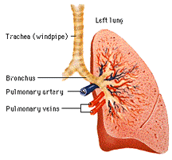
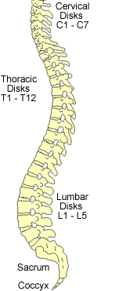
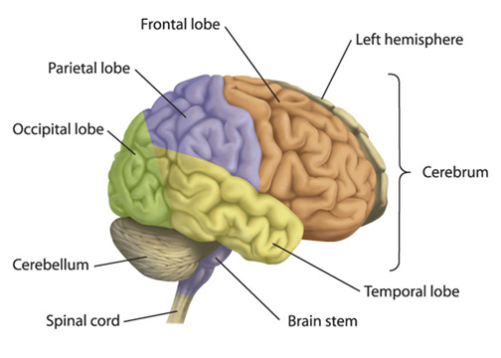

b)
Classical medicine – uses painkillers/ pills/ tablets – fight against deseases and illnesses
Alternative medicine – acupuncture, homeopathy, osteopathy (system of movements), herbs

Injury - fracture, to faint, split bone Ilness – diabetes, to have a sore throat, cold, mumps,
doctor
examine the patient
take the temperature
check the blood pressure
feel the pulse
set the diagnose
administer by injection
prescribe a medicine
(trieštivá zlomenina), cut my finger - deaf, mute, blind, paralysed
wrick (vyvrtnúť členok), Psychical illnesses – mad, insane, crazy
- to bleed (krvácať) Symptomps
Ache-(headache, backache, toothache),
Fever, sneeze, cough (kašeľ)

c)
Healthy lifestyle

You Are What You Eat - Better food habits can help you reduce your risk for heart attack. A healthful eating plan means choosing the right foods to eat and preparing foods in a healthy way.
Exercise & Fitness - Swimming, cycling, jogging, skiing, dancing, walking and dozens of other activities can help your heart.
Psychical health- to relax, no stress, no depression

d)
Prevention – vaccination
e)
doctor - physician / GP – general practicioner / specialist / surgeon / psychiatrist / dentist / pediatrician / analyst / dermatologist /
7 TRAVELLING

Reason, goal, mening of travelling (to work, on holiday, on business trip- služobná cesta, commute to school / work - dochádzať)
Going on foot
Drive a car/ bus/coach
Train/ tram/
Ride a bicycle/ a motorbike/ a horse/
By land
arrival hall
Plane
Airship
By air
b)
Means of transport check- in
Ferry
Ocean liners
Travel by boat/
By sea
Traffic jam passport
contol

departure
gate

hall/
lounge

space ship/ space station/ air bus

Advantages/ disadvantages: convenient, fast, slow, comfortable, long / short distances, offer refreshment,
follow timetable, cheap –expensive…

c)
Individual / collective travelling – compare/ advantages - disadvantages

Travel agencies- provide all services, all inclusive, accommodation, plane/ bus tickets, insurance, visa

Travelling on your own- stay in campground, rent a bungalow, caravan

Home-swaping – exchange home with sb. else abroad

Package holiday – provide accommodation, transport, programme, meals

Self-catering holiday- nothing is provided
rooms – single/ double/ ensuite bathroom/ toilet/ appartment

Holiday planning – arranging h., accomodation : hotel/ bungalow/ hostel/ B´n B/ tent/ caravan

d)
Travelling in the past, now, in the future Catering – meals: full board/ half board
without meals
e)
Possibility of travelling abroad/ favourite destinations of British/ American/ Slovak tourists

Who´s backpacker (na výlet s batohom)/ rambler (milovník potuliek)

Programme – sightseeing/ tours/ excursions/ sunbathing

Journey – plane/ car/ coach/ ferry/ liner (dopravné lietadlo) DIRECT / STOP OVER (prenocovať)

8 EDUCATION
a)
School system, forms of education, organization
Pre-school e.: not compulsory – kindergarten Nursery school: 3-4 y.o.

SLOVAKIA GREAT BRITAIN
1. Primary school Compulsory: 5-16 (11 years)
1st stage – grade 1-4 Infant school: 5-7
2nd stage – grade 5-9 35 children in the class, Teacher+ T´s assistant
- general education, 25-30 lessons/ week- History, - reading, art, practical lessons
Geography/Math/Languages/ Chemistry, Arts/ PE… Junior school: 7-11 – National Curriculum:
English/Maths/ Science/ Technology/ Art…
projects/ topic works
Monitor - exams- grade 9 Exams – 11´s
2. Secondary school
high schools/ s. comprehensive sch./ academies – 1000 – 2000 Ss
4 years - Entrance exams age: 11 -16
GCSE exams
5-8 sbj
16
“gymnazium”- general education/ business academy
technical school (agricultural, forestry, nursing,) – College of further
vocational– 3 years– practical – final exams education (general, vocational,
4 subjects

wtitten – oral part

school-leaving certificate
School-leaving exams

technical )
A-level
3sbj
18
University
NVQ –
national vocational
qualification

3. Higher education
expensive – Ss take loans
University University / College of Art, Music, Education
polytechnic schools
Entrance exams Oxford/ Cambridge – A-level+ Oxbridge
3 years– bachelor degree/ 5 years – master´s degree entrance exam
2 terms – winter/ summer
Lectures/ seminars
Credits+ grades A,B,C,D,E,FX
Complete and defend a thesis- pass state exams

b)
School year/ holiday/ schedule/
2 terms – winter/ summer 3 terms- Autumn/ Spring/ Summer
7.45 – 2.00 9.00- lunch break 1 hour – 3.30/4.00
c) School uniform – red/blue/green,
National curriculum/ syllabus school emblem/ blazer/ shirt/trousers/skirts)
Student´s life, Extra-curricular activities/ Sport activities/ Clubs
Dance club, Floorball, Darts, Fitness Drama, choirs, hockey, football, cricket

d)
Studying of foreign languages
COMENIUS, ERAZMUS/ WORK & TRAVEL/ AU-PAIR

e)
Student / teacher, Teacher/ student relationship

DEVISION OF SCHOOLS
state school – free of payment independent school
1.according to FEE boarding school
private – parents pay fees for tuition and education colleges
Eton, Harrow

UK - USA
Public school (private) Public school (state)
2. 2.according to age
/ stage

pre - school
primary school
secondary school
tertiary
Day school
Evening school/ classes
Boarding school – internátna škola

University/ school campus

Student – boarder (žiak na internáte)/ graduate (absolvent) undergraduate (vysokoškolák)/ freshman (nováčik) junior/ senior/ sophomore (druhoročiak (študent)

School stuff/ employees – headmaster/ headmistress/ principal/ deputy headmaster/ school taker/ cleaners...

School facilities/ interior – entrance/ canteen/ library/ gym

School regulations/ Code / Dress Code – It´s allowed, not allowed

My ideal school – location, subjects/ lessons/ teachers

9 JOBS AND EMPLOYMENT

Job/ work/ profession/ occupation/ employer/ employee/ staff/ personnel (personál)/ position/
promotion (postup, reklama)- prospects/ recruit (nábor, prijímanie)

a) job/ work/ occupation/ career
different kinds of job / physical, mental work/ job choice / motivation
What do these have in common?
professions
Lawyer, doctor, dentist, architect, vet, scientist, priest,
Librarian, child-minder, designer, hairdresser, tailor/ dressmaker, accountant, engineer(technik), sales assistant
police officer, fire fighter/ fireman, civil servant (štátny úradník)
Farmer, mechanic, plumber, carpenter, builder, clerk (sekretár)
WORK PATTERNS:
mechanical/ routine/ repetitive/ monotonous/ glamorous
(čarovný)/ irregular/ stress level/ dead-end job
(postavenie v zamestnaní bez postupu)/ odd job
(príležitostná práca, fuška)

JOB TITLES: white collars, boss, manager, director,
executive(výkonný), administrator (správca/ hospodár),
secretary, public relation/finance/safety/ presonnel officer
broker (obch. s cennými papiermi),unskilled/ skilled worker

CRIRERIA OF JOB CHOICE:
Hours of work: clock in/ out (pichať príchod), shift-work,
be on flexi time,regular day work(9am – 5pm), freelance (journalist)
self-emloyed
Job satisfaction: salary, wage, pay rise, bonus, pension, perks (príjmy, vedľajšie), fringe benefits (sociálne výhody) salary increments (prírastok), overworked / underpaid

b)
labour market
- look for a job/ vacancy (prac. príležitosť)- 2. job centre/ employment office- 3. job adveritisement
– 4. apply for a job – 5. applicant

  - application form/ CV/ qualifications/ work experience/ reference/ covering letter

get/find the job, do for living, make a living as, be offered a job, take on = take up, turn down
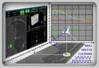
c)
working time/ free time (work improvement/ new technologies)

d)
work at home and abroad/ working conditions (salary/ fringe benefits)
advantages/ disadvantages

e)
career/ family life/ women employment

- take maternity leave/ be on/ take sick leave/ take early retirement/ be workaholic
get the sack (dostať padáka),= be fired= be dismissed= be out of job= be between the jobs, be made redundant (prepustený)/ be laid off/ unemployed/ be on a dole (žiadaný)

- unemployment benefit, sign on/ register, re-training, re-qualification, trainer - trainee

10 HUMAN RELATIONS

a)
human relationships (family, school, neighbors, generation gap ) explain these words!
Relations
Race relations
Diplomatic relations
Industrial relations
have a good relationship/ get along with/ get on with/ be on good terms with
informal
formal

Social behavior: Slovakia/ UK/ USA
Hello/ Hi/ See you - Good morning/ Good Bye

Acts of courtesy: holding the door open for someone, taking the end place in a queue, moving aside to pass sb on the pavement, putting a hand over one´s mouth when yawning/ coughing.
BODY LANGUAGE

influenced by family, school, society – TV, church,...
BRITISH AMERICANS
1.- (private life)-holidays, garden, 1.- work
pet lovers

b)
friendship and love (system of VALUES, attitudes, meetings, celebrations)
relate, to fit in, with ties to, incompatible (neznesiteľný), go out with, be dating, be going steady (vážna známosť), have a love affair, romance, flirt, fling (........... ), split up,

“A man and a woman can be true friends!”

c)
social problems (relation of society to disabled, homeless people)
Negative relationship because of – prejudices, illiteracy (negramotnosť), intolerance, closed- mindedness, suspicion,
Society - disabled people
In the past | Now
ignorance | information
fear | understanding
pity | practical help

d)
negative sides (vulgarisms, aggression, vandalism, egoism, indolence(ľahostajnosť))

e)
possibility of conflict solution

values in conflict : value of money value of being human being

Capital punishment / Gay right/ Euthanasia/ pornography - freedom of expression

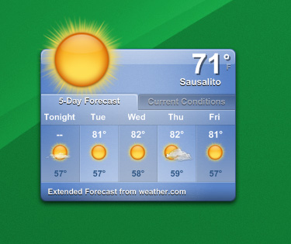
11 THE HUMAN RACE AND NATURE

a) weather forecast: Wet and windy weather, in the southwest
year seasons, weather at first, will spread northeast. Ahead of the
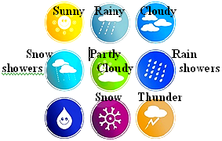
rain bright, or sunny periods. Gale (víchrica)
force winds in exposed parts.

clear, drizzle (mrholenie), precipitation (zrážky), pouring with
rain, heavy rain, rainfalls(lejak), mist (hmla), foggy, smog,
lightning, hot, boiling, warm, cold, chilly(sychravý), frost(mráz),
blizzard(fujavica), snowdrift(závej), freezing, wet, humid - dry
breeze (vánok), windy,gale, hurricane

The greenhouse
effect
Global warming
Holes in the ozone
layer
Acid rain
CLIMATE: tropical, hot, cold, mild/ temperate (mierny)
TEMPERATURE: degrees centigrade, below/ above zero

b)
nature around us / fauna / flora
Destruction of
habitats
Rain forests
Endangered species
physical world: continent, country, island, isles, ocean, sea, lake, river
fall, mountains, mountain range, jungle, forest, rain forest, desert
natural world/ wild life/ animals: mammals, birds, reptiles (plaz), fish
plants: tree (coniferous - ihličnatý/ evergreen, deciduous -listnatý) flower, root (koreň), stem (kmeň)
stalk (steblo), trunk (kmeň), branch (vetva), leaf, spine (ihlica)
c)
environment: pollution- soil/ water/ air,
NATURAL DISASTER: volcanic eruption, earthquake, flood, hurricane, drought (sucho)
harm/ damage/ destroy/ pollute environment

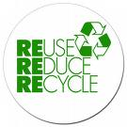
POLLUTANT (znečisťujúca látka): aerosols, fumes (výpary), smog, toxic waste, pesticides, fertilizers (umelé hnojivá), waste, sewage (odpadné vody), trash, greenhouse gases,

d)
protection of environment/ national parks/ nature preservation
ecosystem/ balance/ environmental group/ environmentally friendly, environmentalists,
conservation (ochrana prírody), conservationist, green issues/ product, protest


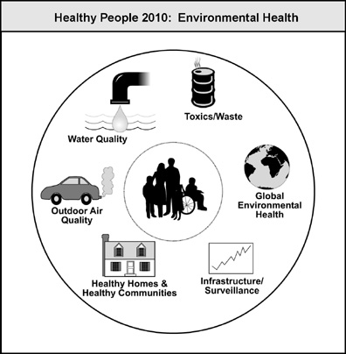
RECYCLE, bottle bank, renewable energy sources: wind power, windmill, wave power, solar power, solar cells, unleaded (bezolovnatý) petrol, recyclabe

e)
influence of environment on mankind / agriculture/
agro tourism/ healthy food

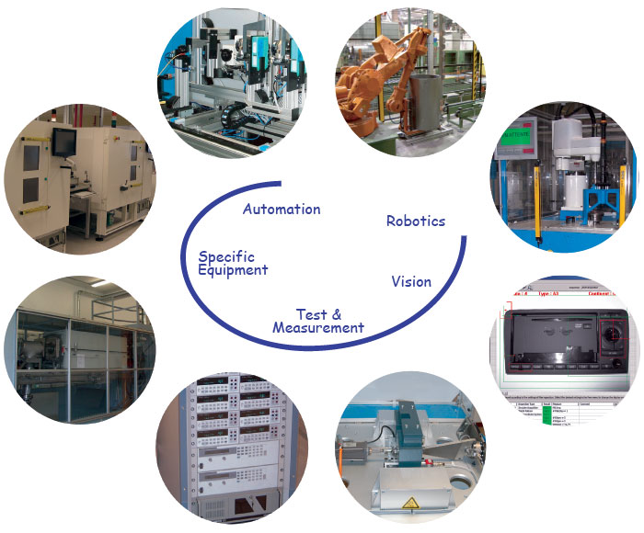
12 SCIENCE AND TECHNOLOGIES

a)
life in the past and now (science, new technologies, inventions,
gadgets and appliances)
PAST – people use their own hands to hunt, to make tools

science/ scientific/ technology/ technological/ field/ branch/
experiment/ laboratory/ formula (vzorec)
tool/ instrument/ appliance/ gadget/ gear (prevodovka)/ equipment/
engine/ machine/ machinery (technika)
TECHNOLOGY AT HOME: phonograph (gramofón), mini Hi-Fi system, telephone switchboard (spojovateľňa), answer phone, fax machine, mobile phones, refrigerator, tape recorder, walkman, TV, DVD, radio, MP3, MP4, microwave oven, washing mashine, dish washer, vacuum cleaner/ hoover, food processor (potravinársky priemysel)

What can we do with them: switch on/ off, turn up/ down, pull a lever (potiahnuť páku), push a button, rotate, insert, dial (vytočiť), plug in (zapojiť), wire (linka), battery/

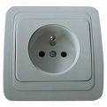
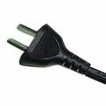
These can be: mains (elektrická sieť) operated, Hi-tech mobile, cordless (iron), portable, remote controlled (diaľkový ovládač), socket (zástrčka), plug (zásuvka)

b)
the most important inventions
- inventor/ researcher/ scientist/ technician/ engineer(strojár, inžinier), computer programmer/ operator/ attendant
- experiment/ invent/ discover/ research
18th – 19th century: Industrial revolution – the steam engine (J. Watt), the electric light bulb (T.A. Edison), the electric motor (M. Faraday), 1st petrol driven car (G. Daimler, K.Benz)
20th century: airplane, the television, the computer, the mobile phone, the Internet, the videophone


c)
man and science and technology (electronics, informatics, nuclear physics, medicine)

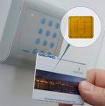
COMPUTER/ personal computer/ word processor/ laptop/ screen/ hard disc/ floppy disc (disketa)/ disk drive/ mouse/ mouse mat (podložka pod myš)/ memory/ menu/ cursor/ e-mail/ internet/ user – friendly/ file/ print/ browse/ hackers

MEDICINE – surgery/ microsurgery

TRANSACTIONS – smart cards – credit cards (magnetic strip), memory cards

d)
misuse of science and technology
weapons/ addictions/ violence/ consumer society/ civilisation illnesses
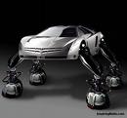
e)
man and science and technology in the future
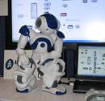
Will teachers be replaced by computers?
- Children and computers
Brain drain (únik mozgov) WHY?

13 MAN AND SOCIETY
a)morality (behavior of young / older people, ethics at school, moral rules, principles of governing a person) right/ legal/ practical(reálne)

ETHICS – based on standards of right and wrong – set as rules – in terms of rights/ obligations (povinnosť)/ benefits to society / fairness (zdvorilosť) / specific virtues (slušnosť)
Retirement pension, maternity pay, maternity allowance (príspevok), widow´s pension, widowed mother´s pension, sickness benefit, invalidity pension, mobility allowance, child benefit, unemployment benefit, income support, housing benefits,
Contributory benefits (príspevok) National Insurance contributions – príspevky sociálneho poistenia
Non-contributory benefits ( príjem z dane)

MANNERS – children learn at home – to keep the temper (nálada),
to behave like gentleman, to be good sportsman
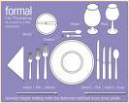
Gain them through positive lifelong habits

b)etiquette – meetings, greetings, congratulations,
- Europe – much more formal than America : younger greet older, a man greets woman, children greet adults, looking into the eyes when speaking.
- Different styles of dining: placement of fork and knife

- Special conventions: women covering head and shoulders when entering a church, women wearing knee-length skirts for diplomacy/ business, wearing hats and gloves when meeting personalities – the Pope/ the Queen

c)morality and law, misunderstanding and conflict
Standards :
- Reasonable obligations to refrain (vyhnúť sa) from rape(únos/ znásilnenie),
stealing, murder, assault (útok), slander (ohováranie), fraud (podvod)
- Encourage virtues of honesty, compassion (súcit), loyalty (lojalita/ vernosť)
Relating to rights: right to life, the right to freedom from injury (krivda), the right to privacy

- Justice (spravodlivosť)/ legal/ illegal/ lawful (zákonný)/ unlawful/ judical system (súdnictvo)
Lawyer/ attorney (advokát)/ barrister (obhajca)/ judiciary (justícia)/ people´s judge/ appoint a judge (vymenovať sudcu)/ solicitor (právny zástupca)/ the prosecution (žaloba/ trestné stíhanie)/ the defence (obhajoba)

- Civil law/ sue (žalovať)/ plaintiff (žalobca)/ defendant (obžalovaný)/ compound a quarrel by mutual agreement (ústna dohoda)/ settle out of court/ criminal law(trestné právo)/ criminal offence (trestný čin)/ juvenile delinquency (zločinnosť mladistvých)
- Theft/ steal (krádež), robbery(lúpež), burglary (vlámanie), break into, kill in self-defence, murder, make attempt on the life of, assassinate (zavraždiť), revenge, manslaughter (zabitie),
rape, treason (vlastizrada), suicide, abuse (zneužitie), cheat (podvod), forge (falšovať), blackmail (vydieranie), bribery (korupcia/ podplácanie), bribe, hijack, kidnap, pickpocket (vreckár), shoplifting (drobná krádež /v obchode), gangster/ hooligan (výtržník)

What happens when the crime has been committed?
Investigation/ search for fingerprints/ lie-detector/ trial/ law-suit (súdny proces)/ case/ give evidence/ eye-witness, testimony (svedectvo)/ innocent/ convict of murder (usvedčený z vraždy)/ pass a sentence on sb (odsúdiť)/ fine (pokuta)/ capital punishment/ death penalty/ ask for mercy (žiadať o milosť)/ imprisonment/ release from prison/ execute/ behead/ hang/ electrocution/ hangman (popravca)/ abolish the death penalty/ pardon (udeliť milosť)

d) expressing interest and help to people in need : the retired/ the sick/ the disabled/ the unemployed/widows/ people on very low income

e) the influence of society on the family

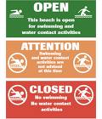
14 COMMUNICATION AND ITS FORMS

a) different types of communication and its significance (verbal – non-verbal)
Language – system of sounds, words, patterns to communicate our thoughts and feelings

VERBAL COMMUNICATION NON-VERBAL COMMUNICATION
spoken language/ face to face/ we use stress body language/ sings, GESTURES, mimics,
intonation/ facial expressions (yawn, whisper (šepkať),
primary

waving hands, sneeze)
secondary
fluency/ accuracy/ appropriacy (primeranosť)
range (rozsah) pronunciation/ interactive
communication / turntaking strategies To become a gesture it has to be seen by sb else-
asking for clarification onlooker! (pozorovateľ)


WRITTEN COMMUNICATION SIGN LANGUAGE
one-way a system of hand movements and gestures
rather formal/ can be read several times/ deaf people/ universal sign language
structured/ organised

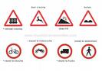
coherence (súvislosť)/ cohesion (previazanosť) signs/ signals/ hand signals/ morse code/
precision (presnosť) shake/ nod/ make a sign/ motion/ wink/ wave/
gesticulate/ cry/ shout/ roar(hulákať), / morse
code MAYDAY: dots/ dashes
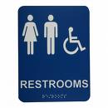
pictograms

sign/ symbol/ emblem/ logo/ insignia (odznaky hodnosti)

b)
communication in different situations (public speech, btw young/ older people, in the street, at school, ...)
formal/ informal/ gossiping(ohováranie)

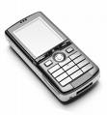

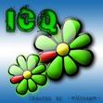
c)
modern forms of communication
communication: face to face – over the phone/ / E-mail/ /

ADVANTAGES / DISADVANTAGES – what do you prefer? why?

d)
communicative language competence
linguistic/ sociolinguistic/ strategic/ discourse (prednáška)
first language/ mother tongue/ official language/ native speaker/ non- native speaker/ bilingual speaker
LANGUAGES: modern/ foreign/ language barrier
linguistic ability/ skills, studies, development, learning strategies

e)
varieties of English/ standard English/ standard American
colloquial (hovorový)/ dialect (nárečie)/ slang/ jargo(odborný)

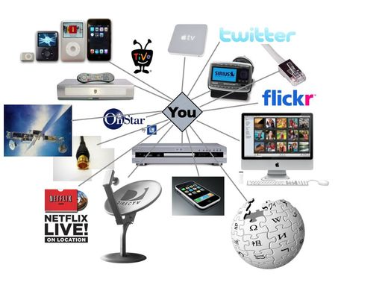
15 MASS MEDIA
a)
different kinds of mass media (advantages/ disadvantages)
- the press/ radio/ television/ internet

INFORM/ EDUCATE/ ENTERTAIN

b)
the press (newspapers, magazines, rubric) - the choice, reading,

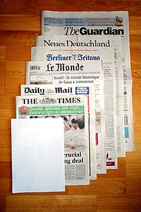
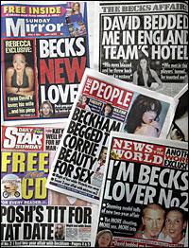
- local paper, Sunday paper, broadsheets / serious, tabloid/ popular/ gutter, press story, article, headline, letters page, news reports, international/ domestic news, sports reports, business news, article, feature article (hlavný článok), scoop (pretromfnúť), editorial/ leading article, interview review, a letter to the editor, classified ads, cartoon, crosswords, coverage, reviews, column,

BROADSHEETS TABLOIDS
Quality papers Popular papers (gutter press)
Large sheet format Smaller sheet format
Serious news/ shorter articles/ big headlines
longer articles/ FEATURES ABOUT
smaller headlines STARS/ SPORTS CELEBRITIES


journalist/ correspondent/ editor/ fashion/ sports/political editor/ investigative journalism/ reader/ readership/ circulation/ subscribe/ newsagent/ news-stand(kiosk)/ paper boy/ girl/ press conference/ press release

c)

Radio and Television (favorite programmes)
Commercial (Supported by charging companies for being advertised)
Non-commercial (no advertisement, supported by state, grants, private organizations)
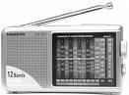
- Radio: listen to, audience, frequency: short/ medium/ long wave, tune (naladiť), tune in
to (naladiť si),
- Television: telly, TV set, the box, be on TV, broadcast, channel, station, cable/ satellite/
remote control , video, DVD, plasma TV
- Programmes: show, chat/ talk/ quiz/ game/ breakfast show, cartoon, sitcom, drama,
soap opera, the news, weather forecast, wild life programmes, documentary, current
affair, serial, series, episode
- Presenter (moderátor)/ host/ newsreader/ commentator/ viewer/ listener/
announcer (hlásateľ),

d)
the influence of mass media on people/ children/ teenagers/ society
THERE IS TOO MUCH VIOLENCE ON TV!
Freedom of the press, censorship, censor, biased towards/ in favour of

e)
the Internet and its influence on people


16 YOUNG PEOPLE AND THEIR WORLD

a)
the characteristic of young people (physical appearance, fashion, personal qualities, hobbies)

- Youth, be in one´s teens, adolescent, youngsters
- Develop one´s talent, have a goal in life, achieve a goal, have high/ low self esteem
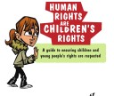
- Spare time activities, attend youth centres/ youth clubs, go to a fitness centre, watch TV/ videos/ DVD, play organized sports/ computer games, dedicate time to (venovať čas), take up sports like swimming, boxing, climbing, go in for a sport/ take a passive interest in sport

b)
Young people in society (rights and duties, study/ job opportunities, young families)
- The United Nations: is a unique international organisation of 192 sovereign States,
representing virtually every country in the world.
United Nations Convention on the Rights of the Child (UNCRC): UN Convention on the Rights of the Child (UNCRC or the Convention) sets out internationally agreed standards relating to children’s civil, political, economic, social and cultural rights.

- You have the right to protection against discrimination
- Adults should do what’s best for you
- You have the right to life
- You have the right to an opinion and for it to be listened to and taken seriously
- You have the right to be protected from dangerous drugs
Leisure expences, get pocket money, be careful with money, earn supplementary/ extra money, spend money on books/ CDs/ magazines/ PC games, save up for a bicycle/ motorbike
Have a Saturday job/ work at weekends, baby-sitting, household chores, do the washing up, do the washing, wash the family car, do voluntary work, work for charity
c)
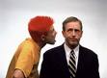
relationship between young people/ generation gap (conflicts btw generations, misunderstandings) - reasons/ consequences
- parental influence, rely on parents, respect authorities, look up
- dating/ have a boy/ girl friend / spend a great deal of time with
go to discos/ pubs/ concerts

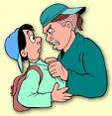
d)
negative aspects in the life of young people (violence, gambling, drugs) Bullying
addiction (závislosť)/ long prison sentence (dlhoročné väzenie)/ undermine (znevážiť)/ get sth across to sb (zrozumiteľne vysvetliť)/ drug relater crimes (zločiny spôsobené drgovou závislosťou)/ fix (dávka drogy pre závislého)/ put up with (tolerate)/ intolerable (neznesiteľný)/ superior (nadradený) aware of sth (byť si vedomý), suicide, side effects, anxiety organ failure

e)
young people and their future plans (expectations, desire, fears)
EDUCATIONAL PROGRAMMES: Socrates, Erazmus, Leonardo DaVinci
Learning card (vzdelávací poukaz), adviser, fulfil ambition, training options (možnosť odbornej praxe), set up business , NVG (National Vocational Qualification)- odborná kvalifikácia


17 FOOD

a)
meals and drinks during the day (breakfast, lunch, dinner) my favorite meal
food/ foodstuffs/ meal/ dish/ course/ snack

be hungry/ thirsty feel like eating sth

MEALS: starter/ appetizer, soups- clear soup, bouillon, creal soup, chicken/ vegetable/ mushrooms/ fish soup, main dishes: beaf steak, pork fillet, fish fingers, roast chicken/ turkey, boiled/ rost potatoes, rice, dumplings, vegetable salad, green salad, cabbage&onion salad, desserts: apple pie, chocolate cake, pakcakes, ice cream, fast food: hot dog, hamburger, pizza, chips/ fries, drinks: soda/ mineral water, lemonade, coke, beer, wine, coffee, ice tea
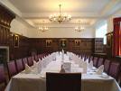

b)
catering facilities
you can eat in a restaurant, at home, in a school canteen

c)
national cuisine , eating habits

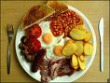
Traditional British breakfast: fried bacon, eggs, sausages, fried bread,
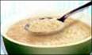
buttered toast with marmalade, fried tomatoes, baked beans, tea, coffee
Scottish: a bowl of Scottish porridge (ovsená kaša)
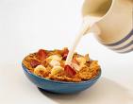
Typical breakfast: cereals with milk
America : fruit juice, eggs,
meat (bacon/ sausage) toast
SUNDAY LUNCH: the biggest meal of the week
Continental breakfast: bread/ croissant

Packed lunch/ sandwiches/ fruit
British dinner: cooked meal with meat/ fish, vegetable salad, followed by dessert
USA: ready-prepared food heated in a microwave

Great Britain: 3 meals a day: light breakfast and lunch, dinner – the main meal, supper (neskorá v.)
Slovakia: main meal of the day : Lunch, home-made food

d)
international cuisine (characteristics, differencies, specialities)
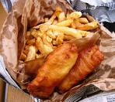

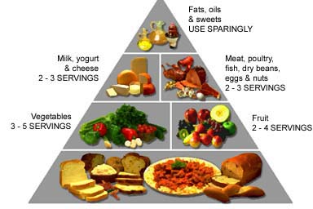
British : Fish and Chips (wrapped in paper and eaten outside)
Slovak: Halušky (dumplings with sheep cheese (bryndza)), wine drinkers
Czech: tradition of beer

e)

healthy eating (vegetarians, vegans, diets)

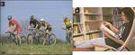
18 HOBBIES, FREE TIME ACTIVITIES AND LIFESTYLE

a)
possibility of spending free time
entertainment, practice one´s hobby, collector´s clubs, keep pets, a weekend cottage,

  - at home : watch TV, listen to music/ play PC games, read, get a video, get a takeaway
  - cinema/ pubs/ discos: go out to dinner/ lunch/ for a meal/ go to the concert/ a bar, theatre/ shopping/ clubbing
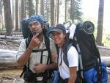
  - outdoors: go to the beach, to the park, have a picnic, go for a walk/ for a run, walk a dog/ take the dog for a walk, go sailing/ climbing/ skiing/ camping

b)
organized free time activities (school clubs, summer jobs)
voluntary work (charity),

- leisure time activities – play a musical instrument, amateur groups, folk/ modern dancing
- sport activities: playing ball games, hiking, cycling, rowing (veslovanie), jogging, swimming, roller-skating, skate-boarding, wind-surfing, skiing, camping, gathering mushrooms

c)
individual hobbies (arts, culture, books, sport, house work, nature )

- spend the time with friends: go over to somebody´s house/ have a party// a barbecue/ meet up with somebody, go out with your boyfriend/ girlfriend

d)
changes in society and their influence on leisure time activities

What influence the choice of your free time activities?

e)

How do people at different age spend their free time ?

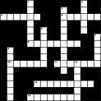
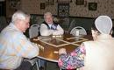
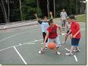

19 MULTICULTURAL SOCIETY

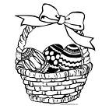
a)
holidays – customs and traditions (religious/ bank holiday/ folklore festivals )
Compare Christmas/ Easter holiday in Slovakia and UK / USA
Send card/ letter, flowers …
Good Friday – Christians remember the death of Jesus Christ on the cross
Easter Sunday – celebrate his resurrection - Go to church
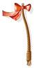
USA - basket of sweets/ chocolate eggs/ chocolate Easter Bunny – left out in the garden/ discovered by children EGG HUNTING
Easter Monday- UK – give presents of Easter Eggs to chidren
Slovakia – whip (vyšibať) willow (vŕba)/ throw water on sb (obliať)

b)
living of different nationalities in one country
race/ colour of someone´s skin/ whites/ blacks/ Afro-American/ Native American/ ethnic group/ ethnic devisions/ ethnic unrest (nepokoje)/ ethnic violence
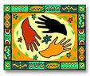
multicultural/ multiracial/ interracial (medzirasové)/ cosmopolitan society/ city/ district, mixed marriage/ parentage

ADVANTAGES DISADVANTAGES


c)
co-existance of nationalities, contacts btw different cultures in the past / now, tolerance
tolerance / understanding/ acceptance/ co-existance/ cooperation/ assimilation (prispôsobenie hodnôt)/ integration/ integrated society/

immigration/ controversial/ individuality

d)
negative sides (discrimination/ intolerance/ relation to minorities)

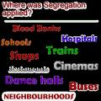
racial conflict/ racial prejudices/ racial harmony/ racial tension/ racism/ racist/ racial outbreaks (prepuknutie)/ race riots (rasové nepokoje)/ fight the police/ throw rocks/ fire – bombs/ smash windows (rozbiť okná) /

SEGREGATION (segregated schools/ restaurants )

e)
cultural values of other nations/ co-existance in EU

arranged marriage/ wedding couple/ church/ registry office/ marital satus
equality/ partnership/ confidence/ faithfulness (vernosť)/ responsibility/ reliability/

refugee (utečenec)/ immigrant/ flee the country (utiecť) / seek asylum

why?
War/ starvation/ bad living conditions…

20 TOWNS AND PLACES
a)
important places in my life (my birthplace, my hometown – the place where you live, study, work)
geographical position: in the south/ north/ east/ west, in the centre of, on the coast, on the River…, on Lake…, lie far from
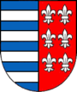
border, frontier (hraničný), mountainous, flat
climate: dry, hot, tropical, moderate(mierny), mediteranean

b)
tourist information (welcoming, basic information about the stay)
history of the town
Place to overnight – Hotel Ďumbier, Hotels/ Private rooms in Mýto, Bystrá, Tále
Place to eat (restaurants) – Elf, Alžbetka, Monami, Barbaricum…
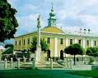
important sightseeings Museums, Synagogue, Churches, Town hall, Bell tower
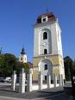
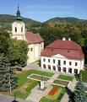
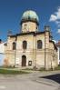

Plague column

Famous people Martin Rázus, writer
Ján Chalupka, writer Ottó Herman, ornithologist
Ivan Bella, astronaut Pavol Habera, singer
Karol Kuzmány, writer Miroslav Leitner, ski mountaineer

c)
Places of interest (Interesting places for tourists to visit)
The Bystrianska Cave, Ski resort Tále, Gray Bear golf ground, Čiernohronska Railway, Vydrovo
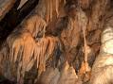
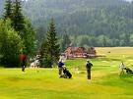
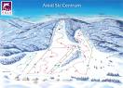
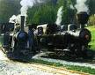


Interesting towns to visit: Open Air Museum
Banská Bystrica, Zloven (castle), Banská Štiavnica (UNESCO), Kremnica (mint - mincovňa), Bojnice – Zoo, Manor-house, Spiš castle…
* monument, church, cathedral, palace, manor house (zámok), museum, gallery
d)
places to relax, entertain
cultural facilities – cinema, theatre, library/ sports facilities – playground, stadium, swimming pool, tennis courts, shopping facilities – shops, department store, boutique, corner shop (obchodík)

e)
My dream town (the place where I would like to live)
capital city, coastal town, seaside town, mountain village, spa town, medieval town

What you like/ dislike about the place where you live?

*
Good communications : public transport, tram (AmE streetcar)
Educational facilities: creches (detské jasle), nursery school, kindergarten, primary school
secondary school, university
street, square, lane (úzka ulica), avenue (trieda/ široká mestská ulica), pedestrian crossing/ zebra crossing, public lavatories (WC)

21 CLOTHING, FASHION
(elegant)
a) clothing, a piece / an item of clothing, get dressed, put on sth, take off sth, dress up, be neatly dressed,
have sth/ nothing to wear/ to be fashion conscious/ it fits me/ it suits you
influence of weather and climate on clothing
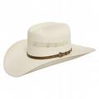
Ancient times : clothing was important bcs it protected people from cold, rain, frost
Now: clothing – sign of social status
Colder countries prefer fur coat/ boots/ fur caps Hot countries – light clothes- straw hats


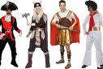
b) to wear casual/ formal clothes, be clothed in black
clothes and accessories for different occasions

summer dress/ two piece dress/ evening dress/ wedding dress/ fancy dress/ morning dress -standard dress/ long dress – grown, robe, cocktail dress, tuxedo – (smoking), dinner jacket (frak)/ bowties
trousers: wide/ narrow V- necked top
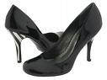
working in a bank/ office – people are dressed up : men – suit, shirt of different colour, ties, shoes –
black or brown
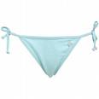
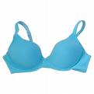
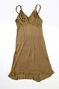
women- fashionable tops, blouses, accessories,
shoes – pumps

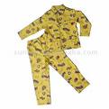
WOMEN´s WARDROBE: underwear (knickers/ bikini briefs, bras, slips (spodnička), stockings),
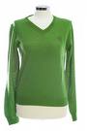
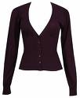
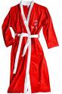
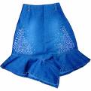
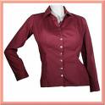

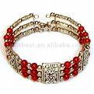
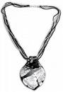

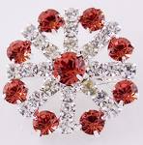
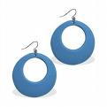
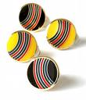
pyjamas/ night dress, dressing gowns (bathrobes), skirts and blouses, jumpers, cardigans, several pairs of trousers, jeans, jackets, tailored suits (kostým), an anorak, a winter/ a fur coat, accessories in matching colours: shoes, boots, handbags, scarfs, gloves, hats and jewelleries: earrings, rings, bracelets , necklaces , chains , brooches , clip-on, hoop earrings

MEN´s WARDROBE: underwear (undershirts, underpants), socks, trousers, shirts, trench coat (kabát), accessories: shoes, boots, ties, gloves, hat, cap, belt, hankerchiefs (vreckovky)

c)
the choice of clothes according to fashion/ age/ dress sense/ mood/ money
sport clothes: jeans, T- shirts, track suit (tepláky), trainers, sneakers (tenisky), athletic shoes
casual clothes: old jeans, loose (voľné) T- shirt, clogs (dreváky), slippers

d)
trends in fashion – colours (cold/ warm, bright/ dark), designers, dress parade/ fashion show

Fashion designers: Calvin Klein/ Vivien Westwood/ Donatella Versache

e)
Tailor clothes or boutique
materials/ fabrics: cotton, linen (ľan), wool, woolen, silk fabrics, (hodváb), man-made fabrics
patterns: plain dress (hladké šaty), dotted (bodkované), striped (pásikavé), checked (kockovaný)


22 THE BOOK A PERSON´S FRIEND to be keen on
a) reading
books – reading, the choice of books
before Guttenberg´s invention – people read MANUSCRIPTS to read a book in
(hand written books) one sitting

You can read: while travelling/ waiting/ during breaks at school, on holiday
WHY DO WE READ?
For pleasure, to learn, for information/ advice, to entertain

LITERATURE
FICTION NON-FICTION
About imaginary people/ events for information
POETRY / PROSE textbooks/ dictionaries
Poems Tales/ short stories/ novellas/ encyclopedias/ biographies/
Westerns/ thrillers/ romances/ autobiographies/ memoirs/
Crime/ spy novels, mysteries, self-help books/ travel/ history/
Science fiction/ historical novels art books, cookery books
b)
my favorite author/ genres

c)
the story by one of an English speaking writer
author/ setting – place - time/ the plot (the series of events which form the story)/ narrator

d)
the NOBEL PRIZE FOR LITERATURE
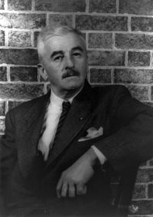
the Nobel Prize winners: A Fable (1954), As I Lay Dying (1930): W. FAULKNER
J. Steinbeck : The Grapes of Wrath; Of Mice and Men
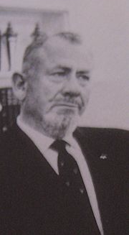
(ovocie hnevu) (O myšiach a ľuďoch)

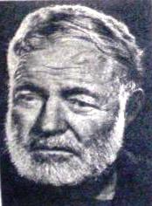
E. Hemingway: belonged to The Lost Generation
The Sun Also Rises
The Old Man and the Sea

All of them won Pulitzer prize!
Samuel Beckett (Irish) : Waiting for Godot
Other British writers: Brontë sisters (Charlotte's Jane Eyre and Emily's Wuthering Heights) Charles Dickens : David Copperfield, A Christmas Carol
R.L. Stevenson (Scottish): Treasure Island, The Strange Case of Dr. Jekyll and Mr. Hyde
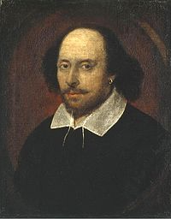
Other American writers: E.A. Poe - The Raven, Sylvia Plath, Mark Twain - Adventures of Huckleberry Finn, The Adventures of Tom Sawyer tragedies:
WILLIAM SHAKESPEARES : Hamlet, King Lear, e) Macbeth
crisis in books reading comedies:
WHY ? A Midsummer Night's
Buying books in a book shop/ borrow books from a library Dream
Reading magazines/ newspapers
Read the book review in the newspaper/ recommend the book to your friend

Recent famous writers: J.R.R Tolkien – The Lord of the Rings
J.K. Rowling – the Harry Potter
* What´s better to read a book or to see the film?

23 EXAMPLES AND IDEALS

a)
virtues and vices (positive and negative characteristic features, an ideal man, values)

VIRTUES : acceptance, bravery, curiosity, devotion (loyality, vernosť/ oddanosť), generosity (štedrosť), honesty, love, justice, openness, patience, responsibility, reliability, sensitivity, hard-working, hospitable,

VICES: anger, arrogance, doubt (pochybnosť), injustice, impatience, jealousy, weakness, greed (lakomosť/ nenásitnosť), meanness , deceitfull (nepoctivý), cheeky (drzý), stubborn, envious (závistlivý)

b)
A person that I admire

Model/ idol/ ideal/ role model/ celebrity/ icon/ VIP/ hero/ heroine, personality
Idolize, copy, worship (uctievať), identify with WHY ?

Mother Teresa, Princess Diana, Martin Luther King, Mahatma Ghandi
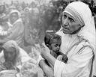
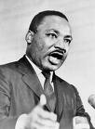
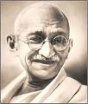
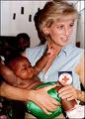

c)
real and literary heroes
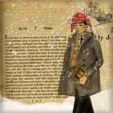
The Catcher in the Rye by J.D Salinger
Holden – typical teenager, clever, middle-class family but lonely, expelled from 3 colleges, poor exam results, communication problems with his family, describes his life, experience, with humor, criticism

d)
No one is born a hero but you have to become a hero! (real heroes in everyday situations)

Lifesaver (plavčík), Policeman, Fire fighter, Doctor
Sacrifice (obetovať sa), risk one´s life, awarded by the head of state on special occasions

Children Act of a Year

e)
Me as a hero

Can you imagine yourself a hero? WHY? WHY NOT?

