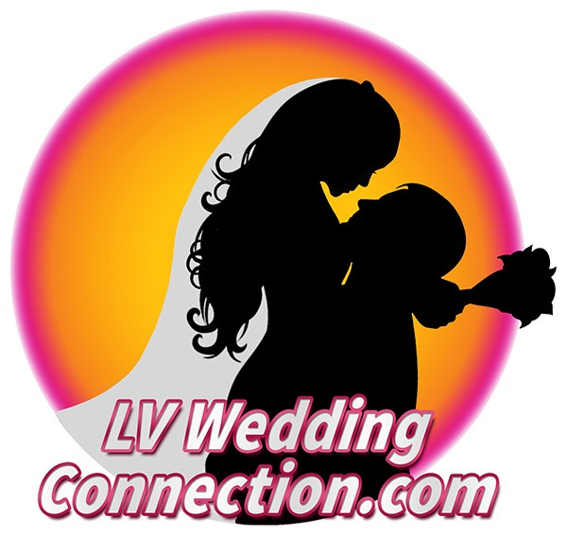 | Going to the Chapel!!!!  An inside look at the Wedding Industry in Vegas  4 Locations including a FASHION SHOW  Monday, November 5,2018  6:00pm-10:30pm

Wedding TOUR
$30.00 per person
Includes Transportation, Tour FOUR locations, Refreshments, a Fashion show of Tuxedos and Gowns, fun and entertaining event with a goodie bag of information

First Name: ________________________________________ Last Name: __________________________________________________________________
Company Name: ____________________________________________________
Email Address: ___________________________________________________________________________________________
Street Address: ___________________________________________ Suite#: _______________________
City: _______________________________________________ State: _____________ Zip: _____________ Country: _____________________________
Mobile Phone: __________________________________ Fax: ________________________________
How many in your group? _________________________
Additional names: ______________________________________________________________
_____________________________________________________________________________________________________________

CREDIT CARD AUTHORIZATION
Payment must accompany your registration application.
Payment Type:  VISA  MasterCard  Discover  American Express
 Check (enclosed with mailed registration – not valid for fax)
Please charge my card for $___________ for ________________
CREDIT CARD SECURITY CODE
Credit cards cannot be processed without this code. The code is located on the back of your VISA, MasterCard and Discover and on the front of your American Express card.

Card: _______________________________________________________________________ Exp: ______________ Security Code: ________________

Name on Card: ______________________________________________ Authorized Signature: ______________________________________________
Deposits are non-refundable. Pay by Credit card and fax to 702-270-6876, or email joni@lvweddingconnection.com or mail to: LV Wedding Connection, 2590 East Windmill Lane #348, Henderson, NV 89074

