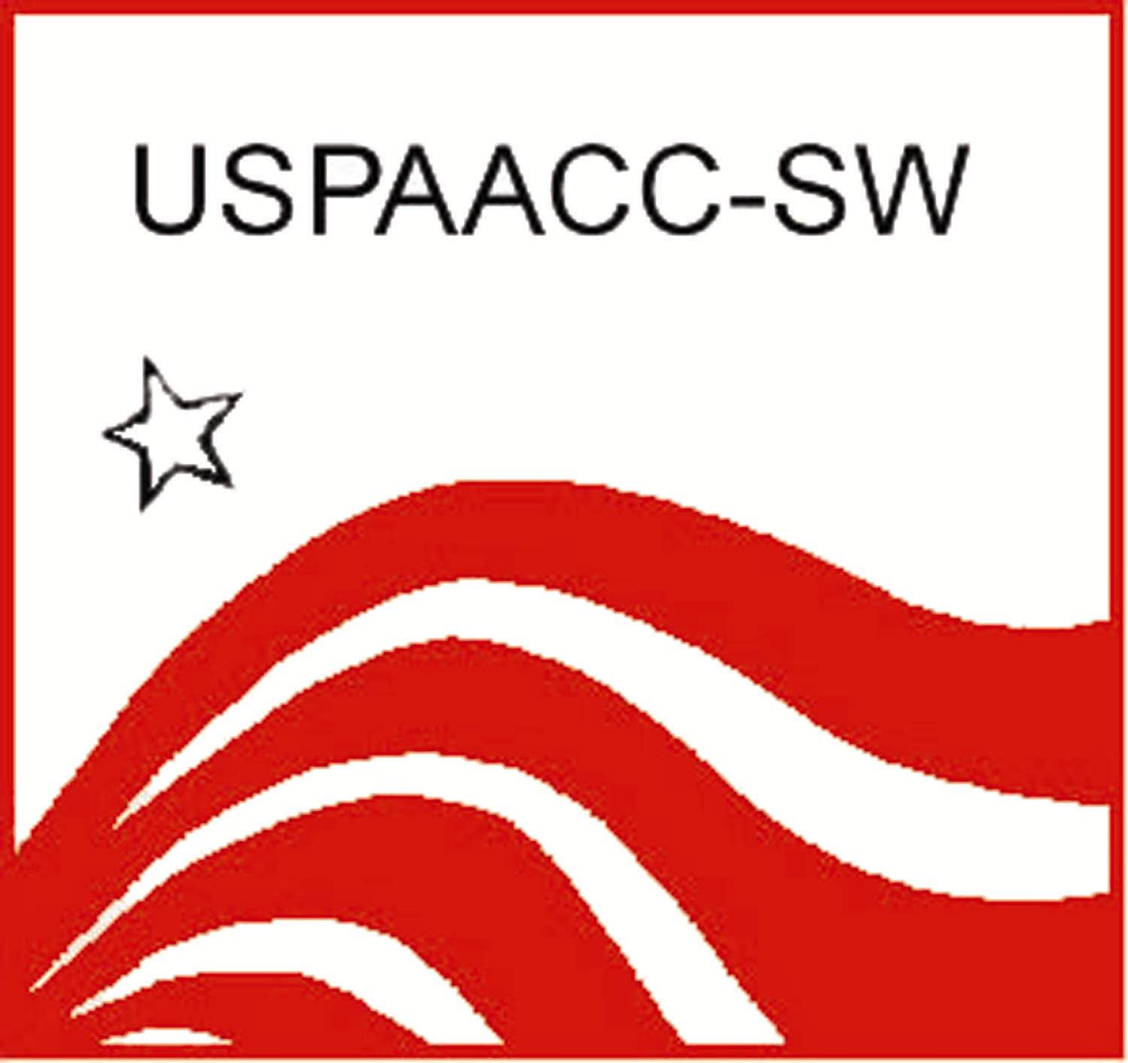
US Pan Asian American Chamber of Commerce
Southwest

Corporate Membership Application

BENEFITS

- Designated as USPAACC-SW Corporate member in USPAACC-SW print & marketing materials
- Company logo prominently displayed on USPAACC-SW Home Page
- Link to Corporate Supplier Diversity website from USPAACC-SW Home Page
- Eligible to apply for USPAACC-SW Corporation of the Year Award
- Opportunity to serve on USPAACC-SW Corporate Advisory Board
- Recruitment & direct referral of Asian American suppliers to fulfill company’s unique needs
- Dissemination of selected contract opportunities to Asian American suppliers
- Opportunity to outreach to the Asian American business community
- Opportunity to highlight partnership in media and on website
- Speaking opportunity at chamber’s events

Corporate Membership (up to 100 employees): $500
Corporate Membership (up to 200 employees): $1,000
Corporate Membership (more than 200 employees): $2000

Date: |  |  |  |  |  | Company:
Contact Person: |  |  |  |  |  |  |  |  | Title:
Type of Business:
Mailing Address: |  |  |  |  |  |  |  |  |  |  |  |  | Website:
City: |  |  |  |  | State: |  |  |  |  |  |  |  |  | Zip Code:
Business Description:
Supplier Diversity Contact: |  |  |  |  |  |  |  |  |  |  | Title:
Phone: |  |  |  |  |  |  | Email:
Does company have small business mentoring program in place?  yes  no
What types of vendors is your business seeking?

Payment Information:
Form of Payment (please specify): |  | Check | Credit Card [MC VISA AMEX DISCOVER]
Credit Card #: |  |  |  | Cardholder's Name:
Expiration Date: |  |  |  | Signature:
Billing Address: |  |  |  |  |  | CVV:  (security code)

 Please endorse the membership fee payable to “USPAACC-SW EF” 

Please Return Completed Application to:

USPAACC-SW, 202 E. Border Street, Ste 144, Arlington, TX 76010; Fax: (817) 469-9485
gmcdermott@uspaacc-sw.org

