MEMBERSHIP APPLICATION FORM

Please complete and forward, together with remittance to the Hon. Membership Secretary.

Tim Marshall,
Gardener's Cottage,
Scampston, Malton,
North Yorks,
YO17 8NG,
UK

I wish to join the International Asclepiad Society and enclose my annual fee, to cover 3 journals of;
□£13.00 for U.K. Membership
□£14.50 [€21.00] for European [Airmail]
□£17.50 [$34.50] for Rest of World [Airmail]

Please tick appropriate box *

Please make cheques etc., payable to the
International Asclepiad Society.
[Payments in local currencies can be made to your National Representative. Please make these cheques payable to your Representative.]

PLEASE PRINT

NAME ……………………………………….
ADDRESS…………………………………..
………………………………………………..
………………………………………………..
………………………………………………..
DATE………………………………………..

AMOUNT ENCLOSED……………………
CREDIT CARD NUMBER:
………………………………………………..

EXPIRY DATE………./………….

3 Figure Security No.(on rear of card)………….

[There is an extra charge of £1.00 for credit card payments]

AIMS OF THE SOCIETY

The International Asclepiad Society (IAS) came into being in 1976 to bring together anyone interested in growing and studying members of the family Asclepiadaceae. This is a large group of plants, and inevitably interest has centred on the succulents: Stapelia, Caralluma, Huernia and other Stapeliads, as well as Ceropegia, Hoya, etc., although other members of the family are not neglected.
In keeping with the latest taxonomical ideas, the family Apocynaceae was added to the scope of the society in 2000. This means principally Adenium and Pachypodium, but other plants in this family are also covered.
The Society aims to increase available knowledge about all aspects of cultivation, ecology and correct naming of Asclepiads and the Apocynaceae. It also aims to provide opportunity for the free exchange of information between members and to increase the number of species that are available in cultivation.
About a third of the members live in the UK, a third in mainland Europe and a third in the USA or other countries. This strong international membership greatly enhances the exchange of ideas and information.

JOURNAL

Members of the Society receive the journal Asklepios three times a year. It contains much information about Asclepiads, which would otherwise not be available to the collector. Articles vary from aspects of cultivation, description of plants in the wild and in cultivation, to more detailed problems of plant identification and ecology. As many species as possible are illustrated by means of line drawings, black and white photographs and often coloured plates. Back numbers of Asklepios are stocked and can be obtained from the Secretary, subject to availability.

SLIDE BANK

The Society is fortunate in possessing a Slide Bank of over 1,300 slides, including around 200 Plowes slides with habitat data. Members can obtain duplicates at cost price.

LIBRARY

Members needing more detailed information about plants can use the Society's Library. At the moment, the bulk of the literature held covers the Stapeliads and Ceropegiads. This is available for personal research purposes.

SEED DISTRIBUTION

The annual seed lists, obtainable on request to members only, are probably the world's finest source of Asclepiad seed. They bring together donations derived from carefully cultivated plants as well as much field-collected seed. In this way the number of species in cultivation has been increased significantly, so greatly enriching our collections.

CD-ROM’s & LITERATURE

In association with the German Society, IG Ascleps the Society has now produced a set of CD-ROM’s containing around 2,700 pictures of a wide variety of Asclepiad families, which make an invaluable reference collection. These are available to members at the following prices including p & p.;
In the UK at £9.00, Europe £9.50
Rest of the World;
Surface £10.00 or Airmail £11.50
For further details see the “Sales Table” page of Asklepios, where you will also find details of Badges, T-Shirts and a number of publications, which are available from the Society.

OTHER ACTIVITIES

Shows, Conventions, etc. are held in the UK and The Netherlands. These are centred on items of Asclepiad interest, but also provide opportunities to meet fellow enthusiasts and to exchange experiences and plants.

WEBSITE

The Society has its own website which can be accessed at http://www.asclepiad-international.org where you will find more details about the Society, and links to several personal sites relating to Asclepiads and the Apocynaceae.

MEMBERSHIP

Membership of the IAS is open to anyone interested in Asclepiads and the Apocynaceae.
Annual membership runs for twelve months and includes 3 issues of the journal Asklepios. For subscription rates see the application section of this leaflet. The Society has a Post Office Giro Account number 14 710 4009 for those UK members who wish to pay by postal transfer. We also accept all major credit cards including Visa, MasterCard and American Express. Alternatively you can of course pay by cheque made payable to the International Asclepiad Society.

REPRESENTATIVES

Membership Secretary : Tim Marshall,
Gardener's Cottage, Scampston, Malton,
North Yorks, YO17 8NG, UK
plantsman@tiscali.co.uk

AUSTRALIA: Mr P. I. Forster, P.O. Box 2171,
Ashgrove West, Queensland 4060, Australia
E-mail: paulforster@uq.net.au

FRANCE: Mr.Jean-André Audissou,
36 Avenue du Stade,17450 Fouras, France
E-mail: j-a.audissou@wanadoo.fr

GERMANY: Dr U. Meve,
Lehrstuhl für Pflanzensystematik,
Universitat Bayreuth, D-95440 Bayreuth, Germany
E-mail: ulrich.meve@uni-bayreuth.de

ITALY: Mr P. d'Annibale, Strada di Sant’Anna 7,
00063 Campagnano di Roma RM, Italy
E-mail: paolo.dannibale@poste.it

NETHERLANDS/BELGIUM: Mr G. P. Shirley,
Julianastraat 16, 2771 DX Boskoop, Netherlands
E-mail: pauI.shirley@wanadoo.nl

NEW ZEALAND: Mrs J. L. Griffith,
249 Te Moana Road, Waikanae, New Zealand
E-mail: j.r.griffith@clear.net.nz

SCANDINAVIA: Dr. L. Wanntorp, Ph.D.,
Associate Professor, Department of Botany,
Stockholm University SE-10691, Stockholm, Sweden
E-Mail: livia.wanntorp@botan.su.se

SLOVENIA: Mr Iztok Mulej
Na Trati 2, SI-4248 Lesce, Slovenia
E-mail: imulej@yahoo.co.uk

SOUTH AFRICA: Mr P. R. Alp,
P.O. Box 475, Mooinooi,
0325 North West Province, Republic of South Africa
E-mail: Philip.Alp@lonpIats.com

SPAIN: Mr Giuseppe Orlando,
Apartado de Correos 322, 38320 La Laguna,Tenerife, Canary Islands, Spain
E-mail: gius_orlando@terra.es

U.S.A./CANADA: Sue Haffner,
3015 Timmy, Clovis, CA 93612-4849, U.S.A.
E-mail: sueh@csufresno.edu

ZIMBABWE: Ms. N. Hughes, 8 Gary Owen Way, Riverside, Bulawayo, Zimbabwe

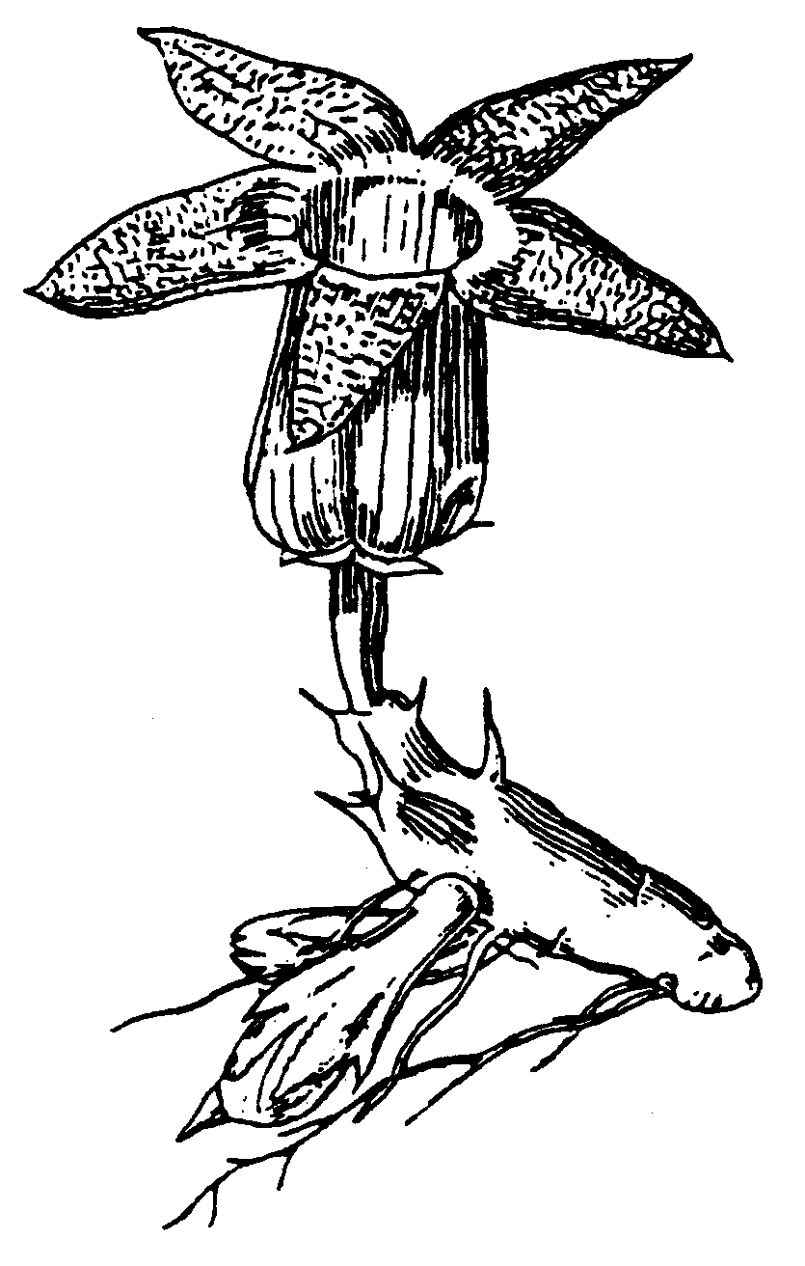
Caralluma distincta E A Bruce,
from Hook Icon Pl. 35: t.3415, 1940,
drawn by Stella Ross-Craig

