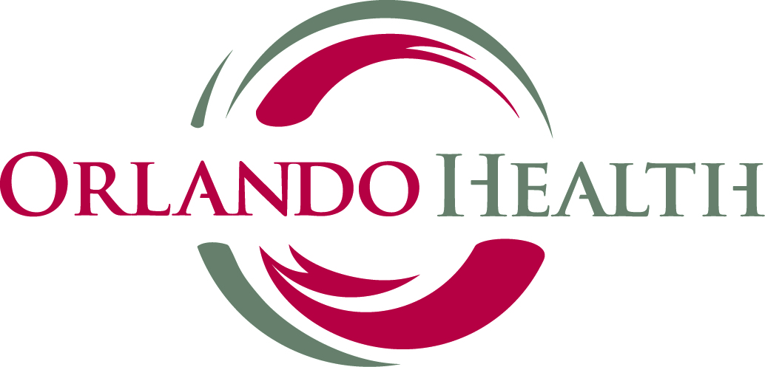

Malignant Hyperthermia Association of the United States
“Let’s Save a Life”
Mini Conference
Hosted by:
Orlando Health
MHAUS • FLASPAN • FSA

Presents
A one-day conference at Orlando Health
1414 Kuhl Ave
Registration Fees
If you are a member of MHAUS take $10.00 off

On or Before August 30th $50.00
After August30th $60.00
Patients/Family Members $25.00
3 or more Family members $60.00
Healthcare Students by August 30th $45.00
Orlando, FL 32806
On October 10, 2015 from 10:00- 4:00 pm
Program objectives upon completion of this program, the participants will be able to:
- Identify the signs and symptoms of an MH event
- Enforce quick treatment regimen for MH event
- Explain the response plan for an MH event to other medical staff
- State proper patient safety steps to take in preparation for an MH – susceptible patient
- Discuss MH testing options with patients and assist them in seeking further information
CME and 4 Contact Hours will be available; information will be on Program Agenda
Lunch included

Mail or fax this registration form today!

Name:________________________________________________________________________________________________________________

Address:_______________________________________________________________________________________________________________

Phone:_________________________________________________________________________________________________________________

Employer:______________________________________________________________________________________________________________

Here is my Payment: Check payable to MHAUS MasterCard Discover Visa Amex Amount enclosed_______________________

Name on Card:__________________________________________________ Exp. Date__________ CV#:_______________________________

Card#:________________________________________________________________________________________________________________

Billing Address:__________________________________________________________________________________________________________
Email:__________________________________________________________________________________________________________________
Make checks payable to MHAUS: POB 1069, Sherburne, NY 13460 or, call (800) 986-4287 to pay by credit card or Fax 607-674-7910
The mission of MHAUS is to promote optimum care and scientific understanding of MH and related disorders

