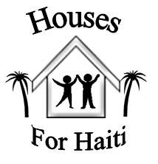

Mission Trip Handbook and Itinerary

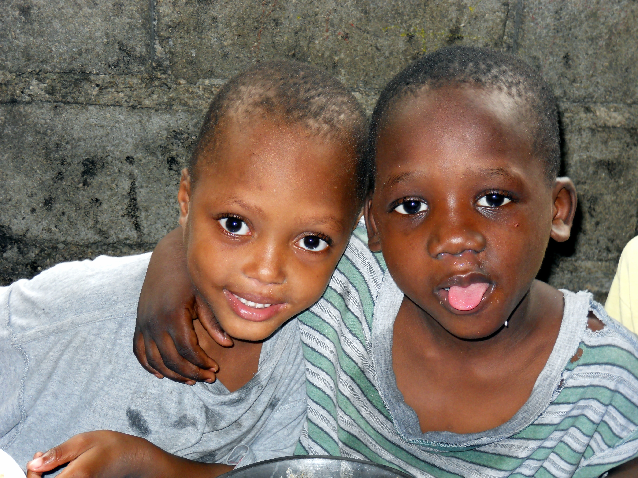

Before you go:

Passport 2
Immunization/Pills, etc. 2
Raising Support 3
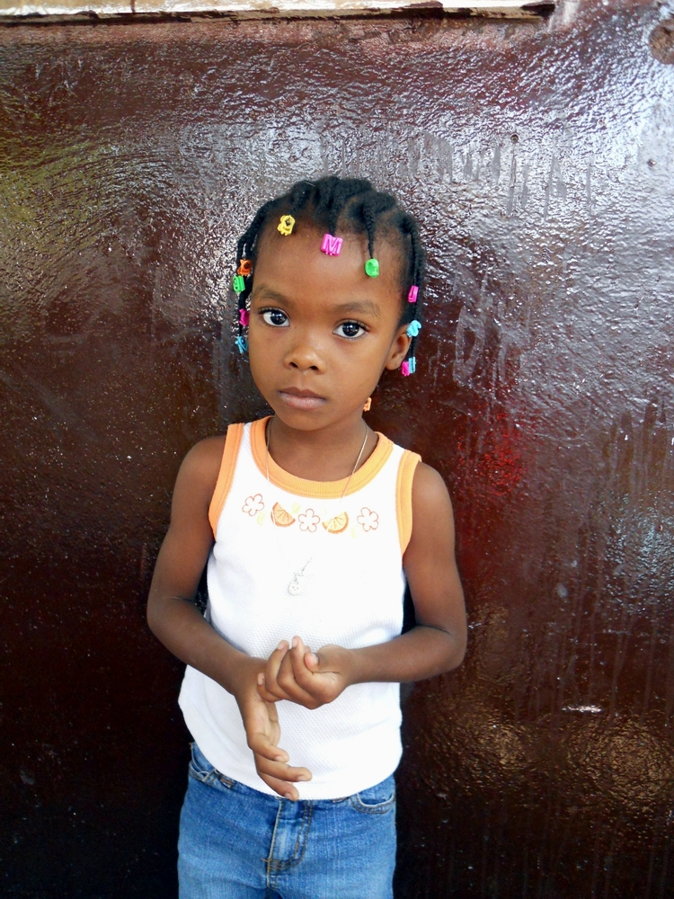
Packing and Luggage 5

While you are in Haiti:

While in Haiti 6
Phrases 8
Where we will go 9
Some Simple Guidelines 10
Facts, Guidelines 11
Contact Information 11

Welcome

Welcome to Houses for Haiti! We are delighted for your interest in coming on a trip
with us. We want you to have a great trip — so please read this packet carefully.
It’s packed full of helpful information about the mission and what to expect on
your trip. May God smile on you as you embark on this incredible journey.

Before You Go
OU GOBEFORE YOU GO
One of the most important things you can do to ensure you experience the best
possible trip is to plan ahead. World travel can be unpredictable and
always requires flexibility, but you can eliminate many “surprises” by being
well prepared.

Passport

The Haitian authorities require that all Americans entering Haiti have a
Passport that is valid for six months beyond the time you will be there.
You will not be allowed into Haiti without one. Check with your post
office for a passport application, or go to the U.S. Department of State web
page: http://travel.state.gov/passport. All travelers should bring a photocopy of
their passport for good measure.

Malaria Pills/Immunizations

Everyone is encouraged to update their tetanus and influenza immunizations. We also recommend Typhoid and Hepatitis A and B vaccines, which provide
long-term protection. You may also need Polio if it’s been awhile since your last one.
You should consult your physician or local health department regarding these and other immunizations you may wish to receive. We require that everyone acquire 6-8 weeks’ worth of Chloroquine or other anti-malaria medication.

Medications

Medical identification (tags, bracelet, card, etc.) must be carried by anyone with
chronic illness such as diabetes or heart conditions. If you take prescription
medications, bring enough to last the entire trip, plus a few extra in case we are delayed for any reason. We ask that each person bring with them an anti-diarrhea medication like Imodium. You may also want to get a prescription form your doctor for Ciprofloxin for intestinal illnesses. Sunscreen and bug spray containing Deet should also be brought with you.
Jewelry

Leave it at home! We do not want to bring attention to ourselves with expensive
jewelry or diamonds, so we suggest you only wear a watch (and someone might
ask you for it...). Small earrings are o.k. for those with pierced ears, but do not bring expensive or big hoop earrings.

Raising Support

How can you raise support?

• Write support letters. Send letters to friends, your parents’ friends, colleagues, neighbors, etc. You may be surprised to find out how many people are willing to help.
If you need guidance, please read the sample support letter below.

• Get your community involved. Make it a project with your youth group, friends, family, or neighbors. Hold a garage sale, car wash, bake sale, or auction.

• Use holidays. Instead of asking for birthday or Christmas gifts, ask family
and friends to help you go on a mission trip.

• Be sure to send thank-you notes to your supporters. And while you’re at it,
bringing them small gifts from Haiti is also a great way to show your appreciation and share with them about your experience.

Sample Letter:

Dear Friends,

I hope things are going well with you. I have some exciting news that I wanted to share! I am going on a mission trip to the poorest country in the Western Hemisphere — Haiti. I have thought about this, prayed, and talked it over with many close friends. I really feel like this is an opportunity that I cannot pass up. I am making the trip with Houses for Haiti, an organization that works in Haiti building houses for some of the poorest and most vulnerable people in the world. The dates of the trip are ________________. The total cost of the trip is $__________. I am writing to you to ask for your financial support. Anything you are able to give would be helpful! If you are unable to give at this time, I completely understand!
While in Haiti, I will have the opportunity to:

• Spend time at orphanages
• Help repair and paint homes
• Work at Mother Teresa’s House of Charity

If you are able to help, please make you check payable to me, and send in the enclosed envelope to me by (DATE). I need to know where my support is coming from and what other support I will need to raise before I leave. To learn more about the mission and its ministry, please visit their web site at www.housesforhaiti.org.
My desire for this trip is to perhaps make a small difference in the life of the Haitian people. Please continue to pray for me as these plans fall into place.

Love, John Doe

Sample Response card:
We want to help you with your mission and are sending our gift of $__________.
Donor(s): ____________________________
Address: _____________________________________
City, State, Zip: ____________________

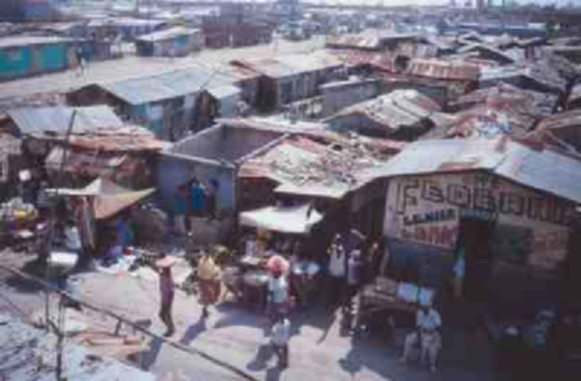
Packing

Everyone is permitted two large pieces of luggage weighing no more than 50
pounds. Both of these bags will be used for supplies that need to go into Haiti. We leave enough space so you can pack your personal liquids and gels. Each person is also
allowed one carry-on bag with your personal items and we suggest you bring a backpack that you can take with on your daily adventures.

In your backpack

- Medical kit – any prescription meds
you are taking, malaria meds, Band-
Aids, first-aid ointment, diarrhea and
motion sickness medication, cold
tablets, ibuprofen, and Wet Ones
- Flashlight
- Snack food for airport and daily travels
- Rain poncho
- Sweat Rag
- Camera
- Passport
- Money – small bills
- Light sweatshirt for cold airplane
and mild evenings in Haiti
- Stuff to do on the plane
- Zip lock baggies
- Straws for drinking anything in a bottle or can in Haiti

You can purchase water after going
through security so you have
safe drinking water until we get to the
hotel

2 Checked Suitcases

There will be room for
toiletries – toothpaste and toothbrush,
shampoo, lotion, deodorant, hand sanitizer,
sunscreen and insect repellent along with items
we collect for the Haitians

Carry-on suitcase

- Photocopy of passport
- Gals – nice skirt/dress for church
- Capri's, skirts, modest shorts, sun
dresses, tanks and t-shirts, – it will be
hot and dirty on the road
- Guys – nice shirt and pants for church
shorts, light weight pants, t-shirts –
it will be hot and dirty on the road
- Light jacket for evening
- Underwear
- Pajamas
- Extra pair of comfortable shoes and
sandals
- Socks if desired
- Hat for sun protection if desired
- Swim suit
- Towel and washcloth if desired

While in Haiti

Water

You should not drink or brush your teeth with any water in Haiti, except for
water from the Culligan containers where we stay. This includes water from
the faucet at hotels (if we stay at one in Jacmel)
Water bottles can be refilled where we stay and bottled water can be purchased
at the supermarket.

Food

While in Haiti, it is best to eat only foods prepared where we stay or at restaurants
at nice hotels. When first arriving you may want to avoid eating salads or fresh fruit,
and eat only food that which has been thoroughly cooked. Everyone is different and
some will have more sensitive stomachs than others.
Carry snacks in your backpack such as granola bars, nuts, beef jerky and dried
fruit. Be prepared to share with our Haitian workers!

Clothing

We ask that you be conscious of dressing modestly and women will need to wear skirts and men pants when we go to help at Mother Teresa’s and when we go to Cite Soleil, to keep with the customs of the locals. Shorts are O.K. where we stay. Open toed shoes should not be worn when we go out, because of the rough roads and sewage sometimes in the streets.

Laundry is available twice a week if needed.

Money

The amount of money you take will depend on your desire to buy souvenirs or donate to specific causes. Do not bring travelers checks, as they are nearly impossible to change. We recommend bringing $100 - $200 in cash for souvenirs. Do not bring any bills larger than $20 – we recommend that you bring numerous $1 bills to tip the boys for helping us out. Airline worker tips will be taken care of for you. Money can be changed into Gourdes where we stay or at the supermarket.

Most souvenirs can be bought with American money NEVER give money or food to anybody unless you first talk with your leader about it. Chaos can happen quickly and you will be surrounded by hundreds if word gets out!

Many people will ask you for a dollar when we are in the streets or at the airport.
The best thing to do is just ignore them (it doesn’t seem very nice or friendly, but it works).

Your Passport

Upon entering Haiti you will be given a card that you need to have when you depart Haiti.
Do not lose this. Tuck it in your passport. We suggest you lock up your original passport with the director where we stay and take your photo copy of your passport with you everyday in your backpack. Items in your room are secure and the rooms do lock.

Going to the Bathroom

Because we work in the poorest areas in Haiti, there is no access to toilets most of the time and if there is, they are usually Haitian toilets. We suggest that you try to get in a routine of using the bathroom before we leave each morning, and try not to drink too much at breakfast.

The water you drink during the day from your water bottles in your back pack, for the most part, is sweated out of your body and you may be surprised that you will not need to pee that often! But, in case you do, that is why you have wipes in your backpack...just go outside and find a spot. If you feel the slightest signs of diarrhea coming on, take Immodium right away or even before you leave each day!

Communicating to Loved Ones Back Home

There is internet access where we stay, but you’ll need a computer. There are also
Internet cafes around that cost about $1 an hour, but they are slow and often not working at all. Cell phones work sporadically, so you may or may not be able to call back home.

Haitians

Most Haitians will understand French, yet they speak Creole. So a morning greeting will be “Bonjour”. After 12:00 pm, the greeting will be “Bonsoir”.

When you are walking in the streets, typically Haitians will not greet you until you
greet them first. Most are very friendly. A normal stance for Haitians is to have
their arms crossed which we might interpret as being mad, grabby or stand offish,
but this is their relaxed position.

We like to give kids we see on the streets in small numbers tootsie rolls and
suckers, but it is next to impossible to hand these out while delivering water.
NEVER give money to anyone that asks on the street.
Sometimes you will hear Haitians call you “Blanc”. This just means “white”.
Be respectful when using your camera, especially in some of the poorest areas.
Some people will not allow you to take their photo. It is best to ask before you
snap someone’s photo

Phrases – A few common phrases in Creole
Bonjou - Good Morning
Bonswa - Good Afternoon / Good Evening
Ki Jan ou ye or Como ou ye - How Are you?
Ki Jan ou rele - What is your name?
M rele …. - My name is …..
Ki la jou How old are you?
Mesi - Thank You
Merite Sa - You’re Welcome
Eske ou pale Angle - Do you speak English?
Konprann - Understand
M Pa Konprann - I don’t understand
Konbien How much
Twop Too much
Sa Kap Fet What’s Up
Zanmi Mwen My Friend
Ki Kote Where?
En Bye Souple One beer please.

Where We will go...
Cite Soliel/ Blanchard
We build houses in Blanchard for people who live in Cite Soliel.
We will go and paint the one of the houses we have funded, and meet
the family and bring them a gift bag. We can also tour Pastor Leon’s
schools in Cite Soliel and Blanchard.

Mother Teresa House of Charity
We will take a Tap Tap(Haitian version of a taxi) and then walk to
Mother Teresa’s to hold, play with and feed the sick and dying babies,
who have been brought by their parents or abandoned to the Sisters.
Most babies will cry and those that are able will put their arms up when
they see a white person! Happy once you pick them up – they won’t be
happy when you put them back down. You may want to hold and nurture
several or pick a few favorites to bond with. They all will appreciate your
loving arms around them! These babies are malnourished, or have TB or
other illnesses or birth defects for which they need special care or medication.
Hours are 9-noon and 3-5 for visitors.

For His Glory Orphange
On the way to Mother Theresa’s is For His Glory Orphanage. We may go there and play with the children for a few hours. As with Mother Theresa’s, these kids are starved for attention. The younger ones will want to be held, and the older ones will want to braid your hair (both male and female), or play games with them

Jacmel/Trinity House
We take a three hour van ride (one way) through the mountains and small villages,
to the seaside town of Jacmel. We will spend the night in a hotel with hot
running water, air conditioning and a pool. We will spend the day at Trinity House
with the boys, playing basketball or walking them to the beach.

We may also go out into the neighborhood and visit some of the daycare kids’ families.
If daycare is in session, we may also play games with those children.

Wings of Hope
We will do a day trip to Fermathe to visit the home for the physically and mentally challenged children. We will go to the Babtist Mission for lunch where they serve American food. You can also do some shopping at the Mission (they accept Credit cards) or from the street vendors in front of Wings of Hope (be prepared to negotiate).

Interesting facts about...Haiti
• Haiti is the poorest country in the Western Hemisphere and only 90 minutes
from the U.S. by airplane
• According to UNICEF, only 30% of Haitians have access to clean drinking
water
• 80% of Haitians live in poverty making less than $2 a day
• 1 in 8 children in Haiti will die before the age of 5 from treatable and/or
curable diseases
• Half of the people in Haiti do not know how to read or write
• Roughly 80% of Haitians are Roman Catholic
• The poor children of Haiti are sometimes fed dirt cookies, made of dirt and
oil, then baked in the sun because their family can not afford food
• Capital City is Port-au-Prince
• Almost 9 million people live in Haiti
• Life expectancy is 53
• Official language is Kreyol although children learn French at school

Some Simple Guidelines
• Be Prompt. The bell will ring for breakfast around 6:00, 7:00. We will typically
eat dinner around 6:00 pm.
• Be flexible. Changes in schedule are likely to occur.
• Be patient and understanding. We are on Haitian time.
• Let us guide. We do not want to restrict giving, just guide you.
• Alcohol. There are no restrictions, we just ask that you be respectful of others and
Drink in moderation. And we ask that you never smoke in front of Haitian
children.

Contact Information
St. Joseph’s Home For Boys
91 Delmas Rue Herne #48

You’ll need this contact information for the form on the airplane

