100 Miles
GOING THE DISTANCE FOR KIDS
ON
LONG ISLAND

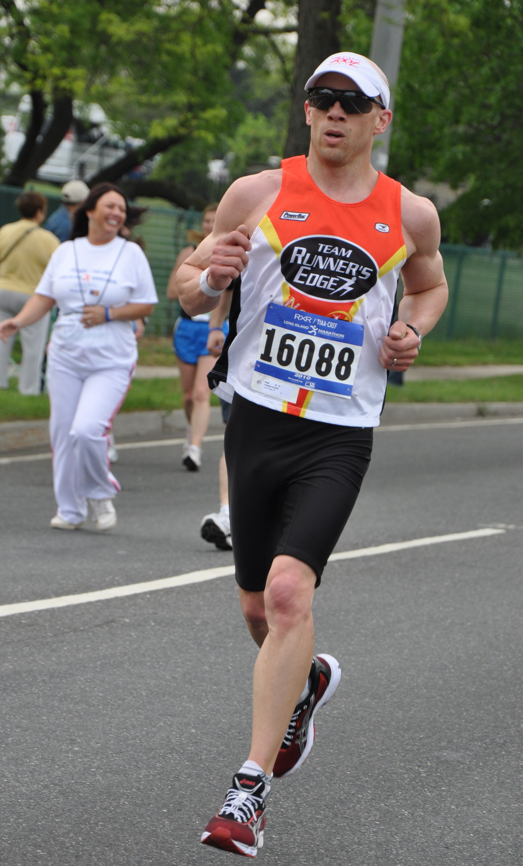

On Saturday, September 15, 2012

Ultramarathon runner and two-time IronMan finisher
Thomas Glenn will run 100 Miles
to raise money for the
John Theissen Children’s Foundation

Tom will begin his journey from the Montauk lighthouse and run (via Montauk Hwy) to The John Theissen Children’s Foundation Family Fun Center, Wantagh
Exactly 100 miles.

Tom will begin at the lighthouse at 7am sharp and finish by
12pm on Sunday in Wantagh

You can team up with Tom by making a pledge for Tom’s efforts in this Ultra event. Please fill out pledge form and mail to JTCF
---------------------------------------------------------------------------------------------------------------------
I would like to Pledge $_______________for each mile
Or a flat pledge Amount $___________

( ) Visa ( ) Mastercard ( ) Amex ( ) Discover

CC#________________________________________________Exp_________________

Name____________________________________________________________________

Address______________________________Town__________________Zip________

Phone________________________ Signature________________________________

Method of Support; Check, Credit Card or Cash
Please make checks payable to : JTCF-Tom’s Run
Please Send this form to JTCF, 1881 Wantagh Avenue, Wantagh , NY 11793

