Online Consumer Buying Behaviour
A Market Research
Ankur Mehrotra 2007B10
Anshul Kapoor 2007B12
Anuja Dua 2007B13

Table of Contents

Executive Summary 3
Introduction 4
Objectives 4
Primary Research Objective 4
Secondary Research Objectives 4
Methodology 5
Survey Administration 5
Sampling 5
Data Reduction 5
Data Analysis 5
Findings 5
CROSS TABULATIONS 5
REGRESSION ANALYSIS 5
ANOVA 5
CLUSTER ANALYSIS 5
DISCRIMINANT WITH CLUSTER ANALYSIS 5
FACTOR ANALYSIS 5
Conclusions 5
Annexures 5
Annexure 1a: Agglomeration Schedule for Cluster Analysis 5
Annexure 1b: Correlation Matrix for Factor Analysis 5
Annexure 1c: ANOVA Table for Regression Analysis 5
Annexure 2a: Questionnaire for Exploratory Research 5
Annexure 2b: Final Questionnaire 5

Executive Summary
The project focused on finding out the Online Buying Behaviour of consumers between the age group of 18-30 years. The stated objective of the study was further broken down to secondary objectives which aimed at finding information regarding the popular product categories, frequency of purchases, average spending, factors affecting buying decision process etc.
The exploratory research was carried out with 27 respondents with a set of 10 open ended questions. The exploratory findings helped us in determining the key factors which needed to be further explored for research. The secondary research was taken from sources like Indian Journal of Management Technology, Zinnov LLC, and ACNielson. The questionnaire designed had 9 questions and was administered to 106 respondents. Each of the questions was designed to satisfy at least one of the secondary objectives of the research. The response format was of a mixed variety which also helped in better determination of outcomes.
Post data reduction, Cross tabulation was used for analyzing the causal relationship between different pairs of factors. ANOVA was also applied to a pair of factors.
The Regression Analysis between the dependent variable “Average Amount spent per purchase made online” and the independent variables of Frequency of Purchase of products and services online, owning a Credit Card, Marital Status, Education and Age, was done. The regression model did not give any significant correlation between the factors and the Dependent Variable. Although there is a strong interdependence between a few variables yet when taken collectively they do not show high correlation.
Then, Cluster Analysis was done on the data and based on the responses; we could divide the respondents in three clearly distinct groups. We named them: Confident Online Buyer, Unsure surfer and Mall Shopper. We also performed Discriminant with Cluster Analysis to predict cluster membership of consumers based on their attitude towards online shopping.
We performed Factor Analysis to find the major factors. We could identify six factors: Value for Money, Trust, Connected and Up to date, Problems Faced, and Traditionalism.

Introduction
India has the world’s 4th largest Internet user base, which crossed the 100 million mark recently. Better connectivity, booming economy and higher spending power helped the Indian e-commerce market revenues to cross $500 million with a CAGR of 103% over last 4 years. This may not be a significant number, averaging to only around $5 per user per year.
With the above background in mind, this research has been conducted to gain an insight into the online buying behaviour of consumers. The objective is to explore the factors which influence online purchase, the psychographic profile of the consumer groups and understanding the buying decision process.
Our findings should help an Internet Marketer to determine the product/service categories to be introduced or to be used for marketing for a specific segment of consumers. This would also allow them to add or remove services/features which are important in the buying decision process. This study however does not aim to identify newer areas to introduce new services, nor should it be used to predict the success or failure of internet ventures.

Objectives

Primary Research Objective
To determine the factors and attributes which influence online buying behavior of consumers between the age group of 18-30 years.

Secondary Research Objectives
- To determine the psychographic profile of consumers who purchase over the Internet.
- To determine the key product or service categories opted for, by consumers depending on their profile.
- To determine the factors which influence the buying decision process of a consumer.
- To determine the average spending and frequency of purchase over the internet by a consumer.
The exploratory research, conducted on over 12 respondents (Annexure I), focused on further analysing the research objectives and also determining various factors which would impact the primary research objective. Through a set of 12 open-ended questions, we could finally conclude on some of the key factors to be further explored in the research, these included frequency of purchase, safety issues, amount per purchase, payment methods etc…
Secondary Research was based on researches done by Zinnov LLC on Internet Penetration in India, Changing Consumer Perceptions towards Online shopping in India – IJMT. Both of the researches stressed on the consumer profiles, popular services and payments methods as important factors.

Methodology
The research was administered both online and in person during a 5 day period in February 2008. The location of in-person administration was SIC Campus, Pune. Over 81 responses are from the online survey and the rest 24 from in-person survey conducted.

Survey Administration
The questionnaire comprised of 9 questions (Annexure II) which measured responses for different factors of frequency of purchase, payment methods, preferred products, average spending, hours spent on the internet etc…

The questions measuring respondent attitudes used Likert Scale (1-5), 18 statements were given to respondents to measure their attitudes towards online buying, and a few factual questions had dichotomous responses.

The methods used for survey was questionnaire administration with respondents filling out the responses themselves and online survey on SurveyGizmo.com

Sampling
The survey was conducted on 105 respondents; sample was based on affordability criteria especially on time constraints. Email invitations were sent to invite respondents on the Internet, and students in SIC Campus were contacted for responses.

Data Reduction
The key steps of data processing which were implemented were Editing, Coding, Transcribing, and Summarizing statistical calculations.

EDITING: For some of the item non-response errors like frequency of purchase, product category or websites. The data was interpreted and assigned to the known categories wherever possible.

CODING: For questions involving qualitative values the responses were codified using numerical categories or values. For example; Online shopping is more convenient, the response of “strongly agree” was coded as 1 and “strongly disagree” was coded as 5.

TRANSCRIBING: The data collected from all 105 questionnaires was edited, codified and finally transferred on MS Excel on computer.

Data Analysis

Post Data Reduction, the data was further used for analyzing the impact of various factors on each other as well the correlation amongst them using SPSS. The factors as well as their correlation were studied with the help of the following techniques:

CROSS-TABS WITH CHI-SQUARE: The factors were grouped into 5 pairs based on the responses from the questionnaire. These were studied using Chi-Square as that would help us to know the interdependency between them. Chi-square in general studies causal relationship and thus the hypotheses were created for each of them was done at 95% significance level. By conducting the test and interpreting the results through the p-value, we can either accept or not accept the null hypothesis.

REGRESSION ANALYSIS: In regression analysis, we create a model wherein we determine the correlation between the dependent variable and multiple independent variables. By conducting the tests and interpreting the results, we can determine the adjusted R² value which tells us how good the regression model fits to the data. If the value is high, then the model fits well to the data and that there is a high correlation between the variables. On the other hand, if the value is low, then the model does not fit very well to the data and there is no significant correlation between the variables.

ANOVA: Analysis of variance, better known as ANOVA, helps us to group the data into various population samples and then check their relationship with an independent variable, which we consider to be significant depending on the responses from the questionnaire. The null hypothesis for this is also created at a 95% significant variable and then depending on the significant value from the results, the hypothesis is accepted or not accepted.
CLUSTER ANALYSIS: This technique is used for segmentation of consumers on the basis of similarities between them. The similarities could be of demographics, buying habits, or psychographics. Hierarchical clustering is used to find the initial cluster solution, and K Means is later used to determine cluster membership of respondents, cluster labelling is also done.
DISCRIMINANT ANALYSIS WITH CLUSTERS: A combination of Discriminant Analysis with clusters to create a model which helps in predicting cluster membership of a consumer on the basis of the input factors.
FACTOR ANALYSIS: This is a technique to reduce data complexity by reducing the number of variables being studies. It helps identify latent or underlying factors from an array of seemingly important variables. This procedure helps gaining insight into psychographic variables.

Findings

CROSS TABULATIONS
- Credit Card- Frequency of Purchase
Null Hypothesis: At 95% significance level, owning a credit card does not have any impact on the frequency of purchase.
Alternate Hypothesis: At 95% significance level, owning a credit card has an impact on the frequency of purchase.
OwnCreditCard * FreqofPurchase Crosstabulation
Count
 |  | FreqofPurchase |  |  |  |  | Total
 |  | Once a Month | 2 -3 Times a Month | Once in 3 Months | Once in 6 Months | Never Tried | Once a Month
OwnCreditCard | Yes | 23 | 14 | 28 | 11 | 1 | 77
OwnCreditCard | No | 3 | 2 | 11 | 10 | 5 | 31
Total |  | 26 | 16 | 39 | 21 | 6 | 108

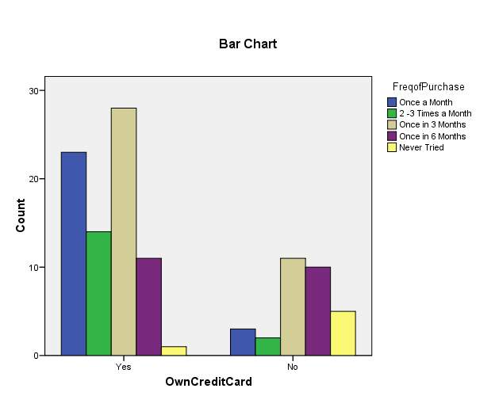
Chi-Square Tests
 | Value | df | Asymp. Sig. (2-sided)
Pearson Chi-Square | 18.222(a) | 4 | .001
Likelihood Ratio | 17.962 | 4 | .001
Linear-by-Linear Association | 15.313 | 1 | .000
N of Valid Cases | 108
a 3 cells (30.0%) have expected count less than 5. The minimum expected count is 1.72.
Case Processing Summary
 | Cases
 | Valid |  | Missing |  | Total
 | N | Percent | N | Percent | N | Percent
OwnCreditCard * FreqofPurchase | 108 | 100.0% | 0 | .0% | 108 | 100.0%
As the p-value from the table is lesser than 0.05, which is our assumed level of significance, we do not accept the null hypothesis, that is, for the sample population, owning a credit card has an impact on the frequency of purchase.

- E-banking-Frequency of Purchase
Null Hypothesis: At 95% significance level, e-banking does not have any impact on the frequency of purchase.
Alternate Hypothesis: At 95% significance level, e-banking has an impact on the frequency of purchase.
E_banking * FreqofPurchase Crosstabulation
Count
 |  | FreqofPurchase |  |  |  |  | Total
 |  | Once a month | 2-3 times a month | Once in 3 months | Once in 6 months | Never tried | Once a month
E_banking | Yes | 22 | 15 | 32 | 11 | 0 | 80
E_banking | No | 3 | 1 | 6 | 10 | 7 | 27
Total |  | 25 | 16 | 38 | 21 | 7 | 107

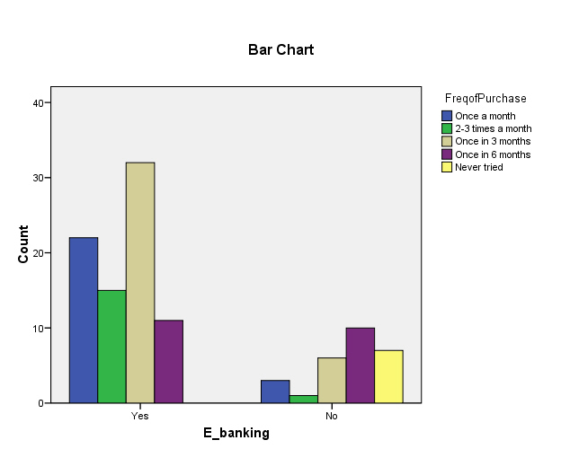
Chi-Square Tests
 | Value | df | Asymp. Sig. (2-sided)
Pearson Chi-Square | 33.492(a) | 4 | .000
Likelihood Ratio | 32.845 | 4 | .000
Linear-by-Linear Association | 20.737 | 1 | .000
N of Valid Cases | 107
a 2 cells (20.0%) have expected count less than 5. The minimum expected count is 1.77.

Case Processing Summary
 | Cases
 | Valid |  | Missing |  | Total
 | N | Percent | N | Percent | N | Percent
E_banking * FreqofPurchase | 107 | 100.0% | 0 | .0% | 107 | 100.0%

As the p-value from the table is lesser than 0.05, which is our assumed level of significance, we do not accept the null hypothesis, that is, for the sample population, E-banking has an impact on the frequency of purchase.

- Gender-Amount Spent
Null Hypothesis: At 95% significance level, gender does not have any impact on the average amount spent per purchase made online.
Alternate Hypothesis: At 95% significance level, e-banking has an impact on the average amount spent per purchase made online.

Chi-Square Tests
 | Value | df | Asymp. Sig. (2-sided)
Pearson Chi-Square | 2.789(a) | 4 | .594
Likelihood Ratio | 2.811 | 4 | .590
Linear-by-Linear Association | .003 | 1 | .955
N of Valid Cases | 106
a 1 cells (10.0%) have expected count less than 5. The minimum expected count is 4.81.
Gender * AmountSpent Crosstabulation
Count
 |  | AmountSpent |  |  |  |  | Total
 |  | Less than 500 | 500 - 1000 | 1000 - 2000 | 2000 - 5000 | Greater than 5000 | Less than 500
Gender | Male | 11 | 13 | 9 | 27 | 12 | 72
Gender | Female | 7 | 4 | 6 | 9 | 8 | 34
Total |  | 18 | 17 | 15 | 36 | 20 | 106

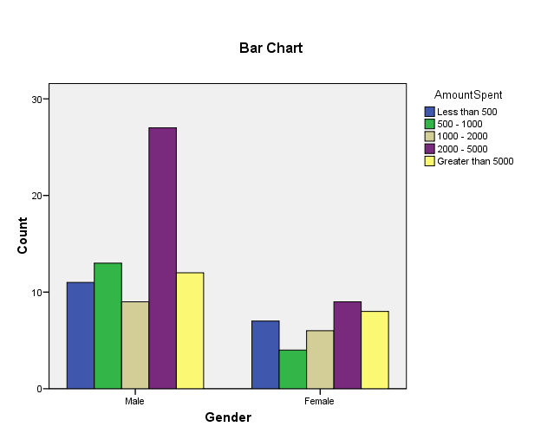
Case Processing Summary
 | Cases
 | Valid |  | Missing |  | Total
 | N | Percent | N | Percent | N | Percent
Gender * AmountSpent | 106 | 100.0% | 0 | .0% | 106 | 100.0%

As the p-value from the table is greater than 0.05, which is our assumed level of significance, we accept the null hypothesis, that is, for the sample population; gender does not have any impact on the average amount spent per purchase made online.
- Gender-Frequency of Purchase
Null Hypothesis: At 95% significance level, gender does not have any impact on the frequency of purchase of online products and services.
Alternate Hypothesis: At 95% significance level, gender has an impact on the frequency of purchase of online products and services.
Gender * FreqofPurchase Crosstabulation
Count
 |  | FreqofPurchase |  |  |  |  | Total
 |  | Once a Month | 2-3 Times a Month | Once in 3 Months | Once in 6 Months | Never Tried | Once a Month
Gender | Male | 20 | 14 | 27 | 9 | 3 | 73
Gender | Female | 4 | 2 | 13 | 11 | 3 | 33
Total |  | 24 | 16 | 40 | 20 | 6 | 106
Chi-Square Tests
 | Value | df | Asymp. Sig. (2-sided)
Pearson Chi-Square | 11.278(a) | 4 | .024
Likelihood Ratio | 11.499 | 4 | .021
Linear-by-Linear Association | 9.084 | 1 | .003
N of Valid Cases | 106
a 3 cells (30.0%) have expected count less than 5. The minimum expected count is 1.87.
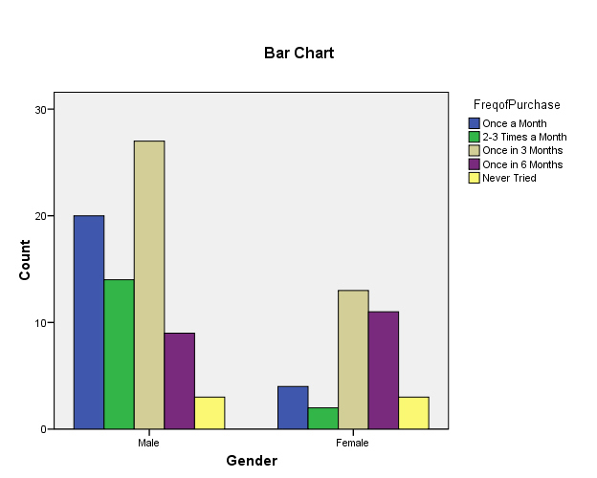
Case Processing Summary
 | Cases
 | Valid |  | Missing |  | Total
 | N | Percent | N | Percent | N | Percent
Gender * FreqofPurchase | 106 | 100.0% | 0 | .0% | 106 | 100.0%
As the p-value from the table is lesser than 0.05, which is our assumed level of significance, we do not accept the null hypothesis, that is, for the sample population; gender has an impact on the frequency of purchase of online products and services.

- Income-Frequency of Purchase
Null Hypothesis: At 95% significance level, income of respondents does not have any impact on the frequency of purchase of online products and services.
Alternate Hypothesis: At 95% significance level, income of respondents has an impact on the frequency of purchase of online products and services.
Income * FreqofPurchase Crosstabulation
Count
 |  | FreqofPurchase |  |  |  |  | Total
 |  | Once a Month | 2-3 Times a Month | Once in 3 Months | Once in 6 Months | Never Tried | Once a Month
Income | Less than 10000 | 2 | 0 | 1 | 0 | 0 | 3
Income | 10000-20000 | 1 | 0 | 2 | 5 | 1 | 9
Income | 20000-30000 | 2 | 2 | 11 | 2 | 0 | 17
Income | 30000-50000 | 5 | 0 | 3 | 1 | 0 | 9
Income | 50000-100000 | 2 | 1 | 0 | 1 | 0 | 4
Income | Greater than 100000 | 1 | 1 | 2 | 0 | 0 | 4
Total |  | 13 | 4 | 19 | 9 | 1 | 46

Chi-Square Tests
 | Value | df | Asymp. Sig. (2-sided)
Pearson Chi-Square | 28.966(a) | 20 | .088
Likelihood Ratio | 29.758 | 20 | .074
Linear-by-Linear Association | 2.806 | 1 | .094
N of Valid Cases | 46
a 29 cells (96.7%) have expected count less than 5. The minimum expected count is .07.
Case Processing Summary
 | Cases
 | Valid |  | Missing |  | Total
 | N | Percent | N | Percent | N | Percent
Income * FreqofPurchase | 46 | 100.0% | 0 | .0% | 46 | 100.0%

As the p-value from the table is greater than 0.05, which is our assumed level of significance, we do not accept the null hypothesis, that is, for the sample population; income does not have an impact on the frequency of purchase of online products and services.

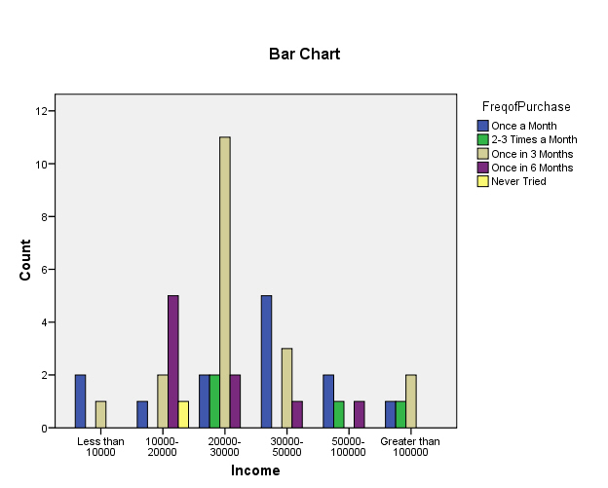

REGRESSION ANALYSIS
The Regression Analysis between the dependent variable “Average Amount spent per purchase made online” and the independent variables of Frequency of Purchase of products and services online, owning a Credit Card, Marital Status, Education and Age, was done using SPSS. The details are as below:

Variables Entered/Removed(b)
Model | Variables Entered | Variables Removed | Method
1 | MaritalStatus, FreqofPurchase, Education, CreditCard, Age(a) | . | Enter
2 |  | Age | Backward (criterion: Probability of F-to-remove >= .100).
3 | . | Education | Backward (criterion: Probability of F-to-remove >= .100).
4 | . | MaritalStatus | Backward (criterion: Probability of F-to-remove >= .100).
a All requested variables entered.
b Dependent Variable: AmtSpent

Coefficients(a)
Model |  | Unstandardized Coefficients |  | Standardized Coefficients | t | Sig.
Model |  | B | Std. Error | Beta | B | Std. Error
1 | (Constant) | 1.696 | 1.954 |  | .868 | .388
1 | FreqofPurchase | .402 | .122 | .330 | 3.305 | .001
1 | Age | .054 | .078 | .083 | .696 | .489
1 | CreditCard | -.695 | .318 | -.234 | -2.186 | .032
1 | Education | -.152 | .202 | -.076 | -.753 | .454
1 | MaritalStatus | .384 | .464 | .096 | .828 | .410
2 | (Constant) | 2.897 | .912 |  | 3.178 | .002
2 | FreqofPurchase | .403 | .121 | .331 | 3.323 | .001
2 | CreditCard | -.755 | .305 | -.254 | -2.477 | .015
2 | Education | -.134 | .199 | -.067 | -.671 | .504
2 | MaritalStatus | .534 | .409 | .134 | 1.304 | .196
3 | (Constant) | 2.564 | .762 |  | 3.364 | .001
3 | FreqofPurchase | .415 | .120 | .341 | 3.467 | .001
3 | CreditCard | -.772 | .303 | -.259 | -2.547 | .013
3 | MaritalStatus | .561 | .406 | .140 | 1.380 | .171
4 | (Constant) | 3.366 | .496 |  | 6.781 | .000
4 | FreqofPurchase | .408 | .120 | .335 | 3.393 | .001
4 | CreditCard | -.882 | .294 | -.297 | -3.005 | .003
a Dependent Variable: AmtSpent
Excluded Variables(d)
Model |  | Beta In | t | Sig. | Partial Correlation | Collinearity Statistics
Model |  | Tolerance | Tolerance | Tolerance | Tolerance | Tolerance
2 | Age | .083(a) | .696 | .489 | .077 | .682
3 | Age | .071(b) | .606 | .546 | .067 | .694
3 | Education | -.067(b) | -.671 | .504 | -.074 | .962
4 | Age | .122(c) | 1.164 | .248 | .127 | .874
4 | Education | -.080(c) | -.798 | .427 | -.087 | .971
4 | MaritalStatus | .140(c) | 1.380 | .171 | .150 | .926
a Predictors in the Model: (Constant), MaritalStatus, FreqofPurchase, Education, CreditCard
b Predictors in the Model: (Constant), MaritalStatus, FreqofPurchase, CreditCard
c Predictors in the Model: (Constant), FreqofPurchase, CreditCard
d Dependent Variable: AmtSpent

As can be seen from the above table, the independent variables can be gradually removed in the regression model as they don’t have any significant impact on the value of R². The value of R² is quite low and so it can be said that the regression model does not fit into the data very well. Also, the sum of squares of regression is lesser than the sum of squares of residuals and this reiterates the findings of R². This is because if the sum of squares of regression is lesser than the sum of squares of residuals, then the independent variables do not explain the variation in the dependent variable well. While cross tabs suggest a positive relationship between multiple pairs of factors, the linear correlation model, with all factors together, does not fit in with the outcomes.

ANOVA
Null hypothesis: At 95% confidence interval for the population taken, income does not have any impact on the frequency of purchase of online products and services.
Alternate Hypothesis: At 95% confidence interval for the population taken, income has an impact on the frequency of purchase of online products and services.
 | N | Mean | Std. Deviation | Std. Error | 95% Confidence Interval for Mean |  | Minimum | Maximum
 |  |  |  |  | Lower Bound | Upper Bound | Minimum | Maximum
.00 | 64 | 2.3125 | 1.29560 | .16195 | 1.9889 | 2.6361 | .00 | 4.00
Less than 10000 | 3 | 2.3333 | .57735 | .33333 | .8991 | 3.7676 | 2.00 | 3.00
10000-20000 | 7 | 2.8571 | 1.46385 | .55328 | 1.5033 | 4.2110 | .00 | 4.00
20000-30000 | 16 | 2.7500 | .85635 | .21409 | 2.2937 | 3.2063 | 1.00 | 4.00
30000-50000 | 7 | 2.7143 | .75593 | .28571 | 2.0152 | 3.4134 | 2.00 | 4.00
50000-100000 | 5 | 2.0000 | 1.22474 | .54772 | .4793 | 3.5207 | 1.00 | 4.00
Greater than 100000 | 7 | 2.4286 | 1.27242 | .48093 | 1.2518 | 3.6054 | .00 | 4.00
Total | 109 | 2.4312 | 1.19696 | .11465 | 2.2039 | 2.6584 | .00 | 4.00

ANOVA
Frequency
 | Sum of Squares | df | Mean Square | F | Sig.
Between Groups | 5.317 | 6 | .886 | .605 | .726
Within Groups | 149.417 | 102 | 1.465
Total | 154.734 | 108

Means Plots

The p-value from the ANOVA table is greater than the significance value of 0.05 assumed by us. Thus, at this significance level we accept the null hypothesis. So we can conclude that income does not have an impact on the frequency of purchase of online products and services for these respondents. Do remember that the same conclusion was arrived at when Cross tabulation of location and usage rate was performed earlier.

CLUSTER ANALYSIS

The cluster analysis was run where people were surveyed about their attitudes towards internet shopping. The preferences indicated by respondents were used to find out the consumer segments that react differently to different parameters related to online shopping. The segments obtained would give an understanding as to how the consumers are placed in terms of their attitudes.
Hierarchical clustering was done to determine the initial cluster solution. While the initial cluster solution by SPSS gives us 2 clusters, we take a difference of coefficients greater than or equal to 2.72 form another cluster. Now we execute the K-Mean cluster to get the final cluster solution and through ANOVA table we get that all the variables bear significance at 95% confidence level.

ANOVA

 | Cluster |  | Error |  | F | Sig.
 | Mean Square | df | Mean Square | Df | Mean Square | df
InternetvsMall | 27.190 | 2 | .515 | 103 | 52.814 | .000
LatestInfo | 1.744 | 2 | .341 | 103 | 5.116 | .008
Accesibility | 6.364 | 2 | .536 | 103 | 11.874 | .000
Convenience | 27.439 | 2 | .367 | 103 | 74.819 | .000
Savetime | 7.485 | 2 | .608 | 103 | 12.312 | .000
AnywhereAnytime | 2.935 | 2 | .559 | 103 | 5.255 | .007
CreditCardSafe | 3.441 | 2 | .619 | 103 | 5.562 | .005
SpecificDateTime | 6.393 | 2 | .553 | 103 | 11.554 | .000
GuaranteedQuality | 4.378 | 2 | .469 | 103 | 9.334 | .000
Discounts | 9.581 | 2 | .710 | 103 | 13.500 | .000
Hasslefree | 8.649 | 2 | .691 | 103 | 12.518 | .000
CashonDelivery | 1.011 | 2 | .791 | 103 | 1.278 | .283
EasyFind | 5.585 | 2 | .838 | 103 | 6.668 | .002
FacedProblems | .866 | 2 | .730 | 103 | 1.186 | .309
Continue | 6.682 | 2 | .823 | 103 | 8.121 | .001
TouchandFeel | 5.330 | 2 | .728 | 103 | 7.320 | .001
DeliveryProcess | 8.284 | 2 | .499 | 103 | 16.612 | .000
NoCreditCard | 12.382 | 2 | .950 | 103 | 13.035 | .000
The F tests should be used only for descriptive purposes because the clusters have been chosen to maximize the differences among cases in different clusters. The observed significance levels are not corrected for this and thus cannot be interpreted as tests of the hypothesis that the cluster means are equal.

Final Cluster Centers

 | Cluster
 | 1 | 2 | 3
InternetvsMall | 3.38 | 2.09 | 4.00
LatestInfo | 1.58 | 1.78 | 2.05
Accesibility | 1.37 | 1.94 | 2.18
Convenience | 2.62 | 1.81 | 3.86
Savetime | 2.33 | 1.59 | 2.55
AnywhereAnytime | 1.88 | 2.09 | 2.50
CreditCardSafe | 2.52 | 2.78 | 3.18
SpecificDateTime | 2.10 | 2.28 | 3.00
GuaranteedQuality | 2.98 | 3.56 | 3.55
Discounts | 2.15 | 2.72 | 3.23
Hasslefree | 2.54 | 2.03 | 3.18
CashonDelivery | 2.15 | 2.34 | 2.50
EasyFind | 2.00 | 2.63 | 2.68
FacedProblems | 2.52 | 2.81 | 2.59
Continue | 2.40 | 2.94 | 3.27
TouchandFeel | 1.81 | 2.53 | 1.95
DeliveryProcess | 2.42 | 2.66 | 3.45
NoCreditCard | 4.08 | 3.81 | 2.82

Variable Description | Cluster 1 (52) | Cluster 2(32) | Cluster 3(22)
I prefer making a purchase from internet than using local malls or stores | Disagree | Strongly Agree | Strongly Disagree
I can get the latest information from the Internet regarding different products/services that is not available in the market. | Strongly Agree | NAND | Strongly Disagree
I have sufficient internet accessibility to shop online. | Strongly Agree | Mildly Disagree | Strongly Disagree
Online shopping is more convenient than in-store shopping. | Mildly Agree | Strongly Agree | Strongly Disagree
Online shopping saves time over in-store shopping. | Disagree | Strongly Agree | Strongly Disagree
Online shopping allows me to shop anywhere and at anytime. | Strongly Agree | Mildly Agree | Strongly Disagree
It is safe to use a credit card while shopping on the Internet. | Strongly Agree | NAND | Strongly Disagree
Online shopping provides me with the opportunity to get the products delivered on specific date and time anywhere as required. | Strongly Agree | Moderately Agree | Strongly Disagree
Products purchased through the Internet are with guaranteed quality. | Strongly Agree | Strongly Disagree | Strongly Disagree
Internet provides regular discounts and promotional offers to me. | Strongly Agree | NAND | Strongly Disagree
Internet helps me avoid hassles of shopping in stores. | NAND | Strongly Agree | Strongly Disagree
Cash on Delivery is a better way to pay while shopping on the Internet. | Strongly Agree | NAND | Strongly Disagree
Sometimes, I can find products online which I may not find in-stores. | Strongly Agree | Strongly Disagree | Strongly Disagree
I have faced problems while shopping online. | Strongly Agree | Strongly Disagree | Agree
I continue shopping online despite facing problems on some occasions. | Strongly Agree | Mildly Disagree | Strongly Disagree
It is important for me to touch and feel certain products before I purchase them. So I cannot buy them online. | Strongly Agree | Strongly Disagree | Agree
I trust the delivery process of the shopping websites. | Strongly Agree | Agree | Strongly Disagree
I do not shop online only because I do not own a credit card. | Strongly Disagree | Disagree | Strongly Agree

On the basis of the above scales, obtained by rating the relative results, we can name our clusters as:
- Cluster 1 : Confident Online Buyer
- Cluster 2 : Unsure surfer
- Cluster 3 : Mall Shopper

DISCRIMINANT WITH CLUSTER ANALYSIS

By combining cluster analysis with Discriminant analysis, we could derive a model which could predict cluster membership of the respondents on the basis of the variables analysed.
The cluster solution is changed with K Means cluster>Save option selected for Cluster Membership. This gives a new column in the Data Sheet, showing the cluster membership of the responses. Using this data sheet, Discriminant analysis is done over the cluster membership column as the dependent variables.
Function | Eigenvalue | % of Variance | Cumulative % | Canonical Correlation
1 | 3.009(a) | 55.0 | 55.0 | .866
2 | 2.464(a) | 45.0 | 100.0 | .843
 | Function
 | 1 | 2
InternetvsMall | .901 | -.372
LatestInfo | -.090 | .216
Accesibility | -.122 | .346
Convenience | .989 | .750
Savetime | .370 | -.747
AnywhereAnytime | -.228 | .185
CreditCardSafe | -.080 | .241
SpecificDateTime | .028 | .510
GuaranteedQuality | -.621 | .543
Discounts | .045 | .232
Hasslefree | .097 | .180
CashonDelivery | .193 | .262
EasyFind | -.038 | .162
FacedProblems | .029 | .272
Continue | -.198 | .179
TouchandFeel | -.447 | .623
DeliveryProcess | .308 | .262
NoCreditCard | .008 | -.609
(Constant) | -3.372 | -7.122
Eigenvalues

a First 2 canonical discriminant functions were used in the analysis.

Wilks' Lambda

Test of Function(s) | Wilks' Lambda | Chi-square | df | Sig.
1 through 2 | .072 | 248.627 | 36 | .000
2 | .289 | 117.402 | 17 | .000

Canonical Discriminant Function Coefficients

Unstandardized coefficients

The Eigenvalues are greater than 1, and the Wilk’s Lamba is below 0.5, this indicates that the Discriminant Model is able to explain the data fairly well.

The Canonical Discriminant Function Coefficients table contains Group-1 number of functions; the equations as derived from above are:
F₁= .901(InternetvsMall) - .090 LatestInfo - .122 Accesibility -.989 Convenience +.370 Savetime - .228 AnywhereAnytime – 0.080 CreditCardSafe + .028 SpecificDateTime - .621 GuarenteeQuality + .045 Discounts - .097 Hasslefree + .193 CoD - .038 EasyFind + 0.029 FacedProblems - .198 Continue - .447 TouchandFeel + .308 DeliveryProcess + .008 NoCreditCard – 3.372
F₂= -.372 InternetvsMall +.216 LatestInfo + .346 Accesibility + .750 Convenience - .747 Savetime + .185 AnywhereAnytime + .241 CreditCardSafe + .510 SpecificDateTime + .543 GuarenteeQuality - .232 Discounts + .180 HassleFree + .262 CoD + .162 EasyFind + .272 FacedProblems + .179 Continue + .623 TouchnFeel + .262 DeliveryProcess - .609 NoCreditCard – 7.122

Classification Function Coefficients

 | Cluster Number of Case
 | 1 | 2 | 3
InternetvsMall | 6.099 | 2.479 | 5.961
LatestInfo | 10.113 | 10.871 | 10.813
Accesibility | -4.203 | -3.056 | -3.047
Convenience | 5.202 | 3.798 | 9.499
Savetime | .077 | -2.731 | -2.261
AnywhereAnytime | 1.323 | 2.440 | 1.705
CreditCardSafe | 5.904 | 6.687 | 6.715
SpecificDateTime | 4.090 | 5.135 | 6.087
GuaranteedQuality | 4.190 | 7.322 | 5.385
Discounts | 1.330 | 1.707 | 2.285
Hasslefree | 2.116 | 2.215 | 2.944
CashonDelivery | 8.338 | 8.321 | 9.619
EasyFind | 1.519 | 1.999 | 2.087
FacedProblems | 5.910 | 6.424 | 6.994
Continue | -.681 | .331 | -.279
TouchandFeel | 6.076 | 8.846 | 7.825
DeliveryProcess | 2.462 | 2.087 | 3.909
NoCreditCard | 3.878 | 2.501 | 1.551
(Constant) | -79.869 | -87.731 | -116.575
Fisher's linear discriminant functions

The above table provides the linear Discriminant function which can be used to judge the membership of each data set by putting the value in each of them, and choosing the one which provides the highest value.

Classification Results(a)

 |  | Cluster Number of Case | Predicted Group Membership |  |  | Total
 |  | Cluster Number of Case | 1 | 2 | 3 | 1
Original | Count | 1 | 51 | 1 | 0 | 52
Original | Count | 2 | 0 | 32 | 0 | 32
Original | Count | 3 | 1 | 0 | 21 | 22
Original | % | 1 | 98.1 | 1.9 | .0 | 100.0
Original | % | 2 | .0 | 100.0 | .0 | 100.0
Original | % | 3 | 4.5 | .0 | 95.5 | 100.0
a 98.1% of original grouped cases correctly classified.

Our Discriminant Model is able to explain 98.1% of the data set correctly, which is significantly high, and indicates that this is a dependable Discriminant Model for prediction.

FACTOR ANALYSIS
The responses are put into SPSS for data reduction through Factor Analysis. The details of the above are provided below:
Total Variance Explained
Component | Initial Eigenvalues |  |  | Extraction Sums of Squared Loadings |  |  | Rotation Sums of Squared Loadings
Component | Total | % of Variance | Cumulative % | Total | % of Variance | Cumulative % | Total | % of Variance | Cumulative %
1 | 3.854 | 21.410 | 21.410 | 3.854 | 21.410 | 21.410 | 2.559 | 14.219 | 14.219
2 | 2.175 | 12.082 | 33.491 | 2.175 | 12.082 | 33.491 | 2.318 | 12.879 | 27.098
3 | 1.652 | 9.175 | 42.666 | 1.652 | 9.175 | 42.666 | 2.160 | 11.997 | 39.095
4 | 1.514 | 8.413 | 51.080 | 1.514 | 8.413 | 51.080 | 1.727 | 9.593 | 48.688
5 | 1.277 | 7.096 | 58.176 | 1.277 | 7.096 | 58.176 | 1.422 | 7.901 | 56.589
6 | 1.098 | 6.101 | 64.276 | 1.098 | 6.101 | 64.276 | 1.243 | 6.903 | 63.492
7 | 1.066 | 5.924 | 70.200 | 1.066 | 5.924 | 70.200 | 1.207 | 6.708 | 70.200
8 | .875 | 4.859 | 75.059
9 | .771 | 4.283 | 79.342
10 | .737 | 4.095 | 83.438
11 | .545 | 3.030 | 86.467
12 | .529 | 2.939 | 89.407
13 | .384 | 2.134 | 91.541
14 | .377 | 2.092 | 93.633
15 | .358 | 1.988 | 95.621
16 | .293 | 1.626 | 97.247
17 | .278 | 1.546 | 98.793
18 | .217 | 1.207 | 100.000
Extraction Method: Principal Component Analysis.

We see from the Cumulative Percentage column that there have been seven components or factors extracted which explain 70.2% of the total variance (information contained in the original 18 variables). This is an acceptable solution as generally, 70% of the total variance should be explained by the factors for the solution to be accepted.
Rotated Component Matrix(a)
 | Component
 | 1 | 2 | 3 | 4 | 5 | 6 | 7
InternetvsMall | .714 | -.279 | .149 | .056 | .046 | -.197 | -.241
LatestInfo | .099 | .322 | -.146 | .804 | -.072 | -.125 | -.105
Accesibility | -.043 | .157 | .158 | .859 | .105 | .084 | .020
Convenience | .796 | .045 | .202 | .206 | .030 | -.078 | -.109
Savetime | .726 | .270 | -.040 | -.015 | .017 | -.120 | .065
AnywhereAnytime | .314 | .571 | .153 | .109 | .251 | .025 | -.034
CreditCardSafe | .023 | -.046 | .657 | -.047 | .090 | -.271 | -.416
SpecificDateTime | .272 | -.198 | .466 | .404 | -.197 | .321 | .107
GuaranteedQuality | .023 | .412 | .647 | .016 | .071 | -.124 | .309
Discounts | .069 | .714 | .208 | .233 | .095 | -.095 | -.158
Hasslefree | .694 | .225 | -.022 | -.153 | -.129 | .320 | -.017
CashonDelivery | -.121 | -.024 | -.022 | .008 | .123 | .882 | -.126
EasyFind | .013 | .869 | .018 | .143 | -.043 | .055 | .012
FacedProblems | -.203 | .020 | -.091 | .084 | .788 | -.025 | .049
Continue | .071 | .379 | .518 | -.040 | .555 | .015 | -.077
TouchandFeel | -.351 | -.060 | -.006 | .079 | -.546 | -.193 | -.065
DeliveryProcess | .112 | .135 | .796 | .065 | -.101 | .126 | -.059
NoCreditCard | -.142 | -.130 | -.047 | -.053 | .084 | -.147 | .885
Extraction Method: Principal Component Analysis.
Rotation Method: Varimax with Kaiser Normalization. a Rotation converged in 8 iterations.
Looking at the rotated component matrix, we see that the loadings of variables-Internet preferred over mall, Convenience and Saves Time, on factor 1 are high (greater than 0.7) and thus factor 1 is made up of these variables. Similarly, we can interpret for the other factors as well and a table for the same has been provided at the end of this section.

Factor | Variables | Label for the Factor
1 | Internet over Mall  Convenience  Saves Time | Time-bound and comfort seeking
2 | Discounts  Easy Find | Value for Money
3 | Delivery Process  Credit Card Safe to Use  Guaranteed Quality | Trust
4 | Latest Information  Accessibility | Connected and Up to date
5 | Faced Problems | Problems Faced
6 | Cash on Delivery  Don’t Own a credit card | Traditionalism
7 | Don’t Own a credit card | N/A

We have combined the sixth and the seventh factor as they go hand-in-hand. A person who does not own a credit card but shops online would invariably prefer to pay by cash on delivery.

PERCEPTUAL MAPS
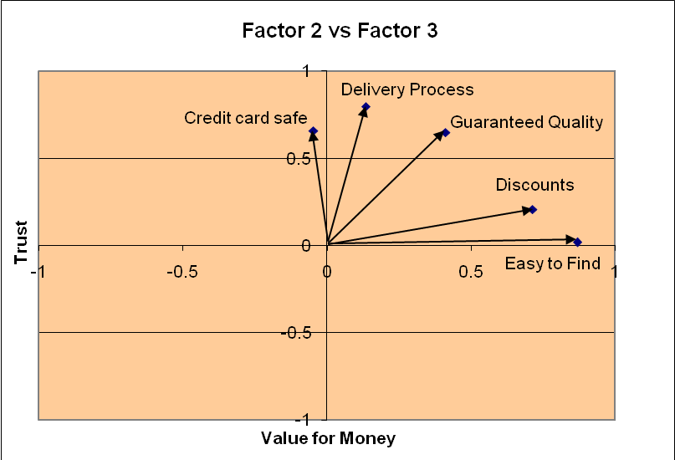
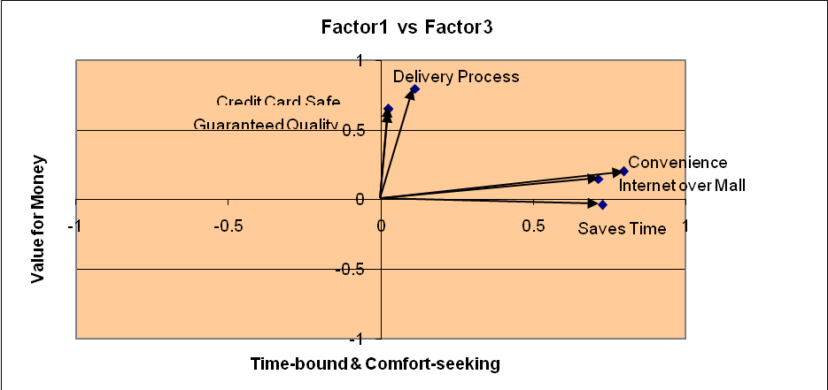
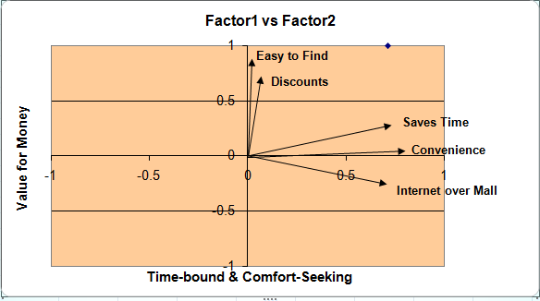

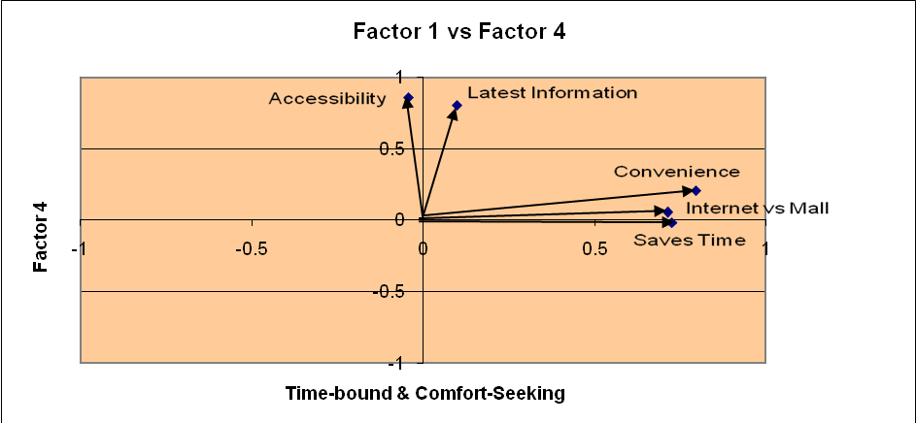
Others:
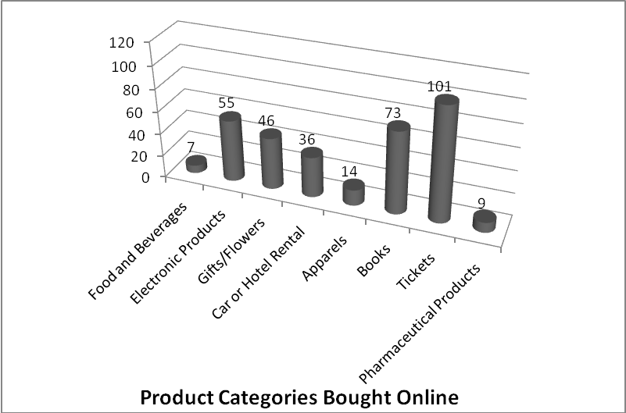

Conclusions
We found a strong inter-dependence between a few variables affecting online buying behaviour. For example, we found that owning a credit card has a significant impact on the frequency of online purchases as credit card is the most popular mode of payment on the Internet. Apart from the credit card, E-Banking is also slowly becoming a popular mode of payment and we found a relationship between people who use E-Banking and their frequency of online purchases too.
Interestingly, we found that gender does not have any major impact on the average amount spent over the Internet in a month, but it does have a relationship with the frequency of purchases. Also, the income of an individual does not have show any significant relationship with the frequency of purchases. These findings are starkly similar to the findings of Changing Consumer Perceptions towards Online shopping in India – IJMT, which was a part of our secondary data.
Based on the responses, we could divide the respondents in three clearly distinct groups. We named them: Confident Online Buyer, Unsure surfer and Mall Shopper. We were also able to successfully able to create a discriminant model which could predict cluster membership of users.
We could also arrive at six factors which can explain the data with 70% significance, these factors could be categorised into Time-bound and comfort seeking Value for Money, Trust, Connected and Up to date, Problems Faced, and Traditionalism.
We also found that the most popular product category sold online is Air/Rail Tickets. This forms a major chunk of the average amount spent by our respondents on the internet, Books come a close second. It must be noted that both the above products have a relatively low touch-and-feel need. These findings depict almost the same ranking as found by ACNielson on popular services on the Internet.
The most popular websites for these were found to be Makemytrip.com and Yatra.com. Apart from Air Tickets, Books, Gifts and Electronic Products are also very popular with the Online Shoppers and they are spending, on an average, Rs2000-Rs5000 per month on online purchases.

Annexures

Annexure 1a: Agglomeration Schedule for Cluster Analysis

Agglomeration Schedule
Stage | Cluster Combined |  | Coefficients | Stage Cluster First Appears |  | Next Stage
Stage | Cluster 1 | Cluster 2 | Coefficients | Cluster 2 | Cluster 1 | Next Stage
1 | 105 | 106 | 0.000 | 0 | 0 | 2
2 | 16 | 105 | 0.000 | 0 | 1 | 4
3 | 103 | 104 | 0.000 | 0 | 0 | 4
4 | 16 | 103 | 0.000 | 2 | 3 | 6
5 | 101 | 102 | 0.000 | 0 | 0 | 6
6 | 16 | 101 | 0.000 | 4 | 5 | 8
7 | 99 | 100 | 0.000 | 0 | 0 | 8
8 | 16 | 99 | 0.000 | 6 | 7 | 10
9 | 97 | 98 | 0.000 | 0 | 0 | 10
10 | 16 | 97 | 0.000 | 8 | 9 | 72
11 | 19 | 85 | 3.000 | 0 | 0 | 31
12 | 1 | 91 | 4.000 | 0 | 0 | 53
13 | 84 | 86 | 5.000 | 0 | 0 | 32
14 | 31 | 49 | 5.000 | 0 | 0 | 44
15 | 92 | 94 | 6.000 | 0 | 0 | 20
16 | 6 | 93 | 6.000 | 0 | 0 | 26
17 | 25 | 89 | 6.000 | 0 | 0 | 36
18 | 43 | 81 | 6.000 | 0 | 0 | 45
19 | 21 | 65 | 6.000 | 0 | 0 | 32
20 | 24 | 92 | 7.000 | 0 | 15 | 55
21 | 52 | 90 | 7.000 | 0 | 0 | 48
22 | 45 | 46 | 7.000 | 0 | 0 | 44
23 | 27 | 44 | 7.000 | 0 | 0 | 49
24 | 70 | 87 | 8.000 | 0 | 0 | 35
25 | 39 | 82 | 8.000 | 0 | 0 | 46
26 | 6 | 69 | 8.000 | 16 | 0 | 37
27 | 42 | 64 | 8.000 | 0 | 0 | 70
28 | 26 | 58 | 8.000 | 0 | 0 | 57
29 | 2 | 37 | 8.000 | 0 | 0 | 49
30 | 15 | 33 | 8.000 | 0 | 0 | 61
31 | 19 | 47 | 8.500 | 11 | 0 | 36
32 | 21 | 84 | 9.000 | 19 | 13 | 54
33 | 30 | 83 | 9.000 | 0 | 0 | 64
34 | 73 | 74 | 9.000 | 0 | 0 | 63
35 | 34 | 70 | 9.000 | 0 | 24 | 54
36 | 19 | 25 | 9.333 | 31 | 17 | 55
37 | 6 | 88 | 9.667 | 26 | 0 | 50
38 | 4 | 78 | 10.000 | 0 | 0 | 53
39 | 54 | 55 | 10.000 | 0 | 0 | 67
40 | 12 | 53 | 10.000 | 0 | 0 | 68
41 | 5 | 41 | 10.000 | 0 | 0 | 45
42 | 7 | 20 | 10.000 | 0 | 0 | 65
43 | 76 | 79 | 11.000 | 0 | 0 | 83
44 | 31 | 45 | 11.000 | 14 | 22 | 52
45 | 5 | 43 | 11.000 | 41 | 18 | 73
46 | 22 | 39 | 11.000 | 0 | 25 | 58
47 | 3 | 23 | 11.000 | 0 | 0 | 79
48 | 52 | 60 | 11.500 | 21 | 0 | 63
49 | 2 | 27 | 11.500 | 29 | 23 | 62
50 | 6 | 32 | 11.750 | 37 | 0 | 58
51 | 18 | 71 | 12.000 | 0 | 0 | 94
52 | 31 | 61 | 12.000 | 44 | 0 | 62
53 | 1 | 4 | 12.000 | 12 | 38 | 67
54 | 21 | 34 | 12.250 | 32 | 35 | 61
55 | 19 | 24 | 12.333 | 36 | 20 | 68
56 | 17 | 67 | 13.000 | 0 | 0 | 87
57 | 26 | 56 | 13.000 | 28 | 0 | 64
58 | 6 | 22 | 13.933 | 50 | 46 | 73
59 | 50 | 63 | 14.000 | 0 | 0 | 66
60 | 35 | 48 | 14.000 | 0 | 0 | 70
61 | 15 | 21 | 14.286 | 30 | 54 | 69
62 | 2 | 31 | 14.450 | 49 | 52 | 71
63 | 52 | 73 | 14.500 | 48 | 34 | 72
64 | 26 | 30 | 14.500 | 57 | 33 | 74
65 | 7 | 59 | 15.000 | 42 | 0 | 81
66 | 36 | 50 | 15.000 | 0 | 59 | 86
67 | 1 | 54 | 15.250 | 53 | 39 | 78
68 | 12 | 19 | 15.250 | 40 | 55 | 71
69 | 15 | 38 | 15.889 | 61 | 0 | 77
70 | 35 | 42 | 16.000 | 60 | 27 | 85
71 | 2 | 12 | 16.522 | 62 | 68 | 74
72 | 16 | 52 | 17.200 | 10 | 63 | 84
73 | 5 | 6 | 17.375 | 45 | 58 | 77
74 | 2 | 26 | 17.653 | 71 | 64 | 78
75 | 28 | 75 | 18.000 | 0 | 0 | 95
76 | 29 | 40 | 18.000 | 0 | 0 | 88
77 | 5 | 15 | 18.017 | 73 | 69 | 82
78 | 1 | 2 | 18.458 | 67 | 74 | 82
79 | 3 | 72 | 18.500 | 47 | 0 | 90
80 | 11 | 57 | 19.000 | 0 | 0 | 100
81 | 7 | 62 | 19.333 | 65 | 0 | 83
82 | 1 | 5 | 20.361 | 78 | 77 | 85
83 | 7 | 76 | 20.750 | 81 | 43 | 87
84 | 16 | 51 | 21.750 | 72 | 0 | 89
85 | 1 | 35 | 22.029 | 82 | 70 | 88
86 | 9 | 36 | 22.333 | 0 | 66 | 92
87 | 7 | 17 | 22.667 | 83 | 56 | 93
88 | 1 | 29 | 23.786 | 85 | 76 | 89
89 | 1 | 16 | 24.603 | 88 | 84 | 92
90 | 3 | 80 | 24.667 | 79 | 0 | 93
91 | 14 | 96 | 26.000 | 0 | 0 | 94
92 | 1 | 9 | 27.223 | 89 | 86 | 95
93 | 3 | 7 | 27.250 | 90 | 87 | 97
94 | 14 | 18 | 28.000 | 91 | 51 | 96
95 | 1 | 28 | 29.506 | 92 | 75 | 96
96 | 1 | 14 | 30.753 | 95 | 94 | 97
97 | 1 | 3 | 32.106 | 96 | 93 | 98
98 | 1 | 10 | 34.825 | 97 | 0 | 100
99 | 8 | 68 | 36.000 | 0 | 0 | 103
100 | 1 | 11 | 37.082 | 98 | 80 | 101
101 | 1 | 95 | 38.550 | 100 | 0 | 102
102 | 1 | 13 | 43.089 | 101 | 0 | 103
103 | 1 | 8 | 43.637 | 102 | 99 | 104
104 | 1 | 77 | 48.423 | 103 | 0 | 105
105 | 1 | 66 | 66.914 | 104 | 0 | 0

Annexure 1b: Correlation Matrix for Factor Analysis

Correlation Matrix
 |  | InternetvsMall | LatestInfo | Accesibility | Convenience | Savetime | AnywhereAnytime | CreditCardSafe | SpecificDateTime | GuaranteedQuality | Discounts | Hasslefree | CashonDelivery | EasyFind | FacedProblems | Continue | TouchandFeel | DeliveryProcess | NoCreditCard
Correlation | InternetvsMall | 1.000 | .053 | -.049 | .569 | .285 | .134 | .189 | .192 | -.020 | -.001 | .341 | -.176 | -.149 | -.111 | .023 | -.174 | .208 | -.205
Correlation | LatestInfo | .053 | 1.000 | .602 | .212 | .132 | .164 | -.046 | .125 | .078 | .374 | .026 | -.089 | .379 | -.047 | .030 | -.025 | .016 | -.151
Correlation | Accesibility | -.049 | .602 | 1.000 | .159 | .051 | .234 | .113 | .255 | .233 | .277 | -.063 | .116 | .236 | .101 | .124 | -.003 | .161 | -.057
Correlation | Convenience | .569 | .212 | .159 | 1.000 | .541 | .260 | .182 | .264 | .133 | .252 | .433 | -.091 | .093 | -.115 | .189 | -.200 | .297 | -.190
Correlation | Savetime | .285 | .132 | .051 | .541 | 1.000 | .325 | .098 | .089 | .130 | .168 | .443 | -.118 | .181 | -.103 | .173 | -.158 | .023 | -.080
Correlation | AnywhereAnytime | .134 | .164 | .234 | .260 | .325 | 1.000 | .136 | .170 | .263 | .413 | .212 | -.031 | .475 | .086 | .406 | -.210 | .142 | -.135
Correlation | CreditCardSafe | .189 | -.046 | .113 | .182 | .098 | .136 | 1.000 | .093 | .310 | .103 | -.031 | -.092 | -.033 | -.062 | .335 | -.005 | .373 | -.241
Correlation | SpecificDateTime | .192 | .125 | .255 | .264 | .089 | .170 | .093 | 1.000 | .113 | .029 | .170 | .063 | -.047 | -.142 | .135 | .051 | .342 | -.103
Correlation | GuaranteedQuality | -.020 | .078 | .233 | .133 | .130 | .263 | .310 | .113 | 1.000 | .333 | .098 | -.119 | .314 | .014 | .446 | -.109 | .425 | .104
Correlation | Discounts | -.001 | .374 | .277 | .252 | .168 | .413 | .103 | .029 | .333 | 1.000 | .143 | -.073 | .536 | .129 | .397 | -.048 | .341 | -.185
Correlation | Hasslefree | .341 | .026 | -.063 | .433 | .443 | .212 | -.031 | .170 | .098 | .143 | 1.000 | .121 | .149 | -.112 | .065 | -.139 | .104 | -.187
Correlation | CashonDelivery | -.176 | -.089 | .116 | -.091 | -.118 | -.031 | -.092 | .063 | -.119 | -.073 | .121 | 1.000 | .012 | .066 | .029 | -.115 | .050 | -.119
Correlation | EasyFind | -.149 | .379 | .236 | .093 | .181 | .475 | -.033 | -.047 | .314 | .536 | .149 | .012 | 1.000 | .014 | .285 | -.076 | .187 | -.098
Correlation | FacedProblems | -.111 | -.047 | .101 | -.115 | -.103 | .086 | -.062 | -.142 | .014 | .129 | -.112 | .066 | .014 | 1.000 | .309 | -.071 | -.107 | .118
Correlation | Continue | .023 | .030 | .124 | .189 | .173 | .406 | .335 | .135 | .446 | .397 | .065 | .029 | .285 | .309 | 1.000 | -.267 | .344 | -.120
Correlation | TouchandFeel | -.174 | -.025 | -.003 | -.200 | -.158 | -.210 | -.005 | .051 | -.109 | -.048 | -.139 | -.115 | -.076 | -.071 | -.267 | 1.000 | -.069 | .015
Correlation | DeliveryProcess | .208 | .016 | .161 | .297 | .023 | .142 | .373 | .342 | .425 | .341 | .104 | .050 | .187 | -.107 | .344 | -.069 | 1.000 | -.123
Correlation | NoCreditCard | -.205 | -.151 | -.057 | -.190 | -.080 | -.135 | -.241 | -.103 | .104 | -.185 | -.187 | -.119 | -.098 | .118 | -.120 | .015 | -.123 | 1.000
Sig. (1-tailed) | InternetvsMall |  | .294 | .308 | .000 | .002 | .086 | .026 | .025 | .420 | .495 | .000 | .035 | .063 | .129 | .409 | .037 | .016 | .017
Sig. (1-tailed) | LatestInfo | .294 |  | .000 | .014 | .089 | .046 | .320 | .100 | .213 | .000 | .395 | .181 | .000 | .316 | .379 | .401 | .436 | .061
Sig. (1-tailed) | Accesibility | .308 | .000 |  | .052 | .303 | .008 | .125 | .004 | .008 | .002 | .259 | .117 | .007 | .151 | .103 | .487 | .050 | .281
Sig. (1-tailed) | Convenience | .000 | .014 | .052 |  | .000 | .004 | .031 | .003 | .087 | .005 | .000 | .178 | .170 | .120 | .026 | .020 | .001 | .025
Sig. (1-tailed) | Savetime | .002 | .089 | .303 | .000 |  | .000 | .160 | .181 | .093 | .042 | .000 | .113 | .032 | .147 | .038 | .053 | .407 | .208
Sig. (1-tailed) | AnywhereAnytime | .086 | .046 | .008 | .004 | .000 |  | .082 | .041 | .003 | .000 | .015 | .376 | .000 | .190 | .000 | .015 | .073 | .084
Sig. (1-tailed) | CreditCardSafe | .026 | .320 | .125 | .031 | .160 | .082 |  | .172 | .001 | .146 | .375 | .174 | .368 | .264 | .000 | .478 | .000 | .006
Sig. (1-tailed) | SpecificDateTime | .025 | .100 | .004 | .003 | .181 | .041 | .172 |  | .124 | .385 | .041 | .260 | .316 | .073 | .084 | .301 | .000 | .148
Sig. (1-tailed) | GuaranteedQuality | .420 | .213 | .008 | .087 | .093 | .003 | .001 | .124 |  | .000 | .159 | .112 | .001 | .442 | .000 | .132 | .000 | .145
Sig. (1-tailed) | Discounts | .495 | .000 | .002 | .005 | .042 | .000 | .146 | .385 | .000 |  | .072 | .228 | .000 | .093 | .000 | .312 | .000 | .029
Sig. (1-tailed) | Hasslefree | .000 | .395 | .259 | .000 | .000 | .015 | .375 | .041 | .159 | .072 |  | .108 | .064 | .126 | .256 | .077 | .144 | .027
Sig. (1-tailed) | CashonDelivery | .035 | .181 | .117 | .178 | .113 | .376 | .174 | .260 | .112 | .228 | .108 |  | .451 | .249 | .383 | .121 | .305 | .112
Sig. (1-tailed) | EasyFind | .063 | .000 | .007 | .170 | .032 | .000 | .368 | .316 | .001 | .000 | .064 | .451 |  | .444 | .002 | .218 | .027 | .158
Sig. (1-tailed) | FacedProblems | .129 | .316 | .151 | .120 | .147 | .190 | .264 | .073 | .442 | .093 | .126 | .249 | .444 |  | .001 | .236 | .139 | .115
Sig. (1-tailed) | Continue | .409 | .379 | .103 | .026 | .038 | .000 | .000 | .084 | .000 | .000 | .256 | .383 | .002 | .001 |  | .003 | .000 | .111
Sig. (1-tailed) | TouchandFeel | .037 | .401 | .487 | .020 | .053 | .015 | .478 | .301 | .132 | .312 | .077 | .121 | .218 | .236 | .003 |  | .242 | .437
Sig. (1-tailed) | DeliveryProcess | .016 | .436 | .050 | .001 | .407 | .073 | .000 | .000 | .000 | .000 | .144 | .305 | .027 | .139 | .000 | .242 |  | .105
Sig. (1-tailed) | NoCreditCard | .017 | .061 | .281 | .025 | .208 | .084 | .006 | .148 | .145 | .029 | .027 | .112 | .158 | .115 | .111 | .437 | .105

Annexure 1c: ANOVA Table for Regression Analysis

ANOVA(e)
Model |  | Sum of Squares | df | Mean Square | F | Sig.
1 | Regression | 35.202 | 5 | 7.040 | 4.396 | .001(a)
1 | Residual | 129.717 | 81 | 1.601
1 | Total | 164.920 | 86
2 | Regression | 34.427 | 4 | 8.607 | 5.408 | .001(b)
2 | Residual | 130.493 | 82 | 1.591
2 | Total | 164.920 | 86
3 | Regression | 33.711 | 3 | 11.237 | 7.108 | .000(c)
3 | Residual | 131.209 | 83 | 1.581
3 | Total | 164.920 | 86
4 | Regression | 30.700 | 2 | 15.350 | 9.607 | .000(d)
4 | Residual | 134.219 | 84 | 1.598
4 | Total | 164.920 | 86
a Predictors: (Constant), MaritalStatus, FreqofPurchase, Education, CreditCard, Age
b Predictors: (Constant), MaritalStatus, FreqofPurchase, Education, CreditCard
c Predictors: (Constant), MaritalStatus, FreqofPurchase, CreditCard
d Predictors: (Constant), FreqofPurchase, CreditCard
e Dependent Variable: AmtSpent

Annexure 2a: Questionnaire for Exploratory Research

Hi,
We are conducting a research on consumer behavior on the internet. As a part of our exploratory research we request you to spare a few minutes in answering the questions below. Do feel free to ask us for any clarifications or doubts.
Your responses would serve as a base to our research; and would guide us in discovering important facts about the buying process.
Thanks.

- What are the online services that you generally use while surfing the net (answer as many)?

- Which are the websites that you visit frequently for the following purposes:
  - E-mail:
  - Chat:
  - Shopping:
  - Job Search:
  - Social Networking:
  - Banking and other Financial Services(Stock Trading):
  - Education:
  - General Browsing:
- How frequently do you shop online?

- If you do not shop online, then what are the reasons behind not shopping online?

- What are the occasions when you buy online?

- While purchasing online, what are the goods and services that you generally buy?

- What are the payment methods you generally use for online purchases?

- What are the different types of payment options that you have come across?

- Do you feel it is safe to buy online?

- What are the features that make a website more attractive than the others while buying online?

- On an average, how much do you spend while buying online?

- What is your general experience of buying online as compared to conventional shopping?

- What additional features, do you feel, would enhance your buying experience on the internet?

Any additional insights:

Name: Age:
Profession: Sex: M/F
Years since you started using the Internet:
Do you own a credit card? Y/N
Do you use Internet Banking? Y/N

Annexure 2b: Final Questionnaire

QUESTIONNAIRE

We would be thankful for your cooperation if you spare a few minutes to answer the following questions:

1. Do you use the Internet regularly?
Yes No

2. On an average, how much time (per week) do you spend while surfing the Net?
a) 0-2 hours b) 2-6 hours
c) 6-10 hours d) 10-15 hours
e) Greater than 15 hours

3. Do you use E-banking?
Yes No

4. Do you own a credit card?
Yes No

5. I am/would be comfortable buying the following categories of products online:
a) Food & Beverages b) Apparels
c) Electronic Products d) Books
e) Gifts f) Tickets
g) Car or hotel rental h) Pharmaceutical Products

Any other product, please specify

6. How frequently do you purchase products/services online?
a) Once a month b) 2-3 times a month
c) Once in 3 months d) Once in 6 months

Any other, please specify

7. What is the average amount that you spend per purchase while shopping online?
a) < Rs 500 b) Rs 500-1000
c) Rs 1000-Rs 2000 d) Rs 2000-Rs 5000
e) > Rs 5000

8. Which of the following web sites do you shop at?
a) www.rediff.com
b) www.indiaplaza.com
c) www.indiatimes.com
d) www.amazon.com
e) www.makemytrip.com
f) www.yatra.com
g)www.ebay.com

Any other, please specify

9. Recall your earlier online buying/shopping experience and please indicate you degree of agreement with the following statements:

 | Strongly Agree | Agree | Neither Agree nor Disagree | Disagree | Strongly Disagree
I prefer making a purchase from internet than using local malls or stores
I can get the latest information from the Internet regarding different products/services that is not available in the market.
I have sufficient internet accessibility to shop online.
Online shopping is more convenient than in-store shopping.
Online shopping saves time over in-store shopping.
Online shopping allows me to shop anywhere and at anytime.
It is safe to use a credit card while shopping on the Internet.
Online shopping provides me with the opportunity to get the products delivered on specific date and time anywhere as required.
Products purchased through the Internet are with guaranteed quality.
Internet provides regular discounts and promotional offers to me.
Internet helps me avoid hassles of shopping in stores.
Cash on Delivery is a better way to pay while shopping on the Internet.
Sometimes, I can find products online which I may not find in-stores.
I have faced problems while shopping online.
I continue shopping online despite facing problems on some occasions.
It is important for me to touch and feel certain products before I purchase them. So I cannot buy them online.
I trust the delivery process of the shopping websites.
I do not shop online only because I do not own a credit card.

Name: Gender: Occupation:

Monthly Income: Education: Marital Status:

