

N1600(E)(J9)H

NATIONAL CERTIFICATE

TRAVEL SERVICES N4

(22030134)

9 June 2017 (X-Paper)
09:00–12:00

Candidates are allowed to use the February 2017 GSA, the
Fares handout DTT and a calendar.

This question paper consists of 10 pages and four addenda of 5 pages.

DEPARTMENT OF HIGHER EDUCATION AND TRAINING
REPUBLIC OF SOUTH AFRICA
NATIONAL CERTIFICATE
TRAVEL SERVICES N4
TIME: 3 HOURS
MARKS: 200

INSTRUCTIONS AND INFORMATION

1.  2.  3.  4.  5.  6.  7. | Answer ALL the questions.  Read ALL the questions carefully.  Number the answers according to the numbering system used in this question paper.  NO correcting fluid/Tipp-Ex may be used and NO pencil may be used on travel documents.  Use taxes as given in the Fares handout. VAT is 14%.  Remember to detach the addenda from the question paper and to put the completed addenda in the ANSWER BOOK.  Write neatly and legibly.

QUESTION 1

Indicate whether the following statements are TRUE or FALSE. Choose the answer and write only ‘true’ or ‘false’ next to the question number (1.1-1.10) in the
ANSWER BOOK.

1.1 | Baggage that is carried on board with the passenger is called checked baggage.

1.2 | A rondavel in a national park is an example of an accommodation provider.

1.3 | According to IATA regulations a passenger who has reached the age of 10 is entitled to pay the full adult fare.

1.4 | Temporary passports are issued to nationals who have applied and are waiting for their normal passport to arrive.

1.5 | To transit at an airport means that a passenger has to change planes at an intermediate stop in order to get his/her destination.

1.6 | A yellow fever vaccination certificate is valid for 10 weeks, beginning 10 days after the date of vaccination.

1.7 | The check-in time for rooms at hotels is normally 19:00.

1.8 | Pregnant passengers are allowed to travel up to 35 weeks of pregnancy, provided that they are healthy and have a doctor’s certificate.

1.9 | An infant paying the full adult fare when travelling with parents in economy class pays PSC.

1.10 | The TGCSA is the association responsible for grading accommodation establishments in South Africa by means of stars ranging from 1–5.
(10 × 1) |  |  | [10]

QUESTION 2

Choose FIVE examples of producers/principals in the travel industry from the names given below. Write the question number and the answer in the ANSWER BOOK.

2.1 | British Airways Comair

2.2 | Tourvest tour

2.3 | Pentravel Agency

2.4 | Virgin Atlantic Airline

2.5 | Intercape

2.6 | Bon Hotels

2.7 | Thompsons Holidays

2.8 | Trafalgar Tours

2.9 | Hertz Car Hire

2.10 | Flight Centre Travel Agency
(10 × 1) |  |  | [10]

QUESTION 3

3.1 | Encode each of the following miscellaneous codes:

 | 3.1.1 | Bassinet/Sky cradle

 | 3.1.2 | Estimated time of departure

 | 3.1.3 | Extra bag

 | 3.1.4 | Agent

 | 3.1.5 | Child
(5 × 1) |  |  |  |  | (5)

3.2 | Decode each of the following meal codes:

 | 3.2.1 | NSML

 | 3.2.2 | KSML

 | 3.2.3 | SFML

 | 3.2.4 | DBML

 | 3.2.5 | VLML
(5 × 2) |  |  |  |  | (5)

3.3 | Give the codes for each of the following airports and name the province in which each airport is located:

AIRPORT AIRPORT CODE PROVINCE

 | 3.3.1 | Hoedspruit ---------------------- ----------------------

 | 3.3.2 | Mmabatho ---------------------- ----------------------

 | 3.3.3 | Skukuza ---------------------- ----------------------

 | 3.3.4 | George ----------------------- ----------------------

 | 3.3.5 | Lanseria ----------------------- ----------------------
(5 × 2) |  |  |  |  | (10)
 |  |  |  |  | [20]

TOTAL SECTION A: |  | 40

SECTION B

QUESTION 4

4.1 | Refer to the Fares handout to calculate the fares for an adult, child and infant for the routings below on the attached ADDENDUM B. Place the completed ADDENDUM B in the ANSWER BOOK. |  | (30)

4.2 | Use the BA, CE, SA addenda (Fares handout) to complete the following table. Write only the answer next to the question number (4.2.1–4.2.10) in the ANSWER BOOK.

FROM
TO | DEP TIME | ARR TIME | FLIGHT NO | DAY (S) | AIRCRAFT
DUR | ELS | 4.2.1 | 4.2.2 | SA550 | 1-7
ELS | PBZ | 0905 | 1525 | SA 4.2.3 | 4.2.4
JNB | HRE | 4.2.5 | 1405 | BA6267 | 1-7 | 4.2.6
CPT | MQP | 0830 | 4.2.7 | CE803 | 4.2.8
WDH | JNB | 1400 | 1700 | BA 4.2.9 | 1-7 | 4.2.10
(10)
[40]

QUESTION 5

5.1 | Refer to the GSA and the attached ADDENDUM A about Rovos Rail answer the following questions:  Your client, Mr Michael Fox and his wife, Jay require accommodation and information about Zimbabwe since they want to book a Rovos Rail trip from Pretoria to Victoria Falls departing on 28 July 2016.

 | 5.1.1 | At what time does the train depart for Victoria falls? |  | (1)

 | 5.1.2 | On which day and at what time does the train arrive in Victoria falls? |  | (2)

 | 5.1.3 | Give TWO methods that can be used to make a reservation with Rovos Rail. |  | (2)

 | 5.1.4 | Mr Fox is a wealthy businessman and wants to reserve the most expensive compartment available.  What is the name of this compartment? |  | (1)

 | 5.1.5 | What is the total cost of the compartment in QUESTION 5.1.4 for Mr Fox and his wife? |  | (2)

 | 5.1.6 | List THREE items that are included in the rack rate other than  the accommodation and the train ride. |  | (3)

 | 5.1.7 | Name ONE attraction where the train stops en route to Victoria falls. |  | (1)

5.2 | Use the GSA and answer the questions for Mr Fox and Mrs Fox who want to know more about Zimbabwe.

 | 5.2.1 | What is the capital city of Zimbabwe and what is its three-letter code? |  | (2)

 | 5.2.2 | What languages are spoken in Zimbabwe? |  | (2)

 | 5.2.3 | When is the best time to visit Zimbabwe? |  | (1)

 | 5.2.4 | Are visas required for South African passport holders to enter Zimbabwe? Write only Yes or No |  | (1)

 | 5.2.5 | Give the address and telephone number of the South African embassy representative in Zimbabwe. |  | (2)

 | 5.2.6 | Mr Fox and his wife plan to return from Victoria Falls to South  Africa by private charted plane.  Name TWO air charter companies from which they can choose. |  | (2)

5.3 | Mr Fox and his wife require accommodation at Arcadia Hotel in Gauteng, Pretoria (Tshwane). Assist them by answering the following questions:

 | 5.3.1 | How many rooms are available in this hotel? |  | (1)

 | 5.3.2 | Which TWO facilities can Mr Fox use for the business meeting he plans while at the hotel? |  | (2)

 | 5.3.3 | Mr Fox requests a double room for him and his wife. They will check in on 22 July 2017 and check out 28 July 2017. The address is 515 Johannes Ramokhoase street, Arcadia, Pretoria, 0083.They would like a room with a view. On 8 July 2017 you confirmed the room with Glodina at a rate of R850,00 per person sharing per night and were given the confirmation number ARH01208072016. Mr Fox will settle the amount by credit card DC3458 9090 67687 EXP092018.  Issue the accommodation voucher on the attached ADDENDUM C. Put the completed ADDENDUM in the ANSWER BOOK. Negative marking will be applied in the marking the voucher. |  | (13)

 | 5.3.4 | If the hotel is charging R850,00 per person per night, what is the total amount the couple should pay for the duration of their stay at the hotel? |  | (2)
 |  |  |  |  | [40]

QUESTION 6

Use the information below to complete the booking form for Mr Fox on the attached ADDENDUM D. Put the completed addendum in the ANSWER BOOK.

Client: Michael Fox
Address: 226 Heavenly Avenue
Boulevard Road
Pine Town
0036

Date of birth: 05 MAY 1979
ID number: 7909055873496
Payment method: Credit card
DC3458 9090 67687 EXP092018
Tel no: (H) 031 387 3456
(W) 031 598 9000
(C) 061 9646 180

FLIGHT DETAILS

DUR CPT BA B THU 0700 0900 BA6870 22 JUN
CPT ELS SA K SUN 1300 1500 SA1238 26 JUN
ELS BFN SA Y TUE 1340 1430 SA8765 28 JUN
BFN JNB SA Y SAT 1600 1655 SA8234 02 JUL
JNB DUR CE C FRI 1700 1900 CE801 08 JUL

TRAIN DETAILS Use information in QUESTION 5.1

ACCOMMODATION Use information in QUESTION 5.3

INTERCOACH DETAILS
Intercape
Departure: Durban (DUR) 22 JUL 08:00
Arrival: Johannesburg (JNB) 22 JUL 16:30
Fare: R750,00
PNR number: ICF22072016
[40]

QUESTION 7

7.1 | Explain the following types of passports:

 | 7.1.1 | Maxi passport

 | 7.1.2 | Diplomatic or consular passport

 | 7.1.3 | Emergency passport

 | 7.1.4 | Crew member certificate
(4 × 2) |  |  |  |  | (8)

7.2 | Name at least FOUR points to be established during consultation when planning a tour. |  | (4)

7.3 | Explain what is meant by inclusive tour charters. |  | (2)

7.4 | List FIVE facilities that can be prebooked at the airport. |  | (5)

7.5 | Which sector of the tourism industry is represented by each of the following organisations?

 | 7.5.1 | International Civil Aviation Organisation

 | 7.5.2 | Guest House Association of South Africa

 | 7.5.3 | Association of South African Travel Agents

 | 7.5.4 | Billing and Settlement Plan of Southern Africa

 | 7.5.5 | South African Tourism
(5 × 2) |  |  |  |  | (10)

7.6 | Name FIVE small carry-on items passengers are allowed to take on board the aircraft at no charge. |  | (5)

7.7 | Describe the procedure for a VAT refund prior to departure from South Africa. |  | (3)

7.8 | Name THREE in-flight facilities available to passengers. |  | (3)  [40]

TOTAL SECTION B: |  | 160
GRAND TOTAL: |  | 200

ADDENDUM A

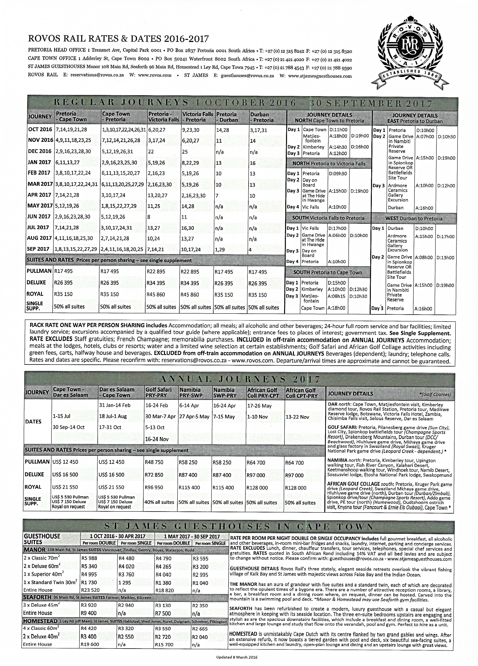

EXAMINATION NUMBER:
ADDENDUM B

QUESTION 4.1

FROM/TO
FARE BASIS
DUR | CARR | ADULT | CHILD | INFANT
CPT | BA B
ELS | SA K
BFN | SA Y
JNB | SA Y
DUR | CE C
FARE | ZAR
FARE ROUNDED | ZAR
VAT | ZAR
PSC | ZAR
YR | ZAR
YQ | ZAR
SC | ZAR
TOTAL | ZAR
(30)
FROM/TO | FARE BASIS
DUR | CARR | ADULT | CHILD | INFANT
CPT | BA B
ELS | SA K
BFN | SA Y
JNB | SA Y
DUR | CE C
FARE | ZAR
FARE ROUNDED | ZAR
VAT | ZAR
PSC | ZAR
YR | ZAR
YQ | ZAR
SC | ZAR
TOTAL | ZAR
(30)

EXAMINATION NUMBER:
ADDENDUM C

QUESTION 5.3.3

DAY AND NIGHT TRAVEL VOUCHER NO. 19580808
Passenger's name: |  |  |  | No. of persons:
Hotel service: |  |  |  | Address:  (Code)
Requirements: |  |  |  | Tel No.:
Date of arrival: |  | Date of departure: |  | Rate:
Account |  | Full account: |  | Reserved by:  Date: | Confirmed by:  Date:
 |  | Extras to be settled direct: | YES or X | Remarks:
 |  |  |  |  |  |  | (13)

DAY AND NIGHT TRAVEL VOUCHER NO. 19580808
Passenger's name: |  |  |  | No. of persons:
Hotel service: |  |  |  | Address:  (Code)
Requirements: |  |  |  | Tel No.:
Date of arrival: |  | Date of departure: |  | Rate:
Account |  | Full account: |  | Reserved by:  Date: | Confirmed by:  Date:
 |  | Extras to be settled direct: | YES or X | Remarks:
 |  |  |  |  |  |  | (13)

EXAMINATION NUMBER:
ADDENDUM D

QUESTION 6

[40]

Client Surname
Client first name as shown in id/passport
Date of birth |  |  |  |  |  |  | Year Month Day
Address
Tel |  |  |  |  |  |  | Home  Business  Cell
FLIGHT DETAILS
Flight |  |  | Departure |  |  |  |  | Arrival |  |  | PNR
Flight | Class |  | City | Date |  |  | Time | City | Date | Time
 |  |  |  |  |  |  |  |  |  | FARE
 |  |  |  |  |  |  |  |  |  | PSC
 |  |  |  |  |  |  |  |  |  | VAT
 |  |  |  |  |  |  |  |  |  | SC
 |  |  |  |  |  |  |  |  |  | YQ
 |  |  |  |  |  |  |  |  |  | YR
 |  |  |  |  |  |  |  |  |  | TOTAL
TRAIN DETAILS
Train
Compartment
Departure(City/Date/Time)
Arrival(City/Date/Time)
Price
Other Details
INTERCITY COACH DETAILS
Company
Departure (City/Date/Time)
Arrival (City/Date/Time)
PNR number
ACCOMMODATION DETAILS
Hotel name:
Address |  |  |  |  |  |  | Tel:  Fax:  Email:
Requirements: |  |  |  |  |  |  | Rate pppn/prpn
Date of Arrival: |  |  |  |  |  |  | Date of Departure
Reserved by (Agent) |  |  |  |  |  |  | Confirmed by (Hotel)
Date of reservation (Agent) |  |  |  |  |  |  | Date of confirmation (Hotel)  Confirmation number
Remarks or special requirements
Payment details |  | Client settles  Direct  Credit card/cash |  |  | Corporate account-hotel bill to be sent to:  Extras to be settled directly by client (YES/NO)

EXAMINATION NUMBER:
ADDENDUM D

QUESTION 6
[40]

Client Surname
Client first name as shown in id/passport
Date of birth |  |  |  |  |  |  | Year Month Day
Address
Tel |  |  |  |  |  |  | Home  Business  Cell
FLIGHT DETAILS
Flight |  |  | Departure |  |  |  |  | Arrival |  |  | PNR
Flight | Class |  | City | Date |  |  | Time | City | Date | Time
 |  |  |  |  |  |  |  |  |  | FARE
 |  |  |  |  |  |  |  |  |  | PSC
 |  |  |  |  |  |  |  |  |  | VAT
 |  |  |  |  |  |  |  |  |  | SC
 |  |  |  |  |  |  |  |  |  | YQ
 |  |  |  |  |  |  |  |  |  | YR
 |  |  |  |  |  |  |  |  |  | TOTAL
TRAIN DETAILS
Train
Compartment
Departure(City/Date/Time)
Arrival(City/Date/Time)
Price
Other Details
INTERCITY COACH DETAILS
Company
Departure (City/Date/Time)
Arrival (City/Date/Time)
PNR number
ACCOMMODATION DETAILS
Hotel name:
Address |  |  |  |  |  |  | Tel:  Fax:  Email:
Requirements: |  |  |  |  |  |  | Rate pppn/prpn
Date of Arrival: |  |  |  |  |  |  | Date of Departure
Reserved by (Agent) |  |  |  |  |  |  | Confirmed by (Hotel)
Date of reservation (Agent) |  |  |  |  |  |  | Date of confirmation (Hotel)  Confirmation number
Remarks or special requirements
Payment details |  | Client settles  Direct  Credit card/cash |  |  | Corporate account-hotel bill to be sent to:  Extras to be settled directly by client (YES/NO)

