Ely Runners Newsletter

NOVEMBER 2009



NEW MEMBERS
This month we welcome the following new members of the club:

Daniel Mould
David Mould
Nathan Pennington
Kirstie Robertson
John Uff
Pete Woods
Esme Wright

COMMITTEE NEWS
Unfortunately, for personal reasons, Peter Gipp has had to stand down from his duties as Chairman and Course Director. Stephen Howard has been appointed Acting Chairman and Stephen Tovey is Acting Course Director.

TRAINING
Please note that the Witchford bypass dog-walking and model aircraft fields are no longer available for training, as both have been cultivated.

DON BROWN HANGS UP HIS RUNNING SHOES
Sadly, Don Brown has decided that the time has come for him to retire from running. Don joined the club in August 2005 and, barely a week later, scooped the prize for male handicap winner in the club’s inaugural Straight Mile Handicap race on Quanea Drove, before going on to set the current M65 club record for the same distance the following year. Many of us have enjoyed Don’s camaraderie and support during training runs and he has been a regular supporter of the club’s Straight Mile and 10k handicap events each year.

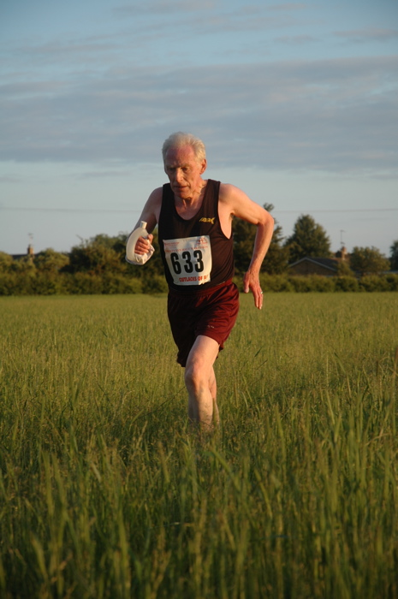
Don Brown – 10k handicap, June 2008

Although we will no longer see Don at training, we wish him well and hope we will still enjoy his company at social events from time to time.

CLUB EVENTS
NEW YEAR’S EVE 10K – marshals needed
The entry limit of 700 has already been reached for the club’s New Year’s Eve 10K (3 weeks earlier than last year), so entries have now closed.

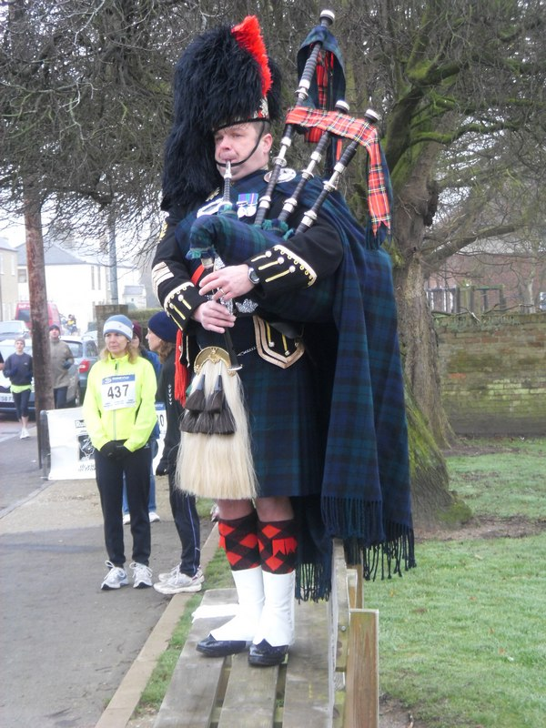
The piper struts his stuff before the NYE 10k in 2008

However, Brenan Morgan is looking for marshals to help on the day and so ensure the smooth- and safe-running of the event. If you can help, please contact Brenan (morgan191@ntlworld.com) as soon as possible.

Club Cross-Country Championships

For the second year running, the club’s cross-country championships will be run on the c. 5-mile course starting from Ely Common. To avoid clashes with other popular local races, they will be held at 10.00am on Sunday 3 January 2010. Steve Tovey will be in touch nearer the time with further details.

Ely Runners’ Turing Trail Relay
Following consultation with club members and discussion by the Committee and Events Working Group, it has been decided that the Turing Trail Relay will be held as a private, self-navigation event only for Ely Runners’ teams next year. A trial of the event, held in 2006, was run on these lines and enjoyed by all the members who took part. The date remains the same: Sunday 21 March 2010. Further details will be available nearer the time.

SOCIAL EVENTS
Pub Night
The next after-training drinks will be at The Cutter on Thursday 5 November.

Christmas Drinks
The Christmas Drinks and draw for the club's London Marathon places will be on Thursday 3rd December this year. (The draw is open to members who were unsuccessful in the ballot for places in next year’s VLM.) The venue this year will be The Cutter on Waterside.

Pre-Christmas Run from Woodditton to Ely
The long training runs from Woodditton and Reach will be on Sunday 20th December this year. As in previous years, members are invited to meet for Sunday lunch in The High Flier afterwards.

Julie Foreman will be in touch nearer the time with further details of these events.

NEWS OF FORMER MEMBERS
Claire Hallissey (formerly Willer) was selected to run for GB in the IAAF World Half-Marathon Championships in Birmingham on 12 October on the basis of her first place in the Bristol Half-Marathon the previous month. In a time of 1:12:14, she finished 25th overall and was first GB lady home.

East Anglian Cross-Country League
Only one member responded to John Turner’s request (via email and in the previous newsletter) for members interested in entering this league for the 2009-2010 to contact him. Therefore, it has been decided not to enter.

FORTHCOMING EVENTS
Frostbite Friendly League
The second FFL race will be at Bushfield on Sunday 8 November. Following a disappointing start to the 2009-2010 campaign, the club is currently lying 12th out of 17 teams in the senior league. Female members are particularly encouraged to come along and run, as the team was penalised last time for only having 2 of the 3 women needed to make up a scoring team. The atmosphere at these races is good and they are a good opportunity for newer runners to gain racing experience.

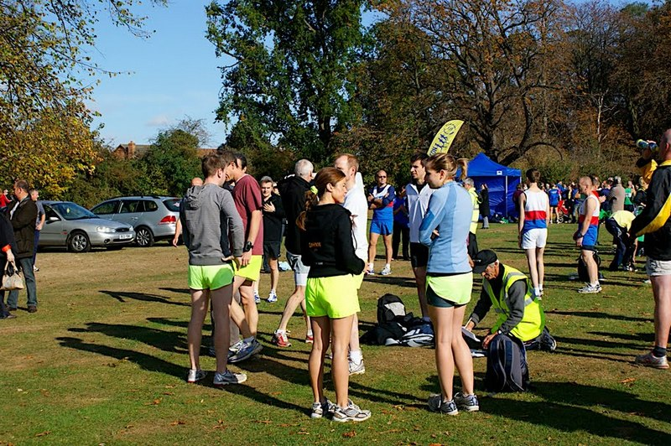
The Ely Runners’ team assembles before the first FFL race at St Neot’s

Two junior members – Alex Ellwood and Hayley Rutterford – spearheaded the club’s debut in the FFL junior league at St Neot’s. A full scoring team consists of 5 runners, including at least one female, so all juniors (aged 9-15) are encouraged to come along to the remaining fixtures to help the team move up the score table. Please contact Alan Rutterford (Alanatrdsltd@aol.com or 01353 741534 or 07821 988959) if you are interested in taking part.

Junior races start at 10:15 am and Senior races start at 11:00 am.

Remaining fixtures:
8 November 2009 Bushfield Sports Centre (Bushfield Joggers)
13 December 2009 Hinchingbrooke Park (Hunts AC)
17 January 2010 Ramsey Sports Centre (Ramsey Road Runners)
7 February 2010 Bourne Woods (Bourne)
7 March 2010 Huntingdon BRJ Club (BRJ)

Further details are available on www.frostbiteleague.org.uk.

SEAA Cross-Country Championships 2009-2010
The dates for the SEAA cross-country championships are as follows:

Saturday 21 November 2009 - Parliament Hill, Hampstead Heath
SEAA Inter-County Cross-Country Championships
U13BG, U15BG, U17MW, U20W, SW, U23W (closing date 30 October)

Saturday 30 January 2010 - Parliament Hill, Hampstead Heath
SEAA Cross-Country Main Championships
U13BG, U15 BG, U17MW, U20MW, SMW (closing date 4 December)

Sunday 14 March 2010 - Trent Park, Cockfosters, Herts
SEAA Masters Cross-Country Championships

ARC Championships 2009
ARC Postal Marathon Championship 2009
Please send your best 2009 result to The ARC Championship Secretary, Ian Vaughan-Arbuckle, at championshipsecretary@runningclubs.org.uk.

Conditions of entry:
- You must be a member of an ARC-affiliated club
- The race must have been run under ARC/UKA rules and over a certified distance
- Your personal result must be verifiable either on a printed result list or on a race website
- The race must have been run during the period 1st Jan - 31st Dec 2009
- Application must be made in writing to Ian V-A’s email (championshipsecretary@runningclubs.org.uk), giving the following details:
Full name, gender, club. Age on race day. Name and date of race. Finishing time (gun to tape)
- Awards will be made at the discretion of the ARC committee.
- There is no entry fee.

Full details are available on the ARC website: www.runningclubs.org.uk > Championships

Hereward Relay
Alan Rutterford is about to finalise teams for the Hereward Relay, to be held on Sunday 22nd November 2009. This event (organised by March AC) is a 4-stage relay from Peterborough Cathedral to Ely City Football Club (38 miles). He has enough runners for 6 teams but would still welcome extra runners to make up a 7th team and also act as reserves.

As March AC kindly help us to marshal the Grunty Fen and New Years Eve races, we usually return the favour by marshalling the finish area from Little Downham to the finish, so Alan is also looking for 4-5 volunteers to help with this.

If you are interested in running or marshalling, please contact Alan at training, by email (alan@elyrunners.co.uk) or phone (07821 988959).

RESULTS ROUND-UP
The Great Eastern Run, run over a fast, flat course in Peterborough, saw no fewer than 7 club members setting shiny new PBs for the half-marathon distance. Craig Holgate went one further by improving his own Senior Men’s club record.

As part of his preparations for the New York Marathon, John Crisp ran the Birmingham Half-Marathon, taking over a minute off his previous PB on his way to his first sub-80-minute time. His good form continued as he produced another sub-3-hour run over the marathon distance in New York.

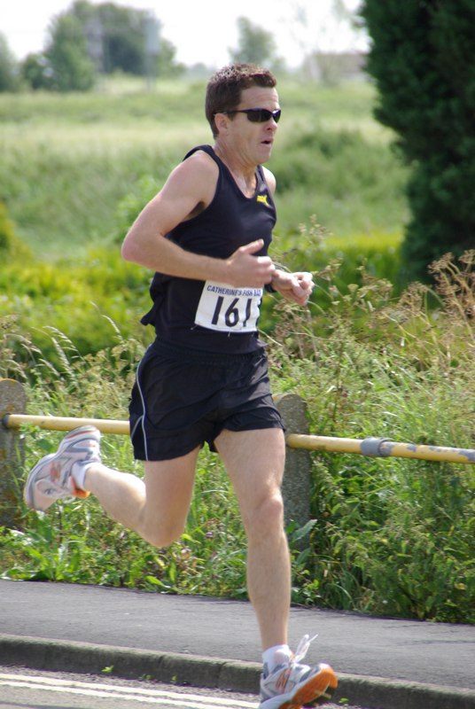 John Crisp

Seven club members pitted themselves against the wind in the Fenland 10. John Manlow placed highly to become the MV40 County Champion. Meanwhile, Steve Tovey and Adrian Stokes both took over 2 minutes off their previous best times.

The Beachy Head Marathon is an annual favourite for many club members. Conditions this year were foul – rain, fog and slippery terrain added to the challenges of an already-tough event. Whilst credit must go to all who braved the elements, Steve Pettit deserves special mention for his 3rd place overall, in the fastest-ever time by a club member –despite falling more than once in the mud and also getting lost in the last 4 miles.

Hannah Shiell enjoyed altogether more scenic conditions in the Lucerne Marathon but had to battle a knee injury in order to finish. Even so, she took 20 minutes off her previous marathon best.

CONTRIBUTIONS TO THE NEWSLETTER
As ever, please send your contributions to the newsletter to me (Rachel Roberts) at: newsletter@elyrunners.co.uk. Many thanks!

RR
November, 2009
newsletter@elyrunners.co.uk

RACES & EVENTS GUIDE 2009/10
November Newsletter 2009

This includes local area/easily accessible races, club, county, regional and national championships, and a selection of UK/overseas events previously enjoyed by members.

November
04 Loch Ness Marathon (&10k/5k), www.lochnessmarathon.com
08 Frostbite League 5m (road & firm paths), 1100 Bushfield Sports Centre, Peterborough
(meet Paradise Centre 0900 to share transport)
14 (Sat) GB & Irish Masters XC International, Birmingham
15 St Neot’s ½ Marathon, 1000 St Neot’s Rec Centre, http://www.half.riverside-runners.com/
21 (Sat) SEAA Inter-Counties XC Championships, Parliament Hill, London, www.seaa.org
21 (Sat) Assoc GB Athletic Clubs (ABAC) AGM, 1100 Thames Valley Athletic Centre, Eton
22 Hereward 4 Stage Relay (39.1m Peterborough to Ely), club teams
22 Hadleigh 10m, 1100 Hadleigh United FC, Duke St, Hadleigh, Suffolk, £10, EOD +£2
22 Pine Ridge 10k, Wisley, Surrey, £15 (no EOD), www.pineridgerace.co.uk
29 Thetford Forest Duathlon (5k run, 14k bike, 3k run), 1100 May Day Events Field, £22 per
individual/£30 per team (+£5 EOD), www.runbikeevents.com

December
04 (Fri) Cambs AA AGM 1930 at Hemingford Grey Conference Centre
13 Frostbite League 5m (soft paths & tracks), 1100 Hinchingbrooke Park, Huntingdon (meet
Paradise Centre 0915 to share transport)
13 Bedford ½ Marathon, 1000 Wotton Upper School, Beds, £15.50 (no EOD),
www.bedfordharriers.co.uk
13 Bunwell Santa Fun Run, 5k/3k, 1100 Bunwell Village Hall, Bunwell, Norfolk, £10,
www.bunwellstrollers.co.uk
20 Long/medium/short club pre-Christmas trail training runs, Woodditton to Ely 18.5m,

Woodditton to Chalk Pit 12m, Reach to Ely 11m, Woodditton to Reach 7.5m, meet 0800

Paradise for transport to starts
26 (Sat) Boxing Day training, meet 0900 Paradise Centre car park
31 (Thu) The 10th Ely New Year's Eve 10k Road Race, 1100 Lt Downham, entries on-line
only, no EOD, www.newyearseve10k.co.uk RACE FULL - entries closed

January 2010
03 Ely Runners Club Cross-Country Championships, 5m/8k, meet 0900 Paradise for
1000 start on Ely Common (private ER event – entries to Steve Tovey).
10 Cambs AA XC Championships, Priory Park, St Neots (entries to Charlie Barker)
17 Frostbite League 5m (sports field, droves, farm roads), 1100 Ramsey Sports Centre
(meet Paradise Centre 0915 to share transport)
24 Folksworth 15m, £15, on-line entry only via Runners World, no EOD
30 (Sat) SEAA XC Championships, Parliament Hill Fields, Hampstead Heath, London,
-13B/G, -15 B/G , -17 M/W, -20 M/W, SM, SW. Club entry if teams of 4 women or 6 men,
otherwise individuals. Entries to Charlie Barker, www.seaa.org

February
07 Frostbite League 5m (soft & firm woodland paths and farm droves), 1100 Bourne Woods,
Lincs (meet Paradise Centre 0845 to share transport)
07 Gt Bentley ½ Marathon, 1030 Gt Bentley Village Hall, Essex, £16
14 St Valentine’s Day 30k, Stamford (further details to follow)

March
07 Frostbite League 5m (roads & firm paths), 1100 BRJ Club, Huntingdon (meet Paradise
Centre 0915 to share transport)
14 SEAA Masters Cross-Country Championships, Trent Park, Cockfosters, London (further
details to follow)
14 Silverstone Half Marathon
21 Ely Runners Turing Trail Relay, 35.5m Ely-Cambridge-Ely (private self-navigation ER
team club event – entries to Steve Tovey)
27 (Sat) 1900-1930 Frostbite League Presentation Evening, (hog roast & live music by
Skyliners), Abbey College, Ramsey. Tickets £12.50 from Adrian Graham, 01487 812829 or
ramseyrunners@yahoo.co.uk

May
09 Eye 10k, Eye nr Peterborough (further details to follow)

June
10 (Thurs) Ely Runners 10k Club Handicap, Little Downham
19-20 (Sat-Sun) BMAF T&F Champs, Alexander Stadium, Birmingham (prov date & venue)

July
08 (Thurs) Ely Runners 1m Club Handicap, Amherst sports field by railway station
15-24 European Masters T&F Champs, Nyiregyhaza, Hungary

September
12 Ely Standard 20th Grunty Fen Half Marathon, Witchford

December
31 (Fri) Ely New Year’s Eve 10k Road Race, Little Downham

NOTES

Races and events are on Sunday unless otherwise mentioned.

Race entry fees are the affiliated (ARC/UKA or just UKA registered) fees

Courses are roads and/or hard footpaths/cycle ways unless otherwise mentioned.
Distances without units (m or k) are probably m = miles.
Frostbite League races are 5-6 miles and entry (league membership) is paid for by the club.
Further details of events from the Club notice board in the Paradise Centre foyer, running magazines, websites, or from John Turner secretary@elyrunners.co.uk) who also has details of all RRC/TRA long distance road/TR/XC races and FRA fell races.

National, regional and county championship team entries are via Charlie Barker (captain@elyrunners.co.uk).

Ely Runners’ private club XC championships, 10k/1m handicaps, and TTR relay entries are via Steve Tovey

Long distance team relay entries are via Alan Rutterford and paid for (if funds available) by the club.

Club website www.elyrunners.co.uk
Grunty Fen 1/2M website www.gruntyfen.co.uk
NYE10k website www.newyearseve10k.co.uk
Turing Trail Relay website www.turingrelay.co.uk (private club event for 2010)
Association of Running Clubs www.runningclubs.org.uk

Rachel Roberts
November 2009
newsletter@elyrunners.co.uk

USEFUL INFORMATION

Data Protection
Email circulations by the club to members are done by the Bcc (confidential) option so that member’s email addresses are not circulated and also these do not take up most of the first page of emails.
See www.elyrunners.co.uk > CLUB INFO > administration for the club’s policy on data protection and use of photos and videos on the club’s website.

Membership
Subscription renewals (£10) were due from 1st January 2009. Members who joined after 15th November 2008 are covered for 2009.

To renew online:
Go to www.elyrunners.co.uk > CLUB INFO > Membership
OR
Send a cheque, payable to ‘Ely Runners’, to Club Secretary: John Turner, 22 Cromwell Road, Ely, Cambs, CB6 1AS.

If you did not renew your membership by the end of March 2009, you will be removed from the membership list and will no longer be entitled to attend training, represent the club in races, take part in club championships, claim affiliated entry fees, or wear club colours.

Benefits of membership include:
- £2 affiliated discount on open race entries
- club affiliations to ARC, ABAC, UKA, EA, TRA, FRA & CAA
- free registration (£5) with EA until 31st March 2010 (on request via John Turner)
- free changing and showers at the Paradise Centre
- free training and coaching advice
- free high-visibility bib for night-time training
- £12 subsidy on club fleeces
- 10-20% discount at most specialist running kit shops
- free entry to the club’s Cross-Country Championships, 10k Handicap and Straight Mile Handicap
- free entry to the six Frostbite League races
- free club team entry to county, regional and national championships and for club relay entries
- entry into the draw (if a member’s ballot entry is rejected) for the club’s guaranteed London Marathon places
- free snacks at club social events
- shared transport to races

Supporting the Club and its Events
Ely Runners hold three popular open races each year (Turing Trail Relay, Grunty Fen Half Marathon, and Ely New Year’s Eve 10k Road Race) that contribute considerably to the club’s reputation and financial stability. This enables the club to provide the many benefits listed above. In return, members are expected to show commitment to the club by helping with these events and taking their share of responsibility. Please don’t just rely on the usual loyal helpers and think of the club only as a convenient way to promote fitness and enter races. We’re all busy these days but commitment is realising the mutual benefits of putting something back into the club and sport we enjoy.

Training
For details of club training sessions at 7pm on Tuesday (intervals/hills) and Thursday (steady 5-8m runs) evenings, please see the homepage of the club’s website. Details of 9am Sunday morning training runs are usually circulated by email a few days in advance.

When meeting at the Paradise Centre for training on Tuesdays and Thursdays, please assemble either in the balcony/bar area upstairs or outside, around the corner by the side of the building. Please do NOT assemble in the foyer or outside the main entrance.

The meeting place for Sunday morning runs is the Paradise car park. The car park toilets are open by 9:00 am and the Paradise Centre is open for showers afterwards.

Please ensure that new members, some of whom are new to running, feel part of the club and are not left alone on training runs.

Club training sessions are intended to cater for a wide range of abilities and racing objectives. If you require specific coaching advice, please ask Club Coach Alan Rutterford to help.

To measure the distance of a route before or after running, see Google Earth > Ruler (toolbar symbol) > Path. Provided measurement is done carefully, the distance should be of similar accuracy as GPS.

Club Noticeboard
This is in the foyer of the Paradise Centre, to the right of the main entrance. It includes details of club events, training sessions, route maps, local races and other events of interest to members. There are usually several copies of race entry forms on the board but please leave the last copy or ask staff at reception to photocopy (Ely Runners' account) a few more copies.

Club Website
Webmaster, Rod Baron, maintains the Ely Runners’ website (www.elyrunners.co.uk) to provide an up-to-date record of the club's activities and a myriad of useful information. The website is frequently updated and well worth regular visits. For member’s general comments, there is a Message Board on the website’s home page and the recently upgraded photo and video section contains a huge selection of members in races. Rod also maintains the club’s websites for the Grunty Fen Half Marathon, New Year’s Eve 10k, and Turing Trail Relay.

Club Library
Grade 2 coach Max d'Ayala has selected a range of books on running and injuries for use by club members. Please see http://www.dayala.co.uk/elyrunners/booklist.htm for details: they have been chosen to provide a combination of interest, information, advice and stimulation for all standards of runners. The books are stored in the club's locker (authenticate membership and ask for key at Reception) at the Paradise Centre staff room. Please record which books you have borrowed in the notebook in the club's locker.

John Turner has the latest (2009) Fell Runners Association Fixtures Calendar & Handbook. Members interested in running a fell race can borrow this booklet. Most fell races are ‘up north’, though there are also many in Wales and other hilly areas of the UK. There is a huge choice throughout the year, including many evening races in the summer, some not too far away in areas like the Peak District. Alternatively, if on holiday in such areas, you can often find a local fell race. They provide an enjoyable, challenging and worthwhile experience, even for Fenland-based runners.

A recent addition to the club’s library includes ‘Feet in the Clouds – A Tale of Fell Running and Obsession’ by Richard Askwith.

Racing
Some open races are very popular and reach the entry limit before the race day. Many races no longer accept entries on the day (marked ‘no EOD’ in the Races & Events Guide). If you are thinking of entering a race on the day, check with the organisers or on the race website before setting out that a place is still available – turning up does not guarantee that the organisers will allow you to run!

Wearing Club Kit
Members wear their Ely Runners’ colours with pride in races far and wide (see www.elyrunners.co.uk > RESULTS) and are encouraged to do so whenever appropriate. Guidelines to wearing Ely Runners' colours (minimum club vest) in all events entered as an individual or team member of Ely Runners are as follows:
1. Obligatory requirement of governing athletic organisations in leagues entered by the club, relays entered for or by the club, all championships and events incorporating championships. Exceptions are members running for county, regional or national teams when they will be given the appropriate team kit to wear.
2. Necessary to avoid disqualification as a team member in open races.
3. Members normally wear their club kit in open races but there are recognised exceptions such as representing a charity, necessary kit change in an ultra run, spur of the moment race entry, non-availability of kit for whatever reason etc.
4. Not wearing club kit also makes it harder for other runners, race officials, and photographers to distinguish club runners, especially in relays.
5. Our distinctive race kit defines us as ambassadors of a well-respected running club.

Race Results
When you send your race results to Stephen Howard (results@elyrunners.co.uk), please advise if you have achieved a PB (including in vet categories), so that it can be included in press reports and to update PB information on the website. If possible, please send Stephen any information you have (including links to race results) by noon on Monday to avoid the extra work involved in updating press reports. Please email any photographs or links to event photographs (with your race number) to Rod Baron at webmaster1@elyrunners.co.uk.

Several members have put themselves on www.athleticsdata.com. This is a statistical website showing:

- UK year rankings
- All-time rankings
- Comprehensive results service
- Athletes’ profiles

This website will enable you to check your form relative to rival runners and allow them to do the same. It’s also useful for the prediction of race results for both runners and organisers.

Payment of club entries into championships, relays and leagues will be funded by the club provided they are team entries made by the club. The club will not pay for individual entries into open races that have an incorporated championship.

To take part in UKA National and SEAA championships, members need to be registered with England Athletics (EA). Also, a few open events still require EA registration to claim affiliated entry fees. However, most events (especially locally) either have ARC permits or, if they have UKA permits, require only membership of an EA affiliated club, like Ely Runners. Please could members who would like to be registered from 1st April 2009 with EA for 2009-10 please contact John Turner secretary@elyrunners.co.uk. It was agreed at the recent AGM that the club will pay the £5 registration fee. Registration number confirmation and cards will be supplied when received from EA.

To enter a County (eg Cambs AA) or Regional (eg SEAA) Championship, members must have been born in the county/region or had 9 months of continuous residency. If you qualify by birth and residency for different counties, you may only run for one county/region during each competition year from October to September.

Club vets who are not members of EVAC may run as guests of the club’s EVAC members in EVAC Championships. EVAC events are included in the Races and Events Guide and can be entered by sending an email to eastvetm75@ntlworld.com. Subject to the availability of funds, the club will pay for club team entries to EVAC and BMAF Championships. EVAC website: www.evac.org.uk
BMAF (vets) events are too numerous to include all of them but they have been circulated to EVAC members via regional and national veteran magazines or see www.bmaf.org.uk/fix/fix.asp

Running Kit
Mary Gates oversees the club’s kit supplies. The club’s joining fee of £33 includes a free club race vest and shorts. Please contact Mary on 01353 861379 or mary@elyrunners.co.uk to order. See www.elyrunners.co.uk for full details of club kit.

New club vests now have the Ely Runners’ cathedral logo top centre on the front. Any members with older vests who would like to have the logo added will need to give their vest to Mary to send. The cost (£1.20 for the transfer + 25p for application) will be covered from club funds. Race vests will continue to have ELY RUNNERS on the back.
Club fleeces are available from Mary Gates at the subsidised price of £10 to members only. This price is for one fleece per member. Subsequent fleeces will be at the cost price of £22.
.

Discounts on Kit Purchases
If you buy running kit from Advance Performance at Cambridge or Peterborough, please show them your membership certificate and the club will receive 10% towards vouchers that we use for prizes for our Christmas charity raffle. Advance Performance do not otherwise give discounts. Other running shop suppliers such as Sweatshop in Cambridge (who sponsor our three open races: New Years Eve 10k, Turing Trail Relay, and Grunty Fen Half Marathon) will usually provide a 10% discount to members on production of a valid membership certificate.

Natalle Etches has purchased a wide variety of fitness stock from a local Internet fitness company that closed down. She is re-selling the stock as low as half price to club members. The stock includes cycling, running, fitness and triathlon wear from brand names including Craft, Gore Bike Wear, Pearl Izumi, and Sugoi. If you’re interested, speak to Natalle at one of the training sessions or contact her on natalle@elyrunners.co.uk.

Social Events
Julie Foreman organises the club’s After Training Drinks on the first Thursday of the month.

