Ministry of Agriculture and Rural Development
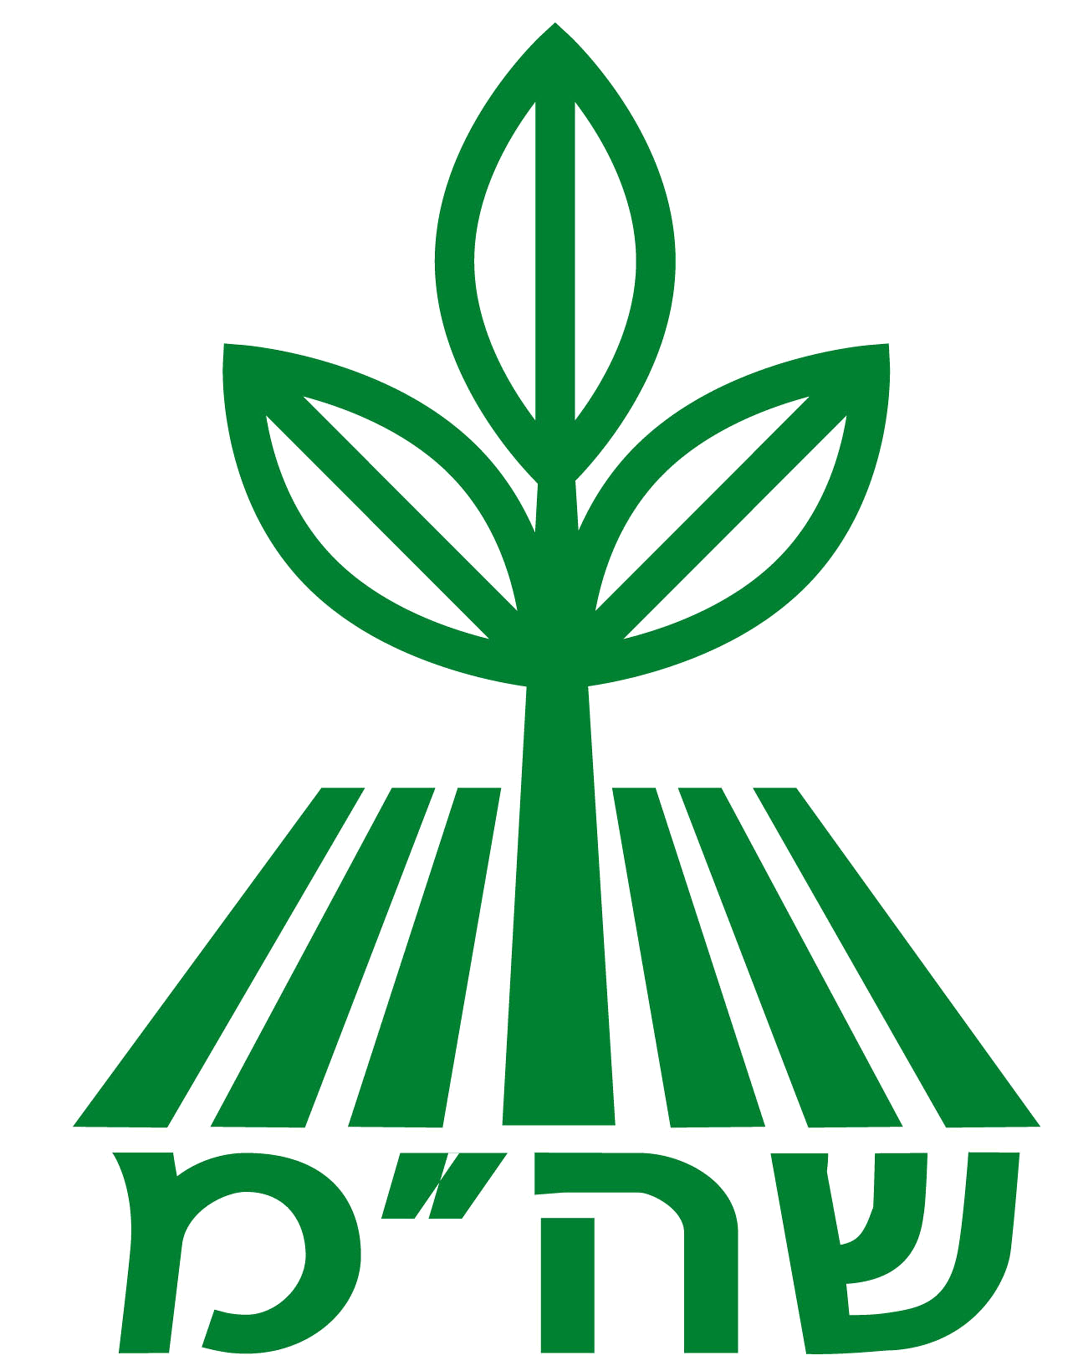

Agricultural Extension Service

The Fruit Division

Growing and Plant Protection Course
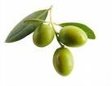

in the Olive Branch

Central and southern region, 2012

We cordially invite you to a plant protection and growing course that will provide novel, current knowledge in diverse fields related to the olive branch.
The course will be held at the Muza el Mul Hayam restaurant in Kibbutz Palmachim and at the Ministry of Agriculture at Beit Dagan in April-June 2012
The course is intended for farmers and all persons working in the branch who are interested in the different aspects of olive growing, as well as working in the olive grove, olive biology, plant protection, irrigation and fertilization, olive picking, olive oil, olive presses and so on.

Venue and dates of the course
The course will be held at the Muza el Mul Hayam restaurant in Kibbutz Palmachim and at the Ministry of Agriculture in Beit Dagan, and will consist of 10 weekly sessions on the following Tuesdays: April 17, 2012, April 24, 2012, May 1, 2012, May 8, 2012, May 15, 2012, May 22, 2012, May 29, 2012, June 5, 2012, June 12, 2012 (visit using private vehicles) and June 19, 2012 at 8:00 a.m. – 4:00 p.m. Seven sessions will be held at the Muza el Mul Hayam in Kibbutz Palmachim and two sessions will be at the Ministry of Agriculture in Beit Dagan (May 15, 2012, May 22, 2012).
The study hours during the course will be: 8:30 a.m. – 4:00 p.m.

Cost of the course
The price of the course per participant is NIS 2,100, including dinners and light refreshments during the study day and an academic visit during one of the course sessions.
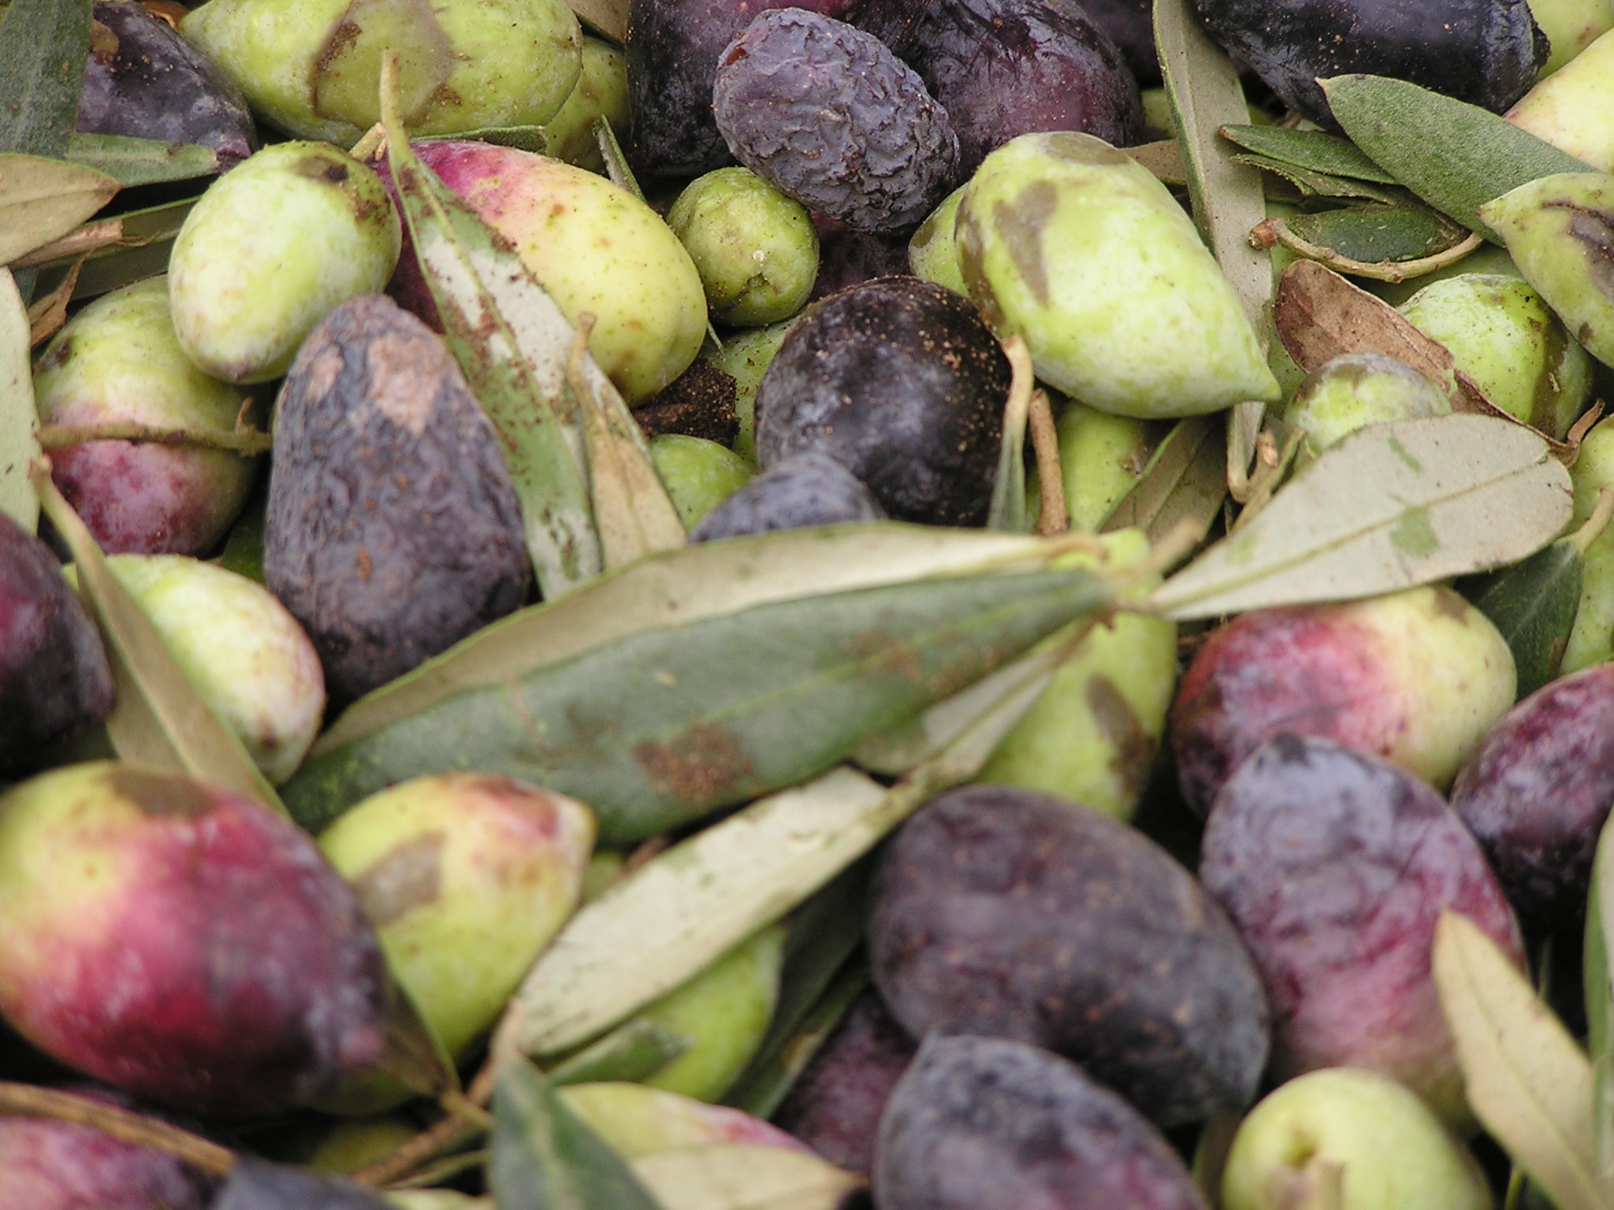
Course subjects:

* Biology and physiology of the olive tree
* Agro-technique of olive grove growing
* Plant protection in the olive grove: pests, diseases and weeds and their control
* The olive industry economy
* Olive harvest
* Olive oil properties and quality
* The olive press
* Visit to plantations working with shaking and harvesting, produce processing plant and olive presses,
Experiments on olive plantations in the area.
* A detailed syllabus will be handed out to participants on the first day of the course.
* Attendance of all study days during the course is mandatory
* Course graduates will be awarded a certificate from the Agricultural Extension Service, the Ministry of Agriculture and Rural Development.
As the number of places is limit, we recommend that you register quickly.
Course will be opened given a minimum of 40 participants.
Manner of registration
Fill in the attachment below and send it to the address stated therein.
The participation fee is to be paid in one of the following ways after arrangement with Yossi, telephone 03-9485330:
- Bank transfer to the account of the Ministry of Agriculture at the postal bank: Branch 09-0001, account 66111
- By credit card via the payment call center, tel.: 03-9485330 (Yossi).
- By credit card via the government payment website (Shaham): www.shaham.moag.gov.il
- Sending a cash check to the address indicated in the attachment.
Professional coordination: Ehud Chanoch - Mobile: 050-6241536
Organizational coordination: Michal Avraham - Mobile: 050-6241081
Office: 03-9485311; Fax: 03-9485614

------------------------Registration slip -------------------------

To: The Finances Department – Ministry of Agriculture and Rural Development

P.O. Box 28, Beit Dagan
I wish to register for the course “growing and plant protection in the olive branch, central and southern region”.
I have made the payment of NIS 2,100 in the following manner (circle):
- Bank transfer to the account of the Ministry of Agriculture at the postal bank: Branch 09-0001, account 66111
- By credit card via the payment call center: 03-9485330 (Yossi).
- By credit card via the government payment website (Shaham): www.shaham.moag.gov.il
- Sending a cash check to the address indicated in the attachment.
Name: Fax:
Telephone: Mobile phone no.:
Address: Email:
Date: Signature:

