Table of Contents
Process Overview 2
Login into AICTE web portal with existing institute id 3
Earnest Money Payment 8
Option1 : ‘Paying EMD using Pay Order’ 8
Earnest Money Payment using ePayment 11
Entering further application details (Programme, Courses etc) 13
Adding (first shift) courses and approval request details for each course 18
Specify the Course Details 20
Specify type of approval request for the course 20
Add ‘Faculty’ records and attach multiple attachments for each faculty record 21
Instructions on Fee Payment modes 24
In case you choose to pay through e-payment mode : 24
In case you chose to pay through Pay Order Mode : 25
Print Pay-In Slips 27

System Help Documentation for extension, introduction of new programme, new course/s and
additional divisions in existing Technical Institutions, A separate Technical Institution in 2’nd
shift working, Closure, TFW quota, PIO quota, NRI quota

Process Overview
Login into AICTE Web Portal
Prerequisite: User needs to have a valid username and password for existing institute (One institute = One login)
(* One institute = One login)

Create a record in the system and add initial details in “Application” and “Application Details” Sections

Pay the Earnest Money Deposit using Pay Order or ePayment option

Add Program(s), Provide details of each existing course and specify approval requested for each course (extension, introduction of new course, additional intake for existing course etc)

Provide other details (Faculty, Staff, Instructional Area, Laboratory details etc)

Pay the Processing Fee using Pay Order or ePayment option

Print and verify the application and attachments
Submit the Application Ensure that you have filled the requested information/attachments before submitting

Login into AICTE web portal with existing institute id
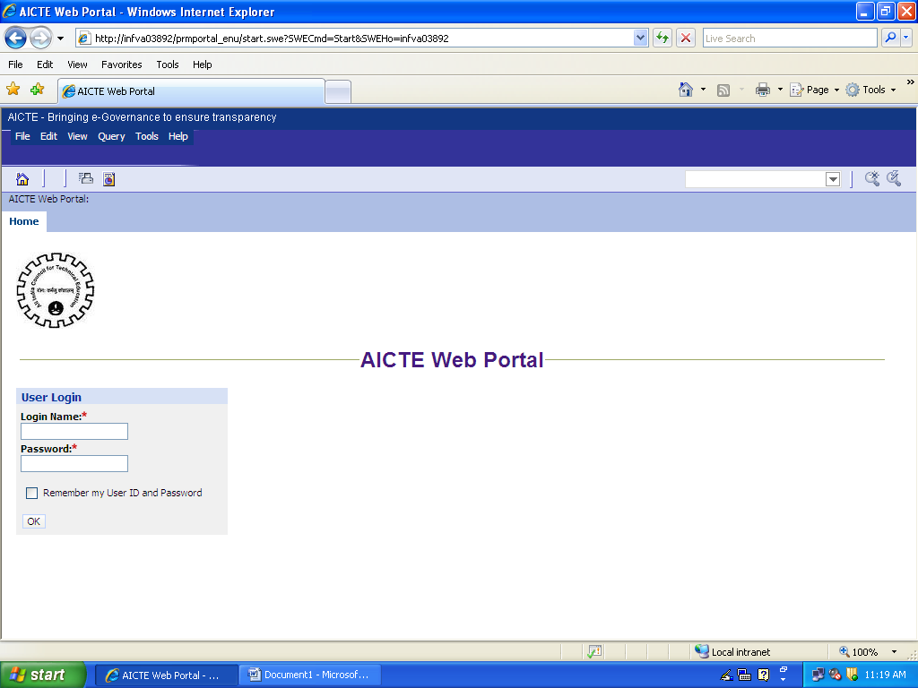

Click on the ‘Extension Approval’ tab
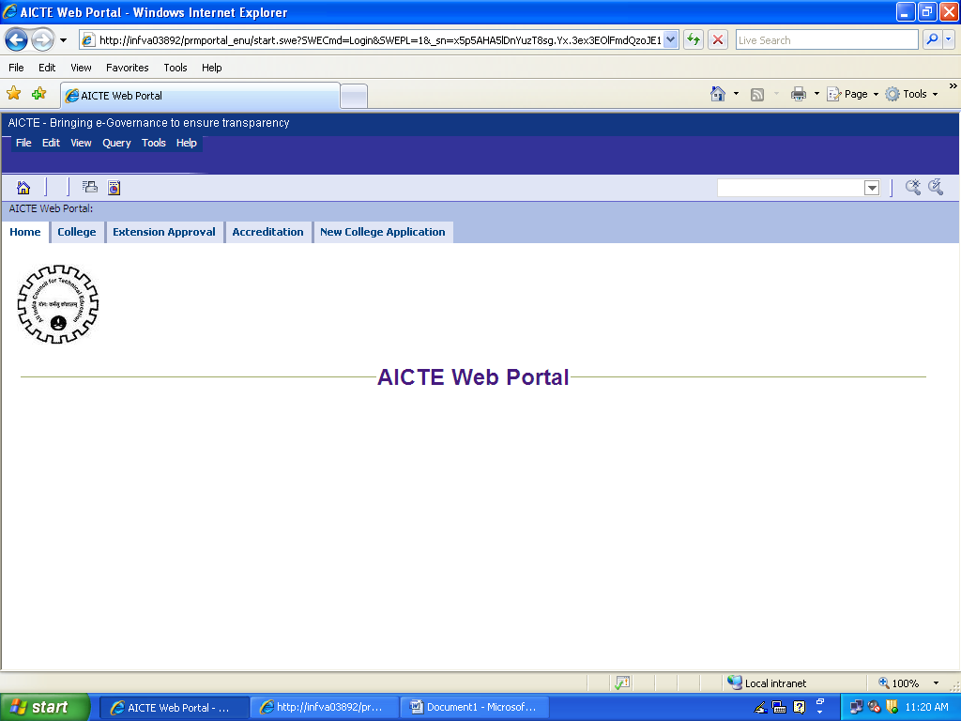

Click on ‘Extension - Applicant Views’ for viewing or entering the details of an application
Click on ‘New Application’ button if you want to create a new application record
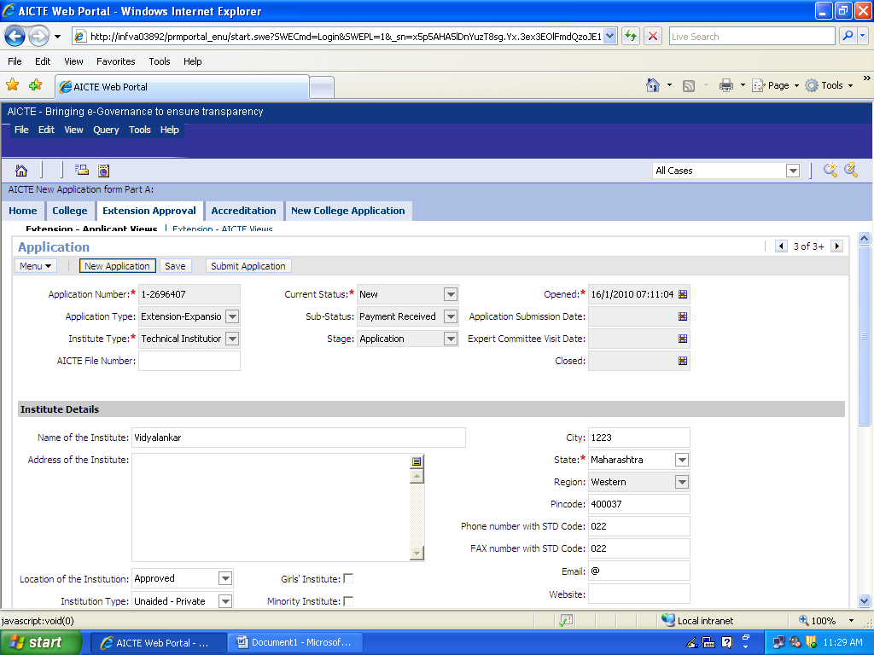

The Application Number is automatically generated by the system. Note down the Application Number. The Current Status is set to ‘New’ while the Sub-Status field is blank.
Fill in the details for all fields displayed on the form (except those fields which are non editable / system fields)
Key Fields :
Institute Type: Select from (Technical Institution / Integrated Campus)
< Select the value carefully which represents type of your institute, you will be allowed to enter information about multiple ‘Programme’ if you choose type as Integrated Campus >
Pending Application? :
Application Ref#:
<Check the ‘Pending Application’ flag to indicate that you had already submitted the application manually and provide the ‘Reference number’ of the same>
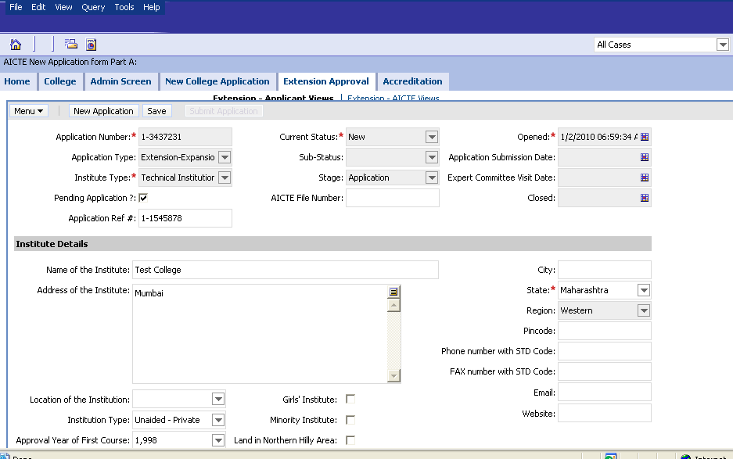
Click on Application Details form.
Enter the details under the ‘Application Details’ Tab
Provide details for all the fields displayed on the form
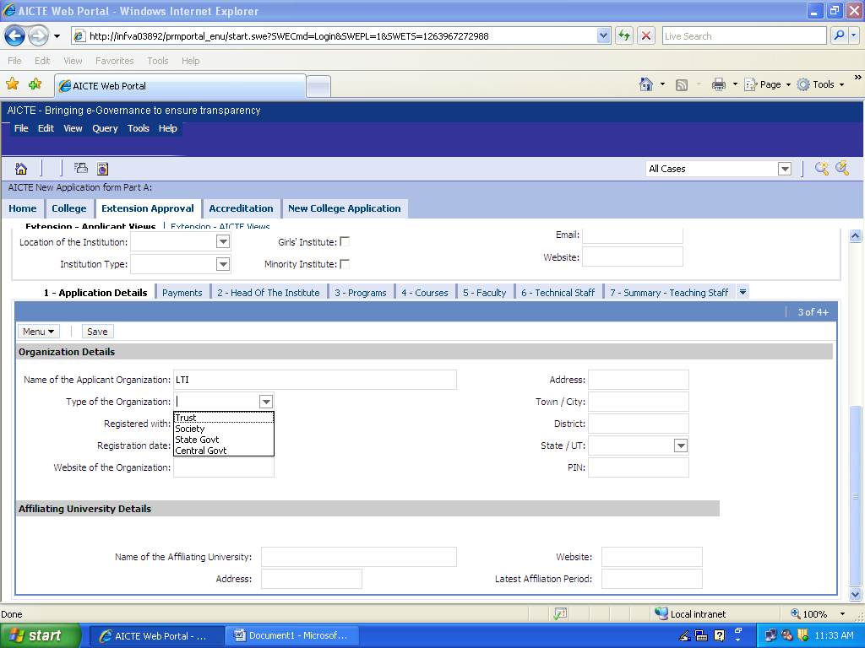

Earnest Money Payment

Option1 : ‘Paying EMD using Pay Order’
Click on the Earnest Money Payments tab. Click ‘Select Mode of Payment’ button to enter the payment mode. Select the option ‘Pay Order’
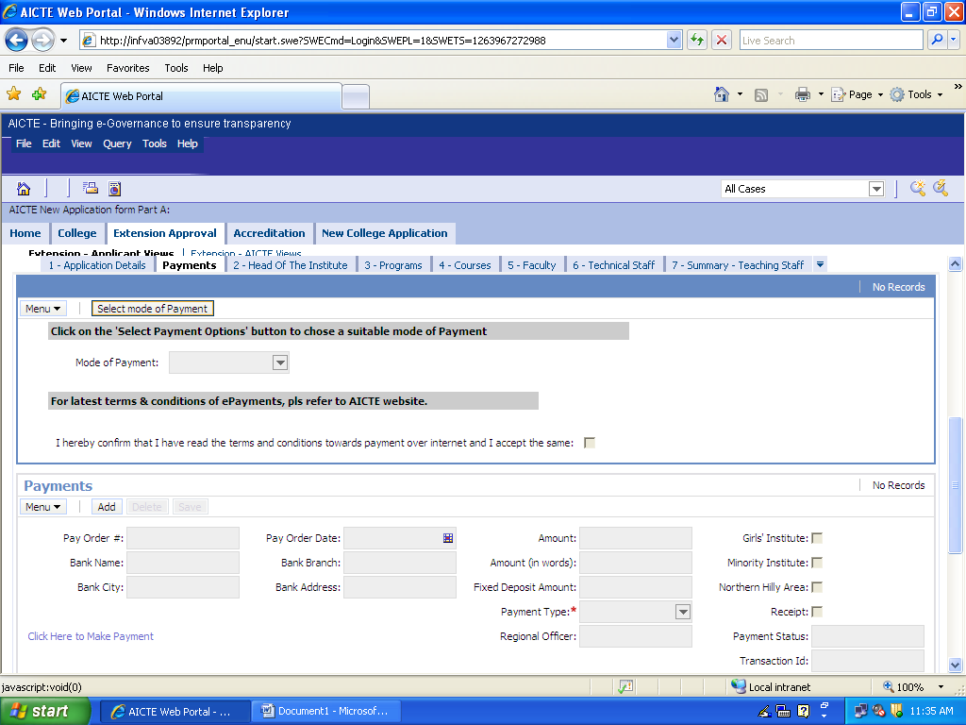

Click on dropdown ‘Mode of Payment’ and select ‘Pay Order'

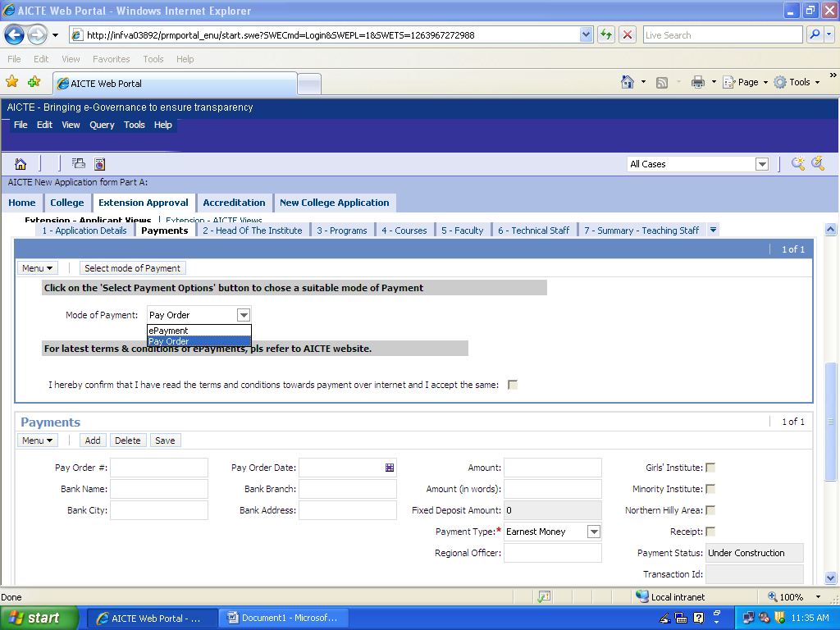

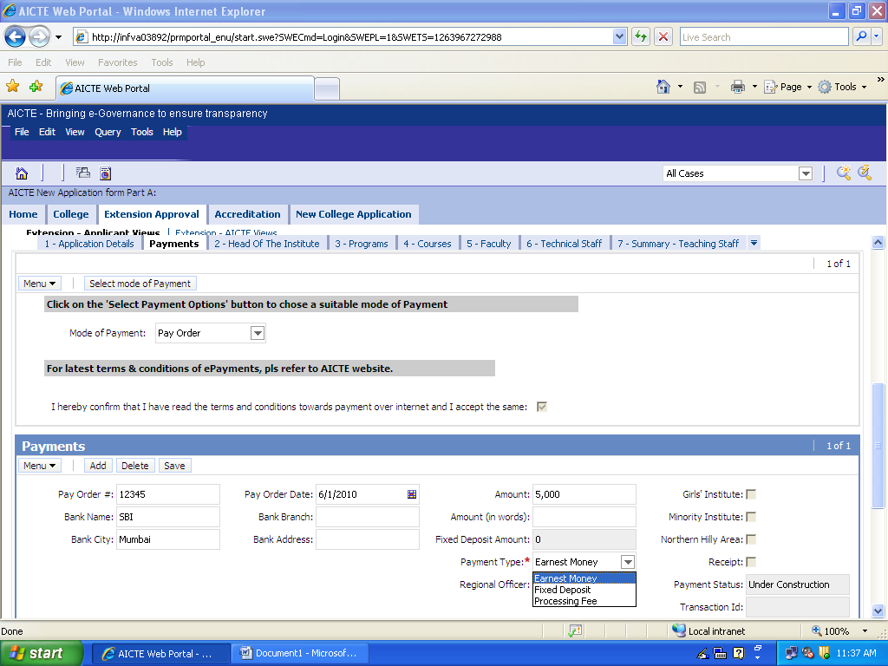
- Payment Type automatically defaults to “Earnest Money”
- Note down the amount and get the ‘Pay Order’ prepared of requisite amount in name of "Member Secretary, AICTE"
< Please refer to section ‘Instructions on Fee Payment modes’ below for more details >
- Fill in all the editable fields as displayed on the ‘Payment’ section (Pay Order#, Bank Name, Bank City, Pay Order Date, Bank Branch, Bank Address)
- Click on ‘Save’ button
- Print and submit the ‘Pay in Slip’
< Please refer to section ‘Print Pay-In Slips’ for further details>
- Please note that the remaining sections of the application shall be active after confirmation of receipt of the earnest money payment this process might take 3-4 days

Earnest Money Payment using ePayment
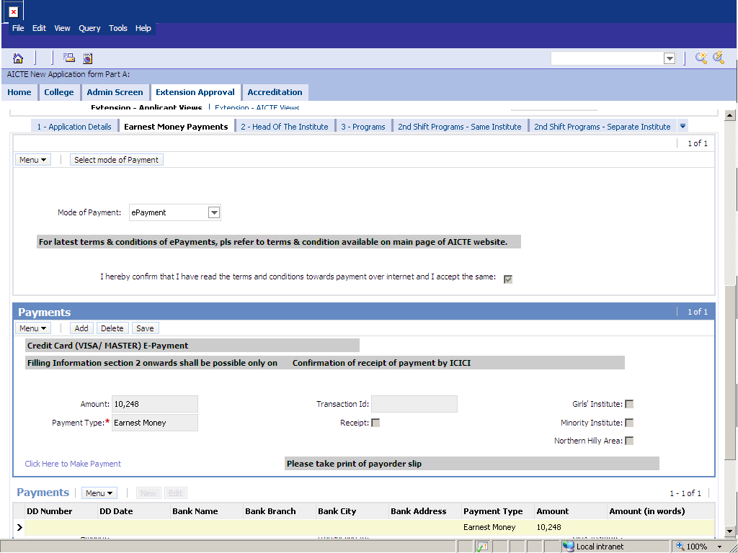

Select “ePayment” as Mode of Payment and click on “Save” button, the applicable amount gets displayed in amount field

Click on “Click here to make Payment” link , this will open ICICI page as shown below
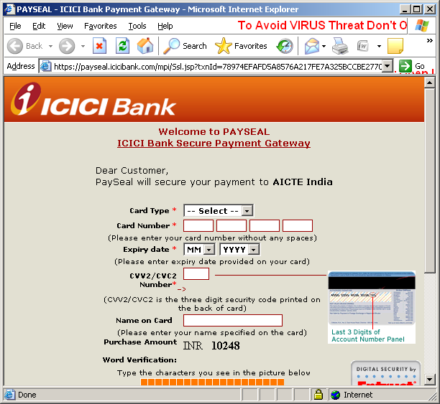
Once you make successful payment, application ‘Sub Status’ filed will be changed automatically to ‘Payment Received’ and ‘Transaction Id’ shall be displayed.

Please note that the rest of the application forms will now become editable

Entering further application details (Programme, Courses etc)

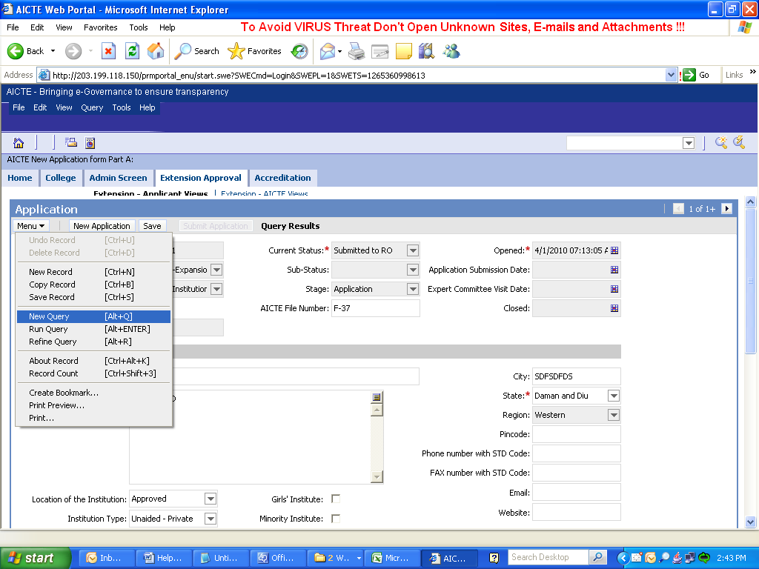
Follow following steps for searching application record once you login back into the system if it is not displayed on the screen by default
Log in to the AICTE web portal and click on the ‘Extension Approval’ tab. Click on Menu -> New Query.

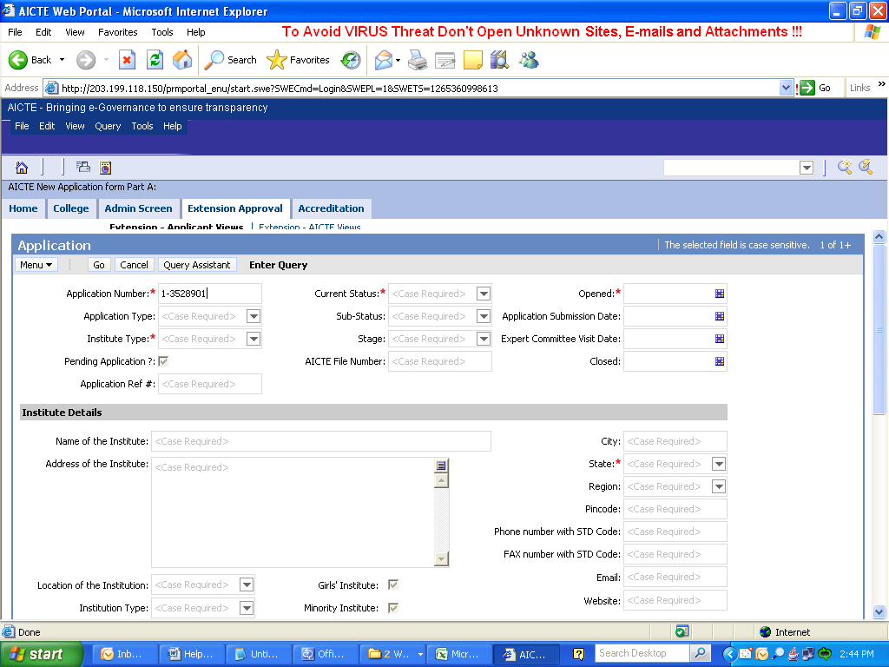
Enter ‘Application number’ in the application number field and then click on ‘Go’ button
Note that your application record is displayed , ‘Current Status’ is ‘New’ and ‘Sub-Status’ is “Payment Received’

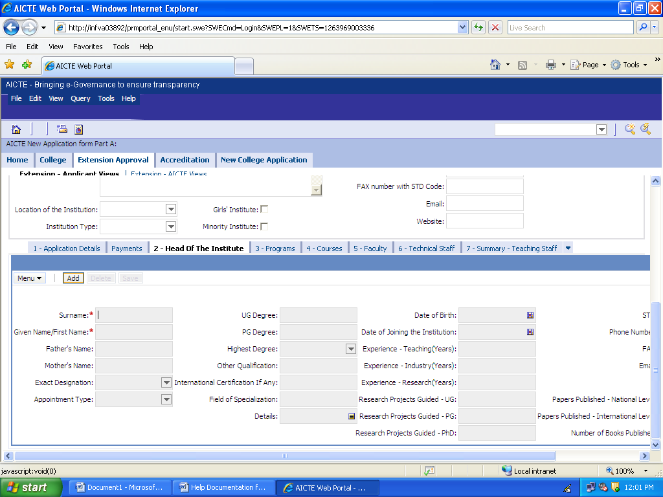

Click on ‘Head of Institute’ Tab and click on ADD to add details about the Head of the Institute.

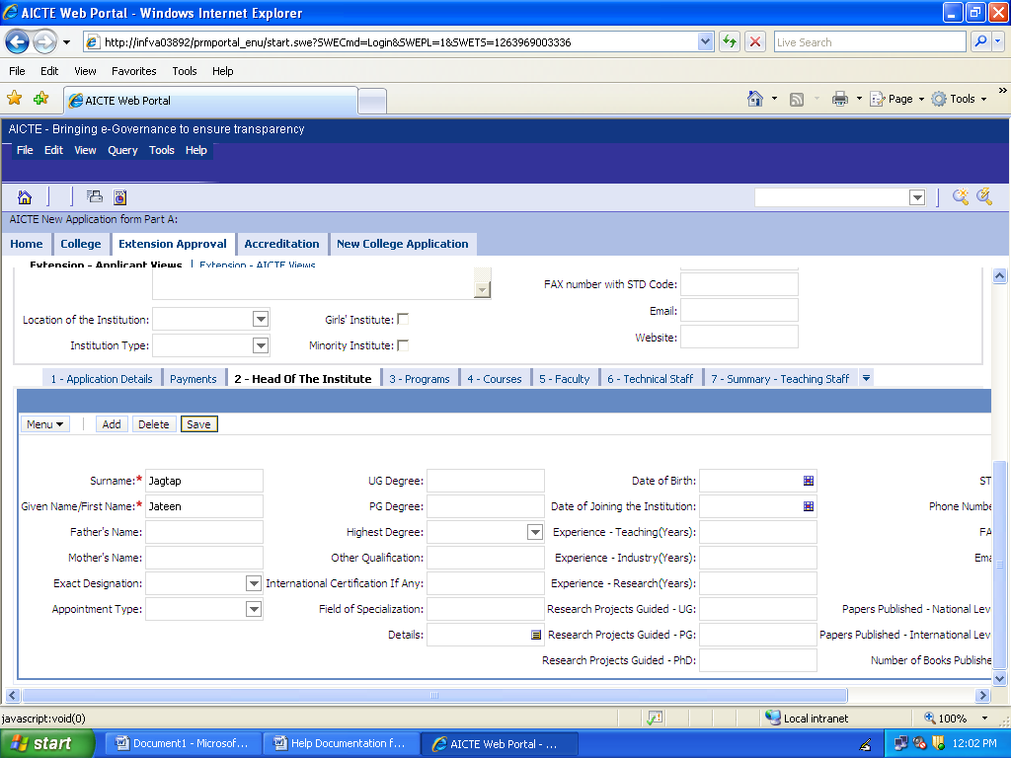

Fill in the details and click on Save

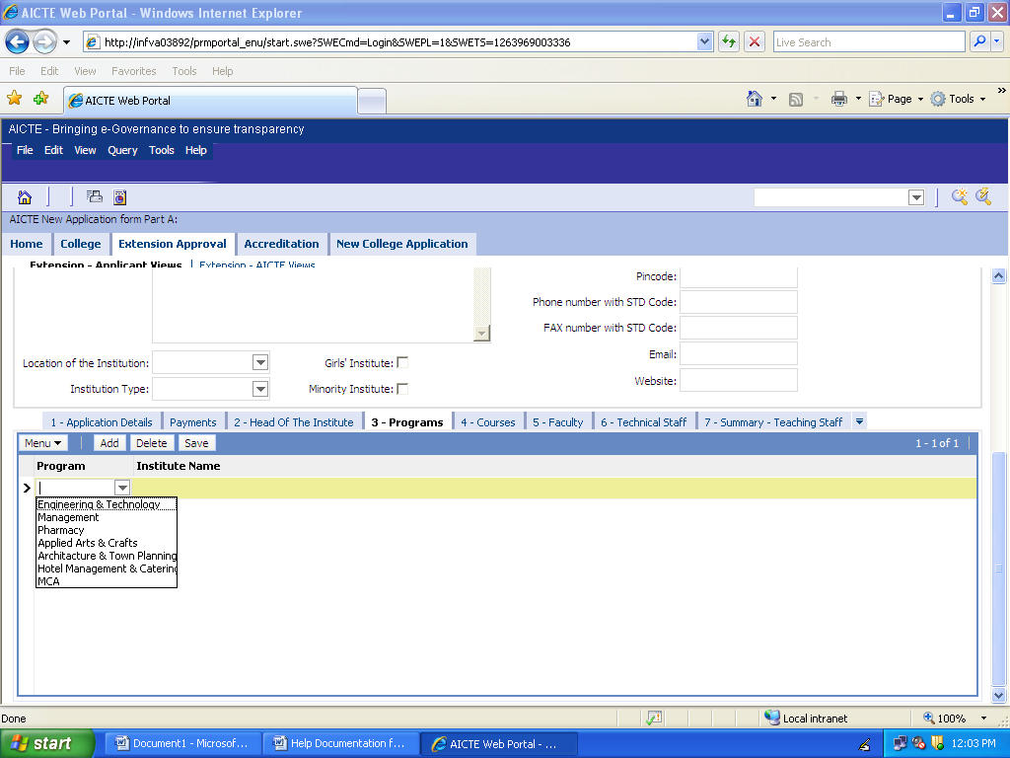
Click on ‘Programs’ tab. Click ‘Add’ and select the programme applicable for your institute from the dropdown
Note: You will be able to enter multiple programs if the ‘Institute Type’ is ‘Integrated Campus’

Step 14

Adding (first shift) courses and approval request details for each course

Click on ‘Add Courses’ button on ‘Courses 1’st Shift’ tab and click on the icon in the Programme field, This will open a dialogue box and the applicable Programme for your institute shall be available for selection
Choose the programme associated with the course for which you want to enter the approval request details

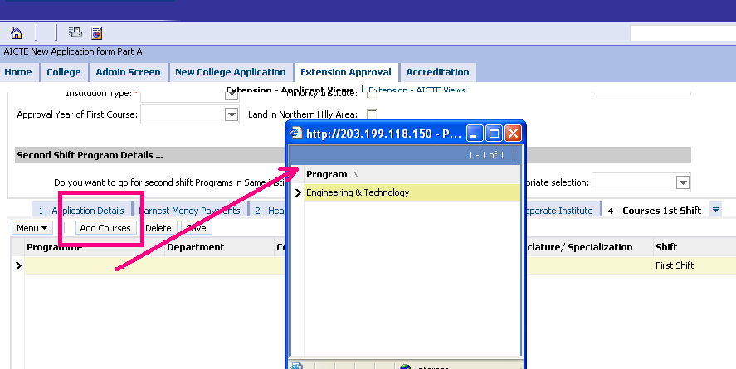

Click on the Course field and select the required course from the dropdown, this will populate the ‘Department’ field automatically
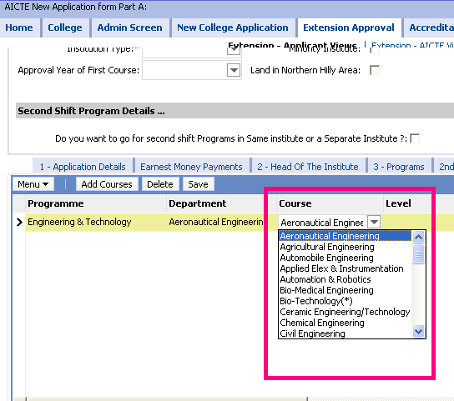

Specify the Course Details

- Select Level of the course (Under Graduate, Post Graduate, Under Grad - 2nd Yr Direct )
- Put in exact nomenclature / Specialization if required
(Put in Specialization in case of PG course and provide ‘exact nomenclature’ if the course your institute is running is not available in the ‘Course’ drop down values)
- Field ‘Shift’ : value defaults to ‘First Shift’
- 1’st Year of Approval : Provide year when you got the approval for the course first time

Specify type of approval request for the course

Current Intake : The current approved intake for the course (Put ‘0’ ONLY IF you are seeking approval for ‘Introduction’ of a course for all ‘existing’ courses in your institution this value must be provided)
Applied for Intake:
  - If the value is same as ‘Current Intake’ the approval request type is considered as “Extension”
  - If the value is more than ‘Current Intake’ the approval request type is considered as “Addition”
  - If the value is entered is less than current intake (and is in multiple of 60) then the approval request type is considered as “Closure”
  - Reset ‘Existing NRI’ and ‘Existing PIO’ flags if you do not have existing NRI/PIO quota already approved for this course
  - Select value “New Request” from drop down if you want to apply for NRI/PIO/TFW

Note: Please refer to the ‘Approval Process Handbook’ for clarifications of governing rules

Enter other details about existing courses (i.e. Intake Current Academic Year (CAY), Intake for CAY-1, Intake for CAY-2 etc)
Repeat the procedure for all those courses currently available in your institute and all those courses you want to introduce

Add ‘Faculty’ records and attach multiple attachments for each faculty record

Click on ‘Faculty’ tab. Click ‘Add’ to enter details
Click on the ‘Course’ field this will open a dialogue box which will list all the courses available for selection
Select the appropriate course
Provide other details i.e First Name, Surname, Exact Designation etc
Repeat the procedure for all the faculties available in your institute
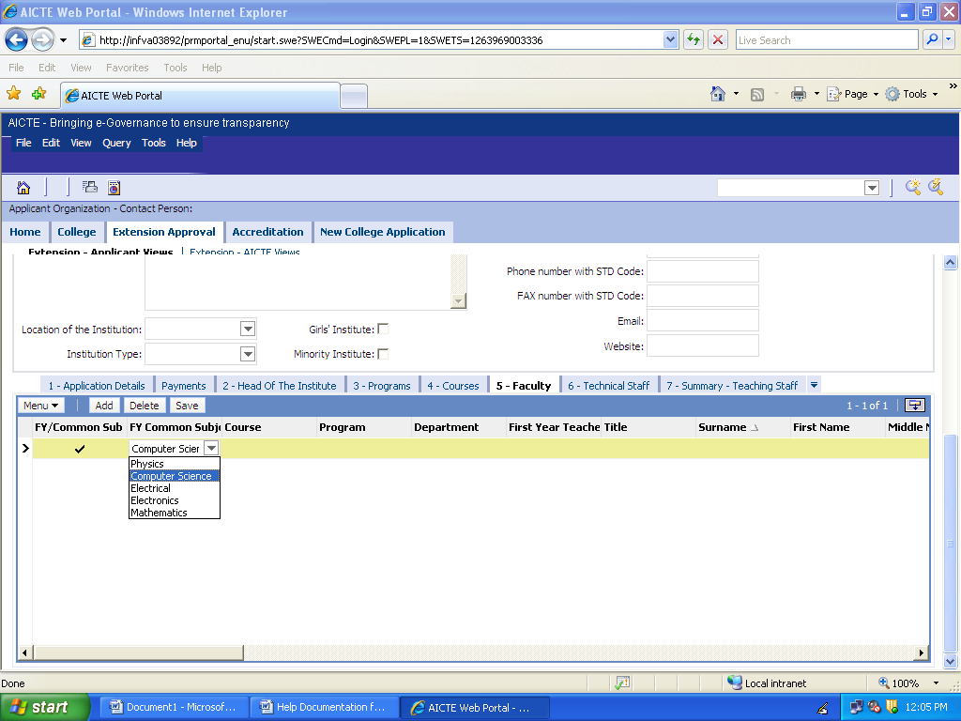

Click on ‘Attachments’ tab below Faculty tab
- Click on ‘New File’ button, this will open a pop up window to select attachment document from your local drive
- Select the required file, this will create an attachment record in the attachment record
- Select appropriate ‘Document Type’ value from the available drop down
Note : Make sure that the pointer is on corresponding ‘faculty’ record while attaching all the attachments for a particular faculty. Once you are done with all attachments for a particular faculty move on to the next faculty record in the Faculty Information and repeat the same procedure
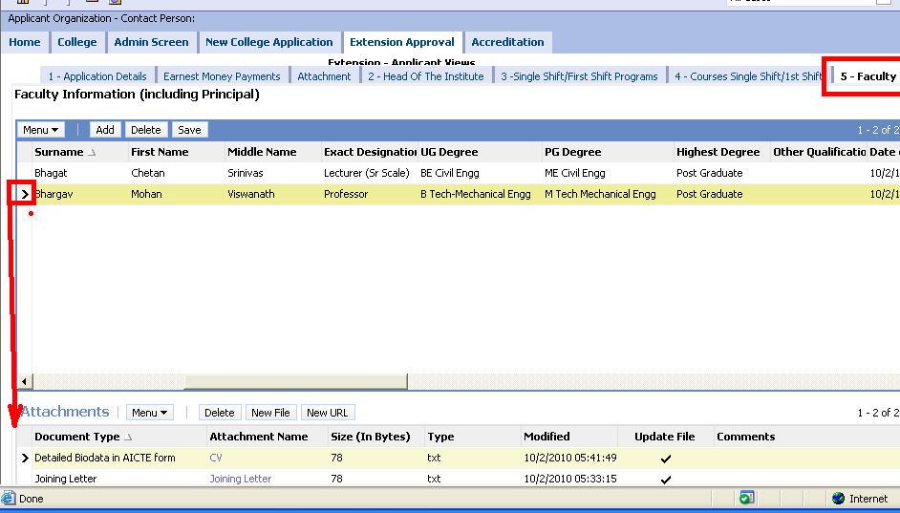

Similarly fill in the details related to other tabs shown in the above screenshot

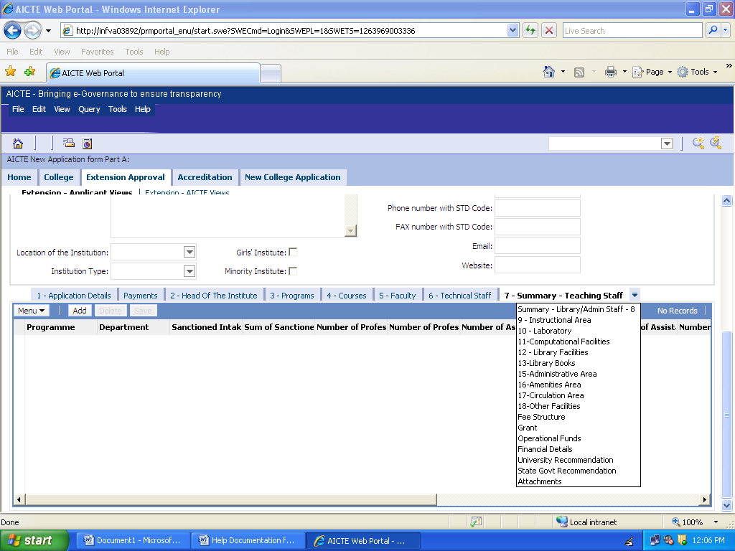

Instructions on Fee Payment modes
Instructions on Fee Payment modes for Applicants to pay to AICTE

In case you choose to pay through e-payment mode :
- A confirmation of your having read the terms and conditions towards the payment over internet would be required for you to proceed further. You may confirm the same by clicking the check box, confirming “ I hereby confirm having read the terms and conditions towards the payment over internet and I accept the same.” To view the same, please click on the link on Terms and conditions available on same page.
- You will then be redirected to ICICI Bank Payment gateway, wherein you will be required to enter the Credit/Debit Card* details before confirming the payment. The amount payable shall include fees payable to AICTE along with additional convenience fees for availing this online payment facility. (Same as of now would include a convenience fee of 2.25% of the transaction amount and a service tax of 10.30% on this convenience fee)
- On our confirming payment of this total amount, you would then be prompted to enter 3D verification details of your card for necessary validation of the card.
- Post validation of details provided, you will be redirected back to AICTE server, where in case of successful payment, your payment status would change to Payment Received.
- In case of unsuccessful payment because of invalid details provided or declining of the transaction by the card issuing bank, you may reattempt the same with corrective action at your end or chose the alternate option to pay through Pay order mode.

In case you chose to pay through Pay Order Mode :

- The screen displays the total amount for which the Pay order is to be made. Please get a Pay order issued in the name of “Member Secretary- AICTE” from a Scheduled Commercial Bank payable at the location in which you shall deposit it in the nearest ICICI Bank branch. Keep the same ready for filling in the online details on the AICTE Website. The total amount of pay order includes Base fee payable to AICTE and Rs.100/- towards bank charges.

- After you obtain the pay order, login to the payment page again & choose “payment through pay order option”.
- Input details of the Pay order in the fields provided in the form and click on Generate Pay in slip. Please refer to section 3.6.15 for detailed instructions about generating Pay in slip.

- Take a printout of this Pay in Slip and attach Pay order with the Pay in Slip.

- Walk into any at ICICI Bank Branch (http://locator.mapmyindia.com/icici/ Click to know branch location details) for depositing this Pay order along with Pay in Slip.

- Please write the application number (as printed on your Pay in Slip) on the back side of the Pay order also. The ICICI Bank branch will give back the duly stamped AICTE and Applicant copy of the Pay in Slip to you for record purposes.

- Final Payment Confirmation at AICTE end is subject to clearance of the Pay order submitted by you and confirmation of the same by ICICI Bank to AICTE.

- Re-login to the AICTE website 3-4 days after the Date of submission of Pay order at the branch to confirm your payment status. (#)

- If confirmed, the payment receipt status on the application module shall be automatically shown as ‘payment received’
* Credit Cards issued by Master or Visa and VISA Debit cards of select banks namely, ICICI Bank, HDFC Bank, State Bank of India, Axis Bank, Andhra Bank, Barclays Bank Plc, Canara Bank, City Union Bank Ltd, Corporation Bank, Deutsche Bank AG, GE Money Financial Services Ltd, Indian Overseas Bank, Kotak Bank - Virtual card, Standard Chartered Bank, Syndicate Bank, The Federal Bank Ltd & The Karur Vysya Bank Ltd as of now.

# Updation of payment status in case of payment through Pay order may take some time as same is subject to realisation of actual funds into AICTE account.

Application | Payments | Payment on portal
The applicant fills in application for approval of 'New Institution / Integrated Campus / New Institution with Foreign Collboration' on AICTE web portal. | The applicant to pay processing fee (100,000/- or 80,000/-**) before submitting online application(Part A) using ePayment or Pay Order | "Payments " tab in "New College" screen
The applicant has already Pending application with AICTE for approval of 'New Institution / Integrated Campus' | The applicant submit an online application using AICTE Web Portal  The applicant checks 'Pending Application' flag and provide 'Application Ref #' for the pending application in the online form  Applicant attaches scanned receipt of the earlier payment(s) for the pending application  The applicant shall pay 'Rs 10,000/-' using ePayment or Pay Order (This amount shall be adjusted while calculating total processing applicable case by case during Scrutiny Committee meeting) | "Payments " tab in "New College" screen
The applicant fills in an application for Extension/addition of Intake/Closure/ PIO/NRI approval on AICTE web portal | The applicant fills online application form in section "Application Details"  The applicant pays Rs. 10,000/- as an EMD (Earnest Money Deposit) using ePayment or Pay Order , (This amount shall be deducted from total Processing Fee as under)  Upon successful payment of EMD remaining sections of the online application shall be editable for the applicant. | "Earnest Money Payments" tab in "Extension Approval" screen
 | The processing fee amount shall be calculated based on the type of application the applicant chooses to apply for (i.e. Extension, Closure, Addition of Intake, Addition of NRI/PIO Seats)  The applicant pays the Processing Fee using ePayment or Pay Order. | "Processing Fee Payments" tab in "Extension Approval" screen

Print Pay-In Slips
(Pay-In Slips to be printed when payment is made by Pay Order)
The detail process to generate a Pay-In slip is as given below.
- Select Pay In Slip from the dropdown.
- Enter Login & Password details.
- Go to appropriate process screen, eg. Extension Approval Screen.
- Go to Payments Tab.
- Fill in Payment related details.
- Click on Reports icon.

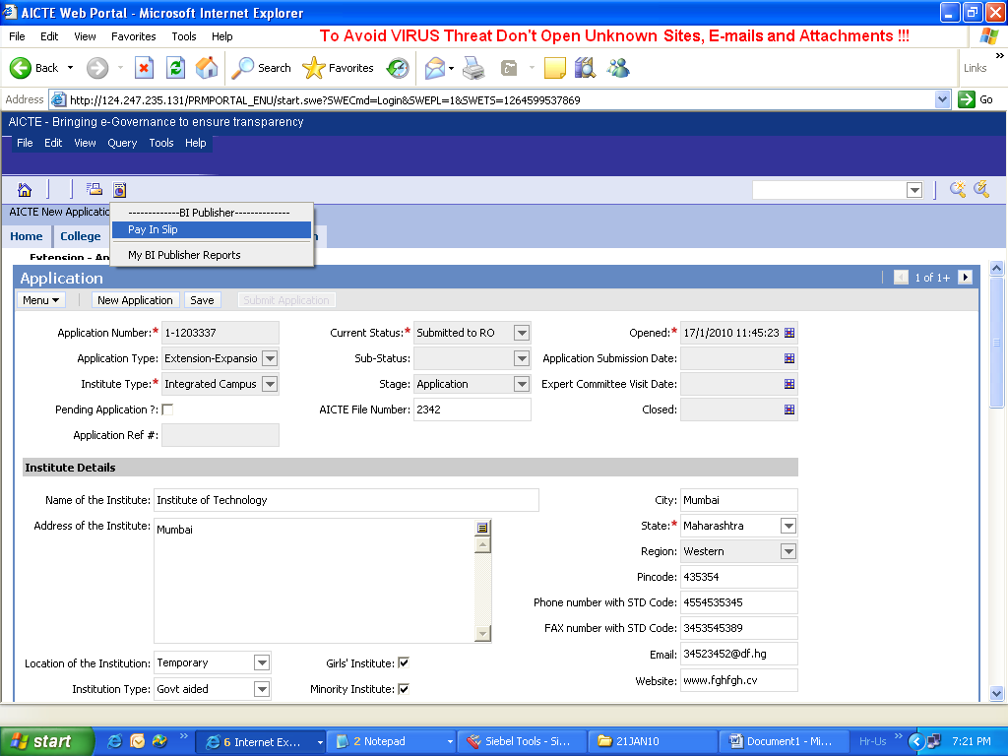

- A Small Pop-up window appears.
- Select Pdf from the dropdown for column ‘Picklist values’.
- Click on 'Submit' button. (Note: Sometimes, the popup does not display the submit button. In that case expand pop-up window until the submit button is visible)

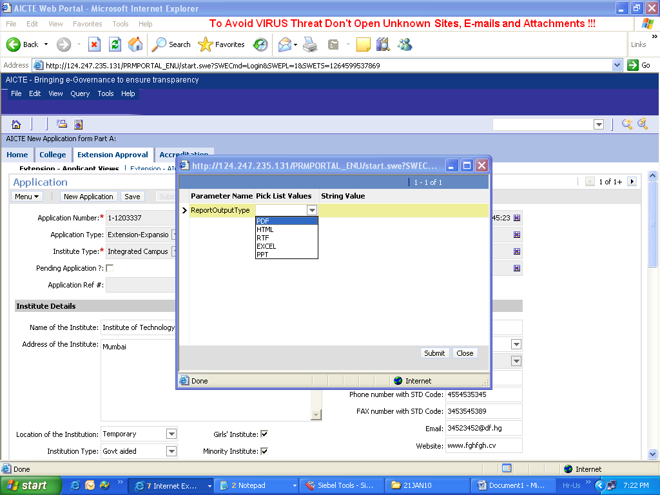

- A file download window appears, asking you to ‘Open / save on download’.
- Click on ‘Open’, this is where Pay in Slip opens up.
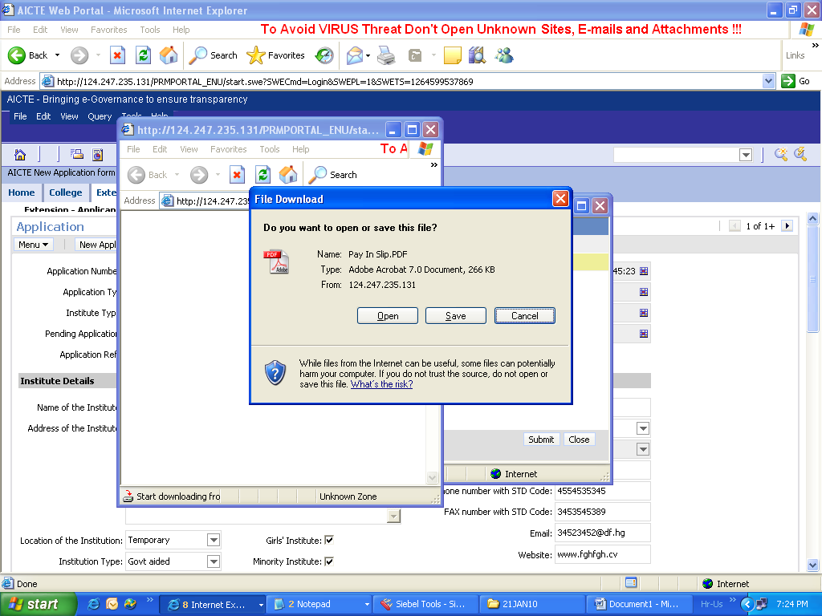

- Print the pay in slip
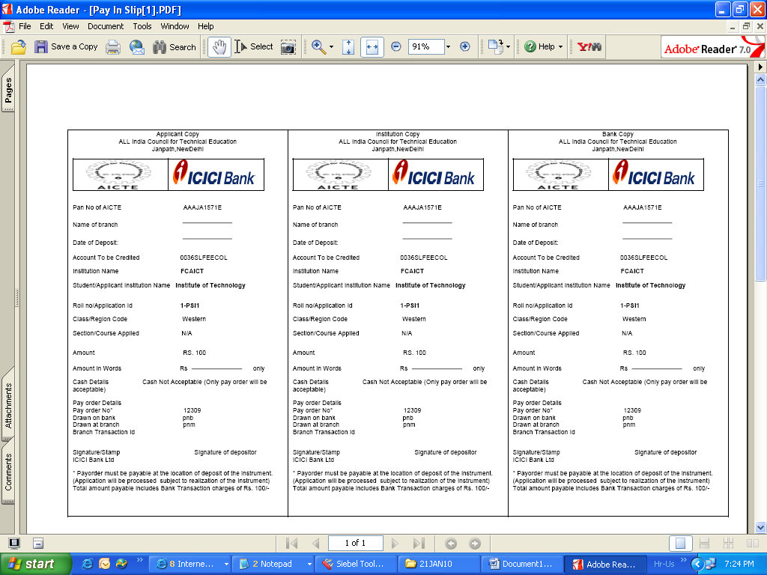
- Sometimes, you might find that in step 11, when you click on ‘Open’ or ‘Save’, the pay in slip doesn’t get displayed and the smalled windows, that had popped up do not respond. In such cases, the user is required to close these pop-up windows in the system. (Pls do not close the main application window)
- Go to reports and click “My BI Publisher Reports” as given below.
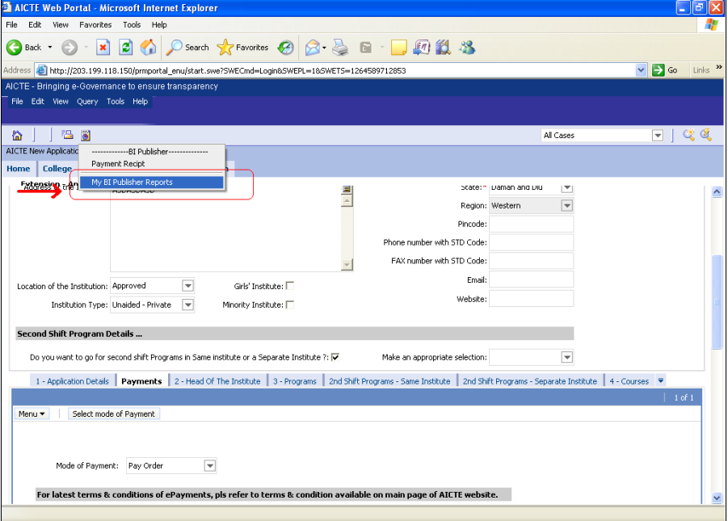
- Click on the “Payment Receipt” link and you will be able to download the Pay in Slip.
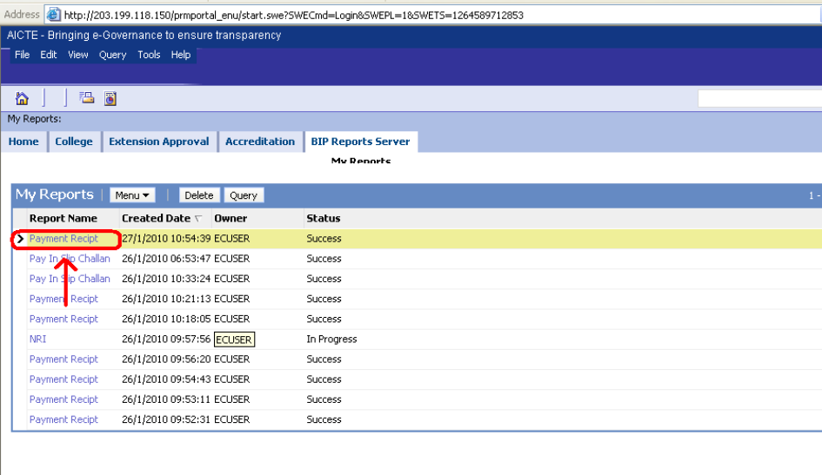
- Print the same

