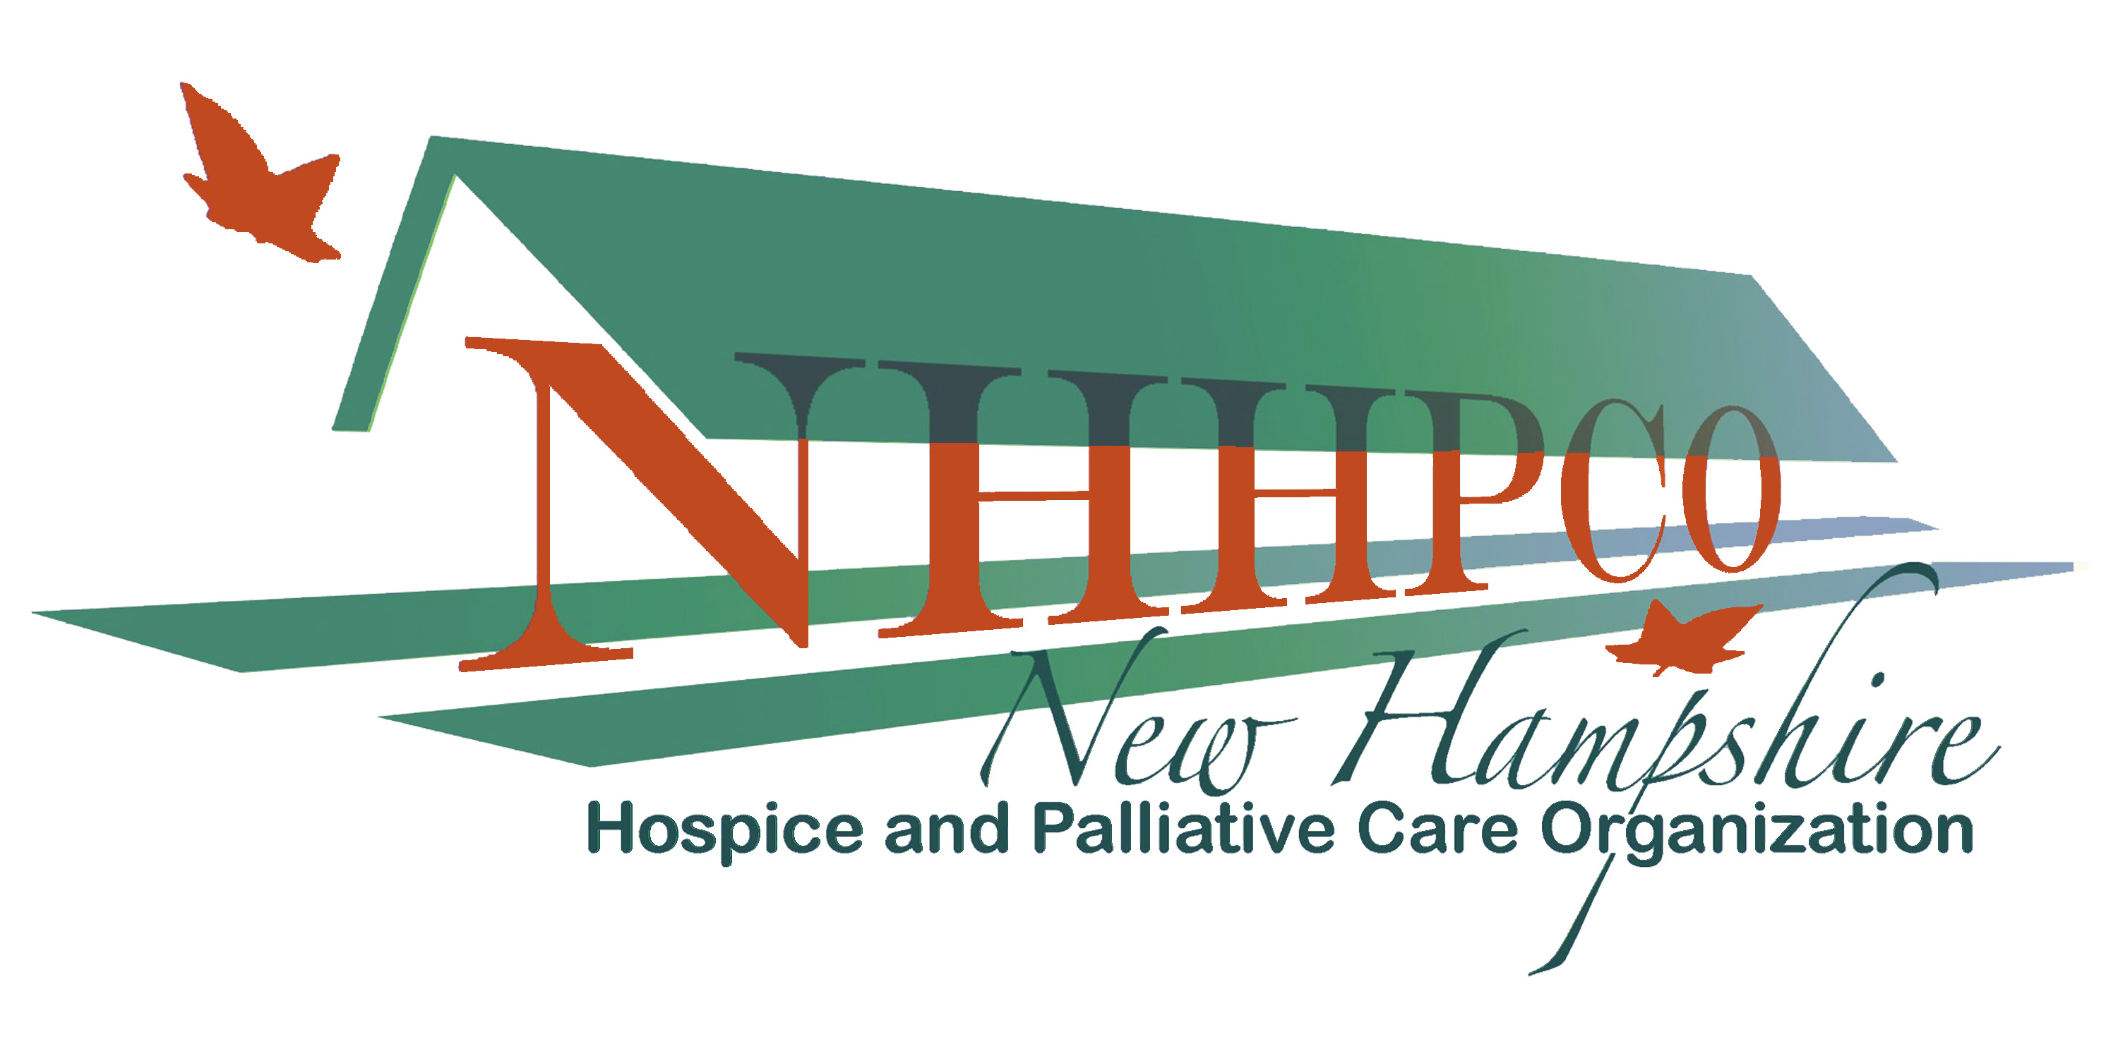 | 125 Airport Road  Concord NH 03301  Phone: 603-415-4298 Fax: 603-672-4409  www.nhhpco.org

Opioid Use Guidelines Pocket Card Orders
Top of Form

COST
$ 6.00 ea | 1 to 4 cards | • shipping included if sent within the USA  **You will be notified of order receipt and shipment
$ 5.00 ea | 5 to 24 cards
$ 4.00 ea | bulk orders (25 or more)

Please send order form and payment to:

NHHPCO, 125 Airport Road, Concord, NH 03301 or
fax with credit card information to 603 672 4409.

Please include:
Name:
Title
Organization
Full Mailing Address:
Email Address:
Phone:

Number of cards requested:___________

Payment:
__ Check __ Credit Card (Circle one): MC VISA Discover

Credit Card Number: ________________________________

Card Expiration Date: ________________________________

Card Holder’s Signature: _____________________________
Thank you.
Bottom of Form

