Created in the cloud with Aspose.Words for Cloud. http://www.aspose.com/products/words/cloud

Donate Now
Published Date : September 28, 2014
Author : pwilson

Ways to Give:

1. Online
You can donate online securely below. Our payments are processed via Paypal. Once completing the form below, you will be led to Paypal’s website to complete the donation. Note, you do not need a Paypal account to donate (you can pay by credit card through Paypal).

2. By mail
Print out the form below, fill out and mail in to Martyrs’ Shrine using the contact information found here.
Mail-in Donation Form

Tax-Deductible
An outright gift of cash and/or property to the Martyrs’ Shrine entitles you to a charitable tax receipt. As an Ontario resident the tax credit for charitable donations will apply up to approximately 46% of your giving. Please remember that there are many ways to use your tax credit to benefit you as they can be joined together ( families ), used over five years and there are many ways to “double dip” using the other giving methods listed on this site.

Donate Online
Fill out the form below to donate securely online (donation processed via Paypal)

JavaScript is not enabled. You must enable JavaScript to use this form.

Donation Information
I would like to make a donation in the amount of:
$500 $100 $50 Other

I would like this donation to automatically repeat each month

Tribute Gift
Check here to donate in honor or memory of someone

Donor Information
First Name:
Last Name:
Email:
Please do not display my name publicly. I would like to remain anonymous
Add me to your mailing list
Phone:
Employer:
Check here if your employer matches donations

Donor Address
Address:
Address 2: (optional)
City:

Province:
Country:
Postal Code:

Other Ways to Give
Bequests and Gifts by Will
A bequest in a will to the Martyrs’ Shrine is a deferred gift and is an acknowledgment of your returning to God a portion of the gifts He has bestowed on you during your lifetime. Bequests will have a significant favourable impact on your over all estate plan and the gifts you make to your loved ones. Everyone can make a bequest, this type of gift is not just for the “wealthy”. Most people do not know that a bequest is the one gift where your estate gets a tax credit for 100% of the gift. You can support the Shrine without affecting your loved one’s inheritance.
The Archdiocese of Toronto maintains a list of public Advisors who are available to assist in your Estate Planning and the making of a Will.
You can also contact the Law Society of Upper Canada’s lawyer referral service at www.Isuc.on.ca/public/a/finding/Irs/ or 1-900-565-4577 ( the service costs $6).
For more information please contact The Martyrs’ Shrine office at 705-526-3788.
All calls are confidential.
This information provided is general in nature, does not constitute legal or financial advice, and should not be relied upon as a substitute for professional advice. We strongly encourage you to seek professional legal, estate planning and/or financial advice before deciding upon your course of action.
Gifts of Listed Securities
A gift of shares of a publicly traded company to the Shrine can have several financial benefits including opportunities of substantially reducing personal income taxes.
Donating publicly traded securities (stocks and mutual funds ) that have appreciated in price can be very advantageous. When you donate to the Martyrs’ Shrine, there is no capital gains tax on any gains from the sale of these securities. You have the double advantage of receiving a much larger tax credit and the amount of the donation is larger because the amount that would have otherwise been payable to the Government for taxes is donated to the Martyrs’ Shrine.
Please download and print the Donations of Securities Form.
Donation of Securities Form
For more information please contact your securities advisor and The Martyrs’ Shrine office at 705-526-3788.
All calls are confidential.
This information provided is general in nature, does not constitute legal or financial advice, and should not be relied upon as a substitute for professional advice. We strongly encourage you to seek professional legal, estate planning and/or financial advice before deciding upon your course of action.
Life Insurance
Life insurance can be a useful and very low-cost way of making a gift to the Martyrs’ Shrine.
The premiums you pay (in the case of a donated policy) are eligible for a charitable income tax credit each year. It often makes a larger gift affordable and proceeds are paid promptly from the insurance company to the Martyrs’ Shrine and not reduced by taxes or fees from an estate.
For more information please contact the Martyrs’ Shrine office at 705-526-3788.
All calls are confidential.
This information provided is general in nature, does not constitute legal or financial advice, and should not be relied upon as a substitute for professional advice. We strongly encourage you to seek professional legal, estate planning and/or financial advice before deciding upon your course of action.
Gifts of Retirement Plan Accumulation
RRSP’s have proven to be extremely popular over the past 20 years or so. In simple terms, individuals can contribute yearly income to an RRSP and will receive a tax refund based upon their individual tax rate and the amount contributed to the plan.
All income earned within an RRSP (dividends, interest, capital gains, etc.) are not subject to tax and individuals expect these funds to grown and provide an important supplement to retirement pensions, Canada Pension Plan, Old Age Security, etc. At age 71, RRSPs must be converted (or “rolled over”) to a Registered Retirement Income Fund (RRIF).
You can also have your minimum withdrawals from your RRIF come directly to the Martyrs’ Shrine which will be tax free and you are also eligible for a charitable income tax credit each year.
For more information please contact your Financial Advisor and The Martyrs’ Shrine office at 705-526-3788.
All calls are confidential.
This information provided is general in nature, does not constitute legal or financial advice, and should not be relied upon as a substitute for professional advice. We strongly encourage you to seek professional legal, estate planning and/or financial advice before deciding upon your course of action.
Endowments
An endowment is a gift that lasts. The original capital of the gift/Endowment Fund is preserved in a secure investment. The income is used for the Martyrs’ Shrine. The Endowment Fund can consist of cash, securities, paid-up life insurance policies as well as personal and real property. Contributions to an Endowment Fund can have significant income tax advantages. Donors contributing an Endowment of $10,000 or more can have their name attached to the Fund.
For more information please contact The Martyrs’ Shrine office at 705-526-3788.
All calls are confidential.
This information provided is general in nature, does not constitute legal or financial advice, and should not be relied upon as a substitute for professional advice. We strongly encourage you to seek professional legal, estate planning and/or financial advice before deciding upon your course of action.
Gifts of Personal Property and Real Estate
Gifts of personal property be made in various ways: outright, residual interest or to fund a charitable remainder trust. Gifts “In Kind” can be as simple as small collections (stamps and coins) or items of larger value like art, musical instruments and real estate.
For more information please contact The Martyrs’ Shrine office at 705-526-3788.
All calls are confidential.
This information provided is general in nature, does not constitute legal or financial advice, and should not be relied upon as a substitute for professional advice. We strongly encourage you to seek professional legal, estate planning and/or financial advice before deciding upon your course of action.
Find a Financial, Legal or Estate Advisor
Find a CFP Professional
Find Legal or Estate advice

Employment Opportunities
Published Date : July 9, 2015
Author : pwilson

2017 SEASON EMPLOYMENT OPPORTUNITIES
Martyrs’ Shrine has the following 2017 seasonal employment opportunities available:
Note: The start date and end date are tentative dates.
Position (Click for Job Description) | Vacancies | Hours | Start Date | End Date
Pastoral Animator | 1 | 37.5 | APR 17 | OCT 20

All other 2017 seasonal employment opportunities have closed.
Evening, weekend and holiday hours will apply to all positions. All applicants are required to provide a cover letter and a resume.
If you have any questions regarding any seasonal position, please contact Mr. Koustov Panda at 705-526-3788 Ext 223 or jobs@martyrs-shrine.com
Interested applicants are invited to apply for more than one (1) position and should submit a resume and cover letter for each position for which they wish to apply.

Martyrs’ Shrine
Attention: Human Resources
P.O. Box 7, 16163 Hwy 12 West
Midland, ON L4R 4K6
E-mail: jobs@martyrs-shrine.com
Fax: 705-526-1546
Only those applicants selected for an interview will be contacted.
We thank all applicants for their interest, however, only those selected for an interview will be contacted. In accordance with the Freedom of Information and Protection of Privacy Act, personal information collected will only be used for candidate selection. Martyrs’ Shrine will accommodate materials or processes required based on the individual’s needs upon request in accordance with the Ontarians with Disabilities Act. Martyrs’ Shrine is an equal opportunity employer.

Events Calendar
Published Date : October 4, 2014
Author : pwilson
- All
- Cultural Pilgrimages
- School Programming
- Special Events
- Tiawenk

First Light Landing
Published Date : November 4, 2016
Author : alaurin

Rates and dates
Evenings 5:30 p.m. – 9:00 p.m.
November 24-26, December 1-3 & 8-10, 2016
Admission $10.00 per person. A donation of a non-perishable food item for the local food bank is appreciated.
Please be advised that with the exception of service animals, pets are not allowed on the historic site for this event.

Parking
Please note that parking is PROHIBITED at Martyrs’ Shrine during the First Light event.
Designated parking lots will be serviced by shuttle bus at the following locations:

Midland Walmart
Multiple shuttle buses will be running between the Midland Walmart, Sainte-Marie among the Hurons and Martyrs’ Shrine. This shuttle runs from 4:30 PM to 9:30 PM. Please plan accordingly.

Downtown Midland
The Town of Midland has graciously facilitated a partnership between First Light and the Downtown Midland BIA by providing the event with a shuttle service to and from the downtown core. Local businesses will have extended hours on the nights of First Light.

About First Light
Now in its 17th year, Sainte-Marie among the Hurons’s “First Light” is a must-see FEO top 100 event with a great line-up of family activities and performers, all amidst the spectacular glow of over 5,000 candles.

First Light Extension
Martyrs’ Shrine is excited to be joining Sainte-Marie among the Hurons for their annual festival and extend the scenery programming to our property. Continue your experience by following the candle-lit path to Martyrs’ Shrine for Native Story telling, multi-cultural Christmas displays, photos with St Nicholas, and take in the spectacular production of a live Nativity scene in our Christmas Courtyard.

Packages
Illuminating History!
For only $159 Stay, Dine and Experience First Light!
The renowned “First Light” event at Sainte-Marie among the Hurons heads into its 17th year in 2016 with an extended schedule of dates that will see the historic site aglow with over 5,000 candles. In addition to November 24th, 26th and 27th, December 1st, 2nd and 3rd the dates of December 8th, 9th and 10th have been added. Also new for 2016 is an impressive historic program provided by our partner. Martyrs’ Shrine, as well the spectacular fireworks display will return this year.
The package includes:
• 1 night accommodation (Double Occupancy)at the Comfort Inn, Midland
• A $50 Dining Voucher (valid at participating restaurants during the First Light weekends)*
• Admission for 2 to First Light Event
• Welcome Package with Lantern/Swag in Hotel Room valued at $10
To make reservations for this package
Call 705-526-2090
Comfortinnmidland.com
Comfort Inn Midland, 980 King Street, Midland Ontario L4R 4K3
*Participating restaurants include: Lot102, The Boathouse Eatery, Mom’s Restaurant, Explorer’s Café, and Restaurant Sainte-Marie.

Funding provided by the Government of Ontario.

Home
Published Date : October 28, 2014
Author : pwilson
- About the Shrine
- Visit Us
- Spiritual Activities
- Support Us
What is Martyrs’ Shrine?
The Martyrs’ Shrine is the National Shrine to the Canadian Martyrs. This holy and historic site honours the eight Jesuit Saints who lived, worked, and died here over 350 years ago.
- The Story of the Shrine
- The Story of the Martyrs
- The Shrine Archives
- Our Location

There’s plenty to do at the Shrine!
Take a tour, explore the beautiful gardens, or visit the relics: there’s always something for everyone at Martyrs’ Shrine.
- Dates, Hours and Rates
- Guided Tours
- The Pilgrim Route
- Gift Shop
- Martys’ Hall Museum and Education Centre
- Programs

Grow deeper in your faith at the Shrine
Served by the Jesuits, there is always something spiritual to participate in at Martyrs’ Shrine – even from home!
- Mass Schedule and Daily Life
- Cultural Pilgrimages
- Light a Candle

We need your support!
It is only with the generous support of donors that Martyrs’ Shrine is able to exist. Consider giving today.
- Make a Donation
- Development and Fundraising Projects

India and Pakistan Pilgrimage Photos
Published Date : July 20, 2015
Author : jadams

Join the Jesuit Pilgrimage to World Youth Day 2016!
Published Date : July 23, 2015
Author : pwilson
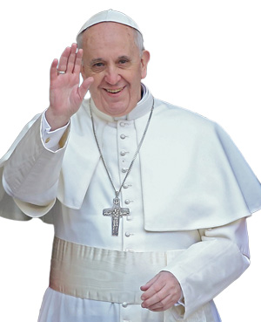

WYD 2016!
Martyrs’ Shrine is pleased to promote the Jesuit Pilgrimage to World Youth Day in Krakow, Poland, being organized by the Jesuits in English Canada.
The trip is open to youth aged 18-35 years old, and will include a pilgrimage through Polish destinations before the WYD events.
In the spirit of a true Jesuit pilgrimage, the accommodations will be basic, but will also provide an opportunity to grow in faith. You’ll also have the opportunity to form friendships with other like-minded youth, and see historic and enriching spiritual landmarks throughout Poland.
For more information, check out the information below:
Download Brochure

Download Printable Poster

Download Registration Form

Light a Virtual Prayer Candle
Published Date : July 13, 2015
Author : pwilson
No matter where you are in the world, you can join our faith community at Martyrs’ Shrine by lighting a virtual candle.
The candle you light isn’t just virtual – a large candle is lit in the Shrine itself to commemorate all the virtual candles lit here. During the off-season, there is a candle lit in the Jesuit chapel with the relics of the martyrs.
A minimum donation of $5 is requested to light a candle. It will be processed through Paypal. Once complete, you will be re-directed to a page on our website where you can light your candle.
Martyrs’ Shrine relies on contributions, and by lighting your candle here, you help contribute to the operation and upkeep of the Shrine.
Thank you for you support.

Light Your Candle

Donations processed through Paypal.
Amount: CAD


Martyrs' Shrine Message
Published Date : September 14, 2016
Author : alaurin

Download your 2016 Summer Edition of the Martyrs’ Shrine Message.
Download Matyrs’ Shrine Message

Ways to Give:

1. Online
You can donate online securely below. Our payments are processed via Paypal. Once completing the form below, you will be led to Paypal’s website to complete the donation. Note, you do not need a Paypal account to donate (you can pay by credit card through Paypal).

2. By mail
Print out the form below, fill out and mail in to Martyrs’ Shrine using the contact information found here.
Mail-in Donation Form

Tax-Deductible
An outright gift of cash and/or property to the Martyrs’ Shrine entitles you to a charitable tax receipt. As an Ontario resident the tax credit for charitable donations will apply up to approximately 46% of your giving. Please remember that there are many ways to use your tax credit to benefit you as they can be joined together ( families ), used over five years and there are many ways to “double dip” using the other giving methods listed on this site.

Donate Online
Fill out the form below to donate securely online (donation processed via Paypal)

JavaScript is not enabled. You must enable JavaScript to use this form.

Donation Information
I would like to make a donation in the amount of:
$500 $100 $50 Other

I would like this donation to automatically repeat each month

Tribute Gift
Check here to donate in honor or memory of someone

Donor Information
First Name:
Last Name:
Email:
Please do not display my name publicly. I would like to remain anonymous
Add me to your mailing list
Phone:
Employer:
Check here if your employer matches donations

Donor Address
Address:
Address 2: (optional)
City:

Province:
Country:
Postal Code:

Other Ways to Give
Bequests and Gifts by Will
A bequest in a will to the Martyrs’ Shrine is a deferred gift and is an acknowledgment of your returning to God a portion of the gifts He has bestowed on you during your lifetime. Bequests will have a significant favourable impact on your over all estate plan and the gifts you make to your loved ones. Everyone can make a bequest, this type of gift is not just for the “wealthy”. Most people do not know that a bequest is the one gift where your estate gets a tax credit for 100% of the gift. You can support the Shrine without affecting your loved one’s inheritance.
The Archdiocese of Toronto maintains a list of public Advisors who are available to assist in your Estate Planning and the making of a Will.
You can also contact the Law Society of Upper Canada’s lawyer referral service at www.Isuc.on.ca/public/a/finding/Irs/ or 1-900-565-4577 ( the service costs $6).
For more information please contact The Martyrs’ Shrine office at 705-526-3788.
All calls are confidential.
This information provided is general in nature, does not constitute legal or financial advice, and should not be relied upon as a substitute for professional advice. We strongly encourage you to seek professional legal, estate planning and/or financial advice before deciding upon your course of action.
Gifts of Listed Securities
A gift of shares of a publicly traded company to the Shrine can have several financial benefits including opportunities of substantially reducing personal income taxes.
Donating publicly traded securities (stocks and mutual funds ) that have appreciated in price can be very advantageous. When you donate to the Martyrs’ Shrine, there is no capital gains tax on any gains from the sale of these securities. You have the double advantage of receiving a much larger tax credit and the amount of the donation is larger because the amount that would have otherwise been payable to the Government for taxes is donated to the Martyrs’ Shrine.
Please download and print the Donations of Securities Form.
Donation of Securities Form
For more information please contact your securities advisor and The Martyrs’ Shrine office at 705-526-3788.
All calls are confidential.
This information provided is general in nature, does not constitute legal or financial advice, and should not be relied upon as a substitute for professional advice. We strongly encourage you to seek professional legal, estate planning and/or financial advice before deciding upon your course of action.
Life Insurance
Life insurance can be a useful and very low-cost way of making a gift to the Martyrs’ Shrine.
The premiums you pay (in the case of a donated policy) are eligible for a charitable income tax credit each year. It often makes a larger gift affordable and proceeds are paid promptly from the insurance company to the Martyrs’ Shrine and not reduced by taxes or fees from an estate.
For more information please contact the Martyrs’ Shrine office at 705-526-3788.
All calls are confidential.
This information provided is general in nature, does not constitute legal or financial advice, and should not be relied upon as a substitute for professional advice. We strongly encourage you to seek professional legal, estate planning and/or financial advice before deciding upon your course of action.
Gifts of Retirement Plan Accumulation
RRSP’s have proven to be extremely popular over the past 20 years or so. In simple terms, individuals can contribute yearly income to an RRSP and will receive a tax refund based upon their individual tax rate and the amount contributed to the plan.
All income earned within an RRSP (dividends, interest, capital gains, etc.) are not subject to tax and individuals expect these funds to grown and provide an important supplement to retirement pensions, Canada Pension Plan, Old Age Security, etc. At age 71, RRSPs must be converted (or “rolled over”) to a Registered Retirement Income Fund (RRIF).
You can also have your minimum withdrawals from your RRIF come directly to the Martyrs’ Shrine which will be tax free and you are also eligible for a charitable income tax credit each year.
For more information please contact your Financial Advisor and The Martyrs’ Shrine office at 705-526-3788.
All calls are confidential.
This information provided is general in nature, does not constitute legal or financial advice, and should not be relied upon as a substitute for professional advice. We strongly encourage you to seek professional legal, estate planning and/or financial advice before deciding upon your course of action.
Endowments
An endowment is a gift that lasts. The original capital of the gift/Endowment Fund is preserved in a secure investment. The income is used for the Martyrs’ Shrine. The Endowment Fund can consist of cash, securities, paid-up life insurance policies as well as personal and real property. Contributions to an Endowment Fund can have significant income tax advantages. Donors contributing an Endowment of $10,000 or more can have their name attached to the Fund.
For more information please contact The Martyrs’ Shrine office at 705-526-3788.
All calls are confidential.
This information provided is general in nature, does not constitute legal or financial advice, and should not be relied upon as a substitute for professional advice. We strongly encourage you to seek professional legal, estate planning and/or financial advice before deciding upon your course of action.
Gifts of Personal Property and Real Estate
Gifts of personal property be made in various ways: outright, residual interest or to fund a charitable remainder trust. Gifts “In Kind” can be as simple as small collections (stamps and coins) or items of larger value like art, musical instruments and real estate.
For more information please contact The Martyrs’ Shrine office at 705-526-3788.
All calls are confidential.
This information provided is general in nature, does not constitute legal or financial advice, and should not be relied upon as a substitute for professional advice. We strongly encourage you to seek professional legal, estate planning and/or financial advice before deciding upon your course of action.
Find a Financial, Legal or Estate Advisor
Find a CFP Professional
Find Legal or Estate advice

Meet Our Staff
Published Date : April 12, 2016
Author : bird
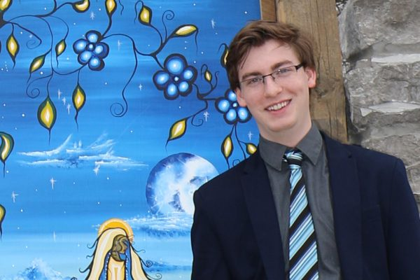

Allex Laurin
Marketing and Communications Coordinator
705-526-3788 x237
Allex joins us with a diversified skillset in tourism, events, and marketing. He previously has operated his own communications business and worked for the Town of Penetanguishene to coordinate…
×

Team Members

Allex Laurin
Marketing and Communications Coordinator
705-526-3788 x237
Allex joins us with a diversified skillset in tourism, events, and marketing. He previously has operated his own communications business and worked for the Town of Penetanguishene to coordinate the commemorative Rendez-Vous Champlain festival. Allex also sits on the board of directors for our local tourism marketing organization, the Heart of Georgian Bay.
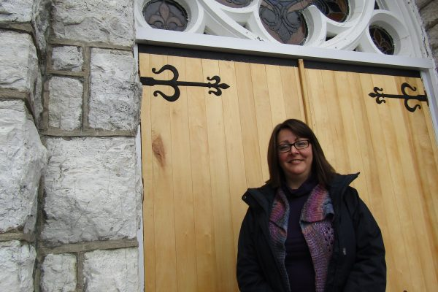

Angela Kruger
Executive Assistant
705-526-3788 x221
Angela Kruger is the Executive Assistant to the Director of Martyr’s Shrine. Angela has two College diplomas, training in non-profit finance and many years’ experience in private, municipal and…
×

Team Members

Angela Kruger
Executive Assistant
705-526-3788 x221
Angela Kruger is the Executive Assistant to the Director of Martyr’s Shrine. Angela has two College diplomas, training in non-profit finance and many years’ experience in private, municipal and non-profit settings. Her practical experience includes bookkeeping, financial reporting, fundraising and providing tax receipts for donations. Angela is an active volunteer in the Township of Tay, currently sitting on the Tay Shore Trail Committee and prior to that serving as the Treasurer for the Waubaushene Parks and Recreation Committee. Angela is also involved in the fundraising and organizing of special events for Tay Station No. 1 Fire hall in Waubaushene.


Debra Peach
ShopKeeper
Debra Peach “Debs” is the ShopKeeper at the Martyrs Shrine Gift Shop. Debs started working at The Martyrs Shrine as a volunteer in 2011 and took on the role…
×

Team Members

Debra Peach
ShopKeeper
Debra Peach “Debs” is the ShopKeeper at the Martyrs Shrine Gift Shop. Debs started working at The Martyrs Shrine as a volunteer in 2011 and took on the role of ShopKeeper in 2012. Originally from the South of England, she emigrated to Canada in 2007 with her husband and young daughter. In her spare time she co-created and ran a youth club for the children of Waubaushene, her interests include architecture and interior design.

Fr Patrick Coldricks
jesuit FatherIm a late vocation to the Jesuit Society, after working for 8 years in India & in the Middle East. I was restless all my life when i was…
×

Team Members

Fr Patrick Coldricks
jesuit Father
Im a late vocation to the Jesuit Society, after working for 8 years in India & in the Middle East. I was restless all my life when i was in college & all through my working years till i found my place in life as a Jesuit Priest, called to Love & Serve in the footsteps of my Master to bring the Kingdom of Heaven through the Society of Jesus.
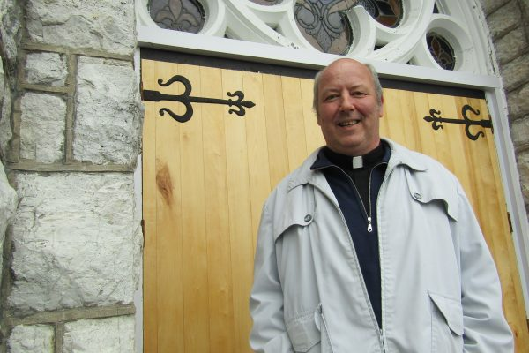

Fr. Jim Kelly, SJ
Jesuit FatherFather Jim Kelly, s.j. returned to the Shrine in 2015 after ten years living on Manitoulin Island as pastor of four small parishes. His experience with the Anishnaabek communities…
×

Team Members

Fr. Jim Kelly, SJ
Jesuit Father
Father Jim Kelly, s.j. returned to the Shrine in 2015 after ten years living on Manitoulin Island as pastor of four small parishes. His experience with the Anishnaabek communities at the northern end of Georgian Bay helped form his perspective of Martyrs’ Shrine as a place of faith at the southern edge of that same water.
In some ways, Father Jim grew up in the shadow of the Canadian Martyrs. Born in Barrie, Ontario, he is one of only two Jesuits who were born in what we call Huronia. As a student at the University of Guelph he joined in pilgrimages to the Shrine led by University Chaplain Father Ed Merchant, a former director of the Shrine, and who always mentioned the Martyrs in the Eucharistic Prayer at Mass. During his university days Father Jim was also discerning his own vocation, and asked the intercession of each of the martyrs, by name.
As a Jesuit, working in media production, pastoral care, and health care administration, Father Jim was deeply attracted to the place of the Canadian Martyrs and of the Shrine as a bold proclamation of the Gospel, and as a quiet message of genuine healing.

Fr. Louis-Martin Cloutier, SJ
Jesuit FatherBorn in Moncton, NB, in 1970, but grew up in Chicoutimi, QC. He joined the Society of Jesus at the age of 26 after having obtained a baccalaureate in…
×

Team Members

Fr. Louis-Martin Cloutier, SJ
Jesuit Father
Born in Moncton, NB, in 1970, but grew up in Chicoutimi, QC. He joined the Society of Jesus at the age of 26 after having obtained a baccalaureate in theology. Then, he did his novitiate in Montreal. He then completed his studies getting a master in theology in Quebec City. After that, he worked mainly in high schools, especially at Saint-Charles-Garnier and at Jean-de-Brébeuf, doing diverse things for ten years. Two Canadians martyrs! He was ordained as a priest in 2006 and did his tertianship in the Philippines in 2012. He pronounced my last vows in 2014. The past three years, he worked at Saint-Joseph Oratory (Montreal). Another great shrine in Canada!
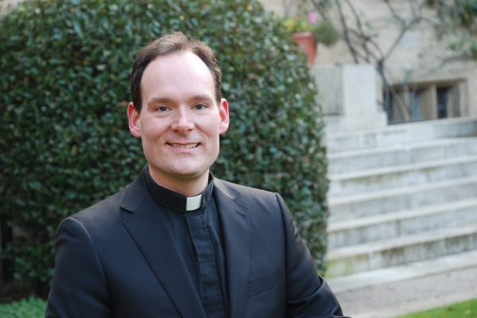

Fr. Michael Knox, SJ, D.Phil (Oxon)
Director
705-526-3788
Fr. Michael Knox, S.J. is a Roman Catholic priest in the Society of Jesus (Jesuits). After entering the order in 1997, he completed a four-year honours bachelor’s degree in…
×

Team Members

Fr. Michael Knox, SJ, D.Phil (Oxon)
Director
705-526-3788
Fr. Michael Knox, S.J. is a Roman Catholic priest in the Society of Jesus (Jesuits). After entering the order in 1997, he completed a four-year honours bachelor’s degree in history at St. Michael’s College, University of Toronto, followed by a diploma in philosophical studies. In 2006, he completed a MA thesis in history at Memorial University, Newfoundland, and Campion Hall, Oxford. Subsequently, in 2009, he completed a Baccalaureate in Sacred Theology and a Master of Divinity at Regis College, University of Toronto, followed by License in Sacred Theology and an MA in Theology at the same school. In 2015, he completed a DPhil in history at Oxford University, entitled: The Rhetoric of Martyrdom in the Jesuit Relations of New France, 1632-1650.
Over the past nineteen years of his religious formation, Fr. Michael has also been involved in a variety of ministries that include the pastoral care to youth, event management, high school education, spiritual accompaniment, seminary formation, television, preservation, lecturing in history and Jesuit spirituality, writing, administration, and Sacramental ministry. Jean de Brébeuf and his companions have always held a central place in his religious life and, over the years, he has maintained a consistent presence in Huronia working as an instructor in Jesuit history for the interpretive staff at Sainte-Marie among the Hurons, as well as serving first as a longstanding member of the Board of Trustees, and then advisor to the Provincial Superior of the Jesuits in English Canada, for the Martyrs’ Shrine. It is with great joy and thanksgiving to God that Fr. Michael takes on the directorship of the Shrine, glad to join the Canadian martyrs, their Wendat Companions, and all those trustees, staff, and friends, who labour there, in their ongoing pilgrimage to Jesus Christ.
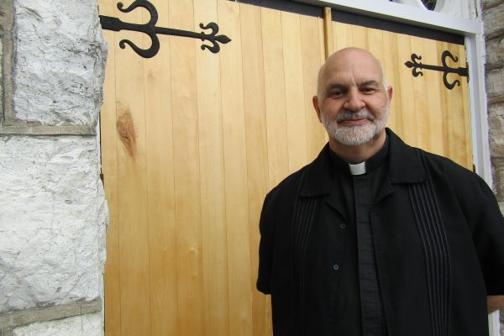

Fr. Steve Leblanc, SJ
Jesuit FatherFr Leblanc was born (and reborn, in baptism) in Halifax, Nova-Scotia. There he received education and catechists in the Catholic schools of the city; subsequently he graduated B.A. from…
×

Team Members

Fr. Steve Leblanc, SJ
Jesuit Father
Fr Leblanc was born (and reborn, in baptism) in Halifax, Nova-Scotia. There he received education and catechists in the Catholic schools of the city; subsequently he graduated B.A. from St. Mary’s University there. Very early in life, he had sensed a calling to priesthood – a calling lived out in the Society of Jesus. Study and training for this took place in Guelph, ON., Spokane, WA., St John’s, NL., Toronto, ON., and in Ireland and the U.K. Since June 1994, he has been on the staff of Martyrs’ Shrine.

Mission
Published Date : October 29, 2014
Author : pwilson

Our Mission
Lorem ipsum dolor sit amet, consectetur adipiscing elit. Nulla convallis egestas rhoncus.
Lorem ipsum dolor sit amet, consectetur adipiscing elit. Nulla convallis egestas rhoncus. Donec facilisis fermentum sem, ac viverra ante luctus vel. Lorem ipsum dolor sit amet, consectetur adipiscing elit. Nulla convallis egestas rhoncus. Donec facilisis fermentum sem, ac viverra ante luctus vel. Lorem ipsum dolor sit amet, consectetur adipiscing elit. Nulla convallis egestas rhoncus. Donec facilisis fermentum sem, ac viverra ante luctus vel.

Keynote Talks
Lorem ipsum dolor sit amet, consectetur adipiscing elit. Nulla convallis egestas rhoncus. Donec facilisis fermentum sem, ac viverra ante luctus vel.

OnStage Discussions
Lorem ipsum dolor sit amet, consectetur adipiscing elit. Nulla convallis egestas rhoncus. Donec facilisis fermentum sem, ac viverra ante luctus vel.

Mentor Session
Lorem ipsum dolor sit amet, consectetur adipiscing elit. Nulla convallis egestas rhoncus. Donec facilisis fermentum sem, ac viverra ante luctus vel.

My Account
Published Date : April 14, 2016
Author : pwilson
[woocommerce_my_account]

Pilgrimage Leaders
Published Date : February 7, 2017
Author : alaurin
Pilgrim Leader Meeting Form
* Your Name
First
Last
* Email
* Telephone
* Pilgrimage Group Name
* Preferred Date and Time
Date
HH
MM

* Type of Meeting
In Person at Martyrs' Shrine
By Telephone
Skype Meeting
Skype Username
[Submit Form]

Projects Grid
Published Date : October 29, 2014
Author : pwilson

Projects Grid with Sidebar
Published Date : October 30, 2014
Author : pwilson

Projects Listing
Published Date : October 29, 2014
Author : pwilson

School Programmes and Pilgrimages
Published Date : April 18, 2016
Author : bird
- Walk-Where-They-Walked
- A Journey of Discovery With Christ

Walk-Where-They-Walked

A Journey Towards Christ with Jean de Brébeuf and His Companions

Available: | May through October
Group Size: | Up to 100 students
Programme Fee: | $ 6.00 (Martyrs’ Shrine) + $ 6.00 (Sainte-Marie among the Hurons)
Programme Duration: | 5 to 6 hours

Walk-Where-They-Walked is a full-day pilgrimage experience developed for both grade school and high school students in the Roman Catholic separate school boards of Ontario. An interdisciplinary experience, and developed following basic principles of education outlined in the internationally recognised Jesuit programme of education (Ignatian-Pedagogical- Paradigm), pilgrims are invited to prayerfully enter into the lives St. Jean de Brébeuf and his companions so as to: (1) enrich their understanding of the Roman Catholic tradition; (2) reflect upon their personal relationship with Jesus Christ; (3) inform them on various aspects of the early modern history of Canada; and (4) provide the opportunity for ongoing physical education.

Sample Programme Schedule
10:00 AM | Arrival at Sainte-Marie Among the Hurons
10:15 AM | A specialised tour of the historic site where the Jesuit missionaries lived and worked among the Wendat people that highlights important historical elements related to: (1) the life of St. Jean de Brébeuf; (2) the story of ‘First Contact’ between the missionaries and their Wendat Companions; and (3) the daily life at Sainte-Marie.
12:00 PM | Lunch Break
12:45 PM | A prayer service at the graves of St. Jean de Brébeuf and Gabriel Lallemant (led by a Jesuit Priest), followed by a procession up to the the Martyrs’ Shrine.
1:05 PM | Film Presentation – Martyrs’ Shrine: A Home of Peace
1:30 PM | Pastoral Integration – A presentation given by a Jesuit Priest integrating aspects of the lives of the Canadian Martyrs into the pastoral reality of the Christian life today.
1:45 PM | Break-Out Discussion – Pilgrims are led, by a Spiritual Animator, in a practical activity that invites them to reflect upon what they have seen and heard during their day of pilgrimage, and to consider how the story of Jean de Brébeuf and his companions might effect their own relationships with God.
2:10 PM | Mass and Blessing with the Relics – Pilgrims have the opportunity to have a personalised Mass in the Shrine Church, and to be blessed with the relics of Jean de Brébeuf and Gabriel Lallemant.
2:40 PM | Optional Tour of the Grounds or physical education activities led by the teaching staff in attendance.

All educational groups participating in our Walk Where They Walked programme will receive an interactive compact disc containing a curriculum based lesson plan upon booking. These lessons have been developed in consultation with the five separate school boards of the Archdiocese of Toronto and the Simcoe Muskoka Catholic District School Board.
This CD contains:
- A lesson plan covering the history of Jesuits in Canada – the Huronia Missions.
- Questions to which the answers can be discovered by students by visiting the Martyrs’ Shrine church, museum and, within the video viewed by programme participants.
- Images of the Martyrs’ Shrine church and grounds.
- 17th Century Maps
- Songs written by Father Brébeuf and Jogues.
This CD is intended to be an introduction to the Martyrs’ Shrine as well as an educational classroom resource for teaching staff integrating the theme of Huronia history with Social Studies and the Fine Arts curriculum.

A JOURNEY OF DISCOVERY WITH CHRIST

Available: | February through March
Group Size: | Up to 50 students
Programme Fee: | $ 12.00
Programme Duration: | 5 to 6 hours

Taking the first steps into post secondary education is for most students filled with excitement, some apprehension, and change. It is important that they approach these milestone events rooted and grounded in a strong sense of identity, able to: (1) reflectively discern God’s desires for them; (2) to live out those desires in a loving and responsible way; and to (3) understand that each of them have been gifted with talents that together can make the divine aspirations for the world a reality.
Recognising, as the Canadian Martyrs’ did, that the more deeply one embraces the Jesus Christ, the more she/he can discover their own vocations, A Journey of Discovery with Christ is a day-long retreat programme that invites students and their teachers to set out on a journey alongside Jean de Brébeuf and his companions towards a deeper union with Jesus Christ.

Retreat Components:
- Facilitated discussions led by a Jesuit priest.
- Integrated activities led by a trained Spiritual Animator
- A Snow-Shoe procession to St. Joseph’s Church
- A Personalised fireside Mass by the graves of St. Jean de Brébeuf and Gabriel Lallemant.
A Journey of Discovery with Christ is a programme that incorporates elements of both the Spiritual Exercises of Ignatius Loyola and the Ontario Catholic School Graduation Expectations with the lives of St. Jean de Brébeuf and his companions.

To Book Your Programme Contact:
Joanne Adams
Pilgrimage Coordinator
705-526-3788
jadams@martyrs-shrine.com
If you would like to expand Walk-Where-They-Walked into an overnight directed retreat programme, please inquire about our 32-bed on-site dormitory facility.

Shop
Published Date : April 14, 2016
Author : pwilson

Spiritual Activities
Published Date : April 19, 2015
Author : pwilson
- 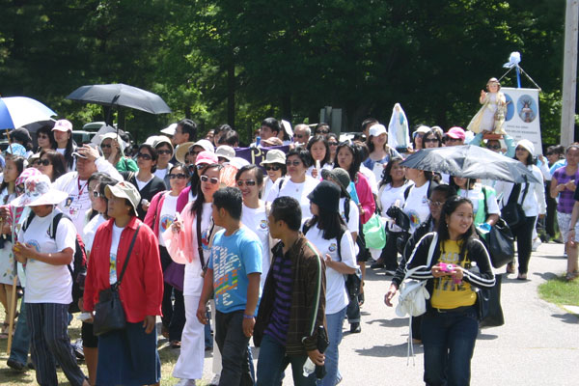Cultural Pilgrimages
- 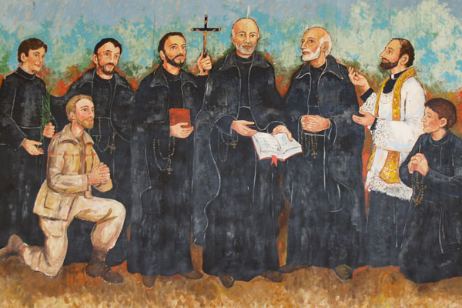Nine Days of Novena
- 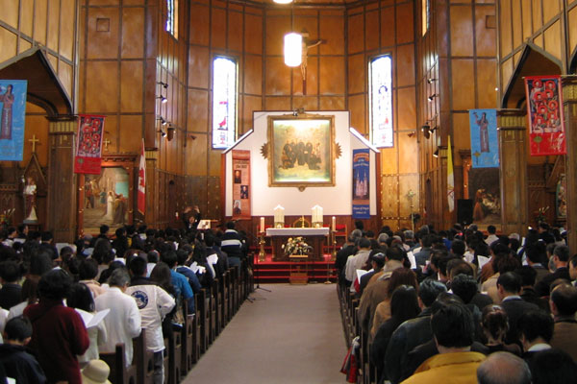Mass Schedule & Daily Life

Cultural Pilgrimages
Published Date : May 8, 2015
Author : pwilson

