Recording and describing 3-D shoulder and upper extremity movements

Coordinator: H.E.J. Veeger

Contributions from: Ali Asadi Nikooyan

This document is meant as an overview, including links and references , of measurement - and analysis methods for measuring upper extremity kinematics, with focus on shoulder motions. It is meant as open-source and additions and modifications are more than welcome. To add, or modify text, please download this file, add your changes using the “track changes” options and mail the new version to me using this link: mailto:h.e.j.veeger@tudelft.nl?subject=modifications to recording document

Last revision:
19 – 7 – 2011: addition ScoRE method
23 – 7 - 2011: addition calculation elbow flexion – extension axis
2 – 8 – 2011: update broken links, add Euler angle discussion
Contents
Introduction 3
Kinematic description theory 3
From local coordinate systems to interpretable descriptions 4
Euler angles are not joint angles 5
Calibration of the reference system: anatomical versus reference pose 5
Recording procedures 6
Recording procedures for motions of the thorax 6
Recording procedures for motions of the scapula 6
Non-invasive measurements 6
Invasive measurements, using bone pins 8
Digitizer / scapulolocator 8
Acromion cluster 8
Recording procedures for motions of the clavicle 9
Calculation of clavicle axial rotation 9
Recording procedures for motions of the humerus 9
Kinematic recordings, IHA 10
Kinematic recordings, SCORE 10
Regression equations 10
Definition of the transverse axis 11
Measurement Protocols 12
Examples of protocols 12

Introduction
The MS assumes that the reader is familiar with the ISB standardization proposal for description of the upper extremity [1] and the paper by Kontaxis et al [2] on the standardization of protocols. However, some of that information will return here, be it in a different organization format.

Although the shoulder mechanism is often loosely referred to as one single ball-and-socket joint between the trunk and the arm, the shoulder mechanism consists of three segments, namely the humerus, clavicle and scapula, that move relative to the thorax (Figure 1), with only one fixed linkage through the sternoclavicular joint. The medial border of the scapula is generally pressed against the thorax by the combined action of the m. serratus anterior, and m. rhomboideus. This connection, the so-called scapulothoracic gliding plane, turns the shoulder girdle into a closed-chain mechanism.
The complex motion constraints of the shoulder girdle result in a three-dimensional (3-D) motion pattern. As a consequence, clinical or biomechanical motion studies that include the shoulder should be performed in three dimensions and 3-D motion recordings and descriptions are necessary. In addition, the fact that scapular motions contribute to overall arm motions makes inclusion of scapular motions in recordings (and descriptions) necessary.
If, for instance for animation purposes, the shoulder is described as a generic thoracohumeral joint, its rotation centre lies well outside the glenohumeral joint. For abduction movements, the compound axis of rotation for the arm lies about 13 cm medial to the position of the glenohumeral joint in the anatomical position [3].

Kinematic description theory
To be able to describe the position and orientation (or pose) of a segment relative to the outside world, or to another segment local co-ordinate systems are necessary. Since the shape of bones and segments are different between individuals, it must be acknowledged that exactly identical reference frames for comparing motions do not exist, and that standardized definitions defined on anatomical landmarks are the best possible alternative. Bony landmarks are defined as well retrievable reference points on a bone, and are preferred above bony ridges like the scapular spine or humeral shaft. The ISB proposal gives an overview of bony landmarks used for the definition of local coordinate systems of upper extremity segments. For comparison of motions between studies, it is essential that the same bony landmarks be used, since these determine the local co-ordinate system that is being used. An overview of the landmark definitions can be found here (Table 1, Figure 1).
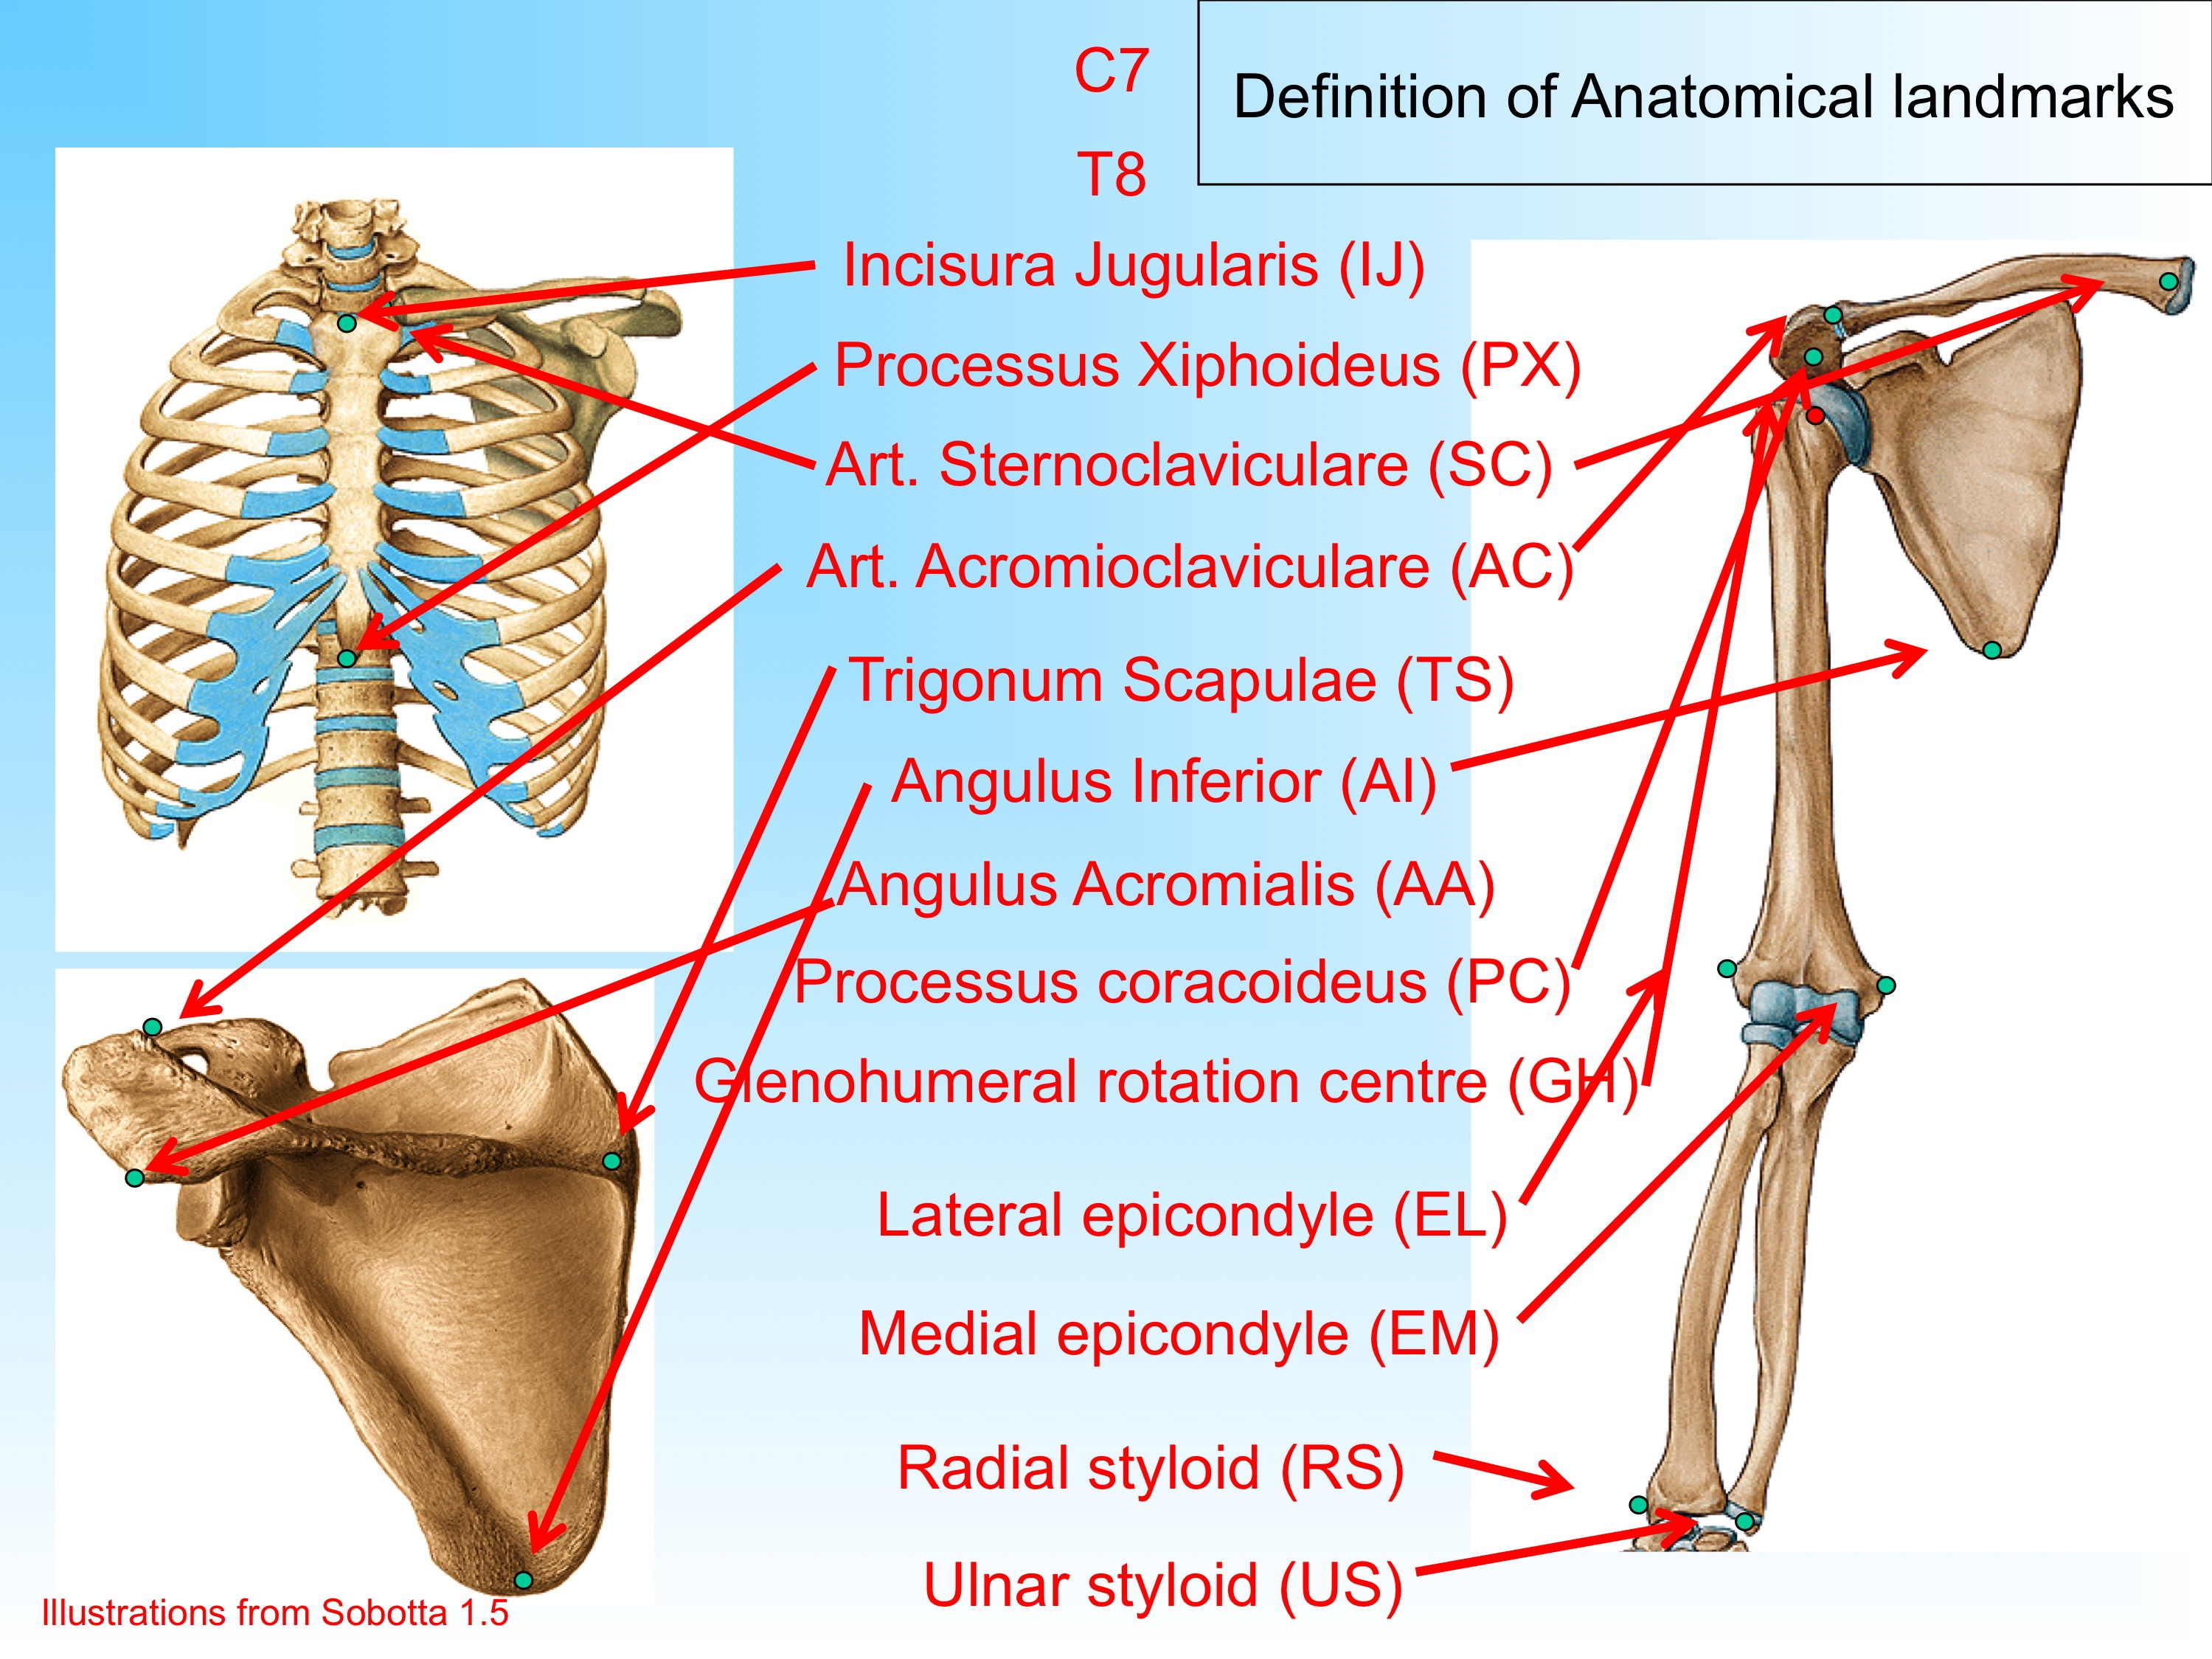
Figure 1.
Overview of anatomical landmarks
The definition of a local coordinate system based upon anatomical landmarks is a straightforward five-step routine. See this PowerPoint movie for a description of the procedure for the (right) scapula.

From local coordinate systems to interpretable descriptions
Local coordinate system pose descriptions are in fact a combination of a 3x3 orientation matrix and a position vector. The position vector defines the position of the local coordinate system origin, which can more or less be freely chosen. The orientation vector is not easy to interpret. It is therefore generally parameterized. The Euler decomposition of an orientation matrix is such a parameterization. The basic procedure consists of the calculation of the three Euler angles using elements from the orientation matrix. Which element and what order is determined by the chosen Euler decomposition. See this PowerPoint movie for a short description. The paper by Cappozzo et al [4] gives an extensive description of the theory.

Relevant links:
matlab file for the decomposition of orientation matrices (any order)

Euler angles are not joint angles
It is quite common to confuse the decomposition results resulting in Euler angles for actual joint rotations. This is incorrect for two reasons:
- Euler angles are descriptions of how one coordinate system can be outlined with a different coordinate system. This implies that the order of rotations is not fixed and, in fact, purely theoretical. The order of rotations is generally chosen based on pragmatic arguments, such as where gimbal lock occurs, or what the particular movement of interest is. The classic example of order effects for the shoulder is Codman’s paradox (Codman, 1934; see Doorenbosch et al., 2003 [check]), which states that the position as depicted in Figure 2 can be called either endo-, or exorotation, dependent on the first rotation (abduction or flexion). The publication by Karduna et al (2000) [check] gives a nice overview of the effect of decomposition orders on the calculated angles. So, in summary: Euler angles DO describe the motion of segments relative to the real world, or each other, and do that precisely, but DO NOT describe what the joint rotations were. They describe a state, or when they are presented as time-series, a series of states.
Figure 2.
Position described in Codman’s paradox: is the arm endorotated or exorotated?
- Although not specifically related to the use of Euler angles, the angles that result from the decomposition of a rotation matrix, describe the relationship between two coordinate systems. If, and only if, one or more of the axes are outlined with the joint rotation axis, or axes, (i.e. for a one- or two-degree of freedom joint), the rotations around those axes are real rotations. And more importantly, the rotations around the other axes are not decomposition effects. For example: if the elbow axis is not aligned with the transverse axis of the humerus local coordinate system, a decomposition of the elbow flexion-extension rotation matrix will result in flexion (which actually does take place), but also in abduction and axial rotation, even when these in reality do not occur… This not an error, but simply the consequence of 1. Piazza & Cavanagh (2000) [check] wrote a nice paper on this issue, using the knee screw-home mechanism as example.

So, why use Euler angles at all? The main reason for this is in my opinion the fact that when chosen well, Euler angles give an accurate description of the motion when we would try to describe this (intuitively) using the anatomical motion description system, with terms like flexion, abduction, or pronation. See also Doorenbosch et al [check] for motion description procedures focused on shoulder motion.

Calibration of the reference system: anatomical versus reference pose

Recording procedures

Technical issues
When upper extremity measurements are performed with opto-electronic systems it is almost inevitable that a large number of camera’s (Vicon) or beams (Optotrak) has to be used. For Optotrak (and almost certainly also for Vicon, or comparable systems), this may lead to unexpected and extremely annoying errors in your raw data. These errors are the result of a switch in 3D recordings from one set of beams to another set, which can lead to small (mm) errors. These errors affect the calculation of coordinate systems and, if technical cluster frames are being used, can lead to large errors in the calculation of anatomical coordinate systems and poses.

I will add an example here on how to identify these errors and how to deal with them.

Recording procedures for motions of the thorax
The thorax is generally assumed to be a solid trapezoid shape, which pose can be defined using the landmarks IJ, PX, C7 and T8 (see Table 1). If the definition of the local coordinate system of the thorax is defined following the ISB proposal (see [1]), the y-axis will be approximately parallel to the vertical.
In cases where it is difficult to measure both anterior and posterior markers, the orientation of the thorax can be estimated using IJ and PX and the combination of both the left and right acromion. IJ and PX will have an offset to the vertical of about 15 – 20 degrees.

Relevant links:
matlab file for the calculation of the thorax LCS (ISB definition)

Recording procedures for motions of the scapula

Non-invasive measurements
Non-invasive measurements of scapular motions are (as most in-vivo methods) based upon the tracking of anatomical landmarks, either directly, or through technical cluster systems. In the scapula this is rather difficult due to the large subcutaneous motions of these landmarks that make tracking by skin markers impossible. In other words, the standard optical methods are not feasible. To overcome the difficulties skin motions, one can use a digitizer, or palpator to iteratively measure anatomical landmarks. It is also possible to use a scapula-locator: a triangular device with three adjustable pins that can be placed over the landmarks simultaneously. The standard anatomical landmarks that are being used for the definition of the scapula local coordinate systems are the landmarks AA, AI and TS (see Table 1). PC and AA are useful for the definition of the GH rotation centre, if it is calculated on the basis of regression equations (see below).
It is clear that dynamic recordings using a palpator or a scapula-locator are rather complicated, if not impossible. However, there are several options to overcome this problem:
- Perform quasi-static measurements, during which a particular task is divided into different steps, or snapshots in which the orientation of trunk, scapula, and arm are measured. These measurements can be done by direct palpation, or with a scapula-locator. A sensor on the device is then used for the recording of the position of those landmarks [5]. Alternatively, markers can be placed on scapula-locator itself. Quasi-static measurements are then taken as a representative description of the actual dynamic process.
- In case of dynamic measurements it is possible to estimate the scapular orientation from INDIVIDUALIZED regression equations: before, or following the experiment, a separate set of thoraco-humeral positions and scapulalocator measurements are performed, and used for the estimation of regression equations that can be used for the specific task at hand and a specific subject [6]. This method can of course also be followed with the combination of an Acromion cluster (see below).
- Alternatively, the orientation of the scapula can be estimated from the measurement of trunk motion and arm motion using GENERAL regression equations. These regression equations [7] [Pascoal, thesis] are based on the existence of a relatively stable relationship between scapular movements and elevation of the humerus. Disadvantage of this method, however, is the fact that for an optimal definition of the motions of the humerus, the center of the humeral head is the most suitable landmark. For the definition of this landmark the orientation of the scapula is required, which can only be derived with this method, not directly measured.
The following regression equations have been published (follow the link for the equations):
  - De Groot & Brand [7]
  - Pascoal (thesis, 2001)
- Direct measurement of scapular kinematics can also be performed with the help of an Acromion cluster, in combination with calibration measurements to define its relationship with anatomical landmarks [8-10]. The acromion clusters is a technical cluster frame that is fastened on the acromial superior bony surface. The cluster appears to work well, certainly below 120° arm elevation angles [8, 9, 11].

Digitizer / scapulolocator
Some tips for the palpator design are:
- the pins should at least be 5cm long to prevent contact of the support with the skin in higher elevation angles.
- A design in which the AI pin actually has a c-shaped point with the rounded surface facing toward the center will greatly facilitate measurements: the shape can more easily be pressed onto the scapular surface;
- Pins could be equipped with pressure sensors that can be used as an indication when contact between pin and bony surface is lost (reference)
- If pins all have the same length and an opto-electronic device is being used for the measurement of the locator’s orientation, markers on the dorsal surfaces of the pins will suffice for the estimation of orientation and no special calibration of the pin endpoints will be necessary.
- Keep in mind that in muscular subject, the AA is sometimes difficult to follow, especially at higher abduction angles. In my (DJV) experience this leads to an underestimation in pre-retraction.

Acromion cluster
The acromion cluster consists of a cluster of at least three markers that function as a technical cluster frame and needs to be calibrated using the standard anatomical landmarks AA, AI and TS (Table 1). The cluster is somewhat awkward to place and easily moved, especially when EMG is also recorded. We (DJV) therefore prefer to combine recordings using a cluster with the recording of scapular orientation using the locator, at least at the beginning of every measurement, which can be used as a check, or correction for possible orientation changes of the acromion cluster.

Relevant links:
matlab file for the calculation of the scapula LCS (ISB definition)

Invasive measurements, using bone pins
@

Recording procedures for motions of the clavicle
The clavicle is notoriously difficult to measure since recording of the axial rotation is virtually impossible. This problem already arises with the definition of the local coordinate system of the clavicle, where a third landmark for the definition of the initial axial rotation is difficult to define. In the ISB protocol [1] it is suggested to define the axial rotation as zero in the anatomical position, by using the thorax y-axis as one of the axes to define the coordinate system of the clavicle. The added matlab files uses the four (globally measured) thorax landmarks to calculate this axis. It should be kept in mind that in between measurements, the subject should not change position!
Alternatively, a temporary third marker can be used that is held on the ACd marker (Table 1), and aligned with the vertical. Of course, in that situation the subject should be as much upright as possible.

Calculation of clavicle axial rotation

Relevant links:
matlab file for the calculation of the clavicle LCS (ISB definition)

Recording procedures for motions of the humerus
The shape of the humerus will make a balanced spread of landmarks for the definition of the local coordinate system difficult. There is no well identifiable proximal landmark. In addition, the distance between the available distal anatomical landmarks on both epicondyles is rather small, which makes axial rotation of the humerus difficult to record. The proximal landmark on the humerus to define its local coordinate that is proposed by the ISB, is the center of the humeral head, or the glenohumeral rotation center. In non-pathological shoulders these are considered coincidental.
The glenohumeral rotation centre can either be defined on the basis of kinematic recordings in a calibration procedure, or from regression equations that describe the position of the centre of the humeral head relative to four anatomical landmarks on the scapula.

Kinematic recordings, IHA
If the glenohumeral rotation centre is estimated on the basis of kinematic recordings, information is needed on the movements of the humerus relative to the scapula. These data can be obtained from measurements in which both the scapula and the humerus are recorded. For the scapula this can be done by placing a marker cluster on the acromion (see above). Alternatively, when a scapula-locator is being used, this locator should be kept fixed on the scapula. If arm elevation angles are low, this procedure appears to be sufficiently accurate [12]. From the relative rotations and displacements of the humerus to the scapula, a rotation centre can be estimated by fitting a sphere on the movements of the humerus, or by the calculation of the intersection of instantaneous helical axes. The latter method is in theory the more correct since it takes axial rotations into account.

Kinematic recordings, SCORE
In 2006, a paper has been published on the SCORE method [13], which uses a slightly different procedure. Comparisons between the SCORE and the IHA methods have shown different results in different studies. Assuming the geometric rotation centre as derived from CT/MRI data to be the reference for comparison, the SCORE method could predict a closer approximation in a study on healthy subjects [14] while in a recent study on patients with a shoulder implant [15] the IHA was the method which predicted a significantly closer approximation.

Relevant links:
how to calculate the GH-center based upon IHA’s
how to calculate the GH-center based upon SCORE
matlab_files\iha_3d.m
matlab_files\pivot.m
matlab_files\woltring3d.m
matlab_files\afgnew3d.m

Regression equations
The centre of the humeral head can also be obtained from regression equations based on the measurement of anatomical landmarks on the scapula [16]. To obtain the co-ordinates for the humerus rotation center, information is needed on AC or AA, TS, AI and the coracoid process (see Table 1).
Relevant links:
add links to files here ….
In the special case where the center of the humeral head can not be defined, it is possible to use the most proximal point on the acromion as a proximal defining landmark, but only if a technical cluster frame is being used for the recording of arm motions, and the proximal marker is measured relative to the technical frame on the humerus when the upper body is held as close to the anatomical position as possible.

Definition of the transverse axis
In special cases it might be necessary to have an exact description of the pose of the elbow flexion – extension axis. This axis can be calculated using the IHA method as described above, but with a few modifications.
See:
how to calculate the elbow flexion-extension based upon IHA's

Measurement Protocols

The descriptions in the previous chapters do describe Recording Procedures and theoretical considerations, but not how to set up a protocol.

@
@

Examples of protocols

Protocol for the measurement of shoulder motions (ROM + ADL + force tasks) for the collection of model input data. These model input data were needed for a study on model scaling. Measurements also included surface EMG recordings (source B. Bolsterlee MSc, Delft University of Technology.

References

[1] Wu, G., van der Helm, F. C. T., Veeger, H. E. J., Makhsous, M., Van Roy, P., Anglin, C., Nagels, J., Karduna, A. R., McQuade, K., Wang, X. G., Werner, F. W., and Buchholz, B., 2005, "ISB recommendation on definitions of joint coordinate systems of various joints for the reporting of human joint motion - Part II: shoulder, elbow, wrist and hand," J Biomech, 38(5), pp. 981-992.
[2] Kontaxis, A., Cutti, A. G., Johnson, G. R., and Veeger, H. E. J., 2009, "A framework for the definition of standardized protocols for measuring upper-extremity kinematics," Clin Biomech, 24(3), pp. 246-253.
[3] Doorenbosch, C. A. M., Mourits, A. J. J. M., and Veeger, D. H. E. J., 2001, "Determination of functional rotation axes during elevation of the shoulder complex," J Orthop Sport Phys, 31(3), pp. 133-137.
[4] Cappozzo, A., Della Croce, U., Leardini, A., and Chiari, L., 2005, "Human movement analysis using stereophotogrammetry - Part 1: theoretical background," Gait Posture, 21(2), pp. 186-196.
[5] Johnson, G. R., and Barnett, N. C., 1996, "The measurement of three-dimensional movements of the shoulder complex," Clin Biomech, 11(4), pp. 240-241.
[6] Veeger, H. E. J., Vanderhelm, F. C. T., and Rozendal, R. H., 1993, "Orientation of the Scapula in a Simulated Wheelchair Push," Clin. Biomech., 8(2), pp. 81-90.
[7] de Groot, J. H., and Brand, R., 2001, "A three-dimensional regression model of the shoulder rhythm," Clin Biomech, 16(9), pp. 735-743.
[8] van Andel, C., van Hutten, K., Eversdijk, M., Veeger, D., and Harlaar, J., 2009, "Recording scapular motion using an acromion marker cluster," Gait Posture, 29(1), pp. 123-128.
[9] Meskers, C. G. M., van de Sande, M. A. J., and de Groot, J. H., 2007, "Comparison between tripod and skin-fixed recording of scapular motion," J Biomech, 40(4), pp. 941-946.
[10] Karduna, A. R., Kerner, P. J., and Lazarus, M. D., 2005, "Contact forces in the subacromial space: Effects of scapular orientation," Journal of Shoulder and Elbow Surgery, 14(4), pp. 393-399.
[11] Karduna, A. R., McClure, P. W., Michener, L. A., and Sennett, B., 2001, "Dynamic measurements of three-dimensional scapular kinematics: A validation study," J Biomech Eng-T Asme, 123(2), pp. 184-190.
[12] Stokdijk, M., Nagels, J., and Rozing, P. M., 2000, "The glenohumeral joint rotation centre in vivo," J Biomech, 33(12), pp. 1629-1636.
[13] Ehrig, R. M., Taylor, W. R., Duda, G. N., and Heller, M. O., 2006, "A survey of formal methods for determining the centre of rotation of ball joints," Journal of Biomechanics, 39(15), pp. 2798-2809.
[14] Lempereur, M., Leboeuf, F., Brochard, S., Rousset, J., Burdin, V., and Rémy-Néris, O., 2010, "In vivo estimation of the glenohumeral joint centre by functional methods: Accuracy and repeatability assessment," Journal of Biomechanics, 43(2), pp. 370-374.
[15] Nikooyan, A. A., van der Helm, F. C. T., Westerhoff, P., Graichen, F., Bergmann, G., and Veeger, H. E. J., 2011, "Comparison of two methods for in-vivo estimation of the glenohumeral joint rotation center of the patients with shoulder hemiarthroplasty," PLoS ONE, 6(3), p. e18488.
[16] Meskers, C. G. M., van der Helm, F. C. T., Rozendaal, L. A., and Rozing, P. M., 1998, "In vivo estimation of the glenohumeral joint rotation center from scapular bony landmarks by linear regression," J Biomech, 31(1), pp. 93-96.

