Measurement and Performance Analysis of Supercomputing Traffic by FlowScan+ 2.0

KookHan Kim*, ManHee Lee*, JaeMin Park**, Jay/JungWon Suh***,
SeoYoung Koh***, TaeHo Kim**, YuSung Kim** and OkHwan Byeon*
* Supercomputing Center, KISTI
52 Uen-dong Youseong-gu Taejeon, Republic of Korea, 305-600
+82-42-869-0586
{ghkim, mhlee, ohbyeon}@kisti.re.kr
** Dept. of Computer Science, KAIST
*** Dept. of Industrial Engineering, KAIST
373-1 Guseong-dong Yuseong-gu Taejeon, Republic of Korea, 305-701
+82-42-869-3554
** sannyas@neowiz.com, thkim@cosmos.kaist.ac.kr, yskim@cosmos.kaist.ac.kr
*** jaysuh@kaist.ac.kr, sepiros@mail.kaist.ac.kr

ABSTRACT
FlowScan is a passive measurement tool generating traffic graphs by analyzing network flows made by routers and switches. 2 years ago, we developed a new version of FlowScan, FlowScan+ 1.0. We added DBMS modules to FlowScan. FlowScan+ 1.0 stores Netflow v5 flows in DBMS and provides useful information for network manager through web query interface. It is successfully measuring traffic of KOREN/KREONet2 - STAR TAP. In this paper, we describe a newer version of FlowScan+ 1.0, FlowScan+ 2.0. It has following improvements: the intensified visualization function, more user-friendly query interfaces, various analysis options such as user groupings, and Netflow v7 analysis module. It is measuring traffic of supercomputing traffic of KISTI (the Korea Institute of Science and Technology Information). And we can expect analysis of new emerged application, detect network abnormality, etc.
Categories and Subject Descriptors
D.0 [General]
General Terms
Measurement
Keywords
Passive measurement, Passive measurement tool, Analysis, FlowScan, NetFlow, Performance, Supercomputing traffic, Traffic Measurement, Visualization, Query Interface

INTRODUCTION
The traffic measurement is an essential element in current network because it is necessary in network management.
Copyright is held by the author/owner(s)
Asia Pacific Advanced Network 2003, 25-29 August 2003, Busan, Republic of Korea.
Network Research Workshop 2003, 27 August 2003, Busan, Republic of Korea.

Using traffic measurement, network engineers can characterize the network and detect problems of network devices and so on. The traffic measurement has two categories: Active measurement and Passive measurement. Whether a measurement tool injects test packets into the network is the criterion for categorizing measurement tools. Active measurement tools are injecting measurement traffic into the network. By doing so, they can know network condition such as round trip time, delay, connectivity, path, topology, etc. Passive measurement tools do not inject traffic but observe traffic focusing on network features and know network condition such as traffic total amount, link utilization, application traffic analysis, etc.
FlowScan is a passive measurement tool generating traffic graphs by analyzing network flows made by routers and switches. It was developed by Dave Plonka and managed by CAIDA. It is very popular in network engineering area because it provides much information of a specific link and automatically updated traffic graphs of web. It is very convenient to see the traffic patter. But it does not have a strong ‘history’ function. It means that we can not analyze one or two days’ traffic in the past and we can not analyze very short time traffic such as one or two minutes. Those drawbacks prompted us to develop a new version of FlowScan, FlowScan+ 1.0. We added DBMS modules to FlowScan. FlowScan+ 1.0 stores Netflow v5 flows in DBMS and provides useful information through a web query interface. It is successfully measuring traffic of KOREN/KREONet2 - STAR TAP.
As result of successful improvement, there was a new request for measuring supercomputing traffic in KISTI. This request made us develop a newer version of FlowScan+ 2.0 which this paper is describing in detail. KISTI supercomputing traffic is rather different from normal link traffic. It has relatively small user groups, so it is more useful in traffic analysis by user groupings. Supercomputers are located in high speed switching devices. These devices are making Netflow v7, not Netflow v5, so we added new functions to receive Netflow v7 traffic from switches. In addition, we added the intensified visualization function and more user-friendly query interfaces.
The remainder of this paper consists of as follows: Section 2 explains related works. Section 3 explains improvements of FlowScan. Section 4 is usage of FlowScan+, Section 5 has conclusions.

RELATED TECHNIQUES

Passive Measurement
The term passive measurement refers to the process of measuring a network, without creating or modifying any traffic on the network. This is in contrast to active measurement, in which specific packets are introduced into the network, and these packets are timed as they travel through the network being measured. Passive measurement can provide a detailed set of information about the one point in the network that is being measured (see Figure 1).
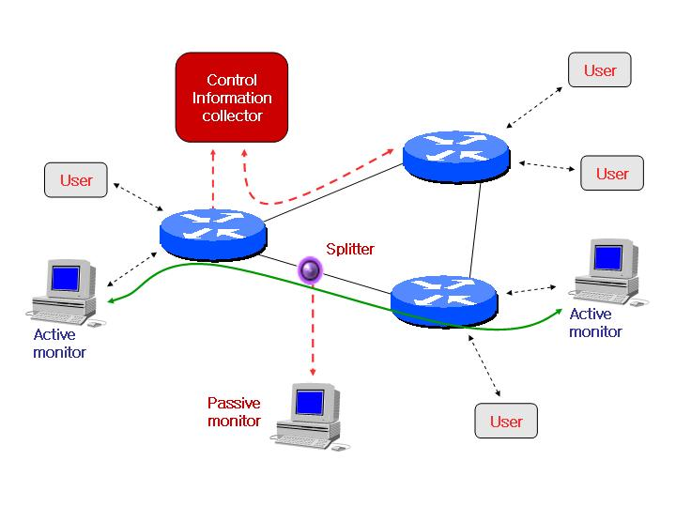
Figure 1. Passive & Active Measurement
The basic principle of passive measurement has three main situations that define what the entities represent. In the first situation the first entity represents the entire Internet and the second a single machine. In the next situation the first entity is the outside world, as seen by an organization. The second entity represents this organizations internal network. A good example of this is a university's Internet connection and their internal LAN. The final situation is a backbone link where the two entities are just both sections of the Internet [1].

Passive Measurement Tools

2.2.1 Link Based Tools : CoralReef, Tcpdump
- CoralReef: CoralReef [2] is a comprehensive software suite developed by CAIDA to collect and analyze data from passive Internet traffic monitors, in real time or from trace files. Real time monitoring support includes system network interfaces (via libpcap), FreeBSD drivers for Apptel POINT (OC12 and OC3 ATM) and FORE ATM (OC3 ATM) cards, and support for Linux drivers for WAND DAG (OC3 and OC12, POS and ATM) cards.
- Tcpdump: Tcpdump [3] is a powerful tool that allows us to sniff network packets and make some statistical analysis out of those dumps. One major drawback to tcpdump is the size of the flat file containing the text output. But tcpdump allows us to precisely see all the traffic and enables us to create statistical monitoring scripts.

2.2.2 Router Based Tools

2.2.2.1 SNMP Based: MRTG, Cricket
- MRTG (Multi Router Traffic Grapher): MRTG [4] is a tool to monitor the traffic load on network-links. MRTG generates HTML pages containing graphical images which provide a LIVE visual representation of this traffic. MRTG is based on Perl and C and works under UNIX and Windows NT.

2.2.2.2 NetFlow Based: FlowScan, cflowd, MADAS, Flowtools,NetFlow FlowCollector, NetFlow Data Analyzer
- FlowScan: FlowScan [5] analyzes and reports on Internet Protocol (IP) flow data exported by routers. Consisting of Perl scripts and modules, FlowScan binds together (1) a flow collection engine (a patched version of cflowd), (2) a high performance database (Round Robin Database - RRD), and (3) a visualization tool (RRDtool). FlowScan produces graph images that provide a continuous, near real-time view of the network border traffic.
- Cflowd: cflowd [6] is a flow analysis tool currently used for analyzing Cisco's NetFlow enabled switching method. The current release includes the collections, storage, and basic analysis modules for cflowd and for arts++ libraries. This analysis package permits data collection and analysis by ISPs and network engineers in support of capacity planning, trends analysis, and characterization of workloads in a network service provider environment. Other areas where cflowd may prove useful include usage tracking for Web hosting, accounting and billing, network planning and analysis, network monitoring, developing user profiles, data warehousing and mining, as well as security-related investigations.
- MADAS (MIRnet Administrative Data Analysis System) [7]: It is improved traffic analysis tool to measure traffic between MIRNET-STARTAP links. It converts NetFlow data into structured data stored in a series of relational database tables, and provides means of browsing summary statistics in graphic and table format. It has merit on real time graph and query interface, but slow speed and application analysis is poor.
- Flowtools: Flow-tools [8] is library and a collection of programs used to collect, send, process, and generate reports from NetFlow data. The tools can be used together on a single server or distributed to multiple servers for large deployments. The flow-toools library provides an API for development of custom applications for NetFlow export versions 1, 5, 6 and the 14 currently defined version 8 subversions. A Perl and Python interface have been contributed and are included in the distribution.
- NetFlow FlowCollector: NetFlow FlowCollector [9] provides fast, extensive and economical data collection from multiple NetFlow export-enabled devices that include Cisco routers and Catalyst 5000 and Catalyst 6000 family switches. FlowCollector is a key provider of time-based, granular data measurements to external applications. Service provider and enterprise customers can use FlowCollector as an integral component of their distributed data collection processes.

NetFlow
NetFlow [10] is series packets having source and destination address endpoint that is generated from CISCO network devices. NetFlow technology efficiently provides the metering base for a key set of applications including network traffic accounting, usage-based network billing, network planning, as well as Denial Services monitoring capabilities, network monitoring, outbound marketing, and data mining capabilities for both service provider and enterprise customers. Network Flow could be distinguished from flow endpoint not only IP address but also port number of transport layer. Also to discern each flow using IP protocol type, Type of Service (ToS), and input interface. That is to say, It statistics empowers users with the ability to characterize their IP data flows. So network manager’s questions about who, what, where, when, and how much IP traffic can be answered.
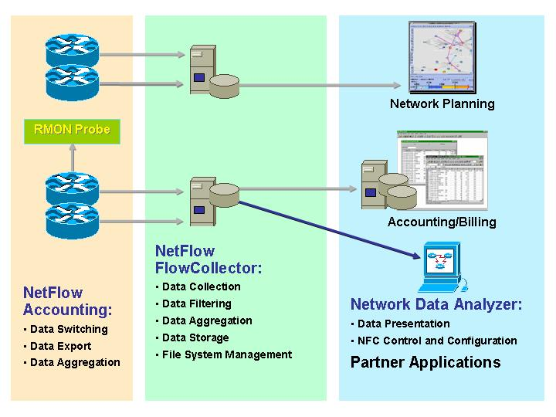
Figure 2. NetFlow Infrastructure
NetFlow includes three key components (see figure 2) [11]. Flow caching analyzes and collects IP data Flows entering router or switch interfaces and prepares data for export. It enables the accumulation of data on flows with unique characteristics, such as IP addresses, application, etc. FlowCollector captures exported data from multiple routers and filters and aggregates the data according to customer policies, and then stores this summarized or aggregated data. Network Data Analyzer [12] is a network traffic-analysis tool that combines a graphical user interface with other companion modules that can retrieve, display, and analyze NetFlow data collected from FlowCollector files. This allows users to complete near-real-time visualization or trending analysis of recorded and aggregated flow data.
Table 1. NetFlow Version Matrix
Cisco IOS Software Release Version | Supported NetFlow Export Version(s) | Supported Cisco Hardware Platforms
11.1CA, 11.1CC | v1, v5 | Cisco 7200, 7500, RSP7000
11.2, 11.2P | v1 | Cisco 7200, 7500, RSP7000
11.2P | v1 | Route Switch Module (RSM), 11.2(10)P and later
11.3, 11.3T | v1 | Cisco 7200, 7500, RSP7000
12.0 | v1, v5 | Cisco 2600, 3600, 4500, 4700, AS5800, 7200, uBR7200, 7500, RSP7000, RSM
12.0T | v1, v5 | Cisco 1000*,1600*,1720**, 2500*,2600, 3600, 4500, 4700, AS5800, 7200, uBR7200, 7500, RSP7000, RSM, MGX8800 RPM
12.0(3)T and later | v8 | Cisco 1000*,1600*,1720**, 2500*,2600, 3600, 4500, 4700, AS5800, 7200, uBR7200, 7500, RSP7000, RSM, MGX8800 RPM
N/A | v7 | Catalyst 5000 NetFlow Feature Card (NFFC)
12.0(6)S | v8 | 12000
NetFlow version is classified according to supported CISCO hardware platforms (see Table1) [13]. In this paper, we use the NetFlow v5 and v7 on FlowSacn. It will try to compare NetFlow contents of each version (see Section 3.5.1).

IMPROVEMENT OF FLOWSCAN

FlowScan and Flow
Network administrators who collect measurement data often find that they either have collected too little data or too much of it. In a sense, flow profiling is a "sweet spot" between those extremes. Flows strike a balance between detail and summary. They are neither captured packets, nor are they merely aggregate totals tallied as packets travel across a given port or interface. Flows are an expressive abbreviation in which each flow represents a series of packets traveling between "interesting" end points. While flow features within the network infrastructure are a convenience, the presence of this feature alone is not sufficient for reliable continuous use in production networks. We need software tools to extract, record, and help us understand the flows.
FlowScan utilizes flows defined and exported by Cisco's NetFlow feature [14]. In their definition an IP flow is a unidirectional series of IP packets of a given protocol type, traveling between a source and destination within a certain period of time. The source and destination are defined by IP addresses. Because the flow is unidirectional, nearly all useful exchanges between two hosts (e.g. client and server), are represented by at least two flows- one flow in each direction. (Note that this is quite different from the bidirectional notion of flows defined by RTFM.)
FlowScan analyzes and reports on NetFlow format data (indigenous to Cisco routers) collected using CAIDA's cflowd flow tool. FlowScan examines flow data and maintains counters reflecting what was found. Counter values are stored using RRDtool [15], a database system for time-series data. Finally, FlowScan uses visualization capabilities of both RRDtool and other front-ends to report on the processed flow data.

FlowScan Architecture
A FlowScan system consists of a number of software components. The first such component is cflowd [16]. FlowScan uses cflowd strictly as a flow collector. As such, the cflowd components used by FlowScan are the cflowdmux and cflowd programs. cflowdmux receives UDP Cisco version 5 flow PDUs from routers and passes them to cflowd which writes them to disk in a portable, well-defined format of its own. FlowScan requires that the installer apply a patch to the cflowd sources. This modification enables cflowd to rotate and time-stamp its flow files at FlowScan's pre-defined sampling interval, which is typically five minutes. The decision to use five-minute samples was influenced by the popular tool MRTG.
The second component is a program called flowscan; note that its name consists of only lower-case characters. "FlowScan" is the package whose primary procedural component is the program flowscan. This program is a perl script that is the central process in the system. It loads and executes report modules of the administrator's choosing. These report modules are simply perl modules that are derived from the FlowScan class defined in the FlowScan.pm perl module. FlowScan reporting modules are described below in the section 4. As such, it is the flowscan script that actuates the whole system by maintaining databases of statistics regarding the IP traffic represented by the flows.
The third major component of FlowScan is RRDtool. RRDtool is described in and is well documented in the supplied on-line manual pages. The FlowScan system uses RRDtool to store numerical time-series data and automatically distill or aggregate it into averages over time. Using RRDtool in this manner essentially replaces cflowd's arts++ data aggregation features, which have a different API, and no integrated graphing features such as those built into RRDtool. Specifically, RRDtool is used by FlowScan's supplied report modules to maintain a set of RRD files that form an extensive database of IP flow metrics. Also, RRDtool and RRGrapher are responsible for producing output such as graphs of IP traffic as GIF or PNG format image files. Figure 3 is a diagram of FlowScan's components [5] and the data objects on which they operate.
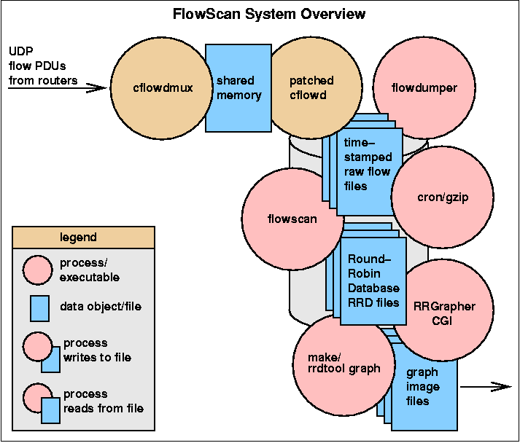
Figure 3. FlowScan's Components
FlowScan uses the disk as a large buffer area in which cflowd writes raw flow files that wait to be post-processed by flowscan. This buffering is an important fail-safe when used in networks with very high traffic or flood-based DoS attacks because FlowScan sometimes develops a backlog of flow files yet to be processed. These pending files may total Gigabytes in size.

Improvement Background of FlowScan+
Many used passive measurement tools are compared with any criteria as like total traffic sum, by application analysis, by AS analysis, top user, etc. There is no tool which is qualified needs to meet passive traffic analysis key set, briefly such as time series graph and query interface which is easy to access data by network manager. Therefore, it has developed FlowScan that graph function is excellent and open source software. And it is a new tool with attached query interface into DBMS (MySQL) and display the result of query in the web.

FlowScan+ structure
FlowScan+ features are divided into next four:
- (existing) FlowScan
- Data Aggregation
- MySQL(Sequential Query Language)
- Query interface
(Existing) FlowScan - Software package for open systems that is freely available under the terms of the GNU General Public License. FlowScan analyzes and reports on flow data exported by Internet Protocol routers. It is an assemblage of perl scripts and modules and is the glue that binds together other freely available components such as a flow collection engine, a high performance database, and a visualization tool.
Data aggregation - How to manage the collected data through cflowdmux and patched cflowd is hot issue in query reporting time and disk storage management. When exist FlowScan receive exported NetFlow data, it is drawing the graph using by rrdtool. Try to solve it we adapt aggregation which operates according to flow dealing rule. Aggregation means grouping storage into fixed scheme every 15 minute. To perform this front table accepts and storages all in-comming flow data, and move aggregated data from front table to each other scheme every 15 minute. So to speak the data aggregation of the FlowScan+ module does not throw away the data which is used to draw graph, and it put in DB after aggregate by specific schema. All data in the front table move to the rawflows table after aggregated. Below Figure 4 roughly describes the data aggregation process [17].
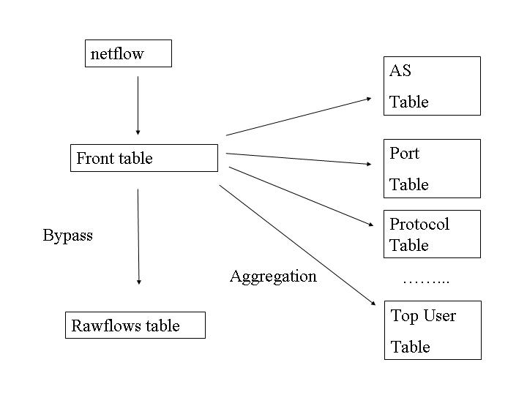
Figure 4. Data Aggregation
MySQL [18] - the world's most popular open source database, recognized for its speed and reliability. We adapt MySQL as a DB in this paper. When insert NetFlow data into DB table, it is known additional two branches information about flow other than the NetFlow entry by Analysis module that is CampusIO.pm or SubNetIO.pm in FlowScan. First traffic can be classified whether inbound or outbound, second when analyze the flow whether graph drawing time or unknown. After confirms additional two branches information about flow by existing analysis module in FlowScan+, (just before put in data to RRDtool) All flows information storage into the DB.
Query interface - A useful information takes stored flow information which form of the NetFlow entry in the data base by SQL. If we consider stored table where until all flow data as rawflow, we can acquire all information of NetFlow from rawflow by SQL. But there are any problems to take information. first query SQL is too long. For example, reporting SQL about Top10 user under subnet of inbound traffic during 05-12, 2003 and 05-13, 2003 likes table 4.
Table 4. SQL example of top10 user query
SELECT INET_NTOA(dstip), SUM(bytes) b, SUM(pkts) p, sum(flows) f from topuser WHERE time >= '2003-05-12' AND time <= '2003-05-13' AND which like 'I' GROUP BY dstip ORDER BY b DESC LIMIT 10
Whenever want to know top user, it does bitterly, it means becomes the considerably complicated work (see Table 4). And also have a problem concerning user interface. It is difficult to query directly to the DBMS in unix consol. Then it needs a part which supports to easy construct SQL command, and needs predefined query format. To solve those problem at FlowSacn+ get a web interface and Perl CGI (Common Gateway Interface). Web interface is categorized to writing already predefined query (by AS analysis, by port analysis, top user, etc.). Wanted analysis should click by mouse in this categories and input desire time. It is sending to the DB with a form of perl CGI. Then SQL command is structured by perl CGI parsing, it applies to the DB and print out results on web interface. With this process analysis can be enough easy (see Figure 5).
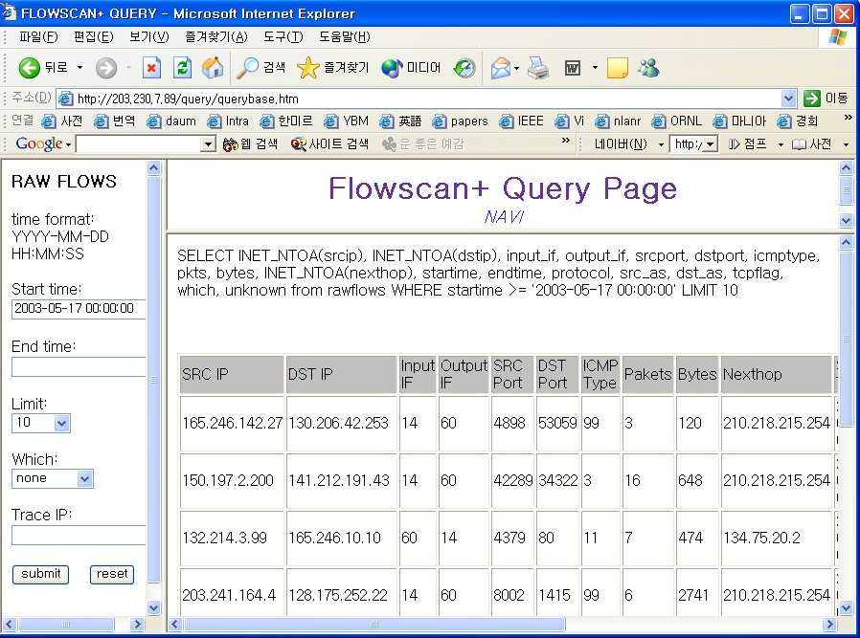
Figure 5. Web Query Interface of FlowScan+ v1.0
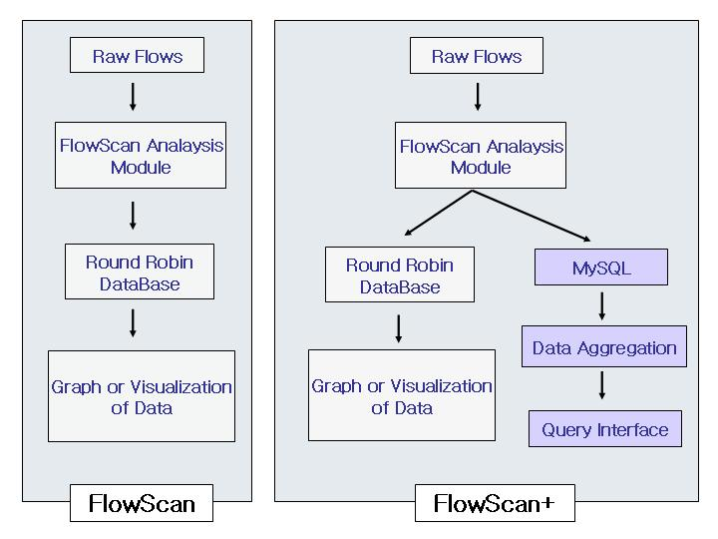
Figure 6. Compare FlowScan with FlowScan+ v1.0
The difference of FlowScan+ is data collection and storage by DBMS, query interface, Flow aggregation. Those functions are attached into basic FlowScan Module (see Figure 6) [17].

Compare FlowScan+ with Compare FlowScan+ v2.0

NetFlow Version 7
We describe about NetFlow from the front (see Section 2.3). As you know, this paper’s measurement focus is Supercomputing traffic and it’s topology (see Figure ) have a catalyst 6500 series switch as a main gateway. Catalyst 6500 series export NetFlow version 7. Existing FlowScan have used cflowdmux and cflowd to collect exported NetFlow version 5.
It is known from table 2 [13], NetFlow v7 has a similar form with other version. But next hop, input physical interface index, TCP Flags, source AS number, destination AS number, source subnet mask and destination subnet mask is setting always 0(zero). Therefore when used NetFlow v7, it will be unable to use information which it refers from the front.
Table 2. NetFlow Record Contents
Contents | V1 | V5 | V7
source IP address | Y | Y | y, zero in case of destination-only flows
destination IP address | Y | Y | Y
source TCP/UDP application port | Y | Y | y, zero in case of source-destination flows or destination-only flows
destination TCP/UDP application port | Y | Y | y, zero in case of source-destination flows or destination-only flows
next hop router IP address | Y | Y | y, always zero
input physical interface index | Y | Y | y, always zero
output physical interface index | Y | Y | Y
packet count for this flow | Y | Y | Y
byte count for this flow | Y | Y | Y
start of flow timestamp | Y | Y | Y
end of flow timestamp | Y | Y | Y
IP Protocol (for example, TCP=6; UDP=17) | Y | Y | y, zero in case of source-destination flows or destination-only flows
Type of Service (ToS) byte | Y | Y | y, switch sets it to ToS of first packet in flow
TCP Flags (cumulative OR of TCP flags) | Y | Y | y, always zero
source AS number |  | Y | y, always zero
destination AS number |  | Y | y, always zero
source subnet mask |  | Y | y, always zero
destination subnet mask |  | Y | y, always zero
flags (indicates, among other things, which flows are invalid) |  |  | Y
shortcut router IP address |  |  | Y

FlowTools
We have to change NetFlow capture module, cflowdmux/cflowd, because of different NetFlow version. FlowTools is a suitable tool to replace previous capture module and a software package for collecting and processing NetFlow data from Cisco and Juniper routers
FlowTools is library and a collection of programs used to collect, send, process, and generate reports from NetFlow data. The tools can be used together on a single server or distributed to multiple servers for large deployments. The FlowToools library provides an API for development of custom applications for NetFlow export versions 1, 5, 6, 7 and version 8 subversions. A Perl and Python interface have been contributed and are included in the distribution.
Export versions 1, 5, 6, and 7 all maintain {nexthop, dPkts, dOctets, First, Last, flags}, i.e. the next-hop IP address, number of packets, number of octets (bytes), start time, end time, and flags such as the TCP header bits. Version 5 adds the additional fields {src_as, dst_as, src_mask, dst_mask}, i.e. source AS, destination AS, source network mask, and destination network mask. Version 7 which is specific to the Catalyst switches adds in addition to the version 5 fields {router_sc}, which is the Router IP address which populates the flow cache shortcut in the Supervisor. It is compared example of NetFlow v5 with v7 by flowdumper (see Table 3).
FlowTools is including many programs in distribution [8]. It is main programs from FlowTools package: flow-capture, flow-fanout, flow-export, flow-print. flow-capture - Collect, compress, store, and manage disk space for exported flows from a router. flow-fanout - Replicate NetFlow datagram to unicast or multicast destinations. Flow-fanout is used to facilitate multiple collectors attached to a single router. flow-export - utility will convert flow-tools flow files to ASCII CSV, cflowd, or pcap format. The flow-print - utility will display flow data in ASCII using pre-defined formats.
Table 3. Compared Example between NetFlow v5 and v7
NetFlow v5 | NetFlow v7
FLOW  index: 0xc7ffff  router: 134.75.20.70  src IP: 128.253.253.59  dst IP: 210.98.25.11  input ifIndex: 60  output ifIndex: 14  src port: 445  dst port: 2979  pkts: 6  bytes: 744  IP nexthop: 134.75.20.3  start time: Thu May 15 15:10:47 2003  end time: Thu May 15 15:10:51 2003  protocol: 6  tos: 0x0  src AS: 17579  dst AS: 17579  src masklen: 16  dst masklen: 19  TCP flags: 0x1b (PUSH|SYN|FIN|ACK)  engine type: 1  engine id: 10 | FLOW  index: 0xc7ffff  router: 150.183.5.251  src IP: 150.183.5.194  dst IP: 150.183.138.216  input ifIndex: 0  output ifIndex: 0  src port: 80  dst port: 3215  pkts: 6  bytes: 497  IP nexthop: 0.0.0.0  start time: Mon May 12 18:41:34 2003  end time: Mon May 12 18:41:34 2003  protocol: 6  tos: 0x0  src AS: 0  dst AS: 0  src masklen: 0  dst masklen: 0  TCP flags: 0x0  engine type: 0  engine id: 0

Visualization Module
From the upper part of figure (see Figure 7), FlowScan original module is not a new module in this FlowScan+, it parse the NetFlow to analysis and draw a stationary graph. The RRD is a kind of DB which is strengthened graphic and no relational DB, therefore user have a limitation to free use query with skillful in SQL. The graph of FlowScan original module draws by stationary method. The NetFlow comes in to follow, continuously it comes to draw little by little, the graph of past is lost when the graph of present comes to draw newly automatically. The user wants to show the graph where accurately is not in order, but static method not supports that. For example, user wants to see 2 days graph (from 2003-05-12 to 2003-05-13) FlowScan original module has only 1 day and 2 weeks graph. FlowScan+ takes into account this point for easy to use. It is a analysis module which is added module when FlowScan+ improve time. FlowScan+ can query with pre-defined format such as Top User, Protocol, Port and Flow by web page.

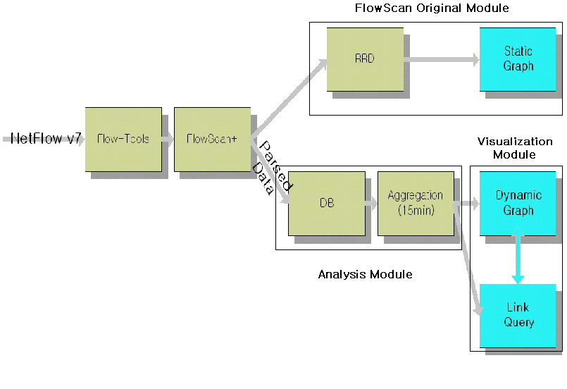
Figure 7. FlowScan+ v2.0 Architecture
An expert user who is good at SQL and DB schema can insert SQL command directly to understand Flow information. In FlowScan+, improved by adding MySQL, has free RDBMS based query interface to get flow information. But result of query is text based information it has a difficult to intuitive understand (see Figure 5).
To overcome that difficulty, improved FlowScan+ v2.0 adds to visualization module (see Figure 7) [19]. FlowScan+ v2.0 can visualize of query result from query interface of the RDBMS base which it provides from the existing flowscan+. FlowScan+ v2.0 can make direct visualization of information which is the user oneself to want, with uses a Servlet function in the jFreechary library which is a Charting Library of the GPL (General Public License).
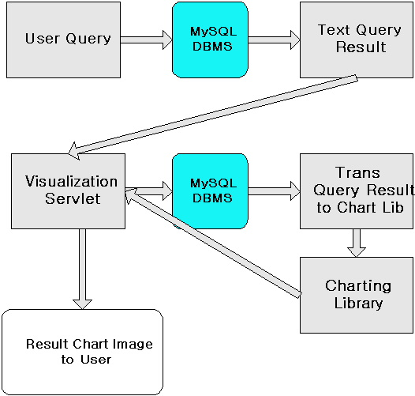
Figure 8. FlowScan+ v 2.0 Visualization Architecture
The analysis module of FlowScan+ performs parsed data and aggregation every 15 minute, user can use it to query about network status through web page. If the visualization module adapts performed data, dynamic graph draws. User can query by web page as FlowScan+. And this query is executed MYSQL which is RDBMS of FlowScan+ and shows a form of text query result on web page (see Figure 5). If user wants to this data visualization, user chooses the need information and requests to visualize. This request accesses to visualization servlet of server and one more query to MySQL. It comes to be exchanged in the form where the Charting Library demands from result set form of the JDBC. The exchanged data draws image file form by Charting Library, when it goes to the visualization servlet, server should send chart image to the user (see Figure 8) [19].

User Grouping
There is not a possibility where it will know the ID of the Super Computer user with NetFlow v7. NetFlow v7 has only IP address. But it uses the IP Address where the user who has the same ID is same always there is not guarantee. So we need grouping concept. For instans grouping, If KAIST SA Lab is a super computer grid application user and ID is sephi, but the person whom it connects with the sephi is not positively uses a what kind of IP Address. However IP address of SA lab. is C class (192.249.24.*), therefore the people whom it connects from the this IP group it will be able to identify the fact that is the SA Lab. One group can consist of only one IP or many IP families. The IP family is divided into A, B and C class of IPv4. Grouping can input with manager mode on web page. This is a process of group registry (see Figure 9) [19].
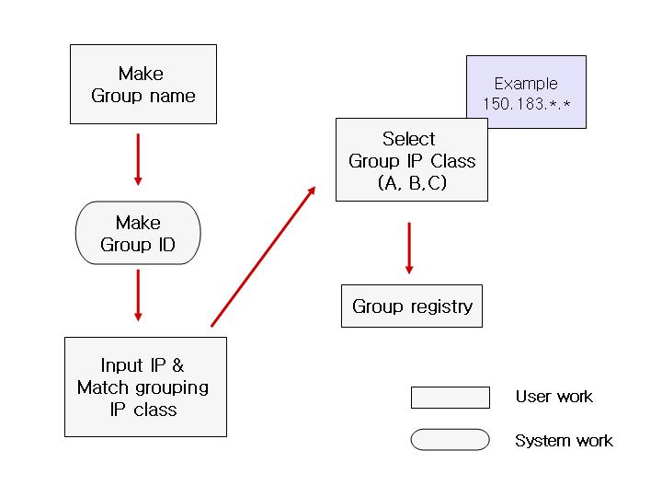
Figure 9. Grouping registry process

USAGE OF FLOWSACAN+ V 2.0

Analysis of Supercomputing Traffic
KISTI Supercomputing Center has various types of supercomputers that are products of NEC, IBM, Compaq and Cray. As the only supercomputing center in Korea, it provides those resources to the researchers in industries, universities, institutes, and government organizations. We have brought NEC SX-5/8B to replace Cray C90 which we have shut down in the year 2001. The system has PVP(Parallel Vector Processor) architecture just as Cray C90, and consists of 8 CPUs, and its peak performance marks 80Gflops (10Gflops per CPU).
As you know from front, there are many users using the supercomputing resource to get a result of theirs experiment which includes extensive research information such as automobile or airplane design, medicine development, weather forecast and complex mathematical formula. We want to know actually how many research traffic has generated and really how many user are use it. To know this, First we have to check supercomputer topology, and according to topology we selects proper measurement method, deploy tool, and choose the entry what is need information. Therefore FlowScan+ is a good tool for this purpose. We can see the topology of supercomputing traffic circuit (see Figure 10).
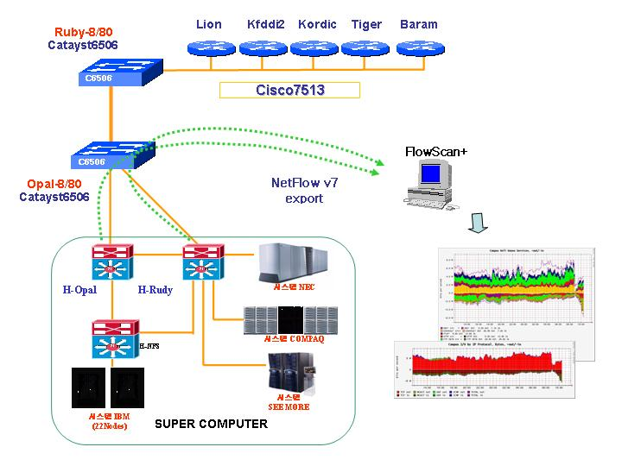
Figure 10. Supercomputing traffic measurement Topology
We can easily know how many traffic generated each any time by FlowScan+. And also we can know that the top user during any time period with query interface. It is a most difference point concerning draw graph of query result from FlowScan+ v1.0 (see Figure 11) [19].
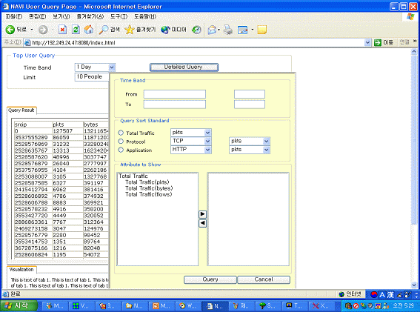
(a)
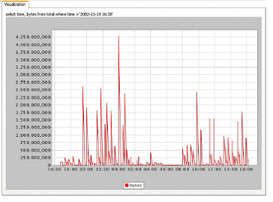
(b)
Figure 11. Web Query Interface of FlowScan+ v2.0 and graph
(a) web query interface (b) query result graph
As like this, we can acquire and analyze more needed information about supercomputing traffic. And query result graph improves to easy understand of analysis of NetFlow data.

Analysis of Grid applications
KISTI established the National Grid Basic Plan on the May of 2001 in order to facilitate grid research activities in Korea and to participate in international grid projects. These day many activities are going on to improve application, middleware, etc, in many institutes and universities. Grid applications are very sensitive to the performance of network and it needs high speed high capacity and high performance to do real time job. And each application needs different kinds of resources such as availability of resource or high computing power and so on. So it is inevitable to know characteristic of each application and accurate usage of network [20]. FlowScan+ has a function which can add easily to new application. If related Grid or not new application emerges, the graph of FowScan+ indicates there is too much unknown traffic flows. By querying unknown traffic for port by flows, One can know which ports are popular yet unknown to update. It is too useful usage of FlowScan+.

Network Abnormality

Port scanning computer
It is possible, actually common, to attempt to make socket connections on a server's multitude of ports in order to determine what services reside on that machine. Port scans should be non-controversial. If your machine is connected to the Internet, you are exposing all of your ports, and you should expect connection attempts on any of them. Because a port scan is sometimes, very rarely, a prelude to hacking attempts, many fascist leaning system administrators mistakenly classify the port scan itself as a hostile act. Port scan is a basic attack and the opening of all hacking.
The port scanning computer has a feasible feature on rawflow’s dump (flowdumper –s). It is a sample of port scanning which probes connectible port by change port number (see Table 4) [21].
Table 4. Port scanning example (flowdumper –s)
2000/01/27 05:24:36 137.68.225.33.48898 -> 37.142.238.201.111 6(RST|SYN) 2 84
2000/01/27 05:24:36 137.68.225.33.48899 -> 37.142.238.202.111 6(RST|SYN) 2 84
2000/01/27 05:24:36 137.68.225.33.48900 -> 37.142.238.203.111 6(RST|SYN) 2 84
2000/01/27 05:24:36 137.68.225.33.48901 -> 37.142.238.204.111 6(RST|SYN) 2 84
2000/01/27 05:24:36 137.68.225.33.48902 -> 37.142.238.205.111 6(RST|SYN) 2 84
2000/01/27 05:24:36 137.68.225.33.48903 -> 37.142.238.206.111 6(RST|SYN) 2 84
2000/01/27 05:24:36 137.68.225.33.48904 -> 37.142.238.207.111 6(RST|SYN) 2 84
2000/01/27 05:24:36 137.68.225.33.48905 -> 37.142.238.208.111 6(RST|SYN) 2 84
2000/01/27 05:24:36 137.68.225.33.48906 -> 37.142.238.209.111 6(RST|SYN) 2 84
2000/01/27 05:24:36 137.68.225.33.48907 -> 37.142.238.210.111 6(RST|SYN) 2 84
2000/01/27 05:24:36 137.68.225.33.48908 -> 37.142.238.211.111 6(RST|SYN) 2 84
2000/01/27 05:24:36 137.68.225.33.48909 -> 37.142.238.212.111 6(RST|SYN) 2 84
2000/01/27 05:24:36 137.68.225.33.48910 -> 37.142.238.213.111 6(RST|SYN) 2 84
2000/01/27 05:24:36 137.68.225.33.48911 -> 37.142.238.214.111 6(RST|SYN) 2 84

Code Red virus detection
The "Code Red" worm is malicious self-propagating code that exploits Microsoft Internet Information Server (IIS)-enabled systems susceptible to the vulnerability. Its activity on a compromised machine is time sensitive, different activity occurs based on the date (day of the month) of the system clock [22].
When system became infected Code Red virus, it is detected in traffic. From Table 5 [21], infector and infected system is exchange traffic and generates traffic to searches another host to make parasite.
Table 5. Infection of Code Red virus (flowdumper –s)
2001/07/19 10:17:14 infector.2179 -> infectee.80 6(PUSH|SYN|FIN|ACK) 7 4327
2001/07/19 10:17:14 infectee.80 -> infector.2179 6(PUSH|SYN|ACK) 5 212
2001/07/19 10:17:15 infectee.4321 -> 52.22.95.40.80 6(PUSH|RST|SYN|ACK) 11 4487
2001/07/19 10:17:15 infectee.4322 -> 91.167.212.99.80 6(PUSH|RST|SYN|ACK) 11 4487
2001/07/19 10:17:15 infectee.4323 -> 130.56.74.159.80 6(PUSH|RST|SYN|ACK) 11 4487

NIMDA virus detection
Nimda [23] is a complex virus with a mass mailing worm component which spreads itself in attachments named README.EXE. If affects Windows 95, Windows 98, Windows Me, Windows NT 4 and Windows 2000 users. Nimda is the first worm to modify existing web sites to start offering infected files for download. Also it is the first worm to use normal end user machines to scan for vulnerable web sites. This technique enables Nimda to easily reach intranet web sites located behind firewalls - something worms such as Code Red couldn't directly do.
Nimda has an explosive infectivity. From Figure 12 [21], it would be starting occupied graph with SMTP (Simple Mail Transfer Protocol) which uses a style of asymmetric request-response protocol popular in the early 1980s, and still seen occasionally, most often in mail protocols.
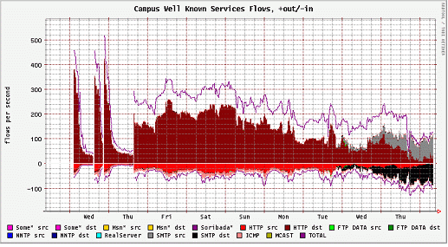
Figure 12. The example graph of Nimda virus detection

DDoS attack detection
Lastly the DDoS (Distributed Denial of Service) becomes many problem in recent times. Today's routers offer a best-effort service: they forward all traffic toward destinations, attempting to deliver fast and fair service to all flows. Policing, reliability, and rate-control mechanisms are therefore left to be deployed by higher layers at end hosts. This feature has been misused in DDoS attacks, where many compromised hosts simultaneously generate excessive traffic to a victim. The number of received packets overwhelms the target, consuming its resources and rendering its services unavailable [24].
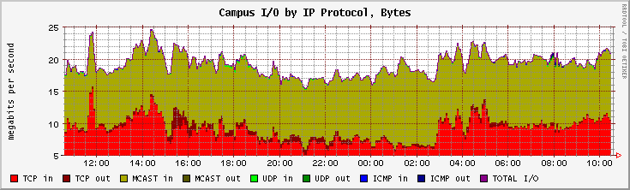
(a) by Bytes
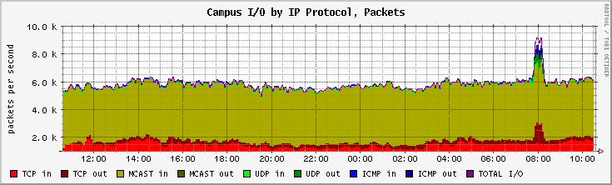
(b) by Packets
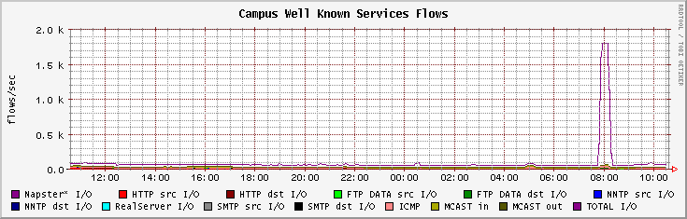
(c) by Flows
Figure 13. Example of DDoS attack
DDoS attack has some feature between flow and traffic amount. It is a graph of same time traffic where monitoring network by byte, by packet and by flow (see Figure 13). From the each graph when byte and packet graph compares with flow one, flow graph shows prominently plentiful increased. It is a DDoS attacks typical pattern that connection of host or network is ruptured by traffic flooding in a moment.
Like this, we can detect various network abnormalities. We describe usage of FlowScan such as specific analysis of NetFlow and classify unknown application relating to Grid application and network abnormalities due to virus, worm and harmful attack in this section. And we can find other unknown usage by FlowScan+.

CONCLUSIONS
In this paper, we describe the traffic measurement method and tools which are used passive measurement, and introduce FlowScan+ structure and usage to measure supercomputing traffic of our networks. The FlowScan is useful tool which has time series graphing function and could adept DB. Both functions are needs as good passive measurement tool to measure our networks. We have made better analysis module of FlowScan, FlowScan+ 1.0 improved a query interface which query to aggregated DB on web page, FlowScan+ 2.0 has issued more classified DB and visualization of information. By FlowScan+, we look up function of traffic measurement, grid application traffic analysis, network statistics and detection of network abnormality. Those functions make network manager easy to charge their networks.
From now on we will estimate some change of network such as bandwidth up-grade, traffic extension, traffic characteristics, etc. We will have to stead-going preparation for those changes. And future works include DB optimization to speed up, operation of platform independent, installation packaging and so on.

REFERENCES
- James Curtis, Analysis of Voice Over IP Traffic, October 1999.
- "cflowd - CAIDA's flow analysis tool" http://www.caida.org/tools/measurement/coralreef/
- http://www.tcpdump.org/
- Tobias Oetiker, "MRTG - The Multi Router Traffic Grapher", USENIX LISA '98 Conference Proceedings, 1998.
http://ee-staff.ethz.ch/~oetiker/webtools/mrtg/
- Dave Plonka, FlowScan: A Network Traffic Flow Reporting and Visualization tool, November 2000.
- "cflowd - CAIDA's flow analysis tool" http://www.caida.org/tools/measurement/cflowd/
- http://www.mirnet.org/madas/reports/
- Flow-tools overview
http://www.splintered.net/sw/flow-tools/docs/flow-tools.html
- NetFlow FlowCollector overview http://www.cisco.com/univercd/cc/td/doc/product/rtrmgmt/nfc/
- CISCO IOS NetFlow http://www.cisco.com/warp/public/732/Tech/nmp/netflow/
- NetFlow Data Sheet http://www.cisco.com/warp/public/732/Tech/nmp/netflow/netflow_learnabout.shtml
- Network Data Analyzer (formerly NetFlow FlowAnalyzer) http://www.cisco.com/univercd/cc/td/doc/product/rtrmgmt/nda/
- NetFlow Services and Applications http://www.cisco.com/warp/public/cc/pd/iosw/ioft/neflct/tech/napps_wp.htm
- K. Claffy, G. C. Polyzos, and H.-W. Braun, “Internet traffic flow profiling”, UCSD TR-CS93-328, SDSC GA-A21526, November 1993. http://www.caida.org/outreach/papers/itf.html
- RRDtool - Round Robin Database Tool
http://ee-staff.ethz.ch/~oetiker/webtools/rrdtool/
- Daniel W. McRobb, "cflowd design", 1998. http://www.caida.org/tools/measurement/cflowd/configuration/design/design.html
- Jay/JungWon Suh, Jaemin Park, “Passive Traffic Measurement on Campus Network (KAIST) and KREONET2-STARTAP International Link”, APAN Phuket meeting, January 2002.
- http://www.mysql.com/company/index.html
- KAIST (Korea Advanced Institute of Science and Technology) SA(System Architecture) Lab. funded by KISTI, “Supercomputer Traffic Analysis and Visualization”, 2002.
- Sung Kyun Kwan Univ. Real Time Lab. Funded by KISTI, “A Study on Analysis for the Requirements of Grid Network Applications”, 2002.
- Jaemin Park, TaeHo Kim, Jay/JungWon Suh,“Installation and Usage of Flowscan for passive measurement”, A part of project report funded by KISTI, 2001.
- CERT/CC, CA-2001-23: Continued Threat of the "Code Red" Worm.
http://www.cert.org/advisories/CA-2001-23.html
- http://www.f-secure.com/v-descs/nimda.shtml
- Jelena Mirkovic, “D-WARD: DDoS Network Attack Recognition and Defense”, 2002.`

CAIDA, the Cooperative Association for Internet Data Analysis, provides tools and analyses promoting the engineering and maintenance of a robust, scalable global Internet infrastructure.
Grid is a type of parallel and distributed system that enables the sharing, selection, and aggregation of geographically distributed "autonomous" resources dynamically at runtime depending on their availability, capability, performance, cost, and users' quality-of-service requirements

