Kinematic Synthesis of Robotic Manipulators From Task Descriptions
Sobh, Tarek M.  University of Bridgeport, CT, USA  sobh@bridgeport.edu  www.bridgeport.edu/~sobh | Toundykov, Daniel Y.  University of Bridgeport, CT, USA  dtoundyk@bridgeport.edu  dtoundyk@bridgeport.edu

Abstract
This paper addresses the kinematic synthesis of robotic manipulators and presents a simple prototyping software tool. The tool, which runs under the Mathematica environment, automatically computes possible optimal parameters of robot arms by applying numerical optimization techniques to the manipulability function, combined with distances to the targets and restrictions on the dimensions of the robot. Our work also discusses possible extensions of the proposed method of kinematic synthesis.

Introduction
Computing optimal geometry for robotic manipulators is one of the most intricate problems in contemporary kinematics. Mathematical equations that describe the behavior of kinematic chains are nonlinear, often contain thousands, sometimes even millions, of terms, and rarely have known closed-form solutions. Most of the existing analytical conclusions rely on rigorous analysis of some particular manipulator configurations, whereas attempts to generalize methods of kinematic synthesis usually end up in the domain of numerical analysis. The complexity of the optimal design problem remains a catalyst for the development of rapid prototyping, which allows engineers to determine structural flaws of the mechanisms by examining the behavior of their prototypes, as opposed to analyzing sophisticated mathematical models. Modern synthesis methods include minimization of cost functions [1], stochastic algorithms [8], distributed optimization [7], parameters space approach [6], and some other techniques [5]. In this work, we concentrate on a popular algorithm for numerical optimization: minimizing functions with the steepest descent method.

A classical way of solving an optimization problem is to select several criteria that describe important aspects of the model, assign weight factors to them and then find minima of the cost function, which is often the sum of the weighted criteria. Minima are located by examining the gradient of the function - the algorithm is known as the steepest descent method. In our case, instead of taking into account individual kinematic parameters, we composed the cost function from the expression for the manipulability measure and distances to the target points. We have designed and implemented a procedural package for Mathematica (v. 4.1, Wolfram Research Inc. 2002) to test this method of kinematic synthesis. The software uses a set of task-points, several weight factors, and produces a table of Denavit-Hartenberg parameters [10] describing a manipulator that attains high manipulability at each of the targets. The program uses the Robotica package (v. 3.60, Copyright 1993 Board of Trustees, University of Illinois) to display the results. Our algorithm employs a simple manipulability measure first defined by Yoshikawa in 1983 [12]. However, the framework can be extended to encompass more complicated and accurate models.

Manipulability Measures
In order to analyze the efficiency of robots we need some quantitative measure of their performance. The theory of kinematic synthesis has significantly advanced during the past decade and various ways have been developed to describe the manipulability and dexterity of robots. Many of these approaches were derived from the definition of manipulability proposed by Yoshikawa [12]. Given a manipulator with N degrees of freedom, denote joint variables by an N-dimensional vector q. Let J(q) be the velocity jacobian of the manipulator. When J(q) loses its full rank, the kinematic chain loses one of its degrees of freedom; hence, manipulability is defined as:
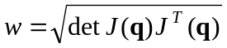 | (1)
For non-redundant manipulators this expression reduces to
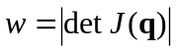 | (2)
By applying the singular value decomposition to the jacobian: 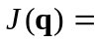U 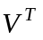 [4] we can show that is proportional to the volume of the ellipsoid with principals axes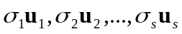, where 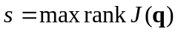, 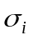 are singular values of J(q), and u_{i} is the -th column vector of U. When J loses rank the ellipsoid becomes degenerate, i.e. one or more of its principal axes have zero length.

During the past few years the manipulability ellipsoid approach has acquired significant enhancements. A number of manipulability measures for parallel mechanisms [3] have been derived; these equations included constraints on joint velocities and forces. J. Lee has developed a method of manipulability polytopes [2], which is more involute then the ellipsoid approach, but provides a better assessment of the mechanism’s efficiency.

Numerical Optimization
All of the previous manipulability measures involve lengthy nonlinear mathematical expressions in many variables. Contemporary mathematics does not possess generic techniques for obtaining closed-form solutions to nonlinear equations, and iterative methods still retain a firm position among the tools for solving complicated systems. Classical optimization usually refers to combining several criteria expressions into a single multivariable function, called the cost function, and then iteratively searching for solutions that minimize that function for a particular domain. The steepest descent algorithm finds minima by always walking in the direction opposite to gradient of the function. This procedure is slow, if compared to locally convergent techniques such as Newton-Raphson method, for instance; however, steepest descent does not require the initial guess to be close to the actual solution. If the range of the function does not contain negative values then the algorithm always converges, with the exception of some rare cases when the gradient vanishes - then the result may appear to be a maximum or a saddle point.

If is the solution vector, then we choose n criteria 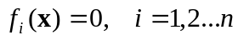, and build the function for optimization:
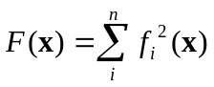 | (3)
The expression (3) is then minimized and if the discovered minimum lies close to 0 then the result yields a good approximation to the optimal value of , provided that such optimum exists.

This method has certain disadvantages: for instance, some criteria may be discontinuous, or may involve complex numbers; also we cannot tell whether the encountered minimum is local or absolute. Nevertheless, the steepest descent procedure, if carefully applied, provides a reliable method to quickly design kinematic chains, and the obtained results can always become initial approximations for other design techniques.

Constructing the Optimization Measure
The goal of our work was to develop a fast and simple synthesis tool for robotic manipulators. The objectives were:
- Generality
- Fast results
- Ease of use
It was intended that a designer would enter several spatial points into a computational module, and within a reasonable amount of time receive a description of a robot that would be able to efficiently operate among the given targets. We chose to base the synthesis algorithm on the manipulability measure, presented in equations (1) and (2), and the steepest descent method.

Suppose we are given m task-points: p_{1,} p_{2,} p₃,…, p_{m}. Let K be the set of constant parameters in the definition of the robot, i.e. all Denavit-Hartenberg parameters with the exception of the joint variables. Let q be the joint vector and 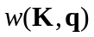 - the manipulability function of the robot described by K and joint variables q. Finally, let 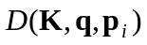 be the distance between the point p_{i} and the origin of the end-frame of the robot, whose form and position are given by K and q respectively. The task is to find an optimal K, such that all of the given points fall within the reachable workspace and w has high values at each of the targets.

The first version of the cost function considered was:
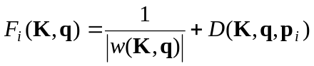 | (4)
As F_{i} decreases, the manipulability grows, and the distance to the target decreases. The absolute value function around w is difficult to work with, and  contains a square root: 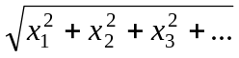 (here x_{i} are the components of the residual vector), which only increases the complexity of the expression. So, (4) was transformed into:
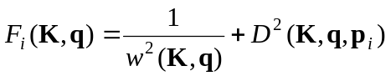 | (5)
After minimization, q becomes the inverse kinematic solution for the point p_{i} and K describes a robot that attains high manipulability at that point. If during the optimization phase the algorithm encounters a singular jacobian, the value of F becomes infinite, so we added an extra term b to eliminate the singularities.
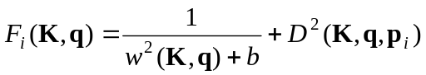 | (6)
b is typically very small so that it does not distort the results; in our case it was set to 10⁻¹⁰.

Initially we intended to solve the problem for each of the target-vectors individually and then use heuristics to merge the solutions into a single parameter table. Yet, combining results usually implies some form of averaging, which carries a negative aspect: when we try to merge very large and very small values of a particular parameter, say, a link length, the outcome is smaller than the larger value, hence some targets may become unreachable. Averaging works only when task-points lie on, or near some sphere centered in the origin, but if targets are arbitrarily distributed in space, this approach becomes unacceptable.

Instead of computing a separate solution for each of the targets, it was proposed to treat the point-set as a single object in 3-space. We combined all manipulability functions and distances into a single expression for optimization. The joint variables have unique values at every task-point, so the joint vector q was made different for each pair {manipulability_at_point_i, distance_to_point_i}. For example, if the first angle parameter is variable then at point p₁ it is called θ_{[1,1]}, at the second point: θ_{[2,1]}, and so on. So for each of the m points we have a separate joint vector q_{i}. Now, writing 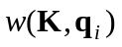 and 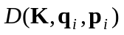 as 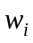 and 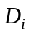 respectively, we can reformulate (6) as follows:
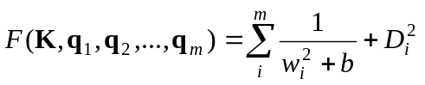 | (7)
The cost function was complete; however, we discovered that expression (7) sometimes resulted in poor precision: i.e. the positioning error for some targets could go up to the order of 10⁻¹. So a weight factor was attached to the distance D:
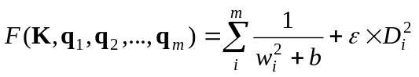 | (8)
By increasing we can increase the precision of the manipulator.

Another issue was that (7) and (8) always produced very large arms, often several times longer than the distance to the remotest target. Therefore we introduced another term 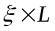:
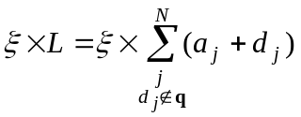 | (9)
Here 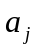 and 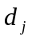, are the length and offset Denavit-Hartenberg parameters respectively; the restriction 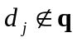 ensures that we include only invariant offsets. is the size dumping factor: values of order higher than 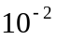 notably reduce the dimensions of the manipulator; however, they also decrease manipulability, because the available workspace shrinks. The final expression for optimization is:
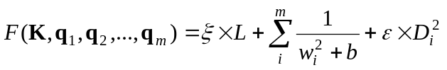 | (10)

A Simple Design Tool
We have written a set of procedures for Mathematica (v. 4.1) to automate the kinematic synthesis of robot arms. A sample run of the program is shown on Figure 1. The software uses the traditional manipulability ellipsoid measures (1) and (2). Detailed descriptions of available procedures and their parameters can be found in the program itself. Here we will concentrate only on the main module that triggers the optimization:

DesignRobot[task_points, configuration, precision, size_dump, file_name]

- The first argument is the set of 3-dimensional task-points. This is the only mandatory argument: the rest have default values, and are optional.
- Configuration is a non-empty string of 'R's and 'P' denoting rotational and prismatic joints respectively. Thus "RRR" stands for an articulated manipulator, "RPP" for cylindrical, etc.
- Precision and size_dump are weights that increase precision and limit dimensions of the robot respectively. See equations (9) and (10).
- file_name is the name of the file where the description of the robot will be stored. The information is saved in the format defined in [11].

Configuration parameter can be a positive integer, then it is treated as the number of degrees of freedom, and the program tries all possible 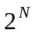configurations. For example, for a 3-link arm those are {PPP, PPR, PRP, RPP, PRR, RPR, RRP, RRR}. For each combination the procedure computes the average volume of the manipulability ellipsoids over the set of task-points. The geometry that yields the highest average manipulability gets selected. This heuristics normally chooses the articulated configuration; however, if the size-dumping factor is large then other outcomes may be possible. This feature also provides an overview of the average values of manipulability ellipsoids over the range of manipulator configurations.

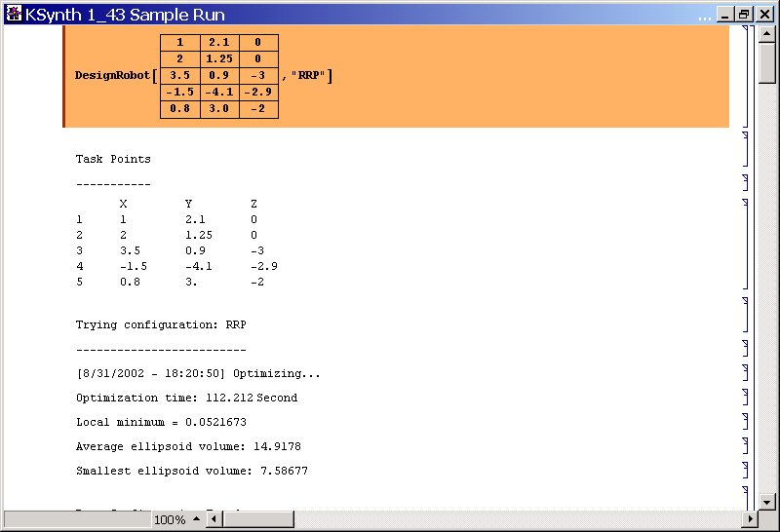
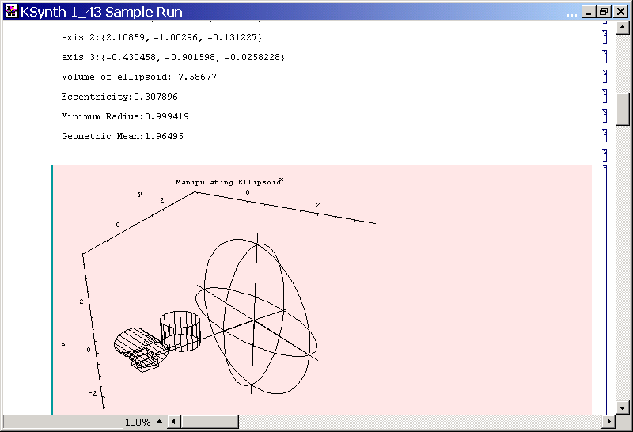

Figure 1. Mathematica environment executing the program
Construction of the cost function requires generic symbolic expressions for the transformation and jacobian matrices. The linear transformations are always the same, whereas jacobians vary depending upon the manipulator configuration (cartesian, spherical, articulated, etc). It does not take much time for a computer to calculate those matrices; however, their simplification is extremely time consuming and for redundant manipulators may take a few hours. Nevertheless, since the matrices are completely generic, they need to be derived only once. After the very first computation the expressions are saved and are reloaded for subsequent operations.

Results
This section contains results from several sample program runs. In each case we chose some parametric trajectory 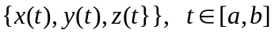, selected several points that belonged to the curve and used them in the optimization module. The precision and size-dumping factors vary for each case. In some samples the types of joints were pre-defined by the user, whereas in others the algorithm generated the configuration.

Sample 1
Here we design a 3-link articulated manipulator. The constraints on the size and precision are negligible.

Task Points |  | 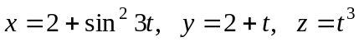; t ranges from -1.0 to 0.9 with a step of 0.1
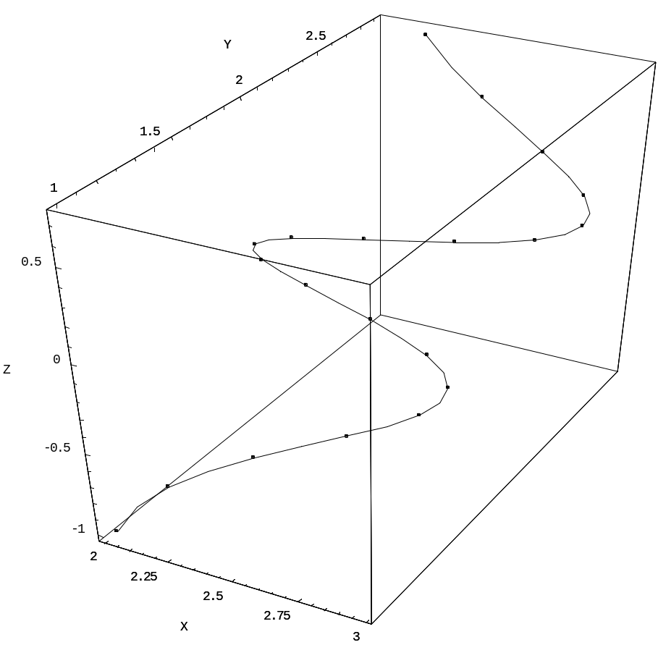
 |  | Figure 2: Trajectory for sample 1; total: 20 points.
Configuration: RRR |  |  | Precision: 1 | Size dumping: 10⁻³
Average Ellipsoid Volume: 41.2865 |  |  | Smallest Ellipsoid Volume: 24.5245
Robot
  Link # | a_{i} | α_{i} | d_{i} | θ_{i}
  1 | -1.32282 | 1.59337 | -0.76117 | q1
  2 | 2.04475 | -1.68142 | 3.03615 | q2
  3 | 3.50069 | 0 | -0.257436 | q3
Figure 3: Some manipulability ellipsoids from sample 1.
Target: {2.01991, 1, -1} | Target: {2.94838, 1.4, -0.216}
Joint vec.: {q10.419545, q20.102612, q31.13198} | Joint vec.: {q10.636441, q20.238941, q30.781471}
Residual position: {0.000567, 0.000285, 0.00009} | Residual position: {0.000082, 3.41811E-6, -0.000134}
Ellipsoid volume: 24.5245 | Ellipsoid volume: 42.2072
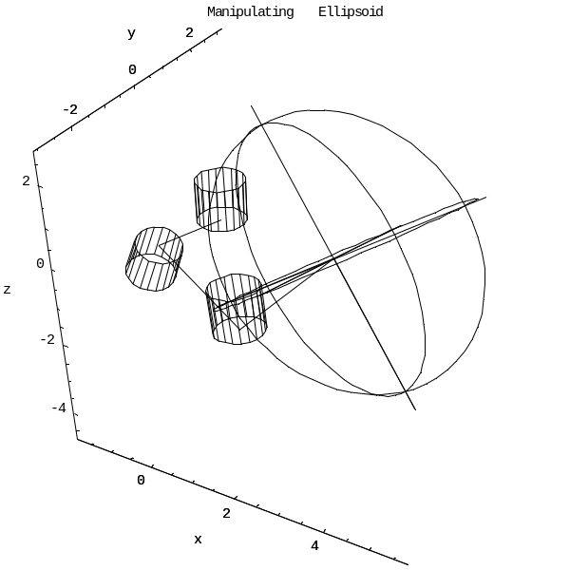 | 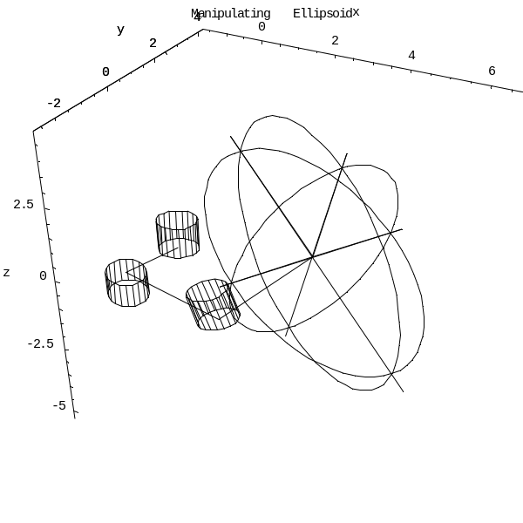
Target: {2.08733, 1.9, -0.001} | Target: {2.18265, 2.9, 0.729}
Joint vec.: {q10.848621, q20.318338, q30.921608} | Joint vec.: {q11.25789, q20.402806, q30.58269}
Residual pos.: {0.0000535, 0.000136, -1.67517E-6} | Residual pos.: {-0.000048, -0.0000259, -0.0001642}
Ellipsoid vol.: 34.769 | Ellipsoid vol.: 48.3164
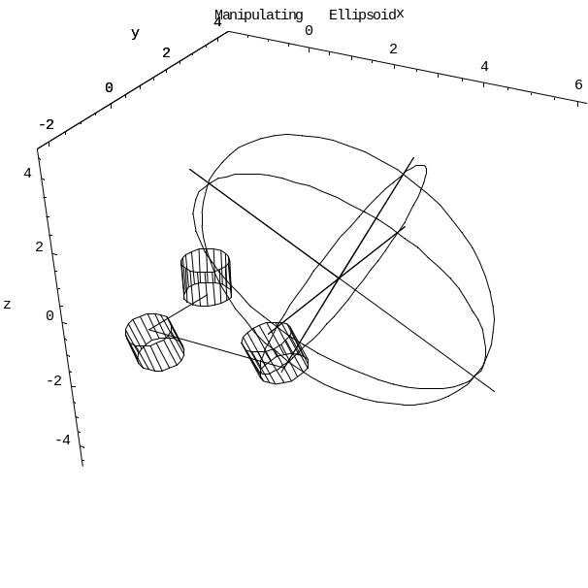 | 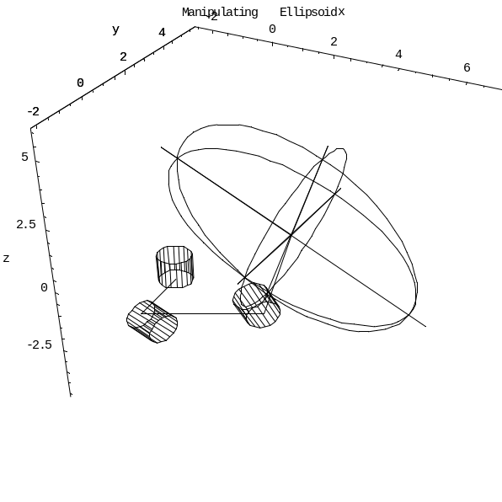

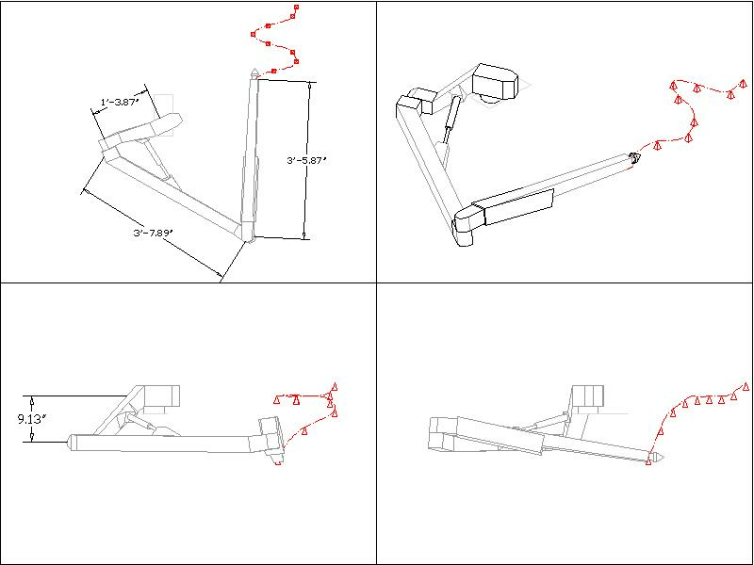
Figure 4: Robot prototype for sample 1. Several positioning targets are indicated by the tips of the pyramids. Unit of length = 1'

Sample 2
We limit the dimensions of the robot and have the software choose the types of joints. We can see that with smaller link lengths the algorithm has to introduce prismatic joints in order to improve manipulability and avoid singularities.
Task Points |  | 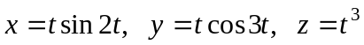; t ranges from 0 to 1.5 with the step of 0.05
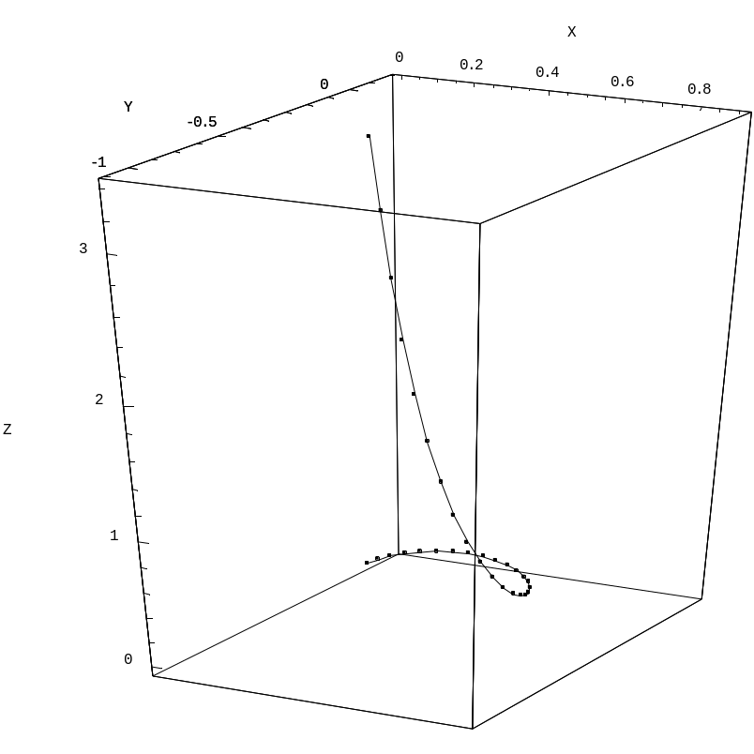
 |  |  | Figure 5: Trajectory for sample 2; total: 31 points.
The configuration has been selected by the program.
Configuration: PRR |  |  |  | Precision: 10.0 | Size dumping: 10.0
Average Ellipsoid Volume: 2.0021 |  |  |  | Smallest Ellipsoid Volume: 1.66684
Robot
  Link # | a_{i} | α_{i} | d_{i} | θ_{i}
  1 | -0.196428 | -1.42081 | d1 | 2.10987
  2 | -0.572675 | 1.5713 | -0.0462867 | q2
  3 | -1.22595 | 0 | -0.00510264 | q3
Figure 6: Some manipulability ellipsoids from sample 2.
Target: {0, 0, 0} | Target: {0.352497, 0.098553, 0.091125}
Joint vector: {d1-1.76912, q21.68501, q3-0.251606} | Joint vector: {d1-1.6723, q21.6291, q30.0288799}
Residual pos.: {0.00497104, 0.00209425, -0.000941464} | Residual pos.: {-0.00328795, -0.00240936, -0.000428824}
Ellipsoid volume: 2.13378 | Ellipsoid volume: 2.1659
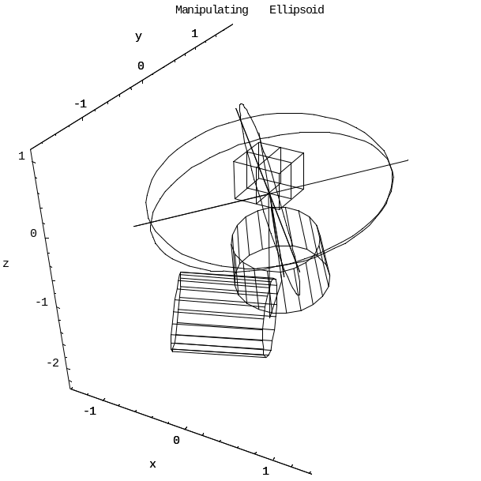 | 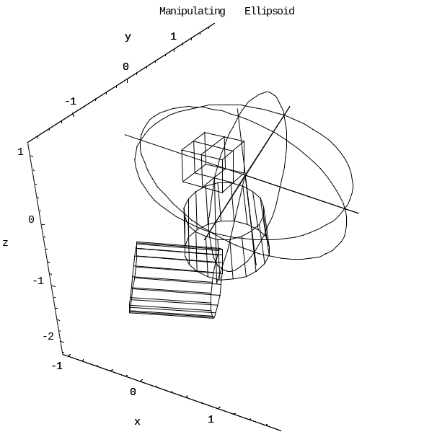
Target: {0.468983, -0.686365, 2.744} | Target: {0.21168, -0.316194, 3.375}
Joint vector: {d11.07365, q21.21213, q3-0.198744} | Joint vector: {d11.60271, q21.46945, q3-0.236225}
Residual pos.: {0.000735159, 0.00718603, 0.000100016} | Residual pos.: {0.00420461, 0.00265684, -0.00100912}
Ellipsoid vol.: 2.0366 | Ellipsoid vol.: 2.144
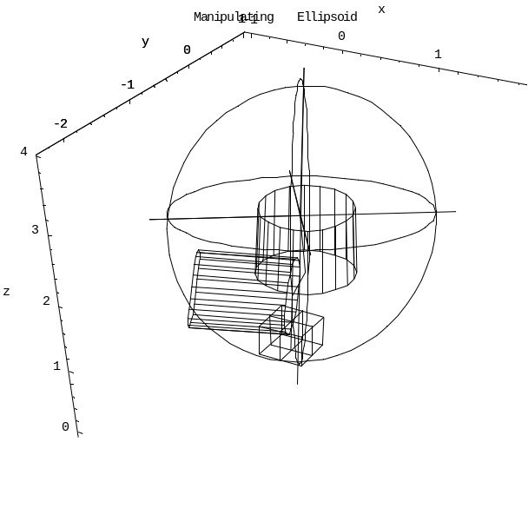 | 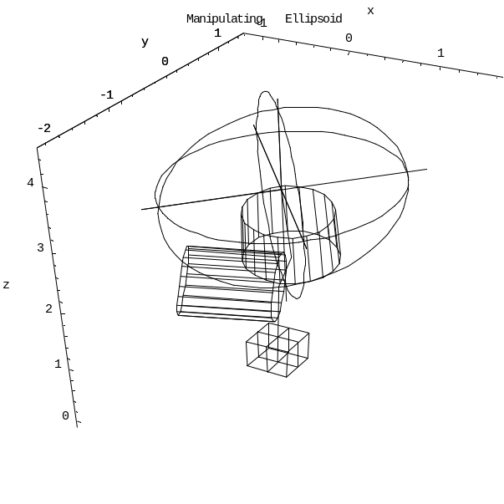

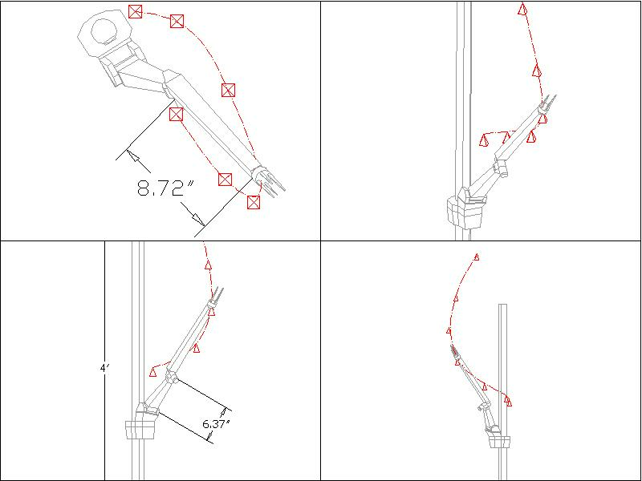
Figure 7: Robot prototype for sample 2. Several positioning targets are indicated by the tips of the pyramids. Unit of length = 1'

Sample 2a
The set of task-points in this example is identical to that of sample 2; however, the size-dumping factor has been increased 5 times and the precision, 10 times. The joints were again selected by the software.

Configuration: PRP |  | Precision: 100.0 | Size dumping: 50.0
Average Ellipsoid Volume: 1.2545 |  | Smallest Ellipsoid Volume: 0.651917
Robot
  Link # | a_{i} | α_{i} | d_{i} | θ_{i}
  1 | -0.61557 | -0.0022699 | d1 | 0.037812
  2 | -0.0025489 | 1.56847 | 0.00050315 | q2
  3 | 0.00041630 | 0 | d3 | 0.92619
Figure 8: Some manipulability ellipsoids from sample 2a (the targets are the same as in #2).
Target: {0, 0, 0} | Target: {0.352497, 0.098553, 0.091125}
Joint vector: {d1-0.0020829, q21.5741, d30.65192} | Joint vector: {d10.088255, q21.6607, d30.98544}
Residual pos.: {0.036335, 0.0012279, 0.00027050} | Residual pos.: {0.010076, 0.0013847, 0.000063659}
Ellipsoid volume: 0.65192 | Ellipsoid volume: 0.985427
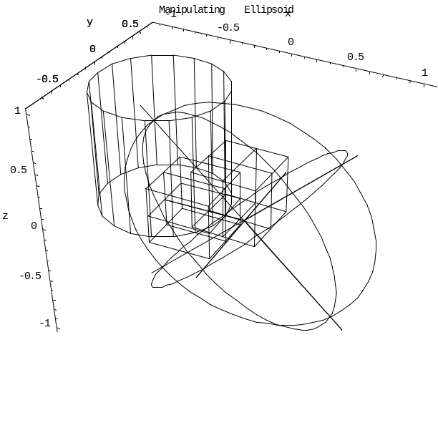 | 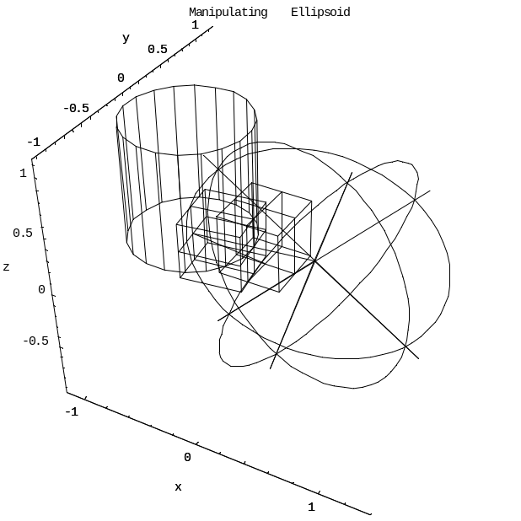
Target: {0.468983, -0.686365, 2.744} | Target: {0.21168, -0.316194, 3.375}
Joint vector: {d12.7383, q20.98607, d31.2754} | Joint vector: {d13.3715, q21.1954, d30.89125}
Residual pos.: {0.0040390, -0.0021331, -0.00025905} | Residual pos.: {0.013377, -0.0044118, 0.00019008}
Ellipsoid vol.: 1.2754 | Ellipsoid vol.: 0.89124
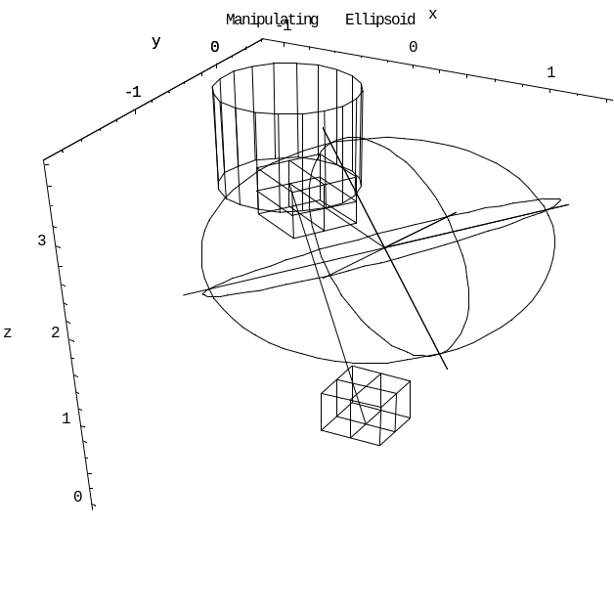 | 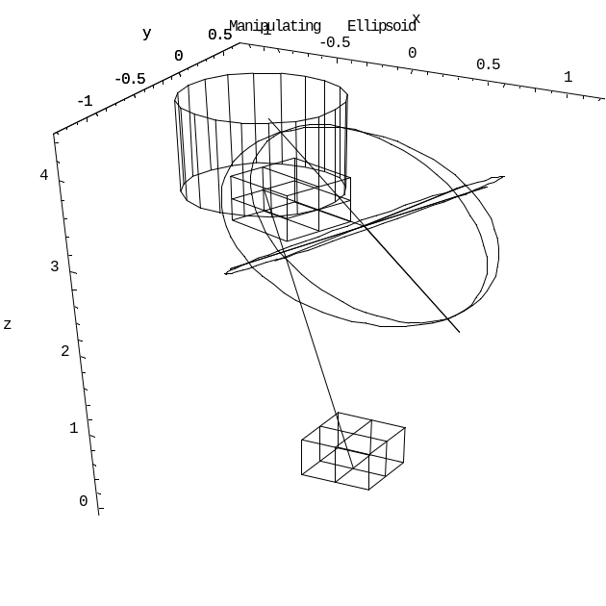

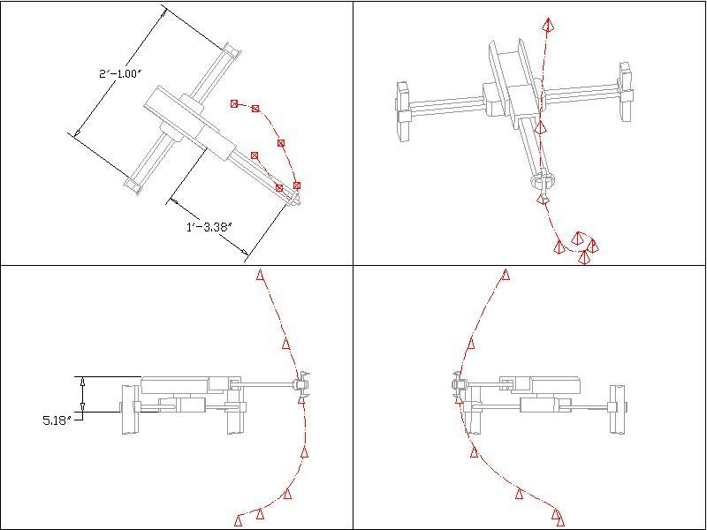
Figure 9: Robot prototype for sample 2A. Several positioning targets are indicated by the tips of the pyramids. Unit of length = 1'
Note that only a fraction of the side rails is shown (their full height is about 3' each).

Sample 3
An articulated arm with slightly increased precision and limited dimensions; this time the software was forced to select rotational joints, but was not allowed to enlarge links in order to raise the manipulability.
Task Points |  | 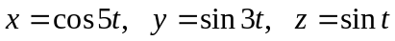, where t ranges from 0 to 2π with the step of 0.1
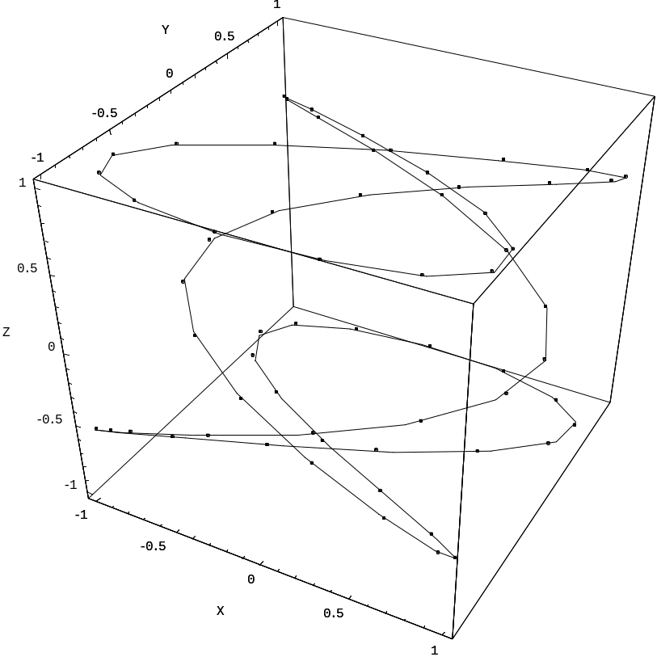
 |  | Figure 10: Trajectory for sample 3; total: 63 points.
The configuration was selected by the user.
Configuration: RRR |  |  | Precision: 25 | Size dumping: 12
Average Ellipsoid Volume: 1.4510 |  |  | Smallest Ellipsoid Volume: 0.81001
Robot
  Link # | a_{i} | α_{i} | d_{i} | θ_{i}
  1 | 1.62611 | -1.56998 | -0.0403649 | q1
  2 | 1.56317 | -0.000493347 | -0.00121933 | q2
  3 | 1.56376 | 0 | 0.000180823 | q3
Figure 11: Some manipulability ellipsoids from sample 3.
Target: {1, 0, 0} | Target: {-0.41614, 0.93203, 0.38941}
Joint vector: {q10.000133501, q24.57559, q3-2.72488} | Joint vec.: {q133.4093, q221.3, q38.9372}
Residual position: {-0.0190905, -0.00063247, 0.00530208} | Residual position: {-0.000203689, -0.00181206, 0.0189074}
Ellipsoid volume: 0.970517 | Ellipsoid volume: 1.16714
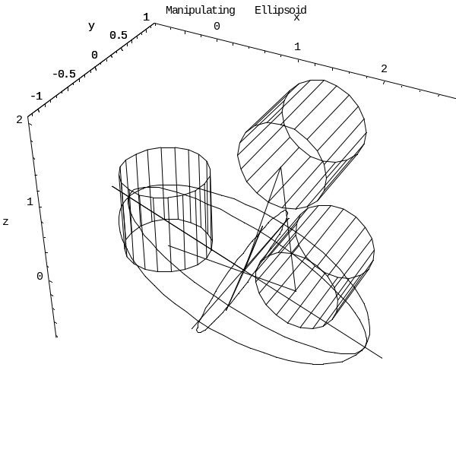 | 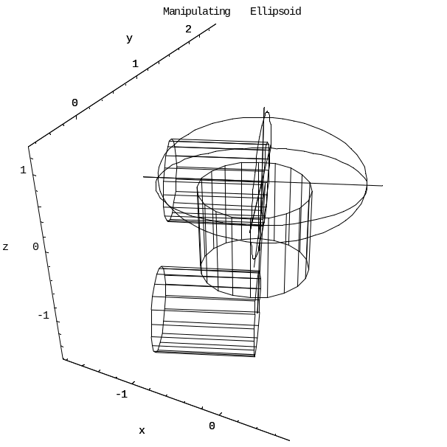
Target: {0.28366, 0.14112, 0.84147} | Target: {-0.99717, -0.55068, 0.94630}
Joint vector: {q16.75146, q22.71147, q32.14002} | Joint vector: {q1-15.2012, q2-9.51343, q3-3.86434}
Residual pos.: {0.0941315, 0.0472549, 0.015007} | Residual pos.: {-0.00570994, -0.00329063, 0.00905416}
Ellipsoid vol.: 0.869193 | Ellipsoid vol.: 1.85245
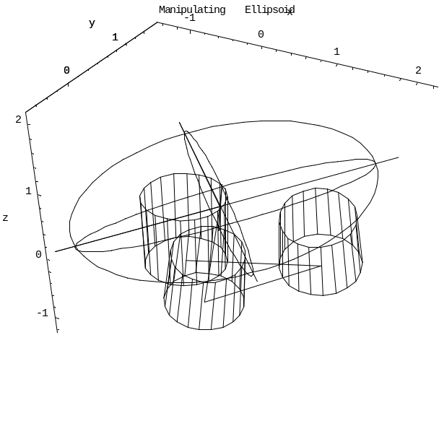 | 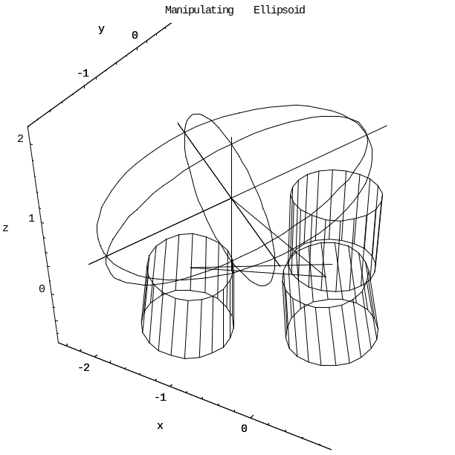

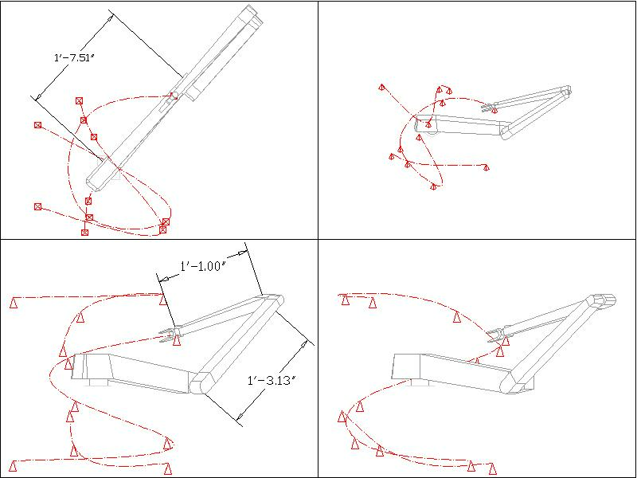
Figure 12: Robot prototype for sample 3. Several positioning targets are indicated by the tips of the pyramids. Unit of length = 1'

Future Developments
Substituting different symbols in place of joint variables for each of the task-points greatly increases the number of unknowns to compute. If, instead of using different symbols, we could introduce functional relations connecting the joint vectors, then the number of variables will decrease. Our model can easily incorporate additional constraints and weights, or even make use of a more elaborate manipulability measure.

Conclusion
We have discussed a new numerical technique for kinematically synthesizing a manipulator based on workspace restrictions. We utilized the classical method of numerical optimization using the steepest descent algorithm. Our software package automatically derives possible optimal parameters for robot arms from sets of task-points. The tool can significantly aid in robot design and prototyping and is another significant step towards the automated generation of optimal robotic mechanisms from task descriptions.

References
- Erdman A.G. Modern Kinematics. Wiley, New York, 1993.
- Jihong Lee. "A study on the manipulability measures for robot manipulators." Proc. of 97 IEEE International Conference on Intelligent Robots and Systems, pages 1458-65, 1997.
- Keum-Shik Hong, Jeom-Goo Kim, and Seung-Hwan Lee. "Optimal link design of a parallel machine tool based on manipulability analysis." Proc. of 2001 IEEE International Symposium on Industrial Electronics, pages 1747-52, June, 2001.
- Klema V. C., and Laub A. T. “The singular value decomposition: Its computation and some applications.” 1980 IEEE Trans. On Automatic Contr. AC-25(2): 164-176.
- Lenarčič J., and Stanišić M. M. Advances in Robot Kinematics. Kluwer Academic Publishers, Dordrecht, 2000.
- Merlet J-P. "Democrat: A DEsign Methodology for the Conception of Robots with parallel ArchiTecture." Robotica, 15(4): 367-373, July-August, 1997.
- Ouezdou F. B., Regnier S., and Mavroidis C., "Kinematic synthesis of manipulators using a distributed optimization method." Journal of Mechanical Design, Transactions of the ASME, 121(4): 492-501, 1999.
- Ramstein E., and Chedmail P. “Robot Manipulators and Mechanisms Synthesis using stochastic approaches.” International Symposium on Robotics and Automation, pp. 79-85, December, 1998.
- Singh J. R., and Rastegar J. "Optimal synthesis of robot manipulators based on global kinematic parameters." Mechanism and Machine Theory, 30(4):) 569-580, 1995.
- Spong M. W., and Vidyasagar. Robot Dynamics and Control. Wiley, New York, 1989.
- Spong M. W. “The Robotica Manual.” (1993). Online. Internet. 21 Dec. 2001. Available: http://robot0.ge.uiuc.edu/~spong/Robotica/newman.ps.Z
- Yoshikawa T. "Analysis and control of robot manipulators with redundancy." Robotics Research, The First International Symposium. Cambridge, MIT Press, pp. 735-747, 1984.
- Yoshikawa T. "Manipulability of robotic mechanisms." International Journal of Robotics Research. 4(2): 3-9, Summer 1985.
- Yoshikawa T. "Translational and rotational manipulability of robotic manipulators." Proc. of 1991 International Conference on Industrial Electronics, Control and Instrumentation, pages 1170-1175, 1991.

Computer Software
  - Mathematica v. 4.1. Wolfram Research Inc, 2002. www.wolfram.org

  - Robotica v. 3.60., University of Illinois, 1993. Online. Internet. 21 Dec. 2001. Available: http://robot0.ge.uiuc.edu/~spong/Robotica/robotica.m

