 | 
     |  | Paravet Training Programmes  in Andhra Pradesh: A Review
 | Author
 |  |  | Other
 |  |  | ● PPLPI Working Paper No. #

Table of Contents

Abbreviations

AHD | Animal Husbandry Department
AP | Andhra Pradesh
APLDA | Andhra Pradesh Livestock Development Agency
VLSP | Village-based Livestock Service Providers
DAHDTC | District Animal Husbandry Training Centers
RAHTC | Regional Animal Husbandry Training Centers

Executive Summary
This report is a part of the project to understand and analyze the performance of the para-vets in Andhra Pradesh with a view to enhancing the performance of the para-vets through restructuring of the programme. In this context, the objective of the current report is “to develop a clear understanding on the training provided to para-veterinarians and para-vet workers by various agencies including the deficiencies and gaps in training, if any.”
For the purpose of this study, a para-worker or a Village-based Animal Health Worker (AHW) is defined as a community based or private village level worker trained to liaise between livestock owners and the veterinarians, besides him/her self being able to provide AI, basic veterinary, and preventive health services to the village livestock in the village itself.
In order to achieve the above stated objective, a comprehensive listing of all organizations providing training to paravets in all the sectors in Andhra Pradesh was prepared. These organizations were then mailed a specially developed questionnaire seeking information on various aspects of their training programmes. Approximately 65% (21 out of 33) responded to the questionnaire. The information so collected was further supplemented by personal visits, interviews to some institutions as well as obtaining relevant documents from other sources such as the state AHD etc.
Department of Animal Husbandry, Government of Andhra Pradesh (DAHD) is the main para-vet training agency. It has a systematic approach at planning, curriculum building and execution of paravet training programmemes to meet its own requirements and those of other government and bilateral development projects in the state. Out of a sample of 26 training programmes included in this study, 23 were from government and quasi-government organizations. Remaining three programmes were organized by NGOs—RAAS, ANTHRA, and JK Trust. These NGOs generally have good training programmemes tailored to meet their specific needs. Given below are some salient features of VLSP training in Andhra Pradesh:
- Almost all the government organizations consider ‘Livestock Development’ and/or HRD as the main thrust of their activity.
- In general, training is open to candidates with any socio-economic background, though those belonging to weaker and poor sections of rural areas were the main trainees.
- The programmes are generally not targeted for providing services to specific agro-climatic areas or socio-economic target group, though some were organized especially for women, tribal and marginalized communities and drought-prone areas. Such programmes are generally organized by voluntary organisations.
- Need for the service, determined mandate and, in a few cases demand by farmers are the main reasons for the organizations undertaking paravet training.
- In assessing the usefulness of their programmes, about 1/3rd of the organizations felt that their paravet training efforts have been very useful to the farmers, while another 1/3rd felt the same to be useful.
From the information available to us, it appeared that the organisations in Andhra Pradesh are reasonably well endowed to organize VLSP training, though there is always scope for improvement. Laboratories and sheds for conducting practical training with live animals seem to be the most important thing to be improved uniformly at all places.
The survey covered the following aspects of the para-vet training:
- Overview of the paravet training programmes in Andhra Pradesh
- Description of the main paravet training programmes
- Assessment of the programmes
- Service delivery by the paravets
- Suggestions for improvement of the training programmes

The main findings of the survey are summarized below:

A. Overview of courses offered

Courses Offered:
Out of nearly 40 course offered by the sample organisations – a) two courses were of 1 or 2 year duration for pre-service candidates, b) 6 courses were of 1 to 4 months duration for community/village based service providers who also act as liaison between farmers and veterinarians, and c) the rest were of 1 to 7 day duration that were either refresher courses for those under category ‘b)’ above or for other purposes.
The courses in category a) mentioned above are the long-term courses, which are for training government paravets as future salaried employees of the department. Main objectives of this study were to understand the training programme for animal health workers providing services in the villages. Thus, the long-term courses were not included in this study. The key programmes covered in this study include:
- Gopalmitra programme focusing on cattle breeding through doorstep Al, fodder development, and calf rearing.
- Sanghamitra programme for veterinary first aid, preventive vaccination and livestock extension. These are to work in thee Velugu Programmeme – AP Rural Livelihoods Project. However, they are not practically working now. The few Sanghamitras approached by the Study Team did not give their responses saying that they are not able to work.
- Sheep Extension Worker in Nalgonda district (with the help of ISNRMPA, Hyderabad) specializing in sheep development, rotation of breeding rams, and vaccination.
- Woman Poultry Health Worker specializing in marketing network and vaccination These are to work in thee Velugu Programmeme – AP Rural Livelihoods Project. However, they are not practically working now. The Study Team could not locate even a single persons; AHD personnel informed that they are not able to work now.
- AI Technicians of the NGO BAIF in Mahabubnagar and Ananthapur districts
- AI Technicians of the NGO JK Trust – in Anantapur district
- Women Village Health Workers of NGO Rayalaseema Sewa Samithi (RASS), working in a limited area in two Mandals of Chittoor district only amongst women SHG as a sort of employee of RASS; information obtained from the NGO.
- Women Village Health Workers of the NGO Girijana Deepika who are trained by NGO Anthra, Hyderabad. Girijana Deepika workers work in a triabal area of the Rampachodavaram Mandal of East Godavari district. Some information on their performance could be obtained from the farmers of the region and on their training from NGO Anthra.
The Gopalamitra programme developed by the APLDA is the most widely taught course for paravet training in AP. This course is also used by some NGOS, development projects and dairy cooperatives either in full or in part to upgrade skills of their own village based workers. For example, the Gopal programme of the JK Trust and the Velugu programme of organized for the World Bank development projects are based on the Gopalamitra programme. However, NGO Anthra develops specific courses to meet their requirements.
Admission Criteria: Selection criteria for Gopalamitra and allied courses are 10th class pass. However, in practice candidates with lower and/or higher than required qualification (some even post-graduates) attended the courses. For the Woman Poultry Extension Workers training programme the minimum qualification is set as the 7th class.
Training intensity: At least one category ‘b’ course is organized each year by the designated RAHTCs. Otherwise the state organizations conduct 3 training programmemes an year on average. Out of the 454 trainees per year, only about 9% were females. The NGO Anthra, conducted 6 training courses where the number of trainees were 123, 40% of which were women, while all the 12 trainees in the one time paravet training of NGO RASS were women.
Coverage: In case of government organizations (11), the coverage was the territory (state/district/block/village) for which they are mandated.
Training Cost: Total training cost for the four-month Gopalamitra training programme was around Rs. 19,500. ANTHRA’S costs varied between Rs. 120 and Rs.300 per trainee per day depending on lodging and boarding costs. ANTHRA uses a graded system of charging for the training programme depending on the ability and willingness to pay. The duration of their programmes varied between 20 and 35 days.
Trainers: Most training organizations generally utilize in-house trainers, almost invariably veterinarians. Out of 26 organizations/programmes considered for this study, 22 used in-house trainers whereas 6 organisations hired consultants.
Certification: For all the courses considered in this study, only a Participation Certificate is given. No certificate is given for most of the short duration (1-7 day) courses.

B. Description of the Main Training Programmes

Gopalamitra
Gopalamitra is a 4 month long, most common modular (blocks) course with modified versions for up-gradation of skills of previously trained workers. The training includes reproduction, AI, common diseases, vaccination, first aid, fodder production, and feeding and management of animals. After training, the candidates are placed at a Gopalamitra Center usually near his or her own village with a demarcated area of operation in a group of villages. Since the inception of the programme in 2000, the contents of the course have been modified periodically learning from the strengths and weaknesses of the previous year both in planning and actual organization of the programmes.
Detailed curricula of the Gopalamitra and other medium duration training programmes – Sangamitra, Sheep extension worker, woman poultry health worker, Gopal programme, Velugu programme etc. are presented in the report.

C. Assessment of the courses
In assessing the courses, the official curriculum of the programme and the actual implementation of the programmes were compared. Results indicate that by and large, the actual training schedule goes on as planned.
In terms of the content of course work, the emphasis seems to be on large ruminants (AI), to some extent on small ruminants, much less on poultry and negligible on pigs. The reason for this is that the Gopalamitra, the most widespread and common course focuses on AI in cattle and buffaloes. The NGOs do teach ‘other’ topics like gender issues, evaluation, and herbal medicines. Nevertheless, AI is the most popular subject, while livestock management, health care subjects, extension and fodder rank a distant second.
Regarding the follow-up activities of the trained paravets, the main activities include stock identification, supply of materials such as liquid nitrogen, AI kit, etc., evaluation of paravet work, and providing technical back-stopping to the paravets. In the authors view, the supervision and evaluation of paravet work needs to be improved significantly.

D. Service Delivery by Paravets (Trainers’ Views)
Location of Service delivery: Most organizations reported that the paravet delivers service both at the farmers’ door-step and at a central point. Out of the 23 organizations that responded to this question, 14 reported providing services at both locations, while 7 organizations provided services only at the doorstep and 2 reported that the service delivery is exclusively at a fixed central point. Out of the 21 government organizations, 3 operated in peri-urban areas, while 8 organizations each covered backward and low potential areas. The NGOs reported providing services mostly in dry and disadvantaged areas. It is evident from the above discussion that large ruminants are the most served species, followed by small ruminants, poultry, and pigs.
Cost Recovery: Not much information could be collected on user charges paid. Regarding AI, NGOs BAIF and JKT charges for providing AI service in the areas of their operation although their areas of operation are relatively small. Apart from that none of the NGOs charge user fee for other services. Over and above this, the NGOs BAIF, RASS and JKT pay their para-workers a monthly allowance of Rs. 1,500 to 2,500 and some part of the user charges. The Gopalamitras, on the other hand, collect Rs. 40 to 50 (Average Rs. 35) from farmers when the service is provided at the doorstep and Rs. 20 when done at a central place. Veterinary aid at doorstep may yield around Rs. 20. Out of the user charges collected for AI, Rs. 20 is paid to APLDA towards cost of materials. It appears that the amounts mentioned above are as and when paid by some one. Actual payment could be moderate in rich delta districts but the payment for these services could be very difficult by the poor farmers of disadvantaged communities, especially the small ruminant keepers.
Problems with service delivery: Most of the organizations (17 out of 23) found paravets using antibiotics, which is beyond their brief. Other undesirable acts observed were - carrying out surgery (3 out of 23), wrong doses (9 out of 23), wrong techniques (9 out of 23), and wrong care of equipment (7 out of 23).

E. Suggestions for improving the training programmes
We also solicited their suggestions for improving the delivery of these services. The suggestion included - a) provision of adequate budget, staff, infrastructure, and transportation facilities at the training institution; b) advance planning of the actual conduct of given training programmemes and educational tours; c) selection and intimation of trainees should be done well in advance and; d) timely sanction and prompt payment of travel costs to trainees, honorarium to trainers and funds for providing refreshments to trainees.
From the many suggestions coming from actual organizers of training paravet programmes, it looks that once the courses are decided at higher level, the organizers are somewhat left to fend for them selves in their training task. This calls for greater monitoring and guidance by the higher authorities (SMILDA) of the paravet training programme. Supervision, monitoring and evaluation of performance of newly trained field workers are some of the aspects that need vast improvement.
Overall, from the discussions with field staff and senior officials of AHD, it looks that, at present, the Gopalamitra is ‘no one’s baby’ and is somewhat hanging in the air. He has difficulties in earning his living, being taken to task for exceeding his brief, no institution including ALDA comes to his rescue in difficult professional situations etc. etc.

- Introduction
This report is part of a project to understand and analyze the performance of the para-vets in Andhra Pradesh. In this context, the objective of the current report is “to develop a clear understanding of the training provided to para-veterinarians and animal health workers by various agencies and identify the deficiencies and gaps in training, if any.”
This report is organized as follows. Section two provides information about data collection process for the study. Section three presents a description of the organizations providing paravet training in Andhra Pradesh. Section four gives an overview of the training programmes following which section five discusses the curricula for the main private training programmes. Section six focuses on service delivery by the paravets. Section seven provides suggestions for improvement of these courses as identified by the organizations. Finally, based on the information available from this study, section eight concludes with some insights into how these training programmes can be improved.

- Data Collection
To collect the data for this analysis, all the organizations concerned with animal husbandry and veterinary services in the various districts of Andhra Pradesh (see Annexure 1 for a Map of Andhra Pradesh) were contacted and inquiries were made about the various training programmemes carried out by them and other organisations. From such enquiries a detailed list of organizations conducting paravet training in some form or other was prepared. A list of all the organizations involved in para-vet training programme in Andhra Pradesh is presented in Annexure 2. A detailed questionnaire was prepared, field-tested and finalized after discussing amongst he members of the study team.
A copy of the Questionnaire was sent to heads of all the training organizations requesting them to provide particulars about their respective organisations by providing the required information. Wherever necessary, personal visits were made to obtain the necessary detailed information and collect relevant documents.
Out of the total 38 Training organizations of the State (35 training community based Health Workers) to which the questionnaires were sent, 21 organisations (71%, all training community based Health Workers)) responded. These include 17 of the 29 organisations of the state AH Department (Government), one Agricultural University (Quasi-Government), and 4 NGOs. Also, the Regional Animal Husbandry Training Centre (RAHTC) at Visakhapatnam, one of the oldest and largest in the state, sent 6 responses – one for each type of paravet course conducted by the organization. This raises the number of responses to 26 (79% responses). Though the total number of responses received is 26, the number of observations cited in the following discussions may exceed that number because some questions are amenable to choosing more than one option. The received responses cover all the agro-climatic regions of the state and all the possible levels and types of paravet training, which gives a rather comprehensive idea about the entire state of Andhra Pradesh.

- Description of the Organizations
As seen from Annexure 2, except the three non-government organizations, all the training centers are with the government - the state Animal Husbandry Department or the state Agricultural University. The first two organizations listed in Annexure 2 are state level organizations and mostly conduct refresher training programmes for veterinary assistant surgeons and Assistant Directors (AH) of the department. The various District Animal Husbandry Training Centers (DAHTC), (listed at 12 to 32 in Annexure 2) are generally located at the District Veterinary Polyclinic under the charge of the Deputy Director (Polyclinic). As regards paravet training, the DAHTCs are primarily concerned with the practical training (around one month) or refresher training (2 to 5 days).
The State Management Institute for Livestock Development (SMILDA) in Andhra Pradesh is the Apex organization of the Animal Husbandry Department (AHD) concerned with human resources development and training. It organizes refresher courses for veterinarians and Assistant Director level officers of the department at Hyderabad or at some of the RAHTCs and SAHTC, especially the ones at Manadapeta. The Indo-Swiss Project Andhra Pradesh, a joint programme of Swiss Development Cooperation and AHD, is responsible for creation and operationalization of SMILDA and the HRD programmes in the field of livestock services. SMILDA is not directly involved in paravet training, but focuses on developing curriculum and strategies for providing basic and refresher training programmes for paravets (community based, private liaison between farmers and vets). This is achieved by setting up committees of experienced officers of AHD and consultants for each training programme.
On an average, the organisations covered in the study have been functioning for about 10 years (range 2 to 29 years). Most of them have training as part of their mandate since 2000 when the Gopalamitra programme was initiated by APLDA under the National Project for Cattle & Buffalo Breeding of Government of India.
Salient features of the organizations presented in Annexure 3 (Figures A-F) are discussed here:
  - Main thrust
Almost all the government organisations (20) consider ‘Livestock Development’ and / or HRD as the main thrust of their activity, while the NGOs consider ‘Rural Development’ (2) and ‘Women Empowerment’ (2), especially the marginalized communities in resource poor areas, as their main activity; livestock services being incidental to that (Figure A).
  - Social background of trainees
In general, the paravet training is open to candidates with any socio-economic background, though those belonging to weaker and poor sections of rural areas were the main (23) trainees. A few programmemes were specially organized for tribal youth and for other beneficiary-oriented development projects (Figure B).

- Comparison of features of different community oriented AHW Training Programmemes in AP
Type of AHWs | Admission qualification* | Duration (Days) | Selection by whom | Training collaboration | Curriculum followed | Certification
Gopalamitra | 10th Class pass | 120 +15 | ALDA & AHD officials | AHD; ALDA and District collector | Gopalamitra Manual | Participation Certificate
Tribal Youth  AHW | 10th Class pass | 120 | Mandal officer, tribal welfare department | AHD & Tribal department | SMILDA curriculum | Participation Certificate
Sanghamitra | 10th Class pass | 45 | Dist. Water Mgmt Agency | APRLP (AHD) DWMA | SMILDA curriculum | Participation Certificate
Small Ruminant Health Workers | 10th Class pass | 45 | Primary Sheep Breeders’ Societies | ISNRMPA, AHD , Breeders Associations | SMILDA Curriculum | Participation Certificate
Anthra’s AHW | Aptitude to work with animals | 20 - 40 | Anthra, NGOs,  Communities | Anthra, Client NGOs | Anthra’s (Trains for other NGOs too) | -
BAIF AI  Technician | 10th Class pass | 180 | BAIF + Community /  Milk Union | Milk Union, BAIF | BAIF Model | Participation Certificate
JK Trust AI  Technician | 10th Class pass | 120 | JKT, AHD | JKT, AHD | Gopalamitra Manual | Participation Certificate
RASS Primary  Health Worker | 12th Class pass | 120 | RASS | COVS (AU) / AHD / | Gopalamitra manual | Participation Certificate
Veterinary Asst | 12th Class pass | 1 year | AHD | AHD / APLDA | Special, own | Course Certificate
Vet Polytechnic | 10th Class pass | 2 years | ANGR Agr. Univ. of the State | ANGRAU / AHD | Special, own (4 semesters) | Course Certificate
*Desirable criteria for admission:
1. He/she should belong to the local area.
2. Preferably from the same socio-economic background.
3. He/she should be above 18 - 35 years of age.
4. The selected candidates should be willing to invest for a vehicle or get loan for mobility.
5. Women to be given better opportunity. (1/3 have to be women for Vet Asst course)
6. Sponsored by local community / project (in some cases)

  - Area specificity
The training programmes are open for all agro-climatic areas (20), though some were organized especially for women, tribal and marginalized communities and in drought-prone areas, especially in the case of voluntary organizations (Figure C).
  - Why paravet training
Need for the service (12), determined mandate (9) and, in some cases (3), demand by farmers are the main reasons for the organizations undertaking paravet training (Figure D).
  - Organizations’ perceived usefulness
In assessing the degree of usefulness of their services, 11 organizations felt that their paravet training efforts have been very useful to the farmers, while 10 felt the same to be useful (Figure E).
  - Training infrastructure
Most of the organisations (16 to 22 of the respondents) have basic infrastructure for paravet training like classroom, audio visual aids, models, facilities and animals for conducting practical training, blackboard and charts and posters (Figure F). Anthra and RASS, the NGOs, have interest creating means like Role-play, Drama, and Puppetry.
- Overview of the courses offered
Details of the courses concerning several aspects of the as the list of courses offered, duration of the courses, admission criteria, total turnout, details of the trainers and trainees, etc. are discussed in this section. The detailed particulars of all the paravet and para worker training programmemes are shown in Table 1 above.
  - Types of courses
Various paravet courses offered by government organizations are listed in Annexure 4; while such a list as mentioned by the organisations in their responses are listed in Annexure 5. There is a good match of the two indicating that what is planned is also executed. The courses are good in number and variety and should be able to meet field requirements of most types. These courses can be categorized according to the duration of the training programmes as follows:
    - Long-duration Courses for Para-vets Service of the AHD
The RAHTCs are concerned with the basic paravet training which comprises of the 1-year Pre-Service Training for Veterinary Assistants, who, though are basically paravets, they are future salaried employees of the department. Same is the case with those passing the 2-year diploma course of the AH Polytechnic of the agricultural university. Both provide a Course Certificate to the successful candidates.
    - Medium Term Courses
Most of the programmes for para-vet training relevant to this study fall in this category. These include :
- Gopalmitra programme focusing on cattle breeding through doorstep Al, fodder development, and calf rearing.
- Sanghamitra programme for veterinary first aid, preventive vaccination and livestock extension. These are to work in thee Velugu Programmeme – AP Rural Livelihoods Project. However, they are not practically working now. The few Sanghamitras approached by the Study Team did not give their responses saying that they are not able to work.
- Sheep Extension Worker in Nalgonda district (with the help of ISNRMPA, Hyderabad) specializing in sheep development, rotation of breeding rams, and vaccination.
- Woman Poultry Health Worker specializing in marketing network and vaccination These are to work in thee Velugu Programmeme – AP Rural Livelihoods Project. However, they are not practically working now. The Study Team could not locate even a single persons; AHD personnel informed that they are able to work now.
- AI Technicians of the NGO BAIF in Mahabubnagar and Ananthapur districts
- AI Technicians of the NGO JK Trust – in Anantapur district
- Women Village Health Workers of NGO Rayalaseema Sewa Samithi (RASS), working in a limited area in two Mandals of Chittoor district only amongst women SHG as a sort of employee of RASS; information obtained from the NGO.
- Women Village Health Workers of the NGO Girijana Deepika who are trained by NGO Anthra, Hyderabad. Girijana Deepika workers work in a triabal area of the Rampachodavaram Mandal of East Godavari district. Some information on their performance could be obtained from the farmers of the region and on their training from NGO Anthra.
Apart from these, the other mid-term courses, the courses organized by the NGOs, such as the Gopal programme of the JK Trust, Velugu programme for the World Bank development projects, etc. are also organized along the lines of the Gopalamitra.
Only a Participation Certificate is given to those who complete the above mi-duration courses successfully.
    - Short Term Courses
Apart from the long and medium term courses mentioned above the DAHTC also organizes a number of short term courses of 1- 7 days duration for young farmers, women of self-help groups, and field workers for various projects with substantial livestock component, students, and workers of NGOs etc. (see Annexure 4).
The Gopalamitra programme developed by the APLDA is the most widely taught course for paravet training in AP. This course is also used by some NGOS, development projects and dairy cooperatives either in full or in part to upgrade skills of their own village based workers. For example, the Gopal programme of the JK Trust and the Velugu programme organized for the World Bank development projects are based on the Gopalamitra programme. However, NGO Anthra develops specific courses to meet their requirements. The details of the curricula of these programmes are presented in the next section.

  - Admission criteria
Please see Table 1 for details of all programmes. The official admission criteria for Gopalamitra are as follows:
- He/she should belong to the local area.
- He/she should have passed 10th class.
- He/she should be above 18 years of age.
- The selected candidates should be willing to invest for a vehicle or get loan for mobility.

Except for the RASS Health Worker and the Pre-service Veterinary Assistant that have 12th Class pass as the admission criteria all other courses have Metric (10th class) as the admission requirement (Table 1 above). Only the Women Poultry Extension Worker (7_day course) has Middle (7th class) schooling as the educational qualification for admission. Obviously, candidates with lower (in the beginning, when suitable candidates did not come forward!) and / or higher (Paid Secretaries of Dairy Coops and those in other business avocations came forward to capitalize on the Gopalamitra programmeme!) than required qualification (some even graduates!) attended the courses. Even for the Woman Poultry Extension Workers training programmeme, the minimum qualification is set as the 7th class. NGO RASS set Intermediate as the qualification for their 4 month course “Woman Village Veterinary Guides”, while Anthra has training criterion as ‘local women having aptitude to work with animals’.
  - Selection
AHD / APLDA has the main role in the actual selection of individual candidates for Gopalamitra and Veterinary Assistant courses. RASS, Anthra and BAIF do the selection themselves in conjunction with the organizations that they serve. Whereas for all other Project related courses the Training Institution select the candidates in collaboration with the stake holders – breeders associations / project managements / concerned line departments (Table 1).

  - Curricula
NGOs Anthra and BAIF have their own course curricula, whereas all other course programmemes follow the SMILDA developed curricula; Gopalamitra curriculum is also followed by NGOs JKT and RASS. Curricula of various paravet / para-worker training programmes are presented in Annexures 6 to ll for the courses offered by AHD / APLDA / ISNRMPA and ANGRAU and in Annexures 13 & 14 for BAIF and Anthra (Basic) programmes.

4.5 Training intensity: On an average, 14 batches are trained in three years or around 5 per year per organization; the range being very wide 1 to 71. The RAHTCs at Guntur (71, 24 per year), Visakhapatnam (64, 21 per year) and Kakinada (EG district, 26, 9 per year) are the major training centers with the highest intensity of training. As many as 1363 paravets of various hues were trained in 3 years (454 per year) out of which just 9% were females. The NGO Anthra, conducted 6 training courses where the number of trainees were 123, 40% of which were women, while all the 12 trainees in the one time paravet training of NGO RASS were women.

It may further be noted that the training programmemes for Tribal AHWs, RASS, Sanghamitra and Women Poultry Extension Workers are for specific project works and are no longer carried out now.
4.6 Training Cost:
All the courses were free for the trainees, though they may meet their own lodging and boarding costs in non-project sponsored courses of the AHD (Gopalamitra). In view of the importance of knowing the training costs involved, an attempt was made to estimate the cost of Gopalamitra training (4 months, 20 per batch) from budgetary information obtained from APLDA and RAHTCs at Visakhapatnam and Kakinada. These are presented in the Table below.
Sl.  No. | Item of Cost | Cost/course / Trainee (Rs) | Cost / day / Trainee (Rs) | Remarks
1. | Travel cost for coming and leaving the training programmeme venue | 550.00 |  | All to be met out of the Rs. 9900 granted per trainee by the AH department to meet the training costs.
2. | Stipend for 3 ½ months of training period | 4,200.00 | 35.00
3. | Stipend for 15 days of on-job training period¹ | 300.00 | 2.50
4. | Institutional costs – stationary items, classroom recurring costs, cost of conducting exams etc. | 750.00
5. | Raw materials cost – procuring slaughter house samples, weekly purchase and resale of slaughter animals and their feeding costs (for conducting practical classes) | 600.00 | 5.00
6. | Tool kit to be provided (AI gun, catheter, kidney tray, small LN container etc) | 3500.00
7. | Cost of trainer manpower (1 AD and 2 VAS are the minimum full time staff of the Training Centre and the remainder do practical training part time – 50% , over and above their other duties; the Man Months being calculated accordingly) | 9,500.00 | 79.00 | ²Estimated on the basis of actual manpower used at RAHTC, Kakinada (see Annex. 8 Table B)
5. | Power, telephone etc estimated @ Rs. 500 per month | 100.00
 | TOTAL COST / TRAINEE / course | 19,500 | 162.5
¹ This is at his normal place of residence; ² Four Assistant Director Months @ Rs. 15,000 per month and 13 VAS Months @ Rs. 10,000 per month = Rs. 1, 90,000, i.e. Rs. 9,500 per trainee

The above comes to a training cost of Rs. 162.50 per day per trainee, which is much higher than the Rs.80.10 to 106.50 per day per trainee estimated from responses, considering that trainer and infrastructure usage costs were not included by the responding organisations. The course duration during the inaugural year was 6 months and training budget per trainee was Rs. 74,000. After two years of experience, it was felt that 4 months duration will suffice but the budget per trainee needed enhancement up to Rs. 99,000 per trainee, an annual increase @ 25% in costs of training.

4.6.1 Anthra’s Training costs: In case of Anthra the cost is on a graded basis; fee for each course being based on the ‘ability to pay’ of the organisation / trainees requesting for the training. Anthra meets the rest of the costs from its own sources. Estimated cost from four of their programmes is given below
Training of/for | Training  Cost (per day per trainee) | Board &  Lodge (per day per trainee) | Kit Ma-terials (per trainee) | TOTAL COST (per trainee) | Anthra’s fee grade
Anthra (30 days, 25 persons) | 60 | 150 | 750 | 7050 | Low
NGO REALS (20 days, 28 persons) | 36 | 50 | 500 | 2339 | Low
NGO SAMUHA (30 days, 10 persons) | 150 | 180 | 400 | 10300 | Low
NGO KAWAD ( 35 days. 24 persons) | 185 | 50 | Included | 4042 | Middle-High
In the year 2003-2004, as per information provided in the Response of Anthra
4.7 Trainers: In-house trainers is the common vogue (22 organisations), while 6 organizations hired consultants, 1 had volunteers and 1 (AH Polytechnic) had proper subject matter specialists. In case of 4 organisations the sponsors provided the trainers. In terms of background, the trainers in most of the organizations were veterinarians (22). Apart from the veterinarians, there was 1 stockman, 2 experienced field workers, and 1 traditional healer.

4.8 Trainees: None of the organisations could provide precise information on the background of the trainees except Anthra, which is as follows.
Trainings of / for | Trainees Total | Male | Female | BPL families | Category of BPL families
Anthra | 25 | - | 26 | 25 | Dalits 18, Adivasis 7
REALS (NGO), Srikakulam Dt AP | 28 | 18 | 10 | 28 | Adivasi-21 Other- 7
SAMUHA (NGO) Karnataka | 10 | - | 10 | 5 | Dalit- 1; ST-1,  Others- 8
KAWAD (NGO) Karnataka | 24 | 18 | 6 | 15 | ST-12, SC-2,  BC-8 ,OBC-2
Total | 87 | 36 | 52 (60%) | 73 (83%)

4.9 Coverage: While 11 organisations (government) cover the territory (state / district / block / village) for which they are mandated (targeted), 3 each also cover their target community (weaker sections exclusively) only, out side their target area/community also and topical (on request, once in a while) area/community any where in Andhra Pradesh.

4.10 Certification: While the Veterinary Assistant course ends with Course Certificate, the AH Polytechnic of the agricultural university provides a Diploma. Otherwise for all the paravet courses (Gopalamitra etc) only a Participation Certificate is given (9). No certificate is given for most of the short duration (in days) courses.

5. Description of the Main Paravet Training Programmes

As mentioned earlier, the programmes most relevant to this study are the mid-term training programmes such as the Gopalamitra, Sangamitra, sheep extension workers, village poultry health worker, etc. Among these programmes, Gopalamitra is the most widely taught programme in Andhra Pradesh, thus, the details of this programme are discussed extensively. Further, the curricula of the long term training courses are also presented in the Annexure 6 and 7 for the sake of comparison.

5.1 Gopalamitra (4 months course):

High school pass unemployed village youth is trained for 4 months as Gopalamitra (friends of the cattle keeper). The training includes reproduction, AI, common diseases, vaccination, first aid, fodder production, feeding and management of animals. The detailed course curriculum of Gopalamitra course is given in Annexure 8. It is a well-formulated curriculum covering all the relevant topics with appropriate detail to prepare the trainees for the field work. As can be seen from the scheduling of modules (Table A of the Annexure) and the daily class schedules (Table B of the Annexure) a precise teaching programme is in place with respect to Gopalamitra course.

After training, they are placed at a Gopalamitra Centre (usually near his/her own village with a demarcated area of operation in a group of villages. They are provided with an AI kit and other equipment. Their main job is to provide AI at the farmer’s doorstep collecting the user charges, out of which they have to meet the material cost. Most of them do some vaccination and provide first aid. Some of them also perform clinical practice, which is viewed with concern. Nearly 2,200 youth have been trained so far and 1,000 more will be trained. Many of the trained candidates established themselves as Gopalamitra with varying success. Some have not taken up the assignment, however, and pursued other jobs.

5.1.2 Evolution of the Programme: Since the inception of the programme in 2000, the contents of the course have been modified periodically learning from the strengths and weaknesses of the previous year both in planning and actual organization of the programmes. Initially, the course was for six month duration and comprised of 3 months on-job training. After a couple of years it was realized that the duration of the course was longer than needed and hence was reduced to four months. Other fine-tuning of course contents also took place (see Annexure 8).

The location of the training was also changed to enhance the effectiveness of the programme. During the one-day workshops organized after the first year in about 15 districts, it was observed that some of the Gopalamitras were still lagging behind in technical skills. The reason was that in most of the DAHTCs there were no fully qualified technical persons. As a consequence, certain RAHTCs were selected based on the staff working there to provide better training and candidates from different districts falling under the jurisdiction of a particular RAHTCs. This training was for 3 ½ months, while the remaining month was on-the-job training at the respective centers.

The selection process of candidates has also changed significantly overtime. In the first year, an open newspaper advertisement was given inviting interested candidates as potential Gopalamitras. Selection of candidates was carried out by the Joint Director (AH) of the district and the DAHTCs gave the training. There were innumerable starting troubles and the drop-out rate was more than 25 percent. In the second year, local organizations like ALDAs, Milk Cooperatives, Panchayats and Livestock Associations were requested to sponsor candidates who would promise to work in their locality and provide livestock services. Selection and training was like in the 1st year. The drop-out rate fell to 16%. In the third year, the above plus the local Veterinary Assistant Surgeon and the Assistant Director (AH) were also involved in selection to ensure that age and qualification criteria were being met. The training of Gopalamitras was restricted to the RAHTCs covering the desired area. An Area Livestock Development Agency was formed for each area with an elected local progressive farmer as Chairman and the concerned Assistant Director AH (Central Semen Collection Centre) of the locality as its Secretary (on deputation). The Chairman of the ALDA and the Joint Director selected the candidates sponsored as in the 2nd year. The drop-out rate came down to less than 5 percent.

Via monitoring, evaluation and workshops the present version was found to be adequate. It may be modified in future if found necessary.

5.1.3 Input supply

Requirement of inputs is assessed in the ALDA with the support of local Veterinary Asst Surgeon and JD (AH). The AD CSCC provides all the required inputs to all the Gopalamitras and departmental AI centers. Now all the required inputs to the Gopalamitras are supplied through the local VAS

5.1.4 Future of Gopalamitra

From discussions with field staff and senior officials of AHD, it looks that, at present, the Gopalamitra is ‘no one’s baby’ and is some what hanging in the air. He has difficulties in earning his living, being taken to task for exceeding his brief, nor institution including ALDA comes to his rescue in difficult professional situations etc. etc. These aspects need to be studied in greater detail in the next stage of the Study so as to find appropriate solutions.

5.2 Small Ruminant Extension Worker: Sheep Extension worker is trained as a village level worker to liaise between sheep community and Vets. He/she performs the basic Veterinary First aid and preventive health coverage. His/her main jobs include - i) dissemination of management practices like avoiding inbreeding, providing effective breeding practices, ii) Providing vaccination as per the vaccination calendar, iii) Providing first aid to the needy shepherd on time; iv) Providing information regarding prevailing diseases and preventive measures in advance; v) Advise shepherds on the management of sheep; vi) Advise shepherds on health management and pasture development.; vii) Convey messages through meetings, presentations, demonstrations and field visits; viii) Organize camps like de-worming camp, vaccination camp; ix) Assist in publicity campaigns; and x) Assess the shepherd's needs. The course curriculum of this course reproduced in Annexure 10 shows the course curriculum is well prepared and adequate.

5.3 Sanghamitra (45-day course): The Sanghamitras are expected – i) to provide proper guidance to farmers in Livestock management, ii) to provide first aid to ailing animals, and iii) to facilitate linkages between line departments, watershed committees (WSC), programme implementation agency (PIA), DPAP and other role players in livestock development. As can be seen from the curriculum of Sanghamitra presented in Annexure 9, it is a well planned course covering sheep management; breeding, feeding, and health management. Economics as well as linkages like marketing, insurance, etc. are covered appropriately with right emphasis on theory and practical experience including hands-on training at veterinary hospitals and farms. Unfortunately, they have mostly gone out of business due to lack of patronage and meager income it looks

This programme is meant for the Field Organizers of the World Bank aided project (Velugu Programmeme) for landless and marginal farmers in selected districts. It was felt that livestock health services are a crucial aspect of the programme and hence there was need for training on aspects of vaccination and veterinary first aid. It runs for 45 days in 2-3 modules with ample supervised practice sessions. Minimum qualification for this course is 10th class pass. 258 candidates have undergone training so far, only about five of them are working in veterinary institutions helping the Veterinary Assistant Surgeons without independent existence.
.

5.4 Woman Poultry Health Worker (6-day course): A woman village worker is trained to assist and guide the farmers-women in poultry rearing, management and marketing of produce from the village backyard poultry. Her job is to preserve and protect existing desi birds via health coverage, vaccination, education of the rural women in preparing low cost feeds and feed management practices, facilitating marketing network, propagation of cost effective management practices among the rural women and showing success stories of Poultry rearing and Motivate the rural Woman for backyard poultry or mini modern layer / broiler farm. As can be seen from the curriculum of WPHW course reproduced in Annexure 11, it is a well planned course comprising of 3 days training on poultry management 2 days of training on preventive health and a day of farm visits. The subjects are covered appropriately with right emphasis on theory and practical including farm visits. Unfortunately, they too have mostly gone out of business due to lack of patronage and meager income it looks, just like the Sanghamitras.

5.5 Rashtriya Seva Samithy - RASS (Tirupati, Chittoor District): The curriculum of this training programme is similar to that of the Gopalamitra programme. 12 women candidates selected from 30 primary health workers were trained at the Tirupati Veterinary College. These women were paid Rs. 200 per lecture as honorarium. During the training period, boarding and lodging was free. In addition Rs.150 per months is paid for other expenses. RASS is providing service in 48 villages of two Mandals. For every 5 to 7 villages one worker is given. Two-wheeler is provided free of cost, Rs.2500 is paid as remuneration in lieu of AI that is done free of cost. In addition, Rs.350 is paid towards fuel charges. Medicines and fodder seed for farmers are given free of cost. Mineral Mixture and concentrate feed is given on 25% subsidy. Four village veterinary centers are supervised by a retired veterinary doctor. For supervision, vehicle is given free plus Rs.500 for fuel charges. A honorarium of Rs. 5000 per month is also paid.

5.6 Gopal training by JK Trust (4 months): Training is given using the facilities of the DAHTC at VPC, Chittoor. Gopalamitra manual is being followed for training Gopals. So far, 8 batches were trained involving 20 persons per batch. As in the case of Gopalamitra, the duration of the course is 4 months, which includes 3 months training at the initial stage. This is followed by 15 days training at a good Veterinary Dispensary and 15 days in the center where he has to work. This one time course (‘O’ in Annexure 4) meant for upgrading the skills of the Gopals or the Village Veterinary Workers of the J.K. Trust to the level of Gopalamitras.

5.7 N.G.O. Samskar (3 months): Twenty candidates from Nizamabad were undergoing training at Chittoor. Training module of Gopalamitra is followed. JK Trust is giving training cost Rs.31,000 per candidate. The minimum qualification for this course is 10th class. Duration for this course is 2 months class room plus one month at ILD center of Gopal. The study team interacted with all the 20 members. Most of them do not know yet what they have to do after training. Selection: 6 candidates from the places where veterinary institution is working + 8 candidates from villages where Gopalamitra is working.

5.8 N.G.O Girijana Deepika: NGO Anthra, Hyderabad trained the women Health Workers of this NGO and providing guidance in field work. Working in the tribal (hilly) Rampachodavaram Mandal of East Godavari district, these workers carry the basic health cover (first aid, vaccination, deworming) and advisary work as per the Anthra pattern of service given. Though the Study Team could not interview these workers directly, depite best efforts, farmers covered by them were interviewed and their views obtained.

5.9 Incentives to AHWs: JK Trust and BAIF are collecting user charges for AI @ from Rs.10 to 30 and other services are provided free of cost. The service providers are given vehicle, fuel free and monthly allowance of Rs.1500 is paid. In addition to this, an incentive of Rs.50 is paid to AHW for each confirmed pregnancy resulting from the service provided by him/her. RASS provides all services free of cost besides providing a vehicle for each AHW free and a monthly honourarium of Rs.5000 and incentives for calves born on AI. These NGOs provide medicines, vaccines and other supplies for farmers free of cost. Whereas, the Gopalamitra collects Rs.40 for every AI and also collects user charges for other services provided to the farmers also making farmers pay for medicines etc. Out of the AI charges collected the Gopalamitra Rs.20 is paid to APLDA towards the cost of frozen semen & LN. No other incentives are provided to Gopalamitra. Consequently the services provided by Gopalamitra to farmers are obviously less endearing than those provided by AHWs of the above NGOs. AHWs of NGO Girijana Deepika also provide free service, it is understood.

6 Assessment of the Training Programmes & Curricula

An attempt was made to know how the well-prepared curricula are translated into actual organization of teaching of different subjects. In this regard, actual hours of theory and practical classes, emphasis on species and popularity of the various topics among the trainees as judged by the trainers (number of organisations so reporting) is given in the Table below.
Topic of training -  Service to be provided | Hours of training |  | Species orientation |  |  |  | Subject popularity+
Topic of training -  Service to be provided | Lecture | Practical | Large R | Small R | Poultry- | Pig | Quoted as Top |  |  | Quoted as Bottom
 |  |  |  |  |  |  | 1 | 2 | 3 |  | 1 | 2 | 3
Artificial Insemination | 16 | 20 | 16 | - | - | - | 10 | 0 | 4 |  | 0 | 0 | 0
Veterinary First Aid | 21 | 12 | 10 | 8 | 3 | - | 3 | 4 | 2 |  | 0 | 0 | 1
Vaccination | 10 | 5 | 10 | 7 | 6 | 1 | 1 | 3 | 1 |  | 0 | 2 | 2
Castration | 8 | 6 | 8 | 3 | 0 | 0 | 1 | 2 | 0 |  | 2 | 1 | 0
De-worming | 6 | 4 | 9 | 8 | 4 | 1 | 3 | 1 | 1 |  | 2 | 0 | 1
Other Minor Vet. Practices | 10 | 8 | 7 | 5 | 1 | 0 | 1 | 0 | 3 |  | 1 | 1 | 0
Use of indigenous medicines (only Anthra) | 12 | 13 | 3 | 2 | 2 | - | 2 | 0 | 0 |  | 0 | 0 | 1
Communication of extension messages | 12 | 9 | 11 | 6 | 4 | - | 5 | 1 | 2 |  | 1 | 1 | 1
Fodder development | 12 | 4 | 10 | 5 | - | - | 4 | 4 | 0 |  | 1 | 1 | 0
Livestock management | 20 | 7 | 13 | 8 | 3 | - | 4 | 2 | 3 |  | 0 | 0 | 2
Combinations of above (mostly 2-5 day courses) | 13 | 4 | 3 | 2 | 2 | - | 0 | 0 | 1 |  | 0 | 0 | 0
Others (only NGOs) | 16 | .8 | 3 | 3 | 1 | - | 0 | 1 | 0 |  | 0 | 0 | 0
A comparison of the theory and practical class hours with that laid down in the curricula (Annexure 7 to 10) indicates that, by and large, the actual training schedule goes on as planned.
However, the emphasis seems to be on large ruminants (AI), to some extent on small ruminants, much less on poultry and negligible on pigs. This is because the Gopalamitra, the most widespread programme focuses on AI in cattle and buffaloes. The NGOs do teach ‘other’ topics like gender issues, evaluation, and herbal medicines. AI is the most popular subject, while livestock management, health care subjects, and extension and fodder management are a distant second.

In terms of follow-up with the trained paravets, the main activities include stock identification, supply of materials such as liquid nitrogen, AI kit, etc., evaluation of paravet work, and providing technical back-stopping of the paravets. In the authors view, the supervision and evaluation of paravet work needs to be improved significantly.

An attempt was made to compare the actual curricula including internship of all the AHW courses in the state of Andhra Pradesh (Table 2). This comparison is based on the close scrutiny of the actual curricula of each course (Annexure 7 to 10) and a subjective analysis of the same by the Veterinarian Consultants. Based on this subjective analysis, each subject / topic is judged as ‘strong’, ‘Average’, ‘Light’ or ‘Not done’. The resultant comparative patterns can be seen in Table 2 below.
Table 1
Comparison of SYLLABI of different community oriented AHW courses in AP
(Consultant’s Broad Subjective Judgment of coverage: +++ Strong, ++ Average, + Light, ─ Not done)

BROAD TOPICS | Gopalamitra | Tribal Youth AHW | Sanghamitra | SR Health Workers | Anthra's AHWs | BAIF AI  Tech. | JKT AI  Tech. | RASS  Primary HWs | *Vet Poly-technique (after 10th) | Vet Asst. (After 12th)
ABCs of Animals | +++ | + | ++ | ++ | ++ | +++ | +++ | +++ | +++ | +++
Reproduction & AI | +++ | ─ | ─ | ─ | ++ | +++ | +++ | +++ | +++ | +++
First Aid -Basic Health Care | +++ | ++ | +++ | ++ | +++ | + | +++ | +++ | +++ | +++
Vaccination. & Deworming | +++ | +++ | ++ | ++ | +++ | ++ | ++ | ─ | +++ | +++
Livestock Management | ++ | + | ++ | ++ | +++ | +++ | +++ | +++ | +++ | +++
Fodder-Grazing Development | ++ | + | + | ++ | +++ | ++ | ++ | ++ | +++ | +++
Herbal Med. Use | ─ | ─ | ─ | ─ | +++ | ─ | ─ | ─ | +++ | +++
S.R. Development | ─ | + | ++ | +++ | +++ | ─ | ─ | ─ | +++ | +++
Poultry Development | ─ | + | ─ | ─ | +++ | ─ | ─ | ─ | +++ | +++
Swine Production | ─ | + | ─ | ─ | ─ | ─ | ─ | ─ | +++ | +++
Extension Skills | +++ | + | +++ | +++ | +++ | +++ | ++ | ++ | +++ | +++
Organisation Skills | ++ | + | ─ | + | + | ++ | ++ | ++ | +++ | +++
Internship (d) | 45 | ─ | ─ | 21 | 1 year post –training follow-up | 30 | 15 | 15 | 180 (@4 h / Work day) | 90
On-job training (d) | 15 | ─ | ─ | ─ | 1 year post –training follow-up | 15 | 15 | 15 | 180 (@4 h / Work day) | 30
NOTE:
1. The State Management Institute for Livestock Development in AP (SMILDA) is the apex HRD organisation located at the headquarters of the AHD developed the curricula for the courses via workshops with the participation of in-house and invited specialist, representatives of sponsors etc. Curricula of all the main courses are presented in the Report.
2. *Vet Poly-technique: A much advanced course with the following additional subjects - Basics In Pet and Zoo Animal Management, Basics of Meat Production & Handling, Veterinary Pharmacy, Analytical Laboratory Techniques, Veterinary Pharmacy, Analytical Laboratory Techniques, Basics of Veterinary Surgery, Laboratory Diagnostic Techniques, Introduction to Biologicals and Vaccines.
3. Tribal Youth HW, Sanghamitra and the 7 day Women Poultry Workers are practically no longer working in the filed due to non-patronage and insufficient income. These were one time training programmemes, any how.
4. JK trust and RASS have trained only that many that are needed for their respective programmemes; these training programmeme are no longer in vogue.
The above comparison shows that the contents of the courses and depth of coverage of each training topic is generally dependent on the immediate pre-determined filed needs of the organization. Thus AI and reproduction are the topics covered in greatest details in Gopalamitra, BAIF AI Tech and JKT AI Tech training programmemes; their coverage being week in all other programmemes. Basics (ABCs) of animals, first aid, vaccination and deworming as well as extension skills are the topics that are generally well covered by all the programmemes and good detail. However, in case of Gopalamitra programmeme, topics like extension, organisational fodder development skills and are not actually mentioned in the curricula are but imparted to the trainees during the internship period; even written notes are given to the trainees on these topics as “Dos’ and ‘Don’ts’ in tune with their job chart (See Annexure 15). Anthra is the only organization that trains candidates in preparation and use of herbal / ayurvedic preparation.

Veterinary Assistant and Vet Poly Technique programmemes are entirely different type of programmemes – 1 or 2 year long and for preparation of paravets to be absorbed into the government service. Because of the diverse duties that these trainees have to perform (Please see Job Chrat of Government Paravets at Annexure 16), by necessity they are trained in greater depth in more wider topics (see Table 2, last two rows. Hence these programmemes can not be actually compared with those of the community based AHW prograsmmes topic to topic.

Discussion on the comparative strengths and weaknesses of the various community based AHW training programmemes and scope for modification of the same towards betterment will be discussed a little later in this report.

7. Service Delivery by Paravets (Trainers’ Views)

7.1 Place of Service Delivery: Most organizations reported that trained animal health workers deliver service both at the farmers’ door step and at a central point. Out of the 23 organizations that responded to this question, 14 reported providing services at both locations, while 7 organizations provided services only at the doorstep and 2 reported that the service delivery is exclusively at a fixed central point. While among the government organizations 3, 8 and 8 mentioned that the area covered is peri-urban, backward and low potential areas respectively. The NGOs reported providing services mostly in dry and disadvantaged areas. It is evident from the above discussion that large ruminants are the most served species, followed by small ruminants, poultry, and pigs. As seen already, large ruminants are the most attended species (24) followed by small ruminants (16), poultry (12) and pigs (6).

7.2 Cost Recovery: Three NGOs -- J.K. Trust, RASS and BAIF are providing AI service free of cost in the areas of their operation. Regarding AI, NGOs BAIF and JKT charges for providing AI service in the areas of their operation although their areas of operation are relatively small. Apart from that none of the NGOs charge user fee for other services.. However, their areas of operation are not very large. Apart from providing free AI, they pay their para-workers a monthly allowance of Rs, 1,500 to 2,500 and some part of the user charges. The Gopalamitras collect Rs. 40 to 50 when done at the farmers’ doorstep and Rs. 20 when done at a central place. Veterinary aid at doorstep may yield around Rs. 20 to the paravet. Out of the user charges collected for AI Rs. 20 is paid back to APLDA towards cost of materials. It appears that the amounts mentioned

Table 3
Comparison of UTILISATION of AHWs trained under different AHW Training Programmemes in AP - (1)

TYPE OF AHW | CRITICAL COMPONENTS | PROVIDES WHAT SERVICES?
Gopalamitra | AI service at doorstep | AI service at doorstep, First Aid, vaccination, deworming and liaison between farmers and AHD
Tribal Youth AHW | First aid, vaccination & deworming | First aid, disease reporting in tribal area
Sanghamitra | First aid, vaccination & deworming of SR | Same, focus on sheep and goats
SR Health Workers | First aid, vaccination & deworming of SR | Same in sheep and goat – also spraying animals and sheds against ticks, extension education, marketing assistance – weighing animals, keeping growth records, market trend info
Anthra’s AHW | Ethno-vet practices; for marginalized areas & communities; also in other areas now; | Community -based AHW; Women workers in the main; First Aid, vaccination, deworming; Fodder/Gazing Dev., Poultry; use of local + modern practices in feeding, fodder dev., grazing; improving local breeds; improving management & housing;
BAIF AI Technician | AI service at doorstep | AI service at doorstep preventive vaccinations, deworming, Fodder Development
JK Trust AI Technician | AI service at doorstep | AI at Doorstep, first aid, preventive vaccination, Deworming
RASS Primary Health Worker | AI service at doorstep | AI at doorstep , first aid, preventive vaccination, poultry development
Veterinat Assistant | Assistance to Vets in various services* | Multiple role – vet assistant, pharmacy asst, lab assistant etc
Vet. Polytechnique | Assistance to Vets in various services,* Independent charge of rural AH institutions*; | Multiple role in advanced mode – also carries out Pet and Zoo Animal management, Meat Production & Handling, Veterinary Pharmacist, Feed Analytical Lab Assts, basic Veterinary Surgery, Diagnostic Lab Assistant, Biologicals and Vaccines production assistance;
NOTE: ‘Sanghamitra’ and ‘Women Extension Workers’ trained for APRLP (Rural Livelihood Project – Velugu) are no longer working now due to field situation;
* Please see detailed Job Chart of the Government Paravets of different cadres in Annexure 16.

Table 4
Comparison of UTILISATION of AHWs trained under different AHW Training Programmemes in AP (2)

TYPE OF AHW | USER FEE | UNIQUE FEATURES / CONSEQUENCES
Gopalamitra | Yes | a) Services available at farmers’ doorstep; b) Increase in conception rate; c) Decrease in seasonal outbreaks; d) 89% (1,862) of the trained are working;
Tribal Youth  AHW | Yes | a) Only 3 of the 27 trained still working; b) Low demand for services due to – low key AH and poverty; c) Minimum patronage given by Tribal Welfare Dept (Sponsors)
Sanghamitra | Yes | Only 10% of the trained candidates are providing first aid; Mostly confined to assisting AHD activities
Sheep Extn Workers | Yes | a) Accountable to the primary Societies; b) Each covers a min. of 5,000 sheep & Goats; c) Patronage by the Breeders Assn;
Anthra’s AHW | No | a) Focus on tribal areas; training in other areas too; b) Usage of herbal medicines widely propagated; c) Women AHWs; d) Awareness of farmers/women increased;
BAIF AI  Technician | Yes | a) Competition with AHD centers in the beginning, but now working in areas not covered by AHD; b) Only AI is taken up, now fodder development too; c) Programmeme implemented and monitored through Cattle Breeders’ Associations; d) Financial support provided to the AHWs for five years; e) Has institutional arrangement to ensure sufficient income to the trained youth;
JK Trust AI  Technician | Yes (AI); No (Other) | a) AI worker is paid monthly allowance; b) Vehicle & fuel charges met by the organisation; c) One tech. supervisor for 10 centers; First aid, deworming, vaccination are free
RASS  Primary HW | No | a) 8 of the 12 trained working; b) AHW (Women) is paid Rs. 2500 per month; c) Vehicle is provided; d) Medicines, AI, vaccination free;
Vet. Assistant* | Placement dependent | Regular employee of AHD ; Multiple role – vet assistant, pharmacy asst, lab assistant etc
Vet Polytechnique* | Placement dependent | Regular employee of AHD; Multiple role in advanced mode – also carries out Pet and Zoo Animal management, Meat Production & Handling, Veterinary Pharmacist, Feed Analytical Lab Assts, basic Veterinary Surgery, Diagnostic Lab Assistant, Biologicals and Vaccines production assistance;
* Please see detailed Job Chart of the Government Paravets of different cadres in Annexure 16.

above are as and when paid by some one. Actual payment could be moderate in rich delta districts but the payment for these services could be very difficult by the poor farmers of disadvantaged communities, especially the small ruminant keepers.

7.3 Problems with service delivery: Most of the organisations (17 out of 23) found paravets using antibiotics, which is beyond their brief. Other undesirable acts observed were - carrying out surgery (3 out of 23), wrong doses (9 out of 23), wrong techniques (9 out of 23), and wrong care of equipment (7 out of 23).

8. Trainers’ Suggestions for improving the training programmes

Various suggestions given by the training organisations can be listed under the following three categories – suggestions concerning trainees, trainers and the institutions providing these services. Discussed below are the specific suggestions in each of these categories along with the frequency with which they were mentioned.

8.1 Anthra’s Suggestions: Training Efficacy:

- Regular review within the organization and the training team contributing towards better planning
- Critical feed back from the trainees after each training module on the methodology, training aids, training content reading material etc.
- Regular follow up with the trainees after completion of the training
d) Evaluation of the performance of the health workers after one year of completion of the training _

8.1.1 On Training Utility and the Role of Paravets

If AHWs trained to deliver services have to be utilised fully, farmers sustaining them through payment, in our experience is completely unrealistic and ineffective. To be fully utilised in terms of using their skills of extension, prevention, first aid, and monitoring of diseases in collaboration with the local AHD, working to improve fodder and grazing resources, such para-professionals need to be sustained and

8.2 Views of AHD/APLDA Trainers

The main suggestions included - a) provision of adequate budget, staff, infrastructure, and transportation facilities at the training institution; b) advance planning of the actual conduct of given training programmes and educational tours; c) selection and intimation of trainees should be done well in advance and; d) timely sanction and prompt payment of travel costs to trainees, honorarium to trainers and funds for providing refreshments to trainees.

From the many suggestions coming from actual organizers of training paravet programmes, it looks that once the courses are decided at higher level, the organizers are somewhat left to fend for them selves in their training task. This calls for greater monitoring and guidance by the higher authorities (SMILDA) of the paravet training programme. Supervision, monitoring and evaluation of performance of newly trained field workers are some of the aspects that need vast improvement.

8.2.1 Specific Suggestions for Improvement

A. Concerning Trainees

Travel allowance and its prompt payment; Transport for field visits; Lodging & boarding facilities; Tea / Snacks / working lunch; Educational tours & field trips needed - especially for fodder cultivation, livestock management; Informing trainees well in advance; Assessment of trainees needed; Disciplining irregular and irresponsible trainees

B. Concerning Trainers

Transport for field visits; Travel allowance; Honorarium / per diem to trainer; Tea / Snacks / working lunch;

C. Concerning Training Institution

Sufficient budget & staff (10 out of 27); Infrastructure facilities (10 out of 27) - Animals for practical/AI centre at tainting institution; PP presentation facilities; Slaughter house specimens; dummy for AI training; dormitories for trainers; labs; Trainers' Trainers/Subject Matter Specialists; field training unit; Introducing new / strengthening existing topics to be taught – economics, PRA, storage and handling of vaccines, zoonotic diseases, de-budding/dehorning calves, demonstration of anatomic & physiological structures, symptoms and control/treatment of common contagious diseases, strengthen teaching extension of fodder development, modern stock management and preparing feeds with local stuffs; Training should be need based - locality specific, in subjects of interest of the trainees; Upgrading contents of certain courses; Shift all paravet courses along with post & infrastructure so as to standardize need-specific course in entire AP; Advance planning of training; Refresher course for every GM once an year; Avoid Training in Breeding Season/sowing & harvesting seasons; Syllabus to contain theory, practical, notes followed by field practice; Training Trainer VAS once every 3 years; Avoid overlapping of courses at district and regional training institutions by specifying when, where and which course; Training in Modules; Increase in duration of GM course, especially for AI; Increase practical for AI by reducing theory; Evaluation by Trainers - at work place 3 months after training, with inputs from trainees ;

Ordinary looking things seem to be the ones most disturbing in the conduct of training programmes. Such items include - a) provision of adequate budget, staff, infrastructure and transportation facilities at the training institution, b) advance planning of the actual conduct of given training programmes and educational tours, and c) selection and intimation of candidates for training well in advance, d) small things like timely sanction and prompt payment of travel costs to trainees, honorarium to trainers and funds for providing refreshments to trainees. From the many suggestions coming from actual organizers of training paravet programmes, it looks that once the courses are decided at higher level, the organizers are somewhat left to fend for them selves in their training task. This calls for greater monitoring and guidance by the higher authorities (SMILDA) of the paravet training programme. Supervision, monitoring and evaluation of performance of newly trained field workers are the aspect that needs vast improvement.

9. Views on Training from the Field

The quality of the training of AHWs is best proved in the field where the trained ones are already in business. Hence the present study also tried to know the views of the – a) trained AHWs of different type working in the field; b) the farmers who have tried their services; and c) the key local persons at Mandal / ALDA level that are directly concerned with the performance of the AHWs. The finding of the same are discussed below.

9.1 Views of Trained AHWs Working in the Field:

9.1.1 Information about Training: Trained AHWs already working in the field (see the adjacent Figure) were asked (in Study II) how they came to know of the training programmes in the first place. 77% of them learnt about the same from local AHD officials – AD, VAS and Paravets, some 8, 13 and 2% from media, village elders and other sources (Annexure 17, 1). Village elders are the ones who encouraged and sent most of the youth for training in case of Small Ruminant Extension Worker and BAIF AI Technician.

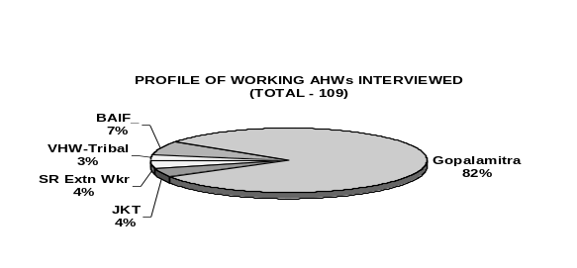

9.1.2 Trainers: Majority of the AHWs said that were trained by APLDA/AHD; as majority of them being Gopalamitras (Annexure 17, 2). Though the AHD has trained the tribal VHWs from Visakhapatnam, they were sponsored by the Integrated Tribal Development Agency under which their native villages fall. All the Small Ruminant Extension workers were trained by the ISNRMPA. NGOs Anthra, BAIF and JKT have their own programmes, though the latter two uses the Gopalamitra curriculum and takes the help of AHD. NGO RASS used facilities and faculty of University Veterinary College and AHD for their one time programme.

9.1.3 Reasons for Undergoing Training: The AHWs felt that the main reason for them to undergo AHW training is the ‘Need of the Farmers’; a third of them for ‘Earning Money’ (Annexure 17, 3).

9.1.4 Opinion on Training Aspects: The AHWs working in the field felt that the theory and practical classes and the course material that they received during training were good, even very good; same being the case with the overall learning climate (Annexure 18, 1 to 5). However, they did have some dissatisfaction with the ‘Food and Stay’ arrangements during the training period (Annexure 18, 3); only JKT and ISNARMPA coming good in this aspect and the worst experience in this respect is of tribal youth trained as VHWs.

9.1.5 Opinion on Training Topics/Subjects: The AHWs working in the field felt that training imparted to them was by far ‘Good’ and even ‘Very Good’ in AI, First Aid, Vaccination, Deworming, Livestock Management Advice, Fodder Development, Castration and Use of Local Medicines; though there seems to be considerable scope for betterment in the two items last mentioned (Annexure 18, 1 to 8), especially for Gopalamitras and BAIF workers.

Apart from all the above subjects, the AHWs were asked to give their opinion on any other topic. ‘Organisation of Health Camps’ emerges as the unanimous ‘Other’

9.2 Views of Mandal/APLDA Level Persons Concerned with AHWs’ Work:

To know the actual performance of the trained and already working in the field AHWs, an attempt was made to interview those official and no-official individuals that are concerned with the work of AHWs as technical supporters, supervisors, observers or leaders of stakeholders at Mandal and/or ALDA level. Profile of such persons concerned with and in close acquaintance with the day to day working of the AHWs is shown in the adjacent Figure.
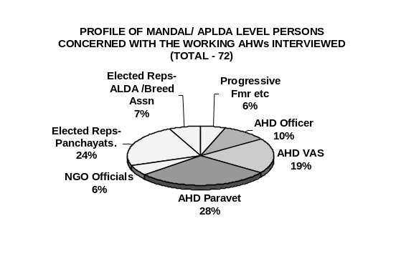

The order of satisfaction of the various individual services being provided by the AHWs in the field as per the above mentioned local concerned persons can be grouped as follows: a) Top Half - only around 5% saying ‘Not Done’ or ‘Not Well’ done (Annexure 20 - 3, 4, 1 and 2 in that order) and b) Bottom Half – as many as 20 to 40% saying ‘Not Done’ or ‘Not Well’ done (Annexure 20 – 6, 7, 5, 8 and 9 in that order). The Top Half services in descending order of delivery quality were Vaccinations, Deworming, AI and First Aid, which may be considered as the service in which the AHWs are quite skillful and doing a satisfactory job. Similar Bottom Half services in descending order of delivery quality were Fodder Development, Castrations, Livestock Management Advice (Extension!), Use of Local Medicines and Organisation of Health Camps.

Obviously the future training efforts have to be modified to pay greater attention to the bottom half subjects in formulating their curricula. The topic/subject ‘Use of Local Medicines’ is crucial as it can make the AHWs use less costly locally available medicaments (home remedies, herbal medicines etc.), which can perhaps reduce the tendency of the AHWs to use costly and often unnecessary antibiotic, anti-allergic and analgesic medicines – observed over-reach, which will be discussed else where in the report.

The topic ‘Organisation of Health Camps’ emerged as an important one. The working AHWs, the local concerned persons as well as the farmers (albeit about 30 – 40% of them) have consistently mentioned this topic under the option ‘Others’ provided to them. Sastry (2004) in his pilot study has brought out that Health Camps are becoming important service innovations because - a) Many official and non-official organisations, charitable and religious trusts and endowments as well as individuals and corporate entities have been coming forward to sponsor them; b) Health Camps permit taking specialists nearer to the farmers; c) Farmers get opportunity to get service and advice on a wide range of their problems; d) There is need for proper planning, scheduling and organisation of the same by the AHD involving Local Bodies.

As a liaison person the AHW has a crucial role in organisation of Health Camps. And hence the need to train him on all aspects of this service too.

9.3 Views of Farmers- the Service Users:

Opinions of 409 farmers with different social background and primary occupations (see the adjacent Figure) across four districts were also obtained on how they perceived the quality of the service provided by the AHWs already working in the field. The idea was to see what bearing does their training have on out-reach and over-reach of AHWs. For this purpose Mandals with different levels of livestock potentials and agro-climatic conditions were included in the sample within the four districts.
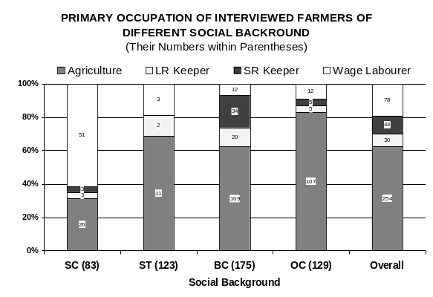

It can be safely said that, among the services studied, quality of provision wise three categories emerge – a) ‘AI’, ‘First Aid’, Vaccination’ and ‘Deworming’ whose quality was felt to be mostly better by the farmers; b) ‘Livestock Management Advice’, ‘Fodder Development’, ‘Castration’ and ‘Use of Local Medicines’ whose quality was felt to be inferior by the farmers; and c) ‘Other – Organisation of Health Camps’ brought up by the farmers themselves under ‘Other’ and for which they felt that the AHWs are not up to the task. Details of the recorded opinion differences across different possible influencing factors are as follows.

9.3.1 District wise Differences: The extent of ‘Very Good’ and ‘Good’ coverage, in the farmers’ opinion, for provision of AI service (Annexure 21, 1) was about 45% as a whole, ranging from 30% in Nizamabad district to 70% in Ananthapur district. Similar percentages responses for First Aid were 70% and 50 to 85% (Annexure 21 - 2, 3 & 4), for Vaccination were 70% and 53 to 81% and for Deworming – 52% and 48% to 60%. Lower percentages of satisfactory coverage of AI may be due to the higher levels of skill required for the same, which the AHWs might bit have yet mastered.

Having said that higher levels of good AI coverage seems to be in Ananthapur district, a drought prone one more known for small ruminants and surprisingly lowest level, in Nizamabad district with higher numbers of breedable bovines. May be the greater importance of large ruminants in livelihood (crossbred cows being the most common assets provided under various schemes) and healthy competition among three types of service providers – Gopalamitra, BAIF and JKT, leading to better overall coverage. More or less similar trends are seen for other services also. The generally lower coverage in agriculturally developed East Godavari district could be the result of more endowed farmers seeking services of doctors rather than AHWs and also naturally lower AI success rate in buffaloes, the more predominant bovines in this district.

But ‘Very Good’ and ‘Good’ coverage of other services – ‘Livestock Management Advice’, ‘Fodder Development’, ‘Castration’ and ‘Use of Local Medicines’ are generally low – below 40% (Annexure 21 - 5, 6, 7 & 8) in all the districts, indicates to a need for more attention to these in future training programmes.

9.3.2 Difference Among Mandals of Different Livestock Potential Levels: All the Mandals in Andhra Pradesh were classified for their Livestock Potential in a big study sponsored by the former ISPA, Hyderabad (Bovine Sector Study, 1991-2, carried out by ISPA, ASCI, CESS, NIRD & ANGRAU). This potential score considered livestock density, net sown area, availability of feeds and fodders, among other things. Among the sample Mandals of this study, there were one ‘Very High’, eleven ‘High’, four ‘Medium’, three ‘Low’ and one “Very Low’ potential Mandals. Thus the study tried to see the quality of service provided by the AHWs in areas with limited livestock potential also; the so called marginalized areas.

A very high percentage of farmers (70 to 85% of the 20) of the ‘Very Low’ potential Mandal (hilly, tribal area) opined that either the AHWs have ‘Not Done’ any service or the quality of all the services provided by them was ‘Not Good’ (Annexure 22 – 1 to 8). This is the hilly tribal area where distances were great, accessibility is difficult and farmers are still under transition from tribal to livestock rearing culture.

But 45 to 77% of the farmers of the ‘Low’ potential Mandals felt that the service provided by AHWs was ‘Good’ or even ‘Very Good’; especially good seems to be the quality of ‘First Aid’, ‘Vaccination’ and ‘Deworming’ services and ‘AI’ being moderately good. Such ‘Low’ potential Mandals turn out to be the most successful terrain for AHWs; the animals being more important to the perhaps financially not so well endowed locals for livelihood. Farmers of the ‘Medium’ and ‘High’ potential Mandals are, in general, next best in satisfactory level with the services of AHWs.

Surprisingly, satisfactory coverage was as low as 22% for most services in the ‘Very High’ potential Mandal; this being a Mandal in the rich Godavari Delta regions, the farmers possessing high valued and better quality animals may prefer the AHWs less and the doctors (even private) more.

As seen already, a high percentage of farmers (55 to 82%) across Mandals of all potential felt that service provision was either ‘Not Good’ and ‘Not Done’ for the services – ‘Livestock Management Advice’, ‘Fodder Development’, ‘Castration’ and ‘Use of Local Medicines’ (Annexure 22 - 5, 6, 7 & 8) in all the districts, again indicating a need for more attention to these in future training programmes.

9.3.4 Difference Among Mandals of Different Agro-Climatic Conditions: As per the Indian Council of Agricultural Research delineation of the different agro-climatic sub-regions of AP (NART, ICAR, New Delhi, 1990) and verification by this study, agro-climatic conditions wise, eight sample Mandals were ‘Marginal’, eight – ‘Average’ and five – ‘Good’. As can be seen from the Figures presented at Annexure 23 – 1 to 8, there does not seem to be much of a difference among the three types of areas with respect to the perception of the farmers of the quality of different services provided by the AHWs.

9.3.5 Difference Due to the Primary Occupation of the Farmers: The satisfaction of the farmers with the quality of ‘AI’ service provided by the AHWs seem to be highest among farmers with ‘Agriculture’ as the primary occupation, followed by ‘Large Ruminant – LR Keeper’, ‘Small Ruminant – SR Keeper’ and ‘Wage Labourer’ in that order (Annexure 24 – 1 to 8). As mentioned at the beginning of this section majority of the SCs are the ‘Wage Labourers’, who opined that ‘AI’ (68%) and ‘Deworming’ (55%) were either ‘Not Done’ or ‘Not Good’; the other services being even more unsatisfactory to them. Thus the task of the planners is to see that the AHWs definitely reach out to the daily wage earning livestock keepers.

9.3.6 Difference Due to the Social Background of the Farmers: The general trend of satisfaction levels of the farmers with the services provided by the AHWs (Annexure 25 – 1 to 8) was - a) highest for livestock keepers of ‘Other’ castes, of whom 82% are agriculturists; followed by b) ‘Backward Castes’, of whom 62% are agriculturists and 12% small ruminant keepers; c) ‘Scheduled Tribes’, of whom 69% are agriculturists, albeit small, and 9% wage earners; and d) ‘Scheduled Castes’, of whom 60% are daily wage earners and 32% small scale agriculturists. This trend is manifest for all the services provided by the AHWs. Thus neglect of the wage earning scheduled caste households with respect to provision of livestock services is definite and disturbing.

9.3.7 Difference Due to the Main Service Providing Organisations Operating in the Sample Village: The sample Mandals were selected in such way that the operational areas of the main livestock service providing organisations in Andhra Pradesh were covered, to the extent possible (Annexure 26 – 1 to 8). It should be remembered that such areas are not exclusive to the named organisation, but it is the main service provider, as the AHD has let certain NGOs and Gopalamitras operate in certain villages/areas. It should be further noted that, any farmer from the operational area of a given service providing organisation always has the option to seek services from some one else, even from outside that area, which many farmers often do.

For example, in the operational village of NGO Girijan Deepika (GD) in the hilly tribal region in East Godavari district, whose AHWs were trained by NGO Anthra, one farmer had his animal artificially inseminated by some one else, as the mentioned AHWs of GD are neither trained nor expected to provide AI service. In this particular area, perhaps due to lower density of workers or their mobility or ability or a combination of all the three factors coupled with the as yet low intensity of livestock production and greater poverty in this difficult region almost all the services were ‘Not Done’ as per the opinion of more than 70% (64 to 88%) of the farmers (Annexure 26 – 1 to 8).

The study team feels that there is a definite need for a special in-depth study of the marginalized hilly tribal region of Andhra Pradesh spread across seven districts for evolving livestock development strategies appropriate to the local conditions and needs. It is difficult from a general study to get precise information about the problems specific to this region that would enable us to plan special strategies.

As regards AI (Annexure 26 – 1), from 40 to 45% of the farmers opined that the service was ‘Very Good’ and ‘Good’, the difference between the service provider organisations being marginal with the exception of NGO JKT. While the performance of the workers of NGO BAIF and Gopalamitra were more or less similar (around 45%) to that of the RLUs (Rural Livestock Units headed by a government paravet) and VD (Veterinary Dispensaries headed by a veterinarian), workers of NGO JKT gave satisfactory service as per 75% farmers. Thus, as regards AI, while there is not much of a difference between the different service provider AHWs and organisations, JKT service was the most appreciated one.

Except in the tribal area covered by NGO GD (for reasons mentioned above), there is practically no significant differences among the different AHWs and AHD institutions in satisfactory levels for other services; only JKT AHWs seem to be better in providing ‘First Aid’ (Annexure 26 – 2) and ‘Vaccinations’ (Annexure 26 – 3).

9.3.8 Differences in Service among Different Land Holding Classes: Simply revealing are the opinions of the farmers of different land holding classes on the quality of livestock services provided by AHWs. Both the ‘Not Done’ and ‘Not Good; responses of farmers for all the services were highest (60 to 80%) in case of landless livestock keepers (who are generally the poorest) and decreased as the land holding size of the farmers increased; 60 to 80% of farmers with more than 15 acres of total land holding saying that the services provided were ‘Good’ and ‘Very Good’ (Annexure 27).

9.3.9 Differences in Service among Different Small Ruminant Holding Classes: The study also tried to look into the service patters of farmers possessing different sizes of small ruminant flocks (Annexure 28). Farmer of ‘None’ small ruminant classes are virtually those who keep only bovines. Farmer of ‘< 10’ small ruminant classes are generally the keepers of goats alone for supplementary income. AHWs were providing reasonably satisfactory services to these categories of farmers. But as high as 65% (40 to 85%) of the ’50 – 100’ and ‘> 100’ categories of small ruminant, who are invariably traditional shepherds felt that the services not provided (‘Not Done) by AHWs or they were ‘Not Good’ (Annexure 28 – 1 to 7). Thus, traditional shepherds, especially those not having big flocks, seem to be at a disadvantage;’ more so because the deprived services include crucial vaccination and deworming.

9.3.10 Differences in Service among Different Backyard Poultry Holding Classes: Similarly the study also tried to look into the service patters of farmers possessing different sizes of backyard poultry units (Annexure 29). As compared to small ruminants, the ‘Vaccination’ and ‘Deworming’ services provided by AHWs to birds across different backyard poultry units were better as per the poultry keepers (Annexure 29 – 2 & 3). ‘First Aid’ and especially ‘Management Demos’ (Extension!) services were rather unsatisfactory.

9.3.11 Role of AHWs in Organising Health Camps: This particular activity was not originally included as a service to be provided by the AHWs, at least in the study. But wherever an option “Any other” was given to farmers, local concerned persons and even to AHWs, invariably ‘Organisation of Health Camps’ cropped up as an important activity – service. This and in view of the findings of an earlier study (Sastry, 2004), this aspect was also studied (Annexure 30). The conclusion that can be formed from the trends shown in Annexure 30 – 1 to 7 is that, though every one feels that organisation of health camps is an important service to the farmers’ animals, such camps are not very frequent as of now. But this ‘service’ may be seriously considered in all our future plans as this is actually a medium for providing a gamut of quality services to large number of farmers periodically at least.

9.3.12 Over-Reach by the AHWs: All said and done, the AHWs were trained and deployed to carry out limited services at the doorstep of the farmers. They are neither trained for nor expected to do such things that can only be done by a qualified veterinarian. If the AHWs still carry out such things, they are clearly over-reaching their brief. To know of this they were asked in a very discrete and simple way (jumbled with other options) to tell whether they carry out any such activities.

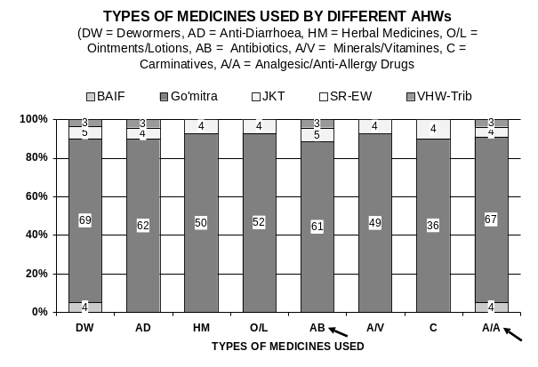 | 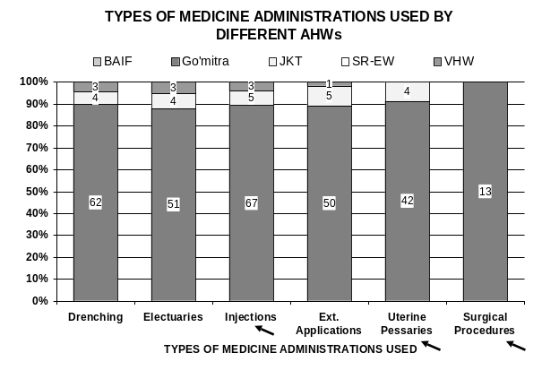

It is obvious from the above figure that most of them, especially the Gopalamitras do undertake actual ‘Treatment’ of animals (as against provision of ‘First Aid’). As can be seen in the adjacent diagram (marked with arrows) the AHWs do carry out some undesirable things (uses) by their own statement. The Gopalamitras were the most notorious in this respect (See the Table below). Only the Sheep Extension Workers were not indulging in such activities. Though BAIF AHWs are also good, they do use of analgesics and anti-allergic medicines, undesirable by persons with their limited qualification. As mentioned earlier, the Tribal AHWs (3 in Visakaha area) are not cared for by any responsible agency. Hence they run riot with use of undesirable medicines.

Percentage of Different AHWs Using / Doing the Following Undesirable Things
Type of  AHW | Use of Anti-  biotics | Use of Analge-sic/Anti-Allergy | Doing Inje-  ctions | Using Uterine  Pessaries | Doing Surgical Procedures
BAIF_AHW | 0 | 80 | 0 | 0 | 0
Gopalamitra | 69 | 76 | 91 | 48 | 15
JKT_AHW | 63 | 50 | 63 | 50 | 0
Sheep EW | 0 | 0 | 0 | 0 | 0
Tribal-AHW | 100 | 100 | 100 | 0 | 0

This tendency has a potential to become uncontrollable later, if immediate steps are not taken now. Apart from improving supervision and related procedures, training can play a crucial part in this. It is during training that they have to be imparted appropriate knowledge about dangers of their over-reach in the long run.

10 Conclusions & Recommendations

10.1 Training – Improvement:

- It is obvious from the discussion in this study that there are a variety of training programmes in Andhra Pradesh to meet the various needs of the livestock owners. Also, the study shows that the programmes are not only good on paper, but are implemented well. However, the study also highlights some weaknesses of the current programme. Addressing these issues can significantly enhance the effectiveness of the programmes in meeting the needs of the livestock programmes.
- First, the number of females trained as paravets is only 9 % in the government programmes. It is common knowledge that women generally have a larger role in livestock production and they are better able to understand and appreciate the Thus, it is important to involve more women in AHW training including Gopalamitras.
- Secondly, the government programmes focus mostly on the peri-urban areas, where as the backward and less developed areas are covered by NGOs and voluntary organization. This calls for enhanced efforts on the part of the government to extend services in remote and marginal areas.
- Third, most of the programmes focus on large ruminants, where as there is not enough emphasis on training programmes for small ruminants.
- Fourth, the Gopalamitra programme needs to be appropriately regulated to address the services provided by the paravets which are beyond their mandate. Finally, more effort needs to be put into regular follow up with the trainees after completion of the training and evaluation of the performance of the health workers.
- From the above observations the study it emerges that there are three problem areas concerning provision of livestock services by AHWs, in fact by any service providers,. They are – a) Marginal, hilly, tribal, low livestock potential areas of Andhra Pradesh spread across 7 districts; b) Landless, daily wage earning, scheduled caste livestock keepers; and c) Medium and large small ruminant holding flock holding traditional shepherd communities. All of them are mostly poor farmers.
- The two training programmes meant for those entering the AHD as employees, the Government Paravets, are a lot more advanced than the various training programmes meant for community based para-workers. The AHD and ANGRAU have to consider together whether it is necessary for them to run two separate programmes (One-year Vetery Assistant Programme by AHD and the 2-year Veterinary Polytechnic Programmes by ANGRAU) to cater to the same purpose and same client. The Study Team feels that there is necessity for merging the two as a joint programmes as a two year course after 10th Class. While ANGRAU use the infrastructure of the Polytechnics (more are to be opened at other places by the State Governemnt) as the nucleus, with the internship training organized by AHD in the field.

10.2 Training of AHWs to Match Field Situations:

10.2.1 Views of Trained & Working AHWs:

- While all other aspects of training were found to be good by AHWs, they did have some dissatisfaction with the ‘Food and Stay’ arrangements during the training period.
- Not well covered subjects include castration and use of local medicines; there is considerable scope for betterment in the two items last mentioned.

10.2.2 Views of Mandal/APLDA Level Persons Concerned with AHWs’ Work:

- The Top Half (better) services in descending order of delivery quality were Vaccinations, Deworming, AI and First Aid, which may be considered as the service in which the AHWs are quite skillful and doing a satisfactory job.
- The Bottom Half services in descending order of delivery quality were Fodder Development, Castrations, Livestock Management Advice (Extension!), Use of Local Medicines and Organisation of Health Camps in which the AHW was found wanting.
- Obviously the future training efforts have to be modified to pay greater attention to the bottom half subjects in formulating their curricula. The topic/subject ‘Use of Local Medicines’ is crucial as it can make the AHWs use less costly locally available medicaments (home remedies, herbal medicines etc.), which can perhaps reduce the tendency of the AHWs to use costly and often unnecessary medicines.
- The topic ‘Organisation of Health Camps’ emerged as an important one. The working AHWs, the local concerned persons as well as the farmers (albeit about 30 – 40% of them) have consistently mentioned this topic under the option ‘Others’ provided to them. As a liaison person the AHW has a crucial role in organisation of Health Camps. And hence the need to train him on all aspects of this service too.

10.2.3 Views of Farmers-Users:

- Quality of service in ‘AI’, ‘First Aid’, Vaccination’ and ‘Deworming’ was felt to be mostly better by the farmers, while the quality of service in ‘Livestock Management Advice’, ‘Fodder Development’, ‘Castration’ and ‘Use of Local Medicines’ was felt to be inferior by the farmers.
- A very high percentage of farmers (70 to 85% of the 20) of the ‘Very Low’ livestock potential Mandal (hilly, tribal area) opined that either the AHWs have ‘Not Done’ any service or the quality of all the services provided by them was ‘Not Good’.
- But ‘Low’ livestock potential Mandals turn out to be the most successful terrain for AHWs; the animals being more important to the perhaps financially not so well endowed locals for livelihood.
- Farmers of the ‘Medium’ and ‘High’ livestock potential Mandals are, in general, next best in satisfactory level with the services of AHWs.
- As seen already, a high percentage of farmers (55 to 82%) across Mandals of all potential felt that the quality of service provision was either ‘Not Good’ and ‘Not Done’ for the services – ‘Livestock Management Advice’, ‘Fodder Development’, ‘Castration’ and ‘Use of Local Medicines’ in all the districts, again indicating a need for more attention to these in future training programmes.
- There does not seem to be much of a difference among the three types agro-climatic conditions wise different Mandals (‘Marginal’, eight – ‘Average’ and five – ‘Good’) with respect to the perception of the farmers of the quality of different services provided by the AHWs.
- Majority of the SCs are ‘Wage Labourers’, who opined that ‘AI’ (68%) and ‘Deworming’ (55%) were either ‘Not Done’ or ‘Not Good’; the other services being even more unsatisfactory to them. This trend is manifest for all the services provided by the AHWs. This neglect of the wage earning scheduled caste households with respect to provision of livestock services is definite and disturbing. Thus the task of the planners is to see that the AHWs definitely reach out to the daily wage earning livestock keepers.
- In hilly tribal area, perhaps due to lower density of AHWs or their mobility or ability or a combination of all the three factors coupled with the as yet low intensity of livestock production and greater poverty in this difficult region almost all the services were ‘Not Done’ as per the opinion of more than 70% (64 to 88%) of the farmers. This is problem area – a challenge for betterment of livestock services.
- As regards AI, while there is not much of a difference between the different service provider AHWs (Gopalamitra, JKT and BAIF) and AHD institutions (RLY & VD), JKT service was the appreciated more.
- Simply revealing are the opinions of the farmers of different land holding classes on the quality of livestock services provided by AHWs. Both the ‘Not Done’ and ‘Not Good’ responses of farmers for all the services were highest (60 to 80%) in case of landless livestock keepers (who are generally the poorest) and decreased as the land holding size of the farmers increased.
- As high as 65% (40 to 85%) of the ‘50 – 100’ and ‘> 100’ categories of small ruminant holdings, who are invariably traditional shepherds felt that the services were either not provided (‘Not Done) by AHWs or they were ‘Not Good’. Thus, traditional shepherds, especially those having medium and big sized flocks, seem to be at a disadvantage; more so because the deprived services include crucial vaccination and deworming.
- ‘Vaccination’ and ‘Deworming’ services provided by AHWs to birds across different backyard poultry units were better than that for small ruminants, as per the poultry keepers; however, ‘First Aid’ and especially ‘Management Demos’ (Extension!) services were rather unsatisfactory.
- Though every one – farmers, local concerned persons, working AHWs - feels that organisation of health camps is an important service to the farmers’ animals, such camps are not very frequent as of now. But this ‘service’ may be seriously considered in all our future plans as this is actually a medium for providing a gamut of quality services to large number of farmers periodically at least.
- Most of the AHWs, especially the Gopalamitras do undertake actual ‘Treatment’ of animals (as against provision of ‘First Aid’). This is a case of over-reach by them as they are indulging in - Use of Antibiotics, Use of Analgesic/Anti-Allergy, Doing Injections, Using Uterine Pessaries, Surgical Procedures.
- This tendency has a potential to become uncontrollable later, if immediate steps are not taken now. Apart from improving supervision and related procedures, training can play a crucial part in this. It is during training that they have to be Quality of service in imparted appropriate knowledge about dangers of their over-reach in the long run.

10.2.4 Remodeling Training Programmes:

- What is suggested in this section is designed to be an ‘in-put’ for an empowered suitable committee, which has to do the actual remodeling of the AHW training programme.
- In the interest of providing satisfactory livestock service to the farmers it is necessary to have similarly trained AHWs everywhere, which ever may be the service providing organisation. In other words, whether Gopalamitra or AHWs NGOs, it is imperative that all have a comprehensive broad-based training. Training mainly for AI service, in the field context, is not desirable; it is seen that Gopalamitras, BAIF AHWs and JKT AHWs are also carrying out other services. It is inevitable in the field.
- There are programmes lasting from 20 days to 180 days for AHWs. Though one organisation may claim that they also teach a given subject (say First Aid) and hence their AHWs are game for it in the filed. But the same ‘First Aid’ might be dealt in a 20-30 day programme would be superficial where as the same taught in a 3 – 4 month programme will be comprehensive. Hence there is need for standardizing the course duration for all; the suggested period is six months (including 2 month internship) due to reasons given below. Such a committee should include representatives of stakeholders, especially NGOs.
- After successful completion of the training as judged by a committee (Concerned JD, Trainer AD and a Retired Veterinarian) via Practical and Viva tests, the trainee should be issued a proper ‘Course Certificate’.
- Such a Course Certificate should clearly mention that the person concerned is ‘permitted to provide basic livestock service under the supervision of a qualified veterinarian’
- In the interest of uniformity, the future training programme may be organized utilising the infrastructure at RAHTCs used for the present Gopalamitra programme with suitable modifications. Desirous NGOs can get their candidates trained there or carry out themselves with the common curriculum as the basis, provided they have the necessary infrastructure.
- So as to address the specific problems of the three problem areas only candidates from the respective societies and localities should be selected in consultation with the society elders; the candidate must satisfy the admission qualifications, however. They are –
- Landless, daily wage earner, SC community - From the same SC Society
- Hilly, tribal, low livestock potential area - From the same Tribal Society
- Medium & large flock owning Shepherds - From the same Shepherd Society
- Taking into consideration the issues that emerged from the study, the suggested subjects and topics for a comprehensive basic AHW training course of 6 months durations (including 2 months internship) is as follows:

SUBJECTS & TOPICS
1. REPRODUCTION & AI: Basics about Animals; Reproduction; AI Service; Bull, buck, ram management; Castration;
2. HEALTH CARE: Basics of Health & Disease; First Aid; Vaccination; Handling vaccines during transit and usage; Deworming; Use of Herbal Medicines & Home Remedies etc; Disease Control – Disease Recording, Disease Reporting, Sample / Specimen Collection and Forwarding, ‘Holding the Fort’;
3. PRODUCTION & MANAGEMENT: Dairy Animal Management; Sheep & Goat Management, Backyard Poultry Farming; Swine Production; Fodder-Grazing Development; Feeding during Natural Calamities;
4. EXTENSION, LIAISON & ORGANISATION: Assessing Local Needs via PRA; Organising - Training, Demonstrations, Meets, Fairs, Health Camps, Emergency Shelters/Camps, Pregnancy Diagnosis by VAS; Distribution of Extension Material; Spreading Extension Messages using local folk songs etc; Referring & Reporting to designated VAS; Keeping Work Records; Care of Equipment; “Dos” and “Don’ts” in service provision with caution on consequences of over-reach; Main livestock schemes in operation;
5. INTERNSHIP: Livestock Farms (10 days), DI Lab & Semen Station (10 days); Hospital/Dispensary/RLU (40 days)

- The whole training cost may be borne by the government. This expenditure may be considered as an investment for low cost spreading services of the department.
- Boarding and lodging facilities be provided by the training organisations. If necessary, facilities available with District Dairy Unions may be requested for the purpose.
- Follow-up as a part of training: At present the trained AHWs, especially Gopalamitras constituting 80% of the AHWs, are on their own from day one with a rather weak support and supervision system in place. The ‘nearest VAS’ who is expected to supervise the work of the AHWs is very busy with a plethora of other technical and non-technical duties. This is an important reason for the not so good out-reach and not so desirable over-reach by them. The following system is suggested as a common solution for – a) improving the quality services of the AHWs along the desired lines; b) making them responsible to the consequences – good and bad – of their activities; c) remove disparities between Gopalamitras and NGO (BAIF, JKT, RASS) AHWs; and c) integrating them into the overall service delivery system.

  - Provide a monthly stipend of Rs. 1,500 per trained and placed AHW for a period of one year so that he/she can establish him/her self. This stipend should be for a period of two years in case of three categories of AHWs listed under Item 7 above.
  - A cadre of VAS, say ‘VAS i/c AHWs’, may be specially assigned in each Mandal just for support and supervision of the AHWs in that Mandal. He should be located at the Mandal level VH or VD, kept free from other duties and provided TA / Transport for touring the Gopalamitra centers in the Mandal. The VAS manning the proposed Mobile Veterinary Clinics could be the ideal person.
  - The monthly stipend amount of the AHWs should be released only after this ‘VAS i/c AHWs’ issues a clearance stating that the work of the AHW during the month was satisfactory.
  - This assessment has to be done on the basis of - a) at least one visit by VAS to Gopalamitra/AHW centre and b) at least one visit by the AHW / Gopalamitra to the office of the VAS. During such visits the following activities may be undertaken – i) Verification of records, ii) Technical back-stopping, iii) Issue of supplies (medicines, vaccines, semen, liquid nitrogen etc), iv) Problem solving and v) Quality control etc. can take place.

10.3 Need for a Further Study:

From the above observations and conclusions of the study it emerges that there are three problem areas concerning provision of livestock services by AHWs, in fact by any service providers,. They are – a) Marginal, hilly, tribal, low livestock potential areas of Andhra Pradesh spread across 7 districts; b) Landless, daily wage earning, scheduled caste livestock keepers; and c) Medium and large small ruminant holding flock holding traditional shepherd communities. All of them are mostly poor farmers. It is difficult from a general study like the present one to get precise information about the problems specific to such areas / communities, for whom livestock are a crucial livelihood resource. The Study Team feels that there is a definite need for a special in-depth study with a focus on such areas / communities that would enable us to evolve livestock development strategies appropriate to the local conditions and needs.

ANNEXURES

ANNEXURE 1

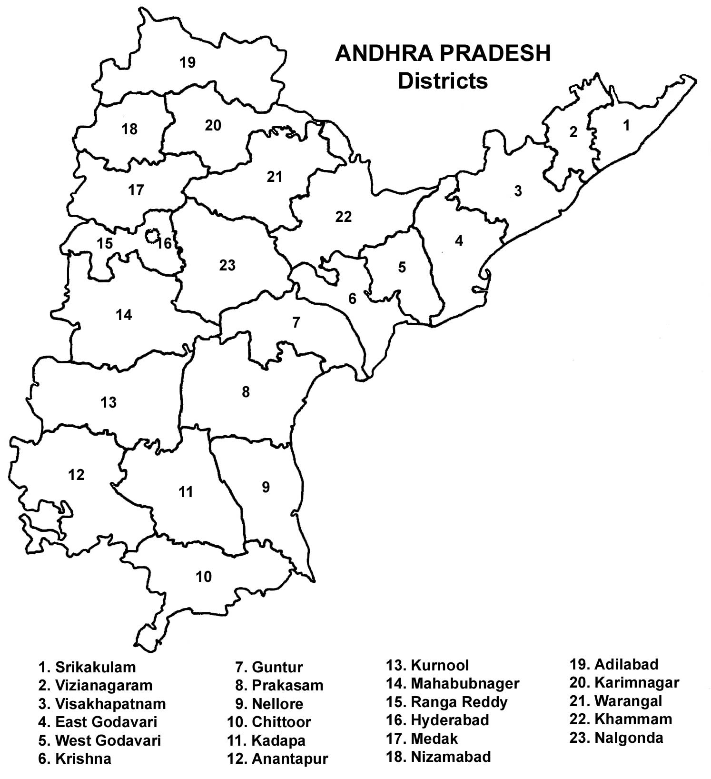

ANNEXURE 2
Organisations Training Paravets in Andhra Pradesh
* Organisations that have responded
**Sent 6 responses – one for each course
State Animal Husbandry Department
1 | State Management Institute for Livestock Development in AP (SMILDA), AH Dept, Hyderabad
2 | State Animal Husbandry Training Centre (SAHTC), Mandapeta, EG District
3 | Veterinary Biologicals Res. Institute Training Centre, DAH, Hyderabad
4 | Regional Animal Husbandry Training Centre (RAHTC), Kakinada*
5 | Regional Animal Husbandry Training Centre (RAHTC), Guntur*
6 | Regional Animal Husbandry Training Centre (RAHTC), Gannavaram*
7 | Regional Animal Husbandry Training Centre (RAHTC), Karimnager*
8 | Regional Animal Husbandry Training Centre (RAHTC), Mamnoor*
9 | Regional Animal Husbandry Training Centre (RAHTC), Visakhapatnam**
10 | Regional Animal Husbandry Training Centre (RAHTC), Reddipally
11 | Regional Animal Husbandry Training Centre (RAHTC), Seetharampeth*
12 | District Animal Husbandry Training Centre (DAHTC), Srikakulam
13 | District Animal Husbandry Training Centre (DAHTC), Vizayanagaram
14 | District Animal Husbandry Training Centre (DAHTC), Visakhapatnam*
15 | District Animal Husbandry Training Centre (DAHTC), Kakinada*
16 | District Animal Husbandry Training Centre (DAHTC), Tanuku* (also known as AP Vet Institute)
17 | District Animal Husbandry Training Centre (DAHTC), Gudiwada*
18 | District Animal Husbandry Training Centre (DAHTC), Guntur*
19 | District Animal Husbandry Training Centre (DAHTC), Nellore
20 | District Animal Husbandry Training Centre (DAHTC), Kadapa
21 | District Animal Husbandry Training Centre (DAHTC), Prakasham
22 | District Animal Husbandry Training Centre (DAHTC), Chittor*
23 | District Animal Husbandry Training Centre (DAHTC), Ananthapur
24 | District Animal Husbandry Training Centre (DAHTC), Kurnool*
25 | District Animal Husbandry Training Centre (DAHTC), Mahabubnager*
26 | District Animal Husbandry Training Centre (DAHTC), Ranga Reddy
27 | District Animal Husbandry Training Centre (DAHTC), Medak
28 | District Animal Husbandry Training Centre (DAHTC), Nizambad
29 | District Animal Husbandry Training Centre (DAHTC), Adilabad
30 | District Animal Husbandry Training Centre (DAHTC), Karimnager
31 | District Animal Husbandry Training Centre (DAHTC), Warangal
32 | District Animal Husbandry Training Centre (DAHTC), Khammam*
33 | District Animal Husbandry Training Centre (DAHTC), Nalgonda
State Agricultural University (ANGRAU), Hyderavad
34. | Veterinary Polytechnic, Palamner, Chittoor district*
Non-Government Organisations
35. | Rayalaseem Seva Samithi (RASS), Tirupati, Chittoor district*
36. | J.K. Trust Gram Vikas Yojana, Chittoor*
37. | Anthra, Hyderabad (also at Pune)*
38. | Bharatiya Agro Industries Foundation – BAIF, Mahbubnagar & Ananthapur districts

ANNEXURE 3

Particulars of the Organisations & Training Facilities Available

A  MAIN THRUST | 
B  TARGET COMMU-NITY | 
C  TARGET AREA | 
D  WHY P’VET  TNG | 
E  UTILITY SELF ASSESS | 
F  AVAILABLE  TRAINING  FACILITIES |  | 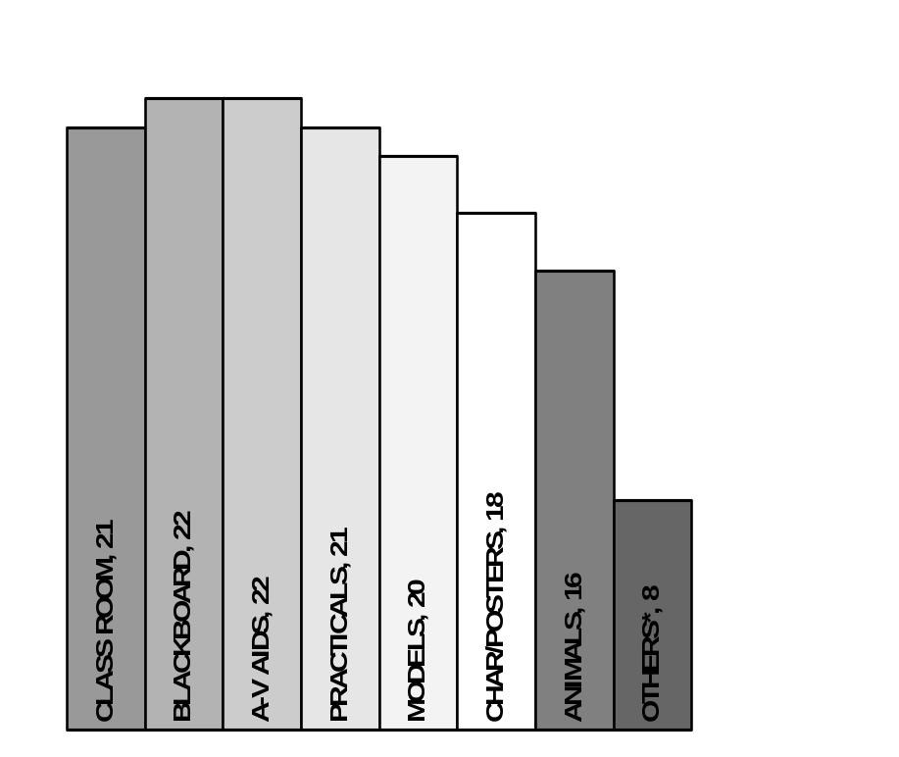

ANNEXURE - 4
Different listed Paravet courses at Regional AH Training Centres of DAH, Andhra Pradesh
(For Young Farmers, DWCRA (SHG) Women, Field Workers of other Projects with predominant Livestock Component, Workers of NGOs, Students, etc )

Code No. | Name of the Training Programme | Duration
1 | Refresher Training for Gopalamitras (Friend of Cattle Keepers) | 5 days*
2 | Fresh Gopalamitra (Friend of Cattle Keepers) Training | 4 mhs#
3 | Sanghamitra (Friend of Society - of sheep rearers – Training | 45 days#
4 | Management of Dairy Cattle | 3 days*
5 | Yadavamitra (Friend of Shepherds) Sheep Training | 2 days*
6 | Rythumitra (Friend of Farmers) Training | 2 days*
7 | A.I.Training to Paid Secretaries of Milk Union | 6 days*
8 | Farmers Training Programmeme | 1 day*
9 | Sensitization on Jalachaitanya (Water Awareness) | 1 day*
10 | Training of Community Coordinator of VELUGU (WB Rural Livelihood Project) | 1 day*
11 | Handling of Animals & Administration of Medicines | 2 days*
12 | Veterinary First Aid For Tribal Youth (like Gopalamitra, minus AI). | 4 days*
13 | Community Livestock Extension Workers Training (for RASS, AHD collaborates) | 30 days#
14 | J.K.Trust (NGO) (to upgrade Gopals into Gopalamitras) | 4 months#
15 | Dairy Science Vocational Course for 1st Year Students of Vet. Polytechnic | 1 month#
16 | M.L.T. Training For 2nd Year Students of Vet. Polytechnic | 5 days*
17 | Zoonoses Day Meeting | 1 day*
18 | Fodder Week Meeting | 1 day*
19 | Sheep Deworming | 1 day*
20 | Calf Deworming | 1 day*
21 | Calf Vaccination Schedules | 1 day*
22 | Animal Welfare Activities | 1 day*
23 | F & M Disease Control Measures in Sheep | 1 day*
24 | Care & Management of Calves | 1 day*
25 | Livestock Activities Training for Velugu (Vaccination, Deworming, First aid) | 45 days#
26 | Skill Up-gradation Training on Dairy Development | 1 day*
27 | Training to A.I. Workers of Milk Anoor Mahila Dairy | 4 days*
28 | Orientation on Livestock Management to Velugu Samakya Members (see J above) | 1 day*
29 | Training on Animal Husbandry Activities | 1 day*
30 | Women Poultry Vaccinator Training | 2 days*
31 | Workshop on Delivery of Quality Service to Rural Poor | 3 days*
32 | One_ Day Orientation to Sanghamitras | 1 day*
33 | Women Training to Mahila Samakya Members (see AE above) | 1 day*
34 | Reorientation Training To Animal Health Workers | 7 days*
35 | Dairy, Sheep, Poultry Management & Fodder Production | 3 days*
36 | Dairy Management SHG Leaders | 2 days*
37 | Livestock Production for Rural Livelihoods | 1 day*
38 | Preventive Health Care & Management of Sheep | 1 day*
39 | Leadership Development Programmes for The President & Secretaries of the Primary Sheep & Goat, Co-Op Societies | 1 day*
NOTE: * denotes courses with duration in days (1 – 7), 33 courses,
# denotes courses with duration in months (1-4), 6 courses
ANNEXURE 5

Different Paravet courses offered by various organisations as mentioned by them

Sl.No. | Course titles
 | Duration in Years
1 | Pre-service training for Vet Assistants (1 year)
2 | Diploma in Animal Husbandry (2 years, Ag. University)
 | Duration in Months
3 | Basic Training for Gopalamitras
4 | Field application of AI with frozen semen, addressing critical gaps (Refresher for G’mitras)
5 | Extensionn for Fodder Dev in dry areas
6 | Course on Vet. First Aid for tribal youth
7 | Village Vet. Guides (NGO - RASS)
8 | Livrestock Extension Workers' Training for Velugu Project of Chittoor Dt
9 | Training of Gopals (NGO – JKGVS
 | Duration in Days
10 | Refresher Training for Gopalamitras
11 | Care & management of calves and heifers
12 | Extension approaches for irrigated and drylsnd fodder development
13 | AI & AH
14 | Collection & Despatch of clinical material
15 | AI and follow up
16 | Calf Managemen
17 | Vet Inst Upkeep (Sterilisation, ecord keeping etc)
18 | Field problems in calf rearing and options for improvement
19 | Preventive health care and management of livestock
20 | Orientation to organisation of animal health camps and follow up
21 | Calender for operations in sheep management;
22 | Course on livestock breeding, feeding and management
23 | Reporting outbreaks and condcting vaccination
24 | Handling frozen semen
25 | Handling animals & administering medicines
26 | Vet First Aid
27 | Extension approaches in sheep rearing
28 | Collection of livestock census
29 | Obtaining critical feed back from the trainees after each training module on the methodology, training aids, training content reading material etc

ANNEXURE 6
Curriculum for pre-service training for 1-year veterinary assistants
A. An Overview of the contents of the 5 blocks of the service training
Block | Loca-  Tion | Purpose/ main contents | Batch size | Dura- tion | Trai- ners
1 | LATC  (Training Centre) | LATC 1: First Basic Training: The trainees are provided with the basics of animal management, artificial insemination, castration, fodder development and extension. This block gives the theoretical fundamentals for the next blocks | 20-25 | 4m | LATC trainers
2 | VD | Internship 1: Practical introduction to Field Reality. The trainees gain hands-on experience on animal management, fodder development, artificial insemination and extension under the close supervision of a VAS. | 2 | 3m  (2x6w) | VAS
3 | VPC/ VH | Intensive Training in Animal Health: Care The trainees become confident and competent in all activities related veterinary first aid and in identifying the common diseases to be referred to the VAS. Additionally the training covers functional knowledge and skills on preventive health coverage. | 5 | 2m | District trainers
4 | RLU | Internship 2: Exposure to the Working Situation. The trainees perform different tasks at his own responsibility under the guidance of an experienced paravet. A strong focus is on extension activities and the administrative procedures required by the AHD. | 1 or 2 | Lm | Para-vets
5 | LATC | LATC 2: Completion: The trainees share their experiences and receive additional input to fill in gaps. The trainees receive more detailed input on animal management, fodder and feeding, as well as administrative procedures. The block puts special emphasis on extension. | 20-25 | 2m | LATC trainers
B. The target group of the pre-service training are newly recruited Veterinary Assistants with the following characteristics
Age | Minimum: 18 / maximum: 35 / average: 25. Sometimes there are groups of attenders (in-service candidates) with an age up to 45 years
Gender ratio - Male : Female | By law the ratio is 2/3 : 1/3
Number: trainees to be trained in one batch as a group | 20 - 25 at LATC, 5 at VPC, 1 or 2 at other places
Educational background -minimal entry requirements, preferred learning style | At present: 10+2 is minimal requirement. In reality many are even graduates, or on the other hand they are attenders with a lower educational background.  In future: Minimal requirement is 10+. Most of the trainees come from rural families and have agricultural background. Lectures, demonstrations and field exposures are preferred learning activities
Motivation : Why do they join this training programme? | Job security, Prestige and social status, Promotion (attenders), Self-employment, Increase of income, Social Security
Strengths : personal characteristics, particular experiences | Newly recruited paravets have high retention (learning) capacity and demand high standards. Trainees are curious to learn and ready for performing well.
Weaknesses : lack of prerequisite knowledge; lack of basic skills. Undesirable attitudes | Newly recruited trainee's lack of knowledge on the job charts. There is a general perception that women are not able (and willing) to work in rural areas. Some older attenders have physical disabilities.
C. Overview of lessons per input Block
Block | Subject/Task |  | Lessons
1 LATC | 1 .General study of body  parts and their functioning  (Ruminants) | 1.1 External body parts of the animal | 4
1 LATC |  | 1.2 Internal body parts of the head region | 8
1 LATC |  | 1.3 Internal body parts of the neck region | 1
1 LATC |  | 1.4 Internal body parts of the chest region | 6
1 LATC |  | 1.5 Internal body parts of abdominal cavity | 6
1 LATC |  | 1.6 Internal body parts of pelvic cavity | 6
1 LATC |  | Total lessons | 31
1 LATC | 2.Livestock management  - (large and small  ruminants) | 2.1 Advise on management of dairy animals | 54
1 LATC | 2.Livestock management  - (large and small  ruminants) | 2.2 Advise on calf management | 6
1 LATC | 2.Livestock management  - (large and small  ruminants) | 2.3 Perform calf deforming | 10
1 LATC | 2.Livestock management  - (large and small  ruminants) | 2.4 Advise on management of small ruminants | 38
1 LATC | 2.Livestock management  - (large and small  ruminants) | Total lessons | 108
1 LATC | 3. Artificial Insemination | 3.1 Upkeep of Liquid Nitrogen Container | 4
1 LATC | 3. Artificial Insemination | 3.2 Ask owner the history of animal | 4
1 LATC | 3. Artificial Insemination | 3.3 Examine animals for heat symptoms | 8
1 LATC | 3. Artificial Insemination | 3.4 Load A.I. Gun | 4
1 LATC | 3. Artificial Insemination | 3.5 Conduct A.I. | 10
1 LATC | 3. Artificial Insemination | 3.6 Advise farmers on post AI care and follow up | 4
1 LATC | 3. Artificial Insemination | 3.7 Arrange examination of repeat breeders by VAS & perform first aid | 6
1 LATC | 3. Artificial Insemination | 3.8 Record information on the animal and the owner | 2
1 LATC | 3. Artificial Insemination | 3.9 Record calf births | 1
1 LATC | 3. Artificial Insemination | Total lessons | 43
1 LATC | 4. Castration | 4.1 Advise farmer on castration of bulls | 2
1 LATC | 4. Castration | 4.2 Maintain casting pit | 2
1 LATC | 4. Castration | 4.3 Cast the animal safely | 6
1 LATC | 4. Castration | 4.4 Sterilise castrator | 2
1 LATC | 4. Castration | 4.5 Perform castration | 10
1 LATC | 4. Castration | 4.6 Advise farmers on post castration care | 4
1 LATC | 4. Castration | 4.7 Record information on castration | 1
1 LATC | 4. Castration | Total lessons | 31
1 LATC | 5. Extension-1 | 5.1 Advise individual farmers | 6
1 LATC | 5. Extension-1 | 5.2 Give short presentations | 6
1 LATC | 5. Extension-1 | 5.3 Conduct a demonstration | 6
1 LATC | 5. Extension-1 | 5.4 Organise field visits | 4
1 LATC | 5. Extension-1 | 5.5 Organise health camps | 6
1 LATC | 5. Extension-1 | 5.6 Organise infertility camps | 6
1 LATC | 5. Extension-1 | 5.7 Organise calf rallies | 4
1 LATC | 5. Extension-1 | 5.8 Assist in publicity campaigns | 6
1 LATC | 5. Extension-1 | 5.9 Assess farmers' (men and women) needs | 10
1 LATC | 5. Extension-1 | Total lessons | 54
1 LATC | 6. Fodder Development - | 6.1 Advise farmers on fodder cultivation | 10
1 LATC | 6. Fodder Development - | 6.2 Advise farmers on pasture development | 10
1 LATC | 6. Fodder Development - | 6.3 Advise farmers on fodder tree development | 10
1 LATC | 6. Fodder Development - | Total lessons | 30
3 VPC | 1. Veterinary First Aid | 1.1 Compound and dispense medicines | 10
3 VPC | 1. Veterinary First Aid | 1.2 Examine Animals | 10
3 VPC | 1. Veterinary First Aid | 1.3 Perform first aid | 35
3 VPC | 1. Veterinary First Aid | 1.4 Send specimens of blood, urine, dung, milk, skin scrapings for examination | 10
3 VPC | 1. Veterinary First Aid | 1.5 Follow up till cured | 4
3 VPC | 1. Veterinary First Aid | 1.6 Assist higher up in animal treatment | 10
3 VPC | 1. Veterinary First Aid | Total lessons | 79

ANNEXURE 7
Course curriculum of the 2-year Animal Husbandry Polytechnic organized by the state agricultural university in collaboration with state HD

NOTE: * Credit Hours: Figures before the ‘+’ are theory classes of hour each per week and those after the ‘+’ are practical classes of 2 hours each per week.

No. | Name of the Course | Credit Hours*
FIRST SEMESTER
1. | Basic in Anatomy and Physiology | 2+2 = 4
2. | Livestock Farm Management | 1+2 = 3
3. | Avian Hatchery Management | 1+1 = 2
4. | Principles of Management of Meat Animals (Sheep, Goat, Swine and Rabbit) | 2+2 = 4
5. | Dairy Management | 2+2 = 4
6. | Basics in Pet and Zoo Animal management | 1+1= 2
 |  | 9+10 = 19
SECOND SEMESTER
1. | Principles of Livestock Feeding | 2+2 = 4
2. | Poultry Management | 1+2 = 3
3. | Basics of Meat Production & Handling | 2+1 = 3
4. | Infectious Disease Livestock & Poultry | 3+1 = 4
5. | Veterinary Pharmacy | 1+1 = 2
6. | Analytical Laboratory Techniques | 1+2 = 3
 |  | 10+9 = 19
THIRD SEMESTER
1. | Fundamentals of Animal Reproduction and Gynecology | 1+1 = 2
2. | Basics of Veterinary Surgery | 1+1 = 2
3. | Fundamentals of Veterinary Medicine | 2+0 = 2
4. | Laboratory Diagnostic Techniques-I | 1+1 = 2
5. | Laboratory Diagnostic Techniques-II | 1+2 = 3
6, | Introduction to Biologicals and Vaccines | 2+1 = 3
7. | Basics of Artificial Insemination | 0+2 = 2
8. | Veterinary First Aid and Clinical Management | 0+4 = 4
 |  | 8+12 = 20
FOURTH SEMESTER |  | 0+14 = 14
1. | Work Experience Programme | 0+4 = 4
2. | Evaluation | 0+18 = 18
 | Total Credit Hours* | 27+49 = 76

ANNEXURE 8
Course curriculum for Gopalamitra training
AH Dept for APLDA

A. Stages of Training Modules in practice now

Week | Description | Location
1st week | - Identification of genitalia  - Naked Eye  - Palpations  - Gold folded  - Simultaneously introductions of AI gun / rod into cervix / handling of Uterus / identification of OS by thumb to be practiced | At Training Center
2 -3rd weeks | - Examination of dummies per rectum  - Introduction of AI gun  - Examination of external OS through speculum  - Rectal palpation of OS / Uterus / Cervix | At Training Center
4th week | - Detection of Heat  - Handling of Frozen semen  - Handling and Loading of A.I. Gun  - Seeing video cassettes on insemination technique | At Training Centre
5-8th weeks | - Taking the trainees to good identified field centers (15 Days one canter and 15 days to another center) | At 2 VDs-AI Centers for each batch of 4-5 trainees per VD
9th week | - Doorstep Approach  - Village wise survey  - Enumerating breedable population etc. | At Training Centre
10th week | - Communication  - Farmer approach  - Extension | At Training Centre
11th week | - MIS  - Administration  - Accountancy | At Training Centre
12th week | - Final reorientation  - Evaluation  - Repacking (fine-tuning skills)  - Summing up | At Training Centre
13-16th week | - On-job training at the practicing area / jurisdiction of the trainee | In field
 | TOTAL: | Four Months

B. DAILY SCHEDULES OF NEW GOPALAMITRA TRAINING SCHEDULE AT R.A.H.T.C., KAKINADA
During the firsts 40 days

 | 9.00A.M-10.15A.M | 10.30-12 Noon | L  U  N  C  H  B  R  E  A  K | 3.00 P.M TO 5.00 P.M
1st week | - Overview on the Gopalamitra Training.  - Need of Gopalamitra Scheme  - Different Breeds /  - Difference N.D. Cows vs C.B. Cows | • Difference between Cows & Buffaloes  • Difference between heifers & once calved animals  • Revision of the above | L  U  N  C  H  B  R  E  A  K | - Daily animal landmarks  - Video Cassette on Gopalamitra by APILDA  - Landmarks on Live animal (Practical)  - Class work on the above
- Brief functions of different parts of genitalia
- Slide show on different parts of genitalia
- Video Cassette on APLDA Technical
2nd Week | - Different parts of genitalia  - Signs of heat  - Revision & class work | • Handling genitalia – slaughter house specimens  - Signs of heat  - Class work | L  U  N  C  H  B  R  E  A  K
3rd Week | - Rectal examination on experimental animals |  | L  U  N  C  H  B  R  E  A  K | - A.I.Gun, Sheath, Semen straw  - LN Container Care & Handling  - Thawing, Video Cassette on LN Container
4th Week | - Rectal Examination by all the trainees |  | L  U  N  C  H  B  R  E  A  K | - How to take required semen straw  - Detailed study loading insemination gun  - Practice by the trainees
5th Week | - Collection of history from animal owner, Naked-eye observation, Loading gun & AI practice by trainees |  | L  U  N  C  H  B  R  E  A  K
6th Week | - Loading of gun & A.I. Practice  - Practical examination on Thawing, Loading and Insemination |  | L  U  N  C  H  B  R  E  A  K | Video Cassettes on Calf rearing, Rectal examination and Heat signs
6th Week |  |  | L  U  N  C  H  B  R  E  A  K | - Revision on theory classes  - Theory examination.

C. OLD - for training existing field vet. Workers as Gopalamitras)
Duration | 6 weeks
Objective | To reach more number of farmers in non AI areas to facilitate breeding their cows / buffaloes at doorstep
Approach | - Select efficient VVWs and reorient them to perform doorstep Al.  - Veterinary first aid and allied activities will not be tagged to the VVW insemination
Training course | Draft overview
l^{rt} week | - Dairy animal body land marks  - Difference heifers Vs. once calved animals  - Difference cows Vs. buffaloes  - Difference ND cows Vs CB cows'.
2nd week | I. Landscape - Pelvic - genital organs (^external - internal.)  - Handle gemtaiia - slaughter house specimens  - Different parts of genitalia  - Brief functions of different parts of genitalia  II. Signs of heat  - Behavioral  - Visible  - Palpable  - What happens when animal comes into heat  - Relate palpable & visible signs of heat and study slaughter house genital specimens
3rd week | Insemination / rectal examination (FN) j
Forenoon | - Perform rectal examination & AI - practice  - Collect history from animal owner  - Make visible inspection  - Perform rectal examination  - Decide if to pet form AI  - Observe how Al performed - procedure - precaution - post Al care follow-up.
Afternoon | - Equipment required  - Detailed study - AI gun, sheath, semen straw  - Detailed study - LNC - handling - protection - how to take a tequued semen siiaw.  - Detailed study - (thawing procedure, precautions etc.,  - Detailed study - loading insemination gun  - Detailed study - passing loaded AI gun in this specimen genitalia  - Describe landmarks that obstruct passing AI gun.
4th week | - AI practice in animals presented for heat  - Field visit to sexual health camps and practice more'more no. rectal examination to gain experience on palpation  - Field visit along with doorstep AI personnel, observe the practice  - Observe sings .of heat and decision making to perform AI
5th week | -------------- do ---------------
6th week | Work as apprentice under the guidance of a field AI worker / supervisor
4 weeks | Attach to experienced insemination Centre as an apprentice
2 weeks  (12 weeks earlier) | - On the job training under an expert mobile AI centre to perform the transactions  - Let the individual work on his own
- Entrust independent door step AI activity

ANNEXURE 9
Course curriculum for Sanghamitra training
AH Dept for APRLP
BLOCK - I (10 days)
Sl. No. | Task | Learning objective | Contents | Suggested method | Time
1 | Advise on different conformation points of animals (cattle& sheep) | Able to list the parts of cattle & sheep | Conformation points of body of cattle &sheep (Head, forelimb joints, udder, Quarters, jugular vein, sternum, brisket, flank, loin, barrel & tail) | - Lecture  - Demo  - Models | 6 hours
2 | Advise on advantages of crossbreds over non-descript | Able to list the advantages of crossbreds over non-descript | a) Breeding policies, b) Advantages of crossbreds reproduction | - Lecture  - Farm Visit /  - Pictorial Demo | 3 hours
3 | Different breeds & selection of good animals | a) Able to identify a breed  b) Able to select a good milch animal, c) Able to select a good Ram/Ewe | a) Different breeds, b) Dairy characteristics, precautions to be taken while purchasing of animals, criteria for selection of ram, c) Measurement of ram age, weight of ram, testicles, masculine characteristics, d) ram-exchange and sex ratio | - Questioning  - Lecture  - Practical demo  - Farm visit | 3 hours
4 | Advise on animal restrain methods and casting | Able to restrain and cast the Animal | a) Why restrain or casting, b) restrain methods or methods of casting, c) restrain animal in the trevis, d) purpose of Trevis, e) erection of Trevis, f) Casting of cattle/Buffaloes, casting pit, precautions before casting | - Lecture  - Skill Demo  - Practice | 6 hours
5 | Advise on Al | Able to outline advantages / merits of AI | a) Why AI - Advantages  b) Crossbreeding/upgrading | - Questioning  - Lecture  - Demo | 3 hours
6 | Heat symptoms | Able to detect heat | a) Heat symptoms - cow / buffaloes+  b) Time of AI | - Lecture  - Demo (Live/ Video) | 3 hours
7 | Describe the health of animals | List signs and symptoms of health | a) Signs of health  b) Signs of sickness | - Lecture  - Practical/ Demo | 6 hours
8 | Advise on housing of animals | Realise the importance of Housing | a) Floor space required for cattle/ sheep & goat  b) Construction of shed with locally available cheap  Materials : Direction, ventilation, mangers, Flooring  Water troughs, feeders, Manure pit | - Lecture  - Practical Demo  - Field visit | 4 hours
9 | Clean milk production | Realise the importance of clean milk production.  Enlist prerequisites of clean milk production | Clean maintenance of cattle shed: a) Do's and don'ts, b) Nutritive value of milk, c) Hygiene practices d) Timing in milking - Do's and don'ts  Contamination of milk & hazards | - Lecture  - Demonstration/ field visit (Milk  Chilling Center) | 3 hours
10 | Advise on basic feeding practices | Realise the importance of  balanced feeding.  Enlist the commonly used feeds and fodders  Describe the feed  ingredients commonly  Available | a) Balanced feeding –Thumb rules  b) Common feeding/grazing practices in AP  c) Type of fodder's : Legume-nonlegumes; Annuals –perennials, Concentrates, roughages  d) Feed preparation with local feedstuffs.  e) Importance of minerals, mineral blocks, UTPS,  different feed formulations  f) Importance of chaffing | - Lecture  - Visit fodder plots | 6 hours
11 | Care of pregnant animals. | Realise the importance of care of pregnant animals. | Care of pregnant animals-feeding and management. | - Lecture  - Pictorial demo | 6 hours
12 | Calf Rearing | To realize the importance of calf rearing | a) Calf management  b) Feeding of colostrum  c) Deworming  d) Calf scours, pneumonia  e) Losses due to ectoparasites | - Lecture | 6 hours  Practical
13 | Advise on importance of insurance | Describe procedure for livestock Insurance | -a) Why insurance, uses, advantages, different rates of premia  ‘NO TAG NO CLAIM’  b) Identification of insured animals  c) Steps to be followed after the death of the animals  d) How to get claim | - Lecture | 3 hours

BLOCK-I On-site activities at veterinary dispensary (6days)
NAME: Veterinary Dispensary on site programme
PURPOSE: The Sanghamitras gain hands on experience of Animal management practices& fodder development under close supervision of Veterinary Assistant Surgeon.
TASK: The Sanghamitras participate and assist in all activities to be carried out at Veterinary Dispensary. The Veterinary Assistant Surgeon is responsible to plan the working agenda in such a manner that the Sanghamitras get the opportunity to prepare the assignments listed below.
ASSIGNMENTS:
- Identify and enlist the different Livestock Breeds in the vicinity of Veterinary Dispensary
- Observe and record the deworming practices in Veterinary Dispensary area.

- Observe and record the practices of clean milk production in organised / Private Dairy farms
- Observe and record different fodder's grown in Veterinary Dispensary area and practices of feeding
- Describe how you have helped the Veterinarian in organising camps / Training's / Ralli
M & A: The Veterinary Assistant Surgeon handholds the Sanghamitras while performing the above assignments and writes a short report on the performance of Sanghamitras

BLOCK - II Course Curriculum for Sanghamitra Training
Subject: VETERINARY FIRST AID Duration: 6 days
DURATION : 6 DAYS
SUBJECT : VETERINARY FIRST AID
 | Task | Learning objective |  | Contents | Suggested method | Time
1. | Importance of First Aid | At the end of lesson sanghamitra will be  able to realize importance of First Aid |  | - Definition of First Aid  - Need & urgency of First Aid at village level | - Lecture  - Group discussion | 1 hour
2. | Material required for First Aid | Sanghamitra will be able to name the  different material names and their uses,  cleaning of materials |  | - First Aid kit  - Different materials required for First Aid  - Uses of materials and medicines | - Lecture  - Demonstration | 2 hours
3. | Different signs of health & ill health and collection of history | Sanghamitra will be able to identify signs of  health and ill health  Able to collect and assess the history of  animal. |  | - External signs of health  - External signs of ill health  - Physical examination of animal  - How to collect history. | - Discussion  - Lecture  - Charts  - Posters  - Practical examination | 6 hours
4. | Recording of temperature | Sanghamitra will be able to record rectal  Temperature of given animal |  | - Structure of Thermometer  - Precautions to be taken before and after inserting Thermometer  - Upkeep of Thermometer  - Do's and Don'ts in recording temperature | - Lecture  - Demonstration  - Guided practice | 3 hours
5. | Handling of pyrexia case | Sanghamitra will be able to give First Aid to  control high temperature |  | - Reasons for pyrexia  - Feeding & Watering during pyrexia  - Procedure for control of high temperature | - Lecture  - Guided practice  - Demonstration |  | 1 hour
6. | Different routes of administration of medicines | Sanghamitra will be able to name and  administer medicines through different  routes  Proper mixing of powders in water. |  | - Different types of administration of medicines  - Oral (Drenching, Hausting)  - Topical  - Parental (Intramuscular, Subcutaneous)  - Intrauterine and Intra-mammary  - Procedures of mixing | - Lecture  - Guided practice | 4 hours  i
7. | Dressing of wounds | Sanghamitra will be able to dress different types of wounds | - Types of wounds  - Causes of wounds  - Materials required for dressing  - Procedure of dressing Do's and Don'ts |  | - Lecture  - Demonstration |  | 3 hours
8. | Handling of Dog bite case | Sanghamitra will be able to handle Dog bite case safely | - History of Dog bite Time and site of Dog bite - -- Procedure of Handling Advises on post bite vaccination |  | - Lecture |  | 1 hour
9. | First Aid in digestive disorders | Able to identify different First Aids in digestive disorders | - Different digestive disorders that require First Aid (Indigestion, Constipation, Diarrhoea, Tympany, Colic) |  | - Lecture  - Demonstration |  | 1 hour
10. | First aid to new born calf | Able to name different disorders of new bom calf along with first aid remedies | Different disorders of new born calves : (Constipation Calfscours, pnemonia Umbellical abscess) |  | - Lecture |  | 2 hours
11. | First aid to pre & post-partem disorders | Sanghamitra will be able to name different pre & post- partem disorders in animals along with first aid remedies. | - Types of prolapse (pre & post-partem )  - Measures to be taken during prolapse  - Feeding and watering of animal during prolapse  - Care of bedding  - ‘Do's and Don'ts’ in prolapse |  | - Lecture  - Group discussion |  | 2 hours
12. | Advises on control of bleeding | Sanghamitra will be able to arrest / control bleeding | - Causes of bleeding  - Application of tourniquet  - Different control methods |  | - Lecture  - Demonstration  - Guided practice |  | 2hrs
13.. | 1Handling of fracture case | Sanghamitra will be able to prevent further damage of fracture part | - Types of fractures  - Measures to be taken in handling fractures |  | - Lecture |  | 1 hour
14 | Advises in poisoning cases | Sanghamitra will be able to do first aid in poisoning case | - Causes of poisoning  - Primary measures to be taken in poisoning |  | - Lecture |  | 1 hour
15 | Advises on indigenous herbal medicines used at village level | Sanghamitra will be able to list the different herbal medicines used as First Aid at village  Level | - Types of herbal medicines used at village level - Advantages and disadvantages of local herbal medicines |  | - Lecture  - Discussion |  | 1 hour
16 | Summary to the course | Sanghamitra will be able to do first aid at village level with confidence | - By questionnaire |  | - Discussion |  | 1 hour

BLOCK-II
ONSITE WORKING AT VETERINARY DISPENSARY (6 days)
NAME: Exposure to working situation at Veterinary Dispensary
PURPOSE: The Sanghamitras perform different tasks, at their own responsibility under the guidance of an experienced Veterinarian.
TASK: The Sanghamitras will work under guidance of an experienced Veterinarian & practice first Aid for re-enforcement of learning
ASSIGNMENTS:
- Enlist & describe the procedures in different wound dressing
- Describe one typical first Aid case
- Describe the symptoms of 2 cases in digestive disorders
- The Veterinarian monitors the activity of sanghamitra and assists in writing the assignments

BLOCK - III Course curriculum for Sanghamitra training
SUBJECT: Preventive health coverage
DURATION - 6 DAYS
Sl.  No. | Task |  | Learning objective | Contents | Suggested method | Time
1 | Health and Disease |  | Differentiate healthy and sick animal | • Definition of disease  • Different types of diseases: Communicable diseases, Infectious diseases, Zoonotic diseases, Metabolic disorders | • Lecture  • Charts  • Posters | 1 ½ hours
2 | Symptomotology and seasonality of common diseases |  | To identify the disease | • Common diseases of Bovines: HS, BQ, FMD - Sheep & Goat-ET, SP, PPR⋅  • Zoonotic diseases-Anthrax & rabies etc.,  • Control of ectoparasites  • Control of spread of disease | • Charts  • Posters  • Lecture | 4 ½ hours
3 | Deworming of livestock |  | To perform deworming in calves and sheep | • Worms of Cattle & Sheep  • Seasonality and occurrence  • Different types of dewormers  • Advantages of dewroming  • Do's and don'ts | • Lecture  • Charts  • Posters /Live demonstration | 6 hours
4 |  | Vaccine & importance | To know types of vaccines & purpose and vaccination schedule  To know the availability of vaccine | • Definition of vaccine  • Definition of immunity  • Advantages of vaccination  • Vaccination schedule  • Classification of vaccines  • Different Bovine vaccines & schedule  • Different Sheep & Goat vaccines & schedule | • Charts  • Posters  • Live  demonstration  • Lecture | 3hrs
5 |  | Equipment and sterilization | Able to perform sterilization | • Definition and importance of sterilization  • Equipment : Thermos flask, Syringes, Needles  • Sterilization methods | • Demonstration  • Lecture | 1½ hours
6 |  | Perform vaccination timely | Describe different methods of vaccination  Vaccinate different types of animals | • Method of reconstitution of vaccine  • Preservation of reconstituted vaccine  • Time, Route & site of vaccination  • Post vaccination complications &" how to overcome  • Cold chain maintenance and transportation | • Lecture  • Demonstration  • Practice | 6 hours
7 |  | Pre and post vaccination care | To realize the importance of pre and post vaccination care | • Definition of booster vaccination and its importance  • Health status of animals and deworming before vaccination  • Booster vaccination for diseases like FMD, ET, PPR  • Post vaccination care of animals  Feed back and gap filling | • Lecture  • Live animal demo | 1½ hours
8 | OB-Reporting |  | To report OB  List schedule diseases & their symptoms | • Definition of OB  • Identification of OB  • Symptoms of scheduled diseases  • Arranging for P.M. | • Lecture | 1 ½ hours
9 | Management of sick animals |  | To describe the importance of isolation of animals | • Isolation of sick animals and precautions  • Feeding of isolated animals | • Lecture | 1 ½ hours I
10 | Sanitation and disinfection methods |  | To realize the importance of sanitation and perform disinfection | • Definition of sanitation and disinfection  • Agents-Bleaching powder, phenols  • Methods-Fumigation, chlorination | • Lecture  • Demonstration  • Practice | 1 ½ hours
11 | Disposal of carcass |  | To describe different types of disposal of carcass | • Importance of disposal of carcass  • Types-Incineration, Burial by lime Eg. Anthrax | • Lecture  • Charts | 1 ¹/₂ hours
12 | Animal products and public health hazards |  | To realize the importance of animal products which cause public health hazards | • Meat borne diseases  • Milk born diseases  • Feed back and gap filling | • Lecture | 1 ½ hours

ON-SITE JOB (6 days)

NAME: Veterinary Dispensary will organise different mass vaccination camps for Sanghamitras exposure

PURPOSE: The Sanghamitras perform different vaccinations in mass camps under the guidance of Veterinary Assistant Surgeon

ASSIGNMENT: 1. Recording of various types of vaccinations conducted onsite
2. Describe the things to be done before, (propaganda, procurement, preservation, and transport) during (Sterilization, Restraining of animals) and after the mass vaccination camps.

BLOCK – IV Curriculum for Sanghamitra Training
SUBJECT: Application of basic extension skills in relation to previous 3 blocks DURATION - 5 DAYS.

Sl.  No | Task | Learning objective | Contents | Suggested  method | Time
1 | Extension in A H activities | - Able to understand the need of extension in propagating A.H activities | - Definition of extension  - Need for rapport building  - Extension bias | - Lecture  - Discussion | 2 hours
2 | Conduct of Rytusadassus | - Able to speak / talk and Discuss with farmers | - Talking & Listening skills  - Adult Learning Principles  - Speech in Rytusadasus, DWARCA group meetings | - Lecture  - Group  - discussion | 3 hours
3 | Conduct of method demonstration | - Able to conduct method demonstrations. | - Procedure of method demonstration  - Examples.  - Urea treatment of paddy straw  - Control of ectoparasities | - Method demonstration  - Lecture  - Video film | 3 hours
4 | Use of success stories | - Able to identify success stories  - Able to organize field visit. | - What are success stories  - Identification of persons who does good  - Care of pregnant Animal, care of newborn calf.  - Procedure & method of conducting field visit | - Lecture  - Success stories | 3 hours
5 | Conducting group discussion | - Able to conduct a group discussion | - Procedure for group discussion  - Do's & Don'ts | - Exercise | 3 hours
6. | Use of Audio Visuals | - Able to Exhibit Extension messages  - Able to do propaganda by using Audio Visuals | Writing on blackboards, preparation of posters and charts on the subjects like'  - Village visit of Veterinarian  - Vaccination calendar  - Collustrum feeding etc.  - Importance of Audio Visual aids  - - Procurement of Video films such as a) Green fodder, b) A I & c) From APDDCF, A.H.& Ag. Dept, . | - Demonstration  - Lecture  - Practice | 6 hours
7 | Communication skills | - Able to motivate & mobilize farmers for rytusadassus, fodder celebration week, calf rallies, fertility camps | Methods of communication : a) How to Motivate and mobilise farmers, b) Importance of particular camp or event like fodder week, zoonoses day, fertility camp etc. | - Lecture  - Practice | 6 hours
8 | Linkages for financial assistance to farmers | - Able to explain about the financial & insurance institutions, government schemes for financial assistance for dairy & sheep development | Financial institutions at village (banks), mandal  (banks), district level (DRDA, SC Corporation,  APDDCF& NGO's) and different government  Schemes | - Lecture  - Lecture by Concerned govt. staff (APO) or NGO person
 |  |  |  |  | 3 hours

ANNEXURE 10
CURRICULUM FOR SHEEP EXTENSION WORKER
AH Dept for APRLP

PURPOSE: The trainees are provided with the basics of animal management (sheep), health management and extension so that they can perform the following Duties/Tasks (out of the Job Chart):

- Advise shepherds on the management of sheep.
- Advise shepherds on health management and pasture development.
- Convey messages through meetings, presentations, demonstrations and field visits.
- Organize camps like deworming camp, vaccination camp.
- Assist in publicity campaigns.
- Assess the shepherd's needs.

SUBJECTS:

- General study of Body parts and their functioning
- Livestock management (small ruminants)
- Extension foundations
- Health and preventive health care

BLOCK-I

SUBJECT: Body parts of sheep & economics of sheep rearing DURATION: 20 days

S.No. | Subject | Learning objectives | Contents | Suggested methoda | Time
1 | Body parts of sheep | Awareness of body parts of sheep | Head  Neck  Legs  Abdomen  Tail, etc, | Teaching  Models  Practicing  Identification on  Sheep | 1 hour
2 | Economics of Sheep Production | Estimate profit from a given flock | Income & Expenditure  Marketing -Common practices  Production costs for different systems. | Lectures  Farm visit  Interaction with shepherds  Shandy visit  Assignments  Calculations | 10 hours

BLOCK-1 On-site Activities:

BLOCK-II

SUBJECT: Sheep Husbandry DURATION : 20 days

S.No. | Subject | Learning Objectives | Contents | Suggested method | Time
1 | Breeds of Sheep | - Identify different breeds of sheep  - Selection of suitable breeds to a given area | - Breeds & Breeding  - Breeds & their distribution  - Selection of Ram & Ewe  - Breeding season  - Breeding policies | - Lectures  - Visit to Sheep Farm  - Interaction with shepherds | 6 hours
2. | Production | - To understand the aspects of production in sheep rearing | - Pregnancy  - Puberty age  - Lambing season  - Lambing  - Lamb mortality  - Wool production & Shearing  - Flock productivity  - Meat Quality etc., | - Lectures  - Farm visit  - Interaction  - Discussions  - Practice calculations on herd productivity | 4 hours
3 | Care &  Management of  Pregnant  animals | - List important points for care of ewes during pregnancy  - Interpret, local practices for care of pregnant sheep  - Assist parturition | - Feeding of pregnant ewes  - Pregnancy - complications  - Care of pregnant ewes | - Lectures  - Demonstrations  - Discussions | 4 hours
4 | Care of lambs | - List important points in lamb care  - Administer deworming medicine  - Describe deworming &  - vaccination schedule | - Stages of partur  ition  - Do's & Don'ts at the  - time of parturition Care of newborn lambs  - Lamb mortality &  control measures  - Internal & external  parasites — control  measures  - Deworming medicines -  dosage  - Vaccination schedule | - Lecture  - Demonstration  - Practice | 4 hours

5 | First Aid | - List out various first aid practices  in sheep and demonstrate any  three of them  - List various medicines used for  first aid  - Suggestions to be given to  shepherds on wound treatment. | - What is first aid  - Situations that need first  aid  various first aid  practices  - Types of wounds  - Do's & Don'ts | - Lecture  - Demonstration  - Practice  - Evaluation | 5 hours
6 | Assist  Veterinarians in  the treatment | - To list out various practices  required in the arrangement of  animals for treatment, e.g.  sterilization of equipment,  asceptic conditions, dressing etc., | - Sterilization  - Dressing  - Preparation of animal &  equipment  - Bandage  - Measures to control  secondary infections | - Lecture  - Demonstrations  - Practice  - Evaluation | 4 hours
7 | Preventive  Health Coverage | - To list out various diseases sheep  have to be protected from  - List for which diseases , vaccines  exist  - Describe dosage, route of  administration & period of  immunity for various vaccines  - List out points to be told to  shepherds before, during and after  vaccination. | - Various diseases &  vaccines available  - Dosage & route of  administration & immunity  - Do's & Don'ts  - Precautions to be taken  - Need of preventive Health care  - Care & Management of sick animals  - Vaccination schedule | - Lecture  - Demonstrations  - Practice  - Field trip  (exposure to vaccination  camp) | 10 hours
8 | Out break  Reporting | - List out scheduled diseases &  their symptoms  - Describes steps to be taken in case  of outbreak  - Describe steps & need for proper  disposal of carcasses  - Assist the staff in outbreak | - Scheduled diseases  - OBR & its importance  - Identification of outbreak  - Quick disposal of carcasses  - Education of the shepherds on OB & carcass disposal  - Follow up | - Lecture  - Field trips to OB  places, if any  - Demonstration  - Practice | 4 hours

BLOCK-II: On-site application

BLOCK-III
SUBJECT: Sheep Extension DURATION: 1 month

S.No. | Subject | Learning Objectives | Contents | Suggested method | Time
1 | Housing & General  hygiene | To create awareness on proper  housing and good hygienic  practices | - Type of housing  - Materials  - Optimum conditions  - Maintenance of hygiene  - Deticking | - Lectures  - Farm visits  - Interaction with  shepherds | 4 hours
2 | Grazing, Feeding & Watering | To create awareness & to make  them able to advise shepherds on  grazing, feeding & watering  aspects of sheep management | - Grazing/Browsing  - Common practices  - Importance of pastures  - Supplementary feeding  - Ram lamb rearing  - Flushing  - Recommended practices | - Lectures  - Farm visits  - Interaction with  shepherds | 6 hours
3 | Advising on Sheep  production/management | - Realize role of sheep extension worker in the existing situation  - Assess shepherd's needs & interests  - Initiate an open discussion | - Present scenario of  sheep production  - Need for extension  - Perception  - Role & qualities of  extension worker | - Lecture  - Role plays  - Case studies  - Field visits | 6 hours
4 | Giving short presentations &  Conducting of demonstration | - List'out features of good presentation  - List out features of good  demonstration  - Give a presentation/ conduct  a demonstration | - Purpose of presentation/ demos  - Principles  - Do's & Don'ts  - A.V.Aids - Their usage  - Preparation  - Follow up | - Demonstration  - Group Discussion  - Role plays  - Practice | 6 hours
5 | Organizing health  camps/ deworming  camps | - List the steps in organizing a  camp  - Plan a dewonning/vaccination  Campaign | - Purpose of camp  - Preparation  - Planning  - Do's & Don'ts  - Follow up | - Lecture  - Field visit  - Practice  planning | 6 hours

BLOCK-III ONSITE APPLICATION

ANNEXURE 11
CURRICULUM FOR WOMAN POULTRY HEALTH WORKER TRAINING
TOTAL DURATION: 6 DAYS
BLOCK -1

SUBJECT: POULTRY MANAGEMENT DURATION - 3 DAYS
No | Task | Learning objective | Contents | Suggested method | Time
1 | Introduction of improved varieties of backyard poultry | - Able to identify different breeds & describe their production characters | - Present poultry rearing practices  - Vanaraja & Giriraja breeds, characters & advantages over Desi birds  - Differences between layers & broilers and economics | - Demonstration & Lecture | 2 hours
2 | Housing | - Able to explain about poultry housing as per requirement | - Measurements  - Types of roofs and materials  - Ventilation | - Demonstration & Lecture | 3 hours
3 | Brooding | - Able to rear chicks day old to 4 weeks  - Procedure / Method | - Importance of brooding  - Do's and don'ts before & after arrival of chicks  - Temperature of brooders  - Height & number of brooders  - Arrangement of feeders and waterers | - Lecture & Farm visit | 6 hours
4 | Poultry feeding | - Able to identify different feed ingredients required for poultry | - Importance of balanced feeding  - Types of feeds (Broilers, Layers)  - Availability of branded feeds  - Methods of feeding  - Times of feeding  - Feed storage methods | - Demonstration guided practices  - Lecture | 3 hours
5 | Watering | - Able to describe the water requirements | - Importance of water  - Requirement of water/bird  - Times of watering  - Cleanliness of waterers | - Lecture | 1 hour
6 | Marketing of poultry products | - Able to facilitate marketing of Poultry products locally | - Collection and preservation of eggs  - Pricing of eggs  - Sale of litter  - Network development for marketing | - Lecture | 1 hour

 | Block – 2 | SUBJECt: Health care and preventive vaccination |  | Duration-2days
No | Task | Learning objective | Contents | Suggested method | Time
1 | Advise on health care | - Able to identify the sick birds  - Identify the seasonal diseases  - Able to differentiate external & internal parasites | - Symptoms of sick birds  - Isolation of sick birds  - Symptoms and control of RD, FP, IBD, BWD, pullorum  - Losses due to parasites Spraying  - Deworming schedule | - Lecture  - Demonstration  - Guided practice | 6 hours
2 | Advise on preventive  vaccination | - Perform sterilization of vaccine equipment  - Perform vaccination | - Importance of sterilization of glass ware, syringes and needles  - Importance of vaccination  - Types of vaccines  - Cold chain and reconstitution  - Dose, route of administration of different vaccines  - Vaccination schedule  - Conduct different types of vaccinations  - Do's & don'ts in Vaccinations | - Skill demonstration  - Guided practice  - Practice in a mass vaccination camp organised at VD | 6 hours
 | BLOCK-3 |  | SUBJECT: Farm visit | DURATION-1 day
1 | Field visit | - Able to understand different managemental tips on visit to farm | - Observe different equipment and managemental practices from morning to evening and gap filling | - Farm visit | 6 hours

ANNEXURE 12
Delivery of Livestock Health and Breeding Services in Andhra Pradesh
A PPLPI-CALPI study of the problems and potential of para-veterinarians and para-workers
DATA SHEET FOR COLLECTION OF DETAILED INFORMATION ABOUT TRAINING PARAVETS & FOLLOW-UP BY DIFFERENT ORGANISATIONS IN ANDHRA PRADESH
Using one sheet for each Training Organisation (Govt., Quasi govt., Edn Institution, private, coop, NGO etc), the interviewer should fill in the particulars obtained via interviews of the concerned person(s) and study of reports/ publications of the organisation concerned.
I. Particulars of organization and training infrastructure available:
1. Name of the organization: | 3. Nature of the organi -zation (Tick ) | 4. Address: | 5. Phone, e-mail: | 6. Chief or i/c person:
  a) Govt. | d) NGO
  b) Quasi gov | e) Coop
  c) Private | f) Other
2. Functioning since:
7. Main thrust of the organisation (Tick  appropriate one):  a) Rural development  b) Women welfare -empowerment  c) Livestock development – services  d) HRD  e) Other (?) - |  | 8. Organisation’s target community (Tick ):  a) SC  b) ST  c) Particular community __________  d) All  e) Other - |  | 9. Target area of the orga-nization (Tick ):  a) Backward area  b) Hilly/Tribal area  c) Natural disaster prone area  d) Home tract of part-icular breed (_______)  e) All areas  f) Other –  __________________
10. Reason for undertaking paravet training (Tick ):  a) Mandate of the organization  b) Need (for service/personnel) felt by the organization  c) Demand by farmers (for service/personnel)  d) Other (?) – |  | 11. Organisation’s assessment of their own effort (Tick ):  a) Very useful  b) Useful  c) Not so useful  d) Other _________________________________
12. Indicate the training faci-lities available (Tick ): > | a) Class room | c) Audio Visual aids | e) Models | g) Animals for practicals
12. Indicate the training faci-lities available (Tick ): > | b) Blackboard | d) Facilities for practicals | f) Charts & Posters | h) Other _______
II. Details of courses offered:
1. Course duration (days):  __________________________ | 3. Minimum Educational Qual-ification for admission (Tick ): | 4. Training intensity (average during the last three years) - |  |  | 5. Fee charged per trainee (Tick ):
2. Number of courses (if more than one type):  ____________________________ |  | Number of batches:  _______________ | Persons trained - |  | Free of cost | Fee to be paid
  a) Inter | c) Metric
  b) Middle sc. | d) Illiterate
  e) Elementary school
 |  | Number of batches:  _______________ | Male: | Female: | Rs. 0/- | Rs.____  ______ /-
6. Name of the course: > |  |  |  |  | - | Rs.____  ______ /-
… continued
6A. Cost (Rs) of training and who bears it (put figures in appropriate cells) |  |  |  |  |  |  |  |  |  | 7. Trainers are from () –  a) In-house  b) Hired Consultants  c) Volunteer trainers  d) Sponsors provide  e) Others –  ____________________ |  |  |  | 8. Background of trainers () –  a) Veterinarian  b) Stockman  c) Experienced field worker  d) Traditional healer  e) Other –  __________________________
Cost (Rs)  By | Training  Cost |  | Bord & lodge | Kit - materials |  |  | TOTAL COST
Organisation
Trainees
Govt/Project
Donor/Sponsor
TOTAL
9. Background of trainees - their residence/community wise with reference to target area/community (Tick ) > |  |  |  |  |  |  |  |  |  |  |  |  |  |  | 10. Coverage of area / community (Tick )
Please give average figures for the last year |  | Residence/community |  |  | Number |  |  | % | Residence/community |  |  | Number | % |  | a) Organisation’s target area
 |  | a) Same village |  |  |  |  |  |  | d) Women farmers |  |  |  |  |  | b) Organisation’s target community
 |  | b) Same Mandal |  |  |  |  |  |  | e) BPL farmers |  |  |  |  |  | c) Also out side target area & commun.
 |  | c) Same community |  |  |  |  |  |  | f) Other (?) - |  |  |  |  |  | d) ____________________________
10. Type of certificate given issued (Tick ) > |  | a) Pass (academic) certificate |  |  |  | b) Participation certificate |  |  |  |  | c) Other  ______________________ |  |  |  |  | d) None
III. Typical contents of the training programmeme and its coverage (Tick appropriate item or items; fill details where necessary):
Sl.  No. | Topic of training *  Service to be provided | Hours of training |  | Species orientation |  |  | Subject popularity+ |  | Any specific observation
Sl.  No. | Topic of training *  Service to be provided | Lecture | Practical | Large R | Small R | Poutry-Pig | Top 3 | Bottom 3 | Any specific observation
1 | a) Artificial Insemination |  |  |  | - | -
2 | b) Veterinary First Aid
3 | c) Vaccination
4 | d) Castration
5 | e) De-worming
6 | f) Other Minor Vet. Practices
7 | g) Use of indigenous medicines
9 | h) Communication of extension messages
10 | i)Fodder development
11 | j) Livestock management
12 | k) Combinations of above (which ones?) + + +
13 | l) Others (?)
* Obtain details under each topic where necessary; + put 1 or 2 or 3 against most or least popular topics;
… continued
IV Follow-up & Feedback on Trainees (concerned organisation’s views)

1. Trainee followup () done for | 2. Service delivery at (Tick ) |  | 6. User charges recovery for service rendered >>> | Range (Rs) at |  | Recovered from -
a) Supply of frozen semen | a) Doorstep | b) Central place | 6. User charges recovery for service rendered >>> | Doorstep | Centre | Farmer | Orgn | Govt/Project
b) Supply of liquid nitrogen | c) Both | d) Other | a) Artificial Insemination
c) Supply of AI delivery kit | 3. General focus ar paravets (Tick ) | Ea of operation by | b) Veterinary First Aid
d) Supply of vaccines | 3. General focus ar paravets (Tick ) | a) Peri-urban | c) Vaccination
e) Supply of medicines/dewormers | b) Backward | c) Low potential | d) Castration
f) Pregnancy diagnosis | d) High potential | e) Other | e) De-worming
g) Stock identification | 4. Species coverage (Tick ) |  | f) Minor Vet. Practices
h) Supervision of paravets’ work | a) Cattle-Buff. | b) Sheep-Goats | g) Extension work
i) Quality control of service | c) Pigs | d) Poultry | h) Other -
j) Tech. back-stopping of paravets | 7. Have you ever observed paravets carrying out (Tick ) -
k) Evaluation of paravet work | a) Antibiotic use - |  | c) Wrong doses |  | e) Wrong care of equipment
l) | b) Surgery - |  | d) Wrong techniques |  | f) Ignores small ruminants
m) | g) Other -

8. Your suggestions for improving training efficacy and utility >

a)
b)
c)
d)
e)

… continued

V. Investigator’s notes & remarks

DATE: PLACE: INVESTIGATOR

ANNEXURE 13: TRAINING PROGRAMMEME OF BAIF AI TECHNICIAN

To: Dr. N.S.R. Sastry,

Sir - As per the directions of our Vice President, BIRD-K, Tiptur, we are furnishing herewith the following answers for your queries.

- The educated unemployed youths will be selected by the Cattle Breeders Associations. The youth has to undergo a written test & oral interview conducted jointly by BAIF, Animal Husbandry & Breeders Association.
- Training on A.I., P.D., Extension, Calf birth recording etc. The syllabus contains Anatomy of female reproductive organ, Cross breeding, Semen collection storage & distribution. Tips for successful A.I., Breeds of India, Fodder Development, First Aid & Primary Health Care, Communication, etc. The training is for 06 months duration.
- The training cost will be varying from Rs. 10000/- to Rs. 15000/- for a period of six months including Rs. 1000/- Stipend per month per trainee. This will be met from the project.
- The criteria for placement of the trainees are placement within/adjacent Mandals preferably not in their native village. Provide mobility on loan basis to cover 10 to 15 villages within 10 km radius.
- The performance is assessed based on the targets fixed & we conduct cross verification of A.I. & P.D. @ 40% of their achievement.
- As per BAIF’s experience in A.P. a Center can produce 1000 to 1200 cross breed calves with an expenditure of about Rs. 7/- lakhs in a period of 5 years. The asset created from the project will be around Rs. 1/- Crore. The Breeders Association formed from the very beginning of the programmeme will be able to run the programmeme from the 6th year onwards. Each Center can build up a corpus of Rs. 2/- to 3/- lakhs to support the programmeme in case of financial shortfall after the project period.
- Each Technician can earn Rs. 3500/- to Rs. 4000/- on an average. This can be further increased by way of adding the other activities.
- A Para worker can be trained to provide First Aid Services for each village & an A.I. Technician who is thoroughly trained in A.I. Technology can be placed one for every 10 to 20 villages providing required input, mobility & incentive.

ANNEXURE 14: BASIC 8 MODULES OF THE TRAINING PROGRAMMEMES OF NGO ANTHRA
Eight Basic Modules of 5 days each (Indigenous knowledge systems and practices and ethno veterinary practices are a critical component at every stage.)
Module 1
1. Linkages between Livestock, Livelihoods and Natural Resources
2. Animals, Breeds and Agro-eco regions
3. Seasonal calendar of diseases
3. Perceptions of Health- Good health/Poor Health
4. Feeding, feed requirements and Management of feed resources includes mapping local feed resources and grazing resources, and identifying opportunities to enhance them
5. Water needs for livestock and water resources mapping local water resources
6. Preventive measures, preventive calendar
Module 2
1. Examination and Diagnosis of Diseased animal
2. Different systems of prevention and treatment (Allopathy, Homeopathy, Ayurveda, Herbal)
2. Anatomy, Physiolog0y of Digestive system
3. Diseases of the Digestive system and First aid
Module 3
1. Anatomy of Respiratory and circulatory systems
2. Contagious and Non-contagious diseases
3. Important contagious diseases affecting all ruminants
Module 4
1. Care and Management and feeding of animals and at different physiological stages (young ones, heifers, pregnant, lactating, bulls, bullocks) (economics and production losses)
2. Overview of reproductive, mammary and urinary systems
3. Important conditions of the reproductive, mammary and urinary systems
4. Introduction (theory) of AI and Natural service
Module 5
1. Sheep and Goat Management (economics and production losses)
2. Important diseases specifically affecting sheep and goat
3. First Aid and simple surgical conditions
Module 6
1. Care and Management of Backyard poultry (economics, production losses)
2. Important diseases of backyard poultry
3. Anatomy of skin, eye, ear, and diseases affecting skin, eye, ear
Module 7
1. Theory of vaccinations, practical of vaccinations
2. Herbal medicine preparation (Medicine making)
Module 8
Extension skills- communication - i) Flash cards; ii) Flannel stories; iii) Role plays; iv) Theatre v) Puppetry

ANNEXURE 15: JOB CHART OF GOPALAMITRAs (Extracted from Dos & Don’ts)

- To visit every single village assigned to him/her daily.
- To provide the following services – AI, First Aid, Vaccination, Deworming and Fodder Development.
- To provide service at the doorstep of the farmer.
- To provide service on payment of user charges, this is fixed at Rs. 40/- per AI.
- To report every fortnight to the nearest designated VAS, who monitors the work of the Gopalamitra.
- To receive technical back-up and inputs (liquid nitrogen and semen) from the nearest designated VAS.

ANNEXURE 16: JOB CHART OF GOVERNMENT PARAVETS (IN SERVICE) - CHAPTER – VIII OF SERVICE RULES

FUNCTIONS OF SENIOR VETERINARY OFFICER / JUNIOR VETERINARY OFFICER I/C RURAL LIVESTOCK UNIT:

1. He/she will attend to cases brought to the unit and render first aid to them including minor surgical and gynecological ailments and refer them to the concerned Veterinary Assistant Surgeon for advanced treatment, if any. He will attend to 6000-7000 such cases in a year. As he is an independent charge of the institution he will himself attend to dispensing and administration of medicines and preparation of ointments, lotions stock solutions etc., required for the institution with the help of the attendant.
2. He/she will attend to the out-breaks in his jurisdiction if any and conduct preventive vaccinations both in out-breaks and free areas and promptly report to Veterinary Assistant Surgeons concerned for diagnosis and confirmation of the disease and take further instructions from him in containing the disease.
3. Will attend to castration of scrub bulls, sheep and goat if any both, at Head Quarters and on tour. Explain the farmers regarding elimination of scrub bulls and uses of Artificial Insemination in the native breeds for increased milk production.
4. Will concentrate mainly on Artificial Insemination work in the Institution and try to cover 70-80% of the broadly population in the area and provide guidance to the farmers in the management of pregnant cows and new-born calves and other livestock.
5. Will advocate fodder development programmeme in the area and pursue with farmers for raising improved fodder crops. He will also take up supply of improved fodder seed and fodder slips to needy farmers.
6. Will also attend to Sheep Development Activities, arrange mass deworming programmeme and organize formation of sheep breeder’s cooperative societies and give them necessary guidance.
7. Will visit to poultry complexes in the area and arrange vaccination and supervise their feeding management etc.
8. Will conduct regular deworming among A.I. Calves cross breeds etc., and explain farmers regarding their benefits like growth rate, early maturity etc.,
9. Will organize calf rallies, fertility camps, cattle shows etc., with the prior approval of the veterinary Assistant Surgeon Assistant Director concerned and attend to follow up cases.
10. Will attend to poultry vaccinations at Headquarters as well as on tour.
11. Will attend to cattle handles (markets) / cattle fairs if any in his jurisdiction and attend to R.P. vaccinations and First Aid of cases if any.
12. Will attend to relief operation works during natural calamities, if any and extend necessary help to the needy farmers as per the guidelines given to him/her.
13. Should collect clinical material of suspected cases of contagious and parasitic diseases and send them immediately to the concerned Veterinary Assistant Surgeon/ Animal Health Centre for necessary diagnosis and seek guidance in treatment.
14. Should visit Animals supplied under weaker section programmemes periodically and attend to their timely vaccinations against Foot & Mouth H.S., B.Q., R.P., etc., and check up their proper maintenance.

15. Will give necessary assistance to the Veterinary Assistant Surgeons during post-mortem examination.
16. Will keep up the institution well maintained and see that the equipment and other appliances are properly maintained and utilized.
17. Will maintain all the technical and Non-technical registers and put-up for inspection whenever the Veterinary Assistant Surgeons or Assistant Director visits the institution.
- Will put-up necessary graphs, maps and comparative statements year wise and item-wise in the institution.
FUNCTIONS OF VETERINARY ASSISTANT WORKING AT RURAL LIVESTOCK UNIT
- He will render first aid to the cases both at the headquarters and on tour. In a year he has to attend to 6000 – 7000 such cases.
- He will attend to preventive vaccinations work against contagious diseases both in outbreaks areas and free areas as per the programmeme given to him by his superiors.
- He will attend to castration of scrub bulls both at headquarter and on tour.
- He will attend to deworming, de-ticking among sheep & Goats A.I. Calves, Cross breed Animals and explain their benefits to the farmers.
- He will conduct Rinderpest Vaccination in cattle shanties. Cattle Fairs if any in his jurisdiction.
- Where there is Artificial Insemination Centre he will attend to A.I. work.
- He will conduct Poultry Vaccination during nights in the villages.
- He will arrange for the supply of improved fodder seed and slips to the needy farmers through the Vet. Asst. Surgeon concerned.
- He will assist the Vet. Asst. Surgeon in organizing Calf Rallies, Cattle Shows, fertility camps etc., in his jurisdiction.
- He will assist the Vet. Asst. Surgeon of concerned jurisdiction in relief operation works during natural calamities if any.
- He will properly maintain the equipment and other appliances supplied to the institution.
- He will maintain technical and non-Technical Registers as per the instructions of his superiors.
- He will maintain good relations with the members of the Advisory committees.
ACCOUNTABILITY:
- He is accountable to the concerned Vet. Asst. Surgeon and Divisional Assistant Director (AH).
FUNCTIONARY MANUAL
- Will assist the Veterinary Assistant Surgeon in the preparation of pay bills and other bills of the institutions for drawl and disbursement of pay and allowances.
- Will attend to cattle census work in his jurisdiction by conducting household survey and maintain proper records.
- Will carry on with all other Animal Husbandry Activities in his jurisdiction as per the instructions given to him/her from time to time either by Veterinary Assistant Surgeon concerned or the Divisional Assistant Director (AH).
- Will maintain good relations with the members of the Advisory committee and try for the over all improvement of the institution.

ACCOUNTABILITY:
1. He/She is accountable to the concerned Veterinary assistant Surgeon and Divisional Assistant Director (AH).
2. He/She has to achieve the work norms prescribed and other targets given to him.
3. He / She has to utilize the medicines and vaccines supplied to him one month before the date of expiry or return them to concerned Veterinary Assistant Surgeon well in time or face recovery of the cost.
4. He/She is liable for recovery of the amount in case of loss or damage to the equipment and appliances etc.
5. He/She will stay at the Headquarters and attend to emergency cases even outside the working hours.
6. He/She will not leave the headquarters without prior permission of the concerned Veterinary Assistant Surgeon.
7. In difficult situation, he will immediately contact concerned Veterinary Assistant Surgeon or Divisional Assistant Director and seek their help in discharging of his duties.
FUNCTIONARY MANUAL
- He has to achieve the work norms prescribed and other Targets given to him.
- He has to utilize the medicine and vaccines supplied to him one month before the date of expiry of return them to concerned Vet. Asst. Surgeon will in time or face recovery of the cost.
- He is liable for recovery of the amount in case of loss or damage to the equipment and appliances etc.,
- He will stay at the Headquarters and attend to emergency cases even outside the working hours.
- He will not leave the Headquarters without prior permission of the concerned Vet. Asst. Surgeon.
- In difficult situation he will immediately contact concerned Vet. Asst. Surgeon or Divisional Assistant Director and Seek his help.
FUNCTIONS OF PARA – VET AT LIVESTOCK FARMS (L.S.AVV.A)
- The Para-vets in the farm are mostly Livestock Assistants of Veterinary Assistants. They are attached to one of the Veterinary Assistant Surgeons in charge of either Dairy Section of Fodder Section.
- He will assist the Veterinary Assistant Surgeon in charge of the section in carrying out the operations as per the institutions given to him.
- He will hold charge of stores and stocks entrusted to him and maintain them in good condition.
- He will assist the Vet. Asst. Surgeon in conducting timely preventive Vaccinations among the farm Animals and record in the concerned registers.
- He will assist the Vet. Asst. Surgeon in recording of Milk Yields calf births their birth weights and weight gains there after.
- He will assist the Vet. Asst. Surgeon in regular deworming, de-ticking and Artificial Insemination work.
- He will specifically attend to the maintenance of hygienic conditions in

ANNEXURE 17  HOW, BY WHOM & FOR WHAT REASONS THE AHW TRAINEES UNDERWENT TRAINING | 1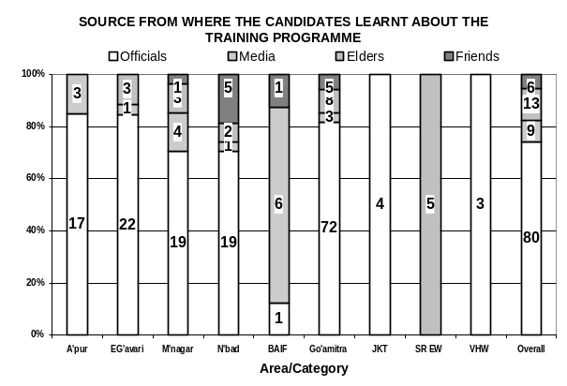
2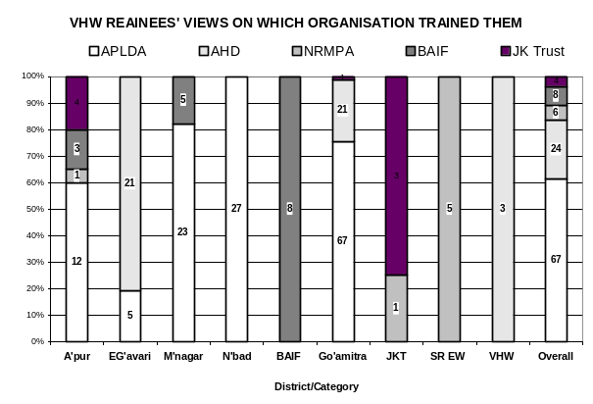 | 3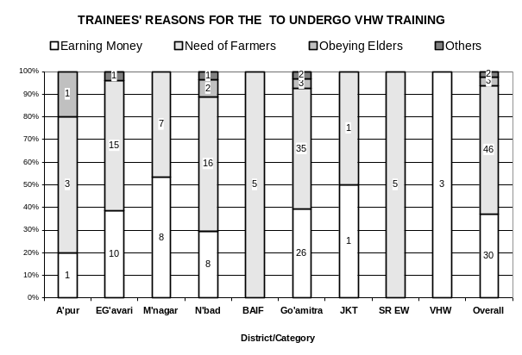

ANNEXURE 18  AHW TRAINEES’ RATING OF THE DIFFERENT ASPECTS OF TRAINING THAT THEY UNDERWENT | 1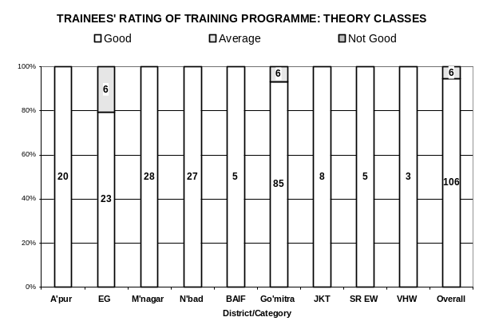
2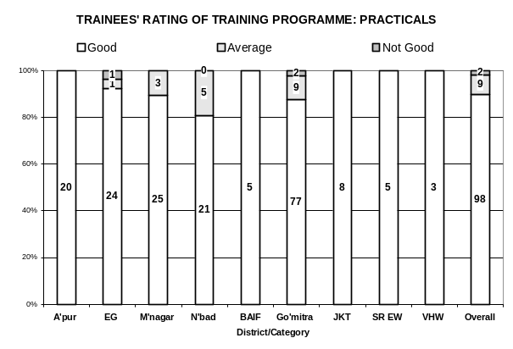 | 3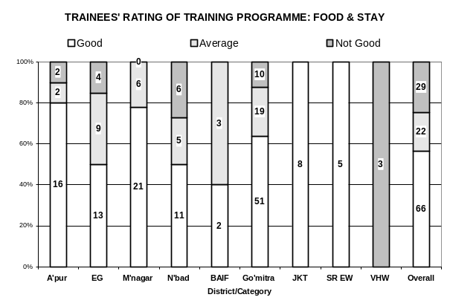
4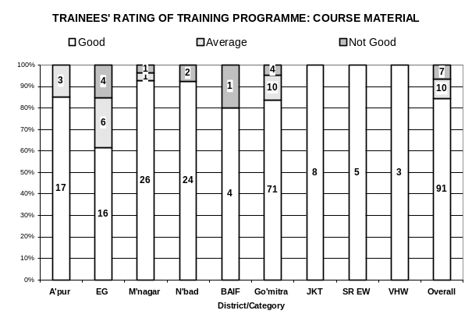 | 5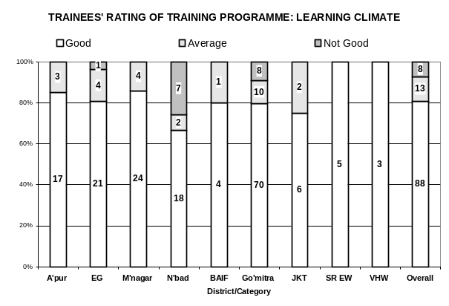

ANNEXURE 19: AHW TRAINEES’ RATING OF THE DIFFERENT SUBJECTS/TOPICS TAUGHT IN THE TRAINING PROGRAMMEME
1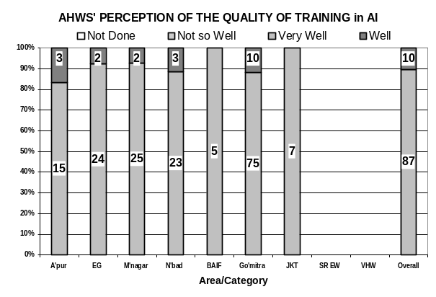 | 2 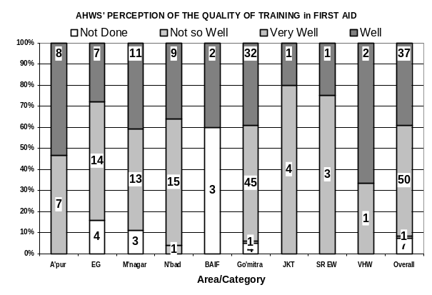
3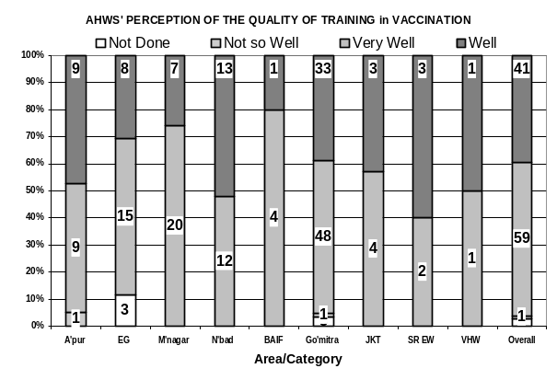 | 4 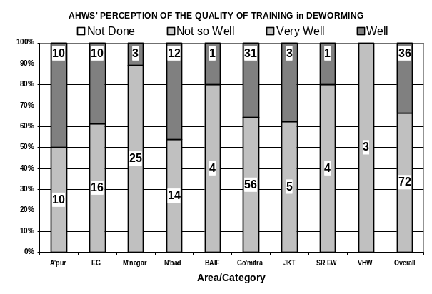
5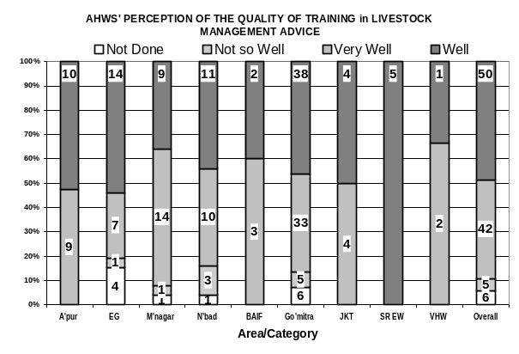 | 6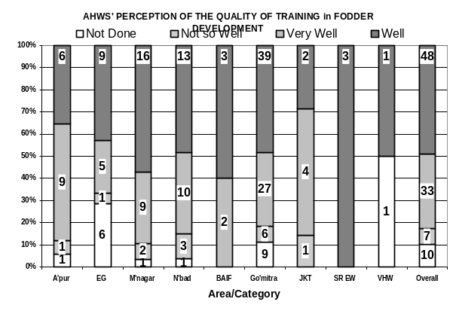
7 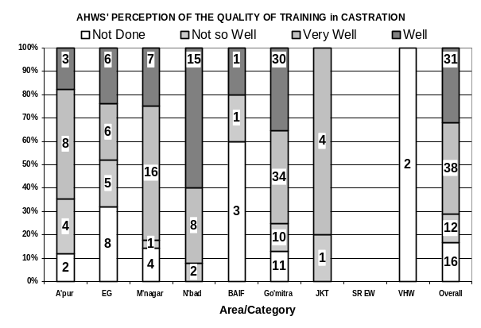 | 8 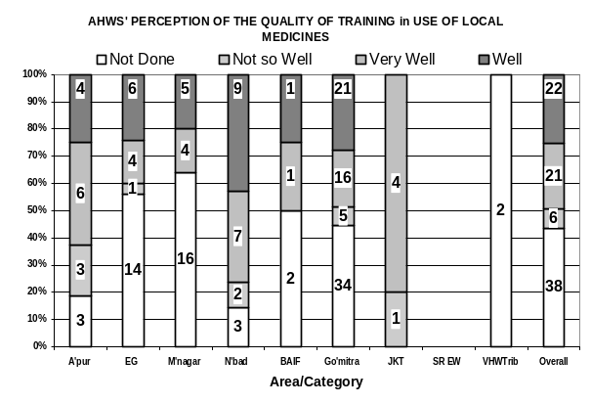
10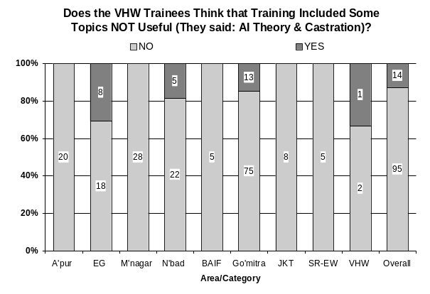 | 11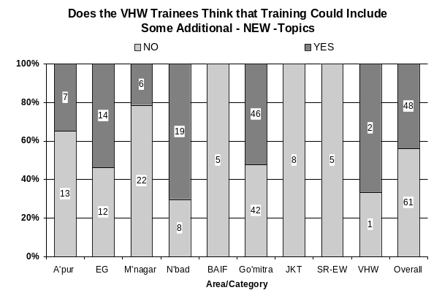
12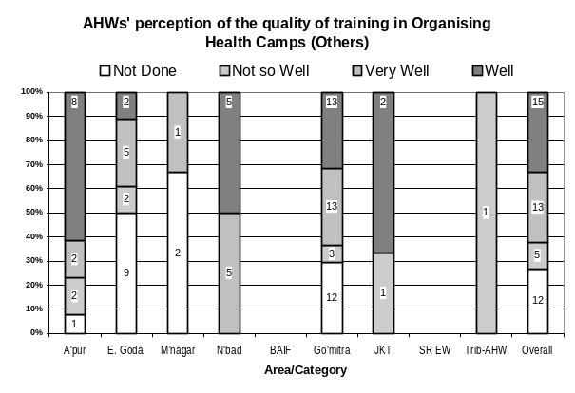

ANNEXURE 20:  OPINION OF THE MANDAL / ALDA LEVEL CONCERNED PERSONS ON THE QUALITY OF DIFFERENT SERVICES PROVIDED BY THE AHWs | 1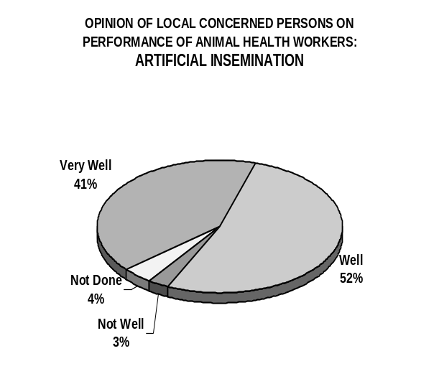
2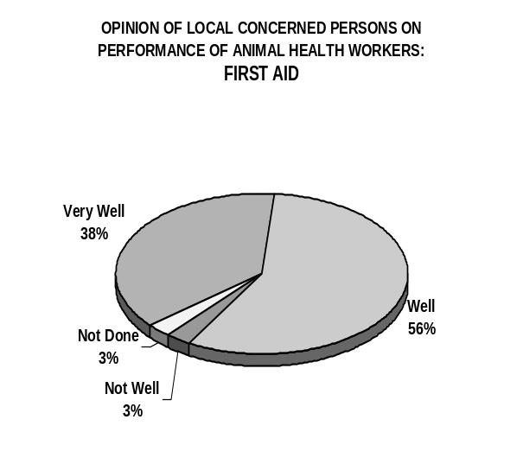 | 3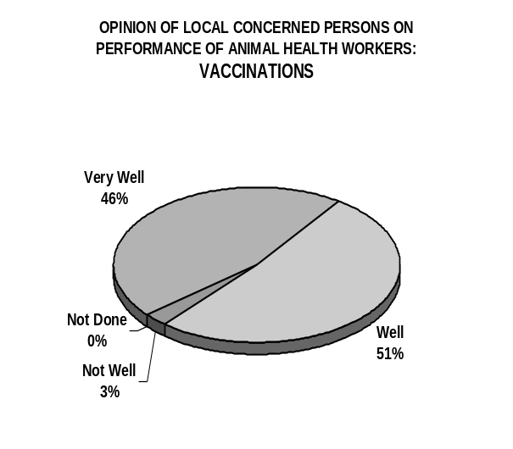
4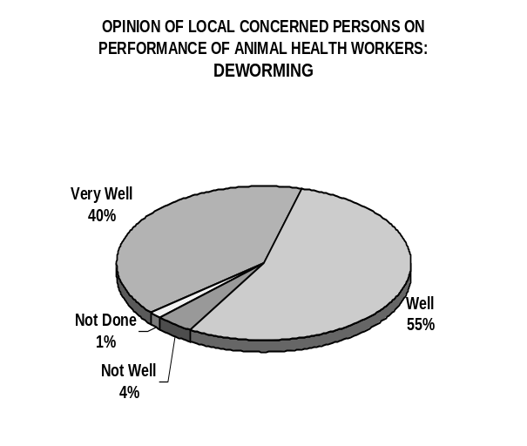 | 5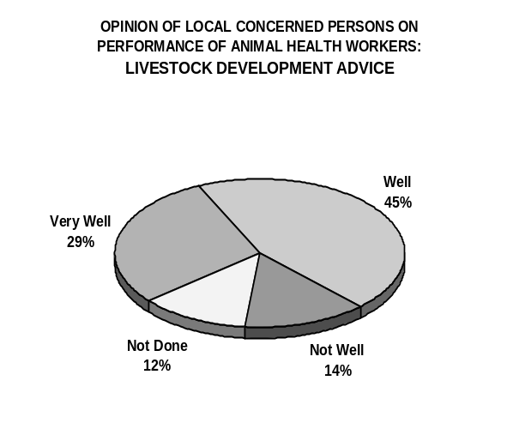
6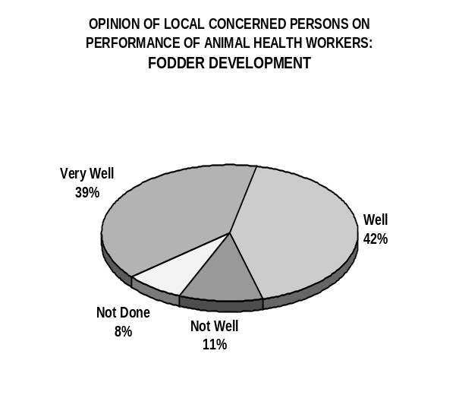 | 7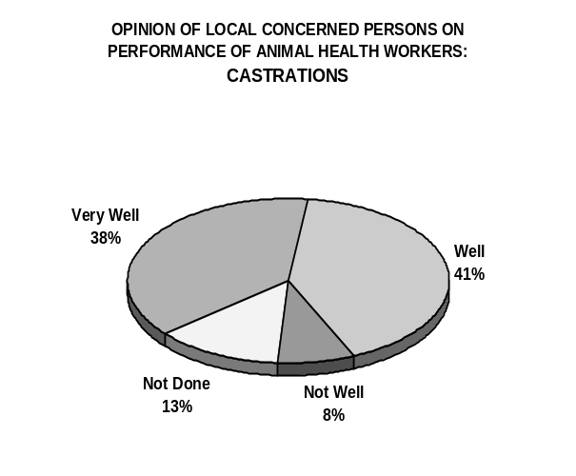
8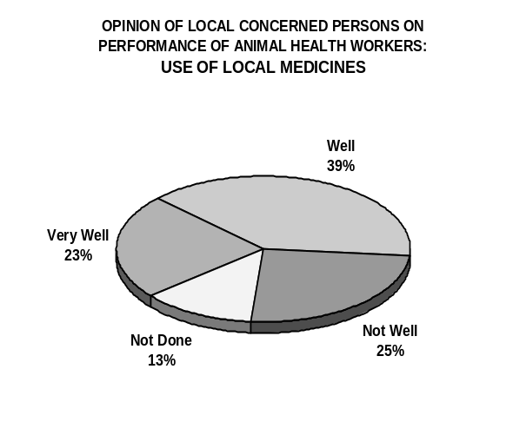 | 9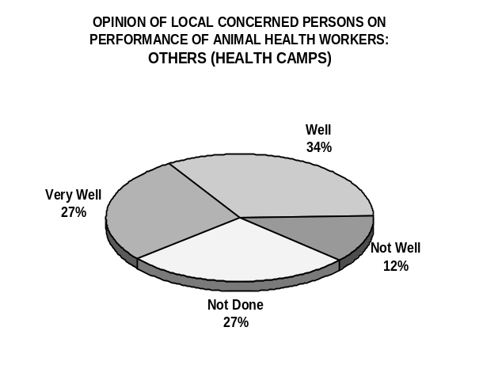

ANNEXURE 21: OPINION OF THE FARMERS IN DIFFERENT DISTRICTS ON THE QUALITY OF ARTIIFICIAL SERVICE PROVIDED BY THE AHWs
1 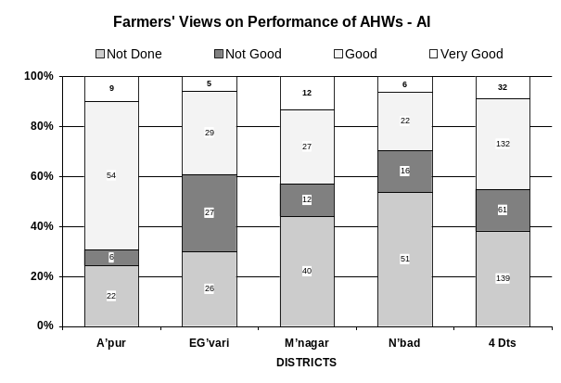 | 2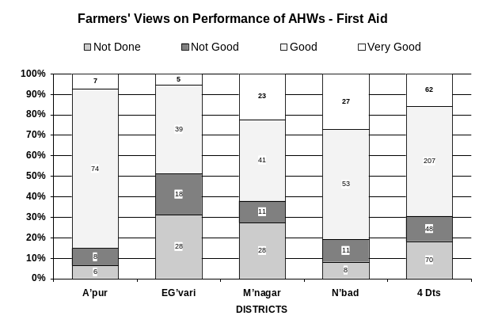
3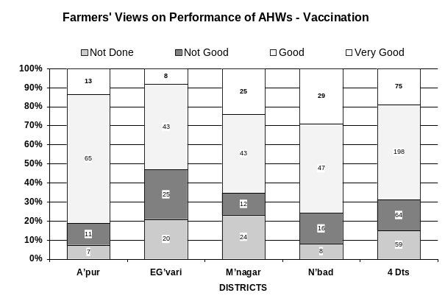 | 4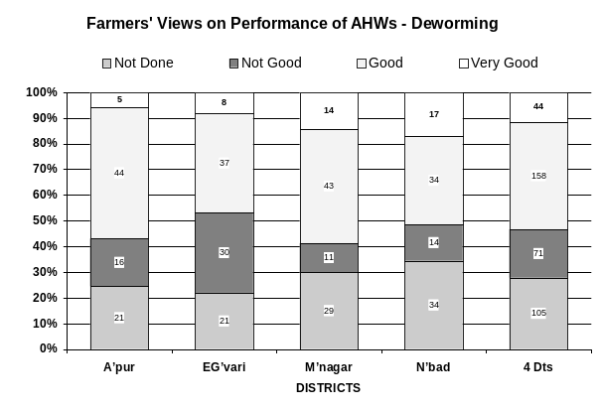
5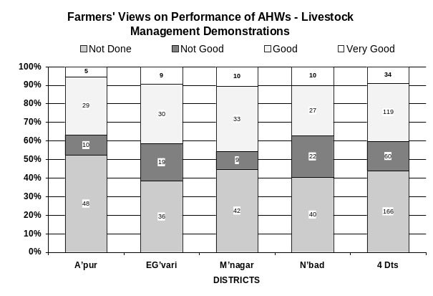 | 6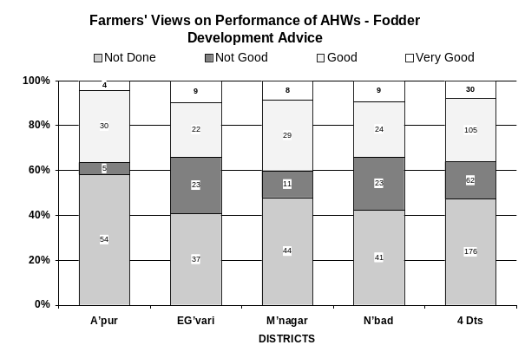
7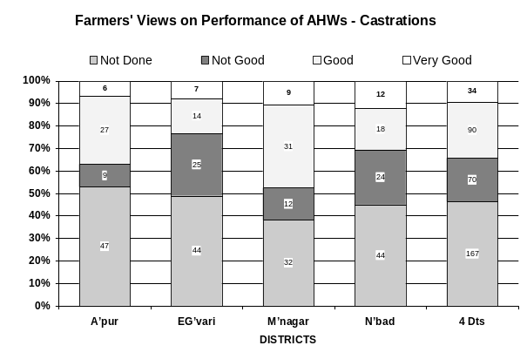 | 8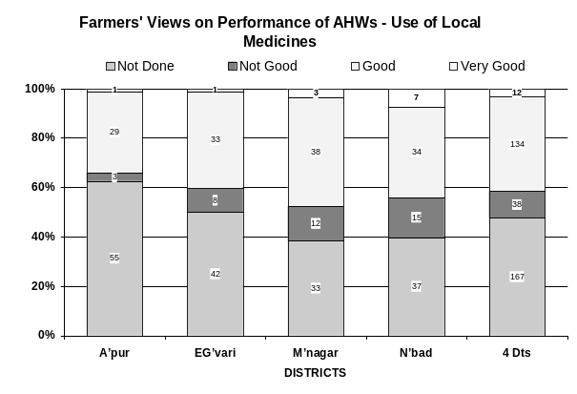

ANNEXURE 22: OPINION OF THE FARMERS IN MANDALS WITH DIFFERENT LIVESTOCK POTENTIAL LEVELS THE QUALITY OF SERVICE PROVIDED BY THE AHWs
1 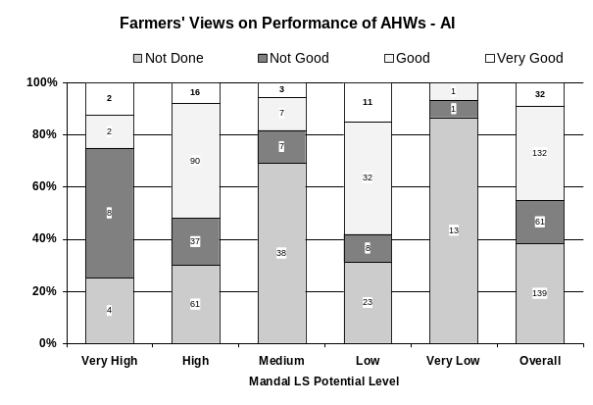 | 2 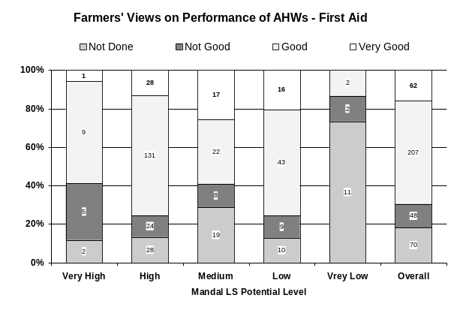
3 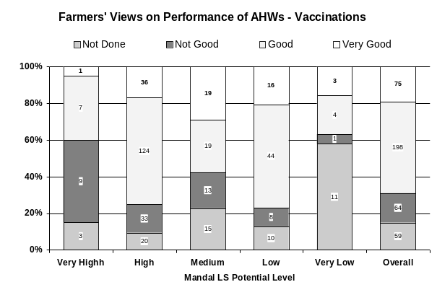 | 4 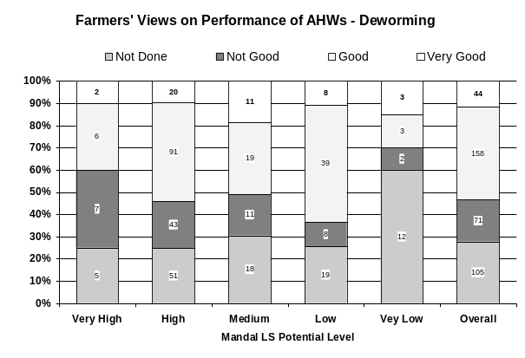
5 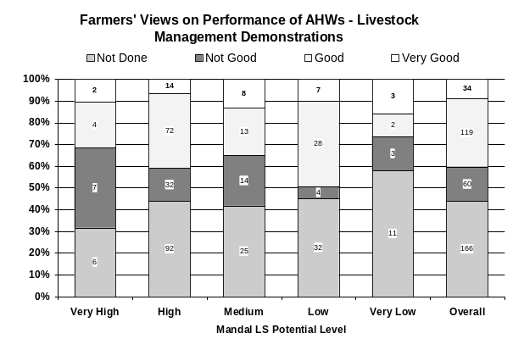 | 6 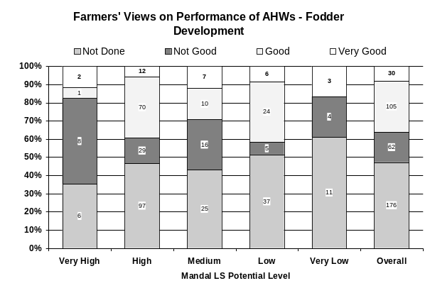
7 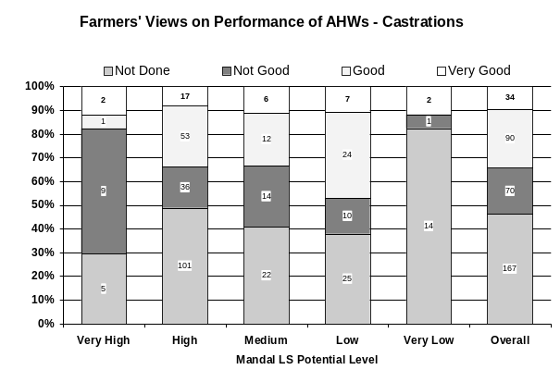 | 8 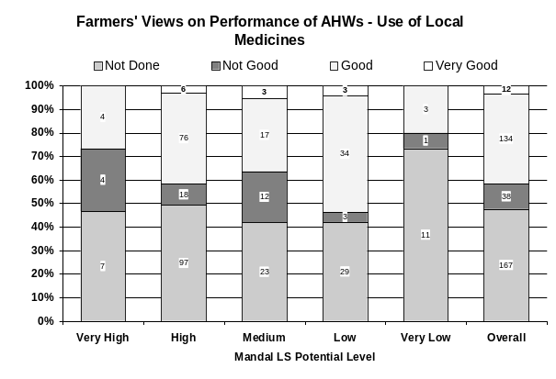

ANNEXURE 23: OPINION OF THE FARMERS IN MANDALS WITH DIFFERENT AGRO-CLIMATIC CONDITIONS ON THE QUALITY OF SERVICE PROVIDED BY THE AHWs
1 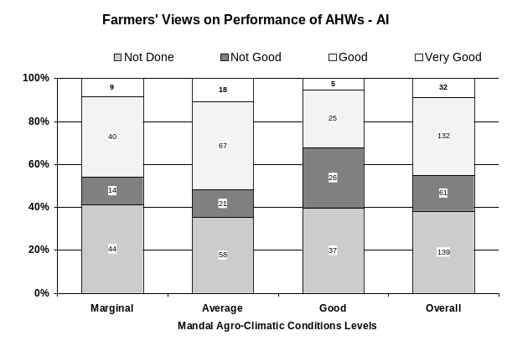 | 2 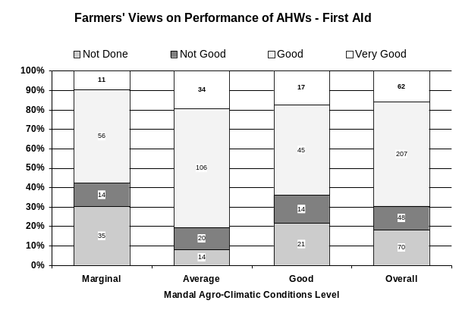
3 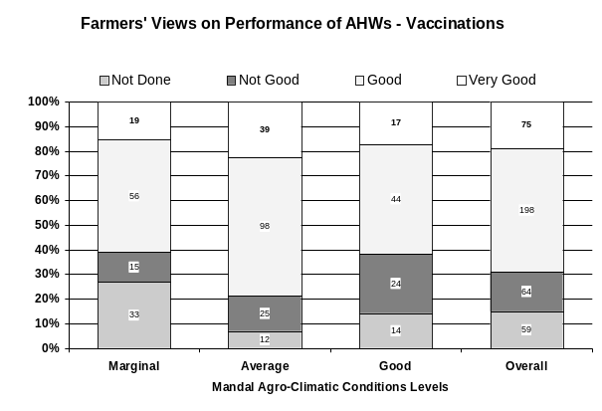 | 4 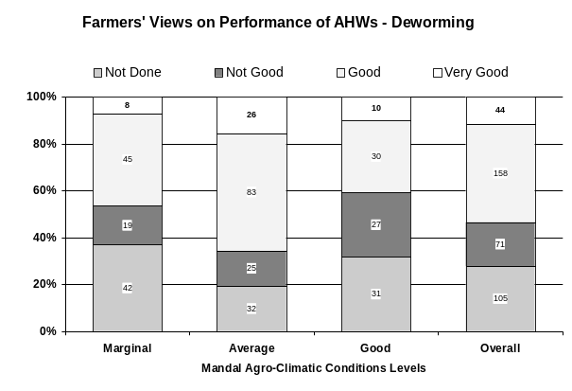
5 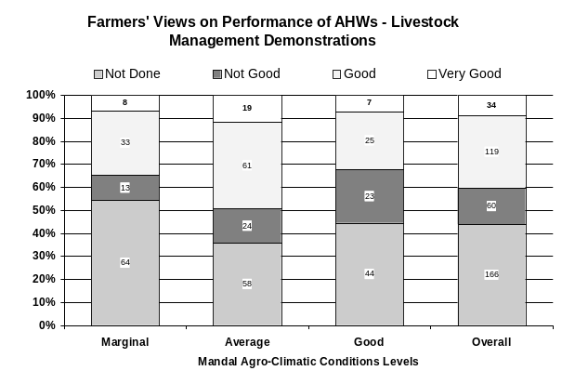 | 6 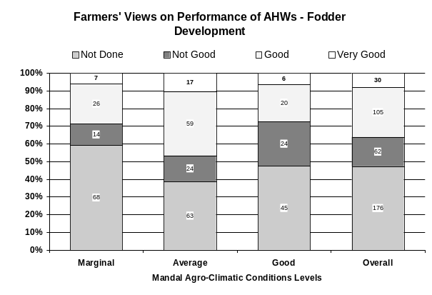
7 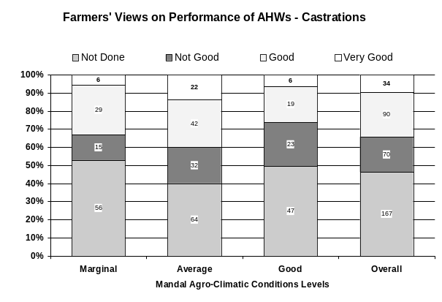 | 8 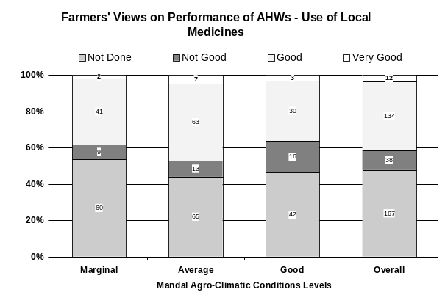

ANNEXURE 24: OPINION OF THE FARMERS WITH DIFFERENT LIVESTOCK PRIMARY OCCUPATIONS THE QUALITY OF SERVICE PROVIDED BY THE AHWs
1 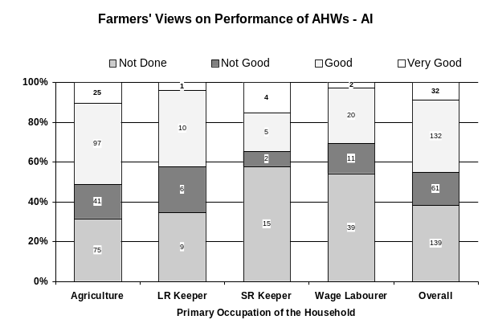 | 2 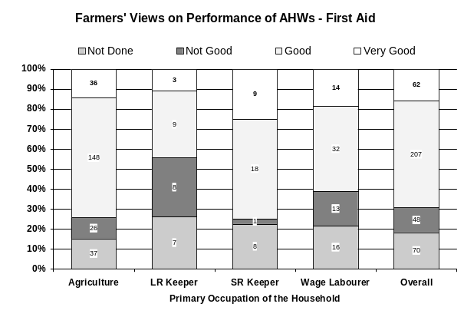
3 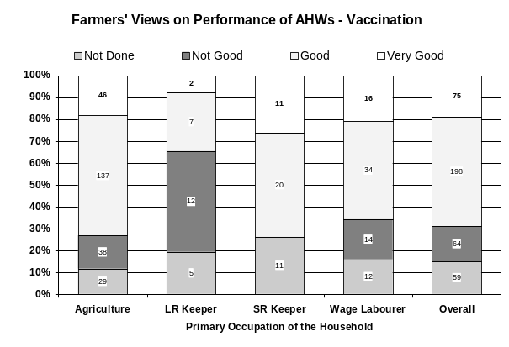 | 4 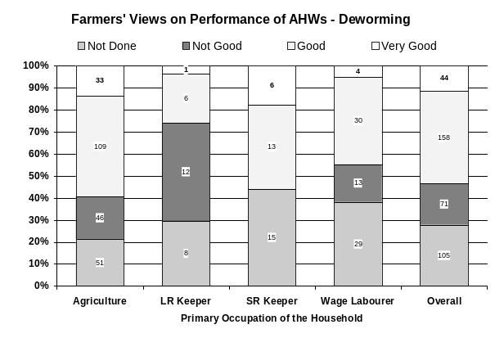
5 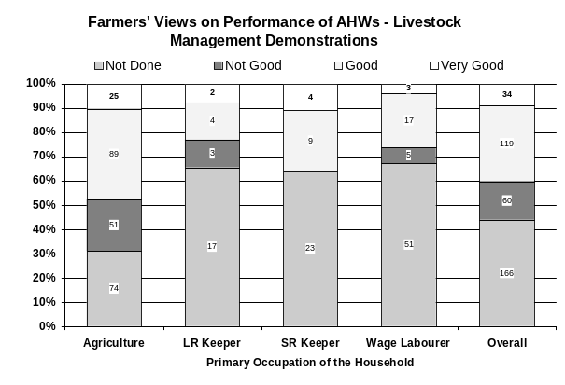 | 6 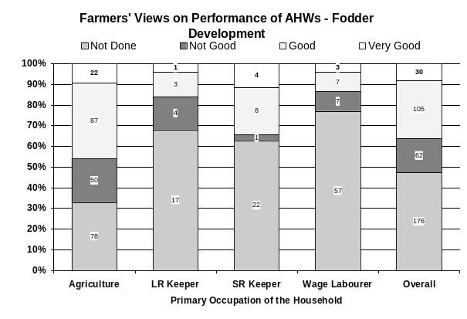
7 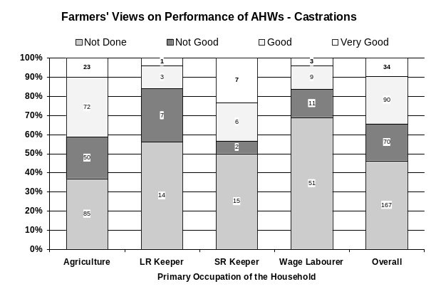 | 8 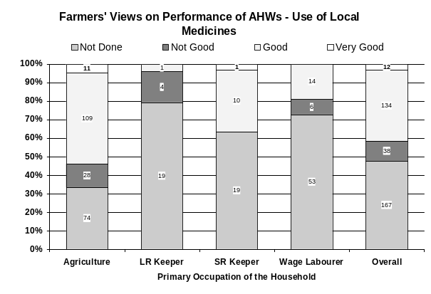

ANNEXURE 25: OPINION OF THE FARMERS OF DIFFERENT LIVESTOCK SOCIAL BACKGROUND ON THE QUALITY OF SERVICE PROVIDED BY THE AHWs
1 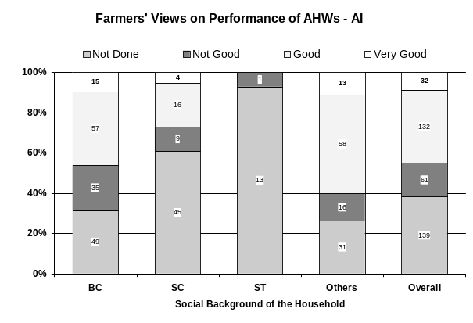 | 2 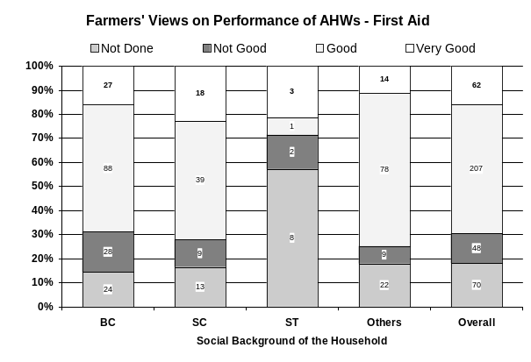
3 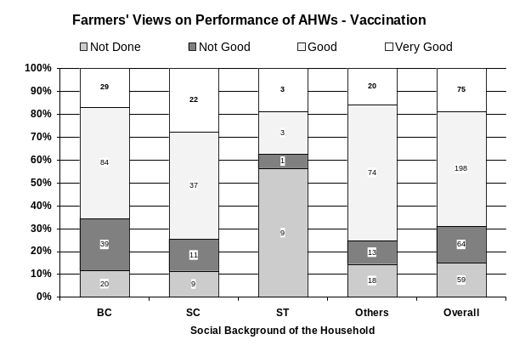 | 4
5 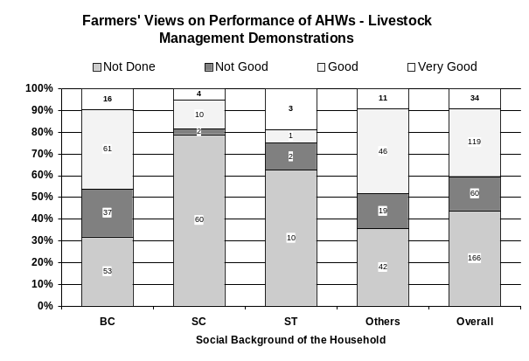 | 6 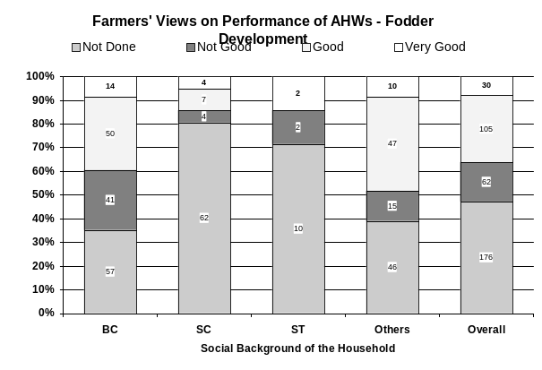
7 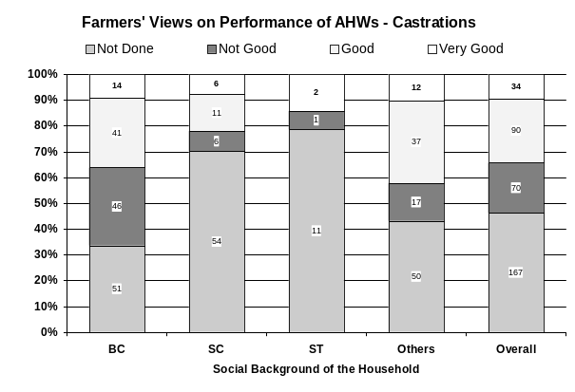 | 8 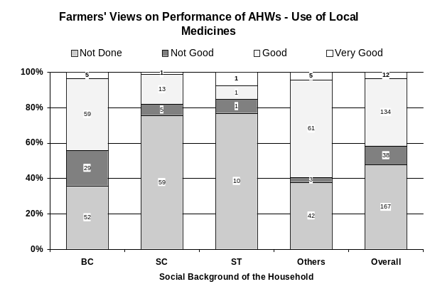

ANNEXURE 26: OPINION OF THE FARMERS IN MANDALS WITH DIFFERENT LIVESTOCK SERVICE PROVIDING ORGANISATIONS ON THE QUALITY OF SERVICE PROVIDED BY THE AHWs
1 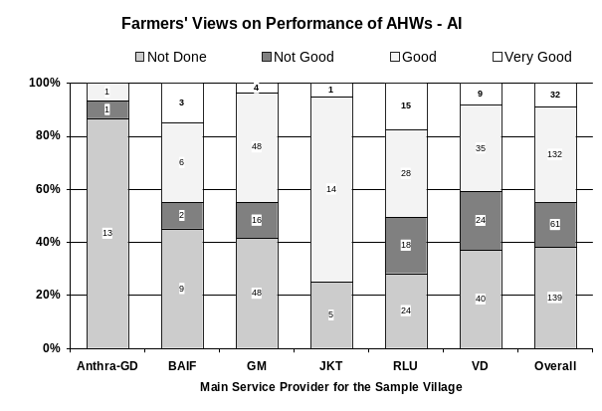 | 2 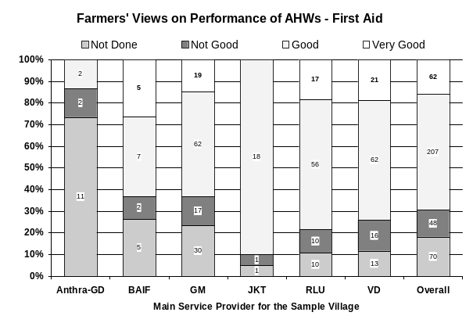
3 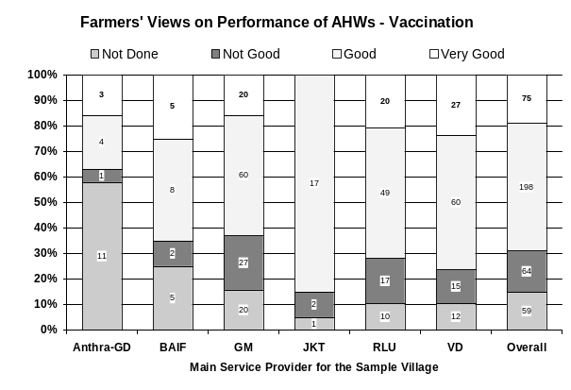 | 4 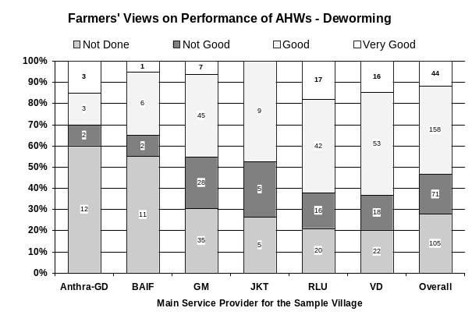
5 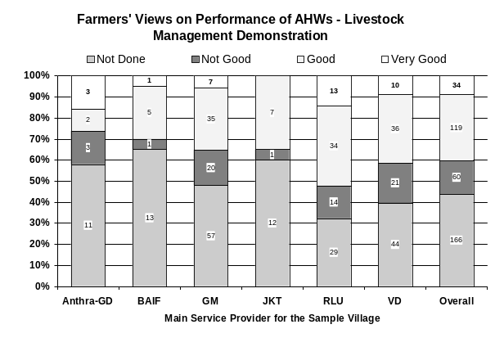 | 6 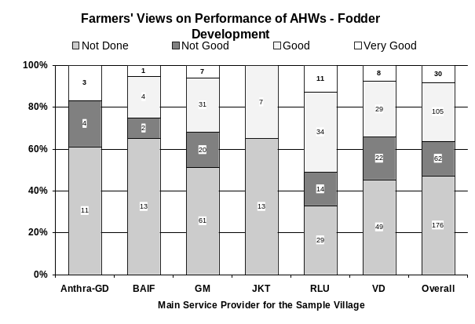
7 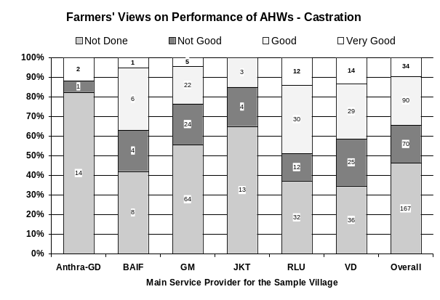 | 8 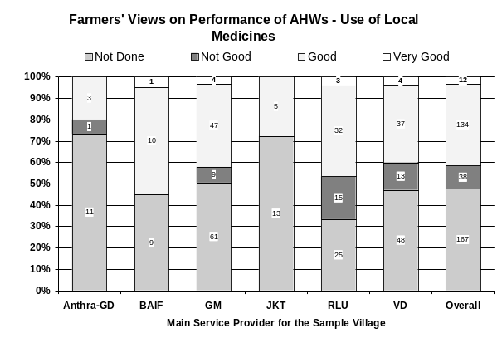

ANNEXURE 27: OPINION OF THE FARMERS OF DIFFERENT LAND HOLDING CLASSES ON THE QUALITY OF SERVICE PROVIDED BY THE AHWs
1 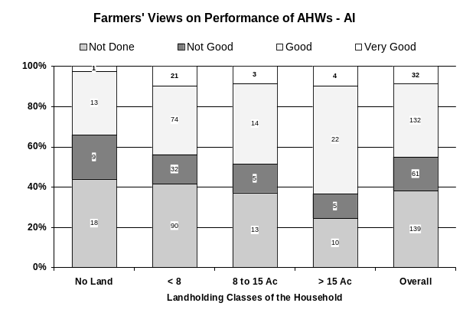 | 2 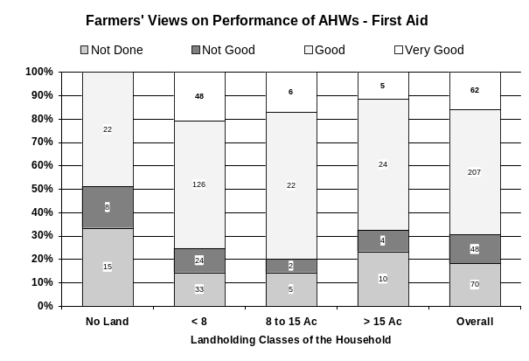
3 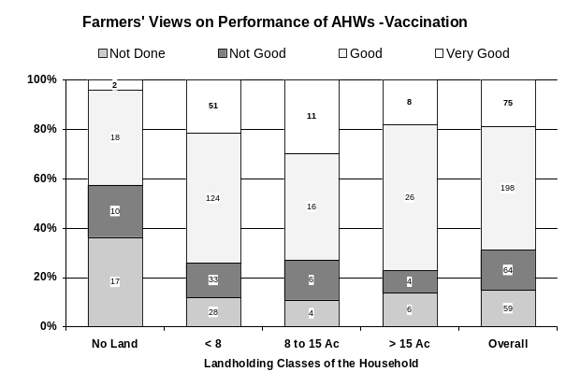 | 4 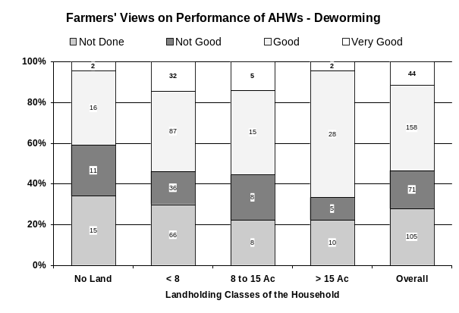
5 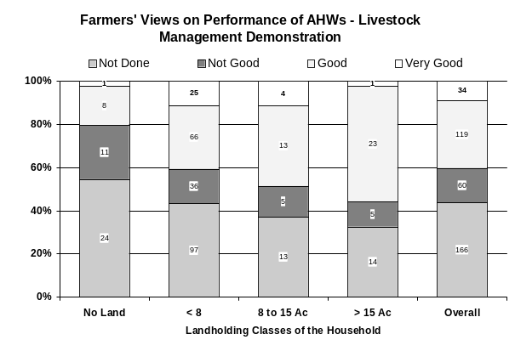 | 6 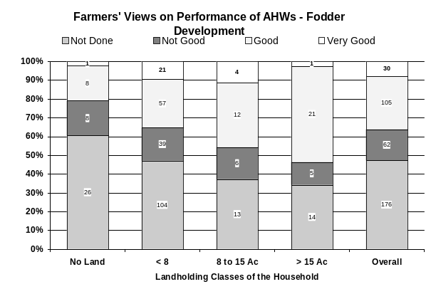
7 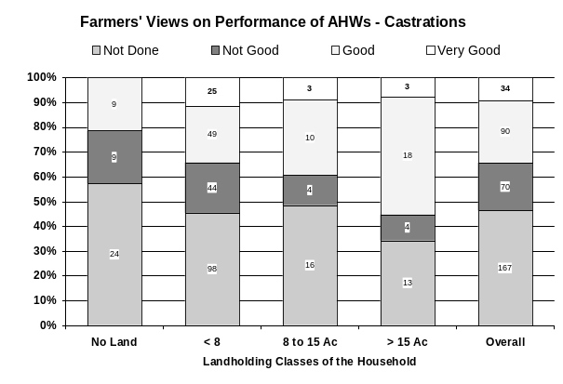 | 8 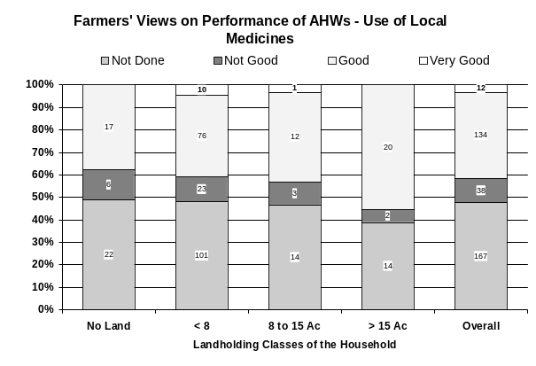

ANNEXURE 28:  OPINION OF THE FARMERS POSSESSING DIFFERENT NUMBERS OF SMALL RUMINANTS ON THE QUALITY OF SERVICE PROVIDED BY THE AHWs | 1 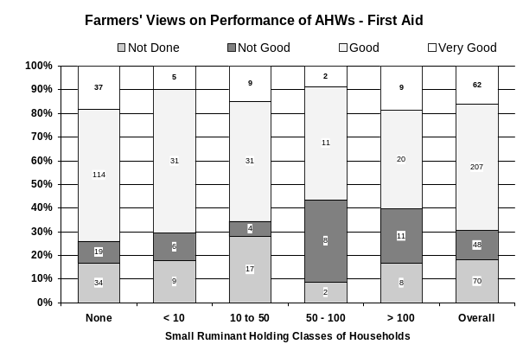
2 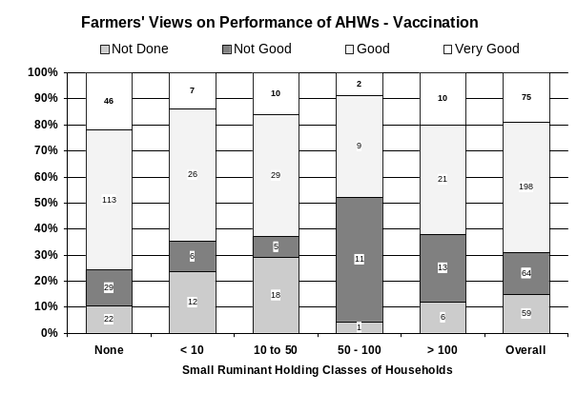 | 3 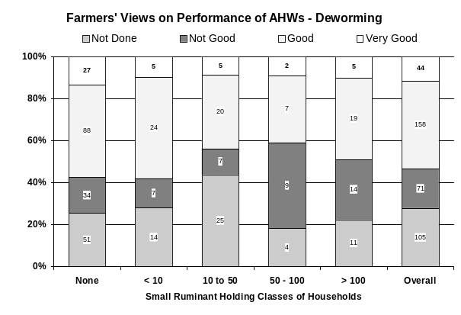
4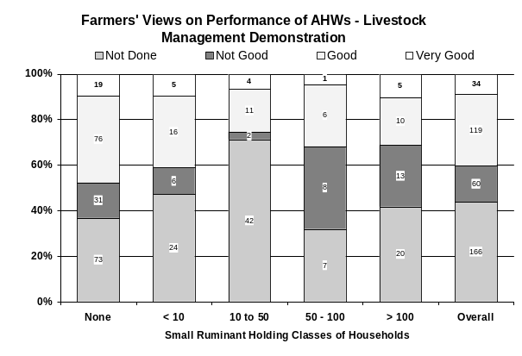 | 5 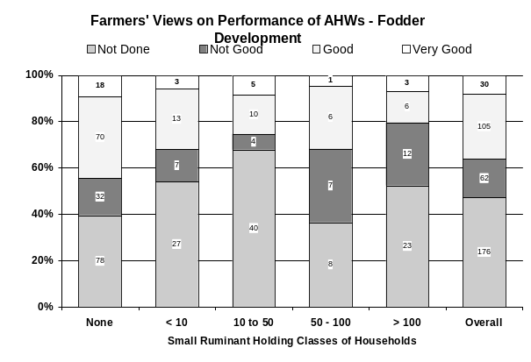
6 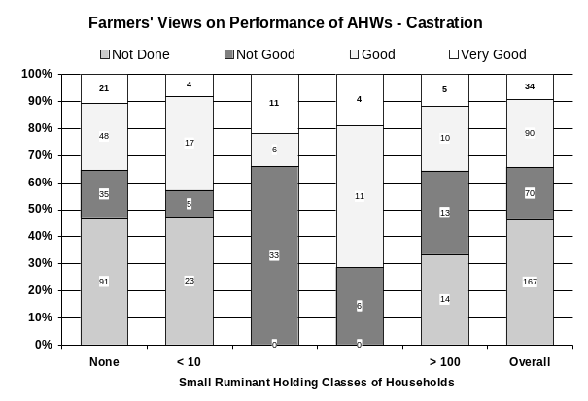 | 7 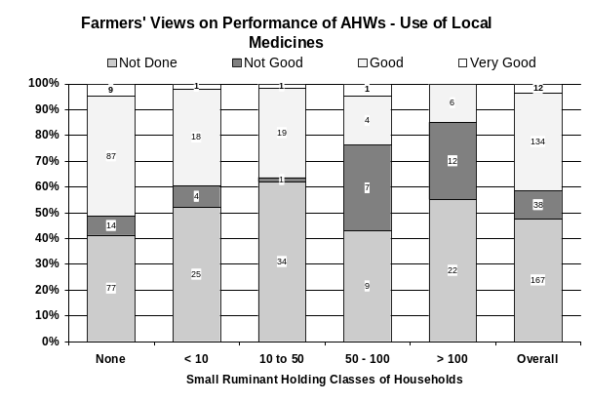

ANNEXURE 29: OPINION OF THE FARMERS HOLDING DIFFERENT NUMBERS OF POULTRY ON THE QUALITY OF SERVICE PROVIDED BY THE AHWs

1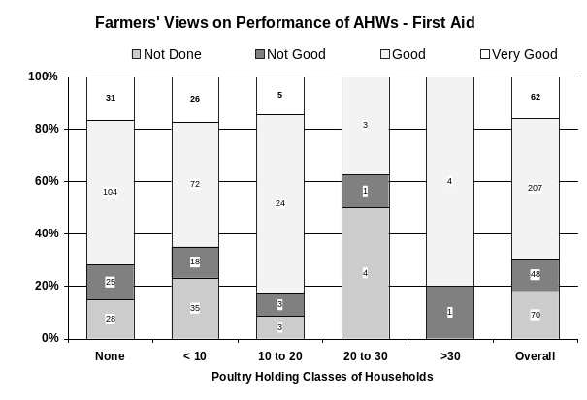 | 2 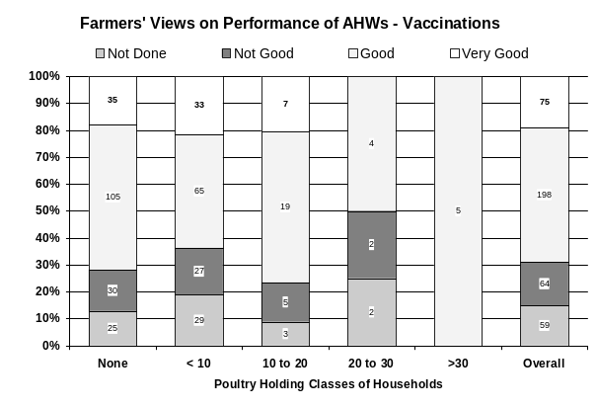
3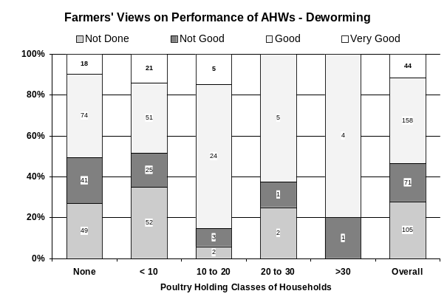 | 4 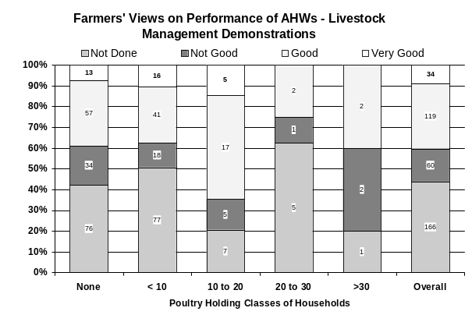

ANNEXURE 30:  OPINION OF THE FARMERS ON THE ABILITY OF THE AHWs IN ORGANISING HEALTH CAMPS | 1 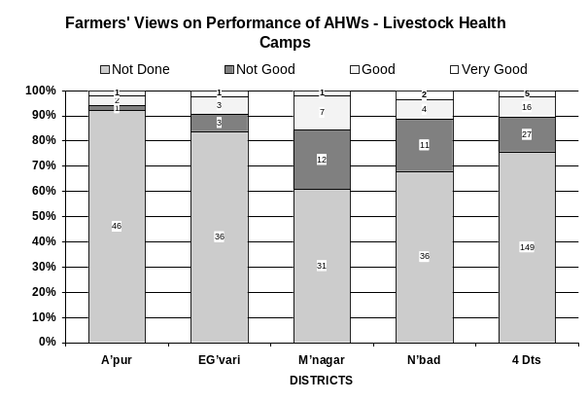
2 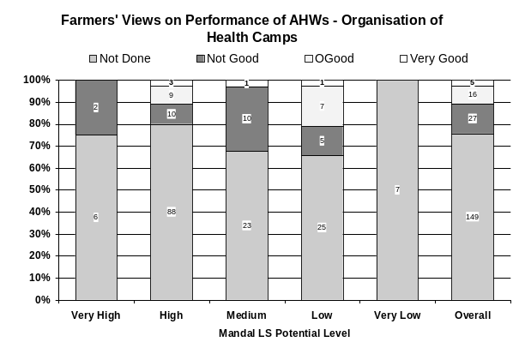 | 3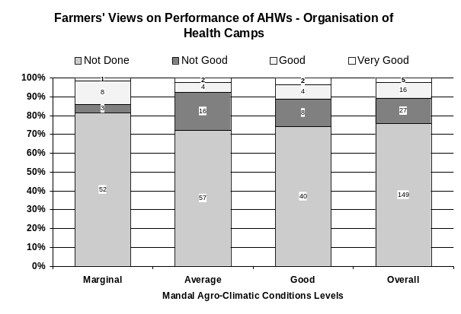
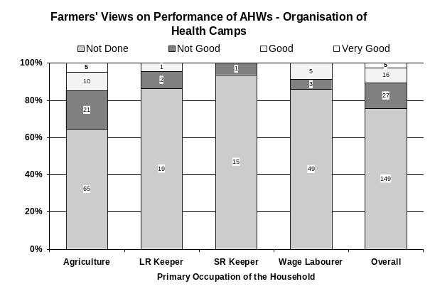  4 | 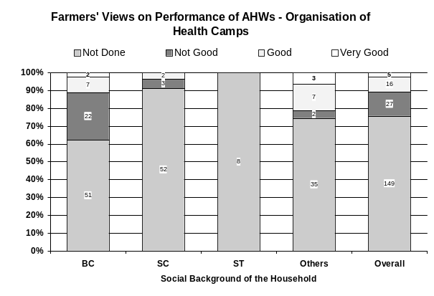  5
6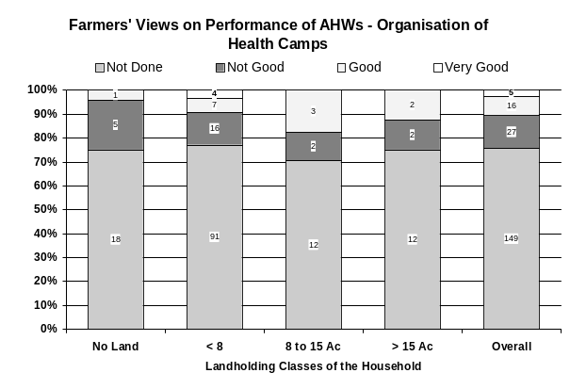 | 7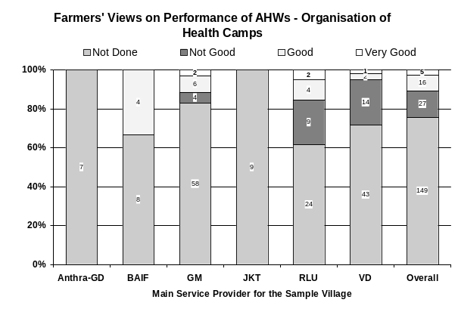

It may be noted that the list of organisations does not contain any dairy cooperative. This is because the dairy coops are now using their training facilities mostly for training farmers. Further, all the secretaries of coops have undergone the Gopalamitra training in management of village level cooperatives.

