International Academy of Astronautics
6 rue Galilee, Po Box 1268-16, 75766 Paris Cedex 16, France
http://www.iaaweb.org

First IAA Symposium on

SEARCHING FOR
LIFE SIGNATURES

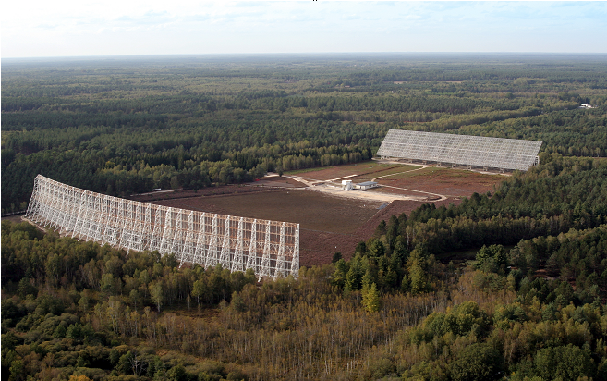
Nançay Decimetric Radio Telescope – Photo Credit Nançay RT.

Program

UNESCO, Paris, France,
September 22-26, 2008
Room III, 125 avenue de Suffren, 75007 Paris, Metro Cambronne
Web site : http://iaaseti.org/searchingforlife.htm
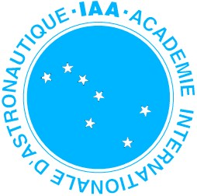


The First IAA Symposium on Search for Life Signature is organized by the International Academy of Astronautics (IAA) and is co-sponsored by “Observatoire de Paris” and its Center of Nançay.

Conference Rationale

SETI (the “Search for ExtraTerrestrial Intelligence”) refers to the experiments intended to find either radio or optical signals from extraterrestrial societies situated on planets around other stars. The largest radio telescopes world-wide have occasionally pursued SETI searches since 1960, in most cases hunting for signals near in frequency to 1420 MHz (the emission line of neutral hydrogen). Optical SETI searches have been pursued since the 1990s. These attempts to detect extraterrestrial signals are called “Passive SETI”.

In recent years, new kind of SETI, called “Active SETI”, has been discussed by radio astronomers and has actually been attempted in a few cases: it consists of deliberately transmitting signals to enhance the probability of making contact with other hypothetical galactic technological civilizations. In addition, the discovery since 1995 of more than 200 extrasolar planets makes it clear that both Passive and Active SETI may now be “targeted” towards exoplanets that are situated within habitable zones, further increasing the probability of a SETI success.
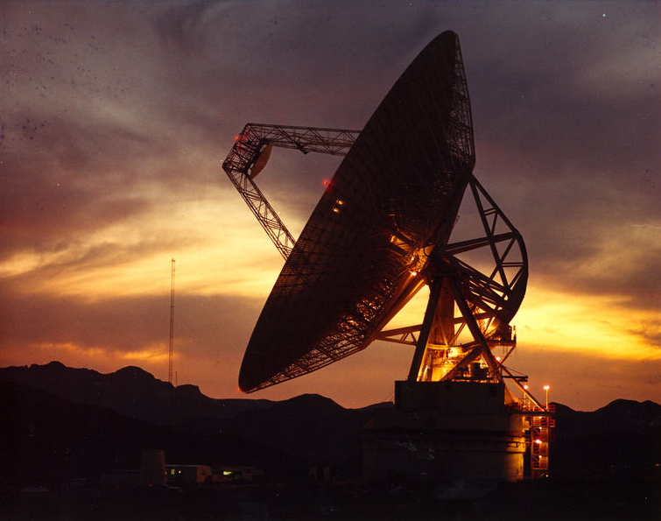
In conclusion, it is now timely to gather a large conference of experts in SETI, biosignatures, the search for terrestrial exoplanets and related disciplines from all over the globe to openly discuss the strategies of both Passive and Active SETI. These are the goals of the “Searching for Life Signatures” Conference that will take place at UNESCO in Paris, September 22nd thru 26th, 2008, in the week just prior to the International Astronautical Congress to be held in Glasgow.

Final Program
Monday, Sept. 22: Morning: Registration and Opening Session.
Afternoon: Passive SETI.
Evening at 19:30: Public Outreach event with Jill Tarter (English language with French translation by Andre’ Brack). The title of Jill Tarter’s Lecture is: “Searching for ExtraTerrestrial Intelligence - Where We've Been and Where We are Going“. The Lecture will be given at the Lecture Theatre of the AeroClub de France, 6 Rue Galilee, Paris (Metro: Boissiere, No. 6 line, near the Etoile) (Organizer: Claudio Maccone).

Tuesday, Sept. 23: Morning: Active SETI, Exoplanets from the Ground.
Afternoon: Exoplanets from Space, Exoplanet and Life.
Evening: Public Outreach event (French language only) with Stephane Dumas at the “science & technology town” of Les Ulis, some 25 km south of Paris. (Organizer: Elisabeth Piotelat).

Wednesday, Sept. 24: Morning: Exoplanets, Astrophysics and SETI. Historical, Philosophical and Societal aspects of SETI.
Afternoon: Detecting & Deciphering in SETI.
Evening at 18:30: Public Outreach Event entitled “Message vers les étoiles” with Anne Jaffrennou and Marie Cuisset (French language only) : Auditorium de la Grande Galerie de l’Evolution, Museum national d’Histoire naturelle, 36, rue Geoffroy St. Hilaire, Paris. (Metro: Censier/Jussieu/Gare dAusterlitz) (Organizer: Florence Raulin-Cerceau).
Thursday, Sept. 25: Morning: At the Edge of the Knowledge. Legal International Issues. General Debate for all the Attendees ONLY.
Afternoon: free.
Evening: Conference Dinner starts at 6 p.m. (18 h) at the Restaurant ‘Le Bouillon Racine”, 3 rue Racine (Metro: Cluny – La Sorbonne, No. 10 line). Concert “Sing a Song of SETI”, slides and songs by H. Paul Shuch also known as Dr.SETI® (Organizers: Jean-Michel Contant and Jean Schneider).

Friday, Sept. 26: 8 a.m.- 7 p.m. - Technical Visit to Nançay Observatory (3h by bus near Orléans) the grand decimetric radio telescope at which SETI searches were conducted in the 1980s and 1990s by Jill Tarter, François Biraud et al. (Organizer: Jean-Michel Martin).
TECHNICAL PROGRAM – interim schedule, subject to change

8:00 – 9:00 Registration of Participants

Opening Ceremony Monday Sept. 22, 09:00 - 09:20
Chair: J.-M. Contant, IAA, C. Maccone, IAA

Welcome to Participants
Maccone Claudio, Italy
Welcome Address
Egret Daniel, President of Observatoire de Paris, France
IAA and SETI: Fifty Years of Scientific Research and Tribute to Jean Heidmann
Contant Jean-Michel, France

Session 1 : Keynote Lectures Monday Sept. 22, morning
Chair: J.-M. Contant, IAA, Paris, Claudio Maccone, IAA, Turin, Italy.

Discoveries of solar system analogues and super Earths IAA-S8-0101
Queloz Didier, Switzerland
SETI: From Pioneering Research to Recent Achievements IAA-S8-0102
Drake Frank D., USA
10:20 – 10:50 Coffee Break
The Allen Telescope Array: a better pitchfork for exploring the Cosmic Haystack IAA-S8-0103
Tarter Jill, USA
Formation of Giant Planets, Super Earths and Habitable Planets IAA-S8-0104
Boss Alan, USA
Future Exoplanet Detections from Space, and SETI IAA-S8-0105
Leger Alain, France
Biosignatures on Exoplanets: beyond the standard views IAA-S8-0106
Schneider Jean, France
13:15 – 14:30 Lunch Break
Extraterrestrial life: what are we looking for? IAA-S8-0107
Brack André, France
European radio message: origin and concept IAA-S8-0108
Zaitsev Alexander, Russia

Session 2: Passive SETI: Listening to Them Monday Sept. 22, afternoon
Chair: Florence Raulin-Cerceau, Museum Histoire Naturelle, Paris
Rapporteur: Jean-Pierre Rospars, INRA, Versailles

New SETI sky survey for radio and optical pulses IAA-S8-0201
Wertheimer Dan, USA
Project Argus Progress Report: T plus twelve years and holding IAA-S8-0202
Shuch H. Paul, USA
16:30 – 17:00 Coffee Break
SETI Italia 2008: On-going Searches and Future Prospects IAA-S8-0203
Montebugnoli Stelio, Monari Jader, Italy
A new 256 million channel spectrometer for SETI observations in Argentina IAA-S8-0204
Larrarte J.J., Lemarchand Guillermo, Siemion A., Argentina, Wertheimer Dan, USA
Professional SETI in Australia to Restart IAA-S8-0205
Oliver Carol, Australia
The SETI Program in Korea IAA-S8-0206
Rhee Myung-Hyun, Korea
The new SETI in France IAA-S8-0207
Martin Jean-Michel, France
Session 3: Active SETI: Sending Messages to Them Tues. Sept. 23, morning
Chair: Alain Labeque, IAS, Orsay, France Rapporteur: Paul Shuch, USA

SETI: The Compact and the Controversy IAA-S8-0301
Shostak Seth, USA
Crypto analysis applied to Active SETI IAA-S8-0302
Dumas Stephane, Dutil Yvan, Canada
Active SETI: Scientific Experiment, Diplomatic Action or Artistic Expression? IAA-S8-0303
Vakoch Doug, USA
Active SETI and the Zoo hypothesis IAA-S8-0304
Labeque Alain, France
Active SETI and Its Possible Dangers: An Overview IAA-S8-0305
Musso Paolo, Italy
Overcome the Great Silence! IAA-S8-0306
Zaitsev Alexander, Russia
11:00 – 11:20 Coffee Break
Session 4: Exoplanets from the Ground Tuesday Sept. 23, late morning
Chair: Seth Shostak, SETI Institute, USA Rapporteur: Alain Labeque, IAS, Orsay, France

Timing of Stellar Brightness Periodic Variations as a Method of IAA-S8-0401
Earth-Like Planet Detection
Beskin Grigory, Russia
Stars as semaphore light towers: Artificial transit and SETI IAA-S8-0402
Arnold Luc, France
Detection of Biomarkers using Infrared Spectroscopy IAA-S8-0403
Dumas Stephane, Joncas G., Dutil Yvan, Canada
13:00 – 15:00 Lunch Break
Session 5: Exoplanets from Space Tuesday Sept. 23, afternoon
Chair: Jill Tarter, SETI Institute, USA Rapporteur: Alain Labeque, IAS, Orsay, France

Searching for Inorganic Life in Universe IAA-S8-0501
Tsytovich V. N, Russia, Morfill G. N., Germany
Extended IRAS-based whole-sky upper limit on Dyson spheres and the implication
for future Dyson spheres searches IAA-S8-0502
Carrigan Dick, USA
LUCAS Experiment: searching for vegetation and other biosignatures on planet Earth IAA-S8-0503
Briot Danielle, France
Super Earths and Life, and the role of NASA’s Kepler Mission IAA-S8-0504
Latham Dave, USA
The diversity of low-mass exoplanets and the search for inhabited worlds IAA-S8-0505
Selsis Franck, France
Exploring Habitable Exoplanets with New Worlds Observer IAA-S8-0506
Turnbull Margaret, USA
16:20 – 16:40 Coffee Break

Session 6: Exoplanets and Life Tuesday, Sept. 23, 2008, late afternoon
Chair: Alexander Zaitsev, Russia Rapporteur: Alain Labeque, IAS, Orsay, France

SETI in the light of Terrestrial Biological Evolution IAA-S8-0601
Rospars Jean-Pierre, France
Our search for extraterrestrial life may be modified considering the unique
group of silicon-utilizing micro-organisms IAA-S8-0602
Satadal Das, India
Self-Assembly of Complex Systems: Artificial Living Cells? IAA-S8-0603
Tamulis Arvydas, Lithuania
Interstellar Organic Molecules: Evidence of prebiology or detritus of biology? IAA-S8-0604
Wickramasinghe Chandra, UK
Unpacking the Great Transmission Debate IAA-S8-0605
Denning Kathryn, Canada
Session 7: Exoplanets, Astrophysics and SETI Weds. Sept. 24, morning
Chair: Douglas A. Vakoch, SETI Institute, USA
Rapporteur: Jean Schneider, Paris Observatory, France

Galactic Habitable Zone IAA-S8-0701
Prantzos Nikos, France
The Statistical Drake Equation IAA-S8-0702
Maccone Claudio, Italy
Two-laser system to transmit optical images to ET civilizations IAA-S8-0703
Beskin Grigory et al., Russia
Laser transition in atomic iodine for passive and active SETI IAA-S8-0704
Kutaev Y. F., Mankevich S. K., Nosach O. Y., Orlov E. P., Russia
10:40 – 11:00 Coffee Break
Session 8: Historical, Philosophical and Sociological Aspects of SETI
Weds. Sept. 24, late morning
Chair: Jean-Michel Martin, Paris Observatory, France
Rapporteur: Florence Raulin-Cerceau, Museum National d’Histoire Naturelle, Paris

Historical review of the first interplanetary communication attempts: a scientific IAA-S8-0801
and literary overview
Raulin-Cerceau Florence, France
Evolution, history & SETI: Some philosophical observations IAA-S8-0802
Lestel Dominique, France
The importance of Active SETI Strategies to Solve Synchronization Uncertainties IAA-S8-0803
in Time and Space among Galactic Civilizations – Ethical Issues
Lemarchand Guillermo, Argentina
An Iconic Approach to Communicating Musical Concepts in Interstellar Messages IAA-S8-0804
Vakoch Doug, USA, Maccone Claudio, Italy
Interstellar Message Composition: Learning about ETs and ourselves IAA-S8-0805
through writings
Lockwood Jeffrey, USA
What would a billion-year-old civilization look like? IAA-S8-0806
Dumas, Stephane, Dutil Yvan, Canada
13:00 – 15:00 Lunch Break

Session 9: Detecting & Deciphering in SETI Weds. Sept. 24, afternoon
Chair: Stephane Dumas, Canada Rapporteur: Nikos Prantzos, IAP, Paris

Search for extraterrestrial civilizations in the optical range IAA-S8-0901
Beskin Grigory et al., Russia
Targets and SETI I – Shared Motivations and Active SETI IAA-S8-0902
Edmondson William, UK
Targets and SETI II – Strategic Issues and Passive SETI IAA-S8-0903
Edmondson William, UK
16:00 – 16:20 Coffee Break
Detecting the Signature of Intelligent Life IAA-S8-0904
Elliott John, UK
The KLT (Karhunen-Loève Transform) to extend SETI searches to broad-band IAA-S8-0905
and extremely feeble signals
Maccone Claudio, Italy
Using Fractional Derivative as Degree of Symmetry to Characterize Natural Shapes IAA-S8-0906
Ilhan Husrev T., Linscott Ivan, USA
On the signature of LINCOS IAA-S8-0907
Ollongren Alexander, The Netherlands
The linguistic pre-requisites of SETI: a critical analysis of H. Freudenthal's IAA-S8-0908
book “LINCOS”
Schneider Jean, France
Session 10: At the Edge of Knowledge Thursday, Sept. 25, morning
Chair: Alexander Ollongren, Sweden Rapporteur: Pierre Colom, France

Virtual Interstellar Cloning IAA-S8-1001
Gardner James N., USA
The lure of local SETI. Fifty years of field experiments IAA-S8-1002
Ailleris Philippe, The Netherlands
When SETI meets an alien form of intelligence: understanding the IAA-S8-1003
troubled relationships between SETI and ufology Lagrange Pierre, France
Investigation and analysis of transient luminous phenomena in the low atmosphere IAA-S8-1004
of Hessdalen valley, Norway
Hauge Bjorn Gitle, Norway
Revelation: the Timescale of ETI Signal Interpretation IAA-S8-1005
Baxter Stephen, UK
10:20 – 10:40 Coffee Break
SETI meets a social intelligence: dolphins as a model for real-time interaction and IAA-S8-1006
communication with a sentient species
Herzing Denise L., USA
Animal Communications, Information Theory and the Search for IAA-S8-1007
Extraterrestrial Intelligence
Doyle Laurance R., USA

Session 11: Legal International Issues & SETI, Thurs. Sept. 25, late morning
Chair: Paul Shuch, USA, Rapporteur: Philippe Ailleris, The Netherlands.

PAC: Protected Antipode Circle at the center of the Far Side of the Moon IAA-S8-1101
for the Benefit of all Humankind
Maccone Claudio, Italy

13:00 Afternoon free

Technical Visit to Nançay Radio Telescope Friday, Sept. 26, 08:00 - 19:00

Bus transportation / Train from UNESCO to Nançay Observatory (3h), the grand decimetric radio telescope at which SETI searches were conducted in the 1980s and 1990s by Jill Tarter, François Biraud et al. (advance registration required).

International Academy of Astronautics
http://www.iaaweb.org

First IAA Symposium on

SEARCHING FOR
LIFE SIGNATURES

Registration Form

Please print out and return to:
1st IAA Symposium on Searching For Life Signatures
IAA
Po Box 1268-16, 6 rue Galilée, 75766 Paris Cedex 16, France
Phone +33 (0)1 47 23 82 15, Fax +33 (0)1 47 23 82 16
office@iaamail.org
Please fill in all applicable fields

Last Name …..
First Name …..
Title …..
Affiliation …..
Address …..
Postcode/ ZIP-Code…..
City, State (US), Country …..

Tel ….. Fax …..
e-mail …..

Fees
Regular Fee Early Bird (until September 1st, 2008) €150.00 ________
Regular Fee (after September 1st, 2008) €200.00 ________
On Site registration €250.00 ________

Student Fee Early Bird (until September 1st, 2008) € 50.00 ________
Student Fee (after September 1st, 2008) €70.00 ________

Gala Evening (Thursday 25 September 20h)
I’m booking ___ tickets for the Gala Evening at €50.00 each ________

Technical Visit to Radiotelescope of Nançay participating to SETI (including bus transport., coffee break and lunch) €50.00 each ________
(Number of participants Limited, first come first serve basis)

TOTAL ________
Accompanying Person
*Last Name
*First Name
Accompanying persons can access social events and technical tour.

I plan to participate to the Symposium lunch:
Monday yes no
Tuesday yes no
Wednesday yes no

Cancellation Policy
Before September 10th, 15% of registration fee will be charged. After September 10th, 50% of registration fee will be charged. All cancellation or alteration must be made in writing by letter, fax or e-mail to IAA. Kindly note, that refunds will be paid back after the symposium.

Payment
Note: The payment needs to arrive at the organizer in full amount. Do not forget to indicate your name, affiliation, and 'IAA-SETI-Symposium 2008' together with your payment.

• by bank order to
IAA SETI Symposium 2008
BNP Paribas
Quartier Latin Branch Office
7 rue Soufflot 75005 Paris, France
BIC BNPAFRPPPRG
IBAN FR76 3000 4009 6900 0033 7703 920

• by credit card
Visa
MasterCard/Eurocard American Express
Card Number

 | Expiration Date |  |  | Signature
 | (2 months before expiration required)

Nota: Payment on site accepted only if advance registration has been sent before the deadline. Registrations by surface mail must be received in the Paris office Po Box before the deadline.

• by cheque
Please make cheque payable to: IAA
(for payment in Euro, foreign checks must be drawn on a bank in France)
- to the order of "International Academy of Astronautics"
- with on the back of the check your Last and First Name

For exact identification - please insert your name at the bottom of every page – thank you!

Last Name
First Name

