

Review Guide
The Why, What, and How of Microsoft® .NET Passport
Published: March 2002

Table of Contents
Table of Contents 0
Executive Summary 2
.NET Passport and Privacy 2
The Purpose of this Document 3
Introduction 4
Distributed Computing 4
Authentication vs. Authorization 4
.NET Passport Defined 5
Section I: User Experience 6
Creating a .NET Passport Account 7
At the .NET Passport Registration Page 7
At a Participating Sites Registration Page 8
At the MSN Hotmail Registration Page 9
With the .NET Passport Wizard in Windows XP 10
Creating a Security Key 17
Unique Identifiers and Operational Information Created with a .NET Passport Account 17
How .NET Passport Accounts are Used 19
Logging into Passport.com and Participating Sites 19
Logging In with the Inline sign in UI 20
Sign in UI when using Windows XP 21
Using a Security Key 22
Signing Out of .NET Passport 22
Managing a .NET Passport Account 22
Managing MSN .NET Passport Accounts from MSN Hotmail 23
.NET Passport Credential and Profile Data 25
Use of the .NET Passport Profile 25
Participating Sites Use of Profile Information 26
User Control over how Profile Information is shared 27
Credential Information 27
Unique ID and Operational Information 28
.NET Passport Privacy Policies 29
Fair Information Practices 29
TRUSTe Certification 30
Safe Harbour 30
Additional .NET Passport Services 31
The .NET Passport Express Purchase Service 31
Use of the .NET Passport Wallet 31
The Kids .NET Passport Service 32
Section II: Technology Overview 33
The Authentication Process 34
Password Protection and Cookie Handling 36
Secure Channel 36
Localization 39
Localization of Additional Services 39
Implementing .NET Passport 40
Step 1: Planning 40
Step 2: Setup 40
Step 3: Development 41
Step 4: Going Live 42
Migrating an Existing User Base to .NET Passport 43
Migration Strategies 43
Appendix A: Glossary of Technology Terms 45
Cookies 45
HTTP Redirects 45
GET and POST 45
Secure Sockets Layer 46
JavaScript 46
Appendix B: Location of referenced documents 46
Appendix C: .NET Passport and Mobile Devices 46
Windows Powered Pocket PC 2002, Phone Edition 47
Mobile Phones 47
Limitations and Changes on Mobile Phones 48

Executive Summary
Today, because most Web sites use unique systems for performing authentication, users are tasked with remembering a multitude of usernames and passwords. This makes it harder for users to access sites, negatively impacting both the user and the Web site. As more applications are written for the Web and as cell phones, PDA’s, and other new devices support Internet access, this problem is on a trajectory to get worse.
Microsoft® .NET Passport offers a suite of services for authenticating users across a number of devices and applications. The .NET Passport single sign in (SSI) service solves the authentication problem for users by allowing them to create a single set of credentials that will enable them to log in to any site that supports .NET Passport (Referred to in this document as “participating sites”).
In addition to being able to use the single sign in service, if a user chooses to, they can store a handful of commonly used information in a .NET Passport profile and, at their option, transmit it to the Web sites they visit. This prevents the user from having to retype information and to allow the sites they visit to customize and enhance their experience. A simple example of this would be a Web site that uses the Time Zone information to properly greet a user with a “Good Morning,” or “Good Afternoon.”
Adjuncts to the single sign in service are the .NET Passport express purchase and Kids .NET Passport services. These optional services are designed to enhance online purchasing and give participating Web sites tools to help them comply with the Children's Online Privacy Protection Act (COPPA), which went into effect in April, 2000 in the United States.
Implemented by a growing number of Web sites and, as of January 2002, supporting over 200 million accounts while performing over 3.5 billion authentications a month .NET Passport is well on it’s way towards the goal of providing the best Internet-wide user authentication system: a system that provides an optimal balance of security, privacy, flexibility, and usability for the task at hand.

.NET Passport and Privacy
The .NET Passport privacy statement clearly states that .NET Passport does not share, sell, or use personal information in a manner that differs from what is described in the privacy statement, unless the user has granted their consent.
No user information flows from participating sites to Microsoft. All data on user activity at participating sites––such as items purchased, pages viewed, and data entered––is solely the property of the participating site and is not seen by Microsoft. Participating sites that choose to collect information in addition to that which is stored in the .NET Passport profile are free to do so. This information is stored at the participating site and is never stored with Microsoft. The relationship between the participating site and the user remains intact.
.NET Passport also makes it possible for users to obtain an account while providing only two pieces of non-personally identifiable information, a unique e-mail address and password, nothing more. This gives the user the ability to create a useful account while maintaining a degree of anonymity.
Lastly, when going live with .NET Passport all participating sites must contractually agree to post a privacy statement, follow legal privacy requirements, and industry standards.

The Purpose of this Document
The purpose of this document is to educate the reader on the existing .NET Passport service. The first section of this document is intended to educate the reader about how the .NET Passport service works from a user’s perspective. Targeted at those interested in adopting .NET Passport on their Web site, the second section is an overview of how the service works and is implemented.

Introduction
The success that Microsoft has enjoyed in its platform business has been dependent on identifying the tools and resources needed by the development community and to provide these items at high volume and low cost. From printer drivers to charting modules to GUI tools, Microsoft® Windows® developers have been given the option to use existing components rather than having to spend the time and effort in recreating them for every project.
Microsoft continues in this tradition with .NET Passport, providing developers with powerful tools for performing user authentication. The difference is that with .NET Passport, these tools are no longer just part of an operating system (OS) but instead are available any time there is a connection to the Internet.

Distributed Computing
The computing power of today’s cell phones and PDA’s often eclipses that of the processing power available in desktop PC’s ten years ago. This proliferation of powerful devices that take advantage of increasing bandwidth has created new and exciting opportunities for software developers. No longer relegated to creating applications that live on the server, only relaying pictures of information to the browser, developers can create solutions that distribute the processing power between the server and the client machine as well as across numerous other servers and client machines, all connected via the Internet.
This model, known as distributed computing, provides developers with the opportunity to create applications that move beyond the limitations of a single server or client. As users continue to increase the number of connected devices they own and use, and as the applications that run on these devices begin to work together the importance of establishing and authenticating identity becomes critical. How does a calendar service know that the person accessing it from a cell phone was the same that interacted with it from a PC an hour earlier? How does that same calendar service interact with separate services hosted by other businesses on the user’s behalf?

Authentication vs. Authorization
It is important to clarify the difference between authentication and authorization, and how these terms are used within this paper. The differences are fairly obvious, but understanding the implications of each is important.
- au·then·ti·ca·tion [aw thènt káysh'n] noun:
The verification of the credentials presented by a person or process.
- au·thor·i·za·tion [àwthr záysh'n ] noun:
To give somebody permission to do something or be somewhere.
Authentication simply implies the trusted recognition of who an individual is by verifying credentials, while authorization is the act of categorizing what they have access to, and what they don't. A driver's license, for example, is a form of authentication; it provides a mechanism by which one can associate an individual with additional tangible information that can be used to assist in some form of transaction. Technically, a driver's license doesn't identify if an individual can legally drink, all it does list their birth date, and from that the business that is checking the authentication of an individual can then decide if they want to authorize them to order a drink or not. It is possible to authenticate somebody without any implied authorization, but it is difficult to conceive the notion of authorizing somebody for some purpose without also providing some form of authentication.
Today, most Web sites build their own authentication service. Often, this takes the form of a database that stores a unique username and password that the user must provide in order to indicate that they are who they say they are. Since these usernames have to be unique, and since each Web site creates their own individual database, it is likely that a user will have to use different usernames at numerous sites. This often leads to users creating a list of their usernames and passwords and storing it on their hard drive, taping it under their keyboard, or utilizing some other storage mechanism with limited security.

.NET Passport Defined
.NET Passport is Microsoft’s offering for authenticating users across a wide variety of devices and applications. The .NET Passport single sign in service solves the authentication problem for users by allowing them to create a single set of credentials that will enable them to easily log in to any site that supports .NET Passport. At the same time, it makes it easier for developers to implement an authentication system and allows them to focus on more important tasks.

Section I: User Experience

Creating a .NET Passport Account
Users can create a .NET Passport account in four ways:
- By registering at the .NET Passport registration page (http://www.passport.com);
- By registering at a participating site, which automatically redirects users to a Microsoft-hosted (and possibly co-branded) .NET Passport registration page;
- By registering for an e-mail account on MSN® Hotmail® (http://www.hotmail.com) or through the MSN Internet Access ISP service, which automatically registers the user for the .NET Passport SSI service; or
- By registering using the Microsoft® Windows® XP .NET Passport registration wizard.

At the .NET Passport Registration Page
Users may create a .NET Passport SSI account by clicking on the link entitled “Sign Up For Your Free .NET Passport Today” located in the top right corner of the .NET Passport registration page. This link directs users to a screen that asks for two types of information (See Figure 1):
- Any e-mail address, or anything that even takes the form of an e-mail address, can be used (e.g., user@foo.com, someone@anywhere.com ). It does not have to be the user’s real name.
- A six character minimum password that the user creates and confirms.
The screen also contains links to .NET Passport’s Privacy Statement, Terms of Use Statement, and Member Services page, where users can obtain answers to several frequently-asked .NET Passport questions.
.NET Passport stores the information it collects in the user’s .NET Passport SSI profile (“.NET Passport profile”). At the time of registration, a .NET Passport user also may consent (opt-in) to have his or her e-mail address shared with participating sites when signing in to those sites.
This is the entirety of the information required to establish a .NET Passport SSI account on the .NET Passport registration page. The user is not asked for his or her actual name or street address or any other identifying information as a prerequisite of opening a .NET Passport account.

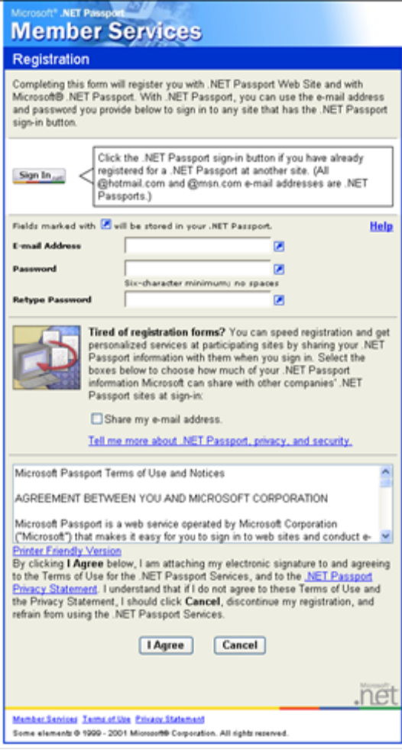
Figure 1: .NET Passport registration page. Note that “Share my e-mail address” is unchecked by default.

At a Participating Sites Registration Page
A user also may establish a .NET Passport account on a participating site by clicking on the standard .NET Passport sign in button (See Figure 5 below) at the participating site. The user will then be redirected to a .NET Passport sign in page (possibly co-branded by the participating site) and asked to sign in using his or her .NET Passport e-mail name and password. If the user does not have a .NET Passport, the user will be asked whether he or she seeks to create a .NET Passport account.
If the user decides to create a .NET Passport account, the .NET Passport login server displays a page (again, possibly co-branded by the participating site) that prompts the user to enter certain information. Participating sites determine what information they require for access to their sites, and they can request any information they choose. However, only a limited amount of information provided by a user during registration at a participating site will be stored by .NET Passport in a user’s profile.
The minimum number of fields required to create a .NET Passport are:
- E-mail Address
- Password
If the participating site chooses to require the user to provide additional fields of information for registration and such data matches one of .NET Passport fields described below, then such information may also be stored in the .NET Passport profile.
- Accessibility Needs
- Country/Region
- Date of Birth
- First and Last Name
- Gender
- Postal Code
- State
- Time Zone
- Occupation
If a participating site uses a single registration form to collect both .NET Passport information and their own site-specific information, the information stored by .NET Passport in a user’s .NET Passport profile will be identified by a .NET Passport icon next to each field. .NET Passport’s system is designed only to accept the categories of information about .NET Passport users listed above, and will not accept other information that participating sites choose to collect from users. Other information (for example, clothing sizes or music preferences) is specific to and only stored by the participating site.
The site where the user registers their .NET Passport account will receive all the profile information, with the exception of password, provided during registration. However, the user may choose not to share this information with other participating sites. This consent process is described in detail later in this document.

At the MSN Hotmail Registration Page
A user may establish a free e-mail account through Hotmail by clicking on the “Sign-up” link on the Hotmail Web site (http://www.hotmail.com). This will direct the user to a registration screen. The Hotmail service requires that all of the fields of the .NET Passport profile be entered.
By registering for an MSN Hotmail account, a user automatically obtains a .NET Passport account. It is effectively a dual registration. Hotmail users may use their Hotmail sign in name and password as their .NET Passport sign in name and password at any participating site. How and to what extent Hotmail users use their .NET Passport account other than for the Hotmail service is up to them.

With the .NET Passport Wizard in Windows XP
Windows XP does not require the user to have or use a .NET Passport. A .NET Passport is also not required to access the Internet through a Windows XP-based Internet connection. When a user engages with a service that uses .NET Passport as its authentication mechanism, the user will interact with .NET Passport at that time. A limited number of optional services in Windows XP use .NET Passport. Users who choose to use such services will be required to obtain a .NET Passport. In addition, a user may browse a Web site or service that requires .NET Passport, but this is a requirement of those particular Web sites and not of Windows XP.
When an end user engages with a service that uses .NET Passport authentication, Windows XP will automatically check to see if the user has saved local .NET Passport account username and password information in the Windows credential manger. In this case, Windows XP will show the .NET Passport sign in wizard if all of the following are true: (1) the user does not have a .NET Passport account saved in Windows; (2) the user has not previously successfully completed the sign-up wizard; and (3) the user has not run the wizard at least five times.
If the user has not saved .NET Passport information in the Windows credential manager, the following will occur:
- The first time a user connects to the Internet; there will be no prompt for .NET Passport sign-up or sign in.
- The second time a user connects to the Internet, the user will see a balloon tip at the lower right hand corner of the screen that asks the user if he or she wants to sign up for a .NET Passport. If the user clicks on the balloon, the .NET Passport wizard (shown below) will appear.
- If the user ignores the balloon, he or she will see the balloon again on the next four connections. That is it. If the user dismisses the balloon by clicking the “X”, then the balloon will never appear again.
- In addition, the first time a user sees the actual .NET Passport wizard (whether by clicking on the balloon or going to a .NET Passport-enabled Web site) the balloon tip will never appear again. This is true even if the user cancels out of the .NET Passport wizard and does not actually create a .NET Passport.
The type of personal information collected through .NET Passport in Windows XP, and the use and disclosure of such information, are the same as described above. However, the registration process depends on whether a user already has a .NET Passport. If a user already has a .NET Passport, the registration process will detect that the e-mail name provided is a registered .NET Passport and will then prompt the user for the password associated with that .NET Passport user name. The following five screens show this process.
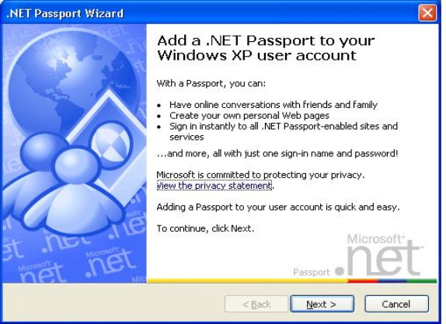
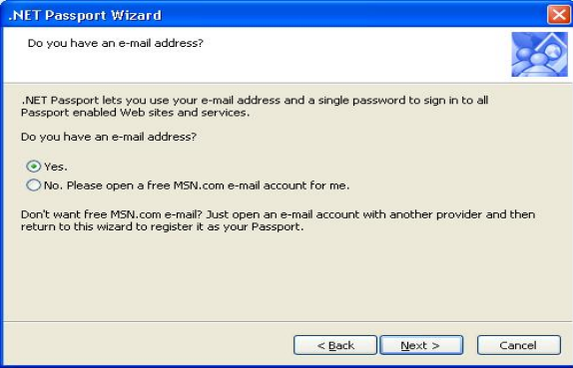
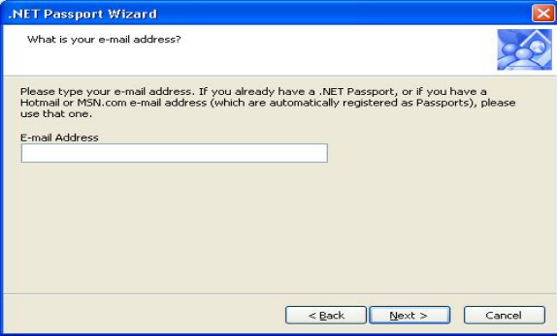
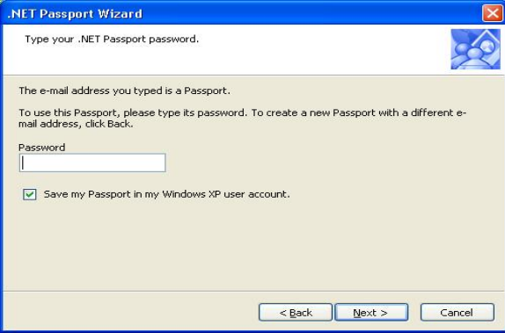
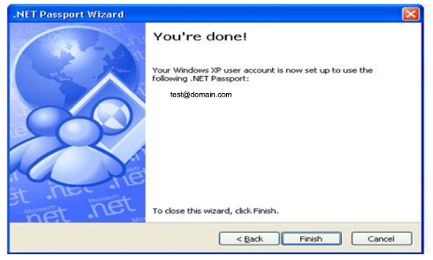
Figure 2: Registration process for existing .NET Passport users.
If the user does not have a .NET Passport, but has an e-mail address, he or she will be presented with an opportunity to sign up for a .NET Passport. If the user agrees to use his or her existing e-mail address as his or her .NET Passport identity, the following information will be collected: (1) e-mail address; (2) password; (3) secret question; (4) secret answer; (5) country/region/postal code); and (6) opt-in consent to share the e-mail address and the regional information with participating sites. The screen also contains a direct link to the privacy statement. The following eight screens demonstrate this process.

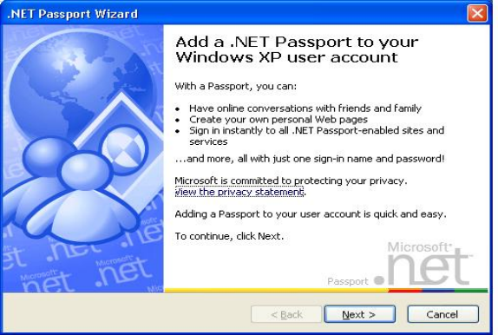
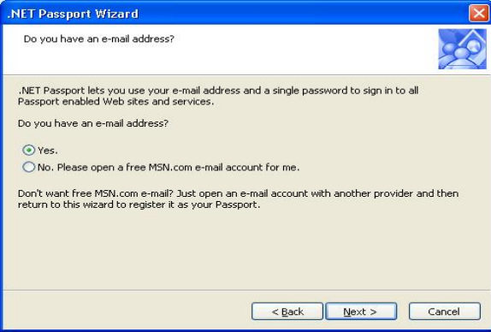
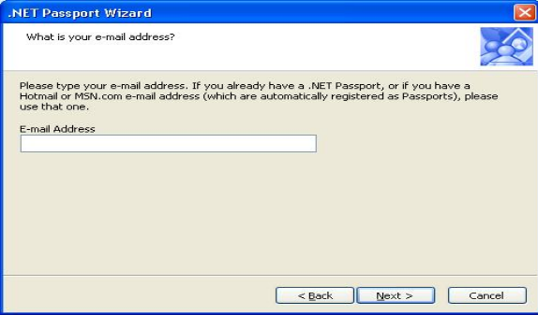
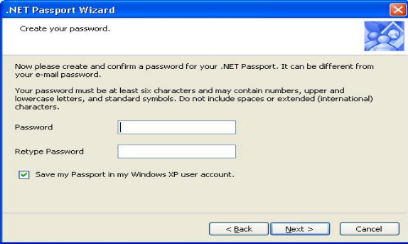
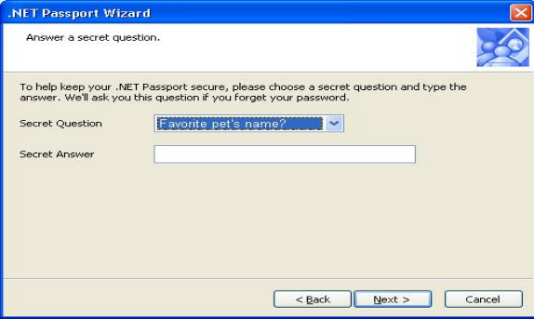
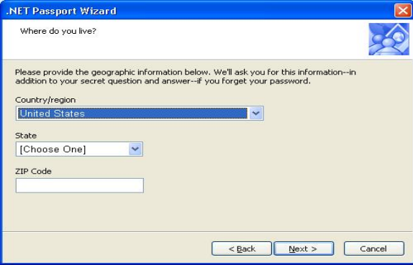
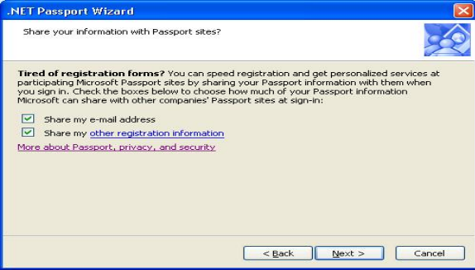
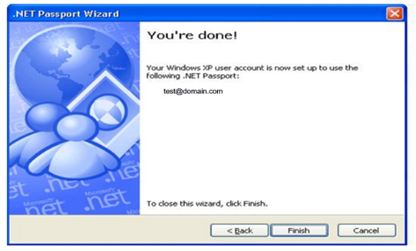
Figure 3: Registration process for non-.NET Passport users who rely on their existing e-mail address.
Finally, if the user does not have an e-mail address, or does not want to use his or her existing e-mail address, then .NET Passport will create a new, free e-mail address for the user in the msn.com domain. In this situation, the following information is collected: (1) first and last name; (2) country/region/postal code; (3) time zone; (4) date of birth; (5) occupation; (6) new e-mail address member name; (7) password; (8) secret question and answer; and (9) opt-in consent to share first and last name, e-mail address, and demographic information with participating sites. Again, there is a conspicuous link to the privacy statement. The following ten screens demonstrate this process.

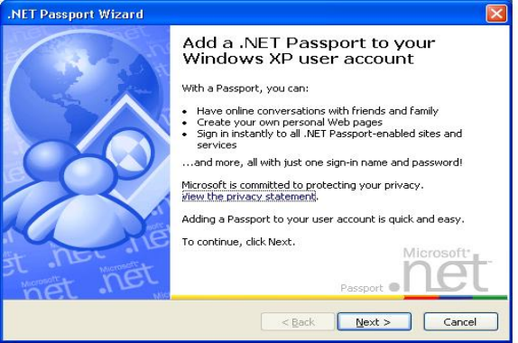
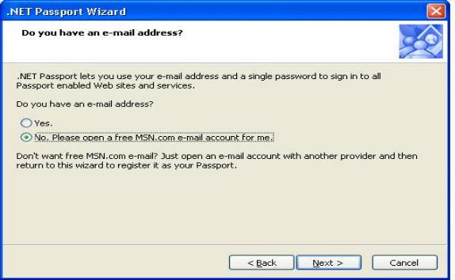
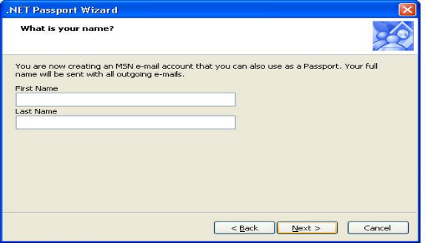
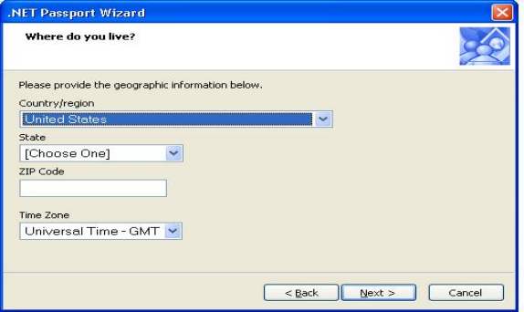
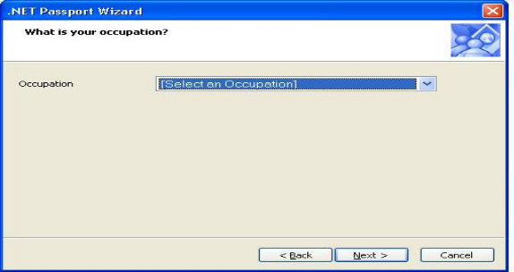
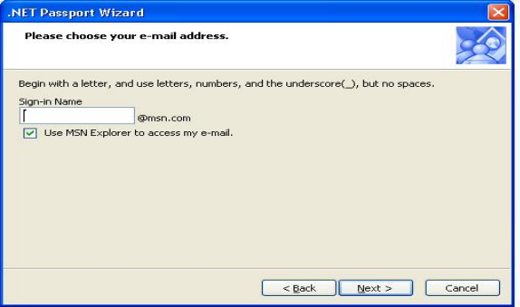
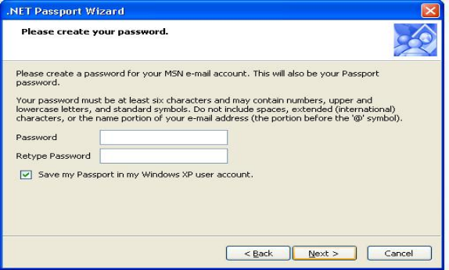
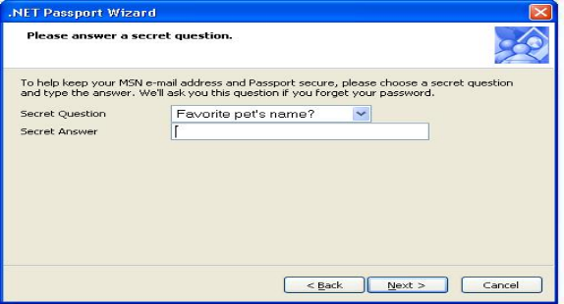
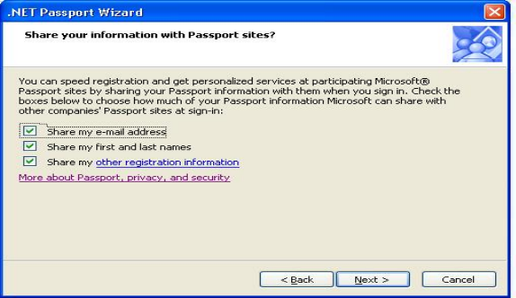
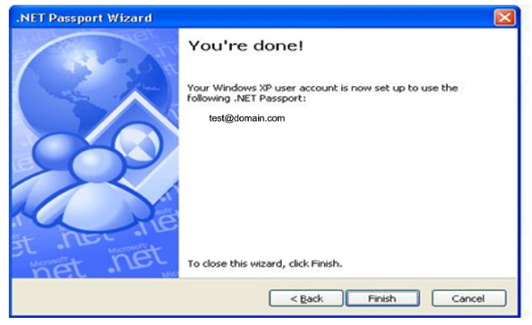
Figure 4: Registration process for non-.NET Passport users and not relying on user’s e-mail address.

Creating a Security Key
Participating sites that want an extra layer of security for their site can require that users enter a separate credential at sign in, in addition to their e-mail address and password. This additional credential is known as a security key.
The first time a user attempts to access a participating site that requires a security key they are redirected to a .NET Passport registration page. When creating a security key a user is asked to provide and confirm a four-character security key and to select and answer three out of ten secret questions.
The three secret questions are used to authenticate the user in the event their key needs to be reset. To ensure that users remember the answers to these three questions they are challenged to re-enter the answers before the registration process is finalized. Once the user has successfully answered all three questions the security key is activated.

Unique Identifiers and Operational Information Created with a .NET Passport Account
When a user establishes a .NET Passport account their account is assigned a Passport User ID (PUID) that is linked to the user’s .NET Passport profile. The PUID is a unique 64-bit identifier sent (encrypted) to participating sites as the authentication credential when a .NET Passport user signs in. The PUID is shared with participating sites for authentication purposes and can be stored by the receiving site. The technical aspects of this authentication process are described in more detail in Section II of this paper.
Some sites need additional .NET Passport information to operate properly and provide the services the user has requested. This "operational" information is shared automatically with the participating site or service when a user signs in using their .NET Passport.
Operational information does not include any of the personal information that may have been provided as part of the .NET Passport registration process. This operational information consists of;
- The version number .NET Passport assigns to the profile. (A new number is assigned each time a user changes their .NET Passport profile to tell participating sites that the information has been updated. Personal .NET Passport profile information is not shared without a user’s permission.);
- Whether the e-mail address has been verified;
- Whether the account has been deactivated;
- Whether the account is a Kids Passport account;
- Whether the account has an associated .NET Passport wallet;
- Whether the user has consented to be listed in the Hotmail member directory or other public directories.

How .NET Passport Accounts are Used

Logging into Passport.com and Participating Sites
Once a user establishes a .NET Passport account a user can log into www.passport.com or into any other participating site.
When a user logs into .NET Passport, the .NET Passport User Interface (“UI”) appears, with links to .NET Passport’s Privacy Statement, Terms of Use Statement, and Member Services page (See Figure 6). The UI also asks the user two questions. First, it asks whether the user is logging in at a public computer. If the user checks the box indicating that he or she is using a public computer, .NET Passport will not automatically enter the user’s e-mail address into the sign in screen when the user logs into the computer again. In other words, if a user signs into .NET Passport, signs out, and then seeks to sign in again during the same browser session, the user’s e-mail address will not be automatically filled in on the sign in dialog box. This will ensure that a second user on the public computer does not have access to any of the first user’s .NET Passport information.
Second, a user can choose to be signed into .NET Passport automatically in the future. If a user checks the box authorizing the automatic sign in feature, the user will never see the .NET Passport UI and will never have to type in his or her username and password. Instead, the user will be able to freely use participating sites without having to input any information, and participating sites will receive the user’s profile information consistent with the user’s consent choices. To disable the automatic feature, a user simply has to select the .NET Passport sign out link (See Figure 5) on Passport.com or at any participating site.
When a user logs into .NET Passport at a participating site, the .NET Passport UI appears; however it may be co-branded and include additional information which is under the control of the participating site. Figure 7 provides an example of how a fictional company named Adventure Works has co-branded the UI.


Figure 5: .NET Passport sign in and sign out buttons

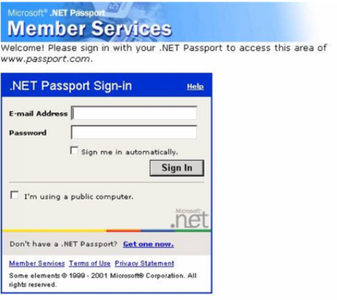
Figure 6: .NET Passport sign in UI

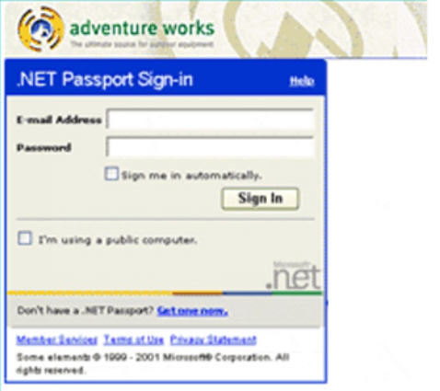
Figure 7: .NET Passport sign in co-branded UI

Logging In with the Inline sign in UI
Inline sign in provides participating sites an alternative to the standard.NET Passport single sign in (SSI) mechanism (see Figure 8). Inline sign in allows a participating site to embed the sign in dialog box directly into a page on their site instead of redirecting the user to a .NET Passport-hosted sign in page. For example, if a user reaches a page on a participating site that requires authentication site but has not been authenticated, .NET Passport normally redirects that person to the .NET Passport Login server. If the participation site uses inline sign in, that redirection is no longer necessary.
When a participating site is using the inline sign in module in this manner, the .NET Passport sign in and sign out buttons still appear in the upper-right corner of pages displaying an inline sign in module. There is also an option that allows the sign in button to be placed within the inline sign in module itself.
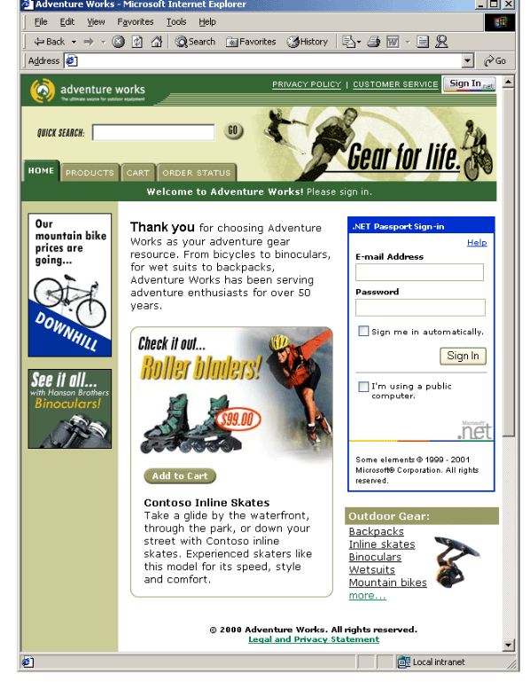
Figure 8: Passport inline sign in UI

Sign in UI when using Windows XP
When a user logs into .NET Passport on a computer that is running the Windows XP operating system a unique .NET Passport User Interface appears (See Figure 9). In addition to prompting the user to enter their e-mail address and password, the UI asks the user if they would like to be signed in to .NET Passport automatically. If the user checks this box, their information will be stored in the Windows credential manager as described above.
Within this UI the user is also presented with links to either get a .NET Passport or go to a help page. If the user clicks on the “Get a .NET Passport” link they will be taken through the registration wizard detailed above. If the user clicks on the “Help” link they are taken to the .NET Passport Member Services page where they can learn more about .NET Passport, discover links to the privacy statement, and manage any existing accounts.
This sign in UI may also be co-branded by the participating site to ensure the user experience is acceptable and so that users understand who they are being asked to authenticate to. A participating site may choose to co-brand this UI by placing their own logo and text at the top of this window, replacing the .NET Passport logo and text shown in Figure 9.
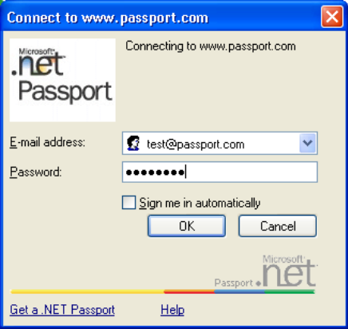
Figure 9: .NET Passport sign in UI when using Windows XP

Using a Security Key
At the point when a participating site requests a security key, users have already been authenticated with their standard .NET Passport credentials. After this initial authentication, they are redirected to a .NET Passport page (Possibly co-branded) where they are prompted to enter their security key. A co-branded example of such a page is shown below.
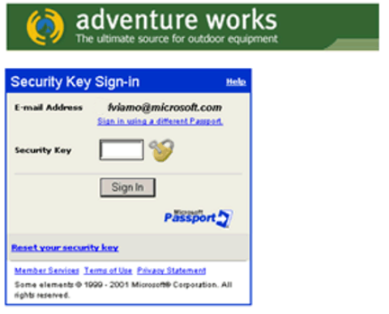
Figure 10: Co-branded security key sign in UI

Signing Out of .NET Passport
Users may sign out of .NET Passport by clicking the .NET Passport sign out logo (Figure 5) on any participating site. Users who have not selected the “automatic” feature in .NET Passport also may exit .NET Passport by closing their Internet browsers. At the time someone signs out of .NET Passport, all .NET Passport cookies from all of the participating sites visited during the browser session are deleted from the user’s computer. This is accomplished by means of HTML image tags and HTTP redirects.

Managing a .NET Passport Account
A .NET Passport user may update/edit the information in his or her .NET Passport account by clicking on the “Edit the information in your .NET Passport” link located on the Passport.com home page. Once authenticated, the user is directed to a screen entitled “Edit Your .NET Passport profile” that contains the user’s e-mail address and several optional data profile fields. The State and Zip Code fields on this page are required. This non-personal information is used for customer support reasons, such as resetting passwords. The remaining fields are optional.
The “Edit Your Password Profile” screen also prompts the user to answer two other questions. First, the screen asks whether the user wants to enable certain accessibility features that may be available on participating sites. The user may ignore the question, in which case the answer remains “No.” Second, the screen asks the user to choose one of three levels of information sharing with participating sites: (1) share only e-mail address, (2) share only first and last name, or (3) share all information placed in the .NET Passport profile. If the user does not affirmatively select one of the above choices, the fields remain blank (See Figure 11).
Once a user updates his or her .NET Passport profile, the user receives a message that his or her profile information has been updated and is directed to a screen entitled “.NET Passport Member Services.” In addition to enabling the user to request information about .NET Passport services and to update his or her .NET Passport profile and/or password, the Member Services directory also gives the user the option of storing credit card and billing/shipping address information in the optional “wallet” portion of the user’s .NET Passport profile. Described in more detail later in this paper, storing such information in a .NET Passport wallet is entirely optional and it enables users to send the information to .NET Passport express purchase enabled sites with a few clicks during a purchase checkout, thereby avoiding having to re-type the information at each participating site or for each purchase.

Managing MSN .NET Passport Accounts from MSN Hotmail
An MSN Hotmail user may also update his or her registration information at any time from within their Hotmail account by clicking the “Options” link on the navigation bar and then clicking on the appropriate menu item.

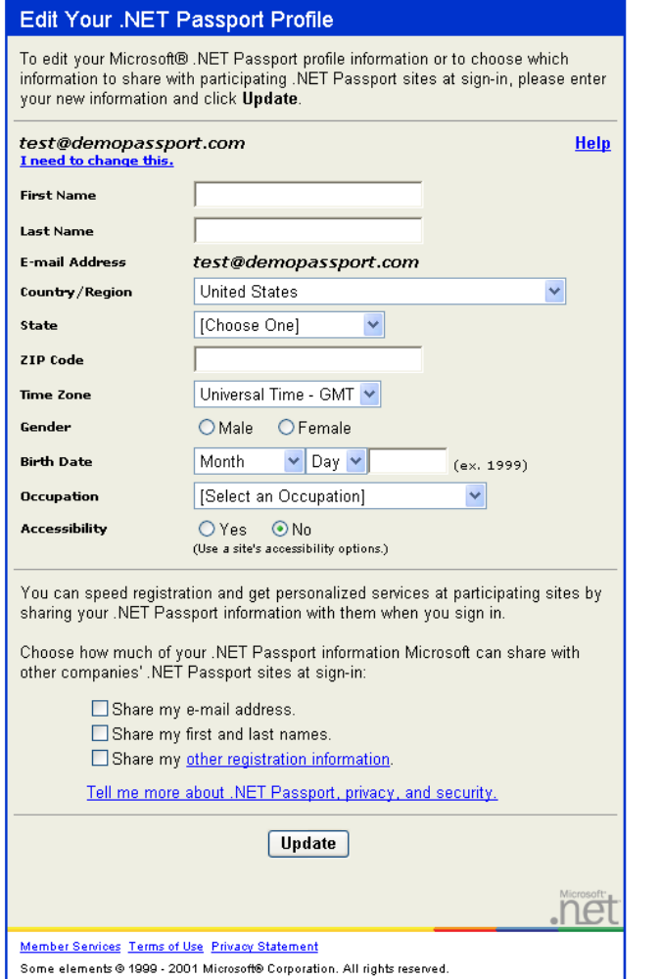
Figure 11: .NET Passport member services page. Note that the sharing preferences are unchecked by default.

.NET Passport Credential and Profile Data
The following table lists the user-definable information that may be stored in a .NET Passport account. While .NET Passport only requires that an e-mail address and password be present to register an account, participating sites may choose to require other fields.

Information | Data Type | Required to create a .NET Passport?
E-mail Address (Sign in name) | Credential | Yes
Password | Credential | Yes
Secret Questions and Answers | Credential | Optional
Mobile Phone Number and Mobile PIN | Credential | Only required when registration takes place on a mobile device; otherwise no
Security Key | Credential | Optional
Accessibility Options  Birth Date  Country / Region  First Name  Gender  Last Name  Occupation  Postal Code  State  Time Zone | Profile | Optional

Use of the .NET Passport Profile
.NET Passport makes limited use of personal information stored in the .NET Passport profile. .NET Passport uses personal information to send new users a welcome e-mail that describes the service, its features, and its operation. This e-mail also includes a link that, if clicked by the user, allows .NET Passport to verify that the user owns the e-mail account that he or she has used for his or her .NET Passport. As the .NET Passport privacy statement indicates, these e-mails are considered essential to the operation of the .NET Passport service. .NET Passport also sends periodic service updates and surveys about the .NET Passport service. Users are not able to choose to unsubscribe to these mailings, but they may choose not to participate in the surveys. Microsoft does not use .NET Passport personal data for any other reason without first obtaining a user’s consent.
.NET Passport does not “mine” user data, and .NET Passport does not collect either “clickstream” data about user sessions at participating sites or purchase related data from .NET Passport transactions. In an effort to understand use of the .NET Passport service, Microsoft reserves the right to report aggregate user statistics on the percentage of .NET Passport users in different groups or areas (such as gender, age, postal code, or region where a user has provided this information). These reports do not include personal information. In addition, these reports are never created for or sold to any Microsoft application providers or third parties in a manner that would permit user data to be tied to a single participating site or service.
.NET Passport enables a user to be authenticated without sharing any personal or profile data. The user may configure the service to send only the PUID and operational data to participating sites during authentication. In that event, participating sites will only be able to link any personal information that they subsequently collect to the user PUID.

Participating Sites Use of Profile Information
By clicking on the sign in logo on a participating site, the user consents to have his or her selected .NET Passport profile information delivered to that site. With the user’s consent, within the guidelines of its own privacy statement, consistent with the agreement signed between .NET Passport and the participating site, and consistent with any privacy coalition program in which it participates, a participating site can then store and use the information it receives from the user’s .NET Passport profile in exactly the same way it could have used this information if it had collected the information itself. The participating site also can use the PUID as the unique key identifier for the .NET Passport user inside the site’s own database.
By signing the contract the participating site agrees to restrictions in their use of .NET Passport data including:
- Participating sites can use .NET Passport profile information only to deliver the products and services requested by users.
- Participating sites cannot use .NET Passport profile information to contact users for any purpose without obtaining the user’s prior consent.
- Participating sites cannot assign, transfer, share, transmit, or publicly disclose .NET Passport profile information––or any identifiable information gathered from .NET Passport profile information––to any third party without the user’s consent. The only exception to this last requirement is when participating sites need to transmit .NET Passport information to third parties in order to deliver goods and services requested by the .NET Passport user (for example, if the participating site sends some of its business, such as shipping services, to an outside provider). In this case:
  - If the third party is another .NET Passport participating site, the site may transmit the PUID.
  - If the third party is not a participating site, the participating site may transmit profile data to third parties, with the following restrictions:
  - The data may only be sent for the purpose of allowing such third parties to participate in the delivery or fulfillment of a product or service requested by the user.
  - Only the amount of profile data that is reasonably necessary for such third parties to receive in order to deliver the product or service requested by the user may be sent.
  - Each third party that receives such data from the participating site must have agreed in advance of receiving such information to:
    - Use such data only for the purpose of delivering the product or service requested by the user; and
    - Respect terms no less restrictive than those that participating sites are required to comply with in terms of the privacy and security of user data.
    - Participating sites agree to post privacy policies on their sites and adhere to legal privacy requirements and industry standards. .NET Passport also now calls for participating sites to comply with the Platform for Privacy Preferences Project (“P3P”) specifications set by the World Wide Web Consortium (“W3C”). This means that participating sites expose their privacy statement in the form of an XML document that conforms to the W3C-P3P specifications. They also post a compact statement describing their use of cookies in the form of a mini-header that conforms to the W3C-P3P specifications.
These documents and headers, in conjunction with the new Internet Explorer 6 support of P3P specifications, enable users to more easily understand a site’s privacy statement and cookie usage. They also make it easier for users to define their default preferences for managing cookies.

User Control over how Profile Information is shared
The user can choose the type of profile information in the .NET Passport profile they want to share with the participating sites that they sign in to. As shown in the various registration methods discussed above, in many cases the user is presented with check-boxes (unchecked by default) that allow them to indicate their sharing preferences. The user can choose whether to share e-mail address, name, and/or the non-identifiable profile information, such as time zone.
There are two specific cases in which a .NET Passport participating site will receive a user’s profile information (except for passwords, secret questions, and secret answers) regardless of check-box settings:
- As part of the process of registering for a .NET Passport, the registering site will receive the profile information.
- When the registering site or service also provides the user with an e-mail account as part of their .NET Passport account, then the company providing that e-mail service will receive the users profile information on sign in. For example, if the site at which a user registers for their .NET Passport account creates a @hotmail.com, @WebTV.net or @msn.com e-mail account, then MSN, the provider of those e-mail services, will receive updates to their profile information whenever they sign in to an MSN site or service. If those e-mail services are co-branded, both service providers may receive updates to the users profile when they sign in to sites or services belonging to those providers. For example, @charter.com and @compaq.net e-mail accounts are MSN-provided e-mail services for whom Charter and Compaq, respectively, are co-branded providers and thus may also receive updates to the profile on an ongoing basis.

Credential Information
Some information, such as password, .NET Passport security key, and secret questions and secret answers, are not profile information and are not shared with any .NET Passport participating site. E-mail address is unique in that it may be shared if the user has opted into sharing that data or in the scenarios described above.

Unique ID and Operational Information
The Passport Unique ID and operational information described earlier is always shared with the Passport participating site at sign in. If a user does not want to share this non-personally identifiable information they should choose to not sign in with .NET Passport.

.NET Passport Privacy Policies
.NET Passport understands that privacy is one of the main concerns with Internet communication and commerce. This understanding goes beyond the .NET Passport service and can be seen across Microsoft as a whole.
Microsoft has made online privacy a priority from both a technical and policy standpoint. The company works with privacy organizations and incorporates security technology into many of its Internet products and services to enable the trusted exchange of private information online. The company has also participated in programs to educate a broad range of users, including children, about effective ways to protect personal data online. Kids .NET Passport is one example of the commitment to support the most current privacy laws while providing technology that helps Web sites comply with these laws.

Fair Information Practices
Microsoft and .NET Passport’s approach to online privacy is based on Fair Information Practices (FIP). These practices are recognized by a number of industry and government organizations including the Online Privacy Alliance, the U.S. Federal Trade Commission, the European Union Directorate General, and the majority of domestic and foreign privacy advocacy groups.
Fair Information Practices include:
- Notice. Microsoft informs users by posting privacy statements that are easy to find and understand. These statements clearly describe the extent and purpose of all information collection and use, including data gathered directly or indirectly from users and uses both within and outside the company. Statement changes might be required occasionally and must be noted prominently to explain what effect the changes have concerning user information and to show the date when the statement is effective. Microsoft also notifies users when information is collected and explains how that information will be used.
- Consent. Users must consent to the collection and use of personal information. Microsoft does not intend to collect or use any information without user consent.
- Access. After a Microsoft site or product collects personally identifiable data, users are given the ability to change that information. Users are able to review, correct, or modify their information easily.
- Security. Microsoft makes every reasonable effort to protect user data from hackers and unauthorized use. All Microsoft sites take strong measures designed to protect user information from unauthorized access, use, or disclosure.
- Remedy and Enforcement. Microsoft responds quickly to any privacy concerns. To foster this, Microsoft has appointed TRUSTe, a privacy watchdog organization, to mediate any possible problems.
Microsoft’s corporate policy for user privacy and data protection embodies these principles and is supported by the company's day-to-day handling of user information. The policy is designed to give users control of their personal information and requires that they be informed whenever personally identifiable information is being collected. It gives them choices over how their data will be used; assures them that their data will be secured from unauthorized access, corruption, and distribution; and provides enforceable standards for compliance.

TRUSTe Certification
Microsoft is a member and premier sponsor of TRUSTe, an independent, nonprofit initiative that exists to help users feel confident about using the Internet for communication, shopping, and research. TRUSTe aims to build user confidence by promoting the principles of disclosure and Fair Information Practices among the Web sites that participate in its program.
As part of the TRUSTe initiative, Microsoft is committed to protecting user privacy and to developing technology that offers the most powerful, safe, online experience possible. Microsoft.com, MSN, and .NET Passport are licensees of the TRUSTe privacy program, which means that these Microsoft sites have agreed to disclose their data-collection practices and to have their privacy practices reviewed for compliance by TRUSTe.
If any TRUSTe-certified Web site, including .NET Passport, does not respond to a user inquiry, or a user feels their inquiry has not been satisfactorily addressed, that user may contact TRUSTe. TRUSTe will act as a liaison between the consumer and .NET Passport in order to resolve the issue.
To review privacy statements for these Microsoft Web sites, please see the following:
- Microsoft corporate Web site: http://www.microsoft.com/info/privacy.htm
- .NET Passport: http://www.passport.com/User/PrivacyPolicy.asp
- MSN: http://www.msn.com/help/legal/privacy.htm

Safe Harbour
Safe Harbour is an agreement between the United States and the European Union (EU) for data protection that is consistent with the Fair Information Practices and the European Union in its Data Protection Directive.
In 1998, the EU issued the Data Protection Directive to ensure the privacy of EU citizens. The Directive says that for those countries outside the EU whose privacy practices are not deemed "adequate," transfers of personal information from Europe to those countries would be stopped. To ensure that personal data flows to the United States are not interrupted the U.S. Department of Commerce and the European Commission have developed a "safe harbour" framework that will allow U.S. organizations to satisfy the European Directive's requirements. The decision by U.S. organizations to enter the safe harbour is entirely voluntary. Organizations that decide to participate in the safe harbour must comply with the safe harbour's requirements and publicly declare that they do so by signing up with the Department of Commerce.
In June 2001, Microsoft signed the Safe Harbour agreement.

Additional .NET Passport Services

The .NET Passport Express Purchase Service
.NET Passport express purchase makes online purchases faster and easier for .NET Passport users by giving them the option of storing credit card and billing/shipping address information in the “wallet” portion of their .NET Passport profiles. Users can then provide this information to .NET Passport express purchase-enabled sites with a few clicks during checkout, rather than retyping it at each site or for each purchase. .NET Passport express purchase enables users to transfer this information, using secure sockets layer encryption (SSL), to a merchant who is a licensed .NET Passport participant and displays the .NET Passport express purchase sign in logo on its Web site.

Figure 12: .NET Passport express purchase sign in button
Clicking this button redirects the .NET Passport user over a HTTPS connection (using SSL) to either:
The .NET Passport sign in page (if the user is not already signed in to .NET Passport), with a subsequent redirect to the .NET Passport wallet profile page.
—or—
The .NET Passport wallet profile page (if the user is already signed in).
On the wallet profile page, the user can add new credit card or billing/shipping address information, or select from the information already stored there. After the user has selected or entered the card, billing address, and shipping address to use for the current transaction, those pieces of information are sent (using the HTTP POST method) over SSL back to the merchant using data field names compliant with the Electronic Commerce Modeling Language (ECML) standard. (ECML is a set of standardized data field names for exchanging commerce information between digital wallets and merchant Web sites.) The merchant then handles the information as if collecting it directly from the consumer and proceeds with the transaction.
.NET Passport does not receive or track the purchase price or product information when processing .NET Passport EP transactions. Also, .NET Passport EP is not a credit card or debit card processing solution. Participating sites are still required to process the transaction directly or through a third-party service. In addition, while .NET Passport uses a basic Luhn checksum to determine the validity of the credit card or debit card number provided by the consumer, it does not perform card authorization.

Use of the .NET Passport Wallet
The user controls which pieces of information in their .NET Passport wallet are shared with .NET Passport express purchase participating sites and services on a per-transaction basis. After clicking the .NET Passport express purchase button at a participating site, the user is able to choose which credit card and billing and shipping address information to send to the participating site for that purchase.

The Kids .NET Passport Service
.NET Passport participating sites may opt to implement the Kids Passport service in addition to the SSI service. The Kids Passport service gives these sites tools to help them comply with the Children's Online Privacy Protection Act (COPPA), which went into effect in April, 2000. COPPA requires that operators of online services or Web sites obtain parental consent prior to the collection, use, disclosure, or display of the personal information of children.
Many Web sites routinely collect personal information from visitors of all ages. Parents with .NET Passport accounts can register children under age 13 for Kids Passports and choose, subject to certain exceptions described in the Passport privacy statement, what profile information will be shared with .NET Passport participating sites when their children sign in.
In addition parents can set additional consent levels for .NET Passport Web sites that have implemented the Kids Passport service. Parents can choose a consent level for the collection, use, and sharing of their child’s personal information by each Kids Passport participating site.
Because it is a .NET Passport, a Kids Passport sign-in profile can store personally identifiable information, such as name, date of birth, and e-mail address, which may be shared with .NET Passport participating sites. When a child with a Kids Passport signs in at a Kids Passport participating site, .NET Passport checks a field that represents the combination of birth date and country in the child’s profile. If the child is covered by the COPPA law, .NET Passport checks the profile to determine whether the parent or guardian has granted consent for that Kids Passport participating site, and at what level. The following table explains these consent levels.

Consent level | Description
Deny | The site or service cannot collect personally identifiable information from the child. Many sites will not let children use their services if this option is chosen.
Limited | The site or service can collect, store, and use the information it collects from the child, but it cannot disclose the information to a third party (individual or company) except as necessary to operate the site/service.
Full | The site or service can collect, store, and use the information it collects from the child, and it can also disclose the information to a third party (individual or company).

If the child’s profile indicates that consent (at one of the three levels) has been granted for that Kids Passport participating site, the child is allowed to proceed at the site. If consent has not been granted, .NET Passport displays a notification message that the child must request consent from a parent or guardian before proceeding at the site.

Section II: Technology Overview

The Authentication Process
When a registered .NET Passport user clicks the standard .NET Passport sign in logo on a participating site or tries to access a protected Webpage within a participating site (e.g., a page that requires user authentication before allowing access), a silent “HTTP redirect” displays the co-branded .NET Passport sign in page.
Once on the sign in page, the user is asked to enter his or her .NET Passport sign in name and password. If the user’s sign in name and password match an entry in the .NET Passport database, the user is authenticated and his or her PUID and .NET Passport profile are extracted from the .NET Passport database. The .NET Passport login server uses this information to create three .NET Passport cookies: (1) the Ticket cookie, which includes the PUID and a time stamp; (2) the profile cookie, which stores the user’s .NET Passport profile; and, (3) the participating site cookie, which stores a list of the sites to which the user has signed in. Described in more detail below, these are temporary session cookies––they are deleted when the user signs out of .NET Passport or closes the Internet browser.
In order to obtain a .NET Passport user’s authentication information, participating sites must take several steps. When a participating site first enlists to use .NET Passport, it registers its URL and return URL (where .NET Passport should send authentication information) with .NET Passport. The site is then issued a site ID, and it receives an encryption key, which is a shared secret between the site and the .NET Passport system (i.e., the login server). Using the site encryption key associated with the participating site’s ID (unique per site), .NET Passport encrypts the Ticket and Profile cookies, adds them as query string parameters to the return URL provided in the authentication request, and presents this URL to the user’s browser. The user’s browser then creates the three temporary .NET Passport session cookies in the passport.com domain on the user’s machine.
Once this process is complete, the browser automatically redirects the user to the participating site, and the encrypted .NET Passport Ticket and Profile cookies are passed to the participating site as query string parameters. The participating site extracts this information and sends it to a simple server-side COM component––referred to as the .NET Passport Manager––that has been installed at the participating site. The .NET Passport Manager looks for and decrypts cookie information, receives the PUID and the profile information, and, with this information, authenticates the user and allows access to the protected pages. At this time, the participating site can store the profile information in its own database or upgrade previously stored data in the case of a returning user.
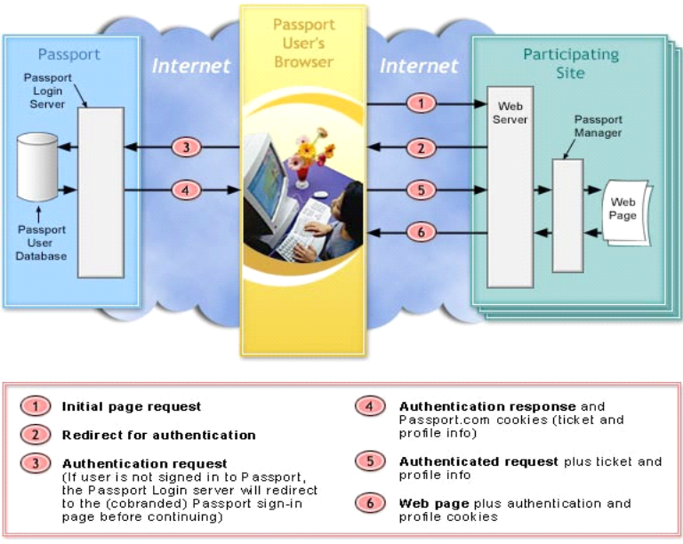
Figure 13: .NET Passport SSI process.

There is no direct server-to-server communication of a user’s authentication and profile information between .NET Passport and participating sites. The information exchange occurs through the client’s browser using HTTP redirects and cookies. However, .NET Passport does perform server-to-server communication to periodically update information about the locations of .NET Passport servers. This gives .NET Passport the ability to provide redundancy without requiring the participating site to take on additional management burdens. .NET Passport can reconfigure its partner Web sites to use different locations for login services as necessary to respond to various high-load or failure scenarios. This works like a traffic controller helping the participating site find the least congested route to the .NET Passport servers to make the sign in experience for .NET Passport users as fast as possible.
After signing in at one .NET Passport participating site, a user can sign in to other participating sites during the same browser session simply by clicking the .NET Passport sign in link on each new site. The HTTP redirects still occur, but .NET Passport issues a set of encrypted cookies to enable silent, seamless re-authentication across sites. However, participating sites do have the option of requiring the user to reenter his or her sign in name and password regardless of the user’s authentication state. By forcing a user to re-type credentials, the site effectively eliminates the ability of someone who does not know the user’s username and password to access that user’s information. Sites collecting sensitive information, such as financial services Web sites, can use this feature. It is unlikely that a site that only displays localized news or weather would force the user to re-type his or her credentials; however, the choice is available.

Password Protection and Cookie Handling

Passwords
Passwords are shared with .NET Passport servers only for authentication purposes. A user’s .NET Passport e-mail address and password are not shared with participating sites

Cookies
A cookie is a very small text file that .NET Passport saves to a user’s computer to store information that a user provides about him or herself or to store a user’s preferences. Widely used in Internet authentication systems, cookies provide the most efficient way to establish compatibility across all browsers commonly used today, and those that are on the horizon.
.NET Passport uses cookies whenever a user signs in to a .NET Passport participating site. These cookies allow users to move from page to page at a participating site without having to sign in again on each page.

Domain Authority Cookies
None of these cookies can be directly accessed by a participating site. They are written only to the domain authority’s domain.
Label | Common Name | Description / Contents
MSPAuth | Ticket | Encrypted with .NET Passport key. Contains the .NET Passport timestamps (last refresh and last manual sign in), saved-password flag, key version verification and any flags set by network servers.
MSPProf | Profile | Encrypted with .NET Passport key. Contains each of the core profile attributes.
MSPSec | Ticket-Granting Cookie | Sent via HTTPS for all browsers that allow HTTPS cookie writes. Contains SSL-encoded PUID and password, used for silent sign in.
MSPPre | Email Pre-filling Cookie | Email name of last user signed in on this machine. Not set if user checks “I am using a public computer” at sign in.
MSPVis | Participating sites Cookie | Each new .NET Passport Participant site visited has its site ID written to this cookie. Used by the Login server to compile the list of sites that must be signed out from when the user clicks any Sign Out link. No encryption.
MSPDom | Domain Cookie | Used to store the last used domain authority used by the user when signing on to .NET Passport (presets the dropdown list of possible .NET Passport authenticating domains). No encryption.
Browsertest | Browser Testing Cookie | Used to check cookie and script capabilities of a users browser.

Participant Cookies
These cookies enable the user to sign in and access personal pages at any .NET Passport participating site during a browser session. If a user disables the browser’s cookie feature, the .NET Passport service will not be available on that computer.
Label | Common Name | Description / Contents
MSPAuth | Ticket | Encrypted with participating sites .NET Passport key. Contains the .NET Passport timestamps (last refresh and last manual sign in), saved-password flag, key version verification, and any flags set by network servers.
MSPProf | Profile | Encrypted with participating sites .NET Passport key. Contains each of the core profile attributes.
MSPCAuth | Kids Passport Ticket | Encrypted with participating sites .NET Passport key. Copy of MSPAuth cookie used in Kids Passport scenarios.
MSPCProf | Kids Passport Profile | Encrypted with participating sites .NET Passport key. Copy of MSPProf cookie used in Kids Passport scenarios.
MSPConsent | Kids Passport Consent | Encrypted with participating sites .NET Passport key. Used in managing consent in later versions of the Kids Passport system.
MSPSec | Ticket-Granting Cookie | Encrypted with participating sites .NET Passport key. Used to cross check MSPAuth for validity.
MSPSecAuth | Secure Sign In | Sent via HTTPS for all browsers that allow HTTPS cookie writes. Used to indicate the participating site is using the secure sign in feature.

All .NET Passport cookies are temporary cookies and are deleted when the browser session is closed. In addition, .NET Passport-related cookies are deleted when a user clicks the sign out link. When the user signs out of .NET Passport, the .NET Passport server checks the cookies for participating sites and launches a script executed by each site to delete the cookies created at sign in. The script for deleting a cookie is provided by each participating site during the site registration process. Only the site that has created the cookies can delete them.
Participating sites also can use the encrypted .NET Passport Ticket and Profile data to write their own cookies (in their own domain names) on the user’s machine. Only these cookies authenticate the user to the participating site and allow the site to deliver personalized content based on the PUID, profile data, and user preferences. Aside from enabling participating sites to create .NET Passport-related cookies in their domain, Microsoft has no control over other cookies set by participating sites. The .NET Passport implementation guidelines that Microsoft provides to all participating sites explicitly requests that sites delete any non-.NET Passport cookies that include personal information. In addition, by signing the contract to go live with .NET Passport the participating site agrees to delete all .NET Passport cookies and other cookies that contain personally identifiable information when a customer signs out.
Even if the user does not sign out of .NET Passport, .NET Passport cookies are time-sensitive and expire at the end of a time period specified by .NET Passport or the participating site. If the user does not re-enter a password after the time period has expired, .NET Passport will deny the user continued access to the .NET Passport service.

Secure Channel
Secure channel sign in enhances the standard sign in process by providing an end-to-end SSL-secured channel during authentication. As with any time SSL is used, participating sites will notice a significant decrease in performance when using this option. Depending on the needs of a participating site, the decrease in performance may or many not offset the need for the secure channel.
Other than that the .NET Passport sign in page is displayed using SSL, the secure channel sign in user interface is the same as the standard sign in user interface.

Localization
.NET Passport offers authentication functionality in 27 languages.
In some cases, significant differences exist between dialects of a particular language, causing those dialects to be considered unique languages in their own right. Chinese (Traditional and Simplified) and Portuguese (Brazil and Portugal) are examples of this, and .NET Passport supports these distinctions.
.NET Passport is available in:
- Arabic  - Chinese (Simplified)  - Chinese (Traditional)  - Czech  - Danish  - Dutch  - English  - Finnish  - French  - German  - Greek  - Hebrew  - Hungarian  - Italian | - Japanese  - Korean  - Norwegian  - Polish  - Portuguese (Brazil)  - Portuguese (Portugal)  - Russian  - Slovakian  - Slovenian  - Spanish  - Swedish  - Thai  - Turkish

Localization of Additional Services
.NET Passport express purchase is currently available in 26 languages.
Kids .NET Passport is somewhat unique in that it is market-based—it applies only to the United States and the Children's Online Privacy Protection Act (COPPA) of that jurisdiction. Accordingly, this service is available only in English.
The .NET Passport SDK, a variety of marketing materials, consumer information (FAQ, home page, participating site directory, and so on), as well as the privacy statement and terms of use are available at www.passport.com. Some of these items are not available in languages other than English. However, the consumer section, terms of use, and privacy statement are all currently available in 26 languages.

Implementing .NET Passport
It is the goal of Microsoft to make implementing .NET Passport as easy as possible. As such, a wealth of information designed to aid implementation is available on the Microsoft Developer Network (MSDN) Web site located at: http://msdn.microsoft.com/myservices.
This chapter is intended only to provide an overview of what it takes to create an outstanding .NET Passport implementation. It is not intended to replace the existing SDK or implementation documents that may be found on MSDN.
Please note that although the coding work is fairly straightforward, .NET Passport is not just about code. It is a service. As such, there are a number of specific policies and best practices that must be followed in order to attest to the “go live” checklist requirements.
A .NET Passport implementation can be broken down into four phases; planning, setup, development, and going live. By following these steps participating sites can integrate .NET Passport with their offerings in a way that provides a consistent, high-quality user experience for the millions of .NET Passport users.

Step 1: Planning
When implementing .NET Passport, a participating site should observe the criteria listed in the SDK (available from MSDN).
One of the criterions is that all participating sites must have a posted privacy statement that conforms to industry standards and is easily accessible from the Home page and other pages on which personal information is obtained. We encourage the exploration of privacy certification programs, such as TRUSTe and BBBOnLine and recommend that sites set time aside to review their privacy statements early in the process.
Planning the customer experience is one of the most critical steps in the .NET Passport implementation process. Co-branding allows a site to carry the look and feel of the site over to the pages that will be hosted by .NET Passport. This extends the site’s brand and prevents customer confusion.
Once a site decides to go live with .NET Passport, both parties must sign a contract. While a signed contract is not required to get started with .NET Passport implementation, it is a good idea to request a contract early so that it does not become a bottleneck later on. Sites may request a contract by sending an e-mail to passcon@microsoft.com with their company's name, URL, and physical address stating that they are interested in .NET Passport.

Step 2: Setup
.NET Passport currently supports two parallel environments with two distinct purposes: Production for live sites and Preproduction (PREP) for sites in development. In order to ensure high quality, Microsoft requires that sites develop against the PREP environment before going live.
Sites that are working in the Preproduction environment will find that regular .NET Passport accounts do not work. In order to authenticate to the PREP environment the site must create a .NET Passport for use only in the PREP environment.
In order to decrypt the information passed to a site by .NET Passport, a site will need an encryption key and PREP site ID. The SDK includes instructions on how to register and get a PREP site ID and encryption key. While implementing a site may use a PREP encryption key, however, this key is for testing only. Encryption keys for live sites are not downloadable.

Step 3: Development
The primary goals of a Web site or service implementing the .NET Passport single sign in (SSI) service are to (1) determine whether the user is been authenticated by .NET Passport, (2) if not, direct the user to the .NET Passport Login server, where (3) .NET Passport will request the user to sign in, if authentication is successful, (4) the participating site will be able to identify this user based on the contents of his or her .NET Passport profile in the site’s database to then (5) grant the user access privileges and be authorized for services.
All of these goals are accomplished by including the .NET Passport Manager object as a server-side object on any page where .NET Passport authentication will be used, and, by adding the .NET Passport Unique ID (PUID) as the key to the user’s data in a database.
.NET Passport requires that participating sites host a "cookie-delete" script to delete both .NET Passport cookies and related cookies whenever a .NET Passport user signs out. This is handled by individual, site-specific scripts rather than automatically, so that each site can delete all necessary cookies when required. The actual sign out process calls many such site-specific scripts as elements of a centrally hosted .NET Passport sign out page; this approach enables a user to simultaneously sign out of all .NET Passport sites that had been previously signed into.
This approach requires that sites implement The Platform for Privacy Preferences Project (P3P). Developed by the World Wide Web Consortium, P3P is designed to cover all the major aspects of a Web site’s privacy statements to help users better understand how the company they are dealing with will handle their personal information.
After a user is signed in, a site can read attributes of the user's .NET Passport profile by calling the Profile property of the .NET Passport Manager object and supplying the appropriate attribute name as a parameter. The primary piece of information that is always guaranteed to exist for a signed-in user is the PUID. After obtaining a user's PUID, a site may use it as the key to locate database records about this .NET Passport user, or as an access control mechanism for other functionality enabled for the user.
As with any development effort, testing is vitally important. The SDK includes some general test cases to help sites identify common implementation problems and to show them where to look to fix them.

Step 4: Going Live
After a site has completed development and testing, they will need to complete and submit a checklist to receive a Production site ID. This checklist and instructions on submitting it to Microsoft can be found in the SDK documentation.
As Production site ID’s and encryption keys are never sent over the Internet please allow a few days in the development schedule for delivery to take place.
After having completed all steps in the Development phase, adequately testing their code in the appropriate testing environment, and receiving a Production Site ID, a site can deploy code to their Production servers. Generally this phase should be done as a pilot to limit broad user access to this new version of the site until a number of small reconfigurations to point the .NET Passport components to the .NET Passport Production environment have been made.

Adding .NET Passport to an Existing Web Site
Many sites that want to use .NET Passport single sign in (SSI) already have a proprietary authentication system in place and potentially a large number of customers with accounts in that system. These accounts typically have data associated with them, and are protected by User IDs and passwords that customers are using today.
It is critical to minimize the impact of any changes on existing customers when adopting .NET Passport SSI. Participating sites may choose to move to .NET Passport from their proprietary authentication system entirely, or they may choose to run the systems in parallel. While by no means the only options, the following section discusses these two common approaches.

Implementation Strategies
Two approaches to implementing .NET Passport on an existing site are:
Conversion—All customers are asked to sign in using .NET Passport, and returning customers must convert their accounts to .NET Passport from the site’s proprietary login.
Coexistence—.NET Passport is presented in parallel with the site’s proprietary login, so that individual customers may choose which to use.

Conversion
Conversion is used when a participating site wants to adopt .NET Passport as the primary authorization mechanism for their site and have all customers sign in with .NET Passport thereafter. As customers return to the site, or visit a protected page for the first time, they are prompted to sign in to .NET Passport (or to get a .NET Passport if they don’t already have one) and then—once only—associate their existing account information (if any) with their .NET Passport. On subsequent visits, the customer will simply sign in with .NET Passport to access their account information.
The conversion approach has been used successfully by several sites including http://www.microsoft.com/. Microsoft.com converted 20 million existing accounts to .NET Passport. Before this conversion was begun, the microsoft.com team performed usability testing of the process with outstanding results.
The advantages of the conversion approach are:
- Customers go through a quick, one-time process and can then simply sign in with .NET Passport to access their account information in the future.
- After some specified period of time (perhaps 3-6 months, but entirely at the participating sites discretion), the proprietary authentication code may be retired.

Coexistence
The coexistence approach to implementation involves adding .NET Passport SSI support as a non-exclusive alternative to an existing, proprietary sign in system. Customers who already have accounts in the proprietary system can continue to use them and customers with .NET Passports can also be authenticated on the site.
The primary advantage of coexistence is that customers who already have accounts in the existing system are free to continue using them if they want to, but customers who have .NET Passports can use them instead of having to register for another account. The disadvantage, however, is that customers will need to make an explicit choice as to which system to use to be authenticated at the participating site. In addition, coexistence implies continuing to maintain and support a proprietary authentication system indefinitely.
The following figure presents an example of how .NET Passport can coexist with an existing proprietary authentication system.
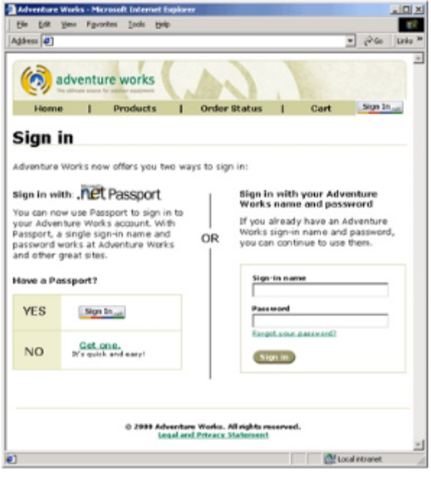
Figure 14: Example of coexisting sign in methods.
Note that coexistence and conversion are not mutually exclusive. Sites may want to introduce .NET Passport to their customers gradually, beginning with coexistence and progressing toward conversion.

Appendix A: Glossary of Technology Terms
The .NET Passport services use standard Web technologies and techniques such as cookies, HTTP redirects, and secure sockets layer (SSL) that are supported on nearly all current browsers. This appendix provides brief overviews of these core technologies.

Cookies
A cookie is a small text file that a site’s Web server stores on a user’s browser. Each time the user requests a Web page from that site, the browser sends the cookie back to the server with the page request. The cookie contains information provided to the site by the user, typically during registration, that identifies the user to the site and enables the site to personalize the user’s experience (for example, by displaying the user’s name on its Web pages).
The .NET Passport service uses encrypted cookies to store the user’s authentication credentials and profile information securely on the browser. This enables the user to sign in and access personal pages at any .NET Passport site during a browser session. When the user signs out of .NET Passport, all .NET Passport cookies are deleted from the computer. If a user disables the browser’s cookie feature, the .NET Passport service will not be available on that computer.

HTTP Redirects
Web browsers, such as Microsoft Internet Explorer and Netscape Navigator, request documents from Web servers by means of hypertext transfer protocol (HTTP). For example, a user goes to a URL (a Web address, such as "http://www.microsoft.com/hello.asp") by typing the URL in the address box or by clicking a link. The browser finds and connects to the computer "www.microsoft.com" using the HTTP protocol and requests the document (in this example, "hello.asp").
An HTTP "redirect" enables the Web server to tell the browser to retrieve a different document instead (for example, "greetings.asp"). The redirection is transparent to the user. By using the consumer's browser as an intermediary to pass query string data between different sites—such as between .NET Passport.com and participating Web sites—HTTP redirects enable sites to communicate with one another without direct connections between the sites’ servers.

GET and POST
The GET method is used with HTTP redirects to pass data between Web servers by packaging the data and appending it to the URL. For example, if a user goes to "http://www.altavista.com/search.asp" and types "passport" in the Search box, the browser would retrieve "http://www.altavista.com/search.asp?search=passport" from the server. The main limitation of the GET method is the size of the data that can be passed in the URL. In conventional browsers and proxy servers, the accepted upper limit is 1,024 characters. More important, GET methods are applicable to hyperlinks or image references.
The POST method is similar to the GET method, except that the data is sent after the request for the document. As a result, there is no practical limitation to the amount of data that can be sent, as long as the server is willing to accept it. POST methods cannot be used with redirects because many browsers do not carry the POST data to the destination server.

Secure Sockets Layer
Secure Sockets Layer (SSL) is a security protocol that provides data encryption, server authentication, and message integrity for a connection to the Internet. Most current Web browsers support SSL, and many Web sites and services—including .NET Passport—use this protocol when transmitting and receiving confidential user information (for example, passwords or credit card numbers). By convention, addresses of Web pages that require an SSL connection begin with https: instead of http:.

JavaScript
JavaScript is a Web scripting language that can interact with HTML code to make Web pages more robust and dynamic by adding application logic to them. Almost all current browsers support JavaScript. .NET Passport uses JavaScript to make certain transactions more efficient (because they require fewer redirects), and also to enable co-branding for participating sites on most centralized Web pages.

Appendix B: Location of referenced documents
URLs referenced in this document were accurate as of the time of writing. Unfortunately, like all URLs, there is a strong chance that they will change from time to time.
If the reader is unable to access the information at the locations listed in this document search tools for finding the new locations are located on the home pages of http://www.msn.com, http://www.microsoft.com, and http://msdn.microsoft.com.

Appendix C: .NET Passport and Mobile Devices
A new feature of .NET Passport provides support for both wireless cell phones and Windows Powered Pocket PC 2002, Phone Edition.
Because mobile devices implement many different browsers' technologies and are limited in terms of screen size, input mechanisms, and graphics capabilities, some .NET Passport features are not supported on these devices in the current version of .NET Passport. Nevertheless, mobile users have access to key .NET Passport features such as .NET Passport registration, SSI, Kids .NET Passport (except the consent process), and sign out.
The following browsers are supported in .NET Passport: Pocket PC 2002, phones using Microsoft Mobile Explorer (MME) in HTML mode or Wireless Application Protocol (WAP) mode, i-mode phones, WAP phones, and Handheld Device Markup Language (HDML) phones.
To address the differences between these devices, .NET Passport offers two new user interfaces (UIs) using different markup languages that will be used for the following types of browsers and devices.

Browser | User Interface | Markup language
All WAP Browsers | Phone UI | Wireless Markup Language (WML)
i-mode and MME | Phone UI | Compact HTML (cHTML)
Pocket PC and Stinger | Pocket PC UI | HTML 3.2
Phone.com 3.2 | Phone UI | HDML

Windows Powered Pocket PC 2002, Phone Edition
These devices support current Internet technologies used in .NET Passport authentication, the only modification to .NET Passport has been to develop smaller sign in, registration, and member services pages. The smaller pages fit onto PDA and phone screens by restricting the pages to a width of 176 pixels, and by preventing horizontal scrolling.
This new Pocket UI is the .NET Passport interface used on all hand-held devices that have a physical or virtual alphanumeric keyboard, a Pocket PC 2002, Phone Edition sized browser screen (no smaller than 176 x 220 pixels), and UI capabilities similar to HTML (for example, pull-down menus and option buttons).
The Pocket UI registration page uses a standard registration process as opposed to the phone-number/PIN process for phones.

Mobile Phones
To support .NET Passport authentication efficiently from mobile phones, some changes have been made.
First, because of input limitations, .NET Passport user credentials can consist of a phone number and a PIN as well as an e-mail address and password. Users who already have an e-mail/password credential can use either their phone number or their e-mail address to sign in. However, the numeric keypad makes phone-number sign in easier. The phone number must be in full international number format (including the country/region code), and the PIN must be at least six characters long.
Second, because of the screen-size limitation, .NET Passport offers a new Phone UI. The Phone UI is intended to be used only on devices with numeric keypads and small screens with primitive UI capabilities. Vertical scrolling is seldom used because it is very difficult for most phone users. The Phone UI supports .NET Passport registration and standard sign in, and provides limited Kids .NET Passport.
The Phone UI registration page enables users to register with a phone number (as their account name) and a numeric PIN (as a password). No other data is required to register. Users who already have a .NET Passport can use the Member Services pages to add a phone number and PIN as alternate credentials.
When users register for a .NET Passport account from a phone, .NET Passport first displays a page that asks them to select a country. They are then presented with a page that asks for their mobile phone number, with the proper country code already entered as the first digits in the form field. They are then asked for a PIN that is from 6 to 16 characters in length. Finally, a confirmation page is displayed confirming the user’s new member name.
Figure 15 shows the three successive screens users see on the phone when registering for a .NET Passport. The UI for signing in with a phone number and PIN appears in Figure 16.
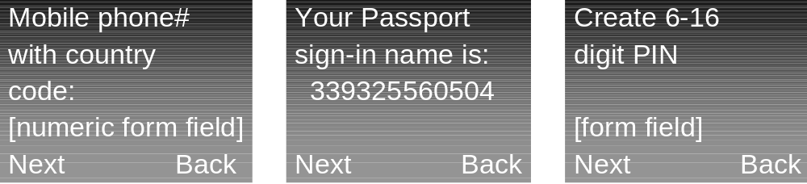
Figure 15: Mobile registration screens.

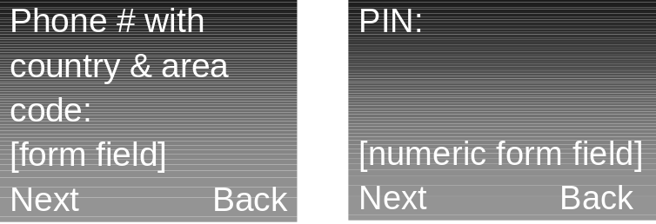
Figure 16: Mobile sign in screens.

Limitations and Changes on Mobile Phones
Because of the limitations of mobile phone browsers, some .NET Passport behavior on phones is different from that on other devices. Following are the main differences:
- Many phones have size limitations with regard to cookie storage. By default, except for HDML devices, .NET Passport does not return any profile information during sign in.
- For phones with no cookie support, .NET Passport can work without cookies (although with some limitations), passing the encrypted authentication and profile information on the URL query string instead of in cookies.
- Cookies on phones are permanent. Users are automatically signed in to .NET Passport and do not have to sign in again every time they restart their phone. Users are prompted to enter credentials again after the initial sign in only if they sign out manually, or if a participating site requires a forced sign in.
- Member Services pages are not available on phones. Users must use a computer to edit their profile or change their phone number or PIN. On the standard sign in page, users who registered their .NET Passport from a phone and only have numeric credentials will enter their phone number followed by “@passport.com” in the e-mail field and their PIN in the password field.
- The current version of .NET Passport supports the basic functionality of Kids .NET Passport on Pocket PCs and Stinger phones. However, it does not support the consent process. This means .NET Passport signs users in to sites on Pocket PCs and Stinger phones if the user is older than 13. If accessing a site requires parental consent, .NET Passport displays a page explaining that the parents must use a computer to grant their consent.

The information contained in this document represents the current view of Microsoft Corporation on the issues discussed as of the date of publication. Because Microsoft must respond to changing market conditions, it should not be interpreted to be a commitment on the part of Microsoft, and Microsoft cannot guarantee the accuracy of any information presented after the date of publication.
This white paper is for informational purposes only. MICROSOFT MAKES NO WARRANTIES, EXPRESS OR IMPLIED, IN THIS DOCUMENT.
Complying with all applicable copyright laws is the responsibility of the user. Without limiting the rights under copyright, no part of this document may be reproduced, stored in, or introduced into a retrieval system, or transmitted in any form or by any means (electronic, mechanical, photocopying, recording, or otherwise), or for any purpose, without the express written permission of Microsoft Corporation.
Microsoft may have patents, patent applications, trademarks, copyrights, or other intellectual property rights covering subject matter in this document. Except as expressly provided in any written license agreement from Microsoft, the furnishing of this document does not give you any license to these patents, trademarks, copyrights, or other intellectual property.
© 2002 Microsoft Corporation. All rights reserved.
The example companies, organizations, products, domain names, e-mail addresses, logos, people, places, and events depicted herein are fictitious. No association with any real company, organization, product, domain name, e-mail address, logo, person, place, or event is intended or should be inferred.
Microsoft, the Microsoft Internet Explorer logo, Hotmail, MSN, the .NET Logo, and Windows are either registered trademarks or trademarks of Microsoft Corporation in the United States and/or other countries.
The names of actual companies and products mentioned herein may be the trademarks of their respective owners.

This paper discusses the features of the .NET Passport service at length, while this Executive Summary merely provides an introduction. For detailed information on these subjects the reader should refer to the body of this paper.
Currently, the following Windows XP services require consumer authentication and utilize .NET Passport as their authentication mechanism: Windows Messenger, remote assistance if using Windows Messenger, and “Get help online from Microsoft,” a resource that provides online assistance to Windows XP users. (The Windows Help Center can be accessed without a .NET Passport). MSN Explorer, which is shipped with Windows XP, also requires a .NET Passport. In addition, Windows XP connects to some services that are provided by Microsoft’s partners, such as Web publishing and photo finishing, and rely on .NET Passport for authentication.
The Windows credential manager enables Windows XP users to store their standard .NET Passport credentials so they will not have to re-type these credentials when accessing Windows XP services that utilize .NET Passport. (In fact, users can store any credentials in the Windows XP Credential manager, including those from other ISPs.) When signing in to a participating site, the Windows credential manager automatically signs in users or displays a dialog box, depending on the users’ choice and the authentication freshness.
While not discussed in this paper, the .NET Passport Manager object has been ported to some non-Windows platforms. For a list of these, please refer to the .NET Passport SDK—which can be found at http://msnd.microsoft.com/myservices.

