Public Health Information and Data:

A Training Manual

 National Network of Libraries of Medicine

 National Library of Medicine

Public Health Information and Data:

A Training Manual

Prepared by the NN/LM Public Health Training Workgroup:

Nancy Allee, MLS, MPH
Public Health Informatics Services and Access
University of Michigan

Kristine Alpi, MLS, MPH, AHIP
Public Health Library
New York City Department of Health and Mental Hygiene

Keith Wilson Cogdill, PhD, Chair
National Network Office
National Library of Medicine

Catherine Selden, MLS
National Information Center on Health Services Research and Health Care Technology
National Library of Medicine

Molly Youngkin, MLS
University of Utah
Midcontinental Region
National Network of Libraries of Medicine

2004 May

Suggested citation:

Allee, Nancy (University of Michigan, Ann Arbor, MI); Alpi, Kris (New York City Department of Health and Mental Hygiene, New York, NY); Cogdill, Keith (National Library of Medicine, Bethesda, MD); Selden, Catherine (National Library of Medicine, Bethesda, MD); Youngkin, Molly (University of Utah, Salt Lake City, UT). Public health information and data: a training manual [Internet]. Bethesda (MD): National Library of Medicine (US); 2004 [cited YYYY MMM DD]. Available from: http://www.phpartners.org/pdf/phmanual.pdf

Table of Contents

page

Introduction……………………………………………………………....  About this manual………………………………………………..  Practical considerations related to training……………………….  Background………………………………………………………  References……………………………………………………….. | A-1  A-1  A-2  A-3  A-8
Staying Informed About News in Public Health…………………………  Chapter summary…………………………………………………  Learning objectives………………………………………………  Applications of learning………………………………………….  Introduction………………………………………………………  Strategies…………………………………………………………  Time for keeping up ……………………………………………..  Sources for getting started………………………………………..  Practice exercise………………………………………………….  References……………………………………………………….. | B-1  B-1  B-1  B-1  B-2  B-3  B-6  B-7  B-17  B-19
Finding Information for Others: Health Education Resources…………...  Chapter summary…………………………………………………  Learning objectives………………………………………………  Applications of learning………………………………………….  Introduction………………………………………………………  Sources…………………………………………………………...  References……………………………………………………….. | C-1  C-1  C-1  C-1  C-1  C-2  C-36
Finding Public Health Statistics and Data Sources……………….……...  Chapter summary…………………………………………………  Learning objectives………………………………………………  Applications of learning………………………………………….  Introduction………………………………………………………  Important features of health statistics and data sets……………...  Health data on the Web…………………………………………..  Data sets: federal…………………………………………………  Data sets: state and local………………………………………….  International data…………………………………………………  Federal statistics………………………………………………….  Statistical information by subject………………………………...  Using the data…………………………………………………….  Exercises………………………………………………………….  References……………………………………………………….. | D-1  D-1  D-1  D-1  D-1  D-2  D-3  D-6  D-9  D-12  D-13  D-16  D-20  D-34  D-35
page

Supporting Decisions with Best Evidence………………………….........  Chapter summary………………………………………………...  Learning objectives………………………………………………  Applications of learning………………………………………….  Introduction………………………………………………………  Key concepts in evidence-based public health…………………...  Key concepts in searching and evaluating the public health literature…………………………………………………………..  Selected Evidence-Based Public Health Internet Resources……..  Case study………………………………………………………...  Additional references…………………………………………….. | E-1  E-1  E-1  E-1  E-1  E-4  E-5  E-6  E13  E16
Appendix A: Suggestions for Trainers…………………………………... | Appendix-1

Acknowledgements

This manual’s development was conceived as a recommendation made in 2003 by the NN/LM’s Public Health Outreach Evaluation Task Force, chaired by Neil Rambo from the NN/LM Pacific Northwest Region at the University of Washington. Following this recommendation, the NN/LM assembled the Public Health Training Workgroup responsible for the manual. Members of this workgroup included the authors of the manual’s chapters. Other members who helped shape its direction and provided feedback on its development were Sharon Talboys and Christine Chalkley from the Utah Department of Health and Kevin Thompson from the Weber-Morgan Health Department in Ogden, Utah.

In February of 2004 seventeen invited reviewers provided valuable feedback on a draft version of the manual. Reviewers were:

Marie Ascher  New York Medical College | William Olmstadt  University of Texas Southwestern Medical Center at Dallas
Sandra E. Bonzo  Centers for Disease Control and Prevention | Susan Payne  University of Southern Maine
Linda C. Butson  University of Florida | Karyn L. Pomerantz  George Washington University
Barbara Folb  University of Pittsburgh | Ammon Ripple  University of Pittsburgh
Diane Jordan  Minnesota Department of Health | Hathy Simpson  University of Massachusetts
Laura Larsson  Cedar Collaboration, Redmond, Washington | Virginia Tanji  University of Hawaii at Manoa
Patty Lee  Vanderbilt University | Lynn Whitener  University of North Carolina at Chapel Hill
Robert Logan  National Library of Medicine | Matthew Wilcox  Yale University
Barbara Nail-Chiwetalu
University of Maryland

Introduction

Keith Wilson Cogdill

About This Manual

Public Health Information and Data: A Training Manual supports instruction provided to members of the public health workforce on issues related to information access and management. This manual is intended primarily for librarians and others who may be responsible for developing training events. There are no copyright restrictions on the manual’s contents, and instructors are free to adapt or duplicate any portion.

The authors of this manual’s chapters are among the members of a public health training workgroup convened by the National Library of Medicine (NLM) in 2003. The authors and other members of the workgroup represent city, county, state and federal agencies. As they prepared the manual, authors were careful to present the material with clear connections to recognized competencies in public health and to provide examples representing much of the diversity inherent in the practice of public health.

Learning objectives. Members of the Public Health Training Workgroup prepared this manual based on four broad learning objectives, each corresponding to a chapter. Participants in training events that cover the manual in its entirety will be able to:

- Stay informed of developments and events related to public health;

- Find reliable and authoritative consumer-oriented materials to support health education;

- Retrieve statistical information and access data sets relevant to public health; and

- Retrieve and evaluate information in support of evidence-based practice. †

This manual may be used in its entirety to accomplish all four learning objectives. Alternatively, librarians designing a training event for members of the public health workforce may choose to emphasize certain portions of this manual and omit others.

Organization. Chapters are arranged in an order that reflects an increasing level of complexity in information management. The manual begins with a chapter devoted to strategies and resources for staying informed about developments and current events relevant to public health. The second chapter addresses how members of the public health workforce can retrieve current, reliable consumer-oriented information to support health education. The third chapter explores strategies and resources for finding statistics and data sets relevant to public health. The final chapter explores how public health practitioners can enhance their information retrieval and evaluation skills to formulate decisions based on the best evidence available.

Each chapter begins with a brief summary as well as a list of specific learning objectives. Each chapter also describes how learning objectives may relate to specific competencies and professional responsibilities in public health. All chapters provide at least one case study illustrating how specific strategies and resources may be applied in a particular setting. Two chapters also conclude with a set of exercises. While many of the resources highlighted in the chapters are from the National Library of Medicine, the National Institutes of Health, and the Centers for Disease Control and Prevention, many are from other government agencies, foundations and other non-profit organizations.

Practical Considerations Related to Training

It is important to note that this manual is intended to be flexible to allow trainers to adapt it based on at least three factors: the disciplines represented by trainees, the program areas in which trainees work, and the time available for a training event. Accommodating flexibility in the content of a training event is particularly important for a resource targeting the public health workforce whose members represent a variety of disciplines, program areas, responsibilities and educational backgrounds.

This manual provides content on a broad range of issues related to accessing and evaluating information. Only a portion of the manual’s content may be needed for a given training event, however. When planning any training session, it is essential to develop the content based on an understanding of the participants’ needs.

Measuring the Difference provides guidance for planning health information outreach projects, including specific advice related to conducting needs assessments [1]. Many of the approaches and methods described in Measuring the Difference can also be used to ensure that a specific training event meets the needs of the targeted population. Measuring the Difference also provides advice about methods for evaluating a project’s outcomes and impact; many of these methods can also be used to evaluate a particular training event.

In tandem with a needs assessment of the target population, librarians may wish to become more familiar with public health. A variety of resources provide an overview of the field, including a Web-based tutorial from the New York and New Jersey Public Health Training Center [2]. Green and Kreuter’s Health Promotion Planning may also be useful for anyone seeking a deeper understanding of community- and population-based interventions [3].

When planning the content of a training event, it may be helpful to set aside time at the beginning to articulate learning objectives clearly. Each chapter in this manual identifies public health competencies that are relevant to the material covered. Instructors may rely on these to relate a training event’s learning objectives to specific competencies in public health.

Providing an opportunity for participants to gain practical experience using information resources may also be helpful. When planning hands-on exercises or demonstrations, trainers may consider adapting the scenarios in the manual’s chapters as well as the exercises presented at the end of each chapter. Findings from a needs assessment will help ensure that exercises and demonstrations are relevant to the work of those attending a training event. In addition to opportunities for hands-on practice, Laura Larsson from the University of Washington encourages trainers to plan time for participants to discuss their experience using information resources and to identify resources they may have used other than those highlighted in the training [4].

Offering continuing medical education (CME) credit is beneficial for many participants. In addition to physicians, other health professionals often are able to use CME credits as part of their recertification process. Information about providing CME credit for public health training events is available from the National Network of Libraries of Medicine’s Web site at <http://nnlm.gov/train/nlmsys>.

Librarians planning an event for public health workers should recognize that they are part of a broader effort. NLM, working with the more than 5,000 libraries in the National Network of Libraries of Medicine (NN/LM), has been a leader in advancing access to information for members of the public health workforce [5]. NN/LM member libraries share a mission of improving access to information for the nation’s health care providers and consumers. The NN/LM members working together to realize this mission represent libraries in a variety of settings including academic health sciences centers, public health agencies and hospitals as well as public libraries. Public health agencies and organizations are eligible to join NN/LM as full or affiliate members. Benefits of joining the Network include eligibility for funding as well as opportunities for collaborating with colleagues in other settings. Information about joining NN/LM is available at <http://nnlm.gov> or by calling 1-800-338-7657.

Background

Information access is of critical importance for members of the public health workforce. This importance is reflected in the prevalence of information-related issues in several recent analyses. Four issues that are closely coupled with information access are informatics, communication, analytic assessment, and public health’s “essential services” of informing, educating and empowering people about health issues.

Informatics. Information technology skills appear in The Public Health Competency Handbook, published in 2002. Information management is one of seven broad competency areas outlined in this resource and subsumes eleven “basic subcompetencies.” Promoting the use of information technology is one of these subcompetencies. Other subcompetencies include collecting and disseminating information emerging from research as well as community infrastructure data [6].

Patrick O’Carroll has articulated 45 public health informatics competencies organized in 25 domains and three classes. The three competency classes are: use of information, use of information technology, and management of information technology projects [7]. The chapters of this manual address a number of the competencies in the first and second competency classes.

In its 2003 report Who will Keep the Public Healthy, the Institute of Medicine (IOM) identifies “eight areas of critical importance to public health education in the 21st century.” Informatics is the first area discussed. Pointing to the work of the CDC’s Public Health Informatics Competencies Working Group, the IOM report highlights “online information access” as a competency defined as “use of IT tools to identify, locate, access, assess, and appropriately interpret and use online public health-related information and data” [8].

Communication. A second area of critical importance identified in the 2003 IOM report is public heath communication. In their discussion of communication, the authors of the IOM report identify behavior adaptation as a goal of health communication and note that it is “more likely when individuals have access to the information, products, and services associated with adapting to health risk” [9].

Access to the information necessary to support provider-patient communication is implicit in Healthy People 2010’s objective 11-6: “Increase the proportion of persons who report that their health care providers have satisfactory communication skills.” With objective 23-2 Health People 2010 also points to the importance of expanding access to information about each community’s health: “Increase the proportion of Federal, Tribal, State, and local health agencies that have made information available to the public in the past year on the Leading Health Indicators, Health Status Indicators, and Priority Data Needs” [10].

On April 11, 2001 the Council on Linkages Between Academia and Public Health Practice adopted a set of core competencies for public health practice. Organized within eight broad domains, these competencies reflect a consensus reached by a broad array of stakeholders within the public health community and are intended to guide curriculum and content development for public health training programs. These competencies may also be applied as tools to support staff evaluation and hiring decisions [11].

Competencies related to communication comprise one broad domain formulated by the Council on Linkages. A specific competency in the communication domain assumes an ability to retrieve information to support communication. That competency is: “Effectively presents accurate demographic, statistical, programmatic, and scientific information for professional and lay audiences.”

Analytic assessment. In its set of public health competencies, the Council on Linkages groups several under the domain, “analytic assessment.” Three specific competencies in this domain clearly rely on information access and management skills:

- “Identifies relevant and appropriate data and information sources.”

- “Evaluates the integrity and comparability of data and identifies gaps in data sources.”

- “Applies data collection processes, information technology applications, and computer systems storage/retrieval strategies.”

Information access and management appear as part of competencies in other domains. The second competency domain, “policy development/program planning,” has as its first specific competency: “Collects, summarizes, and interprets information relevant to an issue.” Among the specific competencies that comprise the domain of “basic public health sciences” is: “Identifies and retrieves current relevant scientific evidence.” Both of these competencies can be understood as related to the practice of retrieving and evaluating information to identify the best evidence to support decision-making, topics addressed in the final chapter of this manual.

Inform, educate and empower people about health issues. Responding to the possibility of reforms in the health care system in 1994, several leaders within public health perceived the need to articulate the role of public health in a health care system. A workgroup led by David Satcher, former U.S. Surgeon General and Director of the Centers for Disease Control and Prevention, with representatives from major public health organizations met during the summer of 1994 to develop a consensus list of the essential services of public health. The ten services that emerged were:

- Monitor health status to identify community health problems
- Diagnose and investigate health problems and health hazards in the community
- Inform, educate, and empower people about health issues
- Mobilize community partnerships to identify and solve health problems
- Develop policies and plans that support individual and community health efforts
- Enforce laws and regulations that protect health and ensure safety
- Link people to needed personal health services and assure the provision of health care when otherwise unavailable
- Assure a competent public health and personal health care workforce
- Evaluate effectiveness, accessibility, and quality of personal and population-based health services
- Research for new insights and innovative solutions to health problems

Figure 1 depicts the relationship between this set of services and the three-part core functions of public health (assessment, policy development, and assurance) formulated in the Institute of Medicine’s 1988 report, The Future of Public Health [12].

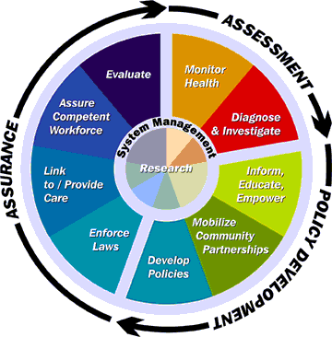

Figure 1. Ten essential services and three core functions of public health [13]

Information access is implicit in many of the ten essential services. Among them, success at “informing, educating and empowering people about health issues” is particularly dependent on information access skills. This manual’s chapter on health education resources introduces a host of resources that assist health educators and others who provide members of the public with authoritative information about a variety of health issues.

Staying abreast of developments in information access and management is clearly important for the practice of public health. These skills help public health practitioners face challenges on multiple levels. In addition to the need for information to address their day-to-day concerns, public health practitioners need to monitor longitudinal data in order to identify trends in the public’s health. Information access and management skills also help in the development of policies that are based on the best evidence available.

There are significant challenges facing public health workers who seek to improve their skills in information access and management. One challenge is the continuous evolution of information technologies and resources, making ongoing training a necessity. Public health workers familiar with desktop applications and Web-based resources now have the opportunity to expand their skills to include familiarity with software available for personal digital assistants and other devices with wireless network access. New information resources for these platforms are now available from the NLM and other developers.

Health sciences libraries are valuable allies for public health workers pursuing competencies that require skills in accessing and managing information. Librarians have collaborated with members of the public health community to provide training as well as to develop resources targeting the needs of the public health community. An example of such a collaboration is Vanderbilt University’s training of public health workers in Tennessee. In addition to the training, the project’s leaders have gathered data related to the information needs of the public health community. Supported in part by the NLM, results of this project point to limited access to computers and Internet resources as well as limited use of the available resources [14].

The NLM has also collaborated with representatives from public health associations and other federal agencies to develop phpartners.org, a Web site providing convenient access to information of interest to the public health community. Developed as part of the Partners in Information Access for the Public Health Workforce project, links from phpartners.org take the user to resources with information about training opportunities, news, conferences and funding opportunities as well as resources to support health education. Public health agencies and organizations that maintain Web sites or intranets are encouraged to link to phpartners.org as well as the other resources highlighted in this manual.

This manual is another example of collaboration between the public health community and health sciences libraries. With ties to recognized competencies, this manual introduces information resources and information search strategies useful for resolving common information needs in public health practice. The authors encourage its widespread use and adaptation for training purposes. Suggestions for its improvement are welcomed and may be directed to Keith Cogdill at cogdilk@mail.nlm.nih.gov.

References

1. Burroughs CM. Measuring the difference: Guide to planning and evaluating health information outreach. Seattle, WA: National Network of Libraries of Medicine, Pacific Northwest Region, 2000.

2. NY-NJ Public Health Training Center. <http://www.nynj-phtc.org/>. Accessed April 15, 2004.

3. Green LW, Kreuter MW. Health promotion planning: An educational and ecological approach. 3rd ed. Mountain View, CA: Mayfield Publishing Company, 1999.

- Larsson L. Personal e-mail correspondence, February 24, 2004.

- Humphreys BL, Ruffin AB, Cahn MA, Rambo N. Powerful connections for public health: The National Library of Medicine and the National Network of Libraries of Medicine. Am J Public Health. 1999 Nov;89(11):1633-6.

- Nelson JC, Essien JD, Cohen D, Loudermilk, R. The public health competency handbook: Optimizing individual and organizational performance for the public’s health. Atlanta, GA: Center for Public Health Practice of the Rollins School of Public Health, 2002.
7. O’Carroll PW and the Public Health Informatics Competency Working Group. Informatics competencies for public health professionals. Seattle, WA: Northwest Center for Public Health Practice, 2002.
- Board on Health Promotion and Disease Prevention, Institute of Medicine. Who will keep the public healthy? Educating public health professionals for the 21st century. Washington, DC: National Academy Press, 2003.

- Ibid, p. 74.

- U.S. Department of Health and Human Services. Healthy People 2010. 2nd ed. Washington, DC: U.S. Government Printing Office, November 2000.

- Council on Linkages Between Academia and Public Health Practice. Core competencies, <http://trainingfinder.org/competencies>. Accessed August 4, 2003.

- Committee for the Study of the future of Public Health, division of Health Care Services, Institute of Medicine. The future of public health. Washington, DC: National Academy Press, 1988.

- Public Health Functions Steering Committee. <http://www.health.gov/phfunctions/public.htm>. Accessed August 4, 2003.

- Lee P, Giuse NB, Sathe NA. Benchmarking information needs and use in the Tennessee public health community. J Med Libr Assoc. 2003 Jul;91(3):322-36.

Keeping Informed About

Public Health Concerns

Kristine Alpi

Chapter Summary

The ever-increasing amount of health information available makes it essential to have a set of current awareness strategies to help manage the flow of knowledge. The multidisciplinary nature of public health creates the challenge of capturing useful updates without becoming overwhelmed with too much information. This chapter will offer strategies for keeping up with public health information, followed by sources to use for each strategy and then case studies to show the strategies and sources applied to public health questions. The public health workforce is a busy one, so ways to keep up with limited time investments are emphasized.

Note that the text of this chapter is in the public domain and may be copied, adapted and used freely for the training of members of the public health workforce.

Learning Objectives

After reviewing this chapter, a public health worker will be able to:
- Identify strategies and resources to help stay informed of developments and events related to a field of interest within public health.
- Identify specific resources related to area(s) of interest within public health including:
    - Web sites that have news updates or continuous news feeds.
    - E-mail discussion lists (Listservs™)
    - E-mail announcement/notification lists
    - Journals (content for the latest issue)
    - Automated subject-specific literature searches
    - Professional organizations
- Outline a plan for incorporating keeping up-to-date into a work routine

Applications of Learning

Knowledge and use of the strategies and resources introduced in this chapter will enhance public health workers’ competencies in:

- Analytic assessment: “Identifies relevant and appropriate data and information sources.”
- Inform, educate and empower people about health issues: “Research for new insights and innovative solutions to health problems.”
- Communication: “Uses the media, advanced technologies, and community networks to communicate information.”

Introduction

While collaborative in nature, public health agencies and community based organizations often find themselves competing with industry for the public’s attention and funding for health concerns [1]. Businesses describe staying informed as competitive intelligence, and like businesses, public health organizations cannot afford to be out-of-date. Staying informed about news and developments in public health is a crucial component of health competencies related to communication [2]. Communication is a two-way street, and public health practitioners need to use the media, advanced technologies, and community networks to gain information as well as communicate it.

The ever-increasing amount of information available makes it all the more important to have a set of current awareness strategies to help manage the flow of knowledge. The multidisciplinary nature of many public health disciplines makes it especially hard to capture useful updates without becoming overwhelmed by the breadth of the information.

Why should one adopt new strategies for staying informed?

- Staying informed is a professional responsibility. The Public Health Code of Ethics [3] suggests that public health should seek the information needed to implement effective policies and programs that protect and promote health.

- Keeping up with newsworthy areas helps public health leaders respond with expertise to legislators at all levels who propose laws or initiatives that can impact health policy or services.

- Watching the news and noting who is publishing on topics of interest can help identify experts in other agencies, academia and industry with whom to collaborate.

- Being informed about developments in public health is important at every level of one’s career. Searching to find information just-in-time is more efficient, but there are times when being notified of new research or a new health threat prior to the media coverage will be quicker than searching.

- In hard budget times, time and funds for traveling to meetings or continuing education events may not be available.

- Access to electronic forms of public health information is faster than reliance on mail delivery or interoffice routing of print materials which may be slowed or delayed.

- Having time to prepare responses or proposals for hot media topics or funding opportunities in advance of being asked about them generally produces a better result.

Discussion Question: Are there other reasons that might convince colleagues or administrators to make time for keeping up?

What are the costs of keeping up? Keeping up can take as much or as little time and money as available. Later in this chapter there is a list of strategies and the time they may require. All resources and services are free unless otherwise stated.

Strategies

Efficient strategies for keeping up will provide the most value (relevant items) while spending the least amount of time. Strategies for keeping up can be short-term, project-specific or long-term. Some people set up “current awareness searches” when they are looking for new positions or filling in for a colleague in an area not directly related to their area of expertise. A librarian or another colleague may be able to assist in composing a useful set of strategies. Long-term ongoing strategies can be assigned to others on staff to monitor, especially if one area encompasses a variety of disciplines.

Keeping organized makes it all easier. Here are some electronic organization strategies:

- Create an e-mail folder for items that aren’t of immediate use, but might be useful in the future. It may be helpful to set up this folder to occasionally purge items that have not been accessed after a period of time.
- Use Web browser bookmarks or favorites to store the addresses of sites that will be visited frequently.
- Know about organizational policies for e-mail and computer use before signing up for services using office computers.
- Remember that not all information is electronically available. Physical folders may still be needed to collect relevant announcements or information.

Following are some general strategies that can be helpful for keeping up. Details on resources for each of these strategies appear in the Sources section of this chapter.

Discussion Question: Are there any other suggestions for staying organized?

Web sites with News Updates

Identify Web sites related to areas of interest that have news updates or continuous news feeds. To make it easier to find these sites again, add these sites to browser bookmarks or favorites. Making one of these sites the default search page when the browser opens so it appears first thing in the morning is an easy way to be presented with the news. If news doesn’t get added very often, setting a Web site page alert (covered below) sends a notification when the page has been updated.

Many sites provide news blurbs announcing the findings of studies. Very few of the news pieces offer the complete citation to the original article—it is important to read the actual studies and data if using the information for decision-making purposes.

Web Page Change Detection Services

If a relevant site does not provide e-mail updates, there are free Web services to track changes and send an e-mail notification when a particular page is updated. Be aware that not all changes to a page will be due to substantial content updates.
One free site that offers this service is ChangeDetection.com
<http://www.changedetection.com/monitor.html>.

E-mail Discussion Lists (Listservs™)

Discussion lists are interactive lists in which members or anyone (depending on the level of moderator control) may post e-mails. The disadvantage is that the volume of e-mail postings may be large. A benefit of the interactive lists is that participants can ask questions when advice is needed from others with similar interests. The default is to receive each posting separately, which may be useful if one anticipates wanting to respond to messages or needs to see messages as they are posted. Some lists offer the option of subscribing to a once-a-day digest format that reduces the volume of e-mail received.

A time cost-benefit analysis for discussion lists is important. Sign on to observe a list for a week or look at a period of time in the archives. Consider the percentage of the messages that were on target or potentially valuable.

Workers of government organizations may have restrictions against actively participating in advocacy work. If the institution has restrictions and subscribing or posting to advocacy lists is part of the plan, it may be best to use a personal e-mail address.

Remember that some lists have searchable public archives and what one posts now can be searchable and findable years later.

E-mail Announcement/Notification Lists

Announcement lists provide one-way communication of information. These lists may be daily, weekly, monthly or as there is news. The volume of these lists tends to be lower and more predictable than interactive lists. Some of these lists are organization-specific such as the Department of Health and Human Services announcement list or the Association of Schools of Public Health’s Friday Letter; other lists are subject-specific.

Table of Contents of Relevant Journals

You can receive the table of contents of relevant journals (such as Emerging Infectious Diseases or the MMWR) via e-mail from the publishers’ Web sites, a commercial service like Ingenta or Infotrieve, or a free journal title search set up from the PubMed database <http://www.pubmed.gov>. Some fields have their own journals and therefore receiving the contents is a good strategy for keeping up; this strategy is less successful for fields that are too narrow to have their own journal or so multidisciplinary that their literature is published in many journals. The Automatic Update Searches strategy discussed in the next section is better suited for those new or multidisciplinary areas.

How does one identify which journals to follow? Most practitioners are already familiar with the key journals in their disciplines. The Core Journal list in Public Health from the Public Health/Health Administration section of the Medical Library Association (<http://publichealth.yale.edu/phlibrary/phjournals/>) provides a starting point. Doing a search of PubMed or other databases will allow the identification of journals with articles related to one’s interests. Searching the Journals Database feature in PubMed (<http://www.pubmed.gov>) or PubList (<http://www.publist.com/>) can also give you ideas. A librarian or colleague in another field can also help identify journals.

Once journals have been identified, use a favorite search engine to find the home page for the journal and then look for a link to something like “e-mail alerts” or “e-mail notifications.” Some sites only require your e-mail address; others may require more complete registration information. Some publishers with several relevant journals may allow registration for multiple titles simultaneously.

As relevant articles are identified and need to be obtained, a local medical, state or public library can help obtain the full text of the articles. If there is no local library, call the National Network of Libraries of Medicine at 1-800-338-7657 to find a library. Copies of articles may be available through PubMed’s LinkOut feature or through the Loansome Doc service.

Automatic Update Searches (also known as SDI – Selective Dissemination of Information)

Setting up “automatic update searches” in a variety of databases relevant to a particular discipline is another strategy. There are free services in which one can set up automatic searches of the PubMed database to be e-mailed regularly. These searches can be by subject area, by author to track particular experts, or by institution to track the work of particular organizations. If only occasional, irregular updates are desired, the “cubby” feature of PubMed can save strategies to be re-run in the future. Just register for a free Cubby and then save the strategies. PubMed often includes the e-mail address of the first author of papers so that they may be contacted.

Some database producers prepare “canned” searches on topics of interest that you can receive as e-mail updates. Another method of getting these search updates is to visit a page with links to prepared PubMed searches such as the Healthy People 2010 Information Access Project (<http://phpartners.org/hp/>).

Join or Follow Associations or Organizations in an Area of Interest

Benefits of joining an association or organization related to one’s professional interests may include newsletters, discussion lists, real and virtual meetings, and continuing education opportunities in a variety of formats. If it is not clear whether an organization will be worthwhile, visit its Web site to see if sample issues of the newsletter or journal are available online. Talk to colleagues about whether the networking in that group has been valuable to them. Keep in mind that local or regional groups may be less expensive and more relevant than national ones.

Online Access to Subscriptions

Many individual and institutional journal subscriptions allow online access to the full content of recent issues. Be sure to activate the online access to subscriptions, particularly those resulting from individual or organizational memberships.

Updates from Central Offices and Other Agencies

Within one’s organization there are central offices such as the grants office, the communications office, and the library that make be able to provide relevant material as they follow broad issues in public health. For example, the communications office might offer a daily news clipping service with local and national news articles related to public health. Ask the library’s staff for notification when the library acquires new books or videos in areas of interest. Other agencies such as a local health department may provide a service to receive press releases via e-mail or fax.

Discussion Question: Has anyone tried any of these strategies already? How did it go?

Time for Keeping Up

Now that a palette of possible strategies has been presented, consider the time available for keeping up. Examples of what one can do with limited time follow:

- Five minutes a day: read and act on one e-mail announcement listing or discussion list digest and peruse the table of contents of one journal.

- One hour a week: the above, plus read relevant abstracts from an update search.

Discussion Question: How much time can you make available for keeping up?

The following table provides rough time estimates for specific strategies for keeping up-to-date.

Table 1: Tasks with Set-Up and Maintenance Times Estimates

Task | Set-Up Time | Maintenance Time | Frequency
Follow a discussion list message-by-message | 15-30 min. to find, evaluate and join list | 45 sec. per message to read and delete or forward on messages  Time to respond to a message varies | A few times a day
Follow a discussion list in digest form | 15-30 min. to find, evaluate and join list | 30 sec. per message to read and delete or forward on messages  Time to respond to a message varies | Once daily
Read an announcement list | 15-30 min. to find, evaluate and join list | 30 sec. per message to read and delete or forward on messages | A few times a week
Peruse a table of contents e-mail with links to relevant articles | 10-15 min. to find and sign up for a table of contents e-mail | 2 min. to consider titles and click through to relevant abstracts | At set frequencies – weekly, monthly, bi-monthly, quarterly
Review the results of an “automatic update search” | 30-60 min. to sign-up and create search strategy | 1-5 min. to consider titles and click through to relevant abstracts depending on number of results and quality of search strategy | At set frequencies – choose once weekly, twice weekly, twice monthly, monthly
Visit a Web site that has just been updated | 5 min. to identify and activate notification for page | 2 min. to visit site and identify the new info. | A few times a week
Read the daily news on your topic | 30 min. to find, evaluate and bookmark sites | 2-5 min. to read relevant articles | Once daily

Sharing the work of keeping up makes a lot of sense, especially in a larger department. A single staff member can receive e-mail updates from a mailing list or discussion list and then forward relevant items with commentary to other staffers as would be useful. A policy-oriented person might want to follow the local news and legislative issues, while a more research or evaluation position might be responsible for following the peer-reviewed literature and deciding which articles need to obtained and shared.

Sources for Getting Started

Here are some general sources for each of the strategies. Consulting a librarian may yield additional resource suggestions for particular topics.

Web sites with News Updates

Partners in Information Access for the Public Health Workforce - News
<http://phpartners.org/news.html>
Some public health news, but also valuable as a collection of links to other public health news sites.

MedlinePlus – National Library of Medicine
<http://medlineplus.gov>
Offers the last 30 days of news from the New York Times Syndicate, Reuters Health Information and others

Medscape Public Health & Prevention®
<http://www.medscape.com/publichealthhome>

Center for the Advancement of Health
<http://www.cfah.org/>
Health news site funded by the John D. and Catherine T. MacArthur Foundation

World Health News – Harvard School of Public Health
<http://www.worldhealthnews.harvard.edu/>
World Health News offers a combination of original reporting and a digest of news stories and commentaries from newspapers and magazines worldwide on pressing issues in public health.

Google News Search Engine
<http://news.google.com/>
If current news is important, articles from regional, national and international newspapers, radio stations and other news venues can be located using Google.
Be aware that some news sites may charge readers for content once it has gone into their archives and readers may have to make a note of the newspaper and date to retrieve it from their archives once it has been taken off the newspaper's Web site.

Many subject-specific sites include a significant news component, for example for HIV/AIDS news:

HIV Daily Briefing – AIDS Education Global Education System
<http://www.aegis.org/>

Web Page Change Detection Services

A list of Web Page Change Detection Services is available at:

Steven Bell’s Keeping Up Web Site
<http://staff.philau.edu/bells/keepup/detectit.htm>

E-mail Discussion Lists (Listservs TM)

Partners in Information Access for the Public Health Workforce - Discussion and E-mail Lists
<http://phpartners.org/dlists.html>
A mix of links to discussion and announcement lists on a variety of topics hosted by APHA, CDC, FDA, PHF and others.

ProMED-mail (Program for Monitoring Emerging Diseases, International Society for Infectious Diseases)
<http://www.promedmail.org/>
The global electronic reporting system for outbreaks of emerging infectious diseases and toxins, open to all sources.

The School of Public Health and Community Medicine, University of Washington has several lists through the Mailman system
<http://mailman.u.washington.edu/mailman/listinfo/>
Insert the name of any of the following lists at the end of this URL, or search for the list name in the list of groups: PHNUTR-L (Public Health Nutritionists List), PNWHEALTH (Pacific Northwest Health Educators and School Health Educators), PHNURSES (Public Health Nurses), PHSW (Public Health Social Work), BIRTH23MH (Mental Health in Children from Birth to Age Three), and HSR-L (Health Services Research List), PH-INFO (Public Health Informatics).

Many other lists can be located through central list directories:

- CataList: L-Soft - <http://www.lsoft.com/lists/listref.html>
- Topica (formerly Listz of Lists) - < http://lists.topica.com/>
- Tile.Net - <http://tile.net/lists/>

E-mail Announcement/Notification Lists

General collections:

Partners in Information Access for the Public Health Workforce - Discussion and E-mail Lists
<http://phpartners.org/dlists.html>

Organization-specific announcements:

News from the U.S. Dept of Health & Human Services
http://www.dhhs.gov/aspa/

Association of Schools of Public Health - Friday Letter
<http://www.asph.org/press/fridayletter/subscribe.cfm>
Friday Letter is a weekly publication of the Association of Schools of Public Health.

Environmental Protection Agency Listservs
<http://www.epa.gov/epapages/epahome/listserv.htm>

Public Health Foundation's E-News
<http://www.phf.org/E-News.htm>

Subscribe to a CDC Mailing List
<http://www.cdc.gov/subscribe.html>

National Criminal Justice Reference Service - Registration Services
<https://puborder.ncjrs.org/secure/register/register.asp>

Receive NCJRS Catalog: a bi-monthly resource with an online order form; JUSTINFO: a bi-weekly electronic newsletter with links to full text; E-mail Notification: periodic messages about new publications and resources that match your specific interests.

Some local health departments have set up e-mail alert lists for their constituents that provide press releases and other announcements – for example:

Public Health, Seattle – King County – Public Health News Alert
<http://www.metrokc.gov/health/news/alert.htm>

New York City Department of Health & Mental Hygiene – Personal E-mail Updates
<http://nyc.gov/html/doh/>

Subject-specific announcement lists abound:

Daily Reports from Henry J. Kaiser Family Foundation
<http://kaisernetwork.org/daily_reports/rep_index.cfm>

Daily reports on health policy, HIV/AIDS or reproductive health

Table of Contents of Relevant Journals

Both general medical journals such as JAMA or New England Journal of Medicine, and general public health journals such as Journal of Epidemiology and Community Health provide e-mail table of contents services. Select journals of interest.

Individual title services include:

Morbidity & Mortality Weekly Report (MMWR)
<http://www.cdc.gov/mmwr/mmwrsubscribe.html>

Emerging Infectious Diseases
<http://www.cdc.gov/ncidod/EID/subscrib.htm>

JAMA
<http://jama.ama-assn.org/>

Examples of publisher-specific alert services include:

Oxford University Press – Content Alerting
<http://www3.oup.co.uk/jnls/tocmail/>

PubList powered by InfoTrieve
<http://www4.infotrieve.com/journals/toc_main.asp>

Automatic Update Searches (also known as SDI – Selective Dissemination of Information)

Free services include:

BioMail (Searches PubMed database) – SUNY Stony Brook
<http://biomail.org/>

PubCrawler (Searches PubMed and GenBank databases)
<http://www.pubcrawler.ie/>

Paid alert services include those available from Current Contents and Ingenta. Selected databases with fee-based access may also provide content alert services.

An example of a subject-specific free service is:

REHABDATA-Connection: Your Link to Disability Research
<http://www.naric.com/search/rhab/connection/about.html>
Once per month e-mail update of items added to the REHABDATA database

Some sites offer pre-formulated literature searches on the site (not via e-mail):

Healthy People 2010 Information Access Project
<http://phpartners.org/hp/>
Pre-formulated PubMed/MEDLINE searches on objectives in 13 of the Healthy People 2010 focus areas.

POPLINE ® (POPulation information onLINE)
<http://db.jhuccp.org/popinform/basic.html>
“Instant Searches” on primary topics with results from the latest four years of literature.

CDC’s HealthCommKey <http://www.cdc.gov/od/oc/hcomm/hcomm_predefined.html>
Predefined searches on a number of topics in health communication.

Join or Follow Associations or Organizations in an Area of Interest

A list of organizations is available at:

Public Health Foundation - Links to Public Health Organizations and Resources Online
<http://www.phf.org/links.htm>

Online Access to Subscriptions

PubMed Link Out Journals by Title
<http://www.ncbi.nlm.nih.gov/entrez/journals/loftext_noprov.html>

This is a list of PubMed journals that provide links to full text articles. User registration, subscription fee, or some other type of fee may be required to access the full text of articles for some journals. Policies vary by provider and by journal.

Case Study A

Scenario for Case Study A

The director of an STD and family planning clinic, Dr. Sara Smith, is concerned about keeping up with local and national trends in reproductive health care. The city’s climate towards sexual health can be tense as advocacy groups debate issues such as access to emergency contraception, the growing rates of STDs, and access to reproductive health care for underinsured immigrant populations. Keeping up with the latest scientific information is important to justify the clinic’s services, but Dr. Smith also wants to be aware of advocacy activities and events that may affect the staff and clients of her clinic.

What combination of resources could Dr. Smith track to keep her informed, given how little time she has available?

Think about which organizations might provide information on STDs and reproductive heath. Bookmark their Web sites:

Reproductive and Sexual Health from the Kaiser Family Foundation at < <http://www.kff.org/womenshealth/repro.cfm>

The What’s New section of the CDC STD Prevention page <http://www.cdc.gov/nchstp/dstd/Whats_New.htm>

CDC’s Reproductive Health Information Source
<http://www.cdc.gov/reproductivehealth/>

Explore discussion lists linked from reproductive health sites:

OB-GYN Net Forums
<http://www.obgyn.net/english/forums/forums.asp>

Reproductive Health Gateway
<http://www.rhgateway.org/listservers.html>
A collection of Listservs and Electronic Newsletters

E-mail updates are convenient:

The Kaiser Family Foundation has a Daily Reproductive Health Report via e-mail
<http://www.kaisernetwork.org/daily_reports/rep_repro.cfm>

The Alan Guttmacher Institute offers several lists
<http://www.agi-usa.org/listserv/index.html>

A few of these are “News Providers Can Use” (distributed quarterly), “AGI State News Quarterly” and “AGI Update” (distributed as produced).

Journal literature is important for evidence-based practice:

Perspectives on Sexual and Reproductive Health is a free online journal produced by the Alan Guttmacher Institute
<http://www.agi-usa.org/journals/fpp_archive.html>
Contents distributed as part of AGI update mentioned above.

Population Reports
<http://www.infoforhealth.org/pr/>
Free quarterly publication of Johns Hopkins Bloomberg School of Public Health

Sexually Transmitted Infections
<http://sti.bmjjournals.com/>
Select E-mail @lerts to receive the contents via e-mail. The full text of the journal is by paid subscription.

Sexually Transmitted Diseases
<http://www.stdjournal.com/>
Register for eAlert to receive the contents via e-mail. The full text of the journal is by paid subscription.

Regular searches of the literature also reveal the latest evidence:

Dr. Smith discovered that in MEDLINE/PubMed, the term Sexually Transmitted Diseases is one possibility for developing a search strategy. She also discovered that there is not a good subject heading for STD clinics. There is the subject heading Community Health Centers, but that would miss a lot of articles about clinics. She concluded that the most comprehensive strategies in PubMed searching use combinations of textwords and Medical Subject Headings. This is the strategy she saved in PubMed’s Cubby feature:

Sexually Transmitted Diseases AND (std clinics OR ambulatory health facilities OR clinics OR community health centers)

The Association of Reproductive Health Professionals (<http://www.arhp.org/>) is just one of many organizations to which Dr. Smith could belong. The journal Contraception is a membership benefit.

Keeping Up Plan for Case Study A

Dr. Smith decided to receive the Daily Reproductive Health report and the AGI update, to set automatic notifications for updates to the CDC STD and Reproductive Health Web sites, and to get e-mailed tables of contents for Sexually Transmitted Diseases and Sexually Transmitted Infections. Setting all this up took her about an hour. Monitoring will take about four hours a month depending on the number of updates to the CDC sites and the number of abstracts she reads from the journals’ tables of contents.

Case Study B

Scenario for Case Study B

Mike Jones is a public health sanitarian with the local health department who investigates foodborne illness complaints and does restaurant inspections. He wants to keep up-to-date on issues in the area of food safety and he is particularly interested in knowing about food recalls in the tri-state area of New York, New Jersey and Connecticut.

What combination of resources could Mr. Jones track to stay on top of recalls and other food safety issues?

Think about which organizations might provide information on food safety and food recalls. Bookmark their Web sites.

National

United States Department of Agriculture - Food Safety and Inspection Service <http://www.fsis.usda.gov>

U.S Food and Drug Administration - Center for Food Safety & Applied Nutrition
<http://www.cfsan.fda.gov/>

Centers for Disease Control and Prevention - Food Safety Office <http://www.cdc.gov/foodsafety/>

State, Local, Non-Governmental

Consider bookmarking state and local health departments as well as agriculture departments.

Center for Science in the Public Interest
<http://www.cspinet.org/>

National Coalition for School Safe Foods
<http://www.foodsafeschools.org/>

Look for automatic update services and e-mail lists relevant to information needs.

Recall Information Center – Food Safety and Inspection Service
<http://www.fsis.usda.gov/OA/recalls/rec_intr.htm>

Click on Notification to sign up for the FSIS News listserv and automatically receive FSIS press releases and product recall releases by e-mail. This page contains links to state agencies involved in food recalls as well.

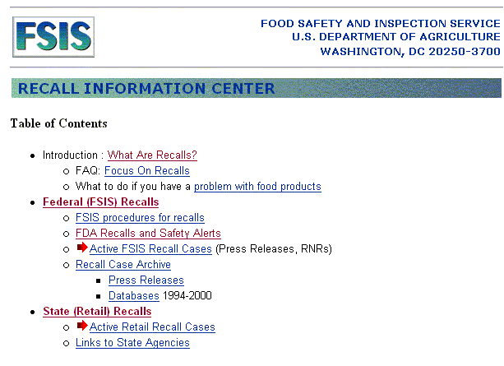

U.S Food and Drug Administration – Center for Food Safety & Applied Nutrition
<http://www.cfsan.fda.gov/list.html>
See the Recalls and Safety Alerts page. There isn’t an e-mail update feature, but you could set an auto-notification for the page.

Foodsafe is an interactive electronic discussion group intended as a communication tool to link professionals interested in food safety issues. To subscribe, go to the USDA/FDA Foodborne Illness Education Information Center (<http://www.nal.usda.gov/fnic/foodborne/foodborn.htm>).

NACCHO’s Food Safety Program (<http://www.naccho.org/project39.cfm>) offers a Food List Service and a Peer Assistance Network.

For specific local alerts, look for an alerts or updates page on the local health or agriculture department Web site:

Connecticut – Food Protection Program – Alerts
<http://www.dph.state.ct.us/BRS/food/fpalerts.htm>

New York State Department of Agriculture and Markets – Food Safety Alerts
<http://www.agmkt.state.ny.us/AD/alertList.asp>

New Jersey Local Information Network and Communications System – Public Health Alerts
<http://www.state.nj.us/health/lh/lincs/phalst.htm>

Following the literature on food safety may also be helpful for keeping up

Set up an automated search of PubMed using BioMail that includes the terms

food safety OR food contamination OR food poisoning

Agricola (<http://www.nal.usda.gov/ag98/>) produced by the National Agriculture Library is another good database to search, but it does not have an automatic update service.

Set up an automatic update search for a journal’s table of contents for relevant journals such as:

Foodborne Pathogens and Disease <http://www.liebertpub.com/FPD/default1.asp>

Journal of Food Protection (International Association for Food Protection)
<http://www.foodprotection.org/Publications/JFP.htm> Sign up for table of contents e-mails via Ingenta or create an automated BioMail search with this journal title.

Keeping Up Plan for Case Study B

Mike Jones decided to subscribe to the Food Safety and Inspection Service e-mail news list and set up Web page update notifications for state food recall pages with ChangeDetection.com. Finding these sites and setting it up took about 45 minutes. Monitoring will take about 5-10 minutes a day depending on the number of alerts released via e-mail or on the sites.

Practice Exercise

Scenario for the Practice Exercise

The North Dakota tobacco control program wants to create a multifaceted plan to keep up with health and legal issues related to secondhand smoke exposure. They want to share the work among a couple of staff members.

Suggested solution:

General tobacco updates

Sign onto an e-mail discussion list. See the list at Smokescreen.org with 33 tobacco control-related electronic distribution (newsletter-type) lists and 69 listservs (discussion lists) that are hosted through the Web site smokescreen.org. Several states use this service to host their own discussion forums and/or coalition e-mail lists. Anyone can join these lists. However, one must log in first in order to subscribe to any of the smokescreen list serves. Once you subscribe to a discussion list, you will be sent instructions on how to post notes and handle maintenance such as unsubscribing. Visit the “All Lists” link at the URL <http://smokescreen.org/list/det.cfm>.

Peer-reviewed literature and program information

1. Identify a few key journals in the field: Tobacco Control and Nicotine and Tobacco Research. Arrange for the online table of contents for the journals to be e-mailed to you:
- Tobacco Control (<http://tc.bmjjournals.com/cgi/alerts/etoc>) Quarterly.
- Nicotine and Tobacco Research (<http://www.tandf.co.uk/journals/titles/14622203.html>) which also comes out four times a year. This journal publisher has a service called SARA which allows you to have the TOC e-mailed to you.

2. Set up an automatic update search on tobacco smoke exposure.
Use BioMail (<http://www.biomail.org>) to set up a PubMed search using the Medical Subject Headings “tobacco smoke pollution” or keywords such as “secondhand smoke.”

3. Join an organization such as Society for Research on Nicotine and Tobacco (<http://www.srnt.org/>) and attend their meetings

Local news and legal information

1. Ask your Communications office to send you tobacco-related news from local papers that may not be covered by other new services.

2. Tobacco.Org News (<http://www.tobacco.org/news.php>)
View news stories by state – choose North Dakota from the pull-down menu on the left. Click on the “Subscribe” tab to sign up for the daily news summary, a compilation of all the days stories, and/or the Breaking News, which allows you to get the stories as they come on a national or state basis.

3. State Legislated Actions on Tobacco Issues (<http://slati.lungusa.org/>)
This American Lung Association Web site has a clickable state map to show North Dakota tobacco legislation. Sign up for the The Tobacco Control Tribune e-mail newsletter which provides updates on tobacco control initiatives, advocacy and legislative rulings.

References

1. Manzo P. Competing for the public good. Los Angeles Business Journal. Reprinted on Center for Nonprofit Management Web site. <http://www.cnmsocal.org/AboutNonprofits/Article4.html>. Accessed September 26, 2003.

2. Council on Linkages Between Academia and Public Health Practice. Core competencies, <http://trainingfinder.org/competencies>. Accessed September 26, 2003.

3. American Public Health Association. Public Health Code of Ethics, <http://www.apha.org/codeofethics/ethics.htm>. Accessed April 18, 2004.

Finding Information for Others:
Health Education Resources

Molly Youngkin

Chapter Summary

This chapter provides a snapshot of several Web-based information resources that are useful for health educators who are striving to provide quality health information for their communities. The list of Web sites visited here is not comprehensive but does provide an idea of the type of authoritative resources available. Indeed, every public health worker will have favorite Web sites that they use for various purposes. Some of the Web sites are more general, others more specific in content. All are intended to provide a quick source of current, quality health information for the health educator under a tight deadline. Readers should feel free to copy or adapt these public domain materials for their own training purposes.

Learning Objectives

Health educators receiving training based on this chapter will:
- learn to recognize several authoritative, health-related Web sites commonly used for general health information for the public;
- find health-related materials written in various languages;
- be introduced to different formats for presenting current, authoritative health information;
- be able to evaluate aspects of a quality health Web site; and
- be introduced to Web sites that discuss literacy and cultural competency issues.

Applications of Learning

This section helps health educators fulfill one of the ten essential services of public health: to inform, educate, and empower people about health issues [1]. In addition, the resources explored in this section help public health workers meet the following two core competencies within the communication domain:

- Effectively presents accurate demographic, statistical, programmatic, and scientific information for professional and lay audiences; and

- Leads and participates in groups to address specific issues [2].

Introduction

Public health covers a wide sphere of activities that affect the health of communities at the federal, state and local levels. Health educators incorporate many of these activities but are primarily responsible for designing, organizing, implementing and evaluating health promotion and health education programs that help to modify and improve health-related behaviors of individuals, families, and the communities in which they live. Communicating with individuals and communities about issues such as high blood pressure, smoking, pregnancy, nutrition, safety, diabetes and immunization involves having access to current, accurate information, often written with the general public in mind.

Why are health information resources important for health educators? In order to make valid decisions about health care, it is necessary to have a foundation of health information that is accurate, timely, and relevant to the individual’s or community’s health information needs. Creating a program that provides evidence-based information from academic institutions and federal and state agencies ensures that the public receives the best available advice. Other benefits of these Web sites include tools for networking with colleagues on similar issues, the elimination of duplicative program development, the discovery of often hard to find but significant health promotion publications, the rapid creation of materials that can supplement teaching, especially bilingual items, and methods to keep up-to-date on guidelines and policy changes that may affect a community’s health.

The following are just a few of the many quality sites that are available for public health workers. Of special note are two Web sites that provide guidance for the development of materials that are written at appropriate literacy levels and that are culturally sensitive. Cultural competence and literacy awareness are extremely important when creating materials for community-based projects. Obstacles encountered range from a scarcity of appropriate materials available for a particular community group to materials that are available but that simply fail to reach the exact information need. The two listed Web sites provide a start when searching for guidelines to help with these issues.

Local health sciences librarians can help demonstrate the features and advantages of all resources discussed in this chapter. Public health workers may consider partnering with libraries when providing training for their communities. Consult the NN/LM Web site at <http://nnlm.gov> or call 1-800-338-7657 to identify health sciences libraries in a specific community.

Sources

These Web sites were selected based on their authority, their wealth of content, their reliability, their recognition as quality sites as demonstrated by awards received, and from the author’s personal experience. They are presented in an order that follows the case studies. The descriptions of these sites are drawn primarily from the sites themselves.

MedlinePlus
<http://medlineplus.gov>

This is one of the National Library of Medicine’s premier sites to help find health information of interest for the general public. A health educator, working on various community health issues, will find authoritative and current information on over 650 diseases and conditions. MedlinePlus also includes extensive information on prescription and nonprescription drugs, health information from the media, and information on thousands of National Institutes of Health (NIH) sponsored clinical trials accessible to the public. There are also lists of hospitals, clinics, and physicians, a medical encyclopedia and a medical dictionary – all information that can assist community members become more informed about their health. A Spanish language version of MedlinePlus can be found by following the “español” link at the top of the page.

healthfinder®
<http://healthfinder.gov>

healthfinder® is an award-winning federal Web site, developed by the U.S. Department of Health and Human Services together with other federal agencies. Since 1997, healthfinder® has been recognized as a key resource for finding the best government and nonprofit health and human services information on the Internet. healthfinder® links to carefully selected information and Web sites from over 1,700 health-related organizations. Many of the materials are written in Spanish.

Partners in Information Access for the Public Health Workforce
<http://phpartners.org>

This site provides a wealth of information for public health workers, including health educators. It is a collaboration of U.S. government agencies, public health organizations, and health sciences libraries devoted to providing quality information to improve the practice of those in public health. Contributions to this site have come from several key players in the field of public health. A health educator can find information for the public on health issues such as diabetes and hepatitis, information on toxic substances, information on hoaxes and rumors, as well as images and illustrations depicting illnesses among the populace.

Nutrition.gov
<http://www.nutrition.gov>

Nutrition.gov is a federal Web site that provides easy access to all online federal government information on nutrition. This national resource makes obtaining government information on nutrition, healthy eating, physical activity, and food safety, easily accessible in one place. Community members can find information on healthy eating, the food guide pyramid, dietary guidelines, dietary supplements, fitness and how to keep food safe. Since nutrition is very important in preventing diseases such as diabetes and heart disease, a health educator can use many of the reliable resources from this site to promote healthy behaviors in the community.

Smart-Mouth.Org
<http://smart-mouth.org>

This nutrition Web site is produced by the Center for Science in the Public Interest, Washington, D.C. Since 1971, this consumer/nutrition advocacy organization has conducted research on food, alcohol, health, the environment and other issues related to science and technology; has represented the citizen’s interests before regulatory, judicial and legislative bodies on food, alcohol, health and the environment; and has educated the public through its newsletter, Nutrition Action Healthletter. CSPI encourages Congress to pass new nutrition and food-safety laws, encourages government agencies to sponsor nutrition campaigns, and urges food companies to change the way they make, sell, and advertise food to make food safer and make it easier for people to eat well and be more physically active.

NOAH: New York Online Access to Health™
<http://www.noah-health.org>
NOAH provides access to high quality full-text consumer health information in English and Spanish that is accurate, timely, relevant, and unbiased. In 1994 four New York City library organizations joined together to establish this single Web site for reliable consumer health information. These organizations are The City University of New York Office of Library Services (CUNY); the Metropolitan New York Library Council (METRO); The New York Academy of Medicine Library (NYAM); and The New York Public Library (NYPL) - later joined by the Queens Borough Public Library and the Brooklyn Public Library. Health educators can find a wealth of bilingual consumer health information at this site.
The 24 Languages Project
<http://medstat.med.utah.edu/24languages>

The Utah Department of Health’s Bureau of Primary Care, Rural and Ethnic Health and the Spencer S. Eccles Health Sciences Library, University of Utah Health Sciences Center, Salt Lake City, have collaborated to provide over 200 public health brochures written in multiple languages available over the Internet. The 24 Languages Project Web site provides online access to these brochures, plus access to several audio files. A generous Library Services and Technology Act grant from the Institute of Museum and Library Services and the Utah State Library Division has made this resource possible.

Multilingual Health Information
<http://nnlm.gov/train/chi/multi.html>
This page is a useful compilation of Web sites offering non-English language health information. This information is organized on the National Training Center and Clearinghouse Web site, National Network of Libraries of Medicine, National Library of Medicine.
Combined Health Information Database (CHID Online)
<http://chid.nih.gov>

CHID is a bibliographic database produced by health-related agencies of the federal Government. This database provides titles, abstracts, and availability information for health information and health education resources. CHID lists a wealth of health promotion and education materials and program descriptions that are not indexed elsewhere. The database covers 12 topics and has been available to the public since 1985. New records are added quarterly and current listings are
checked regularly to help ensure that entries are up to date and still available from their original sources. CHID is updated four times a year.

Community Tool Box (CTB)
<http://ctb.ukans.edu>

The Community Tool Box provides over 6,000 pages of practical information to support public health workers’ efforts to promote community health and development. This Web site is created and maintained by the Work Group on Health Promotion and Community Development at the University of Kansas in Lawrence, Kansas. Developed in collaboration with the AHEC/Community Partners in Amherst, MA, the site has been online since 1995, and continues to grow on a weekly basis. There are “topic sections” or the “big ideas” that have been found to be important in doing community work. Topics such as community assessment, developing a strategic plan, agenda setting, group facilitation, cultural competence, and social marketing provide practical guidance for community development. There are 16 “core competencies” for actually planning the work. These include analyzing problems and goals, increasing participation, advocating for change, sustaining the initiative, and writing a grant application for funding, to mention a few. A Trouble Shooting Guide provides information and possible solutions for those times when obstacles impede community program development. Any public health worker can use this tool to develop a strong community-based health program.

Tox Town
<http://toxtown.nlm.nih.gov>

Tox Town provides an introduction to toxic chemicals and environmental health risks that may be encountered in everyday life, in everyday places. It was created by the National Library of Medicine’s Specialized Information Services Division in October, 2002. It is a companion to the extensive information in the TOXNET collection of databases that are typically used by toxicologists and health professionals. Tox Town is highly interactive, with graphics, animation, and sound. There are currently two scenes for exploration, the Town and the City. Click on scenes from the City or Town to learn more about urban and suburban health risks. Click on a particular location within the Town or City to find out what chemicals may be in that location. Roll the mouse over one of the eight chemical names listed at the bottom of the screen to find out more about that
specific chemical. This is an excellent resource for health educators who are asked to find easy-to-understand information about environmental toxins in their community.

Scorecard
<http://scorecard.org>

Scorecard is a Web site produced by Environmental Defense, a national, nonprofit organization with more than 300,000 members. Since 1967, when a small group of scientists joined together and successfully went to court to obtain a nationwide ban on DDT, this organization has linked science, economics, and law to create innovative, equitable and cost-effective solutions to society’s most urgent environmental problems. Today Environmental Defense employs more than 250 scientists, economists, and attorneys in the pursuit of environmental national reform. Scorecard is used as a strong source for free and easily accessible local environmental information. By typing in a particular zip code or by using one of the available maps, public health workers can learn more about environmental pollutants in their communities. Pollution situations are ranked and compared across the US. Detailed information is provided for more than 11,000 different chemicals. Many of these chemicals have detailed chemical profiles that indicate their health hazards such as they cause cancer, birth defects, or contribute to the deterioration of the immune system. Additional information includes air pollutants, emissions of toxic chemicals, Superfund sites, lead hazards in housing, and animal waste sites in a community. Health educators can use this community information to answer questions of concern regarding the community’s environment.

Centers for Disease Control and Prevention (CDC)
<http://www.cdc.gov>

The Centers for Disease Control and Prevention (CDC) is recognized as the lead federal agency for protecting the health and safety of the public, providing credible information to enhance health decisions, and promoting health through strong partnerships. CDC serves as the national focus for developing and applying disease prevention and control, environmental health, and health promotion and education activities designed to improve the health of the people of the United States. Its mission is to promote health and quality of life by preventing and controlling disease, injury, and disability. There is a wealth of information provided here to help a health educator answer health-related questions from a community.

National Institutes of Health (NIH)
<http://www.nih.gov>

Begun as a one-room Laboratory of Hygiene in 1887, the National Institutes of Health today is one of the world’s foremost medical research centers. An agency of the Department of Health and Human Services, the NIH is the federal focal point for health research. There are fact sheets and information available on public health issues that will be of use to health educators.

National Center for Cultural Competence
<http://gucchd.georgetown.edu//nccc>

The National Center for Cultural Competence is a component of the Georgetown University Center for Child and Human Development and is housed within the Department of Pediatrics of the Georgetown University Medical Center. Its mission is to increase the capacity of health and mental health programs to design, implement, and evaluate culturally and linguistically competent service and delivery systems. This Web site has access to a guide for choosing and adapting culturally and linguistically competent health promotion materials and a checklist to assist organizations and systems of care when developing policies and practices that support cultural and linguistic competence. A database is also available with a wide range of resources on cultural/linguistic competence such as demographic information, policies, practices, articles, books, research initiatives and findings, curricula, multimedia materials, and Web sites. The NCCC also provides a pool of consultants skilled in training issues related to cultural/linguistic
competency. This Web site is very useful for health educators concerned about providing their communities with materials or training that is culturally and linguistically appropriate.

Contentbank
<http://contentbank.org>

The Web site Contentbank is a project of The Children’s Partnership, a national child advocacy organization working to expand digital opportunities for all of America’s children and families. The hallmark of the Children’s Partnership is to forge agendas for youth in areas where none exist, to help assure that disadvantaged children have the resources they need to succeed. Contentbank connects the staff of community-based organizations, who work directly with underserved residents, with the tools and information they need to find high-quality, relevant online content as well as help them to create their own local content. There are guidelines and tools that assist with content creation and evaluation, and assist with disability, English as an alternative language, and limited-literacy issues. Health educators can use guidelines established here to create low-barrier content for their programs.

Case Study

Ms. Diflo, a health educator, has been invited to speak at a local high school. Her audience will be students as well as parents. A large portion of her community speaks Spanish, and she would like to address issues related to health disparities within her community. She will be part of a discussion panel. Based on her familiarity with local health data, she has decided to focus on providing information about diabetes and guiding parents and students to relevant resources available on the Internet. Where can Ms. Diflo begin to find good health information to support parent and children’s information needs regarding diabetes?

MedlinePlus
<http://medlineplus.gov>

Figure 1. MedlinePlus can assist Ms. Diflo by providing full-text health information from quality Web sites on diabetes as well as by providing an interactive tutorial on diabetes management that can be presented to the public. Material on juvenile diabetes can be retrieved by clicking on “Health Topics” or entering “juvenile diabetes” in the search box.

Figure 2. The page for Juvenile Diabetes provides links to other quality Web sites. Spanish materials are available. In the left-hand column is a link for a pre-formulated literature search on “juvenile diabetes” in PubMed/MEDLINE.

Figure 3. (And Figure 1.) Clicking on “Interactive Tutorials” from the MedlinePlus Home page (on the right side of the screen) leads to an interactive tutorial on diabetes that can be presented to the parents of the children in the community.

Figure 4. Many interactive tutorials are also available in Spanish.

Figure 1. MedlinePlus home page <http://medlineplus.gov>

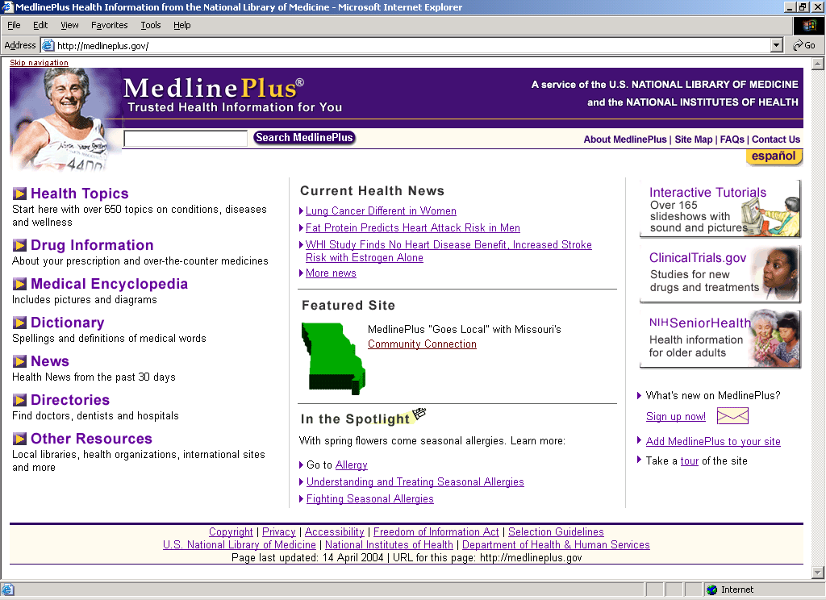
Text and audio tutorials are available for several conditions and procedures. Many are in Spanish as well.
Type “juvenile diabetes” in the search box

Figure 2. Juvenile diabetes topic page on MedlinePlus

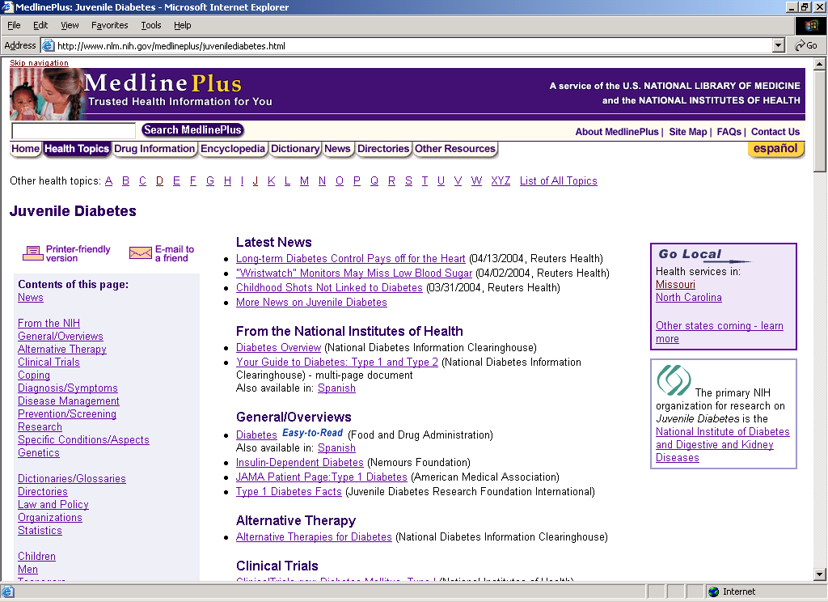
Clicking on this button will provide information in Spanish.

Figure 3. Interactive tutorial on diabetes. There is also an audio component.

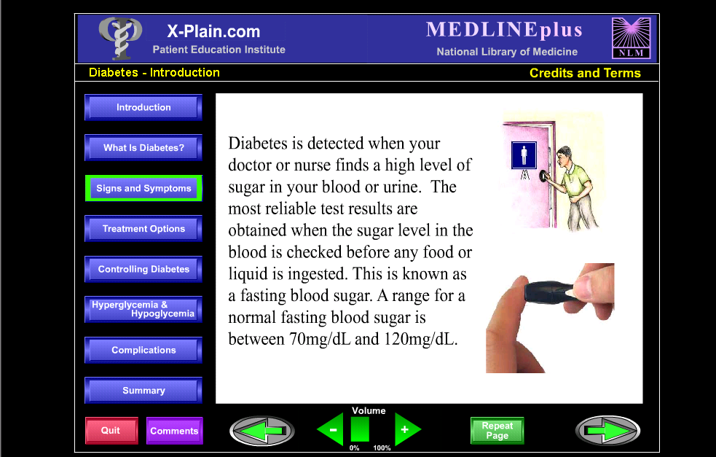

Figure 4. Same interactive tutorial page on diabetes in Spanish.

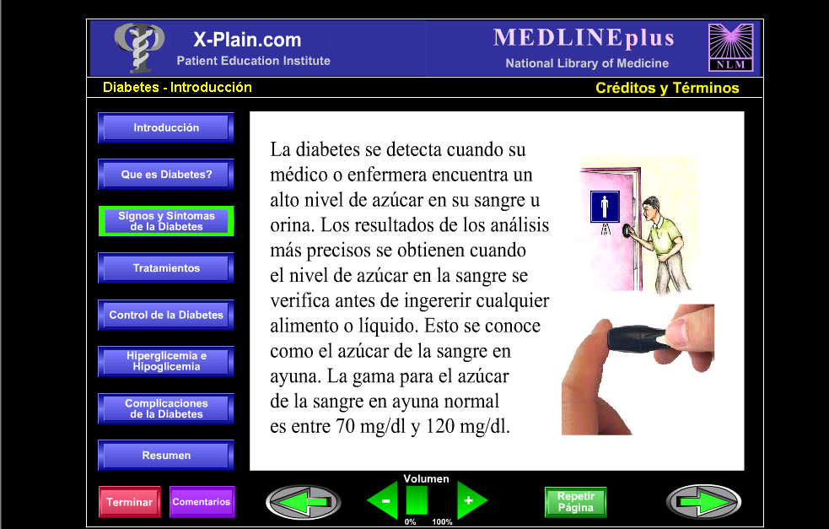

healthfinder®
<http://healthfinder.gov>

Ms. Diflo, working with children or parents of children with diabetes, can use healthfinder to find easy-to-understand material on living with diabetes. healthfinder has many sites in common with MedlinePlus, but is organized differently and has some unique information pertaining to health care organizations and topics such as health insurance, health fraud, and medical privacy. For a more comprehensive search of diabetes, health educators should check both sites.

Figure 1. There are multiple ways of searching healthfinder. A term such as “diabetes” can be entered in the search box for a general search on diabetes. This search will bring back several full-text, quality Web sites with information on the topic. Clicking on the “go” apple will execute the search and retrieve almost 200 documents.

Figure 2. This screen shows some of the useful links found with the topic diabetes in healthfinder.

Figure 3. healthfinder also provides information based on gender, age, race, ethnic origin, and roles in helping others care for their health. Under the section, “Just For You,” are Web sites and documents with information specifically intended for teenagers. Information pertaining to diabetes in teenagers or children can be found here.

Figure 4. As an interesting side note, there are useful Web sites for the public health worker under “health care” within healthfinder. A health educator can use this community information to supplement a talk on diabetes.

Figure 1. healthfinder® <http://healthfinder.gov>

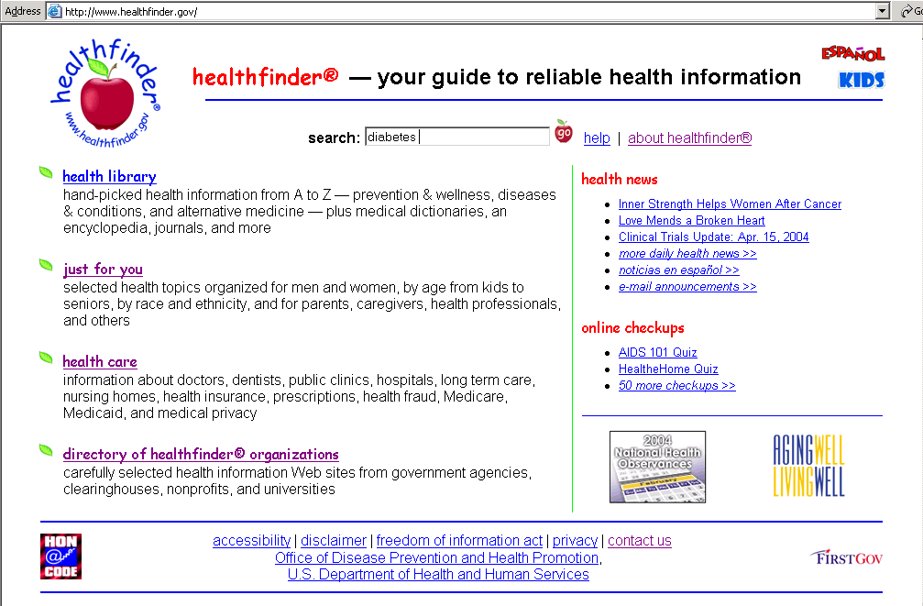
Links for material in Spanish and for children

Figure 2. Page of links from a “diabetes” search in healthfinder

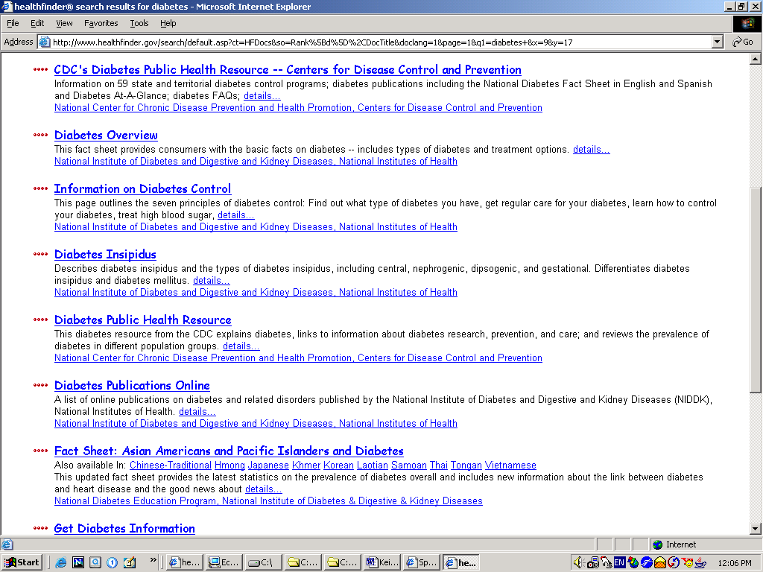

Figure 3. Health information is organized by special groups in healthfinder

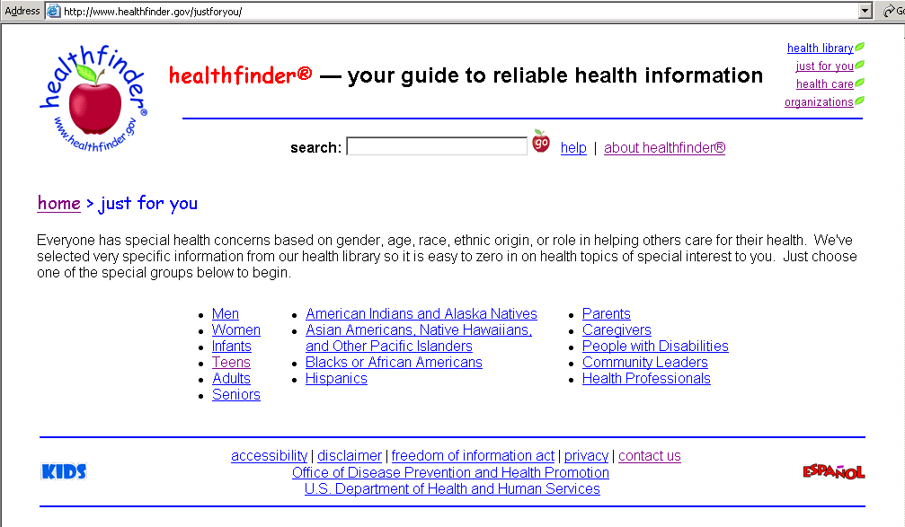
Information of interest to teenagers

Figure 4. Hard-to-find information that a public health worker may find helpful

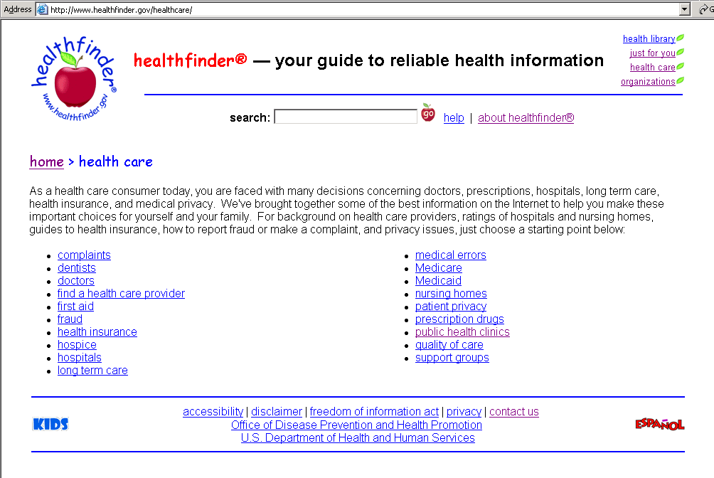

Partners in Information Access for the Public Health Workforce
<http://phpartners.org>

This Web site provides a vast amount of information of importance to any public health worker. The current, authoritative information is provided by key players in the field of public health.

Figure 1 and Figure 2. The Figure 1 screen shot demonstrates the many categories of information within the Partners Web site. Ms. Diflo can find current information and statistics about diabetes in an easy-to-understand format from the Centers for Disease Control and Prevention (CDC). Click “Health Promotion and Health Education,” and then choose either “Frequently Asked Questions” or “Health Topics A to Z” for information on diabetes from the CDC.

Figure 3. Ms. Diflo can also find information to support her work with the community by consulting similar projects involving diabetes work. The Partners Web site provides a link to the Health Disparities Projects and Interventions database, sponsored by the American Public Health Association. Type in “diabetes” as a keyword.

Figure 4. This screen demonstrates a few ongoing projects working with diabetes. The name of the project, a short description of the content, and contact information is given.

Figure 1. Partners in Information Access for the Public Health Workforce <http://phpartners.org>

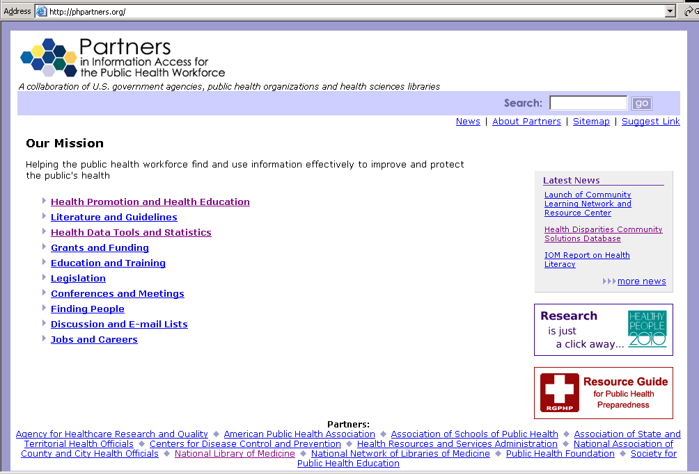

Figure 2. Information on diabetes is available from the CDC

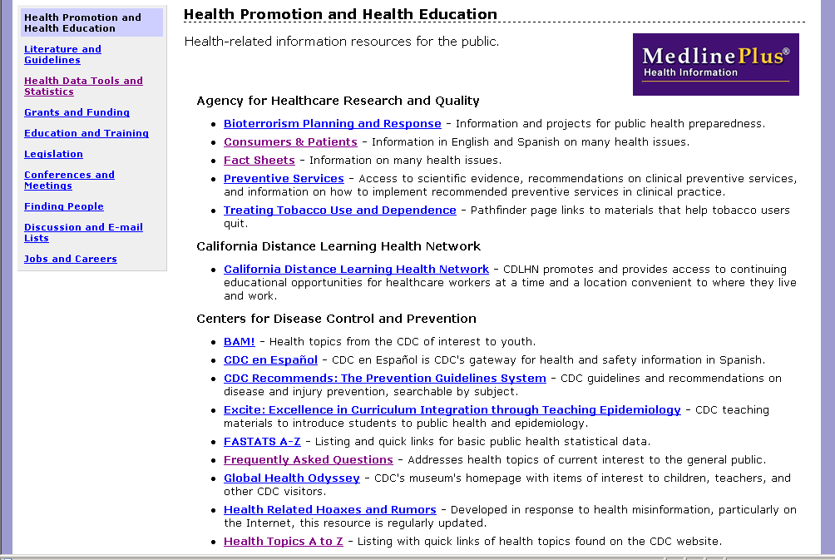

Figure 3. From the Partners Web site, there is a link to information on health disparities. Type in keyword “diabetes.”

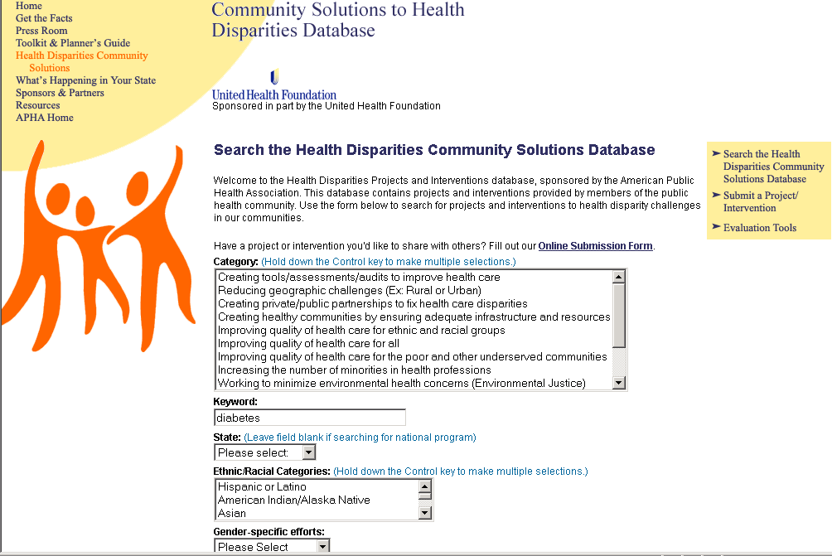

Figure 4. Projects addressing health disparities

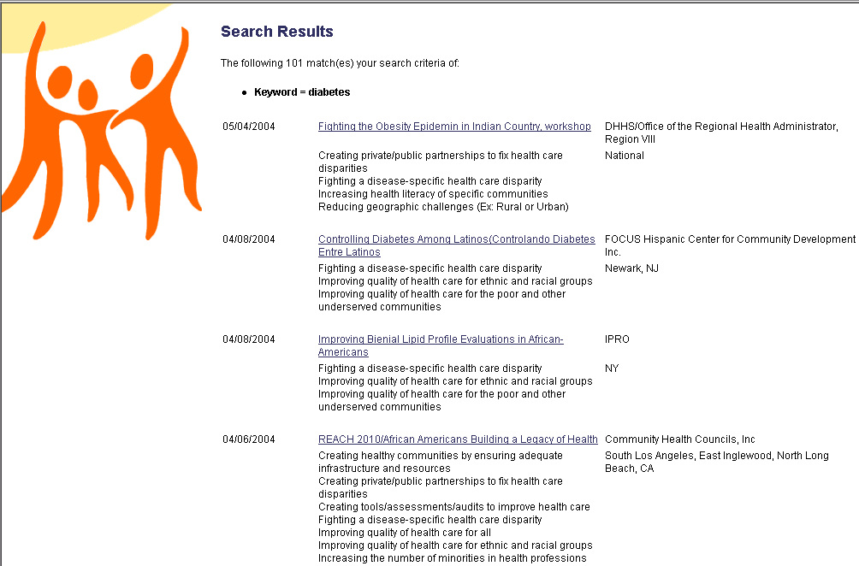

Nutrition.gov
<http://www.nutrition.gov>

Nutrition is important in the prevention and management of diabetes. Ms. Diflo can use this Web site to find resources that demonstrate proper nutrition for the parents of children who are at risk for early-stage diabetes. For instance, Nutrition.Gov can provide a food pyramid to explain nutrition to children. She can also find further information on diabetes for parents under the topic Health Management/Diseases or under Resources/Publications. Some of these links will take a parent to the many resources of the National Diabetes Information Clearinghouse (NDIC).

A fun Web site for children is <http://smart-mouth.org>
Smart-mouth.org, from the Center for Science in the Public Interest, provides information “snacktoids” for children to highlight food myths, provides games and quizzes, and provides some full-text information written for the young person about the food industry.

Figure 1. Nutrition.Gov <http://www.nutrition.gov>

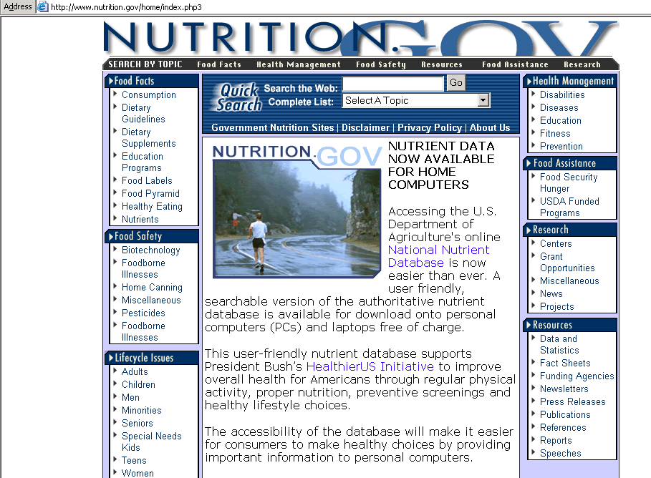
Food Pyramid information can be found here

Figure 2. National Diabetes Information Clearinghouse (NDIC) <http://diabetes.niddk.nih.gov>

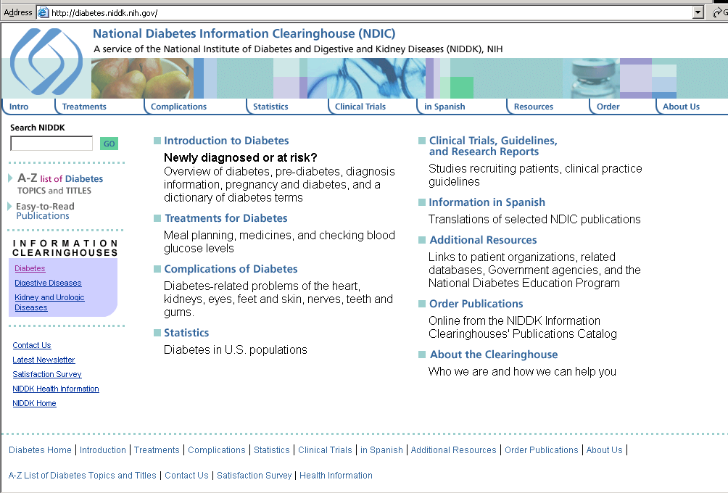
This is one of the organizations linked from Nutrition.Gov

Ms. Diflo is interested in providing her community with resources in the Spanish language as well as in English. She also has a few parents who understand Cambodian. How does she find health-related information that will satisfy everyone’s needs?

NOAH: New York Online Access to Health
<http://www.noah-health.org>

Figure 1 and 2: Similar to the National Library of Medicine’s MedlinePlus site, NOAH provides excellent health information in Spanish. These screens demonstrate how to find quality health information written in Spanish from the NOAH Web site.

Figure 1. NOAH <http://www.noah-health.org>

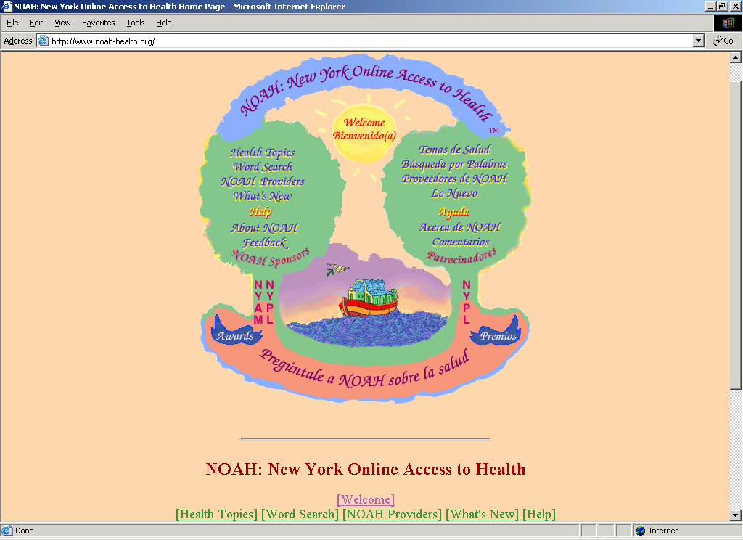
Clicking on “Temas de Salud” provides a list of health topics in Spanish.

Figure 2. Scrolling down on this page provides many different categories of information, pertaining to diabetes, all in Spanish.

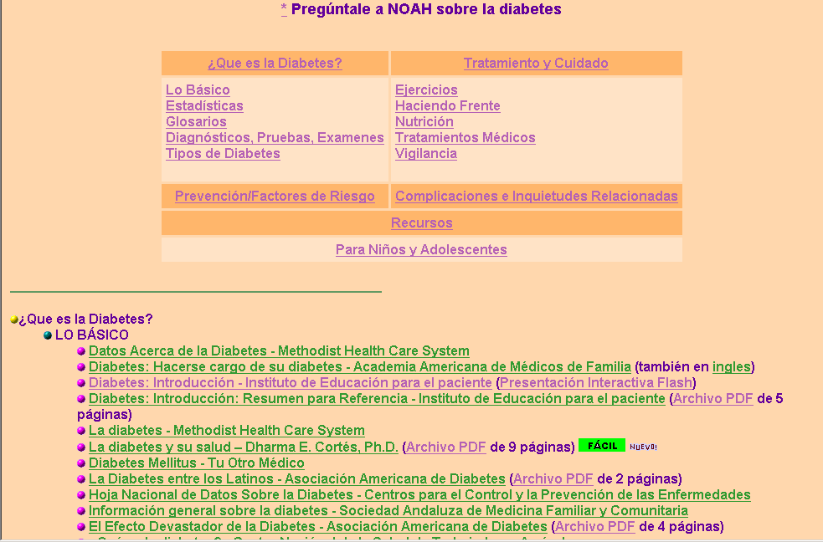

24 Languages Project
<http://medstat.med.utah.edu/24languages>

Figure 1 and 2: This site provides information in a variety of languages beyond Spanish.
It also mentions several other Web sites that can help with finding non-English language materials.

Figure 1. 24 Languages Project: Consumer Health Brochures in Multiple Languages. <http://medstat.med.utah.edu/library/refdesk/24lang.html>

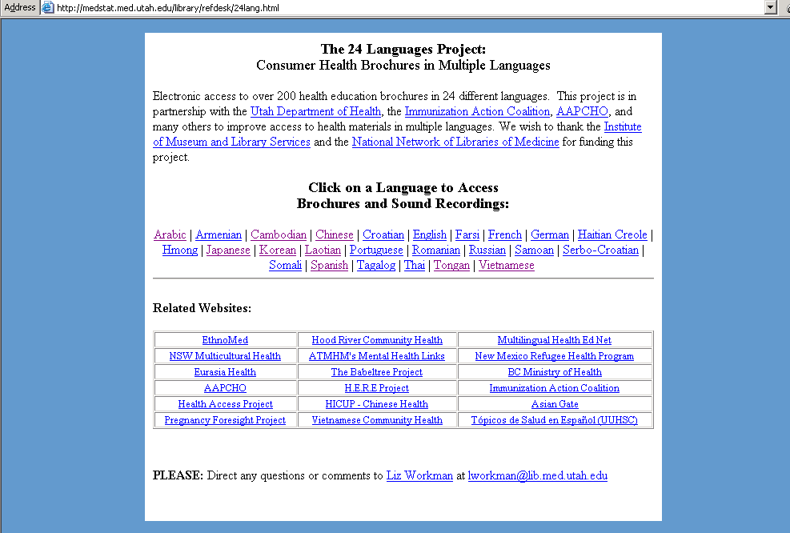
This Web site can help Ms. Diflo find health information in Cambodian
These are other culture- specific Web sites of use to health educators.

Figure 2. This is a Cambodian brochure from the above Web site entitled, Be Healthy, Stay Active, from the Association of Asian Pacific Community Health Organizations.

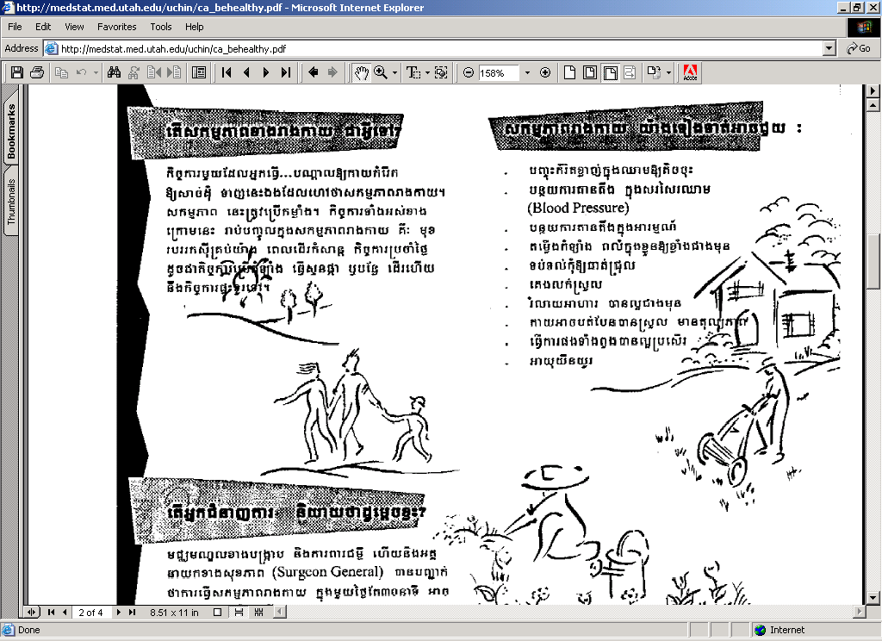

Consumer Health Information/Multilingual Health Information
<nnlm.gov/train/chi/multi.html>

Many other Web sites are available that provide health information in non-English formats. Several of these are listed on this Consumer Health Information page of the National Training Center and Clearinghouse, National Network of Libraries of Medicine.

CHID Online: The Combined Health Information Database
<http://chid.nih.gov>

At one point in her presentation Ms. Diflo stresses that the Internet, while having vast amounts of quality information, is just one possible resource for health information.
Additional resources about diabetes can be identified by searching the CHID database. This database provides titles and abstracts from authoritative journals and chapters from health-related books. There are also other health promotion and education materials and program descriptions included as well. Many are not indexed elsewhere. A public or medical librarian can help the general public acquire these materials. Searching beyond the Internet provides a more comprehensive search on topics such as diabetes.

Figure 1. The homepage for CHID.

Figure 2. Other categories within CHID include AIDS/STD/TB Education, Alzheimer’s Disease, Arthritis, Alternative Medicine, Deafness, Digestive Diseases, Kidney Diseases, Maternal and Child Health, Genetics, Oral Health, and Weight Control.

Figure 3 and 4. A list of materials will be shown from the search. Some items will be free while others will have a charge to obtain them. For questions, consider calling the local public or medical library.

Figure 1. CHID Online: Combined Health Information Database
<http://chid.nih.gov>
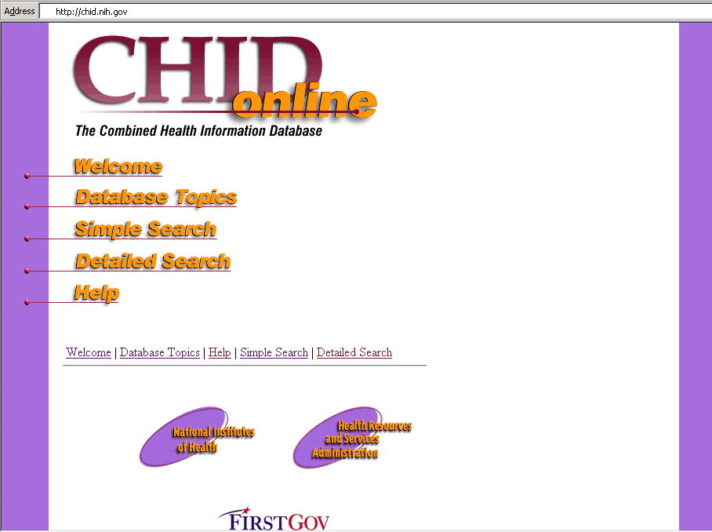

Figure 2. Use the Simple Search Strategy to search for “diabetes” and “children.”

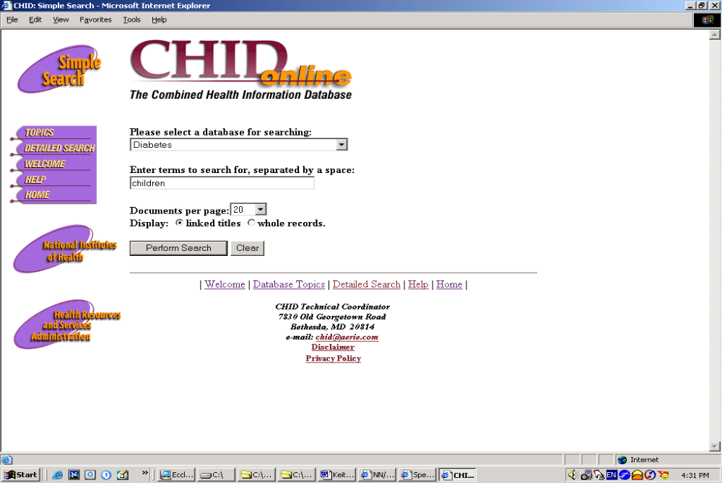
There are 12 choices of broad database categories to search. With the pull down menu, choose “Diabetes.” Type in “children” as a secondary term.

Figure 3. List of available materials on diabetes in children.
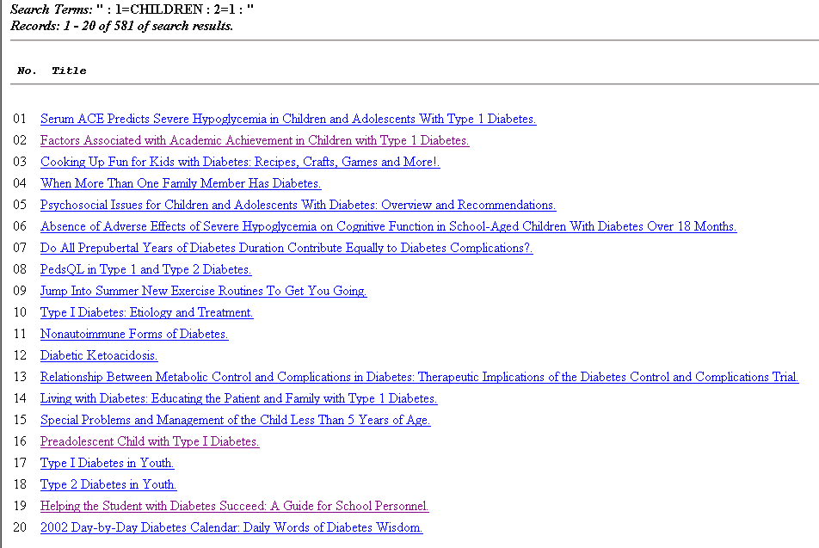
Select 19 -- Helping the Student with Diabetes Succeed: A Guide for School Personnel

Figure 4. This record indicates that the item is free from the National Diabetes Information Clearinghouse. A phone number and Web site are given to obtain the information.

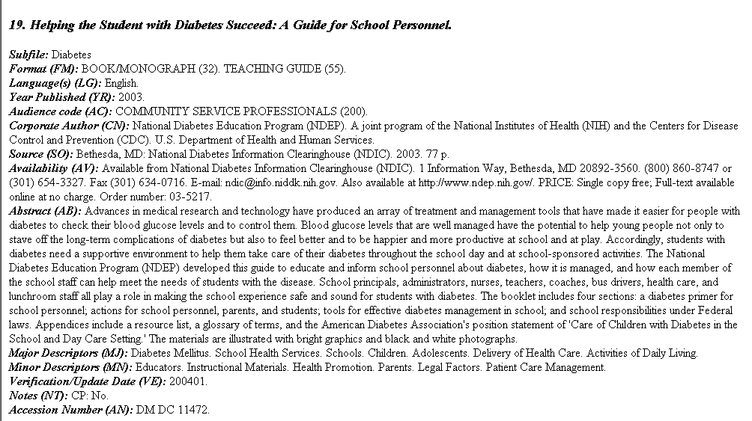

Ms. Diflo, a health educator, recently gave a presentation on important health issues, such as diabetes, at a local high school. The presentation was well received, and she has decided to implement a project based on these health issues. She would like to involve not only her community, but two nearby towns as well. The politics vary in this region, and she knows that she will need to look for ways to sustain the project in the future.

Community Tool Box
<http://ctb.ukans.edu>

Figures 1 and 2. There is a wealth of useful planning information available from this Web site. Many tools and tips are buried deep within this site, and it may take a bit of exploring to find everything.

Figure1. Community Tool Box <http://ctb.ukans.edu>

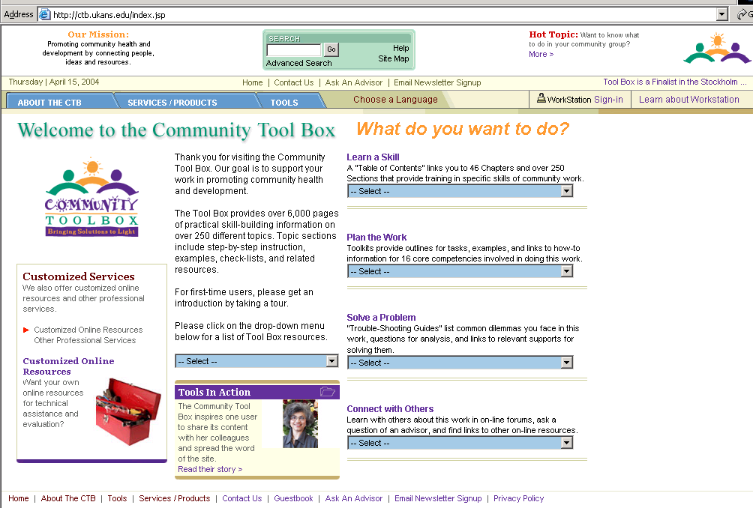
“Tools” provides help and strategies for developing projects.

Figure 2. Several broad topics and chapter ideas are available to help begin and continue a project.

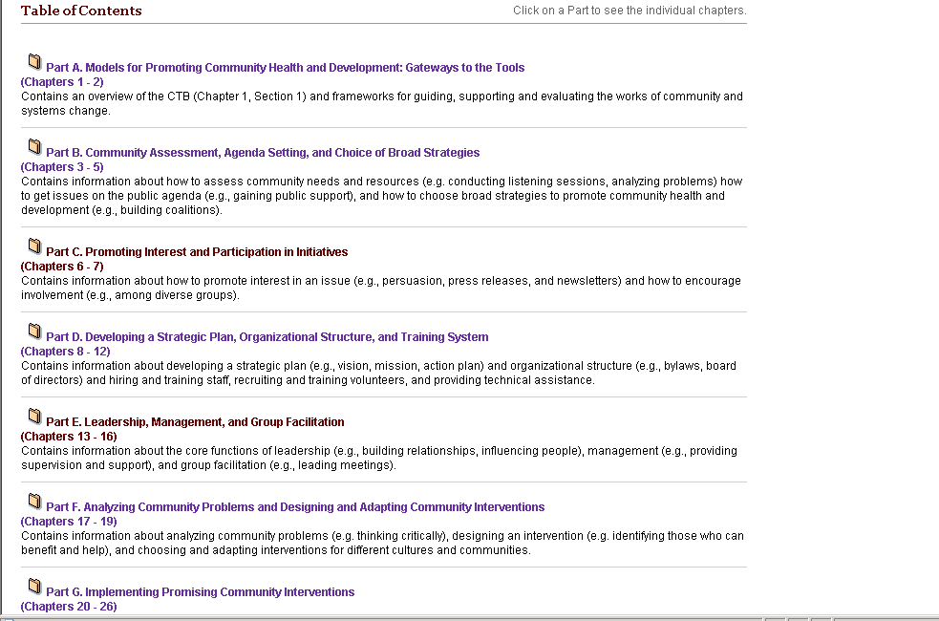

Figure 3. This is an example of one of the chapters, Promoting Interest in Community Issues.

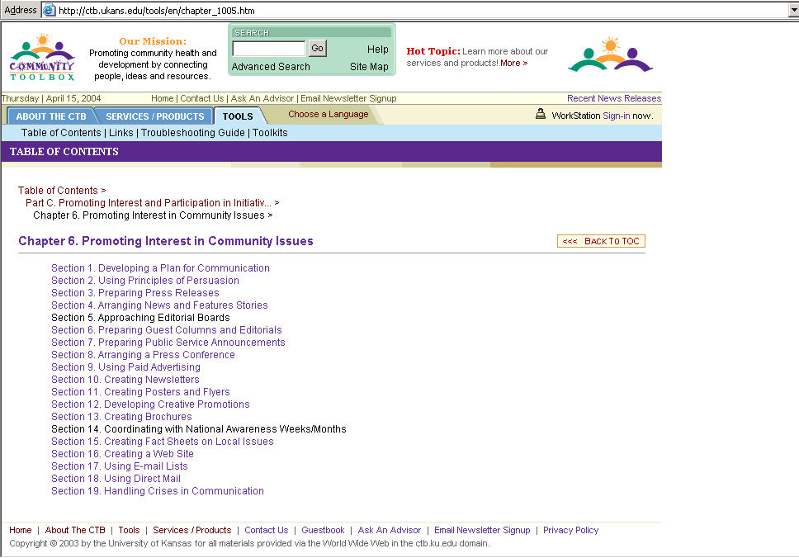

Figure 4. “Toolkits” can be found under the tab for “Tools.” They help organize the work.

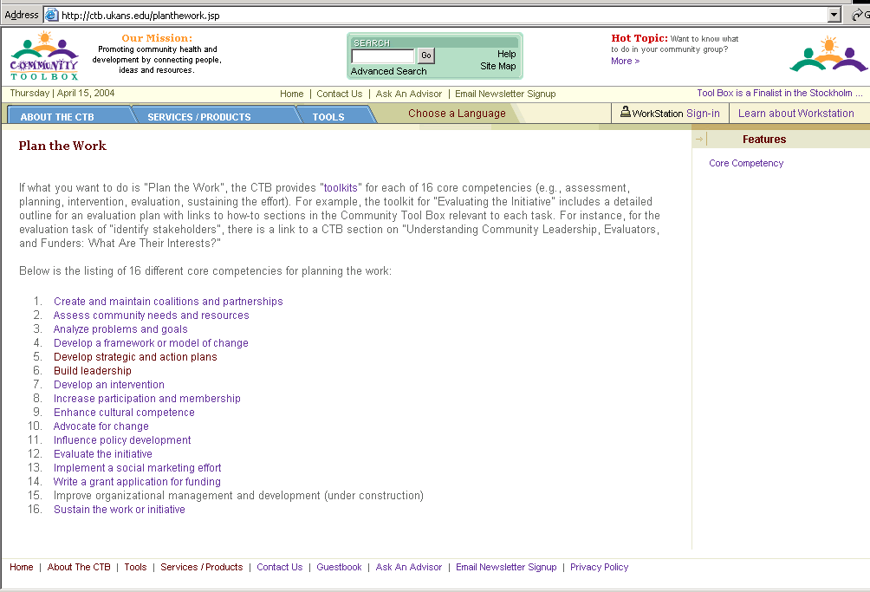

Figure 5. If there are problems with the project, this troubleshooting guide can help.

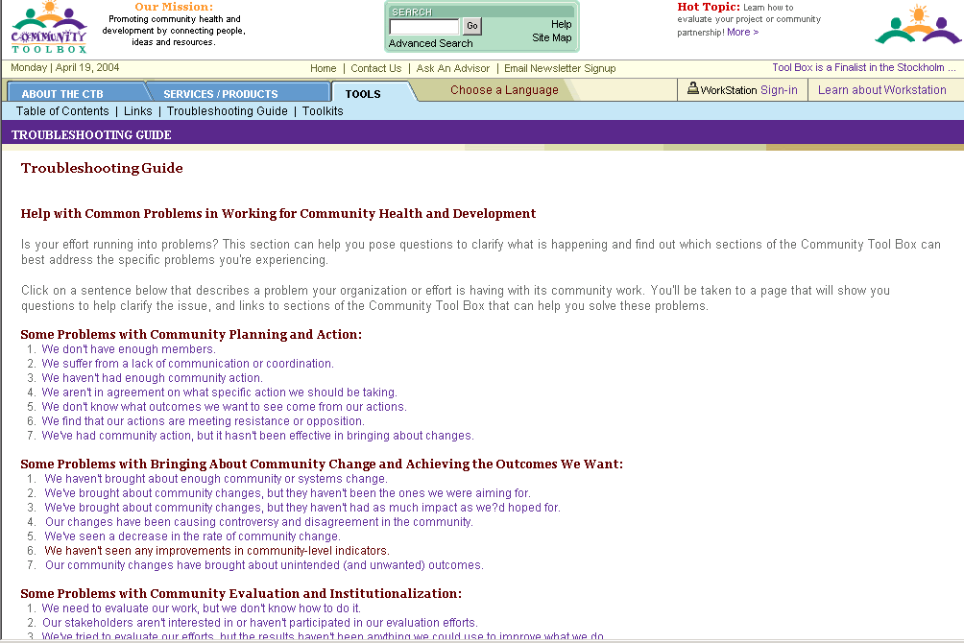

Ms. Diflo, a health educator, is part of a panel discussing various health issues such as the impact of environmental toxins on a community. Parents in her community are very concerned that there may be lead in the local high school. How does Ms. Diflo find accurate, easy to understand information on lead poisoning?

Tox Town
<http://toxtown.nlm.nih.gov>

Figure 1 and 2. Tox Town from the National Library of Medicine provides basic information on many toxic chemicals and environmental risks that we may encounter in our everyday environments. Choose “Go to Town” and then “School” for information about possible risks in the school environment. Notice the word “school” appears in a small dialog box next to the picture of the school.

Figure 3 and 4. These screens demonstrate various links to authoritative agencies providing environmental risk information such as the Environmental Protection Agency and the Occupational Safety and Health Administration.

Figure 1. Toxins/environmental risks can be viewed in either a “town” or “city” environment. Choose “Go to Town.”

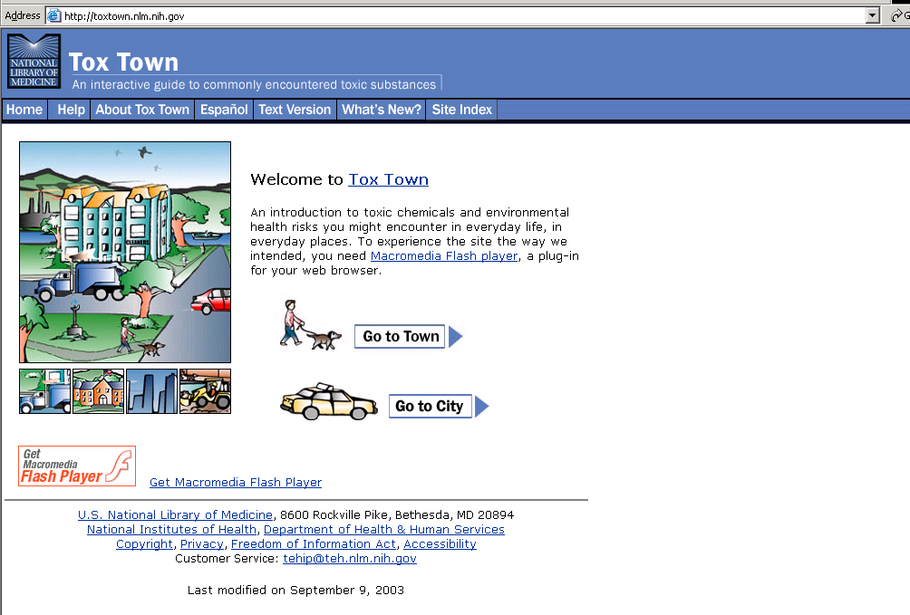

Figure 2. To view information about lead in schools, click on the School.

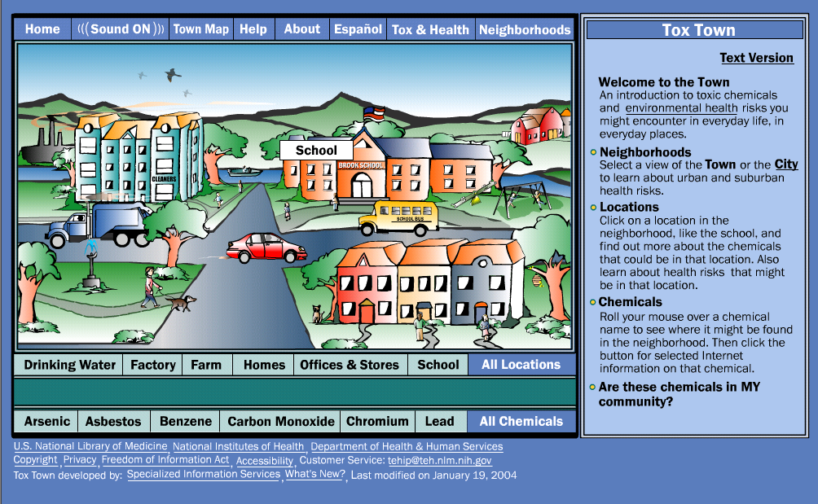

Figure 3. Click on “Chemicals at School” to find information on lead and other toxic chemicals in this environment. Clicking on the link for “lead” at the bottom of the screen will also provide information on lead.

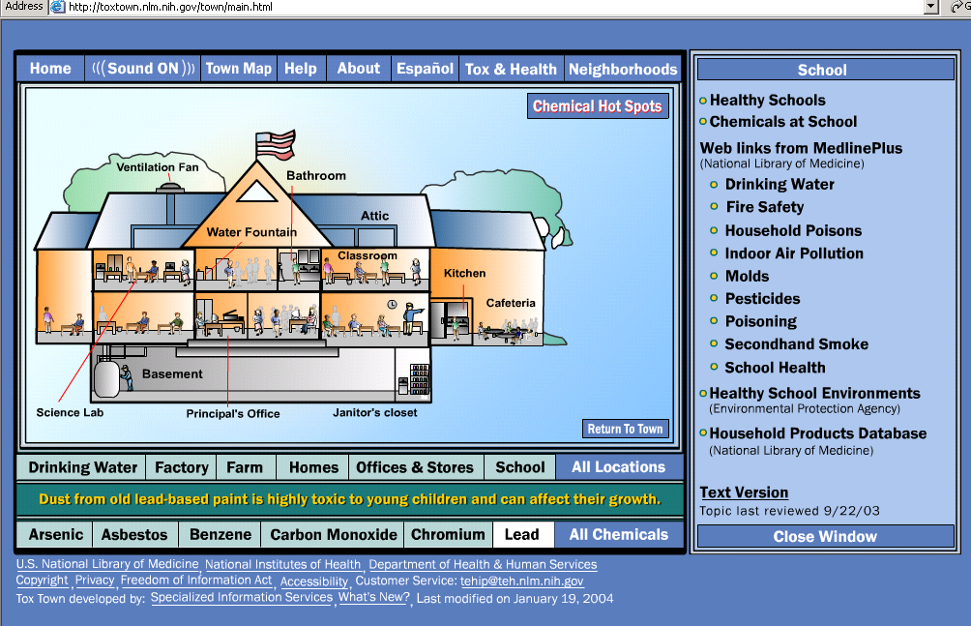

Figure 4. Clicking on “lead” from the bottom of the screen will give information on this topic from a variety of quality Web sites. For instance, clicking on “Lead. ToxFAQs” will produce a fact sheet on lead poisoning from the Agency for Toxic Substances and Disease Registry.

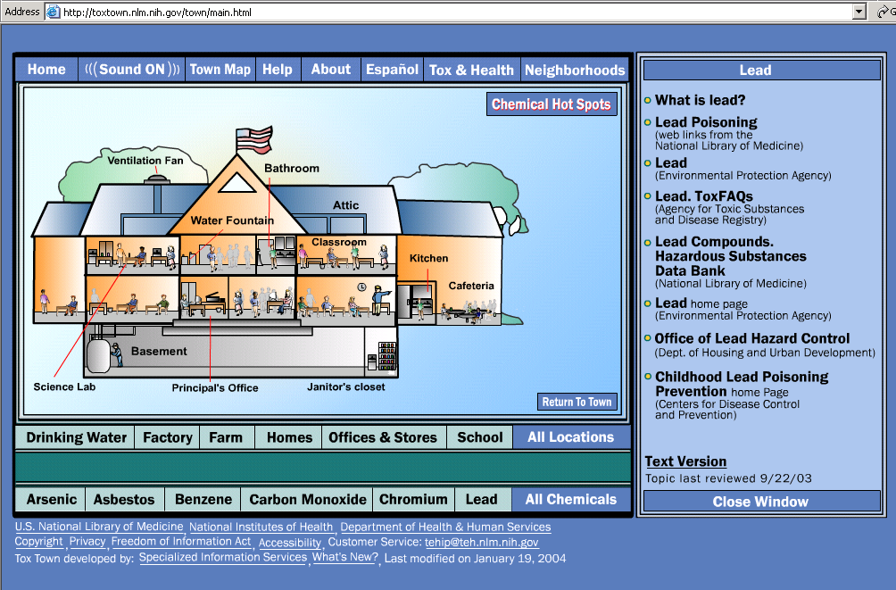

Ms. Diflo can consult the following for further information to supplement her discussion on health for the community.

Centers for Disease Control and Prevention (CDC)
<http://www.cdc.gov>

National Institutes of Health (NIH)
<http://www.nih.gov>

Centers for Disease Control and Prevention <http://www.cdc.gov>

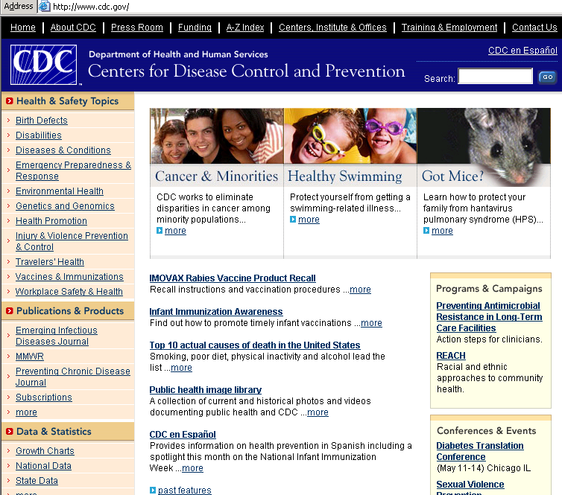
Information on diabetes can be found under Diseases & Conditions. More information is found under Health Promotion.

National Institutes of Health (NIH) <http://www.nih.gov>

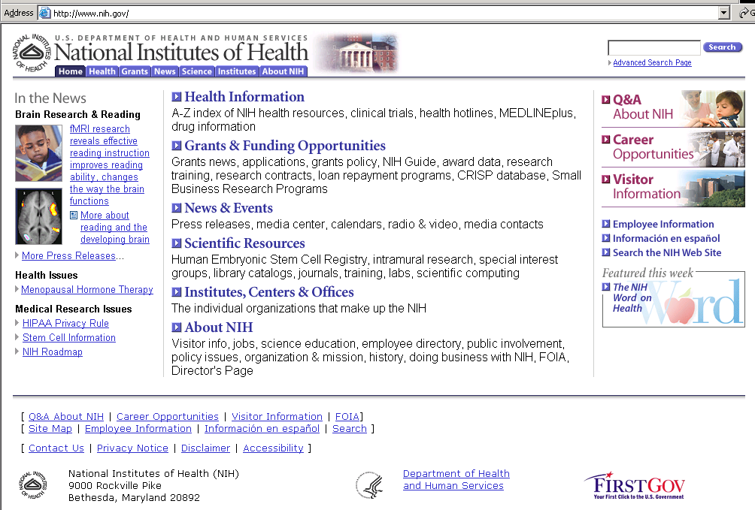

Internet Navigator
<http://medstat.med.utah.edu/navigator>

The Internet Navigator is a Web-delivered course on information management. It provides information on using the Internet as a resource tool and includes a section on evaluating Web resources. This course is a collaborative effort between the Spencer S. Eccles Health Sciences Library at the University of Utah and the Utah Academic Library Consortium (UALC).

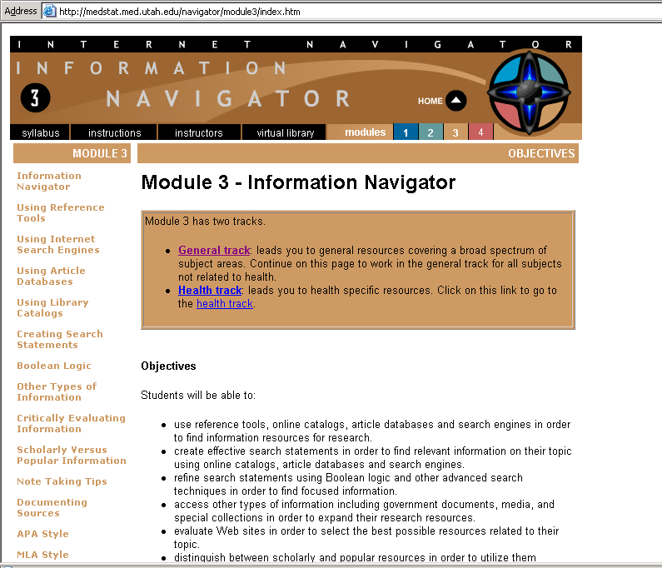

Look here to find information on evaluating the quality of a Web site.

Click on the link for “Critically Evaluating Information” to view a table with factors to consider when evaluating a Web site.

Accuracy or credibility | Is the information provided based on proven facts?  Is it published in a scholarly or peer-reviewed publication?  Have you found similar information in a scholarly or peer-reviewed publication?
Author or authority | Who is the author?  Is she or he affiliated with a reputable university or organization?  What is the author's educational background or experience?  What is their area of expertise?  Has the author published in scholarly or peer reviewed publications?  Does the author/Web master provide contact information?
Coverage or relevance | Does the information covered meet your information needs?  Is the coverage basic or comprehensive?  Is there an "About Us" link that explains subject coverage?  How relevant is it to your research interests?
Currency | When was the information published?  When was the Web site was last updated.  Is timeliness important to your information need?
Objectivity or bias | How objective or biased is the information?  What do you know about who is publishing this information?  Is there a political, social or commercial agenda?  Does the information try to inform or persuade?  How balanced is the presentation on opposing perspectives?  What is the tone of language used (angry, sarcastic, balanced, educated)?
Sources or documentation | Is there a list of references or works cited?  is there a bibliography?  Is there information provided to support statements of fact?  Can you contact the author or Web master to ask for, and receive, the sources used?
Publication and Web site design | How well designed is the Web site?  Is the information clearly focused?  How easy to use is the information?  How easy is it to find information within the publication or Web site?  Are the bibliographic references and links accurate, current, credible and relevant?  Are the contact addresses for the author(s) and Web master(s) available from the site?

References

- Public Health Functions Steering Committee. <http://www.health.gov/phfunctions/public.htm> Accessed August 4, 2003.

- Council on Linkages Between Academia and Public Health Practice. Core competencies, <http://trainingfinder.org/competencies> Accessed August 4, 2003.

Finding Public Health
Statistics and Data Sources

Catherine R. Selden†

Chapter Summary

Finding data sources and effectively using statistics are of vital importance as national, state, and local public health departments are called upon to respond quickly to ever more pressing emergencies. The importance of health data and a brief discussion of how to find statistics and data sources are discussed in this chapter. Also, a case study is used to illustrate how Web sites offering data sets and statistics can be useful in public health practice.

Note that the text of this chapter is in the public domain and may be copied, adapted and used freely for the training of members of the public health workforce.

Learning Objectives

Public health workers learning the material in this chapter will:
- Have a general understanding of the types of statistics and data sets that are available on the Internet
- Be able to identify selected Web sites with data sources and statistics for use at the national, state, and local public health levels.

Applications of Learning

The strategies and resources introduced in this chapter will enhance a public health worker’s competency in:
Analytic/Assessment Skills: Identifies relevant and appropriate data and information sources [1]

Introduction

Technology has markedly improved access to public health statistics. These statistics are derived from data sets which are collections of logically related data arranged in a prescribed manner. Data may represent information collected at the national, state or local levels. Public health data sets may be conveniently envisioned as falling into two broad categories. One category includes counts of individual health related events or services. Counts are made of individuals who are provided particular health services. These counts are normally geographically and chronologically proscribed. For example, one collection of data might focus on a population in the northeast United States between 1960 and 1980 while another might be limited to citizens of West Virginia. Specific events might include hospital emergency room visits, visits to WIC clinics, deaths attributed to a specific cause, and preventive services including cancer screenings or immunizations. Such counts of events, once aggregated, are useful in assessing general health needs and status, setting reimbursement levels, determining eligibility, evaluating care and program coverage and penetration rates. However, because data collection is limited to those who seek services, the results may or may not be representative of the general population.

A second category of data sets describes populations through the use of sampling techniques. Data collection systems that create these data sets survey a subset of a reference population. The reference population could be as broad as all citizens of the United States or it may be more narrowly constrained. Examples include many of the federal surveys of health status and health behaviors and health services utilization. The sampling techniques are used to identify an appropriate survey population [2].

Statistical reports including a mix of text, tables, and figures from data sets are available from an increasing number of federal, state and local sources through a variety of electronic modes including the Internet.

Important Features of Health Statistics and Data Sets

The Importance of Health Data

Health statistics and data are important because they measure a wide range of health indicators for a community. A community can be the entire United States, a region, state, county, or city. Health data provide comparisons for clinical studies, can be used to assess costs of health care, can help identify needed prevention targets for such programs as Healthy People 2010 and are important for program planning and evaluation by finding a baseline against which to measure in the evaluation phase.

The Context of Health Statistics

Health statistics are influenced by an organization’s perspective and bias. These biases can affect the collection device and eventual outcomes that are reported. They also can determine what data are collected and how the data are collected. Whenever possible, read the notes describing the reasons for and methods of data collection. Remember that statistics are collected to meet the needs of the collector.

The populations covered by different data collections systems may not be the same. Data on vital statistics and national expenditures cover the entire population. Most data on morbidity and utilization of health resources cover only the civilian non-institutionalized population.

Some information is collected in more than one survey and estimates of the same statistic may vary among surveys. For example, the National Health Interview Survey, the National Survey on Drug Use and Health, the Monitoring the Future Survey, and the Youth Risk Behavior Survey all measure cigarette use. But estimates of cigarette use may differ among these surveys because of different survey methodologies, sampling frames, questionnaires, definitions, and tabulation categories.

Key Features of Health Statistics

Health statistics are population based and many are collected and analyzed over time. Statistics often use geographic regions such as zip codes for determining health care coverage and comparisons of specific disease occurrences. Most studies focus on variation over time, space and social group.

Health Statistics Come from Diverse Sources
Many studies use administrative data. Administrative data, according to the Centers for Medicare and Medicaid Services (CMS), include enrollment or eligibility information, claims information, and managed care encounters. The claims and encounters may be for hospital and other facility services, professional services, prescription drug services, laboratory services or other services.

Surveys are designed to collect specific data and are often conducted by trained personnel who administer them by telephone or in-person.

CDC states that public health surveillance is the systematic collection, analysis, interpretation, and dissemination of health data on an ongoing basis, to gain knowledge of the pattern of disease occurrence and potential in a community, in order to control and prevent disease in the community.

Health Data on the Web

Statistical Information on the Web

The Internet is a good place to look for already compiled statistics. Current data from federal, state and local governments as well as non-governmental health statistical sources are increasingly available. Access to spatial information is becoming easier, allowing the creation of maps for visualizing statistical information. Keep in mind that while the Internet is a valuable tool, it is not the complete answer.

Remember that Web sites are produced by organizations for a variety of purposes. Web sites provide a variety of information in many formats including:

Summaries and secondary material

Full reports with tables

Digital versions of data

Full data sets

Statistical Information Not on the Internet
Not all health data sets and statistics are freely or publicly available on the Web. In some cases only summaries or partial data sets are available and the full sets must be purchased. New privacy concerns as a result of the HIPPA regulations may cause organizations to limit access to data. For example, the Centers for Medicare and Medicaid Services (CMS) states on its Web site that some data sets are so limited that a Medicare beneficiary might be identified when files are relinked although all direct identifiers are stripped out. CMS requires a signed Data Use Agreement (DUA) between CMS and the requestor to ensure that the data are protected in these files.

Finding Statistics and Data Sets on the Web
There are umbrella Web sites that point to statistical information and data resources. These are called portals and search engines. A portal is a Web site that is commonly used as a gateway to other Web sites. A search engine is a computer program that retrieves documents, files or data from a database or from a computer network (especially from the Internet). Search engine algorithms may give a higher ranking to a site that contains the keyword(s) that are specified by the user. Google is an example of a search engine that points to numerous statistics and data resources across the World Wide Web.

Case Study: Prevention of smoking among teens.

Ms. McBeal, a health educator in Lostlake, West Virginia is interested in developing a promotional campaign to decrease smoking among teens. To interest key players in the community she wants to create a presentation with information about tobacco use among teens with national, state and local statistical data, causes, adverse effects, and prevention.

Search Tips for Google on Smoking and Teens

Click on Advanced Search
Enter smoking on the first line,
Enter “youth teens children” on the line marked “with at least one of the words,”
Scroll down to Domain,
Enter .gov (This will narrow the search to only government Web sites.)
Google Results include:
MedlinePlus – Smoking and Youth
<http://www.nlm.nih.gov/medlineplus/smokingandyouth.html>

What are Internet Portals?

Internet Portals are subject focused, information directories. Typically they do not have their own local content. They point to content created by others. Key word searches within portals can be effective. However, not all portals have keyword searching. You need to know what you are looking for and you need to identify the correct information portal for that need. Several are listed in the material that follows.

Health Statistics Portals/Gateways

Partners in Information Access for the Public Health Workforce
<http://phpartners.org/>

MedlinePlus
<http://medlineplus.gov/>
See Health Topic – Health Statistics

HSS Data Council Gateway to Data and Statistics – Federal Government
<http://aspe.hhs.gov/statinfo/>

Statistical Abstract of the United States – U.S. Census Bureau
<http://www.census.gov/statab/www/>

FedStats – Federal Government
<http://www.fedstats.gov/>

State & County QuickFacts – U.S. Census Bureau – Federal Government
<http://quickfacts.census.gov/qfd/>

Statistical Resources on the Web – University of Michigan
<http://www.lib.umich.edu/govdocs/stats.html>

State Health Facts Online - Kaiser Family Foundation
<http://www.statehealthfacts.kff.org/>

Federal Government Health Statistics Agencies

There are several federal agencies that gather, analyze, and report statistical data useful for public health purposes. Among these are:

National Center for Health Statistics (NCHS)
<http://www.cdc.gov/nchs/>
This is the principal health statistics agency in the U.S. It is part of the Centers for Disease and Control and Prevention (CDC).

Agency for Healthcare Research and Quality (AHRQ)
<http://www.ahrq.gov/>
AHRQ is the lead scientific research federal agency charged with supporting research designed to improve the quality of healthcare, reduce its cost, improve patient safety, decrease medical errors, and broaden access to essential services.

Substance Abuse and Mental Health Services Administration (SAMHSA)
<http://www.samhsa.gov/>
SAMHSA’s Office of Applied Studies (OAS) provides the latest national data on 1) alcohol, tobacco, marijuana and other drug abuse, 2) drug related emergency department episodes and medical examiner cases, and 3) the nation’s substance abuse treatment system.

Centers for Medicare and Medicaid Services (CMS) (formerly HCFA)
<http://www.cms.gov/>
CMS offers researchers and other health care professionals a broad range of quantitative information from estimates of future Medicare and Medicaid spending to enrollment, spending, and claims data.

Data Sets: Federal

A variety of data sets are available from federal agencies. Some Web sites provide interactive interfaces that allow users to download data for manipulation offline. Others allow users to query a data set or collection of data sets with Web-based tools. Information can be extracted and used in custom-made tables.

National Library of Medicine

Health Data Tools and Statistics - Partners in Information Access for the Public Health Workforce
<http://phpartners.org/health_stats.html>
This public health portal has categorized data tools and statistics into these subcategories: Health Statistics, National Public Health Data Sets, State and Local Public Health Data Sets, Public Health Infrastructure Data, Search for Other Tools, and Tools for Data Collection and Planning.

Health Services and Sciences Research Resources (HSRR) – National Information Center on Health Services Research and Health Care Technology (NICHSR)
<http://www.nlm.nih.gov/nichsr/hsrr_search/>
This is a directory of research datasets and instruments used in health services research and public health. Entries have URLs for more information and most have pre-formulated PubMed/MEDLINE searches.

Toxicology and Environmental Health – Specialized Information Services
<http://sis.nlm.nih.gov/Tox/ToxMain.html>
Hazardous Substances Data Bank has chemical data valuable for environmental health concerns.

Agency for Healthcare Research and Quality

HCUP – Healthcare Cost and Utilization Project
<http://www.ahcpr.gov/data/hcup/>
The HCUP is a family of health care databases and related software tools and products developed through a federal-state-industry partnership. HCUP databases bring together the data collection efforts of state data organizations, hospital associations, private data organizations, and the federal government to create a national information resource of discharge-level health care data. HCUP includes the largest collection of longitudinal hospital care data in the United States, with all-payer, discharge-level information beginning in 1988. These databases enable research on a broad range of health policy issues, including cost and quality of health services, medical practice patterns, access to health care programs, and outcomes of treatment at the national, state, and local market levels. It also includes information on admission rates and mean charges by DRG (Diagnostic Related Groups) codes.

MEPS – Medical Expenditure Panel Survey
<http://www.meps.ahrq.gov/default.htm>
MEPS is a survey of the civilian population living in U.S. communities. MEPS produces nationally representative statistics on health care expenses, including the type of medical services used, how frequently they are used, the cost of services, and how they are paid for, as well as health conditions and health insurance availability and coverage. MEPS also collects extensive information on employer-based health insurance plans.

Centers for Disease Control and Prevention (CDC)

Behavioral Risk Factor Surveillance System (BRFSS)
<http://www.cdc.gov/brfss/>
BRFSS is the world’s largest telephone survey; it tracks health risks of adults in the United States. A federal and state partnership allows data collection at the national, state and local levels.

National Health Care Survey (NHCS)
<http://www.cdc.gov/nchs/nhcs.htm>
The NHCS is a collection of health care provider surveys, obtaining information about the facilities that supply health care, the services rendered, and the characteristics of the patients served.

National Health Interview Survey (NHIS)
<http://www.cdc.gov/nchs/nhis.htm>
NHIS is a continuing nationwide survey of the U.S. civilian noninstitutionalized population conducted in households. Each week a probability sample of households is interviewed by trained personnel of the U.S. Bureau of the Census to obtain information about the health and other characteristics of each living member of the sample household.

National Health and Nutrition Examination Survey (NHANES)
<http://www.cdc.gov/nchs/nhanes.htm>
NHANES is a survey that collects information about the health and diet of people in the United States. It is unique in that it combines a home interview with health tests that are done in a mobile examination center.

National Immunization Survey
<http://www.cdc.gov/nip/coverage/default.htm#NIS>
A large on-going survey of immunization coverage among U.S. preschool children (19 - 35 months old).

National Notifiable Disease Surveillance System (NNDSS)
<http://www.cdc.gov/epo/dphsi/nndsshis.htm>
State health departments report notifiable infectious diseases to CDC. <http://www.cdc.gov/epo/dphsi/phs/infdis2004.htm> Provides a list of the notifiable diseases for 2004.

National Vital Statistics System
<http://www.cdc.gov/nchs/nvss.htm>
Compiles information from states on vital events - births, deaths, marriages, divorces, and fetal deaths.

Youth Risk Behavior Surveillance System (YRBSS)
<http://www.cdc.gov/nccdphp/dash/yrbs/index.htm>
The YRBSS includes national, state, and local school-based surveys of representative samples of 9th through 12th grade students. These surveys are conducted every two years, usually during the spring semester. The national survey, conducted by CDC, provides data representative of high school students in public and private schools in the United States. The state and local surveys, conducted by departments of health and education, provide data representative of the state or local school district.

Substance Abuse and Mental Health Services Administration

National Survey on Drug Use & Health (formerly called the National Household Survey on Drug Abuse)
<http://www.samhsa.gov/oas/nhsda.htm>
This is the primary source of information on the prevalence, patterns, and consequences of alcohol, tobacco, and illegal drug use and abuse in the general U.S. civilian non-institutionalized population, aged 12 and older.

Drug Abuse Warning Network (DAWN)
<http://dawninfo.samhsa.gov/>
Relies on emergency department and medical examiner data.

Drug and Alcohol Services Information System (DASIS) <http://www.samhsa.gov/oas/dasis.htm#DASISinfo>
Includes substance abuse treatment facilities data.

Alcohol and Drug Services Study (ADSS)
<http://www.samhsa.gov/oas/adss.htm>
Nationally representative survey of substance abuse treatment facilities and clients

Centers for Medicare and Medicaid Services (CMS) (Formerly HCFA)

Acute Inpatient Prospective Payment System
<http://cms.hhs.gov/providers/hipps/default.asp>

Cost Data Sets
<http://cms.hhs.gov/data/download/default.asp>
This file contains cost, statistical, and other data used in establishing the Home Health Agency (HHA) Cost Limits for fiscal periods beginning after October 1, 1999.

Medicare Current Beneficiary Survey (MCBS)
<http://www.cms.hhs.gov/MCBS/default.asp>
A continuous, multipurpose survey of a nationally representative sample of aged, disabled, and institutionalized Medicare beneficiaries. MCBS produces two files annually, Access to Care and Cost and Use

Data Sets: State and Local

State and local data can be found through federal government and national organization Web sites.

Federal Government and National Organization Sources

Behavioral Risk Factor Surveillance System (BRFSS)
<http://www.cdc.gov/brfss/>
Mentioned previously in this chapter as one of the data sets available from the CDC, BRFSS can be used to access state and local data. BRFSS is the world’s largest telephone survey; it tracks health risks of adults (persons over 18) in the United States. States can add questions on a wide range of important health issues, such as diabetes, arthritis, tobacco use, folic acid consumption, health care coverage, and even terrorism. For example, following the September 11, 2001, terrorist attack on the World Trade Center, New York, New Jersey, and Connecticut added questions to their Behavioral Risk Factor Surveys to measure the psychological effects of this traumatic event. BRFSS data can also be analyzed to examine smaller geographic areas within states. In 2003, CDC analyzed 2002 BRFSS state data for SMART BRFSS (Selected Metropolitan/ Micropolitan Area Risk Trends from the BRFSS). This project produced data for 98 metropolitan and micropolitan statistical areas (MMSAs) and showed that the prevalence of high-risk health behaviors varied substantially among selected MMSAs.

Child Stats – Federal Interagency Forum on Child and Family Statistics
<http://www.childstats.gov/>
This Web site provides federal and state statistics and reports on children and their families.

FEDSTATS – Federal government
<http://www.fedstats.gov/>
Provides access to official statistics collected and published by more than 100 federal agencies, much of it at the state level.

State & County QuickFacts – U.S. Census Bureau
<http://quickfacts.census.gov/qfd/>
QuickFacts tables are summary profiles showing frequently requested data items from various Census Bureau programs. Profiles are available at the national, state, and county level

State and Local Area Integrated Telephone Survey - CDC
<http://www.cdc.gov/nchs/slaits.htm>

State Health Departments - CDC
<http://www.cdc.gov/mmwr/international/relres.html>

Search Tip for State Health Departments on Teens and Smoking

Ms. McBeal would:
Click on State Health Departments
<http://www.cdc.gov/mmwr/international/relres.html>
Select the state she wanted (in this case West Virginia)
Click on the map or
Select West Virginia from the pull down menu
Click on the Public Health tab at the top right of the screen to get to the WV Bureau for Public Health. OR
Enter a term in the Search box in the middle of the screen and search by Keyword.

State Profiles - Children’s Defense Fund
<http://www.childrensdefense.org/states/state_profiles.htm>

State Health Facts Online - Kaiser Family Foundation
<http://www.statehealthfacts.kff.org/>

Search Tip for State Health Facts Online on Teens and Smoking

Ms. McBeal would:
Click West Virginia on the map. (This will bring up various West Virginia state Web sites.)
Click on Health Status on the left hand bar
Scroll down to Smoking
Click on Rate by Age. She would find that the table includes ages 18-65+ not younger teens. The smoking rates shown are taken from the Behavioral Risk Factor Surveillance System (BRFSS). The BRFSS surveys the population aged 18-65+.
Be sure you Select the option to Show Notes and Sources for each table you view.

Statistics for Cities and Other Places – U.S. Census Bureau
<http://www.census.gov/epcd/www/places.htm>
Access to statistics for locations smaller than states e.g., Grafton, West Virginia.

State and Local Data Sources

Many states have their own systems for reporting data. Usually these systems include births, deaths, marriages, and divorces. A core public health function is statewide injury data collection and analysis. This data collection provides data for mortality statistics found on most state public health Web sites. Check individual state public health department Web sites to find what is provided. Often local statistics are available by census tract, community, county and region. Cities and regions are also providing Internet access to data.

Arizona Public Health Services
<http://www.hs.state.az.us/plan/index.htm>
Provides population-level data on patterns and trends in health status of Arizonans.

California Department of Health Services
<http://www.dhs.ca.gov/>
This Web site provides a link to the County Health Status Profiles <http://www.dhs.ca.gov/hisp/chs/PHweek/CProfile2004/Profile2004.pdf> annual report which offers a snapshot of key health indicators in each county.

EpiQMS – Washington State Department of Health and Pennsylvania Department of Health
<http://ecapps.health.state.pa.us/epiqms/>
This is an interactive health statistics Web site that can produce numbers, rates, graphs, charts, maps, and county profiles using various demographic variables (age, sex, race, etc.) from birth, death, cancer and population datasets for the state and counties.

MASSCHIP - Massachusetts Community Health Information
<http://masschip.state.ma.us/>
This site provides health statistics for the entire state, cities and regions within the state. It allows one to use data to create predefined or custom reports. Access to the site is free but requires registration.

Texas Center for Health Statistics
<http://www.tdh.texas.gov/dpa/a_shdpa.htm>
The Center provides statistical health information from official sources in Texas. Some data are accessible online.

Houston Healthways
<http://hhw.library.tmc.edu/>
A public health Web site dedicated to Houston and Harris County public health needs, with links to resources on specific diseases and public health concerns.

International Data

United Nations Statistics Division.
<http://unstats.un.org/unsd/>
The Statistics Division compiles statistics from many international sources and produces global updates in specialized fields of statistics. Free access is provided to country specific population data.

World Bank Group Data and Statistics-
<http://www.worldbank.com/data/>
Provides data derived, either directly or indirectly, from official statistical systems organized and financed by national governments. Click on Data by Topic to find several options including health.

World Health Organization - Statistical Information System (WHOSIS)
<http://www3.who.int/whosis/menu.cfm>
The WHO Statistical Information System is the guide to health and health-related epidemiological and statistical information available from the World Health Organization.

Search Tip for WHOSIS on Teens and Smoking
Ms. McBeal would find statistics such as 50% of youth who continue to smoke will die from smoking.
Go to:http://www3.who.int/whosis/menu.cfm>
Click on Statistics by Disease or Condition
Click on #8. Tobacco
Click on Tobacco (Health Topics page)
Click on Tobacco Free Initiative <http://www.who.int/tobacco/en/>
Click on More Information at the end of WHO Atlas maps global tobacco epidemic <http://www.who.int/tobacco/statistics/tobacco_atlas/en/>
Click on #5 Youth (http://www.who.int/tobacco/en/atlas7.pdf ) for statistics on children and smoking.

Pan American Health Organization (PAHO)
<http://www.paho.org/>

Organisation for Economic Co-operation and Development (OECD)
<http://www.oecd.org/home/>
Select Statistics from the left menu bar, select Health

Federal Statistics

In addition to data sets, many federal agencies provide access to reports, tables and figures that present results of statistical analysis of health data.

National Library of Medicine

MedlinePlus - Health Statistics
<http://www.nlm.nih.gov/medlineplus/healthstatistics.html>
This site provides access to Web sites that contain compiled health statistics, often on a topic or by an audience.

Search Tip for MedlinePlus Health Statistics on Teens and Smoking

Ms. McBeal would:
Go To MedlinePlus at <http://www.nlm.nih.gov/medlineplus/healthstatistics.html>
Scroll down to Children
Click on Child Health USA
Click on Table of Contents
Scroll down to Adolescents and
Click on Cigarette Smoking
She could also find information on Healthy People 2010.
Click on Leading Health Indicators <http://www.healthypeople.gov/Document/HTML/uih/uih_4.htm>
The third Leading Health Indicator is Tobacco Use. This indicator relates to HP2010 Objective 27-2b. - Reduce cigarette smoking by adolescents. She could find statistics on tobacco use by adolescents. Also, she might approach the HP2010 coordinator to work with her

Centers for Disease Control and Prevention

CDC Wonder
<http://wonder.cdc.gov/>
Allows users to query dozens of numeric data sets on CDC’s mainframe and other computers, via “fill-in-the blank” request screens. Public-use data sets about mortality, cancer incidence, hospital discharges, AIDS, behavioral risk factors, diabetes, and many other topics are available for query. The requested data can be readily summarized and analyzed. <http://wonder.cdc.gov/wonder/data/DataSets.html> This site lists the more than 30 data sets that can be queried by CDC Wonder.

Data 2010 – The Healthy People 2010 Database
<http://wonder.cdc.gov/DATA2010/>
Interactive database system contains the most recent monitoring data for tracking Healthy People 2010. Has national and state level data. Users can construct tables for specific objectives, or objectives identified by focus areas, data source, or by select population.

Data and Statistics
<http://www.cdc.gov/scientific.htm>
This parent agency of NCHS has a Web site with a listing of scientific data and statistics.

NCHS Health E-Stats
<http://www.cdc.gov/nchs/products/pubs/pubd/hestats/hestats.htm>
NCHS gathers compiled statistics from its printed publications at this Web site.

Prevalence Data from the BRFSS (Behavioral Risk Factor Surveillance System)
<http://apps.nccd.cdc.gov/brfss/>
Users can query the BRFSS data sets for statistical information.

Youth 2001 Online
<http://www.cdc.gov/nccdphp/dash/yrbs/2001/youth01online.htm>
Youth 2001 Online provides interactive access to Youth Risk Behavior Survey (YRBS) results. You can display detailed results by location(s), question, demographic variables, and survey year. The survey provides a representative sample of 9th to 12th grade students.

Search Tip for Youth 2001 Online on Teens and Smoking:

Ms. McBeal can find an abundance of statistics on tobacco use by adolescents.
She would:
Click on <http://www.cdc.gov/nccdphp/dash/yrbs/2001/youth01online.htm>
Click on Display Detailed Results
Click on West Virginia
Click on Tobacco Use
Click on Year to get charts.
Click on Select Comparisons for additional charts. Ms. McBeal can find 2001 statistics for the United States. The states vary as to whether they include 2001.

Agency for Healthcare Research and Quality

HCUPnet – Interactive Tool for Hospital Statistics
<http://www.ahcpr.gov/data/hcup/hcupnet.htm>
Interactive access to national statistics and trends and selected state statistics about hospital stays. It generates statistics using data from the Nationwide Inpatient Sample (NIS), the Kids’ Inpatient Database (KID), and the State Inpatient Databases (SID) for states that participate. HCUPnet is part of the Healthcare Cost and Utilization Project (HCUP)

HIVnet - Interactive Tool for Statistics on Use of HIV Resources
<http://www.ahcpr.gov/data/hivnet.htm>
Interactive tool that provides information on inpatient and outpatient utilization by persons with HIV disease. This tool is focused on health services delivery.

MEPSnet
<http://www.ahrq.gov/data/mepsnet.htm>
Interactive online service that presents data from the Medical Expenditure Panel Survey (MEPS). MEPSnet is a set of statistical tools: MEPSnet/IC and MEPSnet/HC. These two tools use information gathered from organizations and household respondents, respectively.

Centers for Medicare and Medicaid Services (CMS)

Statistics, Data and Research Information
<http://cms.hhs.gov/researchers/statsdata.asp>
Provides an annotated list of public use data files, statistics and statistical publications.

Substance Abuse and Mental Health Services Administration (SAMHSA)

On-Line Analysis of Alcohol, Tobacco, and Drug Use
<http://www.samhsa.gov/oas/SAMHDA.htm>
System provides ready access to substance abuse and mental health research data. The site also includes links to detailed analysis provided in data tables by Topic and Data Type.

Quick Statistics - - State Profiles <http://wwwdasis.samhsa.gov/webt/NewMapv1.htm>
Get state level data from TEDS which provides information on the demographic and substance abuse characteristics of the 1.9 million annual admissions to treatment for abuse of alcohol and drugs in facilities that report to individual state administrative data systems. Also get statistics from N-SSATS an annual survey designed to collect data on the location, characteristics, and use of alcohol and drug abuse treatment facilities and services throughout the 50 states, the District of Columbia, and other U.S. jurisdictions These resources are good examples of systems that uses state level administrative data.

Substance Abuse and Mental Health Data Archive (SAMHDA)
<http://www.icpsr.umich.edu/SAMHDA/>
Data files, documentation, and reports are downloadable from the Web site and in public use format. The Web site features an online data analysis system (DAS) that allows users to conduct analyses on selected datasets within the archive. SAMHDA also provides user support through e-mail and a toll-free helpline.

Environmental Protection Agency (EPA)

EPA Information Sources, Databases and Software
<http://www.epa.gov/epahome/Data.html>
Lists many categories of resources.

Health Resources and Services Administration (HRSA)

Data and Statistics
<http://www.hrsa.gov/data.htm>
Provides Web links to data sources and statistics available from HRSA.

Statistical Information by Subject

Geographic Information Systems (GIS)

GIS data sets can be useful for many purposes. They are used primarily to display data geographically. In public health, applications for GIS are becoming more accessible as geo-coded health data and environmental exposure data increasingly become available, and new and easier-to-use GIS software is developed. The U.S. Agency for Toxic Substances Disease Registry (ATSDR) uses GIS to monitor the health of persons living near hazardous waste sites, and to identify areas of potential concern resulting from accidental release of chemicals in the environment. The Centers for Disease Control and Prevention (CDC) uses GIS for disease surveillance, and the Environmental Protection Agency (EPA) uses it to support risk assessment, environmental justice analysis, and ecological assessments.

GIS and Public Health – National Center for Health Statistics (NCHS), CDC
<http://www.cdc.gov/nchs/gis.htm>

Search Tip for GIS and Public Health on Teens and Smoking:
Ms. McBeal would find that West Virginia has a high number of lung cancer deaths among black males. This audience might benefit from a “Quit smoking campaign.”
Click on GIS and Public Health <http://www.cdc.gov/nchs/gis.htm>
Click on Selected Maps
Click on Lung Cancer
Browse the maps showing lung cancer deaths by race and gender.

Injury Maps - National Center for Injury Prevention and Control, CDC
<http://www.cdc.gov/ncipc/maps/>
Injury Maps, CDC Injury Center's interactive mapping system, provides access to the geographic distribution of injury-related mortality rates in the United States. Injury Maps allows you to create county-level and state-level maps of age-adjusted mortality rates for the entire United States and for individual states.

Geographic Analysis Tool for Health & Environmental Research (GATHER) - Agency for Toxic Substances and Disease Registry (ATSDR)
<http://gis.cdc.gov/>
GATHER is an online spatial data access system that provides members of the public health community access to spatial data that is pertinent to the analysis and exploration of public health issues.

EnviroMapper Storefront – U.S. Environmental Protection Agency (EPA)
<http://www.epa.gov/enviro/html/em/index.html>
View federal, state, and local information about environmental conditions and features in an area of your choice.

Dartmouth Atlas of Health Care – Center for the Evaluative Clinical Sciences at Dartmouth Medical School
<http://www.dartmouthatlas.org/>
The Atlas project focuses on how medical resources are distributed and used in the United States.

Cancer Mortality Maps & Graphs – National Cancer Institute (NCI), NIH
<http://www3.cancer.gov/atlasplus/>
Provides interactive maps, graphs (which are accessible to the blind and visually-impaired), text, tables and figures showing geographic patterns and time trends of cancer death rates for the time period 1950-1994 for more than 40 cancers.

Hospital and Health Care Records

National Hospital Discharge and Ambulatory Surgery Data
<http://www.cdc.gov/nchs/about/major/hdasd/listpubs.htm>

Medical Expenditure Panel Survey [MEPS]
<http://ahrq.gov/data/mepsix.htm>

HCUP
<http://ahrq.gov/data/hcup/>

Center for Mental Health Services [CMHS]
<http://www.mentalhealth.org/cmhs/MentalHealthStatistics/>

Mortality and Morbidity Data

Mortality Data from the National Vital Statistics System
<http://www.cdc.gov/nchs/about/major/dvs/mortdata.htm>
Includes mortality, cause of death, data based on death certificates.

CDC assumed responsibility for collecting and publishing national data on notifiable diseases in 1961. As of 1998, 52 infectious diseases were notifiable at the nation level. Currently, there are about 56. (see <http://www.cdc.gov/epo/dphsi/phs/infdis2004.htm>) The statistical summary of notifiable diseases in the United States is published to accompany each volume of the Morbidity and Mortality Weekly Report. These surveillance data are presented by the week they were reported to CDC by public health officials in state and territorial health departments. HTML versions are available from:

National Notifiable Disease Surveillance System (NNDSS)
<http://www.cdc.gov/epo/dphsi/nndsshis.htm>

MMWR Search
<http://www.cdc.gov/mmwr/mmwrsrch.htm>

Public Health Preparedness

Bioterriorism and Emerging Infections Site – Agency for Healthcare Research and Quality
<http://www.bioterrorism-uab.ahrq.gov/>
This site has been designed to provide resource information and continuing education about rare infections and potential bioterrorist agents.

Emergency Preparedness and Response – Centers for Disease Control and Preparedness
<http://www.bt.cdc.gov/>
Includes links to additional information on agents, diseases and other threats.

Preparation and Planning
<http://www.bt.cdc.gov/planning/index.asp>

Pulsenet
<http://www.cdc.gov/pulsenet/pus.htm>
This branch of CDC conducts active surveillance for laboratory-confirmed cases of seven bacterial and two parasitic organisms

Chemical Warfare Agents – National Library of Medicine
<http://sis.nlm.nih.gov/Tox/ChemWar.html>
Includes links to government and non-governmental Web sites, information about specific chemical agents with health effects and pre-formulated searches of Toxline

MedlinePlus Biodefense and Bioterriorism - National Library of Medicine
<http://www.nlm.nih.gov/medlineplus/biodefenseandbioterrorism.html>

MedlinePlus Chemical Weapons - National Library of Medicine
<http://www.nlm.nih.gov/medlineplus/chemicalweapons.html>

Toxicology and Environmental Health

TOXNET – Specialized Information Services, National Library of Medicine
<http://toxnet.nlm.nih.gov/>
A variety of databanks and databases on toxicology, hazardous chemicals, and related areas including TRI, Toxics Release Inventory, and HSDB, Hazardous Substances Data Bank.

Search Tip on TOXNET on Tobacco for Teens and Smoking:
Ms. McBeal can find facts about the chemicals in cigarettes using HSDB. She would:
Click on <http://toxnet.nlm.nih.gov/>
Click HSDB button in left hand bar
Enter tobacco in the Search Box; Click Search button
Click NICOTINE entry

IRIS (Integrated Risk Information System) – Environmental Protection Agency
<http://www.epa.gov/iris/>
A collection of computer files covering individual chemicals with human health effects that may result from exposure to various chemicals in the environment.

EnviroFacts
<http://www.epa.gov/enviro/>
An online tool to access multiple EPA databases.

Browse EPA Topics
<http://www.epa.gov/ebtpages/alphabet.html>
Provides access to EPA data by “key topics,” including Air, Food Safety, Forests, Pesticides, Wastes, Public Drinking Water Systems and Water Quality Monitoring.

NIOSH Safety and Health Topic: Chemical Safety
<http://www.cdc.gov/niosh/topics/chemical-safety/default.html#msds>
Lists NIOSH databases and other resources including Pocket Guide to Chemical Hazards (NPG).

California – Office of Environmental Health Hazard Assessment
<http://www.oehha.ca.gov>

EXTONET
<http://ace.orst.edu/info/extoxnet/ghindex.html>

Other Resources

Disability Data - U.S. Census Bureau
<http://www.census.gov/hhes/www/disability.html>

Injuries, Illnesses and Fatalities – Bureau of Labor Statistics
<http://www.bls.gov/iif/>
Provides data on illnesses and injuries on the job and data on worker fatalities.

FactFinder - U. S. Census Bureau
<http://factfinder.census.gov/servlet/BasicFactsServlet>

TransStats - Bureau of Transportation Statistics
<http://www.transtats.bts.gov/>

Using the Data

Tools for Building Reports and Tables

DataFerrett: Federal Electronic Research and Review Extraction Tool
<http://ferret.bls.census.gov/>
A search system for extracting and tabulating data across heterogeneous statistical data sources.

DataWeb – A collaborative effort between the U.S. Census Bureau and CDC
<http://www.thedataweb.org/>
A network of online data libraries. Uses DataFerret as its browser.

Epi Info
<http://www.cdc.gov/epiinfo/about.htm >
Epi Info is a public domain software package designed for the global community of public health practitioners and researchers. It provides for easy form and database construction, data entry, and analysis with epidemiologic statistics, maps, and graphs. CDC supports the development of this product.

Building Your Own Tables

WISQARS (Web-based Injury Statistics Query and Reporting System)
<http://www.cdc.gov/ncipc/wisqars/>
An interactive database system that provides customized reports of injury related data.

Data Warehouse on Trends in Health and Aging
<http://www.cdc.gov/nchs/agingact.htm>

Resources to Help You Learn More

Behavioral Risk Factor Surveillance System - Training
<http://www.cdc.gov/brfss/training.htm>
CDC provides several training options from a 37-slide easy to understand Overview to a complete Operational and Users guide.

Data Skills Online
<http://www.sph.unc.edu/toolbox/index.htm>
This is a Web-based, self-instructional toolbox. It was developed to provide public health professionals at state and local levels with tools for enhancing their analytic and technology skills focused on quantitative and qualitative data collection and analysis.

Glossary
<http://cms.hhs.gov/glossary/>
This glossary explains terms found on the Centers for Medicare and Medicaid Services Web site.

Glossary of Epidemiology Terms
<http://www.cdc.gov/nccdphp/drh/epi_gloss.htm>
Developed by CDC for the Internet. The Dictionary of Epidemiology, 2nd edition, edited by J.M. Last was helpful in providing a number of the definitions according to the Web site.

Glossary of Terms
<http://secure.cihi.ca/cihiweb/dispPage.jsp?cw_page=partner_glossary_e>
Canadian Institute for Health Information

NCHS Definitions
<http://www.cdc.gov/nchs/datawh/nchsdefs/list.htm>
An alphabetical listing of many terms used at NCHS

Online Trainings Available From The North Carolina Center for Public Health Preparedness
<http://www.sph.unc.edu/nccphp/training/training_list/>
Free short audio self-study tutorials are available on the following topics: Acute Disease Surveillance and Outbreak Investigation, Biostatistics, Bioterrorist Agents, Emerging and Reemerging Disease Agents, Epidemiology Methods, Geographic Information Systems (GIS) and a general section on Tools.

Research Data Assistance Center (ResDAC)
<http://www.resdac.umn.edu/Index.asp>
Provides technical assistance to researchers interested in using Medicare and/or Medicaid data

State Health Access Data Assistance Center (SHADAC)
<http://www.shadac.org/>
SHADAC, funded by the Robert Wood Johnson Foundation, helps states monitor rates of health insurance coverage and to understand factors associated with uninsurance. SHADAC provides targeted policy analysis and technical assistance to states that are conducting their own health insurance surveys and/or using data from national surveys.

TOXNET Training Manual – SIS, NLM
<http://sis.nlm.nih.gov/Tox/ToxLecture.html>

Selected US Government Publications

Health, United States, National Center for Health Statistics. Annual. Hyattsville, Maryland.
<http://www.cdc.gov/nchs/hus.htm >
The full-text of this annual report on national trends in health statistics is available on the Internet.

Vital and Health Statistics Series, NCHS
<http://www.cdc.gov/nchs/products/pubs/pubd/series/ser.htm>
Series 1 through Series 24 (commonly called the Rainbow Series) are available in html.

Morbidity and Mortality Weekly Report (MMWR)
<http://www.cdc.gov/mmwr/index.html>
The data in the weekly MMWR are provisional, based on weekly reports to CDC by state health departments.

Case Study: Prevention of smoking among teens – Possible Solution
This is how Ms. McBeal could find the information she needs.
Click on FEDSTATS <http://www.fedstats.gov/> (Listed under Health Data Gateways/Portals) to get some general population information
Select West Virginia in the drop down box
Click the Submit button.
She discovered that 22.3% of the population in West Virginia is under 18 years of age.
She also discovered that only 2.7% of the population spoke a language other than English at home. So, she may only need to create a campaign in English.

<http://www.fedstats.gov/>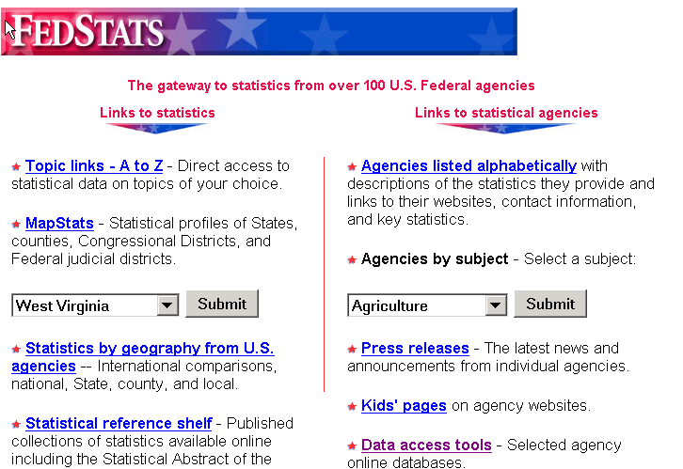

Next she wanted the health facts. She would:
Click on Partners in Information Access for the Public Health Workforce <http://phpartners.org/>
Click on Health Data Tools and Statistics
Click on FASTATS A - Z from the National Center for Health Statistics
Click S under the Topic Links A - Z.
Click on Smoking.

<http://www.cdc.gov/nchs/fastats/smoking.htm>
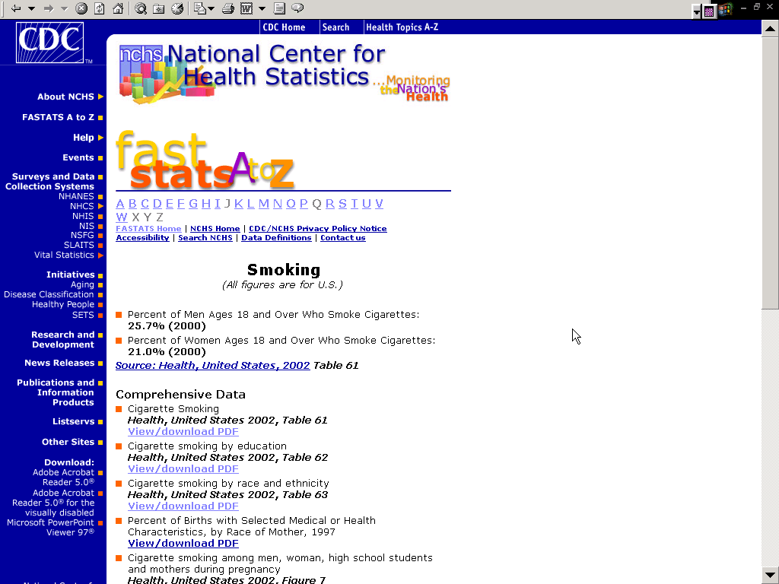

Ms. McBeal wanted other CDC data on Smoking.
Click on the Centers for Disease Control and Prevention Web site, <http://www.cdc.gov>
Click on Diseases and Conditions on the left navigation bar.
Click on Tobacco Use (Under Risk Factors)

http://www.cdc.gov/nccdphp/bb_tobacco/
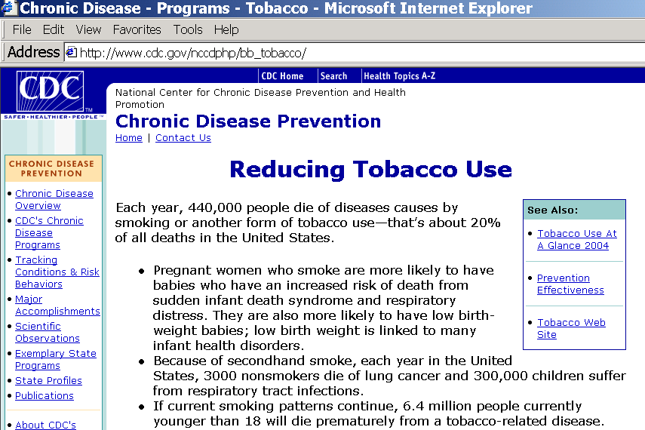
Ms McBeal Clicked on Tobacco Web Site on the right side of the screen.

<http://www.cdc.gov/tobacco/index.htm>

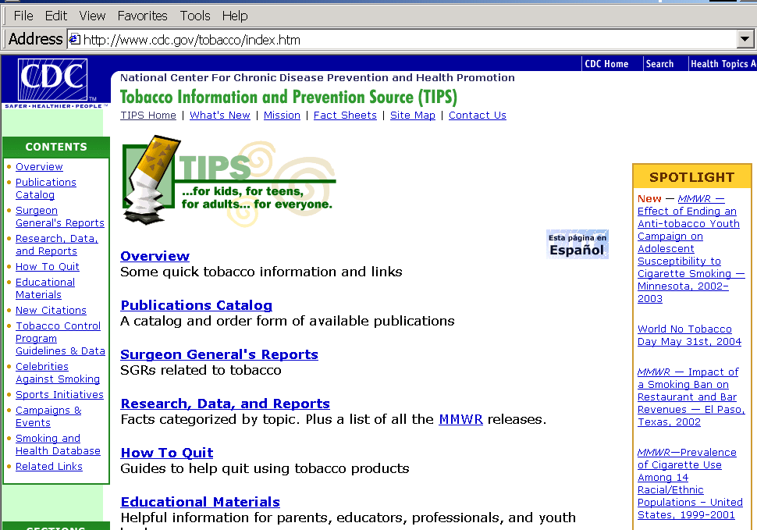

She Clicked Overview and found useful facts.

<http://www.cdc.gov/tobacco/issue.htm>
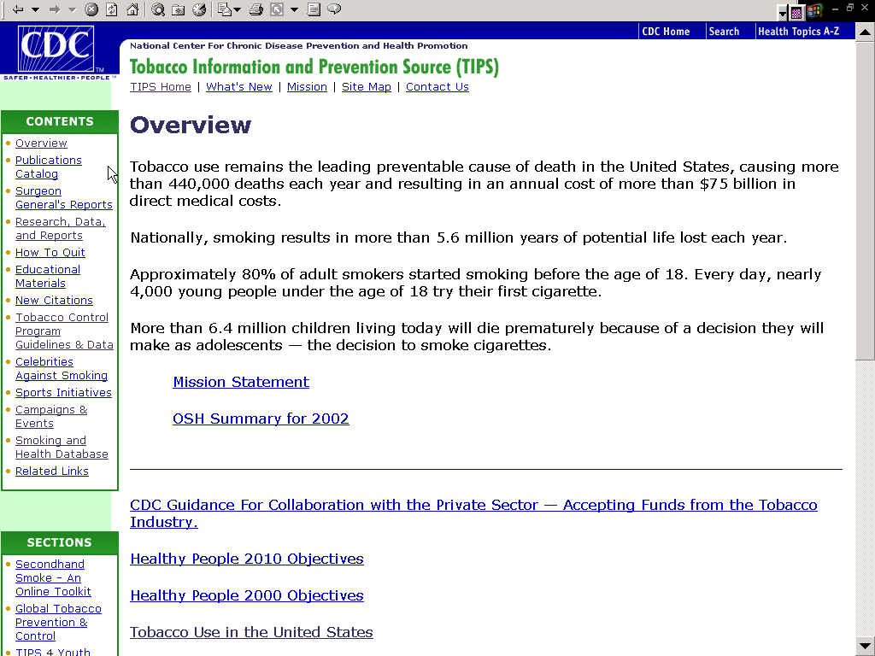

Clicking on Tobacco Use in the United States she discovered many more useful facts.
Armed with these statistics Ms. McBeal is confident she can persuade the city council to fund a campaign.

Ms. McBeal also could find a data resource using the NLM Health Services/Science Research Resources (HSRR) database
Click on <http://www.nlm.nih.gov/nichsr/hsrr_search/>
Type teens smoking in the Search box
Click Search.

<http://www.nlm.nih.gov/nichsr/hsrr_search/>

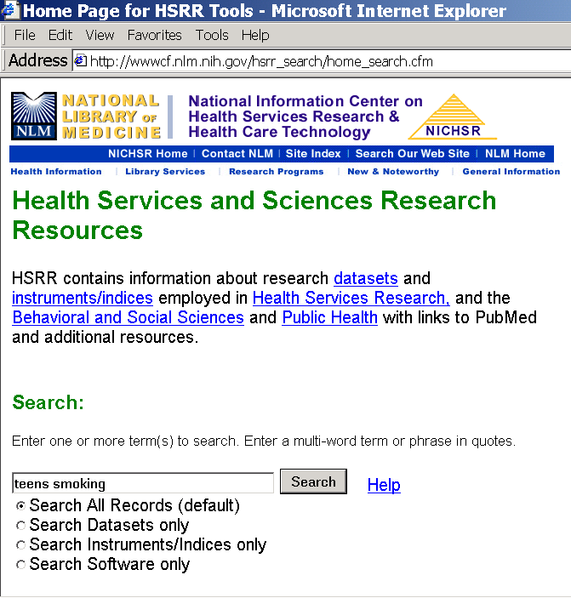
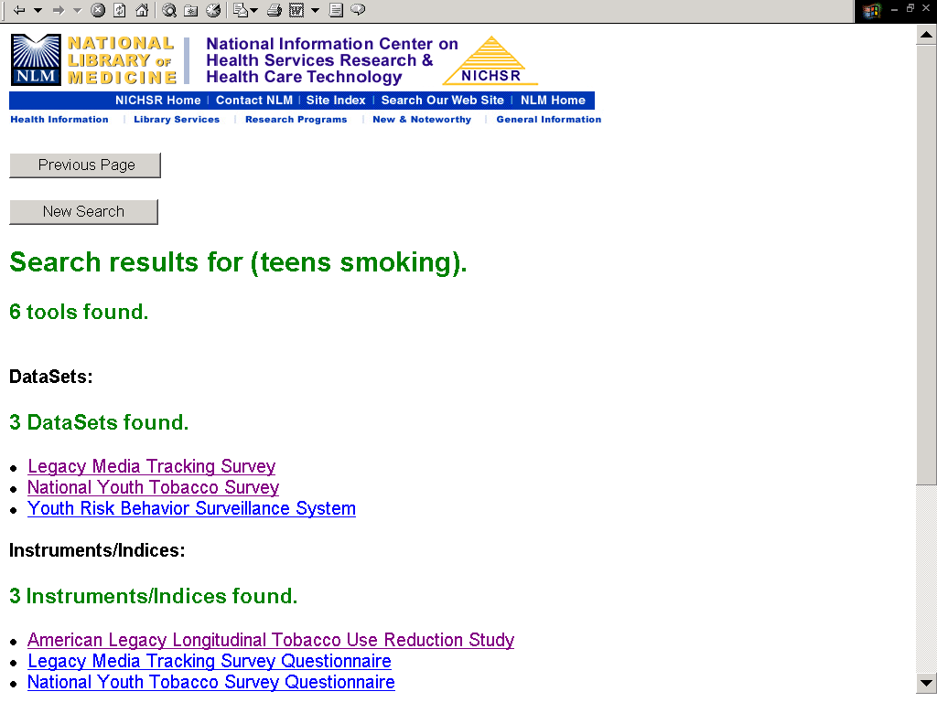

Ms McBeal found 3 datasets.
Click on Youth Risk Behavior Surveillance System to see the HSRR record.

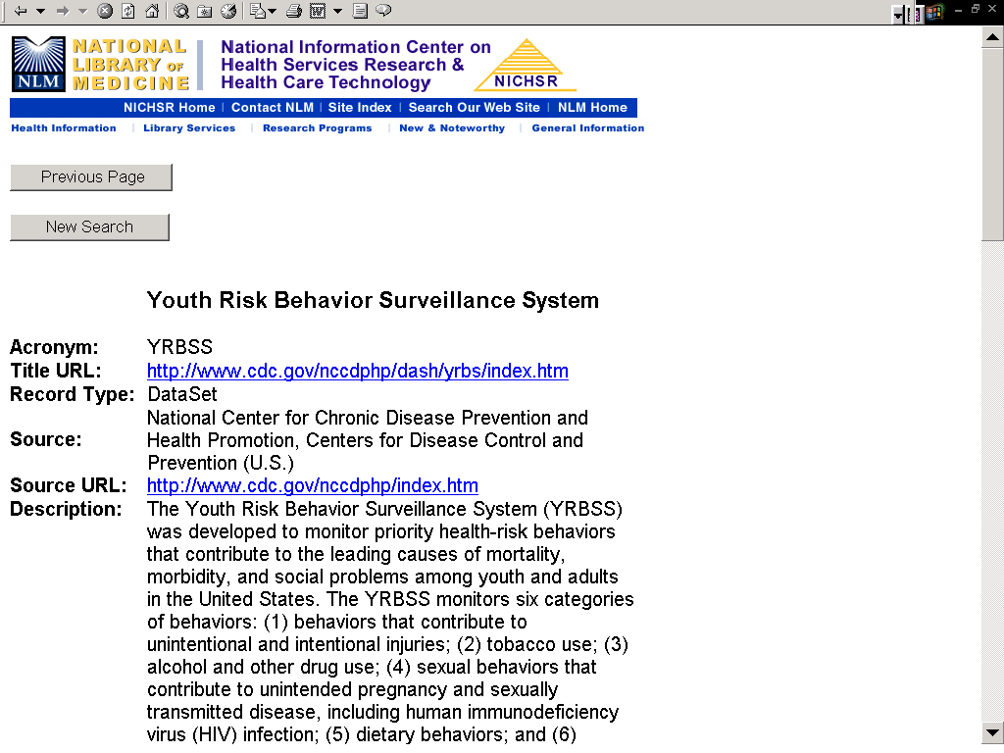

Click on Title URL in the HSRR record.
<http://www.cdc.gov/nccdphp/dash/yrbs/index.htm>
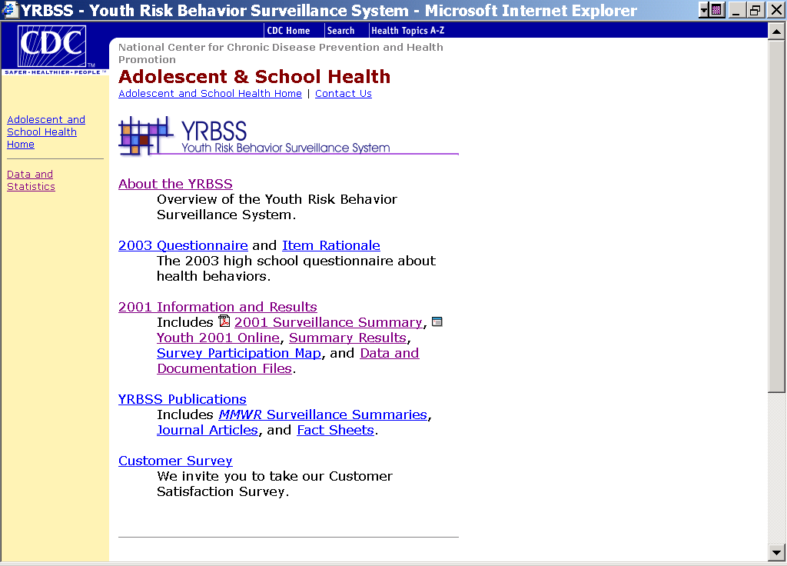

Click on 2001 SurveillanceSummary to see the MMWR summary article at <http://www.cdc.gov/mmwr/PDF/SS/SS5104.pdf >

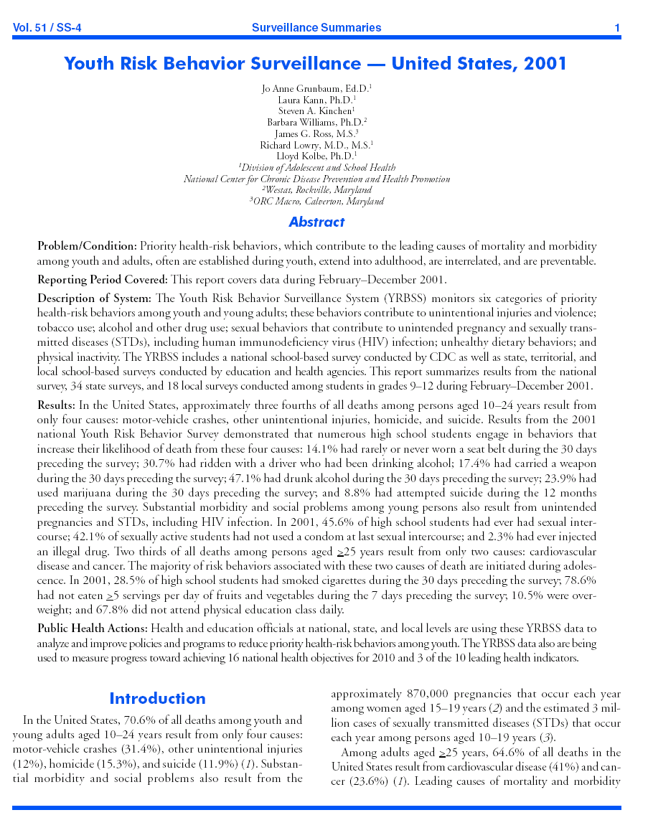

From: Centers for Disease Control and Prevention. Surveillance Summaries, June 28, 2002. MMWR 2002:51(No. SS04).

Click on Browser Back button.
Click on Summary Results to go to:
<http://www.cdc.gov/nccdphp/dash/yrbs/2001/summary_results/>
Click on United States to get national statistics and trend information.

<http://www.cdc.gov/nccdphp/dash/yrbs/2001/summary_results/>
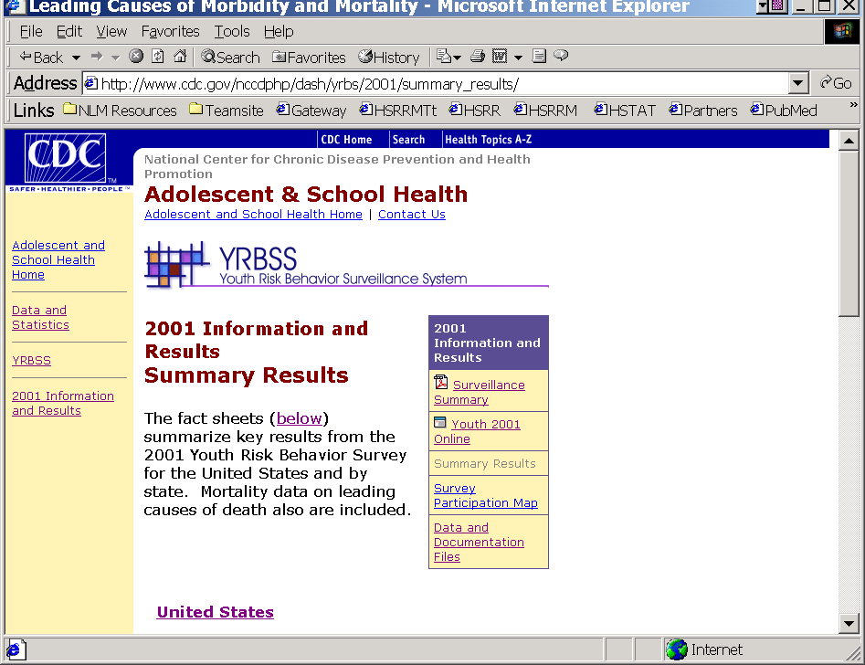
Exercises

- Find the 2001 report showing rates of immunization based on the National Immunization Survey. Are the rates going up or down?

Suggested solution: http://www.cdc.gov/mmwr/preview/mmwrhtml/mm5130a2.htm

- Locate the description of this survey and find out what its limits are.

Suggested solution: Due to sampling methods and sample size constraints of the NIS, coverage for smaller geographical areas can not be estimated, http://www.cdc.gov/nip/coverage/faq.htm#6

- According to the Youth Risk Behavior Surveillance System (YRBSS) has the number of students attending physical education (PE) classes daily in the US gone up or down from 1999 to 2001?

Suggested solution:
Go to <http://www.cdc.gov/nccdphp/dash/yrbs/2001/youth01online.htm>, Click Display Detailed Results, Click United States, Click Physical Activity, Scroll to 3rd question and Click Trend.

- Using the Health Services/Sciences Research Resources (HSRR), can you find state data sets that include physical activity?

Suggested solution:
Go to <http://www.nlm.nih.gov/nichsr/hsrr_search/> , Enter physical activity, Click Search, California and North Carolina surveyed their residents for physical activity.

- Go to West Virginia Bureau of Public Health, find information on Health Statistics. Is it possible to receive special assistance with statistical analysis for research projects?

Suggested solution:
<http://www.wvdhhr.org/bph/>, Click on Health Statistics, Click on Special Requests.

References

1. Core Competencies Without Skill Levels [Internet page]. Competencies Project. Council on Linkages. Public Health Foundation. [cited 2003 15 Sept] Available from <http://www.trainingfinder.org/competencies/list_nolevels.htm>

2. Turnock BJ. Public health: What it is and how it works.3rd ed. Sudbury (MA): Jones and Bartlett; 2004. 420 p. Additional Internet-based resources [cited 2004 23 Apr] available from <http://publichealth.jbpub.com/turnock/>

Supporting Decisions with Best Evidence

Nancy Allee

Chapter Summary
It is important in decision-making, policy development, and the establishment of new programs to improve public health that these initiatives be supported by scientific evidence. Evidence-based practice is based on evaluation research that highlights interventions that have been found to be effective. This chapter covers the emerging area of evidence-based public health. It provides an opportunity to gain a comprehensive overview of concepts in best evidence, to understand distinctions between evidence-based medicine and evidence-based public health, to explore resources that provide evidence-based practice information, and to develop techniques for searching and finding research to support best evidence in the field of public health.
Note that the text of this chapter is in the public domain and may be copied, adapted and used freely for the training of members of the public health workforce.

Learning Objectives
Public health workers will benefit from this chapter by being able to
- Define evidence-based public health and distinguish it from evidence-based medicine;
- Become familiar with key concepts in evidence-based public health;
- Apply key concepts to searching and evaluating the public health literature;
- Learn strategies for effective retrieval of evidence-based public health resources;
- Identify Web-based resources that support best evidence research and practice.
Applications of Learning
The strategies and resources in this chapter will enhance public health workers’ competencies in:

Analytic assessment skills: Identifies relevant and appropriate data and information sources.

Introduction

The evidence-based movement in the health sciences is over a decade old, and its beginnings are tied to evidence-based practice in medicine. The first appearance of the term evidence-based medicine occurred in the fall of 1990 in a document describing the residency program at Canada’s McMaster University:

Residents are taught to develop an attitude of “enlightened skepticism” toward the application of diagnostic, therapeutic, and prognostic technologies in their day-to-day management of patients. This approach, which has been called “evidence-based medicine,” is based on principles outlined in the text Clinical Epidemiology. The goal is to be aware of the evidence on which one’s practice is based, the soundness of the evidence, and the strength of inference the evidence permits. The strategy employed requires a clear delineation of the relevant question(s); a thorough search of the literature relating to the questions; a critical appraisal of the evidence, and its applicability to the clinical situation; and a balanced application of the conclusions to the clinical problem. [Source: Guyatt, G. and Drummond Rennie. 2002. User’s Guides to the Medical Literature: A Manual for Evidence-Based Practice. Chicago: American Medical Association, p. xiv.]

Some of the key concepts in this description are evidence and critical appraisal. Evidence can be defined as that “which furnishes proof,” and critical appraisal can be defined as an evaluation process “which determines the significance or worth of something by careful appraisal and study.” These concepts became a fundamental principle for a new approach to patient care, using evidence-based principles and a philosophy that evidence from the medical literature should support clinical decisions. As a body of literature began to emerge, it was soon recognized that evidence-based medicine approaches could be applied to other fields, including public health. Within this field, some of the principal user groups are practitioners, policy makers, researchers, the general public, and health sciences information professionals.

There are notable differences between the two disciplines of medicine and public health. however, that require distinct approaches to the application of evidence-based practice. Evidence-based public health is defined as “the development, implementation, and evaluation of effective programs and policies in public health through application of principles of scientific reasoning, including systematic uses of data and information systems, and appropriate use of behavioral science theory and program planning models.” (Brownson, EBPH, 2003.) The chart below helps identify some of the key differences in practice.

Definitions and Comparison of Disciplines: Evidence-Based Medicine and Evidence-Based Public Health

Evidence-Based Medicine | Evidence-Based Public Health
Definition: The process of systematically finding, appraising, and using contemporaneous research findings as the basis for clinical decisions | Definition: The process of systematically finding, appraising, and using contemporaneous clinical and community research findings as the basis for decisions in public health
Steps in the Process: 1) Formulating a clear question from a patient’s problem;  2) Searching the literature;  3) Appraising the evidence;  4) Selecting the best evidence for clinical decision;  5) Linking evidence with clinical experience, knowledge, practice, and the patient’s values and preferences;  6) Implementing findings in clinical practice;  7) Evaluating results. | Steps in the Process: 1) Formulating a clear question from a public health problem;  2) Searching the literature;  3) Appraising the evidence;  4) Selecting the best evidence for a public health decision;  5) Linking evidence with public health experience, knowledge, practice, and the community’s values and preferences;  6) Implementing findings in public health practice and programs;  7) Evaluating results.
Goal: The best possible management of health and disease in individual patient(s) | Goal: The best possible management of health and disease and their determinants at the community level

Source: Jenicek, Milos and Sylvie Stachenko. 2003. Evidence-based public health, community medicine, preventive care. Medical Science Monitor: 9(2): p, SR2.

Why use a best-evidence approach?

Evidence-based practice is also referred to as “best evidence.” The terminology is important because it emphasizes that it is the quality of evidence that is of primary significance, not the quantity, that is, it is the “best” information that is sought on a particular topic of interest, not the “most” information. Using a best-evidence approach can be beneficial because it:

- helps in managing the amount of literature to review;
- helps ensure the retrieval of up-to-date and reliable information about what works and doesn’t work for a particular public health question;
- provides assurance that one’s time is being used most efficiently and productively in reviewing only the “best of the best” information available on the particular public health question; and
- provides assurance that decision making is based on the “best of the best” information available on the particular public health question.

Teaching Tip

Try to make the class more interactive by asking participants if there are other reasons they can offer about why to use a best evidence approach in public health practice.

When is it important to use a best-evidence approach?

A best-evidence approach can be used:

- when conducting literature reviews for grant proposals;
- when evaluating the effectiveness and cost benefits of health programs;
- when establishing new health programs;
- when policies are being implemented; and
- when it’s important to have scientific evidence to support decision making.

Teaching Tip

Try to make the class more interactive by asking participants if there are ever disadvantages to using a best-evidence approach. For example, what if a public health department wants to be innovative in establishing new programs and wants to implement a particular program quickly to address a particular public health issue or concern before evaluative information is available on successful interventions?

Libraries have been identified as having a critical role in evidence-based practice (Sackett et al., pp. 29-30) because they provide resources for accessing the medical literature and because librarians and information professionals are trained in the skills and procedures needed for applying evidence-based principles, including information retrieval and evaluation of search strategies and results.

Source: Sackett, David et al. Evidence-Based Medicine: How to Practice and Teach EBM. 2nd edition. Edinburgh, Churchill Livingstone, 2000.

Key Concepts in Evidence-Based Public Health

Systematic Review: critical assessment and evaluation of research that attempts to address a focused question using methods designed to reduce the likelihood of bias.

Meta-Analysis: overview that incorporates a quantitative strategy for combining the results of several studies into a single pooled or summary estimate.

Risk Assessment: systematic approach to characterizing the risks posed to individuals and populations by environmental pollutants and other potentially adverse exposures.

Decision Analysis: systematic approach to decision making under conditions of uncertainty; involves identifying all available alternatives and estimating the probabilities of potential outcomes associated with each alternative, valuing each outcome, and, on the basis of the probabilities and values, arriving at a quantitative estimate of the relative merit of the alternatives.

Economic Evaluation: comparative analysis of alternative courses of action in terms of both their costs and consequences.

Expert Panels: examination of research studies and their relevance to health conditions, diagnostic and therapeutic procedures, planning and health policy, and community interventions.

Practice Guidelines: systematically developed statements to assist practitioner and patient decisions about appropriate health care for specific clinical circumstances; may be developed by government agencies, institutions, or by the convening of expert panels.

Source: Brownson et al. 2003. Evidence-Based Public Health, p. 45+ and JAMA. (2002). Users’ Guides to the Medical Literature, Glossary.

Key Concepts in Searching and Evaluating the Public Health Literature

User’s Guide for Searching the Public Health Literature

- Determine the public health problem and define the question;

- Select information sources, including bibliographic databases;

- Identify key concepts and terms;

- Conduct the search and refine as needed;

- Select and organize documents for review;

- Abstract relevant/pertinent information from the documents;

- Summarize and apply the literature review.

Source: Adapted from Brownson, Ross C., Elizabeth A. Baker, Terry L. Leet, and Kathleen N. Gillespie. 2003. Evidence-based public health. Oxford University Press, p. 128.

Teaching Tip

Prior to the date and time of the class, contact participants about specific projects or search topics of interest. Prepare search strategies in advance. Demonstrate searches and ask for feedback in evaluating the results. You may also want to inquire about whether participants have had PubMed/MEDLINE training. If not, consider offering a PubMed class prior to the Best Evidence/Evidence-Based Public Health class.

User’s Guide for Evaluating Quality, Methodology, and Public Health Research Results

What are the results?
Were the results similar from study to study?
What are the overall results of the review?
How precise were the results?
Can a causal association be inferred from the available data?

Are the results valid?
Did the review explicitly address the public health question?
Was the search for relevant studies detailed and exhaustive? Is it likely that important, relevant studies were missed?
Were the primary studies of high methodological quality?
Were assessments of studies reproducible?

How can the results be applied to public health practice and interventions?
How can the results be interpreted and applied to public health?
Were all important public health outcomes considered?
Are the benefits worth the costs and potential risks?

Source: Brownson, Ross C., Elizabeth A. Baker, Terry L. Leet, and Kathleen N. Gillespie. 2003. Evidence-based public health. Oxford University Press, p. 47 and JAMA. (2002). Users’ Guides to the Medical Literature, p.159.

Hierarchy of Research Designs

Category I: Evidence from at least one properly randomized controlled trial.
Category II-1: Evidence from well-designed controlled trials without randomization.
Category II-2: Evidence from well-designed cohort or case-control analytic studies, preferably from more than one center or research group.
Category II-3: Evidence from multiple times series with or without intervention or dramatic results in uncontrolled experiments such as the results of the introduction of penicillin treatment in the 1940s.
Category III: Opinions of respected authorities, based on clinical experience, descriptive studies and case reports, or reports of expert committees.

Source: Harris, R.P. et al. (2001). Current methods of the U.S. Preventive Services Task Force: a review of the process. American Journal of Preventive Medicine. April 20 (3 Supplement): 21-35.

Selected Evidence-Based Public Health Internet Resources

Bandolier: Evidence Based Thinking about Health Care: Glossary Index
<http://www.jr2.ox.ac.uk/bandolier/glossary.html>

Cancer.gov (National Cancer Institute)
<http://www.cancer.gov/>

Centre for Evidence-Based Medicine (University Health Network)
<http://www.cebm.utoronto.ca/>

The Centre for Evidence Based Social Services
<http://www.ex.ac.uk/cebss/index.html>
“The Centre for Evidence-Based Social Services was established in 1997 and is a partnership between The Department of Health, a consortium of Social Services Departments in the South West of England and the University of Exeter (Peninsula Medical School). Our main aim is to ensure that decisions taken at all levels in Social Services are informed by trends from good-quality research.”

Centre for Health Evidence: Users’ Guides to Evidence-Based Practice
<http://www.cche.net/usersguides/main.asp>

CINAHL (Cumulative Index to Nursing & Allied Health)
<http://www.cinahl.com/>
NOTE: subscription is required for database access.
From CINAHL Information Systems, this database features over 1200 nursing, allied health, consumer health, biomedicine, and health sciences librarianship journals from 1982 to present. Additional citations for selected books, dissertations, and conference proceedings are included.

Cochrane Library
< http://www.cochrane.org/reviews/clibintro.htm>
NOTE: subscription is required for full-text access.
From the Cochrane Collaboration, this online library is a collection of evidence-based medicine databases including Cochrane Database of Systematic Reviews, Database of Abstracts of Reviews and Effectiveness (DARE), Cochrane Controlled Trials Register (CCTR), NHS (National Health Service-UK) Economic Evaluation Database, Health Technology Assessment Database, and Cochrane Database of Methodology Reviews (CDMR). While the review abstracts are searchable free of charge, full-text is only available by subscription.

Community Toolbox: Bringing Solutions to Light
<http://ctb.ku.edu/>

Dal Libraries: Kellogg Library: Best Evidence Resources for Effective Health Care <http://www.library.dal.ca/kellogg/bestevidence/evidence.htm>
Sponsored by Dalhousie University, Halifax, Nova Scotia, this Web site features best evidence databases, clinical guidelines, clinical trials, Web sites, and an evidence-based glossary, calculator, and sources for handheld computing devices.

Edward G. Miner Library: Nesbit Guide to Evidence Based Resources
<http://www.urmc.rochester.edu/hslt/miner/digital_library/evidence_based_resources.cfm>
A well-organized list of evidence-based resources maintained by the health sciences library of the University of Rochester Medical Center. Links are categorized by major sites, organizations, guides and tutorials, search filters, systematic reviews, and practice guidelines.

Effective Public Health Practice Project (Hamilton, Canada)
<http://www.city.hamilton.on.ca/PHCS/EPHPP/AboutEPHPP.asp>
“Evidence is essential to fostering evidence-based practice and decision-making in all health care sectors and professions. The products from the EPHPP are a resource for evidence-based decision-making in public health in Ontario and Canada. EPHPP conducts systematic reviews on the effectiveness of public health interventions, and summarizes recent, high quality reviews produced by others. Although EPHPP reviews focus on public health interventions, review methodology and results are frequently of interest to a broader audience of service and research professionals. The range of review topics is broad. Approximately 4 new reviews and at least 4 new summary statements are completed annually.”

ERIC (Educational Resources Information Center)
<http://www.eric.ed.gov/>
“ERIC is a national information system funded by the U.S. Department of Education’s Institute of Education Sciences to provide access to education literature and resources.”

The European Observatory on Health Systems and Policies
<http://www.euro.who.int/observatory/toppage>
“The European Observatory on Health Systems and Policies supports and promotes evidence-based health policy-making through comprehensive and rigorous analysis of the dynamics of health care systems in Europe. The Observatory is a partnership between WHO Regional Office for Europe, the Governments of Finland, Greece, Norway, Spain and Sweden, the European Investment Bank, Open Society Institute, World Bank, London School of Economics and London School of Hygiene & Tropical Medicine.”

Evidence-based Practice Centers (Agency for Healthcare Research and Quality): Synthesizing scientific evidence to improve quality and effectiveness in health care <http://healthlinks.washington.edu/ebp>

Evidence Network: The Focus Point for Evidence Based Policy and Practice Research in the UK (United Kingdom)
<http://www.evidencenetwork.org/home.asp>

GrayLIT Network
<http://www.osti.gov/graylit/>
This Web site is a portal to grey literature resources from the federal government, including the Department of Defense, the Department of Energy, the Environmental Protection Agency, and NASA.

Grey Literature Producing Organizations
<http://www.nyam.org/library/greylitorgs.shtml>
This Web site features the New York Academy of Medicine’s list of links to agencies and organizations publishing grey literature resources, including non-profit organizations and government agencies and clearinghouses.

Grey Literature Report
<http://www.nyam.org/library/grey.shtml>
This report is published quarterly by The New York Academy of Medicine to identify new grey literature resources as they are added to the academy’s collection.

Guide to Community Preventive Services: Systematic Reviews and Evidence Based Recommendations
<http://www.thecommunityguide.org/>

HealthLinks (University of Washington): Evidence-Based Practice
<http://healthlinks.washington.edu/ebp>

HP2010 Information Access Project (Partners in Information Access for the Public Health Workforce)
<http://phpartners.org/hp/>
“The purpose of this site is to make information and evidence-based strategies related to the Healthy People 2010 objectives easier to find. The National Library of Medicine and the Public Health Foundation staff have worked together to develop pre-formulated search strategies for selected Healthy People 2010 objectives.”

The Lamar Soutter Library: University of Massachusetts Medical School: Evidence-Based Practice for Public Health Project <http://library.umassmed.edu/ebpph/>
A unique Web site provided by the Lamar Soutter Library at the University of Massachusetts Medical School, this project focuses specifically on public health best evidence resources with an aim toward examining evidence-based medicine models and assessing their effectiveness to public health. Links are provided to the top 25 public health journals by impact factor, to public health databases, to the public health knowledge domains, and to evidence-based resources in public health practice.

The Lamar Soutter Library: University of Massachusetts Medical School: Evidence-Based Practice for Public Health Project: Public Health Bibliographic Databases
<http://library.umassmed.edu/ebpph/>
The project Web site features a comprehensive list of public health databases.

MAPP: Mobilizing for Action through Planning and Partnerships [NACCHO (National Association of County and City Health Officials)]
<http://mapp.naccho.org/mapp_introduction.asp>
“Mobilizing for Action through Planning and Partnerships (MAPP) is a community-wide strategic planning tool for improving community health. Facilitated by public health leadership, this tool helps communities prioritize public health issues and identify resources for addressing them.”

MLANET: Evidence-Based Health Care: Resources on the Internet
<http://mlanet.org/education/telecon/ebhc/resource.html>

Morbidity and Mortality Weekly Report (MMWR)
<http://www.cdc.gov/mmwr/>
From the Centers for Disease Control and Prevention (CDC), this Web site provides full-text access to the MMWR, and it links to state health departments and public health organizations from around the world. Also includes disease trends and continuing education opportunities.

NACCHO (National Association of County and City Health Officials): Public Health Advocacy: Resolution 00-12: Resolution on Evidence-Based Public Health
<http://www.naccho.org/resolution91.cfm>

National Center for Mental Health and Juvenile Justice: Evidence Based Practices <http://www.ncmhjj.com/EBP/default.asp>

National Guidelines Clearinghouse
<http://www.guideline.gov/>
Sponsored by the Agency for Healthcare Research and Quality (AHRQ), this Web site provides clinical practice guidelines of systematically developed statements with recommendations, strategies, and other information that assists health care providers in making appropriate health care decisions. The guidelines are produced by a formally recognized society, organization, or agency and have been developed, reviewed or revised within the last five years. (See “Criteria for Inclusion.”)

National Information Center on Health Services Research & Health Care Technology (NICHSR)
<http://www.nlm.nih.gov/nichsr/nichsr.html>
From: the National Library of Medicine (NLM), this site covers health services research, clinical practice guidelines, and health care technology and assessment. Specific resources that are accessible include the Health Services Research (HSR) databases—HSRProj (Health Services Research Project in Progress), HSTAT (Health Services/Technology Assessment Text), and DIRLINE (Directory of Information Resources Online).

National Library of Medicine (NLM) Gateway
<http://gateway.nlm.nih.gov/>
From the National Library of Medicine, this site provides multiple database coverage: MEDLINE/PubMed (journal articles), LOCATORplus (books, journals, and audiovisual material), MedlinePlus (consumer health), ClinicalTrial.gov, DIRLINE (directories of health organizations), Meeting Abstracts, HSRProj (Health Services Research Projects in Progress), OMIM (Online Mendelian Inheritance in Man), and HSDB (Hazardous Substances Data Bank). The NLM Gateway facilitates subject searching of multiple NLM databases at one time.

Nettingtheevidence: A ScHARR Introduction to Evidence Based Practice on the Internet: Library
<http://www.sheffield.ac.uk/~scharr/ir/netting/>
This site is one of the most extensive resources of evidence based practice. It is maintained by Andrew Booth of the School of Health and Related Research (ScHARR) of the University of Sheffield and includes user guides to the medical literature, resources for understanding systematic reviews, meta-analyses, controlled trials, and how to read a paper.

NHS (National Health Service):
National Library for Public Health
<http://www.library.nhs.uk/publichealth/> The National Library for Public Health, a specialist library of the NHS National Library for Health, is being developed to provide high quality evidence e-based information on all aspects of public health. It is designed for those working in the field of public health by providing a single source of access to web based evidence on public health.

Partners in Information Access for the Public Health Workforce: Literature and Guidelines
<http://phpartners.org/guide.html>
A frequently cited resource in Ross C. Brownson’s Evidence Based Public Health (2003), the Partners project is a collaboration of government agencies, public health organizations, and health sciences libraries. The Web site provides links to public health literature and guidelines, including journal articles, journals, newsletters, reports and other publications.

PubMed/MEDLINE
<http://pubmed.gov> or <http://www.ncbi.nih.gov/entrez/query.fcgi>

From the National Library of Medicine (NLM), PubMed provides coverage of over 14 million records from 4,600 biomedical journals. PubMed offers many features for searching the biomedical literature, including search limits and filters relevant to searching for best evidence resources.

SAMHSA’S (Substance Abuse and Mental Health Services Administration) National Mental Health Information Center: Center for Mental Health Services: Evidence-Based Practices: Shaping Mental Health Services Toward Recovery

<http://www.mentalhealth.samhsa.gov/cmhs/communitysupport/toolkits/>

TOXNET
<http://toxnet.nlm.nih.gov/>
This Web site provides access to a suite of databases on toxicology, hazardous chemicals, risk information systems, chemical synonyms and structures, and toxic release information.

TRIP Database
<http://www.tripdatabase.com>
NOTE: subscription is required for full-text access.
Developed by Jon Brassey in 1997, this database assembles a variety of Internet evidence-based health care resources. A basic version can be searched free of charge. The enhanced database, TRIP Plus, includes peer-reviewed journals, e-textbooks, medical images, and patient information leaflets, and it requires a subscription to access. TRIP Plus is updated monthly.

University of Illinois at Chicago: Library of the Health Sciences <http://www.uic.edu/depts/lib/lhsc/temp/ebm/ebmclass.shtml>
This library offers 1 and 2 day workshops on evidence-based medicine for librarians.

World Health Organization: Regional Office for Europe: Evidence (Access to WHO’s Evidence-Based Information and Policy
<http://www.euro.who.int/InformationSources/Evidence/20010827_1>

Teaching Tip

Allow time for participants to explore Web-based resources discussed in class. Working in small groups, ask participants to select one Web site of interest to examine in depth, then take turns reporting to the larger group and commenting on features and resources of the particular sites that are beneficial for evidence-based public health research and practice. Inquire if there are additional Web sites that participants would recommend adding to the list of evidence-based public health resources.

Case Study

Estelle Wilcox is Assistant Director of the Division of Personal Health at a mid-sized health department in a mid-sized town in the Midwest. She’s concerned about overweight children in the local school district and wants to start a weight management program. Before Estelle asks her boss for funding for her idea, she’d like to find out if there are proven approaches to addressing obesity in children and the elements for designing successful programs.

Using our seven-step guide to searching the public health literature, we can begin the process of addressing Estelle’s question.

1) Determine the public health problem and define the question.

The problem can be defined as obesity in children, and the question can be stated as “What are effective programs for reducing obesity in school-age children?”

2) Select information sources, including bibliographic databases.

Initial databases that might be consulted are PubMed, the Partners Healthy People 2010 Information Access Project, and ERIC (see links to Web addresses for these resources under Selected Evidence-Based Public Health Internet Resources).

3) Identify key concepts and terms.

There are three primary concepts for this question. See the table below for suggested terms that might be used in the search.

Obesity |  | Children |  | Effective Programs
Obesity/prevention & control |  | Child |  | Program Effectiveness
 |  | Children |  | Program Evaluation

Discuss other terms that could be included to expand the search such as overnutrition, adolescents, youth, best practice analysis, etc.

4) Conduct the search and refine as needed.

Sample PubMed search strategy: obesity AND children AND program evaluation

5) Select and organize documents for review.

Select the following retrieved article for review:

Health Promotion International 2003 Dec;18(4):287-96.
Evaluation of a pilot school programme aimed at the prevention of obesity in children.
Warren JM, Henry CJ, Lightowler HJ, Bradshaw SM, Perwaiz S.
Nutrition and Food Science Group, School of Biological and Molecular Sciences, Oxford Brookes University, Oxford, UK. jmwarren@brookes.ac.uk

6) Abstract relevant/pertinent information from the documents.

Examine the abstract:

This paper describes the development, implementation and evaluation of a school- and family-based intervention to prevent obesity in children aged 5-7 years. In addition, the efficacy of three different intervention programmes was compared. Children aged 5-7 years (n=213) were recruited from three primary schools in Oxford and randomly allocated to a control group or one of three intervention groups: nutrition group, physical activity group, and combined nutrition and physical activity group. The setting for the interventions was lunchtime clubs, where an interactive and age-appropriate nutrition and/or physical activity curriculum was delivered. The intervention lasted for 20 weeks over four school terms (approximately 14 months). Children's growth, nutrition knowledge, diet and physical activity were assessed at baseline and at the end of the intervention. Significant improvements in nutrition knowledge were seen in all children (p<0.01) between baseline and post-intervention, and results were highly significant in the nutrition and combined group (p<0.001). Overall, fruit and vegetable intake increased significantly (p<0.01 and <0.05, respectively), with changes seen in fruit consumption in the nutrition group (p<0.05) and the control group (p<0.05) in particular. No significant changes in the rates of overweight and obesity were seen as a result of the intervention. Gender differences were not detected in the majority of assessments and there was no clear effect of programme type per se. This pilot study has demonstrated that school may be a suitable setting for the promotion of healthy lifestyles in children, but requires replication in other social settings. Future initiatives should be long-lasting, multi-faceted and sustainable, involving all children in a school, and should target the whole environment and be behaviourally focused. The ultimate goal of any such programme is to lead to positive behaviour change which will have a beneficial effect on long-term health. Successful targeting of the family remains a challenge to such interventions.

7) Summarize and apply the literature review.

Summarize the findings of the study. Determine the type of study: randomized controlled trial. How does PubMed identify the type of study? (Answer: in the MEDLINE citation display PT = publication type.) What does the type of study, i.e. randomized controlled trial, mean in terms of the categories of evidence for evaluating research? (See Hierarchy of Research Designs above.)

Refer to the Evidence Pyramid at <Guide to Research Methods: The Evidence Pyramid: http://servers.medlib.hscbklyn.edu/ebm/2100.htm> and discuss the different levels and types of studies. How does research in public health differ from research in medicine?
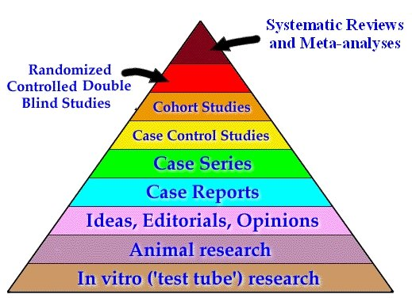

Teaching Tip

Inquire about library resources available to participants in their respective public health departments and agencies. Do they have a resource library? If not, promote awareness of NLM and NN/LM Web sites, resources, and services. Share handouts and other publications.

Additional References

Briss, Peter, Ross Brownson, Jonathan Fielding, Stephanie Zaza. Developing and Using the Guide to Community Preventive Services: Lessons Learned about Evidence-Based Public Health. Annual Reviews of Public Health, 2004, vol. 25, no. 16: 1-22. <http://www.thecommunityguide.org/pubs/briss.pdf>

Brownson, Ross C., Elizabeth A. Baker, Terry L. Leet, and Kathleen N. Gillespie, Editors. Evidence-Based Public Health. New York: Oxford University Press, October 2003.

DeBlois, Holly. You Know What the Problem Is . . . Now What? How Evidence-Based Public Health Practice Can Help. Empowering Communities Through Access to Information & Training. Accessed April 30, 2004. <http://www.nhhealthpolicyinstitute.unh.edu/mayupdate.pdf>

Hills, Marcia and Jennifer Mullett. Community-Based Research: Creating Evidence-Based Practice for Health and Social Change. Paper Presented at the Qualitative Evidence-Based Practice Conference, Coventry University, May 15-17, 2000. Accessed April 30, 2004. <http://www.leeds.ac.uk/educol/documents/00001388.htm>

Hunt, Derek L. and K. Ann McKibbon, Locating and Appraising Systematic Reviews. Annals of Internal Medicine, 1 April 1997, vol. 126, issue 7: 532-538. <http://www.annals.org/cgi/content/full/126/7/532>

Jackson, Catherine A., Kathryn Pitkin, and Raynard Kington. Evidence-Based Decisionmaking for Community Health Programs. RAND, 1998. <http://www.rand.org/publications/MR/MR933/MR-933.ch3.pdf>

Rychetnik, Lucie and Michael Frommer. A Schema for Evaluating Evidence on Public Health Interventions. University of Sydney, Australia: National Public Health Partnership, April 2002. <http://www.nphp.gov.au/publications/phpractice/schemaV4.pdf>

Appendix A:
Suggestions for Trainers

In planning a training event, it may be helpful to consider the experiences of other trainers. Following are recent accounts of training events that targeted public health personnel.

I did a couple of two-hour sessions for Washington State Department of Health people. These were scheduled long before I had seen the manual, but I do think the manual influenced what I covered. The DOH Office of Health Promotion organized the event (two sessions, 15 people each, to maximize my time in Olympia). They also conducted a short needs assessment and post-workshop evaluation.

I started with the Partners page and briefly summarized the information available through its links. For these folks the Healthy People 2010 PubMed searches were the most popular. I demoed MedlinePlus and PubMed. Two topics suggested by the group that worked well were mammography and tuberculosis. I spent a few minutes on "healthy websurfing" and, at their request, on Google. I concluded with the NLM homepage and showed how to branch from it to the toxicology resources as well as AIDSinfo (http://aidsinfo.nih.gov/) and NICHSR (http://www.nlm.nih.gov/nichsr/).

My approach was decidedly low-tech. I wanted to give them something to write on but did not want Powerpoint. I made a "rainbow" packet, one colored sheet for each of the resources I covered. At the top I put the name of the resource, its direct URL, and four or five bullet points. Most used their computers to follow my demo and jotted notes on the colored papers distributed. I tried to minimize additional handouts--only the PHpartners.org brochure, an NLM pen, and my business card.

I echoed Kris Alpi, stressing the importance of “keeping informed,” and I organized my thoughts around the “finding information for others” and “finding evidence to support your work” ideas. I like the scenarios, but didn't fit them in this time.

Linda Milgrom
NN/LM Pacific Northwest Region
University of Washington

The San Bernardino county health department is interested in training related to health education resources, particularly MedlinePlus. I plan to focus on the “Health Education Resources” chapter of the manual by highlighting MedlinePlus, healthfinder, consumer and patient information from AHRQ, PHpartners.org, and perhaps CHID. If there is time and interest, I plan to introduce several statistical sources, such as the PHpartners.og statistics portal, NCHS, Fedstats, and CDC Faststats.

Alan Carr
NN/LM Pacific Southwest Region
University of California, Los Angeles

Before meeting or talking with a public health official or educator, try to figure out a hot topic in his or her jurisdiction and come up with a quick tip on finding information resources that address that issue. The emphasis is on quick. For example, I was talking with a nutrition and public health instructor recently and we got on the topic of dieticians needing to know more about obesity and genetics. I made sure to mention that MedlinePlus had fact sheets from many organizations and the latest news on genetics and obesity, as well as linking to peer-reviewed literature on this topic.

Kris Alpi
New York City Department of
Health and Mental Hygiene

† These learning objectives are derived from the intended outcomes described in a logic model adopted by the National Network of Libraries of Medicine (NN/LM) in 2003 for outreach to the public health workforce. These outcomes are inherent in the broader learning objectives that emerged during the development of this manual. The original outcomes included the following skills: - Describe reasons to access PubMed, MedlinePlus, and other NLM resources; - Acquire documents through LinkOut and Loansome Doc; and - Contact regional medical libraries, resource libraries, or another library, for assistance with information access issues.
† This chapter is based on: “Finding and Using Health Statistics,” a course prepared by Dan Melnick, Ph.D., under the sponsorship of the National Library of Medicine. The original course is available on the NICHSR Web site at: http://www.nlm.nih.gov/nichsr/usestats/index.htm

