
POSPack – Low Cost “In-Vehicle” Printing Solution for PDA (http://www.pospack.com)

BITLEVEL TECHNOLOGY LIMITED
The Republic of Ireland, Dublin
Telephone: +353 87 988 15 68
alex.maekivi@bitleveltechnology.com
http://www.bitleveltechnology.com

Overview: POSPack is a complete low-cost mobile printing solution for “in-vehicle” use, which allows printing up to 5-copy full-page customer invoices, receipts, load reports and other documents en route.
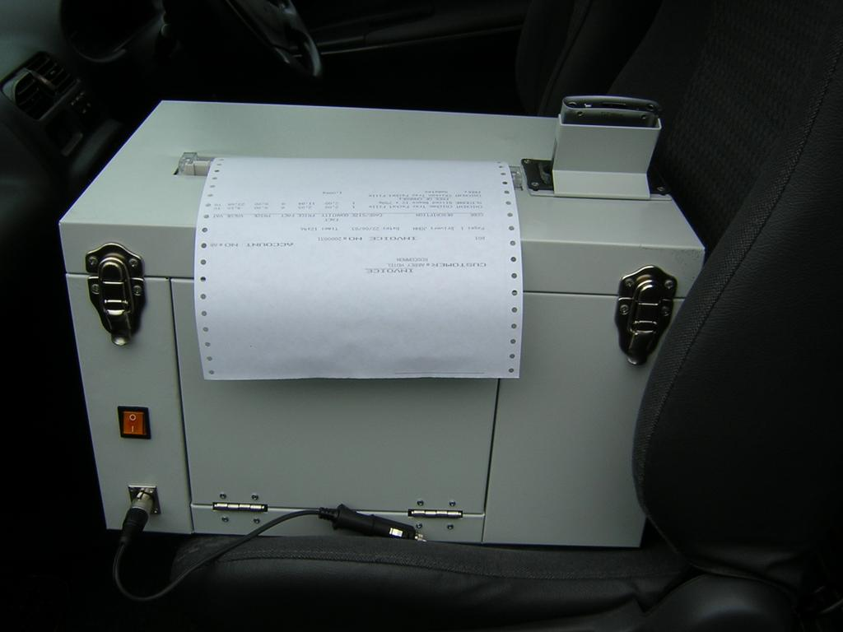
As a turnkey solution, POSPack includes:
- Purpose-built rugged metal box casing with:
  - 12V or 24V socket for car / van power supply
  - illuminated power ON/OFF switch
  - internal paper and cable compartments
  - Integrated communication and charging cradle for many popular HP IPAQ Pocket PC PDAs
- EPSON LX-300+ rugged and reliable dot matrix impact printer, capable of up to 5 copies output at a time
- One of HP IPAQ Pocket PC PDA models
- Optional Pocket PC printing / POS software
- Optional built-in GSM modem to link with central office
- Power cable for connection to car lighter or battery
- Special vehicle mount strap belts
- Operations manual

Possible Applications: route accounting and delivery, direct store delivery, sales force automation, logistics, warehousing and distribution, mobile POS (point of sale).
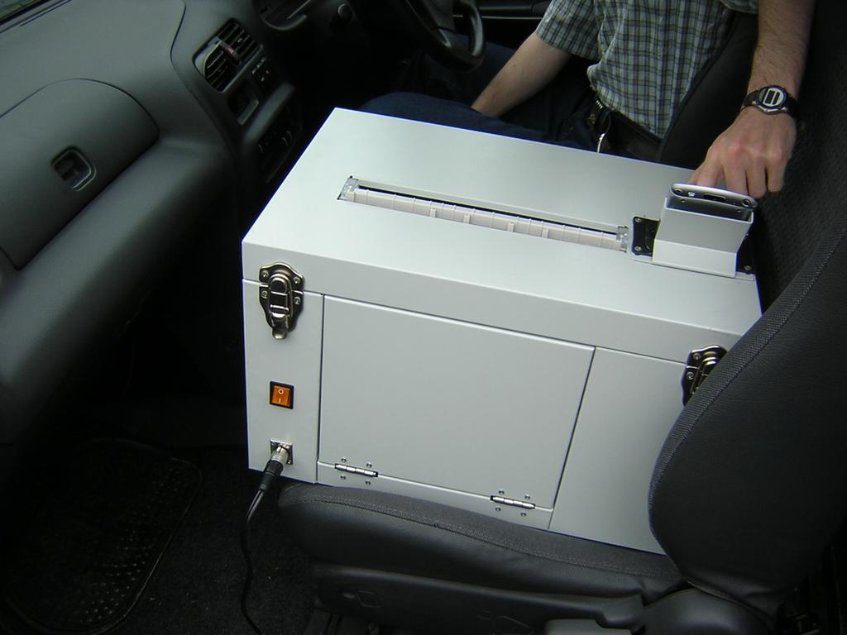

Features:
- Factory built rugged metal box casing:
  - Light-weight metal with special paint coating
  - Power socket (option 12V or 24V) for connection to car / van lighter or battery provides power distribution to printer and PDA cradle
  - Power ON/OFF switch with internal light diode indicates active operation
  - Front and top maintenance hatches for access to paper and printer with two top lid locks
  - Easy access to paper feed control
  - Large paper compartment
  - Fully covered internal cable and power supply compartments
- Integrated cradle for HP IPAQ Pocket PC PDA
  - Provides for PDA charging and printing.
  - All PDA functions and screen are accessible even when it is inserted into the cradle².
  - PDA position in the cradle at 45 deg. aligns with
user eye level during operation
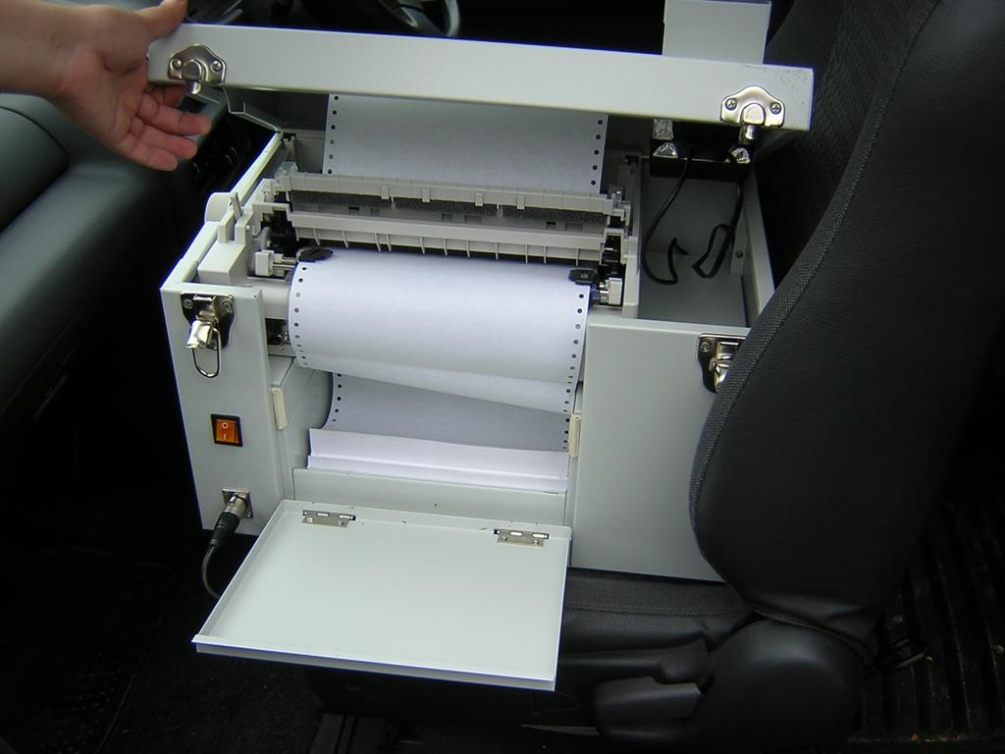
  - Special casing features behind and around the
cradle protect PDA from frontal and side impact
- Epson LX300+ rugged dot matrix impact printer:
  - Low cost and energy efficient
  - Fast and reliable operation
  - Advanced paper handling: 3 paper paths, push
and pull tractor
  - Copy capability: original plus four copies
  - 8 built-in bar code fonts
  - A4 continuous automatic paper feed
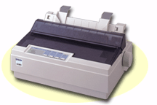
- Choice of the following HP iPAQ Pocket PC Handhelds¹:
(2200, 36/3700, 38/3900 and 54/5500 series)
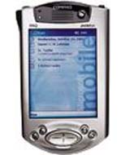

Note 1: Other PDA models (both consumer and industrial are also supported. Contact us for details.

Note 2: PDA cradle designed to accept PDAs with special protective jack or with fitted expansion slots.

POSPack Technical Specifications:

Metal box casing specifications
Metal | Steel plates option of 1 mm or 1.5 mm with special impact resistant rugged paint coating
Dimensions | Width 49cm, Height 30.5cm, Depth 32.5cm
Weight | 19 kg
Power | 12V or 24V input 60 Watt pwr. consumption
PDA cradle | Supports charging and printing for PDA models HP iPAQ Pocket PC: h3950, h3970, h5470 and h3100, h3600, h3700 series

Printer EPSON LX300+ specifications
Type | Serial dot matrix impact printer, 8 pin, 90 columns, colour upgradable
Print dir. | Bi-directional with logic seeking
Noise level | 49 dBA during printing (ISO 7779)
Power drain | 23 watts during printing (ISO 10561)
Speed | From 56 to 337 cps
Paper feed | Friction, Push Tractor, Pull Tractor,  Combined Push & Pull Tractor
Copy capability | Original + 4 copies
Printer Fonts | 1 draft fonts: EPSON DRAFT; 2 NLQ fonts: EPSON NLQ Roman, EPSON NLQ Sans Serif; 8 Barcode fonts: EAN-13, EAN-8, Interleaved 2 of 5, UPC-A, UPC-E, Code 39, Code 128, POSTNET
Reliability | Print head life:Approx. 400 million strokes per wire (Black)Approx. 100 million strokes per wire (Colour MTBF: 6000 POH (25% Duty)
Consumable | Black ribbon: 3 million characters
iPAQ Pocket PC PDA specifications (example h3950)
Processor | 400 MHz Intel PXA250 Application Processor
Memory, std. | 64 MB RAM, 32 MB ROM
Expansion | SD Memory slot, optional expansion packs
Display | TFT LCD, 64K colors (64,536 colors)
Input type | Pen-and-touch interface, handwriting recognition, soft keyboard, character recognition, voice record, inking
Audio | Speaker, Microphone, Audio out jack (3.5mm Stereo)
Dimensions | (L x W x H) 5.3 x 3.3 x .6 in
Weight | 6.5 oz including battery
Warranty | Std. 1-year limited

HOW TO CONTACT US:
For additional information, sales inquiries and
to organize a free demonstration, please contact:

Alex Maekivi, Director.
BitLevel Technology Ltd.

Tel. +353 87 988 1568
(The Republic of Ireland, Dublin)
Email: admin@bitleveltechnology.com
Web: http://www.pospack.com

BitLevel Technology Ltd. is the main partner of
Digsee Inc. in Europe. http://www.digsee.com


