PIConNET Based Distributed System dedicated to Magnet
Test of the CMS Muon Barrel Alignment

Gy.L. Bencze^{3,4}, J. Imrek², J. Molnár², D. Novák²,
P. Raics¹, Zs. Szabó¹, G. Székely², Z. Szillási¹

¹ Institute of Experimental Physics, University of Debrecen, Debrecen, Hungary

² MTA Atomki, H-4001 Debrecen, Pf. 51, Hungary

³ Institute of Particle and Nuclear Physics, Budapest-114, Pf 49, Hungary
⁴ CERN, CH-1211 Geneva 23, Switzerland

Abstract
For the precise measurement of the positions of the barrel muon chambers in the CMS detector, a position monitoring system has been developed. Its first functional test in real conditions will be possible for the first time during the CMS magnet test when a significant part of the system will be installed and operated. As the electronics of the barrel muon chambers will not yet be operational, they are substituted by PIConNET units developed for this test. The aim of this paper is to present and discuss the logical organisation, applied tools and methods of setup dedicated to the forthcoming magnet test.

The Barrel muon alignment system
To obtain the required muon momentum resolution in the CMS detector [1] to be built at the Large Hadron Collider (LHC) at CERN (Geneva, Switzerland) the positions of the muon detectors with respect to the central tracker must be known within the 100 to 400 micrometers precision corresponding to the inner to outer chambers respectively. This information is provided by an optical monitoring (also called alignment) system. It consists of four parts: the tracker, barrel muon and end-cap muon internal alignment systems and the link system connecting the other tree parts [2]. The muon barrel alignment system that measures the positions of all the barrel muon chambers (250 altogether) is based on a network of LED light sources, video cameras and rigid mechanical structures (Fig.1).
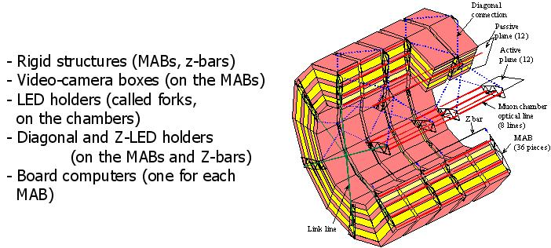

Fig. 1
CMS Barrel Muon Alignment scheme
36 rigid structures (called MABs - Module for Alignment of the Barrel) are fixed to the iron of the return yoke of the CMS magnet and are supporting the video cameras. The muon chambers are equipped with LED light sources that are monitored by the cameras. The system also contains diagonal connections between MABs where the cameras are observing LEDs installed on other MABs, and optical distance measurements where cameras are observing LEDs installed on long bars of known distance (called z-bars).
The total number of the elements: 36 MABs, 9 to 24 cameras per MAB, ~10000 LEDs (40 per muon chamber), 6 z-bars. The system contains also temperature and humidity (T&H) sensors (4 per MAB, 144 altogether).

Components
The main elements of the DAQ and control of the system are the board computers (1/MAB) and the PIConNET units (1/muon chamber). They are connected to the main workstation via Ethernet fan-out units.

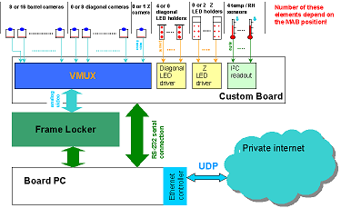
Fig. 2
Board PC functions

The board computers are used to digitize and process locally the video signals coming from the cameras as well as to control the diagonal and Z LEDs and read out the T&H sensors located on the MABs. There is one board computer on each MAB, 36 altogether. They come in a PC/104 form factor, and they consist of four cards stacked on in 2 columns. One column consists of the power supply, an IBM PC compatible single board computer and a video frame grabber card, the other has only a custom board.
The single board computer is a PCM-3346 CPU module of Advantech [3]. It is equipped with the standard PC peripherals (video adapter; keyboard, floppy, hard disk controller; parallel and serial ports) and a 100 Mbit/sec Ethernet interface. It runs Linux 2.6 operating system (OS) booted from network, which makes software configuration and upgrade easier.
The grabber card is used to digitize the video signal coming from the cameras. We have chosen the Ajeco FrameLocker 3.0 [http://www.ajeco.fi/fl.htm], it has four composite video inputs, can capture black and white analog images, and is accessible via ISA bus. We are using only one input, which is connected to the output of the video multiplexer on the custom board (see below). We have developed a Linux kernel driver for the card, and the functionality of the card is available through v4l2 (Video for Linux Two) [6], that is the standard Linux interface for such capture devices. The captured images are processed locally on the board computers, and only the calculated positions of the LEDs are transmitted to the main workstation through the Ethernet network.
The custom board developed in ATOMKI is used to access the hardware components served by the board computer. A PIC18F452 microcontroller [4] is located on the card that controls diagonal and Z LEDs via I2C bus, and accesses the temperature and humidity sensors located on a MAB via SPI bus. A video multiplexer selects the video signal of one of the cameras to be red out by the board computer. The microcontroller is not using the PC/104 interface, but is communicating via a serial line connected to one of the two serial ports of the board computer.
The PIConNET board is an Ethernet-enabled microcontroller used to control the LEDs located on the muon chambers. There is one PIConNET board for each muon chamber. It consists of a PIC18F452 microcontroller [4] and an RTL8019AS NIC (Network Interface Controller) [5]. (The custom firmware running on the PIConNET was developed at our institutes.)
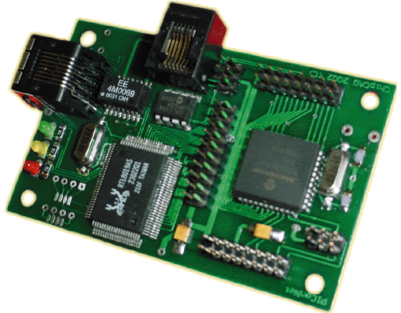

Fig. 1
PIConNET card (credit card size)

The unit is controlling the 40 LEDs located on each muon chamber via I2C bus. The LEDs are mounted on holders (called forks) attached to the muon chambers. Each fork holds 10 LEDs. The PIConNET unit receives commands via intranet, and switches the LEDs on at a given current or off individually.
The components used in the alignment system had to be selected carefully because of the presence of strong magnetic field (within the MAB regions 2 Tesla) during their operation. The parts that saturate and fail to work are typically the DC/DC converters present on many cards and the impulse transformers used for the Ethernet connection. The problem with DC/DC converters can be avoided by using cards that do not contain such component. To solve the problem with the Ethernet transformers we conducted a series of tests, which showed that the transformers can be safely removed from one end of the connections: the Ethernet links work reliably, and the transformers on the other end of the links (built into the network switches) provide the necessary electrical isolation.

Integration

An UDP based protocol will be used for communication between the main measurement workstation and the PIConNET devices, while the more reliable TCP protocol has been chosen for communication between the main workstation and the board PCs. The latter is chosen because it reduces the packet loss and order exchange that can have severe effect on transferring debug images, for example. However deploying UDP protocol to the PIConNET devices require less resource from the microcontroller.
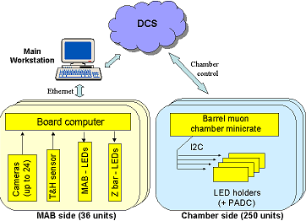
Fig. 4
CMS Barrel Muon Alignment control scheme

Because of the limited current supply capability of the chambers and the multiplexed video frame grabbing method (only one camera signal can be processed on each MAB at a time) correct optimisation and measurement sequencing is needed. This is solved by a measurement control software developed at the Institute of Experimental Physics of the University of Debrecen. In addition to this the measurement control software handles the connection to the PVSS II based CMS Detector Control System (DCS) (fig.4) via DIM (Distributed Information Management System) [7] and connects to the Oracle based CMS database. This software also implements the CMS quasi-standard Finite State Machine model that allows the propagation of commands and states to and from the CMS DCS.

The setup during the magnet test
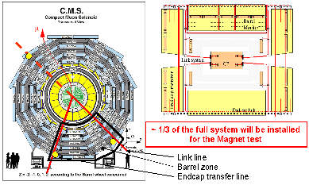
Fig. 5
Physical setup during the Magnet Test

During the Magnet test the 10-th and 11-th barrel muon sectors will be equipped on all the five barrel wheels. This setup consists of 10 MABs, 2 z-bars, 45 barrel muon chambers, consequently 10 board computers and 45 PIConNET units and the necessary networking elements (see figs. 5 and 6). The total number of video cameras is 152, the total number of LEDs is 1896, and the total number of temperature and humidity sensors is 40. The setup is approximately 25% of the full system.
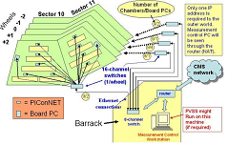

Fig. 6
Control scheme for the Magnet Test

summary
In order to test the barrel muon position monitoring system in real conditions a setup containing about 25% of the full system will be mounted and operated during the Magnet Test of the CMS detector. As the electronic units of the barrel muon chambers (called minicrates) will not be operation during the magnet test, a special unit called PIConNET has been developed to take over those functions of the minicrates that are used by the position monitoring system. These units have successfully been integrated in the scheme of the barrel position monitoring system and enable us to study the system performance during the CMS Magnet Test.

The work was supported by The Hungarian Scientific Research Funds OTKA T034910 and OTKA T043145.

References
[1] CMS Technical Report. CERN/LHCC 94-38.
[2] CMS – The muon project. Technical Design Report. CERN/LHCC 97-32.
[3] http://www.advantech.com/products/ /Model_Detail. asp?model_id=1-TQM3O&BU=ACG&PD=
[4] http://www.microchip.com/stellent/idcplg?IdcService= SS_GET_PAGE&nodeId=1335&dDocName=en010297
[5] http://www.realtek.com.tw/products/products1-2. aspx?modelid=1
[6] http://linuxtv.org/v4lwiki/index.php/Main_Page
[7] http://dim.web.cern.ch/dim

