CHAPTER 5
The Production
Process and Costs

Headline

GM and UAW Butt Heads over Jobs

In an effort to save its shrinking rank and file, the United Auto Workers (UAW) began a two-month-long strike against General Motors on June 5, 1998. At issue was GM's desire to eliminate its "pegged rate' pay system and cut its North American workforce by about 40,000 jobs over four years. GM's pegged rate pay system allows plant workers who meet a daily quota in five or six hours to either go home for the day or collect overtime pay for the remaining portion of the day-a system that GM says creates great ineffiiciency in production. GM believes that eliminating its pegged rate pay system and some workers will make its operations more efficient and raise workers' productivity. However, the UAW is fighting tooth and nail on both issues to keep its declining membership from further shrinking.

To support their position, GM officials cited lagging efficiency measures and high wages relative to other automakers. In 1997, workers at Ford produced an average of 33.2 vehicles per year and were paid wages that averaged $43 per hour. In contrast, GM workers produced an average of 27.9 vehicles per year and received $45 per hour.1

Do these figures justify GM's proposed actions? Why or why not?

------------------
Introduction

In this chapter we will develop tools to help managers answer complex questions such as those posed in the opening headlines. Our analysis will show how managers can determine which inputs and how much of each input to use to produce output efficiently. The material in this chapter will serve as the foundation for later chapters, which describe in more detail pricing and output techniques for managers interested in maximizing profits.

-----------------------------------

The Production Function

We will begin by describing the technology available for producing output. Technology summarizes the feasible means of converting raw inputs, such as steel, labour, and machinery, into an output such as an automobile. The technology effectively summarizes engineering know-how. Managerial decisions, such as those concerning expenditures on research and development, can affect the available technology. In this chapter, we will see how a manager can exploit an existing technology to its greatest potential. In subsequent chapters, we will analyze the decision to improve a technology.

To begin our analysis, let us consider a production process that utilizes two inputs, capital and labour, to produce output. We will let K denote the quantity of capital, L the quantity of labour, and Q the level of output produced in the production process. Although we call the inputs capital and labour the general ideas presented here are valid for any two inputs. However, most production processes involve machines of some sort (referred to by economists as capital) and people (labour), and this terminology will serve to solidify the basic ideas.

The technology available for converting capital and labour into output is summarized in the production function. The production function is an engineering relation that defines the maximum amount of output that can be produced with a given set of inputs. Mathematically, the production function is denoted as

Q = F(K, L),

that is, the maximum amount of output that can be produced with K units of
capital and L units of labour.

Short-Run Versus Long-Run Decisions

As a manager, your job is to use the available production function efficiently; this effectively means that you must determine how much of each input to use
to produce output. In the short run, some factors of production are fixed, and this limits your choices in making input decisions. For example, it takes several years for Ford to build an assembly line. The level of capital is generally fixed in the short run. However, in the short run Ford can adjust its use of inputs such as labour and steel; such inputs are called variable factors of production.

__________________________________________________________
Inside Business 5-1

Where Does Technology Come From?

In this chapter, we simply assume that the manager knows the underlying technology available for producing goods. How do managers acquire information about technology? The answer varies considerably across firms. The accompanying table reports the results of a survey of 650 executives in 130 industries. They were asked to rate how they obtain technical knowledge of new technologies developed by competitors. The responses varied considerably among executives, and there were also systematic differences in responses depending on whether the technical knowledge pertained to a process innovation or a product innovation. A process innovation is simply a new method for producing a given good, while a product innovation is the creation of a new product.

Independent R&D. As the accompanying table shows, the most important means of acquiring product and process innovations is independent research and development (R&D). This essentially involves engineers employed by the firm to devise new production processes or products. Most large firms have a research and development department that is charged with engineering aspects of product and process innovations.

Licensing Technology. The firm that was originally responsible for developing the technology and thus owns the rights to the technology often sells the production function to another firm for a licensing fee. The fee may he fixed, in which case the cost of acquiring the technology is a fixed cost of production. The fee may involve payments based on how much output is produced. In this instance, the cost of the technology is a variable cost of production.

Publications or Technical Meetings. Trade publications and meetings provide a forum for the dissemination of information about production processes.

Methods of Acquiring Technology (Ranked from Most Important to Least Important)

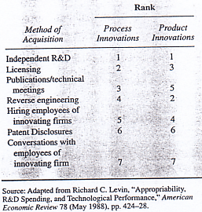

Reverse Engineering. As the term suggests this involves working backward: taking a product produced by a competitor and devising a method of producing a similar product. The typical result is a product that differs slightly from the existing product and involves a slightly different production function from that used by the original developer.

Hiring Employees of Innovating Firms. Former employees of other firms often have information about the production process.

Patent Disclosure A patent gives the holder the exclusive rights to an invention for a specified period of time-17 to 20 years in most countries. However, to obtain a patent an inventor must file detailed information about the invention, which becomes public information. Virtually anyone can look at the information filed, including competitors. In many instances, this information can enable a competitor to "clone" the product in a way that does not infringe on the patent. Interestingly, while a patent is pending, this information is not publicly available. For this reason, stretching out the time in which a patent is pending often provides more protection for an inventor than actually acquiring the patent.

Conversations with Employees of Innovating Firms. Despite the obvious benefits of keeping trade secrets "secret," employees inadvertently relay information about the production process to competitors. This is especially common in industries where firms are concentrated in the same geographic region and employees from different firms intermingle in non business settings
____________________________________________________________

The short run is defined as the time frame in which there are fixed factors of production. To illustrate, suppose capital and labor are the only two inputs in production and that the level of capital is fixed in the short run. In this case the only short-run input decision to be made by a manager is how much labour to utilize. The short-run production function is essentially only a function of labour, since capital is fixed rather than variable. If K* is the fixed level of capital, the short-run production function may be written as

Q = f (L) = F(K*, L)

Columns 1, 2, and 4 in Table 5-1 give values of the components of a short-run production function where capital is fixed at K* = 2. For this production function, 5 units of labour are needed to produce 1, 100 units of output. Given the available technology and the fixed level of capital, if the manager wishes to produce 1,952 units of output, 8 units of labour must be utilized. In the short run, more labour is needed to produce more output, because increasing capital is not possible.

The long run is defined as the horizon over which the manager can adjust all factors of production. If it takes Ford three years to acquire additional capital machines, the long run for Ford's management is three years, and the short run is less than three years.

Measures of Productivity

An important component of managerial decision making is the determination of the productivity of inputs used in the production process. As we will see, these measures are useful for evaluating the effectiveness of a production process and for making input decisions that maximize profits. The three most important measures of productivity are total product, average product, and marginal product.

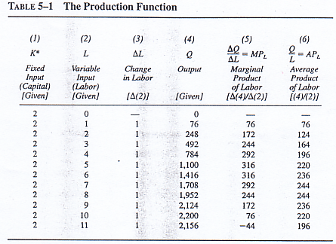

Total Product. Total product (TP) is simply the maximum level of output that can be produced with a given amount of inputs. For example, the total product of the production process described in Table 5-1 when 5 units of labour are employed is 1,100. Since the production function defines the maximum amount of output that can be produced with a given level of inputs, this is the amount that would be produced if the 5 units of labour put forth maximal effort. Of course, if workers did not put forth maximal effort, output would be lower. Five workers who drink coffee all day cannot produce any output, at least given this production function.

Average Product. In many instances, managerial decision makers are interested in the average productivity of an input. For example, a manager may wish to know, on average, how much each worker contributes to the total output of the firm. This information is summarized in the economic concept of average product. The average product (AP) of an input is defined as total product divided by the quantity used of the input. In particular, the average product of labor (AP_{L}) is

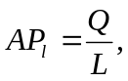

and the average product of capital (AP_{K}) is

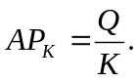

Thus, average product is a measure of the output produced per unit of input. In Table 51, for example, 5 workers can produce 1,100 units of output; this amounts to 220 units of output per worker.

Marginal Product. The marginal product (MP) of an input is the change in total output attributable to the last unit of an input. The marginal product of capital (MPK) therefore is the change in total output divided by the change in capital:
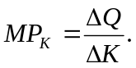

The marginal product of labor (MP_{L} is the change in total output divided by the change in labour:

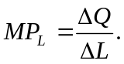

For example, in Table 5-1 the second unit of labour increases output by 172 units, so the marginal product of the second unit of labour is 172.

Table 5-1 illustrates an important characteristic of the marginal product of an input. Notice that as the units of labour are increased from 0 to 5 in column 2, the marginal product of labour increases in column 5. This helps explain why assembly lines are used in so many production processes: By using several workers, each performing potentially different tasks, a manager can avoid inefficiencies associated with stopping one task and starting another. But note in Table 5-1 that after 5 units of labour, the marginal product of each additional unit of labour declines and eventually becomes negative. A negative marginal product means that the last unit of the input actually reduced the total product. This is consistent with common sense. If a manager continued to expand the number of workers on an assembly line, he or she would eventually reach a point where workers were packed like sardines along the line, getting in one another's way and resulting in less output than before.

Figure 5-1 shows graphically the relationship among total product, marginal product, and average product- The first thing to notice about the curves is that total product increases and its slope gets steeper as we move from point A to point E along the total product curve. As the use of labour increases between points A and E, the slope of the total product curve increases (becomes steeper); thus, marginal product increases as we move from point a to point e. 'Me range over which marginal product increases is known as the range of increasing marginal returns.

In Figure 5-1, we see that marginal product reaches its maximum at point e, where 5 units of labour are employed. As the usage of labor increases from the 5th through the 10th unit, total output increases, but at a decreasing rate. This is why marginal product declines between 5 and 10 units of labour but is still positive. The range over which marginal product is positive but declining is known as the range of decreasing or diminishing marginal returns to the variable input.

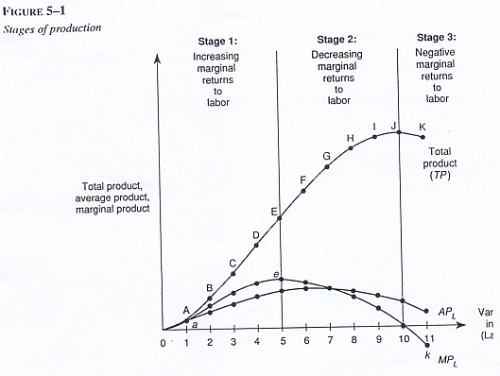

In Figure 5-1, marginal product becomes negative when more than 10 units of labour are employed. After a point, using additional units of input actually reduces total product, which is what it means for marginal product to be negative. The range over which marginal product is negative is known as the range of negative marginal returns.

The relationship between the marginal and average product curves in Figure 5-1 is important to note. As long as marginal product increases, marginal product is greater than average product. In fact, only after 7 units of labour the point where average and marginal products are equal-does average product exceed marginal product.

---------------
Principle
Phases of Marginal Returns

As the usage of an input increases, marginal product initially increases (increasing marginal returns), then begins to decline (decreasing marginal returns), and eventually becomes negative (negative marginal returns).
-----------------

In studying for an exam, you have very likely experienced various phases of marginal returns. The first few hours spent studying increase your grade much more than the last few hours. For example, suppose you will make a 0 if you do not study but will make a 75 if you study 10 hours. The marginal product of the first 10 hours thus is 75 points. If it takes 20 hours of studying to score 100 on the exam, the marginal product of the second 10 hours is only 25 points. Thus, the marginal improvement in your grade diminishes as you spend additional hours studying. If you have ever pulled an "all-nighter" and ended up sleeping through an exam or performing poorly due to a lack of sleep, you studied in the range of negative marginal returns. Clearly, neither students nor firms should ever employ resources in this range.

The Role of the Manager in the Production Process

The manager's role in guiding the production process described earlier is two fold: (1) to ensure that the firm operates on the production function and (2) to ensure that the firm uses the correct level of inputs. These two aspects ensure that the firm operates at the right point on the production function. These two aspects of production efficiency are discussed next.

Produce on the Production Function

The first managerial role is relatively simple to explain, but it is one of the most difficult for a manager to perform. The production function describes the maximum possible output that can be produced with given inputs. For the case of labour, this means that workers must be putting forth maximal effort. To ensure that workers are in fact working at full potential, the manager must institute an incentive structure that induces them to put forth the desired level of effort. For example, the manager of a restaurant must institute an incentive scheme that ensures that food servers do a good job waiting on tables. Most restaurants pay workers low wages but allow them to collect tips, which effectively provides the workers with an incentive to perform on the job. More generally, many firms institute profit-sharing plans to provide workers with an incentive to produce on the production function. A more detailed discussion of this role of the manager is presented in Chapter 6.

Use the Right Level of Inputs

The second role of the manager is to ensure that the firm operates at the right point on the production function. For a restaurant manager, this means hiring the "correct number of servers. To see how this may be accomplished, let us assume that the output produced by a firm can be sold in a market at a price of $3. Furthermore, assume each unit of labour costs $400. How many units of labour should the manager hire to maximize profits? To answer this question, we must first determine the benefit of hiring an additional worker. Each worker increases the firm's output by his or her marginal product, and this increase in output can be sold in the market at a price of $3. Thus, the benefit to the firm from each unit of labour is $3 X MPL. This number is called the value marginal product of labour. The value marginal product of an input thus is the value of

TABLE 5-2 The Value Marginal Product of Labour
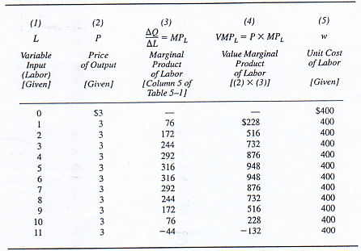

the output produced by the last unit of that input. For example, if each unit of output can be sold at a. price of P, the value marginal product of labour is

VMP_{L} = P X MP_{L},

and the value marginal product of capital is

VMP_{K} = P X MP_{K}.

In our example, the cost to the firm of an additional unit of labour is $400. As Table 5-2 shows, the first unit of labour generates VMP_{L} = $228 and the VMP_{L} of the second unit is $516. If the manager were to look only at the first unit of labour and its corresponding VMP_{L}, no labour would be hired. However, careful inspection of the table shows that the second worker will produce $116 in output above her or his cost. If the first worker is not hired, the second will not be hired.

In fact, each worker between 2 and 9 produces additional output whose value exceeds the cost of hiring the worker. It is profitable to hire units of labor so long as the VMP_{L} is greater than $400. Notice that the VMP_{L} of the 10th unit of labor is $228, which is less than the cost of the 10th unit of labor. It would not pay for the firm to hire this unit of labour, because the cost of hiring it would exceed the benefits. The same is true for additional units of labor. Thus, given the data in Table 5-2, the manager should hire 9 workers to maximize profits.

FIGURE 5-2
The demand for labor
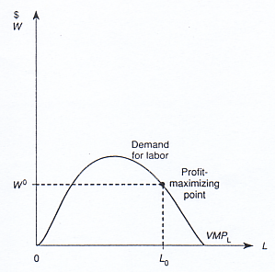

Principle
Profit-maximizing Input Usage

To maximize profits, a manager should use inputs at levels at which the marginal benefit equals the marginal cost. More specifically, when the cost of each additional unit of labour is w, the manager should continue to employ labour up to the point where VMPL = w in the range of diminishing marginal product.

The profit-maximizing input usage rule defines the demand for an input by a profit-maximizing firm. For example, in Figure 5-2 the value marginal product of labor is graphed as a function of the quantity of labor utilized. When the wage rate is w^{O}, the profit-maximizing quantity of labor is that quantity such that VMP_{L} = Y^{O} in the range of diminishing marginal returns. In the figure, we see that the profit-maximizing quantity of labor is L^{O} units.

The downward-sloping portion of the VMP_{L} curve defines demand for labor by a profit-maximizing firm. Thus, an important property of the demand for an input is that it slopes downward because of the law of diminishing marginal returns. Since the marginal product of an input declines as more of that input is used, the value of the marginal product also declines as more of the in put is used. Since the demand for an input is the value marginal product of the input in the range of diminishing marginal returns, the demand for an input slopes downward. In effect, each additional unit of an input adds less profits than the previous unit. Profit-maximizing firms thus are willing to pay less for each additional unit of an input.

Algebraic Forms of Production Functions

Up until now, we have relied on tables and graphs to illustrate the concepts underlying production. The underlying notion of a production function can be expressed mathematically, and in fact it is possible to use statistical techniques like those discussed in Chapter 3 to estimate a particular functional form for a production function. In this section, we highlight some more commonly en countered algebraic forms of production functions. We begin with the most simple production function: a linear function of the inputs.

The linear production function is

Q = RK, L) = aK + bL,

where a and b are constants. With a linear production function, there is a perfect linear relationship between all the inputs and total output. For instance, suppose it takes workers at a plant 4 hours to produce what a machine can make in 1 hour. In this case the production function is linear with a = 4 and b = 1:
Q = F(K, L) = 4K + L.

This is the mathematical way of stating that capital is always 4 times as productive as labor. Furthermore, since F(5, 2) = 4(5) + 1(2) = 22, we know that 5 units of capital and 2 units of labor will produce 22 units of Q.

Another important technology is the Leontief production function. The
Leontief production function is given by

Q = F(K, L) = min(bK, cL),

where b and c are constants. The Leontief production function is also called
the fixed-proportions production function, because it implies that inputs are
used in fixed proportions. To see this, suppose the production function for a
word processing firm is Leontief, with b = c = I; think of K as the number of
keyboards and L as the number of keyboarders. The production function then implies that one keyboarder and one keyboard can produce one paper per hour, two keyboarders and two keyboards can produce two papers per hour, and so forth. But how many papers can one keyboarder and five keyboards produce per hour? The answer is only one paper. Additional keyboards are useful only to the extent that additional keyboarders are available to use them. In other words, keyboards and keyboarders must be used in the fixed proportion of one keyboarder for every keyboard.

DEMONSTRATION PROBLEM 5-1

The engineers at Morris Industries obtained the following estimate of the firm's production function:

Q = F(K, L) = min{3K, 4L).

How much output is produced when 2 units of labor and 5 units of capital are employed?

Answer

We simply calculate F(5, 2). But F(5, 2) = min13(5), 4(2)l = mill( 15, 8). Since tile minimum of the numbers '15" and "8" is 8, we know that 5 units of capital and 2 units of labor produce 8 units of output.

A production function that lies between the extremes of the linear production function and the Leontief production function is the Cobb-Douglas production function. The Cobb-Douglas production function is given by

Q = F(K, L) = KªL^{b},

where a and b are constants.
Unlike in the case of the linear production function, the relationship between output and inputs is not linear. Unlike in the Leontief production function, inputs need not be used in fixed proportions. The Cobb-Douglas production function assumes some degree of substitutability between the inputs, albeit not perfect substitutability.

Algebraic Measures of Productivity

Given an algebraic form of a production function, we may calculate various measures of productivity. For example, we learned that the average product of an input is the output produced divided by the number of units used of the input. This concept can easily be extended to production processes that use more than one input.

To be concrete, suppose a consultant provides you with the following estimate of your firm's Cobb-Douglas production function:

Q = F(K, L) = K^{II2}L^{I12}.

What is the average product of labor when 4 units of labor and 9 units of capital are employed? Since F(9, 4) = 91124 112 = (3)(2) = 6, we know that 9 units of capital and 4 units of labor produce 6 units of output. Thus, the average product of 4 units of labor is APL = 6/4 = 1.5 units.

Notice that when output is produced with both capital and labor, the average product of labor will depend not only on how many units of labor are used but also on how much capital is used. Since total output (Q) is affected by the levels of both inputs, the corresponding measure of average product depends on both capital and labor. Likewise, the average product of capital depends not only on the level of capital but also on the level of labor used to produce Q.

Recall that the marginal product of an input is the change in output that results from a given change in the input. When the production function is linear, the marginal product of an input has a very simple representation, as the following formula reveals.

Formula: Marginal Product for a Linear Production Function. If the production function is linear and given by

Q = F(K, L) = aK + bL,
then

MP_{K} = a
and

MP_{L} = b.

A Calculus
Alternative

The marginal product of an input is the derivative of the production function with respect to the input. Thus, the marginal product of labor is

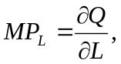

and the marginal product of capital is

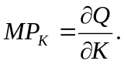

For the case of the linear production function, Q = aK + bL, so

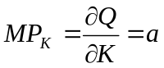 and 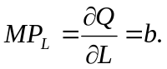

Thus, for a linear production function, the marginal product of an input is simply the coefficient of the input in the production function. This implies that the marginal product of an input is independent of the quantity of the input used whenever the production function is linear; linear production functions do not obey the law of diminishing marginal product.

In contrast to the linear case, the marginal product of an input for a Cobb-Douglas production function does depend on the amount of the input used, as the following formula reveals.

Formula: Marginal Product for a Cobb-Douglas Production Function. If the production function is Cobb-Douglas and given by

Q = F(K, L) = KªT^{b},

then

MP_{L} = bKªL^{b-1}

and

MP_{K} = aK^{a- l}L^{b}.

A Calculus
Alternative

The marginal product of an input is the derivative of the production function with respect to the input. Taking the derivative of the Cobb-Douglas production function yields

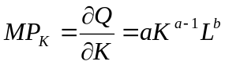
and

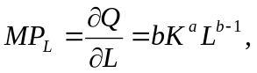

which correspond to the equations above.

Recall that the profit- maximizing use of an input occurs at the point where the value marginal product of an input equals the price of the input. As the next problem illustrates. we can apply the same principle to algebraic functional forms of production functions to attain the profit-maximizing use of an input.

DEMONSTRATION PROBLEM 5-2

A firm produces output that can be sold at a price of $ 10. The production function is given by

Q = F(K, L) = K^{1/2}L^{1/2}.

If capital is fixed at 1 unit in the short run, how much labor should the firm employ to maximize profits if the wage rate is $2?

Answer

We simply set the value marginal product of labour equal to the wage rate and solve for L Since the production function is Cobb-Douglas, we know that MP_{L} = bKªL^{b-1}. Here a = 1/2, b = 1/2, and K = 1. Hence, MP_{L} = .5L^{1/2}. Now, since P = $10, we know that VMP_{L} = P X MP^{L} = 5L^{-1/2}. Setting this equal to the wage, which is $2, we get 5L^{-1/2} = 2. If we square both sides of this equation, we get 25/L = 4. Thus the profit-maximizing quantity of labour is L = 25/4 = 6.25 units.

Isoquants

Our next task is to examine the optimal choice of capital and labour in the long run, when both inputs are free to vary. In the presence of multiple variables of production, there exist various combinations of inputs that enable the manager to produce the same level of output. For example, an automobile assembly line can produce 1,000 cars per hour by using 10 workers and 1 robot. It can also produce 1,000 cars by using only 2 workers and 3 robots. To minimize

FIGURE 5-3

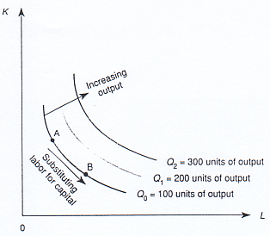
A family of isoquants

the costs of producing 1,000 cars, the manager must determine the efficient
combination of inputs to use to produce them. The basic tool for understanding how alternative inputs can be used to produce output is an isoquant. An isoquant defines the combinations of inputs (K and L) that yield the producer the same level of output; that is, any combination of capital and labor along an isoquant produces the same level of output.

Figure 5-3 depicts a typical set of isoquants. Because input bundles A and B both lie on the same isoquant, each will produce the same level of output,
namely Q₀ units. Input mix A implies a more capital-intensive plant than does input mix B. As more of both inputs are used, a higher isoquant is obtained. Thus as we move in the northeast direction in the figure, each new isoquant is associated with higher and higher levels of output.

Notice that the isoquants in Figure 5-3 are convex. The reason isoquants are typically drawn with a convex shape is that inputs such as capital and labor are not perfectly substitutable. In Figure 5-3, for example, if we start at
point A and begin substituting labor for capital, it takes increasing amounts of labor to replace each unit of capital that is taken away. The rate at which labor and capital can substitute for each other is called the marginal rate of technical substitution (MRTS). The MRTS of capital and labor is the absolute value
of the slope of the isoquant and is simply the ratio of the marginal products:

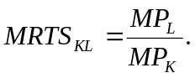

Different production functions will imply different marginal rates of technical substitution. For example, the linear production function implies isoquants that are linear as in Figure 5-4. This is because the inputs are perfect

FIGURE 5-4
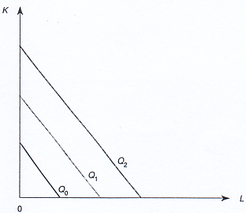
Linear isoquants
substitutes for each other and the rate at which the producer can substitute between the inputs is independent of the level of input usage. Specifically, for the linear production function Q = aK + bL, the marginal rate of technical substitution is bla, since MP_{L} = b and MP_{K} = a. This is independent of the level of inputs utilized.

The Leontief production function, on the other hand, implies isoquants that are L shaped, as in Figure 5-5. In this case, inputs must be used in fixed proportions; the manager cannot substitute between capital and labor and maintain the same level of output. For the Leontief production function there is no MRTS, because there is no substitution among inputs along an isoquant.

For most production relations, the isoquants lie somewhere between the perfect-substitute and fixed-proportions cases. In these instances, the inputs are substitutable for one another, but not perfectly, and the rate at which a manager can substitute among inputs will change along an isoquant. For instance, by moving from point A to point B in Figure 5-6, the manager substitutes 1 unit of capital for 1 unit of labor and still produces 100 units of output. But in moving from point C to point D, the manager would have to substitute 3 units of capital for 1 unit of labor to produce 100 units of output. Thus, the production function satisfies the law of diminishing marginal rate of technical substitution: as a producer uses less of an input, increasingly more of the other input must be employed to produce the same level of output. It can be shown that the Cobb-Douglas production function implies isoquants that have a diminishing marginal rate of technical substitution. Whenever an isoquant exhibits a diminishing marginal rate of technical substitution, the corresponding isoquants are convex from the origin; that is, they look like the isoquants in Figure 5-6.

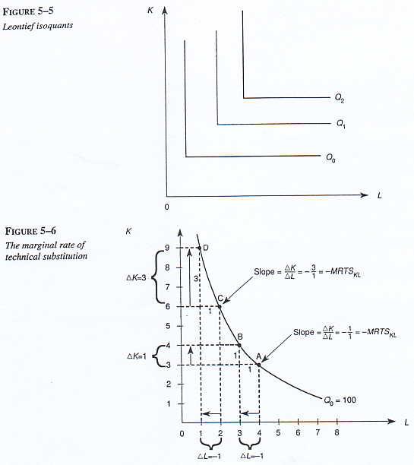

Isocost

Isoquants describe the combinations of inputs that produce a given level of output. Notice that there exist different combinations of capital and labor that end up costing the firm the same amount. The combinations of inputs that will cost the firm the same amount comprise an isocost line.

A Cobb-Douglas Production Function for Water Desalination

One worldwide area of concern today is the availability of fresh water. Because of this issue, the production of fresh water through the process of
desalination of salt water has become a viable area of research. The Middle East is a leader in this form of fresh-water extraction, but desalination is becoming a growing industry along the West t Coast of the United States.

Recently three economists used statistical and econometric techniques to estimate the production function for a water desalination plant. The results of the study suggest that the production function is Cobb-Douglas and is given by

Q = F^{.6}W^{.4},

where Q is cubic meters of desalted water produced per day, F represents factors of production (an aggregation of evaporating pumps, maintenance of those pumps, and labor), and H is the per diem level of heat, which is used in the evaporation process. According to the authors of the study,

The technical inputs of water desalination can be classified into two groups: those for which the cost per unit of desalted water is increasing when die technical index of the number of effects is increasing, and those for which this cost is decreasing under the same circumstances. This classification permits us to express production of desalted water as a function of two aggregates of inputs, corresponding to the above substitutional groups. Thus a production function is extracted for the general case of full-load annual operation of the desalination plant.

Since the estimated production function is Cobb-Douglas, we can apply our formulas for the marginal products of a Cobb-Douglas production function to obtain an algebraic expression for the marginal product of heat in the production of fresh water,

MP_{H} = .4F^{.6}H⁻⁶,

and for the marginal product of other factors of production,

MP_{F} = .6F^{-.4}H^{.4}.

These equations reveal that the production of fresh water obeys the law of diminishing marginal product.

Source; N. Zagouras, Y. Caouris, and E. Kantsos, "Production and Cost Functions of Water Low-Temperature Solar Desalination," Applied Econontics 21 (September 1989), pp.1177-90.

The relation for an isocost line is graphed in Figure 5-7(a). To understand this concept, suppose the firm spends exactly $C on inputs. Then the cost of labor plus the cost of capital exactly equals W.

wL + rK = C,

where w is the wage rate (the price of labor) and r is the rental rate (the price of capital). This equation represents the formula for an isocost line.

We may obtain a more convenient expression for the slope and intercept of an isocost line as follows. We multiply both sides of Equation 5-1 by 1/r and get

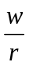L + K = C,
or
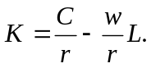

Thus, along an isocost line, K is a linear function of L with a vertical intercept of C1r and a slope of - wIr

Note that if the producer wishes to use more of both inputs, more money must be spent. Thus, isocosts associated with higher costs lie above those with lower costs. When input prices are constant, the isocost lines will be parallel to one another. Figure 5-7(b) illustrates the isocost lines for cost levels C^{O} and C¹, where C^{O} < C¹.

Similarly, changes in input prices affect the position of the isocost line. An increase in the price of labor makes the isocost curve steeper, while an increase in the price of capital makes it flatter. For instance, Figure 5-7(c) reveals that the isocost line rotates clockwise when the wage rate increases from w⁰ to w¹.

Principle
Changes in Isocosts

For given input prices, isocosts farther from the origin are associated with higher costs.
Changes in input prices change the slopes of isocost lines.

Cost Minimization
The isocosts and isoquants just defined may be used to determine the input us age that minimizes production costs. If there were no scarcity, the producer would not care about production costs. But because scarcity is an economic reality, producers are interested in producing output at the lowest possible cost. After all, to maximize profits, the firm must first produce its output in the least-cost manner. Even not-for-profit organizations can achieve their objectives by providing a given level of service at the lowest possible cost. Let us piece together the tools developed thus far to see how to choose the optimal mix of capital and labour.

Consider an input bundle such as that at point A in Figure 5-8. This combination of L and K lies on the isoquant labeled Q_{O} and thus produces Q_{O} units of output. It also lies on the isocost line through point A. Thus, if the producer uses input mix A, he or she will produce Q_{O} units of output at a total cost of C. Is this the cost-minimizing way to produce the given level of output? Clearly not, for by using input mix B instead of A, the producer could produce the same amount of output at a lower cost, namely C². In short, it is inefficient for the producer to use input mix A because input mix B produces the same out put and lies on a lower isocost line.

At the cost-minimizing input mix, the slope of the isoquant is equal to the slope of the isocost line. Recalling that the absolute value of the slope of the isoquant reflects the marginal rate of technical substitution and that the

FIGURE 5-8
input mix B minimizes the cost of producing 100 units of output.
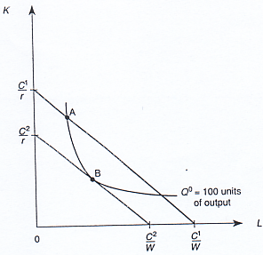

slope of the isocost line is given by -wlr, we see that at the cost-minimizing input mix,

MRTS_{KL} = wlr.

If this condition did not hold, the technical rate at which the producer could substitute between L and K would differ from the market rate at which she or he could substitute between the inputs. For example, at point A in Figure 5-8, the slope of the isoquant is steeper than the slope of the isocost line. Consequently, capital is "too expensive"; the producer finds it in his or her interest to use less capital and more labor to produce the given level of output. This substitution continues until ultimately the producer is at a point such as B, where the MRTS is equal to the ratio of input prices. The condition for the cost-minimizing use of inputs can also be stated in terms of marginal products.

------------------------------------
Principle
Cost-Minimizing Input Rule

To minimize the cost of producing a given level of output, the marginal product per dollar spent should he equal for all inputs:

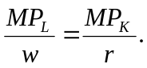
Equivalently, to minimize the cost of production. a firm should employ inputs such that the marginal rate of technical substitution is equal to the ratio of input prices:
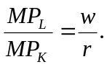

To see why this condition must hold to be able to minimize the cost of producing a given level of output, suppose MPL1w > MP_{K}Ir Then, on a last dollar-spent basis, labour is a better deal than capital, and the firm should use less capital and more labour to minimize costs. In particular, if the firm reduced its expenditures on capital by $ 1, it could produce the same level of output if it increased its expenditures on labour by less than $ 1. Thus, by substituting away from capital and toward labour, the firm could reduce its costs while producing the same level of output. This substitution clearly would continue until the marginal product per dollar spent on capital exactly equaled the marginal product per dollar spent on labour.

DEMONSTRATION PROBLEM 5-3

Temporary Services uses 4 word processors and 2 typewriters to produce reports. The marginal product of a typewriter is 50 pages per day and the marginal product of a word processor is 500 pages per day. The rental price of a typewriter is $1 per day, whereas the rental price of a word processor is $50 per day. Is Temporary Services utilizing typewriters and word processors in a cost-minimizing manner?

Answer

Let MPT be the marginal product of a typewriter and MP, be the marginal product of a word processor. If we let P, and P, be the rental prices of a word processor and a typewriter, respectively, cost-minimization requires that

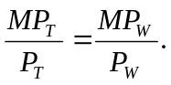

Substituting in the appropriate values, we see that

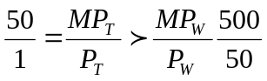
Thus, the marginal product per dollar spent on typewriters exceeds the marginal product per dollar spent on word processors. Word processors are 10 times more productive than typewriters, but 50 times more expensive. The firm clearly is not minimizing costs, and thus should use fewer word processors and more typewriters.

Optimal Input Substitution

A change in the price of an input will lead to a change in the cost-minimizing input bundle. To see this, suppose the initial isocost line in Figure 5-9 is FG and the producer is cost-minimizing at input mix A, producing Q₀ units of

Figure 5-9
Substituting capital for labor, due to increase in the wage rate
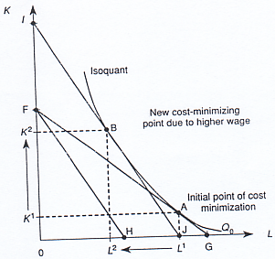

output. Now suppose that the wage rate increases so that if the firm spent the same amount on inputs, its isocost line would rotate clockwise to FH in Figure 5-9. Clearly, if the firm spends the amount it spent prior to the increase in the wage rate, it cannot produce the same level of output.

Given the new slope of the isocost line, which reflects a higher relative price of labor, the cost-minimizing way to maintain the output implied by the initial isoquant is at point B, where isocost line U is tangent to the isoquant. Due to the increase in the price of labor relative to capital, the producer substitutes away from labor and toward capital and adopts a more capital intensive mode of production. This suggests the following important result:

Principle
Optimal Input Substitution
To minimize the cost of producing a given level of output, the firm should use less of an input and more of other inputs when that input's price rises.

Figure 5-10 shows the isocost line (AB) and isoquant for a firm that produces rugs using computers and labor. The initial point of cost minimization is at point M, where the manager has chosen to use 40 units of capital (computers) and 80 units of labor when the wage rate is w = $20 and the rental rate of computers (capital) is r' = $20. This implies that at point M, total costs are CO = ($20 X 40) + ($20 X 80) = $2,400. Notice also at point M that the MRTS equals the ratio of the wage to the rental rate.

Now assume that due to a decrease in the supply of silicon chips, the rental rate of capital increases to r' = $40. What will the manager do to minimize

FIGURE 5-10
Substituting laborfor computers, due to higher computer prices
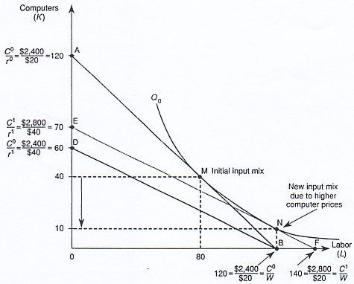
costs? Since the price of capital has increased, the isocost line will rotate counter-clockwise from AB to DB. To produce the same amount of output, the manager will have to spend more than C¹ = $2,400. 'Me additional expenditures will shift the isocost line out to EF in Figure 5-10. The new point of cost minimization is at point N, where the firm now employs more labor (120 units) and less capital (10 units) to minimize the production costs of rugs. Costs are now C¹ = ($40 X 10) + ($20 X 120) = $2,800, which are higher than C^{O}.

--------------------------
The Cost Function

Now that we understand how a manager can use information about the production function to minimize the cost of producing a given level of output, it is useful to examine a very simple way to summarize the information contained in the production function.

For given input prices, different isoquants will entail different production costs, even allowing for optimal substitution between capital and labor. Each isoquant corresponds to a different level of output, and the isocost line tangent

Fringe Benerits and Input Substitution

Government regulations often have unintended consequences. For instance, current federal tax law requires that firms provide fringe benefits in such a way as not to discriminate against lower-income workers. Presumably, the purpose of this regulation is to ensure that low-income workers will have access to health care, pension benefits, and other fringe benefits. Unfortunately, this policy often limits the employment opportunities of lower-income workers.

To see why, consider a company that hires computer programmers and secretaries. Suppose the annual wage bill of a computer programmer is $30,000 and that of a secretary is $15,000. The company is considering offering a family healthcare plan worth $3,600 annually to its employees. Ignoring the fringe-benefit bill, the relative price of a secretary to a computer programmer is $15,0001$30,000 = .5. But when the cost of the health-care plan is added in, the relative price of a secretary increases to a little over .55 of that of a

computer programmer. Isoquant and isocost analysis suggests that firms should substitute away from the now higher-priced secretaries, to minimize costs.

Seem far-fetched? Recently economists Frank Scott, Mark Berger, and Dan Black examined the relationship between health-care costs and employment of low-wage workers. They found that industries that offered more generous health-care plans employed significantly fewer bookkeepers, keypunch operators, receptionists, secretaries, clerktypists, janitors, and food service workers than did industries with lower health-care costs. Moreover, industries with higher levels of fringe benefits hired more part-time workers than did industries with lower fringe-benefit levels, since the IRS does not require firms to offer pension, health-me, and many other fringe benefits to part-time workers.

Source: Frank Scott, Mark Berger, and Dan Black, "Eff" of ffinge Benefits on 1~ Market SegmmtatLon~" Industnal and Labor Relations Review 42 (January 1989), pp. 216-29.

to higher isoquants will imply higher costs of production, even assuming the firm uses the cost-minimizing input mix. Since the cost of production increases as higher isoquants are reached, it is useful to let QQ) denote the cost to the firm of producing isoquant Q in the cost-minimizing fashion. The function, C, is called the cost function.

The cost function is extremely valuable because, as we will see in later chapters, it provides essential information a manager needs to determine the profit-maximizing level of output. In addition, the cost function summarizes information about the production process. The cost function thus reduces the amount of information the manager has to process to make optimal output decisions.

Short-Run Costs

Recall that the short run is defined as the period over which the amounts of some inputs are fixed. In the short run, the manager is free to alter the use of variable inputs, but is "stuck' with existing levels of fixed inputs. Because inputs are costly whether fixed or variable, the total cost of producing output in the short run consists of
- the cost of fixed inputs and
- the cost of variable inputs. These two components of short-run total cost are called fixed costs and variable costs, respectively. Fixed costs, denoted FC, are costs that do not vary with output. Fixed costs include the costs of fixed inputs used in production. Variable costs, denoted VQ(Q), are costs that change when output is changed. Variable costs include the costs of inputs that vary with output.

Since all costs fall into one or the other category, the sum of fixed and variable costs is the firm's short-run cost function. In the presence of fixed factors of production, the short-run cost function summarizes the minimum possible cost of producing each level of output when variable factors are being used in the cost-minimizing way.

Table 5-3 illustrates the costs of producing with the technology used in Table 5-1. Notice that the first three columns comprise a short-run production function, because they summarize the maximum amount of output that can be produced with two units of the fixed factor (capital) and alternative units of the variable factor (labour). Assuming capital costs $ 1,000 per unit and labour costs $400 per unit, we can calculate the fixed and variable costs of production, which are summarized in columns 4 and 5 of Table 5-3. Notice that irrespective of the amount of output produced, the cost of the capital equipment is $ 1,000 X 2 = $2,000. Thus, every entry in column 4 contains this number, illustrating the principle that fixed costs do not vary with output.

To produce more output, more of the variable factor must be employed. For example, to produce 1, 100 units of output, 5 units of labor are needed; to produce 1,708 units of output, 7 units of labor are required. Since labor is the

TABLF 5-3 The Cost Function
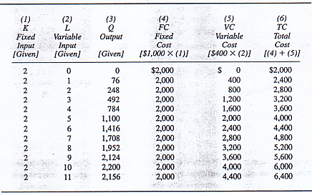

FIGUPE 5-11
The relationship
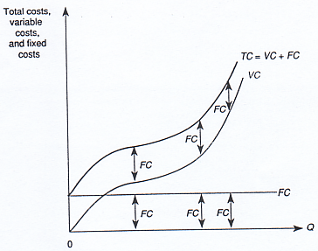

only variable input in this simple example, the variable cost of producing 1, 100 units of output is the cost of 5 units of labour, or $400 X 5 = $2,000. Similarly, the variable cost of producing 1,708 units of output is $400 X 7 = $2,800. Total costs, summarized in the last column of Table 5-3, are simply the sum of fixed costs (column 4) and variable costs (column 5) at each level of output.

Figure 5-11 illustrates graphically the relations among total costs (TC), variable costs (VC), and fixed costs (FC). Because fixed costs do not change with output, they are constant for all output levels and must be paid even if zero units of output are produced. Variable costs, on the other hand, are zero if no output is produced but increase as output increases above zero. Total cost is the sum of fixed costs and variable costs. Thus, the distance between the TC and VC curves in Figure 5-11 is simply fixed costs.

Average and Marginal Costs

One common misconception about costs is that large firms have lower costs than smaller firms because they produce larger quantities of output. One fundamental implication of scarcity is that to produce more output, more must be spent. What individuals most likely have in mind when they consider the advantages of producing large ~ties of output is that the overhead is spread out over a larger level of output. This idea is intricately related to the economic concept of average fixed cost. Average fixed cost (AFC) is defined as fixed costs (FC) divided by the number of units of output:

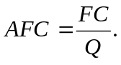

TABLE 5-4 Derivation of Average Costs
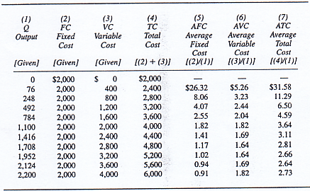
Since fixed costs do not vary with output, as more and more output is produced, the fixed costs are allocated over a greater quantity of output. As a consequence, average fixed costs decline continuously as output is expanded. This principle is revealed in Column 5 of Table 5-4, where we see that average fixed costs decline as total output increases.

Average variable cost provides a measure of variable costs on a per-unit basis. Average variable cost (AVC) is defined as variable costs (VC) divided by the number of units of output:

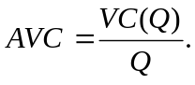

Column 6 of Table 5-4 provides the average variable cost for the production function in our example. Notice that as output increases, average variable cost initially declines, reaches a minimum between 1,708 and 1,952 units of out put, and then begins to increase.

Average total cost is analogous to average variable cost, except that it provides a measure of total costs on a per-unit basis. Average total cost (ATC) is defined as total cost (TC) divided by the number of units of output:

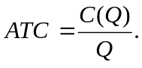
Column 7 of Table 5-4 provides the average total cost of various outputs in our example. Notice that average total cost declines as output expands to 2,124 units and then begins to rise. Furthermore, note that average total cost is

TABLE 5-5 Derivation of Marginal Cost
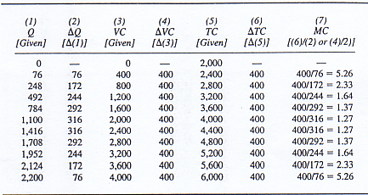

the sum of average fixed costs and average variable costs (the sum of columns 5 and 6) in Table 5-4.

The most important cost concept is marginal (or incremental) cost. Conceptually, marginal cost (MC) is the cost of producing an additional unit of output, that is, the change in cost attributable to the last unit of output:

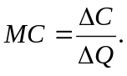

To understand this important concept, consider Table 5-5, which summarizes the short-run cost function with which we have been working. Marginal cost, depicted in column 7, is calculated as the change in costs arising from a given change in output. For example, increasing output from 248 to 492 units (ΔQ = 244) increases costs from 2,800 to 3,200 (ΔC = $400). Thus, the marginal cost of 492 units of output is ΔCIAQ = 4001244 = $1.64.

When only one input is variable, the marginal cost is the price of that input divided by its marginal product. Remember that marginal product increases initially, reaches a maximum, and then decreases. Since marginal cost is the reciprocal of marginal product times the input's price, it decreases as marginal product increases and increases when marginal product is decreasing.

Relations Among Costs

Figure 5-12 graphically depicts average total, average variable, average fixed, and marginal costs under the assumption that output is infinitely divisible (the firm is not restricted to producing only the outputs listed in Tables 5-4 and 5-5 but can produce any outputs). The shapes of the curves indicate the relation between the marginal and average costs presented in those tables. These relations among the cost curves, also depicted in Figure 5-12, are very

FIGURE 5-12
The relationship among average and marginal costs
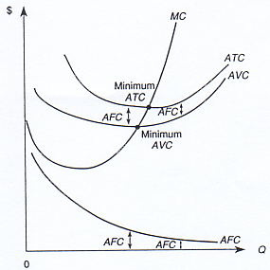

important. The first thing to notice is that the marginal cost curve intersects the ATC and AVC curves at their minimum points. This implies that when marginal cost is below an average cost curve, average cost is declining, and when marginal cost is above average cost, average cost is rising.

There is a simple explanation for this relationship among the various cost curves. Again consider your grade in this course. If your grade on an exam is below your average grade, the new grade lowers your average grade. If the grade you score on an exam is above your average grade, the new grade increases your average. In essence, the new grade is the marginal contribution to your total grade. When the marginal is above the average, the average increases; when the marginal is below the average, the average decreases. The same principle applies to marginal and average costs, and this is why the curves in Figure 5-12 look the way they do.

The second thing to notice in Figure 5-12 is that the ATC and AVC curves get closer together as output increases. This is because the only difference in ATC and AVC is AK. To see why, note that total costs consist of variable costs and fixed costs:

C(Q) = VQ(Q) + FC.

If we divide both sides of this equation by total output (Q), we get

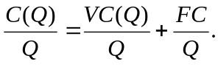

But C(Q)/Q = ATC, VC(Q)/Q = AVC, and FC/Q = AFC. Thus,

ATC = AVC + AFC.

The difference between average total costs and average variable costs is ATC-AVC = AFC. Since average fixed costs decline as output is expanded, as in Figure 5-12, this difference between average total and average variable costs diminishes as fixed costs are spread over increasing levels of output.

Fixed and Sunk Costs

We now make an important distinction between fixed costs and sunk costs. Recall that a fixed cost is a cost that does not change when output changes. A related concept, called sunk cost, is a cost that is lost forever once it has been paid. To be concrete, imagine that you are the manager of a coal company and have just paid $10,000 to lease a railcar for one month. This expense reflects a fixed cost to your firm-the cost is $10,000 regardless of whether you use the railcar to transport 10 tons or 10,000 tons of coal. How much of this $ 10,000 is a sunk cost depends on the terms of your lease. If the lease does not permit you to recoup any of the $10,000 once it has been paid, the entire $ 10,000 is a sunk cost-you have already incurred the cost, and there is nothing you can do to change it. If the lease states that you will be refunded $6,000 in the event you do not need the railcar, then only $4,000 of the $10,000 in fixed costs are a sunk cost. Sunk costs are thus the amount of these fixed costs that cannot be recouped.

Since sunk costs are lost forever once they have been paid, they are irrelevant to decision making. To illustrate, suppose you paid a non refundable amount of $10,000 to lease a railcar for one month, but immediately after signing the lease you -realize that you do not need it---the demand for coal is significantly lower than you expected. A farmer approaches you and offers to sublease the railcar from you for $2,000. If the terms of your lease permit you to sublease the railcar, should you accept the farmer's offer?

You might reason that the answer is no; after all, your firm would appear to lose $8,000 by subleasing a $10,000 railcar for a measly $2,000. This reasoning is wrong. Your lease payment is non refundable, which means that the $10,000 is a sunk cost and has already been lost. Since there is nothing you can do to eliminate this $10,000 cost. The only relevant issue is whether you can do something to enhance your inflow of cash. In this case your optimal decision is to sublease the railcar because doing so provides you with $2,000 in revenues that you would not get otherwise. Notice that, while sunk costs are irrelevant in making your decision, they do affect your calculation of total profits. If you do not sublease the railcar, you lose $10,000; if you sublease it, you lose only $8,000.

Principle
Irrelevance of Sunk Costs

A decision maker should ignore sunk costs to maximize profits or minimize
losses.

DEMONSTRATION PROBLEM 5-4

ACME coal paid $5,000 to lease a railcar from the Reading Railroad. Under the terms of the lease, $1,000 of this payment is refundable if the railcar is returned within two days of signing the lease.

1. Upon signing the lease and paying $5,000, how large are ACME's fixed costs? Its sunk costs?

2. One day after signing the lease, ACME realizes that it has no use for the railcar. A farmer has a bumper crop of corn and has offered to sublease the railcar from ACME at a price of $4,500. Should ACME accept the fanner's offer?

Answer

1 . ACME's fixed costs are S5,000. For the first two days, its sunk costs are $4,000 (this is the amount that cannot be recouped). After two days, the entire $5,000 becomes a sunk cost

- Yes, ACME should sublease the railcar. Note that ACME's total loss is $500 if it accepts the farmer's offer. If it does not, its losses will equal the sunk cost of $4,000 (assuming it returns the railcar by the end of the next business day).

Algebraic Forms of Cost Functions

In practice, cost functions may take many forms, but the cubic cost function is frequently encountered and closely approximates any cost function. The cubic cost-function is given by

C(Q) = f + aQ + bQ² + cQ³,

where a, b, c, and f are constants. Note that represents fixed costs. Given an algebraic form of the cubic cost function, we may directly calculate the marginal cost function.

Formula: Marginal Costfor Cubic Costs. For a cubic cost function,

C(Q) =f + aQ + bQ² + cQ³,

the marginal cost function is

MC(Q) = a + 2bQ + 3cQ².

A Calculus
Alternative

Marginal cost is simply the derivative of the cost function with respect to output:

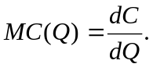

For example, the derivative of the cubic cost function with respect to Q is

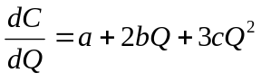

which is the formula for marginal cost given above.

DEMONSTRATION PROBLEM 5-5

The cost function for Managerial Enterprises is given by QQ) = 20 + 3Q. What are the marginal cost, average fixed cost, average variable cost, and average total cost of producing 10 units of output?

Answer

Using the formula for marginal cost (here a = c = 0), we know that MC = 6Q. Thus, the marginal cost of producing the 10th unit of output is $60.

To find the various average costs, we must first calculate total costs. The total cost of producing 10 units of output is

C(10) = 20 + 3(10)² = $320.

Fixed costs are those costs that do not vary with output; thus fixed costs are $20. Variable costs are the costs that vary with output, namely VC(Q) = 3Q². Thus, VQ(10) = 3(10)l = $300. It follows that the average fixed cost of producing 10 units is $2, the average variable cost is $30, and the average total cost is $32.

Long-Run Costs

In the long run all costs are variable, because the manager is free to adjust the levels of all inputs. In Figure 5-13, the short-run average cost curve ATCO is drawn under the assumption that there are some fixed factors of production. The average total cost of producing output level Q0, given the fixed factors of production, is ATC_{O}(Q0). In the short run, if the firm increases output to Q,, it cannot adjust the fixed factors, and thus average costs rise to ATC_{O}(Q). In the long run, however, the firm can adjust the fixed factors. Let ATC, be the average cost curve after the firm adjusts the fixed factor in the optimal manner. Now the firm can produce Q, with average cost curve ATC,. If the firm produced Q, with average cost curve ATCO, its average costs would be ATC_{O}(Q). By adjusting the fixed factors in a way that optimizes the scale of operation, the firm economizes in production and can produce Q, units of output at a lower average cost, ATCI(Q1). Notice that the curve labeled ATC, is itself a

FIGURE 5-13
Optimal plant size and long-run average cost
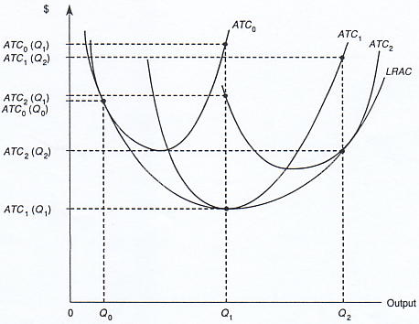

short-run average cost curve, based on the new levels of fixed inputs that have been selected to minimize the cost of producing Q,. If the firm wishes to further expand output-say. to Q₂-'t would follow curve ATC, in the short run to ATC₁ (Q2) until it again changed its fixed factors to incur lower average costs of producing Q₂ units of output, namely ATC₂ (Q₂).

The long-run average cost curve, denoted LRAC in Figure 5-13, defines the minimum average cost of producing alternative levels of output, allowing for optimal selection of all variables of production (both fixed and variable factors). The long-run average cost curve is the lower envelope of all the short-run average cost curves. This means that the long-run average cost curve lies below every point on the short-run average cost curves, except that it equals each short-run average cost curve at the points where the short-run curve uses fixed factors optimally. In essence, we may think of each short-run average cost curve in Figure 5-13 as the average cost of producing in a plant of fixed size. Different short-run average cost curves are associated with different plant sizes. In the long run, the firm's manager is free to choose the optimal plant size for producing the desired level of output, and this determines the long-run average cost of producing that out-put level.

DEMONSTRATION PROBLEM 5---6

Consider the three short-run average cost curves in Figure 5-14. Each curve is associated with a different size plant. Which plant can produce 5 units of output most efficiently? Which can produce 10 units most efficiently?

Answer

The smallest plant in Figure 5-14 is ATC, the largest plant is ATC., and the medium size plant is ATC,. If the firm wished to produce 5 units of output, it would choose the medium-size plant. The average cost would be at level A, which entails the lowest possible cost for producing 5 units. If this company chose to produce 10 units, it would choose the largest plant. The average total cost would be at level B, which is the least cost way of producing 10 units of output.

Economies of Scale

Notice that the long-run average cost curve in Figure 5-15(a) is U shaped. This implies that initially an expansion of output allows the firm to produce at

FIGURE 5-14
A medium-sized plant produces 5 units at lowest cost
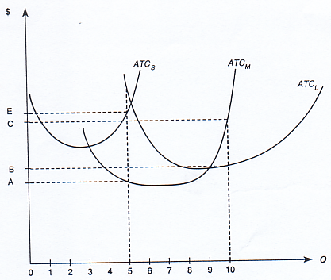
lower long-run average cost, as is shown for outputs between 0 and Q*. This condition is known as economies of scale. When there are economies of scale, increasing the size of the operation decreases the minimum average cost. After a point, such as Q* in Figure 5-15(a), further increases in output lead to an increase in average costs. This condition is known as diseconomies of scale.

Sometimes the technology in an industry allows a firm to produce different levels of output at the same minimum average cost, as in Figure 5-15(b). This condition is called constant returns to scale.

A Reminder : Economic Costs Versus Accounting Costs

In concluding this section, it is important to recall the difference between economic costs and accounting costs. Accounting costs are the costs most often associated with the costs of producing. For example, accounting costs include

FIGURE 5-15
Scale economies
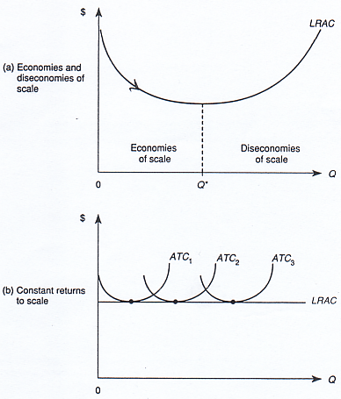

direct payments to labour and capital to produce output. Accounting costs are the costs that appear on the income statements of firms.

These costs are not the only costs of producing a good, however. The firm could use the same resources to produce some other good. By choosing to produce one good, producers give up the opportunity for producing some other good. Thus, the costs of production include not only the accounting costs but also the opportunities forgone by producing a given product.

---------------------------------------------
Multiple-Output Cost Functions

Up until now, our analysis of the production process has focused on situations where the firm produces a single output. There are also numerous examples of firms that produce multiple outputs. General Motors produces both cars and trucks (and many varieties of each); IBM produces many different types of computers and printers. While our analysis for the case of a firm that produces a single output also applies to a multi-product firm, the latter raises some additional issues. This section will highlight these concepts.

In this section, we will assume that the cost function for a multi-product firm is given by QQ, Q2), where Q, is the number of units produced of product 1 and Q2 'S the number of units produced of product 2. The multi-product cost function thus defines the cost of producing Q, units of good 1 and Q2 units of good 2 assuming all inputs are used efficiently.

Notice that the multi product cost function has the same basic interpretation as a single-output cost function. Unlike with a single-product cost function, however, the costs of production depend on how much of each type of output is produced. This gives rise to what economists call economies of scope and cost complementarities, discussed next.

Economies of Scope

Economies of scope exist when the total cost of producing Q1 and Q2 together is less than the total cost of producing Q1 and Q2 separately, that is, when
C(Q₁+ 0) + C(O,Q₂) > C(Q₁+ Q₂).

In a restaurant, for example, to produce given quantities of steak and chicken dinners, it generally is cheaper to produce both products in the same restaurant than to have two restaurants, one that sells only chicken and one that sells only steak. The reason is, of course, that producing the dinners separately would require duplication of many common factors of production, such as ovens, refrigerators, tables, the building, and so forth.

Cost Complementarity

Cost complementarities exist in a multi product cost function when the marginal cost of producing one output is reduced when the output of another product is increased. Let C (Q₁, Q₂) be the cost function for a multi-product firm, and let MC₁(Q₁, Q₂) be the marginal cost of producing the first output. The cost function exhibits cost complementarity if

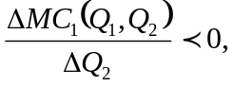

that is, if an increase in the output of product 2 decreases the marginal cost of producing output 1.

An example of cost complementarity is the production of doughnuts and doughnut holes. The firm can make these products separately or jointly. But the cost of making additional doughnut holes is lower when workers roll out the dough, punch the holes, and fry both the doughnuts and the holes instead of making the holes separately.

The concepts of economies of scope and cost complementarity can also be
examined within the context of an algebraic functional form for a multi product
cost function. For example, suppose the multi product cost function is quadratic:

C(Q1,Q2) = f + aQ1Q2 + (Q1)² + (Q2)².

For this cost function,

MC1 = aQ2 + 2Q1.

Notice that when a < 0, an increase in Q2 reduces the marginal cost of producing good 1. Thus, if a < 0, this cost function exhibits cost complementarity. If a > 0, there are no cost complementarities.

Formula: Quadratic Multi product Cost Function. The multi product cost function

C(Q1, Q2) =f + aQ1Q2 + (Q1)² + (Q2 )²

has corresponding marginal cost functions,

MC_{I}(Q1, Q2) = aQ2 + 2Q1

and

MC2(Q1, Q2) = aQ1 + 2Q2.

To examine whether economies of scope exist for a quadratic multi-product cost function, recall that there are economies of scope if

C(Q1, 0) + C(0, Q2) > C(Q1, Q2),

or, rearranging,

C(Q1, 0) + C(O, Q2) - C(Q1, Q2) > 0.

This condition may be rewritten as

f + (Q1)² +f + (Q2 )² - [f + aQIQ² + (Q1)² + (Q2 )²] > 0,

which may be simplified to

f – aQ1Q2 > 0.

Thus, economies of scope are realized in producing output levels Q₁ and Q₂ if f > a Q₁ Q₂

Summary of the Properties of the Quadratic Multiproduct Cost Function The multiproduct cost function C(Q1, Q2) = f + aQ1Q2 + (Q1)² + (Q2 )².

1. Exhibits cost complementarity whenever a < 0.
2. Exhibits economies of scope wheneverf - a Q₁ Q₂ > 0.

DEMONSTRATION PROBLEM 5-7

Suppose the cost function of firm A, which produces two products, is given by
C = 100 - -5Q, Q2 +(Q1)² + (Q2 )².

The firm wishes to produce 5 units of good 1 and 4 units of good 2.

1. Do cost complementarities exist? Do economies of scope exist?

2. Firm A is considering selling the subsidiary that produces good 2 to firm B, in which case it will produce only good 1. What will happen to firm Ks costs if it continues to produce 5 units of good 1?

Answer

1. For this cost function, a 1/2 < 0, so indeed there are cost complementarities. To check for economies of scope, we must determine whether f – aQ1 Q2 > 0. This is clearly true, since a < 0 in this problem. Thus, economies of scope exist in producing 5 units of good 1 and 4 units of good 2.

2. To determine what will happen to firm Xs costs if it sells the subsidiary that produces good 2 to firm B, we must calculate costs under the alternative scenarios. By selling the subsidiary, firm A will reduce its production of good 2 from 4 to 0 units; since there are cost complementarities, this will increase the marginal cost of producing good 1. Notice that the total costs to firm A of producing the 5 units of good 1 fall from

C(5, 4) 100 - 10 + 25 + 16 = 131

to

C(5, 0) = 100 + 25 = 125.

But the costs to firm B of producing 4 units of good 2 will be

C(0, 4) = 100 + 16 = 116.

Firm A’s costs will fall by only $6 when it stops producing good 2, and the costs to firm B of producing 4 units of good 2 will be $116. The combined costs to the two firms of producing the output originally produced by a single firm will be $110 more than the cost of producing by a single firm.

The preceding problem illustrates some important aspects of mergers and sales of subsidiaries. First, when there are economies of scope, two firms producing distinct outputs could merge into a single firm and enjoy a reduction in costs. Second, selling off an unprofitable subsidiary could lead to only minor reductions in costs. In effect, when economies of scope exist, it is difficult to "allocate costs" across product lines.
Answering the Headline

The numbers reported in the opening headline indicate that Ford's hourly workers produce an average of 33.2 vehicles per year, whereas GM employees produce an average of only 27.9 automobiles per year. Notice that these numbers represent the average product of GM and Ford workers and imply that for each 1,000 cars produced, GM employs about 36 workers while Ford employs about 30. Since GM pays its workers a higher hourly wage ($45) than Ford ($43), these numbers suggest that GM is not producing in the cost-minimizing manner. To minimize costs, GM needs to use less labor and more capital.

More formally, assume that Ford and GM produce automobiles by using capital and labor. Further assume that the two firms have similar technologies and pay similar rates for the capital machines used in production. Under these assumptions, the higher wage paid by GM implies that it has a steeper isocost line than Ford; thus GM should use more capital and less labor to minimize the costs of producing a given number of automobiles (i.e., to achieve a given isoquant). In other words, the higher wage faced by GM calls for it to substitute capital for labor to minimize production costs; to produce a given number of automobiles, GM should employ fewer workers than Ford. Since the figures indicate that GM is actually using more workers than Ford for each 1,000 automobiles produced, GM needs to reduce its use of labor and increase its use of capital to minimize costs. This is precisely what GM attempted to do through its negotiations with the union.

Summary

In this chapter, we introduced the production and cost functions, which summarize important information about converting inputs into outputs sold by a firm. For firms that use several inputs to produce output, isocosts and isoquants provide a convenient way to determine the optimal input mix.

We broke down the cost function into average total cost, average fixed cost, average variable cost, and marginal cost. These concepts help build a foundation for understanding the profit-maximizing input and output decisions that will be covered in greater detail in later chapters.

Given a desired level of output, isoquants and isocosts provide the information needed to determine the cost-minimizing level of inputs. The cost-minimizing level of inputs is determined by the point at which the ratio of input prices equals the ratio of marginal products for the various inputs.

Finally, we showed how economies of scale, economies of scope, and cost complernentaries influence the level and mix of outputs produced by single and multiproduct firms. In the next chapter we will look at the acquisition of inputs. We will see how managers can use spot markets, contracts, or vertical integration to efficiently obtain the inputs needed to produce their desired mix of outputs.

Key Terms and Concepts

average fixed cost isocost
average product isoquant
average total cost Leontief (or fixed proportions)
average variable cost production function
Cobb-Douglas production function linear production function
cost complementarity long run
cost function marginal (incremental) cost
cost minimization marginal product
cubic cost function optimal input substitution
decreasing (or diminishing) marginal production function
returns profit-maximizing input usage
diminishing marginal rate of short run
technical substitution sunk costs
economies of scale total cost
economies of scope total product
fixed costs value marginal product
fixed factors of production variable costs
increasing marginal returns

Problems

1. Congress is considering legislation that will provide additional investment tax credits to businesses. Effectively, an investment tax credit reduces the cost to firms of using capital in production. Would you expect labor unions to lobby for or against such a bill? (Hint: What impact would such a plan have on the capital-to-labor ratio at the typical firm?)

2. You have been hired to replace the manager of a firm that uses only two inputs, capital and labor, to produce output. The firm can hire as much labor as it wants at a wage of $5 per hour and can rent as much capital as it wants at a price of $50 per hour. After you look at the company books, you learn that the company has been using capital and labor in amounts that imply a marginal product of labor of 50 and a marginal product of capital of 100. Do you know why the firm hired you? Explain.

3. The manager of a meat-packing plant can use either butchers (labor) or meat saws (capital) to prepare packages of sirloin steak. Based on estimates provided by an efficiency expert, the firm's production function for sirloin steak is given by:

Q=K+L

- Graph the isoquant corresponding to 5 units of output.
- What is the marginal product of capital and labor? Does the answer depend on how much labor and capital are used?
- If the price of labor is $2 per hour and the rental price of capital is $3 per hour, how much capital and labor should be used to minimize the cost of production?

- The manager of a national retailing outlet recently hired an economist to estimate the firm's production function. Based on the economist's report, the manager now knows that the firm's production function is given by Q = P1202 and that capital is fixed at 1 unit.
- Calculate the average product of labor when 9 units of labor are utilized.
- Calculate the marginal product of labor when 9 units of labor are utilized.
- Suppose the firm can hire labor at a wage of $ 10 per hour and output can be sold at a price of $ 100 per unit. Determine the profitmaximizing levels of labor and output.
- What is the maximum price of capital at which the firm will still make nonnegative profits?

- An accountant for a car rental company was recently asked to report the firm's costs of producing various levels of output. The accountant knows that the most recent estimate available of the firm's cost function is QQ) = 100 + I OQ + Q', where costs are measured in thousands of dollars and output is measured in thousands of hours rented.
- What is the average fixed cost of producing 2 units of output?
- What is the average variable cost of producing 2 units of output?
- What is the average total cost of producing 2 units of output?
- What is the marginal cost of producing 2 units of output? e. What is the relation between the answers to (a), (b), and (c) above? Is this a general property of average cost curves?

6. There are over 5,000 banks in the United States-more than 10 times the number per person than in other industrialized countries. A recent study suggests that the long-run average cost curve for an individual bank is relatively flat. If Congress took steps to consolidate banks, thereby reducing the total number to 2,500, what would you expect to happen to costs within the banking industry? Explain.

- A production function exhibits constant returns to scale if a twofold (threefold, etc.) increase in all inputs leads to a twofold (threefold, etc.) increase in output. For example, by doubling the use of capital and labor, the firm would exactly double its output.
- What would the average and marginal cost curves look like under constant returns to scale? Explain.
- Give an example of a production function that exhibits constant returns to scale.

- A production function exhibits decreasing returns to scale if a twofold (threefold, etc.) increase in all inputs increases output by less than twofold (less than threefold, etc.). For example, by doubling the use of capital and labor, the firm would less than double its output.
- What would the average and marginal cost curves look like under decreasing returns to scale? Explain.
- Give an example of a production function that exhibits decreasing returns to scale.

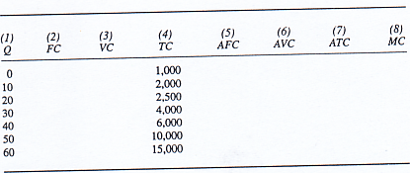
9. The total costs for Morris Industries are summarized in the following table. Based on this information, fill in the missing entries in the table for fixed cost, variable cost, average fixed cost, average variable cost, average total cost, and marginal cost.

10. The following table summarizes the short-run production function for your firm. Your product sells for $5 per unit, labor costs $5 per unit, and the rental price of capital is $20 per unit. Complete the following table, and then answer the accompanying questions.

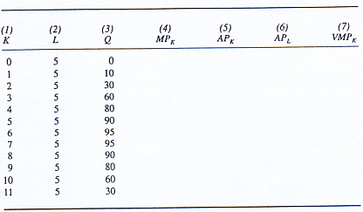

a. Which inputs are the fixed inputs? Which are the variable inputs?
b. How much are your fixed costs?
c. What is the variable cost of producing 20 units of output?
d. How many units of the variable input should be used to maximize profits?
e. What are your maximum profits?
f. Over what range of variable input usage do increasing marginal returns exist?
g. Over what range of variable input usage do decreasing marginal returns exist?
h. Over what range of variable input usage do negative marginal returns exist?

11. Your firm produces two products, Q, and Q2. An economic consulting firm has estimated your cost function to be QQ1, Q2) = 100 + Q1Q2 + Q2/1 + Q2/2.
a. Are there economies of scope?
b. Are there cost complementarities?
c. Your market for Q, is not very good, and an overseas firm has offered to buy the division of your company that produces Q. What will happen to your marginal cost of producing Q2 if you sell the division?

12. In the text, we showed that the multiproduct cost function

C(Q1, Q2) = f + aQIQ2 + (Q1)² + (Q2 )²

exhibits cost complimentarity whenever a < 0 and exhibits economies of scope wheneverf – aQ1Q2 > 0.

a. Can cost complementarities exist without economies of scope?
b. Can there be economies of scope when cost complementarities exist?

13. Standard Enterprises produces an output that it sells in a highly competitive market at a price of $ 100 per unit. Its inputs include two machines (which cost the firm $50 each) and workers, who can be hired on an as-needed basis in a labor market at a cost of $2,800 per worker. Based on the following production data, how many workers should the firm employ to maximize its profits?

Machines Workers Output

2 0 0
2 1 60
2 2 100
2 3 129
2 4 148
2 5 160
2 6 168

14. You are the manager of Telecall. Inc., a small telemarketing company. Your company pays $10,000 per month for office space. A real estate agent has noticed that you are only using 75 percent of your available space and tells you that Telecall could add $800 per month to its bottom line by renting out the space it does not use. Telecall has been asked to do a new telemarketing campaign for a large credit card company, but this would require it to use the remaining office space. What is the opportunity cost of using the extra office space to handle the credit card company's promotion?

15. Suppose the production function for automobiles is given by Q = K^{1/4}L^{3/4}.
- Show that the marginal product of any given quantity of labor increases as capital is increased.
- Suppose Japanese and U.S. automakers produce on identical isoquants with this Cobb-Douglas production function and that labor costs are higher in Japan than in the United States. Do autoworkers in Japan have a higher marginal product than American autoworkers? Explain carefully.
- Now suppose Japanese automakers produce on a different isoquant from U.S. firms, but the prices of Japanese and American cars are identical. Do Japanese or American autoworkers have a higher marginal product? Why?

16. Show that the Cobb-Douglas production function Q = K^{1/4}L^{3/4} exhibits the law of diminishing marginal rate of technical substitution.

17, You are the manager of a firm that sells output at a price of $40 per unit. You are interested in hiring a new worker who will increase your firm's output by 2,000 units per year. Several other firms also are interested in hiring this worker.
- What is the most you should be willing to pay this worker to come to your firm?
- What will determine whether or not you actually have to offer this much to the worker to induce him to join your firm?

18. To open a new business, a manager must obtain a license from the city for $20,000. The license is transferable, but only $3,000 is refundable in the event the firm does not use the license. a. What are the firm's fixed costs? Sunk costs? b. Suppose the manager obtains a license but then decides against opening the business. If another firm offers the manager $2,000 for the license, should the manager accept the offer?

19. The maker of Turbotax produces software that prepares federal income tax returns. In addition, it produces software that prepares various state income tax returns. Why doesn't it pay for the firm to specialize in federal software?

20. The management of Morris Industries is considering a plan to terminate a new employee. The action stemmed from documented evidence supplied by the firm's accounting department that this new employee did not add as much to the firm's overall output as did a worker hired two weeks earlier. Based on this evidence, do you agree that the latest worker hired should be fired? Explain.

21. In 1995 the U.S. Justice Department sued to block a merger between Microsoft and Intuit, the producer of the nation's best-selling business software. The Justice Department argued that the merger-would lessen competition and raise prices of business software. Is there an economic argument that the merger might actually result in lower prices? Explain.

Selected Readings

Anderson, Evan E. and Chen, Yti Min, 1mplicit Prices and Economies of Scale of Secondary Memory: The Case of Disk Drives." Managerial and Decision Economics 12(3), June 1991, pp. 241-48.

CarIsson, Bo, Audretsch, David B., and Acs, Zoltan J., "Flexible Technology and Plant Size: U.S. Manufacturing and Metalworking Industries." International Journal of Industrial Organization 12(3), 1994, pp. 359-72.

Eaton, C., "The Geometry of Supply, Demand. and Competitive Market Structure with Economies of Scope." The American Economic Review 8 1, September 1991, pp. 901-11.

Ferrier, Gary D. and Lovell, C. A. Knox, 'Weasuring Cost Efficiency in Banking: Econometric and Linear Programming Evidence." Journal of Econometrics 46(12), October-November 1990, pp.229-45.

Gold, B., "Changing Perspectives on Size, Scale, atid Returns: An Interpretive Survey." Journal of Economic Literature 19(1), March 1981, pp. 5-33. Gropper, Daniel M., "An Empirical Investigation of Changes in Scale Economies for the Commercial Banking Firm, 1979-1986." Journal ofMoney, Credit, and Banking 23(4), November 1991, pp. 718-27. Kohn, Robert E. and Levin, Stanford L., "Complementarity and Anticomplementarity with the Same Pair of Inputs." Journal of Economic Education 25(1), Winter 1994, pp. 67-73. Mills, D., "Capacity Expansion and the Size of Plants." The Rand Journal of Economics 2 1, Winter 1990, pp. 555-66,

APPENDIX
THE CALCULUS OF PRODUCTION AND COSTS

The Profit-Maximizing Usage of Inputs

In this section we use calculus to show that the profit-maximizing level of an input is the level at which the value marginal product of the input equals the input's price. Let P denote the price of the output, Q, which is produced with the production function F(K, L). The profits of the firm are

π = PQ - wL - rK

PQ is the revenue of the firm and wL and rK are labor costs and capital costs, respectively. Since Q = F(K, L), the objective of the manager is to choose K and L so as to maximize

π = PF(K, L) - wL - rK

The first-order condition for maximizing this function requires that we set the first derivatives equal to zero:

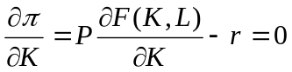
and

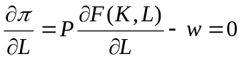

But since

∂F(K, L)I∂L = MP_{L},

and

∂F(K, L)I∂K = MP_{K},

this implies that to maximize profits, P X MP_{L}, = w and P X MP_{K} = r; that is, each input must be used up to the point where its value marginal product equals its price.

The Slope of an Isoquant

In this section, we use calculus to show that the slope of an isoquant is the negative of the ratio of the marginal products of two inputs.

Let the production function be Q = F(K, L). If we take the total derivative of this relation, we have

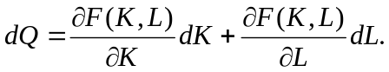

Since output does not change along an isoquant, then dQ = 0. Thus,

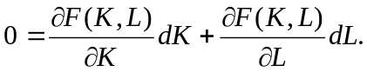

Solving this relation for dKIdL yields

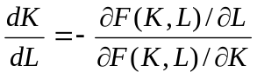

Since

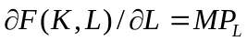

and
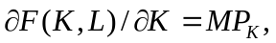

we have shown that the slope of an isoquant (dKIdL) is

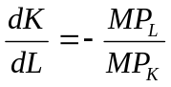

The Optimal Nfix of Inputs

In this section, we use calculus to show that to minimize the cost of production, the manager chooses inputs such that the slope of the isocost line equals the MRTS.

To choose K and L so as to minimize

wL + rK subject to F(K, L) = Q,
we form the Lagrangian

H = wL + rK + [Q - F(K, L)],

where Ii is the Lagrange multiplier. The first-order conditions for a maximum are

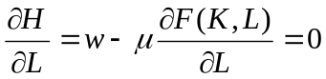 (A-1)

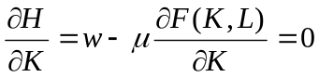 (A-2)

and

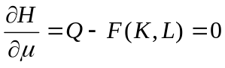

Taking the ratio of Equations (A-1) and (A-2) gives us

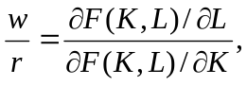

which is

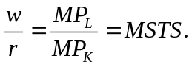

The Relation Between Average and Marginal Costs

Finally, we will use calculus to show that the relation between average and marginal costs in the diagrams in this chapter is indeed correct. If C(Q) is the cost function (the analysis that follows is valid for both variable and total costs, so we do not distinguish between them here), average cost is AC(Q) = C(Q)/Q. The change in average cost due to a change in output is simply the derivative of average cost with respect to output. Taking the derivative of AC(Q) with respect to Q and using the quotient rule, we see that

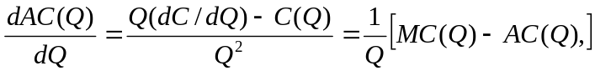

since dC(Q)/dQ = MC(Q). Thus, when MC(Q) < AC(Q), average cost declines as output increases. When MC(Q) > AC(Q), average cost rises as output increases. Finally, when MC(Q) = AC(Q), average cost is at its minimum.

1 Sources: Palmer, Jay, "Reviving GM," Barron's Online, June 22, 1998; In rassia, Paul, "A Long Road to Good Labor Relations at GM," The Wall Street Journal interactive Edition, June 30, 1998.

