 | INTERNATIONAL TELECOMMUNICATION UNION
 | Geneva, 13 September 2006
 | Publication Notice No. 119-04-Rev4

Radio Regulations  Edition of 2004 |  | 

via ITU Website
The Radio Regulations edition of 2004 contains the complete texts of the Radio Regulations as adopted by the World Radiocommunication Conference (Geneva, 1995) (WRC-95) and subsequently revised and adopted by the World Radiocommunication Conference (Geneva, 1997) (WRC-97), the World Radiocommunication Conference (Istanbul, 2000) (WRC-2000) and the World Radiocommunication Conference (Geneva, 2003) (WRC-03), including all Appendices, Resolutions, Recommendations and ITU-R Recommendations incorporated by reference.
Estimated date of publication: | English, French and Spanish available, Arabic, Chinese and Russian to follow
Language: | English, French, Spanish, Arabic, Chinese, Russian
Paper format: | About 2000 pages – A4 (21 × 29.7 cm), A5 (14.8 × 21 cm) in a box
Electronic format: | Microsoft® Word for Windows® – Adobe® Acrobat® PDF
Hardware and software requirements: | For details, see page 2
Article numbers:
   |  | Printed version A4 | Printed version A5 | CD-ROM
   | English | 25144 | 25148 | 25151  (v1.01)
   | French | 25145 | 25149 | 25151  (v1.01)
   | Spanish | 25146 | 25150 | 25151  (v1.01)
   | Arabic |  | 27501
   | Chinese |  | 27502
   | Russian |  | 27214
ISBN numbers:
   |  | Printed version A4 | Printed version A5 | CD-ROM
   | English | 92-61-10661-7 | 92-61-10671-4 | 92-61-10687-0  (v1.01)
   | French | 92-61-10662-5 | 92-61-10672-2 | 92-61-10687-0  (v1.01)
   | Spanish | 92-61-10663-3 | 92-61-10673-0 | 92-61-10687-0  (v1.01)
   | Arabic |  | 92-61-10676-5
   | Chinese |  | 92-61-10675-7
   | Russian |  | 92-61-10674-9
Price in Swiss francs: | Printed version or CD-ROM single user  Catalogue Price: CHF 252.–  Member State Administrations and Sector Members: –15%  Administrations of Least Developed Countries: – 80%  Libraries of educational institutions (CD-ROM only): – 80%  Electronic Bookshop: CHF 252.– (No discount)

CD-ROM: Price multiplier for multi-users at the same site
Number of authorized users | 1 | 2-10 | 11-25 | 26-50 | 51-100 | Other
Price | 252.– | 502.– | 1 008.– | 1 512.– | 2 268.– | on request

Please complete and return the enclosed Order Form, duly signed, to the ITU Sales and Marketing Division.
Radio Regulations
Edition of 2004

The complete texts of the Radio Regulations (RR), as adopted by WRC-95 and subsequently revised and adopted by WRC-97, WRC-2000 and WRC-03, are published in four Volumes plus a separate package of maps to be used in relation to Appendix 27 (Rev.WRC-03).
The contents of this publication are summarized as follows:

Volume 1 – Articles

Volume 2 – Appendices

Volume 3 – Resolutions and Recommendations

Volume 4 – ITU-R Recommendations incorporated by reference

Separate package – Maps to be used in relation to Appendix 27
(Rev.WRC-03)

Format and structure

Printed version: | Both A4 (21 × 29.7 cm) and A5 (21 × 14.8 cm) versions are available (the A5 version is a photo-reduced version with smaller text) with a separate package of maps to be used in relation to Appendix 27 (Rev.WRC-03).
CD-ROM: | Microsoft® Word for Windows® and Adobe® Acrobat® PDF.
Electronic Bookshop: | Microsoft® Word for Windows® and Adobe® Acrobat® PDF.
Hardware and software requirements: | Pentium®-based processor or compatible, with 64 MB of RAM minimum) and CD-ROM drive running Microsoft® Windows® 98 Second Edition, Windows® Millenium, Windows NT® 4.0 with Service Pack 5 or later, Windows 2000, Windows XP® Professional or Home Edition and Adobe® Acrobat® Reader 5.0 with Search.

For other operating systems, please check Acrobat® Reader 5.0 system requirements at the
Adobe® website:
www.adobe.com/products/acrobat/acrrsystemreqs.html#51win

GENERAL CONDITIONS OF SALE

■ Prices
The prices quoted in Publication Notices, as well as in the ITU Catalogue of Publications and in the Lists of ITU-T and ITU-R Recommendations (distributed free of charge and visible on the ITU website at the following address: www.itu.int/publications), are in Swiss francs (CHF) and are subject to change without notice.
Discounts of 15% are granted to Member State Administrations and Sector Members participating in the work of ITU. A discount of 80% of the catalogue price on all ITU publications is granted to Administrations of the Least Developed Countries (LDCs), as well as to libraries of educational institutions (for online subscriptions and CD-ROM/DVD-ROM publications only). Please note that the minimum price for a publication bought from the Electronic Bookshop is twenty Swiss francs (CHF 20.–) and that there is no discount when using this service.
All additional information concerning CD-ROMs, DVD-ROMs, online Recommendations and the ITU Electronic Bookshop can be found in the Catalogue of Publications and its associated Lists of ITU-R and ITU-T Recommendations.

■ Methods of payment
All publications ordered from ITU must be paid for in advance. Payments can be made:
a) by credit card: American Express, Eurocard/Mastercard, Visa;
b) by bank transfer to the UBS SA, Geneva, Account ITU Geneva, No. CH 96 0024 0240 C876 5565 0,
SWIFT UBSWCHZH80A – Clearing No. 240;
c) by cheque made payable to ITU;
d) by international postal order;
e) to the ITU postal cheque account: ITU Geneva, No. 12-50-3 (from within Switzerland);
f) by UNESCO coupon.
Payments normally should be made in Swiss francs (CHF). Payments may also be made in other currencies freely convertible into CHF, provided that, when converted by the bank, the price of the service in CHF is covered. ITU does not accept letters of credit.
For faster order processing, we invite you to either pre-pay by credit card or take advantage of a new service by opening an ITU deposit account.

■ Forms of dispatch
The catalogue price includes the cost of dispatch by non-registered economy-class mail or the means of carriage most advantageous to ITU. Dispatch can be requested in other forms: i.e. airmail, DHL, Federal Express, TNT, UPS or diplomatic pouch. If one of these alternative methods is chosen, the dispatch cost will be added to the quote. As from 1 February 2003, the costs of shipping via registered mail have been added to the economy-class costs. You may, if you wish, refuse these conditions but, in this case, ITU will not be held responsible for the replacement of any undelivered orders dispatched by mail that has not been registered. Customs duties and other taxes or dues levied on imported goods are not borne by ITU. ITU accepts no responsibility for delay, loss or damage in shipment. Any claim must be made as quickly as possible, and at the latest within six months of dispatch of the publication(s).

■ Return of publications
Where a publication found to be faulty is returned to ITU, the latter’s responsibility shall be limited to replacement of the publication and payment of the costs arising from such replacement. Any publication returned to ITU as unwanted must reach it within one (1) month from the date of its dispatch to the customer, subject to ITU’s prior agreement. A minimum charge of fifty Swiss francs (CHF 50.–) will normally be invoiced to the customer by ITU for return of the publication to stock.
No exchange or refund is available for purchases made directly at the ITU Bookshop.
In the case of electronic publications (CD-ROM, DVD-ROM and online), these general conditions shall apply, subject to the specific derogation provisions contained in the Licence Agreements. The placing of an order implies full acceptance of these general conditions of sale.
None of the provisions of these general conditions of sale shall be interpreted as constituting a derogation or renunciation of the privileges, immunities and facilities enjoyed by ITU in accordance with the international agreement applicable to it, in particular the Headquarters Agreement concluded with the Swiss Federal Council on 22 July 1971, as well as the Swiss law or any other relevant national legislation.
Please note that orders cannot be taken over the telephone.
They should be sent in writing.

Article number:  paper A4 q 25144 E q 25145 F q 25146 S  paper A5 q 25148 E q 25149 F q 25150 S q 27501 A q 27502 C q 27214 R  q 25151 Trilingual CD-ROM — v1.01  Number of users | No 119-04-Rev4
Radio Regulations
Edition of 2004
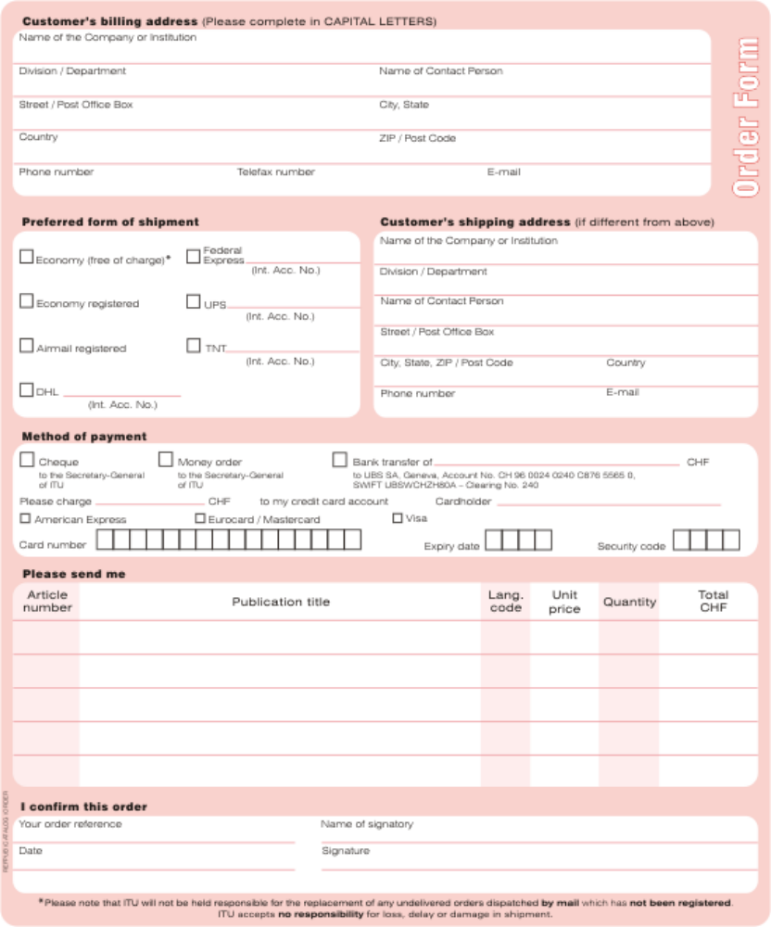
Please sign and return the completed Order Form to:
ITU  Sales and Marketing Division  Place des Nations  CH-1211 Geneva 20 – Switzerland | Telefax: +41 22 730 51 94  E-mail: sales@itu.int

