
The Royal British Legion
Sandy and District Branch

LIVE ON

Registered Charity 219279
July Newsletter 2019




https://catesbooknuthut.files.wordpress.com/2014/05/summer.jpg

Dear Member,

I’m writing this at the end of, possibly, the warmest weekend so far this year.

You will have read, in the latest copy of “Legion” magazine, that we have a new National Chairman – Una Cleminson BEM TD; Una is the first female Chairman of the Royal British Legion and I am sure that you will join me in wishing her a highly successful time in office.

In your newsletter this month we feature:

- Social Events
- Birthday Greetings
- Membership Renewal
- Upcoming Events
  - Membership Meet-ups
  - Poppy Race Day – Newmarket
  - Poppies at the Mill
  - Concert by the Central Band of The Royal British Legion
  - Operation Banner
- Soldiering On Awards
- Quote of the Month
- Future Branch Meetings
- Quiz

~~~~~~~~~~~~~

Social Events – July 2019

Some events may require a deposit to secure seat(s), Room(s) etc. and where a deposit is paid it is non-refundable unless an alternative person(s) can be found to take on the booking.

All cheques for social events to be made payable to The Services Social Fund (Sandy).

Branch Lunch
The Crown, Willington, first Wednesday of each month, 1230 for 1300.
This event continues to be popular. Please note if the two-course menu for that day is not suitable, you can buy off the main menu.

Thursday – 18 July 2019 – Bowls evening, Great Barford commencing 6pm.
Great Barford Bowls Club have kindly invited us once again to a friendly game of Bowls. This is always a lovely evening with plenty of fun and friendship. You do not have to play, just come along and enjoy the evening. If you would like to play bowls, please let me know.

Day Trip to Skegness – Saturday 14th September 2019
Cost £17.50pp. There will be a raffle on the coach in aid of the Poppy Appeal. Prizes would be most appreciated. Please let me know ASAP if you would like to come on this day out.

Saturday 16 November 2019 – Remembrance Social / Buffet with Entertainment
Venue: Conservative Club, Sandy commencing 7.30pm. Cost £10pp. There will be a raffle in aid of the Poppy Appeal. Prizes most welcome.

The Turkey & Tinsel Holiday will be to Scarborough - Monday 18 November to 22 November staying at The Royal Hotel. Cost £239.99pp. Price includes: - Our own coach, Half Board. All rooms with private facilities, entertainment and excursions. A £50 Deposit is required with booking. Travel Insurance is advisable. Cost with this company is £20 for five days. However, you may get it cheaper yourself or may be covered by your Bank. There are no single rooms available now. However, there are still some double and twin rooms.
Please note: Balance for this holiday is due by the September Branch Meeting.

Information:

If you require help you may find the answer you seek by searching our knowledge base at http://support.britishlegion.org.uk/
Or by calling the Royal British Legion Contact Centre on Freephone 0808 802 8080

Sandy/Beeston Good Neighbours Group – Contact 07810 213935

Handy Van Service – Please do not forget this service if you need help. Telephone: 0800 0320306.

Please contact me if you would like a visit or need help. Also, to attend any of our events.

Mary Baker
Branch Community Support Officer
/Social Secretary Tel: 01767 225278 – Mobile: 07483225175

~~~~~~~~~~~~~~~~

Happy Birthday



The following members have birthday’s during this month or next:

JULY
Mrs. S. Butcher
Mrs. B. Erbe
Mr. B. Payne
Mr. A. Willey

AUGUST
Mr. G. Barber
Mr. M. Cottenden
Mr. D. Gale
Mrs. J. Morris
Mr. H. Stevens
Mr. R. Wood

Many Happy Returns to each of you and I hope that you have or have had a wonderful day.

~~~~~~~~~~~~~~~~

Membership Renewal

Membership Renewal now takes place throughout the year with most of our members renewing on 1st October each year, however members who have joined since 2015 may have a renewal date dictated by the date that they physically joined the Legion.

The renewal process is no longer controlled by the Branch, but centrally.

Renewal instructions will be sent to you a month or so before your membership is due, this gives you plenty of time to renew before your membership expires; any communications, information, updates etc. that you receive after your expiry date is totally goodwill and may be stopped at any time and after a period, if your membership is not renewed, it will be lapsed (this may be controlled centrally or by the branch).

Please do not destroy any paperwork that you receive regarding your renewal as you may need it to effect this.

If you are unsure of how you can renew, or you have lost your paperwork, please contact the Legion Contact Centre on 0808 802 8080, They will be able to give you all the information you may need and, if required, will renew your membership there and then (by debit or credit card).

~~~~~~~~~~~~

RBL Upcoming Events

I will publish here any events that I think will be of interest, that are being organised by the RBL, National and Local that I am aware of, but you can also find events published on the RBL website: https://www.britishlegion.org.uk/

Membership Meetups
Our meetups are an opportunity for you to connect with others and find out more about the difference you're making.

The last of these is on 20th July 2019 at the National Memorial Arboretum, if you are interested please follow the below link to the RBL Website:

https://www.britishlegion.org.uk/get-involved/things-to-do/membership/our-members/membership-meet-ups/register-for-a-membership-meet-up

Poppy Race Day – Newmarket

Join us on Saturday August 10, 2019 for a day out at the famous Newmarket Racecourse in aid of The Royal British Legion.
It'll be a fabulous day out where you can enjoy your race-going in comfort and style at this stunning course.
You will enjoy welcome drinks followed by a three-course lunch with wine and afternoon tea in our private marquee. You'll be situated away from the throng but right by the finishing post so you can watch the horses and riders from our private terrace.
Tickets
Tickets cost £125, with the price including course entry, car parking and race card. Contact Rebecca on 020 3207 2272 or rpride@britishlegion.org.uk for further information. You can also purchase tickets online at https://www.britishlegion.org.uk/get-involved/things-to-do/events/poppy-race-day

Poppies at the Mill – Sat. 17th August 2019
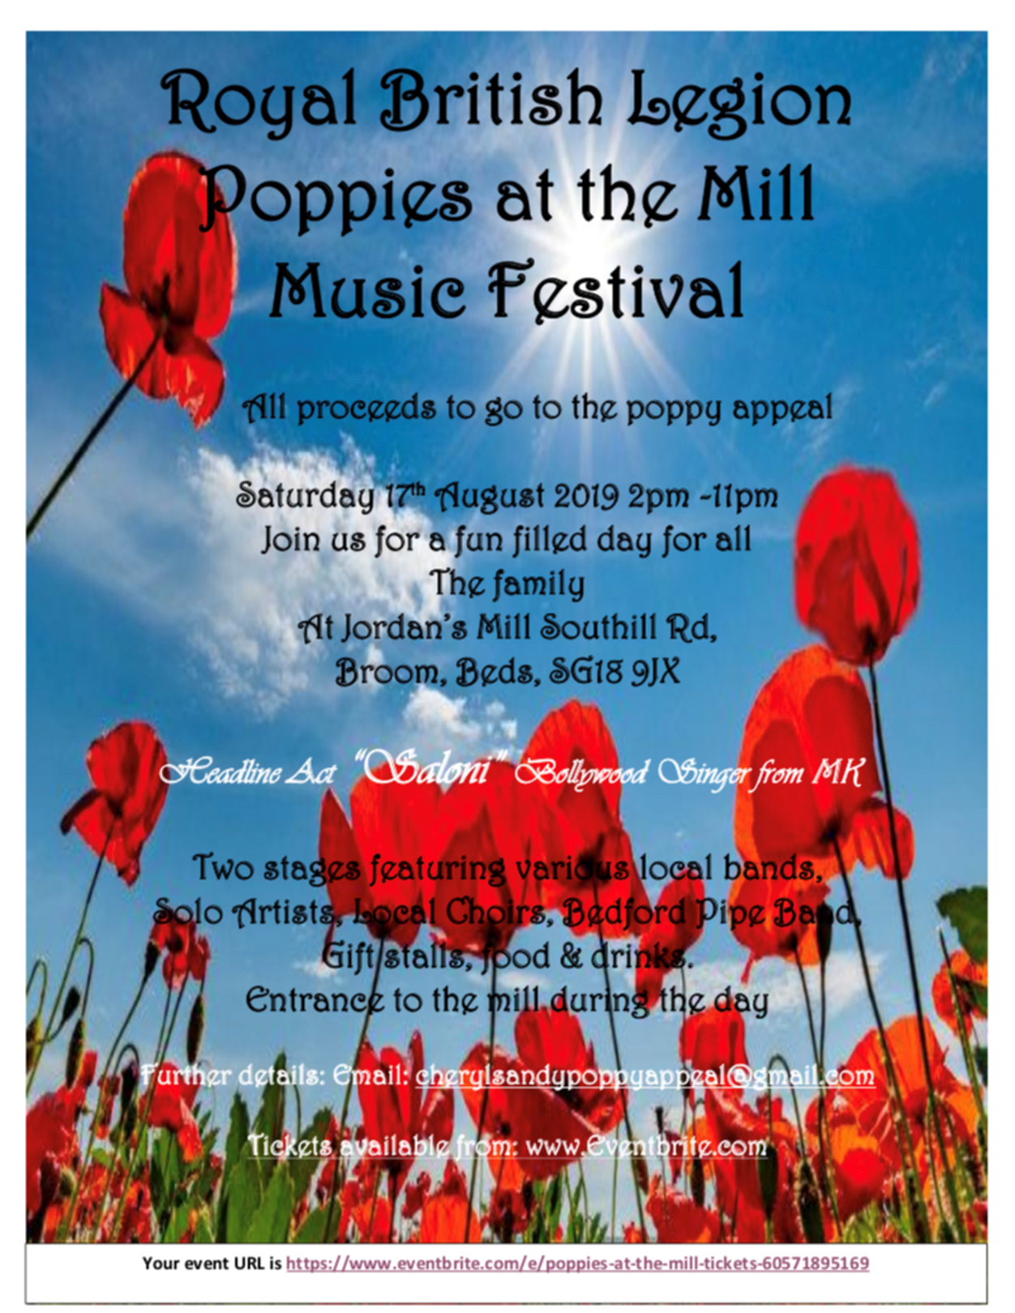

This event is being organised by Cheryl Watkins our PAO.

Tickets can be obtained from: https://www.eventbrite.com/e/poppies-at-the-mill-tickets-60571895169

Further details available from: cherylsandypoppyappeal@gmail.com

Concert by the Central Band of The Royal British Legion – 12th October 2019
Join us for a concert at Southwark Cathedral in London to celebrate our capital and raise money for The Royal British Legion.

Join David Cole, our superb Director of Music, and the ever-popular Central Band for an entertaining performance at our ‘local’ near London Bridge.

Our very own Legion All-Stars will be showcasing the absolute best of what they can do ranging from big show numbers and music from the films, through to jazz and uplifting marches. This band is truly the best of its kind so come and listen for yourself and enjoy the spectacle!

Ticket prices range from £10 to £35. Contact Elinor on 020 3053 7094 or by email on:

specialevents@britishlegion.org.uk

for further information. You can also purchase tickets online at:
https://www.eventbrite.co.uk/e/concert-southwark-cathedral-with-the-central-band-of-the-royal-british-legion-tickets-52912781554?_ga=2.79504276.1200186529.1561963520-656061013.1478272742

Operation Banner
As you will be aware it is the 50th anniversary this year of the deployment of British troops onto the streets of Northern Ireland in 1969.

Over 300,000 service personnel were deployed to Northern Ireland over the subsequent 38 years. In total 1441 UK Armed Forces personnel died as a result of operations in Northern Ireland or paramilitary actions in other countries.

To mark this significant anniversary, we will be hosting a commemorative event at the National Memorial Arboretum on the 14th August 2019.

The event will be open to recipients of the General Service Medal (Northern Ireland). Representatives from families of British Armed Forces personnel killed as a result of operations in Northern Ireland are also invited to register their interest. Registration for the event will be open in Spring 2019 however people are being encouraged to register their interest for this event now.

Please see the link below to the page on the website which provides more information as well as the link to register. The event is also being promoted via the Regimental Associations.

www.britishlegion.org.uk/op-banner-50/

This is a very significant event for us this year and will be of profound importance for many veterans and their families. Please can you do all you can to promote this event.

~~~~~~~~~~~

Soldiering On Awards

The Soldiering On Awards recognise the outstanding achievements of those who have served their country, and the diverse people and groups who work together in support of the Armed Forces Community. Many RBL members have been nominated and some of them have won awards including Susan Coleman who won the Defence Inclusivity Award 2019 and Neil Deaville who won the Lifetime Achievement Award 2018.

Nominations are open, and you're welcome to nominate as many people, groups or organisations that inspire you or which you feel deserve recognition. Can you think of a member that should be nominated?

https://www.soldieringon.org/soa_2020_nominations/

~~~~~~~~~~~

Quote of the Month

If you don’t like something, change it. If you can’t change it, change your attitude.

Maya Angelou

~~~~~~~~~~~~

Future Branch Meetings

Here is a reminder that Branch Meetings are held on the third Wednesday of every month at 20:00 at:

The Conservative Club
Bedford Road
Sandy

The next meetings will be on:

Wed 17th July 2019
Wed 21st August 2019
Wed 18th September 2019
Wed 16th October 2019 (AGM)
Wed 20th November 2019

Please put these dates in your diary.

~~~~~~~~~~~~

Quiz: Here are some general knowledge questions: Answers are on the next page, but don’t look unless you really must.

1. The stars you see when you rub your eyes are called what?
2. A Goldfish kept in a dark room will eventually turn white, True or False?
3. How many years did it take to build Salisbury Cathedral?
4. Al Capone's business card said he was a what?
5. All of the clocks in the movie "Pulp Fiction" are stuck on what time?
6. Which city has the most Rolls Royce's per capita?
7. What is the only US state whose name has just one syllable?
8. Which nut is included in the ingredients of dynamite?
9. "El Pueblo de Nuestra Senora la Reina de los Angeles de Porciuncula" is what?
10. What was John Lennon's first girlfriend called?
11. What was the first song to be performed in outer space, sung by the Apollo IX astronauts on March 8, 1969.
12. Who played the flute on Cat Stevens - Lady D'Arbanville?
13. Clint Eastwood is allergic to horses. True or false?
14. What was the name of Jamie Farr's character in the TV series Mash?
15. After being squirted by Sooty's water pistol, which famous dog trainer stormed off the show?
16. Where would you find the only Royal Palace in the USA?
17. What are the two hottest months at the equator?
18. The Moon's mass is what fraction of the Earth's?
19. What was the original title of Jane Austen's novel, Pride and Prejudice?
20. How many hearts does an octopus have?

Quiz Answers – Only look after you have completed the Quiz or if you are completely stumped.
I do hope that you have enjoyed your newsletter and I hope that you will contribute articles of interest, jokes or advertisements; so, that I can make this, YOUR newsletter as well as mine. Please send contributions to me,
Roger Sparks at:
200 Winchester Road, Sandy, SG19 1RQ or by e-mail to: Sandy.Chairman@RBL.Community or telephone me on 07889 958545

Roger Sparks

- Phosphenes
- True
- The Cathedral was built in just 38 years (AD1220-1258)
- Used furniture dealer
- 4:20
- Hong Kong
- Maine
- Peanut
- The full name for Los Angeles (L.A.)
- Thelma Pickles
- "Happy Birthday"
- Peter Gabriel
- True
- Corporal Klinger
- Barbara Woodhouse
- Honolulu
- March and September
- 1/ 80th
- First Impression.
- 3

