INICHECK ID PRO+ v 1.2

Capstone Project Team # 6 Spring 2009

Instructor
Dr. Kwok-Bun Yue

Mentor
Mr. Bruce Brenner



Team Members

Abby Perez
Sravanthi Kadamati
Venkata Ramisetty
Swetha Lakshmi Mandalapu

Team Website: http://dcm.uhcl.edu/caps09g6/index.htm

Technical Report Version 1.0
05/04/09

Acknowledgement

We take this opportunity to express immense gratitude to our instructor Dr.Kwok-Bun Yue and our mentor Mr. Bruce Brenner for the continuous support, guidance and motivation they have provided us throughout the project. Their encouragement was highly instrumental in our execution of an original idea and developing the application.
We would like to thank previous capstone team (fall 2008 Team # 1) for providing us with all necessary data and details which assist us in solving the key issues. As a team, we enjoyed working with this capstone project which was a high learning experience. We would like to thank Mr. Daniel C Holdgreiwe (Computer Sciences Corporation), USCIS VIS technical support at the Department of Homeland Security for continuously helping us by providing necessary details.

Abstract
MiniCheck-OCR, Inc has developed a suite of applications known as the MiniCheck IDTM , MiniCheck ID ProTM , MiniCheck ID Pro+^{TM.} MiniCheck ID TM and MiniCheck ID ProTM are used for validating ID’s at the point-of-scale or any situation where ID validation or age verification is important. MiniCheck ID TM incorporates advanced identity management by allowing the user to connect to third party databases in order to verify a customer’s identity by verifying the authenticity of a social security number or postal address. All functions executed through the MiniCheck ID TM user interface. It also provides the ability to validate a photo ID such as a driver’s license or state issued ID card in order to prevent fraud and also has an option to capture an image of a photo ID at the point of scale and store it within the record archive maintained on the local PC by the user in the Access database.
MiniCheck ID ProTM adds to MiniCheck ID TM the ability to process credit card transactions. This ability is using a payment gateway i.e., Authorize.net. When a credit card is swiped with a card scanner, it reads the magnetic stripe in the form of raw data. The raw data is parsed into useful information which appears on the user interface. MiniCheck ID Pro+TM application incorporates a new functionality of E-Verify using the credentials provided by the Department of Homeland Security. The user can verify the legal work status of the newly hired employees by providing the necessary information.
Our project is an extension of the work done by the previous team in last semester. The name of newly modified application is MiniCheck ID Pro+TM v1.2 and will continue to use the flexible C#/.NET Framework. The team would stabilize the application in both Windows Vista and Windows XP, thus satisfying Microsoft environment users. All necessary modifications would be carried out and final integration would be done with reliable architecture. Consistency in application performance is needed to be assured.

Table of Contents
Acknowledgment
Abstract
Table of Contents
- Introduction……………………………………………………………………………………6
- Design and Implementation
  - Requirements……………………………………………………………………………...7
2.2 Technologies Used………………………………………………………………………...8
2.3 Software Development Model…………………………………………………………….8
  - Implementation issues…………………………………………………..…………………9
- Features Implemented…………………………………………………………………………9
- Data/Code Cleaning………………………………………………………………………..9-10
- Testing………………………………………………………………………………………..10
- Final Deliverables…………………………………………………………………………....10
- Conclusion………………………………………………………………………………..10-11
- References……………………………………………………………………………………11
Appendix A
Team Roles and Contributions……………………………………………………………….12-13
Appendix B
Images of all devices supported and screenshots……………………………………….........14-32
Appendix C
Terminology related to project …………………………………………………………. …..33-34

- Introduction
The previous capstone team in Fall 2008 (Team # 1) developed an applications called MiniCheck ID Pro+TM which aims at adding functionalities to MiniCheck ID ProTM like to develop a module for E-Verify, integrate the module for the Vivo tech reader, and fine tune the code to remove redundancy so that the end product is clean, compatible with Windows Vista thereby taking a step closer to production level code.

MiniCheck ID Pro+TMv1.2 is developed with an intention that the team will review previous team’s source code to review for consistency, confirm that all features in the application work reliably with all of the previously supported input hardware and modify to correct any errors or instability in the code for the MiniCheck ID Pro+TM application. All features and functionality should be checked thoroughly to ensure they work reliably with Windows XP and Vista.

The goal of the project is to make sure all functionalities are working properly with respect to every device we use. Confirmation of integration of devices like Magtek USB Card Swipe, USB Magtek Excella STX, and USB E seek M250, USB MICR Image and USB RDM, USB vivotech, functionality of TWAIN with both Windows XP and VISTA is very crucial. Code cleaning, refining the GUI(Graphical User Interface), proper and consistent integration of devices, avoiding any discrepancy in team work which would bring out best of us are main goals of the project.

- Design and Implementation
  - Requirements
- Integrate new devices
Integration of new scanners into the existing application to read, parse the data and display meaning information on the user’s screen.
- Changes to GUI
Improvise the configuration file and make any necessary changes. Improvisation is in terms of appearance, removal of unnecessary data from the menu.
- Code cleaning
Code cleaning is removal of redundant and commented lines of code. Proper naming criteria must be defined.
- Providing consistency to application
Make sure all the devices exhibit complete functionalities with both Windows Vista and XP. Avoid cases such as any additional device testing would affect the functionality of the project.
- Issue database reports
Review data base functionality for generating targeted marketing lists using a variety of search criteria and setting up user-defined product ID names or codes.
- Advanced features of application
The team will also modify the user interface and data base so that when choosing an option to process a credit card transaction, other user fields become available so that the user can enter and easily capture valuable customer demographic information regarding the transaction that will be useful for generating targeted marketing lists later on.
- E-verify
Some refinement of the E-Verify integration still needs to be optimized this semester as a part of the project, then testing and certifying all functionality is reliable and working will be done.
- MiniCheck ID Pro+TM currently uses access database which at times gives hard time, if time permits we would improvise it to run in smoother way.

  - Technologies Used
The application was developed in C#/.NET framework and graphical user interface was developed using windows forms. MS-Access 2003 database is used to store the records. We also used Atalasoft.

  - Software Development Model
While making necessary modifications to enhance performance for the existing application, the team had to make sure that the application is divided into different phases like requirements analysis, design, implementation, testing and maintenance.
Requirement analysis was the start up for our team. The team analyzed requirement documents and discussed with mentor. Next came up the design phase where in the system architecture was implemented. Throughout the development phase the maintenance was going on with secured back up.

  - Implementation Issues
The fall 2008 final deliverable application was executed initially, but it was throwing lot of exceptions, after immense research, trial and error methods we could make the application run by first executing Spring 2008 Final deliverables first and then running the Fall 2008. The reason team found out was that the DLL’s were not properly bound in fall code. Then came the issues with devices where the drivers installation was tricky at times, there were exceptions which were solved by writing few try and catch blocks.

- Features Implemented
- Team created an option for customized logo for the user.
The customer can upload any kind of logo in the post login window.
- The entire configuration file was modified.
Configuration file consists of all devices we use. This was modified and any additional unused data was eliminated.
- All device functional compatibility in windows XP and Vista was performed.
Compatibility of windows XP and Vista was checked for this application.
- Addition of new devices to configuration window.
Any new device to be tested was updated to configuration window.
- Implemented twain.
Both import image and twain which are advanced features of the application were implemented efficiently.

- Data/Code Cleaning
One of the crucial tasks of the semester is code cleaning. Code cleaning in common is removal of redundant data. In here we not only removed any data repetition, but also eliminated any unused lines of code. In the code, proper naming indentations were used and re-naming was done to generic entities. This helps to understand the code better.

5. Testing
Testing holds major part of our project. Though there was not much new development involved in the project, the team had to perform thorough testing of the application with respect to any changes or enhancements made. We performed the performance testing to check if the software worked as per expectations. We tested the application with different devices provided by our mentor. All the code which was result of code cleaning was also thoroughly checked to make sure there is no degradation in performance of the application. This entire process has been done by each team member after the code is integrated into a single system.

6. Final Deliverables
The final deliverable is an installer (.exe) file which will install the application MiniCheck ID Pro+TM v1.2 along with all required device drivers necessary. The project source code and technical report would be submitted along with application package as a deliverable.

7. Conclusion
The application we enhanced is a windows application. All the requirements of the project have been met. The code is cleaned ensuring reduction in redundancy and there was improvement in reliability too. It was a great learning experience as it gave us exposure to real time tasks and challenges. We also learnt how to interact with the guides and how to perform as a team. We learned new technologies which increased our scope towards acquiring new concepts.

8. References
- Authorize.Net, www.authorize.net
- Software Development Model www.wikipedia.com
- Fall 2008 Team # 1 http://dcm.uhcl.edu/capf08g1/
- Mentor Website http://minicheckocr.com/
- Atalasoft support http://www.atalasoft.com/HomeB.aspx
- http://twain.org/docs/TWAIN19.pdf
- http://www.rdmcorp.com/EC7000iSeries.shtml

Appendix A:
A.1 Team Roles and Contribution
- Abdon Perez (Abby)
Email: iabster@yahoo.com
Phone No:832-289-9112
Major: Computer Science
Role: Team Leader & Programmer

- Sravanthi Kadamati
Email: kadamatis5518@uhcl.edu
Phone No: 502-287-3058
Major: Computer Science
Role: Programmer & Webmaster

- Venkata Ramisetty (Rakesh)
Email: ramisettyv7018@uhcl.edu
Phone No: 713-502-5854
Major: Computer Science
Role: Programmer & Technical Writer

- Swetha Lakshmi Mandalapu
Email: mandalapus4415@uhcl.edu
Phone No: 936-465-2097
Major: Computer Science
Role: Programmer & Testing

A.2 Team Contribution
Task | Abby | Sravanthi | Rakesh | Swetha
Requirement Analysis | 25% | 25% | 25% | 25%
Research Work | 30% | 30% | 20% | 20%
Team Website | 20% | 25% | 25% | 30%
User Interface | 30% | 30% | 20% | 20%
Documentation | 20% | 20% | 35% | 25%
Data base | 25% | 30% | 20% | 25%
Testing | 20% | 20% | 25% | 35%
Communication with Mentor and Instructor | 30% | 25% | 25% | 20%
Creating API & Installer | 25% | 20% | 30% | 25%
* Contribution in percentage.

Appendix B:
B.1 Images of all devices supported by MiniCheck ID Pro+TM v1.2

Images of all equipments supported by MiniCheck ID
RDM EC7000i | 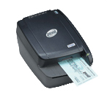 | E-Seek M-250 | 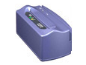
Magtek Excella STX | 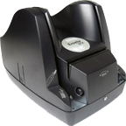 | MICR Image | 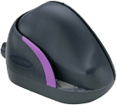
Docket Port 667 | 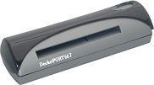 | CardScan 800C | 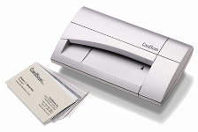
Neat Receipts Scanner | 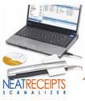 | Magtek Card Swipe (black) | 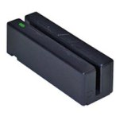

B.2 Screenshots
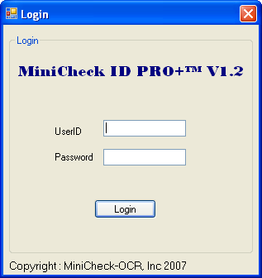
Fig 1: Login Page

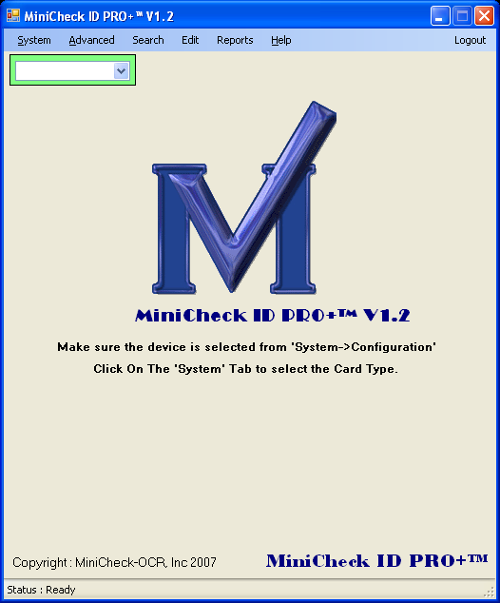
Fig 2: Minicheck ID Pro+ changed to Minicheck ID Pro+ v1.2

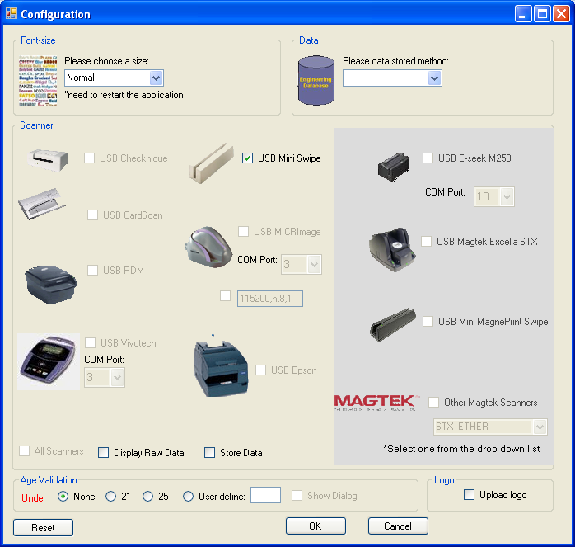
Fig 3: The modified Configuration Page

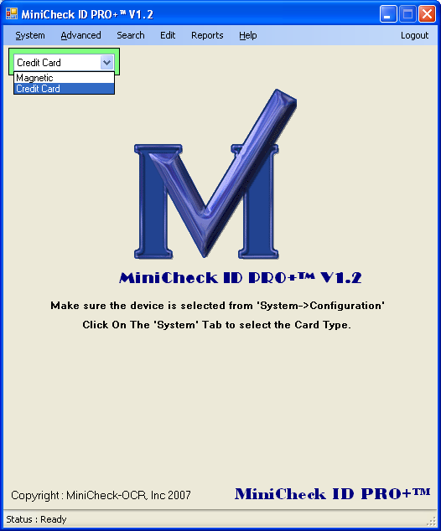
Fig 4: Selection of credit card transactions

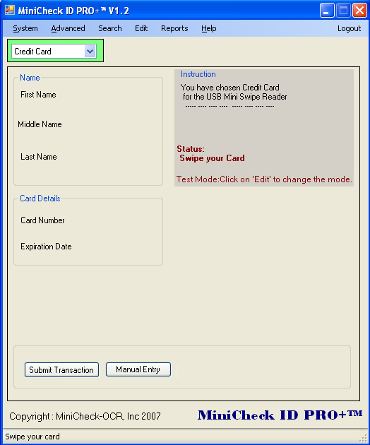
Fig 5: The modified page for credit card transactions

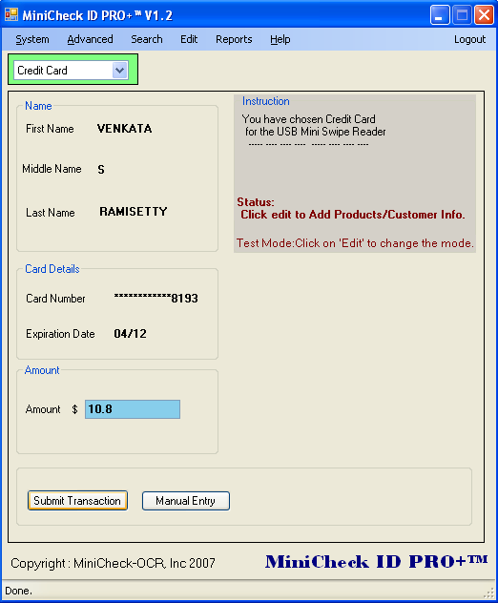
Fig 6: The retrieved data after swiping the credit card

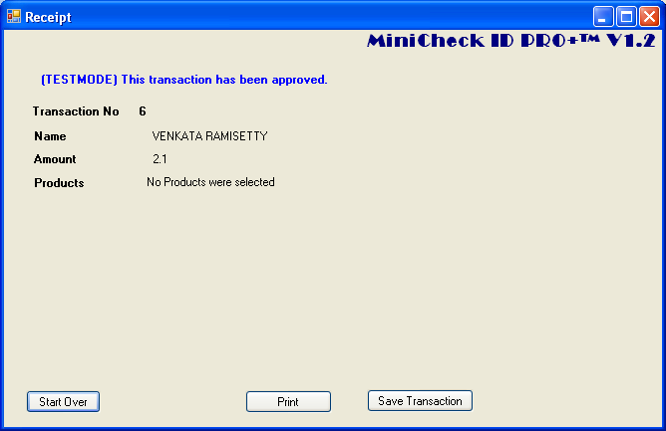
Fig 7: The receipt of the transaction

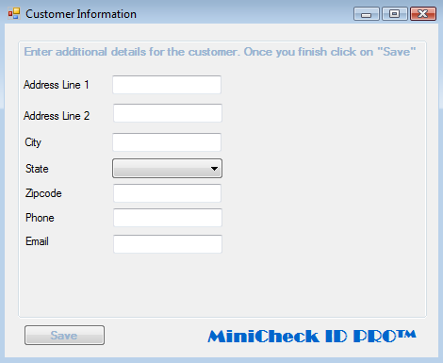
Fig 8: Additional details about the transaction can be entered

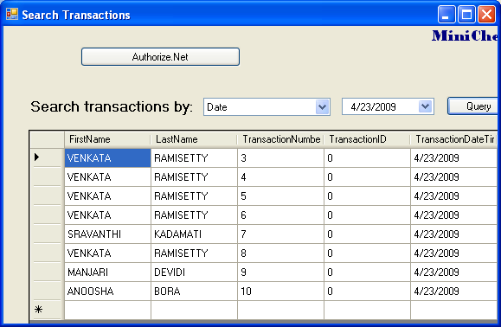
Fig 9: The additional details displayed while searching the transactions

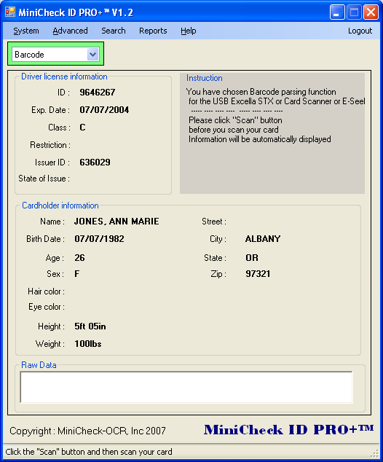
Fig 10: Selection of barcode and the data retrieved after swiping the card

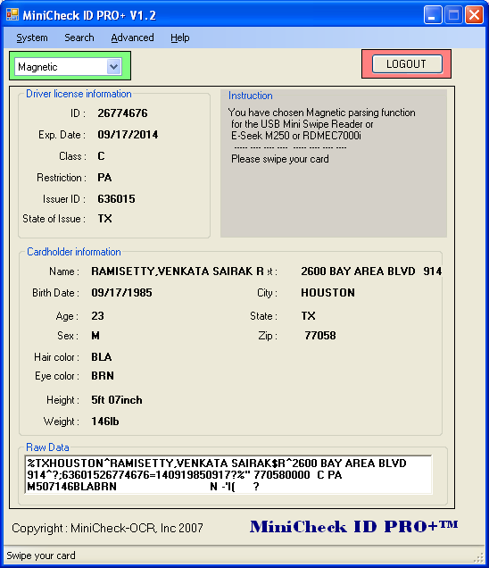
Fig 11: Selection of magnetic and the data retrieved after swiping the card

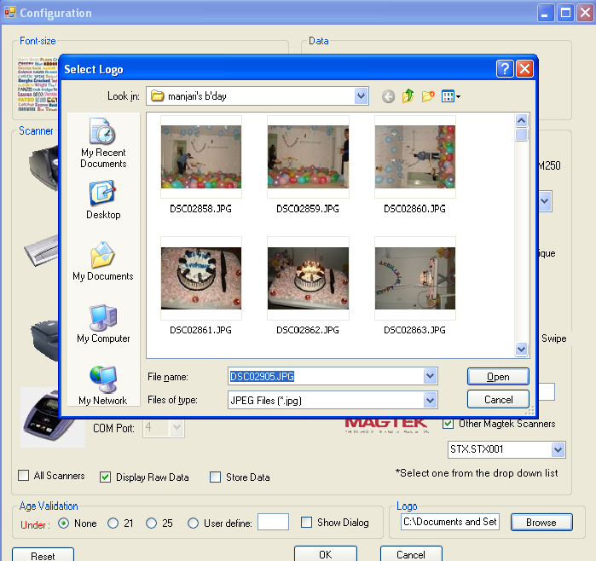
Fig 12: Select browse to select the logo you want to upload in the configuration page

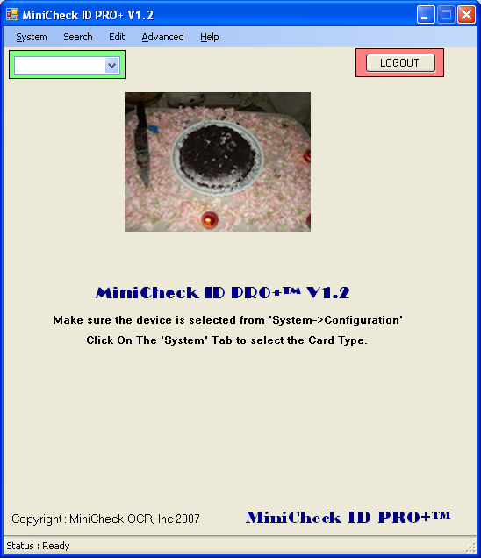
Fig 12: The logo selected uploaded
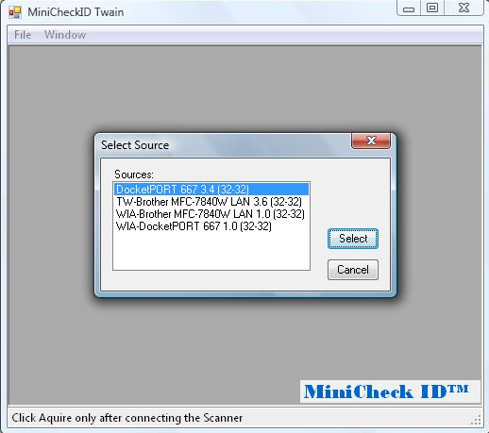
Fig 13: Twain – Select a device

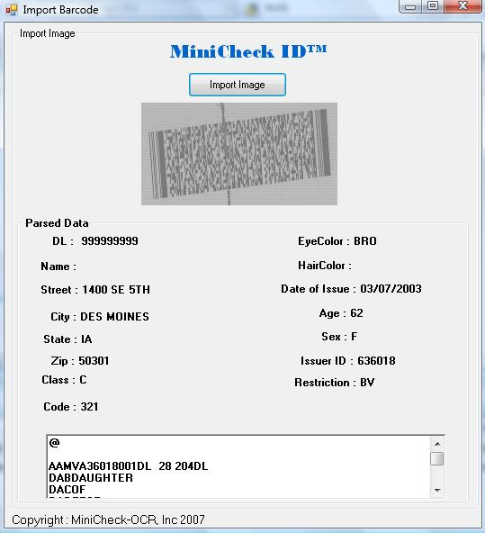
Fig 14: Twain – Import Image

Fig 15: Twain – Select Source
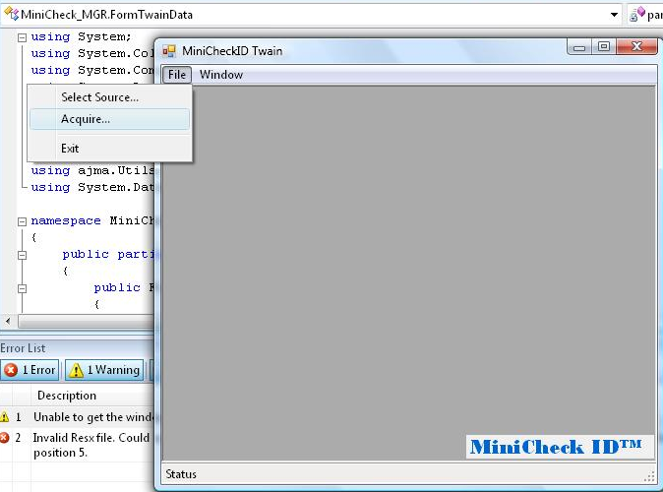

Fig 16: Twain – Acquire Image
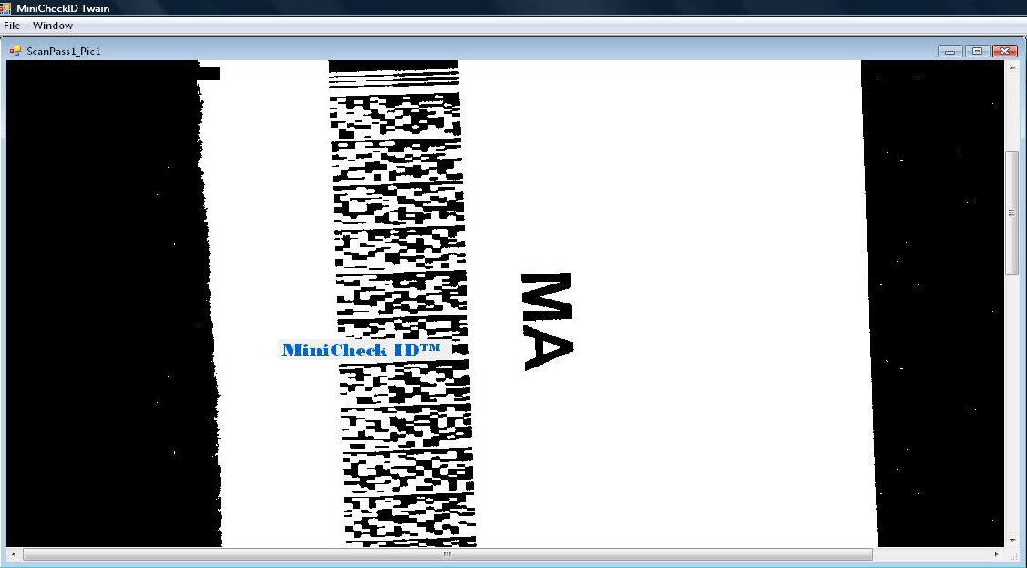
Fig 16: Twain – Acquired Image
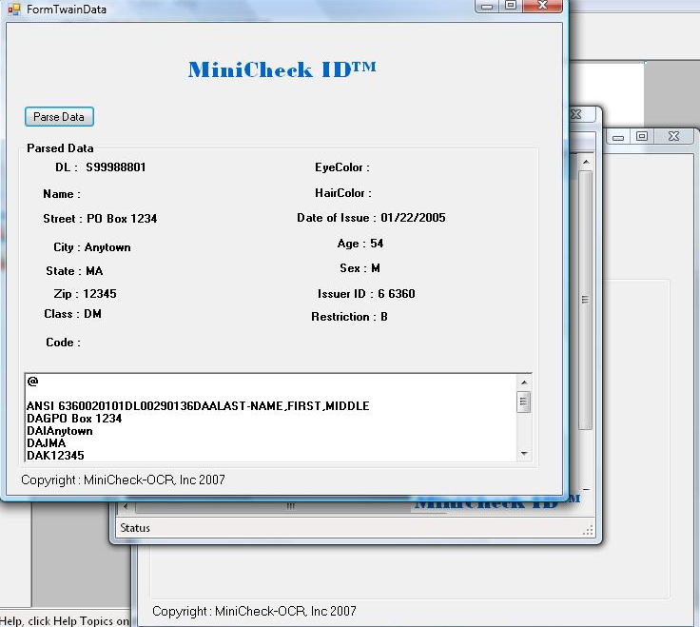
Fig 16: Twain – Parsed Image displaying the data

Appendix C
C.1 Important terminology related to the project
1. Authorize.net: The Authorize.Net Payment Gateway can help to accept credit card and electronic check payments quickly and affordably. [1]
2. E-verify: E-verify are used to verify the employment eligibility of newly hired employees and are implemented with the use of web services. DHS (Department of Homeland Security) provides the web services to implement E-verify in the application. Web service is a service provided by a third party like DHS and is used by calling a Web method. [3]
3. Magtek USB card swipe: This is a magnetic strip card reader that stores data by modifying the magnetism of tiny iron-based magnetic particles on a band of magnetic material on the card.
4. Atalasoft: Atalasoft is an imaging toolkit which is light and powerful SDK to meet photo imaging requirements. It parses the images of the card scanned and converts into raw-data. It can parse both 1D and 2D barcodes and is more cost effective and accurate compared to other parsers available in market. [5]
5. RDM EC7000i: RDM EC7000i captures a high quality two-sided binary image of the check in seconds. It is a bi-directional magnetic stripe reader (MSR) and reads track 1, 2, 3 from the magnetic stripe. [7]
6. E-seek M-250: It is a serial device. It reads 2 dimensional barcode and magnetic stripe reader data. It has built in high performance 3-track magnetic stripe reader.
7. TWAIN scanners: TWAIN defines a standard software protocol and API for communication between software applications and image acquisition devices.
Neat Receipts is one of the TWAIN complaint scanners to test the TWAIN functionality. [6]

