Properties of Paper in Naturally Aged Books
by LEANNE BRANDTS & JAN LYALL
Introduction
An examination of eighteen books, naturally aged for more than one hundred years has been carried out to investigate the effects of natural aging on the paper. The purpose of the study was to determine if there was any relationship between the properties of papers in books which had been artificially aged and those which had been naturally aged. In addition it was hoped that this study might provide some evidence which would assist in drawing comparisons between the microenvironments created within books and those within books which have been shrink wrapped.
In 1980, chemists at the Research and Testing Office at the Library of Congress undertook a study comparing the deterioration of papers under accelerated aging conditions, 90° C and 50% relative humidity, with and without shrink-wrapping¹. Two books were tested: one half of each was shrink wrapped and the other unwrapped. After aging, the paper was tested for pH, acid content, brightness and folding endurance. From the results, they concluded that shrink wrapping significantly increased the rate of degradation of paper. The chemists left it to custodians and conservators to decide whether the physical protection afforded by the shrink wrapping would compensate for any possible increased rate of deterioration.
Researchers at the National Archives and Records Administration, Washington, recently investigated the effect of shrink wrapping on simulated bound volumes². Four volumes were made using 50 sheets of new paper and old bindings. Each volume was cut in half; one half was artificially aged as is; the other was shrink wrapped and then aged. Aging conditions were 70 °C and 65% relative humidity. The brightness, folding endurance, pH and viscosity of paper in each half book was measured. Apart from brightness, the results showed little difference between how paper in the wrapped and unwrapped books aged. The researchers found that the brightness of paper in the wrapped bindings decreased more than the paper in the unwrapped volumes. Testing was performed on the first six pages, the last six and the middle twelve papers. Position was found to have a small but

Table 1: Details of the books used in the study.
a: Books with a significant strength difference between the middle and outer pages

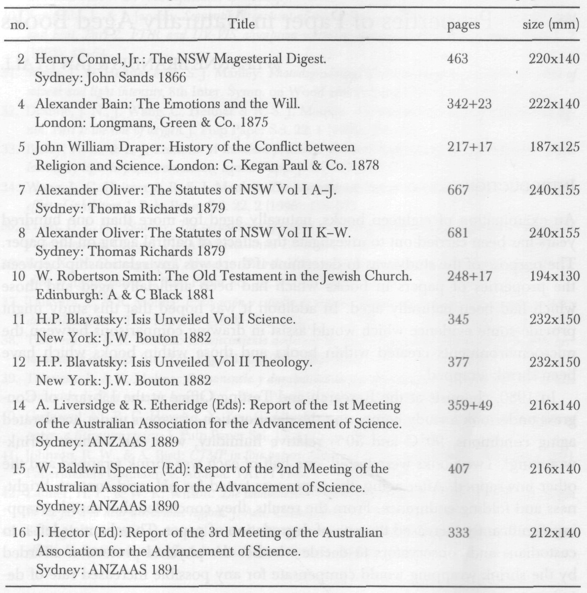

definite effect on brightness; the middle being slightly brighter than those at the front or back of the volume. However, position had no apparent effect on any other properties.
Staff at the Library of Congress have studied the accelerated aging of paper within microenvironments³. Brief details of later work were presented at the International Seminar on Research in Preservation and Conservation held in New York in 1991⁴. At this seminar it was reported that paper in the centre of piles of acidic paper deteriorated more rapidly at 90 ° C and
50 % relative humidity than did single sheets of paper. This was attributed to the retention of degradation products within piles of paper and, by extrapolation, within books also.

Table 1: Details of the books used in the study.
b: Books without a significant strength difference between the middle and outer pages

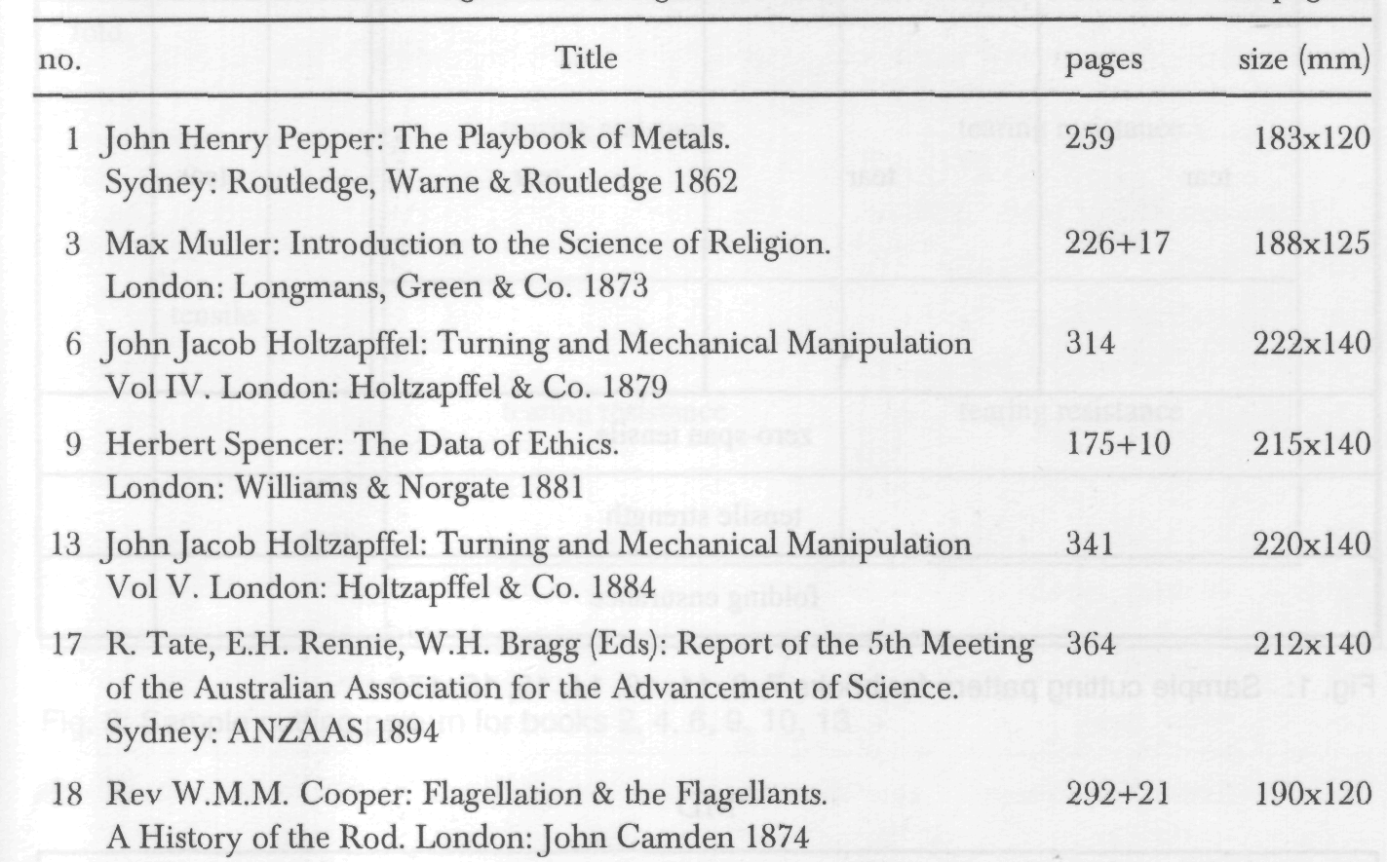

The finding that paper in the middle of a pile deteriorates more rapidly than loose paper is contrary to the commonly held belief that the most deteriorated pages in books tend to be near the front and back covers. This raises the question of whether the findings from the accelerated aging studies could be a result of the elevated temperature and humidity conditions that are required for accelerated aging, and of the temperature and moisture gradients throughout the books that may accompany such aging. To determine if the weaker centre pages were simply an artefact of the accelerated aging process, we examined the strength of papers throughout naturally aged books. This paper reports the findings of our study.
The books
Eighteen books published between 1862 and 1894 were obtained from the clearing centre at the National Library of Australia. All were non fiction, hardcover and in good condition. Their storage history was not known. The books are listed and described in Table 1.
The spines were cut from the books using a guillotine. Five samples of ten adjacent pages were taken from each book (front, front section — halfway between the front and middle, middle, back section - halfway between the middle and the

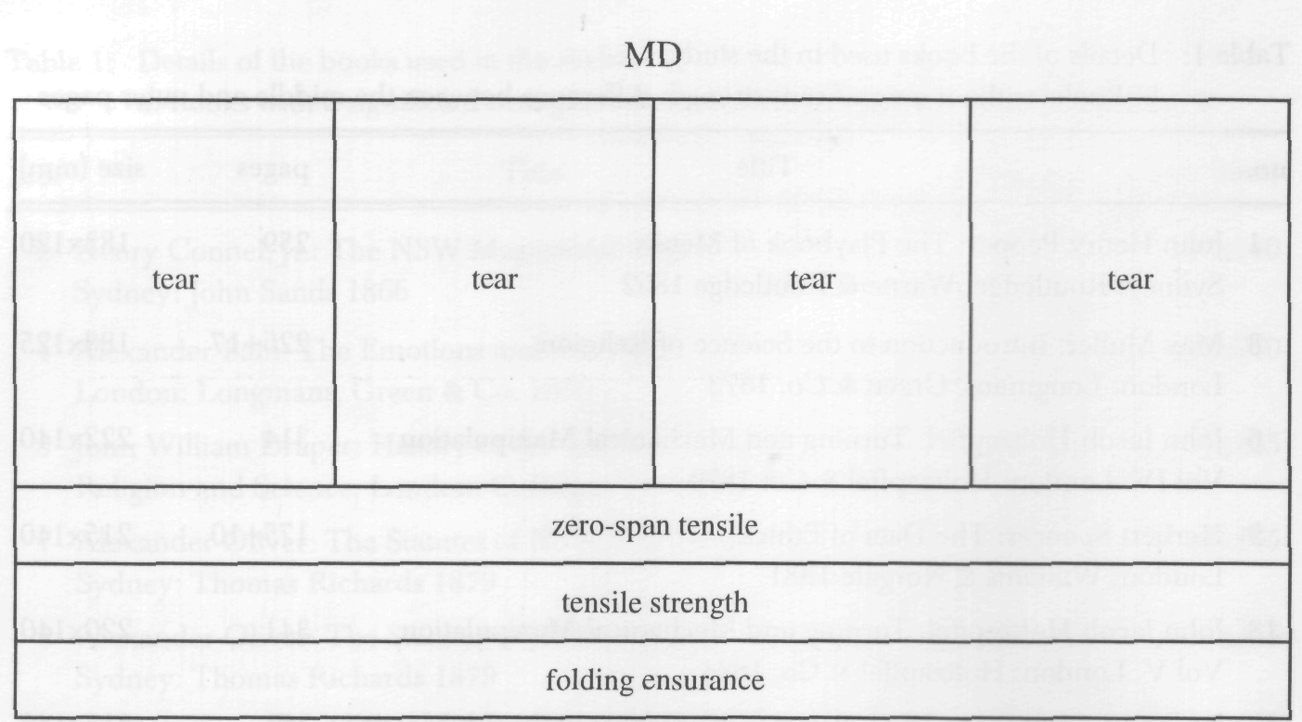

Fig. 1: Sample cutting pattern for books 7, 8, 11, 12, 14, 15, 15, 17

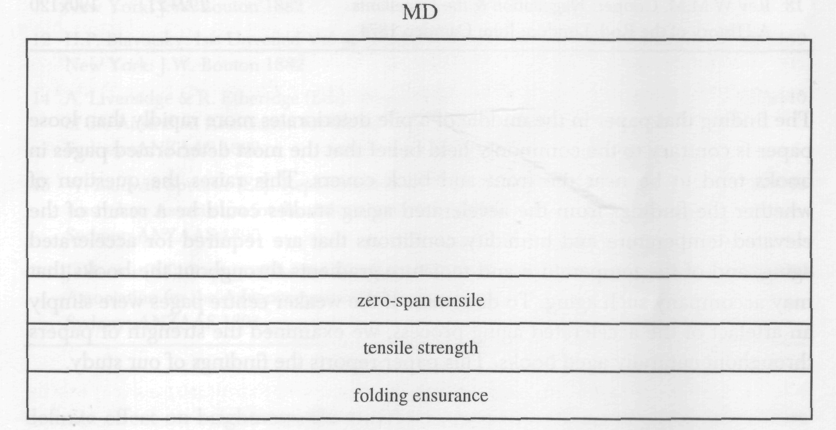

Fig. 2: Sample cutting pattern for books 1,3,5,18
back, and back), designated A-E respectively. Unless the papers were visually different, we assumed that only one type of paper was used in each book. Obviously-different endpapers were not included in the front and back samples. Some books (numbers 3, 4, 5, 9, 10, 14 and 18) had different paper at the end of the book, generally for advertisements or illustrations. Only four samples were possible from these books; sample E was not taken.

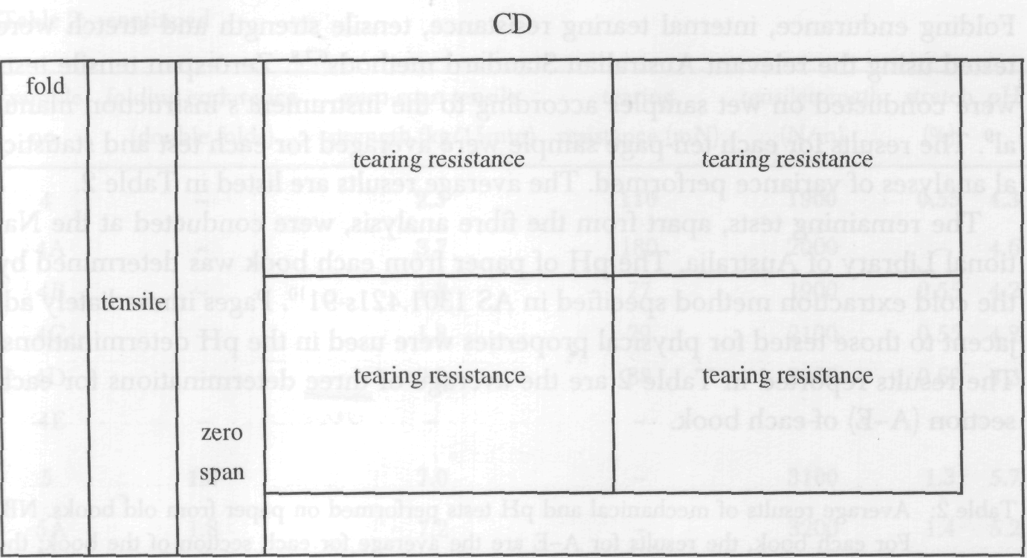

Fig. 3: Sample cutting pattern for books 2, 4, 6, 9,10, 13
The specimen cutting pattern for books 7, 8, 11, 12, 14, 15, 16 and 17, which have the machine direction (MD) of the paper parallel to the spine, is illustrated in Fig. 1. The remaining books with the machine direction parallel to the spine, books 1, 3, 5 and 18, were too small to have pieces for tearing resistance cut from them; the specimen cutting pattern for these books is shown in Fig. 2. Fig. 3 illustrates the cutting pattern for books 2, 4, 6, 9, 10 and 13 which has the machine direction of the paper perpendicular to the spine.
The tests
The samples were tested in the machine direction for folding endurance, tensile strength, stretch and zero-span tensile strength. Tearing resistance in the cross direction (CD) was determined on paper from all books except books 1, 3, 5 and 18. For each test, the direction of testing was that in which the property was greatest, as this would better highlight any differences between papers (in the weaker direction, the properties may have been reduced to such low levels that distinguishing between them is not possible).
Physical testing of the above properties was performed at the Division of Forest Products, Commonwealth Scientific and Industrial Research Organisation, Melbourne, Australia. All paper samples were conditioned for at least twenty-four hours at 23°C and 50% relative humidity according to AS 1301 414m-86⁵.

Folding endurance, internal tearing resistance, tensile strength and stretch were tested using the relevant Australian Standard methods^{6,7,8}. Zero-span tensile tests were conducted on wet samples according to the instrument's instruction manual⁹. The results for each ten-page sample were averaged for each test and statistical analyses of variance performed. The average results are listed in Table 2.
The remaining tests, apart from the fibre analysis, were conducted at the National Library of Australia. The pH of paper from each book was determined by the cold extraction method specified in AS 1301.421s-91¹⁰. Pages immediately adjacent to those tested for physical properties were used in the pH determinations. The results reported in Table 2 are the average of three determinations for each section (A-E) of each book.
Table 2: Average results of mechanical and pH tests performed on paper from old books. NB: For each book, the results for A-E are the average for each section of the book; the number in bold is the average of these results and represents the average result for the entire book.

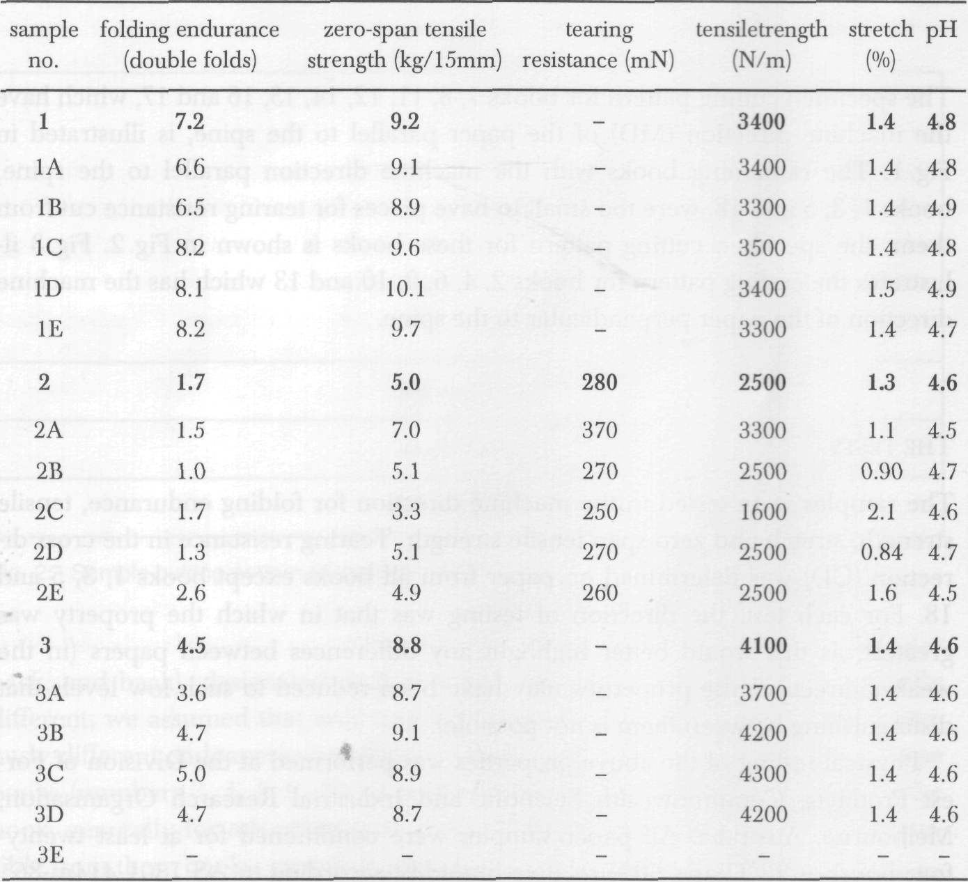

Table 2: continued

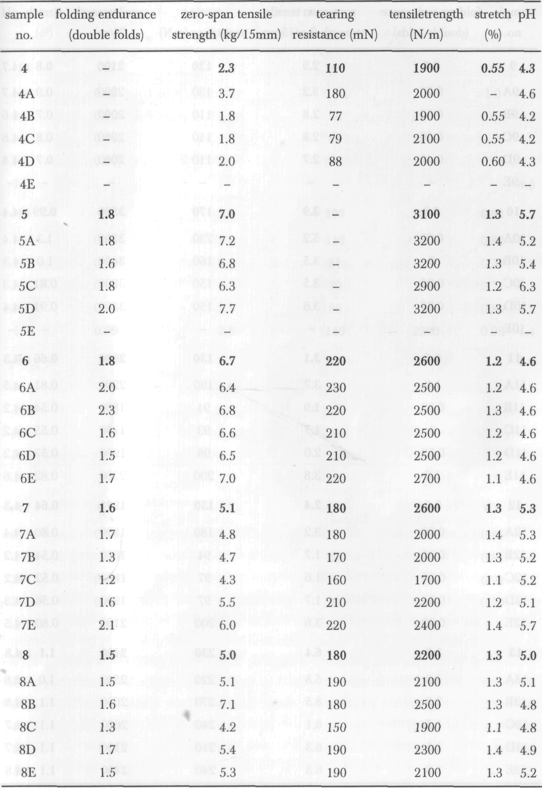

Table 2: continued

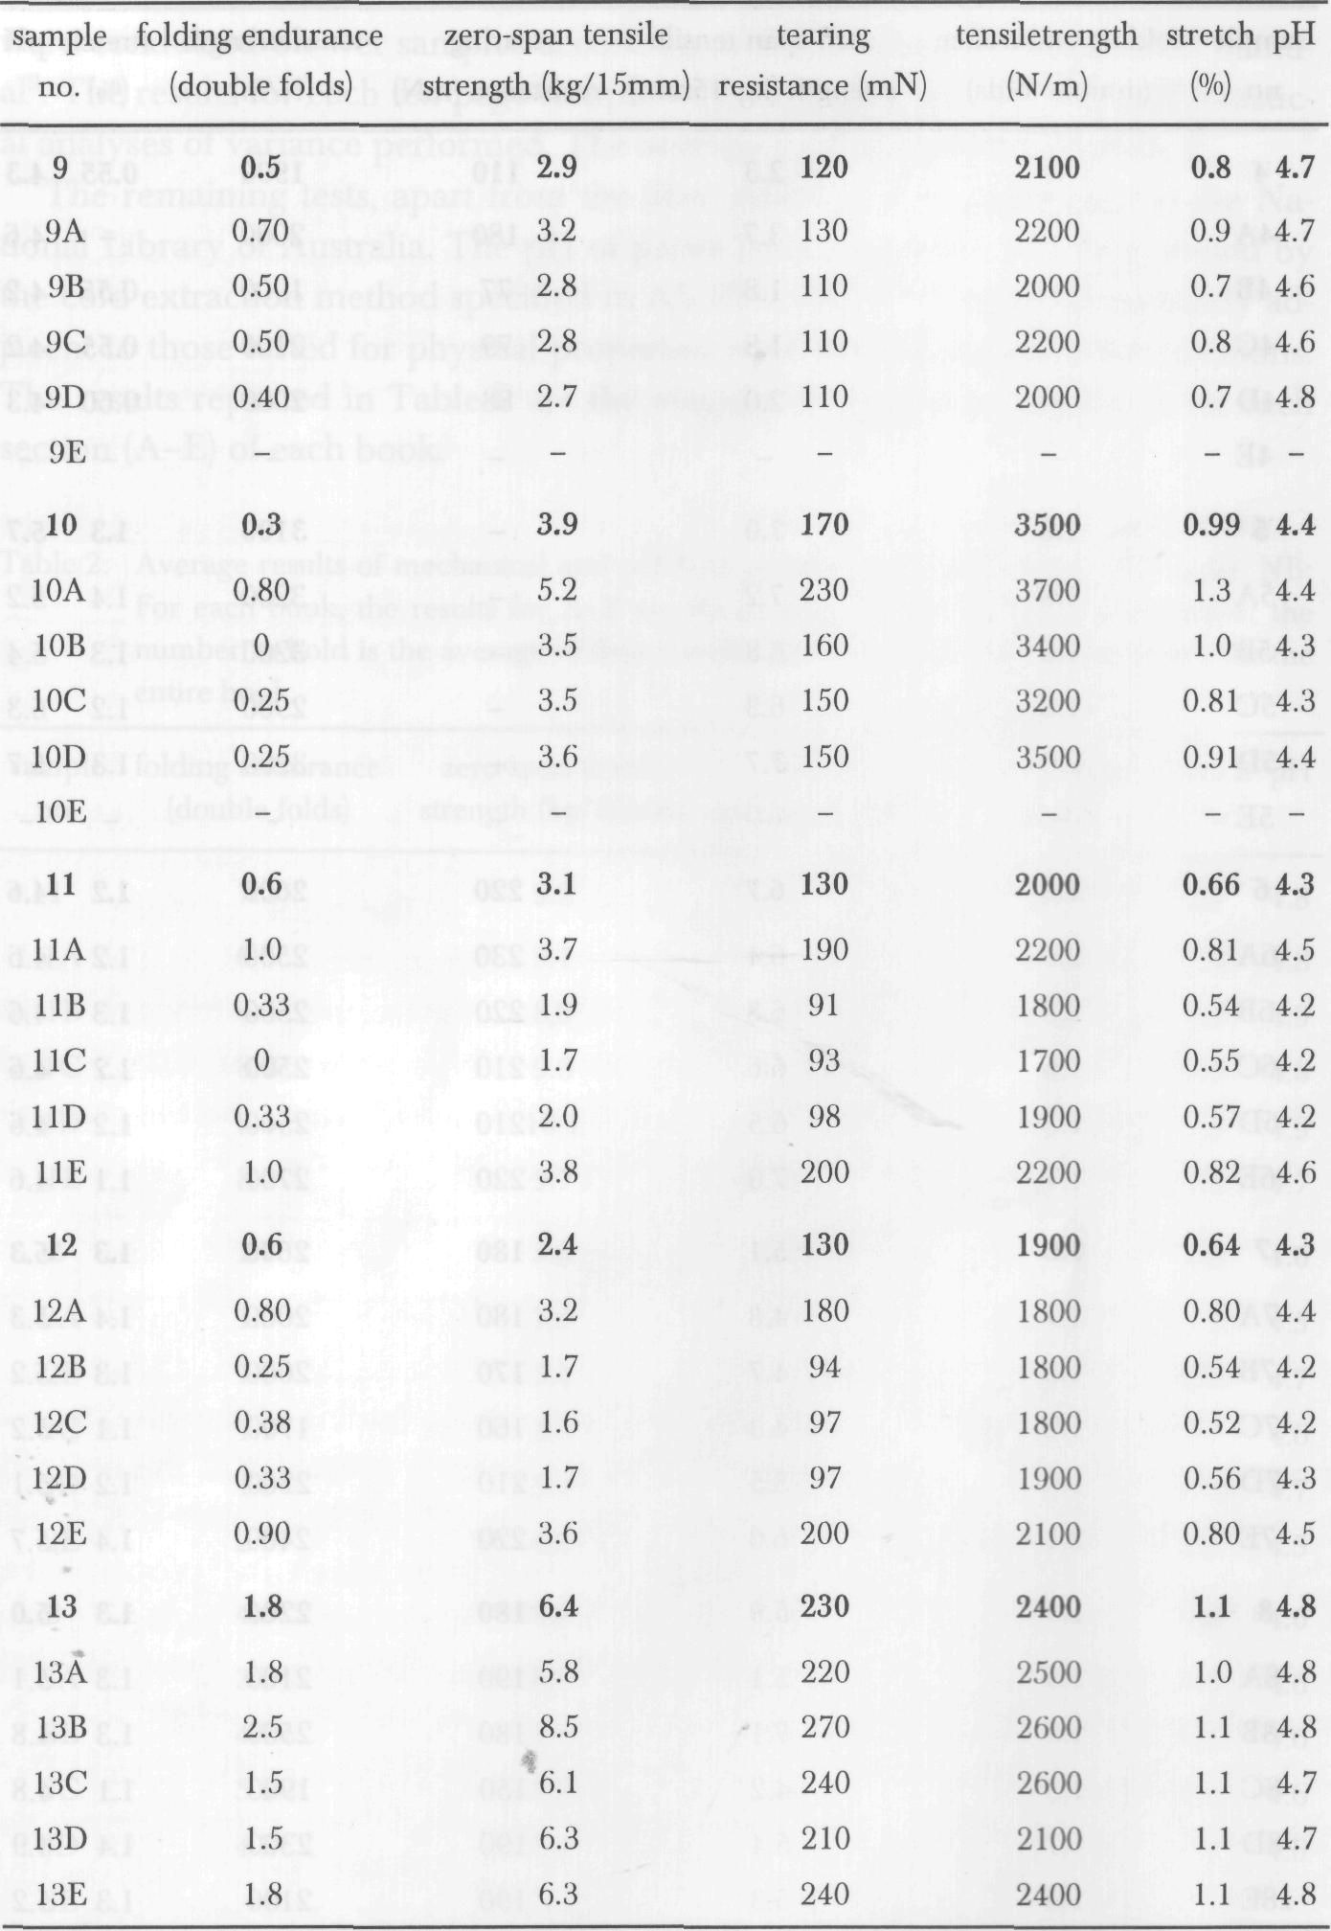

Table 2: continued

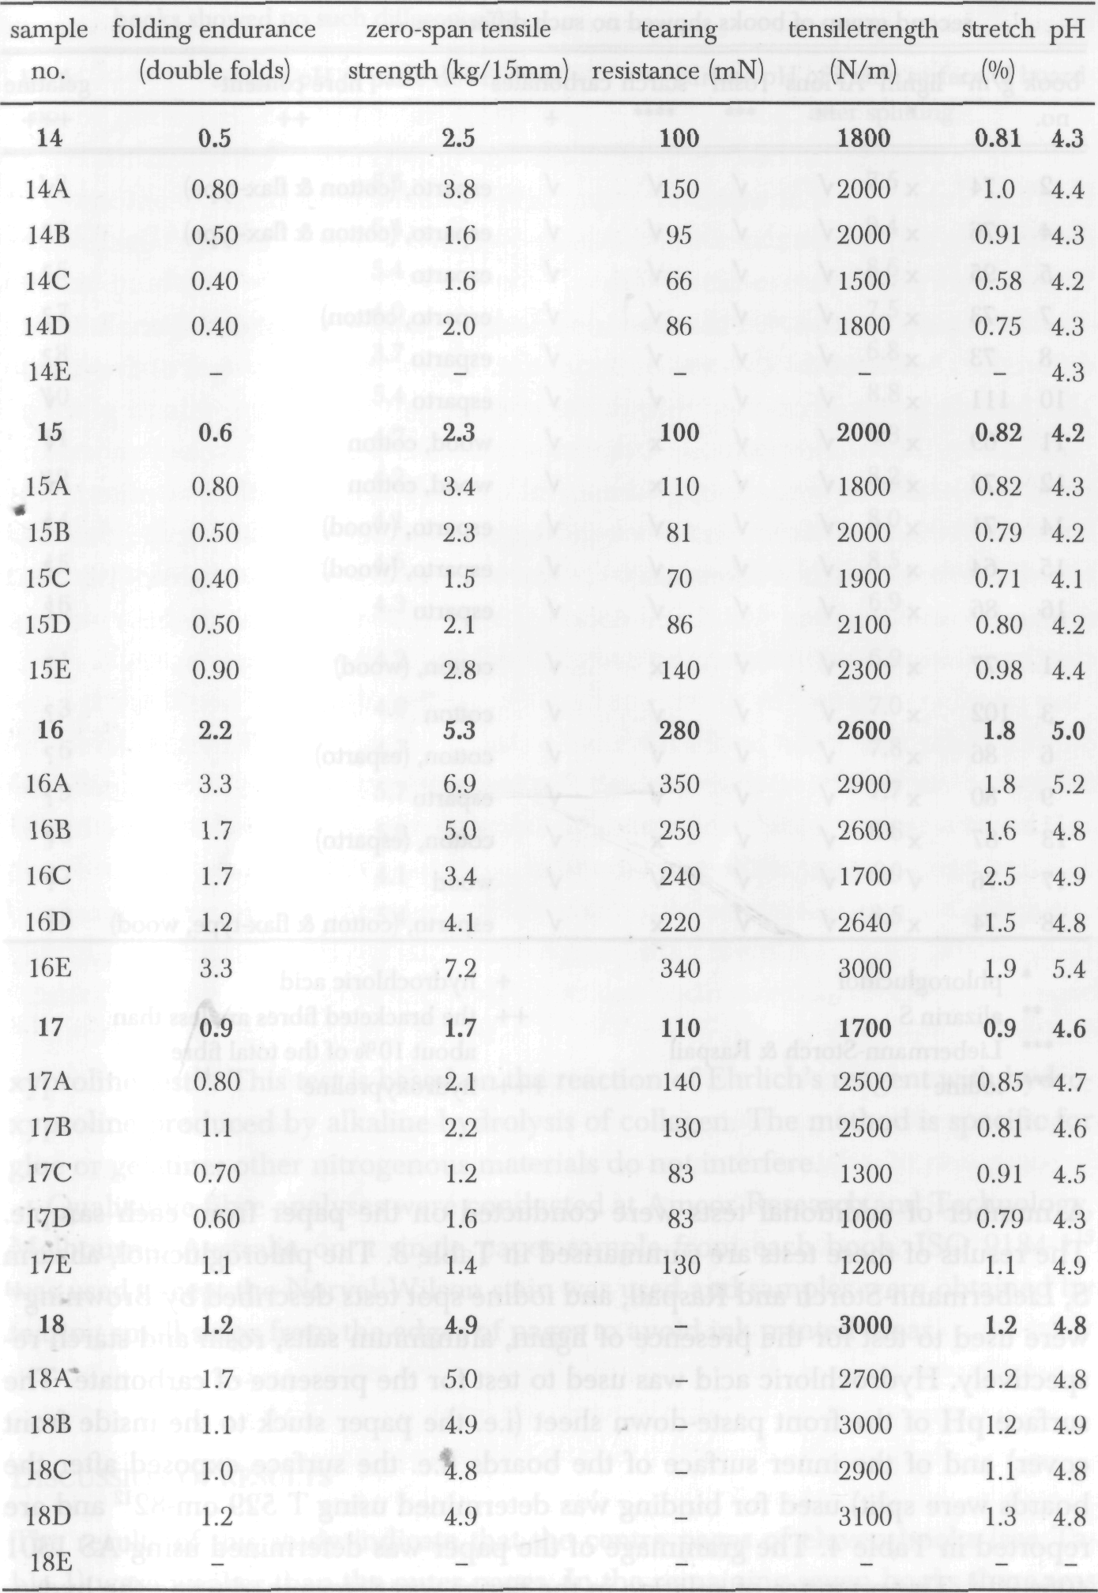

Table 3: Results of tests used to further characterise the paper. The first group of books are those with a significant strength difference between the middle and outer pages; the second group of books showed no such difference.

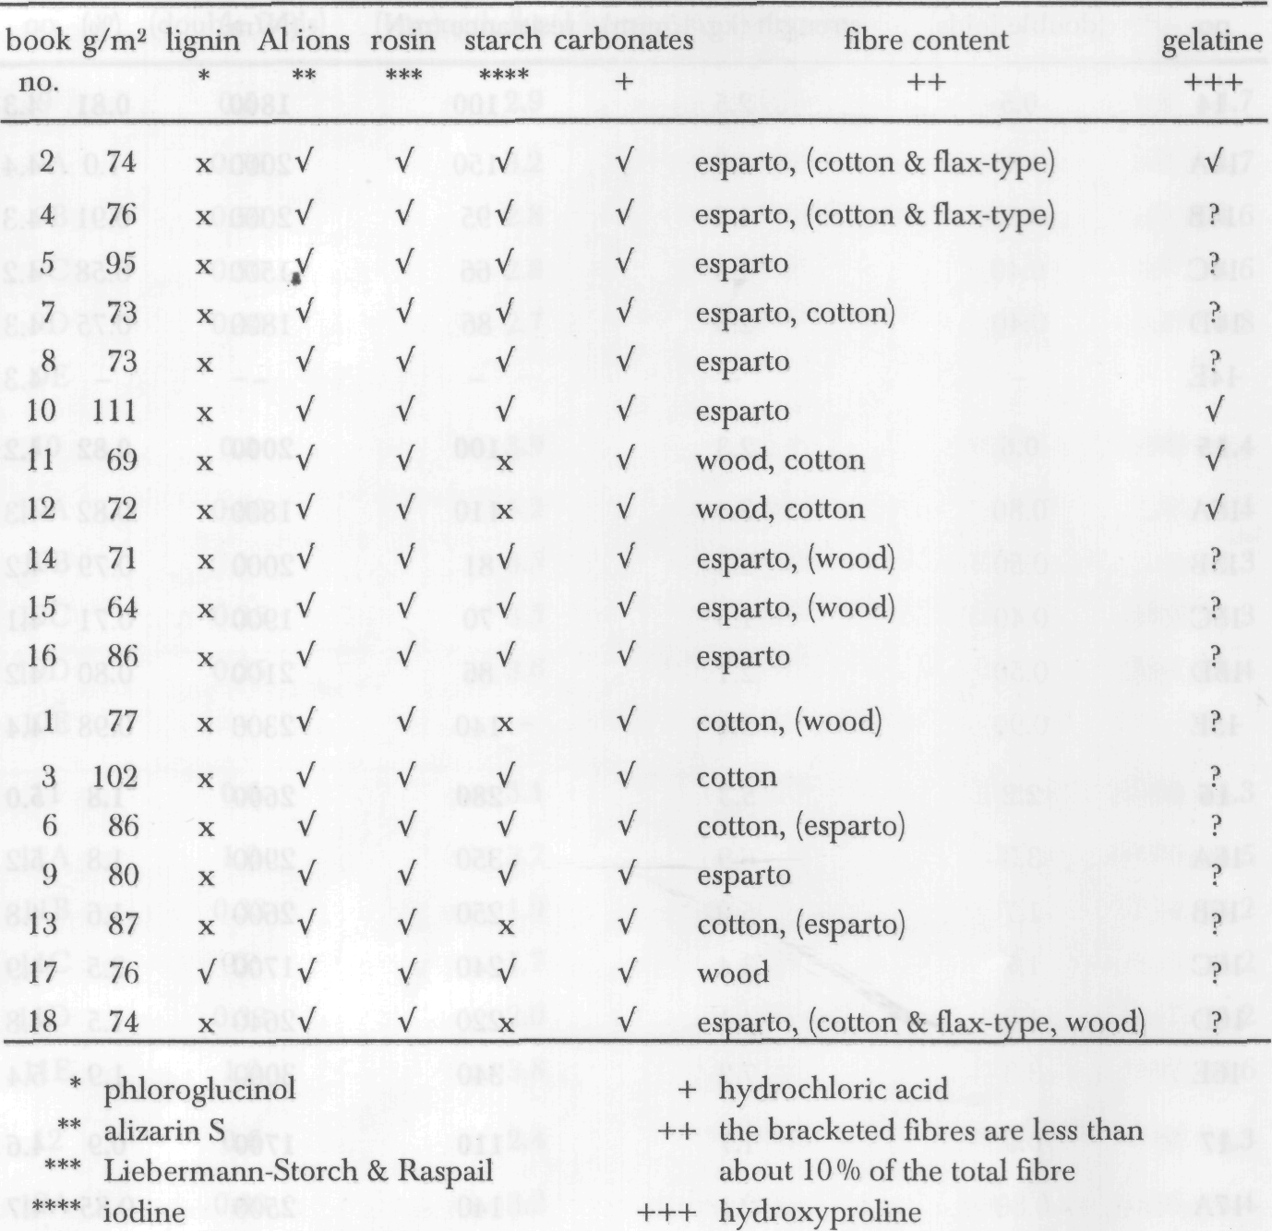

A number of additional tests were conducted on the paper from each sample. The results of these tests are summarised in Table 3. The phloroglucinol, alizarin S, Liebermann-Storch and Raspail, and iodine spot tests described by Browning¹¹ were used to test for the presence of lignin, aluminium salts, rosin and starch respectively. Hydrochloric acid was used to test for the presence of carbonate. The surface pH of the front paste-down sheet (i.e. the paper stuck to the inside front cover) and of the inner surface of the boards (i.e. the surface exposed after the boards were split) used for binding was determined using T 529 om-82¹² and are reported in Table 4. The grammage of the paper was determined using AS 1301 405s-92¹³. The presence of gelatine in the paper was determined using the hydro-

Table 4: Surface pH of boards and endpaper. The first group of books are those with a significant strength difference between the middle and outer pages; the second group of books showed no such difference.

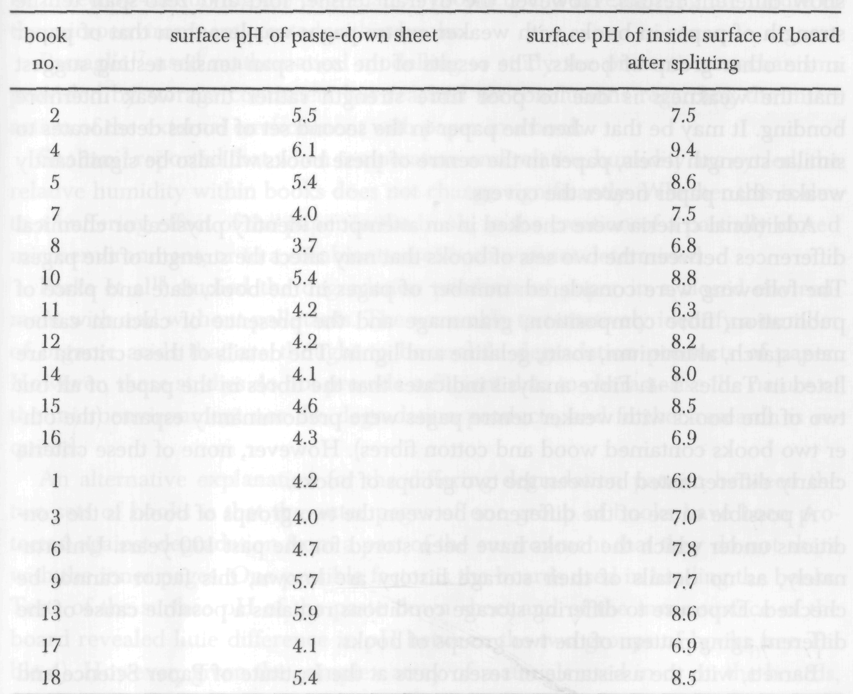

xyproline test¹⁴. This test is based on the reaction of Ehrlich's reagent with hydro-xyproline produced by alkaline hydrolysis of collagen. The method is specific for glue or gelatine; other nitrogenous materials do not interfere.
Qualitative fibre analyses were conducted at Amcor Research and Technology, Melbourne, Australia on a single paper sample from each book. ISO 9184-1¹⁵ was used except the Norval Wilson stain was used and samples were obtained by tearing small strips from the edges of pages to avoid ink printed areas.
Discussion of results
The results of this study indicate that the centre pages of eleven books (see Table 1) were weaker than the outer pages. In the remaining seven books there was

no significant difference between the strength of the middle and outer pages. There was no immediately apparent reason why the two groups of books should show different results. However the overall tensile, fold and zero-span tensile strength of paper in books with weaker centre pages was less than that of paper in the other group of books. The results of the zero-span tensile testing suggest that the weakness is due to poor fibre strength rather than weak interfibre bonding. It may be that when the paper in the second set of books deteriorates to similar strength levels, paper in the centre of these books will also be significantly weaker than paper nearer the covers.
Additional criteria were checked in an attempt to identify physical or chemical differences between the two sets of books that may affect the strength of the pages. The following were considered: number of pages in the book, date and place of publication, fibre composition, grammage and the presence of calcium carbonate, starch, aluminium, rosin, gelatine and lignin. The details of these criteria are listed in Tables 1-4. Fibre analysis indicates that the fibres in the paper of all but two of the books with weaker centre pages were predominantly esparto (the other two books contained wood and cotton fibres). However, none of these criteria clearly differentiated between the two groups of books.
A possible cause of the difference between the two groups of books is the conditions under which the books have been stored for the past 100 years. Unfortunately, as no details of their storage history are known, this factor cannot be checked. Exposure to differing storage conditions remains a possible cause of the different aging pattern of the two groups of books.
Barrett, with the assistance of researchers at the Institute of Paper Science and Technology, examined handmade papers from the 15-19th centuries¹⁶. On the basis of appearance, he described half of these papers as being in excellent condition and half in poor condition.
A number of tests were used to characterise both groups of papers and to draw conclusions about the reasons for their present conditions. One of these tests was the detection of gelatine. Both infra-red and ultra-violet techniques were used to determine gelatine quantitatively. A correlation was found between the paper condition and gelatine content - historical papers in good condition contain significantly more gelatine that paper in poor condition. In the present study, the hydroxyproline test was inconclusive for most papers but indicated the presence of gelatine in books 2, 10, 11 and 12. These four books contained some of the stronger papers and all exhibited weaker centre pages. The infra-red spectro-scopy technique used in Barrett's study was attempted but not successful in quantifying the gelatine content of the paper in the old books in our study. Differing gelatine contents remain a possible reason for the differences between the two groups of books.

Shahani has suggested that the centre pages of some books are weaker because the degradation products are retained within the book⁴. This hypothesis needs to be tested by identifying the degradation products and investigating the nature of the microenvironment created within books.
Passaglia¹⁷ used mathematical modelling to study the protective mechanisms provided by storage containers but reached no conclusions regarding the interaction of the external environment with paper in a book.
Shahani³ reported that when temperature and relative humidity are cycled, the relative humidity within books does not change significantly. Whether this is due to a buffering effect of the paper in the book, to the creation of a partially closed microenvironment, or to a combination of both was not determined.
Parks et al¹⁸ studied the degradation products of paper in a closed environment with and without pollutants. The were able to tentatively identify a number of organic acids that are thought to be mobile degradation products of paper. However, these studies do not provide sufficient data to characterise the nature of the microenvironment nor the degradation products, and further research is required.
An alternative explanation for the differing degradation pattern between the two sets of books is that the outer pages of one group of books have been protected against degradation from a part of the environment that they do not share with the inner pages. One possible factor is the boards used in binding the books. Tests of the surface pH of the paste down sheet and of the inner surface of the board revealed little difference in pH between the two groups of books (see Table 4). However, given the complex array of materials used in or on the boards, factors other than pH may protect paper adjacent to them. It is interesting to note that, for all books, the pH of the end papers was on average three pH units below that of the inner surface of the board.
Conclusion
In the sample examined, a statistically significant portion of the books had centre pages weaker than the outer pages. No logical explanation for this observation has been found.
The observation that the centre pages of some books are weaker than the outer pages concurs to some extent with results from accelerated aging studies of the effects of shrink wrapping on the degradation of books. This indicates that the microenvironment created within a book is such that the centre of the pile deteriorates faster than the outside regardless of whether the book is shrink wrapped or not.

Acknowledgement
We thank the late Mr. Alex McKenzie, formerly Principal Research Scientist at the Division of Forest Products, Commonwealth Scientific and Industrial Research Organisation, Melbourne, Australia, for completing the mechanical paper tests, for his many valuable comments and suggestions, and for his friendly and helpful assistance. We also thank Ray Fish for his comments.
Summaries
Properties of paper in naturally aged books
Artificial aging studies indicate that paper in books deteriorates faster than single sheets of paper, and that paper in the centre of a stack deteriorates faster than paper on the outside of the stack. The present study was conducted to determine if this was also true for naturally aged books. Mechanical tests were performed on paper from naturally aged books that were at least one hundred years old. The results of the testing revealed that the centre pages of a significant proportion of the books were weaker than pages nearer to the book covers. Additional chemical and physical tests have not distinguished between those books with weaker centre pages and the others. The results agree to some extent with those from artificial aging studies.
Proprietes du papier des livres vieillis naturellement
Des etudes realisees sur le vieillissement artificiel du papier ont demontre que le papier contenu dans les livres se deteriore plus rapidement que celui des feuilles de papier isolees; on observe le meme phenomene pour les feuilles de papier empilees dans un tas: celles qui sont au milieu se deteriorent plus rapidement que celles placees vers l'exterieur. Cette etude a ete menee pour determiner si ce phenomene se produisait egalement pour les livres vieillis naturellement. On a me-sure la resistance mecanique sur des livres vieillis naturellement qui avaient au moins cent ans. Les resultats des tests ont revele que les pages centrales d'une proportion significative des livres etaient moins resistantes que les pages placees plus pres de la couverture des livres. D'autres tests chimiques et physiques n'ont pas permis de constater une difference dans la resistance du papier entre les pages centrales et celles plus exterieures. Les resultats correspondent a peu pres a ceux observes lors d'etudes sur le vieillissement accelere.
Messungen an Papier in natiirlich gealterten Büchern
Frühere Untersuchungen zur beschleunigten Alterung zeigen, daß Papier in Büchern schneller an Qualität einbußt als einzelne Blätter, ebenso wie Blätter im Innern eines Stapels im Vergleich zu den äußeren. Jetzt wurde untersucht, ob dies auch für natürlich gealterte Bücher gilt. Es wur-

den die mechanischen Festigkeitswerte des Papiers aus mndestens hundert Jahre alten Büchern gemessen. Die Ergebnisse zeigen, daß in einer signifikanten Anzahl von Fällen die Blätter im In-nern eines Buches schwächer sind als die näher bei den Deckeln gelegenen. AUerdings gibt es keinen korrespondierenden Unterschied bei anderen chemischen und physikalischen Meßwer-ten. Die Ergebnisse stimmen in etwa mit den bei bcschleunigter Alterung beobachteten überein.
REFERENCES
1. Kelly, G.B.: Effect of shrink-wrapping with plastic film on the aging of books and/or papers. Library of Congress Memorandum, October 27, 1980.
2. Debelius, E., Hueber, R., Napier-Cain, E., Rogers, P. & Lee-Bechtold, S.: Initial findings: A study of shrink wrapped, simulated bound volumes. National Archives and Records Administration Report. March 24, 1992.
3. Shahani, C.J., Hengemihle, F.H. & Weberg, N.: The effect of variations in relative humidity on the accelerated aging of paper. In: Zeronian, S.H and Needles, H.L., eds. Historic textile and paper materials II. ACS Symposium Series, 410. Washington, D.C.: American Chemical Society, 1989: 63-80.
4. Shahani, C: Effects of fluctuations in relative humidity and temperature on conditions within the book structure. Paper delivered at the International Seminar on Research in Preservation and Conservation. Arden House, Columbia University, New York, May 1991.
5. Standards Association of Australia: Conditioning of paper for testing. AS 1301.414m-86. Sydney: Standards Association of Australia, 1986.
6. Standards Association of Australia: Folding endurance of paper Kohler-Molin method. AS1301. 423rp-89. Sydney: Standards Association of Australia, 1989.
7. Standards Association of Australia: Internal tearing resistance of paper. AS 1301.400s-91. Sydney: Standards Association of Australia, 1991.
8. Standards Association of Australia: Tensile strength of paper and paperboard. Constant rate of elongation method. AS 1301.448s-91. Sydney: Standards Association of Australia, 1991.
9. Pulmac Instruments International: Instruction manual for TS100 Trouble Shooter. Vermont.
10. Standards Association of Australia: Determination of the pH value of aqueous extracts of paper, board and pulp-cold extraction method. AS 1301.421s-91. Sydney: Standards Association of Australia, 1991.
11. Browning, B.L.: Analysis of paper. New York: Marcel Dekker, 1977.
12. Tappi: Surface pH measurement of paper. T 529om-82. Atlanta: Tappi, 1982.
13. Standards Association of Australia: Grammage of non-crepedpaper and board. AS 1301.405s-92. Sydney: Standards Association of Australia, 1992.
14. Tappi: Glue in paper (qualitative and quantitative determination). T 504om-84. Atlanta: Tappi, 1984.
15. International Organisation for Standardisation: Paper, board and pulps - Fibre furnish analysis — Part 1: General Method. ISO 9184-1 1990. International Organisation for Standardisation, 1990.
16. Barrett, T.: Early European papers/Contemporary conservation papers: A report on research undertaken from fall 1984 through fall 1987. The Paper Conservator 13 (1989).
- Passaglia, E.: The characterisation ofmicroenvironments and the degradation of archival records, Re-staurator 10 (1989): 123-150.

18. Parks, EJ., Guttman, C.M.,Jewett, K.L. & Brinckman, F.E.: Studies on the degradation products of paper with and without pollutants in a closed environment. I, Preliminary results. NISTIR 4456. MD: National Institute of Standards and Technology, US Department of Commerce, 1990.

Leanne Brandis
formerly Chemist, Preservation Services

Jan Lyall, Director, National Preservation Office
National Library of Australia
Parkes Place
Canberra ACT 2601
Australia

