AirTran Airways EventSavers Program

The AirTran Airways EventSavers Program offers discounted air travel and unique benefits for conventions, meetings or other events when ten or more individuals are flying into a single destination from different cities. Event Planners and Travel Agents should call the AirTran Airways EventSavers Desk at 1-866-68-EVENT (1-866-683-8368) to obtain more information about the following features:

- A 10% discount on the lowest available AirTran Airways one-way fare
- No minimum stay length or Saturday night requirement
- Advance seat assignments at time of purchase
- Confirmed upgrade to Business Class, when available, for attendees booking in the “B” and “Y” fare levels
- A one-time waiver of Change/Cancel Fee per reservation for any name or itinerary change for the first change
- A single Event Code provided for each event so attendees may book their own reservations at their leisure
- A convenient toll-free number connects you directly to our EventSavers Desk
- Travel Agents must book all EventSavers reservations directly with the EventSavers Desk to receive the 10% discount.
- Reservations booked through a travel agent General Data System or the Internet will not qualify for the 10% discount
- Attendees may travel three (3) days prior to the event start date and three (3) days after the event close date if they wish to spend any additional time at the event location
- One complimentary round trip coach ticket for every 30 passengers who travel using your EventSavers code
- Receive special EventSavers rates from our rental car partner, Hertz, just for being transferred to the Hertz Desk by our EventSavers Coordinators.

To take advantage of this special program, the event planner should contact the AirTran Airways EventSavers Desk at 1-866-68EVENT (1-866-683-8368) to register the event. All attendees will need to have the listed Event Code and must provide the name of the Event upon booking. Just provide the location and meeting dates of your event as well as the number of attendees who will be flying with AirTran Airways, and we will do the rest!

Thank you for choosing AirTran Airways for all of your air travel requirements.
AirTran Airways EventSavers Program Agreement

Thank you for choosing AirTran Airways for your EventSavers needs. The AirTran Airways EventSavers Program offers discounted air travel and unique benefits for conventions, meetings, and other events when 10 or more individuals are flying into a single destination from different cities. This agreement covers EventSavers Travel only. If your event does not meet the minimum requirements, passengers will be considered individual travelers and must be booked through our standard Reservations Center at 1-800-AIRTRAN (1-800-247-8726).

You will be provided with a single event code that attendees may use to book their own reservations at their leisure. Attendees may travel as early as three (3) days prior to the event and as late as three (3) days after the event. Each reservation will be booked at the lowest available fare at the time of booking, minus a ten percent (10%) discount
Each payment can be made with a check (company, travel agency or cashiers), money order, UATP card, or credit card (Visa, MasterCard, Discover, Diners Club or American Express) for the entire amount due. Multiple checks and/or credit cards are not accepted. Payments received within 30 days of travel must be made by a credit card, cashier check, or money order only. Personal checks are not accepted.

Reservations will be held up to ten (10) calendar days from the original date of booking. All travel must be paid in full 48 hours prior to the departure date (including weekends). The reservation will automatically cancel if payment is not received at the AirTran Airways EventSavers Desk by the allotted time.

EventSavers fares are not refundable. Attendees may make a one-time change or cancellation to the reservation with no change/cancel fee. All subsequent changes will be subject to a change fee and any applicable fare difference. In addition, confirmed B or Y fare class attendees will be upgraded to business class seating, if available. When you book travel to your event, meeting, or convention through EventSavers, you will receive one (1) free roundtrip coach ticket for every thirty (30) passengers that travel.
AirTran Airways reserves the right to cancel this agreement immediately upon any breach of this agreement by either the event planner or any member of the convention, meeting, or event. Transportation on AirTran Airways is subject to the terms of our contract of carriage, which is available at any AirTran Airways airport or ticket office. Please keep in mind that all flights and schedules are subject to change and service can be discontinued without notice. Therefore, we recommend that you confirm your reservation with AirTran Airways several days prior to departure.

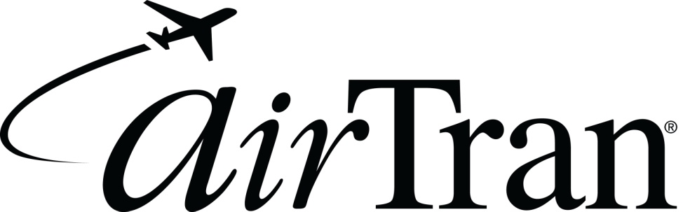
EventSavers Program Agreement (cont’d):
Your event will be registered on the basis of the following information you provided

Today’s Date:
January 25, 2012
Event Code: ZZDC072112 Event Name: RESULTS INTERNATIONAL CONFERENCE_

Event Location: REAGAN - DCA AND BALTIMORE - BWI

Event Date(s): JUL 21 - JUL 25
Approved Travel Dates: JUL 18 - JUL 28

Departure Cities: Various

Event Planner: MRS DIANA TYREE-EDDY

Phone Number: 360 638 2050 /// 360 434 1158

Address: P O BOX 166

City, State, Zip Code: HANSVILLE, WA 98340

Email Address: AUTUMNGUEST@HOTMAIL.COM

Booking Agent:

Reservations will be held for ten (10) calendar days from the original date of booking but will automatically cancel if payment is not received at the AirTran Airways EventSavers Desk by the allotted time.

Address all payments/correspondence regarding this agreement to:

EventSavers Desk
AirTran Airways Inc
1800 Phoenix Blvd Ste 105
Atlanta GA 30349

The EventSavers Desk is available M-F 8:00am-9:00pm EST excluding Holidays.
Toll Free: 1-866-683-8368
Email: grpdesk@airtran.com

HERTZ, OUR RENTAL CAR PARTNER, HAS SPECIAL MEETING RATES.
THANK YOU FOR CHOOSING AIRTRAN AIRWAYS!

