memorandum

To: Missy Kurek, Deputy Executive Director for Finance
Stella Ross, National Finance Director
Fr: Amy Soenksen, Finance Operations Director, DCCC
Dt: November 24, 2014
RE: Finance Operations Director End of Cycle Memo

Job Overview:

The Finance Operations Director role is a very crucial role in supporting the DCCC Finance Department. The two main responsibilities are handling the intake and processing of all incoming contributions to Finance, as well as serving as a liaison between the DCCC and Democratic Leader Nancy Pelosi’s office and DCCC Chairman Steve Israel’s office regarding scheduling, briefings, invitations, and deadlines. It is vital in this role to ensure information is being communicated to the correct people through the proper channels, and that tasks and responsibilities are being completed in a timely and efficient manner. Understanding how the DCCC works, organized systems and steady routines are keys to success in this position.

FIRST THING IN THE MORNING:
- Print the long term – 4 copies double sided and stapled to SPEAKER, 1 for Missy, 1 for Stella, 1 for Krista and 1 for Finance Staff to look at and to be housed at your desk in the bin.
- Keep the long term open on your computer as you will have to refer to it several times throughout the day
- Open the Daily Intake and the Money In spreadsheet and keep open on your computer – you will be editing these throughout the day as well
- Check the online money from the night before. Keep Authorize open – you will be checking this throughout the day as well
- Login to NGP- you will likely be in and out of this all day too.

THINGS YOU SHOULD BE DOING DAILY:
- Printing the Long Term
- Bringing Money to Jackie
- Checking Online Money (every so often, you WON’T receive an email alert about something that has come through)
- Checking the Long Term and Sending Long Term Updates
- Sending Briefing Materials (if they are due)
- Sorting the Mail and Logging Money
- Scanning contributions and sending to regionals

Part I: Money

It is the Finance Operation Director’s job to collect, track, and verify all incoming contributions to Finance. All money goes to you first, and you will log it in the Daily Intake Spreadsheet, endorse it (if a check), date stamp it, scan a copy of the check/cc/cc receipt, save to the appropriate folder on the finance drive and send to regionals.

Daily Intake
- Always log money before you distribute to the regions
- On the daily intake spreadsheet, note if it’s a problem check and what type of problem
- If online, note if it came in through the finance pages, or through online’s Act Blue pages
- Track victory fund contributions on a separate tab
- Note how you received it (online, mail, ups, fedex, dropped off, courier, etc)
- Daily intake Spreadsheet is broken out by quarter, and saved here: S:\2013-2014 Operations\2013-2014\2013-2014Daily Intake
- Endorse and date stamp all contributions
- Highlight if a problem check, and write the type of problem on copy
- Even CCs taken over the phone need to go to you first. *REGIONALS SHOULD NOT BE PROCESSING CCs ON THEIR OWN. If you get a money in email for something you haven’t seen, ask to see it before you put it in the snap
  - Sometimes regions will receive a faxed contribution that came in through the Finance Office machine. They may think that you have already seen this, and this is their copy. If you receive a transmittal for a contribution you do not have in your daily intake or in your drawer, this may be why. Always feel comfortable asking regions if you may look at their copy of the contribution to make sure you also have a copy.

2014 Check Scanning Procedures
Starting in January 2014, we began a paperless money tracking process. ALL checks, credit card and online contributions that are received VIA fax, mail, UPS, FedEx etc. are scanned and emailed as PDFs to the appropriate regions. Each region must save copies of the check, transmittal and any additional documentation (i.e. problem check forms) within their regions folder on the finance drive. Below are the guidelines established in Jan 2014 that outlines how the regionals receive their money and how they should save the files for future reference. All check copies from the 2009-2010 c and 2011-2012 cycles as well as 2013 are saved in binders in our storage space in G1. After the 2014 is complete, all of the 2009-2010 copies can be shredded.

Here is an outline of how the scanned money was saved on the finance drive for the Finance Operations Director’s records:
- Finance Drive → 2013-2014 Operations Folder → 2013-2014 Folder → 2014 Check Scans
  - From here, there are separate folders for the following:
    - DCCC
    - NPVF (Nancy Pelosi Victory Fund)
    - SIVF (Steve Israel Victory Fund)
  - In the above folders, there are folders for each quarter, then by month, then by date. This helps to directly correlate to the “Daily Intake” Spreadsheet for an easier way to find the check copies
- The scans are saved as PDFs in the following title path: “”LAST NAME, First Name, Date, Region” (for PACs/Members: COMMITTEE NAME, Date, Region)
  - Always be sure to scan any supporting documentation with the check copy that comes with it (i.e. a SEC letter or already completed PC form)
  - For Credit card contributions that came online, print the receipt from Authorize and the email alert you receive and scan that as your copy
- Please note, if you receive a cc contribution where the cc # is written out, place a post-it over the number and only show the regionals the last 4. This is VERY IMPORTANT for security purposes.
- To send the regionals the oney, an email was sent to the appropriate email group (DCFinance, Finance East, Finance West, Finance Midwest, Finance South) with the following information:
  - Subject Line: “New Money DATE”
  - Send email “high importance”
  - Copy the listing of PDFs included in email from your Daily Intake Spreadsheet
  - Note: DCFinance will receive separate emails for PAC contributions, DC IND contributions, and MOC money.
    - Include the type of money being sent in the subject line “New DC IND money” or “New PAC Money”
    - MOC money should only be sent to Courtney Lee-Ashley and Michael Lewis with the subject line “New MOC Money”
Below is a copy of what was sent out to the regionals when we first started the check scanning:
How you will receive your new money:
- All PDFs of money will have the same title path: “LAST Name, First Name, Date, Region”
  - Example: “ORDWAY, Edwin 12-19-13 NE”

- Regions will be sent a High Importance email with the subject line “New Money” as online contributions come in, and after UPS/FedEx and daily mail has been received.
  - In the body of the email, you will receive a listing of the money received (name and amount), as well as any notes if it is a problem check.
  - Note: CC numbers will be blacked out minus the last four
New Money Filing Methods:
Each region will be responsible for saving and filing their contributions within their regional folder on the finance drive. In an effort to mimic the old binder filling system, here is what I suggest for filing and saving copies of your contributions.
- Folder “2014 Check Copies”
  - Sub-Folder by Quarter
    - Individual Alphabetical Sub-folders
      - Here you will save PDFs of the check copy, transmittals and additional documentation by LAST NAME
      - Checks: “LAST, First, Date”
      - Transmittals: “LAST, First ‘TRANSMITTAL,’ Date”
      - Additional doc: “LAST, First, ‘SIGNED PC FORM,’ Date”

I will also be saving a copy of all money received as follows:
- Folder “2014 Check Scans”
  - Sub-Folder by Quarter
    - Sub Folder by Month
      - Sub-Folder by Date
*Please note, while we will be saving check copies electronically, you will still need to print ONE copy of your transmittals for accounting!!

SNAP
- Send money in and commits email every day (Monday-Friday) at around 5pm
  - Set a calendar reminder for 5pm with the reminder at 4:45pm
    - Some days you will be busy with other things around that time (i.e. NP office deadlines), and you won’t be able to send at 5pm on the dot- this doesn’t really matter, the SNAP just needs to be generated before you leave for the night.
- Always double check hard commits to make sure you remove when they come in
- Don’t double count hard commits and problem checks
- Reference the money chain and your daily intake to make sure everything the regionals put in their money in have actually came in
  - This is important to make sure all areas are reconciled and will help eliminate questions later.
- Make sure when regions send money in that they do so accurately (aka, even if we get 3 separate 5k checks from JoePAC, don’t put in as 15k from JoePAC, the money in spreadsheet needs to reflect what is in NGP. And make sure partnership checks include both the partnership and partner names and amounts attributed) *This will be crucial for when you reconcile

Problem Checks
- Make sure they know which form to use
- Forms are saved HERE: S:\Finance 2013-2014\Problem Checks
  - Save a copy on your personal drive for your reference as well
  - Please see the problem check binder for explanation of what constitutes as a problem check
  - Victory Funds need to have the forms updated to reflect the correct legal language of the joint agreement
- If you are unsure if something is a Problem Check or what type of Problem Check it is, feel free to ask Jackie – it’s more important that the right thing gets done the first time, than a region sending the wrong form to a donor, and then having to send a second form to get it right
  - Most common problem checks are signature, personal funds, and LLC/entity
  - You can read all descriptions of Problem Checks here: S:\Finance 2013-2014\Problem Checks and in the Problem Check binder
- Always check forms before adding to money in to make sure that they are properly filled out

Over the Limit/Contribution Refunds
- Here are examples from past refund check requests and letters: S:\2013-2014 Operations\2013-2014\2013-2014 over limit contributions
- Occasionally, a donor will request a contribution refund from the DCCC if they have surpassed their FEC contribution limits
- This request has to be submitted in writing from the donor; it cannot be from anyone else that works for them
- If this request comes directly to you (sometimes an assistant will call or the donor will get connected to you directly), flag for the region
  - Since the region has the relationship with the donor, they can propose the following alternatives to the donor – in an effort to not have to refund the contribution
    - Will the donor reallocate the portion of the contribution that is ‘over the limit’ to a spouse or family member?
      - S:\Finance 2013-2014\Problem Checks\2013-2014 Problem Checks\2013-2014 Re-designation
    - Will the donor reallocate the portion of the contribution that is ‘over the limit’ to the Recount Fund?
      - S:\Finance 2013-2014\RECOUNT 2014
    - Will the donor like to receive a refund check, and then have a spouse or family member cut a new check to the DCCC?
- If the donor insists on a refund, it is your job to process the check request for the refund, get the check from accounting, and send it to the donor with a letter
  - Use the standard check request form and fill out the donor’s info and the refund amount (examples of these are in the operations folder); attach the letter from the donor with the request; and attach the original contributions transmittal
  - Have Missy or Stella sign off on it
  - Bring over to Jackie
  - Milly will bring you over the check a few days later and you will mail/UPS this to the donor with a letter (examples in the operations folder)
- Remind the region to include this refund/negative amount in their money in, because this is coming out of that month’s totals and needs to be reflected in the SNAP

Contribution Forms
- Make sure everyone is only using the most up-to-date ones in the Finance templates folder. S:\Finance 2013-2014\Meeting Packet Documents\2014
- Make sure that if a contribution is “taken over the phone” that they use the correct form and fill in all the info (name/title/date)
- Note that nobody (consultants, etc), should be altering our contribution forms. Jackie is very particular about the language, etc

Collecting Contributions
- Every contribution should go into the “New Money” slot in your inbox. If a regional tries to hand it to you, tell them to put it in the inbox, so you don’t risk it getting lost on your desk.

Contributions come into the committee through the mail, UPS/FEDEx, Members dropping off, couriers, staffers dropping off, from events, through the fax and online

- Sorting the Mail:
- Shawn will bring you a pile of mail every day, and you will be sorting the mail essentially into the following different piles
  - The mail comes around 11:30-12pm
  - Finance checks (you will recognize the names, see an official envelope, or open an bank check and see a high dollar amount and/or check w/ the regional to know it’s Finance Money)
  - DM Checks (Shawn already gives Kate Sherril the DM return envelope checks, but he will also give you checks in regular envelopes, and it is your job to sort through these and set aside DM money)
  - Finance Return Mail (will be from an event or renewal- you will recognize the envelope)—these should be given to the region and they will give to the intern to update bad addresses in NGP
  - NP4C or Pac to the Future (PTF) Mail – any letters or check addressed to NP4C or PTF should go directly to Mike Smith and Becca Durr (note: these checks do not need to be date stamped, logged, or processed)
  - Regular office mail (anything to members (things that should go to Member Services), anything addressed to staff, bank documents, bills, invoices, etc)
  - NP political tracking – Personal notes written to NP, and these are given to Amy
- It is your job to “catch” all finance money and you reserve the right to open any mail, so when in doubt – OPEN IT and confirm that it is or isn’t a check for Finance
- Oftentimes, a lot of our mail ends up in DM with Joe and Kate. They will bring you over anything they’ve received by mistake in the afternoon.
- Watch out for bank checks, these check will come in generic envelopes with “Payment Processing Center” or a simple Bank PO Box address on the outside- always open all of these and make sure it’s not a finance check! You will know because they will be in commits or they will be for a high dollar amount, but when in doubt check w/ the regional! (DC Will sometimes raise $200 or $500 checks that will come from the bank!)Sometimes multiple bank checks will come bundled together- check all of these! Member money is sometimes sent this way as well.

UPS/ Fed Ex
- When contributions come via UPS or Fed Ex, they are generally sent to the regional’s attention, so they will get it and open it. They should immediately put it in your inbox.
- Ups/FedEx comes twice daily, in the morning around 10:15am and in the afternoon around 4:30pm

Check Drops/ Couriers
- If a Member does a check drop, or collects checks, or if a check is couriered over, the regional should put it in your inbox

Events
- Often times a regional will come back with a huge envelope full of unsorted checks. They should make sure that any documentation is attached to the contributions, but they don’t always, so make sure you are paying attention to what goes with what.

Fax
- All contributions received via fax should go to the secure fax in the finance office only. Missy/Stella/Amy check this periodically throughout the day, and will bring any faxed contributions to you.
  - Note- these should come directly to you FIRST, NOT the regional.

Credit card via phone by regional, or occasionally by email
- If a regional takes a cc contribution over the phone, he/she should only use the Standard Contribution form via phone found on the Finance drive, which specifically has a place for “Take via phone by, Title, and Date.” They HAVE to fill this out in this space, or Jackie will get really angry. If a donor emails a regional his/her credit card information, the regional should also use this form, and cross out “phone” and put email, and attach the email to the page. They still have to fill out the contribution form regardless.

Online via Finance event pages, Speaker’s Cabinet or Chairman’s council pages, and sometimes through the regular website
- Regionals will often tell you if they are expecting a donor to go online and make a contribution. You should check Authorize constantly, which will tell you if any contributions have been made online. Here is how to check for online money:

- You will receive e-mails when a contribution comes through. When you receive this e-mail, you can just go straight into Authorize, ‘Finance2008’ account, look up the unsettled transactions, and print one copy of the transaction
- I have found that just searching settled contributions on Authorize within a giving date range and printing the ‘unsettled’ transactions is the most efficient way to track all online money
- Go to http://www.authorize.net/ Move the cursor over “Account Login” at the top, then click “Merchant Login” in the drop-down menu
- Log In –– it is helpful to save this info in a “Long Term Operations” folder on your personal e-mail drive, so you can easily refer back to it:
Finance:
U: Finanace2008
P: 2014Dems

Nancy Pelosi Victory Fund:
U: NPVF2012
P: nancy@2014

- From here, you will click the “Search” button at the top of the screen
- Search for name under First and Last, and “Unsettled” (if done that day) and “Settled”
  - Note: some contributions can take 24-48 hours to clear
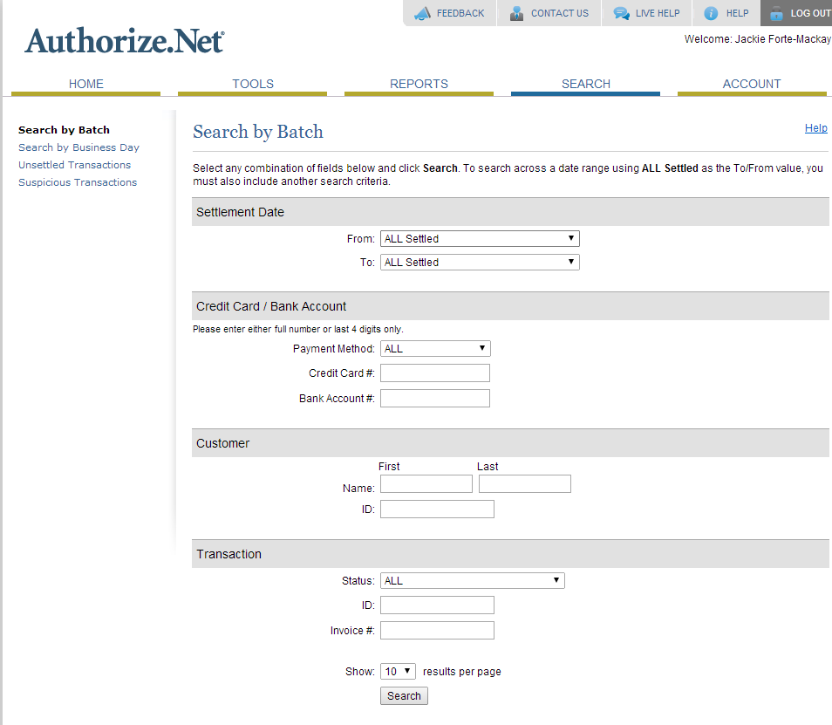
Click here for the “unsettled” or “settled by date” contributions

- Once you’ve found who you are looking for, Click on transaction ID of donor
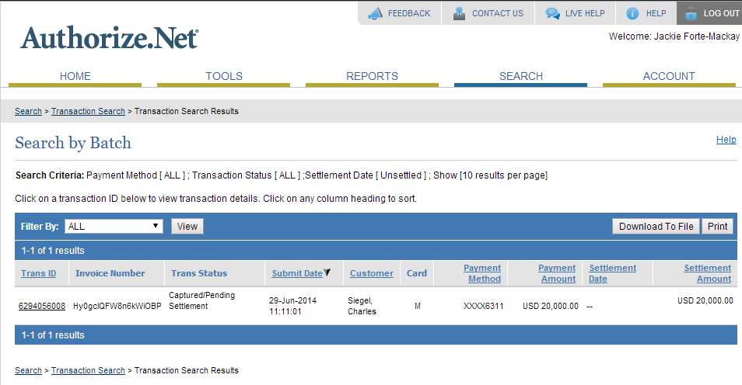
Click this link for transaction ID

- Once you click the link, it will pull up “transaction detail” that looks like this: Note- DO NOT PRESS THE REFUND BUTTON ON THE TOP LEFT!!!
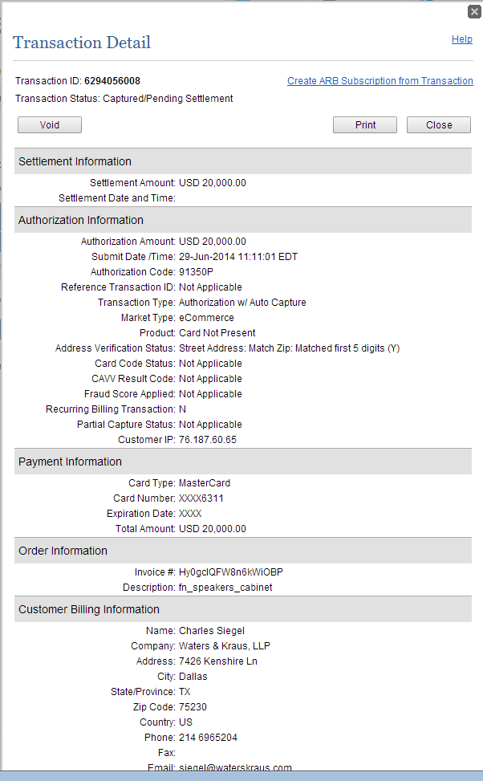
DO NOT CLICK THE VOID BUTTON

- From here, click the Print button, other receipt will pop up with the option to print.
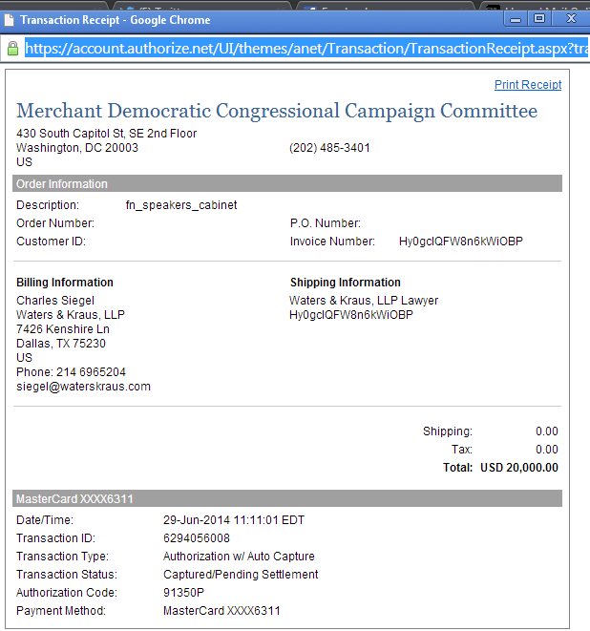

- NOTE: Donations done online MUST be processed for the “Submit Date” found on the top of the contribution print out, as opposed to the “Settlement Date” which can sometimes be different.
- NOTE: Online donations must be processed immediately. This is money that has already gone into our bank account, so when Milly is reconciling her numbers, it throws her off if these are not processed in NGP. She WILL let you know if she is waiting on an online contribution to be processed☺.
- NOTE: Online donations over $5k still need to be vetted, but should NOT be held because, as stated above, it is money that is already in the bank.
- NOTE: When logging online contributions, always put them under the date they were submitted (which might not necessarily by the day you pulled the contribution (i.e., if given over the weekend, holiday, etc.)
- Online (Greg, Charles, Colin or Brandon) will generally let you know if a finance donor has contributed on the online page. You will receive an e-mail, “FIRST LAST just gave $20k online, is this your’s?”. You will then e-mail the appropriate region (you can either look up in NGP or in authorize where this person is from OR you can ask Greg, Charles, Colin or Brandon) and ask the region if this is their donor. If it is, then you just have to let online know, and then you print the contribution from authorize and note on the daily intake that this came in via online’s page.
  - When this happens, Colin Fleming will pull it out of his number and attribute it separate in his Daily “Online numbers” email. Once the contribution is settled, Drew Olsen (the Database Admin) will upload the contributions into NGP. Forward the email with contribution spreadsheet to the appropriate regions and cc Drew saying “Please let Drew know how to code the following contributions”

Logging Incoming Money
- EVERY contribution is logged in the Daily Intake Spreadsheet, found in the Money In Folder
- Daily Intake spreadsheets are done by year and then by quarter. A new Daily Intake Spreadsheet is created every January 1, April 1, July 1, and October 1.
- ALWAYS log money when you are scanning it. It should be the first thing you open when you get to work, and keep it open all day.
  - I would scan a bunch of contributions that were already sorted by region, then as I was saving them in the folder, I would log them into the daily intake. I found this was the most efficient way of scanning/saving/logging. Once a regions set of contributions was scanned, I would then send to the region.
- Note on intake if a contribution is a problem or not.
- Always note on intake how the money came in. This is helpful if and when you need to reference whether a contribution came in or not. Also always note if a contribution came in online, whether it was through a Finance page or Online page
- Scan not just the check or cc form, but also any relevant documentation that accompanies the contribution (except envelopes, but you should keep those too). If there is a business card with the contribution, paper clip it to the copy when you give it to the director.
- Always copy and distribute contributions as soon as possible. In general, it is good to do a first wave in the late morning (after an event the night before or Fed Ex has arrived) and then again in the afternoon after the mail. All money should be copied and distributed before COB so regions can have for the SNAP.

Bringing Money to Jackie
- Jackie is VERY particular about how money is received.
- If the contribution is a check:
  - Staple all documentation (envelop, letter, problem check forms and transmittal) together with the transmittal on top
  - Paper clip the check on top of everything with a “non skid” paperclip
    - Found here: http://www.staples.com/Staples-1-Size-Paper-Clips-Nonskid-1-000-Pack/product_472498

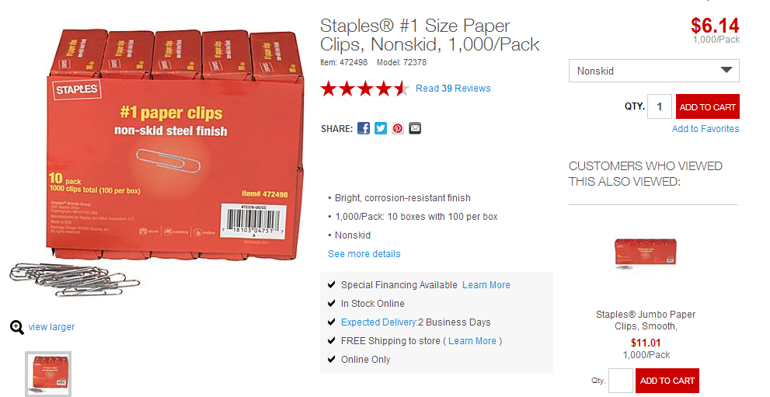

Problem Checks
- It is up to you and Jackie to determine if a contribution is permissible, or if it will require accompanying documentation. Sometimes problem checks are clear cut, sometimes they are not. Always ask Jackie and/or Kate if you are having trouble determining if something is a problem or not.
- If a check is a problem, write that on the copy when you distribute it to the regional. Problem checks do not go in Money In. If a check was in Hard Commits and is a problem when it comes in, REMOVE it from Hard Commits, and put it in Problem Checks.
- Once you have identified for a region if a check is a problem, it is up to them to get it resolved by collecting the proper documentation for a contribution.

Problem Check Forms
- Every contribution (besides ones from incorporated sources because we cannot take these) has a form. These can all be found in the S:\Finance 2013-2014\Problem Checks folder
- Jackie is VERY particular about using the correctly worded forms, and the ones saved in this drive are the correct ones, and the regionals should ONLY be using these forms (updated w/appropriate contact info)
- For reallocation forms (especially for checks that have already been processed that year or the year before and filed with the FEC) Jackie generally likes to sign off on what we are sending the donor, so that it is correct.
  - Why would we be ‘fixing’ a check from a few months before, or the previous year? If a donor reached his federal giving limits, he will often ask if he can reallocate a portion of his DCCC contribution to his spouse or another family member. Doing this requires Jackie’s team to amend the FEC report and it is a nuisance, so Jackie wants to make sure all paperwork is 100% correct before her team puts in the time/work.
  - She may also request that we just refund the amount, and then get the spouse or family member to write a new check; it may be too much of an inconvenience to go back and amend the report

Processing Problem Checks and Tracking in SNAP
- You should always see a problem check form before it is sent as “money in” to make sure it is correctly filled out.
- Problem Checks are tracked separately in the SNAP, and are NOT counted as Money In or a Hard Commit.
- You should note on your list why the check is a problem
- If a hard commit comes in and it’s a problem check, REMOVE it from Hard Commits
- Problem checks should be processed for the date the problem check form was received.
- Once a problem check has been deemed “resolved” make sure to remove it from your Problem Check list and into Money In.

Declined Credit Cards
- When a credit card is declined, Milly will bring it over to you and, usually, there is a note on it as to why it was declined. You can also go into Authorize, and look up the contribution, and see the reason the credit card declined.
- E-mail the regional and explain to him or her why the contribution is declined, and have them either contact the donor, or do whatever else needs to be done to try and re-run the card.
- There are a few common reasons CCs come back declined:
  - Need to verify card number (this can happen if there aren’t enough or are too many numbers, or if Milly cannot clearly read what the numbers are. Either way, you should give to Regional to get the accurate number)
  - If it says, “Contact card issuer to determine reason” this usually means that the contribution has been flagged by the CC company, and the donor has to call his or her CC company to tell them it is ok to let the contribution go through.
  - Address (sometimes a donor will give the wrong billing address for the card. It is up the region to collect the correct address from the donor)

Putting Money Together and Taking Money Over
- Once the contribution has been processed in NGP, the regional will put the NGP transmittal in your inbox, and you will then take the transmittal, check to make sure all info is correct and matches, and attach the contribution and any other documentation to the transmittal.
- What to check for on the transmittal:
  - Name spelled correctly
  - Has proper Account Code (Ind and PAC= 606, Member and Leadership PACs= 607)
  - Has event code
  - Has Employer/Occupation listed and is up-to-date
  - Is credited to correct Region and credited to a Member
  - The Regional noted it’s vetting status (if the check is $5K or higher OR the individual has contributed $5K or more in the calendar year)
  - Note: Look at these details closely, as this is the information filed with the FEC. If an assistant has entered in the incorrect information, e-mail them and ask them to update in NGP. Then make a note on the transmittal (i.e. “Employer and occupation updated in NGP.”)
- Contributions should be in this order: Check paper clipped in upper left hand corner; transmittal, any and all letters or forms included w/ the contribution, problem check form, lobbyist/non-lobbyist screenshot (if applicable), envelope, all stapled together.
- If the contribution is a credit card, that goes directly behind the transmittal stapled w/ the rest of the documentation
- If the contribution is over 5k, the assistant should have written in the Vets section “Passed vet X/X/2014” or “Vet Submitted X/X/2014” – remind them to do this, if they forget. This allows you to track vets and lets you know that a vet was indeed sent and you don’t have to remind the region to do it.
- If the contribution is a resolved problem check, write in the Notes section which form is attached
- You will generally make two trips every day to Jackie’s office to give her the money. If you don’t, she will call and email you several times to ask you where the money is. I suggest you always have money for her by the time she gets to work, and then again before she leaves. You do not have to do this. Just drop it off. She will call if you if there is a problem, or put sticky on it that says, “BRITTANY!” and have Milly take it over to you.
- Refiles: occasionally regionals will update the source code or member credit for a contribution. Whenever they do so, they should print out a new transmittal and attach a sticky note to it that says, “For Refile Only,” which you will take over to Milly (and say sorry when you do, this is annoying for her!)

PAC Contributions
- PAC Contributions are pretty standard, but a few things to note:
- All multicandidate PACs are coded as 602
- Every PAC entry should have an FEC number listed
- The transmittal for a PAC should always say “PAC” in the ‘Name’ line on the transmittal or else Jackie will ask you to update in NGP and reprint

Filing Check Copies
- It is the responsibility of the Finance Assistant on each team to file the check scans for that team. In addition to the NGP transmittal and contribution copy, any other documentation, problem check forms, etc., also must be filed with the contribution. Having this documentation on hand can be critical when trying to resolve future problem checks, etc.
- You should spot check to make sure each assistant is filling these copies at a minimum, a weekly basis
- NOTE: Redacting – anything containing a credit card number (contribution forms, emails, scratch sheets, etc., MUST have the cc# (leaving the last 4 digits remaining) blacked out. This should be happening as copies are filed, and you should spot check to make sure this is happening and continues to happen.)
  - Once a month, e-mail the finance assistants and ask them to have the finance intern redact their CCs

Contribution Vets
- Every contribution from an Individual equal to or over $5,000 must be vetted by Perkins Coie, to make sure we can take a donor’s contribution.
- Note: Contributions from Tribes, PACs, and Campaign Accounts do not have to be vetted
- This rule also applies to contributions which make a donor’s aggregate contributions in a calendar equal to or over $5,000.
- Vets are good for one calendar year
- Accounting CANNOT PROCESS A CONTRIBUTION until it has passed vetting
- A contributor’s vetting status is tracked in NGP; if a person’s vetting status says “Passed” on the day in which we receive the contribution, the regional does not have to send a vet for that contribution. If it says, “Expired” on that day, they must send a vet for the contribution.
- Note: Regionals will sometimes say, “His status says expired in NGP, but we got 10k from him in December of last year, so he’s fine right?” Wrong. This usually means that the donor’s vet was still valid from the previous year’s vet, so they will need to send a new vet if it says Expired.
- Regionals often forget about vetting. Be sure to push them to make sure they send.
- Toward the end of the month, ask regionals to send vetting emails for their outstanding hard commits so that it ensures the money moves through to accounting quickly.

Sending Vets
- Regionals send vetting emails once they receive a contribution that needs to be vetted. They send this email to Jackie, Kate, Jacqui Newman, You, and cc his or her team.
- The email itself will have the subject, “Contribution Vet: Donor Name and Amount IN or HC” OR “Host Vet: Donor Name and Event ” and the body will have the following (Jackie is very particular about the format of these emails, the regions know how she likes it, and should not be taking shortcuts):
  - Donor’s Name,
  - Address,
  - Employer/Occupation,
  - Contribution Amount,
  - NGP ID
  - giving history from 2014-2009
- Each individual donor needs a separate vetting email; they should not be send all in one email; one email per vet

Tracking Vets
- Create whatever system will help you best to track vets, but this is what I did (a little different from my predecessor, who just filtered all emails with “vetting” in the subject line to a separate folder- I liked keeping mine in my inbox so that I knew whether the regionals sent)
- I flagged all vetting emails as I received them and categorized them as “vetting”
- Kate will respond whether the individual is “ok” or “failed” (this is rare) I then flag these as well
- Every few days, I filter my email by category and then update the status in NGP
  - Go to the NGP Page of the donor (it’s easiest to search by NGP ID #, which the region includes in their original vet e-mail)
  - The Vetting Status is on the main page, click ‘update’
  - Type in the date vetted, update the status ‘passed’ or ‘failed’, type in the expiration date, and under comment write ‘contribution’ or ‘host’ and then save and close
  - While you are on that donor’s NGP page, it is also helpful to just spot check that the region is coding their donors properly (i.e. “Speaker’s Cabinet 2014”, “Speaker’s Cabinet”, etc.)
- After each update, I ‘check mark’ the e-mail as complete
- Once I am done going through all of Kate’s responses, I then sort by subject line
- You can literally go from top to bottom and check off all of the region’s e-mails that correspond with Kate’s responses
- And then sort by ‘complete’, and you can move all of these ‘completed/checked off’’ e-mails into your personal folder “Vets in NGP”
- You will hold all money at your desk that is pending vet.
- I also suggest that you have regionals send vets for Hard Commits, and Problem Checks. Sometimes they forget to do this, and it just holds up the process

Below is a quick guide I gave to the regional assistants on vetting.
Vetting
- Any individual who contributes $5K or more in a calendar year MUST be vetted
  - Feel free to send contribution vetting emails for your hard commits before the $ walks in the door
  - Note- Accounting CANNOT PROCESS A CONTRIBUTION until it has passed vetting
- Any individual who hosts an event (whether at their home or part of a host committee) MUST be vetted
- Host Vetting trumps Contribution Vetting-
  - If an individual was vetted to host an event, then later contributes $5K, they won’t need to be vetted again
  - This sadly does not work the other way around- they need to go through host vetting to host even if they’ve already passed contribution vetting
- Vetting lasts a full year from the date vetting passed, so if they contributed $10K in September of 2013 and were vetted at that time, when they contribute $5K in January of 2014, they don’t need to be Vetted again
- A donors vetting status can be found on their NGP page, right below the email box.
  - Vetting status will list either “passed,” “expired,” “not vetted,” and “failed” (I’ve attached a PDF of all of these highlighting where on the page it can be found)
  - You can click on the “update” box next to the Vetting Status to see what type of vetting the donor has:
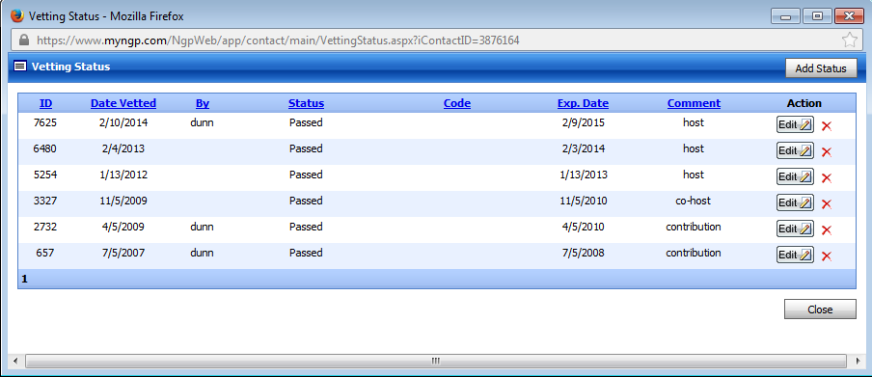

Vetting emails
- Need to be sent to the following people: Kate Zawacki, Jackie Forte-Macay, Jacqui Newman, Finance Ops Director. Your regional team should be cc’d
- Subject line of the email “Contribution Vet: Donor Name and Amount IN or HC” OR “Host Vet: Donor Name and Event ”
- In the body of the email please include the following:
  - Donor Name, Address and NGP ID
  - Contribution Amount- whether it is IN or a Hard Commit
  - Employer/Occupation
  - Giving History dating back two election cycles (that is currently back to 2009)

Transmittals
- When you print out your transmittals you must include the following
  - Your initials in the “Processed By” Section
  - Check off that the addresses and the employer/occupations on the transmittal match what is on the check or credit card receipt
  - In the Note Section- please include the Vetting Status
    - If the donor’s vetting is already passed, just write “Vet Passed”
    - If you just sent a vetting email for the donor, please write “Vet Sent: Date”
- LLP/LLC Transmittals –
  - These contributions require two transmittals
  - If this is a new donor that requires a new record in NGP, then create the partnership first (change type to Partnership). Then enter the contribution like normal, and change code 1 section to “PR-Partnership” – save and print this transmittal. Copy and paste the “contribution id” from the partnership page
  - Go to the individual’s NGP record and add a new contribution. Code 1 needs to be “PT – Partner:” In the link section, paste the Partnership contribution id. This should link the contributions between Partner and Partnership. In the notes section on the individual transmittal, add “Partner’s Allocation – Name of Partnership/LLC”.
  - Print both the individual and partnership/LLC Transmittal. The Org should be on top.
- In-Kind Transmittals
  - Change Method to “I”
  - Code 1: “IK”
  - In the Notes section – pick one of the below that best fits the in-kind contribution:
Catering
Delivery/Postage
Event Catering/Svcs
Equip Rental
Event Food/Supplies
Flowers
Field Organizing
Fundraising Svcs
Internet Development
List Rental
Research Materials
Media Services
Office Space
Printing
Payroll
Phonebanking
Polling
Software
Supplies
Services Rendered
Event Photography
Targeting Data
Telephone Calls/Svcs
Travel
Transfer

Updating and Sending the SNAP
- What we refer to as the “SNAP” is the spreadsheet that captures and tracks all Finance, Online, and Direct Mail money into the committee.
- You will update this everyday, and send an email every night to Jackie Forte-Mackay, Stella Ross, Missy Kurek, Taryn Rosenkranz, Hayley Dierker, Joe Cross and Jacqui Newman
  - CC Brandon English, David Higa, Kasmin Holt, Brian Zuzenak and Courtney Lee-Ashley
  - BCC Yourself
- SNAPS tally contributions quarterly. You will create a new Money In spreadsheet at the beginning of each Quarter (January 1, April 1, July 1, October 1)
  - Open up the previous year’s Money In spreadsheet for that quarter, Save As ex. “Money In 2012 Q4”, and then clear out all of the previous year’s contribution data (i.e. donor names, amount, etc.) on each tab, so that you are starting with a fresh spreadsheet with no data in it, but all the formulas are still there, and it is formatted correctly
- At the end of everyday (around 5pm), you will send an email to Finance Regions All that says to ‘Please send Money In and Commits.’ You will then go in and add/delete in the SNAP.
  - On a notepad or post it, write out all the regions (NE, W, MW, S, DC, PAC, MOC, DM and ON) and cross them out as you enter the information into the SNAP spreadsheet
- When Regions send “Money In” to you, they should always include their region’s total for that month, which you should check against yours. If the two do not match, you then have to figure out why. (Common reasons for discrepancies include: they forget to remove a problem check from money in, or forgot to send in money in because they sent on the email chain. THE SNAP IS NOT THE EMAIL CHAIN.)
- Regions should also note whether a contribution was in Hard Commits or not. If it WAS, you have to remember to remove it from Hard Commits. Otherwise, it will be double counted, which will create a huge problem. You should also verify that number with the regions each day as well.
- Money In and Commit Emails should be sent to You, and cc Missy, Stella, that the rest of that region’s team. If they are not including everyone, please tell them to.
- David Higa sends out the Direct Mail and Online numbers for each day. You will add those into the SNAP, and make sure that your Quarter number, as well as Monthly numbers, match what he has in his email.
- Once you have plugged all of your numbers into the SNAP spreadsheet, you will then do your formulas to update the Daily Quarter to Date Numbers, Monthly Money In Totals, and Daily Change. You will also include the QTD totals from that day in the previous two years. You get this by going into the Money In folders from the two previous years, and copy and pasting it into your SNAP email.

Here are instructions on the SNAP

- Match what each region sends to you with what you have on the “Money In Q[1] spreadsheet”
  - You should insert lines for all new money in and new commits (you might have to “unhide” rows
  - Remove any money that comes in as new money from commits if it was a commit (regions should tell note what money was in commits in their emails)
  - Confirm each monthly total matches for each region – make sure you’re adding to the right section of the spreadsheet and the right month
    - There are separate tabs for individual money, member money, Pac money, and victory fund money
    - Money In is at the top of each tab, commits are in the middle, and problem checks are at the bottom
- Once each region’s monthly total matches open the Q[1] SNAP Tab
- Input Higa’s Online/DM numbers.
  - These will come in a separate e-mail from him that either he will send to you
  - Copy and paste his “Direct Mail Total through [Month] in to the Direct Mail [Month] portion on the SNAP spreadsheet – should be highlighted in purple.
  - Copy and past his “Online Total through [Month} to the online [Month] portion on the SNAP spreadsheet – should also be highlighted in purple.
- Calculating today’s daily change, so this is the different in money/commits from today’s numbers (that you just updated in each region’s sections, now pulling in the TODAY section in pink and yellow) and the previous day’s numbers (this will be hard coded in blue on the spreadsheet).
  - Unhide all of the blue cells in between the pink/yellow “Today” section and the “Daily Change” section to find yesterdays numbers
  - Hide all of the daily SNAP’s EXCEPT yesterday’s. Now you will only have the “Today” Section (pink/yellow), yesterday’s numbers (blue) and the “Daily Change” section (also pink and yellow) showing.
  - Double click in the Pink Daily Change cell for Money In for individuals(should be cell GP4) to reveal this cell’s formula- alter this formula so that it correctly pulls from yesterday’s Money In cell for individuals. It should be equal to the difference in A4 minus yesterday’s individual money in cell number.
  - You can now just drag this formula down for the entire column
  - Double click the Yellow Daily Chance cell for Commits for individuals (should be cell GQ4) to revel this cell’s formula – alter this formula so that it correctly pulls from yesterday’s Money in Cell for individuals. It should be equal to the difference in B4 minus yesterday’s individual commit cell number
  - You can now just drag this formal down for the entire column.
  - Make sure the “Total” Column is also pulling the correct totals,
  - You have now calculated the change in money in/commits from yesterday to today.
- Creating today’s SNAP and creating a record of how much money/commits we currently have for this quarter.
  - Unhide between yesterday’s SNAP and the “Daily Change” section on the spreadsheet to open up more blue cells to create today’s SNAP.
  - Hide yesterday’s SNAP to give yourself more room and to align the empty space with the regional labels.
  - Write in today’s Date at the top of the blue area, then label the cells below “In,” “Commits,” and “Total”
  - Simply COPY and the PASTE SPECIAL (you will need to select VALUES) today’s numbers in columns A/B into the open blue space.
  - * These numbers should MATCH EXACTLY what today’s in/commits numbers are pulling from the other tabs on the spreadsheet.
  - In the “Total” column you just created sum horizontally the “in” and “commit” number from each breakout. You can just drag this formula down once you get the total for individual money.
  - Sum the total money in and total commits AGAIN below the total in the black area.
  - Use the format painter to align everything in the center
  - Double check that the DM/Online numbers total correctly w/ n/a in the Commits section and a real value in the “Total” section
  - You have now created today’s SNAP.
- Creating the SNAP E-mail
  - Reply All to the previous day’s SNAP email –
    - Jackie Forte-Mackay, Stella Ross, Missy Kurek, Taryn Rosenkranz, Hayley Dierker, Joe Cross and Jacqui Newman
      - CC Brandon English, David Higa, Kasmin Holt, Brian Zuzenak and Courtney Lee-Ashley
        - BCC Yourself
  - Delete the “Re:” in the subject line and update the date to today’s date
  - Copy and paste today’s SNAP that you just created into the body of the e-mail.
  - You can delete yesterday’s SNAP from the e-mail body as well as the monthly break out below.
  - Go back to your SNAP spreadsheet and unhide all of the hidden cells to reveal the monthly breakout.
  - Copy and paste this monthly breakout into the email to replace the one you just deleted.
  - Update the daily SNAP’s below from 2013 and 2012. You will need to copy these from the 2013 and 2012 SNAP spreadsheets. Always use the current date, if the current date does not exist on these spreadsheet, use the next forward available date. For example if today is the 18th but there is no SNAP from 5/18/2013 use 5/19/2013 instead.
  - Rehide all of the blue cells in the spreadsheet to get back to the “Daily Change” section that you initially created.
  - Copy and paste this section into your e-mail body to use as a guide to update the change in daily numbers text portion of the e-mail.
  - The total daily increase should be equal to the total number in the black box.
  - Match all values for both money in and commits, pay careful notice to whether something increased or decreased and change the text accordingly.
- Your SNAP e-mail should be complete. Double check you have the following components:
  - Today’s SNAP
  - This quarter’s monthly breakout
  - The 2013 SNAP from this date (or closest date after)
  - The 2012 SNAP from this date (or closest date after)
  - The list of Daily Changed values typed out in text.
- It sounds more daunting than it really is. After a few times going through the motions, it becomes very easy. The biggest recommendation for the completing the SNAP is to not work on anything else until it’s completed, especially the first few times. It requires a tremendous amount of focus and attention to detail to complete. One small distraction could lead you to add something twice, or not remove something that becomes then double counted.

Regional Breakdowns
- The SNAP will also capture Money In and Commits broken down by region. Stella may will ask you for this from time to time, just always be prepared to send it to them.

Joint Fundraisers
- Joint Fundraisers are separate fundraising committees established between the DCCC and a participating candidates or party committees. These are usually based around one particular event, but can also be long-standing victory funds, set up to cover several events (i.e., House Senate Victory Fund and Nancy Pelosi Victory Fund)

Getting Started
- Once it’s been decided that a joint fundraising committee is going to be established, you will play a big role in all aspects of managing it and all its components.
- Missy and/or Stella will relay to Jackie that they want to have a joint fundraiser. Once the allocation formula (or split) is agreed upon by all participants, a Joint Agreement must be written and signed by the treasurer in all parties (Kelly Ward or Jackie on our end, the campaign treasurer on the campaign’s end). This can sometimes take a while, for several reasons. In the meantime, you should do the following:
  - Make sure a postal code is set up if we are keeping the books on the event and sending the invitations. Ask Operations (Hayley, Jacqui or Jillian)
  - Remind the Regions and Jacqui that all materials related to this event (invite, contribution form, website) need to include the Victory Fund’s disclaimer language and allocation formula
  - They will immediately start asking about creating a website and when it can go up. We cannot receive or process donations until we have a bank account, and we cannot have a bank account until we have an FEC number for the joint fundraiser, and we cannot have an FEC number until we have a signed statement of organization and joint agreement.
  - The preferred way to receive and process credit card contributions is to have an authorize account set up. Kasmin will set this up for you and let you know when it is ready.

Administratively
- All expenses for joint fundraisers should go on Jackie’s credit card. No expenses for joints should go on someone’s DCCC credit card. Remind the regions of this!
- You will assign a color paper for the Victory Fund that all transmittals and check requests should be printed on. By creating a different colored paper, this ensures that the accounting team recognizes that these contributions and check requests are associated with the VF account.
  - For our current victory funds, the paper colors are as follows:
    - NPVF- light Blue
    - SIVF- light green
- Joint fundraisers have their own check request. It is essentially a normal DCCC Check Request, but instead at the top is “XX Victory Fund Check Request”. Remind regions of this when they are creating check requests.
- NOTE- in the 2014 cycle, we’ve re-uped the “House Senate Victory Fund,” a joint fundraising committee between the DSCC and the DCCC. The DSCC manages ALL aspects of this fund, so any invoicing for the event etc MUST go through the DSCC
  - DCCC travel associated with this fund is still put onto Jackie Forte’s DCCC cc, then the fund reimburses the committee.

Tracking Money In and Commits for Joint Fundraisers
- Each Joint Fundraiser will get its own tab on the SNAP, and should be tracked completely separate from all other money in. Money committed to the joint should NOT go into a region’s regular hard commits.

- Regions will separate the VFs Money In, HCs, and PCs from their regular DCCC money; they will be included in a separate section in their nightly e-mails to you
  - VF contributions will state the Total Amount of Contribution, DCCC Share, and Candidate/Other Committee Share
- Here is the tricky part:
  - Because we do not know the final ‘Money In’ amount for Victory Funds until after costs are subtracted from the total money raised, you will leave ALL VF Money In & Hard Commits money in Hard Commits (even if the contribution has already been received). So – your Money In will remain $0 and your Hard Commits will actually equal Money In & HCs
  - Why do we do this?
  - The Final VF Money In amount that gets put into the SNAP is the “Transfer Check” amount that Jackie will give to you at the end of the month
  - This “Transfer Check” amount will be equal to the Total Money In MINUS the Total Event Costs; and then the DCCC will receive the “Transfer Amount” based on the VF allocation formula between the DCCC and the Campaign
  - Missy & Stella like to still include an amount in Hard Commits though, because this is generally not very far off from the final Transfer Amount that the DCCC will receive at the end of the month; so it helps them track their totals and how much we have left to raise for the month
  - Since you are leaving all Money in Hard Commits, I highlight what the Hard Commits are – just so you know how to distinguish between the two and to keep track of what HCs are still pending
- Note: Missy and Stella are going to ask you what amount the check is going to be for, and you can tell them that we have $xx money in for that month, but that you don’t know what the expenses are. They will have to ask Jackie this. Jackie gets really mad when they ask her this. FYI.
- Once Jackie tells you the final number, you can move all the Money In into the actually Money In section of the VF tab; and then in the “Final Transfer Amount” cell – you put in this number Jackie tells you
- This is the number that will be included in the SNAP in Money IN for the Victory Fund
- Victory Funds do not get an event/source code. Someone will always ask you to create one, but they do not get coded to an event the way normal DCCC contributions do.
- For Joint Fundraisers where we are keeping the books (i.e. processing the $ and tracking everything), every contribution that comes in must be “processed” as such:
  - Region goes into the person’s record, but does NOT enter in the dollar amounts of the contribution, or any other info. They simply go into the record, update any necessary employment/occupation info, and then generate a “Victory Fund Call sheet.” (Ignore the fact that we call it a call sheet- it’s just a report), this report contains the donor’s name, info, and giving history, and the regional will convert it into a word document, and go into the word document and type in Contribution Amount, the DCCC share, and the Participating Committee’s share. This is what will be printed and taken over with the contribution. Kasmin handles all of these, and at the end of the month, she will send around a list to all participating parties, with each contribution and the split, and ask if everyone can legally take the allocated share of each contribution (i.e. regions need to double check that no one is over their FEC giving limit. For NPVF, Kasmin and Jackie work directly with Perkins Coie and Stella on this (they handle NP4C filings), and you do not have any involvement. Once everyone says yes, then she will work with Drew to import all of the contributions into NGP.
- Note: it is up to the region to make sure that all contributions are being properly allocated, but it’s also not a bad idea for you to double check. Because even though an allocation formula may state that “the first $5,200 of a contribution goes to Nancy Pelosi for Congress, the next $5000 goes to PTF and the remaining goes to the DCCC, if Mark Klein gives $20,000 to the NPVF, and she has already maxed out to NP4C and PTF, then the DCCC would get the full $20,000. There will be several instances like this, and whenever a contribution is allocated in any way other than the agreed upon split, that must be noted on the transmittal (and, if possible, the region should give a Screenshot of CQMoneyLine highlighting that the individual gave X Amount to ‘Nancy Pelosi for Congress’.) Also, every joint agreement states that a contributor may designate his or her donation any way he or she wants, as long they can do so without going over his or her federal limits. If a contributor does wish to do so, then he or she must sign additional documentation specifying such.

Victory Fund Transmittals
- For NPVF, SIVF, etc, go to the NGP record of the donor. Go to reports-->callsheets. Change call sheet type to :”Call Sheet VF” and make sure “current record” is selected. Then click view report. Print that report as the transmittal.
  - Ask accounting what the breakdowns are

Problem Checks and Joint Fundraisers
- Problem checks for Joint fundraisers are treated the same as problem checks for the DCCC, except that all forms must be altered to reflect the name and allocations in the agreement.
- Note about “Earmarking” and Joint fundraisers. Where joint fundraisers are concerned, if a contributor writes the name of the participating candidate in the memo line of the check, then it is considered “earmarked” and we would then be obligated to give the entire amount of the contribution to the candidate’s committee. Sometimes a donor intentionally does this, which is fine, so long as we are aware of the donor’s intent. If it was NOT the donor’s intent to allocate his or her entire contribution to the candidate, then he or she must sign paperwork stating such.

Recount Fund
- Information located here: S:\Finance 2013-2014\RECOUNT 2014
- After the very expensive Senator Franken recount in the 2010 cycle, the FEC started to allow party committees and campaigns to raise recount funds before electionday in preparation for large legal fees. That means that each individual may give an additional $32,400 to the Recount this year and not have count against their federal giving limits AND PAC’s may give an additional $15k to the Recount this year (a full memo from Perkins Coie is attached explaining this in full- please read.) This also means that we do not have to issue refunds to donors who are over their federal limit- instead we can have them fill out the re-designation form attached and have the excess funds be counted as recount funds.
- For 2014, 14792 – 2014 Recount Fund General – is the source code. We will print transmittals on NEON GREEN paper and they will all be deposited into account 1000 – Recount Fund.
  - Note: in NGP, you must also list in the “member” section “Recount14- Contribs for 2014 Recount Contributions”
- All Recount Fund contributions are tracked on a separate tab in the SNAP

WH Events
- We do both joint and regular events w/ the White House occasionally for non-joint WH events, the only thing that is different is:
- Invite language must be approved by WH, and has different wording/disclaimers. Krista knows what these should look like.
- All donors are vetting by the WH, and not the DCCC. The Regionals or Jackie will send updated lists of vetting info to the WH, and they only respond if someone does not pass vetting. Right before a WH event, you should have them send you the final vetting list, which you should send to the region doing the event, and have them add a column on the spreadsheet for the contributor’s NGP ID, then you can send to Drew, and have him automatically update everyone’s vetting status in NGP, w/ a note that it was a WH vet. They can all be done on the date on the event.
- The same rules above apply to joint WH events, and those invites have to have both WH and joint fundraiser language and disclaimers.
- There is a list of WH events and vetting from this cycle saved here: S:\2013-2014 Operations\2013-2014\WH Events and Vetting

Reconciliation and Accounting

- The committee files monthly (instead of quarterly like campaigns) and you will place a significant role in the monthly FEC report. They will file on or around the 20th of the month after the period covered. For example, the June FEC Report will be filed on July 20th. You are in charge of the following:
  - Reconciling w/ the Bank
    - You will reconcile the IND, PAC and MOC money with Kasmin
    - Kasmin asks you to send you a list of all of those contributions, then matches it to what she has from the bank records.
      - Some months match perfectly, other months need to sifted through line by line by date or amount to find the discrepancies.
      - Errors on your end should be updated in your money in spreadsheet
    - Once the reconciliation is complete, Kasmin will send it around to Missy, Stella, Jackie and Kelly Ward
      - Note- she will include a column for “finance plan” which is what should be reflected in the master finance plan
  - Bundling Report:
    - All bundled contributions will be on PINK PAPER.
    - Milly will pull the bundling report about a week before the reporting period deadline and will ask “Do we match”
    - Look at your records, and then ask Mike Smith if he has the same
    - Then e-mail Milly back and let her know you match / what your changes are, and once all updates are made, you’re good to go!
  - Non-Deposits:
    - This is a list that Drew will pull for you or Milly will send to you close to the filing deadline, it shows all of the contributions created in NGP that were never closed out and deposited. You will likely recognize the names that pull. Often it will be a problem check that someone started to process but then they were never able to get the check resolved. The regional needs to delete this record (if the money is never coming) or change the date to the next month so that it does not pull on the current FEC report.
    - If you do not recognize the name that is pulling, look up that contact in NGP then figure out what region he/she is from. Ask the regional if they created it and still have them delete it or move to the next month if it is not a contribution that can be resolved quickly.
  - Over Limits:
    - This is a list that Drew will pull for you or Kate close to the filing deadline that will show all individuals who have given more than $32,400 this year.
    - Look in your records at the donor, how they gave, when they gave etc to see if we can easily transfer the over limit portion to the recount fund
    - Oftentimes, it’s just our donors who get an email from online and give $50-$250 dollars. Our disclaimers found on our webpages allow us to just transfer the money to our recount fund.
      - When doing this, screen shot the disclaimer on the generic giving page and their giving history, write up recount transfer paperwork and bring to accounting.
    - Recount Transmittalss – for Over Limit Contributions/Recount Contributions:
      - Change Type to “O- Other Miscellaneous”
      - Under “Member” choose the “Recount14 – Contribs for 2014 Recount Contributions Option”
      - Change Account section to “1000-Recount Fund”
      - In Note section, type “Recount Contribution”
      - PRINT ON GREEN PAPER
    - When you bring recount money over to accounting, include green transmittal, money info (NGP giving if transfer, or actual scan if actual recount fund contribution), and screenshot (if transfer) with relevant disclaimer
    - Note – work with direct mail when they have over the limit contributions that need to be transferred to the recount fund as not all of their mailings or telemarketing have the proper disclaimer. This means they are required to get a form signed (similar to a PC) by the donor that allows us to transfer the funds to recount.

PART II: SCHEDULING AND NP’s OFFICE

Leader Pelosi Scheduling
- Leader Pelosi scheduling involves a lot of very intricate and nuanced details. You will serve as the primary point of contact for schedule requests and updates to the Leader’s Long Term Schedule

Leader Pelosi Schedule Requests
- Once an NP schedule request has been internally approved by Stella and Missy, the region will send it to you and ask you to send it up to NP’s office for approval
- I saved all schedule requests for 2014 here: S:\2013-2014 Operations\2013-2014\NP Scheduling
  - Documents were saved in folders based on the Quarter the event would take place in
- Here is the process:

DCCC Schedule Requests

TO: mary-kate.barry@mail.house.gov, Devan.ceyea@mail.house.gov
CC: bina.suregon@mail.house.gov, kate.knudson@mail.house.gov, Emily.berret@mail.house.gov, Stella Ross, Missy Kurek, Amy Soenksen
BCC: Yourself
Subject: Schedule Request(s)
Body of the E-Mail:

Please find attached the following schedule request:

- DCCC Women’s Frontline Reception (Thursday, October 24th, 2013 OR Tuesday, October 29th, 2013; 6:00pm-7:30pm; Washington, DC)- new

- Keep ‘flagged’ in inbox until it is approved and added to the LT. Immediately add to the finance calendar as ‘pending’- then change to ‘confirmed’ once approved.

- If the schedule request is ‘updated’, note this and what part of the request was updated (i.e. ‘This request is replacing the previous request sent up on July 1st and includes new dates)
- Immediately add to the finance calendar as ‘pending’ and note in the body of the calendar event when you sent it up to NP’s office– then change it to ‘confirmed’ once NP has approved the request and it is added to the LT
- After a long term scheduling meeting, Missy/Stella will send out to all the regions a listing of all approved requests. At this time, update the calendar accordingly

Political Schedule Requests
- Stella and Missy handle all political requests for NP
- Either Stella or Missy will send up political requests to NP’s office (these are requests with candidates, political organizations, etc.); and you should process these like DCCC Schedule Requests
  - Keep this request ‘flagged’ in your inbox until it is approved and added to the LT
  - Immediately add to the finance calendar as ‘pending’ – then change it to ‘confirmed’ once NP has approved the request and it is added to the LT

Pending Schedule Requests
- Because you are tracking all DCCC and Political Requests in your inbox and on the finance calendar, you will gain a strong understanding of what requests have been approved and added to the Long Term, and what requests are still pending
- Regions will ask you “Do you have an update on this event?” – at this point, Missy/Stella usually reach out to NPs office to check in on the status, and have the item listed as a ‘hot ticket’
- Occasionally, Missy and/or Stella will ask you to send her a list of all pending requests – you can do this in a few different ways:
  - I kept an excel sheet of schedule requests that were sent up with the following information:
    - Event, Suggested Date(s), Suggested Time(s), Location (just city/state), Date sent up, Region, NP Approval Status, SJI Calendar Status (whether or not he should attend), SJI Approval Status
  - You can just go into your inbox, sort by category, and just copy and paste into one blank e-mail, all of the pending schedule requests still in your inbox, and let them know
  - OR you can create a scheduling matrix on the finance calendar, and sort by “Pending NP Requests” and then screen shot this, and copy and paste into an e-mail
  - Choose which way is easiest – I would often use my matrix and then go through my emails, the LT as well as the finance calendar to double check everything

Printing Finance Calendar
- Block Calendar
  - Go to your Finance Calendar
  - Print – Print Style, Monthly View
  - Print Range – Current date through the end of the year
  - We use this calendar for finance department meetings
Leader Pelosi Long Term Updates
- Every night, NP’s scheduling office sends out an email with a PDF attachment of NP’s Long Term Schedule. You need to print four copies of this every morning as soon as you get into the office. One copy goes in the top tray of your Inbox, and the others go to Missy, Stella and Krista.
- How to Print:
  - Print to Speaker – Properties – Basic Setting Tab- 2 Sided-Printing – Staple + Collate- Copies-4
- Regionals will come look at the Long Term, and will occasionally take it to their desks w/ them, but they should always return it promptly. This document cannot float around.
- Once an event has been added to the Long Term Schedule, you need to make sure the regionals check it to make sure the information is correct and updated.
- Throughout the day, regionals will send you emails with the subject, “Long Term Update” in which they will include any updates to the calendar. Depending on the day, I would send the updates as soon I received them, or you could wait until the end of the day (around 4pm, unless otherwise told), and send ONE email with the subject “Long Term Updates” that includes all of the updates for that day.
- I generally copy and paste the current entry in the email, and put updates in red.

Long Term Updates

TO: mary-kate.barry@mail.house.gov, Devan.ceyea@mail.house.gov (and Jaime.minor@mail.house.gov when NP is on west coast)
CC: bina.suregon@mail.house.gov, kate.knudson@mail.house.gov, Emily.berret@mail.house.gov, Stella Ross, Missy Kurek, Amy Soenksen Katie Mulhall (when potentially TP related like tic toc, new events etc)
BCC: Yourself
Subject: Long Term Update(s)
Body of the E-Mail (Copy and paste the event information currently on the Long Term, and make your updates/changes in RED; remember to note the date of the event that you are making updates to as well):

Body of email:
Thursday 09.12.13
6:00 PM - 7:30 PM 5:30 PM – 7:00 PM NANCY PELOSI FOR CONGRESS TEAM PELOSI RECEPTION
Location: TBD, Fiola Restaurant Rooftop, 601 Pennsylvania Avenue, NW Washington, DC 20004
Details: TBD
Event run time: 6p – 7:30p 5:30p – 7:00p
Staff: TBD
(confirmed)

Here is a memo to the regional teams on how they should be sending you their LT updates:
Email Finance Ops Director and cc Missy and Stella, and your entire team
    - Subject: Long Term Update
      - This is important. It should say nothing more and nothing less than this. You can include updates for more than one event in an email.
      - Body: Relevant info only. I need to be able to read this quickly and pick out only what I need to send up. The changes need to be made clear- highlight them or put them in red, it’s important to clearly indicate what exactly the update is.
      - It’s often more helpful to include ALL of the details for the event in the update, rather than just what is being changed.
    - Your job is to fill in the holes as you have the information.
    - Every event needs the following details
  - Location (Name of location, Room, Floor, Suite #, exact address and zip code)
  - Details:
    - -Attendees (Total # and VIPS (Members, candidates with district etc) confirmed to attend)
    - Reservation information (# and name it is under)
    - Event run time (for events, not meetings)
    - Timeline that is exactly what you put in your briefing)
  - Staff (Missy, Stella, etc, with cell phone number)
  - Site Contact - this is the SITE contact- someone at the office, hotel, event space that can give details to NPs security team. This is the person the security detail will call to do the walk-thru of the event. This is important. Please note, this shouldn’t be a campaign staffer, but rather a person who is on site ahead of the event
  - Contact- For finance meetings only, a contact number for the person NP is meeting with and what type of number it is (preferably cell)
Shell of Event:
Day of Week and DATE
TIME: TITLE
Location:
Details: (Tic Toc)
- Event Run Time =
- Attendees = TBD/Reps. X, Y, and Z
Staff:
Site Contact:
Contact: (if a finance meeting)

Ultimately, an update will start like this:
Friday 01.24.14
5:30 PM - 7:30 PM TIME TENT DCCC RECEPTION HOSTED BY REP. MATSUI
Location: TBD Sacramento, CA
Details: TBD
Event run time: 5:30p – 7:30p
- Time and location have not been confirmed
- Attendees = TBD
Staff: TBD
Site contact: TBD

Then end up like this:
Friday 01.24.14
5:30 PM - 7:30 PM DCCC RECEPTION HOSTED BY REP. MATSUI
Location: Home of Tina Thomas and Bill Abbot, 2722 Coleman Way, Sacramento, CA
95818
Details:
Event run time: 5:30p – 7:30p
- 5:30p = Event begins
- 6p = Tina Thomas offers welcome and introduces Rep. Matsui
- 6:05p = Rep. Matsui speaks and introduces you
- 6:10p = You speak
- 7:30p = Event concludes
- This event will be outside on grass
- Attendees = 45 / Reps. Lee, and Matsui; Candidates Michael Eggman (CA-10) and Amanda Renteria (CA-21)
Staff: Lisa Presta, (415) 515-5452 c
Site contact: Tina Thomas, (916) 736-9334 h

Long Term
- Once a day (try for the morning), go through the most recent Long Term and cross check it against the finance calendar
  - Things to look out for:
    - Do times on the LT match up what is on the Finance Calendar?
    - Are there events on the LT that are not on the Finance Calendar? – add them!
    - Is there a political event that has been recently added (i.e. is NP meeting with a Candidate? – flag for Missy and Political– and let them know that an addendum is needed, and whether or not Missy/Ian needs to staff)
    - Is NP meeting with a donor for an official event/meeting? Flag for Stella and ask if an ‘addendum’ is needed (an addendum is needed, instead of a main briefing, because if it is an official event, we can not send up any documents with $$ info on it – hence why an addendum does not include any $$ info); if an addendum is needed, let the region in charge know and flag for them
    - By going through the Long Term every day, you will become aware of what DCCC, HMP, Political/Finance events NP is attending and what is still pending; and then you will know when something new is added because you will recognize what wasn’t there before
- When an event is added to the long term, it’s generally just a shell. The regionals should come look and know what needs to be updated, but you should look for holes. However, about once a week, go through the LT and ask the regionals to update their events that may have holes in them.
- Here are some things to look for:
  - Does it say “Time Tent”? If so, this means they are waiting on us to tell them the time is confirmed, so ask the regional
  - Site Contact – “Site Contact” means site contact, aka, who the security details needs to call to schedule a walk-thru. A cell phone number for the donor she is meeting with it not a site contact. If it’s a meeting or event at a restaurant or hotel, it’s generally the catering manager or events person. Krista usually has information like this. We need a name, and number, and you need to specify if the number is a work or cell. If the event is at someone’s home, a home number is sufficient.
  - Contact – Is the ‘contact’ for the donor/event contact – if there is some sort of emergency and NP’s office/Missy needs to contact the person NP is meeting with/host of the event, etc.
  - Reservations- all meetings need to have reservations usually under Missy’s, Stella’s, a consultant’s, or Nicole Runge (HMP) name. The regional should tell you this.
  - Location- for most events, just saying an event is at the Regency is not sufficient. If it’s in Ballroom, it needs to say that. If it’s in the hotel restaurant, it needs to say that, etc. If it is an event where the VIP Reception is in the A Room and the General Reception is in the B Room, it needs to say that.
  - Attendees – this means approx. # of attendees and VIPs (Members or important public officials) listed out, if they are CONFIRMED to attend. And important officials include Members, Senators, Governors, and Mayors only if it’s a big city. City councilmen are not important enough to be on the LT. Congressional candidates however, are.
    - Note- if a candidate is attending, be sure to list their state and district
  - Timeline – or tic toc. This is the actual timeline of events that is on the briefing, that reflects NP’s arrival, movements, speaking, departure, etc. This has to match what is on the briefing, and is generally not added until a few days before the event.
  - Addresses – addresses for event locations must be right. They check them on Google maps for the drive time between events, and if the address doesn’t come up on Google maps, they freak out.

Briefings

Leader Pelosi Briefings
It is your job to do the following w/ regard to NP briefings

Deadlines
- You will work with Emily, Emma, Bina & Ashley in NP’s office about when briefings are due. Once every two-four weeks, send them an e-mail requesting upcoming deadlines:
  - Attach a word document listing out the dates and all upcoming events over the upcoming 4-6 weeks
  - Emma (usually) will respond and send you the document back with the deadlines in red
  - Generally speaking, when NP is in DC, they will need everything by 3 or 4 the day before. This will change if she will not be returning to the office the day before after a certain time, is not in DC, or is traveling on a longer swing.
  - Once you have all of this in place for the next couple of weeks (or whenever a good breaking points is) you should pdf it as a calendar details style memo and email to Finance Regions All, Katie, Jenny, Claire, and House Majority PAC (Amy, Rachel and Nicole), so that they can have this on their radar for what is coming down the pipe.
    - Note- I would always make the deadlines I sent to the regions between 1-2hrs earlier than what NPs office sent. This ensures things get to NPs office on time and allows for any last minute changes.
    - All previous deadline docs are saved here: S:\2013-2014 Operations\2013-2014\NP Deadlines
- It is your job to set deadlines in conjunction with the NP’s office and communicate this with Finance, Katie (Talking Points), Political (you will work through Jenny), HMP (Rachel Gottke), and Candidate Services (with Claire). Doing so means staying a couple of weeks ahead of yourself by keeping the calendar updated and knowing what’s to come.
- I’d also suggest keeping a hard copy handy so you can always know what is due and what you sent out to people. It is also helpful to check off things as you have them or send them that day as some days will have multiples events/meetings and each require multiple pieces.
- All Finance Events with the Leader need the following:
  - Main Briefing (Regional)
  - Attendee Briefing (Regional)
  - NP Cards (Regional)
  - Talking Points (Katie)
  - Political Memo (If she is traveling outside the DC area or going to a candidate event) (Jenny)
  - An updated Thank You memo (if there are edits from the last event/time you sent this) (Amy)

- All Finance Meetings with the Leader need the following:
  - Main Briefing
  - NP Cards
  - Political Memo (If she is traveling outside the DC area)

Deadlines E-mail
- Every morning, you will receive an e-mail from NP’s office with the ‘Packet Deadline’ for the day
- Forward this e-mail to the appropriate individuals in charge or submitted NP and SJI materials for that day
- Double check both the Long Term and the Finance Calendar as to what events are the next day and who is in charge of what – and include them and their supervisor on the e-mail

TO: knknudseon@hotmail.com, bgsurgeon@gmail.com, emily.berret@gmail.com, Kaplan.elk@gmail.com, ndjminor@gmail.com (when NP is on west coast)
CC: Stella Ross, Missy Kurek, Amy Soenksen, mary, Kelsey.smith13@gmail.com, marykate.barry@gmail.com devanw.cayea@gmail.com ethanmcclelland@gmail.com, Evangeline.m.george@gmail.com
BCC: Yourself

Subject: NP 08.13 Materials (insert date where 8.13 is) (note, this should be the date of the events the materials are for NOT the date you are sending them “up”

Body of the E-Mail (list out events as they are attached to the e-mail, note the date of the event, and whether the material is ‘new’ or ‘updated’:

Please find attached the following:
- DCCC Nevada Political Memo- new
- DCCC Thank You Memo- updated
- 08.13.13 HMP Addendum on United Brotherhood of Carpenters- new
- 08.13.13 Bilbray for Congress and Horsford for Congress Luncheon Talking Points- new
- 08.13.13 Bilbray for Congress and Horsford for Congress Luncheon Cards- new
- 08.13.13 Bilbray for Congress and Horsford for Congress Luncheon Briefing- new

Notes:

- Send everything up in one email if possible, send all updates in that same email
- If you have to fwd briefings, do it from a clean email
- Always list out in the body of the email what is attached, and make sure it matches
- Amy will also print two copies of all of these for Missy or Stella’s trip binder. In addition, she will always ask you to print the most up to date Long Term by the time they are leaving.
- We save all materials that are sent up here: S:\2013-2014 Operations\2013-2014\2013-2014 NP Materials
  - The folders are broken out by Month, than Date of the event.
  - Cards should be sent as PDFs
  - If you are sending updated version of the briefings, save the briefing with “UPDATED” in the title
- HMP Additions:
  - We’ve started added HMP addendums into our briefings for all events that NP attends. HMP coordinates with the appropriate regionals to obtain the list of attendees, they then send you a addendum of HMP and SuperPAC giving history which you will merge into the main briefing from the regionals. This is the version you will send up AND you should send it back to the regionals for any future edits or changes.

INVITES
NP Invites
- Send Host Vets for potential or confirmed hosts
- Regionals get approval from Missy and Stella as to hosts and MOCs whose names will be listed on the invite
- Regionals design the first iteration of the invite
- Regionals gives to Amy for Missy and Stella to sign off
- Regionals make changes (if need be), and email final approved version to Jacqui Newman and CC Kellie, for legal approval
  - Please make the subject, “For Legal Approval: Date of Event, Name of event”
- Jacqui will either respond that the invite is good to go, or give you changes. Once you have either made the changes or gotten sign off, email it to Kellie, who will send to NPs office for final sign off.
- Once Kellie hears back from NP”s office, she will let you know that the invite is good to send out (this can take 24-48 hrs)
- Prior to sending out, Regionals send to all hosts and MOCs who have agreed to lend their name to invite. All hosts and Members on the invite MUST approve their own name.

SJI Invites
- Sent Host Vets for potential or confirmed hosts
- Regionals get approval from Missy and Stella as to hosts and MOCs whose names will be listed on the invite
- Regionals design the first iteration of the invite
- Regionals gives to Amy for Missy and Stella to sign off
- Regionals make changes (if need be), and email final approved version to Jacqui Newman and CC Kellie, for legal approval
  - Please make the subject, “For Legal Approval: Date of Event, Name of event”
- Jacqui will either respond that the invite is good to go, or give you changes. Once you have either made the changes or gotten sign off, email invite to Brenna and Hayley, and CC Kellie for SJI Approval
  - Please make the subject “For SJI Approval: Date of Event, Name of event”
- Once an invite has been approved by SJI’s office, you are good to send out once all other MOCs and/or hosts have approved their names
- Prior to sending out, Regionals send to all hosts and MOCs who have agreed to lend their name to invite. All hosts and Members on the invite MUST approve their own name. (You don’t have to cc Yates on this part)

Other Member Invites
- Regionals get approval from Missy and Stella as to hosts and MOCs whose names will be listed on the invite
- Regionals design the first iteration of the invite
- Regionals gives to Amy for Missy and Stella to sign off
- Regionals make changes (if need be), and email final approved version to Jacqui Newman, and CC Kellie, for legal approval
  - Please make the subject, “For Legal Approval: Date of Event, Name of event”
- Jacqui will either respond that the invite is good to go, or give you changes. Once you have either made the changes or gotten sign off from them, you are good to send out once all other MOCs and/or hosts have approved their names
- Prior to sending out, Regionals send to all hosts and MOCs who have agreed to lend their name to invite. All hosts and Members on the invite MUST approve their own name.

NP Invites
To: mary-kate.barry@mail.house.gov, Devan.ceyea@mail.house.gov
CC: Stella Ross, Missy Kurek, Amy Soenksen
BCC: Yourself
Subject: Please approve date and time

Body of email:

For the attached invite:

- DCCC Finance Reception hosted by Hon. Ben Barnes and Eve Marie & Jeff Angelovich (Sunday, August 25, 2013, 6:00pm-8:00pm, Austin, TX)- new

Keep “flagged” in inbox until Mary-Kate or Devan approves- Once approved, let the regions know that the invite is ‘good to go’

All invitations that are sent up should be saved here: S:\2013-2014 Operations\2013-2014\NP Invites by quarter in which the event takes place.

Host Vets
- All potential individuals who will either be hosting an event in their home, or lending their name to an invite, must be vetted before the invite can go out.
- Host Vets are sent exactly the same way as Contribution vets, except for the subject says, “Host Vet: FIRST NAME LAST NAME” and has the name of the event in the email.
- Host Vets are also good for one calendar year.
- You update Host Vets in NGP the same way you do for contribution vets, except for with Host vets, you write, “host” in the notes field.
- Host vets trump contribution vets. In other words, if someone still has a valid host vet, they do not have to be re-vetted if making a contribution during the time their host vet is still valid. However, if someone passes contribution vetting, then STILL have to be vetted for a host.

Event Web Pages
- Most events will have their own web page, which is requested by the regional and you will set up in Blue State Digital. Make sure to have Greg Berlin/Raffi Appel set you up a Blue State Digital account so that you can update current or create new webpages.
- To send a Web Page request, the region will send you the properly formatted request, and then you will set up the page. See the outline below for the email request regionals will send to you with the rest of their team cc’d

Email Subject line: “Event Web Page Request: DCCC Luncheon hosted by Congressman XXX with Democratic Leader Nancy Pelosi”

Include in the email the following info:

Header: DCCC Luncheon hosted by Congressman XXX with Democratic Leader Nancy Pelosi

URL (dccc.org/xxxx): dccc.org/atlanta

Description Text: Please contribute below to join House Democratic Leader Nancy Pelosi, Congressman John Lewis and Members of the Georgia Delegation for a special event on Thursday, February 20, 2014 at 1:00pm.

Location/Time:
12:30pm Lunch
Four Seasons Hotel,
Atlanta, GA

Contribution Amounts and Levels:
Speaker’s Cabinet ~ $32,400 per couple
Host ~ $10,000 per couple
Chairman’s Council ~ $5,000 per person
Supporter ~ $2,500 per person
Guest ~ $1,000 per person

Needed by: Timeline for when you need this page up and running

Contact Info: For questions or additional information call, please contact Regional contact at (202) XXX-XXXX or by email, Regional@dccc.org.

Name of DCCC Staff Receiving Contribution Alerts: youremail@dccc.org, regionalsemail@dccc.org

Note: We can also change the “Thank You” Page, and confirmation email which generates after contributions are made. Many regions ask to add the address of the event (if it is at a donors home) to these pages. Please let Kellie know if you would like to do this.

Setting up a New Webpage in BlueStateDigital:
*This requires very basic html knowledge.

- Log into BlueStateDigital
- At the top of the page, click “your website”
  - Go to “Donation” in the dropdown screen
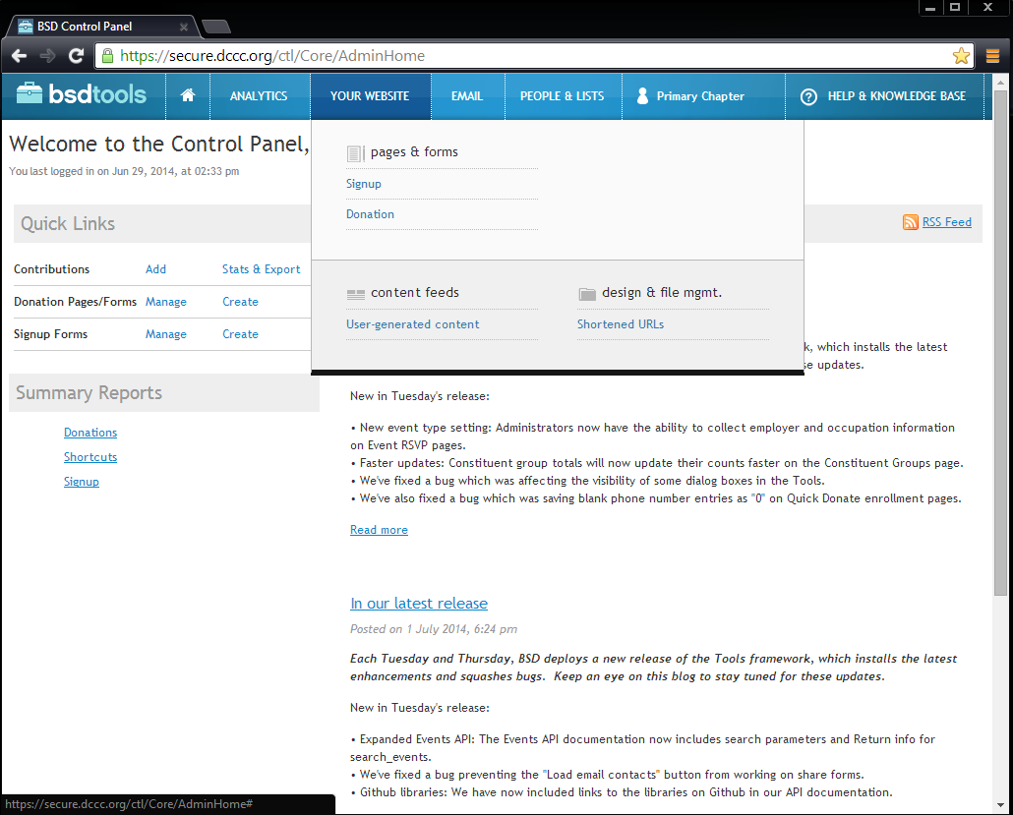

  - This will bring you to a listing of all active donation pages
  - For a new fundraising page, click “New Donation Page” on the top right
    - You will then click “clone and modify an existing fundraising page:
      - This is important as it will keep the back end work like linking to our authorize account and keeping up appropriate disclaimers
      - You can pick any page to clone. You must type the URL in the box that pops up- it makes sense to pick a old page from the same region as most of the changes will just then be to the title and header. Click “choose”
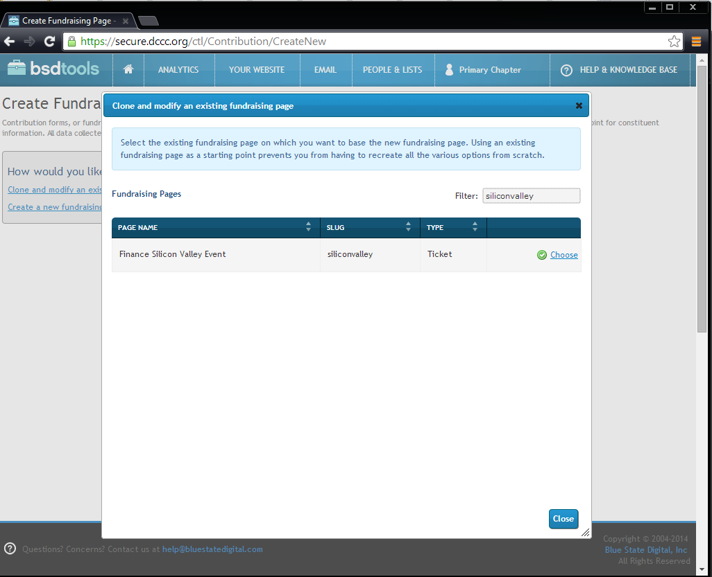
  - Here you will fill in all the necessary information on the first “general tab”
    - For “Page Name” ALWAYS Title the Page “Finance” followed by the event name
      - Ex: Finance Silicon Valley
  - The page URL will be requested from the regional team. Type that name in.
  - Go to the next tab, “amounts”
    - Here you can choose either Tickets (regionals will request this specifically) or custom. We don’t use the simple amount setting.
    - Add in the amounts requested and the titles of what they are called
      - Ex. Amount: $32,400 Label: Speaker’s Cabinet – per couple
      - If they haven’t given you clear labels, be sure to ask. The webpage should match what is on the invite.
      - Hit save and continue when complete
  - Go to the next tab, “Layout and Wrapper”
    - Here you copy and paste the text from the email (note, if there is an apostrophe, you must manually enter it in. if it is copied and pasted in, it will appear as a strange character when the webpage goes live)
      - Header goes here: <h1>
      - Description goes here: <p style="font-size: 120%"><strong>
      - Event/Location/Time goes here: <strong>Event/Location:</strong><br />
      - In the contact section, make sure to correctly enter the email address so that it links on the webpage!
      - <a href="mailto:LASTNAME@dccc.org">LASTNAME@dccd.org</a>
      - Glance at the disclaimer in the box below and make sure it is the correct one.
  - Save and continue, then go to the options page. Here you can edit who should be receiving the email alerts. The email addresses just need to be listed, with a comma separating them.
  - If the regional’s request changes to the Thank you page or thank you email, you can make those changes in the appropriate tabs at the top. We often edit the thank you email for POTUS events to remind donors they need to submit their vetting information to staff.
  - Before moving on to setting up the URL to let the page go live, click “preview” at the bottom of the page. This will let you see the page and double check that you’ve entered or updated all the necessary information.
- Setting up the URL for the page
  - Before you exit the “Create Fundraising Page” in the general tab, copy the page “full URL” so that you can enter it into the shortcut setup
  - Back on the top of the bsdtools dashboard, click “your website,” then click, “shortened URLs” on the bottom right
  - From here, you will click “New Shortcut” on the top right
    - The “slug” is the requested URL from the region
    - The destination is the full URL you copied from the “create fundraising page” followed by the following: ?source=fn_(URL)
      - Ex. Slug: http://action.dccc.org/nyclunch
      - Destination: https://secure.dccc.org/page/contribute/nyclunch
- Once these are all save and set- the page is live, and you can let the regionals know it is set!

Source Codes
- Source Codes
  - Regions will send you source code requests. Finance source does are 5 digits, the first two digits indicate the year of the event and the last three digits are just a random assignment of numbers to differentiate one event from another. Finance always uses 5 digit codes, but accounting and compliance only care about the last three digits.
  - When you get a source code request, always double check to see if this is a repeat event from last year or the year before. If it is- you will use the exact same last three digits, if just create a new code with the current year in front in NGP. For example, if someone were to request a source code for a recurring event, you can look back to the source code lists saved here: S:\2013-2014 Operations\Source Code Lists to see what the previous year’s code was. for example, if the request was for Napa, go to the last 2013 source code list and you will see that Napas code was 13487, as a result, this years code will be 14487.
  - Still send this new code to whichever regional requests it as it will confirm that it’s actually in NGP and sometimes it will be up to your discretion to decide if a new code is needed.
  - To create an entirely new code- log into NGP. Go to reports at the top. Click “report Library” scroll down to “Source Code Report.” In the filter criteria, list the two digits (year) to filter out the report.
  - Then simply go to the end of the sequence and use the next number in line that has not been used yet.
  - In NGP, go to “File” then “edit Codes” Change the type to “source codes” and click “add item.’
  - The source code name should follow the model of “2014 2014 DCCC (Event Name) MO.DA.14[Whatever the date of the event is]” – this is important to keep source codes consistent
  - Anytime you create a code in the system, make sure to cc Kate, Milly and Jackie on the e-mail you send back to the regional. Kate is in the one in charge of updating Navision (their accounting software) w/ the new code. (Note: nothing can be processed in the system, money, check requests, etc, if this code does not exist in their database, therefore it’s your job to ensure that they have this information”
  - Note: These steps will also apply for Main Codes/Attribution Codes, though these come up less frequently. It is your job to create these in NGP the same way you crease Source codes—in these cases you do not need to cc Kate.
  - The Source Code Report is saved here: S:\2013-2014 Operations\Source Code Lists
  - Whenever VISA comes out, you ‘run a source code report’, PDF it, and send it to regions
  - You can save this spreadsheet as a PDF and e-mail it to the regions, Brenna, Joe K. and Emily Bolton in press, who will use for VISA, check requests, etc.

Consultant Check Requests
  - You should aim to be UPS/Second Day Air each consultant’s check on the first of every month. This means having the signed check requests over to Jackie and flagged with a post-it that says “Please cut by [month/1] at least a couple of days before. This also means that you need to request each consultant’s invoice at least a week before the 1st of the month. Jackie likes to cut all consultant check requests together- therefore you need to leave enough time for everyone to get everything to you.
  - Somewhere around the 20th of the month you should e-mail each consultant (listed below) for their current month’s request:
    - Jackie Brot-Weinberg
    - Lisa Deutsch
    - Terri New
    - Lisa Presta
  - Once you have their invoices, fill out a check request form and save on the drive (S:\2013-2014 Operations\Consultant Check Requests) and get Stella to sign off
  - Bring to Jackie with a post it note indicating when they need to be cut.
  - Milly should NEVER mail these directly. Once they’re cut, one of them will return these to you for you to mail. You should 2nd day air them to everyone and e-mail each consultant their tracking number.
    - Jackie Brot-Weinberg will send you a shipping label of her own. Just print and adhere to UPS envelope!

Charters
- You can find previous charter information here: S:\2013-2014 Operations\Charters
- The Finance Operations Director serves as the liaison between our charter flight company (we use New Flight Charters and Air Charter Team) and Leader Pelosi’s office to coordinate the planning, confirmation, and payment of NP’s charter flights for DCCC events
- Missy will e-mail/call you and ask you to request a quote for a certain trip
  - Try and get as many details from them as possible:
    - Date, time of day, departure/arrival airport (i.e. Dulles or Reagan?), how many people
  - E-mail one or both of our contacts requesting a quote
    - Blake Smith – our contact at New Flight Charters (blake@newflightcharters.com, (619) 847-4278)
    - Gregg Pitts – our contact at Air Charter Team (Gregg@aircharterteam.com)
  - In general, both are is very responsive, but occasionally, Blake is in the air and unable to contact you
  - When you reach them, provide him with all the details that you have for the quote request; if he has more questions for you, you can get the answers from Missy
  - He will usually get back to you within a few hours with a quote
  - Send this quote to Missy and Stella, and they will relay to NP office
  - They will either say ‘yes’ or ‘no’ – they have to consult NP first
- If the answer is no, just tell them thank you but we are all set, and have decided not to charter the flight
- If yes, then the fun begins:
  - Let the contact know, and provide him with any additional updates or changes (i.e. if we originally requested for Saturday, but now want Sunday, we need to let him know because the plane may not be available for that day and the quote may change – just remember to convey as much info as possible to him).
  - Ask Contact to send you a formal contract
  - Give this contact to Rajan for Kelly to sign; if unavailable Missy or Hayley can sign
    - Before you give either person the contract to sign, check in with Missy and ask if Kelly (or Hayley) is aware that NP is using a charter flight; if not, then Missy needs to flag for them, so that they know this is coming down the pipeline and aren’t just giving a contract without knowing about it
  - And then scan the signed contract and send back to contact
  - After charter company receives the contract, you will begin working with him to secure the final departure/arrival times, the flight manifest (list of passengers, their DOBs, SSNs (sometimes this is needed), passport #s, place of birth, etc. – he will let you know what info he needs and when it is all due), tail #s, airport information, etc. You will collect information from NP’s office (timing, flight manifest), and you will get information from him to share with NP’s office (airport info, tail #s, pilot’s information)
  - Sometimes, it is helpful to put someone in NPs office (usually Kate or Bina) and Charter Contact on an e-mail together if there are specific questions that you do not have the answers for
  - Occasionally, these requests may come in at the last minute, and you just have to remain on top of it and make sure all information is being conveyed in an efficient and clear matter
  - On the day of the flight, Contact will be e-mailing you and NPs office and giving you updates about the plane, the actual, flight, wheels up/wheels down, etc.
- Capitol Police Reimbursements
  - When we use New Flight Charters (Blake Smith), we have to bill the Capitol Police for the security detail on the flight. When we use Air Charter Team they handle this aspect themselves. We just went through a long process of getting reimbursed for capitol police on charters dating back to 2007, so keep that in mind when requesting quotes.
  - Part of coordinating the charter flights, is also coordinating the Capitol Hill reimbursement portion of the flight
    - Examples can be found here: S:\2013-2014 Operations\Charters\USCP Reimbursement DOCs 2013
  - For each flight, you have to create a Capitol Police Invoice – they need to pay the DCCC for NP’s Security Detail on the flight
  - Research the ‘Fair Market Value’ for the given flight – you can use Expedia/Kayak – and just do a search for First Class tickets for the trip on that date and around that time (if you wind up doing the search after the trip has passed, just do for similar days of the weeks and times)
    - Sometimes there won’t be a commercial flight for the given route (i.e. Bedford, MA to East Hampton, NY – so just search Boston, MA to a nearby NY airport - either Islip, NY or New York, NY)
  - Screen shot these fair market prices
  - And then create an invoice to USCP stating the total amount owed to them (i.e. the fair market price times the number of agents that were on the flight)
  - Scan and e-mail this invoice to Beth and Jackie – they deal with the attorneys and USCP
- After the flight is finalized, e-mail Blake and request a final invoice, and then create a check request, attached the invoice and the Capitol Police reimbursement portion, and have Robby sign off on this
- Milly will give you the check and you will FedEx it to New Flight Charters
- Lastly, save all records related to the flight in the Charters folder in the Operations folder on the Finance Drive – this allows you to keep track of everything

Part III: SJI
- The Finance Operations Director is in charge of adding all of SJI’s finance/political events to the Finance calendar, and for coordinating with Hayley the deadlines for all SJI materials and informing her of all DCCC events that SJI should be made aware of/attend
- Once every few weeks, you will meet with Brenna and review the finance calendar
  - Bring her a copy of the block calendar and list of schedule requests pending for NP
  - Highlight any events that need to be flagged for SJI (i.e. DCCC events recently confirmed on NP’s schedule, other DCCC events)
- As new DCCC (and some HMP) events are getting approved and finalized, it is your job to e-mail and ask Missy, Stella and the Regional, “Would you like me to flag this for Brenna”
  - They will likely say, yes, (some HMP events he does not need to attend), and then you forward the information to Brenna and say ‘Flagging for SJI, he is invited, but does not need to be there OR he needs to be there.’
- Do not delete any e-mails and make sure you can easily find previous correspondence with Brenna
- SJI Materials are usually due at 4pm the day before the event. Brenna will communicate any changes in that deadline.
- Brenna will send you meeting makers for all finance/political events that she schedules for SJI – it is your job to add these events to the finance calendar, and track deadlines/materials for these events

SJI Invites (also in the Invite Section)
- Sent Host Vets for potential or confirmed hosts
- Regionals get approval from Missy and Stella as to hosts and MOCs whose names will be listed on the invite
- Regionals design the first iteration of the invite
- Regionals gives to Amy for Missy and Stella to sign off
- Regionals make changes (if need be), and email final approved version to Jacqui Newman and CC Kellie, for legal approval
  - Please make the subject, “For Legal Approval: Date of Event, Name of event”
- Jacqui will either respond that the invite is good to go, or give you changes. Once you have either made the changes or gotten sign off, email invite to Brenna and Hayley, and CC Kellie for SJI Approval
  - Please make the subject “For SJI Approval: Date of Event, Name of event”
- Once an invite has been approved by SJI’s office, you are good to send out once all other MOCs and/or hosts have approved their names
- Prior to sending out, Regionals send to all hosts and MOCs who have agreed to lend their name to invite. All hosts and Members on the invite MUST approve their own name. (You don’t have to cc Yates on this part)

SJI Scheduling
- For SJI scheduling, the regionals will send Brenna requests directly (unlike the NP scheduling system which is funneled through you). They should be cc’ing you on EVERYTHING they send to Brenna, so that you can keep track and make sure everything has been requested.
- Here is the SJI scheduling template:
Meeting/Event | Suggested Mtg Date/Format or Potential Timeline of event | Description/ Notes/ Expected amount to be raised/ VIPs involved | Location | Remarks Needed? | Staff Requesting

- It is important to include AS MUCH INFORMATION AS POSSIBLE, as SJI will sit on the requests until more details are sent.
- Previous schedule requests are saved here: S:\Finance 2013-2014\SJI Schedule Requests

Part IV: Miscellaneous
House Majority PAC
- It is the Finance Operations Directors role to coordinate Deadlines, Schedule Requests, Briefing Materials, and Long Term Updates with HMP
- Essentially, you can almost treat them like another ‘region’- except, since they are not in the office, you need to communicate with them what is on the Long Term, what the deadlines are, whether invites have been approved, and if you have all of their materials
- Your contacts at HMP are:
  - Ali Lapp (alapp@thehousemajoritypac.com) Nicole Runge D'Ercole (runge@4cpartnersllc.com); Amy Salomone (asalomone@thehousemajoritypac.com) and Rachel Gottke (rgottke@thehousemajoritypac.com)
- On all e-mail correspondence, include Missy, so that everyone is kept in the loop
- Include HMP on the deadlines emails that apply to them
- Include their pending schedule requests on your calendar as well
- We’ve started added HMP addendums into our briefings for all events that NP attends. HMP coordinates with the appropriate regionals to obtain the list of attendees, they then send you a addendum of HMP and SuperPAC giving history which you will merge into the main briefing from the regionals. This is the version you will send up AND you should send it back to the regionals for any future edits or changes.

Candidate/Red to Blue/Frontline Events
- NP and SJI attend candidate events, both in DC and around the country
- Candidate events are political requests, and either Missy or Stella will send these up to NP or SJI’s office
- Red to Blue/Frontline Events are DCCC events, and Claire Wall or Nicole Enyard will send you the schedule requests (to send up to NP’s office) and is in charge of the long term updates, and materials for these events
- Once schedule requests are approved and appear on the Long Term, or Hayley adds to SJI’s calendar, it is your job to collect LT updates from the correct political/candidate services individual, as well as remind them about deadlines for materials, and then get the materials from them
- For events that are in DC, the candidate services/political region will likely prepare the materials, but will contact appropriate regionals to add in finance information.

Member/PAC Events in DC
- NP will attend events for other MOCs and PACs while she is in DC – Mike Smith and Becca Durr, who are in charge of Nancy Pelosi for Congress/PAC to the Future, are in charge of getting you information about these events, including:
  - Long Term Updates
  - Materials
    - They need to flag for Katie Mulhall. if TPs are needed
  - Staffing
- Usually Mary-Kate or Devan will flag for you/Missy/Stella, that these events are being added to the Long Term, but just in case they don’t, if you see these events on the LT, flag for Mike, Becca and Katie.

Interns
- The Finance Operations Director manages the DCCC Finance Internship Program
- The responsibilities are:
  - Interviewing and hiring an intern for each ‘semester’ (Winter/Spring, Summer, Fall)
  - Notifying Paulina that you have hired an intern and getting the proper paperwork filled out
  - Ensuring the intern has projects and touching base with them throughout the semester to see how they are doing, if they need more/less work, and just maintaining a strong relationship with them
  - Working with Paulina on any DCCC Internship related programming (i.e. round table discussions)
  - Working with the other department’s intern coordinators
  - Occasionally, finance staff will receive resumes for potential interns, and you can pass these along to the other coordinators OR hire that intern
- We currently have no interns and should look to hire one for the new year.

Attorneys
- Perkins Coie is our legal representation. Graham Wilson (GWilson@perkinscoie.com) and Danielle Friedman (DanielleFriedman@perkinscoie.com) are the Finance Dept. support team and Andrew Werbrock (awerbrock@perkinscoie.com) and Christine Neville (Cneville@perkinscoie.com) are the compliance support team.
- If you have any questions related to any legal aspects of contributions, feel free to call or e-mail them
- They will work on drafting language for problem checks – and Jackie is always looped in on those emails and working with them too
- Jackie mainly works with them though, so your interaction is as limited or as open as you want it to be
- A full list of the Attorneys we work with from Perkins can be found here: Z:\Legal Memos

Intuit
- In 2012, we started using the Intuit credit card readers at events to process CC contributions
- However, regions have found that it takes awhile and is not very convenient when you have a large crowd
- If you want to utilize this more/push this program, you can do so
- Extra credit card readers are in the filing cabinet at the Finance ops desk
- And you can track contributions here:
- https://merchantcenter.intuit.com/qbms
- Ask Jackie to create an account for you that allows you to have a managing role
- Please note- we have NOT used these in the 2014 cycle.

Wired Contributions
- We will occasionally receive wire transfers of contributions.
- Below are the wiring details. Regionals will let you know someone will be sending a wire, then you should flag for Milly and Jackie. Print out the confirmation once Jackie sends to you, and attach that with the paperwork from the regional
DCCC Wire Instructions
Bank of America
ABA/Routing #026009593
Democratic Congressional Campaign Committee
General Account No. 1
Account #0002680718

Meetings with Katie Mulhall
- Katie Mulhall (Speech Writer) and I met every Friday to go over the following 2-3 weeks’ worth of events and deadlines. We found this to be very helpful as events, especially for the Leader, would often pop up, with little communicated to her or I. for this you will need the following
  - Calendar for up to 4 weeks
  - Deadlines Document
- It is also helpful to send emails out to regionals to remind them to send Katie their talking point requests at least 2 weeks prior to their events. When you touch base with her weekly, you will go over what she has and has not received.

Battleground Brief
- This is an emailed update for our donors that is sent out once a month, coordinated with our filing.
- Katie Mulhall puts this together
- You will be in charge of compling the “upcoming events” section
- Make sure regions approve their events
  - Note- we don’t usually put DC events on there
- Previous battleground briefings are saved here: S:\2013-2014 Operations\2013-2014\Battleground Brief

Emergency Coordinator
- As Finance Operations Director, you are the emergency coordinator for the Finance Department. In the event of an emergency, once the building has been evacuated and everyone has located to the meeting point (on the corner of New Jersey Ave and Ivy St), you will need to take attendance of everyone in the department and check in with Hayley and Jacqui. I kept a list of everyone’s names, cell phone number and personal email address in the “notes” app on my iPhone. Here is a list of everyone in the department as of November 2014:

Missy Kurek, 315-373-9560, missykurek@gmail.com
Stella Ross, 913-558-2901, Stella.ross@gmail.com
Courtney Lee-Ashley, 202-262-6614, courtneysigmon@gmail.com
Krista Jenusaitis, 202-904-0224, kjenusaitis@gmail.com
Amy Soenksen, 760-828-2214, acsoenksen@gmail.com
Mike Smith, 732-610-9658, Michael.k.smit@gmail.com
Becca Durr, 512-413-6882, becdurr@gmail.com
Michael Lewis, 916-335-1702, michaelflewis@gmail.com
Manjiri Machak, 413-563-5035, mcmannino@gmail.com
Emma Levin, 860-965-9040, emma.j.levin@gmail.com
Dan Boysen, 860-716-3956, dboysen886@gmail.com
Hannah Bruce, 603-203-1327, hesbruce@gmail.com
Grace Gaylord, 802-999-3808, gegaylord@gmail.com
Corey Miller, 925-324-5369, coreymiller7@gmail.com
Liz Robertson, 318-286-5391 celizabethrobertson@gmail.com
Adam Blackwell, 601-870-7290, ablackwell601@gmail.com

NP Office Visa
- You will be the point person to compile the Visa reports for NP advance staffers when they travel for political events
- Kelsey Smith and Mary-Kate Barry are currently the only NP staffers with CCs
- They are both very good about getting you whatever you need very quickly\
- Old visas are saved here: S:\2013-2014 Operations\2013-2014\NP Office Visa, Per Diems and Reimbursements

Accuconference Conference Call System:
- To set up a conference call, call the number on the card. Our account number is: 2514471
- Note –if you are confused as to how to set up, ask them to set up like previous conference call (normally, moderated, not recorded, requesting name and org from participants, etc)
- NOTE – if we do not make the minimum required for a call, we get charged an exorbitant amount of money. Do your best to work with Stella and co and make a good faith estimate on how many lines needed. You have up to 24 hours before the scheduled call to add or change lines, although they are normally good about accommodating extra lines as the call occurs.

Organizational Suggestions
Organization in this position is paramount. Here are a few suggestions of what I did to help keep me organized
- Email categories
  - I set up the following email categories to keep my email organized
    - SNAP
    - Long Term Updates
    - Long Term Schedule
    - Vets
    - Money Chains
    - Web Page Requests
    - Schedule Requests
    - For Legal Approval
    - SJI
    - Please approve date and time (invites)
    - NP Materials
    - Source Codes
- Personal Folders
  - I set up personal folders that corresponded to the email categories above with the following additions
    - Battleground Brief
    - Online Contributions
    - Bundling
    - Charter Flights
    - Consultant Requests
    - HMP Requests
    - NPVF
    - SIVF
    - NGP
    - Remarks Requests
    - SNAP
    - HSVF

Supplemental Items (included in this packet)

Addendum 1 - Sample SNAP Email, “Steps to a Successful Snap” One Pager
Addendum 2 - Sample Vetting Email
Addendum 3 - Sample Schedule Request Email
Addendum 4 - Sample Invite Email
Addendum 5 - Sample Long Term Update Email

All saved here: S:\2013-2014 Operations\2013-2014\Cheat Sheets

Feedback

Because this position requires so much interdepartmental interaction, I think it was very helpful to have weekly meetings with the political department coordinator and the speechwriter (for political memos and talking points respectively). This allows for people to get on the same page in terms of deadlines. Overall I have enjoyed this position – it requires immense organization, but also allows for relationship building between staff within the DCCC and the Chairman/Leader’s offices. I think the most efficient way to learn this position is to have the current person teach it. I was very lucky to have Kellie Dunn here for two weeks to help me transition.

Success in this position is dependent upon having a strong understanding of every region’s work style and structure. For example, some regions can handle the real-real deadline for materials and will get their memos in for review with enough time for edits and changes. Others work more slowly and need to have the “deadline” be several hours ahead of the hard deadline. The ability to read people and understand these dynamics is integral.

Overall, I think the systems and processes in place for the finance department work well. I will say that the Finance Operations Director cannot be scared to remind and bug people about deadlines, materials, etc. It is important to send reminders to finance regional teams about formatting for long term updates, transmittals etc. In terms of reconciling with accounting, I think instilling a mid-month reconciliation as a hard-fast rule would be useful.

I am happy to be a resource to whoever takes over the position in the future, acsoenksen@gmail.com or 760 828 2214

