Electronic Article Surveillance
RS002 RS006 digital EAS

User’s Guide

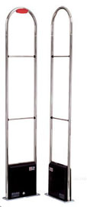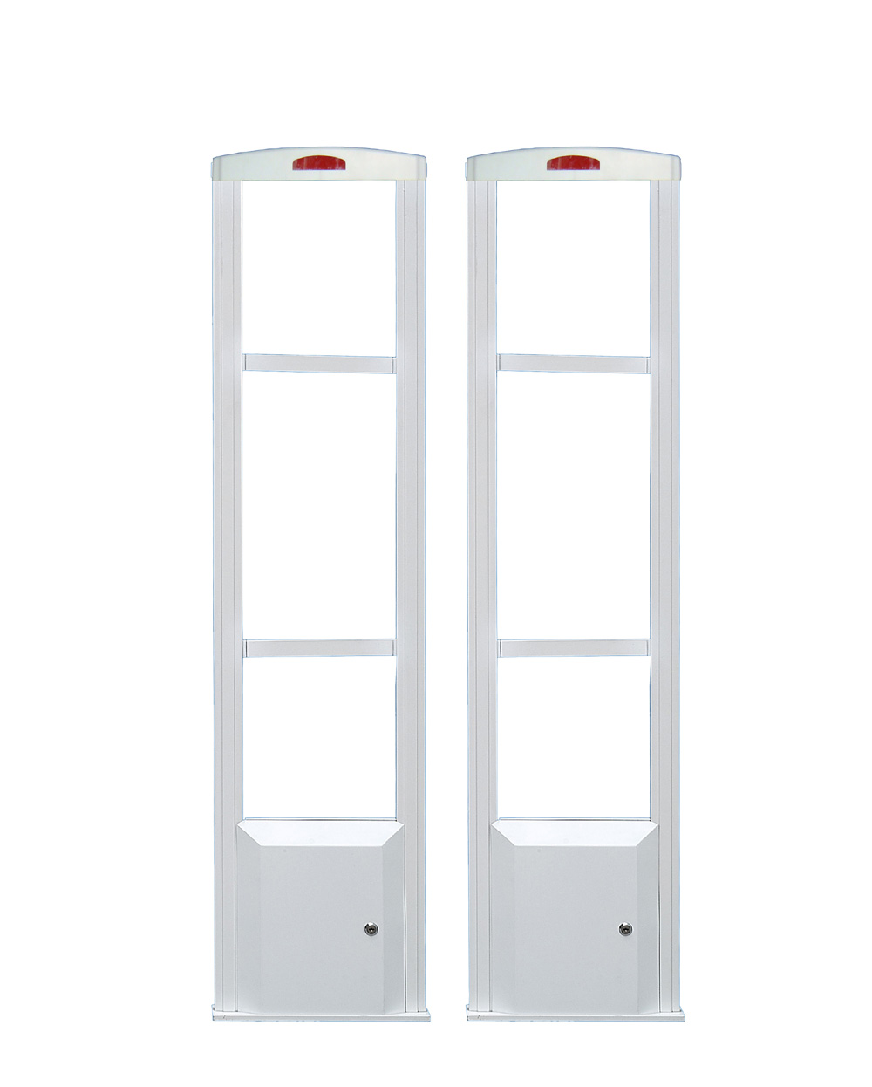

PREFACE
Thanks for your choosing EAS system series products of “DRAGON GUARD” at first. We do hope it can provide the convenience and efficiency for your work and management when you use our advanced EAS system.
The EAS of “DRAGON GUARD”, which is designed and produced specially according to more and more serious phenomenon of shoplifting today in supermarket and bookstores, etc., it will prevent the commodity from being stolen and increase your sales, because the shopper also feel free shopping space since you have installed the EAS.
The EAS of “DRAGON GUARD”, like as the other same products, is not the only standard to judge commodity stolen or not. It can only be regarded as a kind of the best electronic Anti shoplifting tool and reduce the stolen commodity.
Here we write the user’s Guide in order to help you use it more conveniently. As you know, whether EAS is fully used depends on how to install and adjust it.
This User’s Guide has six parts: basic working principle & use illustration、installation、adjustment、system maintenance& common trouble, etc.

You should read this User’s Guide carefully and make training plan for clerk according to the system and supermarket character.
We keep the right of revising this book at anytime without notice.
All rights reserved, we keep every right for this book.
We don’t allow this book copied by anyone without our company’s literal agreement.

Chapter 1：Basic working principal

1.1 RF EAS basic working principle
The basic working principle of Radio Frequency EAS System is: transmitter sends out the swept-band, there will be a scan area between the transmitter and receiver, and then the receiver receives it. Based on the principle of electromagnetic wave resonance to search the labels in special frequency range. It will be alert if any effectual labels exist in the range.
“DRAGON GUARD” Electronic Article Surveillance system would give you the solution for shoplifting. The effectual labels are sticked to the commodity and the sensors are installed in passage or gate, the label will be lapse by deactivator or detacher. The receiver will alarm when the non-payment and unchained commodity goes through the sensors.
Commodity
Take it away
Payment
Deactivate
Non-payment
Commodity
Label or tag is stick to the commodity

Leave
System alarms

Picture 1

1.2 EAS configuration
Electronic Article Surveillance System is consisted with Sensor(transmitter、receiver & special power supply), electronic labels (soft label and hard tags), instrument for deactivating(Deactivator/detacher).
1.2.1 Sensor
There will be a scan area between transmitter and receiver, it will scan the commodity passing through the sensors, and alert if the label with the commodity undetached.
1.2.2 ELECTRONIC LABELS
There are two kinds of electronic labels:
RF Soft Labels: used for one time and can be attached to all kinds of nonmetal commodity.
Hard Tags: repetition used and can be attached to clothes and bags and shoes.
1.2.3 Instruments for deactivating
A. Deactivator: deactivate over 15cm high. The 8.2MHz RF paper labels is deactivated when it is passed through the deactivating area. That is contactless deactivation.
B. Detacher: Can detach the hard tags from commodity quickly, safely and conveniently.

Chapter 2 : Installation Guidance

Ι Main technical parameters
Transmitter:
Power supply DC 22V
DC source ＜300mA
Safeguard 250V, 0.5A fuse
Output current 180mA＜JP1＜240mA
Center frequency 8.2MHZ ±0.05MHZ
Scanning frequency bias ±500KHZ
Scan rate 180HZ ± 1HZ
Receiver:
Power supply DC 22V
DC source ______
in guard status ＜380mA
in alarm status ＜380mA
sensitivity 5μA
Safeguard 250V, 0.5A, fuse
radio-frequency bandwidth 7.5MHZ ～8.5MHZ
Ⅱ Mounting tools instruments and meters
Name Quantities
1、earth groove cutter 1
2、bumping electric hammer 1
3、hand electrical drill 1
4、adjustable wrench 1
5、iron hammer 1
6、clipper 1
7、bevel pliers 1
8、crosshead screwdriver 1
9、screwdriver for adjustment 1
10、universal meter 1

Installation notice points
！
- EAS sensor must be upright with installation ground
- Prohibit putting label and tag to the 30cm surrounding of power supply cable and synchronization cable
- It is unfit to pile up a lot of metal things such as handcraft, metal door surround the EAS sensor，metal wall reinforcements, goods shelves, metal showcases, hand purchasing carts, etc.
- EAS sensor must be kept away from these things at least 1.5 meters, such as POS system, the money machines, ID devices for credit cards, telephones, computers, data cables, neon lamps, air conditioners, heaters, etc. and deactivator
- EAS sensor should keep 30cm distance away form metal counterpoint
- The power supply wire must be used independently and fix hardly, prohibit using bad quality plug
- When using linearity power supply, the linearity power supply must keep away from switch power supply, or it will cause disturbance
- Power supply should use special line independently, don’t share a power supply line together with light and high-power machine.
- There shouldn’t have strong disturbance resource around EAS sensor, especially 7.3~8.7MHz disturbance signal, or the system can’t work normally
(10) Please regulate the surrounding electronic equipment, which will cause disturbance, such as low quality energy saving light
(11) When existing many TX antennas, only permit one TX as Master, the other can be set as slaver, the Master and Slaver can be connected with synchronization wire;
(12) It will cause false alarm under strong electromagnetic disturbance, such as light from metal bounce, switch on light and so on, when disturbance eliminated, the system will return to normal.
Ⅲ Environmental Conditions
1、Mounting position of EAS detector
EAS detector cannot be set up in the distance of 0.5m from a metal door or 1m from any metal objects inducing the metal wall reinforcements, goods shelves, metal showcases, hand purchasing carts, etc. It is also not allowed to mount this detector in 2m nearby the money machines, ID devices for credit cards, telephones, computers, data cables, neon lamps, air conditioners, heaters, etc.
2、To ensure the EAS operation reliability, at first it is necessary to detect the interference sources and set the system far away from these sources if they are difficult to be removed. Generally, there are two kinds of interference: the first is active in nature such as the various electric sparks, motors, blowers and fire due to improper contact, or interferences caused by serious noises of power source; the second is passive in nature such as the conduct rolls, pos machine on money acceptance desk, different signal limes of printer power cords in roll and so on.
3、The power case of EAS detector uses 10A two poles and a grounding plug. A separate power source AC 220V is required to avoid the interference with the other appliance. The power socket must be conformed to the standard 10A double-pole socket with a grounding plug.
4、A pair of RF detectors are used to identify whether there exists an interference source. When they are in the pre-installation position, Look at the receiver lights:DS1,DS2,DS3,If the DS1 and DS2 are lighting, which shows the existence of serious interference, so it is necessary to remove the interference source according to the above 1,2 instructions or replace the power source, move the maim unit into the building or change the suitable unit in order to match the environment.
5、There may be some limitation in use of EAS, since RF detector works on the principle of electronic harmony and the metal shield may become invalid. Users should be aware of the situation that some goods such as milk powder, chocolate, etc. In metal or metal film package may be not protected with the EAS tag adhered directly. In such a case, the dedicated binder tape or protective box is adopted for protection.
Ⅳ Mounting mode
The largest mounting distance of FOCUS RF detector is≤95cm for the soft tags, while ≤120cm for the “small square hard Tag”(≤140cm for the “eccentric circular Tag”) . This distance is checked under the condition that the transmitting antenna is mounted parallel with the receiving antenna, and the center point of the antenna pedestal is taken for the reference point of distance.
One transmitter corresponding to one receiver is considered the standard mode of mounting RF detector. When multiple systems are used together at a horizontal spacing ＜20m and vertical spacing ＜7m, a link mounting of systems as shown below is demanded.
1、Mounting
Make a groove on the definite place to bury the power cords.
The rack base is fixed with the steel tight-fitting screws after drilling the roles (Fig.2).Note that there should not be any carts or metal objects around the main unit. If the power cord comes in through the ceiling, it must be in 2m apart from the detector and the insulation layer grounded to avoid any interference. For power cord, the separate opening is required with good connection. A poor socket is not recommended because the improper contact may cause high-frequency spark resulting in unstable work of system and even misdetecting.
2、Wiring Open the detector panel as shown in Figs 3,4.

The sketch map of Sensor installation The plan of Sensor’s pedestal

picture.2(the unit of size: mm)

Diagram of a transmitting printed circuit board (PCB):
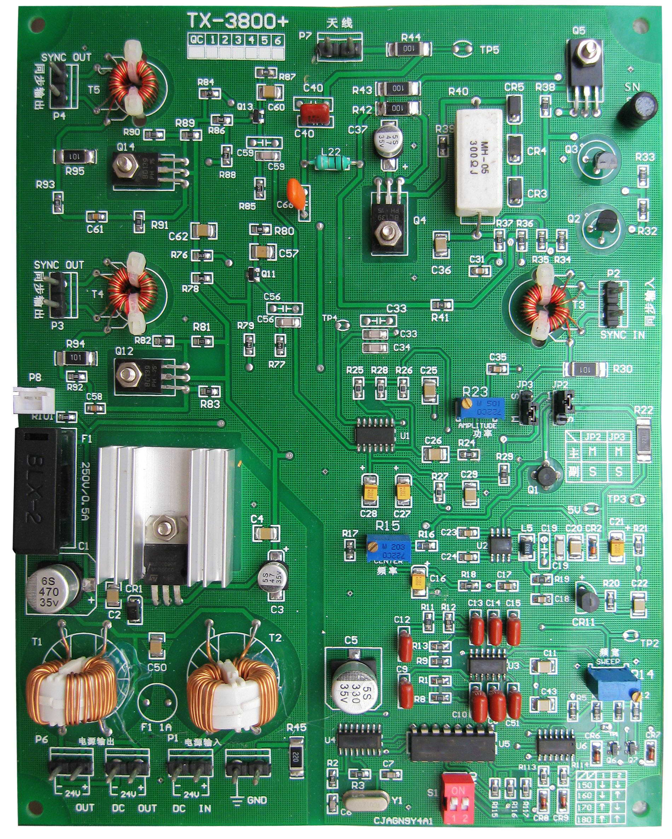
(The synchronous output ports)
SYNC OUT

(The synchronous output ports)
SYNC OUT

(The synchronous input ports)
SYNC IN

the main transmitter： JP2,JP3 to “1-2”
the secondary transmitter: JP2,JP3to “2-3”

to DC input port of another receiver

to DC input port of a receiver

to DC output port of the power case

Fig.3

Diagram of a receiving PCB board:
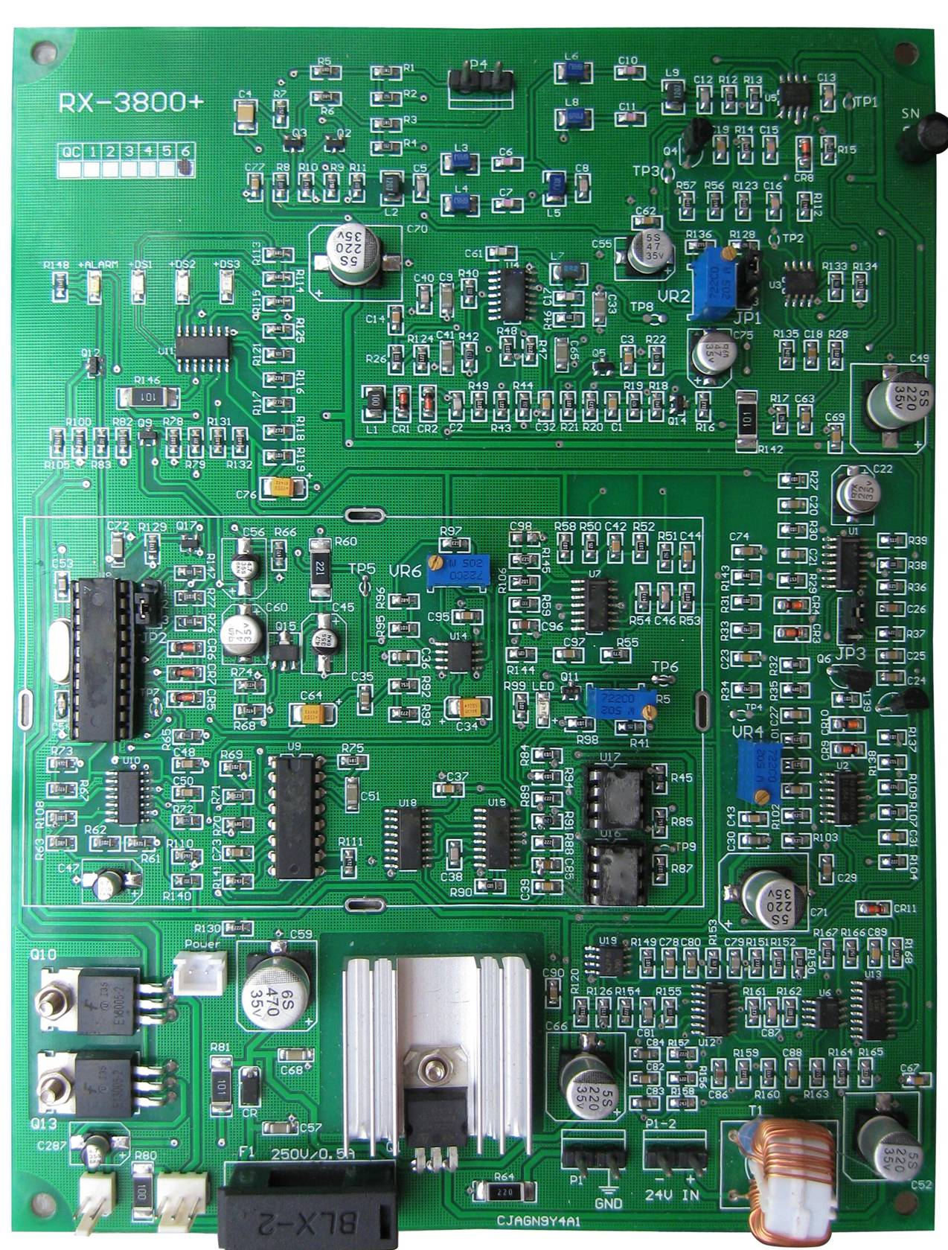

Adjust Sensitivity,
HIGH: rotating VR4 clockwise
LOW: rotating VR4 counterclockwise

Power light

Buzzer of alarm
Light of alarm

To DC output port of the transmitting board

Fig.4
3、Synchronizing connection is shown in Figs 5,6.The jumper settings of the main and secondary transmitters are indicated in Tab 1,2.
a. main transmitting board b.secondary transmitting boar
P3 two.core shielded cable HIYVP160 P2
1 1
1
2

2 positive positive
pole pole
Fig.5
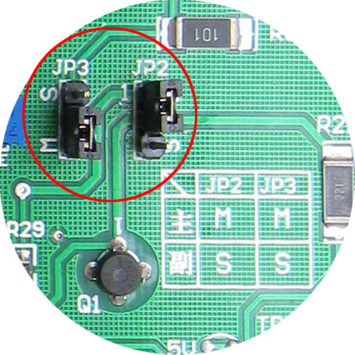
to P2 port of the next transmitting PCB board

TAB1-2
 | JP2 | JP3
Master | M(1,2) | M(1,2)
Slave | S(2,3) | S(2,3)

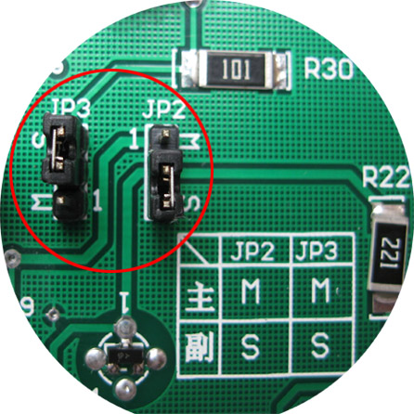
to P2 port of the next transmitting PCB board

to P2 port of the next transmitting PCB board

Fig.6

P3 and P4 of the main transmitter are the synchronous output ports that can output simultaneously two ways of synchronous signal. On the secondary transmitter,P2 port is for the input, while P3 and P4 ports for the output of synchronizing signal. In the condition of link connection, the main transmitter sends out two ways of synchronizing signal from P3 and P4 ports, the secondary transmitter has the synchronizing signal to be input through P2 port and output from P3 and P4 ports.
5、Trial of the system after turning on the power
Before the power is supplied please do the following inspections:
- Check the transmitters to confirm the jumper JP setting of
the main transmitter(note: When the multiple transmitters are connected, specify one of them as the main transmitter JP2:(M)1-2;JP3:(M)1-2)
the secondary transmitter (note: When the multiple transmitters are connected, the other transmitters are considered as secondary ones JP2:(S)2-3;JP3: (S)2-3)
- check the receiver to confirm the jumper JP setting.
JP1;JP2 is shown in Figs4.
3、Turning on the power (pre-heating3 minutes)
Look at the lights on the PCB board of the receiver .If the light DS1 flash, this is caused by the environmental interference)
Sensitivity check pass through the detector with a tag in hand in the direction and place as shown in Fig.7 If there will be no alarm or only a slow alarm sensitivity, it is required to handle according to the following instructions.
Ⅳ Inspection on site
- Repeat test of the transmitting board as follows.
  - Modulating signal (The setting for this item is completed by the manufacturer, so it does not require any adjustment)
When the probe of frequency meter contacts the transmitter TP1,with transmitter TP2 grounded and rheostat R7 adjusted, we have a meter reading 180HZ±1HZ.When the oscilloscope probe contacts the transmitter TP3, with transmitter TP2 grounded…
  - Scanning center frequency (The setting for this item is completed by the manufacturer, so it does not require any adjustment)
When the probe of frequency meter contacts the transmitter TP6,with transmitter TP8 grounded and rheostat R15 adjusted, we have a meter reading 8MHZ ±0.5MHZ.
  - RF output range
When the oscilloscope probe contacts the transmitter TP6,with transmitter TP8 grounded and rheostat R23 adjusted, we have a sinusoid of 16-20Vp-p.With transmitter TP7 grounded there will be a sinusoid of 45± 3Vp-p_{R}.
  - Range of scanning frequency (The setting for this item is completed by the manufacturer, so it does not require any adjustment).When the oscilloscope probe contacts the transmitter TP4,with transmitter TP2 grounded and rheostat R14 adjusted, there will be a sinusoid of 0.6Vp-p and the range of scanning frequency is 7.5～8.5MHZ.
2. Adjustment of the receiving board
- RF signal range
When the oscilloscope probe contacts the transmitter TP1,with transmitter TP20 grounded, the RF signal range will be 6.5-8.5Vp-p.As the oscilloscope probe contacts the transmitter TP4,with transmitter TP21 grounded and rheostat VR1 adjusted, the static noise has its range ≤1Vp-p,when there does exist any tag in the detection area.
- Blocked level
When the oscilloscope probe contacts the transmitter TP22,with transmitter TP21 grounded and oscilloscope set on the DC step, adjust the rheostat VR2 to have the level suddenly change to +7.6V,then rotate for VR2 an angle of 70(?) degrees. When the pedestal bases of transmitting and receiving antennae are held by two hands simultaneously, the level of transmitter TP22 should not skip to OV.
- Threshold voltage value
With the universal meter set on DC step, the red pen contacting transmitter TP14,the black pen contacting transmitter TP6,thus the rheostat VR3 is adjusted such that the voltage value will be 0.75V±0.03V.While adjusting watch the lighting bars and wake them stop flashing.
- Timing pulse width
With the oscilloscope probe contacting transmitter TP5,transmitter TP16 grounded and the resuming tag set and fixed in the center detection area, by adjusting rheostat VR4 the timing pulse width will be 100μs.

Ⅶ Trial on site
    - Open the receiver cover and look at the light DS1 do not flash. In normal condition, the more no flash the light is, the better it will be.
    - If the light DS2 flash of blink, first to check whether there are any metal objects in 2m nearby the antenna, and the conduct labels as well. Please remove them if there are any in order to let the light DS2 do not be flashing.
    - The light DS2 blink because of the large ambient noise. In this situation, the light DS2 and DS1 can be obtained by rotating VR4 counterclockwise.

Ⅷ Easy methods for troubleshooting
Troubles | Items tube checked | Remedy
The power lamp does not light up. | Check that the power switch is turned on. Confirm that the play is connected; the fuse is perfect and not burned. | Turn on the power switch; firmly connect the plug and socket; replace the fuse with a new one.
Super | Check that there are any tags around the detector. Confirm that the timing pulse width of the oscilloscope is 100μs. Check with an oscilloscope whether any strong interfering signal exists in the static noise (for receivers TP4, TP2). | Remove the tags near the detector; adjust the timing pulse width to 100μs;  Check that there are any limitless transmission devices such as the powerful stations, wireless telephones etc. Producing noise.
Alarm indicator lights up. | Check that there are any tags around the detector. Check with an oscilloscope whether the receiver static noise is larger than 1Vp-p. | Remove the tags all around. Remove the noise source, if not, then raise the value of alarm threshold voltage to satisfy the demand of alarm and anti-interference.
No alarm | Check the working status of detector:  - Check that exists the modulating signal and the receiver TP17 has a sinusoid of 180HZ.  - Check whether the scanning center frequency is 8MHZ and for TP7 it is larger than 45Vp-p.Checking mode: set the transmitter JP1 in 3-2 position, check the voltage and scanning center frequency > of TP7.When in normal use, JP7 is set in 1-2 position.  - Check that whether the receiving and transmitting RF range is excess low.  - Blocked level is of 7.6V | According to the trial regulations, make the trial for all parameters step by step till the requirements are satisfied.
- Check the receiver TP14 to have its threshold voltage setting
–0.75V.
- Check that the timing pulse width for receiver TP5 is 100μs.
- Confirm that the power supply works correctly.
- Confirm that all the wires are connected properly.
Alarm sensitivity is low | Check that the threshold voltage is set too high, the transmitting and receiving range are set too low, the tags are allocated reasonably. the static noise of oscilloscope is too high. | Adjust the threshold voltage value properly to satisfy the demand of alarm and anti-interference.  Adjust the transmitting and  Receiving RF range based on the trial regulations.  Change the responding tags.  Insulate the noise source.  Note: At the time to reduce the threshold voltage of receiver and to raise the RF range, viewing the change of static noise with an oscilloscope can increase the alarm sensitivity and depress the noise effectively.

Remark:
Contact the manufacturer or authorized representative when there is still any trouble after taking all the measures stated above. For cleaning please use the fresh water or alcohol, use a soft material to wipe lightly. It is prohibited to use any corrosive solvent. No liquid is allowed to come into the device box.

