  - Experiment: When a process that results in one and only one of many observations is performed, it is called an experiment.

Outcome: The result of the performance of an experiment is called an outcome.

Sample space: The collection of all outcomes for an experiment is called a sample space.

Simple event: A simple event is an event that includes one and only one of the final outcomes of an experiment.

Compound event: A compound event is an event that includes more than one of the final outcomes of an experiment.

  - a. S = {1,2,3,4,5,6}

- S = {HHH, HHT, HTH, HTT, THH, THT, TTH, TTT}

- S = {H1, H2, H3, H4, H5, H6, T1, T2, T3, T4, T5, T6}

  - The experiment of selecting two items from the box without replacement has the following six possible outcomes: AB, AC, BA, BC, CA, CB. Hence, the sample space is written as
S = {AB, AC, BA, BC, CA, CB}

  - Let: Y = student selected suffers from math anxiety
N = student selected does not suffer from math anxiety

The experiment of selecting two students has four outcomes: YY, YN, NY, and NN.

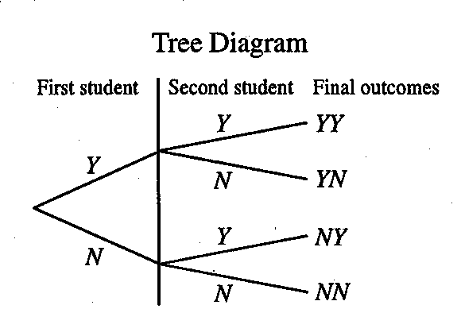
Venn Diagram

• YY | •YN
• NY | •NN

  - Let: L = person is computer literate I = person is computer illiterate

The experiment has four outcomes: LL, LI, IL, and II.

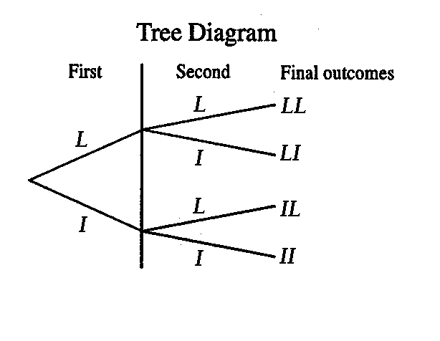
4.6 Let: C = the answer selected is correct W = the answer selected is wrong

This experiment has four outcomes: CC, CW, WC, and WW
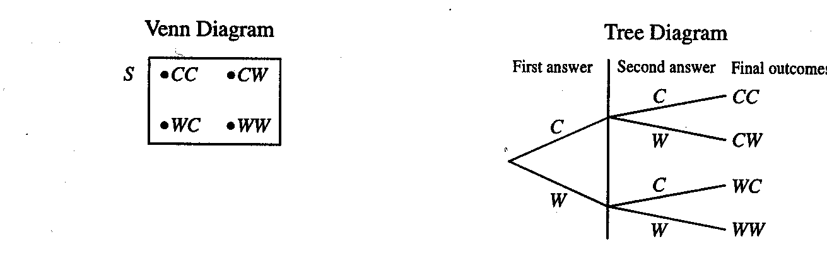
4.7 Let: G = the selected part is good D = the selected part is defective

The four outcomes for this experiment are: GG, GD, DG, and DD

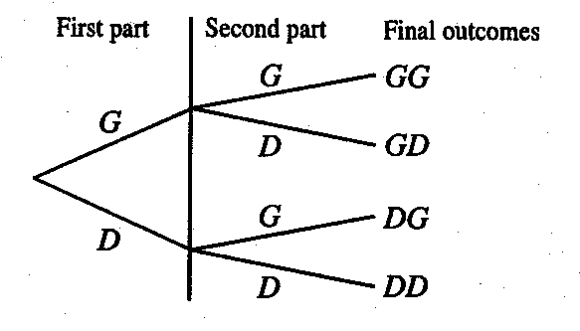
4.8 Let: F = person selected is in favor of tax increase and A = person selected is against tax increase.

The experiment of selecting three persons has eight outcomes: FFF, FFA, FAF, FAA, AFF, AFA, AAF, and AAA. Hence the sample space is written as

S = {FFF, FFA, FAF, FAA, AFF, AFA, AAF, AAA}.

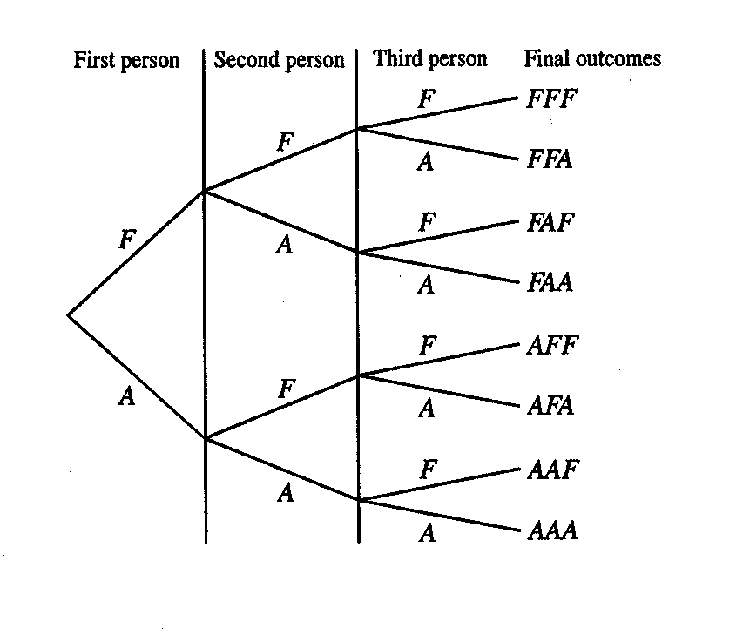

4.9 Let: H = a toss results in a head and T = a toss results in a tail

Thus the sample space is written as S = {HHH, HHT, HTH, HTT, THH, THT, TTH, TTT}

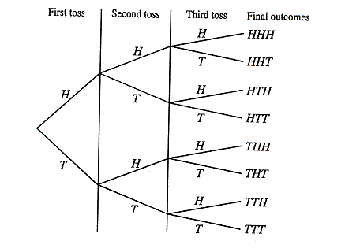
4.10 a. {YY}; a simple event c. {NY}; a simple event
b. {YN, NY}; a compound event d. {NN}; a simple event

4.11 a. {LI, IL}; a compound event c. {II, IL, LI}; a compound event
b. {LL, LI, IL}; a compound event d. {LI}; a simple event

4.12 a. {CC}; a simple event c. {CW}; a simple event
b. {CC, CW, WC}; a compound event d. {CW, WC}; a compound event

4.13 a. {DG, GD, GG}; a compound event c. {GD}; a simple event
b. {DG, GD}; a compound event d. {DD, DG, GD}; a compound event

4.14 a. {FFF, FFA, FAF, AFF }; a compound event
b. {FFA, FAF, AFF }; a compound event
c. {FFA, FAF, FAA, AFF, AFA, AAF, AAA}; a compound event
d. {FAA, AFA, AAF, AAA}; a compound event

  - The following are the two properties of probability.

1. The probability of an event always lies in the range zero to 1, that is:
$0≤P(E_{i})≤1$ and $0≤P(A)≤1$

- The sum of the probabilities of all simple events for an experiment is always 1, that is:
$\sum{P(E_{i})=P(E_{1})+P(E_{2})+P(E_{3})+⋯=1}$

  - Impossible event: An event that cannot occur is called an impossible event. The probability that such an event will occur is zero.

Sure event: An event that is certain to occur is called a sure event. The probability that this event will occur is 1.

  - The following are three approaches to probability.

1. Classical probability approach: When all outcomes are equally likely, the probability of an event A is given by:$P(A)=\frac{\text{Number of outcomes in }A}{\text{Total Number of outcomes ub the experiment}}$

For example, the probability of observing a 1 when a fair die is tossed once is 1/6.

- Relative frequency approach: If an event A occurs f times in n repetitions of an experiment, then P(A) is approximately f /n. As the experiment is repeated more and more times, f /n approaches P(A). For example, if 510 of the last 1000 babies born in a city are male, the probability of the next baby being male is approximately 510/1000 = .510

- Subjective probability approach: Probabilities are derived from subjective judgment, based on experience, information and belief. For example, a banker might estimate the probability of a new donut shop surviving for two years to be 1/3 based on prior experience with similar businesses.

  - The classical approach is used when all the outcomes of an experiment are equally likely. The relative frequency approach is used when all the outcomes are not equally likely, but the experiment can be performed repeatedly to generate data.

  - The following cannot be the probabilities of events: −.55, 1.56, 5/3, and −2/7

This is because the probability of an event can never be less than zero or greater than one.

  - The following cannot be the probabilities of events: −.09, 1.42, 9/4, and −1/4

This is because the probability of an event can never be less than zero or greater than one.

  - These two outcomes would not be equally likely unless exactly half of the passengers entering the metal detectors set it off, which is unlikely. We would have to obtain a random sample of passengers going through New York’s JFK airport, collect information on whether they set off the metal detector or not, and use the relative frequency approach to find the probabilities.

  - We would use the classical approach, since each of the 32 applicants is equally likely to be selected. Thus, the probability of selecting an experienced candidate is 7/32 and that of selecting an inexperienced candidate is 25/32.

  - This is a case of subjective probability because the given probability is based on the president’s judgment.

  - This is a case of subjective probability because the given probability is based on the coach’s judgment.

  - a. P(marble selected is red) = 18/40 = .450
  - P(marble selected is green) = 22/40 = .550

4.26 a. P(a number less than 5 is obtained) = 4/6 = .6667
b. P(a number 3 to 6 is obtained) = 4/6 = .6667

  - P(adult selected has shopped on the internet) = 860/2000 = .430

  - P(student selected has volunteered before) = 28 /42 = .6667

  - P(executive selected has a type A personality) = 29/50 = .580

  - Number of families who paid income tax last year = 3000-600 = 2400
P(family selected paid income tax last year) = 2400/3000 = .800

4.31 a. P(her answer is correct) = 1/5 = .200
b. P(her answer is wrong) = 4/5 = .800
Yes, these probabilities add up to 1.0 because this experiment has two and only two outcomes, and according to the second property of probability, the sum of their probabilities must be equal to 1.0.

4.32 a. P(professor selected is female) = 105/320 = .3281
b. Number of male professors = 320 − 105 = 215
P(professor selected is male) = 215/320 = .6719
Yes, these probabilities add up to 1.0 because this experiment has two and only two outcomes, and according to the second property of probability, the sum of their probabilities must be equal to 1.0.

  - P(person selected is a woman) = 4/6 = .6667
P(person selected is a man) = 2/6 = .3333
Yes, the sum of these probabilities is 1.0 because of the second property of probability.

  - P(company selected offers free psychiatric help) = 120/500 = .240
Number of companies that do not offer free psychiatric help = 500−120 = 380
P(company selected does not offer free psychiatric help) = 380/500 = .760
Yes, these probabilities add up to 1.0 because of the second property of probability.

  - P(company selected offers free health fitness center) = 130/400 = .325
Number of companies that do not offer free health fitness center = 400−130 = 270
P(company selected does not offer free health fitness center) = 270/400 = .675
Yes, the sum of the probabilities is 1.0 because of the second property of probability.

4.36 a. P(company closed down or moved) = 7400 / 15,000 = .4933

  - P(insufficient work) = 4600/15,000 = .3067

c. P(position abolished) = $\frac{\text{15},\text{000}−(\text{7400}+\text{4600})}{\text{15},\text{000}}=\frac{\text{3000}}{\text{15},\text{000}}=\text{.}\text{2000}$

Yes, the sum of these three probabilities is 1.0 because of the second property of probability.

4.37
Credit Cards | Frequency | Relative Frequency
0 | 80 | .098
1 | 116 | .141
2 | 94 | .115
3 | 77 | .094
4 | 43 | .052
5 or more | 410 | .500

- P(person selected has three credit cards) = .0939

- P(person selected has five or more cards) = .5000

4.38
Income | Frequency | Relative Frequency
Less than $30,000 | 90 | .180
$20,000 to $70,000 | 270 | .540
More than $70,000 | 140 | .280

a. P(income is less than $30,000) = .180

b. P(income is more than $70,000) = .280

4.39 Take a random sample of families from Los Angeles and determine how many of them earn more than $75,000 per year. Then use the relative frequency approach.

4.40 Roll the die repeatedly for a large number of times, recording how many times each of the six outcomes occurs. Then apply the relative frequency approach.

4.41 The marginal probability of an event is determined without reference to any other event; the conditional probability of an event depends upon whether or not another event has occurred. Example: When a single die is rolled, the marginal probability of a 2-spot occurring is 1/6; the conditional probability of a 2-spot given that an even number has occurred is 1/3.

4.42 Events that cannot occur together are called mutually exclusive events. Example: A die is rolled once. The events “odd number” and “even number” are mutually exclusive events. The events “a number less than 5” and “a number less than 4” are mutually nonexclusive events.

4.43 Two events are independent if the occurrence of one does not affect the probability of the other. Two events are dependent if the occurrence of one affects the probability of the other. If two events A and B satisfy the condition P(A|B) = P(A), or P(B|A) = P(B), they are independent; otherwise they are dependent.

4.44 The complement of event A consists of all the outcomes for an experiment that are not included in A.
The sum of the probabilities of two complementary events is 1.

  - Total outcomes for four rolls of a die = 6 × 6 × 6 × 6 = 1296

  - Total outcomes for 10 tosses of a coin = 2 × 2 × 2 × 2 × 2 × 2 × 2 × 2 × 2 × 2 = 1024

  - a. Events A and B are not mutually exclusive since they have the element “2” in common.

- P(A) = 3/8 and P(A|B) = 1/3
Since these probabilities are not equal, A and B are dependent.

c. $\bar{A}$ = {1,3,4,6,8}; P$(\bar{A})$ = 5/8 = .625
$\bar{B}$ = {1,3,5,6,7}; P$(\bar{B})$ = 5/8 = .625

4.48 a. Events A and B are mutually exclusive since they have no common element.

b. P(A) = 4/10 and P(A|B) = 0
Since these two probabilities are not equal, A and B are dependent events.

c. $\bar{A}$ = {1,2,5,7,8,10}; P$(\bar{A})$= 6/10 = .600
$\bar{B}$ = {3,4,6,7,8,9,10}; P$(\bar{B})$= 7/10 = .700

4.49 Total selections = 10 × 5 = 50

4.50 Total selections = 4 × 8 × 12 = 384

4.51 Total outcomes = 4 × 8 × 5 × 6 = 960

4.52 Total outcomes = 8 × 6 × 5 = 240

4.53 a. i. P(selected adult has never shopped on the internet) = 1500/2000 = .750
ii. P(selected adult is a male) = 1200/2000 = .600
iii. P(selected adult has shopped on the internet given that this adult is a female) = 200/800 = .250
iv. P(selected adult is a male given that this adult has never shopped on the internet) = 900/1500 = .600

- The events “male” and “female” are mutually exclusive because they cannot occur together. The events “have shopped” and “male” are not mutually exclusive because they can occur together.

c. P(female) = 800/2000 = .400
P(female | have shopped) = 200/500 = .400
Since these probabilities are equal, the events “female” and “have shopped” are independent.

4.54 a. i. P(selected person is unemployed) = $\frac{\text{1615}+\text{1435}}{\text{1615}+\text{1435}+\text{11},\text{232}+\text{10},\text{353}}=\frac{\text{3050}}{\text{24},\text{635}}=\text{.}\text{1238}$
ii. P(selected person is female) = $\frac{\text{10},\text{353}+\text{1435}}{\text{24},\text{635}}=\frac{\text{11},\text{788}}{\text{24},\text{635}}=\text{.}\text{4785}$
iii. P(selected person is employed | male) = $\frac{\text{11},\text{232}}{\text{11},\text{232}+\text{1615}}=\frac{\text{11},\text{232}}{\text{12},\text{847}}=\text{.}\text{8743}$
iv. P(selected person is female | unemployed) = $\frac{\text{1435}}{\text{1435}+\text{1615}}=\frac{\text{1435}}{\text{3050}}=\text{.}\text{4705}$

- The events “employed” and “unemployed” are mutually exclusive because they cannot occur together. The events “unemployed” and “male” are not mutually exclusive because they can occur together.

- P(female) = $\frac{\text{11},\text{788}}{\text{24},\text{635}}=\text{.}\text{4785}$ and P(female | employed) = $\frac{\text{10},\text{353}}{\text{21},\text{585}}=\text{.}\text{4796}$

Since these two probabilities are not equal, the events “female” and “employed” are not independent.

4.55 a. i. P(in favor) = 695/2000 = .3475
ii. P(against) = 1085/2000 = .5425
iii. P(in favor | female) = 300/1100 = .2727
iv. P(male | no opinion) = 100/220 = .4545

b. The events “male” and “in favor” are not mutually exclusive because they can occur together. The events “in favor” and “against” are mutually exclusive because they cannot occur together.

- P(female) = 1100/2000 = .5500
P(female | no opinion) = 120/220 = .5455
Since these two probabilities are not equal, the events “female” and “no opinion” are not independent.

4.56 a. i. P(woman) = 200/500 = .400
ii. P(has retirement benefits) = 375/500 = .750
iii. P(has retirement benefits | man) = 225/300 = .750
iv. P(woman | does not have retirement benefits) = 50/125 = .400

b. The events “man” and “yes” are not mutually exclusive because they can occur together. The Events “yes” and “no” are mutually exclusive because they cannot occur together.

c. P(woman) = 200/500 = .400 and P(woman | yes) = 150/375 = .400
Since these two probabilities are equal, the events “woman” and “yes” are independent.

4.57 a. i. P(more than one hour late) = (92 + 80) /1700 = .1012
ii. P(less than 30 minutes late) = (429 + 393) / 1700 = .4835
iii. P(Airline A’s flight | 30 minutes to one hour late) = 390 / (390 + 316) = .5524
iv. P(more than one hour late | Airline B’s flight) = 80/ ( 393 + 316 + 80) = .1014

- The events “Airline A” and “more than one hour late” are not mutually exclusive because they can occur together. The events “less than 30 minutes late” and “more than one hour late” are mutually exclusive because they cannot occur together.

c. P(Airline B) = (393 + 316 + 80) /1700 = .4641
P(Airline B | 30 minutes to one hour late) = 316/ (390 + 316) = .4476
Since these two probabilities are not equal, the events “Airline B” and “30 minutes to one hour late” are not independent.

4.58 a. i. P(better off) = 1010/2000 = .5050
ii. P(better off | less than high school) = 140/400 = .3500
iii. P(worse off | high school) = 300/1000 = .3000
iv. P(the same | more than high school) = 110/600 = .1833

b. The events “better off” and “high school education” are not mutually exclusive because they can occur together. The events “less than high school” and “more than high school” are mutually exclusive because they cannot occur together.

- P(worse off) = 570/2000 = .2850
P(worse off | more than high school) = 70/600 = .1167
Since these two probabilities are not equal, the events “worse off” and “more than high school” are not independent.

4.59 P(pediatrician) = 25/160 = .1563 P(pediatrician | female) = 20/75 = .2667
Since these two probabilities are not equal, the events “female” and “pediatrician” are not independent. The events are not mutually exclusive because they can occur together.

  - Let D = the diskette selected is defective F = the diskette selected is made on Machine I
Then, P(D) = 20/100 = .2000, and P(D|F) = 10/60 = .1667
Since these two probabilities are not equal, the events “machine type” and “defective diskettes” are not independent.

  - P(business major) = 11/30 = .3667. P(business major | female) = 9/16 = .5625
Since these two probabilities are not equal, the events “female” and “business major” are not independent. The events are not mutually exclusive because they can occur together.

4.62 The experiment involving two tosses of a coin has four outcomes: HH, HT, TH, and TT where H denotes the event that a head is obtained and T that a tail is obtained on any toss. Events A and B contain the following outcomes: A = {HH, HT, TH} and B = {TT}

a. Since events A and B do not contain any common outcome, they are mutually exclusive events.
P(A) = ¾ = .750 and P(A|B) = 0
Since these two probabilities are not equal, A and B are dependent events.

- Events A and B are complementary events because they do not contain any common outcome and taken together they contain all the outcomes for this experiment.
P(B) = 1/4 = .250 and P(A) = 1 – P(B) = 1 – .250 = .750

4.63 Event A will occur if either a 1-spot or a 2-spot is obtained on the die. Thus, P(A) = 2/6 = .3333. The complementary event of A is that either a 3-spot, or a 4-spot, or a 5-spot, or a 6-spot is obtained on the die. Hence, P(A) = 1 – .3333 = .6667.

4.64 The two complementary events are that the person selected has health insurance and that the person selected has no health insurance.
P(has health insurance) = $\frac{\text{231},\text{533}}{\text{274},\text{087}}$ = .8447 P(has no health insurance) = $\frac{\text{42},\text{554}}{\text{274},\text{087}}$ = .1553

4.65 The complementary event is that the college student attended no MLB games last year. The probability of this complementary event is 1 – .12 = .88

4.66 The intersection of two events is the collection of outcomes they have in common. For example, if A = {1,2,3} and B = {1,3,5}, then the intersection of A and B is the event {1,3}.

4.67 The joint probability of two or more events is the probability that all those events occur simultaneously. For example, suppose a die is rolled once. Let:
A = an even number occurs = {2, 4, 6} B = a number less than 3 occurs = {1, 2}
Then the probability P(A and B) = P(2) is the joint probability of A and B.

4.68 Unlike the rule for independent events, the rule for dependent events requires a conditional probability. Thus, if A and B are dependent, then P(A and B) = P(A)P(B|A). If A and B are independent events, then P(A and B) = P(A)P(B).

4.69 The joint probability of two mutually exclusive events is zero. For example, consider one roll of a die. Let: A = an even number occurs and B = an odd number occurs
Thus, A and B are mutually exclusive events. Hence, event (A and B) is impossible, and consequently P(A and B) = 0.

4.70 a. P(A and B) = P(A)P(B|A) = (.40)(.25) = .100
b. P(A and B) = P(B and A) = P(B)P(A|B) = (.65)(.36) = .234

4.71 a. P(A and B) = P(B and A) = P(B)P(A|B) = (.59)(.77) = .4543
b. P(A and B) = P(A)P(B|A) = (.28)(.35) = .0980

4.72 a. P(A and B) = P(A)P(B) = (.61)(.27) = .1647
b. P(A and B) = P(A)P(B) = (.39)(.63) = .2457

4.73 a. P(A and B) = P(A)P(B) = (.20)(.76) = .1520
b. P(A and B) = P(A)P(B) = (.57)(.32) = .1824

4.74 a. P(A and B and C) = P(A)P(B)P(C) = (.20)(.46)(.25) = .0230
b. P(A and B and C) = P(A)P(B)P(C) = (.44)(.27)(.43) = .0511

4.75 a. P(A and B and C) = P(A)P(B)P(C) = (.49)(.67)(.75) = .2462
b. P(A and B and C) = P(A)P(B)P(C) = (.71)(.34)(.45) = .1086

4.76 P(B|A) = P(A and B) / P(A) = .24 / .30 = .800

4.77 P(A|B) = P(A and B) / P(B) = .45 / .65 = .6923

4.78 P(B) = P(A and B) / P(A|B) = .36 / .40 = .900

4.79 P(A) = P(A and B) / P(B|A) = .58 / .80 = .725

4.80 a. i. P(V and C) = P(V)P(C|V) = $\left(\frac{\text{312}}{\text{1800}}\right)\left(\frac{\text{61}}{\text{312}}\right)=\text{.}\text{0339}$
ii. P(N and A) = P(N)P(A|N) = $\left(\frac{\text{1488}}{\text{1800}}\right)\left(\frac{\text{698}}{\text{1488}}\right)=\text{.}\text{3878}$

- This probability is zero since B and C are mutually exclusive events.

4.81 Let: M = male, F = female, G = graduated, N = did not graduate

a. i. P(F and G) = P(F)P(G|F) = $\left(\frac{\text{165}}{\text{346}}\right)\left(\frac{\text{133}}{\text{165}}\right)=\text{.}\text{3844}$
ii. P(M and N) = P(M)P(N|M) = $\left(\frac{\text{181}}{\text{346}}\right)\left(\frac{\text{55}}{\text{181}}\right)=\text{.}\text{1590}$

- This probability is zero since G and N are mutually exclusive events.

4.82 Let: M = man, W = woman, R = has retirement benefits,
and N = does not have retirement benefits

a. i. P(W and R) = P(W)P(R|W) = $\left(\frac{\text{200}}{\text{500}}\right)\left(\frac{\text{150}}{\text{200}}\right)=\text{.}\text{300}$
ii. P(N and M) = P(N)P(M|N) = $\left(\frac{\text{125}}{\text{500}}\right)\left(\frac{\text{75}}{\text{125}}\right)=\text{.}\text{150}$

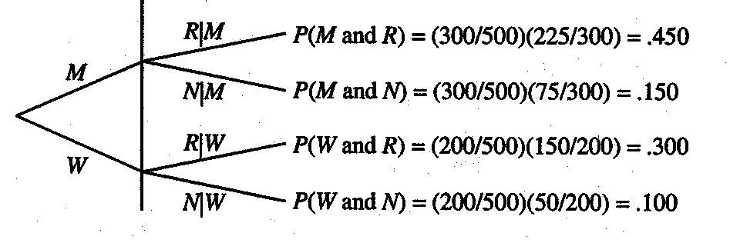

4.83 Let: Y = this adult has shopped at least once on the internet, M = male,
N = this adult has never shopped on the internet, and F = female.
a. i. P(N and M) = P(N)P(M|N) = $\left(\frac{\text{1500}}{\text{2000}}\right)\left(\frac{\text{900}}{\text{1500}}\right)=\text{.}\text{450}$
ii. P(Y and F) = P(Y)P(F|Y) = $\left(\frac{\text{500}}{\text{2000}}\right)\left(\frac{\text{200}}{\text{500}}\right)=\text{.}\text{100}$

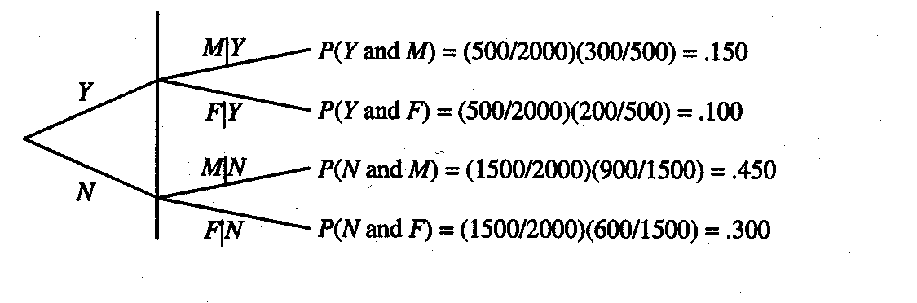
4.84 a. i. P(more than one hour late and on Airline A)
= P(more than one hour late) P(Airline A | more than one hour late)
= (172 / 1700)(92 / 172) = .0541
ii. P(on Airline B and less than 30 minutes late )
= P(Airline B) P(less than 30 minutes late | Airline B)
= (789 / 1700)(393 / 789) = .2312

- This probability is zero since “30 minutes to one hour late” and “more than one hour late” are mutually exclusive events.

4.85 a. i. P(better off and high school) = P(better off) P(high school | better off)
= (1010 / 2000)(450 / 1010) = .225

ii. P(more than high school and worse off)
= P(more than high school) P(worse off | more than high school)
= (600 / 2000)(70 / 600) = .035

b. P(worse off and better off) = P(worse off) P(better off | worse off) = (570/2000)(0) = 0
This probability is zero because “worse off” and “better off” are mutually exclusive events.

4.86 Let: A = first student selected has a volunteered before,
B = first student selected has not volunteered before,
C = second student selected has volunteered before,
D = second student selected has not volunteered before.

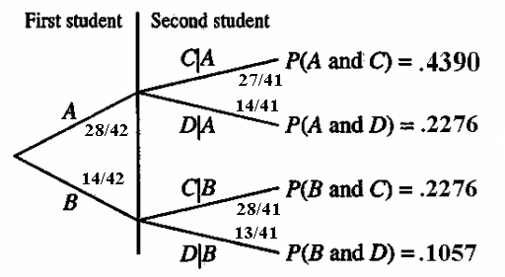
The probability that both students have volunteered before is:

P(A and C) = P(A)P(C |A) = (28 / 42) (27 / 41) = .4390

4.87 Let: A = first selected student favors abolishing the Electoral College
B = first selected student favors keeping the Electoral College
C = second selected student favors abolishing the Electoral College
D = second selected student favors keeping the Electoral College
The following is a tree diagram for the experiment of selecting two students.

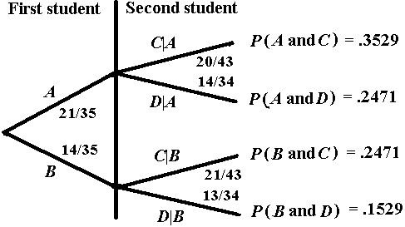

The probability that the both student favors abolishing the Electoral College is:
P(A and C) = P(A)P(C|A) = (21 / 35) (20 /34) = .3529

4.88 Let: A = first candidate selected is a woman
B = first candidate selected is a man
C = second candidate selected is a woman
D = second candidate selected is a man

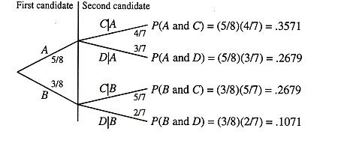

The probability that both candidates selected are women is:
P(A and C) = P(A)P(C|A) = (5 / 8) (4 / 7) =.3571

4.89 Let: C = first selected person has a type A personality
D = first selected person has a type B personality
E = second selected person has a type A personality
F = second selected person has a type B personality

The following is the tree diagram for the experiment of selecting two persons.

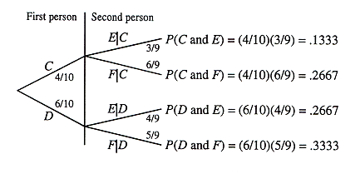

The probability that the first person has a type A personality and the second has a type B personality is: P(C and F) = P(C)P(F|C) = $\left(\frac{4}{\text{10}}\right)\left(\frac{6}{9}\right)=\text{.}\text{2667}$

4.90 Let: A = first selected senior has spent Spring Break in Florida
B = first selected senior has never spent Spring Break in Florida
C = second selected senior has spent Spring Break in Florida
D = second selected senior has never spent Spring Break in Florida

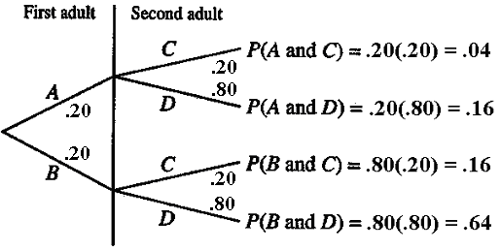

P(B and C) = P(B)P(C) = (.80)(.20) = .160
Note that all seniors are independent in this exercise.

4.91 Let: N₁ = first adult selected has spent less than $100 on lottery tickets last year
N₂ = second adult selected spent less than $100 on lottery tickets last year
Because all adults are independent:
P(N₁ ) = 1 – .35 = .65, and P(N₂) = 1 – .35 = .65
P(N₁ and N₂) = P(N₁)P(N₂) = (.65)(.65) = .4225

4.92 Let: A = wins first contract, C = wins second contract,
B = does not win first contract, and D = does not win second contract

a. P(A and C) = P(A)P(C) = (.25)(.25) = .0625

- P(B and D) = P(B)P(D) = (.75)(.75) = .5625

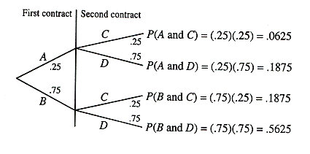

4.93 Let: A = first item is returned C = second item is returned
B = first item is not returned and D = second item is not returned

a. P(A and C) = P(A)P(C) = (.05)(.05) = .0025

b. P(B and D) = P(B)P(D) = (.95)(.95) = .9025

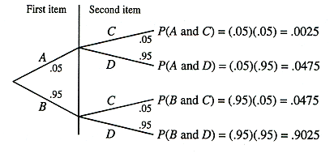

4.94 Let: N₁ = first person selected is not allergic to the drug
N₂ = second person selected is not allergic to the drug
N₃ = third person selected is not allergic to the drug
Then, P(N₁ and N₂ and N₃) = P(N₁)P(N₂) P(N₃) = (.97)(.97)(.97) = .9127

4.95 Let: D₁ = first farmer selected is in debt
D₂ = second farmer selected is in debt
D₃ = third farmer selected is in debt
Then, P(D₁ and D₂ and D₃) = P(D₁)P(D₂) P(D₃) = (.80)(.80)(.80) = .5120

  - Let: L = spent more than $100 on lottery tickets last year and M = person is married.
It is given that P(L) = .35 and P(L and M) = .16
Then, P(M | L) = P(L and M) / P(L)= .16 / .35 = .4571

  - Let: F = employee selected is a female and M = employee selected is married
It is given that P(F) = .36 and P(F and M) = .19
Hence, P(M | F) = P(M and F) / P(F)= .19 / .36 = .5278

  - Let: F = person selected visiting doctor is a female and Y = person selected is 15 to 24 years old
From the data, we can compute P(Y and F) =$\frac{\text{44},\text{313}}{\text{823},\text{542}}$=.0538 and P(F) =$\frac{\text{488},\text{199}}{\text{823},\text{542}}$ = .5928,
hence, P(T|F) = P(T and F) / P(F) = .0538 / .5928 = .0908

  - Let: A = adult in small town lives alone, and
P = adult in small town has at least one pet.
It is given that P(A) = .20 and P(A and P) = .08, hence P(P|A) = P(A and P) / P(A) = .08 / .20 = .400

  - The union of two events A and B is the event “A or B”, which is made up of all outcomes belonging to either A or B or both.
Example: Let A = {1,2,3} and B = {1,3,5}
Then (A or B) = {1,2,3,5}

  - When two events are mutually exclusive, their joint probability is zero and is dropped from the formula.

Let A and B be two events. If A and B are mutually nonexclusive events, then:
P(A or B) = P(A) + P(B) – P(A and B)
However, if A and B are mutually exclusive events, then P(A or B) = P(A) + P(B)

  - When events A and B are not mutually exclusive, P(A and B) > 0, so it is subtracted from
P(A) + P(B) to avoid double counting. For example, consider one roll of a die. Let:

A = an even number is obtained and B = a number less than 3 is obtained

Then, P(A or B) = P(A) + P(B) – P(A and B) = $\frac{3}{6}+\frac{2}{6}−\frac{1}{6}=\frac{4}{6}=\text{.}\text{6667}$

  - The formula P(A or B) = P(A) + P(B) is used when A and B are mutually exclusive events.

For example, consider one roll of a die. Let:

A = outcome is a 1-spot and B = outcome is an even number. Then

P(A and B) = P(A) + P(B) = $\frac{1}{6}+\frac{3}{6}=\frac{4}{6}=\text{.}\text{6667}$

4.104 a. P(A or B) = P(A) + P(B) – P(A and B) = .58 + .66 – .57 = .67
b. P(A or B) = P(A) + P(B) – P(A and B) = .72 + .42 – .39 = .75

4.105 a. P(A or B) = P(A) + P(B) – P(A and B) = .18 + .49 – .11 = .56
b. P(A or B) = P(A) + P(B) – P(A and B) = .73 + .71 – .68 = .76

4.106 a. P(A or B) = P(A) + P(B) = .47 + .32 = .79
b. P(A or B) = P(A) + P(B) = .16 + .59 = .75

4.107 a. P(A or B) = P(A) + P(B) = .25 + .27 = .52
b. P(A or B) = P(A) + P(B) = .58 + .09 = .67

  - a. P(V or B) = P(V) + P(B) - P(V or B)

= P(V) + P(B) - P(V)P(B|V) = $\frac{\text{312}}{\text{1800}}+\frac{\text{592}}{\text{1800}}−\left(\frac{\text{312}}{\text{1800}}\right)\left(\frac{\text{145}}{\text{312}}\right)=\text{.}\text{4217}$
b. P(N or C) = P(N) + P(C) - P(N or C)
= P(N) + P(C) - P(N)P(C|N) = $\frac{\text{1488}}{\text{1800}}+\frac{\text{404}}{\text{1800}}−\left(\frac{\text{1488}}{\text{1800}}\right)\left(\frac{\text{343}}{\text{1488}}\right)=\text{.}\text{8606}$

4.109 Let: M = basketball player selected is a male F = basketball player selected is a female
G = player selected has graduated N = player selected has not graduated

- P(F or N) = P(F) + P(N) – P(F and N)
= P(F) + P(N) – P(F)P(N|F) = $\frac{\text{165}}{\text{346}}+\frac{\text{87}}{\text{346}}−\left(\frac{\text{165}}{\text{346}}\right)\left(\frac{\text{32}}{\text{165}}\right)=\text{.}\text{6358}$
- P(G or M) = P(G) + P(M) – P(G and M)
= P(G) + P(M) – P(G)P(M|G) = $\frac{\text{259}}{\text{346}}+\frac{\text{181}}{\text{346}}−\left(\frac{\text{259}}{\text{346}}\right)\left(\frac{\text{126}}{\text{259}}\right)=\text{.}\text{9075}$

4.110 Let: M = man, W = woman,
Y = has retirement benefits, and N = does not have retirement benefits

- P(W or Y) = P(W) + P(Y) – P(W and Y) = $\frac{\text{200}}{\text{500}}+\frac{\text{375}}{\text{500}}−\frac{\text{150}}{\text{500}}=\text{.}\text{850}$

- P(N or M) = P(N) + P(M) – P(N and M) = $\frac{\text{125}}{\text{500}}+\frac{\text{300}}{\text{500}}−\frac{\text{75}}{\text{500}}=\text{.}\text{700}$

4.111 Let: Y = this adult has shopped on the internet M = male
N = this adult has never shopped on the internet and F = female

- P(N or F) = P(N) + P(F) – P(N and F) = $\frac{\text{1500}}{\text{2000}}+\frac{\text{800}}{\text{2000}}−\frac{\text{600}}{\text{2000}}=\text{.}\text{850}$

- P(M or Y) = P(M) + P(Y) – P(M and Y) = $\frac{\text{1200}}{\text{2000}}+\frac{\text{500}}{\text{2000}}−\frac{\text{300}}{\text{2000}}=\text{.}\text{700}$

- Since Y and N are mutually exclusive events,

P(Y or N) = P(Y) + P(N) = $\frac{\text{500}}{\text{2000}}+\frac{\text{1500}}{\text{2000}}=1\text{.}0$

4.112 Let: E = less than 30 minutes late, A = Airline A, and
F = 30 minutes to one hour late, B = Airline B
G = more than one hour late

- P(G or A) = P(G) + P(A) – P(G and A) =$\frac{\text{172}}{\text{1700}}+\frac{\text{911}}{\text{1700}}−\frac{\text{92}}{\text{1700}}=\text{.}\text{5829}$

- P(B or E) = P(B) + P(E) – P(B and E) =$\frac{\text{789}}{\text{1700}}+\frac{\text{822}}{\text{1700}}−\frac{\text{393}}{\text{1700}}=\text{.}\text{7165}$

- Since A and B are mutually exclusive events, P(A or B) = P(A) + P(B) = $\frac{\text{789}}{\text{1700}}+\frac{\text{911}}{\text{1700}}=1\text{.}0$

4.113 B = better off, S = same, W = worse of
L = less than high school, H = high school, and M = more than high school

- P(B or H) = P(B) + P(H) – P(B and H) =$\frac{\text{1010}}{\text{2000}}+\frac{\text{1000}}{\text{2000}}−\frac{\text{450}}{\text{2000}}=\text{.}\text{780}$

- P(M or W) = P(M) + P(W) – P(M and W) =$\frac{\text{600}}{\text{2000}}+\frac{\text{570}}{\text{2000}}−\frac{\text{70}}{\text{2000}}=\text{.}\text{550}$

- Since B and W are mutually exclusive events, P(B or W) = P(B) + P(W) =$\frac{\text{1010}}{\text{2000}}+\frac{\text{570}}{\text{2000}}=\text{.}\text{790}$

4.114 Let: V = vehicle selected vandalized and T = vehicle selected ticketed
Then, P(T or V) = P(T) + P(V) − P(T and V) = .35 + .15 − .10 = .40

4.115 Let: W = family selected owns a washing machine V = family selected owns a VCR
Then, P(W or V) = P(W) + P(V) − P(W and V) = .68 + .81 − .58 = .91

4.116 Let: B = wedding day has bad weather D = wedding day has a disruptive incident
Then, P(B or D) = P(B) + P(D) – P(B and D) = .25 + .15 − .08 = .32

4.117 Let: F = teacher selected is a female S = teacher selected holds a second job
Then, P(F or S) = P(F) + P(S) − P(F and S) = .68 + .38 − .29 = .77

4.118 Let: H = death by heart attack, and C = death by cancer
P(H or C) = P(H) + P(C) = $\frac{\text{710},\text{760}}{2,\text{403},\text{351}}+\frac{\text{553},\text{091}}{2,\text{403},\text{351}}=\text{.}\text{5259}$

This probability is not equal to 1.0 because heart attacks and cancer are not the only causes of death in the U.S.

4.119 Let: A = response to poll was “player”, and B = response to poll was “announcer/reporter”
P(A or B) = P(A) + P(B) = $\frac{\text{11},\text{715}}{\text{30},\text{270}}+\frac{\text{9982}}{\text{30},\text{270}}=\text{.}\text{7168}$

This probability is not equal to 1.0 because some respondents have other answers, like “cheerleader”.

4.120 Let: A = student selected will get an A in economics
B = student selected will get a B in economics

Since A and B are mutually exclusive events, P(A or B) = P(A) + P(B) = .24 + .28 = .52

This probability is not equal to 1.0 because not all students will get an A or B grade; some may get a C, D, or F grade.

  - P(against or indifferent) = P(against) + P(indifferent) .63 + .17 = .80
This probability is not equal to 1.0 because some voters favor the entry of a major discount store in their neighborhood.

4.122 Let: A = first selected corporation makes charitable contributions
B = first selected corporation does not make charitable contributions
C = second selected corporation makes charitable contributions
D = second selected corporation does not make charitable contributions

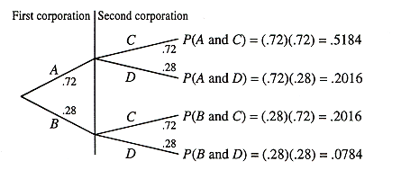
b. P(at most one corporation makes charitable contributions)
= P(A and D) + P(B and C) + P(B and D)
= (.72)(.28) + (.28)(.72) + (.28)(.28) = .2016 + .2016 + .0784 = .4816

4.123 Let: A = first open-heart operation is successful
B = first open-heart operation is not successful
C = second open-heart operation is successful
D = second open-heart operation is not successful
P(at least one open-heart operation is successful) = P(A and C) + P(A and D) + P(B and C)
= (.84)(.84) + (.84)(.16) + (.16)(.84) = .7056 + .1344 + .134 = .9744

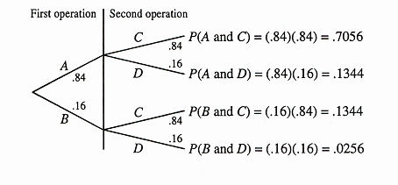
4.124 a. P(selected car has a GPS navigation system) = 12 / 44 = .2727

- Number of cars which do not have a GPS navigation system = 44 – 12 = 32
P(selected car does not have a GPS navigation system) = 32 / 44 = .7273

4.125 a. P(student selected is a junior) = 9 / 35 = .2571

b. P(student selected is a freshman) = 5 / 35 = .1429

4.126 Let: P = psychology major, C = communications major,
H = happy with major, and U = unhappy with major

a. i. P(H) = 195 / 250 = .7800
ii. P(P) = 100 / 250 = .4000
iii. P(C|H) = 115 / 195 = .5897
iv. P(U|P) = 20/ 100 = .2000
v. P(P and H) = P(P)P(H/P) = $\left(\frac{\text{100}}{\text{250}}\right)\left(\frac{\text{80}}{\text{100}}\right)=\text{.}\text{3200}$
vi. P(C or U) = P(C) + P(U) – P(C and U) = $\frac{\text{150}}{\text{250}}+\frac{\text{55}}{\text{120}}−\left(\frac{\text{150}}{\text{250}}\right)\left(\frac{\text{35}}{\text{150}}\right)=\text{.}\text{6800}$

b. P(P) = 100/250 = .4000 and P(P|H) = 80/195 = .4103
Since these two probabilities are not equal, the events “P” and “H” are not independent.
The events “P” and “H” are not mutually exclusive because they can occur together.

4.127 Let: M = adult selected is a male A = adult selected prefers watching sports
F = adult selected is a female B = adult selected prefers watching opera

a. i. P(B) = 109 /250 = .4360
ii. P(M) = 120 / 250 = .4800
iii. P(A|F) = 45 / 130 = .3462
iv. P(M|A) = 96 / 141 = .6809
v. P(F and B) = P(F)P(B|F) = $\left(\frac{\text{130}}{\text{250}}\right)\left(\frac{\text{85}}{\text{130}}\right)=\text{.}\text{3400}$
vi. P(A or M) = P(A) + P(M) − P(A and M) = $\frac{\text{141}}{\text{250}}+\frac{\text{120}}{\text{250}}−\left(\frac{\text{141}}{\text{250}}\right)\left(\frac{\text{96}}{\text{141}}\right)=\text{.}\text{6600}$

b. P(F) = 130 /250 = .5200 P(F|A) = 45 / 141 = .3191
Since these two probabilities are not equal, the events “female” and “prefers watching sports” are not independent.

Events “female” and “prefers watching sports” are not mutually exclusive because they can occur together. There are a total of 45 adults who are female and prefer watching sports. If the selected adult is one of these 45, then both of these events occur at the same time.

4.128 Let: M = lawyer selected is a male A = lawyer selected favors capital punishment
F = lawyer selected is a female B = lawyer selected opposes capital punishment

a. i. P(A) = 45 / 80 = .5625
ii. P(F) = 24 / 80 = .3000
iii. P(B|F) = 11 / 24 = .4583
iv. P(M|A) = 32 / 45 = .7111
v. P(F and A) = P(F)P(A/F) = $\left(\frac{\text{24}}{\text{80}}\right)\left(\frac{\text{13}}{\text{24}}\right)=\text{.}\text{1625}$
vi. P(B or M) = P(B) + P(M) − P(B and M) = $\frac{\text{35}}{\text{80}}+\frac{\text{56}}{\text{80}}−\left(\frac{\text{35}}{\text{80}}\right)\left(\frac{\text{24}}{\text{35}}\right)=\text{.}\text{8375}$

b. P(F) = 24 / 80 = .3000 P(F|B) = 11 / 35 = .3143

Since these two probabilities are not equal, the events “female” and “opposes capital punishment” are not independent.

Events “female” and “opposes capital punishment” are not mutually exclusive because they can occur together. There are a total of 11 lawyers who are female and oppose capital punishment. If the selected lawyer is one of these 11, then both of these events occur at the same time.

4.129 Let: A = student selected is an athlete F = student selected favors paying college athletes
B = student selected is a nonathlete N = student selected is against paying college athletes

a. i. P(F) = 300 / 400 = .750
ii. P(F|B) = 210 / 300 = .700
iii. P(A and F) = P(A)P(F|A) = $\left(\frac{\text{100}}{\text{400}}\right)\left(\frac{\text{90}}{\text{100}}\right)=\text{.}\text{225}$
iv. P(B or N) = P(B) + P(N) - P(B and N) = $\frac{\text{300}}{\text{400}}+\frac{\text{100}}{\text{400}}−\left(\frac{\text{300}}{\text{400}}\right)\left(\frac{\text{90}}{\text{300}}\right)=\text{.}\text{775}$

b. P(A) = 100 / 400 = .250 and P(A|F) = 90 / 300 = .300

Since these two probabilities are not equal, the events “athlete” and “should be paid” are not independent.

Events “athlete” and “should be paid” are not mutually exclusive because they can occur together. There are a total of 90 students who are athletes and favor paying athletes. If the selected student is one of these 90, then both of these events occur at the same time.

4.130 Let: A = first service call due to customer error C = second service call due to customer error
B = first service call due to broken appliance D = second service call due to broken appliance

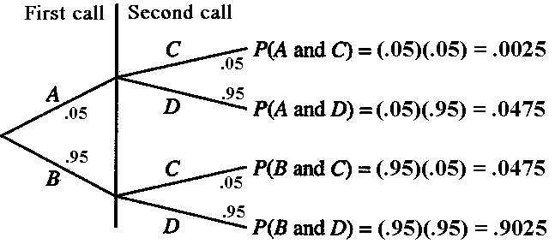

a. P(A and C) = P(A)P(C) = (.05)(.05) = .0025

b. P(at least one service call not due to customer error)
= P(A and D) + P(B and C) + P(B and D) = .0475 + .0475 + .9025 = .9975

4.131 Let: A = first person selected said they would trust public defender,
B = first person selected said they would not trust public defender,
C = second person selected said they would trust public defender, and
D = second person selected said they would not trust public defender.

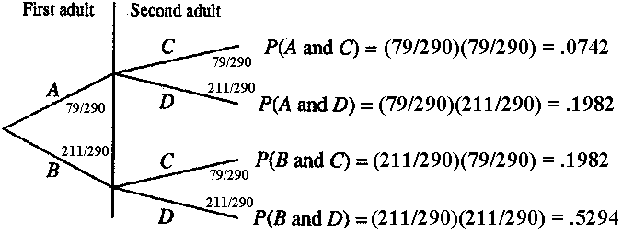

a. P(B and D) = (211/290)(211/290) = .5294

b. P(at most one would trust public defender )
= P(A and D) + P(B and C) + P(B and D) = .1982 + .1982 + .5294 = .9258

4.132 Let: G₁ = first car selected has a GPS system.
G₂ = second car selected has a GPS system.

P(G₁ and G₂) = P(G₁)P(G₂|G₁) = $\left(\frac{\text{12}}{\text{44}}\right)\left(\frac{\text{11}}{\text{43}}\right)=\text{.}\text{0698}$

4.133 Let: J₁ = first student selected is a junior S₂ = second student selected is a sophomore
P(J₁ and S₂) = P(J₁)P(S₂|J₁) = $\left(\frac{9}{\text{35}}\right)\left(\frac{8}{\text{34}}\right)=\text{.}\text{0605}$

  - P(company loses both sources of power) = P(power fails)P(generator stops working)= (.30)(.09)= .027

  - P(both machines are not working properly)
= P(first machine is not working properly)P(second machine is not working properly)
= (.08)(.06) = .0048

4.136 a. P(player wins for first time on tenth bet)
= P(player loses first nine bets and wins the tenth) = ${\left(\frac{\text{37}}{\text{38}}\right)}^{9}\left(\frac{1}{\text{38}}\right)=\text{.}\text{0207}$
b. P(player loses first 50 bets) = ${\left(\frac{\text{37}}{\text{38}}\right)}^{\text{50}}=\text{.}\text{2636}$

c. P(he wins at least once in 38 plays)
= 1 – P(he loses on all 38 plays) = 1 – ${\left(\frac{\text{37}}{\text{38}}\right)}^{\text{38}}$ = 1 – .3630 = .6370

4.137 a. There are 26 possibilities for each letter and 10 possibilities for each digit, hence there are ${\text{26}}^{3}⋅{\text{10}}^{3}=\text{17},\text{576},\text{000}$possible different license places.

b. There are 2 possibilities for the second letter, 26 possibilities for the third letter and 100 possibilities for the two missing numbers, hence 2 × 26 × 100 = 5200 license plates fit the description.

  - Since the median life of these batteries is 100 hours, the probability that a given battery lasts longer than 100 hours is ½.
P(exactly two will last longer than 100 hours)
= P(first and second last longer but third does not)+ P(first and third last longer but second does not)
+ P(second and third last longer but first does not)
= (.5) (.5) (.5)+ (.5)(.5)(.5)+(.5)(.5)(.5) = .375

4.139 Note: This exercise requires the use of combinations, which students may have studied in algebra. Combinations are covered in Section 5.5.2 in the text.

a. Let: A = the player’s first five numbers match the numbers on the five white balls drawn by the lottery organization
B = the player’s powerball number matches the powerball number drawn by the lottery organization, and
C = the player’s powerball number does not match the powerball number drawn by the lottery organization

There are ₅₃C₅ ways for the lottery organization to draw five different white balls from a set of 53 balls. Thus the sample space for this phase of the drawing consists of (₅₃C₅) equally likely outcomes. Hence, P(A) = 1 / ₅₃C₅.

Since the sample space for the drawing of the powerball number consists of 42 equally likely outcomes, P(B) = 1 / 42

Because the powerball number is drawn independently of the five white balls, A and B are independent events. Therefore, P(player wins jackpot) = P(A and B)
$=P(A)P(B)=\frac{1}{{}_{\text{53}}C_{5}}×\frac{1}{\text{42}}=\frac{1}{\text{120},\text{526},\text{770}}=\text{.}\text{0000000083}$

b. To win the $100,000 prize, events A and C must occur. In the sample space of 42 equally likely outcomes for the drawing of the powerball numbers, there are 41 outcomes which do not match the powerball number, and thus result in event C. Hence, P(C) = 41 / 42. Therefore,

P(player wins the $100,000 prize) = P(A and C) = P(A ) P(C)
=$\frac{1}{(_{\text{53}}C_{5})}×\frac{\text{41}}{\text{42}}=\frac{\text{41}}{\text{120},\text{526},\text{770}}=\text{.}\text{00000034}$
4.140 Let: L = left wing engine fails R = right wing engine fails
C = central engine fails

P(crash) = P(C and L, but not R) + P(C and R, but not L) + P(C and R and L)
= (.005)(.008)(.992)+(.005)(.008)(.992)+(.005)(.008)(.008) = .00008

4.141 a. P(sixth marble is red) = 10 / 20 = .5000

b. P(sixth marble is red) = 5 / 15 = .3333

c. The probability of obtaining a head on the sixth toss is .5, since each toss is independent of the previous outcomes.

Tossing a coin is mathematically equivalent to the situation in part a. Each drawing in part a is independent of previous drawings and the probability of drawing a red marble is .5 each time.

4.142 Let: C₁ = first card picked is a club D₁ = first card picked is a diamond
C₂ = second card picked is a club D₂ = second card picked is a diamond
P(you win) = $P(C_{1})⋅P(C_{2}|C_{1})+P(D_{1})⋅P(D_{2}|D_{1})=\frac{2}{4}⋅\frac{1}{3}+\frac{2}{4}⋅\frac{1}{3}=\frac{4}{\text{12}}=\text{.}\text{3333}$
Do not accept this proposition, since the chance of winning $10 is only .3333.

4.143 a. The thief has three attempts to guess the correct PIN. Since there are 100 possible numbers in the beginning, the probability that he finds the number on the first attempt is 1/100. Assuming that the first guess is wrong, there are 99 numbers left, etc. Hence,

P(thief succeeds) = 1 – P(thief fails) = 1 – P(thief guessed incorrectly on all three attempts)

$=1−\left(\frac{\text{99}}{\text{100}}⋅\frac{\text{98}}{\text{99}}⋅\frac{\text{97}}{\text{98}}\right)=1−\frac{\text{97}}{\text{100}}=\frac{3}{\text{100}}=\text{.}\text{030}$

b. Since the first two digits of the four-digit PIN must be 3 and 5, respectively, and the third digit must be 1 or 7, the possible PINs are 3510 to 3519 and 3570 to 3579, a total of 20 possible PINs. Hence, P(thief succeeds) = 1 – P(thief fails) = 1 – $\left(\frac{\text{19}}{\text{20}}⋅\frac{\text{18}}{\text{19}}⋅\frac{\text{17}}{\text{18}}\right)=1−\frac{\text{17}}{\text{20}}=\frac{3}{\text{20}}=\text{.}\text{150}$

4.144 a. P(you must pay gambler) = P(gambler rolls at least one 6 in four tries)
= 1 – P(he rolls no 6 in four tries) = 1 – (5/6)⁴ = 1 – .4823 = .5177

b. Let: E = you obtain at least one double six in 24 rolls,
A₁ = you obtain a double six on the first roll,
A₂ = you obtain a double six on the second roll,
.
.
.
A₂₄ = you obtain a double six on the 24th roll

Then, P(E) = P(A₁ or A₂ or … or A₂₄)
However, A₁, A₂,…, A₂₄ are not mutually exclusive, since it is possible to obtain a double 6 on more than one roll. Thus, we cannot find P(A₁ or A₂ or … or A₂₄) by simply adding P(A₁ ) + P(A₂ ) +… + P(A₂₄) as the gambler does to obtain 24 (1/36).
To find P(E) we may use complementary events, as in part a.
The probability of failing to roll a double six on any one attempt is 1 – 1/36 = 35/36.
Hence, P(E) = 1 – P(you roll no double six in 24 tries) = 1 – ${\left(\frac{\text{35}}{\text{36}}\right)}^{\text{24}}=1−\text{.}\text{5086}=\text{.}\text{4914}$
Since your chance of winning is less than 50%, the gambler has the advantage and you should not accept his proposition.

4.145 a. Answers may vary.

b. Let: B = no two of the 25 students share the same birthday
Note that if B is to occur, the second student cannot have the same birthday as the first student, so the second may have any of the remaining 364 birthdays.

Thus, P(first two students do not share a birthday) = 364 / 365

Furthermore, if B is to occur, the third student cannot have the same birthday as either of the first two. Thus, the third may have any of the remaining 363 birthdays.
Therefore, P(first three students do not share a birthday) = $\frac{\text{364}}{\text{365}}⋅\frac{\text{363}}{\text{365}}⋅$By extending this logic we can show that P(no two of the 25 students share a birthday) = $\frac{\text{364}}{\text{365}}⋅\frac{\text{363}}{\text{365}}⋅\frac{\text{362}}{\text{365}}⋅⋅\frac{\text{341}}{\text{365}}=\text{.}\text{4313}$
Thus, since A and B are complementary events, P(A) = 1 – P(B) = 1 – .4313 = .5687
Therefore, P(A) is greater than 50%.

4.146 Let: S = Smith family is selected, J = Jones family is selected
G =a girl is selected, and B = a boy is selected

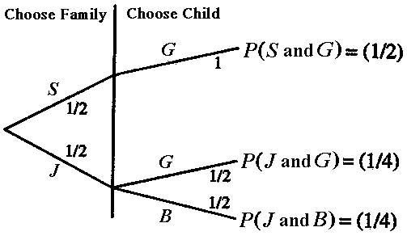

Note that “the other child is a girl” is equivalent to P(the Smith family was selected).

Thus, we must find P(S|G), which is given by $\frac{P(S \text{and} G)}{P(G)}$
From the tree diagram: P(S and G) = ½, and P(G) = P(S and G) + P(J and G) = $\frac{1}{2}+\frac{1}{4}=\frac{3}{4}$
Thus, P(S|G) = $\frac{1/2}{3/4}=2/3=\text{.}\text{667}$
Therefore, the probability that the other child is a girl is .6667.

  - a. Let E = neither topping is anchovies
A = customer’s first selection is not anchovies
B = customer’s second selection is not anchovies
For A to occur, the customer may choose any of 11 toppings from the 12 available.
Thus P(A) = $\frac{\text{11}}{\text{12}}$.
For B to occur, given that A has occurred, the customer may choose any of 10 toppings from the remaining 11. Thus P(B|A) = $\frac{\text{10}}{\text{11}}$.
Therefore, P(E) = P(A and B) = P(A and B) = P(A)P(B|A) = $\left(\frac{\text{11}}{\text{12}}\right)\left(\frac{\text{10}}{\text{11}}\right)=\text{.}\text{8333}$
b. Let C = pepperoni is one of the toppings
Then $\bar{C}$= neither topping is pepperoni
By the same form of argument used to find P(E) in part a, we obtain
$P(\bar{C})$ = $\left(\frac{\text{11}}{\text{12}}\right)\left(\frac{\text{10}}{\text{11}}\right)$= .8333
Thus, P(C) = 1 – $P(\bar{C})$ = 1 − .8333 = .1667
4.148 Note: This exercise requires the use of combinations, which students may have studied in algebra. Combinations are covered in Section 5.5.2 of the text.

Let: A = none of the six boxes sold contains a prize coupon,
B = at least one of the six boxes sold contain a prize coupon, and
C = two of the six boxes sold contain prize coupons

- The sample space for picking six boxes at random from a set of nine boxes has $\left(9C_{6}\right)$ equally likely outcomes. For A to occur, any six of the seven boxes containing no coupons may be selected. Thus, there are ${}_{7}C_{6}$ ways for A to occur. Therefore,$P(A)=\frac{{}_{7}C_{6}}{{}_{9}C_{6}}=\frac{7}{\text{84}}=\text{.}\text{0833}$

- A and B are complementary events, so P(B) = 1 – P(A) = 1 – .0833 = .9167

- The probability that two of the six boxes sold contain prize coupons is the same as the probability that none of the three remaining boxes on the shelf contains a prize coupon. Using the same reasoning as in part a, $P(C)=\frac{{}_{7}C_{3}}{{}_{9}C_{3}}=\frac{\text{35}}{\text{84}}=\text{.}\text{4167}$

4.149 Let: C = auto policy holders with collision coverage
U = auto policy holders with uninsured motorist coverage

- P(C or U) = P(C) + P(U) − P(C and U).
Hence, P(C and U) = P(C) + P(U) − P(C or U ) = .80 + .60 − .93 = .47
Thus 47% of the policy holders have both collision and uninsured motorist coverage.

- The event “$\bar{C}$ and $\bar{U}$” is the complement of the event “C or U”.
Hence, P($\bar{C}$ and $\bar{U}$) = 1 – P(C or U) = 1 – .93 = .07
Thus, 7% of the policy holders have neither collision nor uninsured motorist coverage.

- The group of policy holders who have collision but not uninsured motorist coverage may be formed by considering the policy holders that have collision, then removing those who have both collision and uninsured motorist coverage. Hence,
P(C and $\bar{U}$) = P(C) − P(C and U) = .80 − .47 = .33

Thus 33% of policy holders have collision but not uninsured motorist coverage.

4.150 Let: S = an apple is satisfactory Y = Andy judges an apple as satisfactory
U = an apple is unsatisfactory N = Andy judges an apple as unsatisfactory

The following is the tree diagram for the experiment of picking an apple and judging it.

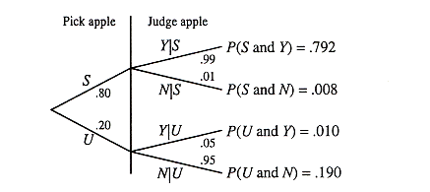

a. P(S and Y) = P(S)P(Y|S) = .792 or 79.2%
b. P(marketed) = P(Y) = P(S and Y) + P(U and Y) = .792 + .010 = .802 or 80.2%
c. Using the solutions to parts a and b:

P(satisfactory given marketed) = P(S|Y) = P(S and Y) / P(Y) = .792 / .802 = .988 or 98.8%

4.151 Let: p = the proportion of the students who used drugs during the past week
D = a student used drugs during the past week
N = a student did not use drugs during the past week
T = a student answers the question truthfully
U = a student answers the question untruthfully

The following is the tree diagram for this problem:

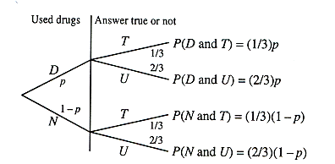

The proportion of students who said that they used drugs during the past week is given by the sum of the probabilities of the events “D and T” and “N and U”. Hence,

P(a student says he or she used drugs during the past week)
= P(D and T) + P(N and U) = $\frac{1}{3}p+\frac{2}{3}(1−p)=\text{.}\text{60}$, which gives p = .20
Thus, we estimate that 20% of the students used drugs during the past week.

Self-Review Test for Chapter Four

1. a 2. b 3. c 4. a 5. a 6. b

7. c 8. b 9. b 10. c 11. b

12. Total outcomes = 4 × 3 × 5 × 2 = 120

13. a. P(job offer selected is from the insurance company) = 1/ 3 = .3333

b. P(job offer selected is not from the accounting firm) = 2 / 3 = .6667

14. a. P(out of state) = 125 / 200 = .6250 P(out of state | female) = 70 / 110 = .6364

Since these two probabilities are not equal, the two events are not independent. Events “female” and “out of state” are not mutually exclusive because they can occur together. There are a total of 70 students who are female and out of state. If any of these students is selected then both of these events occur at the same time.

b. i. In 200 students, there are 90 males. Hence, P(a male is selected) = 90 / 200= .4500
ii. There are a total of 110 female students and 70 of them are out of state students.
Hence, P(out of state | female) = 70 / 110 = .6364

15. P(out of state or female) = P(out of state) + P(female) – P(out of state and female)
= P(out of state) + P(female) – P(out of state) P(female |out of state)= $\frac{\text{125}}{\text{200}}+\frac{\text{110}}{\text{200}}−\left(\frac{\text{110}}{\text{200}}\right)\left(\frac{\text{70}}{\text{110}}\right)=\text{.}\text{825}$

16. Let: (S₁) = first student selected is from out of state (S₂) = second student selected is from out of state
The probability that both students selected are from out of state is calculated as follows:
P(S₁ and S₂) = P(S₁)P(S₂|S₁) = $\left(\frac{\text{125}}{\text{200}}\right)\left(\frac{\text{124}}{\text{199}}\right)=\text{.}\text{3894}$

17. Let: (F₁) = first adult selected has experienced a migraine headache
(N₁) = first adult selected has never experienced a migraine headache
(F₂) = second adult selected has experienced a migraine headache
(N₂) = second adult selected has never experienced a migraine headache

The probability that neither of the two adults have ever experienced a migraine headache is calculated as follows. Note that the two adults are independent. From the given information: P(F₁) = .35, and P(F₂) = .35. Hence, P(N₁) = 1 − .35 = .65 and P(N₂) = 1 − .35 = .65. P(N₁ and N₂) = P(N₁)P(N₂) = (.65)(.65) = .4225

18. P(A) = 8 / 20 = .400 The complementary event of A is that the selected marble is not red, that is, the selected marble is either green or blue. Hence, P(A) = 1 – .400 = .600.

19. Let: M = male, F = female, W = works at least 10 hours, and N = does not work 10 hours
a. P(M and W) = P(M)P(W) = (.45)(.62) = .279
b. P(F or W) = P(F) + P(W) - P(F and W) = .55 + .62 – (.55)(.62) = .829

20. a. i. P(Y) = (77 + 104) / 506 = .3577
ii. P(Y|W) = 104 / (104 + 119 + 34) = .4047
iii. P(W and N) = P(W)P(N/W) =$\left(\frac{\text{257}}{\text{506}}\right)\left(\frac{\text{119}}{\text{257}}\right)$= .2352
iv. P(N or M) = P(N) + P(M) - P(N and M) = $\frac{\text{66}}{\text{506}}+\frac{\text{249}}{\text{506}}−\left(\frac{\text{66}}{\text{506}}\right)\left(\frac{\text{32}}{\text{66}}\right)=\text{.}\text{5593}$

b. P(W) = 257/506 = .5079 P(W|Y) = 104 / 181 = .5746

Since these two probabilities are not equal, the events “woman” and “yes” are not independent. Events “woman” and “yes” are not mutually exclusive because they can occur together. There are a total of 104 adults who are a woman and belong to the “yes” category. If the selected adult is one of these 104, then both of these events occur at the same time.

