Sewing Screens of the ESP-Level Early Beginner

- Home Screen with Lizzie
We have 4 large mode buttons in the middle, lizzie, baste, idle and manual.
This Lizzie button is the stitch regulated mode. Stitches per inch can be changed in the SPI screen just to the left. 10 stitches per inch look a little more like hand quilting and work well on traditional quilts. 12 stitches per inch looks a little smoother if you are stitching small patterns,

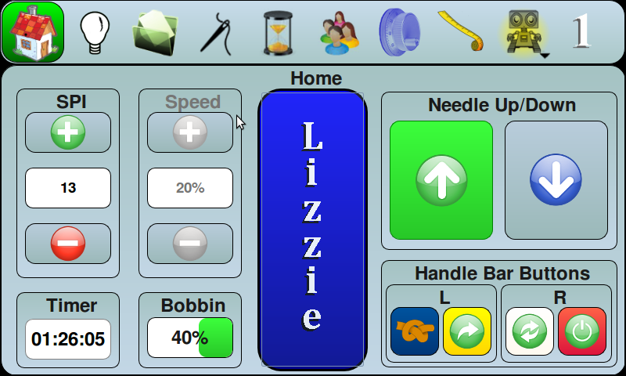

2. Basting. The stitches per inch can be set in the SPI screen but is limited in the basting mode. Basting is generally considered to be 4 stitches per inch or under.

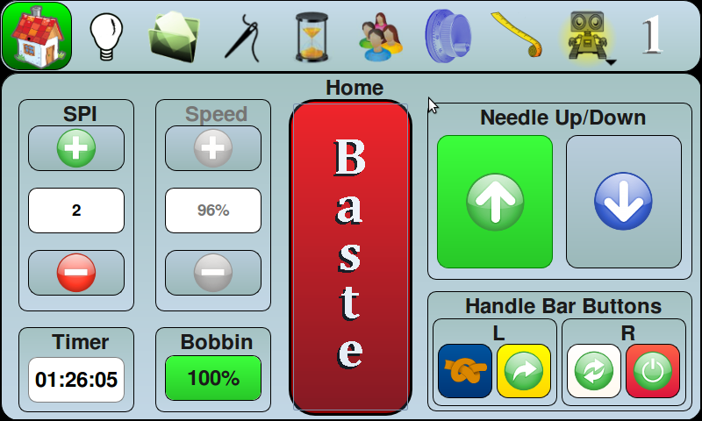

3. Idle. The Idle mode is a two part mode. Going fast you will be stitch regulated. Going slow it drops into a non regulated or manual mode of sewing. This is a professional mode of quilting because pros like to do micro meandering and small shapes in manual mode but for big open designs they like to be in regulated mode. It is important to find out exactly what speed you like to run at in manual mode. The speed number at the left of the idle button is the threshold of the break between stitch regulated and non stitch regulated mode. I have mine set at 30 percent. That means that when I am running less than 30 percent of the total amount of speed that the machine can do I will be in non regulated mode. If you try it you will love it.

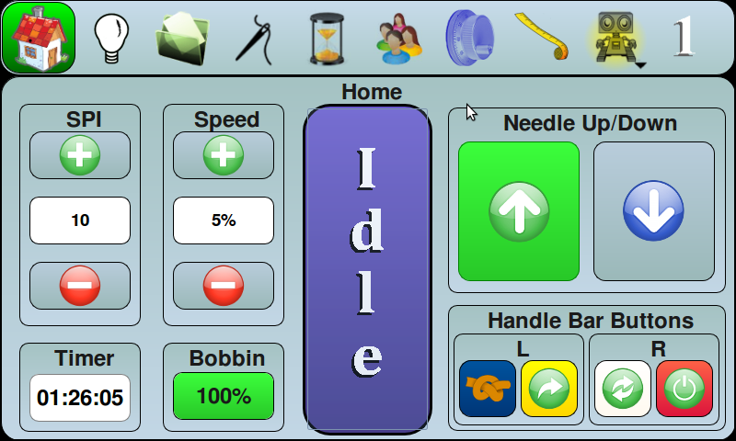

4. Manual Mode. Manual mode is running your machine without the stitch regulator on. Micro meandering and small designs are often done in manual mode. Also if you want to wind some bobbins ahead you would put your machine in manual mode.

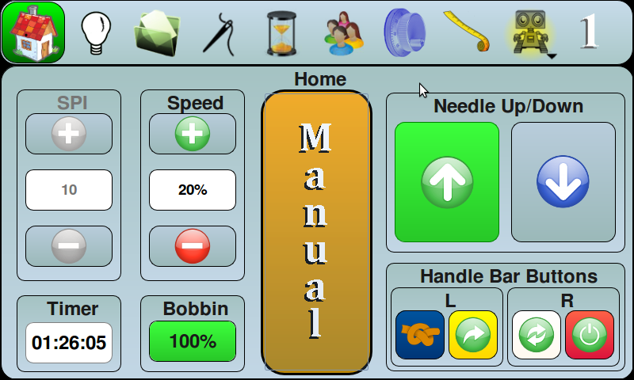

The buttons on the lower right of this screen coordinate with the colors of the buttons on the handle bars. You can change these functions on the buttons to suit a left handed person or set up buttons for certain types of projects we are doing. These are called customizable buttons. As they are set up here the red one is the start/stop button. The white button is the needle full up and down cycle. The white button will end in the position you have chosen in the two buttons just above the handle bar buttons. In this picture the needle will end in the up position when you tap the white button. The yellow button is a half stitch. The needle will go down as a half stitch and you must tap the yellow button a second time to complete the cycle for up. The blue button is a tie of or tack button. If you touch on the needle picture you will find that you can program the number of tie off stitches there.

5. Ready to Sew Screen
When you click the red start/stop button on the handle bar to sew, the center button turns green and indicates it is ready to sew. If you click the red button on the handle bar again the machine will shut off and the center green will change back to the previous mode. Although any button will shut the machine off in an emergency, only the start/stop button will position the needle to the command of up or down as you have selected. A common problem with new quilters is that they shut the machine off with the button right next to the start/stop button and then wonder why the thread is not releasing to roll the machine. If you click a different button to stop the machine you should click the needle up button right after to have the thread released from the hook.

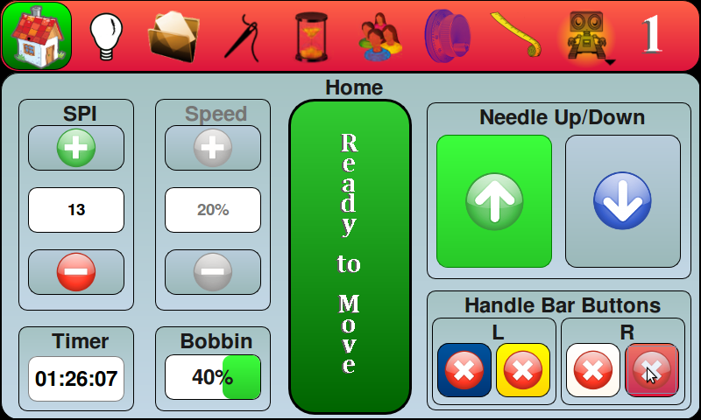

6. File
When you click on the file button you will have 4 buttons.

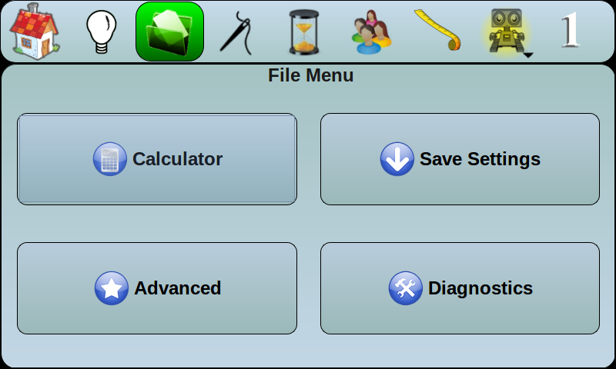

7. Calculator
The calculator is a standard calculator. It is very handy to have the calculator especially when trying to figure how many repeats I can squeeze onto a border.

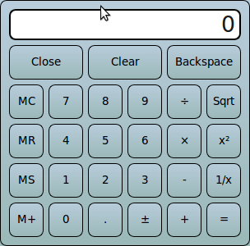

8. Advanced

This screen can tell you which version of software you have. You can initiate an update from this screen, but it’s not the only screen that you can update from. It has a system log of errors which is helpful to a technician. It has a maintenance screen in it which keeps track of sending you a reminder to oil every 6.5 hours of run time.

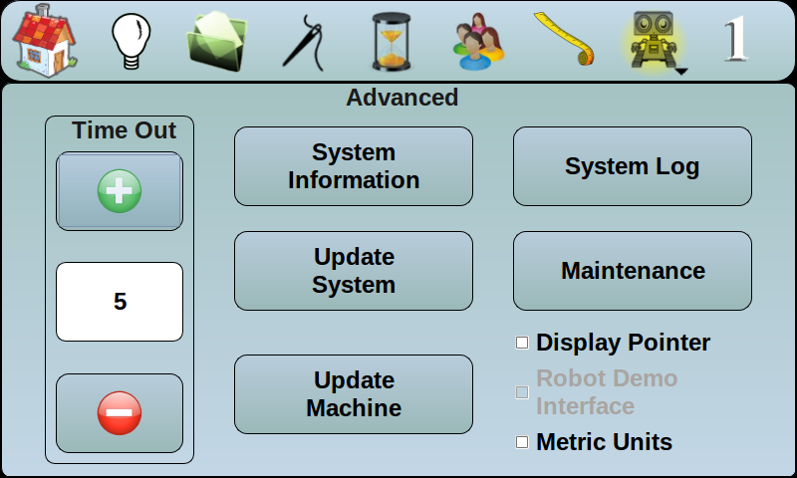

9. Example of System Information
This screen is very important. You need to know what software version you have in order to research for any new updates that are available. The www.quilt-ez.com website is the location you will find any new information on your software or any free updates that are available for you to download.
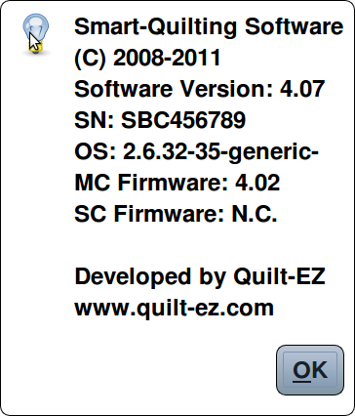

10. Diagnostics

It is nice to know that you have a built in diagnostic system. This screen is used if you have an issue and call in to talk to a technician. They will guide you through what they need and ask you to repeat to them the messages that will pop up during testing
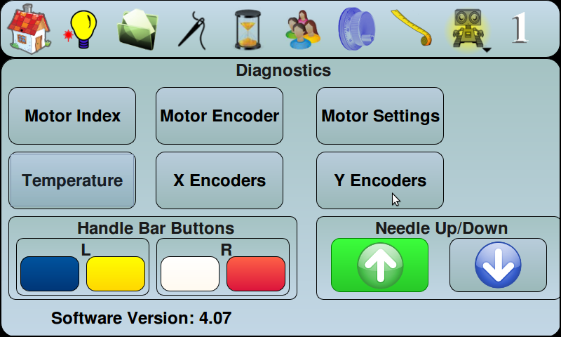

11. Needle modes
Under the needle you will see that you have a stop mode section. The first button will make the need obey the commands you have set up on the home screen for either the up arrow or the down arrow. Essentially this means that when you stop the needle the needle will end up either up or down the just way you have set up the arrows.
Quick means that when you stop the needle it will not obey the pre set commands but stop as quickly as it can. The needle can be in any position even in the fabric.
Tie off mode is generally used when using s slippery thread and you want a tie off each and every time the needle stops. You can select the number of tie offs just to the right of the stop mode section. I have 5 tie offs set on my machine because I often use a tri-lobal poly thread and want to add the extra tie off at the ends.
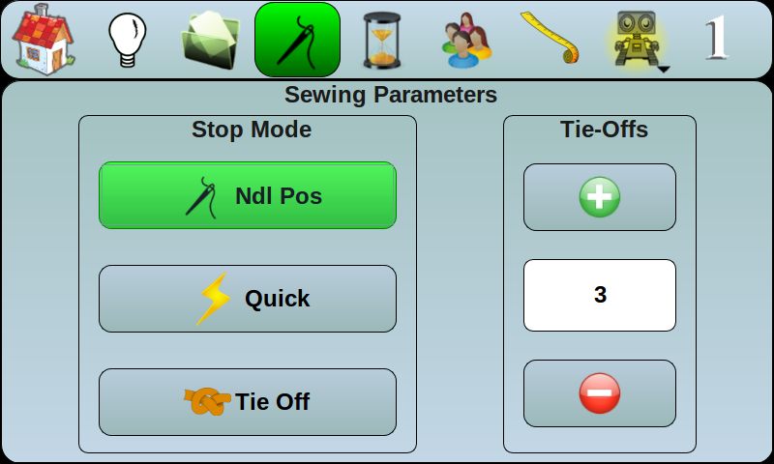

12. Runtime
Under the hour glass you have two types of timers. The first one is the actual run time on the machine. The second one is how many stitches you have stitched.
Long arm professionals sometimes charge by their time. Embroidery pros usually charge by the stitch. Some of the new computer designs resemble embroidery patterns and the pros are using the stitch counter to calculate the costs.
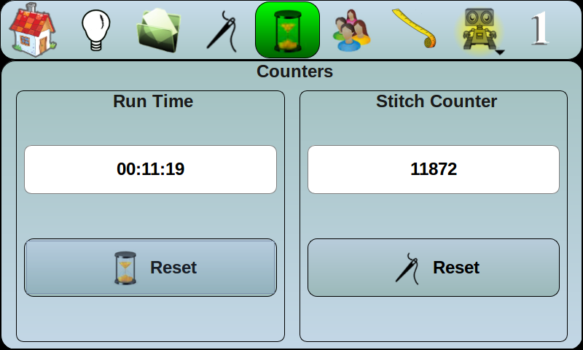

13. People Profile
. You can set up profiles for 5 different people at the same time. Some quilting shops have multiple employees using the machine. Therefore each can have their own profile for button selection.

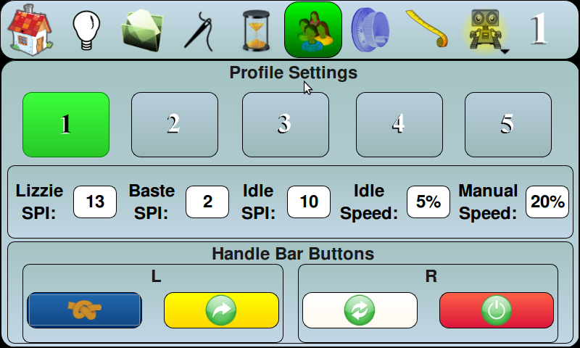

14. Customize the Profile Screen
When you touch on a profile number you will get this second screen that you can plus or minus easily to set your personal profile to your comfort zone.

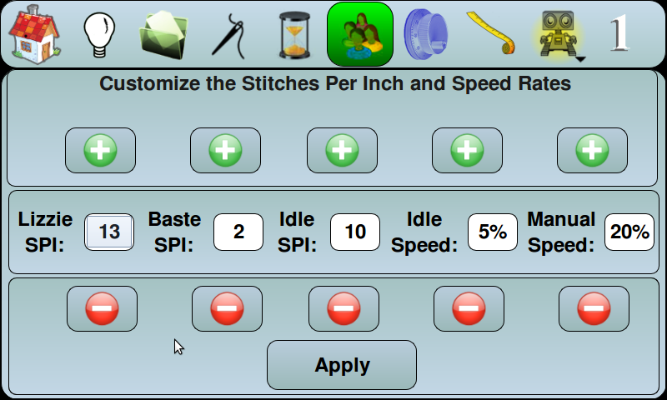

15. Button Choices
You can change the function of the 4 handle bar buttons. This function is especially helpful if you have a left handed person that wants the start/stop button on the left. The none button means that you button will have no function on it. Since there are two buttons on each handle bar you can get confused as to which one you are selecting. If you wish you can make both buttons be the same or you can make one button be none.

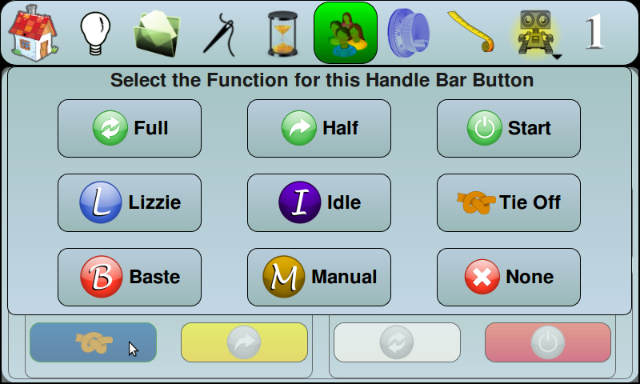

16. Tape Measure
This tape measure is easy to use and easy to read. The best feature is the diagonal measurement. You will realize how great this is when you begin to quilt borders and corners and need to know the height of the pattern on the corner so you can get the straight border design the same size.
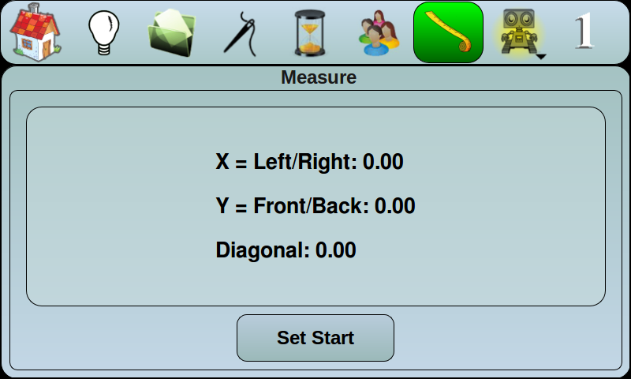

17. Robot Enabled (end of sewing screens)
When the robot is yellow it is now enabled to start quilting with the computerized system. All you have to do is touch on the yellow robot and the next screen will be the beginning of all the computer screen, Once you touch on the yellow robot he will disappear and a yellow sewing machine will appear. You can go back and forth between the sewing screens and the robot screens if you wish.


