ARM TR-025

Solar Infrared Radiation Station (SIRS) Handbook

November 2004

T. Stoffel

Work supported by the U.S. Department of Energy,
Office of Science, Office of Biological and Environmental Research

Contents

1. General Overview 1
2. Contacts 1
3. Deployment Locations and History 1
4. Near-Real-Time Data Plots 2
5. Data Description and Examples 2
6. Data Quality 11
7. Instrument Details 11

Figures

1. 2
2. 3
3. 4
4. 7
5. Plan View of SIRS Instrument Locations 13
6. Component Summation Calibration 21
7. Shade/Unshade Calibration 21
8. Photo of PIR BB Production 0809Unit Blackbody Unit in Enclosure front view 22

Tables

1. 5
2. Flagging Convention for SERI_QC 7
3. SIRS Upgrade: Model 8-48 Pyranometer Installation for Diffuse Irradiance, 4-19-01, Tom Stoffel¹. 9
4. 12
5. 17

General Overview

The Solar Infrared Radiation Station (SIRS) provides continuous measurements of broadband shortwave (solar) and longwave (atmospheric or infrared) irradiances for downwelling and upwelling components. These 1-minute data are collected from a network of stations to help determine the total energy exchange within the Southern Great Plains CART Site.

*The current SIRS instrument suite was preceeded as the ARM Operational broadband instrument suite by the Solar and Infrared Radiation Observation Station (SIROS) instrument suite which included the MFRSR. The change to SIRS occurred in 1997-1998 as described in the text below.

Contacts

Mentor

Tom Stoffel
National Renewable Energy Laboratory
1617 Cole Blvd.
Golden, CO 80401-3393
Phone: 303-384-6395

Fax: 303-384-6391
Tom_Stoffel@nrel.gov

Peter Gotseff (Associate)
National Renewable Energy Laboratory
Phone: 303-384-6327
peter_gotseff@nrel.gov

Instrument Developer

The Eppley Laboratory, Inc.
12 Sheffield Ave.
Newport, RI 02840
Phone: 401-847-1020
http://www.eppleylab.com

Deployment Locations and History

Currently, there are two SIRS located at the Southern Great Plains site: One at Extended Facility 13 and one at Central Facility 1. Figure 1 shows the location of these two SIRS at SGP:

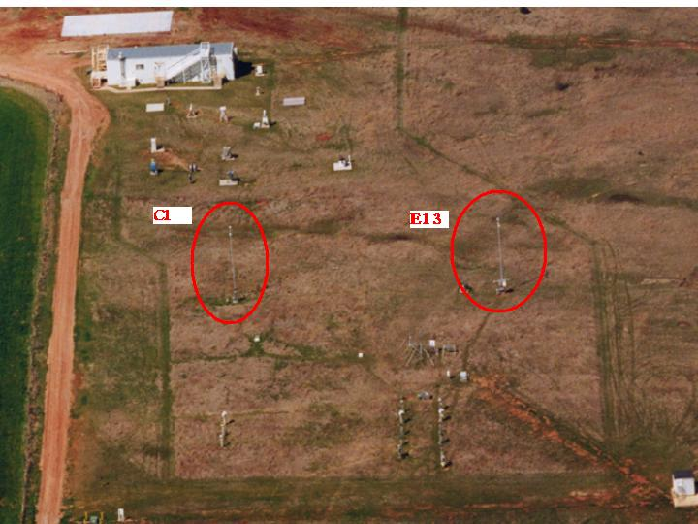

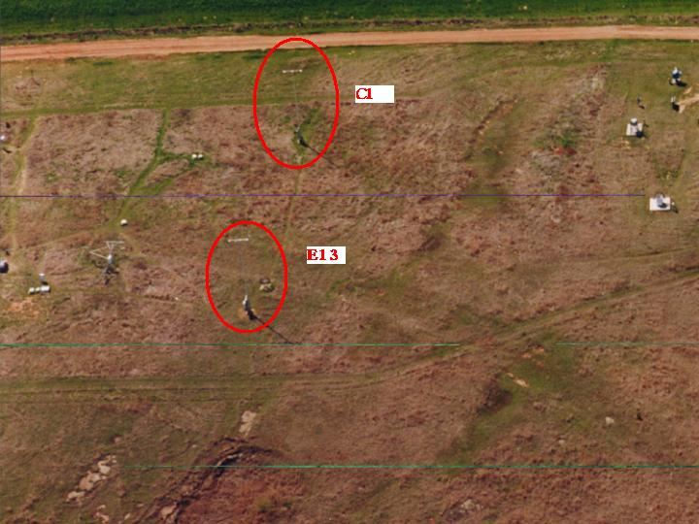

Figure 1.

Near-Real-Time Data Plots

Daily Plots, from SGP Development System
SGP Site Scientist Data Quality Assessment
General Quick Looks

Data Description and Examples

Typical SIRS Data Time-Series Plots

Measured data from the suite of six radiometers forming each SIRS is greatly influenced by the atmospheric conditions and ground cover. The examples given here represent the common range of shortwave (solar) and longwave (atmospheric) measurements.

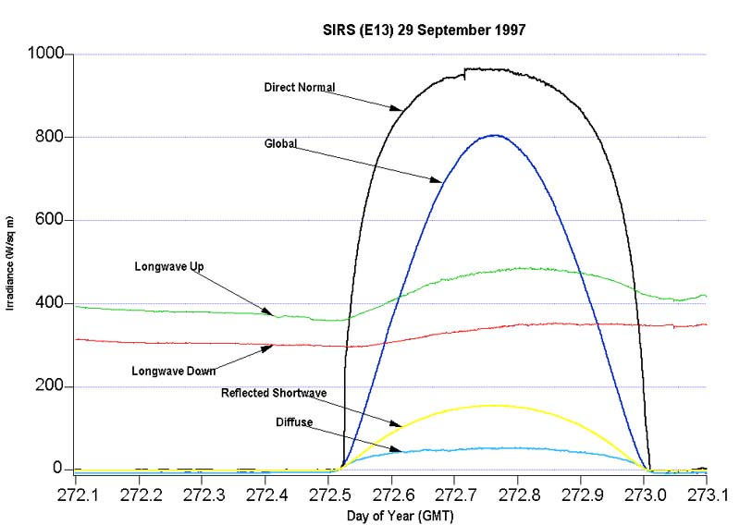

Figure 2.

Data in Figure 2 are typical of the clear-sky conditions at the SGP during the fall. Near solar noon, when the sun is highest in the sky and there is the least amount of atmosphere in the photons path to the surface, the direct normal shortwave (beam) irradiance approaches 1000 Wm⁻² , the global (total hemispheric) irradiance nears 800 Wm⁻², the diffuse (sky) irradiance remains nearly constant at about 50 Wm⁻², and the reflected shortwave reaches a peak of 155 Wm⁻2 (or an albedo of about 19% which is typical for a vegetated surface). Heating of the surface and the atmosphere is evident from the increasing longwave (infrared) irradiance measurements. The peak longwave irradiances occur after solar noon, demonstrating the “thermal lag” of the earth-atmosphere system response to solar heating. The peak upwelling longwave irradiance on this day was 488 Wm⁻² at 19:41 GMT (1:41 PM local standard time). The peak downwelling (atmospheric) longwave irradiance was 355 Wm⁻² at about the same time, producing a net radiation of 133 Wm⁻² . The effect of cleaning the pyrheliometer window is evident from the change in direct normal irradiance prior to local solar noon. Maintenance records show the pyrheliometer window was dry, but had light dust removed from the surface at 17:10 GMT. Comparing the direct normal data before and after the cleaning, 947.81 Wm⁻² and 963.25 Wm⁻² respectively, it suggests a decreased irradiance measurement of 1.6% due to the window contamination.

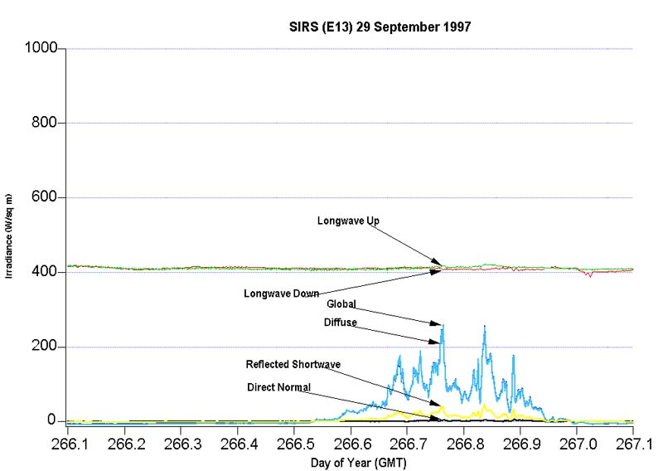

Figure 3.

Data in Figure 3 are typical of cloudy sky conditions at the SGP during the fall. With completely overcast conditions, the direct normal shortwave (beam) irradiance remains near zero all day. Variable cloud thickness during the day allow the global (total hemispheric) and the diffuse (sky) irradiance to peak at about 256 Wm⁻² at 18:20 GMT and a few hours later. The reflected shortwave reaches a peak of 45 Wm⁻2 (albedo of about 18%). The exchange of infrared radiation is nearly constant under these conditions, suggesting low clouds. The two SIRS pyrgeometers indicate 415 W⁻² of longwave irradiance was consistently measured at the Central Facility on 23 September 1997.

Data File Contents

Primary Variables and Expected Uncertainty

The following broadband irradiance measurements are available from the SIRS platform:

DOWNWELLING SHORTWAVE (0.3 to 3.0 micrometers)

- Direct Normal (beam) irradiance measured by a pyrheliometer with a 5.7 degree field of view.

- Diffuse Horizontal (sky) irradiance measured by a shaded and ventilated pyranometer with a hemispherical field of view, but blocked from the direct normal irradiance by a tracking ball.

- Total Hemispheric (global) irradiance measured by an unshaded and ventilated pyranometer.

DOWNWELLING LONGWAVE (4.0 to 50 micrometers)

- Total Hemispheric (atmospheric) irradiance measured by a shaded and ventilated pyrgeometer with a hemispheric field of view.

UPWELLING SHORTWAVE (0.3 to 3.0 micrometers)

- Reflected irradiance measured by an inverted pyranometer with a hemispheric field of view.

UPWELLING LONGWAVE (4.0 to 50 micrometers)

- Irradiance measured by an inverted pyrgeometer with a hemispheric field of view.

Definition of Uncertainty

Estimating radiometer measurement uncertainties continues to be a topic for additional research. Based on experiences with these and similar instruments for renewable energy applications, the following estimated measurement uncertainties conservatively apply to SIRS measurements.

Table 1.

Measurement | Abbreviation | Radiometer Model | Typical Responsivity  (μV/Wm⁻²) | Estimated Measurement Uncertainty*
Direct Normal  (beam) | DNI | NIP | 8.0 | ±3.0% or  4 Wm⁻²
Diffuse Horizontal  (sky) | DD | PSP | 9.0 | ±6.0% or  20 Wm⁻²
Downwelling Shortwave  (global) | DS | PSP | 9.0 | ±6.0% or  10 Wm⁻²
Downwelling Longwave  (atmospheric) | DIR | PIR | 4.0 | ±2.5% or  4 Wm⁻²
Upwelling Shortwave  (reflected) | US | PSP | 9.0 | ±6.0% or  15 Wm⁻²
Upwelling Longwave  (terrestrial) | UIR | PIR | 4.0 | ±2.5% or  4 Wm⁻²
*Field measurement uncertainties include the uncertainties associated with instrument calibration, installation, operation and maintenance.

Secondary/Underlying Variables

This section is not applicable to this instrument.

Diagnostic Variables

This section is not applicable to this instrument.

Data Quality Flags

The SIRS data quality assessments are based on the methods developed by the National Renewable Energy Laboratory (formerly the Solar Energy Research Institute - SERI). A description of the SERI-QC approach to automated quality assessment of broadband radiometric data can be found at the NREL Renewable Resource Data Center.

The ARM Program has incorporated the SERI-QC concepts and upgraded the automated capabilities for SIRS data quality assessment. Information about the new Data Quality Management System (DQMS) can be found at http://www.dqms.com/dqmspart.htm.

As part of the effort to produce the National Solar Radiation Data Base (1961-1990), NREL (at that time called the Solar Energy Research Institute) developed an automated quality assessment tool, SERI-QC for evaluating hourly measurements and model estimates of broadband shortwave irradiance data for 239 locations in the U.S. The ARM Program has since supported the development of the Data Quality Management System Version 3.0 (DQMS-3) which incorporates the SERI_QC methods. Additional elements of DQMS-3 are used for assessing SIRS data quality and providing the means for correcting known instrumentation responses:

- SERI_QC converts 1-minute broadband shortwave irradiance data from flux densities in Watts per square meter to non-dimensional units normalized to the coincident extraterrestrial (exoatmospheric) values:

K_{T} = Total Hemispheric / Extraterrestrial = DS / ETR

K_{N} = Direct Normal / Extraterrestrial Normal = DNI / ETRN

K_{D} = Downwelling Diffuse / Extraterrestrial = DD / ETR

Resulting in the relationship among the three measured shortwave components:

K_{T} = K_{N} + K_{D}

Failing the above “3-component” test, pairs of irradiance data can be evaluated using the transformation.

When presented in K-Space, the data can be evaluated based on acceptable limits determined by physical limits, internal consistency, and careful inspection of historical data.
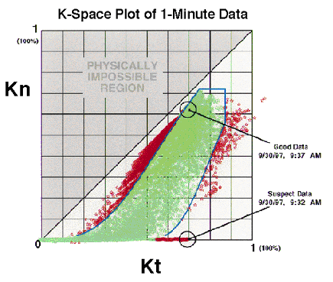

Figure 4.

SERI_QC assigns a two-digit quality flag to each irradiance data element based on the location in the appropriate K-Space coordinates.

Table 2. Flagging Convention for SERI_QC

Flag | Description
00 | Untested (raw data)
01 | Passed one-component test; data fall within max-min limits of Kt, Kn, or Kd
02 | Passed two-component test; data fall within 0.03 of the Gompertz boundaries
03 | Passed three-component test; data come within ±0.03 of satisfying Kt=Kn+Kd
04 | Passed visual inspection; not used by SERI_QC
05 | Failed visual inspection; not used by SERI_QC
06 | Value estimated; passes all pertinent SERI_QC tests
07 | Failed one-component test; lower than allowed minimum
08 | Failed one-component test; higher than allowed maximum
09 | Passed three-component test but failed two-component test by > 0.05 (K-units)
10-93 | Failed two- or three-component tests in one of four ways.  To determine the test failed and the manner of failure (high or low), examine the remainder of the calculation (flag + 2) / 4.  Rem Failure:  0 Parameter too low by three-component test (Kt = Kn + Kd)  1 Parameter too high by three-component test (Kt = Kn + Kd)  2 Parameter too low by two-component test (Gompertz boundary)  3 Parameter too high by two component test (Gompertz boundary)  The magnitude of the test failure (distance in K-units) is determined from:  D = INT ( ( flag + 2) / 4) / 100.
94-97 | Data fall into a physically impossible region where Kn > Kt by K-space distances of 0.05 to 0.10 (94), 0.10 to 0.15 (95), 0.15 to 0.20 (96), and ≥0.20 (97)
98 | Not used
99 | Missing data

More detailed information about SERI-QC is available from the Renewable Resource Data Center: http://rredc.nrel.gov.

Additional information may also be found at SIRS Data Object Design Changes for ARM netCDF file header descriptions.

Dimension Variables

This section is not applicable to this instrument.

Annotated Examples

This section is not applicable to this instrument.

User Notes and Known Problems

Incorrect Metadata

When SIRS radiometers are changed for recalibration or other reasons, the site operators immediately enter the new serial numbers and calibrations in to the Campbell Scientific, Inc., dataloggers (CDLs) dedicated to the SIRS. If this is done properly, the values for the observed geophysical parameters immediately have the correct calibration coefficients applied. These values are ingested in the 60-s data and no further processing is necessary to produce the estimates in geophysical units with correct calibrations. The 20-s data consist of raw values and are not affected by the choice of calibration coefficients or serial numbers. However, the metadata for the 60-s data are not updated with the new calibration coefficients and serial numbers until a special file produced daily near midnight GMT by the CDL are read at that time by the site data system. Hence, it is possible that up to nearly 24 hours of partially incorrect metadata will be generated. This problem could be overcome by a procedure of turning off the data ingest and correcting it whenever the sensors are replaced. All SIRS data collected to date have this problem, because such a procedure has not been implemented. The amount of time and effort to take such actions does not seem to be justified for this fairly minor source of misinformation.

On Time Formats and Values of Downward Shortwave Hemispheric Radiation (P011004.2)

All SIRS data are recorded in UTC. This means local sunset will occur after 24:00 UTC in the summer as can be found, for example, in the data file sgpsirsC1.a1.20000601.000000.cdf. The large positive values are valid for the afternoon period. The negative values after sunset (and throughout the night, depending on the cloud cover) are typical of single-black thermopile detectors used in the SIRS network (see Dutton, E.G, et al, 'Measurement of Broadband Diffuse Solar Irradiance Using Current Commercial Instrumentation with a Correction for Thermal Offset Errors.' Journal of Atmospheric and Oceanic Technology, Vol 18, March 2001, pages 297-306.) Prior to the use of Eppley Laboratory, Inc. Model 8-48 in February 2001, the diffuse shortwave and, to a lesser extent, the global irradiance can be corrected for thermal offsets. In any event, I would treat the small (<15 Watts per sq meter) nighttime shortwave irradiances as '0.0' when computing the daily total irradiation values. We have programmed the Campbell Scientific, Inc. Model CR10X data loggers to output the measurements using the convention where midnight is recorded as 00:00:00 and the date reflects the start of a new 24 hour day. In Campbell-ese, the 4-digit code for 'Time Options' is 1110 for the SIRS program. SIRS 1-minute data for a particular date is then recorded from 00:00 to 23:59. For example, the data recorded for 10:05 are the averages, minima, maxima, and standard deviations of the 2-second samples beginning 10:04:02 and ending 10:05:00.

Pyranometer Thermal Offsets

Broadband downwelling shortwave diffuse (sky) irradiance measurements available from SIRS prior to February 22, 2001 may require adjustment for thermal offsets. After this date, all SIRS were providing diffuse irradiance data as measured with an Eppley Laboratory, Inc., Model 8-48 (black and white) pyranometer. The operational date of each SIRS in 1997/98 and the date and time of Model 8-48 installation in February 2001 can be found in Table 3.

As described in the above Description of Observational Specifications, these thermal, or “zero” offsets refer to the generally reduced output signals from a shaded pyranometer due to the exchange of longwave (infrared) irradiance between the single black thermopile detector, the protective glass domes surrounding the detector, and the atmosphere. Originally considered an acceptable nighttime response of thermopile-type pyranometers, the generally negative bias is now recognized to significantly effect the accuracy of SIRS diffuse irradiance data during daylight periods.

Studies of the Eppley Laboratory, Inc. Model PSP (Precision Spectral Pyranometer), used for the SIRS measurements of diffuse irradiance, suggest the thermal offset correction can range from near 0, to as much as 30 Watts per square meter, depending on the coincident net longwave, or infrared irradiance [1, 2]. Under very clear-sky conditions, the diffuse irradiance from a shaded PSP can be less than the minimum physical limit defined by radiative transfer model estimates based only on Rayleigh scattering effects.

A correction method has been developed for adjusting SIRS diffuse irradiance data [3]. The resulting Value Added Product (VAP) will be applied to SIRS data for the period of this DQR. The VAP will not be applied to SIROS data collected before the instrument platform was converted to SIRS.

Additionally, the Model PSP radiometer has been replaced by a Model 8-48 which uses a black and white thermopile detector known to reduce the thermal offset errors to less than 2 Watts per square meter [3]. The radiometer replacement at this SIRS location was completed on the date shown in Table 3.

Table 3. SIRS Upgrade: Model 8-48 Pyranometer Installation for Diffuse Irradiance, 4-19-01, Tom Stoffel¹.

Site | SIROS to SIRS² | Model 8-48 Installation | Data Logger “OFF” (GMT)³ | Returned to Service (GMT)⁴
C1 | 01-15-97 | 02-22-01 | 20:50 | 21:00
E1 | 11-20-97 | 02-13-01 | 20:15 | 20:25
E2 | 11-06-97 | 02-15-01 | 15:47 | 16:02
E3 | 11-04-97 | 02-14-01 | 19:30 | 19:50
E4 | 11-07-97 | 02-14-01 | 15:10 | 16:06
E5 | 11-06-97 | 02-14-01 | 19:45 | 20:03
E6 | 11-05-97 | 02-15-01 | 15:30 | 15:50
E7 | 10-31-97 | 02-13-01 | 19:25 | 19:45
Table 3. (cont’d)

E8 | 08-19-97 | 02-13-01 | 18:15 | 18:41
E9 | 02-06-98 | 02-13-01 | 15:40 | 16:00
E10 | 10-30-97 | 02-14-01 | 15:00 | 15:10
E11 | 08-20-97 | 02-20-01 | 20:40 | 21:05
E12 | 10-29-97 | 02-20-01 | 16:55 | 17:15
E13 | 08-25-97 | 02-22-01 | 20:21 | 20:35
E15 | 08-23-97 | 02-20-01 | 17:30 | 17:40
E16 | 08-21-97 | 02-21-01 | 16:20 | 16:50
E18 | 09-30-97 | 02-20-01 | 22:20 | 22:40
E19 | 06-16-98 | 02-22-01 | 15:35 | 15:48
E20 | 02-11-98 | 02-20-01 | 18:50 | 19:10
E21 | 07/22/99 | 02-20-01 | 21:00 | 21:35
E22 | 11-24-97 | 02-21-01 | 20:00 | 20:20
E24 | 11-25-97 | 02-22-01 | 16:15 | 16:35
E25 | 10-01-97 | 02-21-01 | 16:00 | 16:15

¹ Information provided by Dan Nelson 2 Mar 99 and revised by Bev Kay 11 Apr 01 using OMIS.

² Date SIRS was fully operational (Assume 00:00 GMT).

³ Ending time for DQR describing shaded PSP thermal offset remains uncorrected.

⁴ Time of data collection beginning with a new shaded Model 8-48 for Downwelling Diffuse (DD).

References:

Cess, R. D., X. Jing, T. Qian, and M. Sun. 1999. Validation Strategies Applied to the Measurement of Total, Direct and Diffuse Shortwave Radiation at the Surface. J. Geophys. Res.

Dutton, E.G., J.J. Michalsky, T. Stoffel, B.W. Forgan, J. Hickey, D.W. Nelson, T.L. Alberta, and I. Reda. 2001. Measurement of Broadband Diffuse Solar Irradiance Using Current Commercial Instrumentation with a Correction for Thermal Offset Errors. J. Atmospheric & Oceanic Technology, Vol. 18, No. 3, pp. 297-314.

Gulbrandsen, A. 1978. On the Use of Pyranometers in the Study of Spectral Solar Radiation and Atmospheric Aerosols. J. Appl. Meteorol., 17, 899-904.

Frequently Asked Questions

This section is not applicable to this instrument.

Data Quality

Data Quality Health and Status

The following links go to current data quality health and status results

DQ HandS (Data Quality Health and Status)

NCVweb for interactive data plotting using.

The tables and graphs shown contain the techniques used by ARM's data quality analysts, instrument mentors, and site scientists to monitor and diagnose data quality.

Data Reviews by Instrument Mentor

This section is not applicable to this instrument.

Data Assessments by Site Scientist/Data Quality Office

All DQ Office and most Site Scientist techniques for checking have been incorporated within DQ HandS and can be viewed there.

Value-Added Procedures and Quality Measurement Experiments

Many of the scientific needs of the ARM Program are met through the analysis and processing of existing data products into "value-added" products or VAPs. Despite extensive instrumentation deployed at the ARM CART sites, there will always be quantities of interest that are either impractical or impossible to measure directly or routinely. Physical models using ARM instrument data as inputs are implemented as VAPs and can help fill some of the unmet measurement needs of the program. Conversely, ARM produces some VAPs not in order to fill unmet measurement needs, but instead to improve the quality of existing measurements. In addition, when more than one measurement is available, ARM also produces "best estimate" VAPs. A special class of VAP called a Quality Measurement Experiment (QME) does not output geophysical parameters of scientific interest. Rather, a QME adds value to the input datastreams by providing for continuous assessment of the quality of the input data based on internal consistency checks, comparisons between independent similar measurements, or comparisons between measurement with modeled results, and so forth. For more information, see the VAPs and QMEs web page.

Instrument Details

Detailed Description

List of Components

The following radiometers manufactured by The Eppley Laboratory, Inc., in Table 4 re used at each SIRS.

Table 4.

Measurement | Radiometer Model | Mounting Arrangement | Typical Responsivity  (μV/Wm⁻²) | Typical Calibration Uncertainty*
Direct Normal | NIP | Solar Tracker | 8.0 | ±2.5% or  2 Wm⁻²
Diffuse Horizontal | PSP | Shaded & Ventilated | 9.0 | ±3.0% or  10 Wm⁻²
Downwelling Shortwave | PSP | Unshaded & Ventilated | 9.0 | ±3.0% or  10 Wm⁻²
Downwelling Longwave | PIR | Shaded & Ventilated | 4.0 | ±2% or  2 Wm⁻²
Upwelling Shortwave | PSP | Inverted w/o ventilation | 9.0 | ±3.0% or  10 Wm⁻²
Upwelling Longwave | PIR | Inverted w/o ventilation | 4.0 | ±2% or  2 Wm⁻²
*Field measurement uncertainties are larger and include the uncertainties associated with instrument calibration, installation, operation and maintenance.

Additional information is available from http://www.nrel.gov/srrl/.

System Configuration and Measurement Methods

Depending on the irradiance measurement, SIRS radiometers are mounted on either an automatic solar tracker or a stationary surface. The following abbreviations are used to describe the SIRS instrumentation and their relative locations shown in Figure 5:

DNI = Direct Normal (beam) Shortwave Irradiance
DD = Downwelling Diffuse (sky) Shortwave Irradiance
DS = Downwelling Total Hemispheric (global) Shortwave Irradiance
DIR = Downwelling Infrared (atmospheric) Irradiance
US = Upwelling Shortwave (reflected) Irradiance
UIR = Upwelling Infrared (terrestrial) Irradiance.

The data acquisition system is a Campbell Scientific, Inc. Model CR10X-1M with AM416 Multiplexer, 4 Mb memory card, and modem. These components are inside a weather-resistant enclosure mounted above ground. The system is designed to operate over the full range of environmental conditions anticipated for the network of SIRS stations (see http://www.campbellsci.com for detailed measurement and environmental specifications).

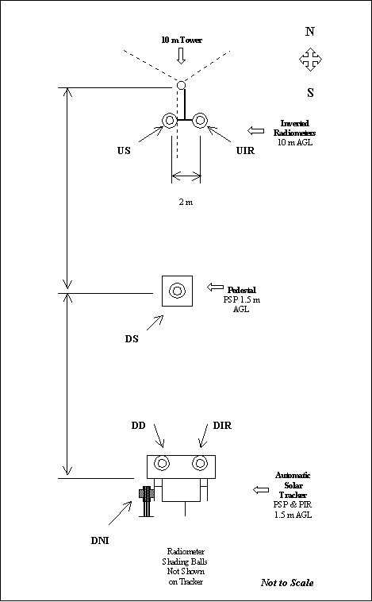
Figure 5. Plan View of SIRS Instrument Locations

The system is programmed to sample ten inputs listed below every 2-seconds and output the average, standard deviation, minimum, and maximum values of the six geophysical elements, described above, at the end of each minute. Appended to each 1-minute data output record are the instantaneous values sampled at 20 seconds, 40 seconds, and 60 seconds within the 1-minute interval. These "instantaneous" data actually require 0.272 milliseconds to complete the analog to digital conversion of each measurement. Additionally, at 23:59:02 each day, the instrument serial numbers and calibration factors used by the data logger program are appended to the last record of the day. The system is designed to store up to two weeks of measured data and statistics, but the data are generally collected by telephone modem every 3-hours. Data stored on the 4 Mb memory card at each station are physically removed as part of the routine SIRS maintenance every two weeks and made available to the SGP Data System.

Measurements collected by the CR10X-1M logger are listed below with a sample data record for reference. All data files are reformatted in NETcdf for distribution.

Measurement Dictionary

DSTp = DS unshaded pyranometer thermopile output voltage (mV)

USTp = US inverted pyranometer thermopile output voltage (mV)

DDTp = DD shaded pyranometer thermopile output voltage (mV)

DNITp = DNI pyrheliometer thermopile output voltage (mV)

DIRTp = DIR pyrgeometer thermopile output voltage (mV)

DIRCr = DIR pyrgeometer case thermistor resistance (Kohm)

DIRDr = DIR pyrgeometer dome thermistor resistance (Kohm)

UIRTp = UIR pyrgeometer thermopile output voltage (mV)

UIRCr = UIR pyrgeometer case thermistor resistance (Kohm)

UIRDr = UIR pyrgeometer dome thermistor resistance (Kohm)

Excerpts from SIRS data file for 28 April 1997

Typical 60-sec output record:

Note: For improved readability, a space has been added after each comma in the original CSV Campbell data logger output file.

199, 1997, 108, 1831, 459.01, 344.61, 204.24, 186.11, 738.7, 839.92, 1.363, .74, .755, 1.302, 10.25, 9.06, 462.3, 345.6, 205.9, 189.1, 758, 857, 456.8, 342.4, 203.2, 184.5, 722, 825, 9.8011, 9.9781, 9.0405, 8.7893, .08167, -.52838, 1.9969, 1.7249, 6.3005, 7.1103, 9.8011, 9.9781, 9.0599, 8.7893, .08034, -.52738, 1.9874, 1.7117, 6.2098, 7.059, 9.8012, 9.9585, 9.0212, 8.7894, .09334, -.51988, 1.9829, 1.7183, 6.3546, 7.1512, 13.14

Penultimate 60-sec output record of the day has last valid irradiance data:

199, 1997, 108, 2359, 423.04, 330.79, 77.44, 61.688, 541.83, 181.26, .661, .626, .525, 2.231, 25.03, 5.988, 424, 332.2, 78.3, 64.46, 569.2, 188.3, 421.9, 329.9, 76.5, 57.16, 488.7, 169.1, 10.492, 10.592, 9.5264, 9.2535, -.04884, -.54438, .75906, .58593, 4.773, 1.5735, 10.492, 10.592, 9.5068, 9.2535, -.05017, -.54472, .75307, .56289, 4.5574, 1.5175, 10.492, 10.592, 9.5068, 9.2535, -.0505, -.54305, .74609, .52833, 4.1591, 1.4303, 13.16

Last 60-sec output record of the day has instrument serial numbers and calibration factors:

(Note: All measurement elements are invalid due to timing restriction.)

199, 1997, 108, 2359, 397.49, 315.72, 72.17, 65.84, 321.97, 272.75, 40.17, 19.63, 95.1, 76.1, 352.5, 335.9, 471.3, 393.9, 400.8, 215.2, 948, 980, 350.3, 291.2, -7.88, -1.427, -4.451, -6.624, 10.492, 10.592, 9.5264, 9.2535, -.04884, -.54438, .75906, .58593, 4.773, 1.5735, 10.492, 10.592, 9.5068, 9.2535, -.05017, -.54472, .75307, .56289, 4.5574, 1.5175, 10.492, 10.592, 9.5068, 9.2535, -.0505, -.54305, .74609, .52833, 4.1591, 1.4303, 13.16, 30783, 245.7, 30696, 268.82, 29618, 102.5, 30802, 108.19, 29737, 117.51, 30891, 118.2
Pos | Element | Value | Units | Range
 |  |  |  | Min | Max
01 | Site Identifier | 199 | n/a | 1 | 511
02 | Year | 1997 | Years | 1997 | 2052
03 | Day of Year | 145 | n/a | 1 | 366
04 | Time (hh:mm) | 1345 | UTC | 0 | 2359
----Begin 60-sec Averages of 2-sec samples for the time ending above----
05 | UIR | 459.01 | W/sq m | 100 | 800
06 | DIR | 344.61 | W/sq m | 50 | 800
07 | DD | 204.24 | W/sq m | -10 | 600
08 | US | 186.11 | W/sq m | -10 | 1100
09 | DNI | 738.7 | W/sq m | -10 | 1100
10 | DS | 839.92 | W/sq m | -10 | 1400
---Begin 60-sec Standard Deviations of 2-sec samples for the time ending above----
11 | UIR | 1.363 | W/sq m | 0 | 600
12 | DIR | 0.74 | W/sq m | 0 | 600
13 | DD | 0.755 | W/sq m | 0 | 500
14 | US | 1.302 | W/sq m | 0 | 400
15 | DNI | 10.25 | W/sq m | 0 | 1000
16 | DS | 9.06 | W/sq m | 0 | 1000
---Begin 60-sec Maxima of 2-sec samples for the time ending above----
17 | UIR | 462.3 | W/sq m | 100 | 800
18 | DIR | 345.6 | W/sq m | 50 | 800
19 | DD | 205.9 | W/sq m | -10 | 600
20 | US | 189.1 | W/sq m | -10 | 1100
21 | DNI | 758 | W/sq m | -10 | 1100
22 | DS | 857 | W/sq m | -10 | 1400
---Begin 60-sec Minima of 2-sec samples for the time ending above----
23 | DIR | 456.8 | W/sq m | 100 | 800
24 | UIR | 342.4 | W/sq m | 50 | 800
25 | DD | 203.2 | W/sq m | -10 | 600
26 | US | 184.5 | W/sq m | -10 | 1100
27 | DNI | 722 | W/sq m | -10 | 1100
28 | DS | 825 | W/sq m | -10 | 1400
----Begin 20-sec Instantaneous samples for 20-sec into the time ending above----
29 | UIRDr | 9.8011 | KOhms
30 | UIRCr | 9.9781 | KOhms
31 | DIRDr | 9.0405 | KOhms
32 | DIRCr | 8.7893 | KOhms
33 | UIRTp | .08167 | mv | -0.2 | 7.5
34 | DIRTp | -.52838 | mv | -0.2 | 7.5
35 | DDTp | 1.9969 | mv | -0.2 | 15.0
36 | USTp | 1.7249 | mv | -0.2 | 15.0
37 | DNITp | 6.3005 | mv | -0.2 | 15.0
38 | DSTp | 7.1103 | mv | -0.2 | 15.0
----Begin 20-sec Instantaneous samples for 40-sec into the time ending above----
39 | UIRDr | 9.8011 | :
40 | UIRCr | 9.9781 | :
41 | DIRDr | 9.0599 | : << as above for 20-sec interval >>
42 | DIRCr | 8.7893 | :
43 | UIRTp | .08340 | :
44 | DIRTp | -.52738 | :
45 | DDTp | 1.9874 | :
46 | USTp | 1.7117 | :
47 | DNITp | 6.2098 | :
48 | DSTp | 7.059 | :
----Begin 20-sec Instantaneous samples for 60-sec into the time ending above----
49 | UIRDr | 9.8012 | :
50 | UIRCr | 9.9585 | :
51 | DIRDr | 9.0212 | :
52 | DIRCr | 8.7894 | : <<as above for 40-sec interval>>
53 | UIRTp | 0.09334 | :
54 | DIRTp | -.51988 | :
55 | DDTp | 1.9829 | :
56 | USTp | 1.7183 | :
57 | DNITp | 6.3546 | :
58 | DSTp | 7.1512 | :
59 | BATT | 13.14 | V | 9.2 | 14.0
Once daily at 23:59:02 the radiometer serial numbers and calibration factors are output AFTER a bogus (insufficient sample size) record as above for positions 1-59.

60 | UIR Serial No. | 30783 | “F3” implied
61 | UIR Calibration Factor | 245.7 | W/sq m per mv
62 | DIR Serial No. | 30696 | “F3” implied
63 | DIR Calibration Factor | 268.82 | W/sq m per mv
64 | DD Serial No. | 29618 | “F3” implied
65 | DD Calibration Factor | 102.5 | W/sq m per mv
66 | US Serial No. | 30802 | “F3” implied
67 | US Calibration Factor | 108.19 | W/sq m per mv
68 | DNI S/N | 29737 | “E6” implied
69 | DNI Calibration Factor | 117.51 | W/sq m per mv
70 | DS S/N | 30891 | “F3” implied
71 | DS Calibration Factor | 118.2 | W/sq m per mv

Note: All PIR and PSP serial numbers are “xxxxx.F3”. All NIP s/n are “xxxxx.E6”

Reconstructing the 1-Minute Averages from Three 20-Second Samples

Use the average of the three samples for each of the elements described below to compute an average irradiance (W/sq m). The data acquisition system program uses these same procedures to compute the 1-minute statistics from the 2-second scans.

Global
DS = DSTp (mV) * DS Cal Factor (W/sq m per mV)

Upwelling Shortwave
US = USTp (mV) * US Calibration Factor (W/sq m per mV)

Diffuse
DD = DDTp (mV) * DD Calibration Factor (W/sq m per mV)

Direct Normal
DNI = DNITp (mV) * DNI Calibration Factor (W/sq m per mV)

Down / Upwelling Infrared (DIR or UIR)
Step 1. Compute Temperature (K) from thermistor resistance (KOhm)

T = 1 / [A + BX + CX³]
where,

T = Temperature (K)
A = 10.425E-04
B = 2.37E-04
C = 1.64E-03
X = 5 * Ln(10) + Ln(R/100), and R = Resistance (KOhm)

Step 2. Compute Irradiance from PIR Temperatures (K) and Thermopile Voltages (mV)

Irrad = T_{p} * C1 + Sig * T_{c}⁴ - C2 * Sig *(T_{d}⁴ - T_{c}⁴)
where,

Irrad = Irradiance (W/sq m)
T_{p} = PIR thermopile voltage (mV)
T_{c} = PIR case temperature (K)
T_{d} = PIR dome temperature (K)
C1 = PIR Calibration Factor (W/sq m per mV)
C2 = PIR Dome Correction Factor (4.0 = default for all PIRs)
Sig = Stephan-Boltzman Constant = 5.67E-08 W/m² K⁴)

Specifications

Selected theoretical measurement parameters of the SIRS radiometers are listed below in Table 5.

Table 5.

Measurement | Radiometer Field of View | Wavelength Range  (microns) | Minimum Irradiance  (Wm⁻²) | Maximum Irradiance  (Wm⁻²)
Direct Normal  (beam) [DNI] | 5.7° | 0.3 to 3.0 | 0.0 | 1100
Diffuse Horizontal  (sky) [DD] | 2π sr | 0.3 to 3.0 | 0.0 | 600
Downwelling Shortwave  (global) [DS] | 2π sr | 0.3 to 3.0 | 0.0 | 1400
Downwelling Longwave  (atmospheric) [DIR] | 2π sr | 4.0 to 50 | 50 | 800
Upwelling Shortwave  (reflected) [US] | 2π sr | 0.3 to 3.0 | 0.0 | 1100
Upwelling Longwave  (terrestrial) [UIR] | 2π sr | 4.0 to 50 | 100 | 800

Field of View and Angular Response

The SIRS pyrheliometer (Eppley Laboratory, Inc. Model NIP) field of view was designed to meet the World Meteorological Organization’s design requirements circa 1960. Without the scattering effects of a clear atmosphere, the solar disc would appear to be about 0.5° at the earth’s surface. The NIP geometry allows for solar tracker alignment tolerances possible at the time of the WMO specification and includes, therefore, an amount of circumsolar (forward scatter) radiation.

The SIRS pyranometers (Eppley Laboratory, Inc. Model PSP) have unique angular response characteristics that can be determined and verified with calibration (see separate section). The angular response of the pyranometer is a major contributor to the estimated measurement uncertainty for the

various shortwave irradiance elements.

Spectral Response

The spectral response of the SIRS radiometers listed above are nominal values. The precise values vary with instrument model. Figures 2 & 3??

<<Insert John’s Spectral Response Plot here>>

Thermal Offsets

Shortwave radiometers should produce a null signal in the absence of solar radiation. However, all commercially available pyranometers based on thermoelectric transducers, exhibit a non-zero output signal in the absence of solar radiation. These signals are believed to be a result of thermal gradients within the pyranometer.

The Eppley Laboratory, Inc. Model PSP is a thermoelectric, single-black detector design with well-established performance characteristics (Thekaekara , 1972, Hulstrom, 1989, McCluney, 1994). As shown in Figure 4, the two Schott Glass hemispheres protect the thermopile detector from the weather. These inner and outer domes are used to also reduce the thermal exchange between the detector, or thermopile “hot” junction, and the environment. The body of the instrument is a relatively massive bronze casting that is used to control the “cold” or reference junction of the thermopile. Recent studies of this and other models of pyranometers suggest thermal offsets are producing as much as 30 Wm⁻² during clear-sky, nighttime conditions. Similarly, daytime measurements of downwelling diffuse shortwave irradiance must be corrected for thermal offsets. ARM will use a correction method based on correlations with the net infrared and observed diffuse irradiances [Dutton, et al, 2001].

Theory of Operation

Shortwave Irradiance

Three pyranometers are positioned to measure the hemispheric irradiance fields:

DS Unshaded, ventilated, and mounted in horizontal orientation
US Inverted, unventilated and mounted 10m above the ground level
DD Shaded, ventilated, and mounted on automatic solar tracker in horizontal orientation.

A single pyrheliometer is mounted on an automatic solar tracker and aligned to the sun’s disc.

The following relationships are expected from the SIRS measurement system for the various broadband shortwave irradiance elements.

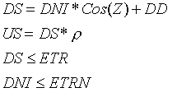

where,

DS = Downwelling Hemispheric Shortwave (Global) Irradiance

DNI = Direct Normal Shortwave (Beam) Irradiance

Z = Solar Zenith Angle (sunrise/sunset = 90°)

DD = Downwelling Diffuse Shortwave (sky) Irradiance

US = Upwelling Diffuse Shortwave (reflected) Irradiance

= Surface Shortwave Albedo (typically 0.2 for vegetation, 0.8 for fresh snow)

ETR = Extraterrestrial (exo-atmospheric) Radiation on horizontal surface

ETRN = Extraterrestrial Radiation Normal (beam) to the sun (1366 ±5 Wm⁻² [REF??]).

Longwave Irradiance

Elements of the pyrgeometer measurements are used to compute the infrared:

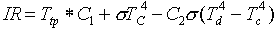

where,

IR = Infrared Irradiance (W/sq m)
T_{tp} = PIR thermopile voltage (mV)
T_{c} = PIR case temperature (K)
T_{d} = PIR dome temperature (K)
C₁ = PIR Calibration Factor (W/sq m per mV)
C₂ = PIR Dome Correction Factor (4.0 = default for all PIRs)
= Stephan-Boltzman Constant = 5.67E-08 W/m² K⁴.

Calibration

Theory

The calibration of all SIRS shortwave radiometers (pyrheliometers and pyranometers) is traceable to the World Radiometric Reference (WRR) maintained by the World Radiation Center (WRC) for the World Meteorological Organization. Calibrations are performed at the SGP Radiometer Calibration Facility (RCF-see separate entry) using the Broadband Outdoor Radiometer CALibration (BORCAL) methods developed at NREL. A group of three electrically self-calibrating absolute cavity radiometers is maintained by NREL as the reference standards for the U.S. Department of Energy (DOE) and ARM. WRR calibration traceability of these reference standards is maintained for all DOE programs by participation in the International Pyrheliometer Comparisons (IPC) held every five years at the WRC. NREL Pyrheliometer Comparisons (NPCs) are held annually at the Solar Radiation Research Laboratory (SRRL) in Golden to transfer the WRR to participating instruments and ensure the measurement performance of the reference standards.

The calibration of all SIRS longwave radiometers (pyrgeometers) are traceable to temperature standards maintained by the National Institute of Standards and Technology (NIST). SIRS pyrgeometers are to be calibrated in the new Pyrgeometer Blackbody Calibration System developed by The Eppley Laboratory, Inc. for the ARM Program and/or by outdoor comparisons with transfer standards. Standard operating procedures are currently under development at NREL for later use at the RCF to provide routine pyrgeometer calibrations.

Shortwave Radiometer Calibrations

The Component Summation Method used for all BORCAL events is a modified version of the shading method described in the American Society for Testing and Materials (ASTM) Standard E913-82, "Standard Method for Calibration of Reference Pyranometers with Axis Vertical by the Shading Method."

The direct normal (beam) irradiance is measured with one or two absolute cavity radiometers, and the diffuse (sky) irradiance is measured with one or two pyranometers shaded with a tracking disk (Figure 6) The two pyranometers providing the reference diffuse irradiance are calibrated by a shade/unshade method involving only the absolute cavity radiometer as a reference (Figure7). The output voltage of these standards and the radiometers under test are measured at approximate 30-second intervals throughout each day during clear-sky conditions (no clouds near the solar disk).

The responsivity for a pyrheliometer is calculated for each data point by dividing the value of the instrument's output signal (microvolts) by the mean value of the absolute cavity radiometer(s) output (W/sq m).

The responsivity for a pyranometer is calculated by dividing the value of the instrument's output signal (microvolts) by the computed reference global horizontal irradiance (W/sq m). The computed reference irradiance is the sum of the diffuse radiation and the vertical component of the direct beam irradiance (cavity radiometer irradiance multiplied by the cosine of the solar zenith angle at the time of measurement). This assumes that the pyranometer has a perfect angular response. The solar zenith angle calculations are corrected for atmospheric refraction effects at the calibration facility.

During a calibration event, one or more pyranometers (The Eppley Laboratory, Inc. Model PSP) and pyrheliometers (The Eppley Laboratory, Inc. Model NIP) are used as control standards to monitor the calibration process.

Figure 6. Component Summation Calibration

Figure 7. Shade/Unshade Calibration

Longwave Radiometer Calibrations

As of January 2001, all SIRS pyrgeometers have the calibration factors assigned by the manufacturer. A new blackbody calibration system has been developed for the recalibration of all SIRS pyrgeometers and is under test and evaluation at NREL. The specifications relative to the temperature ranges to be attained by the blackbody source and the PIR instrument were adapted from the BSRN (WMO's Baseline Surface Radiation Network) operating specifications.

The model PIR pyrgeometer is an instrument for measuring infrared radiation from the atmosphere, or from the ground if used in an inverted position. It defines the radiative transfer relative to the longwave irradiance. A PIR can be calibrated using a blackbody radiator with temperatures in the range given in the cited specification. The blackbody radiator itself is a copper hemisphere mounted in a fluid containing vessel, which is insulated. The geometry is such that the PIR will be in the “up-looking" position when it is inserted into the radiator. The surface of the hemispherical cavity is coated with Parson’s black paint over a layer of Parson’s black primer. This should yield a surface emissivity greater than 0.98. When the PIR instrument is inserted in the hemispherical cavity the effective emissivity approaches 1.0, due to the cavitation and enhancement from reflection of its own radiation. The reason for this approach is that the PIR instrument has a 180° Field of view (FOV). While this concept is simple in principle it is not as straight forward in operation. One reason is that for temperature differences between blackbody radiator and the PIR instrument thermal conduction and convection interfere with achieving the strictly radiative heat transfer desired for a calibration.

In nature, the ambient temperature determines the temperature of the PIR to a high degree. The cold radiative temperatures of the sky are actually affecting the instrument temperature to a high degree. It has been reported that solar radiation heats the hemisphere and/or hemisphere collar during some field use. However, some investigators use ventilation and / or shading to reduce this effect. Correction terms have been added to the data reduction algorithms to reduce such effects. The prototype PIR calibration system offered an opportunity to assess some of these effects. There is a history of relatively good agreement among different calibration laboratories as reported elsewhere. It was intended that information gathered by use of the prototype would allow development of the production units.

The prototype system was based on the system used at Eppley Laboratory for over 20 years. The main differences for the new systems:

Operates over a larger temperature range (see discussion of BSRN spec.)

Is to be fully automatic for a number of functions and all measurements

The temperature of the PIR is controlled (EPLAB system at ambient).

To understand the design and operation of the calibrator, the actual desired result must be defined. The radiation measured by a PIR is calculated from the measurement of the parameters of the instrument. The primary parameters are:

The thermopile output signal

The case temperature (approximation of the cold junction temperature)

The silicon hemisphere temperature.

Note that some users also measure a quantity termed the pyrgeometer output signal. This is a modified output signal from the PIR by virtue of a radiation compensation circuit which act like an analog computer which automatically corrects for the outgoing (emitted) radiation from the thermopile surface.

Generally speaking, investigators define the calibration as the determination of the sensitivity of the thermopile and the correction parameters associated with the temperatures and temperature differences experienced. A thermopile signal is related to the NET radiation at its receiver. This leads to the fact that the outgoing radiation must be assessed to calculate the incoming radiation, which is the desired result of the measurement. This is accomplished by calculating the outgoing radiation using the measured case temperature and making such corrections as deemed necessary. The measured hemisphere (or dome) temperature is also used to calculate correction terms related to other effects due to temperature gradients in the instrument during calibration and/or use.

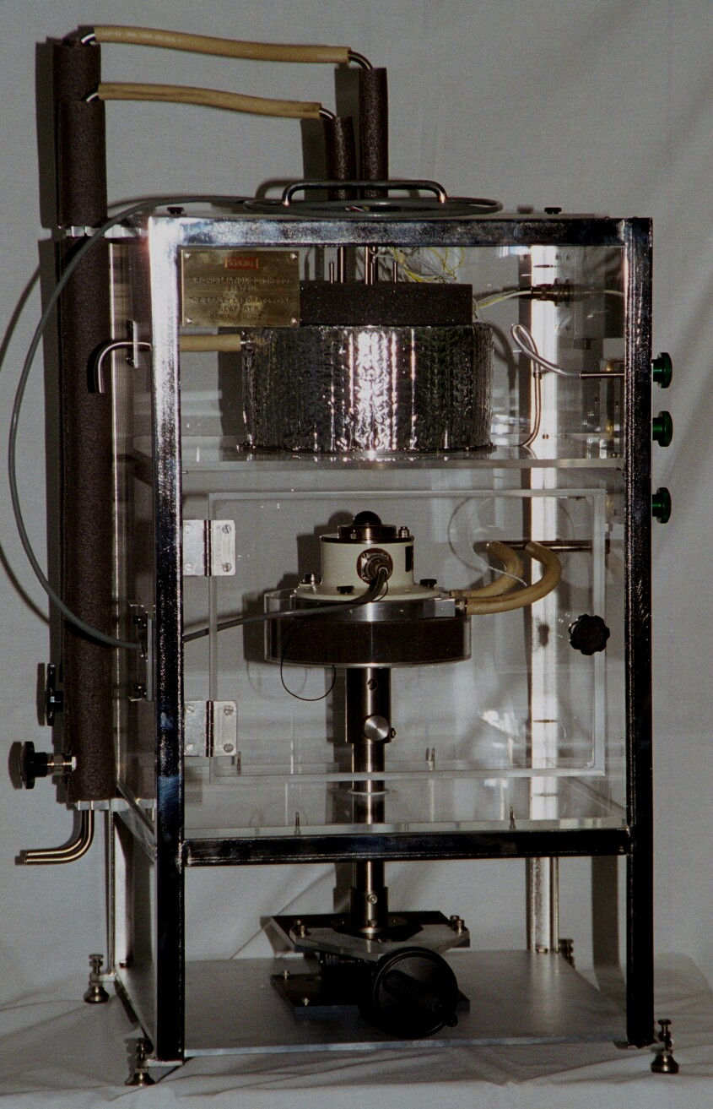-
Figure 8. Photo of PIR BB Production 0809Unit Blackbody Unit in Enclosure front view

Figure 8 shows the PIR BB system enclosure consists of 2 chambers: upper Blackbody chamber and lower PIR chamber which are separately purged with dry gas. Dry air is also directed to the Blackbody hemisphere. The lower section with lab jack for height adjustment is outside the purged volume.

Procedures

This section is not applicable to this instrument.

History

Pyranometers and pyrheliometers are re-calibrated annually at the SGP Radiometer Calibration Facility (RCF). Calibration results and instrument deployment records are available from NREL’s ARM Instrument Management (AIM) System at http://www.nrel.gov/aim/.

Operation and Maintenance

User Manual

This section is not applicable to this instrument.

Routine and Corrective Maintenance Documentation

This section is not applicable to this instrument.

Software Documentation

ARM netCDF file header descriptions may be found at SIRS Data Object Design Changes.

Additional Documentation

In order to provide research-quality irradiance measurements, the SIRS radiometers are re-calibrated annually. The existing radiometer inventory allows for 50% spares, reducing the down time for station operation due to calibration. Maintenance of the SIRS equipment is performed during the biweekly maintenance visits to the SGP facilities. Detailed information is available from the Operations Management Information System (OMIS) at http://ops.sgp.arm.gov.

Glossary

See the ARM Glossary.

Acronyms

See the ARM Acronyms and Abbreviations.

Citable References

Cess, R. D., X. Jing, T. Qian, and M. Sun. 1999. Validation Strategies Applied to the Measurement of Total, Direct and Diffuse Shortwave Radiation at the Surface. J. Geophys. Res.

Coulson, K.L. 1975. Solar and Terrestrial Radiation Methods and Measurements. Academic Press, New York, New York. ISBN 0-12-192950-7, pp. 322.

Dutton, E.G., J.J. Michalsky, T. Stoffel, B.W. Forgan, J. Hickey, D.W. Nelson, T.L. Alberta, and I. Reda. 2001. Measurement of Broadband Diffuse Solar Irradiance Using Current Commercial Instrumentation with a Correction for Thermal Offset Errors. J. Atmospheric & Oceanic Technology, Vol. 18, pp. 297-314. American Meteorological Society, Boston, MA.

Gulbrandsen, A. 1978. On the Use of Pyranometers in the Study of Spectral Solar Radiation and Atmospheric Aerosols. J. Appl. Meteorol., 17, 899-904.

Hickey, J.R., and A.R. Karoli. 1974. Radiometer Calibrations for the Earth Radiation Budget Experiment. Applied Optics, Vol. 13, No. 3, pp. 523-533. ISSN 0003-6935.

Hickey, J.R. 1975. Solar Radiation Measuring Instruments: Terrestrial and Extraterrestrial. Proc. of Soc. of Photo-Optical Instrumentation Engineers, Vol. 68. Optics in Solar Energy Utilization, Y.H. Katz (ed). ISBN 0892520809.

Hill, A.N., J.R. Latimer, A.J. Drummond, and H.W. Greer. 1966. Standardized Procedures in the North American Continent for the Calibration of Solar Radiation Pyranometers. Solar Energy, Vol. 10, No. 4, pp. 1-11.

Hulstrom, R.L. 1989. Solar Resources. The MIT Press, Cambridge, Massachusetts. ISBN 0-262-08184-9, pp. 408.

Iqbal, M. 1983. An Introduction to Solar Radiation. Academic Press, New York, New York. ISBN 0-12-373750-8 (ISBN 0-12-373752-4 for paperback), pp. 390.

Karoli, A.R., J.R. Hickey, and R.G. Frieden. 1983. Self-calibrating Cavity Radiometers at the Epley Laboratory: Capabilities and Applications. Proc. of SPIE-Int. Soc. Opt. Eng., Vol. 416, pp. 43-49. Conference: Arlington, Virginia, April 7-8, 1983. ISSN: 0277-786X.

Latimer, J.R. 1964. An Integrating Sphere for Pyranometer Calibration. J. of Applied Meteorology, Vol. 3, No. 3, pp. 323-326. American Meteorological Society, Boston, Massachusetts.

Maxwell, E.L, and D.R. Myers. 1992. Daily Estimates of Aerosol Optical Depth for Solar Radiation Models. Solar '92, Proceedings of 1992 Annual Conference of the American Solar Energy Society, p. 323. Cocoa Beach, Florida, June 15-18, 1992.

McCluney, W.R. 1994. Introduction to Radiometry and Photometry. Artech House, Inc., 685 Canton Street, Norweed, Massachusetts 02062. ISBN 0-89006-678-7, p. 402.

Reda, I. 1999. Improving the Shade/Unshade Method to Calculate the Responsivities of Solar Pyranometers. NREL/TR-26483 (June 1999).

Thekaekara, M.P., R.H. Collingbourne, and A.J. Drummond. 1972. A Comparison of Working Standard Pyranometers. Bulletin of the American Meteorological Society, Vol. 53, No. 1, pp. 8-15.

World Meteorological Organization. 1971. Guide to Meteorological Instrument and Observing Practices. 4th edition, WMO-No. 8, TP. 3, Geneva, Switzerland. (Note: Most WMO publications are available in the U.S. from the American Meteorological Society, 45 Beacon St., Boston, Massachusetts 02108-3693, Telephone: 617-227-2425.)

