SLOCUM STROKES
As Popularized by a
Master Checker Problem Composer:
George H Slocum, 1855 - 1914

- A nearly complete collection of them
- Multiple biographies of him
- An in-depth commentary on how his problems were composed
_______

Compiled over the Past 50+ Years by a Coterie of
Checker Problemists and Bibliophiles

_______________

Edited by an enthusiastic, latter day, checker problem composer,
Bill Salot, 1929 -

© Copyright 2011, William J. Salot
Feel free to copy any portion provided proper credits are maintained and this source is referenced.

____________
Warning
If you are not an aficionado and devotee of the game of Checkers, this treatise will make no sense to you.
________________________

Updated: January 11, 2012
TABLE OF CONTENTS
Subject | Page
TABLE OF CONTENTS | 1
ACKNOWLEDGEMENTS | 7
INVITATION | 7
PREFACE – Why this book was written | 8
OBJECTIVES – What this book is intended to accomplish | 9
ARRANGEMENT – How the information is presented | 10
LIST OF INDEXES – How to find what you want, as follows:
BY DIAGRAMS – If you have found a Slocum problem, check here to see if it has been included in this book | 11
BY WHERE PUBLISHED – If you have a publication containing a Slocum problem, check here to see it was reviewed for this collection. | 19
BY YEAR PUBLISHED – Check here to see how Slocum’s annual production varied, and when his individual compositions were published. | 24
BY TIMES PREVIOUSLY PUBLISHED – Check here to identify the problems that most contributed to Slocum’s fame. | 25
BY THEME – Check here to see many types of composition, and identify which Slocum settings fit each type. | 26
BY MOTIF – Check here to see many specific ideas that recur, and identify which Slocum settings demonstrate them. | 27
BY EPIPHANY – Check here to see many specific highlights, and identify which Slocum settings demonstrate them. | 28
BY FINALE – Check here to see specific closure mechanics, and identify which Slocum settings demonstrate them. | 29
BY STANDARD POSITIONS – Check here to see specific practical endings, and identify which Slocum settings incorporate them. | 30
BY SIZE – Check here to identify Slocum compositions with a specific number of pieces; from very large to very small. | 31
BY LENGTH OF SOLUTION – Check here to identify Slocum compositions at a specific point on the scale from sight-solver to all-night-study. | 32
BY STAR MOVES AS A PERCENTAGE – Check here to identify Slocum compositions that demonstrate a measurable degree of perfection. | 33
BY FLAWS – Check here to see specific types of flaws, and identify which Slocum settings suffered from them | 34
BY LANDMARKS – Check here to see unusual features, and identify which Slocum settings demonstrated them. | 34
TERMINOLOGY – Definitions of terms used | 35
1ST PRELUDE 1855-1888 – Slocum’s pre-problem composing years | 42
2ND PRELUDE May 1, 1888 – Slocum’s launchpad: | 43
American Checker Review - PART 1 | 43
American Checker Review - PART 2 | 46
SLOCUM’S COMPOSITIONS Slocum’s fans named many of them
#1 “first try” or ”DEBUT” | 50
#2 “ATTACKS I” | 53
#3 “DAINTY TREATMENT” | 55
#4 | 59
#5 | 61
#6 | 63
#7 | 65
#8 | 68
#9 | 71
#10 | 73
#11 “THE ACCOMPANIST” | 75
#12 “THE OPPORTUNIST” | 78
#13 | 80
#14 | 82
#15 | 84
#16 | 87
#17 | 89
#18 “STROKE SYMMETRY” | 91
#19 | 93
#20 “ATTACKS II” | 95
#21 | 97
#22 | 99
#23 “MIRRORED SLIP SQUEEZES” | 101
#24 | 103
#25 “BILLIARD BALL STROKE” or “SNAKE SHOT FINISH” | 108
#26 “TOURNAMENT COVER PROBLEM” | 113
1ST INTERLUDE April 1891 – Slocum’s editor J. P. Reed | 117
#27 | 119
#28 “EXTREME CREDIT CONFUSION I” | 121
#29 “CALL’S FAVORITE” | 125
#30 | 128
#31 | 131
#32 “THE MERRY-GO-ROUND” | 133
#33 “JUNE PUZZLER” | 135
#34 “THE SEED” | 141
#35 | 143
#36 | 146
#37 “THE JUMP TWICE REFUSED” | 148
#38 | 150
#39 | 152
2ND INTERLUDE 1892 – Reed leaves; Head enters | 155
#40 “THE DEFENSE I” | 156
#41 “THE 6-PIECE SMOTHER” | 159
#41A | 161
#42 “LONG PRELUDE I” | 163
#43 | 168
#44 “THE ORIGINAL CROCODILE” | 170
#45 | 174
BE AWARE – June 1892 Slocum’s Chicago Inter-Ocean probs. | 176
#46 “THE LOST BROOKLYN” | 178
#47 “THE CYCLE” or “CROCODILE II” or “ATTACKS III” | 182
#48 EARLY published game - October 15, 1892, A stroke | 184
3RD INTERLUDE 1892-1893 Slocum recognized worldwide | 186
#49 “THE GARBLE” | 188
#50 “PSYCHO I” | 191
#51 “PSYCHO II” | 193
#52 “AVOIDING PAYNE” | 196
PUBLISHED GAME – before Oct 28, 1893, collaborated stroke | 199
#53a “THE JOINT EFFORT” by Slocum and L. S. Head | 200
#53b | 205
#54 | 209
#55 “CROCODILE III” | 212
#56a“EXTREME CREDIT CONFUSION II” | 214
#56b | 219
#57 | 224
#58 “PREMATURELY INVITING” | 226
#59 “SIMPLY DIVERSE I” | 228
#60 “FIRST PRIZE I” | 230
#61 “FIRST PRIZE II”or “biding the time” | 235
4TH INTERLUDE 1894 Slocum’s 1st biography & portrait | 241
PUBLISHED GAME – April 1 & 2, 1894, vs. L. S. Head | 243
#62 | 244
PUBLISHED GAMES – July & August 1894,  1 game joint analysis; 3 games versus L. S. Head | 246
#63 “LONG PRELUDE II” | 248
#64 “LONG PRELUDE III” | 252
#65 “MESMERIZED” | 254
#66 “SIMPLY DIVERSE II” | 257
#67 “THE 3-WAY SLIP PITCH” | 260
#67a “MOST EXQUISITE” | 263
#68 | 265
#69 “THE SEARCHLIGHT” | 267
#70 | 270
#71 “AVOIDING 1ST POSITION I” | 274
5TH INTERLUDE May 1895, Slocum’s 2nd biography, portrait | 277
#72 “KNOX’S FOLLY” | 280
#72a | 283
PUBLISHED GAME – May 1896, vs. Minnesota Champ | 285
#73 “A DELIGHT” | 286
6TH INTERLUDE Nov. 1896 –Jan. 15, 1897, Slocum news | 288
#74 “SHORTY” | 289
#75 “THE WAITER” | 291
#76 “SELDOM SHUNNED” | 293
#77 “ATTACKS IV” | 295
7TH INTERLUDE March 20, 1897, Slocum corrects Richmond | 298
#78 | 300
#79 “OFTEN BOTCHED” | 303
#80 “A BOOK UNTO ITSELF” | 307
#81 “DOES NOT COME EASY” | 322
#82 “THE BURIED PITCH” | 325
#83 | 327
#84 “THE LINKAGE” or “AVOIDING 1ST POSITION II” | 329
#85 “ON THE SPOT I” | 332
#86 | 334
#87 “12 ALL-STARS” or “EARLY AMERICAN POSITION” | 336
#87A “AVOIDING AMERICAN POSITION” | 339
#88 “PETTY THEFTS” | 341
PUBLISHED GAME – before October 13, 1898, a stroke;  plus a Slocum correction of a game played by “Mr. Lees” | 343
#89 “MIRROR I” | 344
#90 “THE PITCH/SQUEEZE/STEAL” or “MIRROR II” | 346
8TH INTERLUDE 1899, J. P. Reed’s obituary | 351
PUBLISHED GAME BETWEEN SLOCUM & J.P.REED, 1900, but published earlier; played before 1892 when Reed left Chicago | 353
#91 “POINTLESS POWER” | 354
#92 “TRANSPO” | 356
#93 “ON THE SPOT II” | 360
#94 “PAR EXCELLENCE” | 364
#95 “THE 2 FOR 1 FAMILY” | 367
#96 “NICE POINTS” | 369
#97 “SLOCUM VERSUS AMATEUR” | 372
#98 | 375
9TH INTERLUDE 1901-1903, Slocum news & cover portrait | 377
#99 “SLOCUM’S DOUBLE CORNER DRAW” | 379
#100 “TWISTER I” | 383
#101 | 387
10TH INTERLUDE – 1904, Slocum news (playing strong players) | 388
PUBLISHED GAMES Apr 17, 1904 vs Denvir 2 strokes | 390
#102 “THE EXHIBITION PROBLEM” or “TWISTER II” | 391
11TH INTERLUDE 1905, 1st Int’l Match - America vs Great Britain | 404
#103a “FAT AND HAPPY I” | 405
#103b “FAT AND HAPPY II” | 407
#104 | 409
12TH INTERLUDE 1908-1909, Slocum exhibition | 411
#105 “THE DEFENSE II” | 412
#106a | 418
#106b | 421
#107 “THE 2-PIECE SLIP PITCH” | 423
#108 “THE COLLAGE” | 426
#109 “A RARE CONCEPT” | 428
#110 “THE LAST HURRAH” | 431
13TH INTERLUDE 1911-1912, Slocum active, but not composing | 434
SLOCUM’S LAST PUBLISHED GAME (versus John Howe, Sr.) | 436
POSTLUDE, Slocum’s obituaries (died March 8, 1914) | 437
1821–1990 COMMENTS BY OTHERS ON COMPOSING | 441
Zach Brogan, 1892; Peter Bennett, 1892 | 441
J.S, 1894; Lyman M. Stearns, 1900; T. J. Riley, 1901 | 442
W. G. Leggett, 1901; Zach Brogan, 1901 | 443
J Wallis, 1901 | 444
Richard Atwell (“N. Alist”), 1905 | 447
Walton, 1910 | 451
W. T. Call, 1913 | 452
A. C. Hews, 1917 | 453
N. W. Banks, 1926 | 458
T. W. Wiswell, 1946 | 461
Saul Cass, 1969; Bill Salot/J. A. Martin, 1970 | 463
J. Charles, 1971 | 464
D. E. Oldbury, 1979-1980 | 465
T. W. Wiswell and Jules Leopold, 1980 | 466
W. V. Scott, 1988-1990 | 467
WHAT I LEARNED FROM SLOCUM ABOUT COMPOSING | 468
ADVICE | 468
APPEAL | 469
APPEARANCE | 470
DECEPTION – UNEXPECTED IDEAS | 471
DECEPTION – UNEXPECTED MOVES | 472
AUDIENCE | 473
CRITIQUES | 473
FLAWS – DUAL SOLUTIONS | 474
FLAWS – OTHER TYPES | 475
IMPROVEMENT | 476
RESTRAINTS | 477
THEMES | 478
TECHNIQUES - FORCING | 479
OTHER TECHNIQUES | 480
269 OTHER PERSONS MENTIONED IN THIS BOOK | 481
LOG OF REVISIONS SINCE INITIAL POSTING | 489

ACKNOWLEDGEMENTS

What follows would have been impossible without huge, early, technical and historical contributions from:

The Late Floyd D. “Brownie” Brown

The Late Milton “Milt” Johnson

The Late Irving V. Windt

The late Ben Boland

The late Tom Wiswell

The late Joe Charles

The late Bob Crue
______________________________________________

Much appreciated information was more recently contributed by:

Al Darrow Jay Hinnershitz Liam Stephens

Lissa Waite Amy Dawson Kelly Brown

Al Lyman Bob Newell

Richard Pask George Hay
_______________________________________________

INVITATION

To keep this project evergreen, please send comments, corrections, and additions to the editor at wjsalot@comcast.net for which your contributions will be gladly acknowledged on this page.

The intent is to keep this collection almost “instantly updated”.
PREFACE

Many checker problem books have been written for the entertainment and edification of rising checker “players”.

In contrast, these pages may be the first to seek the audience of potential checker problem “composers”.

The objective here is to captivate, elevate, inspire and perhaps addict rare individuals who may be susceptible to making problem composing the avocation of their lifetimes.

Believe it or not, checker problem composing is a step up from playing the game of checkers. At least that is what we composers think.

You cannot start checker problem composing until you understand how the game is played. You must learn the objectives and rules of the game itself before you can approach the higher objectives of problem composing.

What follows assumes you are already familiar with the game and its lexicon.

A Different Facet of Checkers

Stop fraying nerves; start sewing beauty;

Stop acclaiming wins; start creating art;

Stop battling foes; start baffling friends;

Stop critiquing games; start composing problems.

OBJECTIVES

Some essays on checker problem composing have been published by individual composers over the years. A few are repeated at the end of this document. Their authors did not delve much beyond their own experiences. They did not “detail” the principles and processes of problem composers. They did not “demonstrate” the concepts, objectives and mechanics of problem composing. They did not “categorize” the attributes, nor “measure” the success, nor “examine” the inspiration, evolution, or evaluation of problem compositions. They did not “provide” examples to support every conclusion, and lessons to be “learned” from every example.

It is a tall order, but this presentation “will try” to fill those gaps by simultaneously addressing 1) the “Composer”, 2) the “Composition”, and 3) “Lessons for Composers”, as follows:

- The “Composer” Objective: Bring together, for the first time, the complete works of a past master composer, plus various biographies and commentaries written about him. George H. Slocum (1855 – 1914) was chosen for this study because of his ongoing reputation, in some quarters, as perhaps the best ever at checker problem composing.

- The “Composition” Objective: Utilize input from many experts, past and present, to dissect Mr. Slocum’s entire output, good and bad, thereby deducing his strengths, weaknesses, and thought processes in some detail.

- The “Lessons for Composers” Objective: Get in Mr. Slocum’s mind and extract and evaluate, from a composer’s perspective, what went into each Slocum composition and what determined its success or failure.

This presentation is not complete. Completeness is an elusive goal. The intent here is to maintain a continuing effort, with the help of others, until that goal is achieved.

ARRANGEMENT

This information is presented primarily in chronological order so as to better track the evolution of Mr. Slocum’s life, compositions, and the responses they evoked from the checker public.

Separate indexes are provided to facilitate studying Slocum’s compositions in different sequences according to their popularity, where they were published, type, theme, finish, size, number of moves, etc.

For consistency, each problem is preceded by historical and introductory commentary by the editor, unless otherwise credited.

For uniformity, each problem is diagrammed so that it is White’s turn to play, with White moving up the board, even if the problem was not originally published that way.

For easier reading, the solutions immediately follow the diagrams, except, for the benefit of solvers, they are not on the same page.

The solutions presume the reader understands the conventional numbering for each move. The playing squares on the diagrams are correspondingly numbered.
- Red moves are hyphenated. White moves are not.
- A move preceded by an asterisk is a “star move”, meaning it is the only move that will achieve the specified result. A non-optional jump is never starred.

Solutions are annotated by the editor, unless otherwise credited.
- Likely steps in the composition process are identified.
- A composer’s perspective is emphasized.

Solutions are followed by a bibliography of all known, pertinent references. Comments published in those references are also included insofar as they are known.

INDEX BY “DIAGRAMS”
A Measure of Slocum’s Legacy

As Slocum compositions became recognized, collections of them appeared:
- In 1909, W. W. Horsfall published a collection of 22 of them.
- In 1923, F. R. Wendemuth published a collection of 20 of them
- In 1970, Floyd D. Brown contributed his collection of 42 of them.
- In 1992-1993, Bob Crue published his collection of 54 of them (pointed out by Jay Hinnershitz), but 3 were duplicates (#67, #77, #79) and one was not by Slocum.

They are at the core of this expanded collection of 114 Slocum problems.
#1 #2 #3 #4
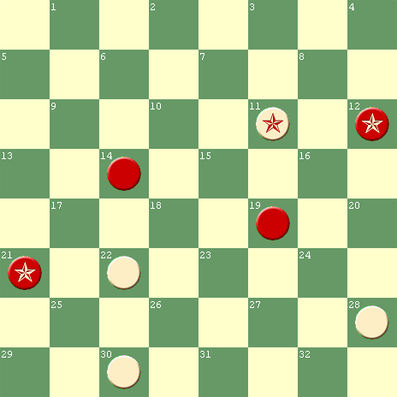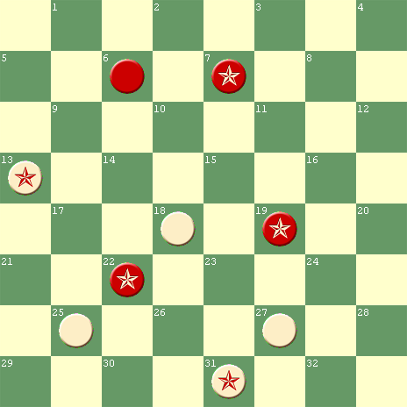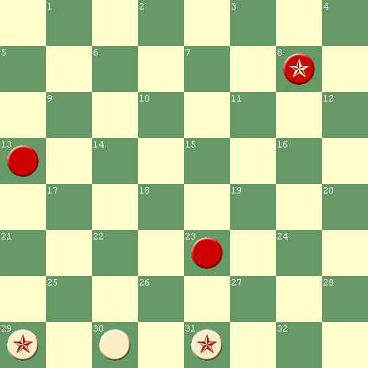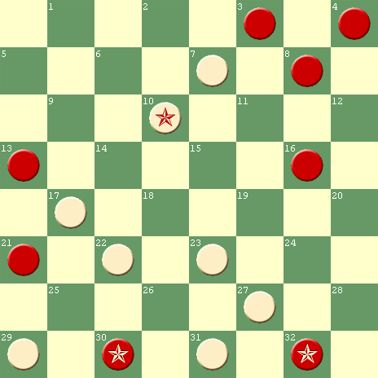
W to Play & W W to Play & W W to Play & W W to Play & W

#5 #6 #7 Dual #8
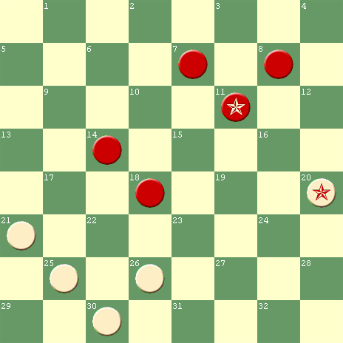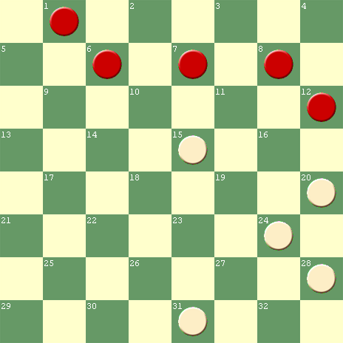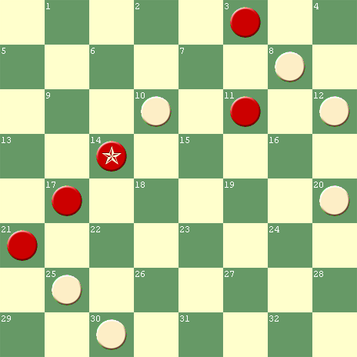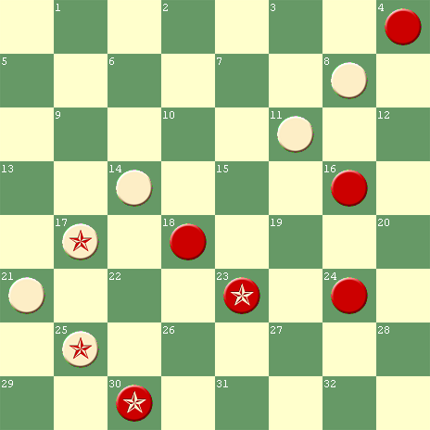
W to Play & W W to Play & D W to Play & W W to Play & W

#9 #10 #11 #12
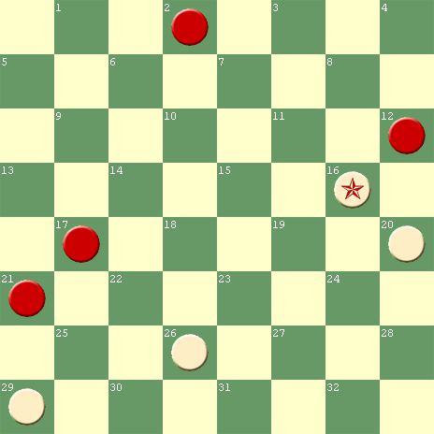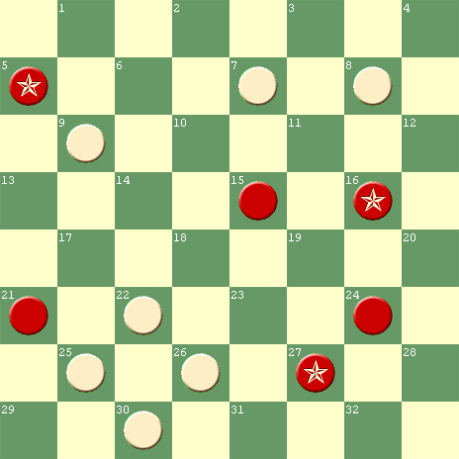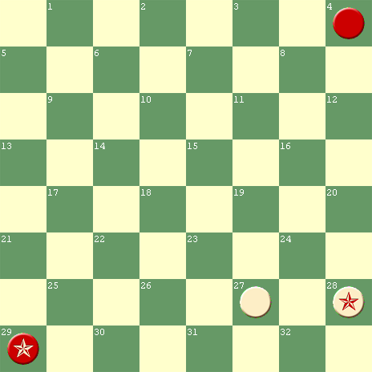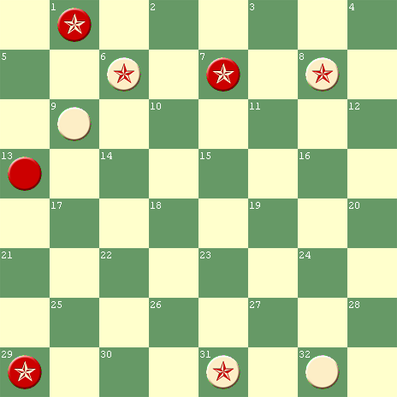
W to Play & W W to Play & W W to Play & W W to Play & W
#13 #14 #15 Duals #16
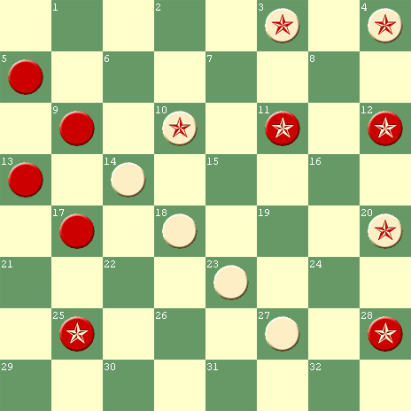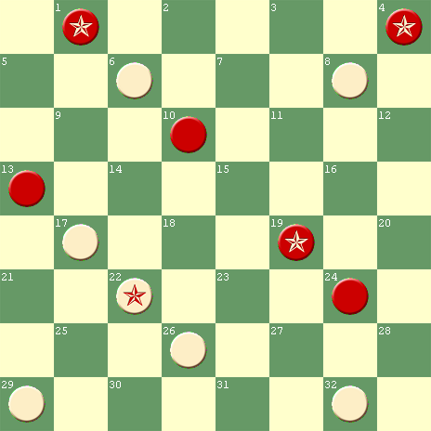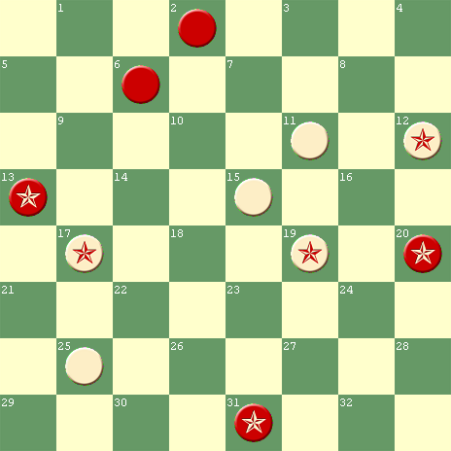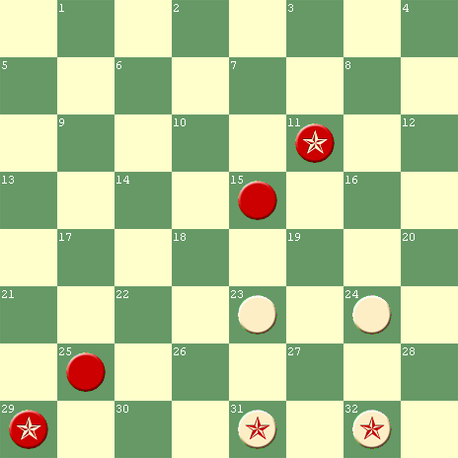
W to Play & W W to Play & W W to Play & W W to Play & W

#17 Unsound #18 #19 #20
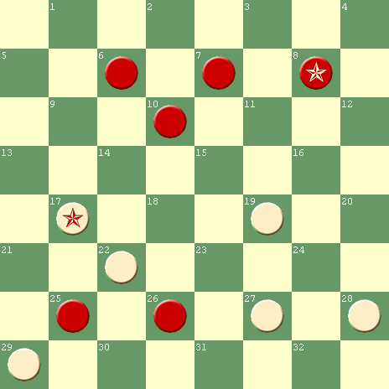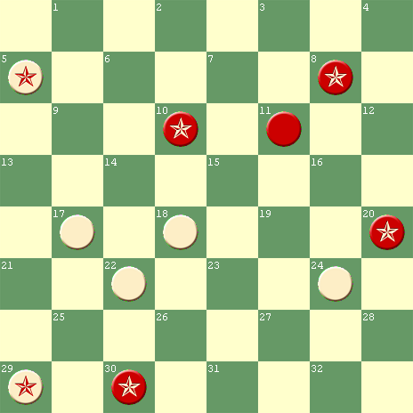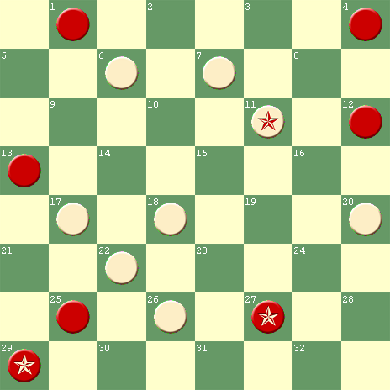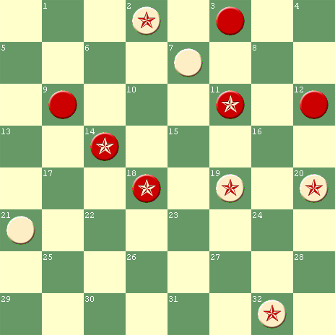
W to Play & W W to Play & W W to Play & W W to Play & W

#21 #22 #23 Dual #24 Dual
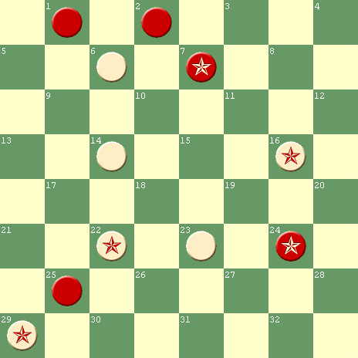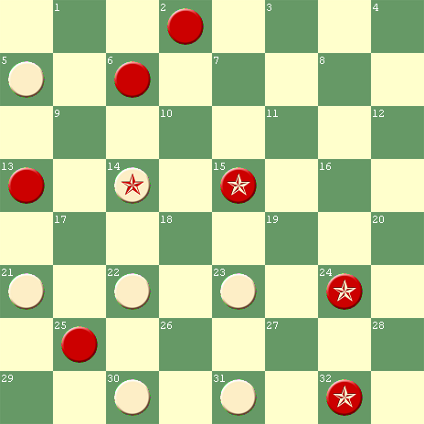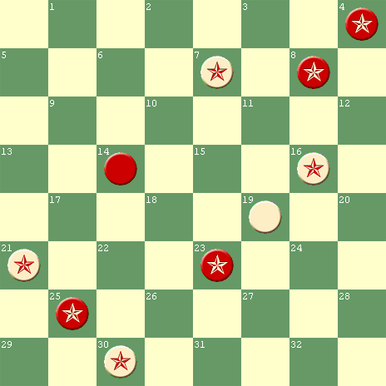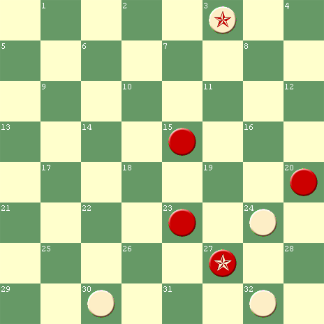
W to Play & W W to Play & W W to Play & W W to Play & W

#25 #26 #27 #28
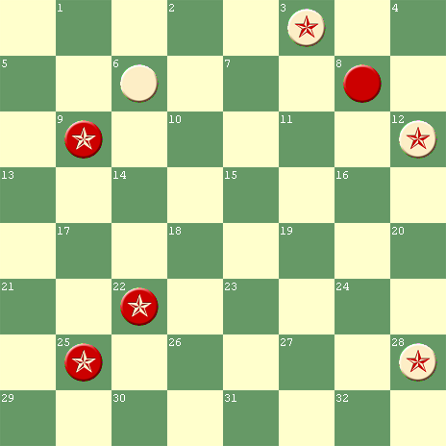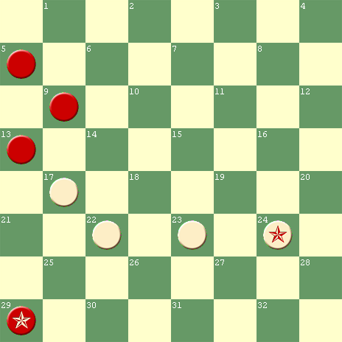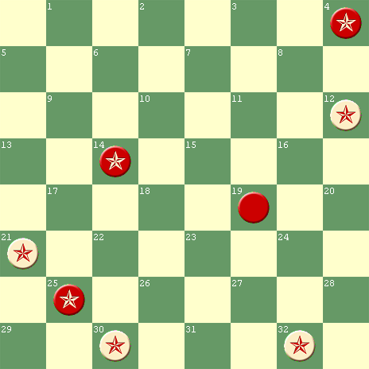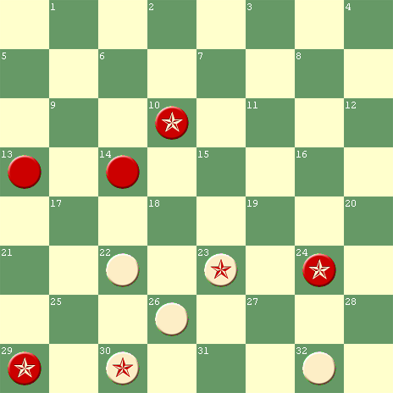
W to Play & W W to Play & W W to Play & W W to Play & W

#29 #30 Dual #31 Dual #32
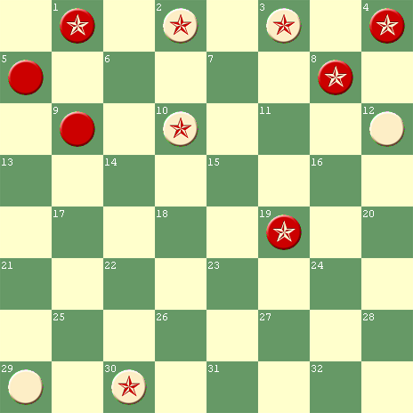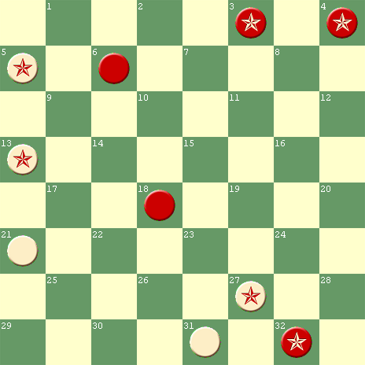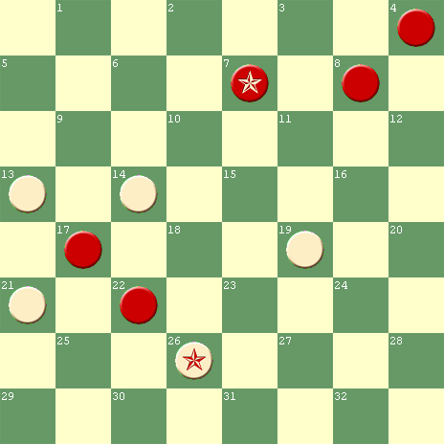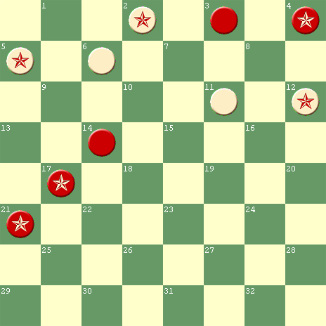
W to Play & W W to Play & W W to Play & W W to Play & W

#33 Corrected #34 Dual #35 #36
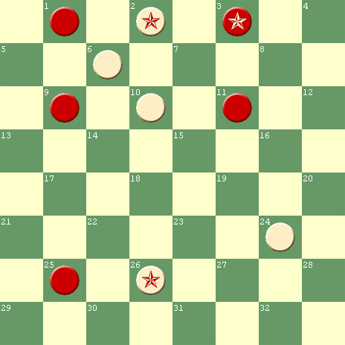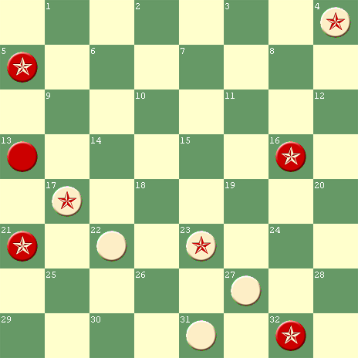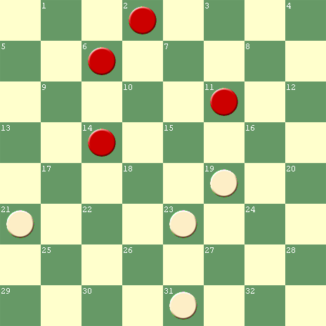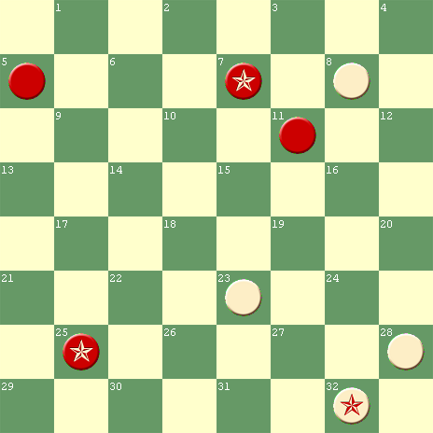
W to Play & W W to Play & W W to Play & D W to Play & W

#37 #38 Unsound #39 Dual #40 Dual
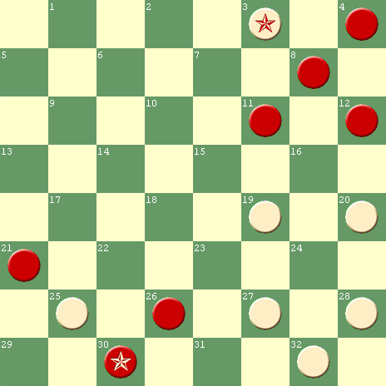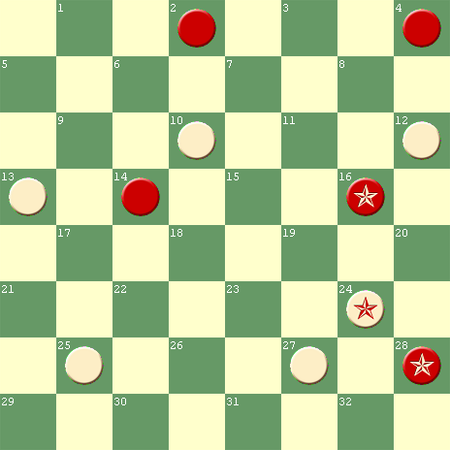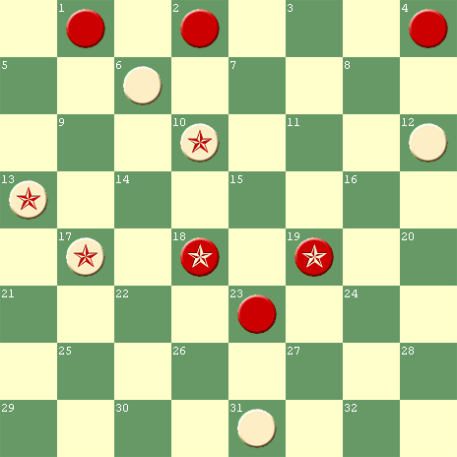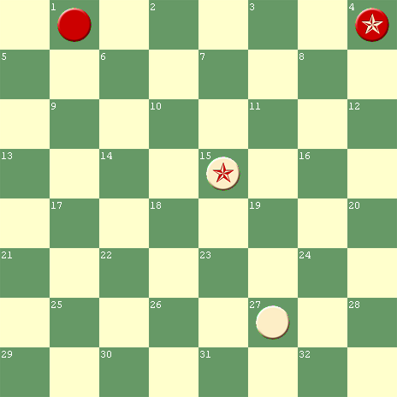
W to Play & W W to Play & W W to Play & W W to Play & W

#41 #41A #42 #43
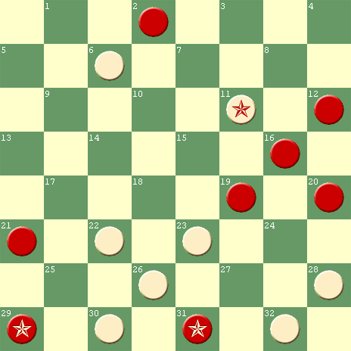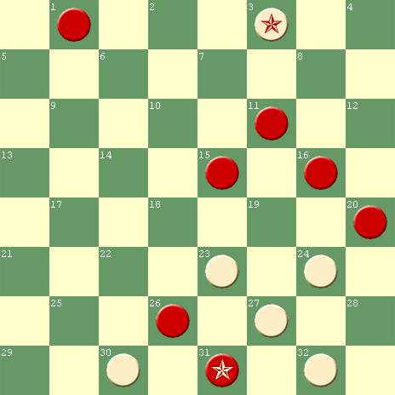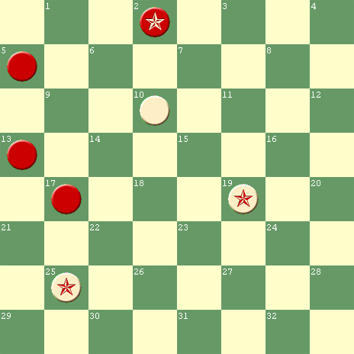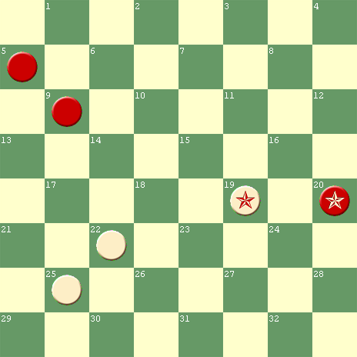
W to Play & W W to Play & W W to Play & W W to Play & W

#44 #45 Unsound #46 #47
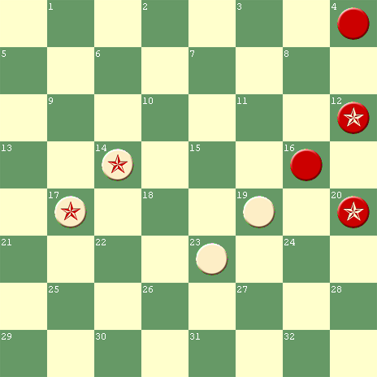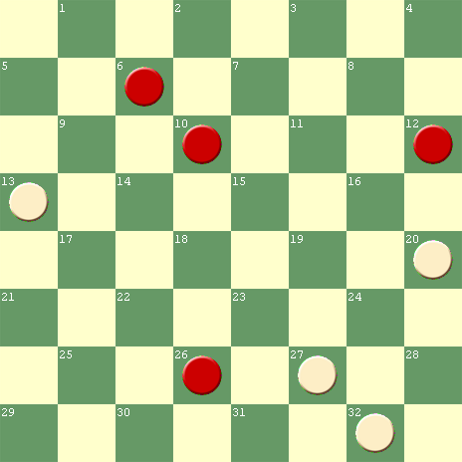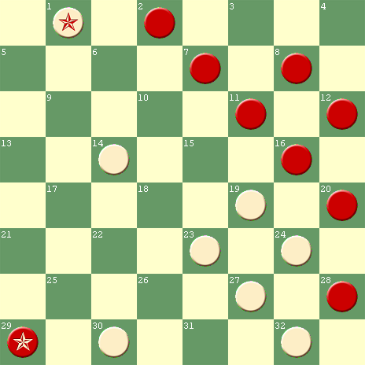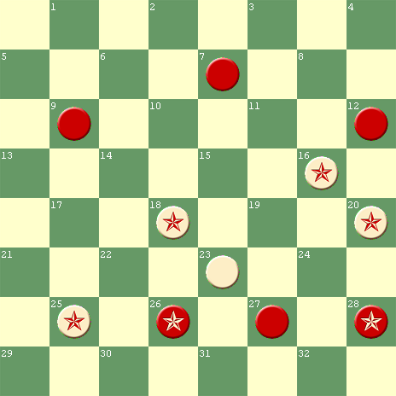
W to Play & W W to Play & W W to Play & W W to Play & W

#48 #49 #50 #51
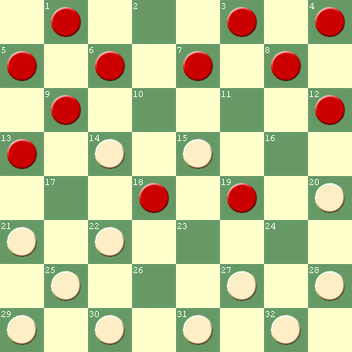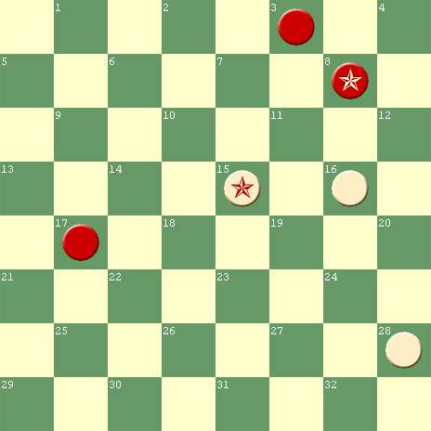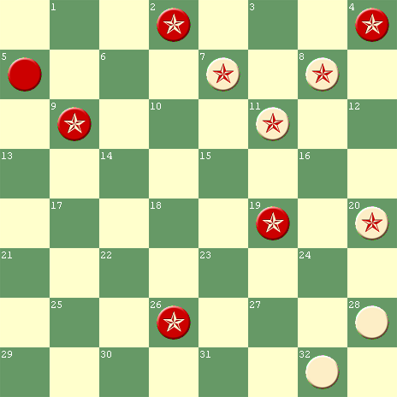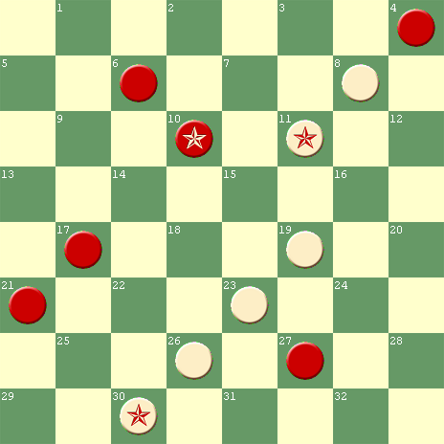
W to Play & W W to Play & W W to Play & W W to Play & W

#52 #53a #53b #54
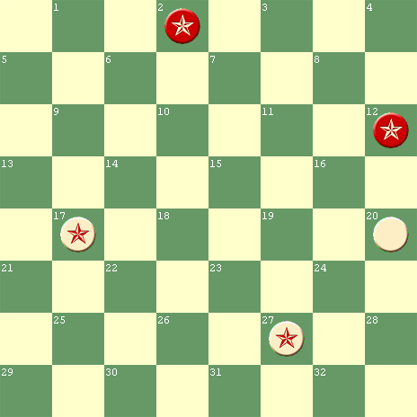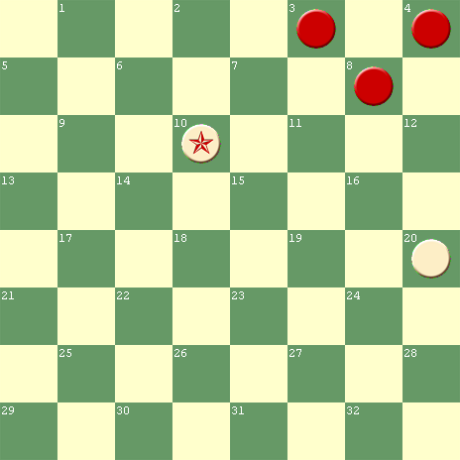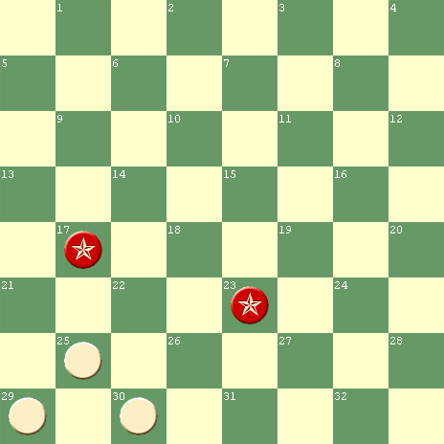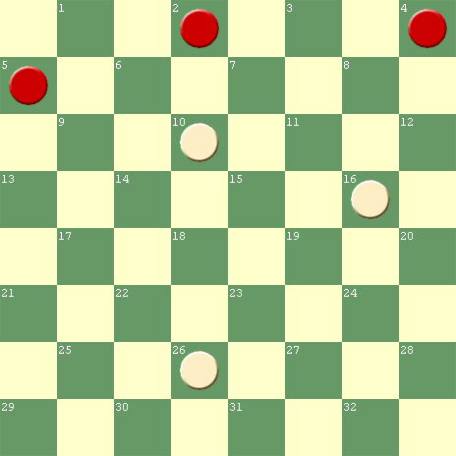
W to Play & W W to Play & W W to Play & D W to Play & W

#55 #56a #56b #57
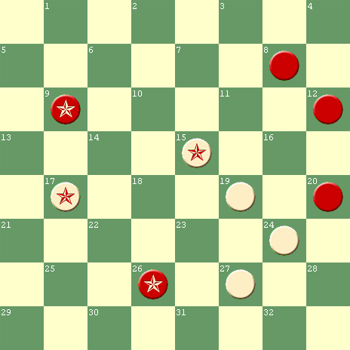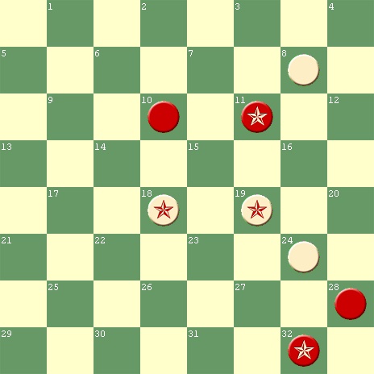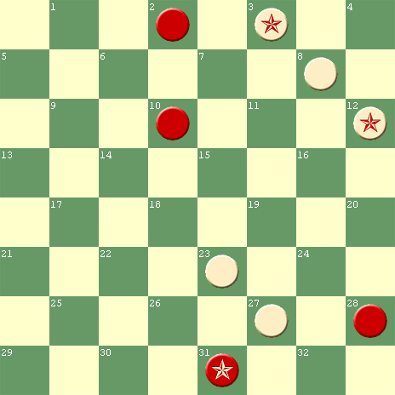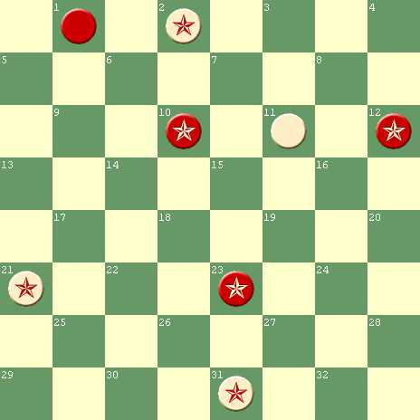
W to Play & W W to Play & W W to Play & W W to Play & W

#58 #59 #60 #61 Dual
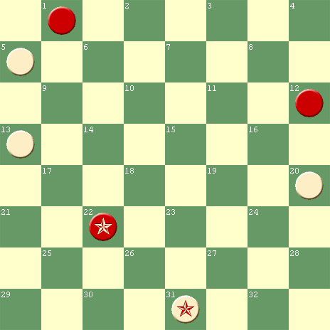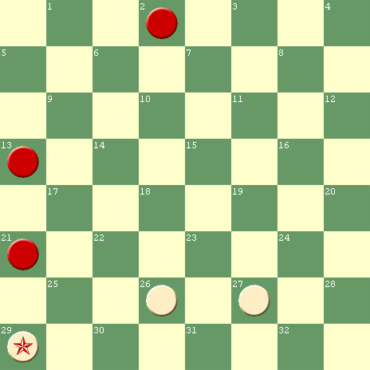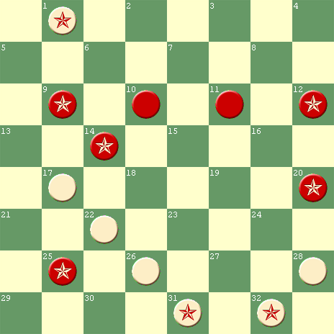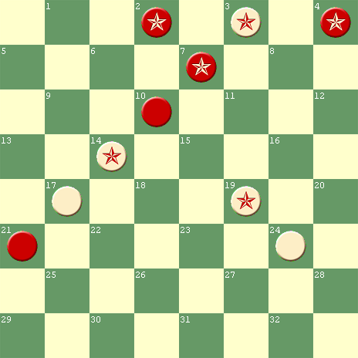
W to Play & W W to Play & W W to Play & W W to Play & W

#62 #63 #64 #65
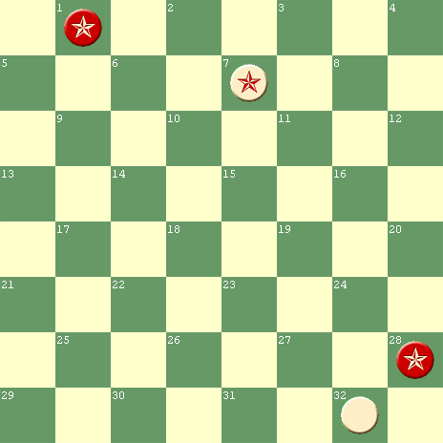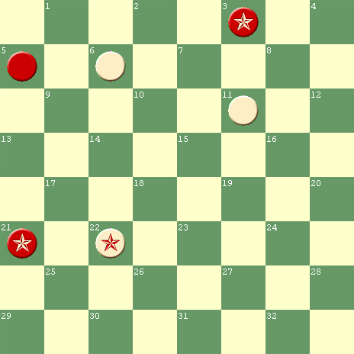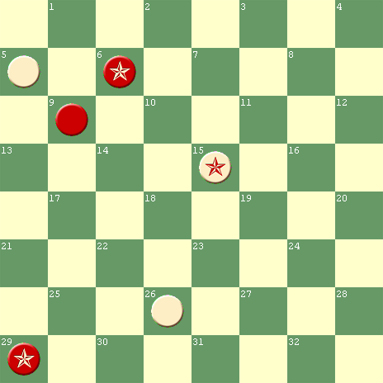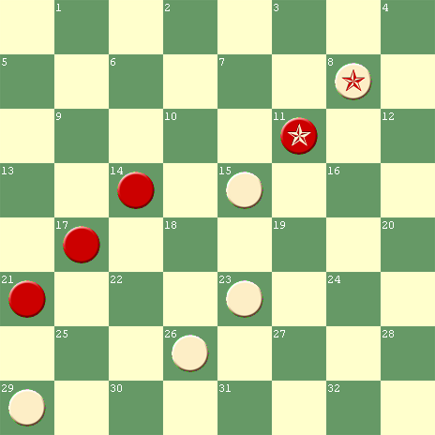
W to Play & D W to Play & W W to Play & W W to Play & W

#66 #67 #67a #68
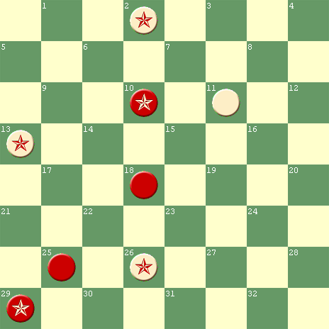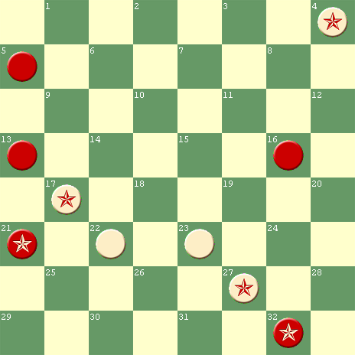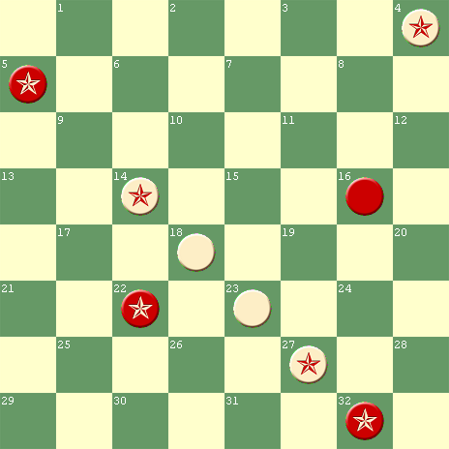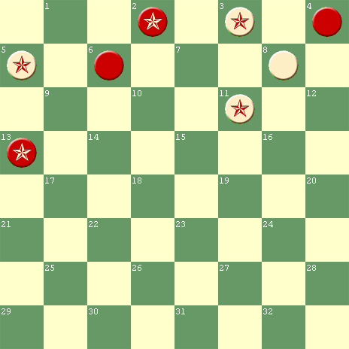
W to Play & W W to Play & D W to Play & W W to Play & W

#69 #70 Dual #71 #72
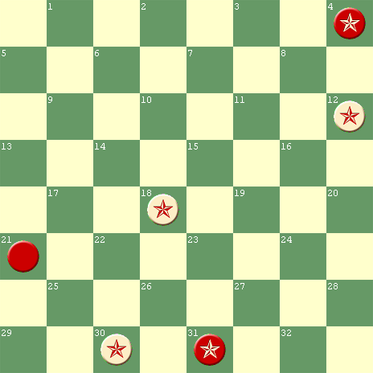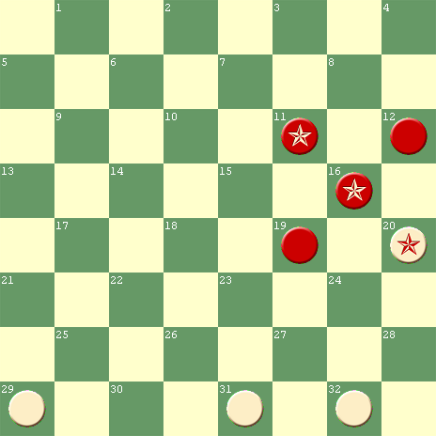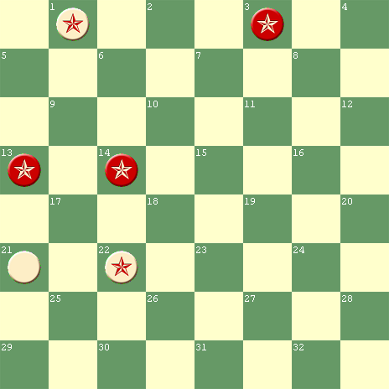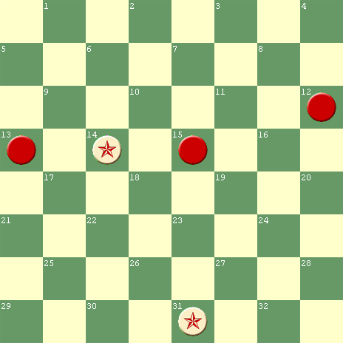
W to Play & W W to Play & W W to Play & D W to Play & W
#72a #73 #74 #75
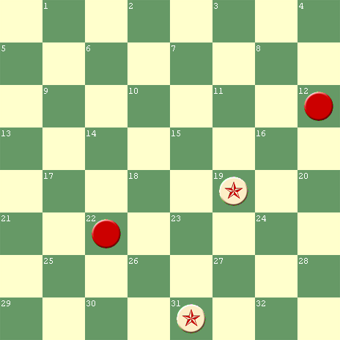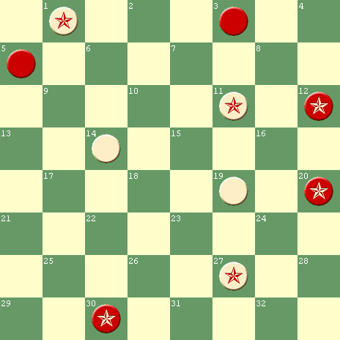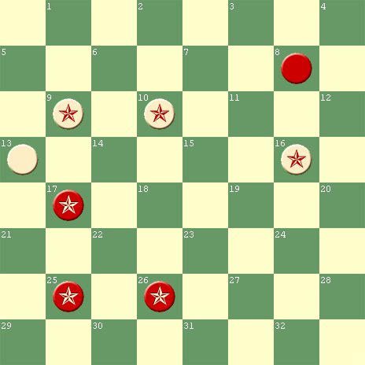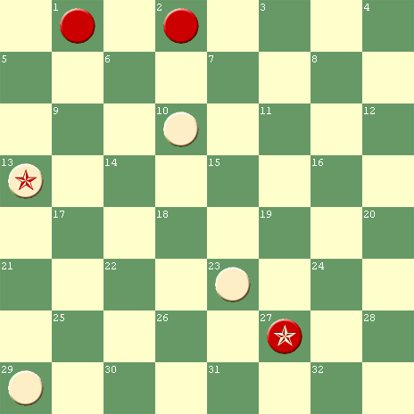
W to Play & W W to Play & W W to Play & W W to Play & W

#76 #77 #78 Unsound #79
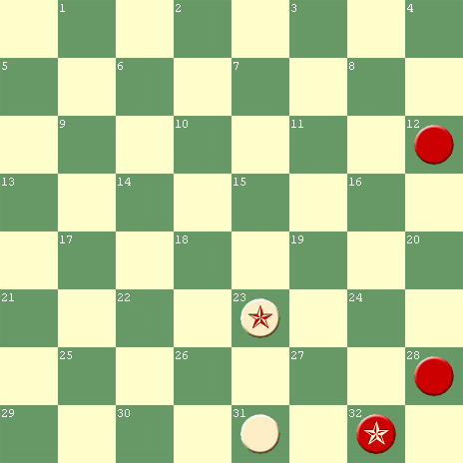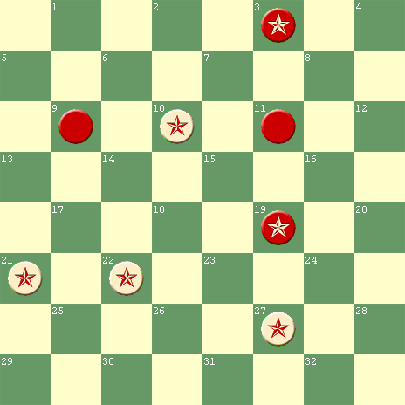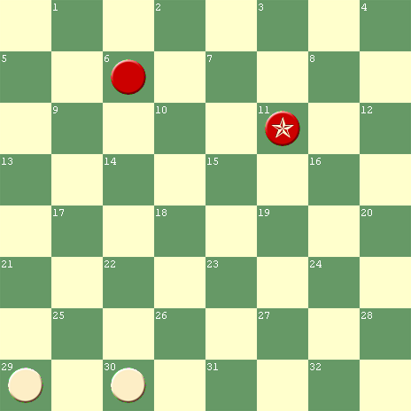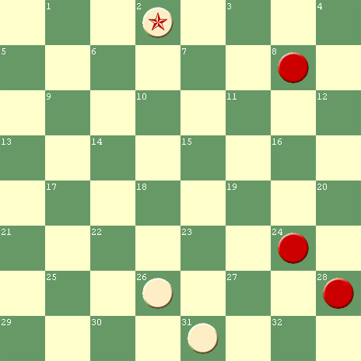
W to Play & W W to Play & W W to Play & D W to Play & W

#80 #81 #82 #83
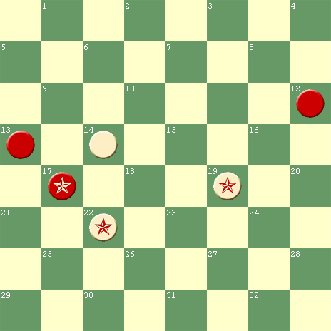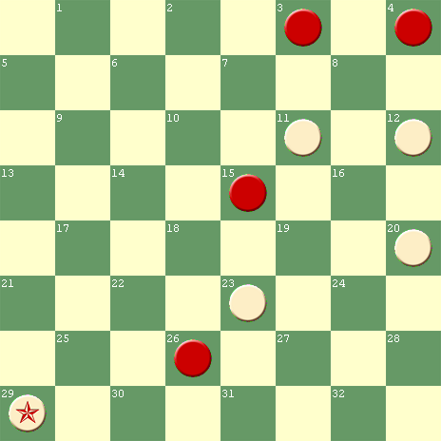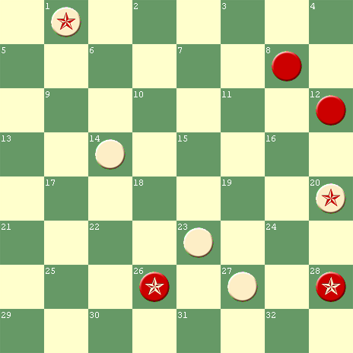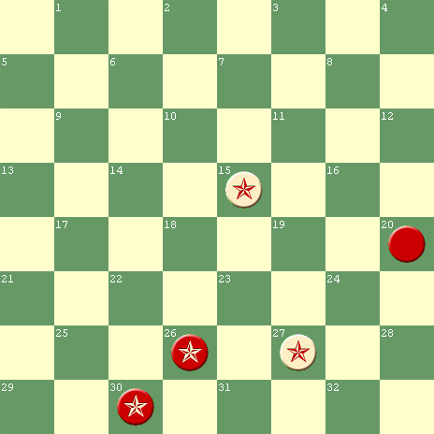
W to Play & D W to Play & W W to Play & W R to Play; W D

#84 #85 #86 #87
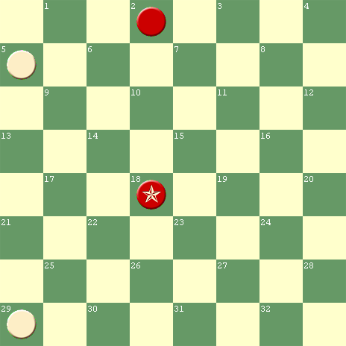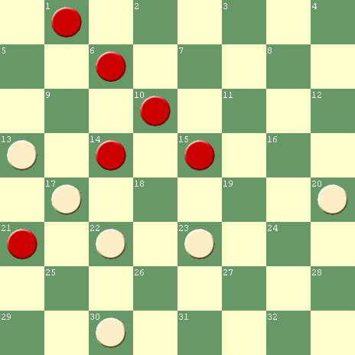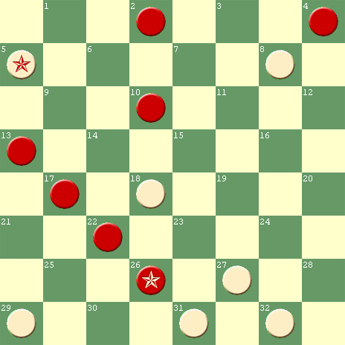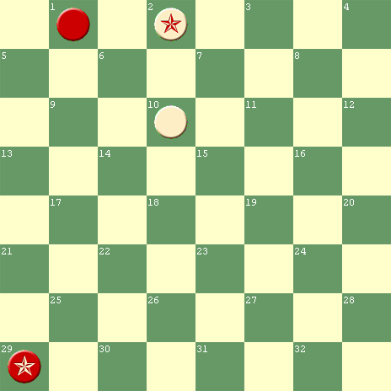
W to Play & D W to Play & D W to Play & W W to Play & W
#87A #88 #89 #90
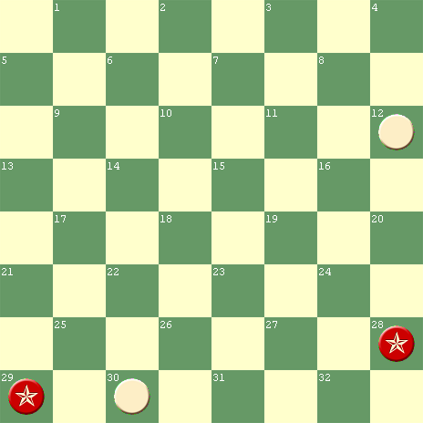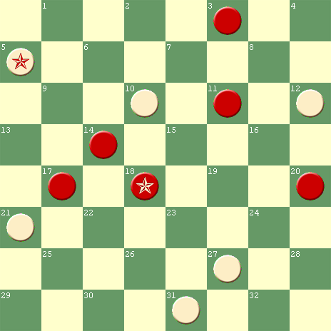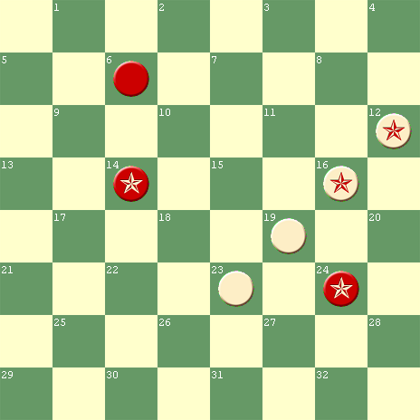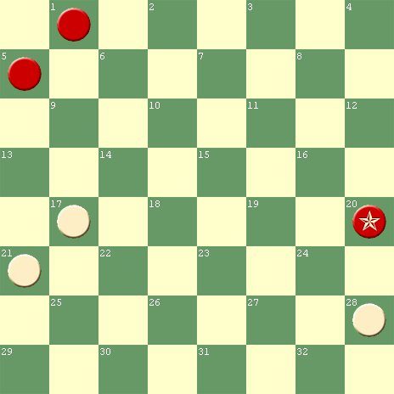
W to Play & D W to Play & W W to Play & W W to Play & D

#91 #92 #93 #94
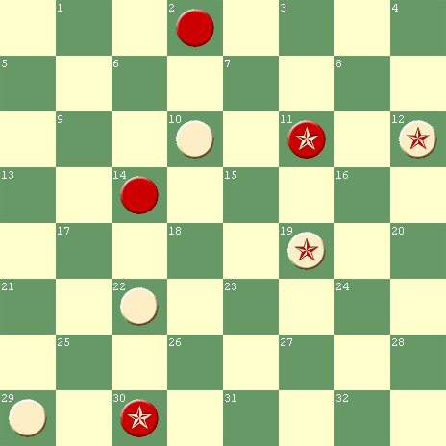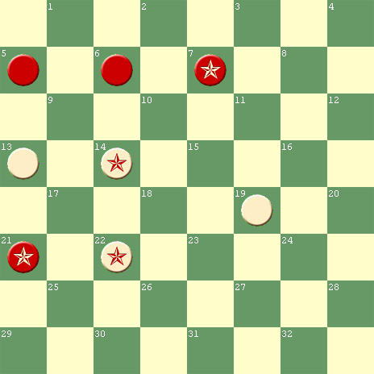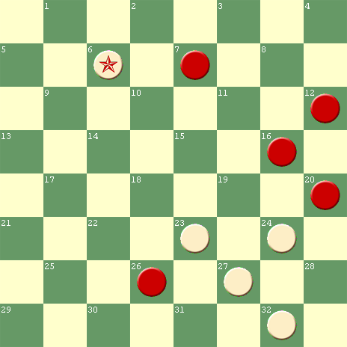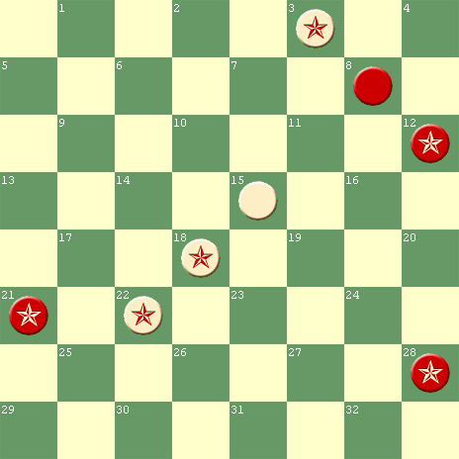
W to Play & W W to Play & W W to Play & W W to Play & W

#95 #96 #97 #98
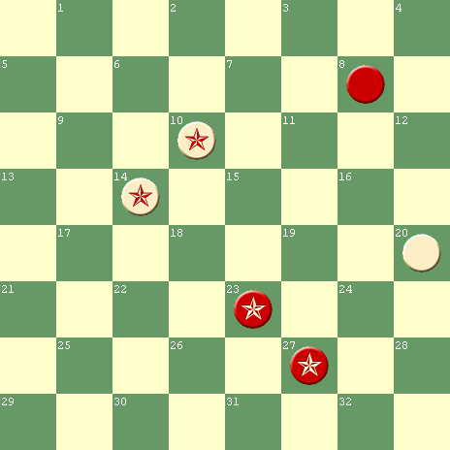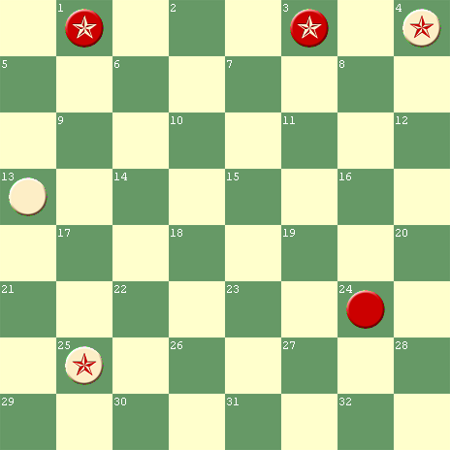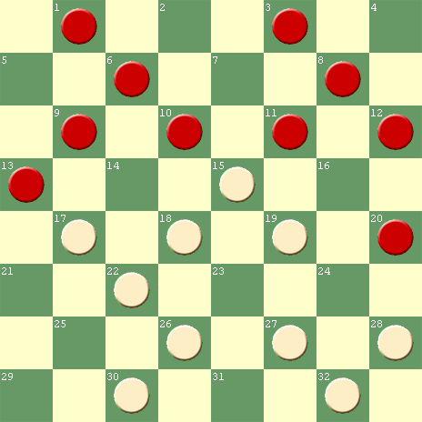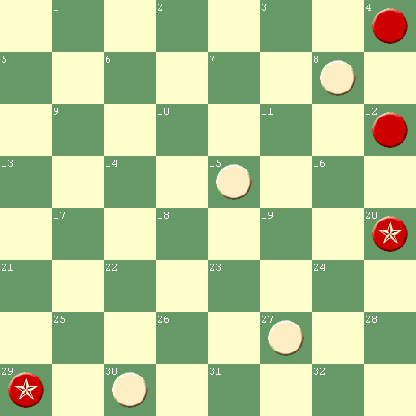
W to Play & W W to Play & D W to Play & W W to Play & W

#99 #100 #101 #102
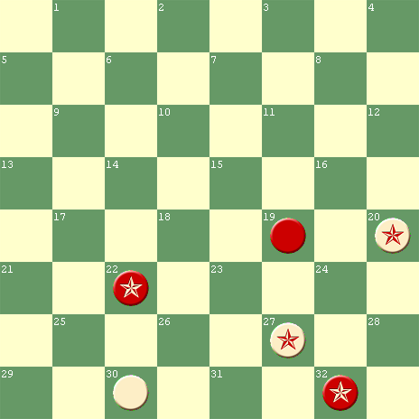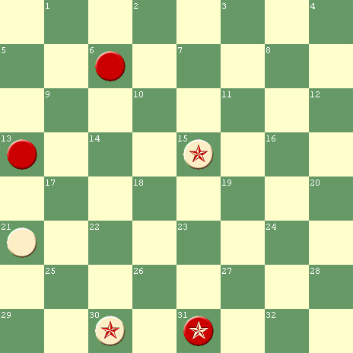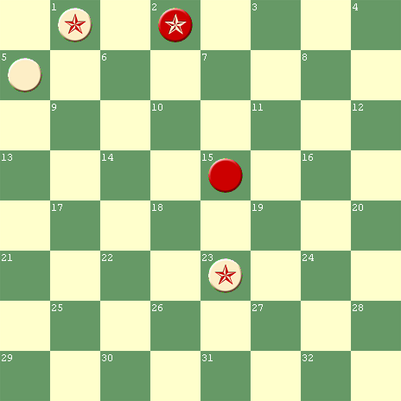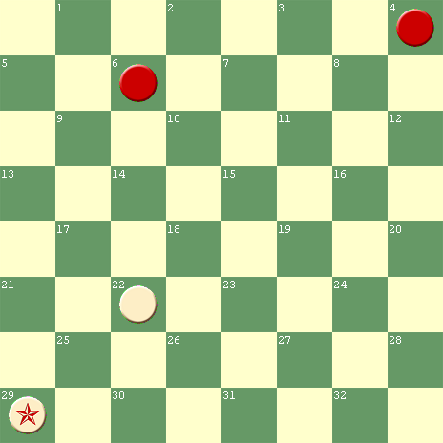
W to Play & D W to Play & W W to Play & W W to Play & W
#103a #103b #104 Dual #105
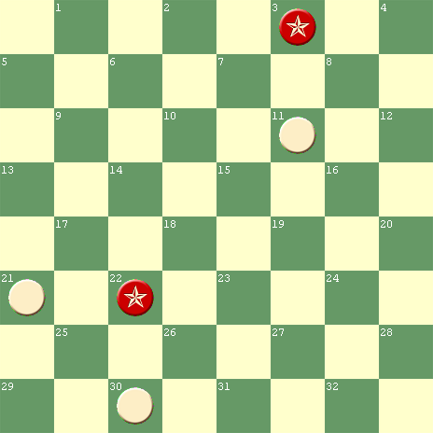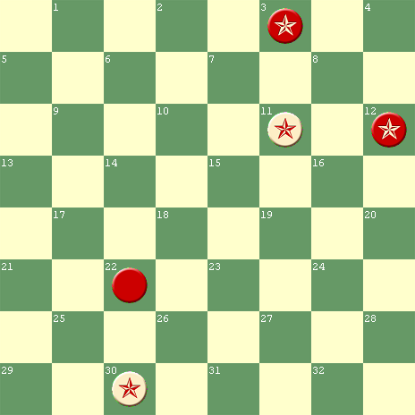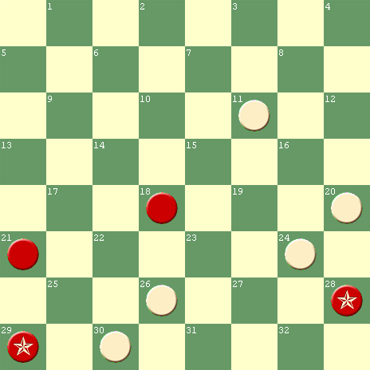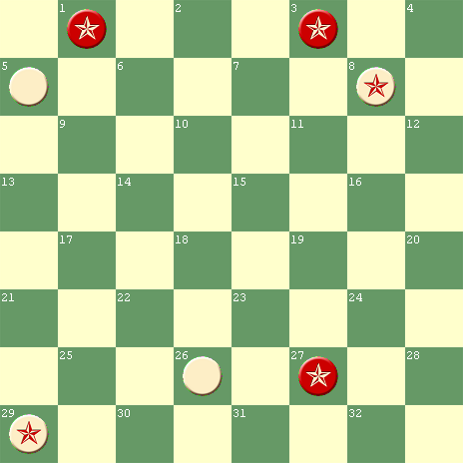
W to Play & D R to Play, W W W to Play & W W to Play & W

#106a #106b #107 #108
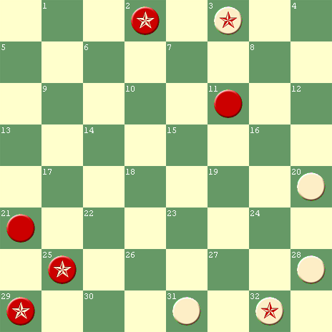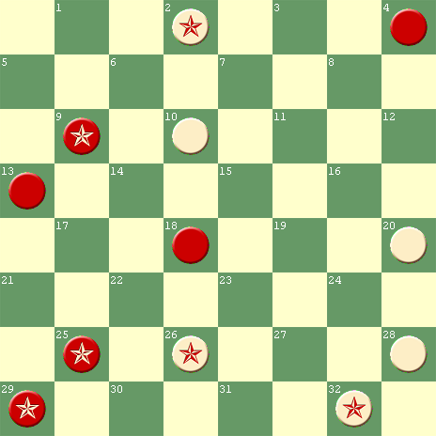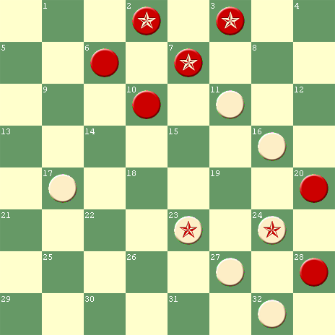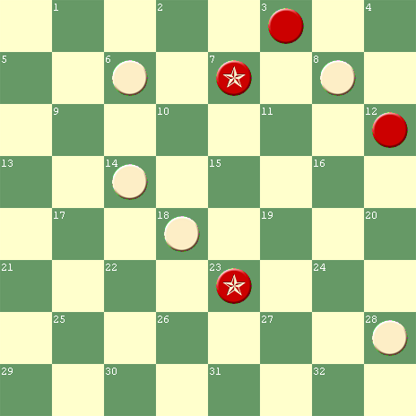
W to Play & W W to Play & W W to Play & W W to Play & W

#109 #110 Duals
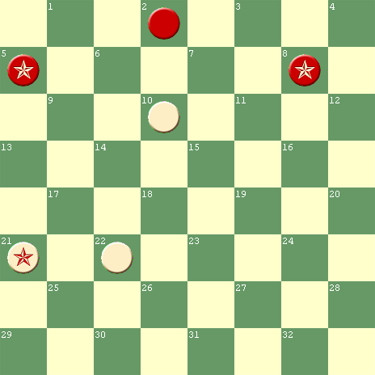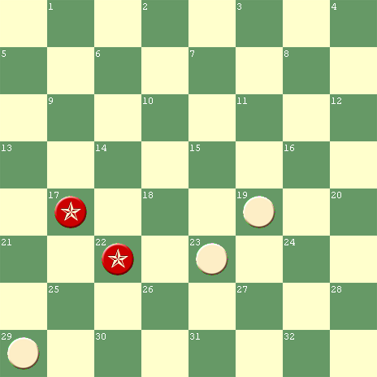
W to Play & D R to Play, W D

Index by “Where Published”
A Measure of Slocum’s Worldwide Reputation

If anyone has publications not listed below, and if they contain one or more Slocum problems or related news items, please send details to the editor at wjsalot@comcast.net . Alternatively, let the editor beg, borrow, steal, buy, rent, or lease the publication from you.

- The column on the right lists the total number of Slocum problems in publications that have been completely reviewed.

- If a rectangle in that column is blank, the publication has not been completely reviewed, so it may contain more as yet undiscovered Slocum information.

Publications |  | Composition Numbers |  |  |  | Quantity
ABC of Draughts, Fred Passey |  | 65
Aberdeen Free Press |  | 4,98
American Checker Federation Bulletin |  | 3,11,18,25,53a,56a,60, 65,67,101
American Checker Federation Web Site |  | 25 |  |  |  | 1
American Checker Monthly |  | 63,79
American Checker Player |  | 94 |  |  |  | 1
American Checker Review |  | 1-4,7-8,10-13,15,17-23, 25,27-30,32,33(4times), 34-35,38-40,42-44,46-47, 49,53-62,72A,77,78,79, 80,82,83,84,85,86 |  |  |  | 54
Atwell’s Scientific Draughts |  | 3,25,52,66,74,94 |  |  |  | 6
Australian Town & Country Journal |  | 25(3),81(2),90,94,96,98, 102
Banks’ Morris-Systems Checkerist |  | 3,65,79,102 |  |  |  | 4
Banks’ Scientific Checkers |  | 102 (2 editions) |  |  |  | 1
Boland’s Bridges |  | 24 |  |  |  | 1
Boland’s Checkers in Depth |  | 6,35 |  |  |  | 2
Boland’s Familiar Themes |  | 26,40,43,53,56a,76,79, 90 |  |  |  | 8
Boland’s Famous Positions |  | 53 |  |  |  | 1
Publications (continued) | Composition Numbers |  |  |  | Quantity
Boland’s Masterpieces | 26,52,101 |  |  |  | 3
Brisbane Courier | 3,16,26,102
Boston Globe | 25,33,69,84,102
British Draughts Journal (1952-58) | 25 |  |  |  | 1
California Checker Chatter | 78
Call’s Midget Problems | 11,40,78,84,102 |  |  |  | 5
Call’s Vocabulary of Checkers | 29,53a,53b |  |  |  | 3
Canadian Checker Player | 25,40,60,62,79,87,102,106b,108 |  |  |  | 9
Checquer Board | 1,25,26
Chequer Chiaroscuro | 24,25,26,28,44,73,77,94 |  |  |  | 8
Checker Players Delight | 28
Checkers in Ten Lessons, Wiswell | 24 |  |  |  | 1
Chess & Draughts Complete Guide | 25 |  |  |  | 1
Chicago Daily News | 28, 66-67,69,90,105
Chicago Evening Lamp | 14,16,24
Chicago Inter-Ocean | 5-7,8(2),9,11,22,25(2)-26, 28-29,36-38,44-45,48,51-53, 60-61, 63,67,72,75,76,81,82, 87,88, 89,92,93,95,99,100, 101,103a,103b,104,109,110
Churchill’s Compilations | 48
Cohen’s Sunday Citizen | 25
Compleat Draughts Player | 3,65,67a,77,108 |  |  |  | 5
Crossboard News | 26
Draughts Players Quarterly Review | 52,73,79,81
Draughts Review | 79,105 (2) |  |  |  | 3
Draughts World | 3-4,25,28,53(2),56a,60-61, 63,65(2),66(3),67,81,90,91, 94(2),96,98,102(2),105
Duffy’s Standard Positions, Part 1 | 84,102 |  |  |  | 2
Elam’s Checker Board | 25(2),26,29,53,69,77,102(4), 103a,103b
Publications (continued) |  |  | Composition Numbers | Quantity
English Draughts Journal |  |  | 3,52
Examiner, Launceston, Tasmania |  |  | 7,25(3),63,65,69(2)
Freeman-Barker Match Games Bk |  |  | 25 | 1
Glasgow Weekly Herald |  |  | 26,31
Gould’s Book of Problems |  |  | 25 | 1
Guide Post |  |  | 56a,102(2)
Hall’s Instructive Positions |  |  | 78 | 1
Hill’s 1891 English Tournament |  |  | 26 | 1
Hill’s Manual of Game of Checkers |  |  | 8,60 | 2
Hopkins’ Home Checker Companion - Our Boys at Home |  |  | 102 | 1
Horsfall’s Problem Book |  |  | 1,3,16,24-26,28,44,51, 60-61,65-67,90,94,96, 98,102,105,106a,107 | 22
Int’l Hall of Fame Presents Checkers |  |  | 56b, 81
Irish Draughts Ass’n Newsletter |  |  | 25,28,50,102 | 4
Jordan’s American Checker Player |  |  | 3
Kear’s Encyclopedia,1st&2nd Editions |  |  | 25,63-64,69 | 3
Kear’s Encyclopedia, Alexander’s Rev |  |  | 25,94
Ketchum’s How to Win |  |  | 28,51,56b | 3
Keystone Checker Review |  |  | 1,3,6-8,11,16,24,25(2), 26,28-29,35,40,41A, 42-44, 51-53,56a,56b, 60-61, 63,65-66,67(2), 67A,69,72-72a,73,74, 76,77(2),79(2),81,84, 90,94,96, 98,101,102, 105,106a-106b,107 | 51
Lancashire Checker Newsletter |  |  | 25
(Edw) Lasker’s Chess and Checkers |  |  | 26 | 1
Leeds Budget |  |  | 56a,94
Leeds Mercury |  |  | 101,102
Lees’ Guide |  |  | 11 | 1
Lees’ Scottish Draughts Quarterly |  |  | 77,90 | 2
Lewis’ Gem Problem Book |  |  | 11,102

Publications (continued) |  | Composition Numbers | Quantity
Liverpool Mercury |  | 33,50,60-61,63
London Daily News |  | 28
(Al) Lyman’s Checker Site |  | 67,67a,77 | 3
Manchester Times |  | 66
Melbourne Weekly Times, Hugh Egan, Editor (for > 50 of its >70 yrs) |  | 52,53a,53b,59,60,61(2),81
Midwest Checkers |  | 33,65,80 | 3
Minneapolis Journal |  | 72
Mitchell’s Checkers |  | 25,90 | 2
Moline Dispatch |  | 3,72a
Mt. Sterling Advocate |  | 33,41A,103a&b,106b
Newark Sunday Call |  | 1,25,26, 81
New Draughts World |  | 90
New Zealand Draughts Newsletter |  | 61
Newell’s Checker Maven |  | 43,90,102(2) | 3
North American Checker Board |  | 52,61,66,72,73,76,94 | 7
Northern Weekly Leader |  | 67
North Otago Times |  | 25(2),50-51,61,63
Nottinghamshire Guardian |  | 60
NWDF Newsletter, Hugh Devlin, editor |  | 53, 81,
Oldbury’s Complete Encyclopedia |  | 67A,101 | 2
Otago Witness |  | 2, 3,7,10,14,16,25(3),26, 33,40,42,53,55,60,61,65,66, 74,90,99,100,102(4)
Pask’s Play Better Checkers &Draughts |  | 25 | 1
Pask's Starting out in Draughts |  | 35 | 1
Pittsburg Chronicle |  | 63
Pittsburgh Chronicle Telegram, DPWB |  | 74,76
Pittsburgh Dispatch |  | 28,60,63-64,66,81,102
Queenslander, Australia |  | 3,26,60-61,79,90(2),94, 97
Reed’s Checker Journal |  | 41,68-71
Richmond’s Single Corner & Alma |  | 25 | 1
Rubin’s Mercury |  | 3,28
Ryan’s Scientific Checkers Made Easy |  | 94 | 1
Schaefer’s Checkerist 10/00-9/01 |  | 11,40,96 | 3
Scott’s 101 Stratagems |  | 52,56b | 2
Sheffield Independent |  | 63
Publications (continued) | Composition Numbers |  | Quantity
(R. J.) Smith’s Daily Worker | 7
Spayth’s Checker Player-Appendix | 53,80
Stearns Book of Portraits, Vol. 1 | 25-26,42,52,60,67 |  | 6
Stearns World Problem Bk, Part 1st | 90, 94 |  | 2
Stearns World Problem Bk, Part2nd | 75,97 |  | 2
Stirling Journal, Scotland | 78
Sunday Times, Perth, Australia | 2,25(2),60(4),61,63,91
Sydney Echo | 26
Sydney Morning Herald, Australia | 98
Teetzel’s American Checker Monthly | 102
The Mail, Adelaide, Australia | 11(2),53a-53b,63,90,102
The Mercury, Hobart, Tasmania | 1,51(3)
Third American Tourney Book | 11,25,56a,69,77,94,102 |  | 7
UNKNOWN | 87A
Weekly Journal, Aberdeen | 53a-53b
Wendemuth’s Checker Companion | 1,3,16,24-26,28,44,51, 60,65-67,94,96,98,102, 105,106a,107 |  | 20
Western Mail, Perth, Australia | 3(4),4,8(4),11(3),16(2), 25(2),60(2)-61,65-66,94, 96, 98,102(2),107
Whyte’s Problemists’ Guide | 52,61,66,94 |  | 4
Wiswell’s Checker Magic | 3,7,25,52,63 |  | 5
W. J. Wood’s Draughts | 102
Wood’s Checker Player | 3,11,16,25,28,33,35,40, 44,52-53,63,66,69,72, 78(2),79,90,96,102,106a
Wood’s Checker Study No. 6 | 90
Worker, Brisbane, Australia | 26
Yorkshire Weekly Post | 65

Index by “Year Published”
A Measure of Slocum’s Productivity

Slocum was prolific early on. His problem composing then ebbed and flowed. In some of the years after 1901, he did not compose any problems. But he continued as an active player into at least 1912.

Year First Published | Composition Number
1888 | 1
1889 | 2,3,4,5,6,7,8,9,10,11,12,13
1890 | 14,15,16,17,18,19,20,21,22,23,24,25
1891 | 26,27,28,29,30,31,32,33,34,35,36,37,38,39
1892 | 40,41,42,43,44,45,46,47,48
1893 | 49,50,51,52,53a,54,55,56a,57,58
1894 | 60,61,62,63,64,65,66,67,67a,68,69
1895 | 70,71
1896 | 72,72a,73,74,75,76
1897 | 77,78,79,80,81,82,83,84,85,86,87
1898 | 88,89
1899 | 90,91,92
1900 | 93,94,95,96
1901 | 97,98
1902
1903
1904 | 99,100,101,102
1905
1906
1907 | 103a,103b,104
1908
1909 | 105,106a?,106b?,107
1910 | 108
1911 | 109,110
1912
1913
1914
? | 41A,87A

Index by “Times Published”
A Measure of the Popularity of Slocum’s Compositions

About a third of Slocum’s compositions received incredible and deserved publicity and acclaim. Another third were published once and never heard from again (until now).

Times  Previously Published | Composition Number
48 | 25
36 | 102
26 | 60
24 | 3
21 | 26
20 | 61,63
18 | 53a,94
17 | 90
16 | 28
15 | 11,56a,66
14 | 52,65
12 | 69
11 | 33(many negative),67,79,81
10 | 51,53b,77
9 | 8,16
8 | 8,96,98
7 | 1,7,24,40,44,78,105
6 | 101
5 | 29,35,67a,72,74,76,84
4 | 4,43,64,73, 106a,107
3 | 2,6,42,50,62,68,72a,91
2 | 10,14,18,22,38,41A,48,55,59,75,80,82.87,97,99,100,103a, 103b, 106b,108
1 | 5,9,12,13,15,17,19,20,21,23,27,30,31,32,34,36,37,39,41, 45,46,47,49,54,57,58,70,71,83,85,86,87A?,88,89, 92, 93,95,104,109,110
Index by “Theme”
A Measure of Slocum’s Preferences in Styles of Problems

Slocum’s fame was not built on just one style of problem, but one style forever bears his name.

Theme | Composition Number
Deferred Strokes  (also known as  Slocum Strokes) | 1,5,7,8,12,14,15,18,19,21,22,23,24,25,26,27,28,29,30,31,32,33,34,36,38.42,44,46, 50,51,56a,61,64,65,67,68,73,74,75,77,81,82,85,89,91,92,93,94,95,98,105,106b,107
Pure Strokes | 4,10,13,20,39,47,48,55,60,67a,86,97
Non-Strokes with Pitches | 2,3,6,9,16,35,37,41,41A,43,52,53a,57,58,62,66,76,79,90,99,101,103a,103b,104, 106a, 108,109,110
Non-Strokes, No Pitches | 11,40,45,49,54,63,69,70,71,72,72a,78,80,83,84,87,87A88,96,100
Piece-down Wins | 42,46,47,53a,72,76,84,106a,106b,115
Sight-Solvers | 2,16,26,48,55,62,67a,72a,74,76,103a, 103b,106a,106b
Known Game Positions | 45,48,55,85,92,93
Likely Game Positions | 6,24,35,52,79,88

Index by “Motif”
A Measure of the Tricks Slocum Favored

The keys to Slocum’s ingenuity lie here.

Motif | Composition Number
All about the Move | 11,40,49,54,58,63,64,66,69,71,72,72a,78,80,83,96,99,100,101,110
Attacking Pitches | 2(two),18,20(two),22,39,41A 47(two),56a,60,61,74,77(two),89(two),99,
Back and Forth | 1,21,22,25,27,34,37,41,45,59,67,67a,69,70,78, 80,83
Breeches | 2,57,62,65,94
Bridges | 24,33,68,96,105
Buried Pitches | 82
Changing the Guard | 11,40,70
Direct Presses | 1,7,23,25,27,28,29,30,32,33,36,38,63,72,88,93
Direct Squeezes | 5,8,12,21,27,28,30,31,35,36,38,42,50,54,57,64
Domino Pitches | 14,22,26,33,50,55,56a,60,68,85,91
Forced Steals | 1,12,17,18,19,20,21,24,26,27,31,33,34,38,41,4243,51,57,63,64,66,73,76,88,89,91,95,109,110
Herding | 42,63,64,72,79,84,87,87A,92,102
3-way Pitches | 2,67,67a,75,89
2-way Pitches | 15,18,26,27,29,33,34,46,55,60,67,67a,68,90, 104
3-piece Pitches | 21
2-piece Pitches | 3,4,8,13,16,17,18,25,26,28,29,36,37,41,44,47, 50,55,59,68,73,74,81
Pitch/Squeeze/Steal | 90
Slip Pitches | 4,8,13,15,19,23,29,30,31,32,34,37,39,44,46,50,55,60,67,67a,68,98,107,108
Slip Squeezes | 17,22,23,27,29,31,50,89
In and Outers | 5,7,10,14,65
Threatened Steal | 3,16,17,23,31,42,45,74,77,81,86,94,95,103a, 103b,106a,106b
Waiting Moves | 3,10,26,49,50,51,52,53a,54,58,75,78,80,83,108
Index by “Epiphany”
A Measure of Slocum’s Showmanship

The keys to Slocum’s personality lie here.

The flashiness of most of his early compositions segued into his later, deeper, studies.

Epiphany | Composition Number
Compound | 17,20,39,46,48,50,51,60(2),86,93,97
Quintuple | 8,10,13,47,107
Quadruple | 4,5,14,19,21,22,29,32,33,34,47,55,67,67a,68,73, 74
Triple | 7,18(2)23,25,28,30,31,36,38,39,44,46(2),47,48,5051, 56a,60(2),65,73,74,77,86,91,94,97,98,106b
Double | 1,9,24,26,27,42,46,47,57,59,61(2),64,75,81,82,8586,89,92,93,94,95(6),105
Single | 2,3,12,16,37,41,52,79,103b,106a,108
Steals | 35,90,109
Merry Go Round | 32
Avoidance | 52,71,84,87A,96,99,103a,110
Tactical | 6,11,40,41A,43,45,49,53a,54,58,62,63,64,66,69, 70,72,72a,76,78,79,80,83,87,87A,88,100,101,102104,105, 108,109,110

Index by “Finale”
A Measure of Finishes Slocum Favored

Slocum had a special appreciation for certain types of closures, such as the Block and the Fork, presumably because they were all shorthanded wins.

Type of Finale | Composition Number
Block | 37,41,41A,56a,76,79,104,106a
Clean Sweep | 67a,68
Escape | 45,53b,57,103a,109,110
First Position | 9,31,53a,81,102
Fork | 2,3,12,13,14,19,26,28,29,59,86,106b
Grip | 43
King Superiority | 97
Lock | 16,66,70
Numerical Superiority | 1,17,18,24,27,34,42,46,47,48,61,74,75,88,89,92,93
Recovered Piece | 35,62,82,90,108,109
See-Saw | 6,80,83,84,87A,96,99,100
The Move | 4,5,7,8,10,11,15,20,21,22,23,25,30,32,33,36,37,38,39,40,41,41A,44,47,49,50,51,52,54,55,58,60,63,64,65,66,67,69,71,72,72a,73,77,78,82,85,87,91,94,95,98,100,101,102,103b,105, 107,110

Index by “Standard Positions”
A Measure of Slocum’s Practicality

Slocum was a master of many standards positions. In fact, he invented the Crocodile Stroke, although he was not credited for it (until now).

Those who find it difficult to study Standard Positions may find Slocum’s approaches to them more entertaining. Slocum used them to make some of his compositions even more difficult.

Standard Positions | Composition Number
American Position | 87,92
American without the Move | 100
Avoiding American Position | 87A
Brooklyn Stroke | 46
Captive Cossacks | 9,72,81
Crocodile Stroke | 44,47,55
First Position | 9,31,53a,81,102
Milligan’s Draw | 71
Payne’s Lock | 16
Payne’s Double Corner Draw | 7thInterlude,80,83
Payne’s Single Corner Draw | 52
Sturges’ Grip | 43

Indexed by “Size of Problem”
A Measure of the Complexity or Simplicity of the Setting

Slocum covered the gamut from 2 x 2s to a 12 x 12.with 4 x 4s appearing most often.

In 8 of his settings, White started a piece down.

Number of Pieces  (Red x White) | Composition Number
12 x 12 | 48
10 x 10 | 97
9 x 8 | 46
8 x 8 | 4,13,41
7 x 8 | 19
7 x 7 | 22,37,60,86,107
7 x 6 | 41A
6 x 7 | 10,14
6 x 6 | 8,17,20,29,39,50,51,85,88,106b
6 x 5 | 47
5 x 6 | 7,15,18,21,34,38
5 x 5 | 5,6,23,28,30,31,32,33,55,61,67,73,93,106a
4 x 5 | 2,12,65,67a,81,82,91,104,108
4 x 4 | 1,9,16,24,25,26,27,35,36,44,45,56a,57,66,68,70, 74,77,92,94,98
4 x 3 | 42
3 x 4 | 58,75,89,105
3 x 3 | 3,43,49,54,63,64,69,71,79,80,90,95,96,99,100,109
3 x 2 | 53a,72,76,83,103b
2 x 3 | 52,101,103a,110
2 x 2 | 11,40,62,72a,78,84,87,87A,102

Index by “Length of Solution”
A Measure of Solution Depth

Slocum’s compositions covered the gamut from sight-solvers to analytical monsters.

But the majority of them required 4 to 6 White moves to complete the specified win or draw.

Number of  Optional White  Moves and Jumps | Composition Number
36 | 70
19 | 54
16 | 80
13 | 42
12 | 6,63,71,87,105
11 | 24,64,102
10 | 38,49,92
9 | 58,69,78,79,96,100,109,110
8 | 1,35,72,83,87A,99,101
7 | 22,23,25,30,31,33,40,41,43,52,65,85,90,106a,107,108
6 | 7,9,10,11,12,19,29,34,37,46,50,51,53a,57,60,61,67,73,94,104, 106b
5 | 5,8,13,14,18,20,27,28,32,36,39,48,72a,82,84,86,88,91,93,98,103a103b
4 | 3,4,15,16,17,21,41A,44,45,56a,62,66,67a,68,75,76,77,81,89,95, 97
3 | 2, 26,47,55
2 | 74

Index by “Star Moves as a Percentage”
A Measure of Solution Tightness

Most Slocum problems require White to make 100% star moves.

Star Moves, % of Total, Excluding Forced Jumps | Composition Number
100.0  (Perfection) | 2,3,4,5,8,11,12,14,16,18,19,20,21,22,25,26,27,28,32,35,3741,43,44,47,49,50,51,53a,55,56a,58,60,62,66,67,67a,68, 72a,73,74,75,76,77,81,84,85,87,88,89,90,91,93,95,96,97, 98,99,101,106a,106b,108, 109
91.7 | 105
90.9 | 64
87.5 | 1,87A
85.7 | 23,30,31,40,52
83.3 | 9,10,29,34,46,57,61,94
81.8 | 102
80.0 | 36,39,48,86,103a
77.8 | 79,100,110
75.0 | 15,41A,72,83
71.4 | 107
68.4 | 54
66.7 | 7,42,63,92,104
61.5 | 6
58.3 | 71
57.1 | 65
55.6 | 78
50.0 | 17,80
44.4 | 69
42.9 | 33
40.0 | 13,103b
33.3 | 38
25.0 | 45
22.2 | 70
18.2 | 24
0.0 | 82
Indexed by “Flaws”
A Measure of Imperfection

Only 4% of Slocum’s compositions proved unsound. In another 12% of them, dual solutions were found. Minor improvements are possible in a number of others. Most of these flaws were discovered with the aid of computers long after Slocum’s generation had passed away.

Considering the degrees of difficulty for which Slocum strived and his lack of computer assistance, his success ratio was excellent.

Flaws | Composition Number
Credit Confusion | 28,44,53a&b,56a,56b,71,79,83,102
Dual Solutions | 7,15(2duals),23,24,30,31,34,39,40,41A,61(?),70, 104,110(2)
Missed Better Setting | 6,13,36,41A,44,46,61(?),98
Missed Better Attack | 33,90,109,110
Missed a Strong Defense | 40,105
Theme not Original | 9,16,43,46,52,56a,71,79,80,81,83,87,102
Unsound Solution | 17,33,38,45,78

Indexed by “Landmarks”
A Measure of the Memorable Properties of Some Slocum Problems

Landmarks | Composition Number
Mirror Positions | 89,90
Piece-down Wins | 41A,42,46,47,53a,72,76,103b
Rare Moves | 26,67,102,107
Reverse Jumps | 33,67
Single Tops King | 13,44,53a/b,103a/b
Slocum Corrects Others | 7thInterlude,85,9thPublished Game(1898),93
Sub-setting of Parent | 71,72a,83,101
Twister Moves | 100,102,109
TERMINOLOGY

Since Mr. Slocum was a professional musician, some attempt will be made here to describe some of his “compositions” in musical terms. Send comments and corrections to wjsalot@comcast.net

Accompanist: One who provides accompaniment to a solo

Back and forth: A motif whereby a piece is pitched, forced, or voluntarily moved first in one direction and then in the opposite direction

Block: A finale in which the opposing pieces cannot move

Breeches: A king inserted between two opposing pieces, such that the king is assured of jumping one or the other

Cacophony: Harsh discord

Captive Cossacks: A finale in which a king squeezes one opposing single piece, in such a way that a second opposing piece must also be sacrificed

Composition: An intellectual creation

Counterpoint: A complementing or contrasting idea

Crescendo: Increasing loudness

Discord: Lack of harmony

Dissonant: Discordant; harmonically unresolved

Encore: Reappearance

Entrée: The first pitch of a stroke

Epiphany: Sudden manifestation or perception; the final jump of a stroke

Episode: An intervening part between repetitions of the main theme

Finale: That which follows the epiphany

Fork: A finale in which a single king pins 2 opposing pieces, like 2 morsels impaled on the prongs of a single fork, resulting in both morsels being devoured. The term was coined, in this context, by Nathan Rubin in his Mercury column, around 1940

Genre: A category of composition characterized by a particular style, form, or content

Grip: A finale in which a king and a single piece, or two kings, restrain three opposing pieces, such that two of the restrained pieces must be sacrificed in order to release the grip

Harmony: Pleasing arrangement

In and Outer: A pitch or forced steal that obligates an opponent’s single piece to jump in and out of your kingrow on different turns. (It generates a free move for the initiator.)

Interlude: Light entertainment between presentations

Improvisation: Fabrication out of what is conveniently on hand

Litany: Repetition

Lock: A finale in which a single king pins three opposing pieces, such that the pinned pieces cannot free themselves

Mirror Position: A position on the Single or Double Corner side of the board, which if set up on the other side would demonstrate the same motif

Motif: Central idea for development, recurring in multiple compositions

Move: The relocation of a piece in accordance with the rules of the game of Checkers; also see “The Move”

- Forcing Move: A move that is not a pitch, but is so strong that it allows only one reasonable response, such as a press, squeeze, or threat

- Free Move: A move made possible when the opponent cannot respond because of a pending obligatory jump; domino pitches, forced steals, and in and outers generate free moves.

- Star Move: The only move that will achieve the specified result. A non-optional jump is never a star move.
- Twister move: A move that is correct when played in one variation but incorrect if played in another.

- Waiting Move: A move that has no other purpose than to let the opponent choose the continuation

Piece: A man or a king in the game of checkers

Pin: A situation where the pinned opposing piece cannot escape without being jumped

Pitch: A non-jumping move that forces the victim to jump one or more pieces (It may or may not initiate a stroke)

- 2-way or 3-way Pitch: A pitch that gives the victim 2 or 3 ways to jump, each leading to a different epiphany

- Attacking pitch: A pitch that offers the victim a choice of jumps and threatens an immediate counter-jump if the pitched piece is not taken

- Buried pitch: A direct pitch that cannot immediately be jumped.

- Direct Pitch: Moving a piece directly in front of an opposing piece so that the opposing piece is forced to jump it

- Domino pitch: A pitch of a piece from the leading edge of a lineup of pieces, such that the opponent is obligated to jump on consecutive turns, like a string of falling dominoes (It generates one or more free moves for the initiator).

- Slip pitch: Movement of a supporting piece to one side, forcing the opponent to jump into or through the vacated square

Pocket: A king inserted into a triangle of 3 pieces, such that the king is assured of jumping one of the pieces

Prelude: Introductory action preparing for what follows

Press: A type of forcing move

- Direct Press: A forcing move where a king contacts an opposing piece from behind, so as to force the opposing piece to move away or be jumped

- Double Press: A forcing move where a king simultaneously contacts two opposing pieces from behind, so as to assure that one of them will be jumped.

- Slip Press: A forcing move where a king already is in contact with an opposing piece from behind, and another piece, in frontal contact with that opposing piece, moves away, thus activating the king’s press from behind

Repertoire: Supply of skills and devices a person is prepared to use

Setting: The arrangement of pieces on a checker board

Squeeze: A type of forcing move

- Direct Squeeze: A forcing move that inserts a piece between an opposing piece and either another piece or a side of the board, so as to force the opposing piece to move out of the way or be jumped

- Slip Squeeze: A forcing move where a piece already is between an opposing piece and either another piece or a side of the board, and another piece, in contact with that opposing piece, moves away, thus activating the squeeze

Sight-Solver: A composition so simple that it should be mentally solved without moving any pieces; also a solver who does exactly that

Single Tops King: A landmark position where a single piece proves stronger than it would if it were a king

Steal: A jump that results from a press or squeeze

- Breeches Steal: A steal achieved by a king squeezing into a pair of breeches

- Captive Cossacks: A steal where a king squeezes one piece and the opponent must move a second piece into the path of the jump, thus giving up two pieces

- Forced Steal: A situation where the victim is forced to threaten a steal, and is then permitted to take it (It generates a free move for the permitter)

- Pocket steal: A steal achieved by a king squeezing into a pocket

- Threatened Steal: A press or squeeze that threatens a steal, but gives the opponent the option of avoiding it or forcing it

Stroke: A jump on a single turn, or jumps on consecutive turns, by the victim, immediately followed by a final decisive jump by the initiator.

- Compound Stroke: A stroke in which one multiple jump triggers another (sometimes called a rebound stroke)

- Deferred Stroke: A stroke preceded by one or more forcing or waiting moves

- Pure Stroke: A stroke with no prelude, consisting of only pitches and jumps

- Slocum Stroke: A particularly deceptive deferred stroke

Theme: The subject of a composition

“The Move”: The timing property which, under the right circumstances, allows one side to pin opposing pieces (sometimes called “The Opposition)

Threat: A forcing move that, without contacting an opposing piece, forces that piece to move
FIRST PRELUDE – 1855-1888

What we know about the personal life of George H. Slocum comes mostly from three biographies presented in 1894, 1895, and 1916, all replayed verbatim later in this document. We never learned his middle name.

Here are some highlights of his first 33 years:

1855 – Mr. Slocum was born in Illinois and raised on a farm, where he may have played a little checkers.

1880 – Already an exceptional violinist, he became an orchestra leader in Chicago at the relatively young age of 25.

1886 – At the relatively old age of 31, he took increased interest in checkers after witnessing an exhibition, in Chicago, by the younger visiting American champion, C. F. Barker.

May 1, 1888 –The first issue of the erratic American Checker Review was published in Chicago. (See the Second Prelude).

October 1, 1888, Slocum’s first composition appeared in the American Checker Review.

October 30, 1888 – He married his pianist.

December, 1888, Harvey L. Hopkins organized the Chicago Chess and Checker Club, and Mr. Slocum became a charter member, along with Messrs. Hefter, Baker, and others.

SECOND PRELUDE – May 1, 1888

The American Checker Review was soon to become the stage for 54 of Slocum’s checkeristic presentations. Its auspicious start and dramatic life were described 50 years later in the February and March 1938 issues of New Draughts World, Volume II, Nos. 16 and 17, Pages 240-241 and 256-257.

The two articles are quoted here in their entirety to describe the unusual environment, atmosphere, and culture in which Slocum’s early career in checker problem composing started and flourished (PART 1):

MAGAZINES OF OTHER DAYS
By W. G. Parker, Glasgow

“The issue of The American Checker Review in Chicago, on May 1, 1888, was a distinct achievement, for the magazine embodied the work of several of the best practical players in America, and technically was a fine example of the printer’s art. The paper used was of excellent quality, the printing above reproach, and it is doubtful whether the issues for which Percy Roberts was responsible have ever been excelled in a draughts periodical. The subscription rate was $1.50 per annum in America, and 7/- in Great Britain, and as these charges covered twenty-four parts, The American Checker Review was certainly remarkable value.

The magazine started as a semi-monthly, appearing on the 1st and 15th of each month; the joint editors were C. Hefter and J. P. Reed, the manager E. T. Baker, and the publisher the Percy Roberts above mentioned. Both Hefter and Reed had impressive records. The former was slightly the younger of the two, and before he was twenty had shown excellent form against Freeman, Kirkwood, Yates, Barker, Reed, and other well-known players. Later, the study of problems had claimed his attention, and at the time the Review started, it is doubtful whether anyone in America had a better all round knowledge of the game. He was not altogether a stranger to journalistic work, for he had assisted the draughts editors of the Sunday Tribune and Cleveland Sunday Sun, and it is recorded that he conducted a checker column in the Chicago Post when but fourteen years of age!
Reed at this time was twenty-nine years of age, and had fulfilled the promise of his early youth. As early as 1876, when only seventeen, he had played Martins, and by 1888 he had met Hefter, Priest (thrice), Wyllie, Wright, Barker (thrice), and Dr. Schaefer in America, and Richmond, Campbell, Smith, Lewis, and Ferrie in this country. During the publication of the Review he was destined to achieve his great ambition – to defeat Barker, and win the American championship. Reed indubitably had genius, but unfortunately had also many of the failings that are commonly associated with it. He was brilliant, and humdrum routine work seems to have been uncongenial to his nature, so that it was a fortunate chance that he was linked with Messrs. Hefter and Baker, for they supplied the ballast their temperamental friend lacked, and uncomplainingly did the donkey-work that the publication of the Review entailed.

The business manager was a lesser star, and his name is now generally remembered in connection with Baker and Reed’s Alma, a brochure he compiled from Hefter’s material and published after revision by Reed, in February 1888. The technical excellence of Robert’s work has already been noticed, and inter-relations of these four very capable men account for the subsequent vicissitudes of their joint work.

During 1888 everything went well; there was no lack of material, and Reed seems to have thrown himself into the work with characteristic ardour. Unfortunately during this time he was living in Pittsburgh, and thus was unable to give any help in the editorial duties, the bulk of which fell upon the shoulders of the conscientious Hefter. This gentleman’s work had increased very considerably for the contributions were so numerous that it had been found necessary to abandon the announced dates of publication, and for a time issue the Review at intervals of from eight to ten days. At the end of 1888 Hefter found that he could not continue unless his work was substantially reduced, and accordingly arrangements were made for Reed to take up his permanent residence in Chicago, have entire charge of the Games department, and give his co-editor a much needed relief. The finances of the magazine also gave rise to some anxiety, for despite its excellence, the Review had only five hundred subscribers, and it was decided to increase the rate for Volume 2 to $2.

About the middle of 1889 the other interests of Mr. Baker forced his retirement, although he did not completely sever himself from the venture for he produced the index at the end of that year. Messrs Hefter and Roberts divided his work, and the Review triumphantly ended the second year of its existence; but Mr. Baker’s departure seems to have destroyed the ties that held the promoters together, for with the completion of Volume 2, Mr. Hefter left the concern, and the magazine then became a monthly at a dollar rate, with Mr. Reed in sole charge.

Then followed a series of disasters: After a few issues, the publisher, Mr. Roberts, failed and new arrangements with Mr. Murray had hardly been concluded when the whole premises were destroyed by fire. As the review had an office in the building, this was far more serious than it seems, for No. 6 was already in type, and this with a list of subscribers, a valuable reference library and much original matter, all vanished in smoke. Incidentally, the plates of Baker and Reed’s Alma perished. Reed was absent at the time, but after some delay succeeded in issuing a new No. 6, and then a mantle of silence fell until No. 7 appeared in April, 1891, some eight months later. In this interval a member of the Chicago Chess and Checker Club purchased a new outfit to enable Volume 3 to be completed; but to run the magazine alone was a task beyond Reed’s power, and with No. 11 he laid down his pen and severed his connection with the Review.

The magazine then entered on another phase of its existence, for the Denvir Bros. took charge as publishers, announced that mismanagement had had its day in the office of the Review, and started out to revive its fallen glories.

Mr. J. T. Denvir was editor and Mr. E. T. Hyde manager. They published the remaining parts of Vol. 3, started Vol. 4 in 1892 at the new rate of $1.50, and continued the paper for another two years. Mr. Hyde retired after eleven months in favour of one of the Denvir brothers and save for the indexing of Vols. 4 and 5 is heard of no more.

At the end of 1893, the continuation of the journal had again to be considered, for the financial return was still unsatisfactory, and the management decided with Vol. 6 to reduce the rate to $1 and trust to an increased support to balance matters.

In April, 1894, a fresh start was accordingly made and the indispensable Hefter roped in with Mr. Head as co-editor, Denvir retaining a general supervision and acting as manager. Hefter returned to the problem department, and Head looked after the games section, but the change came too late, for the Review of 1894 was not the Review of 1888, and after a few double issues, July-August being the last, the magazine came to the inevitable end.”

W. G. Parker, Glasgow, continued his dissertation on the American Checker Review in the March 1938 issue of New Draughts World, Volume II, No. 17, Page 256-257, as follows (PART 2):

MAGAZINES OF OTHER DAYS
By W. G. Parker, Glasgow

“A very noticeable feature in the American Checker Review, at least in its earlier years, is the able annotation of the games and problems. Mr. Hefter had the rare gift of taking a game which had been cut up by a dozen critics and presenting a concise yet complete summary of the matter in a very readable form. His comments on the problems, too, were sound and informative, and stimulated the readers’ interest. The news items were treated very similarly, and as a result the magazine has a wholesome freshness that it is difficult to find in any other Draughts periodical.

In 1889 the Journal naturally gave prominence to the Barker – Reed match for the championship of America. Barker at the New Year had defeated the English champion, Smith, somewhat decisively by five to one, and twenty-three draws, and then returned to America and arranged a match with Reed for June. Barker was a strong favorite owing to his previous successes against Reed – it is said he considered Reed to be worth $100 a year to him – but on this occasion he lost by seven to nine, with thirty-four drawn games.
The match was an extraordinary one in many respects; in the first place Reed had won six games without a loss when over half of the stipulated fifty games had been played – and then Barker won four, and lost one, in the next seven. In comparison the play may be said to have dragged a little, for in the next sixteen games Barker managed to score but three, dropping one by the way.

This threw the result of the match on the last game, and Reed had but to draw this to win the match, and become the American champion. Characteristically enough, Reed departed from the beaten track, and eventually scored a brilliant win by one of the finest strokes that have been taken cross-board.

The peculiarly personal character of the comments in the American Checker Review is still worth reading. Dunlap in the Turf, wrote: ‘That Reed should win the first game could not be counted as a surprise, but that he should go right ahead and score win after win – complete surprise does not express it. It really dumb founds the adherents of both, and the query comes from all sides: ‘What is the matter with Barker?’ We all know what Barker has done in match playing; that he has been given the credit of being the best match-player living; but Reed has never been looked on as such, and he proves now that he has never been properly cared for by anyone when playing a match. This time his friends have carefully coached, advised, and cared for him. Every member of the Chicago Club is his friend, and to the interest taken in him as advisors, particularly by Messrs. Hefter, Baker, and Hopkins, should credit be given for the unequalled score made by him the past week’.

To this, the Journal adds: ‘Every member but one. Robert Freer was no friend: on the contrary, as game after game was placed to Reed’s credit, the expression of his dark face became more and more sinister; he assisted Barker by every means in his power, and his features never relaxed until Barker won a game. As the ex-champion’s score increased, his features gradually broadened; when the forty-ninth game was scored, he actually laughed – a remarkable occurrence with him. But the fiftieth game was such a disappointment to him that possibly he may never smile again.’ Reed and Freer do not appear to have been on the best of terms.
A dramatic explanation is also given of Reed’s collapse in the fatal days when Barker scored so heavily. ‘To relieve a throat irritation, Reed procured some of ‘Smith Bros. Cough Drops’, and entirely ignorant that their curative ingredient is morphine, he consumed one package Monday, two on Tuesday, and three on Wednesday, and was so completely under the effects of the drug that it is surprising that he did not lose more than three games that day. The game he scored was owing to a silly move of Barker’s when all hope for a win had vanished. Everybody thought that Reed had broken down under the severe strain, but Mr. Hefter fortunately discovered the true cause of the trouble, and every possible means was taken to throw off the drowsy dull feeling. This was accomplished in about two days.’

Barker regained the title in 1891 (correction: it was September 1892), but Reed had then ceased to control the Review, and his comments may not be read.

During the Hefter – Reed regime, the Review was served by a singularly choice band of composers, the majority of international reputation . . . Wardell, Sheean, Reed, Richmond, Mercer, Lyman, Pomeroy, Maize, Hefter, Hanson, Davis, Belden, Avery, Hennigan, Robinson, Slocum . . . the list seems inexhaustible, but with the Denvir brothers at the helm, a distinct change in the character of the magazine can be recognized.

In the games department the masterly touch of Hefter was lacking, and lesser lights began to monopolize the problem pages, although Messrs. Belden, Slocum, Wardell, Heffner, and Hefter, maintained the prestige of this section.

On the other hand, a number of interesting biographical articles appeared, many of them from the able pen of ‘Uncle Toby’ – W. H. McLaughlin.

Some space was also extended to the analyst, for the work of Dr. Truax on the Black Doctor was revised, and Mr. Tescheleit’s lengthy examination of the Double Corner Dyke appeared. Mr. Reed the previous year had attempted something of the kind, and had started – but not completed – a compilation on the Second Double Corner.
A column, Checker Chatter, conveyed stray news items to the reader, and in this quite a number of ‘puffs’ for various books regularly appeared.

Toward the close, however, whole pages were given up to advertisements of the kind, an undesirable practice since these pages could not be separated from the legitimate contents of the magazine. The readers of any journal which devotes its numbered pages to advertisements might be considered to have the right of protest: in the case of the American Checker Review the protest appears to have been the silent, but effective one, of decreased support, and without warning, the magazine stopped publication in the summer of 1894.”

NOTES:

W. G. Parker, who wrote the foregoing articles, was evidently unaware that Denvir revived the American Checker Review for a few issues in 1897, Al Darrow

“In my opinion, Volumes I and II were best. From there on, the magazine gradually slipped until the final issues, which were considerably below the par set by the early volumes”, Floyd D. Brown, 1970

Interestingly, Slocum was several years older than Reed, Hefter, and Denvir. With such members, and the others mentioned, the Chicago Club was indeed a strong audience for testing Slocum’s compositions.

According to Stearns Portraits, Volume 1, Page 64, the Chicago Club had “a membership of over 200” in 1894.

#1 - October 1, 1888
Background:

One can only imagine what transpired when Slocum presented his first composition to Charles Hefter, the soon-to-be overworked checker problem editor of the American Checker Review. Hefter was an internationally recognized problemist, many of his problems appearing in the pioneering American classic, Lyman’s Problem Book, 1881, and in its British counterpoint, Gould’s Problem Book, 1884.

Hefter certainly would have looked at any checker problem with a critical eye. He must have been impressed with Slocum’s outstanding first attempt, which became the prototype of a shocking new style of stroke. Its six consecutive forcing moves leading to a deferred stroke were appealing enough to play encores in famous problem books by Horsfall, 1909, and Wendemuth, 1923.

Lesson for Composers:

1. One component of success in any endeavor is a positive response to early efforts.

#1 – “FIRST TRY” or ‘DEBUT”
SLOCUM’S FIRST DOUBLE
AND HIS FIRST BACK AND FORTH
White to Play and Win
Solution #1:

*11 16A, 19-23, *16 19B, 23-27, *19 23C, 27-31D, *23 27, 31-24, 28 19, 12-8E, *19 16, 8-12E, *16 11, 12-16F, *22 17, WW by the forced steal, resulting free move, and double jump, all facilitated by the frozen Red pieces on 14 and 21.

A – The first direct press is necessary; 11 7 falls one move short of stealing the man on 14, a misleading false solution.

B – The second direct press is necessary; 16 20 allows *23-27, 20 24, *27-32, which draws, a subtle difference.

C – Similarly, 19 24 allows the *27-32 escape. Composers should note the piece on 21 had to be a king in order to avoid a dual win by 22 17 at C.

D – Forced to counter the threat of 22 17.

E – An example of the back and forth motif

F – A forced steal that generates the clinching free move

Lessons for Composers:

2. Strokes can be hidden by an intricate prelude of forcing moves

3. Freezing one part of the opposing forces makes forcing moves possible against another part.

4. Dual solutions are the bane of composers.

Bibliography #1 (7 items)

October 1, 1888, American Checker Review, Volume I, Page 136, Problem 118, colors reversed

1909, Horsfall’s Problem Book: Page 59, Prob. 529, colors reversed

Before April 1914, The Newark Call, edited by Dr. Schaefer

April 1914, The Checquer-Board (first issue), Editor Henry Shearer mentioned that Dr. Schaefer published this problem in the Newark Call, “This was said to be one of Slocum’s first efforts”, Shearer

1923, Wendemuth’s Checker Companion: Page 151, Prob. 93, colors reversed

December 16, 1939, The Mercury, Hobart, Tasmania, Page 8, Prob 113, colors reversed

January 1993, Keystone Checker Review, Page 462, Problem 42, colors reversed, solution Page 472, of same issue, part of Bob Crue’s collection of Slocum problems

#2 - March 1, 1889
Background:

Volume II of the American Checker Review began with this issue.

Slocum may or may not have been the first to discover the fork finale, but he certainly began to exploit it with this so-called beginners’ problem. Beginning solvers might disagree with that assessment by the editor of the Otago Witness (New Zealand), Slocum’s first international recognition.

This composition also introduces Slocum’s early concepts of a 3-way problem, pitches as attacking moves, and a stroke involving no multiple jumps. (See the definition of a stroke).

Problems #1 and #2 are unlikely to occur in a game. Hefter and many others objected to unnatural settings, but Slocum used them to demonstrate some maneuvers never before seen on a checker board.

Lesson for Composers:

5. Innovative ideas must not be inhibited by setting appearance.

#2 – “ATTACKS I”
SLOCUM’S 1ST FORK, HIS 1ST BREECHES,
HIS 1ST ATTACKING PITCHES, HIS 1ST 3-WAY PITCH
White to Play and Win
Solution #2:

*27 23A, 19-26B, *13 9C, 6-13D, *18 15, WW by the exchange, a fork (2 pieces pinned on the prongs of a single fork), and the move

A – White is a piece up, but about to lose a piece from the breeches. It is a situation where attacking pitches, like this, deceptively threaten a counter-jump. The fact that it is a 3-way pitch makes it even more deceptive. Composers should note the piece on 7 had to be a king in order to avoid a dual win by 18 14, and the piece on 19 had to be a king in order to avoid a dual win by 13 9. Such points make composing a sound setting more challenging than solving one.

B – Red has 3 ways to jump. Jumping the attacking pitch is the only way to avoid remaining a piece down.

C – A second attacking pitch!

D – With even pieces, jumping the attacking pitch is forced to avoid allowing a triple.

Lessons for Composers:

- Unexpected finales hide themselves.

- Attacking pitches are deceptive to solvers.

- 2-way and 3-way pitches are deceptive to solvers.

- Deception should be the composer’s primary objective.

Bibliography #2 (3 items)

March 1, 1889, American Checker Review, Volume II, Pg 5, Prob 8, cols reversed

June 6, 1889, Otago Witness, “Positions for Beginners”, No.4, colors reversed

May 15, 1910, Sunday Times, Perth, WA (Australia), Page 11, Problem 50, colors reversed, “Very pretty”

#3 - March 15, 1889
Background:

A problem built on an intriguing idea seldom satisfies its composer. The motif haunts for weeks, months, even years. So it was with Slocum and fork finales. Possible ways that 1 piece can beat 2 are confined to one side of the board. Although rare, their shock value remains unsurpassed.

Although #2 was very deceptive, Slocum managed to improve on it. #3 reduces the number of pieces, changes the prelude from attacking pitches to innocent waiting moves, and ends with a terrific epiphany.

It has been extremely well received, published at least 24 times over many decades, including twice in the Otago Witness (New Zealand) and thrice in the Western Mail (Australia).

Lessons for Composers:

10. Multiple intriguing compositions can often be built on a single intriguing idea.

11. The quality of a composition improves with time spent composing it.

#3 – “DAINTY TREATMENT”
SLOCUM’S SECOND FORK FINALE,
HIS 1ST 3 X 3, HIS 1ST 2-PIECE PITCH
White to Play and Win
Solution #3:

*29 25A, 8-11B, *25 22, 11-15, *30 25C, 23-26, *22 18D, WW by the 1 for 2, and a fork with no frills

A – One thing that distinguishes a composer from a solver is an interest in why the setting is as it is, and whether it could be made better. Here the Red king on 8 could have been on 6 or 7, without changing the solution. Also the White king on 29 could have been on 21. Then the problem could have been set back a little.

B – Of course Red must not let White steal the piece on 23.

C – A quintessential waiting move

D – Two more deceptive moves in succession will not be found.

Lessons for Composers:

12. Ask why a setting is as it is and whether it can be made better.

13. Unexpectedly offering a free path to the king row is deceptive to solvers.

14. 2-piece pitches are often deceptive to solvers.

Bibliography #3: (24 items)

March 15, 1889, American Checker Review, Volume II, Page 16, Prob 15

June 1900, Draughts World, Vol. 15, No.42 New Series; Prob. 310,

“Our Yankee Cousin again gives us a taste of his qualities as a problem composer”, DW’s editor

Before October 17, 1900, Otago Witness, Issue 2431, Page 56, Problem 1901, solution October 17, 1900

December 22, 1900, Western Mail, Perth, WA (Australia), Page 34, Problem 177

Before May 8, 1901, Moline Dispatch
May 8, 1901, Otago Witness, Issue 2460, Page 58, Problem 1940, from Moline Dispatch, solution June 19, 1901

1905, Atwell’s Scientific Draughts, Prob. 197

1909, Horsfall’s Problem Book, Page 23, Prob. 201

Nov.-Dec., 1913, Jordan’s American Checker Player, Cover Prob.

October 17, 1914, Queenslander, Brisbane, Australia, credits and terms transposed with those of another problem, corrected with solution October 24, 1914, “The position is so simple, yet the key so amazingly obscure – it is indeed a Slocum gem.”

February 8, 1918, Western Mail, Perth, WA (Australia), Pg 24, Prob 1070

Before August 8, 1920, Chicago Daily News, Problem 196

1923, “Wendemuth’s Checker Companion”, Page 150, Prob. 89

April 3, 1924, Western Mail, Perth, WA (Australia), Page 34, Prob 1381

May 1924, Morris-Systems Checkerist, Volume 2, Issue 5, “Advanced Players’ Problem Section”, Problem 100, solution Issue 6, June 1924

January 3, 1929, Western Mail, Perth, WA (Australia), Pg 7, Prob 1604

August 12, 1933, Brisbane Courier, Australia, Pg 17, Prob 698,

“The problem set on the board today is the work of the well-known American composer, who has given the draughts world many interesting and instructive studies, among which is that illustrated today”, Oblique

Circa 1940 (?), Nathan Rubin’s Mercury, Prob. D;

“George Slocum gave this maneuver a very dainty treatment in this setting”, Nathan Rubin

1943, Wiswell’s Checker Magic, Prob. 83;

“George H. Slocum was undoubtedly one of the greatest, if not the greatest, Problemists of all time. His works have been more widely copied than those of any other Composer. In fact, many positions are known as “Slocum Problems” because of the resemblance they bear to his work. For simplicity and beauty, it would be hard to beat No. 83”, Tom Wiswell

Nov. 1945, Wood’s Checker Player, Vol. 9, Page 42, Prob. D
“Taken from Nathan Rubin’s column in the Mercury several years ago”, Rex Wood, Editor of Wood’s Checker Player

1981, Irving Chernov’s Compleat Draughts Player, Pg. 257, Problem 4

May 1992, Keystone Checker Review, Page 356, Problem 13, solution on Page 362 of same issue, part of Bob Crue’s collection of Slocum problems

April 2000, ACF Bulletin, Issue 284, Pg. 7, Prob. 43, solution same page

September 2011, English Draughts Association Journal, Volume 51, Issue 191, Page 8, Problem 146, attributed to Jim Somers in error.
#4 - May 1, 1889
Background:

With each new composition so far, Slocum has experimented with something new for him. Here is his first big, pure stroke. It has a sudden 4 for 1 epiphany and introduces his first slip pitches.

Although pure strokes have become common over the years, this one is more natural appearing than most. It incorporates not one, but two slip pitches. One of them is a two-piece pitch (Lesson 14). It may be a carryover from # 3.

#4 proved worthy of encores in at least 4 publications. But at this point, Slocum had no idea that any of his first four compositions would be republished.

Lessons for Composers:

15. Slip pitches are often deceptive to solvers.

16. Multiple pitches are attention-getting crescendos.

#4 - SLOCUM’S FIRST PURE STROKE,
HIS FIRST QUADRUPLE,
HIS FIRST SLIP PITCH,
AND HIS SECOND 2-PIECE PITCH
White to Play and Win
Solution #4:

*23 18A, 32-14, *31 26, 30-23,*22 18B, 13-22, *10 12, WW by the quadruple jump, followed by the forced exchange and the Move

A – Composers should note that this two-piece slip pitch would not work without the passive presence of the piece on 21, and the finale would not work without the passive presence of the piece on 29.

B – This second slip pitch triggers the epiphany.

Bibliography #4: (4 items)

May 1, 1889, American Checker Review, Volume II, Page 52, Problem 47, colors reversed, (publisher’s typo corrected)

Date unknown, Aberdeen Free Press, Prob. 3225

July 22, 1911, Western Mail, Perth, Australia, Page 38, Problem 716

December 1911, Draughts World, Vol. 38, Prob. 863

#5 – June 29, 1889
Background:

Perhaps influenced by turmoil at the American Checker Review, Slocum decided to start publishing some problems in the thriving Chicago Inter-Ocean’s checker column, which was ably edited by another rising Chicago star named John T. Denvir.

Here is Slocum’s first of many appearances in Denvir’s Chicago Inter-Ocean. It is the first Slocum composition that has not been republished (until now).

Wikipedia says the Chicago Inter-Ocean was launched in 1872, after the 1871 Chicago fire destroyed its predecessor. It was an upscale weekly newspaper delivered by mail on transcontinental railroads throughout the central and western U. S. It lost subscriptions beginning in 1895 when linotype newspapers made weekly newspapers obsolete. Reportedly out of business in 1907, its checker columns somehow continued into 1912.

Having taken a liking to quadruple jumps, Slocum followed #4 with a second quadruple, this one deferred by a forcing move. It also incorporated the combination of a squeeze, direct pitch, and slip pitch together with his first “in and out” motif.

#5 - SLOCUM’S SECOND DEFERRED QUADRUPLE
AND HIS First in and outer
White to Play and Win
Solution #5:

*26 22A, 11-15, *21 17B, 14-21, *30 26C, 21-30, *20 16, 30 23, *16 12, WW by the quadruple jump and the Move, Note D

A – Compare the force of this squeeze with that of the waiting move 20-24. There is a big difference.

B – Composers should note that the piece now on 15 must be a king in order to prevent several dual wins.

C –Slocum goes beyond the typical in and out motif. Here the single slip pitch forces Red to jump on its next three turns (not just two), thus giving White freedom to follow up with two free, unhindered moves (not just one). There are not many settings that feature such a powerful triggering pitch.

D – The fact that #4 and #5 both conclude with a quadruple and the Move is no coincidence. One setting was surely built on the other like succeeding verses of the same song.

Lessons for Composers:

17. A single pitch that forces the victim to jump on more than one consecutive turn generates one or more free moves for the initiator.

Bibliography #5: (one item)

June 29, 1889, Chicago Inter-Ocean, Problem No 6, colors reversed

#6 – July 6, 1889
Background:

This problem, at the time, seemed out of character for a Slocum composition. Although not so stated, it may have been a position reached in a game, rather than a composition. It is fairly long, but not too difficult. There are several optional moves for both sides. There is only one real pitfall for White. A better setting is possible. As a composition, it is imperfect, but it has a lot of star moves.

It may be that Slocum was fascinated by the finishing mandown see-saw draw in the middle of the board.

Boland included the problem as one of a family of similar appearing settings in his Checkers in Depth, 1947.

Lessons for Composers:

18. Positions arising in games can usually be reset to make them more difficult.

#6 - SLOCUM’S FIRST SEE-SAW
& HIS FIRST PROBABLE GAME POSITION
White to Play and Draw

Solution #6 (Slocum’s favored solution):

*31 26A, 7-11B, *15 10, 6-15, 24 19C (26 23 also draws), 15-24,
28 19, 1-6 (or 1-5), 26 22C (26 23 also draws), 6-9, *22 18D, 9-13, *19 15, 13-17, *15 10, 17-21 (or 17-22), 10 6E, 21-25, 6 2F, 25-30, *2 6, 30-26, *6 10G, See-Saw Draw in the Middle of the Board

A – Not 24 19; it’s a false solution because *7-11, 15 10, 6-24, 28 19, Red Wins. It looks similar to the trunk play, but the Move is different.

B – Red has three other options: 1-5, 6-9, and 7-10. They allow easy draws, but are distractions that bypass the favored solution.

C - Composers should note that these two moves would have been star moves if the piece originally on 31 had been on 29 instead.

D - The only pitfall is 22 17, *10-14, 17 10, *11-15, Red Wins, a direct pitch and squeeze, Milton Johnson, 1970

E – Or 10 7, 21-25, *7 2, same, Milton Johnson

F – Or 6 1, 25-30, *1 6, same, Milton Johnson

G– Continue either 26-23, *10 14, or 26-22, *10 15, Draw, Milton Johnson

Lessons for Composers:

19. Avoid allowing optional defenses that bypass favored solutions.

Bibliography #6: (three items)

July 6, 1889, Chicago Inter-Ocean, Prob. 7

1974, Boland’s Checkers in Depth, Page 140, No. 6, included in the “Sinclair’s and Drummond’s Coup” family

Nov. 1992, Keystone Checker Review, Page 429, Prob. 36, solution Page 440 of same issue, part of Bob Crue’s collection of Slocum problems
#7 – July 15, 1889
Background:

Slocum was building more and more on his earlier themes. The similarities of #7 to #5 are rife. Recurrence of the in and out motif is almost obvious. An encore of the forced 11-15 and a similar epiphany and finale are less apparent, but straightforward.

One shocking move makes it all possible and is a distinguishing nuance introduced here. Tom Wiswell, in 1947, called that move “An enchanting ‘Slocum’ key”.

Now, after more than 120 years, another shocking revelation arises. Without benefit of a computer, Slocum, Hefter, Wiswell, and many others, missed a remarkable, unpublished, independent, dual solution to #7. Mr. Slocum, in his penchant for exploring new frontiers, had set his idea back too far.

Lessons for Composers:

20. Do not set a composition back too far, lest it create dual solutions or extraneous variations. Question every setting.

#7 - SLOCUM”S FIRST TRIPLE,
HIS SECOND IN AND OUTER,
BUT HIS FIRST MISSED DUAL SOLUTION
White to Play and Win
Solution #7 (Slocum’s solution):

8 4A & Var. 1, 14-7, *12 8B, 3-12, *4 8, 11-15C, *30 26, 21-30, *8 3, WW by the triple jump and the Move

A – White is a piece up, but facing a threatened steal. Wiswell placed an exclamation point after this free move, suggesting his belief that the more natural 10 6 was an inviting false solution intended to distract the solver. That was indeed Slocum’s intention. He had used a similar ploy in #1. But in #7, it did not work out as planned. See Variation 1 (below) for the hidden, long missed, dual solution via 10 6. Slocum had simply set this composition back too far. It should have begun at Note B.

B – Pitches are not uncommon in stroke problems. But they are difficult to find when they are separated from the stroke itself. Then they appear premature. In this case, the crucial pitch seems incredibly mis-timed. Beginning at B, the composition is excellent and unflawed.

C – This forced move, followed by the in and outer, and the almost identical multiple jump, accurately retraces ideas demonstrated in Slocum’s #5.

Variation 1 (the dual solution), off of Slocum’s Solution at Note A:
Composers should note there are some clever ideas for original compositions here. If the Red king on 14 were on 15, Variation 1 would be the only sound solution.

10 6, 14-18D, 6 2 (or 6 1) E, 17-22F, *2 6, 22-29, *6 10, 18-23,
*8 4, 23-19, *4 8, 11-15, *8 11, 15-18, *11 15, 3-7, 15 22G, 7-14, 20 16 (or 12 8, 19-15, *20 16, 15-19 same), 19-24, 12 8 (or 16 11, 24-19, *12 8 same), 24-19, *16 11, WW

D – Necessary to prevent a *25 22 exchange at the appropriate time, resulting in a White win by maintaining numerical superiority

E – This waiting move is easy to overlook; it allows the immediate steal. In contrast, 8 4, *11-15, delays the steal, but allows a draw.
F – If 11-15, rejecting the steal, then *2 6, 15-19, 20 16 or 8 4, WW

G –15-24 also wins by 7-14, *24 19, 14-17H, 12 8, 29-25, 8 3 (or 8 4), 25-22, *19 24, 18-23, 3 7 (or 3 8), 22-18, 7 11 (or 7 10), *20 16, WW

H – If 29-25, *19 15, 25-22, *30 26, 22-31, 15 22, 31-27, 20 16 (or 12 8, 27-24, *20 16 same), 27-24, 12 8 (or 16 11, 24-19, *12 8 same), 24-19, *16 11, WW similar to Variation 1, Trunk

Lessons for Composers:

21. A natural false solution is difficult to devise, but, when it works, it can effectively distract solvers from better play.

22. Pitches that appear premature or mis-timed are easy for solvers to miss.

Bibliography #7: (7 items)

July 15, 1889, American Checker Review, Volume II, Page 122, Problem 79, colors reversed, missed the dual

October 17, 1889, Otago Witness, Problem 730, colors reversed, solution November 14, 1889, 3 solvers were recognized; all missed the dual

December 4, 1910, Chicago Inter-Ocean, Problem 5, colors reversed

1943, Wiswell’s Checker Magic, Prob. 84, entitled “CHICAGO”. “We present another gem by this distinguished author which we are sure you will enjoy. Do not look at the solution, for that will rob you of half the fun”, Tom Wiswell, missed the dual

April 1951, R. J. Smith’s Daily Worker, Problem 195

Feb 28, 1953, Examiner, Launceston, Tasmania, Pg 14, Prob 39, “Slocum Touch”

May 1992, Keystone Checker Review, Page 356, Problem 14, solution on Page 362 of same issue, part of Bob Crue’s collection of Slocum problems
#8 – August 1, 1889
Background:

Even when solvers know a stroke is coming, they have trouble solving Slocum’s strokes.
- Would it help them to know that this was Slocum’s biggest stroke to date?
- Would it help them to know that this one utilized several of Slocum’s earlier devices?
- Would it help them to know that, just like #7, it involved one or more forcing moves, free moves, seemingly premature pitches, and slip pitches?
- Would it help them to know that, just like # 5 and #7, Red is forced to move 11-15 immediately before the crescendo to the epiphany?
- Would it help to know that the White piece on 25 must be a king?

It is clear that Slocum was continuing to build on his own ideas. This one elicited great praise from Editor Hefter.

#8 - SLOCUM’S FIRST QUINTUPLE,
HIS SECOND SLIP PITCH
AND HIS THIRD 2-PIECE PITCH
White to Play and Win

Solution #8:

*11 7A, 4-11, *17-22B, 11-15C, *21 17D, 30-21, *7 2E, 18-25,
*14 10F, WW by the quintuple jump and the Move

A – Seemingly premature slip pitch

B – Forcing squeeze facilitating second slip pitch

C – Same move forced again, as in #5, #7, and now #8. Composers should note that if the White king on 25 were a single piece, 11-15 would not be forced. In fact, *16-20, 22 8, *23-18, 14 10, *30-26, 8 11, *26-22, recovers the piece to Draw, Liam Stephens, September 6, 2010.

D -Second slip pitch generates a free move

E – The free move

F – Third slip pitch, 2-piece pitch, sacrifices two to claim five and a ride on a merry-go-round

Lessons for Composers:

23. Employ multiple deceptive devices in the same problem.

Bibliography #8: (9 items)

August 1, 1889, American Checker Review, Volume II, Page 134, Problem 90, colors reversed, “Mr. Slocum is again to fore with one of his neat endings. This particular one is a stroke and would reflect credit on Mr. Richard Lyons, the acknowledged leader in that style of problem composition”, Hefter; (In the March 1, 1889, issue, Hefter had noted: “All European columns conceded the right of our estimation of Mr. Lyons as the ‘king of stroke problemists’”, Darrow); hence Mr. Lyons may have indirectly provided incentive for Mr. Slocum’s continuing progress, Salot
1893 (?), Hill’s Manual of the Game of Checkers, first edition and/or four later editions, Problem 47

August 27, 1899, Chicago Inter-Ocean, Problem 1701, colors reversed, solution September 3, 1899

January 1, 1911, Chicago Inter-Ocean, Problem 15, colors reversed, solution January 8, 1911

November 17, 1916, Western Mail, Perth, WA (Australia), Page 34, Problem 986a, colors reversed, “A neat stroke ending”

June 29, 1917, Western Mail, Perth, WA (Australia), Page 32, Problem 1028, colors reversed, “A ‘stroke’ of the ordinary type, but with a clean finish”

March 9, 1922, Western Mail, Perth, WA (Australia), Page 30, Problem 1280, colors reversed

June 28, 1928, Western Mail, Perth, WA (Australia), Page 13, Problem 1577, colors reversed

September 1992, Keystone Checker Review, Page 406, Problem 29, colors reversed, solution on Page 409 of same issue, part of Bob Crue’s collection of Slocum problems

#9 – August 31, 1889
Background:

One of the earliest and most popular motifs in checkers was long ago named “Captive Cossacks” (meaning captured Russian cavalrymen). The motif dates back to Payne (1756) and Sturges (1800). Boland’s Familiar Themes (1938) includes 33 examples, and admits that there were “more settings”. One of those not included by Boland was this #9.

Here Slocum provided White opportunities to go wrong before extending the old finale to an anticlimactic first position win. He made the most of the old motif by incorporating an unusual two pitch approach, but overall the theme does not leave composers much to work with.

#9 was Slocum’s second composition to be published only once (until now). Although clever and subtle to some, it may not have been sufficiently original to satisfy sophisticated tastes. Almost 8 years later, Slocum used the same theme, but improved on it. See his #81.

Lessons for Composers:

24. Most ideas have potential for improvement; some have more potential than others.

# 9 - SLOCUM’S FIRST “CAPTIVE COSSACKS”
HIS SECOND DEFERRED DOUBLE
White to Play and Win
Solution #9:

*16 19A, 2-6, 19 23B, 6-9, *23 27C, 9-13, *26 22, 17-26D,
*29 25E, 21-30, *27 31F, 13-17, 31 13, 30-26, 13 17 (or 13 9), 26 23, *17 14, 23-19, *14 10G, WW by First Position

A – Echoing #7, this is one of many Slocum settings that open with a threatened steal. Composers should note that the White king cannot be on any other square without either losing the win or allowing a dual solution.

B – 19 24 wins similarly, an unavoidable imperfection.

C – The king had the opportunity to wander elsewhere, but to no avail. It must be planted on 27 here and now to achieve the win.

D – This piece becomes the leader of the “Captive Cossacks”.

E – Most “Captive Cossacks” problems do not incorporate a second pitch like this.

F – Slocum’s solution ended with this squeeze assuring the immediate capture of two “Cossacks”.

G – Not 14 18 because then *12-16 draws.

Lessons for Composers:

25. Improve on old ideas, or leave them alone.

26. Sometimes imperfections are unavoidable.

Bibliography #9: (one item)

August 31, 1889, Chicago Inter-Ocean, Prob. 15, colors reversed
#10 – September 15, 1889
Background:

If you can create a unique new stroke by building on an earlier stroke idea, why not create a new one by simultaneously incorporating ideas from two previous ones?

Here Slocum cleverly uses the two free moves from the in and outer of #5 to produce a pure stroke with an epiphany and finale identical to those in #8. It may not be better than either of the previous two, which were both deferred strokes, but #10 does show Slocum’s willingness to demonstrate a growing repertoire of repeatable themes.

Here is a bit of trivia. Of the many times G. H. Slocum’s name appeared in print, the two known typographical errors in his name were associated with this problem. See the bibliography on the next page.

#10 - SLOCUM’S SECOND PURE STROKE
HIS SECOND QUINTUPLE,
And His Third in and outer
White to Play and Win

Solution #10:

8 3 (or 7 2) A, 5-14, *26 23, 27 18, *30 26B, 21-30, *7 2, 30-23,
*3 7, 18-25, *7 10, WW by the quintuple jump and the Move, C

A – White is a piece up, but must convert the threatened steal to a forced one. The optional waiting move sequence of 8 3 and 7 2 is an unavoidable shortcoming. Composers should note that the White pieces on 7 and 8 cannot be relocated, and the Red piece on 16 must be a king. Otherwise White has dual wins by 9 6 and 22 17, both of which retain numerical superiority.

B – Look familiar? It is an in and outer that generates 2 free moves, just like #5.

C – Epiphany and finale just like #8

Lessons for Composers:

27. Do not discard old themes; build a repertoire of them.

Bibliography #10: (two items)

September 15, 1889, American Checker Review, Volume II, Page 171, Problem 125, colors reversed, incorrectly credited to J. H. Slocum, but the typo was corrected in the index

January 9, 1890, Otago Witness, Problem 746, colors reversed, repeated the typo crediting J. H. Slocum, solution January 30, 1890
#11 – October 15, 1889
Background:

It was time for Slocum to test a different frontier; one of strategy without strokes; the field of midget problems pioneered by Dr. T. J. Brown; a stage with plenty of room for 2 x 2 improvisations by a newcomer named Slocum.

Although 2 x 2 midget problems were a far cry from the style of his early compositions, Slocum showed adeptness in this, his first attempt, which eventually found its way into Call’s famous collection, Midget Problems, 1913, and into the Third American Tourney Book, 1915, with its collection of problems which, according to Floyd D. Brown (1970), was “said to be the nicest ever published”.

2 x 2’s are distinguished, not only by the small number of pieces, but also by relatively great freedom of movement on the open board. Their emphasis is on positioning and timing, rather than on brute force. This composition features a unique, mid-board “changing of the guard” idea.

#11 – “The Accompanist”
SLOCUM’S FIRST 2 X 2
HIS FIRST “ALL ABOUT THE MOVE”
HIS FIRST CHANGING OF THE GUARD
White to Play and Win

Solution #11:

*28 24A, 4-8B, *24 19C, 8-11B, *27 24D, 29-25, *19 23E, 11-15, *23 26, 25-21F, *26 22, WW by the Move

A – This is the only move that can stop the red king from running to the Red double corner for a draw. Composers should note that if the two White pieces were reversed, pinning the opponent’s pieces would be direct and uninhibited. The challenge in this Slocum setting is for the poorly located White king to overcome blockage by its own accompanist (pun intended).

B – Since the Red king cannot single-handedly escape to the Red double corner, the best defense is to threaten a breakthrough on the second front.

C – If 27 23, *29-25 draws because the White king is blocked.

D – Although non-intuitive, White must change the guard. It must be initiated now, and can only be accomplished with this unnatural move. If 19 23, *11-16, 23 26, *29-25, draws, and if 27 23, *29-25, 23 18, 25-22 or 25-21, draws.

E – The delay of this move until after *27 24 was crucial.

F – Red has four moves, but *26 22 beats them all.

Lessons for Composers:

28. Interrupting a natural sequence with an unnatural move can be baffling to solvers.

29. Whether a move works or not often depends on its timing.

Bibliography #11: (15 items)

October 15, 1889, American Checker Review, Volume II, Page 194, Problem 144, colors reversed

October 1893, Lees’ Guide, Selected Position No. 5, colors reversed, the only Slocum setting in the book

February 1901, Schaefer’s Checkerist, Problem No. 24, "Schaefer's Encyclopaedia of Problems", total of 12 issues, contained 94 “2 x 2s”

February 6, 1910, Chicago Inter-Ocean, Problem 3145, colors reversed

1913, Call’s Midget Problems, Page 41, colors reversed, “Group 10: Wins with the move by pinning”, Call

March 5, 1915, Third American Tourney Book, Prob. No. 13; “the 132 problems in this book were arranged by Hefter; these problems were said to be the best ever published”, Floyd D. Brown, 1970

October 14, 1920, Western Mail, Perth, WA (Australia), Page 38, Prob 1297, colors reversed

March 15, 1923, Western Mail, Perth, WA (Australia), Page 34, Prob 1328, colors reversed

1924, Lewis’ Gem Problem Book, Prob. No. 48, colors reversed

November 1, 1924, The Mail, Adelaide, Australia, Page 21, Problem 48, colors reversed

September 18, 1926, The Mail, Adelaide, Australia, Page 23, Problem 242, colors reversed, solution October 2, 1926

January 16, 1933, Western Mail, Perth, WA (Australia), Page 14, Problem 1814, colors reversed

January 1942, Wood’s Checker Player, Volume 5, Issue 6, Page 155, Prob. No. 506A, part of a 2x2 collection

March 1992, Keystone Checker Review, Page 335, Problem 7, colors reversed, solution on Page 350 of the same issue, part of Bob Crue’s collection of Slocum problems

October 1992, ACF Bulletin #239, Page 17, Problem 7, colors reversed, from Keystone Checker Review, “Problems of George H. Slocum” by Bob Crue
#12 – November 15, 1889
Background:

This is the third time a Slocum composition has been published only once (until now).

Eight months have passed since #2 and #3 were published, but the melody lingers on. Slocum just had to play that old finale again.

With most of the Red pieces hiding around the edges of the board, they do not appear vulnerable to forcing moves, and the setting does not suggest that a stroke is in the offing. But looks can be deceiving. A litany of forced and forcing moves followed by a deferred stroke is about to begin.

White is a piece up. That situation can enable an opportunist to force the victim to either steal a piece or lose by numerical inferiority. The victim’s forced steal creates a free move for the opportunist. Slocum was beginning to like this ploy.

He was not above applying it as a prelude to a pitching party. Here we go again.

#12 – “THE OPPORTUNIST”
SLOCUM’S THIRD FORK FINALE
White to Play and Win
Solution #12:

*6 2A, 7 3B, *8 11C, 1-5D, *9 6A, 5-1D, *32 27E, 1-10, *11 15, 10-19, *27 23, WW by the exchange and the Fork

A – As in #10, White is a piece up, and a steal is threatened. In this case White, in order to win, is forced to avoid the steal.

B – Forced because 7-10 would allow *9 5, WW by numerical superiority

C – The only way to turn the tables on the upcoming steal

D – The two squeezes are forced to equalize forces

E – The forced steal gives White this needed free move. If you can abide the stroke definition in the Terminology section, what follows is a stroke.

Lessons for Composers:

30. Some moves are both forced and forcing.

31. Forcing the opponent to steal gives you a free move.

Bibliography #12: (one item)

November 15, 1889, American Checker Review, Volume II, Page 221, Problem 171, colors reversed
#13 – December 26, 1889
Background:

This is Slocum’s twelfth composition published in the year 1889. Is his one per month rate of output increasing or decreasing? We shall see.

This pure stroke is flawed in that the sequence of pitches may be varied without affecting the outcome.

It is the fourth time (and second consecutive time) that a Slocum composition was published only once (until now). The publishers were a discriminating audience.

The well hidden slip pitches generate a quaint pair of quintuples, one of which wins while the other loses. Amazing!

There are two simple ways to improve the setting of #13 and make harmony out of discord.

# 13 - SLOCUM’S THIRD PURE STROKE
HIS THIRD QUINTUPLE,
HIS FOURTH 2-PIECE PITCH,
HIS THIRD SLIP PITCHES
HIS FOURTH FORK FINALE
HIS 1ST “SINGLE STRONGER THAN A KING” (Note D3)
White to Play and Win

Solution #13:

4 8A, 11-4, 20 16A, 12-26, 27 24B, 28-19, *18 15C, 9-18, *10 7CD, WW by the quintuple jump and the Fork

A (two places) – Or play 27 24 first leads to the same epiphany; two unnecessarily discordant flaws

B – Or 18 15 first; an unavoidable shortcoming

C – The two concluding slip pitches are hard to anticipate.

D – Not 10 14, which also generates a quintuple, but loses because it drops the fork. Composers should note that critiquing the setting of #13 will raise a number of points:

- The Red pieces on 12 and 25 need not be kings for the solution to work. Why did Slocum make them kings? If it was to make Red seem more formidable, why not make the Red piece on 17 a king?

- The White piece on 20 need not be a king for the solution to work. Why did Slocum make it a king . . . an editorial error?

- The optional timing of 27 24 can be eliminated by moving the White king from 20 to19, thus converting the pitches at A to stars, Milton Johnson, private communication, 1970. (Another way is change the Red king on 12 to a single piece. Then 20 16 must precede 27 24, an example of a single piece being stronger than a king. That is two improved settings for the price of one.)

Lessons for Composers:

32. Critiquing problems can be more rewarding than solving them.

Bibliography #13: (one item)

December 26, 1889, American Checker Review, Volume II, Page 245, Problem 190, colors reversed.
#14 – before March 13, 1890
Background:

Slocum found a different stage for this strange looking arrangement. It was the first Slocum problem to appear in the Chicago Evening Lamp.

The exact date of its Evening Lamp appearance has not yet been determined, but it took at least a cross-country ride plus an ocean voyage before it arrived for a March 13, 1890, publication date in Otago, New Zealand.

#14 generates a kaleidoscope of free moves, including three ways of generating them: 1) a forced steal, 2) a domino pitch, and 3) an in and outer. Slocum then adds a quadruple for the epiphany, and closes with his familiar favorite fork finale for the fourth time. You will seldom see so many motifs in a single setting.

“No 14 made me go WOW! - The finale so cleverly hidden and disguised. It is amazing how after publication in the Otago Witness it apparently fell from view”, Liam Stephens

#14 – SLOCUM’S THIRD QUADRUPLE,
FIRST DOMINO PITCH,
FOURTH in and OUTER
AND FIFTH FORK FINALE
White to Play and Win
Solution #14:

*29 25A, 4-11, *17 14B, 10-17, *22 18C, 1-10, *32 27D, 24 31, *18-23, WW by quadruple jump and fork

A - The first free move, courtesy of the threatened steal converted to an obligatory jump. White is a piece up. 8 3 is an inviting false solution, but it allows a draw by *10-15.

B – Slocum’s first domino pitch

C – The second free move, this one courtesy of the domino pitch

D – Slocum’s fourth in and outer

E – The third free move, this one courtesy of the in and outer

Lessons for Composers:

33. Domino pitches create free moves.

34. Multiple motifs in a single setting confuse solvers.

Bibliography #14: (two items)

Well before March 13, 1890, Chicago Evening Lamp

March 13, 1890, Otago Witness, Problem 761, refers to the Chicago Evening Lamp, solution April 3, 1890, “Mr. Slocum’s is one of a deceptive character that probably will not occur in play, but elucidates the numerous ways that an ending can be won by a stroke”, Joseph Abernethy,

#15 – January 20, 1890
Background:

This was the final issue of Volume II of the American Checker Review. With the completion of Volume II, Hefter left the concern, and Reed assumed sole charge of the magazine.

This composition was the fifth on a growing list of those not picked up for republication (until now). Could it be that editors, other than Hefter, saw a fatal dual solution, which has remained unpublished (until now)?

Slocum’s solution was a clever combination of forced steal, resulting free move, and slip pitches leading to Slocum’s first deferred 2-way epiphany. 2-way pitches would soon become one of Slocum’s favorite motifs.

The dual solutions were equally shocking. Yes there were two. Both could have been avoided by a minor change in the setting.

Have you ever seen three more unusual solutions to one problem?

#15 - SLOCUM’S FIRST 2-WAY PITCH,
HIS FOURTH SLIP PITCHES,
BUT HIS SECOND & THIRD MISSED DUAL SOLUTIONS
White to Play and Win
Solution #15 (Slocum’s solution):

25 22A & Var.1, 20-16B, *19 24C, 16 7, *22 18D, 13-22, *15 11D, WW by the 2-way stroke

A – White is a piece up, but must permit Red to recover it. Slocum undoubtedly intended the inviting 17 14 to be a false solution. See Variations 1 and 2 for the remarkable dual wins, which spoiled the false solution. Composers should note that the dual could be eliminated by resetting the White piece from 25 to 22, and the White king from 12 to 16. Then *16 12 intersects Slocum’s solution after the first move, and bypasses the dual.

B – A forced pocket steal to avoid losing by numerical inferiority

C – A free move generated by a forced pocket steal
D – Two slip pitches; the second one offers Red 2 ways to jump, both succumbing to a stroke. Unlike #2, it is a prototype of Slocum 2-way pitches to come.

Variation 1 (first dual solution) off Slocum’s solution at A

17 14, 20-16E, 15 10F & Var. 2, WW by 3-way maintenance of numerical superiority

E - If 31-26 or 31-27, *11 7 WW by numerical superiority

F – This remarkable 3-way pitch trumps the 2-way pitch in Slocum’s solution. But 15 10 is not a star move. 19 23 also wins impressively, as in Variation 2. Chalk up both of these corrections to the computer age. Slocum was disadvantaged by having no computers to check his work.

Lessons for Composers:

35. 2-way and 3-way pitches are deceptive to solvers.

36. Use a computer program to check your compositions.
Variation 2 (second dual solution) off Variation 1 at F

19 23, 16 7, *15 11, 7-16, 12 19, 6-10, 14 7, 2-11, 25 22G, 13-9, *22 18I&J, 9-13, *18 14, 13-17, *14 9K, 17-14, *9 5L, 14-10, *19 24M, 10-14, *24 28N, 14 10, 5 1, 10-7, 1 6O, 7-3, 6 10, 3-8, 28 24, 8-12, 24 19, WW by the Move or the steal

G – At this point, there are two ways to win, but neither is easy. The second way is by 25 21, 13-9, *19-24 (21 17 is Note H), 9-14, *24 28, 14-10H, 21 17, 10-7, 17 14, 7-3, 14 10, 3-8, 10 7, 8-3, 7 2, 3-7, 2 6, WW, same as Variation 2 at O

H – 14-9, 21 17, 9-13, 17 14, 13-17, 14 10, 17-22, 10 7, 22-25, 23 27 (now or later), WW by the steal.

I – Not 22 17, *11-15, 19 10, *9-14, draws by pitch and breeches.

J - Not 19 24, then either 11-15, 24 28, *15-19, 23 16, *9-14, or 11-16, 24 20, *16-19, 23 16, *9-14 draw; both by a pitch and steal

K – Not 14 10, *17-14, 10 6 or 10 7, *14 10 followed by *11-15 Draws

L – Not 9 6, same as Note J

M – Not 5 1, *11-15, 19-24, *10-14, 24 28, *15-18, Draws

N – Not 5 1, same as Note L

O – Same as Note G at end; White can win various ways from here.

Bibliography #15: (one item)

January 20, 1890, American Checker Review, Volume II, Page 268, Problem 213, colors reversed.
#16 – before May 22, 1890
Background:

Like #14, this problem in the Chicago Evening Lamp (date unknown) was discovered by way of New Zealand.

Simpler than his recent efforts, #16 was one of three Slocum compositions, along with six similar problems by other authors, to reappear in 1944 on “The Tyro’s Page” of Wood’s Checker Player.

It was only Slocum’s third setting to appear later in Horsfall’s 1909 and Wendemuth’s 1923 Problem Books. #1 and #3 were the other two.

The finale of #16 is called “Payne’s Lock” because it is identical to one by William Payne, 1756. In lock finales, one piece beats three, which, in a way, is more pleasing than fork finales, where one piece only beats two.

It takes some deft forcing moves to snap the lock on this setting.

#16 - SLOCUM’S FIRST LOCK
AND HIS FIFTH 2-PIECE PITCH
White to Play and Win

Solution #16:

*23 19, 15-18, *31 26A, 25-30B, *26 22, 18-25, *19 16, WW by Payne’s 3-piece lock

A – 19 16 is a mildly misleading false solution. The Move is wrong.

B – Forced because of the threat to squeeze

Lessons for Composers:

37. Show versatility; diversify compositions

Bibliography #16: (9 items)

Before May 22, 1890, Chicago Evening Lamp, colors reversed

May 22, 1890, Otago Witness, Prob 782, colors rev, sol’n June 5, 1890

1909, Horsfall’s Problem Book, Page 62, Prob. 550, colors reversed

February 6, 1914, Western Mail, Perth, Australia, Pg 38, Prob 844, colors reversed

February 20, 1914, Western Mail, Perth, Australia, Pg 88, Prob 846, colors reversed

1923, Wendemuth’s Checker Companion, Pg 151, Prob. 95, colors reversed

September 13, 1924, Brisbane Courier, Problem 183, colors reversed
“Slocum was one of the most noted of American composers of problems. His positions invariably are of great practical interest and of very natural construction. Neat strokes are prominent features in the situations composed by him, and the ‘Slow come’ strokes, so named as an appropriate play on his name, besides aptly describing the nature of the composition – a series of forced moves and then sacrifices ending in the stroke capture of several of the opposing units – made his reputation in every country in which draughts was played. Today’s problem is a little example of Slocum’s genius”, ‘Oblique’

April 1944, Wood’s Checker Player, Vol 7, Pg 211, “Tyro’s Page”, Prob. 5, colors reversed, Solution: Page 223, the finish “is by William Payne and was given in his Game of Draughts in 1756; it should be called Payne’s Lock”

July 1992, Keystone Checker Review, Pg 379, Prob 20, cols rev, sol’n on Pg 397 of same issue, part of Bob Crue’s collection of Slocum problems
#17 – February 1890
Background:

Volume III of the American Checker Review began with this issue under J. P. Reed’s sole leadership. The publication was about to start downhill.

Is the same true of Slocum’s compositions? His #7 and #15 suffered the cacophony of dual solutions. With #17 comes a worse nightmare, a setting with terms that cannot be met. It is Slocum’s sixth composition to not reappear in any other publication (until now).

Keep in mind however that Slocum at this point has been composing problems for less than 18 months. His primary publisher is struggling. He has no idea of the acclaim his themes are generating. Some of his offerings have shortcomings of which he is unaware.

Discounting the flawed beginning of #17, composers should find this, Slocum’s first slip squeeze and first compound stroke, a neat 3 for 2 triggering a 2 for 1, worthy of note.

#17 - SLOCUM’S FIRST COMPOUND STROKE,
HIS FIRST SLIP SQUEEZE,
AND HIS SIXTH 2-PIECE PITCH,
BUT HIS FIRST UNSOUND SOLUTION
White to Play and Win, but corrected to a Draw
Solution #17 (Slocum’s unsound solution):

22 18A, *25-30, 17 22B, 26-31C, *18 15, 31-24, *22 26, WW by a 2-piece pitch and a compound stroke to gain numerical superiority

A – One might call this a slip squeeze. Composers should note that the Red piece on 8 is a king. Why? Slocum may have believed that, if it were not a king, White would have a dual win by 19 16 at A. But he may have been wrong here too because, in that situation, following 19 16 with *25-30 and computer aided afterplay seems to draw.

B – Slocum thought this press would force Red to steal, thereby creating the free move needed to set up the compound stroke.

C – Loses! Slocum overlooked Red forcing White to steal by playing the surprising free move: *30-25, 22 31, *25 22 leading to an easy draw. Again credit the computer.

Lessons for Composers:

38 – Don’t assume your work is flawless.

39 - Compound strokes are crowd pleasers.

Bibliography #17: (one item)

February 1890, American Checker Review, Volume III, Issue 1, Page 6, Problem 8, colors reversed.
#18 – March 1890
Background:

If you are looking for a basic 2-way stroke, this is it. Of course, being a piece up, you must first dodge the false solution, force steals, get free moves, and make both attacking and 2-way pitches. After all that, the twin epiphanies are pure symmetry, and pure Slocum.

#18 is a difficult setting worthy of admiration by all problem composers.

In this setting, it is not clear why the Red piece on 10 is a king. Slocum may have been trying to avoid extended or inconclusive variations.

Lessons for Composers:

40. Deciding whether or not a piece should be a king may be crucial or may only be a personal preference.

41. Extended or inconclusive variations are not attractive.

#18 – “STROKE SYMMETRY”
SLOCUM’S SECOND TRIPLE (2 IN PARALLEL)
SLOCUM’S SECOND 2-WAY PITCH
HIS SECOND ATTACKING PITCH
AND HIS SEVENTH 2-PIECE PITCH
White to Play and Win
Solution #18:

*18 14A, 20-27, 14 7, 8-3B, *7 2, 30-25B, *2 7C, 3-10, *17 14D, WW by one of two appealing, parallel triples

A – With a piece up and a steal threatened, 24 19 is a fleeting temptation, but admits of easy draws, allowing Red more than one way to recover the piece and draw. Slocum intended similar false solutions at the first moves of #15 and #17, but they were flawed. In contrast, there is no doubt that 24 19 here is a false solution. *18 14 at A is correct; a free move generated by allowing the steal. Composers should note:
- The Red piece on 10 need not be a king. Slocum may have made it a king to better ensure against a dual solution. On the other hand, leaving it a single piece may have made the false solution more inviting.
- The Red piece on 20 may not need to be a king, but then the play after 24 19 would be extended and perhaps inconclusive. Such play does not enhance a composition.
- If both of the Red pieces on 10 and 20 are single pieces, then 24 19 is a dual solution.

B – Red is forced to steal, or lose by remaining a piece short.

C – This free move, generated by the forced steal, is an attacking pitch. Red must either jump the attacking piece or be jumped by it.

D – Slocum’s first 2-way, 2-piece pitch leading to seldom seen stroke symmetry.

Bibliography #18: (one item)

March 1890, American Checker Review, Volume III, Issue 2, Page 18, Problem 19, colors reversed. Note: This and the next problem were in the same issue.

June 1998, ACF Bulletin, Issue 273, Page 5, colors reversed, solution Page 7
#19 – March 1890
Background:

Are you game for another fork? It is the fifth in Slocum’s first nineteen compositions. Forks are always pleasing. This one requires a bewildering set of pitches before you can get there from here.

Since #18 and #19 were published together, and since both settings incorporate a threatened steal and have a little triangle of white pieces on 17, 18, and 22, they probably evolved in close succession, but they ended up very different.

Unlike #18, the kings in #19 are all necessary. #19 also bears ancestral resemblance to #13 in the pattern and type of pitches. Ideas never die.

#19 was not published again (until now), making 7 such out of 19 total.

Lessons for Composers:

42. The construction path into a composition is as important as the solution path out of it.

#19 - SLOCUM’S FOURTH QUADRUPLE
HIS FIFTH SLIP PITCHES, AND HIS SIXTH FORK FINALE
White to Play and Win
Solution #19:

*7 2A, 1-10, *17 14B, 10-17, *26 23C, 17-26, *18 15C, 27-18,
*20 16, 12-19, *11 7D, WW by the quadruple into the fork while retaining the Move on the loose piece

A – Although White again is a piece up, the false solution by 6 2 cannot save all of the vulnerable White pieces. Question: Why did Slocum set this up as a forced steal, rather than a pitch? Answer: It created a false solution and a subtle free move. Selecting *7 2 as the free move requires the solver to visualize the solution all the way to the end.

B – The first of 5 consecutive, critically sequenced pitches

C – These two slip pitches are at the heart of the deception, as in #13

D – The importance of *7 2 at A is now evident. Composers should note that the Red pieces on 4 and 25 could be kings without changing the solution. Without a compelling reason to make them kings, Slocum in this case apparently favored the cleaner appearance of fewer kings, quite the opposite of his choices for #18.

Lessons for Composers:

43. Forced steals create automatic opportunities for both free moves and false solutions.

Bibliography #19: (one item)

March 1890, American Checker Review, Volume III, Issue 2, Page 18, Problem 20, Note: This and the previous problem were in the same issue.
#20 – April 1890
Background:

After two excellent settings in the March 1890 issue, Slocum added two more in the April 1890 issue. All four threatened a steal at the outset. Although flawless, three of the four were not published again (until now), bringing that total to 9 out of 21. One wonders whether the low response resulted from the magazine, rather than from Slocum’s work.

#20 is the only one of the four where White is not a piece up. Unlike #19, which relied heavily on slip pitches, #20 is built on less common, but equally effective, attacking pitches. Frustrating to the solver are the many White options that all appear hopeless, not to mention the complications of a compound stroke that you can’t see coming.

Slocum used attacking pitches only twice before (#2 and #18) and a compound stroke only once before (#17).

Lessons for Composers:

44. Excellence is its own reward.

#20 – “ATTACKS II”
SLOCUM’S 4TH PURE STROKE; HIS 2ND COMPOUND STROKE
HIS 3RD ATTACKING PITCHES
White to Play and Win
Solution #20:

*21 17A, 3-10B, *19 16C, 12-19, *20 16C, 11-20, *2 6, 14-21,*6 24D, WW by the compound stroke and the Move on the remaining piece

A – The threatened steal gives White a selection of free moves. False solutions include 2 6, *11 2 draws, and 20 16, *11-20 draws, and 19 16, *3-10, 16 7, *9-13 draws. Composers should note that the trunk *21 17 is not an attacking pitch because, if Red does not jump it, there is no immediate counter-jump.

B – Or 14-21, *19 16C, 12-19, *20 16C, 11-20, *2 6 back to the trunk win

C (4 Places) – Two incredible, but essential, attacking pitches in proper sequence and quick succession; Red can jump in any sequence, but cannot avoid losing three pieces.

D – The purpose of the attacking pitches is now evident.

Lessons for Composers:

45. Using free moves to make pitches confuses solvers.

Bibliography #20: (one item)

April 1890, American Checker Review, Volume III, Issue 3, Page 30, Problem 27, colors reversed, Note: This and the next problem were in the same issue.

#21 – April 1890
Background:

Slocum continues his series of settings that start with threatened steals. Sometimes, as in this case, the “benefit” of generating free moves and false solutions comes at the “cost” of a grossly unnatural setting. In this regard, #12, #14, #19, and #20 have already demonstrated where Slocum’s cost / benefit priorities lie.

For composers who place more importance on appearance, a good exercise is to try revising questionable settings to improve appearance without diminishing epiphanies and finales. It is possible with some settings, but #21 is not among them.

The prelude of #21 employs a back and forth motif, where an opposing piece is forced first in one direction and then in the opposite direction, a deceptive ploy. Slocum previously used it only in #1.

Lessons for Composers:

46. Ideas supersede appearance.

#21 - SLOCUM’S FIFTH QUADRUPLE,
HIS FIRST 3-PIECE PITCH,
AND SECOND BACK AND FORTH
White to Play and Win
Solution #21:

*14 9A, 1-10, *16-20B, 24-28C, *9 6D, 2-9, *20 24E, WW by the quadruple with the Move on the remaining king

A – White is a piece up, but Red is threatening to steal three pieces. 22 18 is a false solution allowing a draw by *1-17 and the breeches.

B – This squeeze begins a back and forth motif, forcing the Red king to back away to the southeast.

C – If 24-27, White has a choice of shots to win.

D – This pitch must not be thrown before the squeeze at B. Otherwise Red will allow the squeezed king to be jumped, thus avoiding the stroke.

E – Pitching the Red king to the northwest completes the back and forth motif, and the 3-piece pitch triggers the stroke.

Lessons for Composers:

47. Pitching or forcing an opposing piece first in one direction and then in the opposite direction is difficult for solvers to find.

Bibliography #21: (one item)

April 1890, American Checker Review, Volume III, Issue 3, Page 30, Problem 28, colors reversed, Note: This and the previous problem were in the same issue.
#22 – May 31, 1890
Background:

This was Slocum’s last composition to appear in the American Checker Review before disaster struck that publication. It was also the first to be subsequently published in the Chicago Inter-Ocean.

#22 is definitely up to Slocum’s highest standards. It is replete with an extended prelude of false solutions, forcing moves, back and forth motif, and three types of pitches, followed by the usual explosive epiphany.

#22 breaks Slocum’s string of four consecutive settings that incorporated threatened steals at the outset.

#22 - SLOCUM’S SIXTH QUADRUPLE,
His second slip squeeze,
HIS FOURTH ATTACKING PITCH,
HIS SECOND DOMINO PITCH,
AND HIS THIRD BACK AND FORTH
White to Play and Win

Solution #22:

*23 19A, 15-18B, 14 23, 24-15, *21 17C, 25-29D, *22 18E, 15-22, *23 18F, 22-15,*31 27G, 32 23, *5 1H, WW by a quadruple and the Move

A – 14 10 and 5 1 are fleeting false solutions that go nowhere fast

B – 15-11 and 15-10 threaten steals, but backfire when the resulting White free move taken is *5 1.

C – This is a slip squeeze. Avoid 22 18, 15-22, 21 17, because Red, now being a piece up, is not forced to play 25-29 into the stroke.

D – 6-10 puts up a fight, but the sacrificed piece is not recoverable.

E – This attacking pitch initiates a back and forth motif.

F – This domino pitch completes the back and forth, while generating a free move.

G – This direct pitch extends the free move to H.

H – The extended free move triggers the epiphany.

Lessons for Composers:

48. Free moves can be extended by inserting additional pitches.

Bibliography #22: (two items)

May 31, 1890, American Checker Review, Volume III, Issue 4, Page 42, Problem 37

January 17, 1891, Chicago Inter-Ocean, Prob. 140, (The solution followed on January 31, 1891)

#23 – July 31, 1890
Background:

When Volume III, Issue 6, of the American Checker Review was finally published after the fire, this composition was in it. Out of 23, this was the 10th Slocum setting to not be republished (until now).

This is an awkward situation. The setting shown has an easy, almost obvious dual solution. The dual solution evaporates if the White king on 16 is changed to a single piece. There was no logical reason for Slocum to make it a king. It is very likely that Editor Reed simply diagrammed it incorrectly, but lacking proof, it is shown here as published, except colors reversed.

The piece on 8 need not be a king. Slocum probably made it a king just to make the defense look more formidable.

Otherwise it was an outstanding “Slocum Stroke”, featuring a lengthy prelude and permitting Red some optional defenses, each resulting in an attractive variation. It uniquely demonstrated slip squeezing the same piece two different ways, depending on the opted defense.

#23 – “MIRRORED SLIP SQUEEZES”
SLOCUM’S 3RD TRIPLE; HIS 3RD SLIP SQUEEZE;
HIS 6TH SLIP PITCH; HIS 4TH MISSED DUAL SOLUTION
White to Play and Win
Solution #23 (Slocum’s solution):

16 12A, 23-16, *12 3B, 14-18C, *21 17D, 25-29E, *17 14F, 18-23, *30 25, 29-22, *14-18, 22-15, *7 11, WW by a Triple and the Move

A – Slocum expected this slip pitch to be less attractive than a false solution by 7 10. But 7-10 turns out to be a simple dual solution. Continue 14-18, *16 12, 23-16, *12 19, WW by stealing the piece on 18. Composers should note that to avoid the dual solution, the White king on 16 should have been a single piece.

B – The ill begotten king also generates messy play here by 12 19, *25-22, 7 10, *22-17, 10 6, *17-13, 19 23, *8-11, W cannot win

C – Of course 25-22 walks into a triple. But the other two options strangely require slip squeezing the same piece from opposite directions. If 16-19, we see that the Red piece on 4 must be a king to avoid a double. Since it is a king, the only way to beat 16-19 is to slip squeeze the Red king on 25 by *30 26, 25-30 or 25-29, *26 22 (threatened steal), 19-15, *7 11, WW by the Move. In contrast, trunk play at D requires slip squeezing that king from the opposite direction.

D – A unique mirror image of the slip squeeze in Note C

E – If 25-21, then *30 26(free move), 21-14(forced steal), *7 11 WW by double and steal back

F – Direct press

Lessons for Composers:

49. Contrasting variations have special appeal.

Bibliography #23: (one item)

July 31, 1890, American Checker Review, Volume III, Issue 6, Page 64, Problem 51, colors reversed

#24 – October 4, 1890
Background:

Slocum’s first bridge position eventually found its way into several publications, perhaps because of a pleasing epiphany and possible practicality for players. It is the only Slocum setting in Boland’s Bridges, 1954.

But as a composition it sadly suffered many shortcomings:
- It could have been set a couple of moves earlier.
- It allowed many optional sequences, resulting in a severe shortage of star moves.
- Probably unbeknownst to Slocum, the latter part of his solution had been published more than 10 years earlier by James Wyllie, in the Glasgow Weekly Herald, December 27, 1879.
- An unusual dual solution, missed by both Wyllie and Slocum (and perhaps Boland), pervades the last 5 moves of their solutions and poisons the theme beyond the point of recovery.

#24 - SLOCUM’S FIRST BRIDGE
HIS THIRD DOUBLE
HIS SECOND PROBABLE GAME POSITION
BUT HIS FIFTH MISSED DUAL SOLUTION
White to Play and Win

Solution #24 (Slocum’s solution becomes Wyllie’s solution at G:

*3 7A, 15-18B, 7 10C, 18-22D, 10 14E, 22-26, 14 17F, 26-31, 17 22G, 23-26, *32 23, 20-27, 22 18H &Var.1, 27-32, 18 15I, 32-28, 15 19J, 28-32, 19 24K, 32-28, 23 18L, WW by the forced steal, resulting free move, and double jump, all facilitated by the frozen Red pieces on 26 and 31. Composers should note in those respects #24 is similar to #1.

A – The first of only two star moves. If 3 8, *27-31 draws. White must get to Square 22, while continuing to guard against early draws by 27-31. Composers should note that the diagrammed setting could be set back a couple of moves (*8 3, 11-15).

B – If 27-31, *7 10, WW by gaining a piece

C – Or 7 11, preventing 27-31, same WW. But 7 2 and 7 3 allow draws by 18-22 or 27-31 in either order

D – If 27-31, *10-15, WW by the lock

E – Or 10-15, preventing 27-31, same WW. But 10 6 and 10 7 allow the draw by *27-31

F – Or 14-18 or 14 10 or 14 9, same WW. Red cannot reply 27-31 to any of them without losing by the block.

G – Or 17 21 or 17 13 or 17 14, same WW, but they waste time. White must eventually occupy 22 to prevent the see-saw between 31 and 26. After 17 22, the position is “No. 647 Glasgow Weekly Herald, December, 27, 1879, from Switcher game”, colors reversed, by James Wyllie, except the piece on 24 was a king (no effect on the solution). The Wyllie position can also be reached from the Second Double Corner opening, as shown in Boland’s Bridges, Page 41.

H – This and succeeding moves in the trunk represent the shortest and neatest way for White to win, and the only way to force the intended epiphany. However, Variation 1 shows a clever, tedious, previously unpublished, dual solution, applicable from here through Note L, and apparently missed by both Wyllie and Slocum.

I – 18 14 and 18 22 both fall back to the dual solution in Variation 1.

J – 15 10 and 15 11 both fall back to the dual solution in Variation 1. Beware 15 18 loses by *31-27, 30 25, *26-30, Red Wins

K – Or 19 15 or 1916, which keep both solutions alive

L – Or 24 19, which keeps both solutions alive and makes it impossible to compose a single solution setting of the Wyllie win. Beware 24 20, *28-24, Draws.

Variation 1 (dual solution) off Wyllie’s solution at Note H

22 25M, 27-32, 25 22N, 32-28O, *22 17P, 28-24, *17 13Q, 24-20, *13 9R, 20-16, *9 6S, 16-11, *6-10T, 11-16, 10 15U, 16-20, 15 11V, 20-24, 11 8W, 24-20, 8 12X, 20-24, 23 18Y, 24-20, 30 23, 31-26, *23 19, 26-22, *18 14Z, 22-18, *14 9, 18-14, *9 5, 14-10, *12 8, WW

M –The dual solution requires the White king to go to Square 12. At A, 22 25 is most difficult because it wastes more moves. 22 17 wastes only one move, enabling White to reach Square 12 in fewer moves via 27-32, 1714, 32 28, 14 10, 28-24, 10 15, 24-20, 15 11, forming the position at Note V.

N – Or 25 21, same WW. But 25 29 allows a narrow draw by *32-28, 29 25, *28 24, 25 22, *24 20, 22 17, *20 16, 17 13, *16 11, 13 9, *11-15,
9 13, *15-11, 13 17, *11-16, 17 22, *16-20, Draws, a long back and forth from which Red must not vary

O - Forms a long, difficult, trap-laden problem for White.

P –22 18 loses by *31-27, 30 25, *26-30, Red Wins

Q – 17 22, *24-20 is the draw in Note N. 17 14 allows the *24 19 domino pitch to a draw.

R - 13 17, *20-16 is the draw in Note N.

S – 9 13, *16-11 is the draw in Note N. 9 14 allows the *16 19 domino pitch to a draw.

T – 6 9, *11-15 is the draw in Note N. 6 2 allows *11-15, 2 7, and the *15- 18 domino pitch to a draw.

U – Or 10 7 same WW. 10 14 allows the *16 19 domino pitch to a draw.

V – Not 15 19, *31-27, Draws. 15 18 loses by *31-27, 30 25, *26-30, Red W

W – 11 16 wastes time by 24-19, *16 11 (16 12, *19-15, Draws; 16 20, *19-24, Draws), 19-24, repeat.

X – Other moves waste time.

Y – 12 16 is Back to Note W

Z - Not 19 15, *20-24, 12 16, *24-27, Draws

Lessons for Composers:

50. When dual solutions appear near the end of the solution, the composition is probably unredeemable.

Bibliography #24: (7 items)

October 4, 1890, Chicago Evening Lamp, “An ending with Mr. Orcult”, colors reversed

1909, Horsfall’s Problem Book, Page 62, Prob. 552

1923, Wendemuth’s Checker Companion, Page 152, Prob. 97

1954, Boland’s Bridges, No. 56, Page 44, colors reversed (The only Slocum setting in the book); for Wyllie’s earlier version, see Boland’s Bridges, No. 51, Page 41, colors reversed

1959, Wiswell’s Checkers in Ten Lesson’s, Page 93, Diagram 43, Solution Page 101, “A beauty, by George!”, Wiswell (Wrong on both counts! Salot)

1966, Oldbury’s Chequer Chiaroscuro, Page 93:7

March 1992, Keystone Checker Review, Page 335, Problem 9, colors reversed, solution on Page 350 of same issue, part of Bob Crue’s collection of Slocum problems
#25 – October 25, 1890
Background:

Any disappointment with the preceding two problems is more than compensated by the accolades accorded the next two.

Read the next two bibliographies and be amazed at the number and rapidity of enthusiastic republications and favorable comments in leading journals and books. They are triumphs in “discontinuity” and “misdirection”. Note the terms “masterpiece” and “gem” independently applied to both. What a turnaround!

The ovations were so strong and enduring that #25 appeared in the Otago Witness, Examiner (Australia), and Australian Town & Country three times each, and in Chicago Inter-Ocean, North Otago Times, and Elam’s Checker Board twice each. Otago Witness (1905) and British Draughts Journal (1955) independently suggested it as the best ever example of a deferred stroke. It is the most often published checker “composition” of all time.

The early responses (1890-1891) to #25 and #26 surely gave Slocum a realization that his works were appreciated by a worldwide audience.

#25 – “BILLIARD BALL STROKE” or “SNAKE SHOT FINISH”
SLOCUM’S 4TH TRIPLE; HIS 4 TH BACK AND FORTH,
HIS 8 TH 2-PIECE PITCH
White to Play and Win
Solution #25

*6 1A, 8-11B, *3 7C, 11-15, *7 10C, 15-19, *1 5C, 9-13, *12 16C, 19-23, *5 9D, 13-15, *16 19, WW by the triple and the Move

A – A steal is threatened, but to choose correctly this move over 6 2 calls for long distance visualization.

B – Forced by another threatened steal.

C – The first of four consecutive, direct presses of two different pieces by three different kings in a seemingly erratic sequence. White counterintuitively must push the single piece toward the kingrow, rather than futilely trying to impede it. Composers should note that the second press threatens breeches, while the third press creates an unexpected discontinuity, or change of pace, and is not interchangeable with the fourth press.

D – A 2-piece pitch, a Slocum favorite, his 8th. The Red king had been pressed one way and is now pitched the other, a back and forth.

Lessons for Composers:

51. A simple, effective, deceptive device is counterintuitive misdirection.

52. One type of misdirection is a discontinuous solution.

Bibliography #25: (48 items)

October 25, 1890, Chicago Inter-Ocean, Prob. 120

1890, Freeman-Barker Match Games Book, Prob. 1

May 7, 1891, Otago Witness, Problem 880

September 17, 1892, North Otago Times, Volume XXXVI, Issue 7469, Page 4, Problem 19, “A ‘masterpiece’; It will repay any of our younger authorities of the ‘Brod’ to find the correct solution of this problem.” Solution October 1, 1892

Nov 1, ‘93, American Checker Review, V5, P 174, Prob 99, Sol: 12/1/93, P 192

June 2, 1894, North Otago Times, Volume XXXVII, Issue 7991, Page 1, Problem 111, “Those who have not seen this problem will ascertain all its points from a study of its solution”; “A beautiful example of draughts strategy”

1894, Stearns Book of Portraits, Vol. 1, Pg 107, Prob. 65, “This problem, paired with 2 others, won a prize in the Liverpool Mercury competition, 1894, as best selected problem”

1894, Gould’s Book of Problems, Critical Positions and Games, 2nd Edition, Prob. 978 (The only Slocum setting in the book; it was retained as Prob. 978 in the 3rd and 4th Editions, edited by Marlborough, but the 3rd Edition by McKay mistakenly showed a different setting and credit, while retaining the Slocum solution.)
Nov 9, 1895, Coulter Fell’s Australian Town & Country Journal, Pg 22, Problem 18, “I must add a word of favorable criticism on Mr. Slocum's famous problem. In my opinion it is the best position, so far, printed in the 'Journal' ", T. P. Larsen, Girilambone, December 14, 1895
February 19, 1898, Coulter Fell’s Australian Town & Country Journal, Page 46, Problem 130, forgot publishing it in 1895

June 25, 1899, Chicago Inter-Ocean, Problem 1640; “For correct solution of the above, we will give a copy of Hill’s Pocket Manual; is it not neat?”

1901, Richmond’s “Single Corner and Alma” Book

March 1901, Draughts World, Vol XVII, Issue 51 (New Series), Pg 1011, Gem 346, gathered from Richmond’s book, “This position has been published many years ago, but we cannot refrain from drawing our readers’ attention to it. We consider this one of the finest problems ever composed”

August 3, 1901, Western Mail, Perth, WA (Australia), Page 42, Problem 209

March 22, 1902, Coulter Fell’s Australian Town & Country Journal, Pg 58, Problem 337, forgot publishing it in 1895 & 1898, “The Draughts World says of this problem: We consider this one of the finest problems ever composed”

February 1, 1905, Otago Witness, Issue 2655, Pg 63, Prob 2263,
“Last week we promised to give, for the information of our correspondent ‘Chequerist’, an example of a ‘deferred stroke’ problem. The above is the best of the kind we can recall; and although some of our readers may have seen it before, its beauties will be none the less appreciated”, Abernethy

1905, R. Atwell’s Scientific Draughts, Prob. 263
May 8, 1907, Otago Witness, Issue 2773, Pg 67, Prob 2477, “Yerex sends the above as ‘a good thing’. So it is, although not new. It is a sample of the author’s ‘deferred stroke’ style”, Joseph Abernethy

April 1908, Canadian Checker Player, Vol 2, Issue 4, Prob 45, "A Slocum gem (Gould's 978) much admired by J. M. Dykes, Wardsville, Ont."

1909, Horsfall’s Problem Book, Page 62, Prob. 554

February 20, 1910, Sunday Times, Perth, Australia, Problem 38, “The above problem is one of Mr. Slocum’s masterpieces and a true Slocum stroke”

Before April 1914, The Newark Call, edited by Dr. Schaefer

Apr 1914, The Checquer-Board (1st issue), Henry Shearer, from Newark Call

June 21, 1914, Sunday Times, Perth, Australia, Problem 262; “The above is another of the late Slocum’s artistically arranged compositions. It is of the kind known as a Slocum stroke, and is taken from ‘Gould’s Book of Problems’.”

March 5, 1915, Third American Tourney Book, Prob. 101

1916, Chess & Draughts–A Complete Guide (3rd Ed), P 20, Prob 5; P 31,
He was known as the most original of America's, and perhaps the world's problem kings

1918, Mitchell’s Checkers, Problem 77

1920, Boston Globe, Herb Morrall’s “Checkers” column, Problem 82

1923, Wendemuth’s Checker Companion, Page 152, Prob. 99

1928, Kear’s Encyclopedia, Edited by Alexander, Prob. 177

October 9, 1930, Western Mail, Perth, WA (Australia), Page 5, Problem 1694

Date (?), Examiner, Launceston, Tasmania (see March 6, 1937)

March 6, 1937, Examiner, Launceston, Tasmania, Page 14, Prob 500, “The above is a famous problem – considered by many to be one of Slocum’s best – which has appeared in practically every newspaper column and draughts magazine. It was published in ‘The Examiner’ many years ago, and is now re-published for the benefit of those who have not previously seen it. The problem adorned the birthday cake made by Mr. H Shepherd and presented to Mr. Harold Knight recently”

Dec 1939, Wood’s Checker Player, Vol 3, P 119, Solving Ladder, Prob. 6
1943, Wiswell’s Checker Magic, Prob. 87, “Our final offering by this celebrated composer is as fine a piece of forcing Checkers as one could wish for. Note how evenly matched the Black and White armies are and yet how neatly White keeps pressing his slight advantage and ultimately triumphs”, Tom Wiswell

May 31, 1952, Examiner, Launceston, Tasmania, P 12, Prob 1, Selected Slocum

January-February 1955, British Draughts Journal, No. 18, Prize Competition,
“One of our leading composers, Mr. B. Oldman of Malvern, has kindly offered book prizes for the best original problems submitted to the journal before 31st May next. The position must be either “Slocums” or “End games”, and the pieces employed must not exceed 10 in all. Composers are restricted to one entry in each class, and their problems must be clearly marked “competition”. A “Slocum” may be regarded as an ending in which one side is gradually forced into a position that allows a final coup, but as an example is worth any number of definitions, we cannot do better than give a specimen by the genius himself”. (#25 was the example.)

April 1965, Elam’s Checker Board, Page 6379, “Slocum’s Famous Billiard Ball Stroke”, D. A. Letourneau

1966, Oldbury’s Chequer Chiaroscuro, Page 93:6, solution Page 93:8

January 1967, Elam’s Checker Board, Page 6970, “Slocum’s Famous Snake Shot Finish”, D. A. Letourneau (Forgot publishing it less than 2 yrs earlier)

January 1967, S. Cohen’s Sunday Citizen, Problem 2277

April 1991, Lancashire Checker Newsletter, Issue No 3, Problem 6

September 1991, Keystone Checker Review, Page 244, Problem 132

May 1992, Keystone Checker Review, Page 356, Problem 17, solution Page 362 of same issue, part of Bob Crue’s collection of Slocum problems

December 1997, ACF Bulletin, Issue 270, Page 3, Prob 1, solution Page 11

2004, Richard Pask’s Play Better Checkers and Draughts, Page 32, Prob 12

Dec. 18, 2006, American Checker Federation Website, Cover Prob

April 2009, Irish Draughts Association Newsletter, Vol 3, Issue 1, Prob 23
#26 – January 17, 1891
Background:

A typical reaction to this splendid follow-up to #25 was “Win it? I can’t even draw it!” It introduces one of the most subtle moves in all of problemathology. #26 was the ultimate in misdirection and introduced an explosive motif, afterward copied many times. It anchored what was probably the most famous pair of consecutive compositions ever published.

During the same year as its initial publication, #26 appeared in at least four other publications, including on the cover of the 1891 English Tournament Games. Four writers were so carried away with the composition itself that they lost track of who composed it. It was Slocum’s third most popular setting, behind only #25 and #102.

#26 became so well known that, six years later (1897), some analysis was published to show how a position very similar “to Slocum’s famous problem” could have come up in a “Will o’ the Wisp” game. The game appears in the bibliography for #26.

#26 – “TOURNAMENT COVER PROBLEM”
Slocum’s 4TH DOUBLE; HIS 2ND 2-WAY PITCH;
HIS 3RD DOMINO PITCH; HIS 9TH 2-PIECE PITCH
AND HIS 7TH fork FINALE
White to Play and Win
Solution #26:

*24 28A, 29-25B, *17 14C, 9-27 or 25-27, *28 32D, WW by the double and the fork

A – What could be more counterintuitive than a lone king’s cowardly retreat from a threatened steal? It is a quintessential waiting move.

B – Threatened steal.

C – What could be more explosive than forcing a steal and using the resulting free move to make a 2-way, 2-piece, domino pitch, for another free move to squeeze into a double jump and then a fork?

D – Words cannot describe something so short, sweet, and decisive.

Lessons for Composers:

53. A winning retreat away from the fray is awesome misdirection.

Bibliography #26: (21 items)

January 17, 1891, Chicago Inter-Ocean, Prob. 139

March 28, 1891, Glasgow Weekly Herald, Prob. 1488, colors reversed (Referenced from Boland’s Masterpieces)

June (?), 1891, Otago Witness, Problem 897, colors reversed, solution July 30, 1891

1891, James Hill’s “1891 English Tournament Games”, Cover Problem, colors reversed “This is a masterpiece”, James Hill

1891, Sydney Echo, Problem 135, colors reversed, miscredited to James Bennett, St. Petersburg

1894, Stearns Book of Portraits, Volume 1, Prob.66, colors reversed

May 30, 1896, Worker, Brisbane, Queensland, Australia, Page 10, Prob 4, “A very fine problem”

May 20, 1897, Otago Witness, Issue 2255, Page 40, Game 2624, J. A. Boreham showed a game finish very similar “to Slocum’s famous problem”, colors reversed, “The following game was played between J. A. and Jacob Boreham in the championship tournament” held at Oamaru:
11-15 16-23 19-23 4-8 8-11 16-19
23 19 27 18 24 20a 2 9 32 28c 8 15
9-13 10-19 3-7b 5-30 12-16 6-10
22 18 24 15 21 17 23 19 14 9 15 6
15-22 12-16 7-10 30-26 17-14 5-1
25 18 29 25 15 11 28 24 10 7 Red Wins
7-11 16-19 23-26 26-17 14-5 J. A. Boreham’s
26 22 31 27 30 23 18 14 7 3 analysis
11-16 8-12 2-7 10-15 1-6 beginning at c
18 15 27 24 11 2 19 10 3 8d

a. “This seems to lose. Could White draw by anything else?” Joseph Abernethy

b. “13-17 gives Red the pull”, Joseph Abernethy

c. “If 32 28, a very neat win comes up a la Slocum”, Joseph Abernethy (Jacob Boreham actually played 32 27 and lost quickly.)

March 28, 1908, Queenslander, Australia, Page 19, Problem 1576

1909, Horsfall’s Problem Book, Page 62, Prob. 553, colors reversed

Before April 1914, The Newark Call, Dr. Schaefer published this problem in the Newark Call and went on to say that it was “among the best half-dozen problems ever published”, Darrow

April 1914, The Checquer-Board (first issue), Editor Henry Shearer mentioned that Dr. Schaefer published this problem in the Newark Call

1919, Edward Lasker’s Chess and Checkers – the Way to Mastership, Page 281, Diagram 117, uncredited

1923, Wendemuth’s Checker Companion, Page 152, Prob. 98, colors reversed, “Slocum’s Gem”, Wendemuth

December 19, 1925, Brisbane Courier, Australia, Page 19, Problem 253, colors reversed, “Today’s problem is an old gem, light, bright, and very much in keeping with the festive spirit of the season”

July-Aug. 1935, The Crossboard News, Problem: No. 21, p, 75, (Solution: p. 89, Sept. 1935, Editor Harry French, a strong Glasgow player, mentioned that this was a selected problem. (No source)

1938, Boland’s Familiar Themes, Page 51, No. 18

1947, Boland’s Masterpieces, Page 180, No.7

October 1961, Elam’s Checker Board, Page 5064, Prob. 4108, submitted by George E. Olsen, who wrote. “I do not know the origin”.

1966, Oldbury’s Chequer Chiaroscuro, Page 93:7

May 1992, Keystone Checker Review, Page 356, Problem 18, solution on Page 362 of same issue, part of Bob Crue’s collection of Slocum problems
FIRST INTERLUDE – April 1891

After becoming American champion in 1889, Reed “challenged James Wyllie (who was then in Australia) to play for the world’s championship. The defi was accepted and articles signed. Money was posted with the late A. J. Dunlap of the Turf. Play was to begin in Chicago on April 1, 1891. Wyllie failed to arrive, going to England instead, and the referee awarded the money and title to Mr. Reed. He was soon challenged by Mr. Barker”, Stearns’ Portraits, Volume 1, 1894, Page 176

Coincidentally (?), Reed resumed publication of the American Checker Review Volume III with Issue 7 on April 10, 1891, after neglecting it since July 31, 1890. The new issue included two excellent Slocum originals, #27 and #28.

Reed and Barker “played at Chicago September 1891 and Reed was badly worsted. The score was 5 to 0 and 23 drawn”, Stearns’ Portraits, Volume 1, 1894, Page 176, and Volume 2, 1895, Page 211

Reed’s last issue of the American Checker Review was December 31, 1891

“We ask why some of our American contemporaries have such a dogged persistency after the ‘championship of the world’ for Barker when he never played for it? The miserable fiasco of the forfeiture to Reed, the generous act of Mr. Paterson, for the credit of his country, in returning the money, said to be forfeited, to the Herd Laddie, and the fact that Reed never used the title he never played for, should silence them”, January 1894, Draughts World, Volume III, Issue 31, Page iii (inside back cover)

NOTE: Mr. Paterson was R. W. Patterson of Pittsburgh, who knew both Reed and Dunlap, and who was described, in the preface to Stearns Portraits, as “the greatest friend of the game in the world”

“Again, what a weak and shallow statement to make, that because Mr. Patterson has said lately that ‘Dunlap’s death was a sad loss to checkers, and we can’t get anyone who can fill his place’ that that gentleman acquiesced in the decision Dunlap gave in the Wyllie-Reed case. The fact remains – and Reed cannot explain it away – that Patterson’s generous act of refunding Wyllie’s so-called ‘forfeiture’ showed his sympathy with the old man, and was an expression against the decision. We all admired Dunlap. He was the soul of honour. But will even Reed attempt to assert that the best of men do not at times make mistakes of judgment? – aye, even ‘Lord High Chancellors’! We have heard it said that Dunlap himself deeply regretted that decision in after days, and perhaps no other player in America would have accepted the forfeiture, under the circumstances, but J. P. Reed”, November 1894, Draughts World, Volume IV, Issue 41, Page 509

#27 – April 10, 1891
Background:

This and the following #28 appeared together in the resuscitated American Checker Review, which had not been published since July 31, 1890.

#27 was the 11th never republished (until now). One wonders whether that would be the case if it had been published first in the Chicago Inter-Ocean, as were the acclaimed #25 and #26, instead of in the beleaguered American Checker Review.

Note the arrangement of the pieces on 21, 25, and 30. It is the same as in #23, and similar to #25. Slocum apparently wanted to get more out of its slip squeeze possibilities. The result is this savvy study covering several types of subtly timed forcing moves and a 2-way pitch.

The setting could be altered without affecting the solution, but Slocum’s arrangement was arguably the best. It was technically strong, but fell a tad short of the brilliancies that immediately preceded it.

#27 - SLOCUM’S FIFTH DOUBLE
HIS FOURTH SLIP SQUEEZE,
FIFTH BACK AND FOURTH,
AND HIS FOURTH 2-WAY PITCH
White to Play and Win
Solution #27:

*12 16A, 19-24, *30 26B, 25-29, *32 28C, 24-27, *28 32D, 27-31, *21 25E, WW by either of the doubles to achieve numerical superiority

A – Composers should note:
- The Red king on 4 could have been on 1, 2, 3, or 7 without altering the solution. Placing it on 4 tempts White to keep it pinned, while exploring false solutions 30 26 and 32 27.
- The Red king on 14 must not be a single piece because there would be dual solutions by both 30 26 and 32 27.
- The White king on 12 must not be on 11 because it would allow essentially the same win by either 11 15 or 11 16
- One or both of the kings on 25 and 30 could be single pieces without altering the solution, but without any benefit.

B – This slip squeeze forces 25-29 only now; not sooner; not later.

C – Composers should note that if Red king on 4 were on 6, or if it were a single piece on 3 or 4, there would be a dual solution here by 32 27, 24-31, *21 25, WW.

D – This completes a back and forth direct squeeze, which in turn forces Red to squeeze into a forced steal creating a free move.

E – The free move is used to make a winning 2-way pitch.

Lessons for Composers:

54. Make false solutions tempting.

55. The nature and location of every piece in a setting must be as it is for a reason.

Bibliography #27: (one item)

April 10, 1891, American Checker Review, Volume III, Issue 7, Page 76, Problem 57, colors reversed, same issue as next problem
#28 – April 10, 1891
Background:

This beauty also appeared in the long delayed Issue 7 of American Checker Review. It remained obscure and underappreciated for more than 17 years; then suddenly it became famous under very strange circumstances. If it had been patented, the patent had run out!

Occasionally two composers will unknowingly compose the same problem. Usually the replication is quickly discovered and the composer of the one that was published first is promptly credited. Not this time!

In 1908, the London Daily News published this Slocum setting, colors reversed, and credited it to J. George, a respected British composer.

In 1909, Draughts World lifted it from the London Daily News and republished it, again crediting J. George. Almost simultaneously, Horsfall’s Problem Book published it with the credit to Slocum.

Then the compromises began.

In 1910, Draughts World lifted it from the Pittsburg Dispatch and republished it for the second time in twenty months, but this time crediting Slocum. It was the first time Slocum was given credit for it on the east side of the Atlantic.

But in 1923, Wendemuth’s Checker Companion topped that by unwittingly including the composition twice in the same volume, crediting one diagrammed setting to Slocum, and the other to J. George. This was the first time J. George was given credit for it on the west side of the Atlantic.

The credit confusion did not end there.

In the 1930s, the composition was credited to Slocum by Ketchum.
In the 1940s, J. George was credited by Rubin, Rees, and Rex Wood. In the 1960s and beyond, several more have credited Slocum.
The most incredible thing is that apparently none of persons involved were ever aware that there was any confusion about who should be credited as the originator of #28.

For the purposes of this presentation, Slocum is credited for the earliest publication of #28, J. George is recognized as having independently composed it, and the composition itself is recognized as among the best works of both composers.

The fact that #28 has been published sixteen times is testament to the quality and popularity of the setting.

Behold a fantasy of squeezes and pitches leading through a hidden triple into another fork finale.

Lessons for Composers:

56. Great minds, oceans apart, can independently conceive the same thought.

#28 – “EXTREME CREDIT CONFUSION”
SLOCUM’S FIFTH TRIPLE
HIS TENTH 2-PIECE PITCH,
AND HIS EIGHTH FORK FINALE,
LATER INDEPENDENTLY COMPOSED BY J. GEORGE
White to Play and Win
Solution #28:

*32 28A, 24 20, *22 18A, 14-17, *26 22B, 17-26, *18 14B, 10-17, *28 24C, WW by a triple and a fork

A – Two consecutive direct squeezes must be made in the proper sequence.

B – Two consecutive direct pitches initiate a preparatory crescendo. Composers should note that if the king on 10 were a single piece, there would be a dual solution here by 28 24.

C – Culminating in a 2-piece pitch and a decisive triple jump roundel to a fork finale.

Lessons for Composers:

57. Clean-cut, variation-free compositions are widely applauded.

Bibliography #28: (sixteen items)

April 10, 1891, American Checker Review, Volume III, Issue 7, Page 76, Problem 58, colors reversed, same issue as preceding problem

August 29, 1908, London Daily News, Prob. 1116, credited to J. George, Cardiff, contributed by Richard Atwell

March 1909, Draughts World, Volume XXXIII, No. 147 (New Series), Page 772, “Stray Gems from Other Pages”, GEM 730, credited to J. George,
“Our readers will appreciate the above fine composition”

1909, Horsfall’s Problem Book, Page 85, Prob. 762, colors reversed, credited to G. H. Slocum

September 25, 1910, Chicago Inter-Ocean, Problem 4873, colors reversed, credited to Slocum, minor error as diagrammed

Date (?), Pittsburg Dispatch, Prob. 301 per Draughts World, November 1910, but reference was incorrect (301 was not a Slocum problem)

November 1910, Draughts World, Volume XXXVI, Number (?), Page 92, “Stray Gems from Other Pages”, GEM 813, colors reversed, credited to G. H. Slocum

Circa 1921, Chicago Daily News, Prob. 434, Wendemuth credited J. George

1923, Wendemuth’s Checker Companion, Page 148, Prob. 79, credited to J. George, but Page 153, Prob. 104, colors reversed, credited to G. H. Slocum,
“That is an odd way to address conflicting credits”, Salot

1932 (3rd Ed), Ketchum’s How to Win, Page 18,
“A forced stroke characteristic of the great composer, George Slocum”

Circa 1940 (?), Nathan Rubin’s “Mercury”, Prob. B, credited to J. George

January 7, 1943, Checker Players Delight, Prob. 25, colors reversed, credited J. George; sent by E. J. Rees, Llanelly, Carmarthenshire, Wales

Nov. 1945, Wood’s Checker Player, Vol. 9, Page 42, Prob. B, credited to J. George, “taken from Nathan Rubin’s column in the Mercury several years ago”, Rex Wood, Editor of Wood’s Checker Player

1966, Oldbury’s Chequer Chiaroscuro, Page 93:7, credited to Slocum, solution Page 93-8

January 1992, Keystone Checker Review, Page 308, Problem 1, colors reversed, credited to Slocum, solution Page 312 of same issue, the first in Bob Crue’s collection of Slocum problems

December 2006, Irish Draughts Association Newsletter, Volume 1, Issue 1, Problem No 1, “I credited Slocum. Until I read your findings, I had not heard of J George. I made the following comments in the Newsletter: "A beautiful stroke composition combined with a familiar problem theme”, “Appeared in the Draughts World as Gem No 813", Liam Stephens
#29 – May 1, 1891
Background:

This and #30 are the second consecutive pair of eye-openers that Slocum submitted to the recovering American Checker Review.

#29 received deserved recognition in some other publications. It brought back recent motifs as encores and rode a big epiphany into yet another fork finale. It featured an all-king, 2-way, 2-piece, domino, slip pitch. How is that for a big clue? Are we having fun yet?

In 1965, Dr. D. A. Letourneau called it a “classic stroke”.

Composers should note that all four of the Red kings need to be kings in order to avoid dual solutions. The four White kings are also necessary.

#29 - SLOCUM’S SEVENTH QUADRUPLE
HIS FIFTH SLIP SQUEEZE
HIS FOURTH 2-WAY PITCH
HIS ELEVENTH 2-PIECE PITCH
AND NINTH FORK FINALE
White to Play and Win

Solution #29:

*3 7A, 8-3, *2 6B, 9-13C, *10 14D, 1-17 (or 3-17), 29 25 (or 12 8) E, 3-10, *12 8, 4-11, *25 22, WW by a quadruple to a fork

A – Look familiar? It is essentially the slip squeeze utilized in #23 and #27, and threatened in #25, apparently favored by odd-numbered settings.

B – If this press had been made at the first move, Red would have drawn by 9-14. Composers should note that if the Red king on 19 were a single piece, White would have a dual solution win here by 10 15. Also if either or both of the Red kings on 1 and 4 were single pieces, 7 11 here would lead to lengthy dual solutions.

C – Now 9-14 does not escape . . . clever?

D – Returning for a classic encore was the 2-way, 2-piece, domino pitch introduced in #26. This time it was done with a slip pitch instead of a direct pitch, and the pieces involved here were all kings, by necessity.

E – The domino generated this choice of winning free moves for White. The lost star was an unavoidable, minor shortcoming in an otherwise outstanding composition.

Lessons for Composers:

58. Masterpieces memorialize multiple motifs.

Bibliography #29: (five items)

May 1, 1891, American Checker Review, Volume III, Issue 8, Page 88, Problem 63, same issue as next problem, solution on Page 96

June 27, 1891, Chicago Inter-Ocean, Prob. 199, Solution provided August 27, 1891

1909, Call’s Vocabulary of Checkers, Page 168, colors reversed, “Slocum stroke: This term is frequently used to designate that class of strokes in which more or less preliminary maneuvering is necessary to get the pieces into position before the exchanging begins. The skillful manner in which G. H. Slocum, of Chicago, has worked out this theme in many brilliant problems is shown in the following example”, W. T. Call

December 1965, Elam’s Checker Board, Page 6599, titled Stroke Classic,
“Of all the strokes in all books, publications, reviewed and studied in games, this is the classic stroke chosen by W. T. Call, New York business man and checker devotee, in his long out-of-print (1909), much-sought-after collectors’ item, the famous Vocabulary of Checkers”, D. A. Letourneau, Boston, Massachusetts

January 1993, Keystone Checker Review, Page 462, Problem 38, colors reversed, solution Page 472, of same issue, part of Bob Crue’s collection of Slocum problems
#30 – May 1, 1891
Background:

After an unprecedented string of five consecutive, fabulous, flawless, first class hits, this Slocum composition fell a little short by comparison. It was his 12th to not be republished (until now). It initiates a string of seven lesser compositions.

This setting requires effort to establish the best defense. Red has a variety of ways to resist, and some are not pretty. Red can easily choose another path, resulting in completely bypassing the intended stroke.

Slocum’s solution selected an out-of-sequence defensive move that introduced a dual solution, but did not bypass the stroke. A better defense avoids the dual and validates another incredible stroke.

In other words, the setting technically meets a high standard, but Slocum’s solution is not as clean-cut as some might prefer.

Lessons for Composers:

59. Optional defenses are dissonant distractions.

#30 – SLOCUM’S SIXTH TRIPLE
HIS EIGHTH SLIP PITCH
BUT HIS SIXTH MISSED DUAL SOLUTION
White to Play and Win
Solution #30 (Slocum’s solution):

*27 24A, 3-7B, 24 19C, 4-8D, *5-9E, 7 2, *19 15F, 18-22, *15 11G, 8-15, *31 27G, 32-23, *13 17H, WW by a triple to a double pin

A – Once White eludes the immediate threatened steal, it is evident that the Red single pieces are in jeopardy. The real problem here is identifying Red’s best defense. A stroke is not forced if the defense is likely to vary from the intended path.

B – Slocum viewed this as Red’s most likely defense. But it allows a dual solution. 4-8 is better insofar as it averts that dual solution. Then, if *24 19, 3-7, play returns to the trunk, so, strictly speaking, the original setting was dual-free, but Slocum’s solution was not. At B, running the single pieces is futile.

C – Here Slocum overlooked the easy dual solution by 5 9, 7-2, *31 26, 4-8, *9 14, WW by the steal. Composers should note that the setting after 24 19 at C makes a fine deferred stroke. Setting it back further made it more difficult to solve, but perhaps less attractive.

D – If 7-2, *13 17, WW. If 18-22, then 5 1 or 13 17 in either order, WW

E – Direct squeeze

F – Direct press

G – Two direct pitches

H – Slip pitch

Bibliography #30: (one item)

May 1, 1891, American Checker Review, Volume III, Issue 8, Page 88, Problem 64, same issue as preceding problem, solution on Page 96
#31– May 2, 1891
Background:

Like #26, this appeared in the Glasgow Weekly Herald.

The prelude of this thirteenth Slocum composition to go unrepublished (until now) features a remarkable series of forcing moves on a small portion of the board. But the buildup is blemished by a heretofore unpublished dual solution.

Many dual solutions are rife with themes overlooked by the composers who most needed to find them. Dual solutions provide specific examples of what composers seek to avoid, as well as fruitful themes for new compositions. They offer effective incentives for composers to improve their flawed compositions and tricky material to practice on.

Lessons for Composers:

60. Composers can learn much by exploring dual solutions.

#31 – SLOCUM’S SEVENTH TRIPLE
HIS SIXTH SLIP SQUEEZES
HIS NINTH SLIP PITCHES
BUT HIS SEVENTH MISSED DUAL SOLUTION
White to Play and Win

Solution #31 (Slocum’s Solution):

*26 30A, 22-25B, *14 9C, 17-22B, *21 17C, 25-29B, 30 25D&Var.1, 22-26B, *9 6E, 29-22, *13 9F, 22-13, *6 1F, WW by a Triple with a First Position Finale

A – This does not look like a forcing move, but it is a deferred threat to steal the piece on 17; hence it is a forcing move. Composers should note this move is the only reason that the White king is not a single piece. One way to eliminate the dual solution at D is to reset the problem to begin after the second move and change both kings to single pieces.

B – The need to extricate threatened pieces immobilizes unthreatened pieces.

C – Two slip squeezes

D – A direct squeeze, but Slocum missed a difficult dual solution here by 17 14 per Var. 1 on the next page. Composers should note that the Red piece on 7 was made a king in order to avoid dual solutions. It didn’t work this time.

E – A free move generated by a forced steal

F – Two slip pitches to the epiphany; the immobilized Red pieces on 7 and 8 never had a chance to move before being wiped out.

Lessons for Composers:

61. Forcing moves immobilize unthreatened pieces.

62. Look for resettings that will eliminate dual solutions.

Variation 1 (Dual solution not previously published):

17 14G, 7-2H, *9 5I, 2-7J, 5 1K, 7-2, 13 9L, 2-7, 1 6M, 7-2, 6 10, 8-11, *10 6, 4-8, 6 10, 11-15N, 19 16, 15-19O, *16 12, 8-11, *30 25, WW by a Triple

G – White’s objective is to steal the stranded piece on 22 while preventing Red from rescuing it.

H – Red’s best defense is to maintain control of square 2.

I – This may have been the star move that Slocum missed. In contrast, 14 10, *8-11, Draws.

J – Advancing the single pieces early ends up in the same play.

K – Or 13 9, 7-2, *5 1, same

L – Or 1 5, 2-6, *5 1, wastes time

M – Or 1 5, 7-2, 14 10, 8-11, *19 15, 11-18, *9 6, WW by the Move

N – If 8-12, *10 6, 2-7, 6 2 confines the Red king to squares 3 and 7, leaving White free to crown another king and threaten to steal the piece on 22. But White must avoid a last ditch trap. Continue 7-3, 9 5, 3-7, 5 1, 7-3, 1 5, 3-7, 5 9, 7-3, 9 13, 3-8 (sets trap), now 2 7, WW, but 13 17, *29-25 followed by *11-16, Draws.

O – If 15-18, *9 6, WW; Red has nowhere to move.

Bibliography #31: (one item)

May 2, 1891, Glasgow Weekly Herald, Prob. 1494; Solution: May 16, 1891
#32 – May 25, 1891
Background:

Here is the first of a pair of Slocum quadruples appearing together in the American Checker Review. Both fall a bit below his brilliant standard. Perhaps he was churning them out too fast.

#32 is a comparative lightweight. Overshadowed by the ignominy of its partner #33, it was his fourteenth composition remaining unselected for republication (until now). Still, having more than 50% of his works chosen by multiple editors was an accomplishment, perhaps unrivaled.

Slocum’s purpose in #32 may have been primarily to play a new chord that he found intriguing. He blended it into a nice tune. The new sound was a merry-go-round epiphany, where a jump begins and ends on the same square. Demonstrational compositions were about to become part of Slocum’s repertoire.

Nevertheless #32 is not exactly a beginners’ problem. It is challenging.

A question for composers is: Why were the Red kings made kings?

#32 – “THE MERRY-GO-ROUND”
SLOCUM’S EIGHTH QUADRUPLE
HIS TENTH SLIP PITCH
White to Play and Win
Solution #32:

*5 9A, 14-18B, *11 7, 3-10, *12 8, 4-11, *2 7, 11-2, *9 13C, WW by a slip pitch to a merry-go-round quadruple followed by the Move

A – This press must precede the first pitch. If the sequence is reversed by 11 7, 3-10, 5 9, Red draws by *17-22.

B – Composers should note:
- The White piece on 12 must be a king to prevent the escape by 3-7.
- If the Red king on 4 were a single piece, White might have a dual solution win by maneuvering five kings to three while herding the two single pieces to the side. The same is true if the Red kings on 17 and 21 are also single pieces.
- The three red kings are good insurance against long-winded dual solutions without making a complete analysis.

C – Slip pitch

Lessons for Composers:

63. Compositions demonstrate themes.

64. To crown or not to crown is often a composer’s dilemma.

Bibliography #32: (one item)

May 25, 1891, American Checker Review, Volume III, Issue 9, Page 100, Problem 69, same issue as next problem
#33 – May 25, 1891
Background:

Slocum really blew it this time, and the critics pounced, perhaps because of his great reputation. Within a month, the terms of #33 were upset by a Slocum error at the 6th move. Within nine months, a stronger attack restoring the terms was shown at the 1st move, although upsets of it were eventually offered and then refuted.

Years later (1945), Slocum’s win was restored by a winning attack at the 5th move, but, much later (1987), the restoration was upset by a Slocum error at the 4th move. The net result is Slocum made four errors of varying magnitude, and many hidden traps were uncovered.

One remarkable revelation was a pair of mirrored quadruples, where different attacks jumped the same four pieces in opposite directions. Surprisingly, the reverse jumping Quadruple also arose in #67, Note E.

Lessons for Composers:

65. Composers can learn from Slocum’s mistakes, just as he did.

#33 – “JUNE PUZZLER”
SLOCUM’S 2ND BRIDGE; HIS 6TH 2-WAY PITCH;
HIS 9TH QUADRUPLE; HIS 2ND UNSOUND SOLUTION;
HIS 1ST MISSED BETTER ATTACK
White to Play and Win
Solution #33 (Slocum’s Solution):

26 22A&Var.1, 25-30, 2 7B, 11-16C, 7 11D, 16-20E, 22 17F, 20-27, *10 7G, 3-10, *11 15H, 10-19, *17 13, WW by the free move to a quadruple, all generated by the domino pitch

A – 1st error – Here, at the outset, Slocum missed the correct way to play his own instrument, as shown in Variation 1. Composers should note that the Trunk and Variation 1 remarkably led to the same quadruple, except jumped in reverse.

B – If 24 20, 11-15 (or 9-14, 2 7, *11-15, same), 2 7, *9-14, 7 11, *14-18, 22 17, *30-25, 6 2, *18-22, 17 26, *25-30, Draws, Boland. Composers should note that if the Red king on 3 had been a single piece, this note would have ended as a WW. Slocum made it a king to avoid that dual solution.

C – 2nd error – Instead *9-14, 7 16, *14-18, Draws, as published by Ben Boland in October 1987. Boland pointed out that this correction is just a repeat of the Seigal idea shown in Note E. Thus the terms were upset at both C and E, a rare dual appearance of one escape.

D – 3rd error – Instead *24 20, 16-19, *7 11, 19-23, *11 16, 23-27, *16 19, 27-31E, *19 23, 3-8, *6 2, 8-11, *10 7, 9-13, *7 3, 1-5, *3 7, 11-8, 2 6, 8-3, 7 11, 5-9, *6 10, WW, Ray E. Cast, September-October, 1945. Were it not for the correction in Note C, which Mr. Cast missed, Note D would have restored Slocum’s terms.

E (off D) – 27-32, *19 23, 32-28, 6 2, 28-24, 2 6, 9-13, *6 9, 3-8, 10 7, 8-12, 7 3, 24-28, 9 14, 28-32, 14 10, 32-28, 23 19, 28-32, 20 16, 32-28, *16 11, 28-32, *19 23, 32-28, 11 7, 28-24, 7 2, 24-20, 10 15, 20-24, 2 7, 24-28, 15 19, 28-32, 7 11, WW, Ray E. Cast

F – 4th error – Instead *9-14, 11 20, *14-18, 22 15, *3-7, Draws, S. Seigal, June 25, 1891. Shortly later, W. J. Smith, Modesto, California, made the identical correction in Boston Globe Problem 1649, August 1, 1891. Composers should note that only after 16-20 at D is the trunk stroke legitimate.

G – Or 10 7 first, a minor, unavoidable shortcoming – this choice of free moves was generated by the forced steal

H – A 2-way pitch followed by. . .

I – . . . a domino pitch, which generates the final free move

Variation 1 (various critics’ solutions):

*26 30J, 25-29, *2 7, 11-16K, *7 11, 16-20, 30 26M, 20-27, *10 7, 3-10, *11 15, 10-19, *26 31, WW (M. H. Brennan); the free move was generated by the same domino pitch and led to the same quadruple as in the Trunk, except the jumps were oddly in the opposite direction.

J – M. H. Brennan, February 1, 1892, offered this “to correct Slocum and sustain the original terms of the problem”. “A dozen critics said the position was a draw”, March 1, 1892. Mr. Brennan then said “Their solutions were unsound and incomplete” and offered a year’s subscription to the Review for a sound draw. Draws were demonstrated and refuted, but the prize was never claimed.

K – Many claimed a draw by 11-15, *7 11L, 15-18, 11 15M, *9-14, 15 22, *14-18, 22 15, *3-7, Draws, W Beattie, March 5, 1892, and later credited to Robert Stevenson in the Otago Witness, August 25, 1892. Composers should note that only after 11-16 at J is Variation 1 a legitimate deferred stroke.

L (off K) – Not 30 26, because 15-18, “Old Evergreen” (Rex Wood), July 1945, and 29-25, 26 23, *9-14, Kings Row, both draw. If instead, White plays 6 2 at L, then *15-19, 24 15, *1-6, Draws, O. V. Mills, February 14, 1939.

M (off K) – If 30 26, either 9-14, Beattie, March 5, 1892, or 9-13, D. A. Brodie, August 25, 1892, both draw. Everybody missed Brennan’s win by *6 2, also August 25, 1892. A continuation was never shown, but heavy computer analysis vindicates Brennan’s claim.
Lessons for Composers:

66. Composers have the option of changing the direction of jumps.

67. Composers have bad days too, but tomorrow or next month is another time to find a better setting.

Bibliography #33: (eleven items – many negative)

May 25, 1891, American Checker Review, Volume III, Issue 9, Page 100, Problem 70, same issue as preceding problem

June 25, 1891, American Checker Review, Volume III, Issue 10, Problem 72, Sam Seigal showed a draw

August 1, 1891, Boston Globe, Prob. 1549, W. J. Smith, Modesto, California, independently showed the Seigal draw

February 1, 1892, American Checker Review, Volume IV, M. H. Brennan offered a win to restore original terms

March 1, 1892, American Checker Review, Volume IV, “a dozen critics said the position was a draw. Mr. Brennan then said ‘Their solutions were unsound and incomplete’. And if they would send a stamp and write him, etc. No one received the prize.

March 5, 1892, Liverpool Mercury, W. Beatty showed a draw on the Brennan line.

August 25, 1892, Otago Witness, Problem 974,
“Our readers will remember that when this problem was published, we stated that Mr. Brennan, Michigan, offered the American Checker Review for one year to anyone showing a forced draw on the position. We offered to forward the play of any aspirants for the A.C.R., and received solutions from Messrs Brodie and Stevenson. We have received the following letter from Mr. Brennan in answer to play sent:

TO DRAUGHTS EDITOR OTAGO WITNESS

Dear Sir:

I received today from Mr. J. T. Denvir, Draughts Editor American Checker Review, your letter containing play for a draw, by Mr. Robert Stevenson, Skippers, Otago, and Mr. D. A. Brodie, Dunedin, to my position published on Page 22 in the February issue of the above magazine. After a careful examination of the play sent by the above-named gentlemen, I find it incomplete, unsound, and it shows no definite or forced line of draw for (Red).
Mr. Stevenson’s play is –

26 30, 25-29, 2 7, 11-15, 7 11, 15-18, 11 15-a, 9-14, 15 22, 14-18, Drawn

a. 30 26, 9-13, 11 15, 18-22, Drawn. At the note at the seventh move, for 11 15 or 30 26, play 6 2, &c, and I cannot find a draw for (Red). Mr. Brodie’s play is the same as Mr. Stevenson’s. At the seventh move he plays 30 26, but 6 2, &c, and no draw. This position admits of a great many variations, none of which will draw. This is my opinion, - however I am not one of the kinds of draughts players that think there is nothing beyond their own little horizon, so I am still open for conviction, my offer is still good and none are barred. If anyone will send me a sound draw for (Red), I will see that they get the A.C.R. free for one year, no matter in what country they are. Please accept my best wishes. – I am always your checker friend, M. H. Brennan, Muskegon, Michigan, June 23 (1892) U.S.A”

February 14, 1939, Mt. Sterling Advocate, O. V. Mills showed a draw on the Beatty line

June, 1945, Wood’s Checker Player, Volume VIII, Issue 10, Page 274, “OUR JUNE PUZZLER”, “Some good players have ‘stubbed their toe’ on the above”, 25-cent rewards were offered for the first 5 correct solutions; solution July 1945, Page 303

September-October, 1945, Wood’s Checker Player, Volume IX, Issue 1, Page 24, “OUR JUNE PUZZLER”, “This problem has brought us a few interesting comments, and we have decided to again diagram the position”, diagrammed incorrectly with a single piece instead of a king on 3. We “submit the following play by Ray E. Cast, the Champaign (Ill.) expert, to show a win”. . . “If the above play proves sound, then Slocum and Cast should be put at the top of this problem as the authors”, Rex Wood

October 1987, Midwest Checkers, Volume 9, Issue 5, Page 594, Ben Boland summarized the history and corrected Mr. Cast’s attempt to alter it. Boland also asked, “If the king on square 3 were a man, what would the result be? I will give a solution later. Ben Boland”. Midwest Checkers ceased publication with the December 1990 issue, but never published an answer to Boland’s question. The result would be a dual WW by both Notes B and M above, Salot
#34 – June 25, 1891
Background:

#34 and #35 were paired together along with Seigal’s upset of #33, all in the same issue of the American Checker Review. #34 probably evolved from #33. It features a similar quadruple, except initiated from the opposite side of the board. It was met with silence, his 15th effort not published again (until now), probably because of an unpublished, but obvious dual solution at the next to last move.

Nevertheless #34 was the seed of some special strokes to come, notably dual-free, triple-twisting twins #67 and 67a; also #60, a prize winner, each appears related. They are all so similar, and yet so different.

#34 is good example of an intermediate building block in a long line of maturing themes. Composers should note that the pieces on 16 and 23 must be kings.

#34 – “THE SEED”
SLOCUM’S TENTH QUADRUPLE
HIS ELEVENTH SLIP PITCH,
HIS SEVENTH 2-WAY PITCH,
HIS SIXTH BACK AND FORTH,
BUT HIS EIGHTH MISSED DUAL SOLUTION
White to Play and Win

Solution #34

*17 14A, 21-25, *22 18A, 25-22, *4 8B, 22-15,*23 18C, 15-22D, 14 9E, 5-14 or 32-23, *8 12, WW by a quadruple and numerical superiority

A – White is a piece up, but Red can recover it. White must force Red to turn the recovery into a losing steal.

B – The time is right. This entrée forces the desired steal and earns the first of three free moves. The premature 14 9 loses by *5-23. Composers should note that this demonstrates why the White piece on 27 is not a king while the Red piece on 16 is a king. Slocum reversed their roles in #67 and #67a.

C – With the first free move, White must make this 2-way, back and forth, slip pitch, which generates the second free move.

D – The other jump allows White to win by the double. Composers should note that this explains why the White piece on 23 had to be a king.

E – The second free move can be used to make this additional pitch, which sets up the third free move for the quadruple, or it can simply take the triple by 14 17, a dual solution at the next to last move, a penultimate spoiler, which Slocum later ingeniously eliminated in #67 and 67a.

Lessons for Composers:

68. It is never too late to correct a defective composition.

Bibliography #34: (one item)

June 25, 1891, American Checker Review, Volume III, Issue 10, Page 112, Problem 75, same issue as next problem

#35 – June 25, 1891
Background:

This appears to be a game position with demonstrated practical value to players. It is a non-stroke, and it practically plays itself. A direct pitch, four consecutive direct squeezes, and a final steal, at the appropriate times, bring White safely home.

The pitch was the only original highlight. The squeezes were cute, but obvious, and had been published by a New Yorker (S. Delap) more than ten years before. Composers should note there is not much that can be done with this theme.

Lessons for Composers:

69. Not all ground is fertile.

70. Not much ground remains unplowed.

#35 – SLOCUM’S UNORIGINAL DELAYED STEAL
& HIS THIRD PROBABLE GAME POSITION
White to Play and Draw

Solution #35

*31 26, 6-10, *26 22, 11-15A, *19 16, 2-7B, *21 17C, 14-21D, *23 18E, 15-19, *18 15 E, 10-14, *22 17 E, 14-18, *17 14, Drawn by the fourth squeeze ending in the long deferred steal finale

A – Practicality was proven when this position, colors reversed, was reached in the March 1939 issue of Wood’s Checker Player, Volume 2, Page 169, Game 192, between L. G. Friel and C. B. Pavlicek. Coincidentally, that game was “Played in a friendly sitting at the Chicago C. & C. Club”, Slocum’s old haunt many years before:
10-15 23 14 6-15 22 18 5-14 28 19
22 17 12-16a 23 19b 7-10 25 22 *4-8
6-10 24 19 15-24 14 7 8-12 26 23
17 14 *16-23 28 19 3-10 30 26 *8-11
10-17 26 10 1-6 29 25 11-15 22 18
21 14 2-6 25 22 9-14 32 28 Position
9-18 27 23 6-9 18 9 15-24 at A, cols
reversed.
a – 1-6 stronger

b – 23 18 stronger
B – Of course if 2-6, *22 17 Draws. The position, after 2-7 is played, is diagrammed in Richard Pask's "Starting out in Draughts" (2001), Page 81, Diagram 49, the play continuing as in the trunk and credited there as follows: "Jack Botte drew this against Tom Wiswell in their 1973 match", Pask was apparently unaware of the prior play.

C –Not 22 17, forms Problem 71, by editor J. P. Reed, in the same issue of American Checker Review, then *15-19, 16 12, 19-26, 12 8, 26-30, 8 3, 30-26, 17 13, 26-22, 13 9, *22-18, 9 5, *14-17, 21 14, 18-9, 5 1, *9-5, 1 6, *5-1, 6 15, *7-10, RW, this little help from the editor preserves the star on Slocum’s pitch and the terms of Slocum’s problem. Since Slocum was not credited for this variation, he probably overlooked the strength of White defense and the subtle sacrifice necessary to beat it. Composers should note that, in some respects, this variation was better than the original problem.

D – This jump forms New York Clipper, February 1, 1880, Problem 45 after its first move, by S. Delap. Credit for the succeeding play therefore belongs to Delap.

E – Three squeezes!

Lessons for Composers:

71. Variations should complement but not surpass the intended theme.

Bibliography #35: (five items)

June 25, 1891, American Checker Review, Volume III, Issue 10, Page 112, Problem 76, same issue as preceding problem

1974, Boland’s Checkers in Depth, Page 22, No. 26, included in Boland’s “Stealing the Man” family

March 1939, Wood’s Checker Player, Volume 2, Page 169, Game 192, colors reversed, pointed out by Boland, private communication, 1970; see Note A of the solution

January 1993, Keystone Checker Review, Page 462, Problem 37, solution Page 472 of same issue, part of Bob Crue’s collection of Slocum problems

2001, Richard Pask's "Starting out in Draughts", Page 81, Diagram 49, after the 6th move
#36 – July 11, 1891
Background:

If a series of direct squeeze, press, and pitch moves introduces a “Slocum Stroke”, then here we have a prime example. No slip squeezes; no forced steals; no 2-way attacking pitches; no back and forths; no compounding; only the basics are featured here. Does that explain why this setting was Slocum’s 16th to miss republication (until now)? Still he was maintaining his better than 50% republication pace.

Or could it be that the setting was not the best for sounding this epiphany? Strange as it may seem, there are several possible resettings with solutions identical to #36. Another resetting turns it into a clean sweep quadruple. See Note D.

Lessons for Composers:

72. Find the best setting.

#36 - SLOCUM’S EIGHTH TRIPLE
HIS TWELFTH 2-PIECE PITCH
White to Play and Win

Solution #36:

* 8 3, 7-10A, *3 8, 11-16B, *8 11, 16-20, 28 24C, 20-27, *11 15D, WW by the double pitch to a triple with finale by the Move

A – If 7-2, then *23 19, WW

B – If 10-15, then *23 19, 15-24. *28 19, WW

C – Or 11 15 first; minor flaw

D – Composers should note that the Red piece on 25 need not be a king, and the Red piece on 5 may be relocated to 13 or 17 as a single piece, or to 29 as a king, all without spoiling the solution. But if that Red piece is relocated to 13 or 17 as a king, Red could draw by *11-15 at B. Placing that Red piece on 17 as a single piece turns the stroke into a clean sweep quadruple. Slocum may not have gotten the most out of this theme.

Bibliography #36: (one item)

July 11, 1891, Chicago Inter-Ocean, Prob. 211, colors reversed (Solution July 18, 1891)
#37 – August 27, 1891
Background:

Issues with the preceding seven settings were pointed out for the benefit of composers. If doing so appeared unduly critical of Slocum, apologies are in order.

Let it be noted here that nothing but praise is aroused by #37, Slocum’s first composition with a block finale. One might assume a first effort at a block would simply involve pitching one or two pieces into locations where they can no longer move. Instead Slocum created a massive 5-piece block of unmatched excellence.

Deferred, sequenced, and varied types of pitches, with two rare closing jump refusals, resulted in a flawless, unexpectedly difficult solution. The composition was further enhanced by its reasonably natural appearance. What more could one ask?

Even so, it was Slocum’s 17th setting to escape republication (until now). Go figure.

#37 – “THE JUMP TWICE REFUSED”
SLOCUM’S FIRST BLOCK
HIS TWELFTH SLIP PITCH,
HIS THIRTEENTH 2-PIECE PITCH
HIS SEVENTH BACK AND FORTH
White to Play and Win
Solution #37:

*28 24A, 26-31, *20 16B, 11-20, *27 23C, 20-27, *19 16D, 12-26, *3 12E, 4-8, *12 3E, WW by a 5-piece Block maintained by back and forth jumps

A – Not 19 16, 12-19, 3 12, *26-31, 12-16, 31-24, 16 23, *24-27, and White must run *23 18 to escape with a Draw

B – Direct pitch

C – Slip pitch

D – 2-piece pitch

E – Composers should note that the success of this block depends on having these back and forth jumps available to avoid twice the 32 23 jump release. In other words, the pieces on 3 and 8 are crucial. The piece on 4 is a flourish. Compare with #41.

Lessons for Composers:

73. Problems can be built around a refusal to jump.

Bibliography #37: (one item)

August 27, 1891, Chicago Inter-Ocean, Prob. 227, colors reversed (Solution September 5, 1891), Slocum’s address was listed as Lake Geneva, Wisconsin

#38 – December 1, 1891
Background:

Slocum’s final two offerings for the year 1891 appeared together in this issue of the American Checker Review. Subsequently J.P Reed was no longer its editor.

#38 appeared to be a brilliant, winning, deferred stroke with an extremely deceptive sacrifice after a lengthy prelude. Alas, too late, Slocum discovered a surprising draw. He corrected himself more than two years later.

On top of that, the modern computer has identified a second equally brilliant correction, unpublished until now, almost 120 years later.

Composers should note that both corrections suggest themes for new problems.

Lessons for Composers:

74. Corrections of old problems are seeds for new ones.

#38 – SLOCUM’S NINTH TRIPLE
BUT HIS THIRD UNSOUND SOLUTION
White to Play and Win
Corrected to a Draw two different ways

Solution #38 (Slocum’s solution):

24 20A, 16-11B, 27 23C, *11-15, 10 6, 2-9, 13 6, *15-18, 6 2D, 18-27, 25 22, 27-23 (or 27-31), 2 7E, 23-26F, *22 17, 14-21, *20 24, 28-19, *12 8, W by the triple and the Move

A – With a piece up, Slocum thought this was the first forcing move of an all-star solution leading to a winning triple. His terms were subsequently upset in two clever ways, first by himself, and 2nd unpublished (until now)

B – The recent upset is by 16-19, 20 16, *19-15, 10 6, 2-9, 13 6, *28-32, 27 24, *15-18, followed by *14-17, which recovers the piece for a shocking Draw, Kings Row. Composers should note that Slocum recognized a similar theme in Note D, but missed it here.

C – If 10 6, 2-9, 13 6, then both 14-18 and 11-15, Draw.

D – Slocum recognized that 23 19 would allow *14-17 to Draw, but he missed the same drawing idea in Note B.

E – With the upset of Slocum’s 2 7 trap, the strongest move here becomes 2 6, *23-26, 6 9, 26-17, 9 18, but Red can then park a king on 21 at any time to achieve the drawing member of Bowen’s Triplets. Composers should note this as a minor flaw. It is not desirable to let a difficult, standard ending become a legitimate variation.

F – This falls into Slocum’s intended trap. But instead, the upset discovered first was via the unexpected pitch *4-8, 12 3, *31-26, Drawn, by Slocum, January 1, 1894

Bibliography #38: (two items)

December 1, 1891, American Checker Review, Volume III, Issue 11 (J. P. Reed’s final issue), Page 137, Problem 87, same issue as next problem, corrected by Slocum in Volume IV, January 1, 1894, Page 6

September 25, 1910, Chicago Inter-Ocean, Problem 4874 (missed both upsets)
#39 – December 1, 1891
Background:

Feeling jumpy? This one features multiple opportunities for multiple jumps in multiple directions. Skip the preludes. Get on with the pitches. But beware of the false solutions.

Alas, like its partner of the month, #39 was flawed. Slocum deceived himself by assuming an optional sequence of pitches was inconsequential. By ignoring the other option, he missed an attacking pitch that differed from his own and led to an independent dual solution, unpublished (until now). The dual solution may or may not have been the reason #39 was 18th composition not picked up for republication by any other editors (until now).

Incidentally, the Red piece on 19 did not have to be a king.

#39 concluded Slocum’s most prolific year yet with his 14th published setting, two more than in each of the two preceding years.

#39 – SLOCUM’S 5TH PURE STROKE
HIS 3RD COMPOUND STROKE; HIS 10 TH TRIPLE
HIS 5 TH ATTACKING PITCH; HIS 13 TH SLIP PITCH
BUT HIS 9 TH MISSED DUAL SOLUTION
White to Play and Win
Solution #39 (Slocum’s solution):

12 8A&Var.1, 4-11B, *31 26C, 23-30, *17 14D, 18-9E, *10 7F, 1-10, *13 8, WW by the compound stroke and the Move

A – One might think that playing 31 26 first, leading to the same play, would just be a change in the sequence of unavoidably optional pitches. But the fact is it leads to an independent dual solution as shown in Variation 1 on the next page. Slocum backed up his setting too far. It should have started at C.

B – Of course if 2-9, 13 6, 4-11, 31 26 or 31 27, WW by a merry-go-round quadruple.

C – White must see all the way to the finale in order to confidently choose *31 26 over 31 27.

D – This is the necessary attacking pitch. The other attacking pitch, 10 14, is a false solution by *18-9, 17 22, 1-10, White takes a triple, but is still a piece short, RW. Another false solution at D is by the slip pitch 10 7, *1-10, but the resulting merry-go-round quadruple only draws.

E – 2-9, *17 10, WW only because this triple is followed by a steal.

F – This slip pitch invites White to lose by taking multiple jumps with the wrong king.

Lessons for Composers:

75. Optional sequences invite dual solutions.
Variation 1 off Trunk (Dual Solution)

31 26(C above), 23-30, 10 14G, 18-9H, 17 22I, 1-10, 13 24, 2-7, 24 19, 7-11, 22 18, 11-16, 19 24, WW by trading to get the Move

G – At this point, there are three moves that win, only 10 14 initiates an independent dual solution. 17 14 and 12 8, in either order, also win by returning to the Trunk. They are just optional sequences. In contrast, 10 7 is a false solution by *2-11, 12 8, 1-10, 17 14, White takes a triple, but is still a piece short, RW.

H – If 1-10, *14 16, WW various ways against any defense.

I – WW various ways, but this is the shortest.

Bibliography #39: (one item)

December 1, 1891, American Checker Review, Volume III, Issue 11(J. P. Reed’s final issue), Page 137, Problem 88, colors reversed, same issue as preceding problem
SECOND INTERLUDE – 1892

Soon after his loss to Barker in September 1891, J. P. Reed “returned to Pittsburg, where he has since been employed in a printing office at his trade”, Stearns’ Portraits, Volume 1, 1894, Page 176

Upon his return to Pittsburgh, Reed launched his sporadic Checker Journal in January 1892. It eventually included some Slocum compositions.

In March 1892, a brilliant 27-year old future editor of the Review, and future “Internationalist”, traveled from Minneapolis to Chicago to visit his high school mentor, A. O. Robinson, a noted player and member of the Chicago Chess and Checker Club. The young man was Lucius S. Head. At the age of 24, he won the Minnesota state championship from Dr. W. E Truax, who had held the title for 18 years. A year later, Mr. Head resigned the title as “he considered State championships of no importance”. Head was “headed” for bigger things, including moving to Chicago, joining the Club, and befriending Slocum, who was ten years older than him. (This summary is based on a biography in the American Checker Review, Volume IV, July 1, 1892, Page 100)

October 29, 1892, Draughts World, Volume I, Issue 9, Page 73,
“Mr. J. P. Reed, the American Champion, has not enjoyed the best of health for some time, but he is improving.”

November 26, 1892, Draughts World, Volume I, Issue 13, Page 98, “James P. Reed, the ex-champion of America, says: ‘None of the checker columns of America are any good.’ This is rather severe criticism on such expert editors as Denvir, Clouser, De Freest, M’Ateer, Stearns, Calvert, Hall, etc.”

November 26, 1892, Draughts World, Volume I, Issue 13, Page 105, “We have the American Checker Review to hand for November, and it is as complete and useful as any previous issue. Besides the usual number of games and problems, news, &c, there is an excellent biographical sketch of the New England champion, Herbert L. Wright of Boston, Mass. The Messrs Denvir Bros., are the most enterprising editors of this century, and every draughts-player should see that they read this magazine.”
#40 – January 1, 1892
Background:

After more than two years since his first 2 x 2, Slocum presented this, his second such offering. #40 was well received, although his “Changing of the Guard” solution admitted of a dual solution missed by editors Denvir, Abernethy, Teetzel, Call, and Boland, as well as by compilers Donaghy and R. B. Wood.

They all also missed a better defense against which there is no dual solution. Although that solution avoids the dual solution in Slocum’s Trunk win, it succumbs to a lackluster, squeeze win. The result is not outstanding.

Strictly speaking, the setting was dual-free, but Slocum’s solution was not.

From a solver’s perspective the play is educational. From a composer’s standpoint, the setting is mediocre, but probably cannot be significantly improved.

#40 – “THE DEFENSE I”
SLOCUM’S SECOND 2 X 2
HIS SECOND CHANGING OF THE GUARD
HIS SECOND “ALL ABOUT THE MOVE”
BUT HIS 10TH MISSED DUAL SOLUTION
AND HIS FIRST MISSED STRONG DEFENSE
White to Play and Win
Solution #40 (Slocum’s solution):

*27 23A, 1-6B, 23 18C, 6-9D, *15 11, 9-13, *18 15, 13-17, *11 16, 4-8, *16 12, 8-3, *15 11, WW by Changing the Guard.

A – To draw against 27 24 is not obvious: *4-8, 24 19, *8-12, draws.

B – 4-8 is a better defense because it prevents 23 19 by threatening *8-12 as in A, thus escaping the dual solution at C. It succumbs to an ordinary squeeze, by*23 18, 1-6, into D at the 2nd move.

C – Slocum and others evidently missed the simple dual solution here by 23 19, 4-8 (or 6-9), *19 16, 6-9 (or 8-12), *16 11, 8-12, *11 7, WW with the Move on both Red pieces.

D – If 4-8, *18 14, 8-3, *14 10, WW various ways after the squeeze

Lessons for Composers:

76. The 2 x 2 field offers composers relatively little flexibility.

Bibliography #40: (seven items)

January 1, 1892, American Checker Review, Volume IV, Page 11, Problem 5, but with the man on 27 misplaced to 23, Slocum’s address given as Wisconsin

February 11, 1892, Otago Witness, Prob. 957, solution March 3, 1892

August 1901, Schaefer’s Checkerist, Problem No. 82, "Schaefer's Encyclopaedia of Problems", total of 12 issues, contained 94 “2 x 2s”

May 1911, Canadian Checker Player, Volume 5, Issue 5, Page 119, from “a list of 2x2 problems all having a man or king on Square 1, as compiled by W. Donaghy from his collection”, Teetzel

1913, Call’s Midget Problems, Page 41, colors reversed, “Group 10: Wins with the move by pinning”, Call

1938, Boland’s Familiar Themes, P. 19, No. 5, “Changing the Guard”

March 1942, Wood’s Checker Player, Volume 5, No.8, Page 205, Prob. 618B, colors reversed, part of a 2 x 2 collection

November 1992, Keystone Checker Review, Page 429, Problem 33, colors reversed, solution Page 440 of same issue, part of Bob Crue’s collection of Slocum problems

#41 – January 1892
Background:

Clearly, Slocum’s second block composition (#41) evolved from the first (#37), with an almost identical back and forth finale.

Strangely, they were the only two unflawed settings in his last five efforts.

The second block (6 pieces) is bigger than the first (only 5 pieces), and its solution is longer, but it is arguably less subtle and has a less natural appearance.

Both have all-star solutions, requiring perfect sequencing. But neither was picked up for republication (until now), raising that total to 19.

Which was the better block? Are there any bigger than #41?

Lessons for Composers:

77. Sequels seldom surpass originals.

#41 – “THE 6-PIECE SMOTHER”
SLOCUM’S 2ND BLOCK; HIS 14TH 2-PIECE PITCH
HIS 8 TH BACK AND FORTH
White to Play and Win
Solution #41

*23 18A, 2-9, *30 25B, 21-30, *26 23, 19-26, *18 14C, 9-25, *28 24, 20-27, *11 20D, 12-16, *20 11, WW by the 6 piece block

A – This key move, generated by the forced steal, sets up four direct pitches that must be made in the correct order.

B – No, it is not an in-and-outer.

C – Deferred 2-piece pitch

D - Composers should note that the success of this block depends on having these back and forth jumps available to avoid the 32 23 jump release. In other words, the pieces on 11 and 16 are crucial. The piece on 12 is a flourish. Compare with #37.

Bibliography #41: (one item)

January 1892, Reed’s Checker Journal, Volume 1, No.2, Pittsburgh, Page 6, Prob. 6, colors reversed (solution Page 8)

#41A – Date unknown
Background:

We do not know when #41A was first published. It is inserted here because it is similar to Slocum’s other 2 big block problems, #37 & #41.

But #41A is seriously flawed. Composers should note:

- There is a dual solution.

- Relocating the White king from Square 3 to Square 4 eliminates the dual solution

- Relocating the Red piece from 1 to 13 lengthens the solution, adds 3 star moves, and increases the size of the block from 5 to 6 pieces.

Slocum probably did not spend enough time on #41A.

Lessons for Composers:

77A. Minor relocations may make major improvements.

77B. Take your time or you will miss something.

#41A – SLOCUM’S BLOCK OF UNKNOWN ORIGIN
HIS ATTACKING PITCH OF UNKNOWN ORIGIN
White to Play and Win
Solution #41A:

3 8A, 15-19B, *8 15, 19-28, *27 24, 20-27, *23 19C, WW by a 5 piece block and the Move

A – There is a dual solution by 32 28, 15-18 (nothing better), 23 14, 11-15, 30 23, 31-26, 3 7 (or 14 9 or 14 10), 26-19, 7 10 (or 14 9 or 14 10), 15-18, 24 15, 16-19, 14 9 or 15 11, WW by numerical superiority. Composers should note that if the White king were on 4, the 32 28 win would disappear.

B – A classic attacking pitch to no avail

C – Composers should note that if the Red piece on 1 were instead on 13, White would have to add 3 more star moves, ending with a 6 piece block. Continue 16-23, *15 18, 13-17, *18 22, 17-21, *22 25, WW

Bibliography #41A: (two items)

June 17, 1941, Mt. Sterling Advocate, Problem 1945

September 1993, Keystone Checker Review, Page 587, Problem 50, solution on Page 596 of same issue, part of Bob Crue’s collection of Slocum problems

#42 – April 1, 1892
Background:

Showing a burst of creativity, three diverse Slocum settings appeared as triplets in this issue of the American Checker Review. The first one (#42) was Slocum’s initial venture into each of two new genres.

- To supplement his earlier piece-down winning fork finales, #42 became his first piece-down winning initial setting, a motif that would prove increasingly attractive to him.

- The unusually long, narrow, scientific, tactical prelude to a stroke was another pleasing aspect of #42, a feature that he approached again with #64 and #92; are they better”?

The solution to #42 is replete with false solutions. Most of them can only be falsified by employing unexpectedly pervasive “pitch and steal” combinations.

“Excellent and surprising it has not been published more frequently”, Liam Stephens (2010)

#42 – “LONG PRELUDE I”
SLOCUM’S FIRST PIECE-DOWN WINNING SETTING
HIS SIXTH DOUBLE
HIS LONGEST PRELUDE TO A DEFERRED STROKE
White to Play and Win
Solution #42:

*25 21A, 17-22, *21 17A, 22-26 (or 22-25), *17 14, 26-30B, 19 23 (or 19 15), 30-25, *23 18C, 25-21, *18 22D, 5-9, 14 5, 21-17E, *22 18F, 17-21, 18 23G&Var.1, 21-25H, 23 26I, 25-21J, 5 9K, 21-17L, *26 30M, 17-22, *9 5N, WW by the long deferred 2 for 1

A –19 15 and 19 23 are false solutions. Red, being a piece ahead, draws various ways by pitching at appropriate times.

B – If 26-31, *19 23, WW

C – White must first eliminate Red’s numerical advantage. Any delay allows Red to crown another king and draw.

D - Almost 8 years later, Slocum revisited the position formed after *18-22. See #92, Note B, a remarkable transposition, unpublished (until now).

E – The squeeze threatens to steal the piece on 10 to draw.

F – White must prevent the steal.

G – 18 15, 18 14, 18 22 and 5 9 also win, but they each waste time, just giving the Red king more see-saw time. Such alternatives are minor flaws when they are unavoidable, as in this case. Experienced players may claim that there are dual solutions at G, H, and K, all by the American Position with extra pieces on 2 and 10. Sorry, they are just incredibly clever false solutions. Variation 1 shows how Slocum crushed all such claims with a brilliant, closing, “pitch and steal”, a true highlight.

H – Red is now bound by severe restraints.
- 21-17 is no longer viable because of the 2 for 1 threat.
- 13-17 loses, but *23 18 followed by *10 6 is the only way to beat it. If instead of *23 18, White tries to win with 5 9, the position formed is the same as Variation 1 at O, allowing the great “pitch and steal escape”.

I – 23 18, 23 19, 23 27 and 5-9 also win, but, like the options in G, they each waste time. If 5 9, Red has two reasonable options:
- 25-22 forces White to retreat *9 5, then Red must avoid the shots and return to Trunk at H by playing 22-25, WW.
- 13-17 forms the position in Variation 1, Note P at 1, 21-25, WW.

J – If 25-22, 26 17, 13-22, *10 6, WW by regaining the Move

K – Playing either 26 22 or 26 23 wastefully gives the Red king more see-saw time. In contrast, 26 30a) and 26 31b) are false solutions that force the American Position pins and blow the win by again allowing the climactic “pitch and steal” shown in Variation 1:

- Not 26 30 (premature), *13-17, 5 9, *17-22, 9 14, *22-25, 14 18, *25-29, 18 22, forms Variation 1 at 9, 26 30, setting up the “pitch and steal” for the Draw

- Not 26 31, *13-17, 31 27, *17-22, 27 23, *22-25 (not 21-25, *23 18, 22-26, *18 22, WW by the same clean sweep Triple as in Q), 23 26, *25-29, 5 9, forms Variation 1, Q at 5, 22 26, and “déjà vu”.

L – Or 21-25, *26 30, 25-22, same

M – 26 23 and 26 31 win, but waste time.

N – Not 9 14, because it allows Red another “pitch and steal” by *13-17, 14 21, *22-18, Draws

Lessons for Composers:

78. Piece-down winning settings have a special appeal.

79. Long, narrow solutions have a special appeal.

Variation 1 (off G):

5 9, 13-17N, 18 23O, *17-22P, 9 14Q, *22-25, 23 26, *25-29, 26 30, *29-25, 14 18, *25-29, 18 22, White achieves the American Position objective of pinning the Red pieces in the Single Corner. But what about those extra pieces on 2 and 10? Continue: *29-25, 22 29, *21 17 followed by *17 14, Drawn. Did you see that pitch and steal coming?

N – This is the only threat:
- If 21-25, then 9 14 and 9 5, and 18 23 and 18 14 all WWs, but 18 15 is not.
- If 21-17, then 9 5 and 18 15 and 18 23 all WWs.

O – This throws away the win; instead*9 5 followed by *10 6 is the only way to win. But look at what happens when White plays for an American Position win (?) with extra pieces.

P – Notice that 21-25 fails to draw here, although the continuation is virtually the same. See the difference? It forms a position reached via a T. J. Brown 2x2 in Gould’s Problem Book, 1881, Problem 72, except for the extra pieces on 2 and 10. Brown continued *9 14 (not 9 13, *25-22, Draws), 17-21, 23 26 (or 14 17), Brown WW. For clarification, proceed 25-29, 26 30 (14 9 also wins), 29-25, 14 18, 25-29, 18 22, WW with or without the extra pieces. Compare with the finale of Variation 1. See the difference?

Q – Or 23 18, *22-25 (not 21-25, *9 5, 22-26, *18 22, WW by the clean sweep Triple as in K, b), 18 22, *25-29, 22 26, now two paths to the pitch and steal draw:
- 29-25, 9 14 returns to Variation 1 at 7, 23 26; or
- 21-17, 26 30, *17-21, 9 14 returns to Variation 1 at 9, 26 30

Lessons for Composers:

80. Hidden “pitch and steal” combinations have special appeal.

Bibliography #42: (three items)

April 1, 1892, American Checker Review, Vol. 4, Page 63, Prob. 36 (mis-numbered 30 in the publication) , colors reversed, same issue as next 2 problems

1894, Stearns Book of Portraits, Volume 1, Page 107, Prob. 64, after 2nd move, colors reversed

Jul 8, 1903, Otago Witness, Issue 2572, Page 68, Problem 2104, colors reversed,
“A nice artistic little structure”, solution August 5, 1903

September 1993, Keystone Checker Review, Page 587, Problem 54, colors reversed, diagrammed after the first two moves (like Stearns), solution on Page 596 of same issue, part of Bob Crue’s collection of Slocum problems

#43 – April 1, 1892
Background:

The second of Slocum’s triplets in this issue of the American Checker Review was lighter fare, but not without practical tactics. It was only his second 3 x 3, a difficult genre for composers, but one he would soon pursue with increasing frequency.

#43 bears some similarity with #16 in that both were built on ancient themes (Sturges’ Grip and Payne’s Lock, respectively), probably unbeknownst to Slocum. Both could be rated as advanced beginners’ problems.

The location of every piece in this setting is purposeful and precise. It is doubtful whether Sturges’ grip could be set back any further or any better than Slocum did without adding one or more pieces.

Lessons for Composers:

81. There is a limit on how far a given finale can be set back flawlessly without adding one or more pieces.

#43 - SLOCUM’S FIRST DEFERRED GRIP
HIS SECOND 3 X 3
White to Play and Win

Solution #43:

*22 18A, 9-13, *25 22B, 5-9C, *19 15D, 20-24, *15 10, 24-27 (or 24-19), *10 6E, 27-23F, *6 1, 23-14, *1 5, WW by Sturges’ grip

A – Without the move, White would be happy to see 9-14 in response. But that is only because the White piece on 19 is a king.

B – *25 22 works only because the White piece on 19 is a king. One must visualize the finale in order to understand why 25 21 does not also work here.

C – After this move, the White piece on 19 need no longer be a king.

D – Not 19 23, 20-16, now *18 15 is necessary to keep White from losing. If instead of *18 15, White plays 23 26, then *16-19, 26 30, *19-23, 18 15, *9-14, 22 18, *14-17, 18 14, *23-18, Red Wins.

E – This forms Sturges’ Critical Situation No. 62, 1800, except colors reversed with single piece instead of king on 6. Composers should note there are many ways to set back such a basic finale. But nobody has ever set this one back as far as Slocum did flawlessly without adding one or more pieces. Try it.

F – A classic example of a forced steal

Bibliography #43: (four items)

April 1, 1892, American Checker Review, Vol. 4, Page 63, Prob. 37, colors reversed, same issue as both the preceding and the following problems

1938, Boland’s Familiar Themes, Page 8, No. 14, colors reversed

May 31, 2008, Bob Newell’s “The Checker Maven”, Uncle Ben’s Porch, Tommy’s Tryout, Problem 14
November 1992, Keystone Checker Review, Page 429, Problem 32, colors reversed, solution Page 440 of the same issue, part of Bob Crue’s collection of Slocum problems
#44 – April 1, 1892
Background:

Remember #28, the beauty independently composed by Slocum and J. George, and the confusion that resulted? Well it happened again. This time the settings were not identical, but the epiphanies and finales were the same. Later credits and setting titles (Crocodile versus Alligator) were frequently bungled, while Slocum was ignored.

Slocum invented the theme. His #44 had Red kings on 12 and 20. He published a 2nd in 1893 (#55) with single pieces on 12 and 20. Three later versions were credited to W. H. Russell in 1914, F. B. Fishburne in 1926, and M. F. Tescheleit in 1928. The Fishburne setting was also credited to Alfred Jordan in 1929. (See Note D for detailed references.) Their settings all had single pieces on 12 and 20. Their preludes were longer, different, and from games, but apparently nobody noted (until now) that their concluding strokes were the same as Slocum’s.

Slocum’s two Crocodile settings were probably not as good as the later versions, but #44 does show, perhaps for the first time, that the king on 12 is weaker than a single piece would be, a point not previously noted (until now).

#44 – “THE ORIGINAL CROCODILE”
SLOCUM’S 11TH TRIPLE; HIS 14 TH SLIP PITCH
HIS 15 TH 2-PIECE PITCH; HIS 2ND CREDIT CONFUSION
HIS 2 ND “SINGLE STRONGER THAN A KING”, (Note B)
White to Play and Win
Solution #44:

*14 18A, 4-8B, *18 15, 20-24C, *23 18D, 16-23, *15 11 (Two-piece pitch . . . and the “crocodile” snaps!), WW by a triple and the Move

A – 17 22 would also prevent 20-24, but would abort the stroke.

B – If the Red king on 20 were a single piece, 20-24 here would draw. It is Slocum’s second example of a single piece being stronger than a king, but not his last.

C – If the Red king on 12 were a single piece, Red could pitch 8-11, but White would still win by 15 8, 20-24, *19 15, 24-27, *23 18, WW, so making it a king was unnecessary.

D – This slip pitch initiates what has become the famous stroke with reptilian names. If the kings on 12, 15, and 24 were all single pieces, we would have the finish of the following, perhaps better, settings of the same stroke, all credited to others without mention of Slocum:

- 1914, Dawson’s Revision of Lees’ Guide, Page 195, Problem 43, colors reversed, by W. H. Russell, “A magnificent conception. A gem of the purest ray serene”, Dawson

- 1926, Tescheleit’s Master Play, Part 1, Page 18, Var. 15H, from a 9-13, 22 17 game, by F. B. Fishburne; 17 moves later Fishburne’s solution intersected the 9th move of Russell’s position, continuation not credited to Russell

- 1928, Tescheleit’s Master Play, Part 4, Page 249, Var. 22D, Diagram 125, from a 10-15, 21 17 game, by Tescheleit; 6 moves later Tescheleit’s solution intersected the 4th move of Russell’s solution, Tescheleit named the intersection the “Crocodile Position” and properly credited the continuation to Russell.

- 1929, Ryan’s It’s Your Move, Page 35, Problem 24, same as Fishburne’s setting except credited to Alf Jordan for the setting and “Captain Fishburne” only for naming it the “Alligator” position because “it had such a wicked snap”

- 1940, Boland’s Famous Positions, Page 172, did not sort things out, diagrammed Fishburne’s setting, titled it “Crocodile Position”, credited it to Russell, gave Lees credit for Dawson’s comment, and quoted both Tescheleit and Ryan in detail without resolving the disparities between their statements

- 1950, Ryan’s Tricks, Traps & Shots, Page 71, again diagrammed Fishburne’s setting, but titled it “Russell’s Crocodile”, crediting the setting this time to Russell, while again only crediting Fishburne for dubbing it the “Alligator Position” “because it had such a wicked tail-end snap”

- 1981, Irving Chernev’s Compleat Draughts Player, Page 256, Problem 1, diagrammed the Lees Guide setting, correctly credited Russell, called it the Alligator Position, and said “the alligator snaps its tail”.

- December 2003, ACF Bulletin #306, Page 13, “Target Practice”, Problem 7, credited to Russell, but the solution doesn’t intersect the Russell solution until after the first move, colors reversed

- May 2010, Bob Newell’s The Checker Maven, based entirely on Ryan’s presentation in his Tricks, Traps & Shots, “We don't know why Willie mixed his metaphor, so to speak; perhaps it is because his expertise ran stronger in checkers than it did in biology”, Newell

Lessons for Composers:

82. There always seems to be room for improvement.

83. A single piece sometimes can be stronger than a king.

Bibliography #44: (six items)

April 1, 1892, American Checker Review, Vol. 4, Page 63, Prob. 38, colors reversed, same issue as preceding 2 problems

September 16, 1893, Chicago Inter-Ocean, Prob. 516

1909, Horsfall’s Problem Book, Page 59, Prob. 530, colors reversed

1923, Wendemuth’s Checker Companion, Page 151, Prob. 91, colors reversed

1966, Oldbury’s Chequer Chiaroscuro, Page 93:6

January 1992, Keystone Checker Review, Page 308, Problem 3, solution on Page 312 of same issue, part of Bob Crue’s collection of Slocum problems

January 1993, Keystone Checker Review, Page 462, Problem 41, colors reversed, solution Page 472, of same issue, part of Bob Crue’s collection of Slocum problems; he overlooked his duplication of one year earlier
#45 – May 14, 1892
Background:

In the May 7, 1892, issue of Chicago Inter-Ocean, a pairing between Messrs. Richmond and Dunne during the Third English National Draughts Tournament was discussed. The match was even after six games, so “a restricted opening was drawn from the hat”. It proved decisive, Richmond winning with Red and drawing with White. The winning ending improved play that had been published at the time.

“Mr. Slocum’s criticism” appeared a week later. It purported to show a draw by deviating from Dunne’s play at the stage diagrammed below. Slocum’s claim went uncorrected until, seventy-eight years later (1970), Milton Johnson showed where Slocum slipped. Apparently everyone else also missed Milton’s unpublished correction (until now).

#45 was Slocum’s 20th unrepublished setting (until now).

Lessons for Composers:

84. “Late corrections are a grab bag”, Milton Johnson

#45 - SLOCUM’S FIRST ATTEMPT
TO CORRECT PUBLISHED PLAY,
HIS FOURTH UNSOUND SOLUTION
White to Play and Draw
Corrected to a Red Win by Milton Johnson
Solution #45 (Slocum’s solution):

27 23A, 26-31C, 23 19, *31-26D, 32 28, 26-22E, *20 16, Draws by converting steals to exchanges

A – Slocum’s attempt to correct Dunne, who played 27 24 and lost by 10-15B, 32 27, *26-31, 27 23, *31-27, 23 19, *15-18, 19 15, *27-32, 24 19, 32-27, 19 16, 12-19, 20 16, 27-23, 16 11, 19-24, BW, Richmond defeated Dunne, Third English National Draughts Tournament

B – 26-31 also wins by Milton Johnson’s play, as in Trunk to Note E

C – Or 26-30 gets the same win, but 10-15 instead allows a draw by *20 16

D – Back and forth move

E – Instead an unpublished (until now), back and forth (and back again) move, *26-31 maintains the win. Continue 20 16, *10-14, 16 11, *6-10, 11 7, *31-27, 7 2, *27-24, Milton Johnson, private correspondence, 1970.

Lessons for Composers:

85. Check every move.

Bibliography #45: (one item)

May 14, 1892, Chicago Inter-Ocean

BE AWARE – June 1892

The chronology of Slocum’s efforts from this date forward is likely to bear inaccuracies, and possibly a few omissions.

The reason is that many of Slocum’s compositions were first published in the Chicago Inter-Ocean. John T. Denvir, its long-time checker editor, put together 26 scrap books of columns from that publication.

- They included all of the columns he edited, from his first, dated May 25, 1889, through his last, dated November 20, 1910.

- They also included all of the subsequent columns edited by Professor H. C. Hartshorn from November 27, 1910, through February 12, 1911,

- Plus subsequent columns edited by Julius D’Orio from February 19, 1911, through April 7, 1912.

In 1970, when this Slocum project was beginning to roll, Irving Windt was the proud owner of those priceless scrapbooks. His valued contribution to this collection consisted of going through all 26 scrapbooks and recording the Inter-Ocean problem numbers of all 71 of the problems attributed there to Slocum. Subsequently he and his able assistant, Milton Johnson, went back, recorded by hand, and submitted the settings, solutions, and dates of 24 of the problems.

Unfortunately they skipped problems known to be already in the collection, and their work was not completed before Milton Johnson died “with his arms around his checker board”. Irving Windt subsequently sold the library.

The scrapbooks now belong to the “Fine Arts and Special Collections Department of the Cleveland Public Library”. Most of them reside somewhere in 400 plus boxes of unprocessed material, “enough to fill a small house”. The Special Projects Librarian is committed to process all of the boxes, although it will take years to complete.

Despite limited resources, the Special Projects staff at the Cleveland Public Library did locate a few of the scrapbooks and identified 17 of the referenced Slocum problems. About 28 remain unidentified. The Inter-Ocean problem numbers and approximate dates of the unidentified problems are as follows:

- 285, 299, 314, 330, 331, 461, 465, 466, and 516, between May 1892 and September 1893

- 951, 953, 962, 990, around 1896

- 1738, 1745, 1749, 1911, 1917, around 1900

- 2008, 2126, 2127, between 1901 and 1904

- 2143, 2144, 2392, 3145, between 1904 and 1907

- 4873, 4874, 6121, after 1907

The information provided above is to aid in possible future research by us soon, or later by our posterity.

In the meantime, we can take solace in the belief that most of the unidentified Slocum problems published in Chicago Inter-Ocean are probably already in this collection from other sources, except without the correct original publication dates.
#46 – September 1, 1892
Background:

#46 & #47 (published together) are both magnificent piece-down settings.

Remember #44, the theme of which later was popularized under the “Crocodile” family name? Well, #46 is a member of an even more famous family name: the “Brooklyn”.

A “Brooklyn Stroke” is difficult to define in words, but you will know one when you see one. It always involves a “slip pitch” or a “slip jump”, that requires the adversary to jump into the vacated square, thereby creating an “elbow”. What precedes and/or follows this combination is the basis of the great variety of published “Brooklyn Strokes”. #46 will demonstrate.

The countless “Brooklyn Strokes” that have been published could fill a book. Even the number of published collections of them is imposing. Such collections may be found in:

- 1895, Stearns Book of Portraits, Volume 2, Page 18 (Collection by Henry Spayth)

- 1905, Denvir’s Traps and Shots

- 1910, Gould’s Memorable Matches, 3rd Edition, Appendix, Page 268 (also 4th Edition, 1925)

- 1938, Boland’s Familiar Themes, Page 11

- 1940, Boland’s Famous Positions, Page 184

- 1980, Oldbury’s Complete Encyclopedia, Volume 3, Page 288

Slocum’s “Brooklyn Stroke” did not appear in any of those collections. In fact, after its initial publication, #46 was never shown again (until now). It was his 21st composition in that category. Perhaps that is why the collectors missed it.
#46 was not the first of its kind, and it did not arise in a game. But, in several respects, it was and remains among the best of its kind.

- It may be the only “Brooklyn Stroke” where the winning side starts a piece down.

- It incorporates a rare 2-way slip pitch

- It compounds two triples and a double; in effect three epiphanies.

_________________________________________________________

Here is a “trivia” question: “When, how and why did the Brooklyn Stroke get its name?”

A century ago, probably every dedicated checker player knew the answer. Now hardly anyone does. Thanks to the team of Al Darrow, Jay Hinnershitz, and Liam Stephens, the answer has been pieced together for your benefit, as follows:

In 1905, John T. Denvir published his Traps and Shots. On Page 80, Trap No. 143, he referred to “what is now considered an old but familiar stroke, which the author (Denvir) recently named The Brooklyn.”

Denvir provided no further information on why he chose the name, but, in 1909, W. T. Call, a Brooklynite, said, on Page 27 of his Vocabulary of Checkers, that Denvir named it “in honor of R, D. Yates, whose home was in Brooklyn, N. Y.”

There was no further mention of the name until 1938, when Ben Boland, another Brooklynite, in his Familiar Themes, Page 11, used the title THE BROOKLYN STROKE, recognized Denvir’s Traps and Shots as one of his sources, and included a celebrated example by Yates.

The “Brooklyn Stroke” has been well recognized ever since.

Lessons for Composers:

86. Distinctive compositions can have common themes.

87. Popular themes are often given popular names.

Composers should note the diagram below can be set back a couple of moves (*5 1, 4-8, forming the diagram).

#46 - “THE LOST BROOKLYN”
SLOCUM’S SECOND PIECE-DOWN WINNING SETTING
HIS FOURTH COMPOUND STROKE
HIS EIGHTH 2-WAY PITCH
HIS SEVENTH DOUBLE
HIS TWELFTH TRIPLE & ONLY DOUBLE TRIPLE
White to Play and Win

Solution #46

*14 9A, 7-10, 9 6B, 2-9, *30 25, 2922, *23 18C, 22-25D (or 16-23 first), *1 5, 16-23D, *5 16E, WW by A second triple, followed by a double, and numerical superiority

A – Not 1 5, *2-6, 30 25, 29-22, 23 18, now 22-15 draws, but 16-23 loses by *5 1, 22-15, *1 26, White can win although a piece down

B – Or 30 25 first, a minor flaw

C – A 2-way slip pitch like this is not typical of “Brooklyn Strokes”

D – These two jumps form the elbow that is typical of all “Brooklyn Strokes”

E – Unlike most “Brooklyn” strokes, this one continues to compound interest a third time.

Bibliography #46: (one item)

September 1, 1892, American Checker Review, Vol. 4, Page 143, Prob. 91, same issue as next problem, solution Page 157
#47 – September 1, 1892
Background:

At this point, Slocum seems to have taken a liking to piece-down winning settings. #47 is the more lighthearted second half of its pairing with #46, both piece-down wins. Like its partner, it was unexplainably not picked up for republication (until now), Slocum’s 22nd such composition out of 47. It is an exaggeration of the “Crocodile”, #44.

Like #2 and #20, #47 incorporates multiple, counter-intuitive, attacking pitches well calculated to wrinkle your brow & bring a smile to your face.

#47 also gives the defender a remarkable selection of four pure strokes to fall prey to: a Double, Triple, Quadruple, and Quintuple. In baseball terms, you could say Slocum hit for the cycle on this one.

Composers should note the setting of #47 was reached when the Red king was pitched from 19 to 28. Slocum avoided the setting before that pitch because it would permit dual solutions by both 18 22 and 25 22.

#47 – “THE CYCLE” or “CROCODILE II” or “ATTACKS III”
SLOCUM’S 6TH PURE STROKE; HIS 4TH QUINTUPLE;
11TH QUADRUPLE; 13TH TRIPLE; 8TH DOUBLE;
HIS 3RD PIECE-DOWN WINNING SETTING
HIS 6TH ATTACKING PITCHES; HIS 16TH 2-PIECE PITCH
White to Play and Win
Solution #47

*25 22A, 26-17B&C, *20 24D, 28-26E, *18 15, WW by a quintuple and the Move

A – The first of two attacking pitches emulates #2 and #20

B – If 12-19, *22 15, WW by a triple and numerical superiority

C – If 26-19, WW by a double and the Move

D – An attacking 2-piece pitch with a domino effect

E – If 12-26, WW by a quadruple and numerical superiority

Composers should note the defender in this setting has the options of losing by a double, triple, quadruple, or quintuple.

Lessons for Composers:

88. Variations are welcome when they are short and significant.

Bibliography #47: (one item)

September 1, 1892, American Checker Review, Vol. 4, Page 143, Prob. 96, same issue as preceding problem, solution Page 157
#48 – October 15, 1892
Background:

Probably Slocum’s first published game was the loss shown in the Eighth Interlude of this book. Perhaps it should be no surprise that another of the earliest Slocum games chosen for publication by Chicago Inter-Ocean editor Denvir would end in the devastating 2-way, compound stroke by Slocum, as shown below.

But it is a surprise that Slocum played this game like a modern day master. His star move at b preceded Hellman’s analysis by 80 years.

It was the fifth in a series of games between Slocum and Gansby in a tournament at the Chicago club. Gansby played Red in the following Denny game:

10-14 19 15 14-18 *26 22b 2-6c
23 19 16-19 17 14 6-9 forms #48 below:
11-16 22 17 9-13a 24 20
a – Loses according to Churchill’s Compilations, Page 895, Var. 8
b – Starred by Hellman, 6th District Newsletter, July 1972, P. 178-D
c – If 7-11, *30 26, WW, Churchill’s Compilations, Page 713, Col.2 at 2

#48 – AN EARLY SLOCUM PUBLISHED GAME
HIS 7TH PURE STROKE; HIS 5 TH COMPOUND STROKE
HIS 14TH TRIPLE; HIS ONLY 12 X 12 PROBLEM
White to Play and Win
Solution #48

15 10A, 6-15, *22 17, 13-22, *27 23, 18-27B, *25 2, 9-18, *32 14, WW, Gansby vs. Slocum

A – Or 22 17 first; but not 30 26, *19-23, 26 19, *6-10, 15 6, 2-26, 3115, *7-11, Draws, Kings Row

B – If 19-26, 30 23, 18-27, *25 2, 9-18, *32 14, WW Similarly

Lessons for Composers:

89. Playing games is good practice for problemists.

Bibliography #48: (two items)

October 15, 1892, Chicago Inter-Ocean, Game 414, “Fifth game in the Slocum – Gansby series, club tournament”

1972, Churchill’s Compilations, Page 899P, Variation 1

Related Note:

#48 was Slocum’s ninth and last effort published in the year 1892. That is down from his record fourteen in 1891, and represents his lowest annual production rate so far.

THIRD INTERLUDE – 1892-1893

December 24, 1892, Draughts World, Volume I, Page 135, printed the following article first published in The Liverpool Mercury, December 1892 (It was the first mention of Slocum’s name in Draughts World):

“The Liverpool Mercury says: - For many years past the “stroke” problem has been reckoned of no account in the magazines and newspaper columns. The reason is that the aim at the scientific has engrossed the attention to such an extent as to leave little time and space for anything else. In reality a good stroke illustrates, as nothing else can, the possibilities of the checker men in combination; and what’s more, it teaches the young player in a fashion which is quick, entertaining, and unmistakable. The difficulties attending the construction of a fine stroke are such as the best players cannot always overcome. Slocum, of America, has manufactured some of the nicest specimens of late years, and he is only a third-rate player of the Chicago Club. He first of all conceives the stroke, and then puts back, as it were, the necessary key moves. On the problem appearing, your expert sees at a glance that it must be done in a decisive way; but considerable study sometimes fails to disclose the method. Slocum’s ideas are, we observe, becoming appreciated.”

The above article was reproduced verbatim in January 1897, Draughts World, Volume IX, Issue 1, Page 4.

The third and fourth sentences of the above article were repeated in A. C. Hews’ Stroke Problems, Page 5

The last five sentences (highlighted above) were included in Oldbury’s Chequer Chiaroscuro, 1966, Page 93:5, and in Oldbury’s Complete Encyclopedia, 1980, Volume 3, Page 329

Regarding the “third-rate player” comment, see Slocum’s #48.

April 27, 1893, Otago Witness, “A great problemist – Mr. G. H. Slocum, the well known American problemist, is also a talented musician and an original thinker who has made wide explorations into the realms of philosophy”, Joseph Abernethy

May 4, 1893, Otago Witness, Issue 2045, Page 38, “The stroke problemist – Slocum, the greatest problemist of Chicago, is coming rapidly to the front as a player. He is a musician, and an original thinker who has made wide explorations into the realms of philosophy”, Joseph Abernethy

October 1893, Liverpool Mercury:
“It is refreshing to find the stroke problem, which has so long been ostracised in the magazines, finding its way to the front. About the only thing that the merest tyro can understand in draughts generally received little attention in the past; while column after column became filled with difficult end games and figures which have earned the title of analysis. The problems have usually been so abstruse as to defy the possibility of a correct solution being furnished by the author, for it not infrequently happened that after a problem had been received as a win during a decade somebody turned up in the eleventh year and demonstrated a draw. Positions involving play of so highly scientific a character obviously appealed only to a small circle. The amateur avoided them for the simple reason that his unskilled eye could not discern, even with the solution before him, the object and scope of this move and that; hence he threw aside the sheet, and possibly never again sought to penetrate the mysteries of the game.

Now, with the stroke problem, matters change; every move is forced and to the point; the evolutions of the men and kings in combination display to the untutored mind fascinating possibilities, and, if the final coup be pretty, the culmination inspires a desire for emulation, and three months from date the novice becomes a player.”

The above article was republished verbatim in Oldbury’s Chequer Chiaroscuro, 1966, Page 93:5, and in Oldbury’s Complete Encyclopedia, 1980, Volume 3, Page 330. Except for a change in the first few words, it had been repeated earlier in A. C. Hews’ Stroke Problems, 1917.
#49 – January 1, 1893
Background:

Slocum’s compositions became increasingly profound. He made each new setting more difficult than the last. #49 was only his third 3 x 3, but it was a real heavyweight study, orchestrating ten (10) consecutive star moves in the trunk play with many starry variations and a sad story.

Unfortunately, although one of Slocum’s most difficult, #49 became his 23rd setting unrepublished (until now). The story may explain it.

The publisher (Denvir) inserted two errors into Slocum’s solution. One was a typo that changed one legitimate move into a different legitimate move. The other was the omission of a move, which made it appear that White made two consecutive moves, without waiting for a response, and followed up by botching the win on the last move, which Slocum had starred. It is amazing that the garbled solution played out as if Slocum intended to demonstrate a new trick win via the illegal move.

All of this probably distracted readers and editors alike from picking up on the breadth and depth of this truly ingenious rendition of an intricate win by little more than maintaining the Move with waiting moves.

#49 – “THE GARBLE”
HIS 3RD 3 X 3, HIS 3RD “ALL ABOUT THE MOVE”
White to Play and Win
Solution #49 (Publisher’s garbled solution; no variations published):
Note the typo (26-31) and the two successive White moves, all underlined. The consecutive White moves changed the Move creatively, but not legally.

*16 11, 8-4, *15 19, 17-22, 28 24, 22-26, 24 20, 26-31, *19 23, 20 16, 3-8, 11 7, 8-11, 16 12, 11-16, 7 2, 16-20, *23 19, WW

Composers should note that the last move (*23 19), starred by Slocum threw the win away; instead 2 6 or 2 7, 20-24, *23 27, 24-28, *27 32, WW

Solution #49 (Slocum’s intended solution; corrections underlined):

*16 11A, 8-4B, *15 19C, 17-22D, *28 24E, 22-26, *24 20F, 26-30G (corrects the typo), *19 23, 30-25H (the missing Red move), *20 16, 3-8, *11 7, 8-11I, *16 12, 11-16, *7 2, 16-20, *23 19, WW by the Move

A – 16 12 may briefly tempt, but 17-22, 17-21, and 8-4 replies all draw.

B – Red must retreat back into that deadly doghole. If 8-12, White has *28 24, 12-16, *11 8, 3-12, *24 20, a clever WW

C – Two false solutions here invite the unwary:

- White must evacuate 15. The premature 28 24 allows *3-8, which ties up the White pieces on 11 and 15, leading to an easy draw.

- The misdirected 15 18 almost wins, but allows an obscure escape by *17-21a, 18 22b, *3-8, 11 7, *8-12c, 7 3, *4-8, Draws

  - Not 3-8, *11 7, 8-12, 7 3 or 18 15 in either order, WW

  - If 28 24, *3-8, 11 7, *8-11, 24 20, *4-8, Draws

  - Not 8-11, *7 3, 11-16, *22 18, 21-25, *18 15, 25-30, *3 7, WW

D – If 3-8, *11 7, WW various ways. If 17-21 at D, then *28 24, 21-25, *24 20, 25-30, same as Trunk at G (26-30), WW
E – Not 19-23, *22-25d, 28 24, *3-8e, 11 7, *8-12, Draws

d. Not 3-8, *11 7, 8-12, 23 18 or 7 3 in either order, WW

e. Not 25-30, 24 19 WW various ways or 24 20, same as G at 2 (*19 23), WW

F – Not 19 23, *3-8, Draws

G – The typo 26-31 makes a worthy variation; continue: *19 23(Must force 3-8), 3-8, *11 7, 8-12, *7 2 (Must hold king on 31), 4-8, *2 6, 8-11, *6 10, 12-16, *23 18, 16-19, *10 15, WW, Kings Row

H – Adding this Red move makes the garbled solution work. If instead 3-8, an encore of Note G follows: *11 7, 8-12, *7 2, 4-8, *2-6, 8-11, *6 10, 12-16 (if 30-25, *23 18, WW), *23 18, 25 21, *10-15, WW

I – If 8-12, *16 11, 25-22f, 7 2g, 12-16, 2 6 or 2 7, 16-20, *23 19, WW

f. If 12-16, 7 2 or 7 3, 16-20, *23 19, WW

g. Not 7 3, *22 17, Draws. 23 19 at g also wins, but takes much longer because it allows 22 -26 to get to the double corner whereupon White must crown a third king to win.

Composers should note the creative value of the above variations.

Lessons for Composers:

90. Composing a difficult problem from among many possible settings may require more analysis than a difficult opening.

Bibliography #49: (one item)

January 1, 1893, American Checker Review, Vol. V, Page 14, Prob. 2, colors reversed, “solution garbled” as published
#50 – before June 17, 1893
Background:

It is time for another change of pace, back to an old-fashioned Slocum Stroke. It may have been inspired by Slocum’s recent forays into compound strokes (#39, #46, and #48). This was his sixth compound stroke, but the first to achieve a measure of popularity. It introduced a new psychological deception.

There is something else new and different about it. Look at those 9 kings. Only 3 of them are necessary to make the stroke viable. Composers should note the extra White kings added potential false solutions, while the extra Red kings avoided dual solutions that might arise from straggling Red single pieces.

“One of the best which we have published”, Joseph Abernethy
(It was probably first published in the Chicago Inter-Ocean.)

Lessons for Composers:

91. A composition is incomplete pending dispensation of its kings.

#50 – “PSYCHO I”
SLOCUM’S 6TH COMPOUND STROKE
HIS 15 TH TRIPLE; HIS 15 TH SLIP PITCH
HIS 8 TH SLIP SQUEEZE; HIS 17 TH 2-PIECE PITCH
White to Play and Win
Solution #50

*20 24A, 19-23, *24 27A, 23-18B, *11 16C, 4-20 (or 2-20), *28 24D, 2-11, *27 31E, 20-27, *32 14F, WW by the triple and the Move

A – These two direct squeezes to set up the stroke are not too difficult to find.

B – Clearly forced to avoid the breeches

C – A 2-piece domino slip pitch. Usually when you reach this crescendo, the epiphany soon follows - not this time. In fact, the correct continuation is not at all obvious.

D - An unexpected waiting move, followed by –

E – A deceptive slip pitch/slip squeeze, and –

F – Based on the slip squeeze, the mindset is to jump the wrong way, a subtle psychological deception by Slocum to hide, until the last moment, the confusing criss-crossing compound action to come.

Lessons for Composers:

92. The directionality of moves can create mental blocks.

Bibliography #50: (three items)

Before June 17, 1893, Liverpool Weekly Mercury

Before June 17, 1893, North Otago Times, Problem 57, solution June 17, 1893,
“J.C. – We agree with you that the problem by Mr. G. H. Slocum was one of the best which we have published. Your solution was correct, and the ‘stroke’ does you credit”, Joseph Abernethy, June 24, 1893

April 2009, Irish Draughts Association Newsletter, Volume 3, Issue 1, Problem No 24.
#51 – before July 1, 1893
Background:

Success breeds success. #50 probably bred #51.
- Both were compound strokes.
- Both ended in a triple with the Move.
- Both were 6 x 6’s.
- Both required 6 consecutive star moves to win.
- Both were probably first published in the Chicago Inter-Ocean.

#51 was Slocum’s most popular compound stroke. The reasons for its popularity were its inviting false solutions that baffled many solvers. It also echoed a psychological twist similar to Note F of #50. One solver claimed to have found another way to win #51, but could not back it up. The dual solution did not exist.

“By all who have seen it, it has been described as the finest problem that Mr. Slocum has given to the draughts world. It is far and away ahead of anything I have yet seen published”, “J.B.” (J.A. Boreham?), July 1, 1893.

#51 – “PSYCHO II”
SLOCUM’S SEVENTH COMPOUND STROKE
HIS SIXTEENTH TRIPLE
White to Move and Win
Solution #51

*23 18A, 27-31B, *19 15C, 31-22D, *18 14, 10-19, *14 10E, 6-15, 11 25, 4-11, *25 22, WW by the triple and the Move.

Composers should note the reason the White piece on 30 had to be a king was not evident until the finale. The stroke works even when the pieces on 10 and 30 are not kings, but one of them must be a king to avoid a dual solution, and the other must be a king to sustain the win

A – With this move, White suddenly restricts Red’s freedom of movement. In contrast, 19 15, 10-19, 23 16, is also restrictive, but then *27-31 draws.

B – This returns to one of Slocum’s favorite motifs, a forced steal.

- If instead 6-9, White scores a triple by either 11 15 or 19 15, WW

- If instead 27-32, either 18 14 or 19 15, WW

C – Not 26 22, 17-26, 30 23, *21-25, 8 3, *6-9, draws only because the Red piece on 10 is a king. In contrast, Slocum’s *19 15 at C created for many a mindset to look futilely for something similar to the triple in Note B. Such a mindset mentally blocked discovery of the critical continuation needed to complete the correct compound stroke. Yes, this was an encore of the psychological deception he had just introduced in Note F of #50.

D – Or 10-19 first

E – It’s time to clear the mental block and uncork the compound epiphany with a dandy domino double. Bravo!

Lessons for Composers:

93. The main sign of a quality setting is solver chagrin.

94. Creating false objectives creates mental blocks for solvers.
Bibliography #51: (10 items)

Before July 1, 1893, Chicago Inter-Ocean

July 1, 1893, North Otago Times, Volume XXXVII, Issue 7715, Page 1, Problem 64 (kings were placed where men ought to be; corrected July 8, 1893), contributed by “J.B.”, solution July 15, 1893

“Mr. Slocum first published this problem in the Inter-Ocean and, by all who have seen it, it has been described as the finest problem that Mr. Slocum has given to the draughts world. It is far and away ahead of anything I have yet seen published”, “J.B.” (J.A. Boreham?), July 1, 1893

“We agree with our correspondent, and it is certainly one of the best problems we have seen”, Joseph Abernethy, Editor, July 1, 1893

“’Celt’ – We will be glad to receive the other way of winning Slocum’s problem as discovered by yourself”, Joseph Abernethy, Editor, July 29, 1893, no published response

1909, Horsfall’s Problem Book, Page 92, Prob. 827

1923, Wendemuth’s Checker Companion, Page 153, Prob. 105

1928, Ketchum’s How to Win, 1st and 2nd editions, Page 20

1932, Ketchum’s How to Win, 3rd edition, Page 26,
“Forced strokes are usually called ‘Slocum Strokes’ named after the late George Slocum, the problem king. This is a fine example of his skill”, Ketchum

May 23, 1936, The Mercury, Hobart, Tasmania, Page 8, Problem 23, “A beautiful stroke problem and a typical example of the late Mr. Slocum’s compositions”, solution July 4, 1936

January 30, 1937, The Mercury, Hobart, Tasmania, Page 6, “A ‘Slocum’ stroke or a ‘deferred’ stroke is a most difficult problem to compose – that is, one of any merit. Here is a typical example, and it is suggested that the men be put on the board, and the solution attempted without looking at the author’s solution. This problem is by the late G. H. Slocum (from whom this type of problem takes its name) and is a beauty”

December 17, 1938, The Mercury, Hobart, Tasmania, Problem 90; “This fine study is set to test solvers’ ability. Can you solve it?” Solution: January 28, 1939

September 1992, Keystone Checker Review, Page 406, Problem 27, solution on Page 409 of same issue, part of Bob Crue’s collection of Slocum problems
#52 – September 23, 1893
Background:

More than 10 years before Slocum took up problem composing, a pitch to avoid Payne’s Draw was discovered and was well analyzed in various checker columns. Its history is described on Page 8 of Boland’s Masterpieces, and summarized here in the solution to #52.

If Slocum was aware of the pitch, then #52 represents only a setback of the old motif. Even so, it is still better than its predecessors. It adds several consecutive, forcing, unnatural star moves and inviting new opportunities to be entrapped in the house of Payne.

Judging by the number of times it was republished, it was indeed well received, probably because of its perceived practical aspects.

Lessons for Composers:

95. There is always room for composers to create new beginnings from old themes.

#52 – “AVOIDING PAYNE”
SLOCUM’S AVOIDANCE OF
PAYNE’S SINGLE CORNER DRAW
White to Play and Win

Solution #52

*17 22A, 2-7, *22 26B, 7-11, *26 31B, 11-15C, 27 23D, 15-11E, *23 19F, 12-8, *20 16G, 11-20, *19 24, WW by the Move

A – Not 27 23 (or 27 24), *2-7, 23 19, *7-11, 17 22, *12-8, 22 26, *8-3, 26 31, *3-7, into Payne’s Single Corner Draw, 1756. Also at A, 17 14, *2-7, draws similarly.

B - Composers should note that false solutions continue to abound.

C – 12-16 forms a position earlier reached by R.D.Yates in Turf, Field and Farm, Problem 1074, colors reversed, July 4, 1879. Yates continued 27 23, 16-12, returning to the Trunk at E. If 11-8 at C, 20 16 is a quick WW

D – 27 24 and 31 26 also get the same win.

E – Intersects the earlier Yates play from Note C

F – Intersects still earlier play, colors reversed, by W. W. Avery, Turf, Field and Farm, September 7, 1877; Avery was already the author of the famous “Third Position”, Turf, Field and Farm, Problem 717, August 30, 1872.

G – This pitch was first missed in published play by James Wyllie, Leeds Magnet, Problem 107, colors reversed, August 4, 1877. He left, as a draw, the position before the pitch. Yates later missed the pitch in his play from Note C above. Yates instead played 31 27 at G, which allows *8-3, 27 31 or 27 32, *3-7, into Payne’s Single Corner Draw, 1756.

Lessons for Composers:

96. Skirting around standard positions is a fertile field for exploration.

Bibliography #52: (fourteen items)

September 23, 1893, Chicago Inter-Ocean, Prob. 519, the finish was not original
1894, Stearns Book of Portraits, Volume 1, Page 107, Prob. 63, colors reversed

July 1896, Draughts Players Quarterly Review, Volume 5, No. 1, Prob. 18, colors reversed

1901, Whyte’s Problemists’ Guide, Prob. 303

September 1901, North American Checker Board, Volume XI, Issue 3, Page 47, Prob. 24, colors reversed, solution October 1901, Page 62

1905, Atwell’s Scientific Draughts, Prob. 272

April 1942, Wood’s Checker Player, Vol. 5, Issue 9, Pg. 230, Prob. 570

1943, Wiswell’s Checker Magic, Page 100, Prob. 85
“It seems certain that Red can escape defeat in this ending by Payne’s Draw. He has the move and in a move or so will have both Kings in the single corner. How then, can White Win? Mr. Slocum proves that it can be done – and without too much trouble at that”, Wiswell

August 1946, Wood’s Checker Player, Vol 9, Issue 11, Pg 284, Prob. 1071

1947, Boland’s Masterpieces, Page 6, No. 9, “The Third Position Family”

1947, Farr L. Scott’s 101 Stratagems, Page 21, Prob. 13
“Any port in a storm means Payne’s Draw. Checker Players, short a piece will take refuge there and wreck a winning game. Here is a valuable lesson in side stepping that payneful draw”, Farr L. Scott

May 9 1962, Melbourne Weekly Times, Problem 7115, colors reversed, “Very practical”, Hugh Egan

March 1991, English Draughts Journal, Volume 30, Issue 3, Problem 121, Bill Brewer problem editor

May 1992, Keystone Checker Review, Page 356, Problem 15, solution on Page 362 of same issue, part of Bob Crue’s collection of Slocum problems
PUBLISHED GAME – before October 28, 1893

October 28, 1893, North Otago Times, Volume XXXVII, Issue 7812, Page 1, printed the following article, including notes, from the Liverpool Weekly Mercury, Notes by Stearns have been added in italics:
GAME No. 154
A BRILLIANT GAME “BRISTOL”
Played at Chicago, Messrs Slocum and Head manipulating the (Red) against other experts in consultation (Head had recently moved to Chicago, Salot):
11-16 7-10 5-9 12-16 16-20 2-11
23 18a 17 13 29 25 22 18c 23 16 15 8
10-14 14-18 18-23b 10-14 20-27 6-31
18 15 21 17z 27 18 17 10 31 24 13 6
16-19 9-14 14-23 20-27 8-11 1-10e
22 17 25 21 25 22 32 23 16 7d
a) A move which may, we think, be classed as the best possible reply to the “Bristol Opening”
b) A pretty mode of play; he goes right into the enemy’s encampment
c) Admitting of a stroke which removes 14 pieces from the board. The learner cannot fail to appreciate so fine a specimen of the united efforts of Illinois and Minnesota. (a beautiful stroke, Stearns)
d) If he had taken it the other way, the win would, of course, been still more decisive. (If 15 8, then 14 pieces are removed, Stearns)
e) The continuation will doubtless prove to be somewhat harassing for the novice who could, we daresay, wish that the stroke had been still more overwhelming; but those possessed of a little skill will have no difficulty in effecting the win from the position as it now stands.
z) 2622 is better, Stearns

May 1894, Stearns’ Book of Portraits – Volume 1, Page 82, Game 29, repeated the game with different notes (above in italics)

February 7, 1895, Otago Witness, Issue 2137, Page 38, Game 2260, “New Bristol” repeated the Liverpool Mercury article verbatim

December 8, 1900, Queenslander, Brisbane, Australia, Pg 1146, repeated the game

December 14, 1917, Western Mail, Perth, WA (Australia), Pg 30, repeated the game, “A splendid stroke”

Related Note: This game was the first of a number of cooperative efforts by Slocum and Head. So far, both of Slocum’s published games involve strokes. See #48.
#53a – November 1, 1893
Background:

This was one of seven (7) Slocum settings published together. Slocum’s most famous collaboration with Head resulted in #53a. Its popularity is best explained as the cumulative effect of small factors, none dominant:

- The most unusual factor was the fact that it was co-authored. One is hard-pressed to find another co-authored gem.

- The compact grouping of the Red pieces made it obvious that the setting could not arise in a game. That fact could and did arouse public criticism, starting with Peter Bennett in 1913.

- Winning while a piece-down is an attractive feature, but that factor did little to popularize Slocum’s earlier examples of it: #42, #46, and #47.

- #53a and b demonstrate that a single piece can be stronger than a king. #44 was an earlier example. Composers should note #53b may be a better problem.

- There was some credit confusion and strong reaction; see the bibliography. Composers should note that credit should be given where credit is due.

#53a – “THE JOINT EFFORT” BY SLOCUM AND L. S. HEAD
SLOCUM’S 3RD “SINGLE STRONGER THAN A KING”
HIS 4TH PIECE-DOWN WIN; HIS 3RD CREDIT CONFUSION
(Read this in conjunction with #53b)
White to Play and Win
Solution #53a:

*20 16A, 8-12, *16 11, 12-16, *10 15B, 16-20C, *15 19, 3-8, *19 15D, 8-12C, *15 19, 12-16, WW by First Position

A – If you recognize 2-for-1’s and First Position, this piece-down win practically plays itself. There are no inviting false solutions. However, changing the White single piece on 20 to a king weakens White enough to allow Red to draw, as pointed out in a note by the authors. The latter may be the better setting. Meeting its terms is trickier, with more ways to go wrong (false solutions). It deserves its own diagram (#53b).

B – Who would consider 11 7? In reply to it, anything draws, even 16-19.

C – (2 places) – Red obviously must avoid the 2-for-1’s (twice).

D – Not 11 7, *8-12, 7 2, *4-8, 2 6, *8-11, Draws

Lessons for Composers:

97. Audience reaction is often unpredictable.

Bibliography #53a: (18 items)

November 1, 1893, American Checker Review, Vol. V, Page 172, Prob. 94, “Minority Rules”, same issue as #54 through #59, solution: December 1, 1893, Page 192

January 1894, Draughts World, Volume 3, Issue 31, Page 341,
“Stray gems gathered from other columns”, Gem No. 4,

“A striking illustration of the power of position over numerical superiority; the authors note that crowning the man on 20 permits Red to draw”, Problem Editor “P. B.” (Peter Bennett)

February 4, 1897, Otago Witness, Issue 2240, Page 40, Problem 1443,

“A beginner who has racked his brains over the above position presents it with a request for its publication and solution, as he has given it up. He says it is from the American Checker Review. Can you solve it without moving a piece?” Joseph Abernethy, solution February 18, 1897

November 12, 1899, Chicago Inter-Ocean, Problem 1715, colors reversed, Solution November 26, 1899

1899, Spayth’s Appendix to his Checker Player; Spayth appeared to claim credit for both #53a (colors reversed) and #53b (set back one move, making it Red to play and White to Draw).

November 1899, Draughts World, Volume XIV, No.35 (New Series), Page 691, Gems 282 and 283, duplicated and credited Spayth;

“The above are really fine gems. They illustrate that a single piece may sometimes be stronger than a King”

Spayth’s solution in the December 1899 issue, Page 713, was accompanied by the following:

“Mr. L. S. Head, Albany, N.Y., writes: - Re Gems 282 and 283, credited to H. Spayth. Now he has the same right to be credited with them as anyone else who purloins other people’s play, but no more claim on them. They are the joint production of G. H. Slocum and L. S. Head, and were published by us in the American Checker Review, November 1893 (I think that’s the date), we giving the last problem as a note on the first, Mr. Spayth has simply reversed the colour of the pieces.”

1909, Call’s Vocabulary of Checkers, Page 38, COMPANION PROBLEM No. 1, colors reversed; T. J. Call defined Companion Problems as:

“Two closely related formations that would become identical by some slight physical change, such as, for instance, shifting a piece to an adjacent square, or substituting a man for a king. When the positions are identical, but the turn to play is changed, the problems are commonly called twins; as, for example, Bowen’s twins. The following companion problems are the joint production of G. H. Slocum and L. S. Head”

June 1913, Draughts World, Volume 41, among Peter Bennett’s (P.B.’s) collection of 22 “Impossible Settings’ included in his essay on the subject, setting was slightly different: W. King on 6 instead of 10, W. Man on 16 instead of 20, colors reversed

Before July 4, 1925, Aberdeen Weekly Journal, special

July 4, 1925, The Mail, Adelaide, Australia, Page 23, Problem 116 with 116a, “The above twin problems illustrate a peculiar point in the game, viz., that a king may be of less use than a ‘man’ at times – from ‘The Weekly Journal’ special, Aberdeen”

1938, Boland’s Familiar Themes, Page 58, No.1,

“If the man on 20 were a king, it would draw”, Boland (Spayth’s solution included)

1940, Boland’s Famous Positions, Page 194, No. 14, Peter (P.B.) Bennett’s essay on Impossible Settings was reprinted on Pages 192-194

September 1943, Wood’s Checker Player, Volume 7, Page 11, Prob. 754, “Selected Problems for the Student”, which included 5 man-down wins, solution on Page 27, “Note if the piece now on 22 were a king, then White could draw” (Spayth’s solution included)

August 7, 1965, Melbourne Weekly Times, colors reversed, “companion problems”
January 1971, Elam’s Checker Board, Page 8135, “Martin Pondering”,

“Fine little problem; illustrates one of the fallacies of Oldbury’s ‘Move Over’. A king is not necessarily much stronger than a single piece. Its strength depends upon circumstances. Here if the man on 20 were a king, Black could draw. Hence, the single piece is far more valuable to White than would be a king”, John Martin

November 1992, Keystone Checker Review, Page 429, Problem 35, solution on Page 440 of same issue, part of Bob Crue’s collection of Slocum problems

December 1999, NorthWest Draughts Federation Newsletter, Hugh Devlin editor, Vol 2, Issue 2, Page 3, credited to Slocum, colors reversed, setting as in the June 1913 Draughts World reference above. Heading is “Can a single man be stronger than a King”; A second diagram is printed alongside, showing the draw if the man on 16 is replaced by a King, and incorrectly credited to only L. S. Head.

June 2001, ACF Bulletin, Issue #291, Page 7, Problem 3,

“Slocum and L. S. Head coined this one ‘The power of position over material’. Crowning the piece on 20 permits a draw”
#53b – Continued from #53a
Background:

Don’t let the diagram below confuse you. It is the same as #53a except inverted and colors reversed with the famous single piece changed to a king and advanced one move. As a result, White is at the bottom, with White to play, consistent with all of the other settings in this collection.

#53a and #53b are jointly to Slocum and Head. They mentioned #53b in a note to #53a, but gave no diagram or play. In 1899, Spayth published both and apparently claimed credit for them. Head sharply objected; Slocum remained silent. Spayth’s original solution to #53b, repeated by others, was disappointingly brief, and never expanded (until now).

#53b is diagrammed here because there is much to catch the eye of those with problem composing inclinations. It deserves a separate setting. Prepare for a picturesque pitching parade.

Lessons for Composers:

98. Spin-offs can be a fruitful part of the composing process.

#53b - SPIN-OFF OF #53a (Read this in conjunction with #53a)
White to Play and Draw

Solution #53b (Spayth’s solution Trunk and Note A only):

*25 21, 17 22A&K, *30 25, 23-18, *21 17, 22-13, *25 22, Draws, Spayth

A – If 17-14, *29 25B, 14-18D&I, 25 22J, 18-25, *21 17, Draws, Spayth

B (off A) – Not 30 25, 23-26C, 25-22, 26-17, 29 25, *14-18, RW

C (off B) - 14-9 also wins by either 21 17, *9-13, 17 14, *13-17, RW, or 25 22, *9-13, 29 25, *23-26, RW

D (off A) – 23-18 puts up more fight, *30 26, 14-9E, 21 17F, 9-13, *26 22G&H, 18-23, *17 14, Draws. Composers should note the false solutions at G and H.

E (off D) – If 18-15, *26 23 is essential to draw because 25 22 and 26 22 both allow *15-10, 22 17, *14-9, 17 13, *9-14, RW. After *26 23, continue 14-9 or 14-10, *21 17, Draws by preventing the return to 14.

F (off D) - Or 26 22 first, then 18-23, *21 17, 9-13 same

G (off D) – Not 25 22, 18-25, 17 14, *13-17, 14 9, *17-14, 9 5, 14-18/14-10, RW

H (off D) – Not 26 23, *18-27, 17 14, *27-23, 14 10, *13-9, 10 7, *9-14, 7 2 (7 3, *14-17, then the exchange changes the Move, RW), *14-10, 25 21, now wait for the piece on 21 to reach 9, then *10-6, 9 5, *6-1, RW by the Move

I (off A) – If 14-9, White may reply either 25 22, 9-13, *21 17, or 21 17, 9-13, *25 22, same. Then, if 13-9 follows, there are many ways for White to draw. Composers should note all of the pitches:
- 17 14 pitch draws
- 17 13, 9-14, 22 18, 14-10, 18 14 and 18 15 pitches both draw
- 17 13, 9-14, 30 25, 23-26, 13 9 or 25 21 pitches both draw, but the 22 18 pitch loses by First Position
- 30 25, 9-13, *17 14, 23-26, 14 9 pitch draws
- 30 25, 9-13, *17 14, 23-26, 14 10 pitch draws by 26-17, *10 6 (not 10 7, *17-21, 25 22, *21-17, 22 18, *17-14, RW)
- 30 25, 9-13, *17 14, 23-26, 22 18, 26-22, *18 15 pitch draws

J (off A) – 21 17 also draws

K (off Trunk) – If 17-13, *29 25L, 23-18M, * 30 26, 13-9, same as D at 3 (14-9)

L (off K) – Not 30 25, *13-9, same as C at 1 (14-9)

M (off K) – If 13-9, same as H at 1 (14-9)

Lessons for Composers:

99. Piece-up settings are ripe for pitches.

Bibliography #53b: (10 items)

1899, Spayth’s Appendix to his Checker Player; Spayth appeared to claim credit for both #53a (colors reversed) and #53b (set back one move, making it Red to play and White to Draw).

November 1899, Draughts World, Volume XIV, No.35 (New Series), Page 691, Gems 282 and 283, duplicated and credited Spayth; “The above are really fine gems. They illustrate that a single piece may sometimes be stronger than a King”; Spayth’s solution in the December 1899 issue, Page 713, was accompanied by the following:
“Mr. L. S. Head, Albany, N.Y., writes: - Re Gems 282 and 283, credited to H. Spayth. Now he has the same right to be credited with them as anyone else who purloins other people’s play, but no more claim on them. They are the joint production of G. H. Slocum and L. S. Head, and were published by us in the American Checker Review, November 1893 (I think that’s the date), we giving the last problem as a note on the first, Mr. Spayth has simply reversed the colour of the pieces.”

1909, Call’s Vocabulary of Checkers, Page 39, COMPANION PROBLEM No. 2, (Spayth’s solution included)

Before July 4, 1925, Aberdeen Weekly Journal, special

July 4, 1925, The Mail, Adelaide, Australia, Page 23, Problem 116a with 116, “The above twin problems illustrate a peculiar point in the game, viz., that a king may be of less use than a ‘man’ at times – from ‘The Weekly Journal’ special, Aberdeen”

1938, Boland’s Familiar Themes, Page 58, No.1,
“If the man on 20 were a king, it would draw”, Boland (Spayth’s solution included)

September 1943, Wood’s Checker Player, Volume 7, Page 11, Prob. 754, “Selected Problems for the Student”, which included 5 man-down wins, solution on Page 27, “Note if the piece now on 22 were a king, then White could draw” (Spayth’s solution included)

August 7, 1965, Melbourne Weekly Times, “companion problems”

January 1971, Elam’s Checker Board, Page 8135, “Martin Pondering”,
“Fine little problem; illustrates one of the fallacies of Oldbury’s ‘Move Over’. A king is not necessarily much stronger than a single piece. Its strength depends upon circumstances. Here if the man on 20 were a king, Black could draw. Hence, the single piece is far more valuable to White than would be a king”, John Martin

December 1999, NorthWest Draughts Federation Newsletter, Hugh Devlin Editor, Vol 2 Issue 2, Page 3, incorrectly credited it to only L. S Head, but with the king on 23 placed on 27 and the terms Black (Red) to play, White to draw.

#54 – November 1, 1893
Background:

#53 through #59 constituted the greatest number of original Slocum problems ever published simultaneously in any periodical. All 7 were submitted to the American Checker Review, as a favor to editor Denvir. Bob Crue published his Slocum collection in groups of only 6.

#54 was Slocum’s 24th to not be republished (until now). It also provided one of his longest solutions, with strings of star moves interspersed with multiple options leading to the same play. Red has 2 primary ways to lose.

The draws in Notes E, G, and R are ponderous. It might have been better to break the big battle into smaller skirmishes centered on the star strings in Notes K and L, and at the close of the Trunk, Variation 1, and Note Q. Still Slocum’s setting is sound, essentially dual-free, and suitable for serious students of strokeless sequences.

Lessons for Composers:

100. Long solutions can be pleasing or irritating, depending on whether beauty or tedium dominates.

#54 - SLOCUM’S 2ND LONGEST SOLUTION;
HIS 4TH 3 x 3; HIS 4TH “ALL ABOUT THE MOVE”
White to Play and Win
Solution #54

*16 11A, 5-9, *10 6B, 9-14C & Var. 1,*6 1, 14-18D, *1 5, 2-6, *11 7E, 6-10F, *5 9G, 4-8H, 7 3I, 8-12, 3 7J, 10-14, *9 13, 12-16, *7 11L, 16-19, *11 16, 18-23, *26 22, 14-17, *22 18, 17-22M, 13 17N, 22-26O, 17 22N, 26-30P, 18 15 or 18 14, 19-24, *22 26, 23-27, *26 31, 27-32, WW sooner or later by 16 19 and 19 23, leading to either a pin or a steal

A – Composers should note that the piece on 16 could have been on 15. But that would have offered fewer false solutions.

B – Not 10 7 because 4-8, 9-13, and 9-14 all draw.

C – 9-13 puts up a long struggle too, but allows more options for White. See Variation 1.

D - 14-17 intersects Variation 1 at 3 (13-17)

E – Not 5 1 because Red can draw by getting 2 kings and being careful.

F – If 4-8, both 7 2 and 7 3 win for White.

G – Not 7 3 or 7 2, because Red has long draws by both 10-14 and 10-15

H - 10-14, *9 13, 4-8 leads to the same play

I – Or 7 2, 10-14, *9-13, 8-11, *2 7, 11-15, *7 11, 15-19, same as trunk at 20: (16-19). The optional sequence is a minor, but unavoidable flaw.

J – Or 3 8, 10-14K, *9 13, 12-16, 8 12 (or 8 11, same as trunk at 19: *7 11), 16-19, *12 16, same as trunk at 21: (*11 16)

K (off of J) – 12-16 is a little different, 8 11 (or 8 12), 16-19, *11 16, 19-24, *16 11 (back and forth motif), 24-28, 11 7 or 9 6, WW

L – Not 7 10, *16-19 (Not 18-22, *26 17, 14-21, *10 15, WW), 10-17, *18-22, Draws. Composers should note that this may have been the starting point of the composition.
M – 17-21 leads to the same play.

N (2 places) – Or 18 14 or 18 15 first; optional sequence; minor flaw

O – 22-25 leads to the same play

P – 26-31, 18 14 or 18 15, now 31-27, *22 26, WW, or 19-24, *16 19, WW

Variation 1 (off Trunk)
9-13,*6 1, 13-17, 26 23Q, 17-22 (or 17-21), 23 18 (or 23 19), 22-26 (or 22-25), 18 14 (or 18 15), 26-31 (or 26-30), 1 5 (or 14 9), 31-27 (or 31-26), 14 9 (or 14 10), 27-23 (or 27-24), *9 6, 2-9. 5 14, 23-19, *14 10, 19 16, *10 7, 16-12, *7 3, 12-16, 11 7 (3 7 wastes time), 16-12, *7 2, 4-8, *2 6, 8-11, *6 10, 11-16, *10 15, 16-20, *15 19, WW

Q – Composers should note the unnatural 1 5 wins the same way, unless Red tries to escape with 2-6, then problem themes abound. Continue 11 7 (or 26 23 first), 6-10, *26 23R, 17-21S, *23 18T, 4-8, *7 3, 8-11, *3 8, 10-15, *18 14, WW

R (off Q) – There are two false solutions:
- 5 9, *10-15, 26 23, *4-8, 9 13 (or 9 6, *8-12, Draws), *17-22 (not 17-21, *13 17, 8-12, *23 18, WW), 13 17, *22-26, Draws
- 7 3, *10-14 (Not 17-21, *3 7, WW; nor 10-15, *26 23, is S at 2, *7 3, WW), 5 9, *14-18, 9 13, *18-22, 26 23, *17-21, 13 17, *22-26, 17 22, *26-31, W can get 3 kings to 1, but it is just a long draw.

S (off Q) – If 10-15 (or 4-8, *7 3, 8-12, *23 18, WW), * 7 3, 17-22, *3 7, 4-8, *7 10, WW

T (off Q) – Not 5 9 (nor 7 3, *10-14, draws as in R, 2nd bullet), *21-25, 7 3, *25-30, 23 19, *30 26, Draws

Bibliography #54: (1 item)

November 1, 1893, American Checker Review, Vol. V, Page 173, Prob. 95, colors reversed, same issue as #53 and #55 through #59, solution: December 1, 1893, Page 192
#55 – November 1, 1893
Background:

The last five of the settings in this Slocum septet were lighter fare than the first two.

We take privilege and dub #55 a Crocodile shot because its appearance and initial move are typical of the genre. Slocum’s first Crocodile (#44) appeared exactly 19 months earlier, but the two were probably related in the composer’s mind. Of note is that both were published many years before the name was coined and before similar settings began appearing.

Slocum reportedly said #55 arose from an “Old 14th” game. If so, Red’s last move was a loser.

Composers should note that #55 bears a strong resemblance to #47, although their initial pitches are of different types.

#55 - “CROCODILE III”
SLOCUM’S EIGHTH PURE STROKE
HIS SEVENTEENTH SLIP PITCH
HIS NINTH 2-WAY PITCH
HIS SIXTH DOMINO PITCH
HIS EIGHTEENTH 2-PIECE PITCH
White to Play and Win

Solution #55

*27 23A, 20-27, *19 16B, 26-10C, *17 13D, WW by the Quadruple and the Move

A – The slip pitch typical of Crocodile shots (See #44)

B – This 2-way pitch departs from the usual Crocodile continuation. One way begets a simple triple; the other orchestrates a 2-piece domino pitch to a free move and a quadruple.

C – If 12-19, *15 22, WW by the Triple and numerical superiority

D – The free move

Lessons for Composers:

101. A single move can serve many functions.

Bibliography #55: (2 items)

November 1, 1893, American Checker Review, Vol. V, Page 174, Prob. 97, colors reversed, “from Old 14th”, same issue as #53,#54, and #56 through #59, solution: December 1, 1893, Page 192

January 11, 1894, Otago Witness, Issue 2081, Page 38, Problem 1151, colors reversed
#56a – November 1, 1893
Background:

Fourth in Slocum’s concluding septet for the year 1893 was #56a.

If you enjoy confusion over credits, do not skip this one. Here is the bare-boned, stranger-than-fiction, story (see the bibliography for details):

In 1881, William Barrenger, Pierson, Michigan, published a setting that featured a shocking combination of attacking and domino pitches. (It appeared in the June 1881 issue of New England Checker Player, Volume 6, No. 66, Prob. 598.)

In November 1893, Slocum, unaware of the Barrenger setting, published #56a as diagrammed below, except colors reversed. After the trivial first move, Slocum’s solution, colors reversed, intersected the 5th move of Barrenger’s solution. At that point, Barrenger had a single piece on 19, where Slocum had a king. Slocum’s king eliminated a worthwhile Barrenger variation, but otherwise had no effect.

A fair conclusion is that Slocum’s setting contributed no original ideas and was inferior to Barrenger’s setting on technical grounds (length, difficulty, and missing a clever variation).

#56a is included here only because it is Slocum’s setting. Slocum does not deserve credit for more than the first move of his solution.

The credit saga began three months after Slocum’s publication of #56a.

- In February 1894, W. L. Coudon, Perryville, Maryland, independently published the identical setting exactly as Slocum diagrammed it.

- Ten months after that, in December 1894, J. George, Cardiff, published a different problem that also had the Barrenger finale. Since Slocum had no involvement, it would appear that the J. George setting would have no place in this collection. But that changed in 1947, 33 years after Slocum’s death. See #56b.

The Coudon entry triggered the first wave of credit confusion.
- During the next 15 years, through 1909, #56a was published eight more times. Coudon was credited for every one of them, except one that was not credited to anyone.

- Even after Slocum’s earlier publication was pointed out by Mr. Sheean in 1908, Coudon was credited five more times.

- It was not until 1911 that the true thread of authorship, starting with William Barrenger, was permanently clarified by Will H. Tyson. Mr. Tyson even hinted that Mr. Barrenger’s famous fellow townsman O. H. Richmond may deserve some of the credit. (In 1938, the essentials of Tyson’s clarification were reiterated in Boland’s Familiar Themes, Page 34.).

The second wave of credit confusion will be discussed with #56b.

Lessons for Composers:

102. Once a composition is published, a composer has no control over it

#56a – “CREDIT CONFUSION II”
SLOCUM’S 17TH TRIPLE; HIS 7 TH ATTACKING PITCH;
HIS 7 TH DOMINO PITCH; HIS 3RD BLOCK,
(Read this in conjunction with #56b)
White to Play and Win
Solution #56a

*8 3A, 32-27B, *19 16C, 11-20D, *18 23E, 27-18, *3 7, WW by the Triple into a Block

A – After this trivial move, all credit belongs to William Barrenger, 1881 (see background and bibliography)

B – If 11-7, *19 15, 10-19, *24 15, 7-2, *18 23, WW by blocking two pieces and numerical superiority over the other. Composers should note that the threat of the steal forced Red to allow the block – a very unusual theme!

C – Attacking pitch

D – Composers should note that, if the White king on 19 were a single piece (as in the earlier, superior, Barrenger setting, 1881), then the 27-20 jump would be the better option. In order to win against it, White must play 16 7, 20-16, 7 2 (3 8, 16-12, *8 3 wastes time), 16-11, *18 22, 10-14 or 10-15, *3 7, WW

E – Domino pitch

Bibliography #56a: (15 items)

November 1, 1893, American Checker Review, Vol. V, Page 174, Prob. 98, colors reversed, same issue as #53 through #55 and #57 through #59, solution: December 1, 1893, Page 192

February 1894, Guide Post, Problem 114, colors reversed, credited to W. L. Coudon, Perryville, Maryland

May 7, 1903, New York Tribune, Problem 1283, colors reversed, credited to W. L. Coudon

January 1908, Canadian Checker Player, Problem 29, colors reversed, credited to W. L. Coudon

March 11, 1908, “The Day”, “Mr. Sheean pointed out that the position was No. 98, A.C.R., for November 1893, and that the author was G. H. Slocum”

March 1908, Draughts World, Problem 1528, colors reversed, credited to W.L. Coudon

Unknown Date, Leeds Budget, No. 295, colors reversed, credited to W. L. Coudon

February 1909, Draughts World, Volume 33, No. 146 (New), Page 752, Gem No. 728, taken from Leeds Budget, credited to W. L. Coudon, “A pretty little ending”

1909, Horsfall’s Problem Book, Page 43, Prob. 387, credited to W. L. Coudon

May 1911, Canadian Checker Player, Volume 5, Issue 5, Page 125 and 126, colors reversed, credited to Slocum,

- “The Slocum position seems to have been published long before the George and Gordon problems were composed and probably before the Wragg position was evolved, and is, of course, the finished product of one of the world’s greatest problemists”, Ivan Powers, Natchez, Mississippi

- “Criticism - Look at Guide Post for February 1894, Problem 114, by W. L. Coudon of Perryville, Md.”, J. K. Lyons, Seacombe, England

June and July 1911, Canadian Checker Player, Volume 5, Dual Issue 6 and 7, Page 146,

“The problem has appeared in nearly all the publications in recent years, credited to W. L. Coudon, Perryville, Md. No doubt it was original with him and the same can be said of Slocum, whose priority of publication gives him the authorship, 1893. However, I feel that Mr. Powers, as well as J. K. Lyons will take some interest in the following, taken from the New England Checker Player, June 1881 (Vol. VI, No. 66), Problem 598 . . . Unless some one can trace the idea back prior to 1881, we must credit it to William Barrenger of Pierson, Mich., who wins the setting with single piece on 19 instead of its being a king as the others have it. In conclusion, I might merely state that to my mind back of the Barrenger problem appears the hand of one O. H. Richmond, of Pierson, Mich., whose compositions for purity, beauty and brilliancy are the equal of any given out for publication”, Will H. Tyson, Big Run, Pa.

March 5, 1915, Third American Tourney Book, Prob. 110, credited to G. H. Slocum

1938, Boland’s Familiar Themes, Page 34, No. 2, Boland credited both Slocum and Coudon (including their publication dates), but pointed out that, after the first move, the position is the same as one reached by William Barrenger in the June 1881 issue of New England Checker Player, Volume 6, No. 66, Prob. 598, except the White King on 19 was a single piece.

November 1992, Keystone Checker Review, Page 429, Problem 34, colors reversed, solution Page 440 of same issue, credited to Slocum, part of Bob Crue’s collection of Slocum problems

December 1999, ACF Bulletin #282, Page 9, 1st Diagram, colors reversed, uncredited, no solution
#56b – Continued from #56a

Don’t be confused. #56b is not by Slocum. It would not be in this collection were it not for a mistake that permanently linked #56b to Slocum’s name 33 years after his death.

Here is how it happened: In 1894, J. George published an excellent “prize problem” that ended in the Barrenger finale, as discussed under #56a. Composers should note that his setting was superior to 56a in that it added a second attacking pitch, and incorporated a false solution that reputedly fooled 150 analysts competing for the prize.

It was popular enough to be published and properly credited several more times. It was often compared with similar problems, including #56a and other versions that appeared later. Boland’s Familiar Themes, Page 34, shows many such settings.

In 1907, J. T. Gordon briefly claimed credit, but his claim was discredited in 1911 by J. K. Lyons. This confused Boland who, in 1938, miscredited Gordon with a similar problem by W. H. Wragg.

Sometime after 1911, J. George’s setting was set back two moves to form #56b as diagrammed below.

In 1932, Ketchum diagrammed and published the setback version (#56b with colors reversed), but still crediting it to J. George. By coincidence, in Ketchum’s display, the diagram immediately above the J. George diagram showed a setting by Slocum (#51 herein).

Now you can guess what happened.

In 1947, 33 years after Slocum’s death, Farr L. Scott published a popular, pocket-sized booklet called “101 Checker Stratagems”. He probably copied Ketchum’s diagram of the setback J. George problem, but mis-read and miscredited it to Slocum.

Since 1947, #56b was published twice more, but never again properly credited to J. George (until now).
Yes, it was the same J. George who was involved in the first Slocum credit confusion (over # 28).

It seems a balance has been struck:

- J. George innocently received undeserved credit for Slocum’s prior publication of #28.

- Slocum innocently received undeserved credit for J. George’s prior publication of #56b.

Slocum was later credited for second problem that he did not compose. Prob 146 by H. Jacob, in Horsfall’s Problem Book, 1909, was republished, except colors reversed, as Prob 49, in the Keystone Checker Review, Sep 1993, Pg 587 with solution on Pg 596, where Bob Crue unexplainably credited it, not to H. Jacob, but to Slocum while correctly referencing Horsfall’s Problem Book.

Lessons for Composers:

103. Crediting errors, once published, are virtually irrevocable.

##56b - COMPOSITION BY J. GEORGE, 1894
NOT BY SLOCUM, BUT LATER MISCREDITED TO HIM
HIS 5TH CREDIT CONFUSION (Read this in conjunction with #56a)
White to Play and Win
Solution #56b

*27 24A, 31-27A, *3 7B, 2-11, *12 16C, 11-20, *8 3D, 27-18, *3 7, WW by the Triple into a Block

A – The first two moves were set back, presumably by J. George, from his original 1894 setting. But the original date of the resetting has not been determined. It was probably well before Ketchum published it in 1932. The threatened steal generates a free move.

B – A necessary attacking pitch. For the prize of a Dunne’s Guide, approximately 150 analysts chose 23 18 at this juncture, an inviting false solution, labeled a “Mare’s Nest” by J. K. Lyons. That 23 18 tries to set up a steal of the piece on 10, but allows a fine escape by 27-20, 8 4, *28-32, 4 8, *2-7, 8 11, 7-16, 12 19, *32-28, 19 23, *28-24, 23 26, *24-27, Draws

C – This second attacking pitch is not included in #56a. It sets up the domino action and generates the needed extra free move

D – This free move forms Barrenger’s finale (1881)

Lessons for Composers:

104. You know a setting is good if it baffles many would-be solvers and critics.

Bibliography #56b: (10 items)

December 3, 1894, issue of Liverpool Mercury, same as diagram after the second move, credited to J George, “Prize problem”, published terms: “White to play; what result?” Won by W. Parker, London

March 1907, Draughts World, Gem 634, same as diagram after the second move, “Contributed by J. George, Cardiff (From Liverpool Weekly Mercury)”, “The above was published with the terms – White to play; what result? Dunne’s Praxis was offered for the best analysis of the position, and was won by Mr. W. Parker, London”, J. George, solution April 1907, Page 313
April 1907, Draughts World, Page 313, “Mr. J. T. Gordon, Sheffield, informs us that he composed a position about a year ago similar to above gem, but it never was published. In his communication he says: “I arrived at the position from a problem composed by Mr. W. H. Wragg, Sheffield, viz. – (Wragg setting then given). My contention is this – Gem 634, which I composed from W. H. Wragg’s setting, was the origin of it, or vice versa. Which appeared first? That is the question.”

- May 1911, Canadian Checker Player, Page 126, “I saw Mr. Gordon’s assertion that he had evolved a similar setting of the idea somewhere about 1906, but, as is my opinion and that of many others, Mr. Gordon’s problems indicate a proclivity towards imitation rather than creation. I did not consider it worth while to notice his half hearted claim. Even on his own showing, his claim could not stand good, as it is an accepted principle that first publication carries with it the right to authorship (as in the case of Joseph Maize against Robert Martins in the dispute over a line of the Single Corner game), unless it can be shown that the publisher was knowingly in possession of the author’s play”, J. K. Lyons

- 1938, Boland’s Familiar Themes, Page 34, sidestepped that controversy and started a potential new one by miscrediting Gordon with Wragg’s setting.

March 1911, Canadian Checker Player, Volume 5, Page 85, same as diagram after the second move; both the Draughts World’s March 1907 crediting of J. George, and the J. T. Gordon claim in their April 1907 issue, were recognized by Ivan Powers in his column on “Identical Positions and Similar Ideas”

Date unknown, “The Day”, Problem 965, same as diagram after the second move, “The George problem was contributed by R. W. Patterson, author unknown, and Mr. Calvert, not having the original play, solved the prize problem by a probable dual solution”, Powers, (but Calvert’s play was later corrected by J. K. Lyons, see Note B),

May 1911, Canadian Checker Player, Volume 5, Issue 5, Page 125, same as diagram after the second move, “I had the privilege of publishing Mr. Jack George’s excellent problem some time during 1904 (I cannot at the moment make a reference to find the exact date), and few, very few, who examined the problem could strike the correct solution . . . I have, however, a doubt in my mind as to whether Mr. George was not anticipated in the idea by an American author. Look at Guide Post for February 1894, Problem 114, by W. L. Coudon of Perryville, Md.”, J. K. Lyons, Seacombe, England, (He was of course referring to #56a in this collection.)

June and July 1911, Canadian Checker Player, Volume 5, Dual Issue 6 and 7, Page 145, same as diagram after the second move, “The George problem was published in Liverpool Mercury, Dec. 3rd, 1894. Calvert’s so-called dual solution is a mare’s nest, like a hundred and fifty others sent in trying for the prize – a Dunne’s Guide. At this point (end of Note B, #56b solution), Calvert plays 20-16, but 24-27 draws comfortably”, J. K. Lyons

1932, Ketchum’s “How to Win”, 3rd edition, Page 26, set back two moves from the 1894 setting, and colors reversed, credited to J. George, (not known when J. George set back his 1894 setting by two moves)

1947, Farr L. Scott’s 101 Stratagems, Prob. 85, colors reversed, was incorrectly credited to Slocum; (Scott probably copied it from Ketchum and accidentally miscredited it to Slocum who authored the diagram located immediately above the J. George diagram); “One of Slocum’s masterpieces. (White) is a piece up. Notice the super-strategy of (White) to retain the piece. This will tax the experts”, Scott

March 1988, International Hall of Fame Presents Checkers, Page 16, (page edited by Scott), Prob. 85, incorrectly credited Slocum, from Scott’s Stratagems, included Scott’s quotation

March 1992, Keystone Checker Review, Page 335, Problem 11, colors reversed, solution on Page 350 of same issue, part of Bob Crue’s collection of Slocum problems, incorrectly credited to Slocum (copied from Scott’s Stratagems)
#57 – November 1, 1893
Background:

The fifth member of the seven sister settings, #53 through #59, is a circus of simple squeezes.

It is Slocum’s 25th setting to escape being republished (until now).

Perhaps that is because it is a relative lightweight. One could easily stumble on the crucial opening movements even without realizing their relevant role in reaching the 2-way epiphany.

White’s piece on 11 is a goner, but Red is ultimately reduced to returning the piece by either yielding a double or opening a pair of breeches.

All things considered, this is a pleasing problem.

#57 - SLOCUM’S SECOND BREECHES
HIS NINTH DOUBLE
White to Play and Draw

Solution #57:

*21 17A, 1-5B, *17 13, 23-19C, 31 27D, 19-15, *11 8E, 12-3, *2 7, 10-6F, *7 10, Draws by deferred breeches

A – White must get to Square 13. If 21 25, then 23-19 or 1-5, wins. But composers should note that 23-18 instead allows a neat double squeeze draw by *2 6, 10-15, *31 26, 1-10 or 15-8, *26 22, Drawn

B – 23-19 and 23-18 allow the same escape

C – 23-18 allows the same escape

D – 31 26 draws the same way

E – Pitch and squeeze

F – If 10-14, another squeeze, *13 9, shows why reaching Square 13 was crucial to achieve the Draw

Lessons for Composers:

105. Even simple squeezes are among what pleases.

Bibliography #57: (1 item)

November 1, 1893, American Checker Review, Vol. V, Page 174, Prob. 100, same issue as #53 through #56, #58 and #59, solution: December 1, 1893, Page 192

#58 – November 1, 1893
Background:

Sixth in the Slocum’s simultaneous seven was this subtle study in timing.

#58 was Slocum’s 26th composition to be published only once (before now). It deserved more recognition than that. It is an outstanding example of a non-stroke with a long, narrow solution and plenty of opportunities to go astray. #58 is also unusual in that:

- It transitions from a critical 3 x 4 to a legitimate 2 x 2 that hangs on a subtle star waiting move essential to the win.

- It uses timing devices to poison early play of, not one but two, moves that are falsely inviting early, but essential later.

Lessons for Composers:

106. If a crucial move cannot be hidden, make it prematurely inviting at a stage when that move fails.

#58 – “PREMATURELY INVITING”
SLOCUM’S DELAYED 2X2
HIS FIFTH “ALL ABOUT THE MOVE”
White to Play and Win

Solution #58:

*31 27A, 22-18, *27 24B, 18-15, *13 9C, 12-16D, 20 11, 15-8, *9 6E, 1-10, *5 1F, 8-11, *1 5G, 11-15H, *5 9, 15-18, *24 19I, 18-22, *19 23, WW by the Move

A – White is a piece up and has the Move. But the White king cannot break out of the confines of the double corner region without moving 13 9 at some point. But when? Not now: 13 9, *22 17, 31 26, *17-13, Draws.

B – Not now: 13 9, 18-22 (or 18-14), 27 23, *22-17, 23 18, *17-13, Draws

C – Now is the time for *13 9. Not 24 27 (or 24 28) because *12-16, 20 11, 15-8, enables the Red king to reach Square 2 in time to draw with the Move.

D – This exchange changes the Move and enables Red to steal the White piece on 9. If instead Red runs the king to 2 or 17, White thwarts the steal by driving the White king to 10.

E – This pitch cannot be postponed. It marks the beginning of a good 2 x 2. The inviting 24 19 becomes a move that must be repeatedly deferred. If 24 19 first, then *8-11, 9 6, 1-10, 5 1, *11-15, 19 23, *10-14, Draws

F –Not now: 24 19, *8-11 Draws same as E at 2 at 4 (1-10).

G –Not now: 24 19, Draws same as E at 5, (5 1). Not 1 6 at G because *11-16, 6 15, *16-19, Draws. The subtle key *1 5 waiting move is easily missed.

H – If 10-15, *5 9, 11-16, now WW any of 3 ways: by 9 14, 24 20, or 24 28. Also If 11-16 at H, WW any of 3 ways: by 5 9, 24 20, or 24 28.

I – Now at last is the time for *24 19.

Bibliography #58: (1 item)

November 1, 1893, American Checker Review, Vol. V, Page 174, Prob. 101, same issue as #53 through #57 and #59, solution: December 1, 1893, Page 192
#59 – November 1, 1893
Background:

This concludes the remarkable, if not sensational, septet that Slocum submitted together to close out his fifth full year of problem composing.

All seven were sound, dual-free, and difficult. Only one (#56a) was marred by prior publication elsewhere. Three were deferred strokes and three were challenging non-strokes, while #59, below, combined both.

Three of the seven were not published again (until now). Perhaps the reaction to them was influenced by the continuing deterioration of the American Checker Review’s mailing list under Denvir’s editorship.

#59 is a clever combination of simplicity and diversity. The Red piece on 2 can make it to Square 9, 10, or 11. All three resulting variations have short, pitch-perfect solutions to bewilder beginners and please sight-solving experts.

Hugh Egan called it an “Unusual Slocum”. Enjoy!

#59 – “SIMPLY DIVERSE”
SLOCUM’S TENTH FORK
HIS TENTH DOUBLE
HIS NINETEENTH 2-PIECE PITCH
White to Play and Win
Solution #59:

*27 23, 2-6A, *23 18, 6-9B, *18 14, 9-18, *26 22, WW by the Fork

A – 2-7, *23 18, 7-11C, *18 15, 11-18 is Trunk at 5, 9-18

B – 6-10, *26 22, 21-25, *18 14, WW by a 2-piece pitch into a double and the Move

C (off A) – 7-10 is B at 1, 6-10

Lessons for Composers:

107. Combining key attributes, such as simplicity and diversity, makes good problems better.

Bibliography #59: (2 items)

November 1, 1893, American Checker Review, Vol. V, Page 174, Prob. 102, colors reversed, same issue as #53 through #58, solution: December 1, 1893, Page 192

#59 April 18, 1962, Melbourne Weekly Times, Problem 7108, colors reversed, “Unusual Slocum”, Hugh Egan

#60 – 1893-1894
Background:

For a number of years, the Liverpool Mercury had been conducting checker problem and game competitions. They were divided into categories, called “sections”, probably to avoid comparing apples and oranges. The entries were published during the course of the competition, and were subsequently judged.

Slocum submitted entries in at least two sections of the competitions beginning in 1893, and judging was completed in 1894. We know he entered two sections because he won first prize in both. His prize winners were presumably first published in the Liverpool Mercury sometime in 1893. They are #60 and #61.

Slocum pulled out all of the stops on #60. The solution speaks for itself.

Here is how #60 (and the situation surrounding it) was described by the Liverpool Mercury column in early 1894. The description was quoted in the March 24, 1894, Chicago Inter-Ocean, as follows:

“Stroke Problem Award – For the problem which the arbitrators shall adjudge the most brilliant original ‘stroke’, £3 3s”

“The arbitrators have had before them and have carefully examined and compared the problems entered in this section of the recently closed competition, with the result that they were favorably impressed by the efforts of the following named gentlemen: W. Veal, Southampton; H. H. Turnbull, Chelsea, U.S.A.; J. Swain, Bridlington; R. Mar, Queensland, Australia; and G. H. Slocum, Chicago. Having separated the problems entered by these competitors from the general mass of contributions, the judges carefully reviewed the respective merits of each, and they unhesitatingly award the palm to Mr. Slocum for the following:”

#60 – “FIRST PRIZE I”
SLOCUM’S FIRST PRIZE STROKE PROBLEM
HIS 9TH PURE STROKE; HIS 8 TH COMPOUND STROKE
HIS 18 TH TRIPLE; HIS 8 TH ATTACKING PITCH
HIS 10TH 2-WAY PITCH; HIS 18 TH SLIP PITCH
HIS 8 TH DOMINO PITCH; HIS 10TH BACK AND FORTH
White to Play and Win

“The problem, with its solution, it will be recollected, appeared during the course of the competition. To those who did not examine its construction at the time it cannot fail to be a pleasant exercise, and we shall now leave the answer to their ingenuity. It may be interesting to our amateur readers to know that the successful competitor does not by any means pretend to be a player of the first class; and although he has, during the last year or two earned enviable distinction as a problemist, the present is the first occasion on which his efforts have been appreciated in a practical; fashion. Most players will think they can solve this problem from the diagram, and will conclude that 32-27, 25-18, 1-5, 14-21, 5-16, 12-19, etc., will win, overlooking the fact that black must not jump from 12-19, but from 20-11. Can you solve it?

In accordance with the above decision the sum of £3 3 shillings shall be forwarded to Mr. G. H. Slocum, leader Slocum’s Orchestra, No. 167 Oakwood boulevard, Chicago”, Liverpool Mercury, 1894
Solution #60:

*32 27, 25-18, *28 24A, 14-21, *27 23B, 18-27C, *26 23D, 27-18, *1 5E, 20-27, *5 16, WW by the compound triples and the Move

A – The false solution by 1 5 was covered above.

B – An ordinary, 2-way, attacking, slip pitch into 2-way compound stroke (just kidding about the “ordinary”)

C – If 20-27, *23 16, WW by a compound triple into a quadruple (sounds like a figure skating competition)

D – A creative, back and forth, domino pitch, with the resulting free move

E – The free move followed by another compound triple, this time into another triple (and the gold medal)

Lessons for Composers:

108. When inspired, pull out all the stops.

Bibliography #60: (26 items)

1893, Liverpool Mercury (details unknown)

1893 (?), first edition and/or four later editions of Hill’s Manual of the Game of Checkers, Prob. 61; the last problem in the book

March 24, 1894, Chicago Inter-Ocean, First Prize Stroke Problem (No Prob. Number), “One of the largest prizes ever given for a stroke problem has been awarded by the judges in the Liverpool Mercury competition to Mr. G. H. Slocum of this city”

Early 1894, Liverpool Mercury, included announcement quoted above

April 1 & 2, 1894, American Checker Review, Volume VI, Issues 1 & 2, Page 34 (unnumbered), Problem 19

April 5, 1894, Pittsburgh Dispatch, Prob. 310

April 1894, Draughts World, Volume 3, Page 394, “Stray Gems Gathered from Other Columns”, GEM No. 15,
“Awarded the prize of three guineas for the most brilliant original “stroke” in the Liverpool Mercury competition (1893-94)”, Peter Bennett
(In the May 1894 Draughts World, Peter Bennett commented on “a type of ‘stroke’ which Mr. G. H. Slocum of Chicago has done so much more than any other to develop and perfect that it has become associated with his name in the term ‘Slocum Stroke’”)

May 12, 1894, Queenslander, Australia, Problem 287, “Above is the stroke problem which gained the first prize for that class in the Liverpool Mercury competition”

May 17, 1894, Otago Witness, Issue 2099, Page 38, “First prize stroke problem in the Liverpool Mercury Competition”, accompanied by the solution without notes,
“(Slocum as a ‘stroke’ problemist stands second to no one with whose name we are acquainted, and he is generally very happy both in construction and execution; the above, however, is rather an exception so far as construction is concerned, but the solution is characteristic of his productions)”, Joseph Abernethy

1894, Stearns Book of Portraits, Volume 1, Page 107, Prob. 68, “Awarded first prize in Liverpool Mercury Competition, 1894”

Before Whyte’s Guide, Nottinghamshire Guardian, published an essay by R Atwell on the value of problem study. It stated “The ‘Slocum Stroke’, which possesses the characteristic of necessitating several forced moves before the time comes for bringing off the coup”; Atwell followed his statement with this as an example.

1901, Whyte’s Problemists’ Guide, Page 11, quoted Atwell’s essay, including this as an example

March 16, 1904, Otago Witness, Issue 2609, Page 62, Problem 2172,
“A very fine stroke which took first prize in the Liverpool Mercury competition for the best original ‘stroke’ 10 years ago. Its resurrection is due to a Home player recently contributing it to a well known English journal as his own ‘original’ production!” Joseph Abernethy

March 18, 1906, Sunday Times, Perth, WA (Australia), quoted from the Atwell essay in the Nottinghamshire Guardian, including this as an example

February 1909, Canadian Checker Player, Vol. 3, No. 2, Prob. 62, “No. 62 appeared as first prize problem in Chicago Inter-Ocean, March 29, 1894”

1909, Horsfall’s Problem Book, Page 96, Prob. 862

September 4, 1909, Western Mail, Perth, WA (Australia), Pg 38, Prob 625

December 5, 1909, Chicago Inter-Ocean, Problem 6121July 29, 1908, Otago Witness, Problem 2604, solution August 19, 1908;
“From all parts of the country, we have heard of the interest caused by this ‘stroke’. Many players imagined it was easy, but when their solution was put to the test it failed. If anyone thinks he has another way of winning, we should like to have it”, Joseph Abernethy

March 26, 1911, Sunday Times, Perth, WA (Australia), Pg 15, Prob 95, “2 points for correct solutions”, solution April 9, 1911

May 17, 1914, Western Mail, Perth, WA (Australia), Page 13, Problem 257, “The author of the above magnificent stroke problem passed away at Chicago, Ill., U.S.A., at the early age of 58 years. He was one of the most famous problemists, and his master hand will be much missed in the problem world. The above problem is 20 years old, and it won the prize of three guineas for the most brilliant original ‘stroke’ in the ‘Liverpool Mercury’ competition (1893-94)”

January 29, 1922, Sunday Times, Perth, WA (Australia), Pg 8, Prob 18, “This beautiful stroke problem was awarded the prize of three guineas for the most brilliant original stroke in the ‘Liverpool Mercury’ competition (1893-94)”

1923, Wendemuth’s Checker Companion, Page 153, Prob. 106

March 5, 1931, Western Mail, Perth, WA (Australia), Page 9, Problem 1713, “One of the finest problems ever composed”

May 1, 1963, Melbourne Weekly Times, Problem 7269, “Very stylish”, Hugh Egan

September 1992, Keystone Checker Review, Page 406, Problem 30, solution Page 409 of the same issue, part of Bob Crue’s collection of Slocum problems

February 2000, ACF Bulletin, Issue 283, Page 3, Problem 6, solution April 2000, Page 7
#61 – 1893-1894
Background:

1893-1894, Liverpool Mercury Competition (This problem and the preceding one won first prizes in two different sections of the competition):

It is with trepidation that one hints criticism of this so-called “most interesting and pleasing problem, hitherto unpublished”, a setting eventually published at least 17 times and consistently accompanied by nothing but praise.

- If you define a dual solution as one that meets the terms by making a move different from the original solution while inviting (not forcing) a worthy alternate continuation, then #61 may have a dual solution, a major flaw. If the alternate continuation is forced back into the original solution, then it is not a dual solution, but just a wasted or out-of-sequence move, a minor flaw. You be the judge. See Note H.

- And, if a better setting would eliminate a wasted or out-of-sequence move while preserving the worthy alternate continuation, then a better setting of #61 may exist. You be the judge. See Note H-a.

The points that made this deferred stroke so pleasing in the minds of the judges were not only its attacking pitch to a 2-way, 2 for 1 finale, but how well it was hidden by the many false solutions and seemingly pointless star moves along the way.

Composers should note the Red piece on 4 need not be a king.

Lessons for Composers:

109. Players and solvers are often satisfied with seeking and discovering a win or draw on a given setting; composers are seldom fully satisfied with either the solution or the setting.

110. Wasted and out of sequence moves are minor off-key notes that do not totally destroy an entire composition, unless they lead to utter discord.

#61 – “FIRST PRIZE II”
SLOCUM’S FIRST PRIZE “PLEASING” PROBLEM
HIS NINTH ATTACKING PITCH
HIS 11TH DOUBLE
HIS ELEVENTH DUAL SOLUTION
White to Play and Win

Solution #61; the notes that accompanied the first published solution were by William Beattie, Editor of the Liverpool Mercury. They have been republished verbatim at least 4 times and never questioned (until now):

24 20A&H, 21-25B, *19 16C, 25-30, *14 9D, 30-25E, *17 13, 25-22, *9 6F, 2-9, 13 6, 7-2, *3 7G, WW by a Double and numerical superiority

A – “The student will find that this is the only move to win; for if 19 16, (Red) plays *4-8, &c.; if 14 18, the reply would be *10-15; if 14 9, the grip would be relaxed by 7-11; and, lastly, if 19 23, then *21-25, 23 26, *25-30, 26 22, *2-6 – Drawn”, Beattie (Composers should note why stars were added to many of Beattie’s moves, and that after Beattie’s last move *2-6, play must continue 24 19, *7-2, 14 7, 2-11, 17 14, *6-10 to sustain the draw.)

“Thus the problem appears to have but one key move”, Beattie. (Composers may question this sentence and Beattie’s claim that 24 20 “is the only move to win”. Instead, 14 9 at A does not throw away the win; see Note H.)

B – “Obviously he has nothing else”, Beattie

C – “Again this would seem to be the only continuation”, Beattie

D – “Here we see the necessity for this being a King; were it a man, 10-14 would now draw”, Beattie

E – “It is immaterial how he comes out”, Beattie

F – “Probably most people will not even now see how the win is coming in”, Beattie

G – A 2-way pitch - “The foundation or idea upon which the whole structure was built. Simple though it is, we rarely see so beautiful a finish, and it is to be remembered too, that it is forced from the beginning”, Beattie; but see Note H for a rebuttal. Also note how the timing of jumps defuses 3 8.

H (off A) – You may disagree, but 14 9 at A could be judged a dual solution via 7-11a, *9 14b, 2-7c, *24 20, 21-25, *19 16, 25-30, now WW with both 14 18d and 14 9e. Composers should note the surprises in Note e.

a – Beattie said this would relax the grip, implying a draw. Instead it forms a more difficult, perhaps better, setting for White who must now contend with two formidable defenses. If instead 21-25, then both 19 16 and 17 13 will win, as in the Trunk.

b – This restores the grip and wins. Composers should note the piece on 2 must be a king to prevent a win by 3 7.

c – This puts up more prolonged resistance than 11-7 which returns to the diagram and loses by the Trunk play. If 11-7 were regarded best, then the claim of a dual solution would not be legitimate.

d – Continue after 14 18, 30-25, 17 13, 25-21, 13 9, 21-17, *9 6, 17-13, *6 2, 13-9, 3 8, WW, not much to it; other White attacks also win

e – Composer alert! Some promising themes are exposed in this note. In contrast to 14 18, sustaining a WW by 14 9 requires eluding several 2-way, 2-piece, slip pitches leading to surprising escapes. Continue: 30-26, *9 5 (not 9 6, *7-2 Escape), 26-23 (Red cannot advance 11-15 because of the exposed elbow and cannot attack 26-22 because of *3 8), *5 1 (not 17 13 because then 11-15 and 23-18 both draw), 23-26 (23-18 allows *1 6, WW), *17 13 (not 1 6, *7-2 Escape), 26-22, *13 9 (not 1 6, *7-2 Escape and 1 5 only draws), 22-25 (or 22-26), now at last 1 6, WW, but 9 6, *7-2 Escape and 9 5, 25-22, 1 6, *7-2 Escape, while 1 5 wastes time

Bibliography #61: (20 items)

1893, Liverpool Mercury (details unknown)

Early 1894, Liverpool Mercury, Liverpool Mercury Competition – “for the most interesting and pleasing problem, hitherto unpublished”, included annotated solution by draughts editor William Beattie

March 31, 1894, Chicago Inter-Ocean, colors reversed, (No Prob. Number)

April 1 & 2, 1894, American Checker Review, Volume VI, Issues 1 & 2, Page 34 (unnumbered), Problem 20, colors reversed

April 1894, Draughts World, Volume 3, Issue 34, Page 394, “Stray Gems Gathered from Other Columns”, GEM No. 16,
“Awarded the prize of two guineas in the same competition for the most interesting and pleasing problem, hitherto unpublished”, (solution followed in May 1894, Page 421, with Beattie’s original notes)

May 17, 1894, Otago Witness, Issue 2099, Page 38,
“First prize end game in the Liverpool Mercury Competition”, accompanied by the solution with “Notes by Mr. Beattie”

May 19, 1894, Queenslander, Australia, Page 931, Problem 289, colors reversed, “Prize end game in the Liverpool Mercury competition”

June 17, 1894, North Otago Times, Volume XXXVII, Issue 8010, Page 1, Problem 114, colors reversed, “Slocum’s Masterpiece”, solution June 25, 1894,
“I consider Slocum’s problem published by you last week the deepest and most subtle exhibition of draughts strategy I have seen”, MAC, June 25, 1894

1901, Whyte’s Problemists’Guide, Page 104, “Selected Problems”, Prob. 324, colors reversed, solution Page 114 with “notes by the draughts editor of the Liverpool Mercury, in which the problem appeared. We are sure that the beauty of the play evolved will commend itself to the solver”, Whyte

September 1901, North American Checker Board, Volume XI, Issue 3, Page 47, Prob. 28, colors reversed, solution October 1901, Page 62

Before October 15, 1902, Otago Witness, Issue 2535, Page 59, Problem 2029, colors reversed, solution October 15, 1902 (notes by editor of Liverpool Mercury)

Before August 4, 1909, Otago Witness, Problem 2696, solution August 4, 1909, Issue 2890, Page 67
1909, Horsfall’s Problem Book, Prob. 763

September 24, 1910, Western Mail, Perth, WA, (Australia), Page 37, Problem 679, “Neat and pretty”, solution October 22, 1910

November 27, 1910, Sunday Times, Perth, WA (Australia), Page 15, Problem 78, colors reversed, “Two points will be allotted to solvers of this beautiful gem”, solution December 11, 1910

May 9 1962, Melbourne Weekly Times, Problem 7117, colors reversed, “A Real Slocum”, Hugh Egan

May 1 1963, Melbourne Weekly Times, Problem 7270, a repeat of Problem 7117, except colors reversed, “Biding the time”, Hugh Egan

December 1969, New Zealand Draughts Association Newsletter, Issue 33, Prob. 116

September 1992, Keystone Checker Review, Page 406, Problem 26, colors reversed, solution on Page 409 of same issue, part of Bob Crue’s collection of Slocum problems
FOURTH INTERLUDE – 1894

January 1894, Draughts World, Volume III, Issue 31, Page iii (inside back cover):
“It may not be generally known on this side of the ‘pond’ that J. P. Reed – the little giant – has passed through the ordeal of printer’s ‘devil’, and is fully employed as a compositor in one of the leading printing offices in Pittsburg.

1894, Stearns Book of Portraits – Volume 1, Page 106, published this:
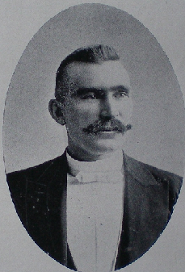
“George H. Slocum. The author of some of the neatest stroke problems in existence was born in Whiteside County, Illinois, in 1855, of American parentage. Raised on a farm, but having a talent for music, he learned the violin, and at the age of 25, he joined the theatrical profession as orchestra leader, traveling with dramatic companies for a number of years. He married in the fall of ’88, his wife being a fine pianist. In 1890, the Chicago Ideal Concert Company was organized, he being the violinist and his wife the pianist of the company, of which he owned a half interest. The company toured Illinois and the adjoining states and became quite popular with lecture and Y.M.C.A. courses. They continued traveling for two years, and since then he has continued his orchestra work in the city of Chicago, where he now resides.

He paid no particular attention to checkers until about 1886. He witnessed the American champion, C. F. Barker, in exhibition play, and became enthused over the silent game, and has continued to be a great admirer since. He is especially fond of problems, and has composed some of the finest gems of the stroke class. . . He holds the honor of being a charter member of the Chicago Chess and Checker Club, and still retains his membership.”

PUBLISHED GAME – April 1 & 2, 1894

April 1 & 2, 1894, American Checker Review, Volume VI, Issues 1 & 2, Lucius S. Head published some analysis (9 variations and 3 notes) on the Single Corner Fife. He called it the “White Fife”. It included the following Slocum versus Head game. The game reappeared in Duffy’s Single Corner (P. 75, Var. 83, Note P), 1934, without reference to the American Checker Review.

11-15 16-20 3-28 13-17 19-24 24-27
22 18 28 24 18 15 22 13 26 22 Draws
15-22 8-12 4-8 6-9B 8-12C G.H.Slocum
25 18 19 15 25 22 13 6 22 18 versus
12-16 14-17A 2-7 1-19 7-11 L.S.Head
29 25 21 14 23 18 23 16 14 10
10-14 7-10 9-13 12-19 11-16
24 19 14 7 27 23 18 14 18 14

- Forms the Single Corner Fife. 4-8 is considered best. Duffy

- 12-16, 13 9, 6-13, 15 10, 7-14, 18 9, 5-14, 23 18, W.W., Head

- 8-11, 22 18, 24-27, 32 23, W.W., Head

May 1894, Draughts World, Volume III, No. 35, Page 408,
Problem Department, conducted by Peter Bennett, Glasgow, published the following:

Referring to two problems by other authors), “They are first rate specimens of a type of “stroke” which Mr. G. H. Slocum of Chicago has done so much more than any other to develop and perfect that it has become associated with his name in the term Slocum Stroke”.

#62 – April 1, 1894
Background:

This issue of the American Checker Review attempted a fresh start with Hefter back as Problem Manager and Head as Games Manager.

#62 was the third of Slocum’s 2 x 2s. More than two years had passed since the last one. This one was not very popular, but strangely it appeared in the American Checker Review twice, undoubtedly an oversight by Denvir.

#62 did not appear in Call’s Midget Problems, perhaps because the solution was considered too simple. It should have qualified for Call’s “Group 8: Draws without the move by threat of exchange”

In this case, there is more beauty in beating the bad moves than in confirming correct ones.

Lessons for Composers:

111. True solutions are camouflaged by false ones. To find the true, you must refute the false.

#62 - SLOCUM’S THIRD “2 x 2”
HIS THIRD BREECHES
White to Play and Draw
Solution #62

*32 27A, 1-6B, *27 23C, 28-24, *23 19D, 24-15, *7 10, Draws by the Breeches

A – Although not immediately obvious, the Draw requires the White king to remain anchored on 7 to the end. For example, if 7 10, *28 24 (not 1-5, *10 6, Draws by see-saw), 10 15, 1-6 (or 1-5), 15 18 (if 32 28, *24-27, RW), *24-19 (to prevent 18-23), RW - Composers should note the see-saw draws that result if that 18-23 is permitted

B – If 1-5 (avoids the “Breeches, but), *27 23 (not 7 10, *5-9, 10 15, *9-14, 15 19, *14-18, 19 23, 18-15, 23 26, 28-32, RW), 28-24, *23 18, 24-19, *18 14, 19-15, *7 2, Draws

C – Not 7 11, *6-9 (not 6-10, *27 24, Draws by the Breeches again), 27 23 (11 15 is B, 2nd parentheses, at 3, 10 15), *28-24, 23 18, 24-19, 11 7 (now same as the position after the 4th move of F. Allen’s 1870 version of the “American Position, colors reversed, continuation by Allen), *9-6, 7 3, 6-10 (or 19-23, 18 15, *23-19, same), 18 15, *10-6, 15 11, *6-10, 11 8, *19-16, 8 4, *16-12, RW

D – Not 23 18, *24-19 is C at 8, *9-6.

Bibliography #62: (3 items)

April 1 & 2, 1894, American Checker Review, Volume VI, Issues 1 & 2, Page 16, Problem 16, colors reversed

April 1897, American Checker Review, Volume VI, Issue 8, Page 8, Problem 2, colors reversed, one of four “composed for John T. Denvir’s Lessons”, Solution: June 1897, Volume VI, No. 10, Page 8

May 1911, Canadian Checker Player, Volume 5, Issue 5, Page 120, from “a list of 2x2 problems all having a man or king on Square 1, as compiled by W. Donaghy from his collection”, Teetzel

PUBLISHED GAMES
July & August 1894

July & August 1894, American Checker Review, Volume VI, Issues 5 & 6, Game 50 (Double Corner), contains some joint analysis by Head & Slocum

Trunk:
9-14 8-11 29 25 2-6 17 13 1-10
24 19 18 15 8-11 22 17 9-18 5 1
5-9 11-18 27 23 11-15 19 16 *10-15, C
28 24 21 17 10-14, 1 32 28, B 12-19 “White for
11-15 14-21 25 22 14-18 26 23 Choice”
22 18 23 5 6-10 23 14 19-26 G.H.Slocum
15-22 4-8 24 20, A 6-9 31 6 L.S.Head
25 18 Analysis

“Apparently they collaborated on several points in this analysis”, Al Darrow

A. “A very strong move; will it win? Lack of time prevents our giving it more than a cursory examination”, Head (ibid, Var. 2d)

B. Head merely commented, “19 16?”

C. “This is a fine position for the problemists. Can White force a win? If so, how? It is not as easy as it looks – at least we found it so”, Head and Slocum (ibid, Var. 3).

“Nemesis values this position a draw”, Al Darrow:
*10-15, 1 5, 15-18, 5 9, 18-22, 9 14, 7-10, 14 7, 3-10, 20 16, 22-25, 30 26, 10-14, 26 23, 14-17, 23 19, 25-29, 19 15, 29-25, 16 12, 25-22, 15 11, 22-18, 11 8, 18-15, 13 9, 15-11, 8 4, 11-7, 4 8, 7-3, 8 11,
21-25, 11 15, 3-7, 15 18, 7-3, 18 23, 3-7, 23 26, 7-3, 26 30, 17-21,
9 6, 3-7, 30 26, 7-2, 26 22, 2-9, 22 29, 9-14, 12 8, 14-17, 8 4, 17-22,
4 8, 21-25, 8 11, 25-30, 11 15, 30-26, 15 10, 26-23, 10 14, 22-18,
14 17, 18-15, 17-21, 15 11, 29-25, 11 8, 25-29, 8 4, 29-25, Nemesis, April 2010.
Var.1 (Off Trunk):
11-15 26 22 15-24 17 13 24-28 31 22
25 22 7-11, 2, 3 28 19 16-20 19 15 32-28
6-9 32 28 3-7 22 17 10-26 22 17
22 17 11-16 20 11 20-24 17 10 Draws
9-14 24 20 7-16 13-9 28-32 Slocum
vs. Head
Var. 2 (Off 1):
14-18 24-28 1-10 15-18 22-26 26-19
23 14 31 26 5 1 6 10 9 6 10 7
2-6 6-9 7-11 18-22 26-31 3-10
24 20, 3 17 13 1 6 26 23 6 1 6 8, D
15-24 10-17 10-15 12-16 31-26 Draws
22 18 13 6 18 14 14 9 1 6 Slocum
vs. Head
D. (ibid Var. 6)

Var. 3 (Off 2):
32 28 9-18 2 6 15-24 31 24 17-22
12-16, E 13 9 1-10 28 19 2-27 Red
19 12 18-23, F 5 1 10-14 14 10 Wins
6-9 9 6 11-16 6 10 27-32 Head
22 18 7-11 1 6 14-17 10 15, G versus
15-22 6 2 16-20 10 14 22-25 Slocum
17 13 10-15 24 19 23-27 15 18 (ibid, Var. 5)

E. “Only two men short”, Head (ibid, Note b)

F. “10-15, 9 6, 1-10, 5 1, draws easily”, Head and Slocum

G. “Playing for 32-27, 12 8, 3-12, 23 19, to draw.” (ibid, Note d)

“Slocum and Head apparently played three practice games and shared some analysis. Head won a hard fought game, and they drew the other two. Neither Head nor Slocum played like a third rate player”, Al Darrow
#63 – before July 7, 1894
Background:

#63 and #64 are both “all about the Move”. They appeared in the Pittsburg Dispatch; not in the fading American Checker Review, but not sure when.

In both cases, White does not have the Move, and therefore cannot pin Red without first getting it. Their means of getting it are different, but the circuitous intricacies required to reach that stage are strikingly similar.

#63 proved to be the most popular, as attested by being published at least 20 times. Its solution is effective and efficient, but suffers from many unstarred moves (different routes to the same finale). These minor flaws did not diminish its attraction. There is something fascinating about herding the prey into no more than a simple, but killing, exchange.

It is difficult to find other settings that demonstrate the same or similar theme. But Slocum used the same finale again in #66.

A superior example of “all about the Move” was by “Author Unknown”, and called “The Long, Long Trail” on Page 50 of Wiswell’s Science of Checkers and Draughts (1973).

#63 – “LONG PRELUDE II”
SLOCUM’S 5TH “3 X 3”; HIS 6TH “ALL ABOUT THE MOVE”
White to Play and Win
Solution #63

*6 1A, 5-9, 1 6 (or 1 5), 9-13, *6 9B, 21-17, 22 26 (or 22 25), 17-21, 9 14, 13-17C, *26 30, 17-22, *14 18, 22-25, *18 22, 25-29, *30 26, 21-25, *22 18, 25-30 (or 25-21), *26 22, 30-25, 18 15D, WW by the Move

A – Without the Move, White is off key and frustrated. This problem is all about changing the Move, while herding Red into the single corner.

B – If the Red piece on 3 were not a king, the 11 7 exchange would gain the Move and win by the “American Position”. This and Note C of #62 exhibit a certain kinship. The two compositions may have sprouted from the same seed.

C – 21-25, *14 18, 13-17, *26 30, 25-21, 18 22 (or 18 14 is Trunk at 11, 26 30), WW by the exchange, changing the Move

D – The stoic presence of the pieces on 3 and 11 provides the necessary, facilitating backup for the final, forcing, Move-changing exchange. The exchange is not a star because it can be postponed.

Lessons for Composers:

112. Intricacies fascinate.

Bibliography #63: (20 items)

Before July 7, 1894, Pittsburg Dispatch

Before July 7, 1894, Liverpool Mercury

July 7, 1894, Chicago Inter-Ocean, Problem 573, “The above problem originally appeared in the Pittsburg Dispatch, but since its first appearance it has gone the rounds and finally appears in the Liverpool Mercury, and is commented on by Mr. Beattie as follows: ‘Apparently White can win by methods not beyond the ordinary, and this is unlike your average Slocum problem. The amateur solving it, however, will have a nice experience in scientific finishing.’”
Before August 1894, Pittsburg Chronicle

August ?, 1894, North Otago Times, Volume XXXVII, Issue 8067, Page 1, Problem 128, solution September 3, 1894

October ?, 1894, North Otago Times, Volume XXXVII, Issue 8103, Page 1, Problem 138 (a repeat), solution October 15, 1894

1911, Kear’s Encyclopedia, 1st Edition, Prob. 61

March 1912, Draughts World, Volume XXXIX, Page 412, “Stray Gems Gathered from Other Pages”, GEM 876, “by G. H. Slocum, Chicago”,

“A fine exhibition by America’s noted problemist”

Before April 1913, Sheffield Independent, Prob. 1168, “by G. H. Slocum, Chicago”

April 1913, Draughts World, Volume XLI, Issue 196 (New Series), “Stray Gems Gathered from Other Pages”, GEM 928,

“A pretty little finish”, same problem published twice by Draughts World in a span of 13 months

May 25, 1913, Sunday Times, Perth, Australia, Page 15, Problem 207, “Two points”

1917, Kear’s Encyclopedia, 2nd Edition, Prob. 61, not in 3rd and 4th Editions

Before September 1924, Bradford Observer, Prize Problem

September 1924, American Checker Monthly, Vol. IV, Issue 9, Page 213, Prob. 64,

“Tom Goldsboro, ex-champion of England, recently ran this as a prize problem in the Bradford Observer with this introductory remark: ‘For many years the name, ‘Slocum”, attached to a problem was a sure sign it was one of the gems of the board’.

January 16, 1926, The Mail, Adelaide, Australia, Page 25, Prob 171

December 25, 1934, Examiner, Launceston, Tasmania, Problem 686 “with the compliments of the season”;

“Slocum was renowned for his ‘deferred strokes’. Occasionally he composed rather more practical problems of which the above is a fine specimen.”

June 1940, Wood’s Checker Player, Volume 3, Page 259, Ladder Prob. 30, Solution, July 1940, Page 293

1943, Wiswell’s Checker Magic, Prob. 86, “Turning the Tables”;

“Here is still another gem by this noted composer. White has the upper hand, but Black is in possession of the move. How to make a trade and thereby change the move? That is the problem – and Mr. Slocum shows us how to do it – scientifically”, Wiswell

May 1992, Keystone Checker Review, Page 356, Problem 16, solution on Page 362 of same issue, part of Bob Crue’s collection of Slocum problems
#64 – before October 1894
Background:

We do not yet know when and where #64 was first published.

As pointed out under #63, coupling #64 with it made an impressive duet: same size; same terms; same herding motif; same single corner congestion; and almost the same number of moves. Differences were a Red king was pinned on 2 instead of 3; the Move was changed with a neat 2 for 2 shot instead of a simple 1 for 1 exchange; and 8 star moves versus 10.
#63 was more popular, but #64 was technically better, based on the above differences and greater difficulty. Do you agree?

While you are in the judgmental role of a critic, compare #64 with #42. Again similarities abound. #42 may be better because it offers more false solutions and resulting difficulty. Do you agree?

Lessons for Composers:

113. Good settings hide more than meets the eye.

#64 – “LONG PRELUDE III”
SLOCUM’S 7TH “ALL ABOUT THE MOVE”;
HIS 12TH DOUBLE; HIS 6 TH 3 X 3
White to Play and Win
Solution #64

*5 1, 6-2, *1 5A, 9-14B, *5 9C, 14-17, 9 14 (or 9 13), 17-21, *15 10,
29-25D, *14 9, 25-30 (or 25-29), *26 22, 21-25, *9 13E, 25-29, *13 9F, 30-25 or 29-25, *9 5, 25-18, *10 6, WW by the Double and the Move

A – Composers should note that 1-6 allows *9-13, 6 10,*29-25, Draws. But if the Red King on 2 is a single piece, 1-6 is a dual win.

B – “If 9-13, White Wins by *15 10, 29-25, *26 22.”

C – “He may not play 15 10 on account of the drawing “breeches” resulting”, Abernethy

D – Composers should note that, if 21-25, then 14 9 and 26 22, in either order, returns to Trunk

E – “Every move fits beautifully”, Abernethy

F – Composers should note the forced steal, free move, and double to change the Move

Bibliography #64: (4 items)

Before October 1894, Pittsburg Dispatch

October ?, 1894, North Otago Times, Volume XXXVII, Issue 8103, Page 1, Problem 139, solution October 15, 1894, included above notes in quotation marks

1911, Kear’s Encyclopedia, 1st Edition, Prob. 63

1917, Kear’s Encyclopedia, 2nd Edition, Prob. 63, not in the 3rd and 4th Editions

#65 – before November 1894
Background:

We are not yet sure where or when #65 was first published.

It proved quite popular despite its unavoidable shortage of star moves. Trivial White alternate moves, early on, may have mesmerized solvers, thus exacerbating the deception when the epiphany finally presented itself. Composers should note that if the White piece on 29 were on 30, there would be a dual WW; and if the White pieces on 26 and 29 were on 25 and 30, Red could draw. Slocum found the only sound setting.

In 1894, Peter Bennett, known as P.B., conducted a competition to determine the best definition of the term: “stroke”. The results did not satisfy him because, as he pointed out, there are “three main classes” of stroke, and no single definition covered them all. P.B. used #65 to explain:
“First, what we may term the ‘pure stroke’, in which every move of the opposition, from start to finish, is a ‘take’; Second, the ‘Slocum Stroke’. The opposition here is compelled, under penalty of obvious and irretrievable loss, to form a pure stroke. For example: - (#65). Third, the ‘Mixed Problem’”, etc., P.B.

#65 – “MESMERIZED”
SLOCUM’S 19TH TRIPLE; HIS 4TH BREECHES;
HIS 5TH IN AND OUTER
White to Play and Win
Solution #65 including Peter Bennett’s notes:

*15 10, 11-4A, 10 6 (or 10 7), 4-8B, 6 1 (or 6 2), 8-11C, 1 6 (or 1 5), 11-15D, *23 19E, 15-24, *29 25, 21-30, *6 9, 30-23, 9 20F, WW by a Triple and the Move

A – “A ‘take’”, P.B.

B – “Nothing else without loss”, P.B.

C – “Must move in this direction to relieve the prisoners if possible”, P.B.

D – “Forms the pure stroke, but must be played to prevent the more obvious loss by 6-9”, P.B. Composers should note that if the White pieces on 26 and 29 were on 25 and 30, Red could avoid the Trunk win and instead draw by 11-7, 11-8, or 11-16. White then could not attack the Red piece on 14 without losing the piece on 25.

E – Not 6-9, *15-18, 23 19, *18-22, 9 25, 21-30, 26 23, *30-26, Draws. Composers should note that if the White piece on 29 were on 30, there would be dual solutions by either the Trunk win or 6 9, 15-18, *23 19, WW.

F – “Decisive”, P.B.

Composers should note that P.B. was demonstrating that strokes are classified based on the defender’s moves. In contrast, the moves of the protagonist determine the quality of the composition.

Lessons for Composers:

114. The quality of a composition depends more on the deception of the protagonist than on the travails of the opposition.

115. Similar appearing settings seldom signal similar results.

Bibliography #65: (14 items)

Date (?), Yorkshire Weekly Post, Leggett’s “Half-Hours with the Best Authors”, Prob. 6
November 1894, Draughts World, Volume 4, Issue 41, Page 510, Example of “Slocum Stroke” in an article summarizing a stroke definition competition

January 17, 1895, Otago Witness, Issue 2134, Page 38, a verbatim copy of the above Draughts World article

February 1896, Draughts World, Volume 7, Issue 56, Page 806, “Stray Gems Gathered from Other Pages”, GEM No. 103,
“Worthy of the Chicago composer’s reputation”

1909, Horsfall’s Problem Book, Page 72, Prob. 648

1916, ABC of Draughts, by Fred Passey, Queensland, Australia

December 15, 1916, Western Mail, Perth, WA (Australia), Page 33, Problem 990, from “ABC of Draughts”, “A SLOCUM STROKE”

1923, Wendemuth’s Checker Companion, Page 152, Prob. 101

November 1923, Morris-Systems Checkerist, Volume 1, Issue 4, “Advanced Players’ Problem Section”, Problem 27, solution Issue 5

December 2, 1931, Examiner, Launceston, Tasmania, Pg 11, Prob 528, “One of Slocum’s easiest, but how many will solve it at first attempt?” solution December 16, 1931

1981, Irving Chernov’s Compleat Draughts Player, Page 258, Problem 6

December 1990, Midwest Checkers, Volume 12, Issue 6, Page 892, Problem 2, one of two problems “sent by Ben Boland. He called them ‘Gemini’”; solution Page 907, last issue of Midwest Checkers

July 1992, Keystone Checker Review, Page 379, Problem 23, solution on Page 398 of same issue, part of Bob Crue’s collection of Slocum problems

February 2000, ACF Bulletin, Issue 283, Page 3, Problem 3, solution April 2000, Page 7
#66 – before October 1894
Background:

We don’t know when or where #66 was first published. But we know Draughts World published it three times.

As in #59, three short, clever, divergent variations helped #66 achieve its great popularity. Two of them were reminiscent of #16 and #63, respectively. Two of them hark back to older classics.

There was nothing particularly original about #66 except the fact that it parlayed the three different finales together in one unique setting.

#66 was obviously an outgrowth of #63, and an improvement insofar as it introduced multiple pitches, and the percentage of White star moves rose from 66.7 to 100.

Interconnecting thought between different Slocum settings were becoming apparent as the number of settings mounted.

#66 also demonstrated Slocum’s ongoing interest in the intricacies of the Move and playing a piece short.

#66 – “SIMPLY DIVERSE II”
SLOCUM’S 8TH ALL ABOUT THE MOVE; HIS 2ND LOCK
White to Play and Win
Solution #66

*2 7, 10-3A, *13 17B, 18-23C, 26 19, 25-30D, *17 22, 30-25, *19 15, WW, by the Move, same finale as #63

A – Now a piece-down win. The piece on 11 pins the king while being available for backup duty in case an exchange is needed to change the Move, as in #63.

B – Any other move not only fails to win; it loses.

C – Red’s piece on 18 is in jeopardy. There are three defenses; two of them succumb to old classics:

- If 18-22, *26 30 (not 26 23, *25-30, Red has the Move to draw), 22-26, *30 23, White has the Move to win by the “American Position” with extra pieces.

- If 25-30, *26 22, 18-25, *17 21, WW by “Payne’s Lock” with extra pieces; see #16

D – Red now has the Move. White must force the exchange to change the Move and win, just like #63, except with a closing star move.

Lessons for Composers:

116. The linkage of divergent themes in the same setting is an appreciated attribute.

Bibliography #66: (15 items)

Date (?) Pittsburgh Dispatch, Prob. 177

October 1894, Draughts World, Volume 4, Issue 40, Page 493, “Stray Gems Gathered from Other Pages”, GEM No. 38,

“Simple enough, yet one of the most perfect that the author has composed. There are three variations and each finishes neatly”

Date (?), Manchester Times, Prob. 938

July 1901, Draughts World, Vol. 18, Issue 55 (New Series), Page 1091, “Stray Gems Gathered from Other Pages”, GEM 365, colors reversed,
“The author’s name sufficeth to guarantee the quality of above production”

1901, Whyte’s Problemists’ Guide, Prob. 310

August 21, 1901, Otago Witness, Issue 2475, Page 58, Problem 1959, colors reversed,
“The author is noted for his ‘stroke’ compositions, and the solver may be ‘looking for it’ in this one. But it is not a stroke”, Joseph Abernethy, solution September 18, 1901

September 1901, North American Checker Board, Volume XI, Issue 3, Page 47, Prob. 25, colors reversed, solution October 1901, Page 62

October 19, 1901, Western Mail, Perth, WA (Australia), Page 36, Problem 220, colors reversed, solution November 9, 1901, Page 37

1905, Atwell’s Scientific Draughts, Prob. 252

1909, Horsfall’s Problem Book, Page 62, Prob. 555

September 1909, Draughts World, Volume 34, Issue 153 (New Series), Page 892, “Stray Gems Gathered from Other Pages”, GEM No.757,
“We enjoy giving our readers some of Mr. Slocum’s fine touches”

June 7, 1923, Chicago Daily News, Problem 503, solution June 14, 1923

1923, Wendemuth’s Checker Companion, Page 152, Prob. 100

April 1944, Wood’s Checker Player, Volume 7, Page 211, “Tyro’s Page”, Prob. 7, Solution: Page 223

July 1992, Keystone Checker Review, Page 379, Problem 22, solution on Page 397 of same issue, part of Bob Crue’s collection of Slocum problems
#67 – 1894
Background:

Composers, prepare for a feast. Consider together #67 and #67a. We don’t know when or where either of these versions was first published. They appear to have been based on the flawed #34 (June 21, 1891).

One or the other has been shown to all levels of checkerists over the years. Unless they have seen it before, even the best have struggled before finding the solution or giving up. Try one or show it to your strongest opponents.

The evolution of #34, into #67 and #67a, required subtle, but crucial changes: primarily the reversal of the White pieces located on 23 and 27; and the changing of the Red piece on 16 to a king.

#67 and #67a both feature arguably the most unusual and sensational move in all of checker problemathology. See their solutions.

Other features are the dramatic effects that small changes in the setting can have on the solution. Changing either of the Red pieces on 5 or 16 to a king, or relocating the White king from 4 to 3, all have stories to tell.

#67 – “THE 3-WAY SLIP PITCH”
SLOCUM’S 13TH QUADRUPLE; HIS 11TH BACK AND FORTH,
HIS 19TH SLIP PITCH; 11TH 2-WAY PITCH; 2ND 3-WAY PITCH
White to Play and Draw
Solution #67:

*17 14A, 21-25, *22 18A, 25-22B, *14 9C, 22-15D, *23 18E, 15-22F, *4 8G, 5-14 (or 32-23), *8 12, Draws by the Quadruple, but is not a WW because the Move is wrong at the end.

A – White seems helpless against the Red king’s initial presses. Composers should note that the Red piece on 13 is necessary to make these two presses work. And in the end, it is this same unmoved piece that has the Move to prevent a winning finale for White.

B – If 16-19, 23 16, 32-23, *14 19 is required to draw.

C – Dodging the foreboding dangers facing White’s dilly-dallying discs demands doubly drastic deductions to derive the difficult draw. This 2-way pitch is just the beginning.

D – Composers should note that if the Red piece on 16 were a king, Red would win by *5-14, 18 9, *16-20, 27 31, *20-24 eventually followed by 32-28 and 24-27, RW

E – This unique 3-way slip pitch has baffled countless solvers. Two ways sacrifice two pieces and the third seems to be a purposeless back and forth give-away. But the results of all three are crushing epiphanies. Has there ever been a more sensational move?

F – Avoids both Triples, but falls into a Quadruple

G – Composers should note that if the White king on 4 were on 3, there would be a dual solution at E by 3 7, 5-14 (or 32-23), *7 10, Draws by the same Quadruple as the Trunk, except backwards! The reverse jumping is reminiscent of #33, Variation 1. Also note that by simply changing the Red piece on 5 to a King, this dual solution is eliminated.

Lessons for Composers:

117. One Motif may have many settings.
Bibliography #67: (11 items)

1894, Stearns’ Book of Portraits, Volume 1, Page 107, Prob. 67

NOTE: “Geo. H. Slocum, the noted problemist of Chicago, Ill., writes: Your Book of Portraits received, and I value it very highly. It is a very interesting work, and I think you have done nobly in getting such a book before the public. I enjoy the book immensely. Yours fraternally, G. H. Slocum, Lake Geneva, Wis.”, June 15, 1895, North American Checker Board, Volume 1, Issue 2, inside back cover

November 10, 1907, Chicago Inter-Ocean, Prob. 4013

1909, Northern Weekly Leader, Prob. 1699

March 1909, Draughts World, Volume XXXIII, Page 772, “Stray Gems Gathered from Other Pages”, Gem No. 732,
“A very fine exposition by a well-known composer”

1909, Horsfall’s Problem Book, Page 85, Prob. 760

Circa 1921, Chicago Daily News, Problem 433, diagrammed with the Red piece on 5 as a King

1923, Wendemuth’s Checker Companion, Page 153, Prob. 102

July 1992, Keystone Checker Review, Page 379, Prob 24, solution on Page 398 of same issue, part of Bob Crue’s collection of Slocum problems

September 1993, Keystone Checker Review, Page 587, Problem 53, solution on Page 596 of same issue, part of Bob Crue’s collection of Slocum problems

April 2000, ACF Bulletin, Issue 284, Page 7, Prob 43, solution same page

2010, Al Lyman’s Checker Site, http://www.checkerworld.com/ , “Slocum-2”, second of three by Slocum
#67a – 1894?
Background:

You will note that #67a is identical to the position reached after the 4th move of #67, except with two additional changes:
- The red piece on 5 was changed to a King for no apparent reason.
- The silent Red piece on 13 was eliminated, thus changing the draw to a WW by a clean sweep.

The solution of #67a is identical to the solution of #67 beginning at Note C., thus clearly attributable to Slocum. But we are not sure whether the modified setting was ever published by Slocum. Jack Birnman may have modified the original setting when he set it up for New York City players in 1944 (see Bibliography).

#67a is included here only because it has been published at least 4 times as a separate setting credited to Slocum.

Which setting is better: a deferred stroke to an anti-climactic draw, or a pure stroke to a clean-sweeping win? It is the composers’ prime dilemma.

#67a – Modification of #67; “MOST EXQUISITE”
SLOCUM’S 10TH PURE STROKE; HIS 14TH QUADRUPLE
HIS 12TH BACK AND FORTH, HIS 20TH SLIP PITCH,
HIS 12TH 2-WAY PITCH, HIS 3RD 3-WAY PITCH
White to Play and Win
Lessons for Composers:

118. A composition must first satisfy the composer.

Solution #67a:

Same as #67 beginning at Note C

Bibliography #67a: (5 items)

Nov 1944, American Checkerist, Vol 4, Issue 1, Page 12, Prob 141, “The immortal George H. Slocum is the inventor of example 141, which we consider one of the most exquisite stroke problems on the record, first published many years ago. When Jack Birnman of Washington, D.C., was recently vacationing in New York City, he was setting up some of his cannonballs for the crowd, when who should stalk through the door in a cloud of dust but Julius Brandler – Dama’s own desperado, the nasty man who baits beginners for bets and then sends them home crying to mama, sans bootle in their britches. Spoke Julius in stentorian gusto that resembled a super-charged breeze from Canarsie, “I can solve any stroke problem on the board!” Whereupon, Mr. Birnman quietly graced the squares with No.141, opining that he considered it one of the finest problems on record. It was really a beautiful sight to see bad boy Brandler flourish the pieces in various futile directions, repeatedly chanting, “I’ve got it!”, while Professor Birnman vainly tried to turn his dimpled grin outside in. The popular theory here is that if Julius can solve a problem on the first try, it ain’t worth publishing!” William F. Ryan, Page 13, solution Page 15

1980, Oldbury’s Complete Encyclopedia of Checkers, Volume 3, Page 347, Problem 171, solution Volume 4, Page 486

1981, Irving Chernev’s Compleat Draughts Player, Page 257, Problem 2

May 1993, Keystone Checker Review, Pg 539, Prob 47, solution Pg 542 in same issue, part of Bob Crue’s collection of Slocum problems

Nov 2011, Al Lyman’s Checker Site, http://www.checkerworld.com/ , “Slocum-3”, third of three by Slocum
#68 – December 1894
Background:

#68 and #69 were submitted as a beautiful pair to J. P. Reed’s Checker Journal.

#68 was another short, sweet, Slocum stroke that still seems to stump savvy solvers. Here is a huge hint: look for a devastating 2-way, 2-piece, domino, slip pitch. Liam Stephens calls it “a beauty”.

Composers should note the Red piece on 2 is a king. Why? By making it a king, Slocum astutely avoided dual solutions at Notes A and C.

In 1938, Chicagoan Milton Johnson, unaware of Chicagoan Slocum’s setting, published a very similar one (see Bibliography). After the first move, the solutions were identical. But Johnson’s version had a single Red piece on 2. His version avoided the dual solution at Note A, but succumbed to the one at Note C.

#68 - SLOCUM’S FIFTEENTH QUADRUPLE
HIS THIRD BRIDGE
HIS 21ST SLIP PITCH
HIS NINTH DOMINO PITCH
HIS 20TH 2-PIECE PITCH
HIS 13TH 2-WAY PITCH
White to Play and Win
Solution #68:

*3 7A, 13-17, *5 1B, 6-9, *11 15C, 2-18 or 4-18, *1 6, WW by a clean-sweep Quadruple

A – Composers should note if the Red king on 2 were a single piece, 5 1 would lead to a long dual solution: 5 1, 6-9 (or 6-10, *3 7, 10-14, same) *3 7, 9-14 (13-17 is Trunk at 4, 6-9), *7 10, eventual WW. Some interesting themes arise along the way.

B – Not 8 3, *17-14, 1 5 or 3 8, *6-9, Draws

C – A 2-way, 2-piece, domino, slip pitch. Again composers should note that if the Red king on 2 were a single piece, 7 10 at C would lead to another long dual solution with worthwhile themes.

Lessons for Composers:

119. Minor changes in settings can have major effects on solutions.

Bibliography #68: (3 items)

December 1894, J. P. Reed’s Checker Journal, Volume 1, Issue 10, Prob. 40, Solution: February 1895, Checker Journal, Volume 1, Issue 11, Page 44

July 1938, Games Digest, Volume 1, Issue 11, Problem 45 except with a single Red piece on 2, and the White kings on 3 and 5 relocated to 7 and 9, composed by Milton Johnson unaware of Slocum’s setting

March 1939, Wood’s Checker Player, Volume 2, Issue 3, Problem 202, repeat of Milton Johnson’s setting

#69 – December 1894
Background:

Although Slocum submitted #68 and #69 for publication in 1894, #69 was not published correctly until 1895 (see Bibliography).

While #69 had a low percentage of star moves and no fireworks, it proved to be pleasingly popular. White’s job is to contain the Red king on 31, as it runs everywhere but loose. Plot its flight path, right to left, back and forth, left to right, like a pinball, or a punching bag, or a meandering searchlight.

White has opportunities to blow the win (false solutions), and has other opportunities to go astray but then recover without throwing away the win (time-wasters). The former are praiseworthy; the latter are technically flaws. Ultimately the solver must circumvent them all.

Lessons for Composers:

120. Both false solutions and time-wasting moves make problems more difficult to solve.

#69 – “THE SEARCHLIGHT”
SLOCUM’S 9TH “ALL ABOUT THE MOVE”
HIS 7TH 3X3; HIS 13TH BACK AND FORTH
White to Play and Win
Solution #69:

*18 23A, 31-26, 23 19B, 26-22, 19 15A&B, 22-17, 15 10A&B, 17-22C, 10 6A&B, 22-18D, *30 26A, 18-15, *12 16A&E, 21-25F, *26 22G, 25-30, 6 9 (or 6 1), WW by the Move or Breeches

A – White must not let the Red king escape to either double corner.

B – Other moves waste time. “W.T.” in the Examiner, Australia, November 21, 1934, explored some of these moves, but they are not repeated here.

C – Back and forth he goes. If 17 13, the kings on 4 and 12 become superfluous. If they are removed at this point, the position, colors reversed, becomes a 2x2, which Call’s Midget Problems, Page 37, (1913) and Boland’s Famous Positions, Page 49, (1938) both credited to C. M. Potterdon (date ?). Slocum’s setting may have been earlier. Continue with or without the superfluous pieces: 10 6A&B, 13-17 (back and forth), 30 26B, 21-25, *26 30, 25-29 (17-21 ends the same way), 6 9 (or 6 10), 17-21, 9 14 (30 26 wastes time), 29-25, 14 18, WW by American Position, G. Moodie (1940)

D – 22-17 is C at 3, 13-17. If 22-25 at D, then 30 26, 25-29, 6 9, WW,
G. Moodie (1940)

E – At this point, the kings on 4 and 12 are no longer superfluous.

F – If 15-18, *16 11, 18-14, 26 22, WW, G. Moodie (1940)

G – Not 26 30, *25-29, 6 9, *15-18, 30 26 or 16 19, *4-8, Draws

Bibliography #69: (12 items)

December 1894, Reed’s Checker Journal, Volume 1, Issue 10, Page 38, Prob. 39, colors reversed, diagrammed incorrectly with a single piece instead of a king on 12, thus spoiling the win. It was corrected in the next issue, as follows:

February 1895, Reed’s Checker Journal, Volume 1, Issue 11, Page 42, Prob. 43, colors reversed; Page 44, “Problem No.39. This problem was set wrong, see Problem No. 43”, Reed, solution March 1895, Reed’s Checker Journal, Volume 1, Issue 12, its last issue.
1911, Kear’s Encyclopedia, First Edition, Prob. 58, “An excellent study showing how to take full advantage of the possession of The Move”, J. K. Lyons
March 5, 1915, Third American Tourney Book, Prob. 49

1917, Kear’s Encyclopedia, Second Edition, Prob. 58; after Kear, Sr., died, Kear, Jr., completely revised the problem section, and eliminated this problem from subsequent editions

1920, Boston Globe, Herb Morrall’s “Checkers” column, Prob. 65, colors reversed

October 31, 1921, Chicago Daily News, Problem 342, solution November 5, 1921

October 31, 1934, Examiner, Launceston, Tasmania, Problem 678, “Totally different from the author’s celebrated ‘deferred strokes’, but of more practical use, and perhaps equally beautiful”; expanded solution November 21, 1934

November 5, 1940, Examiner, Launceston, Tasmania, Problem 987,
“A scientific ending, every move made by White being essential in order to prevent Red slipping through for a draw. I think this is one of Slocum’s best, and well worth working out again by any who may have seen it previously. (Try it without moving a piece)”, G. Moodie, Tasmanian Champion, Solution: November 19, 1940, with added variations, “a beautifully timed win”, G. Moodie

December 1941, Elam’s Checker Board, Problem 2052, colors reversed

June 1943, Wood’s Checker Player, Volume 6, Issue 10, Page 275, “The Searchlight”,
“Searchlights sometimes comb the night air looking for planes and spotlights often make clear the beauty or skill of the stage performer. How can strong light be cast upon an elusive checker problem? “I cannot see even one ray of light” complained Hatley in regard to the following problem by G. H. Slocum. “Take off the pieces on 4 and 12 and the problem would be White to play and Black to draw” suggested the Internationalist. To Hatley’s astonishment, the draw had a clever point to it which threw light on the problem diagrammed. “Of course, you must keep Black out of the double corner”, said the famous player”, A. J. Banks

September 1993, Keystone Checker Review, Page 587, Problem 51, colors reversed, solution on Page 596 of same issue, part of Bob Crue’s collection of Slocum problems
#70 – February 1895
Background:

#70 appeared with the corrected diagram of #69. Like #69, #70 had a long solution and a low percentage of star moves with no fireworks.

But, like so many of Slocum’s compositions, #70 was uniquely different:

- It is not uncommon to grip some of the opponent’s pieces so as to limit the mobility of the remaining pieces. #70 carries this principle to the extreme, forcing one Red piece to move 35 consecutive times. Note the final location of the Red pieces on 11, 12, and 16 after the lengthy play is complete.

- Slocum employed the back and forth motif one time in 13 of his prior compositions. In #70, Red was forced back and forth 29 times.

- Changing of the guard has been demonstrated in many published problems, but none cleverer than in #70. Don’t miss it.

The solution to #70 proceeds unquestioned for 42 total moves, including the changing of the guard. That is longer than the solution to any of Slocum’s other compositions. If the solution to #70 could have legitimately ended at that point, the composition would have been a classic.

But at the 43rd move a simple 2-move dual solution was pointed out by S. Rogers shortly after #70 was published. The many moves necessary to prepare for and execute the changing of the guard, and the many repeated back and forth moves, must have combined to put Slocum to sleep.

Essentially the same dual solution was available and missed many more times throughout the remainder of Slocum’s solution, effectively crippling the composition beyond redemption. This explains why #70 became Slocum’s 27th composition to be never published again (until now).

Lessons for Composers:

121. A dual solution among the early moves is less devastating because early moves can be eliminated without destroying the composition.

122. Long solutions are usually built around maintaining a grip on some opposing pieces so as to confine mobility to the other pieces.

Some attempts were made to establish a second dual solution to #70. But Slocum upset those attempts, vindicating himself by publishing #71 to document his analysis.

#70 - SLOCUM’S THIRD CHANGING OF THE GUARD
HIS FOURTEENTH BACK AND FORTH
HIS THIRD LOCK
HIS TWELFTH DUAL SOLUTION
White to Play and Win
Slocum’s Solution #70:

*32 27A, 19-24, *27 23A, 24-28, *29 25, 28-32, 25 22 (or 25 21), 32-28B, *22 17C, 28-32B, 17 14 (or 17 13), 32-28B, 14 9 (or 14 10), 28-32B, 9 6 (or 9 5), 32-28B, *6 1D, 28-32B, 1 6 (or 1 5), 32-28B, 6 9 (or 6 10), 28-32B, 9 14 (or 9 13), 32-28B, 14 17E, 28-32B, 17 22 (or 17 21), 32-28B, 22 25 (or 22 26), 28-32B, 25 30F, 32-28B, 31 26F, 28-32B, 26 22G, 32-28B (if 32-27, *30 25, WW), 30 26G, 28-32B, 26 31H, 32-28B, 22 17C&I, 28-32B, 17 14J (or 17 13), 32-28B, 14 9 (or 14 10), 28-32B, 9 6K (or 9 5), 32-28B, *6 1D, 28-32B, 1 6K (or 1 5), 32-28B, 6 9 (or 6 10), 28-32B, 9 14K (or 9 13), 32-28B, 14 17E, 28-32B, 17 22K (or 17 21), 32-28B, 22 25 (or 22 26), 28-32B, 25 30K, 32-28B, 31 27L, 28-24, 27 32M, 24-27, *30 26, 27-18, *26 23, WW by maintaining the Lock

A – White must maintain a grip, leaving Red only one movable piece.

B – Slocum employed the back and forth motif many times before, but this is ridiculous.

C – Not 22 18, *11-15, Draws

D – Not 6 2, *11-7, Draws

E – Not 14 18, *11-15, Draws; 14 9 and 14 10 waste time

F – White must station the king here and clear out the piece on 31 in order to accomplish a complicated “changing of the guard”.

G - 30 25 wastes time

H – 26 30 wastes time

I – Not 31 27, *28-24, 27 31, *24-19, 31 26, *19-15, 26 30, *15-10, Draws

J – “We very much regret that a double solution spoils the beauty of this splendid problem. Thus 31 27, 32-28, 27 32, WW”, S. Rogers, March 1895

K – Or 31 27, dual WW as in J

L – “Several correspondents have played 31 26, 28-32, 23 19, 16-23, 26 19, and win by ‘First Position’ at this point, but it only draws. See Problem No. 47”, J. P. Reed (Reed’s No. 47 is #71 in this collection). But, at L, 30 26 and 30 25, 28-32, 31 27, both achieve the dual WW as in J

M – 27 31 wastes time

Bibliography #70: (1 item)

February 1895, Reed’s Checker Journal, Volume 1, Issue 11, Page 42, Prob. 44, colors reversed, solution March 1895, Reed’s Checker Journal, Volume 1, Issue 12, its the last issue.

#71 – March 1895
Background:

#71 arose directly from #70, Note L, colors reversed. Critics claimed it to be a dual WW by First Position with extra pieces. Slocum disagreed. J. P. Reed published #71 as vindication for Slocum. Unfortunately #71 appeared, without solution, in the final issue of Reed’s Checker Journal. It was Slocum’s 28th never republished (until now).

Unbeknownst to all participants, the principles of the draw were worked out earlier by J. Cosgriff in an obscure 1882 column and D. Milligan in the internationally known Glasgow Weekly Herald in 1884. The draw has long been known as “Milligan’s Draw”. The Cosgriff claim did not become recognized until Boland’s 1965 revision of his Famous Positions.

At first, #71 creates difficulties. The sole escape comes late in the solution. Once known, it is routine as with most standard positions.

The first several moves of #71 are insignificant. None of them are star moves. Their timing is not critical. Locating a White king at a key location becomes a late, unexpected essential. What seem to be multiple ways to draw turn out to be only one: the Cosgriff / Milligan draw.

#71 - “AVOIDING 1ST POSITION I”; SLOCUM’S 8TH 3X3,
HIS 10TH “ALL ABOUT THE MOVE”; 6TH CREDIT CONFUSION
White to Move and Draw
Lessons for Composers:

123. A key square may be the key to a solution.

Solution #71:

22 26A&Var.1, 14-18, 26 31A, 18-23, 1 6 (or 1 5), 3-7, *6 1, 13-9 (best), *1 5C, 9-6 (best), *5 1, 7-10B(best), *1 5, 6-1(best), *5 9, 10-15(best), 9 14C, 1-5, 21 17D, 5-1, *17 13, 1-5, *14 17E, 15-10, 17 22 or 17 21, Drawn by see-saw, or by releasing the king on 31.

A – These are not star moves. The draw is there as long as the White king on 22 has access to Square 31. There is no need to hurry up getting there. Composers should note that White cannot draw without, sooner or later, moving that king to 31. See Variation 1 for an unsuccessful attempt.

B – At this point, the solution intersects Milligan’s (and presumably Cosgriff’s) solution at Milligan’s 14th move, 14-10. Credit Cosgriff / Milligan from here on.

C – Or 21 17, 15-18 (best), *17 13, 18-15 (best), *9 14, returns to Trunk

D – Or 14 9, same as C at 1, 21 17

E – Now the effect of the kings on 23 and 31 is evident. If they were not there, Red would wrap up the First Position win with 15 10, 17-21, 10 14, 21-25, 5 1, eventually pinning the White king.

Variation 1 (off Trunk):

1 6F, 3-8, 6 1, 8-11, 1 6, 11-15, 6 1, 14-18, *22 26 (forced), 13-9 (best), 1 5, 9-6 (best), 5 1, 15-10 (best), 1 5, 6-1 (best), *26 31G (forced), 18-23, returns to Trunk at 14, 6-1, the Cosgriff / Milligan draw, Liam Stephens

F – White can draw without immediately running to Square 31. The question is: “Can White draw without falling back on the Cosgriff / Milligan finish, thereby creating a dual solution?” The answer is: “No”.

G – If White tries to delay this one more time by 5 9, then *1-5, 9 13, 10-15, 26 31, *18-23, 21 17 (if 13 17, both 5-9 and 15-18, RW), 15-11 (or 15-19), 17 14, 11-15 (best), 13 17, 5-1 (best), 17 13, 15-18 (best), 14 9, *1-5, 9 6, *5-1, 6 2, *18-14, RW by the Move

Bibliography #71: (1 item)

March 1895, Reed’s Checker Journal, Volume 1, Issue 12 (his last issue), Prob. 47, Solution not included,
“Mr. Slocum squeezes a draw from a position which appears to lose by the First Position”, J. P. Reed

“The play cannot be claimed by Slocum. It is known as Milligan’s Draw. Milligan published it in 1884, but was actually preceded by J. Cosgriff, 1882”, Milton Johnson, 1970

Boland’s Famous Positions, Revised Edition, 1965, Page 75, states Milligan’s Draw is “"From Cross Game No 1687, G. W. H. June 7, 1884. The draw was also shown by J Cosgriff, No. 326, Cinn. Com. Jan. 28, 1882", Boland did not give the Cosgriff setting as such.
(What is the meaning of the abbreviation: “Cinn. Com.”? It is not an e-mail address. It means “Cincinnati Commercial”, a weekly that ran from 1865-1883, Liam Stephens)

FIFTH INTERLUDE – May 1895

May 1895, The Draughts World, Volume V, No. 47, Page 625 (the leadoff article), published the following:
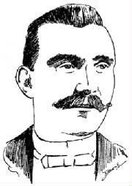
Biographical

GEORGE H. SLOCUM

In the arena of draughts, as in the world of letters, ever and anon bright luminaries suddenly make their appearance – “like meteors from unknown worlds” – spreading the luster of their genius before our admiring gaze, unfolding what were hitherto unsolved mysteries and sounding depths of the “quiet game” never previously dreamt of, and delighting enthusiastic draughts-players of every grade in every clime.

Few of those in our day who have made the composition of problems a special study have attained the eminence reached by the subject of our sketch, George H. Slocum, who has given his name to a type of the “stroke” problem which possesses interesting characteristics peculiarly its own. Several of his compositions have appeared in draughts publications and columns devoted to the game in newspapers all over the world, and have attracted the attention and won the admiration of all who are fascinated by the art of working out the deepest intricacies of Dameh’s labyrinth.

Slocum was born in Whiteside County, Illinois, U.S., in 1855. His father, who was engaged in farming pursuits, was American born, and no doubt anticipated for George also an agricultural career, but the young hopeful early manifested a distinct talent for music, and found his inspiration not beside the plough, but in the compositions of Wagner, Mozart, and other men of genius.

George learned to play the violin before he learned to play draughts, and possibly if the next-door people at the time he was acquiring the first-named accomplishment were asked, they would say that George was a more estimable neighbour when practicing the “silent game” than when he exorcised the genius of harmony – for no matter how gifted a man may be, people who live near him will say unkind things about him when he is in the early stages of fiddle playing.

However, Slocum progressed very rapidly in his studies, and became so proficient as an artiste that at the age of 25 he was appointed leader of an orchestra, and traveled for a number of years with dramatic companies.

He was married in the autumn of 1888, his wife being also an accomplished musician, and together they had a large share in the “Chicago Ideal Concert Company”, which was organized in 1890, and which made a very successful two years’ tour of Illinois and the adjoining states, being particularly popular at lectures and Y.M.C.A. entertainments. He is now a citizen of Chicago, and enjoys an enviable reputation as a musician.

It would appear as if he took up the study of draughts merely as a relaxation from his other pursuits, for it was not until the year 1886 that he paid any attention to the game, and it was seeing Charles F. Barker at exhibition play that evoked his admiration for the “dambrod”. Possibly if the American champion had not at that time visited Chicago the “Slocum stroke” would never have been known, and it is likely that when Barker knows this he will give himself airs on that account – and he is entitled to them.

Mr. Slocum is particularly fond of problems, most of those which he has composed being decidedly “hard nuts”. It would cause him some pleasure if he knew how much patience many would-be solvers have exhausted over the endeavor to find the way to the “win” or the “draw” set by the composer, and how much exasperation when they found every attempt a failure. Their feelings in this are probably only equaled by their admiration for the beauty of the solution.

So far as we know, Slocum has never aspired to distinction as a cross-board player, but many of his problems have won valuable prizes in newspaper competitions, a recent instance occurring last year, when two beauties set by him won the three-guinea and two-guinea prizes respectively offered by the Liverpool Mercury. These problems were published as “gems” in the Draughts World for April 1894, and were certainly worthy of the prizes which they won for their author.

Slocum has the distinction of being a charter member of the Chicago Chess and Checker Club, and is still one of its most honoured members. His congeniality and charming disposition make him a favorite wherever he is known, and his valuable contributions to the “pictorial” literature of the game have brought him world-wide celebrity. We hope he will continue to communicate the products of his genius to the numerous publications which his compositions have enriched, and thus afford draughts-players over the world more of the pleasure his problems have already given them.

#72 – March 6, 1896
Background:

#72 is Slocum’s first since March 1895. Have we missed some settings?

When trying to win #72 while a piece down, White must contend with a plethora of potential Red pitches to draw. Anticipating Red’s best defense may be White’s greatest challenge.
- Each defense requires White to find a different winning theme.
- But each winning way revolves around properly managing the Move.

#72 was the sixth of Slocum’s last ten compositions to be both stroke-free, and “all about the Move”. Slocum’s collection of compositions on manipulating the Move may be the best by any one composer. Composers should note the White kings are located exactly where they must be to win.

Another Slocum critic, F. T. Knox, bit the dust trying to upset #72.

Like #58, one of the variations of #72 segues into a fine 2 x 2, one that was appreciated enough to be published separately. See #72a.

#72 – “KNOX’S FOLLY”
SLOCUM’S 5TH PIECE-DOWN WIN;
HIS 11TH “ALL ABOUT THE MOVE”
(Read this in conjunction with #72a)
White to Play and Win
Solution #72:

*14 10A, 15-18B, 10 14 (or 10 15), 18-22, *14 18D, 13-17 (pitch) E, 18 25, 12-16, *31 27, 16-20, 27 32 (or 25 30 first), 20-24, *25 30, 17-21F, *30 26, 21-25, *26 31, 24-28, WW by changing the Move via a doghole force.

A – 31 27 requires *12-16 for Red to draw. Composers should note that relocating the White king from 31 to 32 throws away the win, Boland’s private notebook of 3 x 2s.

B – If 13-17 (pitch), 10 19, 17-22C, forms #72a.

C (off B) - If 17-21, WW by either 19 24 or 31 26.

D – Not 14 17, *22-26 (pitch), draws; surprised?

E - 22-25, *18 22, 25-30, *31 27, WW by First Position after another pitch.

F – If 17-22, *32 28, 24-27, *30 26 (pitch), 22-31, *5 1, WW by Captive Cossacks

Lessons for Composers:

124. A single setting can demonstrate multiple themes.

Bibliography #72: (5 items)

March 6, 1896, Chicago Inter-Ocean, Problem 965; solution “is a reply to Mr. F. T. Knox’s inquiry in our last issue”: March 20, 1897

Before April 15, 1897, Minneapolis Journal, Prob. 274

April 15, 1897, North American Checker Board, Volume II, Issue 6, Page 103,

“F. T. Knox writes that Problem No. 274 of Minneapolis “Journal”, by Geo. H. Slocum is unsound – B., 12, 13, 15; W., king 14, 31, white to play and win, should read white to play and draw. How many of our readers can find the draw?”

Mr. Knox joins the crowd of those fooled by Slocum. It really is a man-down win as published.

September 1943, Wood’s Checker Player, Volume 7, Issue 1, Page 11, Selected Problems for the Student, Prob. 751, colors reversed

January 1993, Keystone Checker Review, Page 462, Problem 39, colors reversed, solution Page 472, of same issue, part of Bob Crue’s collection of Slocum problems
#72a – March 6, 1896
Background:

#72a arose directly from #72, Note B.

Why, after almost five years, the checker editor of the Moline Dispatch chose to separately publish this variation as a separate problem is anybody’s guess.

- Perhaps he preferred short, sweet, all-star solutions over deep, diverse ones with variations.

- Perhaps he was simply adding to his collection of 2 x 2s.

It makes a nice sight-solver from the diagram.

Lessons for Composers:

125. Some audiences want composers to use the K.I.S.S. approach: “Keep It Simple Stupid”.

#72a - Slocum’s Fourth 2 x 2
HIS TWELFTH “ALL ABOUT THE MOVE”
(Read this in conjunction with #72)
White to Play and Win

Solution #72a:

*19 24A, 22-25B, *31 26, 25-30C, *26 22, 12-16, *22 18, 16-20, *18 23, WW by changing the Move via a forced exchange.

A – Exact play is required:

- Not 19 15 (or 19 23), *22-25, 15 18, *25-30, 31 27, *30-25, 27 24, *25-21, Draws

- Not 31 27, 22-26 (or 22-25), 27 23, *26-30, 23 18, *30-25, 19-24, *25-21, Draws

B – Composers should note that if 12-16, WW by either:

- 24 20, 16-19, *31 27, 19-24, *27 32, WW by changing the Move via the doghole force, or

- 31 27, 22-26, *24 28, 26-30, *27 23, 30-25, *28 24, 16-20, *23 27, WW by changing the Move via the exchange

C – If 25-29, both 26 22 and 26 30, WW

Bibliography #72a: (3 items)

A variation of, March 6, 1896, Chicago Inter-Ocean, Problem 965

January 22, 1901, Moline Dispatch, Problem 82

May 1993, Keystone Checker Review, Page 539, Problem 45, solution Page 542 in same issue, part of Bob Crue’s collection of Slocum problems
PUBLISHED GAME – May 1896

May 1896, North American Checker Board, Volume 1, Issue 1, Page 2, reprinted a “Biographical” on George A. Pierce including some of his games and analysis on the Flora Temple Opening. The article was originally published in Pierce’s home town newspaper, the Anoka (Minnesota) Union.

Pierce was the ambitious 25-year-old “Champion Checker Player of Minnesota”. In the spring of 1895, he followed in Lucius S. Head’s footsteps (1892) by visiting Chicago. There Pierce “met defeat by Hefter, Denvir, Robinson, Barnes, Slocum, Reed and Crowell”.

The article included the following game, which he played against Slocum.

Red: George A. Pierce White: George H. Slocum
11-15 26 22B 19 15 23 16 25 21 11 7
22 18 8-11C 10-19 12-19 20-24 19-24
15-22 30 26 24 15 17 14 27 20 28 19
25 18 4-8 5-9 7-16 6-10 15-24
12-16 28 24 21 17 14 10 11 7 7 2
29 25 8-12 1-5 6-15 10-15 24-27
9-13 32 28 15 11 18 11 20 11 31 24
24 19A 11-16 16-19 2-6 3-10 10-14
16-20 Drawn

A – “Rarely seen in modern practice”, Richard Fortman, Basic Checkers, 1982, Opening #92, Note C), 1)

B – “A favorite of the late P. H. Ketchum”, Duffy’s Single Corner, 1934, Variation 66, Note A. In contrast, this article about Pierce also included a game where Ketchum instead played 25 22 at this point against Pierce and lost. Maybe that is why 26 22 became his favorite. Maybe he learned it from Slocum. 28 24 is considered best.

C – Off the books? The continuation was well played, Salot

#73 – June 15, 1896
Background:

Unless we missed something, this is Slocum’s first new stroke since January 1895. It represented a big change from his 18-month array of studies all based on intricacies of the Move.

But Slocum had not forgotten how to fashion a fresh deferred stroke. In # 73, four of the five Red pieces are pinned. What White needs to do is manipulate the mobile Red king into one of several traps. Standard stuff somehow turns sensational when Slocum does it.

Composers should note why the pieces on 12, 20, and 27 must be kings.

Composers should also note the problem could be set back several moves: for example, *10 6, 21-25, *6 1, 25-30, forms the diagram. Why didn’t Slocum do that?

Lessons for Composers:

126. The pinning of multiple pieces may set multiple traps.

#73 – “A DELIGHT”
SLOCUM’S 16 TH QUADRUPLE OR 20TH TRIPLE
HIS 21ST 2-PIECE PITCH
White to Play and Win
Solution #73:

*1 6, 30-25A, *6 9B, 25-22C, *9 13, 22-18D, *27 24E, 20-27, *19 16, 12-19, *11 7, WW by either a Quadruple or a Triple and the Move

A – If 30-26, 27 24 (or 14 9), 20-27, 19 16 (or 14 9), 12-19, *14 9, 5-14, *11 7, WW by quadruple and the Move

B – Composers should note that if either of the Red kings on 12 or 20 were a single piece, White would have a probable dual win by 6 10 at B.

C – If 25-21, *9 13, White can win by pinning the mobile Red king.

D – If 22-26, *27 24, 20-27, *19 16, 12-19, *11 7, WW by quadruple and the Move. Composers should note that if the White king on 27 were a single piece, Red could draw by 3-8 or 3-7 at D.

E – With the White piece on 14 under attack, White counters by giving Red a series of optional jumps in perfect order, culminating in a Hobson’s choice of old-fashioned, deferred, “Slocum Strokes”. They are not 2-way pitches, but they have the same effect.

Bibliography #73: (4 items)

June 15, 1896, North American Checker Board, Volume 1, Issue 2, Page 28, Prob. 13, “One of this famous Chicago Problemist’s masterpieces; He has no other but good ones attached to his name. A delight to solvers”, Lyman M. Stearns, Editor and Proprietor, Solution: July 15, 1896, Issue 3, Page 44

July 1896, Draughts Players Quarterly Review, Volume 5, No. 1, Prob. 21, colors reversed

1966, Oldbury’s Chequer Chiaroscuro, Page 93:7

January 1992, Keystone Checker Review, Page 308, Problem 2, solution on Page 312 of same issue, part of Bob Crue’s collection of Slocum problems
SIXTH INTERLUDE – November 1896 –January 15, 1897

November 1896, North American Checker Board, Volume 2, Issue 1

“Checkers are quiet in Chicago. Hefter and Denvir very seldom appear at the club. Mr. Crowell has been entertaining the Minneapolis players for several weeks, and Messrs. Slocum and Robinson, with a few others, have been doing the lion’s share of the playing for some time. Nevertheless, the coming winter will probably be a very busy season.

J. Drouillard, of Kansas City, has been mystifying the players of Minneapolis, Minn. He introduced himself as J. Drew; polished off his opponents neatly and easily, and had them guessing for some time. The joke was discovered later on.

Valentine is playing in great form just now. Whenever we meet (about every four weeks) we have a sitting of a series which we have agreed upon. The score is decidedly against me at present, but as we are to play both sides of all recognized openings, I think I have a chance to catch him. L. S. Head”
________________________________________________________

January 15, 1897, North American Checker Board, Volume II, Issue 3, Page 34, provided a biographical sketch of Dr. Wallace M. Purcell, M. D., a well known surgeon and end game analyst. It included this:

“He (Dr. Purcell) does not fancy strokes; indeed, he thinks that very few of those wonderful structures are worthy to be called problems. Per chance you may hit upon a fragment from the hand of the “Wizard”, George H. Slocum, whose compositions are in reality stroke Problems, and then some”.
#74 – Before December 24, 1896
Background:

White has ten first move options, including a couple of inviting mirages. Assuming the correct first move is picked, White has ten more second move options. Is it any wonder that a clueless solver, seeing #74 for the first time, could be a bit bewildered?

On the other hand, a solver, who has seen a few Slocum strokes, and who is presented with the monster clues at the head of the diagram, should be able to solve #74 from the diagram. Give it a try.

Composers should note the similarities between #73 and #74, suggesting that Slocum built one from the other. Both were triggered by a 2-piece pitch that left Red with the Hobson’s choice of succumbing to a triple or a quadruple.

Lessons for Composers:

127. Offering many false options at every turn is a good way to sidetrack would-be solvers.

#74 – “SHORTY”
SLOCUM’S SHORTEST PROBLEM
HIS 17 TH QUADRUPLE OR 21ST TRIPLE
HIS 10 TH ATTACKING PITCH; HIS 22ND 2-PIECE PITCH
White to Play and Win
Solution #74:

*10 15A, 8-12B, *9 14C, WW by Triple or Quadruple and Numerical Superiority

A – Other threatened steals don’t work:

- If 10 7, *8-12 Draws

- If 16 12, 17-14 Draws quickly, while 8-11 is a longer Draw.

- If 9 14, *25-21 Draws, but 17-21 and 17-22 allow *16 12, 8-11, *10 15, WW

B – Composers should note that the White piece had to be on 13 to prevent a Draw by *17 13. Otherwise it could have been located elsewhere.

C – An attacking 2-piece pitch, similar to #73

Bibliography #74: (5 items)

January 2, 1897, Draughts Players Weekly Bulletin in Pittsburgh Chronicle Telegram, J. A. Kear, Sr., Volume 1, No. 9, Prob. 78, “very neat”, J. A. Kear, Sr.

January 21, 1897, Otago Witness, Issue 2238, Page 40, Problem 1439, from Chronicle Telegram,
“This is one of those little ones that make you smile”, Joseph Abernethy, solution February 4, 1897

1905, Atwell’s Scientific Draughts, Page 77, Problem 85, incorrectly credited to Atwell

Before May 15, 1907, Otago Witness, Problem 2473, solution May 15, 1907

May 1993, Keystone Checker Review, Page 539, Problem 43, solution Page 542 of same issue, part of Bob Crue’s collection of Slocum problems
#75 – December 5, 1896
Background:

Slocum composed #75 and #76 “expressly for The Inter Ocean”.

They are both little cuties, with #75 being the more difficult.

In #75, White is a piece up, but it would seem a miracle is required to maintain the numerical superiority. Slocum demonstrates it with a perfect waiting move.

Lessons for Composers:

128. Moves that have no other purpose than to wait are pleasingly rare.

Composers should note there are also some other interesting problem themes linked to #75, particularly the Ben Boland original in Note A, unpublished (until now).

#75 – “THE WAITER”
SLOCUM’S FOURTH 3-WAY PITCH
HIS 13TH DOUBLE
White to Play and Win

Solution #75:

*23 18, 27-23, *18 14A, 23-18B, *10 6C, 18-9D, *29 25E, WW by the Double and numerical superiority

A – Composers should note: “Take away 2 & 29, and you have another excellent setting for a WW via the Craig Position”, Boland. The play from Boland’s setting goes *18 14, 23-18, *13 9, 18-15, 9 13 (9 6 wastes time), 15-6, forms the Craig 2 x 2, colors reversed, Call’s Midget Problems, Page 46, continue *13 17, 6 2, *14 9, 2-7 (if 1-6, *17 13, WW), *17 14, 7-2, 14 10 (14 18 wastes time), WW, J. C. Craig. Boland may have surpassed Slocum on this one.

B – If 23-19, *14 9, WW Composers should note the problem idea that arises if, at B, Red plays 1-5, then 13 9 (29 25 first also wins), 23-26 (if 23-18, *29 25, WW), *29 25, 26-30, 25 22 (25 21also wins), 30-25, *22 18, 25-22, *10 6, 22-15, *14 10, 5-14, *6 1, WW by the Double and the Move.

C – A 3-way pitch

D – If 2-9, *14 5, WW

E – A classic, pure, waiting move; with no other purpose than to wait

Lessons for Composers:

129. 3-way pitches are pleasingly rare.

Bibliography #75: (2 items)

December 5, 1896, Chicago Inter-Ocean, Problem 1000, “The following two problems were composed expressly for The Inter Ocean by George Slocum, the ‘Problem King’, whose fame as a composer is world wide”; Solution: December 12, 1896.

September 1901, Stearns’ World Problem Book, Part Second, Pg 82, Problem 231, colors reversed, Stearns shortened the problem by setting it up after *23 18, 27-23.
#76 – December 5, 1896
Background:

#76, the second half of Slocum’s donation to the Inter-Ocean, was easier, but more popular.

Add it to Slocum’s list of always popular piece-down wins.

Unlike the other piece-down wins, add it also to Slocum’s list of sight-solvers.

Unlike #74, the sight-solver where White had many false options, #76 has relatively few. That makes it easier to solve.

But, as with most Slocum compositions, solvers must still expect the unexpected.

Lessons for Composers:

130. Offering few false options is an invitation to sight solving.

131. Slick sight-solver settings are seldom shunned.

#76 – “SELDOM SHUNNED”
SLOCUM’S 6TH PIECE-DOWN WIN; HIS 4 TH BLOCK
White to Move and Win
Solution #76:

*31 27A, 12-16, *27 24, 16-20B, *23 26C, 20-27D, *26 31E, WW by the Block

A – Of course 23 19, *32-27, Draws because White then does not have the move for First Position.

B – Red is forced to threaten the steal.

C – A free move resulting from the threatened steal; White does not have time enough to run for a second king.

D – The forced steal

E – This is not the same as the “Captive Cossacks” theme in #9 and #72. The fact that it leaves Red with no moves makes it a Block.

Bibliography #76: (5 items)

December 5, 1896, Chicago Inter-Ocean, Problem 1001; “Can you solve the above problems? If so, send us your solutions and we will credit you with same”, J. T. Denvir (refers to #75 and #76)

December 24, 1896, Draughts Players Weekly Bulletin in Pittsburgh Chronicle Telegram, J. A. Kear, Sr., Prob. 84, Solution: January 9, 1897

April 1, 1899, North American Checker Board, Volume 6, Issue 6, Page 89, Prob. 176, colors reversed, miscredited to John Armour, N.Y.

1938, Boland’s Familiar Themes, Page 44, No. 12
November 1992, Keystone Checker Review, Page 429, Problem 31, solution Page 440 of the same issue, part of Bob Crue’s collection of Slocum problems
#77– February 1897
Background:

For the year 1896, we found only six new Slocum compositions. Remarkably every one of them was flawless and published multiple times. Slocum’s skill and popularity were consistently increasing.

The two settings (#75 and #76) that Slocum composed “expressly for The Inter Ocean” were followed by four “composed for John T. Denvir’s Lessons” in the American Checker Review. Denvir was the editor of both.

#77 was the first of the four. One might suspect it evolved from #74, since both used a threatened steal followed by an attacking pitch.

#77 also seems to hark back to #2, #20, and #47, all of which invoke two consecutive attacking pitches. Obviously the attacking pitch continued to be one of Slocum’s favorite motifs.

Lessons for Composers:

132. Don’t abandon what works for you.

#77 – “ATTACKS IV”
SLOCUM’S 22ND TRIPLE; HIS 11TH ATTACKING PITCHES
White to Play and Win
Solution #77:

*22 17A, 9-13B, *10 7C, 3-10, *27 23D, 19-26, *17 22, WW by a Triple and the Move

A – Threatened steal. Composers should note that if the White king on 22 were a single piece, Slocum’s solution would fail, but a strangely different solution would work instead; namely, *21 17, 9-13 (if 9-14, *17 21, WW), 27 23 (or 10 7 first), 19-26, *10 7, 3-10, *17 21, WW by the same epiphany and finale as in Slocum’s Trunk. The *22 17 to *21 17 switch required no more than changing the king to a single piece. Slocum’s setting was the better of the two.

B – If 9-14, *17 22, WW

C – The first of two attacking pitches Composers should note that it requires the White piece on 10 to be a king. Composers should also note that if the Red king on 3 were a single piece, White would have lengthy alternate wins by both 17 14 and 17 22 at C

D – The second of the two attacking pitches. Composers should note that it requires the White piece on 27 to be a king. The consecutive, dual, attacking pitches are reminiscent of #2, #20, and #47; Red must immediately jump the pitched pieces or suffer the consequences.

Bibliography #77: (10 items)

February 1897, American Checker Review, Volume VI, Issue 7, Inside Cover, Problem 2, colors reversed

April 1897, American Checker Review, Volume VI, Issue 8, Page 8, Problem 2, colors reversed, one of four “composed for John T. Denvir’s Lessons”, Solution: June 1897, Volume VI, Issue 10, Page 8

Date? Scottish Draughts Quarterly, Problem 40, Lees’ Scottish Draughts Quarterly was published in the years 1896 – 1899.

March 5, 1915, Third American Tourney, Prob. 103

December 11, 1941, Elam’s Checker Board, Problem 2052, colors reversed

1966, Oldbury’s Chequer Chiaroscuro, Page 93:6

1981, Irving Chernov’s Compleat Draughts Player, Page 257, Problem 5

January 1992, Keystone Checker Review, Page 308, Problem 6, solution on Page 312 of same issue, part of Bob Crue’s collection of Slocum problems

September 1993, Keystone Checker Review, Page 587, Problem 52, colors reversed, solution on Page 596 of same issue, part of Bob Crue’s collection of Slocum problems

November 2010, Al Lyman’s Checker Site, http://www.checkerworld.com/ , “Slocum-1”, colors reversed, first of three Slocum Problems

SEVENTH INTERLUDE – March 20, 1897
Slocum’s Correction of O. H. Richmond;
Presented by J. T. Denvir, Editor; Reviewed by Al Darrow

March 20, 1897, Chicago Inter-Ocean, Problem 1021, Composers should note that Slocum’s correction made this one great problem.

“The following corrects Problem No. 7 of the Draughts Players’ Quarterly Review, it being one of O. H. Richmond’s celebrated compositions. If Mr. Slocum’s reputation as a problemist of the highest order was not already established, this beautiful correction would immediately give him a position among the famous problemists of the world”, Denvir

“FOR THE INTER OCEAN”
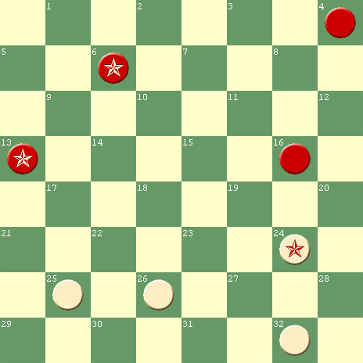
White to Move, Red to Draw

“Can you solve it? Start off with” 24 20, *13-17, 20 11, *17-21, “and now it is with you to select the correct route for the Red men”, Denvir

O. H. Richmond’s Faulty Solution (with his designations of star moves):
24 20, 13-17, 20 11, 17-21, 25 22, 21-25, 22 18, 25-30, *26 23, 30-26(1), 18 14, 26-19, 32 27, 6-1, 14 9, 1-5, 9 6, 5-9, 6 2, 9-14, 2 7, 4-8, 11 4, 14-18, 7 11, 18-22, 4 8, 22-18, 8 12, WW, Richmond, Grand Rapids, Mich., December 1888, DPQR, Vol I, P.62, Prob.7, Trunk

(1) 6-10, *11 16, 30-26, 16 19, 26-22, 18 15, 10-14, 15 11, 14-10, 19 24, 10-15, 11 7, 22-26, 23 19, 15-11, *7 3, 26-23, 24 20, 23-16, 3 8, WW, Richmond; “Clever maneuvering. Sometimes incorrect analysis contains interesting points. Continue 16-12, 8 15, 12-8, 20 16, 8-3, 16 11, 3-8, 32 28, 8-12, 28 24, 12-8, 15 19, Useful idea”, Al Darrow, 8/1/2010

Since we don’t have Slocum’s exact solution in hand, what follows is a thorough study prepared by Al Darrow in 2010:

Slocum’s Solution, Correcting Richmond (stars added by Salot):

24 20, *13-17, 20 11, *17-21, 25 22A, *21-25, 22 18,*25-30, 26 23, *30-26, 18 14B, 26-19, 32 27, *4-8C, 11 4, *19-15, 27 23D, 6-1 (or 15-11 first), 14 9, *15-11, 23 19, *11-7, 4 8, *7-2, 9 5E, becomes Payne’s Double Corner Draw, Darrow and Nemesis

A – 26 23, 21-30, 11 15, 6-2, 15 18, 30-26, 23 19, 2-6, 18 23, 26-22, 23 27, 6-2, 27 24, Draws, Nemesis, 7/28/2010

B – 23 19, 26-23, 11 15, 23-16, 18 14, 16-11, 15 8, 4-11, 32 27, 11-15, 27 23, Draws (easy 2 x 2), Darrow, 7/30/2010

C – “Denvir in the Inter-Ocean said that Slocum corrected Richmond brilliantly. This sacrifice and the next move were probably the reason for his comment. After the pitch, Red attacks the White man on 14, equalizing”, Darrow, 7/31/2010

D – 2 notes:
- “Presenting Red with a poisoned Breech. 15-18 gets the Choice 14 10 or 14 9, White wins”, Darrow, 8/1/2010
- 4 8, *15-18, “Easy draw from here”, Darrow, 7/31,2010

E – 2 notes:
- “In Man-Down endings, the rule I follow is Hold the man in the even system. Here we have the Payne setting of Boland’s Masterpieces, Man-Down Double Corner Masterpieces Family. The drawing ending requires the defender to have the Move (i.e., an odd count in the defender’s system.) This analysis is a combination of Nemesis and me, Darrow, 8/1/2010. See #80 for more discussion
- If 8 3, the only way to draw is by *1-6 (not 1-5, *19 15, 5-14, *15 10, WW), 9 5, *6-1, Payne’s Double Corner Draw, Salot, 2011

#78 – April 1897
Background:

What goes around comes around. After his acclaimed correction of Richmond in March 1897, Slocum published #78 in April 1897 as the 2nd of four settings composed for Denvir’s “Lessons”. It was his first unsound composition since #45 in 1892. It became the subject of, not one, but multiple corrections, some published and some not (until now).
Slocum did not get a chance to learn from these corrections. He did not live to see any of them. They were found by a later generation, more than 30 years after Slocum’s death.

Once kindled, Slocum’s interest in 2 x 2s never waned. While #78 faltered, the best was yet to come.

The corrections of #78 are instructive. Back and forth waiting moves tricked Slocum into exploring only one Red attack, the wrong one.

Lessons for Composers:

133. You can learn from your mistakes only if you live long enough.

78 - SLOCUM’S 5TH 2 X 2, HIS 15TH BACK AND FORTH
HIS 13TH “ALL ABOUT THE MOVE”; HIS 5TH UNSOUND SOLUTION
White to Move and Draw
Corrected to Red win, W. G. Parker, F. A. Miller, & Ben Boland

Slocum’s Faulty Solution to #78:

30 26A, 11-15B, 26 23, 6-9C, Var.1, *29 25, 15-10, *23 19, 10-14, *25 22, 9-13, *19 16, 14-10, 22 18 (16 11 & 16 12 also draw), 13-17, *18 14, Drawn

A – 29 25 is hopeless.

B – Or 11-7, 26 23, *7-11 (back and forth waiting moves), RW, same as Var. 1 at 1, 15-11, Boland. (11-8 and 11-16, at B, win by similar back and forth waiting moves, Salot)

C – This throws away the win. Variation 1 summarizes the corrections.

Variation 1 (Corrections):

15-11(back and forth waiting moves) D&E, 29 25F, 11-15 (or 6-10 is E at 3, *15-11), 25 22G, 6-10H, 23 18, 15-11 (or 15-19), 22 17, 11-7 (or 11-16), 17 13, *7-11, 13 9, *10-14, RW, Parker 1945

D (off 1) – This move by W. G. Parker, 1945, was the first correction to #78. The second correction was by F. A. Miller, 1947, and is shown in E.

E (off 1) – Or 6-10, 29 25, *15-11(back and forth waiting moves), 25 22 (23 19 is F at 3, 29 25), *11-15, RW, same as Var. 1 at 5, 6-10, Miller 1947

F (off 1) – 23 19 (or 23 18, Boland), *6-10, 2925, *11-15, 19 16, 10-14 (or 15-18), 16 12, 14-17 (or 15-18), 12 8, 15-18 (or 15-10), 25 21, *18-14, 8 3, *14-18, RW, Parker 1945

G (off 1) – If 25 21, then 6-10 (or 6-9), RW, Parker 1945

H (off 1) – Wardell reached this position from another setting (Feb. 1, 1893, American Checker Review, Vol. V, Prob. 17, colors reversed). Wardell played 6-9, 23 18, *15-19, 22 17, *9-13, 17 14, *19-23, RW.

Lessons for Composers:

134. Key back and forth waiting moves fool some of the best.
Bibliography #78: (7 items)

April 1897, American Checker Review, Volume VI, Issue 8, Page 8, Problem 1, colors reversed, one of four “composed for John T. Denvir’s Lessons”, Slocum gave a solution to draw: June 1897, Volume VI, Issue 10, Page 8

1913, Call’s Midget Problems, Page 62, Call copied Slocum’s solution, “Call grouped Slocum’s setting under Group 15: Draws with the move by keeping it. Belongs to Call’s Group 14: Wins without the move by exchanging”, Al Darrow

March 1942, Wood’s Checker Player, Volume V, Issue 8, Page 205, Problem 615B, part of a 2x2 collection, Wood copied Slocum’s solution

Before January 1946, Stirling Journal, Scotland
January 1946, Wood’s Checker Player, Volume IX, Issue 4, Page 116, “taken from the Stirling Journal”, W. G. Parker “CORRECTS SLOCUM”
November 1947, California Checker Chatter, F. A. Miller showed another way for Red to win, Boland subsequently found a third way, private correspondence
1952, Hall’s Instructive Positions, Page 1, Problem 1, “A correction of a Slocum problem by F. A. Miller”, L. L. Hall

#79 – April 1897
Background:

This third in the quartet of compositions for Denvir’s “Lessons” is the most subtle. Both sides have two pieces that initially have freedom of movement. In each case, moving one is more natural than moving the other.

If White chooses the wrong first move to begin the win, then Red is must find the one move that can begin an escape. Both the win and the escape require going a piece down. Some well-known checkerists (Newell Banks, Rex Wood, Millard Hopper, and Bob Crue) have publicly missed one or the other. Incorrect published solutions abound.

Lessons for Composers:

135. A win is difficult to find when you don’t see the lurking escape, and vice versa.

The epiphany and finale of #79 were not original with Slocum. But the originality of the prelude more than compensated.

#79 – “OFTEN BOTCHED”
SLOCUM’S 5TH BLOCK;
HIS 9TH 3X3; HIS 7 TH CREDIT CONFUSION
White to Play and Win
Solution to #79:

*26 23A, 28-32, 23 19D, 32-27, *2 7, 27-32E, *7 3, 8-12, 3 7 (or 3 8), 32-27, *7 11, 27-23, *19 16F, 12-19, *11-16G, 24-28, *31 27H, WW After the jumps, the Block finale was first shown by Sturges, 1800. “Locked in the double corner – one of the most beautiful problem themes in checkers”, Wiswell, 1952

A – Is this subtle or what? It invites Red to crown and take the offensive by chasing the now exposed White piece. Isn’t it more natural to bring the White king into the fray by 2 7? Newell Banks (1925), Rex Wood (1940), and Bob Crue (1994) apparently thought so, but that allows the surprise draw by 2 7B, *8-12C, 7 11, *28-32, 26 23, *24-27, 31 24, *32-27, Draws

B (off A) – The position after 2 7, colors reversed, was reached in Game 14 of the 1951 unrestricted match between Millard Hopper and Tom Wiswell, and is diagrammed in both their Checker Kings in Action, 1952, Page 72, and Oldbury’s Square World, March - April issue, 1965, page 18, "Problem Gems in Play No. 3". Neither publication recognized Slocum’s earlier setting. Here is that game:

Red: Wiswell White: Hopper
10-15 15-24 9-14 1-5 15-24 20-27
22 18 28 19 18 9 32 28 22 18 23 18
15-22 4-8 5-14 5-14 12-16 27-31
25 18 29 25 27 23 28 19 18 9 18 14
11-15 8-11 11-15 7-11 16-20 10-17
18 11 25 22 22 18 26 22 9 5 21 14
8-15 6-10 15-24 11-15 24-27 31-26
24 19 23 18 18 9 30 25 31 24 14 9
<<<
Now 3-7 formed B at 1, 2 7, colors reversed. Hopper missed the draw in Note A above, allowing Wiswell to score the win as in C below.

C (off A) – The natural 28-32 “is now caught in a ‘mating net’ from which there is no escape”, Wiswell, 1952. It loses by *26 23, 32-27 (or 8-12 first), *23 19 is Trunk at 5, *2 7, WW

D – 2 7 also wins forming C at 2, *26 23.

E – Hopper played 8-12, forming Trunk at 10, 32-27. He couldn’t play 27-23 at E because of *7 3, WW

F – Slocum’s solution (1897) was original through this move. The piece-down winning continuation had already been popular for many years. It was first shown from a different setting, colors reversed, by J. Wyllie, Dundee Weekly News, February 18, 1865; The Wyllie setting was independently discovered by W. Borland, Glasgow Weekly Herald, January 10, 1874, Problem 96, colors reversed.

G – “Proving once again that problem ideas do arise in actual play”, Wiswell, 1952. The position after this move was reached from different settings by E. Northrop, in the St. Clair (Michigan) Republican, August 22, 1871, Problem 130, colors reversed, and by J. E. Brickman, Gould’s Problem Book, 1882, Problem 906. Another likely example was by W. Beattie, B. D. Clipper, Problem 14, date not given in Boland’s Familiar Themes.

Bibliography #79: (11 items)

April 1897, American Checker Review, Volume VI, No. 8, Page 8, Problem 4, colors reversed, one of four “composed for John T. Denvir’s Lessons”, Solution: June 1897, Volume VI, No. 10, Page 8

September 1897, Draughts Players Quarterly Review, Volume 5, No. 3, Prob. 66, colors reversed

March 26, 1898, Queenslander, Problem 615, colors reversed

January 1910, Canadian Checker Player, Volume 4, No.1, Page 21, Second Prob., colors reversed, “We have again the touch of the master hand”, Ivan Powers, Natchez, Mississippi

May 1925, Morris-Systems Checkerist, N. W. Banks Editor, Volume III, Issue 5, Page 18, Prob. 306, colors reversed, (incorrect solution per Note A above)

December 1929, Draughts Review, “The Student’s Corner” by G. E. Trott, Problem 5

March-April 1936, American Checker Monthly, Problem 298, miscredited to J. D. Gallagher

1938, Boland’s Familiar Themes, Page 17, No. 12

January 1940, Wood’s Checker Player, Volume 3, Page 139, Ladder Problem No. 10, colors reversed, solution on Page 165, February 1940 (repeated the error in Morris-Systems Checkerist)

January 1992, Keystone Checker Review, Page 308, Problem 4, colors reversed, solution on Page 312 of same issue (repeated the error in Morris-Systems Checkerist), part of Bob Crue’s collection of Slocum problems (Nate Cohen pointed out Crue’s error on Page 331 of the March 1992 issue.)

March 1994, Keystone Checker Review, Page 687, republished G. E. Trott’s 1929 “The Student’s Corner”, Problem 5, with correct solution (On P. 707, May 1994, Nate Cohen pointed out a relevant 1951 Wiswell-Hopper game; see Note B above)
#80 – April 1897
Background:

This last of the four compositions for Denvir’s “Lessons” was unique in Slocumdom. It was a monster that some would say only a Boland could love. Indeed the only time it was republished was by Ben Boland himself, and that was not in any of his books.

- Slocum published only the Trunk and what he called Note B containing a short variation. Editor Denvir apparently forgot or lost Slocum’s Note A.

- Boland published only Slocum’s Trunk and note plus four more notes mostly referencing transpositions to other published positions.

- In contrast, you will find appended here nine (count ‘em: 9) pages of analysis. Even so, many minor transpositions, both internal and external, have been omitted.

A little (actually a lot) of explanation and guidance are in order here.

Before you decide, dear readers, to skip it in its entirety, please recognize that #80 offers much of value to both players and composers. It is possible to extract some of that value without plodding through all of the analysis. Here are some shortcuts:

- If a second interested player is available, why not set up #80 and play it out like a crossboard game? Play both sides and record the play. Then compare the results to the analysis herein; expect new insights to appear. After the first couple of White star defensive moves, the burden shifts to Red who must find a reasonable attack.

- Individually, readers may simply read the notes to taste the various flavors of the analysis.

- Those interested only in Slocum’s contribution need only check out the Trunk and Variation 3. They are sound, but was Slocum aware of all he omitted?
- Those interested in new play, unpublished (until now), will find it in Variation 1. Red’s best attack forces White to cross the “Great Divide” that leads to an extremely exacting and extended draw that Lyons published 4 years after Slocum’s setting.

- For transpositions into portions of earlier, historic, piece-down, double corner studies, all referenced in Boland’s Masterpieces, 1947, see:
  - Trunk, Note Y (J. Stark, 1880),
  - Variation 1, Note AA¹ (C. G. Roger, 1875)
  - Variation 1, Notes X¹ and Z¹ (J. H. Tregaskis, 1874)
  - Variation 2, Note A² (E. Woodward, 1894)
  - Variation 4, Note E⁴ (D. Gourlay, date unknown)
  - Variation 4, Note G⁴ (J. D. Janvier, 1857)
  - Numerous places (Payne, 1756)

- For maximum entertainment value and composer interest, the following traps are recommended:
- Trunk, Note Z (off Note Y)
- Variation 1, Notes I¹, M¹, and O¹
- Variation 4, Note F⁴

Assessing #80 as a composition is not easy. There are a couple of good, original star moves at the beginning and several more toward the end before merging into worthwhile, previously published play. But in between White has numerous, credible, non-star options to draw. They are not dual solutions because, against Red’s most restrictive attacks, they all must conclude with Payne’s Double Corner Draw. Such moves would not attract votes in a problem composing contest.

Lessons for Composers:

136. Non-star moves are not crowd pleasers.

137. Incomplete solutions reap incomplete benefits.
After White falls a piece behind at the outset, Al Darrow described White’s prospects this way:

“The formational motif gives White the opportunity to hold either man. Often such endings resolve into Payne’s Single or Double Corner Draws”, Darrow, 2010

In Payne’s Single Corner Draw, White prevents Red from crowning the piece on White’s single corner side of the board. Slocum flirted with it in #52, Notes A and G.

In Payne’s Double Corner Draw, White prevents Red from crowning the piece on White’s double corner side of the board. Slocum took advantage of it when he corrected O. H. Richmond’s famous problem just a month before #80 was published (see the “Seventh Interlude”). Perhaps it was the seed that led to #80.

White must decide early on which Red single piece to prevent from crowning. That piece may advance, but not to the king row. The wrong choice loses for White. There are at least 4 ways to decide early and correctly.

- Boland assumed one of the Red single pieces was removed from the board; then if White has the Move on the remaining pieces, the removed piece is the one White must prevent from crowning.

- “W. T. Call’s method is to put a dummy piece, or imagine it, on the single corner square of the two defending kings, and apply this rule: If the two kings with the aid of the imaginary piece, have the opposition (the Move), Payne’s (Single Corner) Draw is indicated (hold the piece on the left); if they have not the opposition, Tregaskis’s Draw is indicated (hold the piece on the right)”, Call, 1909
- Darrow’s rule is: “Hold the piece in the even system”.
  - The Red “system” consists of Squares 1, 2, 3, 4, 9, 10, 11, 12, 17, 18, 19, 20, 25, 26, 27, and 28.
  - The White “system” consists of Squares 5, 6, 7, 8, 13, 14, 15, 16, 21, 22, 23, 24, 29, 30, 31, and 32.

In any 3 x 2 position, there will always be an “odd” number of pieces in one “system” and an “even” number in the other.

If Red has single pieces on opposite sides of the board, they will be in different “systems”.

Then, if it is White’s turn to move, the Red piece in the “even system” is the one White must prevent from crowning.

- The most publicized guideline is Petterson’s Rule.

“This rule was published by R. D. Petterson in the Liverpool Courier in 1886. It is of practical value to expert and beginner alike in computing the Move with unequal forces and has saved many a game”, Ketchum, 1928

“The rule is simple and will save a lot of time and hard study. When you have the defending side and it is your turn to move, count the pieces in your own system, and if the sum of the pieces is even, hold the piece on the single corner side of the board. If the sum of the pieces is odd, hold the piece on the double corner side”, Ketchum, 1928

Note that when Darrow and Ketchum said, “Hold the piece”, they meant “Prevent it from crowning”, not “Prevent it from advancing into one of Payne’s Draws”. #80 concisely demonstrates this point by temporarily pinning the piece on the “wrong side” in order to force the other piece to advance.

Composers should note the moves leading up to the diagram were presumably 16 19, 21-17, but there is little value in setting the position back that far because 16 20 (instead of 16 19) would draw the same way.

#80 – “A BOOK UNTO ITSELF”
SLOCUM’S PATH TO
PAYNE’S DOUBLE CORNER DRAW,
HIS 2ND SEE-SAW,
HIS 10TH 3X3,
HIS 16TH BACK AND FORTH,
HIS 14TH “ALL ABOUT THE MOVE”
White to Play and Draw
Solution to #80: (Slocum showed only the Trunk & Var. 3 with no notes):

*22 18A, 17-10B, *19 24C, 10-7D, 24 19E and Var.1, 13-17F, 19 15G and Var. 1, 17-21, 18 22H, 7-2, 15 10I, 12-16, *10 15, 2-6J, 22 18K, 6-9L, *18 23M, 9-14, *23 27N, 21-25O, 27 24P, 16-20, 24 27Q, 25-30R, *27 32S, 14-17T and Var. 3, 32 27U, 17-22V, *27 32W, 22-26X and Var. 4, *32 27Y, Draws, Slocum, his Trunk Line

A – Not 22 26, 17-10, 26 23, 13-17 and 10-14 both win for Red, but only after long struggles. Composers should note that Red’s objective is to avoid advancing the Red piece on 12 while attacking with two coordinated Red kings.

B – After this jump, the setting is as presented in 1989 by Boland, who said, “The Move is wrong for Payne’s Single Corner Draw”. Composers should note that White’s objective is to achieve a perpetual motion, see-saw draw. To maintain control, White may have to force the Red piece on 12 to advance to 28, but must hold it there to achieve Payne’s Double Corner Draw in accordance with Petterson’s Rule.

C – Not 18 23, same as A at 3, 26 23. RW

D – Red options are limited.
- If 10-6, *18 14, 12-16, *14 18 (back and forth), 6-10, *24 20, Draws by the breeches.
- If 13-17, *18 14; or if 12-16, *24 20, either way White again draws by the breeches.

E – White must not permit 12-16 until the Red king is brought under control. Completing this back and forth maneuver is best because it controls the Red king while enabling the other White king to prevent the free Red piece from crowning. It demonstrates excellent coordination, but it is not essential. 18 15 also controls the Red king, but it allows the free Red piece to crown. Slocum probably thought it would lose, but it is a deep and difficult draw replete with strange maneuvers, as shown in Variation 1. Variation 1 is not a dual solution because it eventually returns to the Trunk finale.
F – Red needs a second king. The isolated Red king can do nothing without help. For example: 7-11, 18 14 and 18 22 and 19 15 all force Red to immediately retreat to avoid 11-16 and entrapment in a perpetual draw.

G – Not essential; 18 15 also draws by Variation 1, unpublished (until now), but not 18 14, *12-16, 14 18, *7-11, RW.

H – Not essential, but most efficient (temporarily pinning the piece on the wrong side of the board in order to force the other single piece to advance); 18 14 and 18 23 also draw (similar to Variation 1). Composers should note that if 15 19, *7-10, RW against any of a variety of defenses.

I – Not essential; 15 19 (or 15 18, 2-6, *18 15, same) 2-6, *19 15, 6-9, *15 10, 9-13, *10-15, also draws, but the back and forths take longer. Red cannot advance 12-16 without returning to the Trunk play.

J – If 16-20, *15 19, 2 6 or 2 7, 22 18 or 22 26, draws similarly

K - Not essential; 22 26 draws similarly

L – Again Red has two other futile options:
- If 21-25, *18 23, 25-30, *23-27, draws similarly
- If 16-20, *15 19, 21-25 or 6-9 or 6-10, *18 23 followed by *23 27 draws similarly

M – Not 18 22, 16-20 (9-14, 22 17 wastes time), 15 19, *9-14, RW

N – Not 23 26, *16-20, 15 19, 14-18 or 21-25, RW

O – And again there are two other Red options:
- If 14-17, White has 6 moves that will draw, all leading back to the Trunk play
- If 16-20, 27 32 or 15 19, draw similarly

P – Not essential; White has 5 moves that will draw. Three of them (27 31 and 27 23 and 15 11) require that the next White move complete the back and forth combination by immediately returning the king to the square from whence it came.
Q – Not essential; 24 28, 25-30, *28 32, gets the same back and forth

R – If 14-17, White has 5 moves that will draw (27 32, 15 19, 15 18, 15 10, and 15 11).

S – Not 15-19 or 15 11, *14-18, RW

T – Variation 3 is the only variation attributed to Slocum.

U – Not essential; White has 4 moves that will draw (32 27, 32 28, 15 19, and 15 11).

V – If 30-26, same as Variation 3 at 3, 14-17

W – Not 15 19 or 15 10 or 15 11, *22-18, RW

X – If 30-26, then 32 27 (relatively easy) and 15 19 (awesome) both draw. Composers should note their starry continuations as detailed in Variation 4.

Y – Slocum’s solution ends with this back and forth. It forms #83, which is a position reached earlier by J. Stark, November 27, 1880, Glasgow Weekly Herald, Problem 721, and republished as Problem 762 in Gould’s Problem Book, 1881. Stark’s solution continued: 26-31, *27 23, 30-25, 15 19Z, 25-22, 19 15 (or 19 16), Drawn, Stark 1880. Now continue: 20-24, *23 27 (back and forth), 24-28, *27 32, 22-26, *15 11, 26-23, *11 16, 31-27, *16 20, Payne’s Double Corner Draw 1756

Z (off Y) - 15 11 also draws. White must avoid falling into one last trap by 15 18 (or 15 10), *20-24, 23 27. *24-28, 27 32, *31-26, 18 15 *26-23, 15 11, *23-19, RW, preventing White access to square 20 and Payne’s Double Corner Draw.

Variation 1:

18 15A¹, 13-17B¹, 15 18C¹, 17-21D¹, *18 15E¹, 21-25B¹, 24 28 F¹,
25-30B¹, 28 32G¹, 30-26B¹, *32 27H¹, 26-22I¹, *27 23J¹, 22-25 B¹K¹,
23 18L¹, 25-30B¹M¹, *18 23N¹, 30-25B¹, 23 18L¹, 25-21B¹O¹, *18 23N¹, 7-2 P¹, *15 10, 21-17Q¹ unpublished to here (until now), *23 18 Var. 2, 17-13R¹, *18 14, 12-16, *10 15, 2-6, *14 9, 6-1, *9 14S¹, 1-5, *14 18S¹, 5-9, *18 23S¹, 9-14, *23 27S¹, 13-9, *27 32S¹T¹, 9-6, *15 11U¹,16-20V¹, 11-15 (or 11 16), 6-9, 15 19W¹, 9-13, 19 23W¹, 13-17, 32 27W¹, 17-22X¹, 27 32W¹, 22-25Y¹, 32 27W¹, 25-30, 27 32W¹, 14-17, 32 27Z¹, 17-22AA¹ Lyons 1901, 27 31W¹, 20-24, *23 27, 24-28, *27 32, 30-26, *31 27, Draws, Roger, 1875, forming Payne’s Double Corner Draw, 1756

A¹ – The fact that this also draws detracts from Slocum’s setting, but it exposes several excellent problem themes, some old and famous, others new and surprising.

B¹ – Red can play 7-2, *15 10 now or later, always leading to the same drawn result.

C¹ – Not essential; White has 5 moves that will draw. This is the scenic route.

D¹ – If 7-2, *18 14, 17-22 or 17-21, *14 10, is necessary and gets the same result.

E¹ – White must complete this back and forth.
- If 18 14, *12-16, 14 18,*7-11, RW
- If 24 19, 7-10 or 7-2, RW

F¹ - Not essential; White has 4 waiting moves that will draw. This again is the scenic route.

G¹ – Or 28 24, 30-26, 24 27 (or 24 19), same

H¹ –White must prevent 26-23. Now watch this White king travel desperately up and down the straight and narrow diagonal from 32 to 9 and back.
I¹ – Composers should note that Red can play for a subtle trap via: 7-2, *15 10, 26-31, *27 23, 12-16, *10 15, 16-20 (sets the trap), now 15 11 and 15 19 draw, but 15 10 and 15 18 lose by *20-24, 23 27, *24-28, 27 32, *31-26, RW because White cannot get to Square 20 for Payne’s Double Corner Draw.

J¹ – White must prevent the mobile Red king from escaping.

K¹ – Composers, are you ready to play for two more traps? They are super subtle.

L¹ (2 places) – White can afford to move this king in any of the four directions and still draw. But 23 18 and 23 26 are the most natural and exposed to the traps.

M¹ – This sets the first trap, inviting White to move to 22 for the pin. Then RW by *7 2, 15 10, *12-16, 10 15, 2-6 or 16-20, RW

N¹ (2 places) – An outstanding back and forth retreat; no matter which direction the White king moved at L¹, it must return to Square 23 from whence it came.

O¹ - This sets the second trap, inviting White to move 18 22 (or 18 14). Then RW by *7 2, 15 10, *12-16, 10 15, *2-6, 22 18, *21-17, 18 23, *17-14, 23 27, *14-10, 15 18, *16-19, RW

P¹ – Red might as well play 7-2 now or it soon will be forced. For example: 21-17, *23 18, 17-13, *18 14, 7-2 (forced), *15 10 returns to Trunk play.

Q¹ – This forms a position that Boland published three times (“Famous Positions”1940, “Masterpieces” 1947, and an extensive column in “Midwest Checkers”1989. Allan Hynd, a checker editor and member of the triumphant British First International team, published it in 1900, claiming a Red win. But, in 1901, another checker editor named J. K. Lyons corrected it to a draw and dubbed it “The Great Divide”. Variation 1 follows Lyons’ fine correction; Variation 2 covers Hynd’s overturned win.

R¹ – One wonders if Lyons seriously considered 17-21 here. It plays for the trap in Note O¹, requiring the unnatural, back and forth, retreat by *18 23 to draw. If the trap at O¹ doesn’t work, Red can continue down to Square 30, playing for the trap at M¹. If both traps fail, Red can still return to 17 to test White’s ability to find Lyons’ outstanding opening string of ten star drawing moves that follow Q¹.

S¹ (5 places) – After forcing the Red kings away from the action, this White king can and must now run for dear life, an astonishing string of five essential retreat moves all in a straight line.

T¹ – Utterly unnatural, but necessary because 15 11 and 27 24 allow *16-19, RW, while 27 23 and 27 31 allow *9-6, RW.

U¹ – The long retreat culminates in a crucial counter-attack. It is White’s first and last opportunity to force 16-20. Moving the other White king allows *14-10, 15 18, *16-19, RW, same as the trap in O¹.

V¹ – If 16-19, *11 15, 19-24, *15 19, quickly forces Payne’s Double Corner Draw 1756. In effect, the solution might as well end at V¹. There are no subsequent star moves. White has optional moves to draw the rest of the way, as indicated in W¹.

W¹ (7 places) – These moves are not essential; other moves also draw.

X¹ – This forms a position published earlier by J. H. Tregaskis in Volume 2 of the “Recreationist”, August 25, 1874, Problem 83, colors reversed. His continuation varied at Y¹.

Y¹ – The Tregaskis analysis proceeded 14-10, 32 27W¹, 10-7, 27 32W¹a¹, 7-11, 23 19W¹, 22-17, 32 27W¹b¹Veitch 1894, 17-14, 27 23W¹, 14-10, 23 18W¹, 10-7, 18 23W¹, 7-3, 23 18W¹, 3-8, 18 23W¹, 8-12, 23 27W¹,
11-16, 27 23W¹, Drawn, Tregaskis 1874.

a¹ (off Y¹) – This move by G. S. Veitch in the Pittsburgh Dispatch, June 28, 1894, Problem 356, corrected Tregaskis who slipped by moving 27 31, overlooking *20-24, 23 27, *24-28, 27 32, *7-11, RW, Veitch, 1894. The idea of taking Square 20 to thwart Payne’s Double Corner Draw was first shown by Payne, 1756.

b¹ (off Y¹) – The position now returns to the Tregaskis analysis, and the continuation from here to the end is his. Credit the play from a¹ through b¹ to Veitch, 1894.

Z¹ – This forms a position reached by Tregaskis at an earlier stage of his 1874 analysis. Tregaskis here continued 17-14, 27 31W¹, 30-25, 31 27W¹, 25-22, forming the position at X¹. This represents a curious, but insignificant, twist. Tregaskis reached Z¹ before X¹, but Lyons reached X¹ before Z¹.

AA¹ – This forms a position reached earlier by C. G. Roger in Glasgow Weekly Herald, April 24 and May 29, 1875, Problem 215, colors reversed. Lyons followed Roger’s continuation to the end.

Variation 2 (off Variation 1):

Hynd showed 23 19 to lose as follows: *17-13, 19 23, *13-9, 23 19, *9-5, 19 23, 5-1, 23 19, 2-6, 10 14, 1-5, 14 18, 6-10, 18 23, 5-9, 23 27, 9-14, 27 23, 14-17, 23 27, 17-22, 27 23, 10-14A² Hynd 1900, 23 27B², 22-18C², 27 24D², 14-17, 24 27, 17-21, 27 24, 21-25, 24 27, 25-30, 19 23, 18-15, 27 24, 12-16, 24 28, 30-25E², 28 24, 25-22F², 24 28, 22-17, 28 24, 17-14, 24 28, 15-18, 23 26, RW Woodward 1894

A² – Forms a position reached earlier by E. Woodward in the Nottinghamshire Guardian before April 1894, Problem 615. The play from here is by Woodward.
B² – Forms a position that “may arise” from Leeds Weekly Mercury, August 23, 1884, Problem 375, by W. Taylor

C² – “Most important”, Boland 1940. Other moves waste time.

D² – Hynd see-sawed with 27 32, 14-17, 32 27, same

E² – “Only move to win”, Boland 1940. Really?

F² – Hynd played 25-21, 24 28, 21 17, same

Variation 3 (off Trunk):

30-26, 32 27A³, 14-17 (26-30 is back to Trunk), 15 19A³, 17-22, 27 31A³, 26-30, 19 23A³, Draws, Slocum, his Note B (Note A was not published); the position is now Variation 1, Note AA¹, continuation by C. G. Rogers.

A³ – Not essential; other moves also draw.

Variation 4 (off Trunk):

30 26, 15 19A⁴, 26-31B⁴, *19 23, 22-25, 23 19C⁴D⁴, 25-30, *19 23C⁴E ⁴, 31-27, *23 18, 27-24, *18 23C⁴, 24-28, *23 27F⁴, 30-26, *27 31, 26-23, *31 27C⁴, 23-19G⁴, *27 31C⁴, 19-16H⁴, *31 27C⁴, 16-12, 27 31C⁴I⁴, 28-24, 31 26I⁴, 24-19, *32 27, 12-16, 26 31I⁴, 19-15, *31 26C⁴, 15-18, *26 23J⁴, 18-22, *27 32, 22-17, 23-27I⁴, Drawn, Gourlay

A⁴ – 32 27, 26-31, *27 23, is a much easier draw, making Trunk, Note Y at 6, 19 15. Composers should note the longer, more difficult draw by 15 19 is shown only to demonstrate some historical problem themes.

B⁴ – If 22-17, 32 27, draws making Variation 3 at 4, 15 19. At B⁴, 32 28 also draws, but not 19 24.

C⁴ (8 places) – Back and forth

D⁴ – Or 32 28, 25-30, *28 32, same, back and forth
E⁴ – This forms a position reached by D. Gourlay, date unknown, as recorded in Boland’s Masterpieces, 1947, Page 197. In a reverse sort of way, Gourlay’s play from E⁴ to G⁴ should be credited to J. D. Janvier, 1857. See G⁴ for Janvier’s setting. His solution played Gourlay’s moves in reverse order all the way back to E⁴.

F⁴ – Not 32 27a⁴, *28-32, 27 31b⁴, 30-25, 31 26, *25-21c⁴, 26 22, 20-24, 22 26, *21-17, 23 19, *32-28, 26 31, *17-14, 19 23, *14-10, 23 19d⁴, *10-7, 19 23, *7-11, 23 19, 11-16 (or 24-27), 19 12, *24-27, beautiful RW, Roger, 1872

a⁴ – This forms a position reached by E. Whelahan, New Haven (Conn.) Sunday Union, September 18, 1879, Problem 85, colors reversed

b⁴ – This forms a position reached by C. G. Roger, Paisley and Renfrewshire Gazette, July 6, 1872, Problem 441, colors reversed.

c⁴ – Not 25-29, 26 22 (forms a position reached by J. Wyllie, Glasgow Weekly Herald, November 21, 1885, Problem 1095; 26 30 also draws), 20-24, *22 26, 29-25, 26 31 (or 23 19), 25-22, *23 19, 32-28, *19 23, 22-17, *23 27, drawn, Wyllie, 1885

d⁴ – If 23 27, *10-15, 27 20, *15-19, 20 24, *19-23, 24 20, *23-27, RW, Roger, 1872

G⁴ – This forms a position reached by “Nemo” (J. D. Janvier), New York Clipper, June 27, 1857, Problem 124, colors reversed.

H⁴ – Janvier played 19-23, as discussed in E⁴. At this juncture, Spayth’s American Draughts Player, 1860, Problem 10, colors reversed, played 20-24, *31 26, 19-15, 26 22, Drawn

I⁴ (4 places) – Not essential

J⁴ – Not 26 31 or 26 30, *18-22, RW; not 27 32 or 27 31, *20-24, RW

Bibliography #80: (2 items)

April 1897, American Checker Review, Volume VI, Issue 8, Page 8, Problem 3, colors reversed, one of four “composed for John T. Denvir’s Lessons”, Solution: June 1897, Volume VI, Issue 10, Page 8

April 1989, Midwest Checkers, Volume 11, Issue 2, Page 742, Problem 14, same as #80 after the 2nd move; the central diagram in a group of 9, constituting the second half of a Ben Boland presentation entitled “A KALEIDOSCOPE OF IMAGES, IMPRESSIONS AND INTERRELATIONSHIPS THAT ILLUMINATE THE STANDARD POSITIONS”; the solutions appeared under the title: “The Howard, Tregaskis & ‘GREAT DIVIDE’ A New Look at the Old Standards by Ben Boland”, May 1989, Page 785
#81 – April 24, 1897
Background:

Coincidentally, #80 and #81 appeared almost simultaneously, but in different publications. Judging by the number of republications, #81 was much more popular than #80. A comparison of their solutions makes the reason clear.

Regarding #81: “The solution does not come easy for me”, Floyd D Brown, 1970, (private communication); how about you?

In #81, both sides have very little mobility. Red, being a piece down, obviously intends to steal the piece on 23. Unlike #80, there are not many alternatives. By the process of elimination, the win should become readily apparent from the diagram, but not in this case.

Alas, Slocum was up to his old tricks, creating a mind block. It is a shame to give it away in the title. But that is the kind of help most of us need to deal with #81, a true crowd-pleaser.

# 9 used the same theme. After almost 7 years, that seed yielded #81.

#81 – “DOES NOT COME EASY”
SLOCUM’S THIRD “CAPTIVE COSSACKS”
HIS 23RD 2-PIECE PITCH; HIS 14TH DOUBLE
White to Play and Win
Solution to #81:

*29 25A, 26-31, *12 8B, 3-12, *20 16C, 12-26, *25 30D, WW by “Captive Cossacks” into First Position

A – Composers should note why Slocum did not place this king on 21. It would have created a dual solution by 21 17, 26-31, *17 14, 31-26, *14 10, 26-19, *11 7, 4-8, *10 6, WW

B – When trying to save an endangered piece, you tend to overlook sacrifices. If the natural 25 22, *31-27, 23 18, *27-23, 18 14 (or 11 7, *23-14, 7 2), *23-18, 14 10, White appears strong, but is not strong enough to win.

C – This 2-piece pitch obliterates the piece that you were concerned about saving.

D – A 3-way “Captive Cossacks”, probably the only one ever published. Composers should note that others are possible. For example at D, relocate the Red piece from 15 to 14 and swap the Red and White kings. That wins similarly by a different 3-way “Captive Cossacks” into First Position.

Lessons for Composers:

138. The most popular moves are the head-slappers.

Bibliography #81: (11 items)

April 24, 1897, Chicago Inter-Ocean, Problem 1026, “Who can solve it?” asked J. T. Denvir; solution: May 1, 1897

Before September 1897, Newark Sunday Call

September 1897, Draughts Players Quarterly Review, Volume 5, No. 3

July 31, 1897, Coulter Fell’s Australian Town & Country Journal, Page 6, Problem 103, “A new setting to an old idea”
November 27, 1897, Coulter Fell’s Australian Town & Country Journal, Page 46, Problem 120, Fell published it twice in 4 months

Date? Pittsburgh Dispatch, Prob. 1293

January 1905, Draughts World, Volume XXV, No. 97, “Stray Gems Gathered from Other Pages”, GEM 530, “A tid-bit”

April 7, 1965, Melbourne Weekly Times, Problem 7560,
“Simple but effective”, Hugh Egan

May 1988, International Hall of Fame Presents Checkers, Page 15, Prob. 530

May 1993, Keystone Checker Review, Page 539, Problem 46, solution Page 542 in same issue, part of Bob Crue’s collection of Slocum problems

Dec 2002, NorthWest Draughts Federation Newsletter, Hugh Devlin editor, Vol 5, Issue 2, Page 10, Problem No 31, colors reversed

#82 – June 3, 1897
Background:

Denvir was editing two checker publications. He published #82 in both of them in quick succession. But it was never published by anyone else (until now).

#82 is a decent little ditty. White starts a piece up, but goes a piece down to create a situation where Red has a choice between three moves that all lose.

The main feature is an unusual pitch that Slocum had not used before. Call it a buried pitch, a direct pitch that cannot be immediately jumped.

Lessons for Composers:

139. Wins may be buried in piece-down tie-ups.

140. The rarest pitch is a buried pitch.

Here is a bit of trivia. If the White piece on 20 is not a king, Red can escape with a draw two ways, and both escapes start with the same move! See Notes A and E.

#82 – “THE BURIED PITCH”
SLOCUM’S ONLY BURIED PITCH; HIS 15TH DOUBLE
White to Play and Win
Solution to #82:

23 19, 28-24A, 27 23B, 24-15, 14 10, 26-19C, 20 16D, 15-6, 1 10, 19-23E or 19-24E, *16 11, WW by a double and the Move

A – Red, being a piece behind, is forced to go for the pocket steal. Composers should note that if the White piece on 20 were not a King, Red could draw by 8-11 both here and at Note E.

B – This is a buried pitch because the piece cannot be immediately jumped.

C – Or 15-6, 1 10, 26-19, 20 16, same

D – Creates a piece-down tie-up that leaves Red a choice of moves to lose

E – Or 8-11, *16 23, WW. Composers should note that if the White piece now on 16 were not a King, Red could draw here by 8-11. See Note A.

Bibliography #82: (2 items)

June 3, 1897, Chicago Inter-Ocean, Problem 1033, colors reversed, “BY GEORGE SLOCUM OF PROBLEM FAME”, “Can you solve it?” J. T. Denvir

September 1897, American Checker Review, Volume VI, Issue 11, Page 8, Problem 7, colors reversed, no solution published, American Checker Review expired with Issue 12

#83 – June 1897
Background:

Slocum reached this position at the end of his Trunk solution to #80.

Evidently somebody requested or suggested that the instructive continuation be shown. So editor Denvir obliged, but he should not have credited the setting to Slocum. They were probably both unaware of the prior publication by J. Stark in 1880.

Not counting Stark’s analysis, #83, as diagrammed below, was published only once (before now). It ended a string of 11 settings credited to Slocum and published multiple times. #83 was only Slocum’s 29th setting unrepublished (until now).

Lessons for Composers:

141. Many (most?) late endgames have already been published.

#83 – SLOCUM’S EIGHTH CREDIT CONFUSION,
HIS THIRD SEE-SAW
First shown by J. Stark, 1880
Red to Play; White Draws

Solution to #83:

Stark’s solution played 26-31A. It continued as shown in Note Y (off Trunk) of #80.

A – If 26-22, the position is the same as at Note V (off Trunk) of #80. The continuation is shown there.

Bibliography #83: (1 item)

June 1897, American Checker Review, Volume VI, Issue 10, Page 8, Problem 3, colors reversed, Denvir credited Slocum, no solution published, American Checker Review expired with Issue 12

(Denvir should have credited it to J. Stark, November 27, 1880, Glasgow Weekly Herald, Problem 721. It was republished as Problem 762 in Gould’s Problem Book, 1881, credited to Stark.)

#84 – September 1897
Background:

In the next to last issue of the American Checker Review, three Slocum compositions appeared. #84 was the first of them.

His last previous 2 x 2, the ill-fated #78, was published just 5 months earlier. #84 turned out much better.

- W. T. Call featured it in his Midget Problems, 1913, “GROUP 6: Draws without the move by avoiding first”. (Call’s GROUP 6 was later termed “negative 1st position” by M. F. Tescheleit in his Master Play Part 2, 1927, Page 95, Note f.)

- Duffy expanded on it in his Standard Positions, 1934.

#84 was a setback of a classic 2 x 2 by Dr. T. J. Brown. The two settings will be forever linked.

Lessons for Composers:

142. Setbacks of famous positions can yield avoidance plays.

#84 – “THE LINKAGE” or “AVOIDING 1ST POSITION II”
SLOCUM’S 6TH 2 X 2; 4 TH SEE-SAW; 2ND AVOIDING 1ST POS’N
White to Play and Draw
Slocum’s Solution to #84:

*29 25A&Var.1, 2-7B&Var.2, *5 1C, 7-11, *1 6C, 18-14, *6 2, 11-15D, *2 7, Draws by Running the White king to its double corner, avoiding First Position

A – Not 5 1, which forms a famous setting by Dr. T. J. Brown, Call’s Midget Problems, 1913, Page 13, with Red winning brilliantly, as shown in Variation 1. Slocum sets it “back a move and shows an important draw”, J. Duffy, 1934

B – J. Duffy later demonstrated 18-14 to draw as shown in Variation 2.

C (2 places) – Not 25 21, *18-14, RW by First Position

D – If 14-10, 25 21 and 25 22 both draw.

Variation 1:

5 1, *18-22E, 1 5, *2-6F, 5 1, *6-9, 1 6, *9-13, 6 9G, *22-17H, 29 25, *17-21, 25 22, *21-17, RW, Dr. T. J. Brown

E – “Anything else allows the Slocum Draw”, Duffy, 1934

F – “2-7 only draws, 5 9, 7-11, 9 14, 11-16, *14 10, 22-18, *10 7, 18-15, (if 16-19, then *7 11, 19-23, *11 16 drawn), *29 25, 16-19, 25 22, 19-23, 22 17, 18-15, 7 2, 23-26, 2 6, 26-30, 6 9, 30-25, 17 14, drawn”, Duffy, 1934

G – If 6 10, *22-18, 10 6, 18-14, 6 1, 13-17, RW, Duffy, 1934

H – “The only move to win; if 22-18, *29 25, 13-17, *25 21 draws; and if 13-17, *9 14, 17-21, then *14 10 is an important draw by Sturges (1800); White is ready to race to square 28 should Red attempt to crown the piece on 21”, Duffy, 1934

Variation 2:

18-14, *5 1 I, 14-17J, *1 5, 2-6, *5 1, 6-9, *1 6, 9-14K, *25 21, 17-13, *6 10, 14-18, 10 15, 18-23, 15 19, Draw, Call 1913

I – Forms a position reached by W. T. Call in his Midget Problems, 1913, Page 26, at 3, 5 1.

J – Duffy, 1934, explored 14-10, *1 5, 10-14, *5 1, back to J.

K – If 9-13, 6 1, 17-14, *25 22, 14-10, 1 5, Drawn, Gourlay in Duffy’s Standard Positions, 1934

Bibliography #84: (5 items)

September 1897, American Checker Review, Volume VI, Issue 11, Page 7, Problem 5, no solution published, American Checker Review expired with Issue 12

1913, Call’s Midget Problems, Page 26, Group 6, “Draws without the Move by avoiding First”, Call, “The Red King escapes to his Double Corner”, Al Darrow

1920, Boston Globe, Herb Morrall, “Checkers” editor, Problem 45

1934, Duffy’s Standard Positions – Part One, Page 4, Problem 9, solution on a different Page 4, Duffy numbered the solution section independent of the diagram section.

May 1993, Keystone Checker Review, Page 539, Problem 44, solution Page 542 of same issue, part of Bob Crue’s collection of Slocum problems

#85 – September 1897
Background:

Slocum settings #82 through #86 were his last 5 to appear in the American Checker Review. Their solutions were never published in that journal. Fortunately the solutions to #82, #83, and #84 were available elsewhere.

#85 was the second in the trio of Slocum settings appearing in the next to last issue of American Checker Review. It was Slocum’s 30th to never be republished (until now). Unfortunately its solution has never been published anywhere. So we must improvise.

All we know is that #85 arose in a Single Corner game, colors reversed, between A. O. Robinson and Berry Mitchell (both Chicago players). Robinson moved 20 16 and lost. Slocum corrected it, presumably on the spot. Therefore we too should solve it from the diagram; right? Try it.

Lessons for Composers:

143. Game positions are analyzed, not composed. Often they make good problems.

#85 – “ON THE SPOT I”
SLOCUM’S FIRST GAME Correction
HIS TENTH DOMINO PITCH; HIS 16TH DOUBLE
White to Play and Draw
Slocum’s Presumed Solution to #85 (unpublished until now):

*22 18A, 15-22, *20 16, 22-26B, *16 11, 26-31, *11 7, 31-27, *7 2, 27-18, 2 9, 1-5, *30 25C, 21-30, *9 6, 14-21, 6 22, *21-25, Draws by a double and a pin, King’s Row

A – A. O. Robinson moved 20 16 and lost to Berry Mitchell. Slocum’s unpublished correction presumably proceeded as shown above.

B – Natural, but 22-25 is also strong. Continue 16 11, 25-29, 11 7, 29-25, 7 2a, *6 9, 13-6, *25-22, 2 7b, 22-13, *23 19, 13-9, *6 2, 1-5, *7 11, 14-17, *11 15, 10-14, *19 16, 17-22, *15 10, Draws a piece down.

a (off B) – Or 7 3, 25-22, 3 7, 6-9, 13 6, 22-13, same

b (off B) – Or 23 19 first, but not 17 13, *10-15, 2 7, 1-10, *15-18, 23 19, *14-17, 11 15, *10-14, 13 9, *18-23, 9 6, *23-27, 6 1, *27-31, 1 6, *14-18, RW

C – A necessary domino pitch. Avoid 9 6, *18 15, 6 9, *14-18, 9 14, *18-23, 14 7, *23-27, 7 3, *15 10, RW

Bibliography #85: (1 item)

September 1897, American Checker Review, Volume VI, Issue 11, Page 7, Problem 6, colors reversed, “Slocum corrected a Single Corner ending between A. O. Robinson and Berry Mitchell”, no solution published, American Checker Review expired with Issue 12
#86 – September 1897
Background:

#86 is the last of the Slocum trio in the second to last issue, and the last of all 54 Slocum settings published in the American Checker Review.

#86 was never published again (until now). It was Slocum’s 31st in that category, and his solution was never published at all (until now).

Fortunately, #86 was a “relatively” light, solvable, tune, not requiring a computer to orchestrate.

Composers should note that it is a throwback similar to many of his earlier compositions.

You can almost see Slocum smile at the litany of his old themes.

Lessons for Composers:

144. Review old themes for new tunes.

#86 – SLOCUM’S ELEVENTH PURE STROKE
HIS NINTH COMPOUND STROKE
HIS 23RD TRIPLE
HIS 17TH DOUBLE
HIS ELEVENTH FORK
White to Play and Win
Solution to #86:

*27 23A, 4-11 (or 26-19 first), *32 27, 26-19, 29 25 (or 18 15 first), 22-29, *18 15, 11-18, *27 23, WW by a Triple, compounded into a Double, landing in Slocum’s old favorite, the Fork

A – For those interested in such things, the last two moves to form this weird position were 11 16, 12-26. Slocum resorted to his old practice of initiating a pure stroke by putting a piece in jeopardy, thus creating a free move, then establishing more free moves by making additional pitches. His earlier examples of this were #10, #20, #39, #47, #60, and #67a, but none of them ended up with a fork like this one.

Lessons for Composers:

145. Some composers believe a checker problem setting, for the sake of natural appearance, should be reachable by a pair of consecutive legitimate moves.

Bibliography #86: (1 item)

September 1897, American Checker Review, Volume VI, Issue 11, Page 8, Problem 8, no solution published, American Checker Review expired with Issue 12

__________________________________________________________

September 11, 1897, Worker, Brisbane, Queensland, Australia, Page 6,
“. . . Slocum whose name is deservedly attached to a ‘stroke’ ”

#87 – December 18, 1897
Background:

#87 was Slocum’s 11th and final composition of 1897, the most in any year since 1891. Of the 11, 5 of them, including #87, led to famous endings published earlier by others. Clearly, Slocum’s later problems have greater depth and more educational value than his earlier ones.

If you reset Slocum’s #87 by relocating the White king from 2 to 3 and the White single piece from 10 to 9, you will have an earlier 2 x 2 by Dr. Timothy J. Brown, in Lyman’s Problem Book, 1881, Problem 15, colors reversed. After a few moves, the solutions to both settings merge. Both settings are among the best 2 x 2s ever published.

If Slocum, or editor Denvir, had seen Dr. Brown’s similar setting and solution, they probably would not have published #87 at all. Composers should note that Slocum’s setting is slightly better because all twelve of Slocum’s White moves are star moves, while two of Brown’s are not.

Among all of Slocum’s compositions with all-star solutions, #87 is the longest with all 12 White moves starred. #80, Variation 1, also had a string of 12 consecutive White star moves, but not 100% of all its White moves.

#87 – “12 ALL-STARS” or “EARLY AMERICAN POSITION”
SLOCUM’S SEVENTH 2 X 2,
White to Play and Win
Solution to #87:

*2 6A, 1-5B, *10 7, 29-25, *6 10C, 5-9, *7 2D, 25-21E, *10 15F, 9-14, *2 6G, 21-25, *6 9, 14-17, *9 14H, 17-22I, *15 19, 22-26, *19 23, 26-30, *14 17J, T. J. Brown, 25-29, *17 21K, WW, H. Spayth

A - White must not let the Red king advance to 17.

B – If 29-25, *6 9, 25-22, *9-14, WW by pinning both Red pieces.

C – White must not let the Red king escape to the White Double Corner.

D - At this stage of the earlier T. J. Brown setting, Lyman’s Problem
Book, 1881, Problem 15, colors reversed, Brown crowned 6 1, whereas 6 2 would have merged with Slocum’s *7 2.

E - 9-13, *10 14, 25-21, 2 6G (or 2 7), 13-17, 6 10, WW. T. J. Brown, or 6 9 also is a WW by American Position

F – White must avoid the 9-14 exchange.

G (off both Trunk and Note E) – Merges with T. J. Brown’s play. The continuation is by Brown.

H – Not 15 18, *17-21, 18 23, *25 22, Draws

I – If 25-21, 15 10, T. J. Brown, or 15 11 or 15 19, all WW by the American Position

J – Merges with a variation of the original American Position in Henry Spayth’s Game of Draughts, 1863

K – Completes Slocum’s longest all-star solution (12 consecutive stars)

Lessons for Composers:

146. Star moves often distinguish otherwise similar settings.

Bibliography #87: (2 items)

December 18, 1897, Chicago Inter-Ocean, Problem 1226, colors reversed,
“The above intricate invention recalls ‘First Position in Embryo.’ Mr. Slocum after about twenty-five forced moves, works into a well-known finish, which is a known characteristic of this eminent composer”, solution not published.

May 1911, Canadian Checker Player, Volume 5, Issue 5, Page 121, from “a list of 2x2 problems all having a man or king on Square 1, as compiled by W. Donaghy from his collection”, Teetzel; no solutions provided.
#87A – Date unknown
Background:

We do not know when #87A was first published. It is inserted here because of its similarity to #87. They make a nice combination: one on how win the American Position, and the other on how to avoid it.

Considering their practical appearance, it is surprising that neither is included in any of Boland’s books, nor in Call’s Midget Problems.

Lessons for Composers:

147. Although games are often terminated before they reach the unappreciated 2 x 2 stage; do not add pieces to your 2 x 2s merely for appearance sake.

#87A – “AVOIDING AMERICAN POSITION”
SLOCUM’S 2X2 OF UNKNOWN ORIGIN
White to Play and Draw

Solution to #87A:

*30 26A, 29-25B, 26 23C, 25-22B, *12 8D, 28-24, *8 3E, 24-20F, *23 19G, 22-18, *3 7H, 20-24, *19 16, 18-15, *16 12, Draws by threatening an exchange to get control of Square 11 with the White king.

A –White must prevent the Red king from advancing to 19. Playing 12 8, first fails by *28-24, 30 26, *24-19, 26 22, 19-15 or 19-23, RW by the Move.

B (2 places) – Red must prevent White from running to the double corner.

C – Or 12 8, 28-24, *26 23 (not 8 3, *24-19, RW), 25-22, same

D – Not 23 19, *22-18, 12 8, *28-24, RW by the American Position

E – Not 8 4, 22-17 and 24-20 are both RW by the American Position

F – If 22-17, *23 18, 24-19, *3 7, 19-16, *18 15, Draws

G – Not 3 7, *20-16, 7 10, 16-11 or 22-17, RW various ways

H – Not 3 8, *20-24, same as #87, colors reversed, Trunk at 13, *6 9

Bibliography #87:

Date unknown, credited to Slocum by Joe Charles, private communication, but “no published record” has so far been found.
#88 – January 1, 1898
Background:

Slocum occasionally orchestrates an out of character composition.

#88 looks as if it could have arisen in a game, but it presents play unlike any of his other offerings. It is neither a stroke nor an end game study. White manages to win by taking 3 for 2, but not all at the same time. It is a neat, but different, change-up to kick off the New Year 1898.

The fact that a list of correct solvers was published, along with the solution, only a week after #88 was published suggests that it was not particularly difficult.

Its limited difficulty helps explain why it was Slocum’s 32nd setting to not be published again (until now).

Still it is pleasing to see this addition to the variety of themes Slocum staged for our enjoyment over the years.

Lessons for Composers:

148. Composers now and then should change their tune.

#88 – “PETTY THEFTS”
SLOCUM’S BACK AND FORTH STEALS
White to Play and Win
Solution to #88:

*5 9A, 18-15, 9 18, 15-22, 21 14, 22-18, *14 9, 18-14, *9 6, 14-7, *6 2, 7-10, *2 7B, WW by numerical superiority

A – Although White has many options here, there are no dual solutions. For example, 10 6 is strong, but *17-22, 6 2, *22-25, 5 1, *18-15, 1 6, *14-18, Escapes with a draw.

B – “Correct solutions received from J. P. Faurot, Smith Trotter, L. B. Anderson, J. B. Cave, C. A. Corbin, M. J. Babcock, J. C. Williams, W. H. Kist, Levi H. McCallum, E. M. Griner, J. S. Neff, J. M. Francis, C. H. Ocock, Charles Clark, J. A. Spencer, and John Dresback”, Inter-Ocean, January 8, 1898

Bibliography #88: (1 item)

January 1, 1898, Chicago Inter-Ocean, Problem 1229
“The above is beyond doubt a neat one and a credit to its renowned author. Can you solve it?” solution January 8, 1898
PUBLISHED GAME – before October 13, 1898
Before October 13, 1898, Glasgow Herald
October 13, 1898, Otago Witness, Issue 2328, Page 40, Game 2727, “Single Corner”: Played recently at the Chicago Club between Messrs G. H. Slocum and Berry Mitchell – Slocum’s move:
11-15 16-20 8-11 9-14 5-9 6-13
22 18 19 16 16 12 22 18 26 23 15 6
15-22 8-12 5-9 14-23 24-27 2-27
25 18 25 22 24 19 27 18 31 24A (Red)
12-16 12-19 11-16 20-24 9-14 Wins
29 25 23 16 18 15 32 28 18 9
9-13 4-8 16-23 1-5 13-17
24 19 28 24 26 19 30 26 21 14
A – Slocum executes a Brooklyn stroke in play (see #46), Salot
____________________________________________________
SLOCUM’S FIRST GAME CORRECTION
November 20, 1898, Chicago Inter-Ocean, “Mr. Slocum calls our attention to where Mr. Lees slips.”
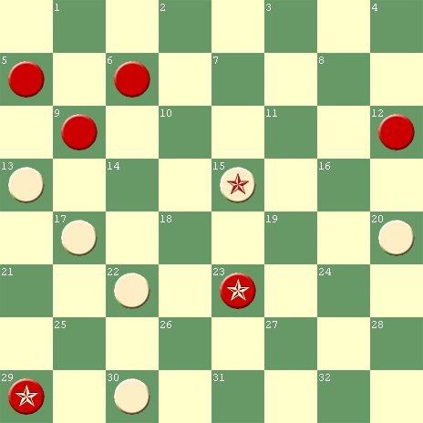
White to Play
“Mr. Lees could have played *15 19 and won.” If 20 16, 12-19, 15-24, “Mr. Slocum now points out that *6-10, 13 6, *23 18, would draw. Mr. Lees overlooked the neat coup”, J. T. Denvir
#89 – November 20, 1898
Background:

The 11 month gap between #88 and #89 suggests we may have missed some Slocum compositions during this period. Maybe Slocum vacationed after the demise of the American Checker Review at the end of 1897.

At any rate, we return here with a first rate, old-fashioned, discombobulating, Slocum Stroke featuring several of his pet motifs. The theme has an unusual mirror property; see Note E.

It is amazing that #89 was not picked up by any later checker editors (until now). It was Slocum’s 33rd setting so ignored. The Chicago Inter-Ocean may not have had the readership that it once had.

Lessons for Composers:

149. Some gems are buried in darkness waiting for the light of day.

#89 – “MIRROR I”
SLOCUM’S FIRST MIRROR POSITION
HIS 12TH ATTACKING PITCHES; HIS 5TH 3-WAY PITCH
HIS 8TH SLIP SQUEEZE; HIS 18TH DOUBLE
White to Play and Win
Solution to #89:

*19 15, 24-19A, *15 10B, 14-7C, *23 18D, 19-23 (or 19-24), *16 11E, WW by a Double (or Triple) and resulting numerical superiority

A – This pocket steal is the best defense. If 24-27, *23 19, 14-18, 15 11 and 16 11 both win for White.

B – A nice 3-way attacking pitch

C – If 6-15, *16 11, WW by a Double

D – Slocum’s first slip squeeze in more than 5 years. The last previous one was #50.

E – A second attacking pitch sews up the shocking sequence. Composers should note that, while it is set up for action on the White Double Corner side, #89 is Slocum’s first setting whose mirror image works from beginning to end on the opposite side of the board. Slocum chose the more natural appearing of the two settings.

Lessons for Composers:

150. Uncommon mirror positions demonstrate the same theme from opposite sides of the board.

Bibliography #89: (1 item)
November 20, 1898, Chicago Inter-Ocean, Problem 1603, “Send us your solution and we will give you credit for same in list of solvers”, J. T. Denvir
#90 – March 1899
Background:

Liam Stephens pointed out the similarity between #90 and “the finish of a game between Messrs. Grant and M’Guire”. The latter was published in the Paisley and Renfrewshire Gazette, March 12, 1870, Problem 201, and has since been immortalized in many publications. Review of Boland’s Familiar Themes 1938, Page 7; Famous Positions 1940, Page 67; and Checkers in Depth, 1974, Page 15, indicates the Grant-M’Guire position was the first of a family of published problems incorporating similar pitch / squeeze / steals. Many of them preceded #90.

Although #90 was a belated addition to the “Grant-M’Guire Family”, it does not transpose into any earlier published problems. It is a unique, original rendition of the old motif. Pitch / squeeze / steals typically occur at mirror positions. It is strange that Slocum’s second mirror position immediately follows his first, #89.

#90 was subjected to a “correction of a correction” sequence that brought it some fame and made it better. Both Slocum and Vance should be credited.

#90 – “THE PITCH/SQUEEZE/STEAL” or “MIRROR II”
SLOCUM’S 2ND MIRROR POSITION; 11TH 3X3;
13 TH ATTACKING PITCH; 14 TH 2-WAY PITCH;
HIS SECOND MISSED BETTER ATTACK
White to Play and Draw
Slocum’s Solution to #90:

*17 14A, 1-6B&Var.1, *21 17, 20-16, *28 24, 16-11, *24 19, 6-9C, *19 15D, 11-18, *17 13, 18-15, 13 6, 15-18, *14 10, Drawn

A – Comments in the bibliography suggest that, sometime after publication of #90, Hefter believed Red could win and convinced Slocum. Almost five years after #90 was published, the editor of the Otago Witness heard about the claim, published the setting after the obvious *17 14, and asked his readers to look for Hefter’s win against it. The fact that his readers were unsuccessful was the first hint that Hefter may have been wrong.

B – We do not have Hefter’s play, but it is likely that Vance’s solution in Variation 1 followed it to the point where Hefter erred. Composers should note that identifying Hefter’s error is worthwhile challenge.

Lessons for Composers:

151. Deducing another person’s thought process is good exercise.

C – It might seem trivial to point out that, after this 6-9 move, the Red piece on 11 must be a king in order to prevent a dual solution draw by 14 10. But incredibly, Problem 50 in Atwell’s Scientific Draughts, 1905, diagrammed the position after 6-9 without crowning the Red piece on 11, overlooking the dual solution. Atwell credited his flawed setting to “N. Alist” (his own nom de plume).

D – This 2-way attacking pitch, squeeze, and steal combination is Slocum’s second mirror position, coincidentally following on the heels of #89, his first mirror position. It can be set up on both the Single and Double Corner sides of the board. Not only that, each mirror position can also be set up at two different vertical locations, making a total of four different possible locations on the board. One came up in a game between Don West and Alex Moiseyev during a recent game, ACF Forum, Positions, “From Strawberry Fest 2011”. Composers should note that Slocum’s choice of locations offered the best set back opportunities.
Lessons for Composers:

152. Find the best location on the board for exploitation of your theme.

Variation 1 (Vance’s solution to #90)

20-16E, *28 24F, 16-11, *24 19G, 11-7H, *19 15I, 7-3J, 15 10K, 3-8, *10 7L, 1-6, *7 3M, 8-11, *21 17, 6-9, *14 10, 11-15, *10 6N, 15-10, *6 2, Drawn, R. W. Vance, 1925

E – In order to highlight Vance’s draw, Wood’s Checker Player (1944) diagrammed the position (on the cover) after this 20-16 move.

F – Not 14 10 or 21 17 because 16-11 and 16-19 both lead to Red wins. Composers should note their continuations.

G – The alternatives lose:
- If 14 10, 11-15 and 5-9 both lead to Red wins
- If 21 17, 11-7 and 11-16 both lead to Red wins, but other moves do not. Composers should note why not.

H – Or 11-8, *19 15 (forced), 8-3 same

I – Not 21 17, *7-11, RW

J – If 1-6, *21 17, 7-3, now *14 10 draws, but 15 11 loses by *6-10, 14 7, 3-10, 11 8, *5-9, 17 13, *10-6, RW

K – White has three other moves:
- If 21 17, *3-7, RW
- If 15 11, *1-6, 21 17, *6-10, RW as in Note J
- But apparently not mentioned (until now) is the fact that 14 10 at K also draws. Continue 5-9, now *21 17 draws, but 15 11 loses by 9-14 or 9-13, 11 7, *1-6 into First Position, RW.

L – Not 21 17, *8-11, RW

M – This is unnatural; could it have been the escape that Hefter missed? The alternatives are cleverly beaten as follows:
- If 7 2, *6-10, 14 7, *8-3 (Captive Cossacks), 21 17, 3-10, 17 13, *5-9, RW
- If 21 17, *8-3, 7 2, *6-10, 14 7, same as first bullet at 21 17

N – Not 10 7, *9-13, 17 14, *15-10, RW

Bibliography #90: (17 items)

March 1899, James Lees’ Scottish Draughts Quarterly, Prob. 83; missed strongest attack; Lees’ Scottish Draughts Quarterly appeared 1896–1899.

1900, Stearns’ World Problem Book, Part First, Pg. 12, Prob. 17, colors reversed, “one of Mr. Slocum’s neatest”, Stearns (missed the strongest attack); ironically, Mr. Stearns included the following in his “Prefatory”:
“What others may think of the problems gathered together herein I know not, but the compiler is happy to say, that in his own humble opinion, many of these problems are such that no possible fault could be found with them – are absolutely perfect – in fact, are ideal and could well serve as models for the use of problem authors”, Stearns; (#90 was not one of the perfect ones, Salot)

1900, Draughts World, Vol. XVI, Prob. 791, “contains a point which might easily be overlooked”, missed strongest attack

November 17, 1900, Queenslander, Brisbane, Australia, Page 1002, Problem 860, colors reversed, missed strongest attack

November 24, 1900, Coulter Fell’s Australian Town & Country Journal, Pg 59, Prob 271, colors reversed, quoted Draughts World, missed strongest attack

February 10, 1904, Otago Witness, Issue 2604, Page 58, Problem 2161, colors reversed, after the first move: “The above is one of Slocum’s little games; but we have seen somewhere that Chas. Hefter can make a win off it. The suggestion may add interest to the problem. Please send the result of your investigations”, Joseph Abernethy, Solution March 2, 1904: “Quite a number of solutions have been received to the above, but no satisfactory win has been shown, although a few solvers thought they had secured that result”, Abernethy (strongest attack not shown)

1909, Horsfall’s Problem Book, Prob. 200, missed strongest attack

August 30, 1913, Queenslander, Brisbane, Australia, Page 19, unnumbered prob
1918, Mitchell’s Checkers, Page 138, Problem 71, missed the strongest attack; solution Page 175, “A good example of boldness in getting out of trouble”, David Mitchell

September 27, 1924, The Mail, Adelaide, Australia, Pg 21, Prob 33, colors reversed, missed the strongest attack

November 12, 1925, Chicago Daily News, Problem 773, colors reversed, showed, for the first time Vance’s draw against the strongest attack; a note said, “Both Slocum and Hefter missed this draw - and they were both really good”

September 1935, Wood’s Checker Study No. 6, Prob. 45, republished Vance’s draw against the strongest attack

1938, Boland’s Familiar Themes, Page 7, did not show Vance’s draw, but referenced Wood’s Checker Study No. 6

October 1938, New Draughts World, Vol 2, Issue No 24, Page 373, Problem 182, colors reversed

September 1944, Wood’s Checker Player, Volume 8, Issue 1, Page 17, Boland’s Instructive Problems, Prob. 866, Vance’s draw was the cover problem,
“A note in the Chicago Daily News said that both Slocum and Hefter missed this draw, and they were both really good”, Boland

March 1992, Keystone Checker Review, Page 335, Problem 10, solution, on Page 350 of same issue, included Vance’s draw, but without proper credit; part of Bob Crue’s collection of Slocum problems

November 10, 2007, Bob Newell’s “The Checker Maven”, “Uncle Ben’s Porch, An Argument with Mom”, Relative positions, First Diagram

EIGHTH INTERLUDE – 1899

In a period of three months, three all time great, combination players and publishers of the game died: James Lees, 35, of Dalmellington, Ayrshire, in October 1899; James P. Reed, 40, of “Pittsburg, U.S.A.”, in December 7, 1899; and Julian D. Janvier, 60, of Newcastle, Delaware, in January 1900. Lengthy obituary notices were published in Draughts World, November 1899 and January 1900.

Lees published three of Slocum’s compositions (#11, 77, and 90).

The only Slocum composition to have a link to published analysis by Janvier was #80, Variation 4, Notes E⁴, G⁴, and H⁴.

Reed was a former American champion, publisher, and touring match and blindfold exhibition player. As editor of the American Checker Review and Reed’s Checker Journal, he published 33 Slocum compositions, second only to Denvir. Parts of Reed’s colorful life were detailed in the Second Prelude (May 1, 1888), First Interlude (April 1891), Second Interlude (1892), Fourth Interlude (1894)

Despite their earlier word wars, the obituary of Reed in Draughts World was appropriately respectful without conceding any prior arguments. It is repeated below:

JAMES P. REED

Blow after blow seems to fall in quick succession upon the followers of our grand old game, and to the formidable list of those who have crossed the bourne this year we have to add the name of J. P. Reed of Pittsburg, U.S.A. Cut away in the prime of life, his death has come as a great shock to his friends and admirers on this side of the Atlantic.

During his two sojourns here, he made many friends, his genial wit, his sly but inoffensive humour coupled with his gentleness of voice made him certainly the most popular peripatetic expert who visited our draughts resorts giving exhibitions.
This is the severest loss sustained by our American cousins, as in the death of Reed, their chief exhibitor, and one who has done more in this way than any other, with the exception of our old Herd Laddie.

He toured all over the States and Canada, and wherever a checkerist could be found, the Little Giant, as he was facetiously named by one of his Pittsburg coadjutors, never hesitated to visit him.

His career in draughts was pretty much like his career in life, subjected to many ups and downs. That he was a great player was established beyond doubt, but that he accomplished all that was expected of him by his friends and admirers is another question. James Reed was no saint –few draughts players are, but we are satisfied that had he been the disciplined force his great contemporary was and is, the latter, we are afraid, would not have had that splendid record he has today of having won 5 matches to Reed’s 1.

We were present in America when the subject of our sketch won his only match from Barker, and on that occasion his success was brought about by the energetic and assiduous attentions of Charlie Hefter, a celebrated expert, of whom we hear far too little. Barker then stated that he was sure no player in the world would beat Reed in the form he was then showing.

It is now a matter of history the almost sensational finish of this match – the cough drop incident being a little too suggestive for the not over credulous follower of the game. It was in this match that Reed entitled himself to rank as the most brilliant match player, by winning a Denny with the largest stroke which ever came up in first-class match play.

NOTE – See SECOND PRELUDE – beginning May 1, 1888, (PART 2) for a description of the cough drop incident.

Notwithstanding our very high opinion of Reed, we do not wish it to go forth that we speak disparagingly of Barker’s ability. Far from it, as our high opinion in dubbing Barker the best match player alive is still maintained.
The heroic or poetic temperament of his Celtic nature made it too huge an effort for Reed to restrain himself with the stoic-like doggedness and determination which are so essentially characteristic of the model match player. That Reed failed as a great match player is partially acknowledged but his pluck was never wanting, and among his supporters he had the most honourable sportsmen ever associated with the game.

In Mr. R. W. Patterson we have a high-minded gentleman who was most devoted in his attentions to poor Reed through good report or bad, and through this gentleman we beg to convey our sincerest sympathy to the relatives of Reed and to the many friends in America, and Pittsburg in particular, in the great loss draughts has sustained.

Reed was only 40 years of age, and died at the Homæopathic Hospital, Pittsburg, from an epileptic fit.

December 1, 1900, Queenslander, Brisbane, Australia; Here is what may be Slocum’s earliest published game and the only published game between him and J. P. Reed (Original source and date unknown; probably played before 1892 when Reed left Chicago):
“Game 1255; ‘Ayrshire Lassie’;
Played between J. P. Reed and G. H. Slocum at Chicago
Slocum’s move:
11-15 15-18 10-15 9-13 11-18
24 20 22 15 19 10 23 19 20 16
8-11 11-18 6-15 7-11 12-19
28 24 32 28 30 26 19 10 24 15 and
4-8 9-14 5-9A 2-6 6-9 Reed
23 19 26 23 26 22 22 15 27 24 won.

A. Loses. Anderson gives 8-11, 24 19, 15-24, 28 19, 14-17, as drawing for Red with a piece down, but the chances of winning are all in Red’s favor.”

#91 – December 1899
Background:

“No 91 sure is a beauty”, Liam Stephens (2011)

#91 was Slocum’s 34th setting to be published only once (until now); it was an incredible oversight on the part of other editors. Perhaps the fact that it was showcased in the famous Draughts World intimidated editors of lesser publications from replicating it.

It is one of Slocum’s most deceptive compositions. Just set it up, without the clues given here, and learn why seasoned solvers struggle with it. Even with the clues, they have trouble. Try it yourself.

White is a piece up, but has two pieces in jeopardy.

‘Nuff said! Let the solution do the talking.

Lessons for Composers:

153. Don’t give clues to solvers (violated here).

#91 – “POINTLESS POWER”
SLOCUM’S 24TH TRIPLE
HIS ELEVENTH DOMINO PITCH
White to Play and Win
Solution to #91:

*29 25A, 30-21, *10 7B, 21-25C, *22 17D, 14-21, *19 15E, 11-18, *12 8, WW by a Triple and the Move

A – This pitch has no point unless you see through to the end. The White piece on 22 is still in jeopardy.
- The more natural 10 7 allows *2-6, 7 2, *11-16, 2 18, 16-14, 12 16, *30-26, Draws
- Avoid 19 23, *11-15, Draws

B – This sets up a domino; avoid 19 23, now *21-25 draws, but 11-15, *22 17, WW

C – The steal is forced; if 2-6, *22 17, WW by 2 for 1

D – This second pitch is also pointless unless you see that a domino pitch has been set up for a Triple.

E – The domino pitch does it.

Lessons for Composers:

154. Apparently pointless pitches empower problemists.

Bibliography #91: (3 item)

December 1899, Draughts World, Volume XIV, Prob. 738, “Another of those fine touches by the famous composer”; no earlier publication was mentioned.

February 10, 1900, Coulter Fell’s Australian Town & Country Journal, Pg 57, Problem 231, colors reversed

May 14, 1911, Sunday Times, Perth, Australia, Page 15, Problem 102, colors reversed

#92 – Before January 7, 1900
Background:

January 1900, Draughts World (SCOTLAND), Volume XV, Page 726, reported, “G. H. Slocum, America’s choice problemist and talented violinist, was in Moline, Ill., lately, and between overtures and fantasias, entertained the checker players cross-board”.

On the other side of the world, the same news item was quoted verbatim in the March 8, 1900, Otago Witness (NEW ZEALAND), Issue 2401, Page 52, DRAUGHTS ITEMS. You are not likely to find better evidence of Slocum’s world renown.

Not much earlier, Slocum won an ending from an unpublished game at the Chicago Club. #92 is that ending. From it, a unique story evolves.

- First, add #92 to the list as Slocum’s 34th setting published only once (until now). It deserves more attention.

- Second, recognize that, if it had been a composed problem, it could have been set back several moves; for example, *28 24, 16-11 (16-20 no better), *24 19, 11-7 is one way to reach the diagrammed setting.

- Third, although not composed, #92 combines, in one setting, two of Slocum’s divergent themes: a deferred stroke and a variant of a standard position. Specifically, Red has two defenses: one is beaten by the deferred stroke; the other by American Position with extra pieces.

- Fourth, it is not known which defense was used in the game that produced #92. But if it was the one requiring Slocum to execute the deferred stroke, what would be the odds that Slocum executed it correctly as a result of his already having composed a setting requiring that stroke to win? Well, #42 was that prior composition. It was published almost 8 years earlier.

To properly digest #92, it needs to be reviewed together with #42. They have a common transposition at a key landing just before the pitches begin.

That pair of settings raises the debatable question: Which was better?

- #42 had a slightly longer solution, and was focused on a single defense.

- #92 arose in a game, and presented a second reasonable defense for the solver to decipher.

The choice is a matter of personal preference; in other words, a toss-up.

Lessons for Composers:

155. Positions can transpose between games and compositions.

#92 – “TRANSPO”
SLOCUM’S 19TH DOUBLE
HIS AMERICAN POSITION WITH EXTRA PIECES
White to Play and Win

Solution to #92:

*19 15A, 7-3B, *13 9C, 6-13, *15 11D, 5-9, 14 5, 21-17, *22 18E, 17-21, 5 9F, 13-17, 18 23G, 17-22H, 9 14I, 22-25, *23 26J, 25-29, *26 30, 29-25, 14 18 WW by American Position with extra pieces on 3 and 11.

A – A beginner would correctly select this move. A more experienced checkerist would see the 13 9 pitch will have to be made sooner or later, so might prematurely choose to try it now. But continue 6-13, 19 15, *5-9, 14 5, *21-17, 22 18, *17-21, 5 9, *21-17, 18 23, *17-22, Draws because now White cannot mount an attack without exposing the White single piece.

B – Here Red has a choice of 7-3 and 7-2 (best). Their continuations are both long and, although initially similar, they lead to surprisingly different finishing themes. After the pitches, one win depends on the American Position with extra pieces, while the other needs to force a deferred stroke. The best defense surprisingly transposes into #42, as follows: If 7-2, *13 9, 6-13, *15 10 forms #42 at D, *18 22, WW after a long, beautiful, difficult struggle. Don’t miss it.

C – Not 15 11 (premature), *6-10, Draws. Not 14 10, *21-17, Draws.

D – Correctly timed; from here the win is relatively easy. Notice the similarity with #42 at D, which is much more difficult.

Lessons for Composers:

156. Timing is everything.

157. Appearances are deceiving.

E – Composers should note that if 22 25, both sides must make a pair of star moves to draw: *17-14, *25 22, *14-10, *11 7, Draws

F – Strangely 18 15 and 18 14 both win, but 18 23 allows a draw (In contrast, at the corresponding point in #42, Note G, 18 23 is the best way to win):

- 18 15, 13-17, *5 9, 17-22, *15 18, 22-25 (22-26, *24 19, 21-25, *19 16, 8-12, 16 11, WW), *18-22, 25-29, *22 26, 21 25 (or 21-17, *26 30, 17-21, same), *26 30, 25-21, *9 14, 29-25, 14 18, WW, essentially by T. J. Brown, Bristol Draughts Player, 1874, although he started with the White kings located differently.

- 18 14, 13-17, *5-9, 17-22, *14 18, same as F, a., at 5, *15 18, WW

- 18 23, *21-25, 23 18 (5 9, *25 22, Draws), *13-17, 5 9, *17-21, Draws

G – 18 15 and 18 14 still win too, forming F, a., at 3, *5 9, and F, b., at 3, *5 9, respectively.

H –21-25 forms a position reached by a T. J. Brown 2x2 in Gould’s Problem Book, 1881, Problem 72, except for the extra pieces on 3 and 11. Brown continued *9 14 (not 9 13, *25-22, Draws), 17-21, 23 26 (or 14 17), Brown WW. For clarification, proceed 25-29, 26 30 (14 9 also wins), 29-25, 14 18, 25-29, 18 22, WW with or without the extra pieces. Compare with the finale of #42, Note P. See the difference?

I – 23 18 also wins here, but. . .

J – . . . now 23 18, allows *25-29, 18 23 or18 22, *12 8, Draws.

Bibliography #92: (1 item)

Before January 7, 1900, Chicago Inter-Ocean, Problem 1722, colors reversed, “The above ending occurred at the Chicago Club during the week between Mr. Slocum and an able exponent of the game. It is a ‘gem of the first water’ and in keeping with many of Mr. Slocum’s beautiful compositions. Can you solve it? Don’t be too quick”, solution January 7, 1900
#93 – January 21, 1900
Background:

Imagine you are watching a tournament game, which reached the diagrammed position #93 and proceeded to a draw. After the game, could you set up the position and then demonstrate the win that was missed? That is what Slocum did.

Many game positions are beset by dual solutions. #93 has a variety of alternative themes that initially appeared to have the potential of winning another way. But Slocum’s solution proved to be both singular and sensational.

The setting bears some resemblance to a Brooklyn stroke (see #46), but it is more accurately classed as a compound stroke. An intriguing feature is not one, but two multiple-choice jumps. In each case, one jump is correct and the other is not.

If #93 were a composition, the setting could have been set back to a variety of earlier stages. Also, the White king may be a single piece.

#93 was Slocum’s 35th setting overlooked for republication (until now).

#93 – “ON THE SPOT II”
SLOCUM’S 3RD GAME Correction
SLOCUM’S 10 TH COMPOUND STROKE; HIS 20TH DOUBLE
White to Play and Win
Solution to #93:

*6 2A, 7-11, *2 7B&Var.1, 26-30C, *23 19D, 16-23, *27 18E, 20-27, *7 16E, WW

A – Efforts to find a dual solution have not been fruitful. If 6 9, *26-31, 9 14, *16-19, Draws

B – Composers should note the narrow escapes if the White king comes out the other way. They are summarized in Variation 1.

C – Chicago Inter-Ocean’s published solution gave 26-31 here. Surely it was a mistake. Four different moves beat it: 23 19, 7 2, 7 3 and 32 28. Composers should note the three nifty themes following 32 28, 11-15:

- If 7 11, 16-19, 23 16, 12-19, 11 18, 19-23, 18 22 (or 18 14 or 18 15), 23-32, 22 18 (22 17 or 22 25), *18 22, WW by a nice lock.

- If 7 2 (or 7 3), 31-26 (if 16-19, the White king has the move on the Red king, WW), 2 6 (or 2 7), 26-19, *6 10, 15-18, 24 15, 18-22, *15 11, 22-26, *10 15, 26-31, *15-18, good timing, WW

- Not 7 10 (almost loses), *31-26, 10 19, is G, first bullet, at 1, 32 28

D – Composers should note that there are four moves to win if 26-31 is played at Note C, but only one if 26-30 is played instead. Continue:

- 7 2 is Var.1 at 3, 6 2, Draws

- 7 3 is Var.1 at 8, 22-25, Draws

- 7 10 is G at 1, 6 10, Draws

- or 32 28, both 30-25 and 11-15 will Draw

E (two places) – Two timed jumps – avoid jumping the wrong way

Lessons for Composers:

158. Wrong way jumps spell disaster.

Variation 1:

2 6, *26-30, 6 2F&G, *30-25, 2 7, *25-22I, 7 3J, 22-25L, 3 8M, 25-22 (or 25-30), 8-15, *16-19N Draws

F (off Var.1) – 6 9, *30-25, 9 14, *25-22, 32 28, *11-15, 14 18, *15-19, *18 25, 19-26, 25 22, *26-30, 22 18, *30-25, Draws

G (off Var.1) - 6 10 bad: It almost loses by 11-15H, 10 19, *30-26, which leaves two desperate escapes for White:

- 32 28, *26-22, *19 15, *16-19, 23 16, 12-19, *27 23, Draws (Multiple star moves by both sides)

- 23 18, 16-23, *18 14, 26-22 (if 12-16, 27 18, 20-27, 32 23, 26-19, *14 9, Draws), 27 18, 22-15 (or 20-27, 32 23, 22-15, *14 9, same), *14 9, 20-27, 32 23, 12-16, 9 6 (or 9 5), 16-20, 6 1 (or 6 2), 20-24, *23 19, 15-11, 1 6 (or 1 5), 24-27, *6 9, 27-31, *9 14, 31-27, *14 18, 27-24, *19 15, Draws

H (off G) – 30-25 is inferior to the pitch, but also draws. Continue:

- 10-14 is F at 3, 9 14

- 10-7 is Var.1 at 5, 2 7

I (off Var.1) – Crucial: the only move to prevent 23 19

J (off Var.1) – Two bad choices:

- The 23 19 stroke, which won at D with the Red king on 30, loses here with the Red king on 22; a complete reversal of fortune.

- 7 10 is almost as bad; continue 11-15K, 10 19, 22-26 is G at 4, 30-26
Lessons for Composers:

159. The location of one piece can spell the difference between winning and losing.

K (off I) – 22-25 and 22-17 are inferior to the pitch, but also draw:

- 22-25 is H at 1, 30-25

- 22-17, 10 7, *17-22 is Var.1 at 6, *25-22

L (off Var.1) – Or 22-17, 3 8, *17-22, same

M (off Var.1) – 3 7 is Var. 1 at 5, 2 7

N (off Var.1) - 22-26 succumbs to a Triple via *23 18, 16-19 (26-23 is beaten by 3 different moves: 24 19, 15 11, and 15-19, WW), *32 28, 19-23 (26-23, *18 14, WW), *24 19, 23-32, *28 24, 20-27, *19 16, WW

Bibliography #93: (1 item)

January 21, 1900, Chicago Inter-Ocean, Problem 1725;
“The above ending occurred in a game in the Chicago tournament. The game resulted in a draw. Mr. Slocum pointed out a neat win. Can you find it?” Solution February 11, 1900
#94 – February 1900
Background:

#94 became Slocum’s most popular setting since #66. Although years apart and very different in theme, the two settings had some similarities:
- Both were published at least 14 times; both multiple times by Draughts World alone.
- Both were 4x4 settings
- Both had three diverse variations of note.
- Neither setting can be improved.

Composers should note the Red piece on 12 need not be a king, but it does equalize the number of kings on each side.

Although a couple of pitches are interchangeable, #94 is a model Slocum Stroke par excellence. What more can be said?

Lessons for Composers:

160. You know quality when you see it.

#94 – “PAR EXCELLENCE”
SLOCUM’S 25TH TRIPLE; HIS 21ST DOUBLE
White to Play and Win
Solution to #94:

*18 14A, 28-24 (or 28-32), *14 10, 24-27B, *10 7, 27-23C, 22 17 (or 15 11 first), 21-14, *15 11, 8-15, *7 10, WW by the Triple and the Move

A – Composers should note the stroke cannot be forced unless the mobile Red king is on Square 28. Even then, White cannot waste any time getting to Square 7. The timing is perfect.

B – Red has a choice between three poisons:

- If 24-19, *10 7, 19-10, 7 14, 8-11, 14 18 (or 14 10), 11-16, *18 15, 16-20, *15 19, WW by the double pin.

- If 24-20, *10 7, 20-16 (20-24 is C at 1, 27-24), *15 11, 8-15, *7 11, WW by the Double and the Move

C – Red heads for the breeches. If instead 27-24, the same stroke prevails, but it allows White the option of safely wasting time by 7 10 or 7 2. Also at C, avoiding the stroke by backing out 27-31 or 27-32, of course allows White to steal the piece on 8.

Bibliography #94: (18 items)

February 1900, Draughts World, Volume XV, Issue 38, Prob. 753, colors reversed,
“Another of those splendid compositions by our Yankee cousin”

February 1900, A. J. Heffner’s American Checker Player, Volume 1, Issue 6

April 14, 1900, Queenslander, Brisbane, Australia, Page 685, Problem 805, colors reversed

1900, Stearns World Problem Book, Part First, Page 19, Prob. 60, colors reversed

August 11, 1900, Australian Town and Country Journal, Problem 256, colors reversed, The ‘Draughts World’ characterizes this as ‘another of those splendid compositions by our Yankee cousin”

1901, Whyte’s Problemists’ Guide, Prob. 317

September 1901, North American Checker Board, Volume XI, Issue 3, Page 47, Prob. 27, colors reversed, solution October 1901, Page 62

1905, Atwell’s Scientific Draughts, Prob. 266

1909, Horsfall’s Problem Book, Page 59, Prob. 531

Date? Leeds Budget, Problem 535

May 1911, Draughts World, Volume XXXVII, Issue 173, Page 212, Gem 836, “A fine effort by the Chicagoite”

March 30, 1912, Western Mail, Perth, WA (Australia), Pg 38, Prob 750, colors reversed, solution April 27, 1912

March 5, 1915, Third American Tourney, Prob. 102

1923, Wendemuth’s Checker Companion, Page 150, Prob. 90

1928, Kear’s Encyclopedia, Alexander’s Revision, Prob. 178

1943, Ryan’s Scientific Checkers Made Easy, Page 165, Prob. 50, last problem in the book

1966, Oldbury’s Chequer Chiaroscuro, Page 93:6

January 1992, Keystone Checker Review, Page 308, Problem 5, solution on Page 312 of same issue, part of Bob Crue’s collection of Slocum problems

#95 – September 30, 1900
Background:

Do you remember learning how to recognize a simple “2 for 1”? And then occasionally scoring one in actual play? And sometimes “threatening” one or more to your advantage?

Slocum has been there and done those things in the extreme. Would it impress you if he threatened two (2) simple “3 for 1’s” plus six (6) simple “2 for 1’s”, scoring one, all from the same setting? #95 is that setting.

Other editors were evidently not impressed by such simple ideas. Or maybe they did not notice the multiplicity of those ideas. Anyway, #95 became Slocum’s 36th setting unrepublished (until now).

Lessons for Composers:

161. Beauty is in the eye of the beholder.

#95 – “THE 2 FOR 1 FAMILY”
SLOCUM’S 12TH 3x3
HIS 22ND DOUBLE
White to Play and Win

Solution to #95:

*10 15A, 27-24B, *20 16C, 23-19D, *14 10E, 19-12, *15 11, WW by a Double and the Move

A – Threatens to take the first 2 for 1 by 15 19. But the false solution by 20 16 also threatens to take a second 2 for 1 by 16 11. After 20 16, Red has 3 ways to avoid the threatened 2 for 1, but only one of them draws:

- 8-12 walks into a third 2 for 1 by *10 15, WW

- 23-26 allows either:
  - 16 12, 8-11, then a fourth 2 for 1 by *10 15, WW
  - 10 15, 8-12 (to prevent the steal by 16 12), *10 15, WW by a 3 for 1.

- *23-19, 16 12, *8-11, Draws

B – Red has 2 other ways to avoid the threatened 2 for 1, but:
- 8-12 walks into a fifth 2 for 1 by *20 16, WW
- 23-26, *20 16, is A, 2), Second Bullet, at 1, 10 15, WW

C – Unnatural because it forms a pocket for Red to attack

D – The pocket steal is successful

E – But White finally scores the sixth 2 for 1. Composers should note that it is different from the five 2 for 1’s listed in A and B.

Bibliography #95: (1 item)

September 30, 1900, Chicago Inter-Ocean, Prob. 1916
#96 – December 1900
Background:

Red has the Move and is threatening to pin all three White pieces.

The attraction featured in the much appreciated #96 is that White must first get off on the right foot (with a move that is by no means obvious) and then string together nine consecutive star moves (to avoid repeated traps) before nullifying the Red advantage with a counterpunch.

It demonstrates again that Slocum’s magical manipulation of the Move rivals the magic of his stroke settings.

Composers should note that the Red kings are necessary, but if the White king on 4 were changed to a single piece on 12, White could still draw. Slocum chose the better location for that piece. See Note E.

Lessons for Composers:

162. Settings sparkle with strings of stars.

#96 – “NICE POINTS”
SLOCUM’S” 16TH ALL ABOUT THE MOVE”
HIS 13TH 3X3;HIS 4TH BRIDGE; HIS 5TH SEE-SAW
White to Play and Draw
Solution to #96:

*13 9A, 1-5B, *9 6, 5-1, *6 2, 24-27, *25 22C, 27-31, *22 18C, 31-26, *18 15C, 26-23, *15 11D, 23-18E, *11 16, now if 18-15, *16 11, Draws by changing the Move, while 18-23, *16 11, Draws by See-Saw.

A – This move is essential. Moving the mobile White king initiates nothing but false solutions. Red wins by responding 1-5 or 1-6, subsequently preventing the White king from escaping to the White Double Corner. Composers should note the various continuations run into standard positions; for example:

- If the mobile White king stays on the Single Corner side and tries to release the single piece, Red wins by First Position with extra pieces.

- If the mobile White king runs toward the Double Corner side and tries to release the pinned White king, Red wins by the American Position with extra pieces.

B – Red’s strength lies in keeping the Move. If White is allowed to dive into the doghole by *9 5, the Move will change. White then draws easily.

C (3 places) – White must run to Square 11, while avoiding Square 10.

D –Square 10 is a land mine. Stepping on it triggers disaster. Red forces an exchange, without changing the Move, and winds up with a win by a double pin: 15 10, *23-18, 2 6 or 2 7, *18-14, RW

E – White cannot be pinned on Square 11; if 23-19, then *2 6, 1-10, *11 15, Draws. Composers should note that if the White king on 4 were a single piece on 12, the *2 6 pitch and breeches would not be necessary because 11 16 would also draw.

Bibliography #96: (8 items)

December 1900, Schaefer’s Checkerist, Problem 3, listed Slocum as from Chicago, Ill., solution January 1901

June 1902, Draughts World, Volume XIX, No. 66 (New Series), Page 310, “Stray Gems from other Pages”, GEM 409, colors reversed,
“Contains some nice points”

August 16, 1902, Coulter Fell’s Australian Town & Country, Journal, Page 59, Problem 358, colors reversed, quoted Draughts World

September 17, 1904, Western Mail, Perth, WA (Australia), Page 38, Problem 371, colors reversed, solution October 8, 1904

1909, Horsfall’s Problem Book, Page 23, Prob. 199, colors reversed

1923, Wendemuth’s Checker Companion, Page 150, Prob. 87, colors reversed

September 1944, Wood’s Checker Player, Volume 8, Issue 1, Page 17, Boland’s Instructive Positions, Prob. 867

January 1993, Keystone Checker Review, Page 462, Problem 40, colors reversed, solution Page 472, of same issue, part of Bob Crue’s collection of Slocum problems

#97 – September, 1901
Background:

Alert! Alert! Sight-solver sighted! Solve #97 from the diagram. Slocum solved it in a crossboard game. The game was not published.

After solving it, solvers typically move on. But composers dig deeper, looking for dual solutions, setbacks, and potential setting improvements.

- #97 has no dual solution, but it is unusual in that if you miss the win, you lose. The solitary solution produces a White win. Missing it results in a Red win. Either way, with correct play, there is no draw. That would be a big turnaround in competitive play.

- #97 cannot be improved by setting it back. Doing so allows Red escapes. Red’s last previous move had to be 7-11 or 7-10 or 5-9:

If 7-11 had formed #97, then Red missed a Triple via *8-11, RW

If 7-10 had formed #97, then Red missed the draw by *9-14, now *17 10, Draws, but 18 2 triggers a compound stroke that removes 11 pieces from the board, leaving Red with the win by numerical superiority

If 5-9 had formed #97, then Red missed the draw by *3-7 (not 11-16, *18 14, 16-23, *27 18, WW) Draws

#97 was published under the following unusual circumstances:

- When L. M. Stearns published “Part First of the World’s Problem Book”, 1900, it contained 200 problems by 148 authors, including Slocum’s #90 and #94. Although Stearns was an accomplished composer, he did not include any of his own compositions. In his “Prefatory”, Stearns stated:

“Many of the endings occurred in actual play. Comparatively few stroke problems are presented, for strokes, it is generally conceded, are of secondary importance. The few strokes that are submitted, however, will, I trust, prove pleasing, for they are natural in appearance as well as brilliant in solution”, Stearns, (this is an excellent description of #97)

- #97 appeared, along with #75, in Stearns’ “Part Second of the World’s Problem Book”, 1901. This volume also contained 200 problems, but, in another respect, it represented a major departure from the previous volume. Stearns explained the change as follows:

“In this part of our work will be noticed that the author has one hundred thirty-nine of the two hundred problems of his own composition – the reason is obvious – getting the work out during the heated term, the contributions promised did not come in as was hoped, only sixty-one being contributed, but we were determined to have the book out in early fall and here we are. As to the usefulness of the problems, no one can question”, Stearns, September 1901

#97 – “SLOCUM VERSUS AMATEUR”
SLOCUM’S 12TH PURE STROKE
HIS 11 TH COMPOUND STROKE
HIS 26TH TRIPLE, HIS 22ND DOUBLE
White to Play and Win
Solution to #97:

*17 14A, 10-17, *19 16B, 12-19, *15 10, 6-15, *27 24C, WW by the compound stroke

A – Stearns published the bare bones solution with no notes or variations. Solvers are satisfied, but composers look deeper. Composers should note that if White cannot find the win, Red can win. There is no middle ground:

- If 30 25, *11-16, 27 23 (26 23, 8-11 or 10 14, RW), *10-14, 17 10, *13-17, 22 13, *8-11, 15 8, 6-31 and 6-29 both RW

- If 26 23, *1-5, 30 26, *3-7, 28 24, *9-14,18 3, 11-25, 2 4, 13-31, eventual RW

- If 27 23, 9-14 and 20-24 both RW

- If 28 24, 9-14 and 12-16 both RW

B – If 28 24, now*3-7, RW, but 11-16, *18 15, Draws

C – White goes 4 pieces down, with 4 perfectly sequenced pitches, and recovers to win after 10 pieces have been removed from the board.

Lessons for Composers:

163. Wins are appreciated even more when the only options are losses.

164. Good settings hide more than meets the eye.

Bibliography #97: (2 items)

September 1901, Stearns’ World Problem Book, Part Second, Page 105, Problem 368

December 11, 1926, Queenslander, Page 40, “A SLOCUM BRILLIANT – The famous G. H. Slocum won the following game with a brilliant stroke, which astonished the onlookers as well as the amateur with whom he was playing, many years ago”
#98 – Before December 1901
Background:

Reminiscent of #21, #86, and others, Slocum was not bashful about presenting compositions in unnatural settings in order to demonstrate surprising themes. In #98, Red’s last move was presumably 2-20.

“Our opinion - setting is fair – not impossible”, Milton Johnson, 1970

Judging by the number of times #98 was published, it was well received.

Composers should note that the Red piece on 20 need not be a king, but making it a king invites Red to make the losing 20-16 at Note B.

Composers should also note that there is another, possibly better, way to set #98: replace the White pieces on 8 and 15 with a king on 3 and a single piece on 11. The same deferred stroke is necessary to win, but White has more false options, and it looks more natural.

Lessons for Composers:

165. Even well received settings can sometimes be improved.

#98 – SLOCUM’S 27TH TRIPLE
HIS 22ND SLIP PITCH
White to Play and Win

Solution to #98:

*15 11A, 12-16B, *27 23C, 20-24,*30 25D, 29-22, *23 18D, 22-15, *8 3D, WW by Triple

A – Is 8 3 a false solution? Well, not a good one. Against it, both 12-16 and 4-8 Draw easily, but not 20-16, *15 11, WW

B – If 20-16, *8 3, WW

C – Not 8 3, *16-19, 3 7, *19-24, Draws

D (3 places) – This 3-pitch sequence is a unique key to the win.

Note to Composers: Because of its similarity to #98, Milton Johnson suggested referencing Horsfall’s Problem Book, No. 51, by H. F. Shearer. It was originally published in Durgin’s Single Corner Book, and then in Chicago Inter-Ocean, June 16, 1894, Problem 570, solution June 23, 1894, predating Slocum’s setting.
Red - 4, 12, 20, 22; White – 11, 19, 27, 30; White to Play and Win:
*11 7, 4-8, *19 15, 12-16, *30 26, WW

Bibliography #98: (8 items)

Before December 1901, Aberdeen Free Press, Prob. 1268

December 1901, Draughts World, Volume XVIII, No. 60 (New Series), Page 1191, “Stray Gems Gathered from Other Pages”, Gem 382, “Very neat”

February 8, 1902, Australian Town and Country Journal, Prob 331, “The ‘Draughts World’ pronounces this a ‘very neat’ problem”

March 5, 1904, Sydney Morning Herald, Problem 680, solution March 19, 1904

1909, Horsfall’s Problem Book, Page 62, Prob. 551

June 13, 1913, Western Mail, Perth, WA (Australia), Page 88, Problem 810

1923, Wendemuth’s Checker Companion, Page 151, Prob. 96

July 1992, Keystone Checker Review, Page 379, Problem 21, solution on Page 397 of same issue, part of Bob Crue’s collection of Slocum problems

NINTH INTERLUDE – 1901-1903

June 22, 1901, Australian Town and Country Journal, Pg 60, “Mr. G. H. Slocum, the author of some of the finest ‘stroke’ problems extant, is conducting an interesting checker column in Chicago. He must be a veritable glutton at the game, for at St. Paul during a recent fortnight’s stay in that city he contested no fewer than 2000 games”, Coulter Fell, (Slocum an editor? 143 games per day?)

August 1901, North American Checker Board, Volume XI, Issue 2, Page 29, “Preston Ketchum, who was first champion of Wisconsin, but was in Louisiana during his last tourney, has been in Chicago, breaking even with Charles Hefter and Welen, Wendemuth and Banks. Geo. Slocum quit one game to the good. Mr. Ketchum will next stop at Buffalo and expects a try with the wonderful John F. Horr and the other stars of the Pan-American city”, Stearns

September 1901, North American Checker Board, Volume XI, Issue 3, George Slocum’s portrait graced the cover and four of his problems appeared inside.
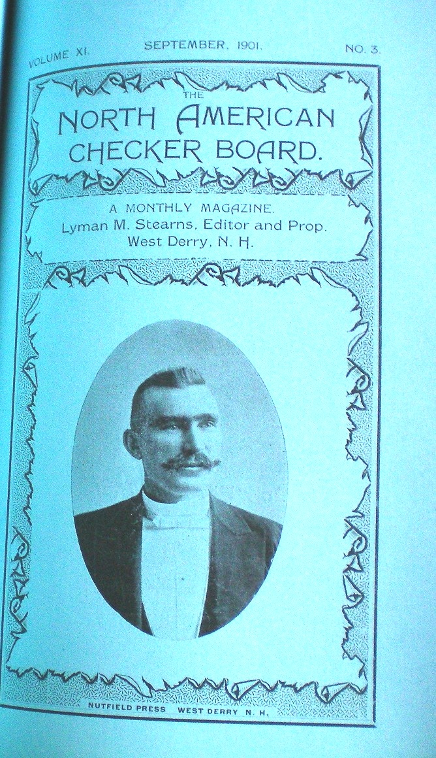
August 1902, Draughts World, Volume XX, No. 68 (New Series), inside back cover, printed the following:

“G. H. Slocum, the Chicago man who has established on four continents a reputation as the constructor of a large number of the slickest and cutest problems ever put on for the purpose of confounding the “cock-sure” solver, who knows he has got it when he is only enmeshed in one of George’s nets spread for just that purpose, has been absent for nearly a year from his usual haunts; but the rest seems to have improved his playing points, as he recently defeated R. D. Banks in a ten-game match, the score being: Slocum, 1; Banks, 0; 9 draws.”
_______________________________________________________

February 1903, Draughts World, Page 24,
“George Slocum, the noted problemist, is traveling with the Noble Theatrical Company, and recently stopped at Mitchell, S.D. and succeeded in defeating the local champion.”
________________________________________________________

NOTE: We have found no Slocum problems with initial publication dates in 1902 or 1903.

#99 – April 17, 1904
Background:

After an apparent 2-year vacation from composing problems, Slocum returned with #99 and #100, a pair of 3x3’s that appeared together in the Chicago Inter-Ocean on this date. Both were soon after republished in the Otago Witness, and then dropped out of sight (until now). Both are highly tactical, relying on see-saws, manipulation of the Move and fine false solutions, all devices long favored by Slocum.

Simple see-saw finales, or so-called perpetual draws, are commonplace on the checkerboard, but you will seldom see a piece-down double corner draw like #99. Payne would be impressed.

White must build and maintain a fortress to withstand attacks from all sides, while avoiding temptations to be more aggressive along the way.

Lessons for Composers:

166. Simple themes sometimes can be made incredibly complex.

167. Composers should not be satisfied with the solution alone.

#99 – “SLOCUM’S DOUBLE CORNER DRAW”
Slocum’s 6 TH see-saw; HIS 13 TH ATTACKING PITCH, HIS 14TH 3X3; HIS 17TH ALL ABOUT THE MOVE”
White to Play and Draw
Solution to #99:

*20 24A, 19-28, *27 31B, 22-17C, *30 26D, 17-14E, *26 23F, 14-10G, *31 27H, 10-14I, *27 31J, 14-17, *31-27, 17-22, *27-31, Draws by See-Saw (after eight consecutive star moves)

A – This attacking pitch is necessary in view of the tricky, but impotent alternatives:

- Not 27 23, 19-26, 30 23, *32-27, 23 19, *22-18, 19 16, *18-15, 16 12. 15-11 or 15-10 (American Position), RW

- Not 27 24, 19-28, 20 24, *32-27, 24-32, *28-32 (must prevent 31 27), 30 26, *22-25 (must avoid trades), 26 23, *25-22, RW

B – Not 27 23, *22-26, RW; not 27 24, forms Note Ab, at 3, 20 24, RW

C – If 22-18, either:

- 31 26 followed by *26 23, Draws, or

- 30 26, 18 15 (18-14 is Trunk at E, 17-14), *26 23, 15-11 (15-10 is Trunk at G, 14-10), *31 27, 11-16, 27 24 or 27 31, Draws

D – Composers should note that if 30 25, then 17-21, 17-13 and 17-14 all win for Red.

E – If 17-21 or 17-13, White must still play *26 23 followed by the *31 27 See-Saw to escape with the Draw.

F – After this move, the position is the same as Trunk at J, *27 31. Composers should note that 26 22 here must be avoided because Red can beat it three ways, all impressive problem themes:

- 14-9, 22 18 (or 22 17), *9-13, 18 14, *13-17, 14 10, *17-14 (not 17-22, 10 6 or 10 7 Draws), 10 7, *14-10 (not 14-18, *31 26, Draws), 7 3 (or 7 2), *10-15, 3 8 (or 3 7), *15-19, 8 12 (or 8 11), *19-24, RW (after seven consecutive star moves)

- 14-10, 22 18, forms Note H at 1, 23 18, RW

- 32-27, 31 24, *28-32, 24 19, 32-27 or 32 28,RW by a steal or a pin

G – The position is now the same as Trunk at J, but with different continuations. If 14-9, White must still go for the *31 27 See-Saw Draw.

H – The solution in the Otago Witness appended a note here, saying that 23 18 “forms another neat problem”, Red to play and win. (Virtually the same comment appears in #100, Note A.) In fact, the problem formed by 23 18 was so much appreciated that it was published a week later (see #101, colors reversed). Continue: *10-7a, 18 15, *7-3b, 15 11, *32-27, 31 24c, *28-32, 2419, *32-27, 19 15, *27-23, 15 10, *23-18, 10 15d, *3-8, RW by the Move (after eight consecutive star moves).

- Not 32-27 (Nor 10-6, *18 14, Draws), 31 24, 28-32, *24 19, 32-27, *18 15, 10-7, *19 16, 27-23, *16 20, 7-2, *20 16, 23-18, *15 11, Draws; essentially the “Kirkwood Draw”, except the pursuing Red king comes from a different direction, Chelsea Public, Problem 58, January 3, 1874

- Not 32-27 (Nor 7-2, *15 10, Draws), 31 24, 28-32, now either 24 19 Draws (as in a.) or 24 20 Draws (quicker)

- Composers should note that #99 probably was built from this 2x2.

- If 11 7, *18-14, RW

I – If 10-15, then *27 31, forms Cb at 3, *26 23, and is the only move to Draw. 27 24 instead of *27 31 allows *32-27, 24 31, *28-32, RW

J – This returns to Trunk at F, *26 23.

Bibliography #99: (2 items)

April 17, 1904, Chicago Inter-Ocean, unnumbered problem, colors reversed

June 22, 1904, Otago Witness, Issue 2623, Page 62, Problem 2200, colors reversed, solution July 13, 1904, “This interesting little study is from the Chicago Inter-Ocean”, Joseph Abernethy

#100 – April 17, 1904
Background:

#100 was a fitting complement to its published partner, #99. Their similarities were summarized in the commentary on #99. Their see-saw variations are both outstanding and deserve more recognition than they have received so far.

In #100, the Move is against White, and White must make a critical decision at the outset. Red has a hidden, mid-board, see-saw draw in the offing, and White must circumvent it to win in a climactic 2x2 ending.

Another stumbling block for White is a twister move, a move that is correct when played in one variation but incorrect if played in another.

Lessons for Composers:

168. See-saw draws are not confined to the Single and Double Corners.

169. A twister move is an attraction rarely found in a composed setting.

#100 – “TWISTER I”
SLOCUM’S 7TH SEE-SAW, HIS 15TH 3X3,
HIS 18TH ALL ABOUT THE MOVE”
White to Play and Win
Solution to #100:

*15 11A, 31-27B, *30 26C, 6-10D, *26 22, 27-23E, *21 17F, 23-27G, *22 18, 13-22, 18 25H, 27-23, *25 22I, 23-27, 22 26J, 27-24, 11 7K, 10-14, *26 22, WW by the steal

A – At the outset, White has to make a critical decision by looking accurately into the future. Red threatens a see-saw draw down the road by delaying movement of the piece on 6 until the king on 31 can get in a position to run interference. To win, White must force the piece on 6 to advance before the king on 31 can come to the rescue. The solution in the Otago Witness appended a note here, saying that if 30 25, “we have another interesting problem”, Red to play and draw. (Virtually the same note appeared in #99, Note H.) Continue here with: *31-27, 25 22a, *27-23b, 15 11, *23-19, 11 7c, *19-23, See-saw draw because Red cannot attack the piece on 6 without allowing it to escape to the double corner.

- If 15 19, 6-9 and 6-10 both Draw

- Establishes the fulcrum of the See-saw

- If 21 17, *6-9 Draws

B – If 6-9 (or 6-10), *30 25a, 9-14, *25 22, 31-27, *11 7b, WW by the steal

- Suddenly this move changes roles to become the correct move to win. It is a rare “Twister” move; that is, a move that is correct in one variation and incorrect in another variation, both stemming from the same setting.

- Composers should note that with this king on 11, White has time to make the steal, but when it is on 19, as in Note Aa, sufficient time is lacking.

C – This is the first key to the win because it prevents Red from immediately advancing 27-23, as in Note Ab, and instead forces Red to move the piece on 6.

D – If 27-24, now 26 23, WW (11 15 wastes time; other moves allow draws); if 6-9 at D, then 11 7, 11 15, and 26 22 all WW

E – This move “appears” to make White back off, but “appearances” deceive. 10-14 forms B at 5, 31-27, WW. Other moves allow a WW by either 21 17 or 22 18.

F – No backing off; this move is the second key to the win, heading for a 2x2.

G – If 23-26, 22 31, 13-22 (forming a Slocum 2x2), *11 7, 10-14, *7 10, 14-17, *10 14, 17-21, *14-17, 22-25, 17 22 (or 31 26 first), WW by American without the Move, Sturges, 1808

H – Forms another Slocum 2x2

I – If 25 21, *10-14, Draws

J – 22 17 (or 22 25), 27-23, *17 22, wastes time

K – 26 22, 24-27, 22 26 wastes time

Bibliography #100: (2 items)

April 17, 1904, Chicago Inter-Ocean, unnumbered problem

July 6, 1904, Otago Witness, Issue 2625, Page 67, Problem 2204, solution July 20, 1904

#101 – April 24, 1904
Background:

Does #101 look familiar? It is #99, Note H, 23 18, colors reversed.

#101 was first published just one week after #99. Apparently, editor Denvir felt that the 8 consecutive star moves in the inviting false solution to #99 deserved more recognition. We agree.

To have a variation of a composition singled out for republication is a testament to the depth of that composition. Few composers have had that honor. But it happened to Slocum four times: #71, #72a, #83, and #101.

- The fact that all four appeared relatively late in Slocum’s career is an indication of the increasing depth of his compositions.

- Based on the number of times #101 was published, it was clearly the best of that quartet. It is probably the only such excerpt to appear in both Boland’s Masterpieces and Oldbury’s Encyclopedia.

Composers should note #101 was 3 times as popular as its parent #99, and #99 was no slouch. There is a lesson there.

Lessons for Composers:

170. When a variation is better than the trunk, it should have its own setting.

171. A single-lane road is more scenic than a multi-lane highway.

Composers should note that #101 works the same way if the White king on 23 is instead located on 31. Both settings can be set back a little, but without significant improvement. For example: 13 6, 7-2, *6 1, 11-15, can form either setting.

#101 – SLOCUM’S 19TH ALL ABOUT THE MOVE”
White to Play and Win

Solution to #101:

The complete solution is presented in Note H of #99, colors reversed

Bibliography #101: (6 items)

April 24, 1904, Chicago Inter-Ocean, Prob. 2140

May 5, 1904, Leeds Mercury Supplement, Prob. 2656

1947, Boland’s Masterpieces, Page 11

1980, Oldbury’s Complete Encyclopedia, Volume 3, Page 331, Problem 107, solution Volume 4, Page 477

March 1992, Keystone Checker Review, Page 335, Problem 8, solution on Page 350 of same issue, part of Bob Crue’s collection of Slocum problems

October 1992, ACF Bulletin #239, Page 17, Problem 8, from Keystone Checker Review, “Problems of George H. Slocum” by Bob Crue
TENTH INTERLUDE – 1904

Before April 13, 1904, Daily News

April 13, 1904, Otago Witness, Issue 2613, Page 58, “DRAUGHTS ITEMS”, and July 30, 1904, Western Mail, Perth, Australia, Page 88, both reprinted the Daily News item as follows:

“Mr. Richard Atwell explains in the Daily News that a ‘Slocum Stroke’ is a problematic position, the solution to which is begun by forcing several moves, usually by threatening the capture of one or more pieces; and is finished by the sacrifice of several pieces in order to bring off a coup de grace. Mr. G. H. Slocum made a specialty of this class of ‘stroke’, and the result has been that strokes which have similar characteristics are now known as ‘Slocum strokes’ or deferred strokes.”
_______________________________________________________

Before June 22, 1904, Chicago Inter-Ocean

June 22, 1904, Otago Witness, Issue 2623, Page 62, reprinted the following two articles from the Chicago Inter-Ocean:

“Not since the days of the world’s famed ‘Herd Laddie’ (James Wyllie) has there been as much interest manifested in exhibition play as Mr. George H. Slocum, the famous problemist, is stirring up in this country with his simultaneous exhibitions which attract players from all classes to engage the redoubtable in battle across the squares. After giving a successful treat to the members of the Young Men’s Christian Association at Chicago, he departed for St. Louis, Mo., where he will give a two weeks engagement at the Broadway muse. It is expected that he will visit all the leading cities in America, where his exhibitions are eagerly sought after. Mr. Slocum, by his ingenious performances, is doing more to advance the interest in our noble game than has been accomplished in the last quarter of a century. Chicago Inter-Ocean”

“Mr. Slocum, the noted problemist, has recently given exhibitions of simultaneous play in Clark Street Theatre and Museum, Chicago, and played 800 games. Mr. Slocum’s exhibitions are novel from the fact that he faces his opponents with sixteen boards neatly arranged on a large table. Some of the famous players (says the Inter-Ocean) were at the doors before they were opened. Mr. French, a player of 25 years’ standing, contested about 25 games with Mr. Slocum. Messrs Field, Howe, Doyle, Welen, Gregg, Blaidsell, Kirk, Bloom, Wendemuth, Shockey, Groshaus, and numerous other notables faced the redoubtable Slocum of problem fame across the board.”
_________________________________________________________

July 30, 1904, Sydney Morning Herald, New South Wales, Page 4, also referenced the Inter-Ocean article:

“G. H. Slocum, the famous problemists, is arousing great interests in the game in America by his exhibitions of simultaneous play in various cities. Not since the days of the famous ‘Herd Laddie’ has so much interest been manifested in the game, says the ‘Inter-Ocean’. In his final performance at the Y.M.C.A., Chicago, on May 7, Slocum contested 41 games in a little over two hours, of which he won 33, and the remainder were drawn,”
PUBLISHED GAMES – April 17, 1904

April 17, 1904, Chicago Inter-Ocean, Game No. 2177 (3 games), “Played at Chicago Chess and Checker Club between George Slocum and John T. Denvir.”
Single Corner
Red – Slocum White – Denvir
11-15 21 14 4-8 28 24 13-22 27 24
22 18 6-10A 27 23 8-11 14 7 22-25
15-22 29 25 16-19B 23 18 11-15 8 11
25 18 10-17 24 15 12-16 7 3 18-22
12-16 25 21 7-10 22 17 16-19 Drawn
18 14 1-6 14 7 5-9 24 20
9-18 21 14 3-26 32 27 15-18
23 14 8-12 30 23 9-13 3 8
10-17 26 22 6-10 18 14 19-23

A – “In another game, Mr. Slocum varied here with:”
6-9 6-9 6-9 11-16 20-27 10 -14
29 25 30 26 24 19 32 27 31 24 15 11
9-18 9-18 16-23 4-8 7-10 Drawn
26 23 26 23 27 18 27 23 14 7
1-6 2-6 8-11 16-20 3-10
23 14 23 14 28 24 23 19 18 15

B – Always looking for strokes!

Glasgow
Red – Denvir White – Slocum
11-15 24 20 2-11 24 19C 1-6 6 2
23 19 16-23 17 13 15-24 2 9 15-19
9-14 27 11 11-15 31 27 5-14 2 7
22 17 7-16 22 17 24-31 13 9 Drawn
8-11 20 11 12-16 30 25 14-18
25 22 3-8 28 24 31-22 9 6
11-16 11 7 16-20 25 2 10-15

C – Always looking for strokes!
#102 – May 1904
Background:

It is time for superlatives.

#102 was Slocum’s greatest 2x2. Some believe it is the best 2x2 ever. For example:

- “After considerable reflection, I have decided to designate the following problem as my favorite 2 vs 2. There are several reasons for my choice. First, it is by G. H. Slocum who was one of America’s finest problemists whose name on a problem is always a guarantee of perfection. Second, no 2 vs 2 is harder to solve. I think this is the toughest and most complicated of all the 2 vs 2’s. Third, the problem has an interesting history. As Slocum died in March 1914, it is doubtful if he ever did publish a solution to his problem”, Floyd D. Brown, private correspondence, July 23, 1969

- “With all due respect to Dr. Brown, the father of the 2x2, I think Slocum’s exhibition problem is the best and most difficult 2x2 ever composed”, Bill Salot, January 1970, Elam’s Checker Board

#102 probably has had more exposure than any other composed checker problem:

- For the better part of ten years, Slocum included it in his many exhibitions.

- It was published 30 times, second only to #25 for the lead in times published. #102 was published an incredible seven times during its first three months of existence.

#102 vies with #26 for featuring the most subtle moves in all of checker problemathology. In the case of #102, the unusual move at C is a Twister that is correct against one defense and incorrect against another. White’s path is narrow, while Red has lots of options. Against the best defenses (such as via Notes D-b and Q), the White move at C is only one of 8 consecutive star moves, most of which are unnatural.
White clearly must prevent Red from crowning both Red pieces. A topsy-turvy battle plan is required. Here it is:

- Give both Red pieces free run to the king row;

- Chase them using only the little White single piece on 22;

- Start; then abruptly stop advancing the cowardly White king. Keep it out of the fray. The plan is insane, but it is the only way to win.

Lessons for Composers:

172. Deception is rooted in misperception.

Some would tone down the above praising of #102:

- In 1901, 3 years before #102 was composed, Willie Gardner, former champion of England, wrote to the Notts Guardian: “The two-to-two catch problems, though often brilliant, very rarely occur in play; hence their educational value is not so great”.

- In 1934, Joe Duffy, author of several checker books, published #102 and commented, “The setting is not practical from a playing standpoint, but the play is fine”.

- In 1970, John A. Martin, “an old-time student of problems”, wrote, “Mr. Salot is favorably impressed by the Slocum exhibition problem. It is, indeed, a fine one, as are most of Slocum’s compositions. But to the fine end-game player, it would offer nothing except amazement that such a position had arisen. He would almost immediately see the winning theme”.(Martin also showed the finale arose from a more natural setting by Wardell)

Lessons for Composers:

173. Individual responses are rooted in individual tastes.

Let the solution and bibliography make the case.
However please note that the Draughts World published #102 twice, each time crediting the solution to Frank Dunne. The first time it showed only a Trunk, one variation, and three notes, while the second time it showed a Trunk, two variations, six notes, and changed some moves. In one case, one of the changed moves led to incorrect play (Note L).

We doubt that Dunne changed any of his moves. Not knowing which moves were intended by Dunne, we over-credited him for them all, except for the error. That belongs to the Draughts World. It is too bad that we cannot credit Purcell for the earlier variations that his editor chose not to publish.

Lessons for Composers:

174. Careless editors can spoil the presentation.

The strangest presentation of #102 appeared in 1950. Robert Kennedy of Cedar Rapids, Iowa (not Massachusetts), contributed it, colors reversed, provided a Trunk and variations, all of which were sound, but different from the previously published solutions by Purcell and Dunne, and added a poem of praise. But he did not mention Slocum, as if he were claiming credit for himself. Editor Emin Elam said the problem was “from the land of the tall corn” (Iowa).

#102 –“THE EXHIBITION PROBLEM” or “TWISTER II”
SLOCUM’S SECOND TWISTER; HIS EIGHTH 2 X 2
White to Play and Win
Solution to #102 (Since Slocum did not publish his solution, the names listed below are of those who first published the variations shown. Notes and play in italics are previously unpublished.):

*29 25A, 6-10(unnatural, but best)Var.1, *22 17(Twister Move; correct here; incorrect in Var. 1)C&Var.2, 4-8(best)Var.3, *17 13, 8-11BD, *13 9, 11-16B, 9 6F, 16-20(inferior)E, 6 2 (or 6 1), 10-15B, 2 7(or 2 6), 15-19B, 7 11(or 7 10), 19-24B, 11 15G&Var.4, 24-28R, 25 22 (or 25 30), 20-24H, *22 26 (Twister Move; avoid 15 19), WW, Dr. W. M. Purcell, Guide Post, June 1904; This was the first published solution; Purcell also furnished several variations that were not published.

A – Anything else permits Red to crown the piece on 4 and draw, Frank Dunne, Leeds Mercury, July (?) 1904.

- If 22 18, 6-10 (or 4-8), Draws, Kennedy, 1950

- If 22-17, now *4-8 Draws, Kennedy, 1950, but 6-10, *29 25, is Trunk at C),

B (5 places off Trunk; 7 places off Note D) – Red may play these moves in any order. In his exhibitions, Slocum probably loved playing Reds because, with these defensive options, he never had to play the same way twice.

C – “The puzzling point is to discover why the king is left inactive on Square 25, but the reason becomes clear as the solution is evolved”, Dunne. It appears that White has changed horses in mid-stream. See Note R for the explanation.

Lessons for Composers:

175. Occasional illogic elicits extraordinary wins.

D – Purcell, Dunne, and Kennedy parted ways here. The two alternates were:

- 8-12B, *13 9, 10-15B(12-16 is back into the Trunk play), *9 6F, 15-19B, *6 2F, 12-16B, *2 7(not 2 6, Red draws by holding back 16-20), 16-20E, same as Trunk at 14, 15-19, WW, Dunne

- 10-15B,*13 9, 15-19B, *9 6F, 19-24B, *6 2F, 8-12(best to avoid 1st Position), *2 7 (not 2 6, Red draws by holding back 16-20), 12-16(best to avoid 1st Position), same as Q at 8, 11-16, Kennedy, 1950

E (off Trunk and D-a) – It is better to hold back 16-20, as in Note D, thus forcing White to make 3 more star moves, starting with crowning on Square 2 and ending with forcing 16-20 via *7-11 in Note Q. This point has not been emphasized in any previously published solutions.

F (1 place off Trunk, 4 places off Note D) – The White piece must crown on Square 2. The reason is demonstrated in Note Q.

G – Dunne and Purcell again parted ways here, but continuations came together again after a few moves.

H - If 28-32, *15 19(Twister Move; avoid 22 26), same as Var. 4 at 5, *16 19, WW

Variation 1 (off Trunk):

4-8 (natural, but inferior), *25 30 (Twister Move; correct here; incorrect in the Trunk), 8-11IJ, *30 26, 11-15KL, *26 23, 6-9, 23 18 (23 27, 15-19, *22 17 also WW), 15-19, *22 17, 9-13, *18 15, 13-22, 15 24, 23-26, 24 19, WW, Dunne, a nice finale; compare it to the foul-up in Note L.

I (off Var.1) – 6-10, *30 26, 10-15, *26 23, 8-12, 23 18 (23 27, 12-16, 27 23 or 27 24, also WW), 15-19, *18 15, 19-24, *15 19, 24-28, 22 18 (or 22 17) WW by “First Position”, Dunne

J (off Var.1) – 8-12, *30 26, 12-16, same as L at 1, 11-16, Dunne

K (off Var.1) – 6-10, 26 23 (22 17, 10-15, *26 23, same), 10-15, 22 17 (23 27, 15-19, *22 18, 19-23, *27 24, 23-26, *24 19, also WW), 11-16, *17 13, 15-19, *23 27, WW, Dunne

L (off Var.1) – 11-16M, *26 23, 6-9N, now either 22 17, WW, F. D. Brown, 1969, or 22 18, WW, Liam Stephens, 2011, both correcting 23 18, Draughts World, February 1910, which allows a draw by *16-20, F. D. Brown, 1969, which in turn corrects 16-19, *22 17, 9-13, *18 15, WW, Draughts World, February 1910. These corrections were all unpublished (until now). What a tangled web!

M (off L) – Draughts World attributed this move to Dunne, but Dunne’s move at this point was 11-15. The attribution error led to two more errors and two corrections, all detailed in Note L.

N (off L) - 16-20, *23 19, 6-9, 22 18 (or 22 17also WW), 9-13, 18 14, Dunne (or 18 15, J. Duffy, 1934), WW

Variation 2 (off Trunk):

22 18O, *4-8, 25 22, *8-11, 22 26, *10-15, 18 14, 15-19 (or 11-16 first), 14 10, *11-16, 10 7, 16-20 (or 19-24 first), 7 3, *19-24, 3 7, 24-27 (or 24-28, also Draws), 7 11, 27-31 (or 27-32, also Draws), etc., and Red draws, Dunne

O (off Var.2) – Allows a critical draw, Joseph Abernethy, Otago Witness, August 1904; “Mr. A. M’Gill, Shawlands, gives 25 30, only drawing”, Draughts World, August 1904. Continue after 25 30, *10-15 (not 4-8, which forms I at 1, 6-10), 30 26, *15-19 (not 4-8, which forms I at 3, 10-15), 22 18, *4-8, 18 15, *8-12 (not 19-24, *26 23, 8-12, *23 19, WW by 1st Position), Draws, “Red isn’t afraid of the king and doesn’t yet feel the potential power of the little piece. Also, an impatient king ruins things”, Kennedy, 1950

Variation 3 (off Trunk):

10-15P, 17 14(or 17 13), 4-8Q, 14 10(or 14 9), 8-12, 10 7(or 10 6), 12-16, 7 3(or 7 2), 16-20, 3 7(or 3 8), same as Trunk at 13, 2 7, Dunne

P (off Var.3) – Inferior defense because it allows White to crown on either 2 or 3; Dunne parted ways with Purcell here, but later transposed back to the Trunk.

Q (off Var.3) – 15-19, 14 10(or 14 9), 19-24, 10 7(or 10 6), 4-8, 7 3(or 7 2), 8-11, 3 7(or 3-8), 11-16, *7 11 (not 7 10, 24-27 or 24-28, Draw, which demonstrates why White must not crown on Square 1), 16-20, same as Trunk at 16, 19-24, WW, Dunne

Variation 4 (off Trunk):

11 16, 24-28R, 25 22S, Dunne, continue 28-32T, *16 19 (Twister move; avoid 22 26), 32-27U, 22 18, 27-32, 18 23, 32-28, 23 27, WW, M. H. C. Wardell, Lyman’s Problem Book, 1881.

R (2 places: off Trunk and Var.4) – If 24-27, White must prevent 20-24, which would draw. The pursuing White king is just in time to do that by advancing to Square 19. Then continue 27-32, 25 22, returning to Var. 4 at T, and Wardell’s win. This clearly demonstrates why White could not afford to delay the chase by moving the King on 25 even once after Note A.

S (off Var.4) – “Shows why the king was left on 25”, Dunne (Duffy and Trott erroneously starred this, but 25 30 wins similarly.) The position after 25 22 is identical with Lyman’s No. 54 by Wardell, at the fifteenth move, Ivan Powers, Canadian Checker Player, February 1912.

T (off Var.4) – If 20-24, *22 26 (Twister move, avoid 16 19), 24-27 (28-32, 16 19 or 26 31, WW, Dunne), *26 31, 27-32, 16 19, WW, Dunne

U (off Var.4) – If 32-28, 22 18, 28-32, same, Dunne

Bibliography #102: (36 items)

May 1904, Guide Post, Volume 3, Issue 4, Page 2, no problem number, “A hard nut”, no solution

June 1904, Guide Post, Volume 3, Issue 5, Page 6, Prob. 145, reprinted, “No solution has been received from Mr. Slocum and Dr. W. M. Purcell was the only solver”; he furnished a trunk and “several variations”, but only the trunk was published.

July (?) 1904, Leeds Mercury, F. Dunne, Draughts Editor

July 1904, Draughts World, Volume XXIV, Issue 91 (New Series), Page 370, “Stray Gems Gathered from Other Pages”, GEM 507,
“The Guide Editor says, a “hard nut”, and our readers will quite coincide with this statement”;

Solution: August 1904, Issue 92 (New Series), Page 392, “The solution to this position is not to hand, as the Guide Post has run its race. We give the subjoined solution by Mr. F. Dunne, Warrington”

August 10, 1904, Otago Witness, Issue 2630, Page 62, Problem 2213, “A hard nut”,

“The above is No. 2 in our ‘two v. two’ series. It is from the Guide Post, and is the first publication of one of Slocum’s best efforts. The problem has been used by the author upon a ‘display board’ for several years, in his exhibition play, and thousands who tried to solve it have all failed. The editor of the Leeds Mercury Supplement (Frank Dunne) said, ‘The problem is one of the very finest ‘two v. two’ endings we have ever come across worthy to rank with the best efforts of Dr. T. J. Brown, ‘P. B.’, and other celebrated problemists.’ Can any of our readers solve it, or must all be numbered among the thousands who have failed?” Joseph Abernethy,

Solution August 31, 1904, as “published by the draughts editor of the Leeds Mercury (Frank Dunne), Slocum’s solution not having seen the light of day, owing to the collapse of the Guide Post.”
August 17, 1904, Otago Witness, Issue 2631, Page 63,
“TO CORRESPONDENTS D. A. Brodie – Your solution of Slocum’s Problem 2213 is correct. Yours is the only solution to hand so far, but many have been at it. There is no question about its difficulty”, Joseph Abernethy

August 24, 1904, Otago Witness, Issue 2632, Page 63,
“Slocum’s little gem, which appeared as No. 2 in our ‘two v. two’ series, has created a great amount of interest. Over a dozen correspondents have spoken of the long time they spent over it before they had settled all the difficulties; and, as may be supposed, many have spent hours over it without being satisfied that White has a win at all. As a sample of some remarks, a Port Chalmers correspondent says: ‘The Slocum problem is all the rage among Port players. It has quite taken the place of football.’ We withhold the solution for another week”, Joseph Abernethy, solution August 31, 1904

“TO CORRESPONDENTS
H. M. and F. K., Port Chalmers – Your solutions of Slocum’s gem are correct. Pleased you found it interesting.
G. B., Alexandra South – Your solution of Slocum’s Problem 2213 is correct.
Interim – Your solution of Problem 2213 commences correctly, but your third move, 22 18, allows a critical draw.
A. H., Gore – Your solution of Problem 2213 is correct, and very good”, Joseph Abernethy

September 14, 1904, Australian Town and Country Journal, Page 58, Problem 450, “The Guide characterizes this puzzle as a ‘hard nut’.”

1909, Horsfall’s Problem Book, Prob. 8

Before August 18, 1909, Otago Witness, Problem 2697, solution by Frank Dunne, England, August 18, 1909, Issue 2892, Page 67

Shortly after November 9, 1909, Pittsburgh Dispatch, Problem 251, “A very fine exposition of scientific checkers”, Hugh Henderson

January 1910, Draughts World, Volume XXXV, Issue 157 (New Series), Page 972, “Stray Gems Gathered from Other Pages”, GEM 770, diagrammed incorrectly (has the single white piece on square 26, not on 22 . ....the written terms are correct , just the diagram is wrong.)

“Though oft defeat may come thy way,
Let not it bring to thee dismay”

“The above is culled from various columns, and displays some fine play by the American genius”,

Solution: February 1910
“The above solution is by Frank Dunne, and as far as is known, the author has not published his. The author used the problem for exhibition purposes for a number of years, during which time some of the best American players made futile attempts to solve it, playing against Slocum’s defence.”

February 1912, Canadian Checker Player, Volume 6, Issue 2,”It’s a problem that the author discovered in exhibition play. He never published its solution as I understand Purcell gave it in the Guide Post in June1904, and anyone having a knowledge of Wardell’s position should have no difficulty in solving it. Both are, of course, fine compositions by eminent composers”, Ivan Powers

March 28, 1913, Western Mail, Perth, Australia, Page 38, Prob 799

April 11, 1913, Western Mail, Perth, Australia, Pg 22, Prob 799 (2nd time), Solution April 18, 1913

1913, Call’s Midget Problems, Page 9, “Group 1: Wins with the move by first position”, Call, “has been much admired”, Call

March 5, 1915, Third American Tourney Book, Prob. 2
1916, Harvey L. Hopkins’ “Home Checker Companion – Our Boys at Home”, Prob. 35

1916, W. J. Wood’s Draughts, 1 of 4 2x2’s

1920, Boston Globe, Herb Morrall, “Checkers” editor, Prob. 30, cols rev
January 1923, Teetzel’s American Checker Monthly, Vol 3, Issue 1, Prob. 35

1923, Wendemuth’s Checker Companion, Page 132, Prob. 35

1923, Morris-Systems Checkerist, Page 49, “Advanced Players’ Problem Section”, Prob.86

1924, L. M. Lewis’ Gem Problem Book, Prob. 30

December 27, 1924, Brisbane Courier, Australia, Prob 199, colors reversed, solution January 3&10, 1925, “for the average player, the win requires demonstration”, Oblique

July 24, 1926, “Kelso’s” The Mail, Adelaide, SA (Australia), Pg 23, Prob 225, colors reversed

1929, N. W. Banks’ Scientific Checkers, Page 49, Prob.86, second edition of Morris Systems Checkerist

January 1930, Draughts Review, Volume 6, Issue 1, Page 16, “The Student’s Corner”:
FINISHING TACTICS
By G. E. Trott
In positions where a king appears able to hold up men, or in which a rear king can follow hard on men running for safety, it seems natural to play the king rather than lose time by crowning another man. Diagram 1 is an example of a position in which the apparently time-wasting tactics are correct. Such endings, with “unnatural tactics”, are very deceptive to play across board, and involve calculating many moves ahead to decide what to do. In No. 1, which is an earlier setting of Wardell’s position, keeping the king idle appears to be letting the men get away.

1934, Duffy’s Standard Positions – Part One, Page 7, Problem 29, colors reversed, “A poor setting but very fine”, Duffy, solution on Page 9, “The setting is not practical from a playing standpoint, but the play is fine”, Duffy
1938, Boland’s Familiar Themes, Page 48, No. 10, Boland mistakenly referenced Horsfall’s Problem Book as the original source.

1940, Reprint of N. W. Banks’ Scientific Checkers, Page 49, Prob.86
December 1941, Wood’s Checker Player, Volume 5, Issue 5, Page 127, Midget Problem 411A in a collection arranged by Ben Boland

June 1950, Elam’s Checker Board, Page 1199, colors reversed, “And Beautiful as a Spring Day”, uncredited, contributed by Robert Kennedy, Cedar Rapids, Iowa (not Massachusetts):
“The easy little two-by-two –
No simpler do they come,
Though it’s the deducibility
That makes the brain waves hum.
A thrill a player gets
On the win that’s finally scored –
To the simplest looking problem
That’s on the checker board”, Kennedy

January 1970, Elam’s Checker Board, Pages 7903-7905, CONTEST PROBLEM ANATOMY, Bill Salot’s article comparing it to William Veal’s giant stroke,
“With all due respect to Dr. Brown, the father of the 2x2, I think Slocum’s exhibition problem is the best and most difficult 2x2 ever composed. Slocum was so successful with it that, to his dying day in March 1914, he never did publish his solution, but the problem has been published many times, always with solutions by others”, Salot

December 1970, Elam’s Checker Board, Pages 8121-8123, MARTIN PONDERING, John A. Martin compared the common theme of the Slocum and Wardell settings.

January 1971, Elam’s Checker Board, Page 8152 – 8153 (mis-numbered 8119 – 8120), MORE ON SLOCUM”S EXHIBITION PROBLEM, Salot

March 1992, Keystone Checker Review, Page 335, Problem 12, colors reversed, solution on Page 350 of same issue, part of Bob Crue’s collection of Slocum problems
February 9, 2005, Bob Newell’s “The Checker Maven”,

Who Was That Masked Man?
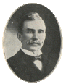For the next little while, we’ll be running a monthly “guess the author feature problem. We’ll present you with a checker problem, and a photograph; your challenge will be twofold:
- Solve the problem (of course).
- Identify the person in the photo (on the left), who is the problem’s compositor. You can click on the photo for a full size version.

February’s entry will be what will probably turn out to be the easiest of the tree, at least in terms of identifying the person in the photo; we’re not so sure about the problem itself! Here it is: (See #102.)
________________________________________________

Did you recognize the famed problemist G. H. Slocum? If you didn’t, don’t feel bad; while many people recognize the name, very few could identify the portrait.

Perhaps you had better luck with the problem, one of those lean two-per-side types that challenge more than expected.
________________________________________________

September 17, 2005, Bob Newell’s “The Checker Maven”, (second appearance in seven months), “Simple Elegance - When you’ve solved this, we think you’ll agree that there is genuine charm in such a compact position, requiring just the right play.”

September 2007, Irish Draughts Association Newsletter, Volume 1, Issue 3, Problem No 9.
ELEVENTH INTERLUDE –1905

January 25, 1905, Otago Witness, Issue 2654, Page 62,
“TO CORRESPONDENTS
A Chequerist – A ‘deferred stroke’ problem is one in which the solution is begun by forcing several moves, usually by threatening the capture of one or more pieces, in order to bring off a coup de grace in the form of a stroke. This is a common style with Slocum. Next week we shall endeavor to give you an example of the ‘deferred stroke’”, Joseph Abernethy

February 1, 1905, Otago Witness, Issue 2655, Page 63, Problem 2263, “Last week we promised to give, for the information of our correspondent ‘Chequerist’, an example of a ‘deferred stroke’ problem. The above is the best of the kind we can recall; and although some of our readers may have seen it before, its beauties will be none the less appreciated”, Joseph Abernethy; NOTE – The example was #25 in this compilation.

March 1905, the FIRST INTERNATIONAL MATCH between America and Great Britain was played in Boston, the most important checker event during Slocum’s lifetime. Great Britain won with 74 wins, 34 losses, and 363 draws. Slocum did not compete or attend the event, but he surely must have followed it with great interest, as the ten-member American team involved a number of famous players who had great influence on his checker career.
- Charles Barker, who initially sparked Slocum’s interest in the game, had the second best American score.
- Lucius Head, Slocum’s friend, co-author, and former editor, had the fifth best American score.
- John Denvir, publisher of more Slocum compositions than any other editor, was one of two player replacements, and had the eighth best American score.
In addition, Charles Hefter, Slocum’s mentor and former editor, was invited to join the American team, but declined for business reasons.
And James Reed, publisher of more Slocum compositions than any other editor, except Denvir, and whose presence would have strengthened the American team, did not live long enough to be invited.

#103a – December 22, 1907
Background:

Unless we missed some Slocum compositions, more than 3 years passed since his exhibition problem. Then the next 3 settings appeared together. Denvir offered book prizes for the 3 best solutions to the 3 settings.

#103a and #103b were companion novelty problems. Both were sight-solvers. They were among Slocum’s easiest settings. Milton Johnson believed their common theme (the initial pitch and chase) were not original with Slocum, but we haven’t found any published earlier.

#53a and #53b were more difficult companion problems of the same size as 103a and #103b. Let’s compare them from the novelty standpoint:

- #53a and #53b demonstrated settings where the piece-down side could win with its single piece, but not if that piece were a king.

- 103a and #103b went a step further. They demonstrated settings where the piece-down side could beat three kings, but could not win if two of those kings were single pieces.

#103a – “FAT AND HAPPY I”
SLOCUM’S 4TH “SINGLE STRONGER THAN A KING”
(Read this in conjunction with #103b)
White to Play and Draw
Solution to #103a:

30 25A, 22-29, *21 17, 29-25, *17 14, 25-22, *14 10, 22-18, *11 7B, Draws by crowning

A – Or 30 26 draws similarly, but not 21 17, 22-13, 30 26, 13-9 or 13-17, RW various ways

B – The threat of an exchange prevents Red from attacking.

Bibliography #103a: (2 items)

December 22, 1907, Chicago Inter-Ocean, Prob. 4040, colors reversed, published together with the next problem; Denvir offered book prizes for the best 3 solutions to #103a, 103b and 104

October 15, 1940, Mt. Sterling Advocate, part of an article: “Checkers on Broadway”, presented, colors reversed, by A. Heller (unaware of Slocum’s prior publication), published together with #103b, “The late Abe Heller, owner of a New York cab company, was no problem composer, His skits “Happy and Fat” amused the readers”, Milton Johnson,

A paradoxical position –
“Of all the tough breaks!” complains Happy, “I outnumber you 3 to 2, and I’ve got to take a draw!”
“Ain’t that just too bad!” gloats Fat. “You ought to be glad those two men on 30 and 21 are NOT KINGS or you would lose”, (continued on next problem)

Lessons for Composers:

176. Novelty themes make good conversation pieces.
#103b – December 22, 1907
Background:

Don’t be confused. #103b is the same as #103a except the colors have been reversed and the pieces on 3 and 12 are now kings. The play is equally easy and essentially the same as #103a for several moves. Denvir’s prizes for the best solutions to all 3 problems were probably determined by the more difficult #104.

Composers should note:

- Both #103a & b depend on the threat of an exchange at the end.

- In #103b, there is only one star move leading up to the final exchange. This is a serious shortcoming.

Lessons for Composers:

177. Some novel themes do not make quality compositions.

But we did get a “fat and happy” story out of it (see the bibliographies).

#103b – “FAT AND HAPPY II”
SLOCUM’S 7TH PIECE-DOWN WINNING SETTING
SPIN-OFF OF #103a (Read this in conjunction with #103a)
Red to Play; White to Win
Solution to #103b:

3-8A, 11 4, 12-16, *4 8, 16-19, 8 11 (or 8 12), 19-23, 11 15 B (or 11 16), 22-26C, *15 19, WW by the Move

A - If 3-7, WW similarly; if 12-16, 11 20, 3-7, 20 24 or 20 16, WW various ways

B – The threat of an exchange handcuffs Red again, but unlike #103a.

C – If 23-18, 30 25, WW by the Move; other White moves waste time.

Bibliography #103b: (2 items)

December 22, 1907, Chicago Inter-Ocean, Prob. 4041, published together with the preceding problem; Denvir offered book prizes for the best 3 solutions to #103a, 103b and 104

October 15, 1940, Mt. Sterling Advocate, part of an article: “Checkers on Broadway”, presented by A. Heller (unaware of Slocum’s prior publication), published this and the preceding problem, continue:
“Now, Fat, don’t try to be funny. You know a king is stronger than a single man. Even Tommie Wiswell said that a king is often the ace in the hole.”
“I don’t give a dama ‘bout what Tommie said. In this case, you’ll find that the KINGS will get you in a hole from which there is no escape”, and Fat puts up the pieces.
“And furthermore”, continues Fat, “this position is a White win, even if you start off with the 12-16 pitch.”
“As the English would say, that isn’t cricket”, exclaims the surprised Happy.
“That’s right, it ain’t cricket”, agrees Fat in the choicest King’s (County) English, “It ain’t cricket – It’s checkers!” (Note to readers: Brooklyn is in King’s County.)
#104 – December 22, 1907
Background:

#104 was the third of Slocum’s trio of new compositions after a long layoff. Apparently he was rusty. #103a and #103b were soft and #104 suffered from Slocum’s first dual solution since #70 in January 1895.

#104 was Slocum’s 37th setting to be published only once (until now). It is the first since #95 on September 30, 1900.

In #104, White is a piece up and is looking for an opportunity to create a block by pitching the piece on 26. But Red is simultaneously threatening to steal a straggling piece. If White gets the block, but loses both pieces doing so, Red will threaten to draw by releasing the block with a return pitch. Is there a way out of the dilemma?

Believe it or not, there are two ways out. And neither one is obvious. Solvers will do well to find just one of them.

Lessons for Composers:

178. Some dual solutions deserve separate settings.

#104 – SLOCUM’S SIXTH BLOCK
HIS 14 TH 2-WAY PITCH
HIS 13TH DUAL SOLUTION
White to Play and Win
Solution to #104:

*24 19A, 28-24, *19 15B, 24-19C, 20 16D, 19-10E, 11 7 (or 26 22 first), 10-3, *26 22, 18-25, *16 11, WW by the Block and Pin

A – Red is about to equalize.

B – Forced because 19 16 allows the draw by *18-23

C – This attempt to recover a piece walks into two hidden traps. Other moves succumb to White’s numerical superiority.

D – We are not sure whether any of Denvir’s solvers found the dual solution here by 15 10 (If not, this may be its first time published). Continue: 19 -15a, 10 6b, 15-8, *26 22c, 18-25, *20 16, 8-12, *16 11, 12-16, *6 2, WW by the block. Composers should note the excellent theme involved in the dual solution.

- If 19-24, *26 22, WW; or if 18-23, *20 16, WW

- Or 26 22 first, 18-25, *10 6, same

- Not 20 16, 8-12 and 29-25 both draw

E – If 19 12, 11 8 (or 26 22 first), 12-3, *26 22, 18-25, *15 11, WW by the same Block and Pin

Bibliography #104: (1 item)

December 22, 1907, Chicago Inter-Ocean, Problem 4042, “For the three best solutions to the three above problems”, Denvir offered a prize of “‘Lees’ Guide’, ‘Denvir’s Trap and Shot Book’, and ‘One Hundred Problems’”.

TWELFTH INTERLUDE – 1908-1909

March 1908, Canadian Checker Player, Volume 2, Issue 3, “Geo. H. Slocum the noted Chicago problemist gave a simultaneous exhibition at Milwaukee recently. He scored 18 wins, 11 draws, and 2 losses. Bates and Steffen picked up the two games. Only Bates and McCool escaped without a loss.”

1909, Stearns’ Draughts Marvel, Twentieth Century Checker Compendium, Page 135, provided 9 brief biographies including the following:

Some of the World’s Expert Players
Analysts, Problemists and Historians of the Game whose Portraits adorn other pages.

GEORGE H. SLOCUM, Chicago, Illinois, Expert and Problemist – Pen nor tongue fail to describe the beauty, depth and execution of this world’s famous composer’s work. The name of Slocum is attached to some of the most deceptive problems in existence.

“Surprisingly, the Draughts Marvel contains no Slocum problems”, Jay Hinnershitz
#105 – 1909
Background:

Another long dry spell passed since the sub-par trio in 1907. Maybe Slocum was working on #105 during all that time.

# 105 certainly made up for lost ground. In the words of the editor of Draughts World, it was “One of the finest endings we have ever had the pleasure of placing before our solvers”.

The scope of #105 rivals #80. That may be taken as praise or criticism, depending on your taste in such matters.

For those willing to probe its subtleties, there is much to be learned.

# 105 is a most unusual bridge position that matches or betters most of the settings in Boland’s book on Bridges. Red refuses to break and White is unable to break the bridge until very late in the solution.

In 1934, Tom Colston showed an extremely agile defense that Slocum did not mention. Most of Colston’s voluminous work on it is omitted here because it has been superseded by the faster fruits of modern computers. Variation 1 shows only the shortest way to beat Colston’s defense. It is, in effect, a dual to Colston’s longer solution.

Which is the better defense is perhaps debatable. Our conclusion is simply: Slocum missed a strong defense that avoids his intended theme.

- Slocum’s defense elicits ten consecutive star moves before succumbing to three pitches (not all in succession), leading to a duly deferred double, which finally wins by the Move.

- Colston’s defense involves several mind-boggling variations, each about 50% longer than Slocum’s solution, but with few, if any, star moves. It is a tenacious, tortuous, onerous, and vexing defense that will probably take you hours to digest.

For those unable to spend much time on #105, it is recommended that you at least check out:

- Slocum’s finishing touch beginning at Note F.

- The sight solver formed by 22-17 at Note R.

Lessons for Composers:

179. Dual solutions are acceptable as long as they do not appear in the Trunk line.

#105 – “THE DEFENSE II”
SLOCUM’S FIFTH BRIDGE
HIS 23RD DOUBLE
HIS SECOND MISSED STRONG DEFENSE
White to Play and Win

Slocum’s Solution to #105:

*8 11, 27-31, *26 22A, 31-26, *22 17B, 26-22, *17 13B, 22-17C, *29 25, 17-14D, *25 22E, 14-10FVar.1, *13 9G, 10-14H, *9 6J, 1-10, *5 1J, 14-9K, *11 7, 10-14L, 1 5 (or 22 17 first), 3-10, *22 17, WW by a Double and the Move

A – In all published solutions, White runs to Square 13. Running the other way to Square 16 is only a draw. Here is one way to that draw: 26-23, 31-26, 23-19, 26-23, 19-16, *23-18, 29-25, *18-14, 11 15, 14-9, 16 11, 9-6, 25 22, 6-2, 22 18, 2-6, 18 23, 6-2, Draws; the Red formation is impregnable, even if White crowns a third king, Bill Salot, Liam Stephens, and Sune Thrane's Most Famous Checkers (MFC) program., 2011

B (two places) – If this White piece puts itself in jeopardy by straying from the diagonal path directly to Square 13, Red then has multiple ways to draw, including 1-6.

C – Or 22-18, *29 25, 18-14, same; Slocum assumed Red’s objective would be to run this king to Square 6, resulting in an impregnable formation similar to the one in Note A.

D – If 17-21, 25 22, 21-17, same as Variation1 at 1, 14-17

E – Crucial, as becomes evident at Note K

F – This move forms an excellent problem that could stand on its own. The chances are that your computer program would avoid it by playing the 14-17, as in Variation 1. “Mr. Slocum must have considered that this line could be easily met when he only gave 14 10 here”, Tom Colston, 1934.

G – Stops 10-6, which would draw similar to Note A.

H – If 3-7, 11 2, 10-6, WW only because the move is wrong for Payne’s Double Corner Draw.

J – Puts Red in an exquisite bind.

K – The criticality of *25 22 at E is now evident; it prevented a draw by *14-18 at this point.

L – If 10-15, *1 5, WW by a Double and numerical superiority

Variation 1 (Colston’s defense + an improved attack against it)

14-17M, 22 18, 17-21, 18 14N, 21-25, 14 10O, 25-22, 11 16P, 3-8Q, 13 9, 8-12R, 16 11, 22-17, 10 7, 17-14, 7 3, 14-17, 11 7, followed by a swap, WW

M – “I think that 14-10 should have been a side line as 14-17 sets up a very stubborn defence and White has to steer a very careful course to win”, Colston, 1934. Composers should that note most of the White moves in Variation 1 are not the only moves to win, but they represent the shortest route to the win. Alternate wins are not shown.

N – Or 18-15, 21-17, 15-10a, 17-22, same as Var. 1 at 7, 25-22, Liam Stephens, 2011

a – “15-19, *17 22, 11-15 (if 13 9, *22-18 draws), 3-7 and White is making no headway”, Colston, 1934. Composers should note that Colston starred *17-22 only because it was much the best of the collection of losing moves.

O – “It would seem that White’s only hope of a win is to drive the Red king on 25 away to the other side of the board and gain complete command of Red’s double corner”, Colston 1934. Colston proceeded with 11 15 followed by extensive analysis (not shown here) on the 25-21, 25-22, and 3-7 replies. Two of his lines of play continued for 56 and 61 moves respectively. Composers should note that the continuation in Variation 1 is much shorter, simpler, and unpublished (until now). It may have been what Slocum had in mind all along.

P – This is the shortcut to the win, as jointly analyzed by Salot, Stephens and Sune Thrane’s MFC program.

a – 11 15 and 10 14 also win, but they both fall back on Colston’s lengthy play.

b – 13 9 allows a draw, for example by *22-17, 9 6, *17-13, 6 2, *13-9, 11 16, *3-8, 16 12, *8-3, 10 15, *9-13, 15 18, *13-9, etc.

Q – 3-8 is the best defense at this point because it prolongs the play more than the other choices: If instead 22-18a, 13 9, 18-22b, 9 6, 3-8c, 16 12, 8-3de, 6 2 followed by 2 6 (not 2 7, *1-6, RW) and 10 7 swap, WW

a – If 22-17, 16 19, 3-8, 10 15, 17-14, *13 9, 14-17, *9 6 swap, WW

b – 3-8, 16 12, now:

- 8-3, 9 6, 18-22, same as c at 2, 16 12

- 8-4, 9 6, 18-22, same as e at 1, 8-4

c – If 22-18 (22-17, 16 19, followed by the 10 15 swap, WW), 16 12, 18-22, same as Q at ef, 8-3

d – If 8-11, *6 2, 22-17, 10 7, 11-15, 7 11, WW because the Move is wrong for Payne’s Double Corner Draw.

e – If 8-4, 6 2 followed by 10 7 and 12 8 swap, WW

R – A clever sight solver is formed by 22-17a. To win, White must play *10 15b followed by *16 19 and the *9 6 swap, WW

a – If 22-18, same as b at 1, 3-8

b – Now Red cannot press 17-13 because of the 16 12 swap, WW because the Move is wrong for Payne’s Double Corner Draw. This was the objective of playing 11 16 at P.
Bibliography #105: (7 items)

1909, Horsfall’s Problem Book, Page 37, Prob. 326

April 1909, Draughts World, Volume XXXIII, Issue 148 (New Series), Page 791, “Studies for the Amateur and Expert”, Prob. 1630, by G. H. Slocum, Prophetstown, Illinois, U.S.A.,

“One of the finest endings we have ever had the pleasure of placing before our solvers”

May 17, 1923, Chicago Daily News, Problem 497, incorrectly diagrammed

1923, Wendemuth’s Checker Companion, Page 150, Prob. 89

August 1934, Draughts Review, Volume 10, Problem 2054

January to December 1934, Draughts Review, Volume 10, Cover, which was included when one purchased a complete volume

July 1992, Keystone Checker Review, Page 379, Problem 19, solution on Page 397 of same issue, part of Bob Crue’s collection of Slocum problems

#106a – 1909?
Background:

As far as we know, #106a and #106b were not published together. In fact, we do not know when they were first published, or whether they were ever published together (until now). Both were in Bob Crue’s collection, but he published them separately.

They are both old-fashioned “Slocum Strokes”, paired here because they are so much alike. They were very likely composed in the same time frame, perhaps on the same day or in the same hour.

Those who by now have become familiar with Slocum’s style will be able to solve them from the diagram. Others may be as bewildered as ever.

Lessons for Composers:

180. Very similar settings sometimes type-cast their solutions.

#106a – SLOCUM’S SEVENTH BLOCK
White to Move and Win

Solution to #106a:

*3 7ABC, 11-15, *7 10, 15-18, *31 26, 25-30, *26 22, 18-25, *10 7, 2-11, *20 16, 11-20, *28 24, WW by the Block, one piece beats four.

A – Not 32 27, *11-15a, 27 23, *25-22b, 3 8, 22-17c and 29 25c Draw

a - Not 25-22, *3 7, 11-15, *7 10, WW

b – Not 2-6, *3 8, 25-22, *31 26, 22-31, *23 27, WW by the Triple.

c - Not 2-7 or 2-6, *31 26, 22-31, *23 27, WW by the Triple.

B – Not 3 8, but it is a tenacious attack thwarted only by an unexpected drawing theme. Continue *11-15, 8 11, *15-18, 31 26, *2-6d, 32 27e, 6-10f, 20 16g, *25-30, 26 22, 18-25, 27 23, *10-14h, 11-15, *14-17i, 28 24j, 17-22, 24 19j, 22-26k, 15 18l, *26-22, See-Saw Draw

d – Avoids the Trunk where 25-30 was forced. Here 25-30 still runs into Slocum’s block by *26 22, 18-25, *11 7, etc.

e – The surprise is that White can still force a block at g. White first threatens to steal the piece on 18.

f – Or 25-30 first; it is not forced yet.

g – This quietly forces it into another block; if 10-15, *16 12, WW

h – Red threatens to pitch 14-18 for a draw; 10-6 loses by *11-15.

i – 14 9 loses by *15 18, 9-13, *18 22, WW

j (2 places) – Another subtle idea.

k – Threatens 26-31 and the 31-27 pitch.

l – Prevents 26-31 by threatening *18-22, WW. If instead 19 15, then 22-26 or 22-17 both Draw
C - Composers should note:

- If the Red king on 2 were a single piece, there would be a nice dual block solution by 3 8, 11-15, *8 11, 15-18, *31 26, 2-6 (if 25-30, *26 22, 18-25, *11 7, as in Trunk at 9, *10 7), *32 27, 25-30, *26 22, 18-25, *27 23, 6-10, 20 16 (or 28 24), 10-14, *11-15( preventing the 14-18 pitch), 14-17, now or later15 18 and 15 19 lead to equally decisive WWs by the pin and the exchange, respectively.

- If the Red king on 25 were a single piece, there would be another nice dual solution by 32 27, 11-15, *27 23, 25-30, 3 8 (or 31 27 first), 29-25, *31 27 (not 8-11, *15-18, 23 14, *30 26, Draws), 2-7, *27 24, 25-22, *8 3, WW

- If the Red kings on 2 and 25 were both single pieces, White could win with four different moves: 3 7, 3 8, 28 24 and 32 27, Liam Stephens, 2011.

- If the White king on 32 were a single piece, White could not win at all because none of the blocks would have worked.

Bibliography #106a: (4 items)

1909, Horsfall’s Problem Book, Page 85, Prob. 761, colors reversed

1923, Wendemuth’s Checker Companion, Page 153, Prob. 103, colors reversed

April 1944, Wood’s Checker Player, Volume VII, Page 211, “Tyro’s Page”, Prob. 6, Solution: Page 223

September 1992, Keystone Checker Review, Page 406, Problem 25, colors reversed, solution on Page 409 of same issue, part of Bob Crue’s collection of Slocum problems
#106b – 1909?
Background:

We have found no references to where #106b might have been published before Slocum’s death in 1914.

#106b was slightly shorter and slightly less popular than #106a. But it was slightly more difficult in that the initial move is slightly less natural and is accompanied by more options.

#106b has a couple of novelty features:

- White makes four consecutive pitches of the same Red piece and nets only a triple in return.

- White can make any of six different initial moves and then score a quadruple if Red follows with a certain incorrect response.

Lessons for Composers:

181. Novelty features are talking points.

#106b – SLOCUM’S TWELFTH FORK
HIS 28TH TRIPLE
White to Move and Win
Solution to #106b:

*26 22A, 18-23, *22 18, 23-26, *2 6, 9-2, *10 7, 2-11, *20 16, 11-20, *28 24, WW by Triple into a Fork

A – Composers should note:

- If you are a born optimist, you could play 2 7 or 10 6 or 10 7 or 20 16 or 28 24 or 26 31. Then if Red ventures 13-17, you could win in every case via the same quadruple.

- Since that won’t happen, the best try for a dual solution at A is the doubtful 26 30, 25-22 or 25-21, 32 27, trying to put the Red piece on 18 in jeopardy. It doesn’t work.

- White cannot first pitch 2 6, and then expect to force the same win by 26 22, *18-23, 22 18, because then 25-22 or 25-21, 18 27, *22-17, 27 23, *17-14, Draws

Bibliography #106b: (2 items)

May 11, 1937, Mt. Sterling Advocate, Problem 796, colors reversed

May 1993, Keystone Checker Review, Page 539, Problem 48, colors reversed, solution on Page 542, of same issue, part of Bob Crue’s collection of Slocum problems
#107 – 1909
Background:

If it were possible to rank Slocum’s settings by how difficult they are to solve, #107 would probably be near the top of the list.

“Amazing! I doubt that I would solve it in a month of Sundays; the final stroke is so cleverly concealed”, Liam Stephens

The ultimate purpose of the subtle initial move is not evident until the very end. That move triggers a sequence of moves that set up a stroke so well hidden that, when the stroke is almost complete, many solvers would still be unable to finish it. The final move is in a unique class of its own, different from any Slocum move employed before or since.

It is also a major challenge to figure out whether any of the Red kings could be single pieces. The simple answer is that changing any one of those kings to single pieces creates dual solutions. The hard part is finding those duals. They are indicated in Note G. Slocum wisely avoided them all with his three Red kings.

#107 – “THE 2-PIECE SLIP PITCH”
SLOCUM’S FIFTH QUINTUPLE
HIS 23RD SLIP PITCH
White to Play and Win
Solution to #107:

*23 19AG, 6-9, *17 13, 9-14B, *13 9, 14-17C, 11 8D, 3-12, 9 6D, 2-9, *27 23E, 20-27, *19 24F, 12-26, WW by the Quintuple and the Move

A – The correct first move is hard to find. With this one, White unnaturally blocks his own king.

- It is tempting to try 23 26 or 23 18, hoping for 6-9, then winning by the *11 8 Triple. But Red avoids it and draws rather easily with *10-15.

- So White’s initial move must stop 10-15. But 24 19 is no good because *6-9, 17 13, then Red draws by *10-15 (an attacking pitch forcing *19 10), but not by 9-14, 23 26 (easier than 23 18, 14-23, *19 26, WW), 14-17 or 14-18, 11 8 (easier than 19 23), 3-12, *19 24, WW, Liam Stephens, 2011.

B – Now 10-15 doesn’t work because White is free to jump *13 6, WW

C – Red can avoid the fireworks and put up a fight with the unlikely 14-18, *19 15, 10-19, 24 22 (this explains why the White piece on 24 had to be a king), 7-10, now both 16 12 and 11 7 win for White, but they take many, many moves to accomplish it.

D (2 places) – Or 27 23 first; even at this late stage, the stroke is not obvious.

E – Now this slip pitch sets up one of Slocum’s most creative moves:

F – Slocum’s first and only “2-piece slip pitch”, demonstrating the critical importance of the star move at A. Amazing!

G – Composers should note:
- If the Red king on 3 were a single piece, there are multiple dual solutions starting with 23 26, 23 18, and 17 13, Liam Stephens and Sune Thrane's Most Famous Checkers (MFC) program., 2011
- If the Red king on 7 were a single piece, there are dual solutions starting with 23 26 (or 17 13 first), 10-15, 17 13, WW, Liam Stephens and MFC, 2011
- If the Red piece on 2 were a single piece, there are dual solutions starting with 23 19, 6-9, *17 13, 9-14, *13 9, 14-17, now instead of taking Slocum’s stroke, both 9 6 and 19 23, WW, Liam Stephens and MFC, 2011

Lessons for Composers:

182. When a dual win is suspected, strengthen the defensive forces.
183. Your computer program will find one solution by itself, but it will not pursue a dual solution without direction from you.

Bibliography #107: (4 items)

1909, Horsfall’s Problem Book, Page 96, Prob. 864, “the last problem in this book, perhaps a late contribution to it”, Salot

July 13, 1912, Western Mail, Perth, WA (Australia), Page 42, Prob 764

1923, Wendemuth’s Checker Companion, Page 153, Prob. 107

September 1992, Keystone Checker Review, Page 407, Problem 28, solution on Page 409 of same issue, part of Bob Crue’s collection of Slocum problems

#108 – November 1910
Background:

We are down to Slocum’s last few problems, which were published less frequently and never more than twice (until now).

#108 deserves more recognition. It is an intricate delicacy par excellence, a pleasing collage of themes, for which no fitting title exists.

When White plays properly, avoiding the false solutions, Red is tossed to and fro in a maze of mixed squeezes, pitches, and steals, not in any particular order. Red has no options along the path to destruction, other than a choice of suicidal jumps and a choice of fatal finales.

Lessons for Composers:

184. The whole is greater than the sum of its parts.

#108 – “THE COLLAGE”
SLOCUM’S 24TH SLIP PITCH
White to Play and Win

Solution to #108:

*14 10A, 23-14, *6 2B, 7-11C, *28 24D, 11-4 (or 14-7), *24 19D, 14-7, 2 11, 3-8CE, *11 16F, 8-11C, 16 7, 4-8C, *19 15, 12-16C (or 8-3 or 8-4), *7 11, WW by pocket steal (or 2-piece pin) without the Move

A – White is a piece up, but Red threatens to recover it by trading 7-10 and then stealing the White piece on 18. This calls for action more drastic than the false solution by 6 2, *7-11, 8 4, *23-26 (not 23-19, *14 9, WW), 14 9, *26 22, 18 14, *22-17, 14 10, *17-14, Draws. It calls for the *14 10 slip pitch followed by . . .

B – A squeeze.

C (5 places) – Red is trapped at every turn.

D (2 places) – White must take two free moves to get in perfect position, while going two pieces down, with no stroke in the offing.

E – This squeeze is somewhat reminiscent of #53a, but the required response is different.

F – In this case, moving to the right is right. But beware the false solution that follows moving to the left by 11 7, a disastrously wrong turn. This simple mistake in direction turns a Slocum piece-down win into an excruciating loss by *8-11, 7 16, *4-8, 16 20, *8-11, 20 24, *11-16, 19 15, *16-19, RW. Ouch!

Bibliography #108: (2 items)

November 1910, Canadian Checker Player, Volume 4, Issue 11, Prob. 89, “a teaser from one of America’s most gifted composers”, Teetzel

1981, Irving Chernov’s Compleat Draughts Player, Page 257, Problem 3
#109 – January 22, 1911
Background:

Under Professor H. C. Hartshorne, the new interim editor of the Chicago Inter-Ocean, A Slocum composition appeared for the first time. #109 became Slocum’s 38th setting to be published only once (until now).

The challenge is for White to draw without breaking into Red’s king row or changing the move. It is quite a feat.

Slocum’s solution to #109 is very good, but there may be more to the setting than he, his new editor, and his readers realized. Red has a second tricky, dual-free, “Twister” attack, and can sequence the two attacks so as to force White to defend against both of them, thus making it all the more difficult for White to escape.

Lessons for Composers:

185. A rare concept is to force a defender to deal with both sides of a “Twister” in a single solution.

#109 – “A RARE CONCEPT”
SLOCUM’S MISSED TWISTER;
HIS 16TH 3X3;
HIS 3RD MISSED BETTER ATTACK
White to Play and Draw

Slocum’s Solution to #109:

*21 17A, 8-3B&Var.1, *17 13CD, 5-1, *13 9, 2-7, *9 6, 7-14, *6 10, 14-18, 22 15E, 1-5, *10 14, 3-7, *15 10, 7-2, *14 18, 5-1, *18 23, Drawn

A – White is in dire straits without the Move and with two single pieces facing various traps and a near solid king row, for example:

- If 22 17, 5-1, then if:
  - 17 14, 8-11, 10 7, 11-15, RW by a steal
  - 17 13, 2-6 (or 8-3), RW by a Double (or a steal)
  - 21 25, 2-6 (or 8-3, RW by a steal), 10 7, 8-3 (8-11 takes longer), RW by a Triple

- If 22 18, 8-3, then if:
- 18 14, 3-8 (5-1 takes longer), 21 17, 8-11, 10 7, 11-15, RW by a steal
- 18 15, 5-1 (or 5-9, RW), 21 17, 2-7 (2-6 takes longer), 17 14, *1-5, RW by a Double
- 21 17 is C at 1, 22 18
- 21 25, 5-9 (5-1 takes longer), 10 6, *9-13, 6 1, *13-17, 25 21, *17-22, 18 14, *22-17, 14 9 or 14 10, *17-14, RW by a steal

B – 5-1 is a “Twister” move because White must respond differently to maintain the draw. This “Twister” was not shown by Slocum, but is arguably a better offensive move because it sets up an extremely inviting false solution, and, if White avoids the false solution, Red can force the play back into Slocum’s Trunk, thus requiring White to circumnavigate both sides of the “Twister”. It is all explained in Variation 1.

C – Not 22 18, 2-7 (5-1 takes longer), 10 6, *5-9, RW by a Double or Triple

D – Not 17 14, *2-7 (not 3-8, same as Var. 1 at H, 1-5), 10 6 or 22 17 or 22 18, RW by Doubles every which way

E – Another melodious 2 x 2 finale
Variation 1:

5-1E, *17 14FG, 1-5H, *14-17I, same as Trunk at 1, *21 17

E – Composers should note that this “Twister” move forces White to make two additional star moves.

F (off Var.1) - Not 17 13 (the “Twist”; this move is necessary in the Trunk, but wrong here), *2-6, 10 7, 6-9 or 8-3, RW

G (off Var. 1) - Not 22 18, 8-3 or 8-12, RW (8-4 and 1-5, waste time)

H (off Var. 1) - Composers should note the setting, after this 1-5, is equal to the original setting of #109 in that they demonstrate the same themes with identical play after the first move. If 8-3 at G, White can draw two ways:
- 14 9, same as Trunk at 5, *13 9
- 14 18, 2-7, *18 15, 7-14, *15 10, same as Trunk at 9, *6 10

I (off Var. 1) – White is forced to return to Slocum’s Trunk to face the other half of the “Twister”. Composers should note that, beginning here, this king must take a circuitous, 6-square route to return to this very same square. In contrast, the more natural 14 18, at H, leads to a fine false solution that succumbs to only *8-11, 10 7, *2-6, 7 3, *5-9, 18 23, *9-14, 23 26, 6-10 (14-9, 26 23 wastes time), 26 30, 10-15 (14-9 and 11-7 waste time), 30 25, 15-19 (14-9 wastes time), 25 21, 19-24 (11-15 wastes time, and 19-23 only draws), RW by the Move

Lessons for Composers:

186. Time-wasting moves detract from the beauty of solutions.

Bibliography #109: (1 item)

January 22, 1911, Chicago Inter-Ocean, Problem 23, diagrammed upside down, solution January 29, 1911; Professor H. C Hartshorne took over editorship briefly from November 27, 1910, through February 12, 1911
#110 – January 29, 1911
Background:

Two of Slocum’s compositions appeared in Professor Hartshorne’s columns. #109 was the first. #110 was the last. #110 may also have been the last problem that Slocum ever composed. Too bad it was flawed.

#110 was not the first published 2 x 3 setting where the side with the piece up was in danger of losing by First Position. But it was a truly original rendition of that theme.

#110 was only Slocum’s 3rd setting with the terms: “Red to Play, White to Draw (or Win)”; #83 and #103b were the others. Such terms usually mean two things:
- The position cannot or should not be set back any further.
- It is a way to present more than one problem in a single setting.

In #110, the initial Red moves, 17-14 and 22-26, set up two different challenges for White. The first lives up to Slocum’s usual high standards. The second inexplicably suffers two dual solutions.

#110 was Slocum’s 39th problem to be published only once (until now).

#110 – “THE LAST HURRAH”
SLOCUM’S 20TH ALL ABOUT THE MOVE”
HIS 14TH & 15TH DUAL SOLUTIONS
Red to Play, White to Draw
Lessons for Composers:

187. The terms “Red to Play, White to Draw (or Win)” are not popular because they divide the solver’s attention.

Solution to #110:

17-14Var.1, *29 25AB, 22-29, *19 15C, 29-25, 23 19D, 25-22, *15 11E, 14-10, *19 16F, 22-18, *11 8G, 10-7H, *8 3, 7-2, 3 8I, 18-15, *16 11, Drawn, Slocum; continue 2-6, *11 7, Drawn

A – Not 19 15, *22-18a, 15 10, *18-27, RW by First Position

a. (off A) - Not 22-26, *23 18, 14-23, *15 10, 23 18, *10 6, 18 14, *6 1, Draws by the Move

B – Not 19 16, 22-18b, 23 19, *18-23, 29 25c, *14-18d, 25 21, *18-14e, 16 12f, 23-16, 12 8, *16-11, 8 3, *14-9, 21 17, *11-15, RW by the exchange and the Move.

b. (off B) – Or 22-26, 23 19, *26-23, same

c. (off B) – If 19 15, *23 19, RW

d. (off B) – Not 14-17, *19 15, Draws

e. (off B) – Not 18-22, *16 12, Draws

f. (off B) – If 19 15, *23-19, RW

C – Not 19 16, *14-10g, 23 19, *10-7h, 19 15, *29-25, 15 11, *7-3, RW

g. (off C) – Not 29-25, *16 11, 14-10 (or 25-22, *23 19, 10-7, same), *23 19, 25-22, same as Trunk at 9, 14-10

h. (off C) – Not 29-25, *16 11, same as f at 4, *23 19

D – Or 15 11, 14-10 (Or 25-22, *23 19, same as Trunk at 8, 15 11), *23 19, 25-22, same as Trunk at 9, 14-10

E – Or 19 16, 22-18, *15 11, 18 15 (14 10 is Trunk at 11, 22 18), *11 8, 15-19, *16 12, 19-15, *8 4, 14-10, *12 8, Draws

F – Not 11 8, *10-7, 19 16, *7-3, 8 4, 22-18, 16 12, 18-15 or 3-7, RW into Payne’s Critical Situation No. 1, 1756

G - Not 16 12, *18-15, 12 8, *10-14, RW

H – 18-15 is better; it forces White to make more star moves. Continue: *8 3, 10-6 (or 10-14, *3-8, Draws), *3-8, 6-2, same as Trunk at 17, 18-15

I – 16 12 and 16 11 also Draw.

Variation 1:

22-26J, 29 25K, 17-14, *25 21, 26-22, 19 15L, 22-26, 23 18, Drawn

J (off Var.1) – Much inferior to 17-14; Composers should note the duals

K (off Var.1) – Slocum ignored a straightforward dual solution here by 23 18, 26-23, *18 15, 23-16, *15 10, 17-14, *10 6, 14-9, *6 1, Draws because the Move is wrong for First Position

L (off Var.1) – There is a second, more flashy, dual solution here by 19 16, 22-26, now *21 17 Draws, but not 23 19, *26-23 is B at e, *18-14

Lessons for Composers:

188. Like the Phoenix, new themes rise from the ashes of duals.

Bibliography #110: (1 item)

January 29, 1911, Chicago Inter-Ocean, Problem 25, diagrammed upside down, solution February 5, 1911; Professor H. C Hartshorne became editor briefly from Nov. 27, 1910, through Feb. 12, 1911
THIRTEENTH INTERLUDE – 1911-1912

Clippings indicate Mr. Slocum was still active, but not composing problems:

January 1911, Canadian Checker Player, Volume 5, Issue 1, “George H. Slocum, Prophetstown, Ill., $8 to the 2nd American Ty. FUND”

November 1911, Canadian Checker Player, “On Thanksgiving Day, the players of Illinois met at the South Side Club in Chicago to organize a state checker association. A.W. Valentine was elected President, and then appointed the following to executive committee: Julius D’orio, Peter Doran, Bert March, Wm. Wood, G.H. Slocum, W.I. Lundy, and Ed Emery”

December 1911, Canadian Checker Player, Volume 5, Issue 12,
“Illinois State Association Organized
On Thanksgiving Day the players of Illinois met at the South Side Club in Chicago to engage in a South Side Club versus Illinois team match (which the South Siders won) and to organize a state checker association to hold tournaments on Washington’s Birthday. A. W. Valentine, of Rock Island, was elected president, J. O. L. Carmody, of Carrollton, vice president, Prof. H. C. Hartshorn, of Chicago, secretary, and Fred Williams, of Normal, assistant secretary. The president appointed the following executive committee: Julius D’Orio (Chicago), Peter Doran (Chicago), Bert March (Chicago), Wm. Wood (Waukegan), G. H. Slocum (Prophetstown), W. I. Lundy (Decatur), and Ed. Emery (Galva).”

January 1912, Canadian Checker Player, Volume 6, Issue 1,
“CONTRIBUTIONS TO THE RICHARD JORDAN FUND, UP TO AND INCLUDING JAN.30, 1912 C. (SIC) H. Slocum…......5.00”

February 1912, Canadian Checker Player, Volume 6, Issue 2,

“Hefter champion of Illinois

The Illinois checker Association held an all round tourney for the state championship at the South Side Checker Club, Chicago, February22-24. From rather meager reports in the Inter Ocean we learn that Charles Hefter, of Kankakee, was the winner among 15 contestants with the remarkable score of 26 points out of a possible 28, losing but one game, and that to A. W. Valentine, of Rock Island. F. R. Wendemuth, of Chicago, stood second with 24 points, Prof. H. C. Hartshorn, of Chicago, third, with 22 points. Other Chicago contestants were G. M. Tanner, W. T. Cooper, D. A. Plumly, and Harry Lieberman. Up state entrants, besides Valentine, were G. H, Slocum, of Prophetstown; Fred Williams, of Normal; Oscar Appel, of Rock Island; Ed. Emery, H. C. Mellow and – Thorp, of Galva, and – Stoddard presumably of Peoria, but probably C. H. Stoddard, of Merom, Ind. who plays in Indiana and Ohio tourneys.”
________________________________________________________

November 2, 1912, The Queenslander, Brisbane, Queensland, told the following story about a draughts player named Slocum. December 18, 1912, The Brisbane Courier republished it word for word. We suspect the story was not about George H. Slocum.

TOO BUSY FOR BUSINESS

“In a quiet little country town, so quiet that the silence hurt, a commercial traveller entered the general store. Going through to the parlour at the back, he came upon the proprietor and a friend engaged in a game of draughts.

“Here, Mr. Slocum,” he said, in an energetic whisper, “There’s two customers in the shop.”

Slocum never took his eyes from the board. He merely nodded his head and whispered in reply: “That’s all right. Keep quiet, and they’ll go away again.”

SLOCUM’S LAST PUBLISHED GAME

We don’t know when it was played, but it was published in the Melbourne Weekly Times on November 29, 1961 (47 years after his death), Game 7098, “Dundee”, and later in Churchill’s Compilations:

SLOCUM AS PLAYER

The late G. H. Slocum was so closely identified with his famous problems, that his ability at actual crossboard was often overlooked. Here’s a fine game between him and John Howe, Sr., in a one-time Chicago City Tournament. Howe was the father of John Howe, Jr., a recently retired lieutenant from the Chicago police force:

Red – John Howe, Sr. White – G. H. Slocum
12-16 16-23 11-15 6-10 15-22 22-18
24 20 27 9 18 11 25 22 32 27 10 6C
8-12 6-13 8-15 10-14A 22-25 2-9
28 24 26 23 20 11 21 17B 27 23 13 6
9-14 10-15 7-16 14-21 25-29 18-15
22 18 31 27 24 20 16 11 23 18 *6 2
3-8 12-16 16-19 13-17 29-25 15-18
18 9 23 18 20 16 22 13 18 14 *2 7D
5-14 15-22 1-6 19-23 25-22 Drawn
23 19 25 18 29 25 27 18 14 10

A – The position was diagrammed at this point.

B – 16 11, 14-18, then 30 25 or throwing 22 17 will draw, as follows: 22 17, 13-22, 21 17, 19-23, 17 13, 2-6, 11 7, 6-10, 7 3, 10-14, 3 7, 22-26, 7 10, 15-19, 10 17, 18-22, 27 18, 26-31, 17 26, 31-15, 13 9, ultimately drawn, Hugh Egan.

C – 10 7 will also draw, Hugh Egan

D – A neat draw, Hugh Egan – Slocum demonstrated good knowledge of the Dundee. The entire game appears in Churchill’s Compilations, Page 2345, #4, which incorrectly has Slocum playing Reds.
POSTLUDE – 1914-1979

April, 1914, The Checquer-Board, Henry Shearer, editor, gave Slocum’s obituary, March 8, 1914, 58 years, in its first issue, (Born Mar. 1, so actually age 59, Darrow).
__________________________________________________________

May 17, 1914, Western Mail, Perth, WA (Australia), Page 13, “The author of the above magnificent stroke problem (#60) passed away at Chicago, Ill., U.S.A., at the early age of 58 years (actually 59). He was one of the most famous problemists, and his master hand will be much missed in the problem world.
__________________________________________________________

1915, Third American Tourney Book:

MINUTES OF THE BIENNIAL MEETING OF THE
AMERICAN CHECKER ASSOCIATION, HELD AT
THE SPORTSMAN’S CLUB OF AMERICA,
CHICAGO, ILL., JAN. 11, 1915

The meeting was called to order by President A. W. Valentine at 10 a.m.

After conducting tourney business, the meeting closed as follows:

The association passed resolutions of respect and sympathy for the families of all deceased members during the past two years, G. H. Slocum, Prophetstown, Ill.; Dr. W. S. Turner, Newark, Ohio; Dr. S. D. Logan, Cincinnati, Ohio; J. K. Lyons, Seacombe, England; Prof. J. M. Greenwood, Kansas City, Mo., and instructed the secretary to forward said resolutions to the respective families.

Without further formality, the meeting adjourned for the purpose of conducting the Third American Tourney.
_______________________________________________________

1916, Harvey L. Hopkins’ “Home Checker Companion – Our Boys at Home”, Pages 5-6

IN MEMORIAM

G. H. Slocum was born at Albany, Illinois, March 1, 1855, died at Prophetstown, Illinois, March 8, 1914. He married Miss Naomi S. Stevens, of Prophetstown, October 30, 1888. They were married and settled in Chicago, Illinois, where Mr. Slocum was residing and had made it his home for several years; devoting his time to the study of music, and learning to master the violin, with which he became exceptionally proficient.

In 1899 he organized and conducted his own Concert Company (a high class organization), with marked success, leading with his violin. His estimable wife, with her recognized musical attainments, presiding at the piano. He played in many theatres of Chicago, and with theatrical troupes upon the road. In 1900 they moved to Prophetstown, where he continued his prominence in musical circles, and was for many years instructor of the Local Band. He was proud of his profession and his profession was proud of him.

Mr. Slocum was one of the Charter Members of the Chicago Chess and Checker Club in December 1888, and was an ardent devotee of the game. He became the recognized ablest stroke checker problemist of the world, and held this position until he passed away. His name is a “household word” in checker circles everywhere. As a checker player, he was highly classed, and as an agreeable checker companion and true gentleman, he had no superior in any walk of life. The writer has spent many happy hours with him “across the board” and knows whereof he writes.

The life and character of Mr. Slocum exemplify these lines:

“That man has reached the goal and won the prize
Who lives with honor, and who calmly dies
With name unstained, in soft remembrance kept,
By friends, by kindred and by country wept,
Blending with life’s last faded spell
An angel’s welcome with the world’s farewell.”

This work is dedicated to the memory of Mr. Slocum.

Harvey L. Hopkins, February 1916

September 1916, Albert Belasco’s Chess and Draughts – A Complete Guide, How to Play Scientifically, 3rd Edition (and subsequent editions entitled Chess and Draughts – How to Play Scientifically), Page 31, “Who's Who in the Draughts World”, Belasco states that he was largely indebted to W.G.W. Leggett, the well known problemist, for the biographical information provided in this section:

“G. H. Slocum, born in Whiteside County, Illinois, USA, 1855; he died about the year 1915 (actually 1914). He was known as the most original of America's, and perhaps the world's problem kings”
________________________________________________________

1920, Boston Globe, Herb Morrall’s “Checkers” column, Problem 78, a fine deferred stroke by L. J. Vair, was “Dedicated to the memory of G. H. Slocum”.
________________________________________________________

May 23, 1936, The Mercury, Hobart, Tasmania, Page 8, repeated Belasco’s biography and added “and was the author of the ‘delayed’ stroke type of problem which bears his name”
____________________________

1979, Anthony Bishop’s 'The Encyclopedia of Checkers", Page 196

“Slocum, George H. (1855 – 1914)
George Slocum was born in Whiteside County, Illinois, in 1855. Seeing Charles F. Barker perform at exhibition play evoked his interest in checkers in 1886. Two years later, Slocum in collaboration with Harvey Hopkins founded the Chicago Checker Club.
Slocum was a professional violin player, but is best remembered today as the ‘stroke king’. He was the author of some of the best stroke problems in checker literature.”
__________________________________________________________

November 2, 2011, Personal communication; this sums it all up:

“Slocum problems are as beautiful as they get”, Al Lyman

1821 – 1990 COMMENTS BY OTHERS ON
PROBLEM COMPOSING

Before 1821, Joseph-Marie, compte de Maistre, a French diplomat, lawyer, writer and philosopher who died in 1821, said, “It is one of man’s curious idiosyncrasies to create difficulties for the pleasure of solving them”

June 18, 1892, American Checker Review, Volume IV, Page 100,

“As the horizon of our checker knowledge widens, we obtain a glimpse of many beautiful vistas of speculative interest, which we hope to see explored, written up and contributed to the belles-lettres of the game, by capable readers of your splendid magazine; even to the writers it would be a further educative exercise in the science of checkers. For instance: what a bizarre thesis might be made on that fanciful species of problemizing – “Strokes, figured and curious problems?” What edifying essays on “Unequal forces and the Move,” “Historical growth,” etc. An important, and possibly a checker epoch-making symposium will someday be had on the question: “Is it practicable to give an algebraic or other equation or formula, which would determine the drawing or winning value of a given position?” Zach Brogan, Leavenworth, Kansas
______________________________________________________

September 24, 1892, Draughts World, Volume I, Issue 4, Page 26, last two sentences,

“- - - problemists who, with means so primitive, built up such a splendid literature, must ever command the highest admiration. Their work, an inexhaustible mine for the student, will, with that of the Greek geometers of old, remain a lasting testimony of what man may accomplish by sheer force of intellect”, Peter Bennett predicting the state of the game in the year 2054
_________________________________________________________
May 24, 1894, Otago Witness, Issue 2100, Page 38,

Problem Making

We asked our contributor (J.S.) if he could let us have some of his nice problems. He had none on hand, but invited us to come and see him make one. We went, and were rather surprised at the masterly manner at which he set about making it. “First of all”, said he, “I must get an idea to work upon”. For a little time he tried to find something good, and at last struck a position which pleased him for a neat finish. “The next part”, said he, “is to hide the finish as well as possible, which always gives me most trouble, as upon this depends the merit of a problem”. We were with “J.S.” half an hour, when he gave us the above neat problem, assuring us he had never “thought of the position or any part of it before”. The problem is evidently meant as a “stroke”, as which it is quite neat; but it unfortunately seems to yield the same result without taking the stroke. Try it”, Editor Oamaru Mail.

(Evidently speed affects quality, Salot)
___________________________________________________________

1900, Part First of the World’s Problem Book, by Lyman M. Stearns, “Prefatory” included the following comments about checker problems:

“Tastes differ vastly . . . There is need of a higher standard”, Compiler
___________________________________________________________

1901, The Problemists’ Guide, by William Whyte, Draughts Editor of the People’s Journal, on Page 9, quoted “OPINIONS OF EMINENT PLAYERS” which were excerpted from the Notts Guardian, including the following words related to problem composing:

T. J. Riley, Draughts Editor of Notts Guardian, stated that “the composing and solving of problems have long been known – apart from their own peculiar fascination – to tend to strengthen and improve the play of the student, and writers on the game have frequently expressed regret that more attention has not been given to this branch of the subject.”

W. G. Leggett, of Westminster, a prolific problemist of world-wide fame” said: “Personally, I am a living witness of the error of taking to solving without any knowledge of cross-board play. At the age of 27, I was impelled to start solving by acquiring a copy of Sturges’ book (quite by accident). From solving I drifted into composing, and when I tried to learn the openings, I found the labour so dull and uninteresting, after the brilliancy of my pet problems, that I threw up the sponge so far as playing was concerned, and for the last twenty-three years have kept to my early love – problems, and I unblushingly admit that I don’t care a button for cross-board play at all. Let the foregoing be a dreadful warning to the novice not to bother about problems or solving until he has learned the theory of the game and its openings, then he may become free to graze on the more fascinating pastures of St. Problematicus.”
______________________________________________________

1901, the same Problemists’ Guide, on Page 14, added:

Lastly we shall hear what Zach Brogan, that king of American draughts writers, says on the matter: “Checker problems are primarily subservient to practical play, in that they test, exercise, and increase our stock of end-game knowledge; but their unlimited capabilities for courtly controversy, originality, and charm, have raised their consideration to a species of scientific sport, rivaling – in extent of literature and patronage – the originating game itself. In this branch of checkers, the ingenious, synthetic mind finds pleasure in the construction of intricate brilliancies, and the critical, analytic disposition finds alluring sport in unearthing the elusive solution from its hidden lair, or in enucleating its main ‘idea’ (Qui e nuce nucleum esse vult frungat nucem).”

“The ‘idea’ of a problem is the adroit manœuvre which sustains the given terms against the strongest opposing play. While the basic conception of each problematic position has a distinctive characteristic of its own, it has also relations to the game similar to many other checker enigmas, and a study of them enables us to methodise the multifarious gems the art of problem perfecting has produced, so that the learner may acquire with facile certainty, and without the vagueness of desultory research, a knowledge of end-game play – one of the main essentials to checker success.”
_______________________________________________________

1901, the same Problemists’ Guide, beginning on Page 12, included the “following interesting paper, which was contributed to the New England Checker Player by Mr. J Wallis:

There is a fascination in working out an idea, and a satisfaction at overcoming the difficulties in the construction of a draughts problem, quite equal to the pleasure of playing a regular game. The problemist needs no opponent when he has some principle in mind which requires development. If he cannot complete it mentally, he may be seen with the board and men, or with paper and pencil, patiently working out the various combinations, and trying to catch the ‘will o’ the wisp’. Sometimes he is fortunate enough to accomplish what he requires at the first attempt, but at others little unforeseen difficulties crop up, and perhaps he is haunted by the ghost of an idea for weeks or even months. But when at last he has surmounted all the obstacles, he feels as much gratified at the victory as a Wellington.

It may be interesting to follow him through the stages of development of a successful problem. For this purpose, problems may be broadly divided into two classes – ‘strokes’, which are brought to a consummation by exchanges, and ‘end games’, which require a series of moves to pin the adversary or to prepare a ‘stroke’.
Supposing the idea on which he wishes to build is the following series of sacrifices and final capture:
RED
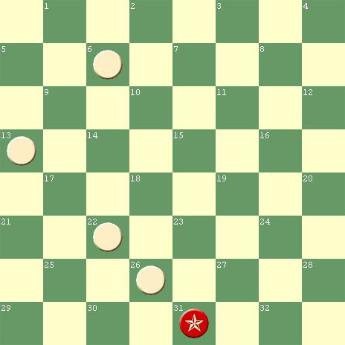
WHITE
White to play and win

22 17 31-22 13 9 22-13 6 2 13-6 2 9 W. wins

He must, of course, have more Red men to make the forces move on an equality, so he places Red men on 14, 15, 16, 23 and 24, which would all be captured by the White king. Here, however, he finds that the moves cannot now be played as before, as his own men would be taken; hence he places a Red man on 19 to stop the capture that is open, and a White man on 30 to stop Red from taking the man on 26. A Red man placed on 21 will permit 22 17, and a Red man behind 14 – that is on 10 – will prevent adverse moves. By the addition of a White man on 32 the problem is complete.

RED
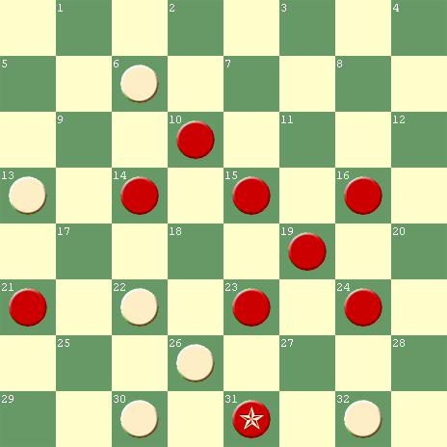
WHITE
White to play and win

But the great disproportion of the Red men seems to suggest an exchange of a few men to gain a greater number; so, to give it the appearance of an ‘end-game’, the men on 6 and 13 are each put back a move to 9 and 17. The Red men on 10 and 14 are placed, for captures and as a blind, on 3 and 5, with White men on 7 and 10. The man on 23 is made a King to prevent other solutions, and the position is as shown below (next page):

NOTE: The Red piece on 23 need not be a King; there are no other solutions that the King would avert, Salot

RED
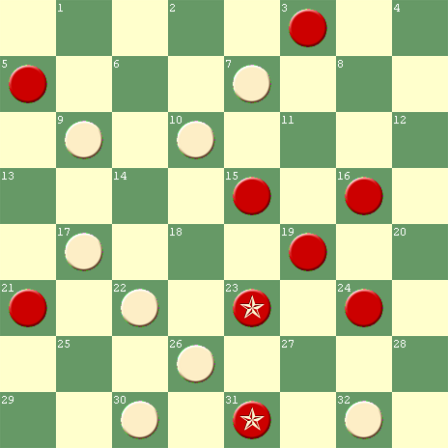
WHITE

*17 13 10 6A *22 17 *13 9 22-13 *6 2 13-6 2 18
5-14 3-10 31-22

The position now becomes similar to the class of ‘end-games’. Continue 19-24, *18 22, 10-15, 22 26B, 15-19, 26 31C, 19-23, 32 28D White wins

A – 22 17 also wins, Salot

B – 30 26 also wins, Salot

C – 26 22 also wins, Salot

D – 31 26 also wins, the finale was less than ideal, Salot
__________________________________________________________
1905, Atwell’s Scientific Draughts, Page 39, Atwell’s original article consisted of three paragraphs; his long paragraphs have been broken down into the shorter paragraphs below for easier reading, Salot:

HOW TO COMPOSE PROBLEMS

Though problem solvers are everywhere to be found, the ability to compose a good problem is rarely met with amongst Draughts players, and experience shows that a very small percentage manufactured by the average player are worthy of publication. But now that diagrammed graduated problems for sight solution have met such universal appreciation, and created many amateur composers, it is an opportune moment to point out common faults in construction, and show the methods adopted by acknowledged proficients.

If you wish to compose a problem, the first thing necessary is to find a good finishing idea, for it is obviously of first importance to know what species of termination you wish to arrive at. If you are incapable of originating such an idea, you should note the nuclei of short problems which have caused you some trouble to solve.

Take these and endeavor to modify them, combine any two or more, make the solution more difficult to discover, the finish more startling, or dissect a composition of many variations.

The value of problems is to familiarise a player with strategical combinations which are likely to arise in practical play; therefore avoid positions which are too crowded, intricate, or interwoven with Men and Kings of different colours. Generally speaking, any position is natural when only Men are used, but when kings are employed a position should rarely contain more than twelve pieces, and even with ten or more the Kings are best placed near the King row where they are crowned. A study of recorded games will show that they are practically finished before many Kings are obtained.

The opposing sides should be fairly evenly balanced; a declared winning side should have no obvious advantage in force or position; a drawing side should be placed at a distinct disadvantage; and there should not be a dual solution, even allowing an unlimited number of moves.
The first move or moves should be well concealed, and appear ineffective unless the end of the problem is perceived.

Positions containing a few pieces on the board are seldom improbable, unless one side possesses Men which have not been moved from the King row, or where two pieces of the same colour are en prise in different parts of the board, and in a few other striking instances which can easily be detected by mentally retracting a few moves and endeavoring to advance to the position.

The play up to a finishing idea must, of course, be accomplished by forced moves. A “forced” move is a move necessary to avoid immediate and decisive loss of pieces or position. The absolute disadvantage of a piece, or its equivalent in position, is an immediate loss in problems, and in practical play the result would be effected by the opposing side simply kinging and exchanging, unless, as is usual with players, the inferior side promptly resigned. The most common form of forcing moves is by limiting your opponent’s replies through pressing him in a confined situation, threatening a stroke, or to capture a piece; and so move by move one arrives at the preconceived termination.

In the terms of the problem, the side to play, the result, and the number of moves should always be stated. Solutions should be carried to a point where the result is apparent.

As problems increase in difficulty according to the number of moves in the solution, they should not usually contain more than, say, nine White moves, for the object is to defeat a solver while allowing him the same number of minutes per move as is ruled in practical play, and under these conditions good problems of nine or fewer moves are quite sufficient to defeat the greatest player, and also to illustrate the principles of Draughts strategy. In fact, an analysis of games between masters proves that the majority of games are lost through failure to see, on the average, five- or six-move ideas.

Long problems generally come under the head of analysis, or Standard Endings, such as First, Second, Third, and Fourth Positions. The latter differ from ordinary problems in the fact that their solution depends not so much upon the ability to see ahead as a knowledge of the calculation of the Move and other general principles. It must be remembered that, while the most practical problems are those for sight solution by different grades of players, there are innumerable positions which require a practically illimitable time for their solution or analysis.

For the sake of uniformity in recording problems, the White should be the first to move, - the declared winning or the drawing side, - and should also be placed as playing from the bottom of the diagram, which on paper is the correct position in relation to the numbers of the squares. In recording positions of games, however, the declared winning or drawing side, or the side whose turn it is to move, should be placed at the bottom of the diagram, whether White or Red.

The following illustration of a well known idea, and its development from three different settings, will show the principles which are the foundation of all problem construction:

RED RED
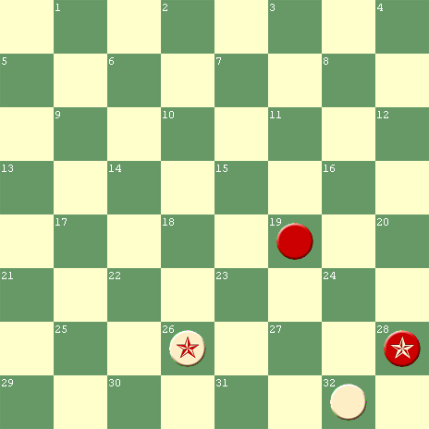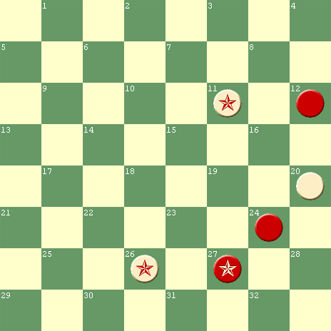
WHITE WHITE
White wins in three by - White wins in five by –
*32 27 19-28 *26 31 12-19 *31 27
28-32 *26 23 27-23 *11 16 23-32
*27 24 *20 16 24-28 16 23
RED
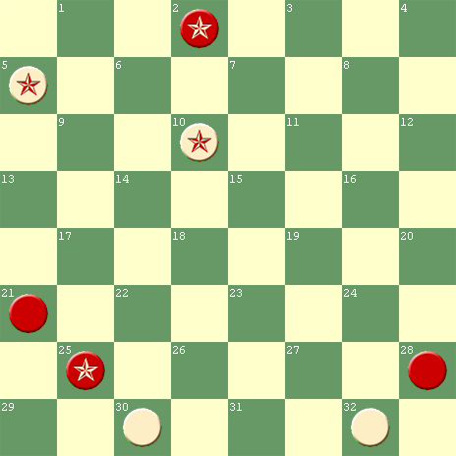
WHITE
White wins in eight by –

*5 9A 22-18 *13 9 30-23 *10 6
25-22 30 26B 25-30 *32 27 2-9
*9 13 21-25 9 5C 23-32 5 23

A – This is the continuation of a problem by A. J. Heffner in the Woonsocket Reporter, prior to its republication in the Otago Witness, May 25, 1888, Liam Stephens

B – 13 9 also wins, Salot

C – 10 6 also wins, Liam Stephens
January 1910, The Canadian Checker Player, Volume 4, No.1, Page 1, excerpts from:

PROBLEMISTS AND PROBLEMIZING

The printing of problems took a step forward when they were put into print with the White side at the bottom. Chess problems are not only set in this style , but the terms are always “white to move”. For purposes of comparison there are some advantages to such a plan, but I doubt whether the several checker magazines and the columns will ever come to the same way of thinking.

The composition of a problem may mean the taking of a simple “ending” or “end game” and adding pieces to those already on the board. The original scheme or setting, before it is elaborated in this way, is called the “idea” or the “theme”. Of course the “theme” is the kernel of the nut and the solution merely (?) the stripping away of the shell or husk. Now to take a problem and reset it with but a trivial change of the arrangement is an act that the honest and well informed will shun. It looks too much like stealing the other fellow’s thunder. Yet it is often done, and done in good faith, I am sure. And as a matter of fact some of the most enjoyable of checker productions are reconstructed problems. The ambitious tyro, though he may not know it, thereby challenges comparison with all who have gone before, and that is always an interesting situation. Whilst on the other hand, when the expert takes a well worn “idea” and puts a brand new thought into it he assuredly adds zest to the game.
Mr. Walton, Boston
_____________________________________________________

July 1913, Call’s Midget Problems, Preface, Mr. Call wrote the following about Dr. T. J. Brown, “the father of the 2 vs 2 problem family”, but it applies to all great checker problemists:

“He was a problem scientist. He went to the bottom of things, delving for secrets. He delighted in conquering the real antagonist in checkers – the board, not the individual opponent.”

In the same dissertation, Mr. Call wrote:

“To set back a finish a few moves, without concealing the idea in an original way that is crafty and misleading, is trifling. It sometimes happens that the solution to a problem may allow a choice in finishing, but that is a matter of little consequence. Some of the finishes may be illustrated in many different ways without changing the principle involved, which is the main thing.”

“Every compiler or author has felt the tyranny of fear that he has missed something essential, or has overlooked a distressing blunder; but that is a responsibility that he cannot dodge by craving indulgence.”
W. T. Call, Brooklyn
________________________________________________________

Date unknown, Norwich Mercury published this caveat and praise of the stroke problem. It reappeared in A. C. Hews’ Stroke Problems, 1917, Page 5:

“The stroke problem has a charm and a value of no less importance in its way than a natural ending. In his aim at complexity and difficulty, the composer too often neglects to impart a due element of naturalness and possibility to his conception. But where there is a proper balance of these qualities, no problem is more pleasing to the average player, no problem is more useful as an exercise or a discipline in sighting possible combinations in exchange strategy, and no problem is more expressive of the beauty and profundity of the game than the stroke.”

Date and source unknown, but quoted in A. C. Hews’ Stroke Problems, 1917, Page 17 is the following:

“The man who constructs a good problem is amply compensated for the time taken up in construction by the delight which it gives him when completed. The first thing should be to get an idea. It is no use for a man to get out his board and think that he is going to build up a good thing right away. He should first of all get an idea of a stroke with an artistic termination, then settle down to his board and try to put the pieces back as far as possible, so as to conceal the trick”, B. Taylor

1917, A. C. Hews’ Stroke Problems, Pages 17 through 24; Except for the omission of its many examples, the following article is complete:

THE COMPOSITION OF STROKE PROBLEMS

“The stroke problem may, perhaps, be best considered by dividing it into two parts – the idea and the setting. The idea is the trick or foundation upon which the problem is built; and the setting is the presentation of the idea in problem form.

It is difficult to say which of these is the more important inasmuch as the one is interdependent on the other. The perfect problem is in short, a good idea well set.

As so happily expressed by Mr. Taylor (above) in his excellent advice given above, the starting point of a problem is the idea. There are, of course, innumerable ideas from which the composer may choose, but those which are original, or a little out of the common, are (when he can obtain them) naturally preferred by the experienced problemist as bases for his compositions.

The following are examples of various ideas – set in their simplest form – from which stroke problems may be constructed.

Ten examples were listed.

In each of the next, one move is gained by the White piece making the final coup:

Ten more examples were listed.

In each of the following, two moves are gained by the piece making the final coup:

Ten more examples were listed.

The player who intends taking up stroke-composing will probably have the greatest scope offered him in the composition of problems in which two or more ideas are combined. For example, take the last of the foregoing illustrations. By introducing an additional idea, we get the following:

Another example

It will be noticed that White gains three moves before culminating the stroke

If the position is altered by . . . White can gain four moves. The position is then:

Another example

When attempting to work up a particular idea into a problem, the composer sometimes comes across another which appears more attractive, and the problem is eventually constructed upon the later inspiration.

It is a good plan to keep a book in which to record ideas as they occur. There is then no danger of any being forgotten, and the problemist can at leisure set to work on an idea which immediately upon its discovery he may not have either the time or inclination to develop into a problem. The compositions in this book (Hews’ book) are arranged, for the most part, so that those with similar ideas are grouped collectively.

The idea having been selected or invented, the next consideration is how it may be set. In his first attempt at setting, the novice usually commences with a simple direct idea, probably somewhat on the following lines:

Another example

In the process of setting or building up, he perhaps places . . . This gives the following position:

Another example

By the time a few positions of this kind have been constructed, he has probably found that there are ideas by which a move may be gained, and one of these is embodied in the problem:

Seven more examples

A knowledge of various methods of hiding the idea, and of bringing the pieces into position for the final stroke, may be acquired by the student through the constant solving of stroke problems. These methods, together with any improvements he may be able to effect, should be noted for his own use in composition.

Few rules for the setting of stroke problems having hitherto been published, the author has ventured to formulate a few simple suggestions. The first two must be regarded as essential; the remainder merely desirable.

- There should be no dual solutions. That is to say, the side enforcing the terms should not at the first, or at any subsequent move of the solution, have any other way or ways of attaining the same result.

- The first move should not be interchangeable with any other move of the solution.

- Every move of the solution should be made in order, no one move being interchangeable with another.

NOTE – This is somewhat difficult to arrange, but its accomplishment considerably improves the problem.

- Only pieces essential to the action of the stroke should be used.

- No kings should be placed where men will serve the same purpose.

NOTE – It is sometimes necessary to crown a piece in order to avoid a dual solution, but kings should not be introduced merely to render the solution more difficult. Personally I have a preference for the problem in which the side, having to achieve the required result, has at the commencement only uncrowned pieces.

- Not more than twelve pieces (a king counting as two pieces) on either side should be used.

NOTE – There are exceptions to this rule. Some complex ideas are very difficult, and in instances impossible, to set without employing more than this number. When starting to compose strokes, a common tendency to build up positions with thirteen or fourteen pieces on each side, but when experience has been acquired, one’s aspirations generally assume more moderate dimensions.

- A definite finish should be left at the end of the stroke. For preference, only one piece of the side enforcing the terms should remain.

NOTE – The following are elementary positions – given for the benefit of the novice – in which, after the stroke, one White piece wins against two or more Red pieces, the latter having to make the next move:

Ten examples are listed.

There are many other positions in which a number of pieces are defeated by one. The last four of the above examples will give the beginner a fair idea of what constitutes a ‘block’ position. The drawback to this class of problem is that it is usually easily solved. The position of the pieces practically labels it as a ‘block’ to the experienced solver.

- The composer should be able to demonstrate that there is a possible move immediately preceding the position forming the problem.

NOTE – A problem set with several pieces en prise, apparently without any connection with each other, will tend to raise doubts in the mind of the solver of its practical utility. If a natural position can be attained, it will enhance the value of the composition.

The problem should be made as difficult as possible after due observance of the preceding rules. It is desirable to select as the first (or key) move of the solution, one which is improbable or difficult to discover. The existence of one or more variations from the correct solution, which only narrowly fail to achieve the same result, will also add to the difficulty and thereby to the interest in the problem. Complexity is generally to be aimed at, but it should not be the chief consideration. It is well to bear in mind that all solvers are not experts, and that a good clean stroke, even if it is easy, may be appreciated by the less experienced.

The idea should be tried in a number of settings – if it admits of this – and the best selected. Occasionally two or more good settings of the same idea are discovered, each of which is worth recording as a problem. A simple idea can, obviously, be set in a greater number of ways than one which is complex.

The beginner may possibly learn something of how a simple idea may be varied in setting by studying . . . five examples. It is difficult to find even one satisfactory setting for some complex ideas, and it is sometimes necessary to alter or modify the idea until it is reduced to practical form.
It is desirable that a problem, after construction, should be kept on the board a short time before recording it. If looked at again in a few days’ time some method of improving it may be seen. A slight alteration may, perhaps, make it more pleasing or artistic. The problem should be carefully examined, both immediately after construction, and also at a later period, to ensure there are no duals or flaws of any kind. It is easy, as most problemists know to their cost, to overlook some other means of attaining the same result. Even a simple two, or perhaps three for one dual stroke may occasionally be missed unless care is exercised.

After the problem has been recorded, it is advisable to wait a few weeks before sending it for publication. It is sometimes found that a problem which, when newly constructed, appears to the composer (in the enthusiasm of the moment) to be very good, when reduced to its true perspective is really of quite ordinary merit, and not worth publishing. The stroke problemist, like students of the other branches of the game of draughts, must have patience, and possess the faculty of taking pains. It is usually only after several unproductive efforts that a satisfactory problem is evolved. He has also occasionally the chagrin of finding a cherished composition upset through a dual or flaw of some kind being discovered in it. His early efforts are usually attended with a few difficulties, and here and there disappointment. When, however, the elementary stage is passed, the beauties of the stroke are soon perceived, and, as increasing knowledge of problem composition is acquired, the more fully is its fascination realized.”
______________________________________________________

February 1926, Morris Systems Checkerist, Volume 4, Issue 2, N. W. Banks, Editor

PROBLEM REVIEW

To determine the better checker player, the general method or procedure is to have them play a set match, and the one winning the most games is considered the better player. It is thus actually and mathematically possible to arrive at a definite conclusion on this point.

There is no such competition in the problem realm, for the aim of the true problemist and analyst is to conquer the board, and prove his contentions by deductions of sound worth. To the problemist or analyst, the winning of a game means little; for the win might be clinched by means of unsound play which trapped his opponent into taking the wrong line of action. “The play is the thing” with the problemist – thus it is a hazardous venture to possibly determine who the best problemist is.

Our choice would be A. J. Heffner, whom we consider the greatest problemist and analyst in the world. His tremendous grasp and knowledge of the fine points of the game gives him that advantage which a master obtains over an experimenter.

As to problemists only, ‘twould be a venturous undertaking to state who is best. Each has his style; and each style appeals to a certain following.

Of the old masters, Richmond, Purcell, Wardell, Slocum, Drinkwater, Brown, Flower, Hefter, and others – each favored certain styles of problems, and each had his select followers.

Today we have a capable field of brilliant problem composers. There’s A. J. Heffner, C. Hefter, F. Dalumi, L. J. Vair, J. A. Finn, C. A. Woodard, L. S. Hart, Jr., Parson Brown, S. Gonotsky, L. C. Ginsberg, W. J. Wood, Geo. L. King, Roy M. Allin, Maurice F. Hammar, J. H. Robinson, W. E. Davis, Ralph E. Powers, Ivan Powers – and many others who are keeping the grand old game alive by furnishing stimulating problem gems to the various checker publications.

Here’s health to them all. This month we offer some dandy strokes by those prolific pyrotechnic artists, Shapiro and Berry, than whom there are no better in there class. And some finished studies by Woodard, Finn, and Heffner will keep you busy until next month.

COMMENTS: This collection refutes one of the above claims. Slocum’s repertoire was not limited to one style of problem, Salot

We may never agree on the best composer, but, of the many problemists listed by Banks, only Slocum had a “style” of problem named after him. Here are examples found by Jay Hinnershitz in Banks’ Morris Systems Checkerist:

- September 1925, Volume 3, Issue 9, Page 15, “Quite a brilliant sequence of forced moves on the Slocum idea is seen in No. 376 by the Michigan problemist, Geo. L. King”

- October 1925, Volume 3, Issue 10, Page 15, “Wood Pusher in No. 396 gives us a regular Slocum stroke of merit”

- November 1925, Volume 3, Issue 11, Page 15, “Problem 408, by J. Hendry, is an unusually brilliant and surprising forced stroke of the Slocum order”

_______________________________________________________
1946, Twentieth Century Checkers, Page 164-166

The ABC of Problem Composing

EVERY player is a problem composer in embryo, but he seldom knows how to go about creating a problem. He is like the budding author who aspires to write the great American novel, but does not know just how to begin.

A good problemist must have imagination, analytical ability, sound positional judgment, perseverance in the face of many disappointments, and, what is most important of all, originality of conception. The works of Slocum, Heffner, Dalumi and Nelson all show a great wealth of varied and assorted themes. The successful problemist must have an idea to start with.
It is said that every novel is founded on one of six or seven basic plots, and to a certain extent this is also true of checker problems. Yet, just as tens of thousands of different stories have been written around these basic plots, so, too, have thousands of fine problem settings been published around the basic ideas – the stroke, the smother, the waiting move, the captive Cossack, the fugitive King, and so on. So to the student problemist I would say, first you must have an idea, an original one if possible, but an idea, anyway.

Your next task will be to develop the proper setting for your brain-child, and there your woes and difficulties will begin, as any veteran composer can attest. It is necessary to avoid duals and yet maintain the terms of the problem. To do this and satisfactorily conceal the idea from the solver is no easy task. Many a composer has suffered heart-break by having a beautiful idea but no satisfactory setting with which to embellish it and thus mystify and intrigue the solver.

Slocum’s settings, for example, are among the finest of any composer. His ideas are consummately hidden, his solutions not too long or burdensome, and all his problems bear an innocent, natural appearance. I would recommend a close study of Slocum’s gems to any budding problem composer. They reveal all the admirable finesse of the composer’s art.
The student is cautioned against the use of numerous Kings in his work as they often tend to lend an artificial appearance to the setting. Now and then one may run across a nice problem containing all Kings, but such problems are in a different category entirely.

It is also a good habit for the embryo composer to show his problems to a friend or two before submitting them for publication. This insures against duals and incorrect terms. One cannot always trust his own judgment, no matter how accurate one may be as a rule. We have often seen “duffers” point out simple errors we overlooked in our pardonable zeal and enthusiasm. Remember, a composer who submits many problems with imperfect solutions or incorrect terms soon loses caste among the players. The best composers will err now and then, of course, but the greater they are, the fewer their errors.

Don’t try to “turn out” dozens of problems at a time on a mass-production, “assembly line” basis. Many problems published in weekly and monthly periodicals are not worth the paper they are printed on. Such composers are not worthy of the name. Some problemists are gone but not forgotten; others are forgotten but not gone! Be sure you are not in the latter group.

It is, of course, sometimes difficult to avoid unintentional plagiarism, but always strive for originality and, above all, avoid any intentional “stealing” of settings. If one of your variations runs into a known theme, be frank and say so in your solution and give full credit where due.

An interesting and valuable point to bear in mind is that every game eventually evolves into a problem setting. Be on the alert, therefore, for problem possibilities in all your games. I have seen many players run up beautiful continuations and quickly reset the pieces for a new game, never realizing they had wholly neglected an interesting and perhaps instructive problem setting in the game they had just completed. Such players invariably remind me of the man who slept while traveling, in broad daylight, through the Grand Canyon. I have been able to get as many as half a dozen fine settings from a single game, and this number is small indeed.

Above all, don’t get discouraged. The first problem is always the toughest. Don’t expect a gem to start off with. Be content with a nice beginner’s problem as your initial effort. Depth and true beauty will come with time.

Slocum, Heffner, Dalumi, and Nelson (the Four Horsemen) did not attain eminence overnight. Rather their stature and greatness developed slowly with the years, as players the world over came to recognize that the works of these masters were gems of the highest order, elevating their handiwork to the stratosphere of a fine art.
T. W. (Tom) Wiswell)
________________________________________________________

1969, private correspondence, “When you see a good problem, you just know it”, Saul Cass, a prolific problemist
_________________________________________________________

In the waning issues of Elam’s Checker Board, the following exchanges took place:

January 1970, ECB, Pages 7903 – 7905, CONTEST PROBLEM ANATOMY, Bill Salot:

“The 2x2 and the giant stroke represent problem extremes, not only in number of pieces, but subtleties and impudence as well. All other types of problems fall somewhere in between. It is impossible to compose a good problem with less than two pieces per side, and I doubt that anyone will ever compose one with more pieces than the Veal Stroke”, a 14x15

January 1971, ECB, Pages 8132 – 8136, MARTIN PONDERING, John A. Martin, Ohio:

“You say, and rightly so, that it is impossible to compose a good problem with less than two pieces per side. I wish to go further and say that it is very probably impossible to compose a good problem at all without using a previously published theme.

The end-game themes in our game are numerous, indeed, but by no means infinite in number. It is very likely that most fine players are familiar with them all! For this reason, I shall never claim an ending to be original with me, unless by some miracle I should actually be inspired with something new. I have never had a new and original idea concerning end play in my life.”

NOTE – Mr. Martin died in 1970 without seeing publication of his above article or the following response to it.

July 1971, ECB, Pages 8270 - 8272, NEW PROBLEM THEMES, Bill Salot and J. Charles:

“For another viewpoint on problem themes, I would like to quote a letter from J. Charles, with his permission, of course. His credentials include over 700 problems since 1930, demonstrating problems on TV six times, a problem book, twice winning the Cheshire Cup, and competing against four world champions (British version), namely R. Stewart, S. Levy, S. Cohen, and M. Tinsley. Whether you agree with him will depend upon your definition of ‘themes’, but I am sure you will like his examples”, Salot

“Are there any new themes? I believe there are. When I first composed a deferred stroke, I was told there were very few to be found and that the great Slocum had almost drunk the cup dry. But as time passed, I saw beautiful settings by C. J. Greensword, S. J. Pickering, Saul Cass, Bert Berry, Paul Semple, and others. This evidence convinced me there was room for more. Since then, I have composed more deferred strokes than Slocum, and many have won prizes. New themes? I believe I have discovered a few:

Five examples followed.

Are there new themes? I say, ‘Yes”. Seek and you will find. The secret of problems is not only in knowledge, but also in the unknown. Such is the greatness of checkers”, J. Charles
________________________________________________________

1979, Oldbury’s Complete Encyclopedia, Volume 2, Page 249

“Composed problems belong largely to the world of entertainment; yet, whenever tactical niceties are exhibited there is some lesson to be learnt”, Derek Oldbury

1980, Oldbury’s Complete Encyclopedia, Volume 3, Page 329

“Stroke problems: compositions, in contrast to strokes from actual play, appear to have come upon the scene rather late, that is, if we are to count only those exhibiting a degree of sophistication. The composing of a stroke is to be done in terms of strict discipline, involving rules, and is not the result of merely dropping pieces through a sieve on to the board, as many might think.”

NOTE – Oldbury was probably referring to the eight Hews’ rules, 1917, enumerated above.

“Objections to strokes come mainly from those who consider them, firstly, artificial (as, say, a sonnet or string quintet?), or, secondly, too easy. While it may be true that, set before Marion Tinsley or Tom Wiswell (try them both), they will rattle off the solution of any stroke problem, like shelling peas, some do not find strokes all that easy.”

“The delayed action strokes popularized by George H. Slocum in the late 19th Century have come to be regarded as a separate species from the type perfected by Hews; the two are not mutually exclusive I find. Slocum’s output was relatively small, bequeathing to posterity more disciples than problems; in this volume I have concentrated on theirs rather than his: not in a spirit of perversity but merely because the problems of Slocum himself have been oft-quoted almost to the point of over-exposure (for a selection from his best: see my Chequer Chiaroscuro)”, Derek Oldbury
________________________________________________________

1980, Wonderful World of Checkers and Draughts, by Tom Wiswell and Jules Leopold, Page 62, “Just for Openers”:

“Every published problem position originated in one of two sources: Either it had arisen in an actual game, or it had sprung full-blown from the brain of a problem creator (though often after long inner struggle!).

Often, of course, the two may merge. A problemist’s creation may be found to recur in a game, or vice versa. And very often an actual game situation may suggest to the problemist an idea from which he will create an original problem”, Wiswell and Leopold

1980, Wonderful World of Checkers and Draughts, by Tom Wiswell and Jules Leopold, Pages 65-66, “Fifty Selected Problems”:

“However in all problems, the important thing to realize is that BEST PLAY ON BOTH SIDES IS ALWAYS TO BE ASSUMED, AND IT IS THE SOLVER’S TASK TO DETERMINE WHAT THAT IS. To demonstrate a WIN for your side, you must be able to show your opponent’s best defensive moves . . . and how your countermoves will defeat them. Similarly, to demonstrate a DRAW for your side, you must deal with your opponent’s best offensive plan”, Wiswell and Leopold. That is good advice for composers as well as solvers, Salot

“Now if you see a likely-looking move that is not shown in the printed solution, probe carefully its ramifications before you conclude that it upsets the terms of the problem. You may be fairly sure that something is nix with that move. Also you may experience a certain delight in finding out for yourself why it won’t work. However, if you finally remain convinced that you have corrected the terms of the problem (or found an alternate solution), write us. Should your correction prove valid, you’ll receive credit with any future publication of the problem as corrected”, Wiswell and Leopold. Those words also apply to this Slocum collection, except send the corrections to Bill Salot wjsalot@comcast.net
In the February 1988 issue of Midwest Checkers, there appeared a new column called “Checker Chitchat”, by William V. Scott, a problem composer for more than 50 years. His various columns included the following comments on composing:

“For a problemist to build a problem, he must first have an idea, either from a friend who had a special ending from a real game, or from one of his own games, or from researching the great endgame themes of yesteryear. Over the years, I have exhausted most of those means, and am usually depending upon the works of the old endgame Masters”, February 1988, W. V. Scott

“It is difficult to surmise as to the thoughts or ideas that any problemist may use in putting together a problem. As far as this problemist is concerned, I can only use the basic theme and do my best to hide it . . . safely”, February 1988, W. V. Scott

“I am only capable of handling one problem at a time and I have no way of double checking one of my ‘home built’ problems. I have never had the facilities to do that kind of research . . . and never expect to have it. I will leave that to the checker vultures who thrive on the dedicated works of the problemist. After all, this is a major part of checkers. If it weren’t for the beloved vultures, it would not be worthwhile to be a checker problemist. When they give their time to try to upset my problems . . . then I am thoroughly honored”, April 1988, W. V. Scott

“When a checker problemist sets his sights on a specific theme, it is almost impossible to get away from the theme until he has ‘milked it dry’ ”, April 1990, W. V. Scott

“A number of times during the past fifty years I have attempted building problems from tournament game endings”, June 1990, W. V. Scott

WHAT I LEARNED FROM SLOCUM ABOUT COMPOSING By Bill Salot

Much of what Slocum’s compositions taught me about problem composing is summarized in the “Lessons for Composers” that accompany individual Slocum compositions in this collection. I have grouped those lessons into thirteen (13) overlapping categories, while maintaining the link between each lesson and its supporting setting.

First, some “Advice” seemed to jump from Slocum’s board into my head:

LESSON | Prob#
ADVICE
9. Deception should be the composer’s primary objective. | 2
19. Avoid allowing optional defenses that bypass favored solutions. | 6
23. Employ multiple deceptive devices in the same problem. | 8
25. Improve on old ideas, or leave them alone. | 9
36. Use a computer program to check your compositions. | 15
37. Show versatility; diversify compositions. | 16
38. Don’t assume your work is flawless. | 17
42. The construction path into a composition is as important as the solution path out of it. | 19
44. Excellence is its own reward. | 20
54. Make false solutions tempting. | 27
89. Playing games is good practice for problemists. | 48
117. One Motif may have many settings. | 67
127. Offering many false options at every turn is a good way to sidetrack would-be solvers. | 74
148. Composers now and then should change their tune. | 88
151. Deducing another person’s thought process is good exercise. | 90

Second, the worldwide respect and admiration that Slocum earned over his less than 23 years of problem composing can only be explained by the near universal “Appeal” of his most popular offerings.

LESSON | Prob#
APPEAL
16. Multiple pitches are attention-getting crescendos. | 4
39. Compound strokes are crowd pleasers. | 17
49. Contrasting variations have special appeal. | 23
56. Great minds, oceans apart, can independently conceive the same thought. | 28
57. Clean-cut, variation-free compositions are widely applauded. | 28
58. Masterpieces memorialize multiple motifs. | 29
78. Piece-down winning settings have a special appeal. | 42
79. Long, narrow solutions have a special appeal. | 42
80. Hidden “pitch and steal” combinations have special appeal. | 42
87. Popular themes are often given popular names. | 46
88. Variations are welcome when they are short and significant. | 47
105. Even simple squeezes are among what pleases. | 57
112. Intricacies fascinate. | 63
116. The linkage of divergent themes in the same setting is an appreciated attribute. | 66
128. Moves that have no other purpose than to wait are pleasingly rare. | 75
129. 3-way pitches are pleasingly rare. | 75
131. Slick sight-solver settings are seldom shunned. | 76
138. The most popular moves are the head-slappers. | 81
139. Wins may be buried in piece-down tie-ups. | 82
162. Settings sparkle with strings of stars | 96
163. Wins are appreciated even more when the only options are losses. | 97
171. A single-lane road is more scenic than a multi-lane highway | 101

Third, the appeal of a composition is not always dependent on whether its “Appearance” is natural or not.

LESSON | Prob#
APPEARANCE
5. Innovative ideas must not be inhibited by setting appearance | 2
46 Ideas supersede appearance. | 21
55. The nature and location of every piece in a setting must be as it is for a reason. | 27
115. Similar appearing settings seldom signal similar results. | 65
145. Some composers believe a checker problem setting, for the sake of natural appearance, should be reachable by a pair of consecutive legitimate moves. | 86
147. Although games are often terminated before they reach the unappreciated 2 x 2 stage; do not add pieces to your 2 x 2s merely for appearance sake. | 87A
157. Appearances are deceiving. | 92

Fourth, the single most important step toward generating appeal is to incorporate “Deception” into the composition. One way is to introduce “Unexpected Ideas”.

LESSON | Prob#
DECEPTION – UNEXPECTED IDEAS
2. Strokes can be hidden by an intricate prelude of forcing moves | 1
6. Unexpected finales hide themselves. | 2
13. Unexpectedly offering a free path to the king row is deceptive to solvers. | 3
21. A natural false solution is difficult to devise, but, when it works, it can effectively distract solvers from better play. | 7
28. Interrupting a natural sequence with an unnatural move can be baffling to solvers. | 11
34. Multiple motifs in a single setting confuse solvers. | 14
51. A simple, effective, deceptive device is counterintuitive misdirection. | 25
52. One type of misdirection is a discontinuous solution. | 25
53. A winning retreat away from the fray is awesome misdirection. | 26
92. The directionality of moves can create mental blocks. | 50
94. Creating false objectives creates mental blocks for solvers. | 51
135. A win is difficult to find when you don’t see the lurking escape, and vice versa. | 79
156. Timing is everything. | 92
172. Deception is rooted in misperception. | 102
175. Occasional illogic elicits extraordinary wins. | 102

Fifth, a second source of “Deception” consists of individual “Unexpected Moves”.

LESSON | Prob#
DECEPTION – UNEXPECTED MOVES
7. Attacking pitches are deceptive to solvers. | 2
8. & 35. 2-way and 3-way pitches are deceptive to solvers. | 2, 15
14. 2-piece pitches are often deceptive to solvers. | 3
15. Slip pitches are often deceptive to solvers. | 4
22. Pitches that appear premature or mis-timed are easy for solvers to miss. | 7
45. Using free moves to make pitches confuses solvers. | 20
47. Pitching or forcing an opposing piece first in one direction and then in the opposite direction is difficult for solvers to find. | 21
134. Key back and forth waiting moves fool some of the best. | 78
140. The rarest pitch is a buried pitch. | 82
154. Apparently pointless pitches empower problemists. | 91
158. Wrong way jumps spell disaster. | 93
169. A twister move is an attraction rarely found in a composed setting. | 100
185. A rare concept is to force a defender to deal with both sides of a “Twister” in a single solution. | 109
Sixth, the appeal of a composition is often determined by the presumptions and prejudices of the “Audience”.

LESSON | Prob#
AUDIENCE
1. One component of success in any endeavor is a positive response to early efforts. | 1
93. The main sign of a quality setting is solver chagrin | 51
97. Audience reaction is often unpredictable. | 53a
102. Once a composition is published, a composer has no control over it | 56a
103. Crediting errors, once published, are virtually irrevocable. | 56b
125. Some audiences want composers to use the K.I.S.S. approach: “Keep It Simple Stupid”. | 72a
174. Careless editors can spoil the presentation. | 102
173. Individual responses are rooted in individual tastes. | 102

Seventh, composer skill and audience interest are both enhanced by “Critiques” of the compositions.

LESSON | Prob#
CRITIQUES
32. Critiquing problems can be more rewarding than solving them. | 13
104. You know a setting is good if it baffles many would-be solvers and critics. | 56b
113. & 164. Good settings hide more than meets the eye. | 64, 97
114. The quality of a composition depends more on the deception of the protagonist than on the travails of the opposition | 65
160. You know quality when you see it. | 94
161. Beauty is in the eye of the beholder. | 95
Eighth, audience appreciation is enhanced when their attempts to find “Flaws” in a composition are unsuccessful. The opposite results when a flaw is found.

- The most devastating flaws are upsets of terms.

- The most common flaws are “Dual Solutions”.

LESSON | Prob#
FLAWS – DUAL SOLUTIONS
4. Dual solutions are the bane of composers. | 1
50. When dual solutions appear near the end of the solution, the composition is probably unredeemable. | 24
75. Optional sequences invite dual solutions. | 39
121. A dual solution among the early moves is less devastating because early moves can be eliminated without destroying the composition. | 70
178. Some dual solutions deserve separate settings. | 104
179. Dual solutions are acceptable as long as they do not appear in the Trunk line. | 105
182. When a dual win is suspected, strengthen the defensive forces. | 107
188. Like the Phoenix, new themes rise from the ashes of duals. | 110

In addition to upset terms and dual solutions, there are many “Other Types” of “flaws”.

LESSON | Prob#
FLAWS – OTHER TYPES
41. Extended or inconclusive variations are not attractive. | 18
59. Optional defenses are dissonant distractions. | 30
71. Variations should complement but not surpass the intended theme. | 35
110. Wasted and out of sequence moves are minor off-key notes that do not totally destroy an entire composition, unless they lead to utter discord. | 61
130. Offering few false options is an invitation to sight solving. | 76
136. Non-star moves are not crowd pleasers. | 80
137. Incomplete solutions reap incomplete benefits. | 80
186. Time-wasting moves detract from the beauty of solutions. | 109
187. The terms “Red to Play, White to Draw (or Win)” are not popular because they divide the solver’s attention. | 110
Ninth, when a flaw is found, try to make an “Improvement” in the setting. “Improvement” in the Composer will follow. Make lemonade out of the lemon. Pride will follow embarrassment.

LESSON | Prob#
IMPROVEMENT
11. The quality of a composition improves with time spent composing it. | 3
12. Ask why a setting is as it is and whether it can be made better. | 3
20. Do not set a composition back too far, lest it create dual solutions or extraneous variations. Question every setting. | 7
24. Most ideas have potential for improvement; some have more potential than others. | 9
26. Sometimes imperfections are unavoidable. | 9
62. Look for resettings that will eliminate dual solutions. | 31
65. Composers can learn from Slocum’s mistakes, just as he did. | 33
67. Composers have bad days too, but tomorrow or next month is another time to find a better setting. | 33
68. It is never too late to correct a defective composition. | 34
72. Find the best setting. | 36
77A. Minor relocations may make major improvements. | 41A
77B. Take your time or you will miss something. | 41A
82. There always seems to be room for improvement. | 44
84. “Late corrections are a grab bag”, Milton Johnson | 45
85. Check every move. | 45
108. When inspired, pull out all the stops. | 60
118. A composition must first satisfy the composer. | 67a
119. Minor changes in settings can have major effects on solutions. | 68
132. Don’t abandon what works for you. | 77
133. You can learn from your mistakes only if you live long enough. | 78
165. Even well received settings can sometimes be improved. | 98
167. Composers should not be satisfied with the solution alone. | 99
Tenth, composing checker problems is not easy. The practice is beset by many “Restraints”.

LESSON | Prob#
RESTRAINTS
29. Whether a move works or not often depends on its timing. | 11
40. Deciding whether or not a piece should be a king may be crucial or may only be a personal preference. | 18
64. To crown or not to crown is often a composer’s dilemma. | 32
69. Not all ground is fertile. | 35
70. Not much ground remains unplowed. | 35
76. The 2 x 2 field offers composers relatively little flexibility. | 40
77. Sequels seldom surpass originals. | 41
81. There is a limit on how far a given finale can be set back flawlessly without adding one or more pieces. | 43
90. Composing a difficult problem from among many possible settings may require more analysis than a difficult opening. | 49
91. A composition is incomplete pending dispensation of its kings. | 50
109. Players and solvers are often satisfied with seeking and discovering a win or draw on a given setting; composers are seldom fully satisfied with either the solution or the setting. | 61
141. Many (most?) late endgames have already been published. | 83
180. Very similar settings sometimes type-cast their solutions. | 106a
183. Your computer program will find one solution by itself, but it will not pursue a dual solution without direction from you. | 107
Eleventh, the first challenge to composing checker problems is finding or selecting “themeS” to build them on.

LESSON | Prob#
THEMES
10. Multiple intriguing compositions can often be built on a single intriguing idea. | 3
18. Positions arising in games can usually be reset to make them more difficult. | 6
27. Do not discard old themes; build a repertoire of them. | 10
60. Composers can learn much by exploring dual solutions. | 31
63. Compositions demonstrate themes. | 32
74. Corrections of old problems are seeds for new ones. | 38
86. Distinctive compositions can have common themes. | 46
95. There is always room for composers to create new beginnings from old themes. | 52
96. Skirting around standard positions is a fertile field for exploration. | 52
98. Spin-offs can be a fruitful part of the composing process. | 53b
124. A single setting can demonstrate multiple themes. | 72
142. Setbacks of famous positions can yield avoidance plays | 84
143. Game positions are analyzed, not composed. Often they make good problems. | 85
144. Review old themes for new tunes. | 86
149. Some gems are buried in darkness waiting for the light of day | 89
150. Uncommon mirror positions demonstrate the same theme from opposite sides of the board. | 89
155. Positions can transpose between games and compositions. | 92
166. Simple themes sometimes can be made incredibly complex. | 99
168. See-saw draws are not confined to the Single and Double Corners. | 100
176. Novelty themes make good conversation pieces. | 103a
177. Some novel themes do not make quality compositions. | 103b
181. Novelty features are talking points. | 106b
Twelfth, “TECHNIQUE” is required to build a theme into an original composition. The most common “TECHNIQUE” involves “FORCING” the opponent to make specific responses.

LESSON | Prob#
TECHNIQUES - FORCING
3. Freezing one part of the opposing forces makes forcing moves possible against another part. | 1
17. A single pitch that forces the victim to jump on more than one consecutive turn generates one or more free moves for the initiator. | 5
30. Some moves are both forced and forcing. | 12
31. Forcing the opponent to steal gives you a free move. | 12
33. Domino pitches create free moves. | 14
43. Forced steals create automatic opportunities for both free moves and false solutions. | 19
48. Free moves can be extended by inserting additional pitches. | 22
61. Forcing moves immobilize unthreatened pieces. | 31
99. Piece-up settings are ripe for pitches | 53b
Thirteenth, there are many “other techniques” for enhancing original compositions.

LESSON | Prob#
other techniques
66. Composers have the option of changing the direction of jumps. | 33
73. Problems can be built around a refusal to jump | 37
83. A single piece sometimes can be stronger than a king. | 44
100. Long solutions can be pleasing or irritating, depending on whether beauty or tedium dominates. | 54
101. A single move can serve many functions. | 55
106. If a crucial move cannot be hidden, make it prematurely inviting at a stage when that move fails. | 58
107. Combining key attributes, such as simplicity and diversity, makes good problems better. | 59
111. True solutions are camouflaged by false ones. To find the true, you must refute the false. | 62
120. Both false solutions and time-wasting moves make problems more difficult to solve. | 69
122. Long solutions are usually built around maintaining a grip on some opposing pieces so as to confine mobility to the other pieces. | 70
123. A key square may be the key to a solution. | 71
126. The pinning of multiple pieces may set multiple traps. | 73
146. Star moves often distinguish otherwise similar settings. | 87
152. Find the best location on the board for exploitation of your theme. | 90
153. Don’t give clues to solvers (violated here). | 91
159. The location of one piece can spell the difference between winning and losing. | 93
170. When a variation is better than the trunk, it should have its own setting. | 101
184. The whole is greater than the sum of its parts. | 108

272 OTHER PERSONS MENTIONED IN THIS BOOK
Individuals Mentioned | On Pages
Abernethy, Joseph | 83,115,156,187,191-192,195,202,233-234,253,259,290,349,398-399,404
Allen, Fred | 245
Allin, Roy M. | 459
Anderson, L. B. | 342
Appel, Oscar | 435
Atwell, Richard (“N. Alist”) | 233-234,347,388,447
Avery, W. W. | 48,197
Babcock, M. J. | 342
Baker, W. T. | 42,43,47
Barker, C. F. | 42,46-48,155,242,278,352,404,440
Banks, A. J. | 269
Banks, Newell W. | 303-304,458
Banks, R. D. | 377-378
Barnes | 285
Barrenger, William | 214-216,218-219,221
Bates | 411
Beattie, William | 137,237-239,249,305
Belasco, Albert | 440
Belden | 48
Bennett, Peter, “P.B.” | 200-201,233,243,254-255,398,441
Berry, Bert | 459,464
Birnman, Jack | 263-264
Bishop, Anthony | 440
Blaidsell | 389
Bloom | 389
Boland, Ben | 63,71,103-104,136,140,156,172,178-179, 215,218-219,291-292,300-302, 307,309, 316,319,321,346,386,401,412
Boreham, J. A. | 115,193?,195?
Borland, W. | 305
Botte, Jack | 144
Brandler, Julius | 264
Brennan, M. H. | 137,139

Individuals Mentioned | On Pages
Brickman, J. E. | 305
Brodie, D. A. | 137,139,399
Brogan, Zach | 441,443
Brown, Floyd D. (Brownie) | 11,49,75,322,391,396
Brown, Parson | 459
Brown, Dr. T. J. | 75,166,329-330,336-337,359,391,398, 402,452,459
Call, William Timothy | 75,156,179,203,244,309,329-331,400, 452
Calvert | 155,222-223
Campbell | 44
Carmody, J. O. L. | 434
Cass, Saul | 453,464
Cast, Ray E. | 136,140
Cave, J. B. | 342
Charles, Joe | 340,464
Chernev, Irving | 172
Churchill, Ernest R. | 184,436
Clark, Charles | 342
Clouser | 155
Cohen, Sam | 464
Colston, Tom | 412,414-415
Cooper, W. T. | 435
Corbin, C. A. | 342
Cosgriff, J. | 274-275
Coudon, W. L. | 214-218,223
Craig, J. C. | 292
Crowell | 285,288
Crue, Bob | 11,209,220,303-304
Dalumi, Fausto | 459,461,463
Darrow, Al | 49,69,179,246-247,298-299,302,309,310, 331,437
Davis | 48
Davis, W. E. | 459
Dawson | 171-172
De Freest | 155
Individuals Mentioned | On Pages
Delap, S. | 143,145
Denvir, J. T. | 46,49,61,139,155-156,176,178-179,184, 188,209,228,244,285,288,295,298-299, 307,325,327-328,336,343,390,404-406, 410
Devlin, Hugh | 204,208,324
Donaghy, W. | 156,245
Doran, Peter | 434
D’Orio, Julius | 176,434
Doyle | 389
Dresback, John | 342
Drinkwater, F. W. | 459
Drouillard, J. | 288
Duffy, Joseph | 243,329-331,392,396-397,401
Dunlap, A. J. | 47,117-118
Dunne, Frank | 174-175,221,393-400
Egan, Hugh | 228-229,240,436
Elam, Emin | 393
Emery, Ed | 434-435
Faurot, J. B. | 342
Fell, Coulter | 377
Ferrie, James | 44
Field | 389
Finn, J. A. | 459
Fishburne, F. B. | 170-172
Flower | 459
Fortman, Richard L. | 285
Francis, J. M. | 342
Freeman | 43
Freer, Robert | 47
French | 389
Friel, L. G. | 144
Gansby | 184
Gardner, Willie | 392
George, J. (Jack) | 121-122,170,214,217,219-223
Ginsberg, Louis C. | 459
Goldsboro, Tom | 250
Individuals Mentioned | On Pages
Gonotsky, Sam | 459
Gordon, J. T. | 217,219,222
Gould, Joseph | 50,178
Gourlay, D. | 308,319-320,331
Grant | 346
Greensword, C. J. | 464
Greenwood, Prof. J. M. | 437
Gregg | 389
Griner, E. M. | 342
Groshaus | 389
Hall | 155
Hall, Leonard L. | 302
Hammar, Maurice F. | 459
Hanson | 48
Hart, L. S. Jr. | 459
Hartshorn, Prof. H. C. | 176,428,430-431,433-435
Head, Lucius S. | 46,155,199-200,202-205,207,243-244, 246-247,285,288,404
Heffner, August J. | 48,450,459,461,463
Hefter, Charles | 42,46-50,53,65,68-69,84,244,285,288, 347,349-350,352,377,404,435,459
Heller, Abe | 406,408
Hellman, Walter | 184
Hennigan | 48
Henderson, Hugh | 399
Hendry, J. | 460
Hews, A. C. | 186,452-458,465
Hinnershitz, Jay | 11,179,411
Hopkins, Harvey L. | 42,47,400,438-440
Hopper, Millard | 303-305
Horr, John F. | 377
Horsfall, W. W. | 11,87
Howe, John. Sr. | 389,436
Hyde, E. T. | 46
Hynd, Allan | 316,318-319
Jacob, H. | 220
Janvier, J. D. (“Nemo”) | 308,320,351
Individuals Mentioned | On Pages
Johnson, Milton | 64,81,174-176,265-266,276,376,405-406
Jordan, Alfred | 170,172
Jordan, Richard | 434
Jos.-Marie, compte de Maistre | 441
Levy, Sam | 464
Kennedy,Robt,CedarRapids,IA | 393-396,402
Ketchum, Preston H. | 195,219,221,223,285,310,377
King, George L. | 459-460
Kirk | 389
Kirkwood | 43,381
Kist, W. H. | 342
Knight, Harold | 111
Knox, F. T. | 280-282
Lees, James | 171-172,343,349,351
Leggett, W. G. W. | 440,443
Leopold, Jules | 466
Letourneau, Dr. D. A. | 125
Lewis | 44
Lieberman, Harry | 435
Logan, Dr. S. D. | 437
Lundy, W. I. | 434
Lyman, Al | 440
Lyman, H. D. | 48,50
Lyons, J. K. | 217-219,221-223,269,308,316-318,437
Lyons, Richard | 69
Maize, Joseph | 48,222
Mar, R. | 230
March, Bert | 434
Martin, John A. | 204,208,392,402,463-464
Martins, Robert | 44,222
M’Ateer | 155
McCallum, Levi H. | 342
McCool | 411
McLaughlin,W.H.‘UncleToby’ | 48
Mellow, H. C. | 435
Mercer | 48

Individuals Mentioned | On Pages
M’Gill, A. | 396
M’Guire | 346
Miller, Frank A. | 300-302
Milligan, D. | 274-275
Mills, O. V. | 137,139
Mitchell, Berry | 332-333,343
Moiseyev, Alex | 347
Moodie, G. | 268-269
Morrall, Herb | 440
Murray | 46
Neff, J. S. | 342
Nelson, Chris | 461,463
Newell, Bob | 172,403
Northrop, E. | 305
Ocock, C. H. | 342
Oldbury, Derek | 178,186-187,204,208,304,386,465
Parker, W.G. | 43,46,49,221,300-302
Pavlicek, C. B. | 144
Pask, Richard | 144
Patterson, R. W. | 222,353
Payne, William | 71,87,168,196,299,308-309,312,314-318, 379,433
Petterson, R. D. | 310
Pickering, S. J. | 464
Pierce, George A. | 285
Plumly, D. A. | 435
Pomeroy | 48
Potterdon, C. M. | 268
Powers, Ivan | 217-218,222,397,400,459
Powers, Ralph E. | 459
Priest | 44
Purcell, Dr. Wallace M. | 288,393-395,398,400,459
Reed, James P. | 43,46-49,84,89,101,117,144,150,155, 241,265,273-274,276,285,351-353,404
Rees | 121
Richmond, O. H. | 48,174-175,215,218,298-299,309,459
Riley, T. J. | 442
Individuals Mentioned | On Pages
Roberts, Percy | 43
Robinson, A. O. | 48,155,285,288,332-333
Robinson, J. H. | 459
Roger, C. G. | 308,315,318-320
Rogers, S. | 270,273
Rubin, Nathan | 121
Russell, W. H. | 170-172
Ryan, William F. | 172,264
Schaefer, Dr. | 44,11
Scott, Farr L. | 219,223
Scott, William V. | 467
Seigal, Sam | 136,138,141
Semple, Paul | 464
Shapiro, M. | 459
Shearer, Henry | 111,437
Sheean | 48,215,217
Shepherd, H. | 111
Shockey | 389
Smith, W. J. | 44,136
Spayth, Henry | 178,202,205,207
Spencer, J. A. | 342
Stark, J. | 308,314,327-328
Stearns, Lyman M. | 49,155,241,287,349,372-374,377,442
Steffen | 411
Stephens, Liam | 69,82,163,179,265,276,346,354,396,414-416,420,423-425,450
Stevens, Naomi S., his wife | 438
Stevenson, Robert | 137,139
Stoddard, C. H. | 435
Sturges, Joshua | 71,168-169,385
Swain, J. | 230
Tanner, G. M. | 435
Taylor, B. | 453
Taylor, W. | 319
Teetzel | 156
Tescheleit, M. F. | 48,170-172,329
Thorp | 435
Individuals Mentioned | On Pages
Thrane, Sune | 414,416,425
Tinsley, Marion | 464-465
Tregaskis, J. H. | 308,317-318
Trott, G. E. | 397,401
Trotter, Smith | 342
Truax, Dr. W. E. | 48,155
Turnbull, H. H. | 230
Turner, Dr. W. S. | 437
Tyson, Will H. | 215,218
Vair, L. J. | 440,459
Valentine, A. W. | 288,434-435,437
Vance, R. W. | 346-348,350
Veal, William | 230,402,463
Veitch, G. S. | 318
Wallis, J. | 444
Walton | 451
Wardell, M. H. C. | 48,301,392,397,400,459
Welen | 377,389
Wendemuth, F. R. | 11,50,87,377,389,435
West, Don | 347
Whelahan, E. | 320
Whyte, William | 239,442
Williams, Fred | 434-435
Williams, J. C. | 342
Windt, Irving | 176
Wiswell, Tom | 65-66,144,248,251,304-305,408,463, 465-466
Wood, Rex B. | 87,121,137,139-140,156,303-304
Wood, William J. | 434,459
Woodard, C. A. | 459
Woodward, E. | 308,318
Wragg, W. H. | 217,219,222
Wright, Herbert L. | 44,155
Wyllie, James (Herd Laddie) | 44,103-104,117-118,197,305,320,352, 388
Yates, Dr. Robert D. | 43,179,197

LOG OF REVISIONS SINCE INITIAL POSTING
Date | Revision | Page
9/23/2011 | First Posted on  http://www.online-museum-of-checkers-history.com/ | -
9/26/2011 | #75, Note A, corrected typo | 292
9/26/2011 | Added Slocum’s “LAST PUBLISHED GAME” (found by Liam Stephens) | 436
10/6/2011 | Added reference to Hugh Egan’s Melbourne Weekly Times and 7 Slocum settings that appeared there (found by Liam Stephens) | 21
10/6/2011 | #5, Background: pointed out a Wikipedia error | 61
10/22/2011 | #81, Note B, added a natural, but futile, variation | 323
10/22/2011 | Added “WHAT I LEARNED FROM SLOCUM ABOUT COMPOSING” | 468
10/22/2011 | Added “LOG OF REVISIONS SINCE INITIAL POSTING” | 489
10/22/2011 | Added “Update” date at bottom of cover page | Cover
11/19/2011 | Acknowledged three new contributors: Kelly Brown, Al Lyman, and Richard Pask | 7
11/19/2011 | #25, added ref to Chess & Draughts – A Complete Guide, with a complimentary comment on Slocum (found by Liam Stephens) | 20 & 111
11/19/2011 | Noted Hugh Egan’s long editorship, Liam Stephens | 21
11/19/2011 | Listed all Slocum’s inactive years on the time line | 24
11/19/2011 | #20, Note A, added a comment for composers | 96
11/19/2011 | #25, added new ref to KCR, found by J Hinnershitz | 113
11/19/2011 | #44, Kelly Brown revised an Inter-Ocean reference | 173
11/19/2011 | Added ref to a 2nd problem miscredited to Slocum | 220
11/19/2011 | #67, 67A,#77, added three references to Al Lyman’s checker site | 262, 264,297
11/19/2011 | Added Al Lyman’s comment on Slocum problems | 440
11/19/2011 | Added Belasco’s “Who’s Who” on Slocum, thanks to Richard Pask and Liam Stephens | 440
11/19/2011 | Listed “269 other persons mentioned in this book” | 481

01/11/12 | #24, added reference to Wiswell book, George Hay | 107
01/11/12 | Added Slocum’ 1st published game; it is the only published one he played against J. P. Reed | 353
01/11/12 | Added story at end of Thirteenth Interlude | 435
01/11/12 | Added Australian obituary | 437
01/11/12 | Added biography from Tasmania | 440
01/11/12 | Added 77 references to Slocum problems published in 10 old Australian newspapers; found via this link provided by Liam Stephens: http://trove.nla.gov.au/newspaper/result?q=draughts%2C+Slocum | 19 22 23

