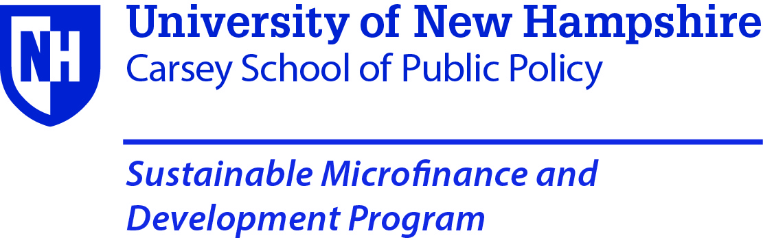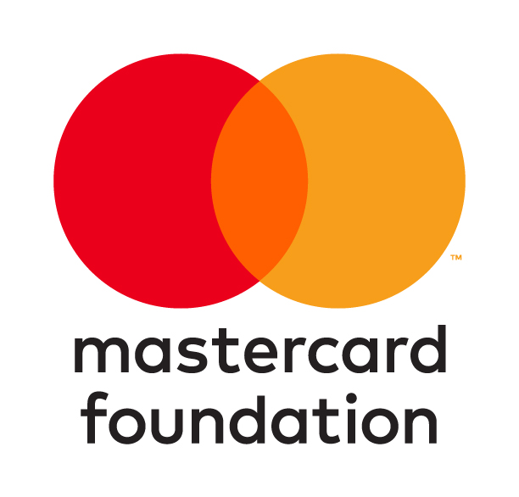
The Mastercard Foundation Scholarship Application for:
Sustainable Microfinance and Development Programme 2019 – Pietermaritzburg, South Africa
Monday August 26 – September 6, 2019
Scholarship application deadline:
Friday July 19th, 2019
No applications received after this date will be considered and the selected candidates will be notified no later than Wednesday 31st July 2019
Email completed application to: smdpsa2019@gmail.com

Selection Preferences:
You may apply for a Mastercard Foundation Scholarship only if you meet most of our Selection Preferences (listed below), which are the sole determinant of selection. Please read these carefully before you complete this form.
Preferences are for practitioners who work in Africa and who:
- work for institutions that have a demonstrated commitment to the economic and social well-being of women who are from disadvantaged backgrounds, preferably from rural and resource-poor areas
- are female practitioners
- have at least two years of experience in the Microfinance development field
- are of a sufficient educational level to take advantage of the programme(s)
- work for institutions whose programmes have a strong savings and credit focus and are
currently involved in, or planning to begin, savings groups programming
- have NOT previously received a scholarship award for our programmes.
- make a non-refundable financial contribution to tuition, room and board (mandatory) by the 5th August2019. Those who cannot make this contribution will not be accepted and failure to make payment on time will lead automatically to the loss of the scholarship. Do NOT apply unless you are 100% sure that you, or your organisation, can meet this commitment. There will be no exceptions
Note: If you do not meet most of these preferences and criteria, you should NOT apply for the scholarship and instead complete the regular registration form that can be found on our website: https://carsey.unh.edu/smdp/South Africa
Selection Criteria:
Scholarship awards will be based on the following considerations:
- How well does the applicant meet the selection preferences listed above?
- Based on the candidate’s stated background profile, how will the scholarship make a positive impact on their target group, their personal professional development and to their organization?

If you feel you meet the criteria described above, read this application in full and make sure that you understand how it will be processed. Complete this application in its entirety and send via e-mail to smdpsa2019@gmail.com

1 Biodata
- Prefix (Ms. Mrs., etc.):
- First Name:
- Last Name:
- Name to be printed on certificate:
- Job Title:
- Company/Organization:
- Email address
- Postal address Line 1:
- Postal address Line 2:
- City:
- Country:
- Home/Cell Phone (include national ‘phone prefix):
- Work Phone (include national ‘phone prefix):
- Country Passport Issued From:
- Passport Number:
- Emergency Contact Name:
- Emergency contact Phone:

- Direct Supervisor Name
- Direct Supervisor Title
- Direct Supervisor Email
- Direct Supervisor Phone
- Direct Supervisor Mobile

2 You and your institution
- Have you received a Mastercard Foundation scholarship from the Carsey School to attend a programme in the past?
Yes: No:
If Yes, please state name and year of the programme:

- Describe the target group your organization mainly focuses on. If you have a specific emphasis on working with women and girls, please describe this. 100 words maximum

- Please describe your current position and previous experience stating your educational and professional background. Also include your past and current employment in the Microenterprise/microfinance development field. 100 words maximum

- What are the main activities of the institution you work for? 50 words maximum

- What is the size of the institution you work for?
  - Total number of beneficiaries/members/clients across all projects
  - Number of savers
  - Number of borrowers

- What is the geographic area you work in?
  - Country
  - Region/Province (within the country)

- Is your organization involved with policy issues with government? If so, what are these? 50 words maximum

- What are your responsibilities in terms of 100 words maximum?
  - Programme design
  - Programme implementation
  - Programme evaluation

- Specifically, how will you apply what you expect to learn from the SMDP course or courses for which you are applying? 100 words maximum

- What is the name of the organization that will be sponsoring you by paying the 10% minimum contribution? If you will personally be paying, if selected, please say so

3 Scholarship Room/Board and Commuter options
A full scholarship includes all books, reading materials, USB, and field trips and Room/Board. Room and Board includes breakfast, lunch and dinner for six days for a one-week enrollment and 13 days for a two-week enrollment, coffee/tea breaks twice per day Monday through Friday and field visit transportation costs.
3.1 Course Selection
Please select the course or courses that you wish to attend by placing a large ‘X’ in the box or boxes on the left-hand side to indicate your choice(s). You may apply for one or both courses at the same time.
Before making course selections please refer to the course descriptions by clicking on the URL below
https://carsey.unh.edu/smdp/South Africa/courses

Select with an ‘X’ in the box below | WEEK ONE August 26th – August 30th 2019
 | Savings Groups: Programme Design and Implementation Management

Select with an ‘X’ in the box below | WEEK TWO September 2nd - September 6th
 | Savings Groups: The SAVIX Management Information System
4 Attestation
By submitting this application, I certify that I will be responsible for all travel expenses from my home city and country to Kigali South Africa and return and any other costs that exceed the tuition and room/board award I receive from the Mastercard Foundation. If I am selected and I do not transfer the 10% minimum contribution by Friday, the 2th of August 2019 I understand that my place will be given to another applicant and that the SMDP will not be responsible for any costs I may have incurred.
If I am not awarded a scholarship and still wish to attend the SMDP – South Africa I understand that I must complete a SMDP – South Africa registration form and pay the full fees by the 9th August 2019
Please type your initials below.

Yes ___________ No______________

Email completed application to: smdpsa2019@gmail.com

5 Payment information
Payment Information for 10% scholarship contributions by Friday 2th August 2019
Successful applicants must make a 10% contribution to the full costs of their courses as listed below, no later than Friday 2nd August 2019. Those who do not will not be accepted on the course(s). There will be no exceptions
- One-week enrollment Resident $250 Commuter $150
- Two weeks enrollment Resident $500 Commuter $300

Contribution amount you commit to paying (enter here) $_________________

Wire transfer
Transaction must be completed in U.S. Dollars
Be sure to include your name on the draft and send us an email letting us know that it has been processed. Please add a $25 fee to cover the cost of the transfer and other Bank charges.
Account information:
Name: VSL Associates Ltd.
Account Number: 0168161
Bank Name: Deutsche Bank
IBAN: DE70 3427 0024 0016 8161 22
BIC (Swiftcode) DEUTDEDB342

Please contact VSL Associates on smdpsa2019@gmail.com or telephone +49 176 72483304 or +49 212 818305 if these instructions are not clear
Credit Card:

If you wish to pay by credit card, contact the SMDP office at william.maddocks@unh.edu or call +1 508-574-3285 and we can take your card information over the phone. There is a 2% processing fee for all payments made through a credit card. DO NOT EMAIL CREDIT CARD INFORMATION
Note: No cash payments will be accepted at the programme.

6 Visas for South Africa
Visas on arrival are available for visitors from most countries, but where possible these should be obtained before travel. No visas are required for citizens of most East African and some West African countries. See the map at
https://en.wikipedia.org/wiki/Visa_requirements_for_South_African_citizens

Email completed application to: smdpsa2019@gmail.com

