SuperSalon
Install Manual- Draft

2008

Copyright © 2008 Rogers Software Development Inc
1292 Sadler Way, Suite 335
Fairbanks, AK 99701
For support call 888.458.1001
Email support@rogerspos.com


______________________________________________________________________________
Sales & Management Software for the Salon & Spa Industry

SuperSalon

Install Manual

SuperSalon Install Manual

Phone: 888-458-1001:
For Support Press 1/For Paper & Hardware Orders Press 2/For Sales Press 3
For Accounting Press 4/For Directory Press 5/For Fax, Email & Postal Address Press 6
Email: sales@rogerspos.com/support@rogerspos.com
SuperSalon & Rogers POS ©Copyright Rogers Software Development Inc., 2003-2008

ROGERS SOFTWARE DEVELOPMENT INC.
SuperSalon v 5.x
Install Manual

Copyright © 2008 Rogers Software Development Inc.
1292 Sadler Way, Suite 335
Fairbanks, AK 99701

The information in this document is subject to change without notice and does not represent a commitment on the part of Rogers Software Development Inc. This software may only be used or copied in accordance with the terms of the software license agreement. It is against the law to copy the software through any means except as specifically allowed in the software license agreement. No part of this document may be reproduced or transmitted in any form or by any means, electronic or mechanical, including photocopying and recording for any purpose without the express written consent of Rogers Software Development Inc.

Table of Contents
Section 1 – Introduction 1
SuperSalon Point of Sale System 1
Section 2 – Setup 2
Slave/Master 2
Kiosk Setup 3
Configuring Static IP Addresses 5
Complete Setup on Brand New Computer 9
Zebra Label Printers 12
Section 3 – Data Import 14
Mize Conversion Process 14
Guest Vision Conversion Process 18
Section 4 – Network/Remote Access 19
Broadband Setup Process 19
Port Forwarding/Backdoor Setup/VNC Setup 21
Logmein Setup 22
Section 5 – PCCharge Installation and Setup 25
Payment Processor 25
PC Charge Serial Numbers 42
PC Charge FAQ 43
Section 6 – Setting Up Gift Cards/Types 58
Creating an SVS Payment Method 58
Creating an SVS Payment Method 59
Setting Up SVS Gift Card Integration 60
Entering SVS Settings 61
Section 7 – Miscellaneous 63
Subject 1 63
Section 8 – FAQs/Troubleshooting 64
Peripheral Issues 64
Software Issues 68
Section 9 – Checklists 72
Subject 1 72
Help 73
Software License Agreement 74

Section 1 – Introduction
SuperSalon Point of Sale System
This manual is intended to be used to help with various SuperSalon installations and setups. Please feel free to contact us if further help is needed.
- Technical Support is available Monday through Friday 6 am to 9:30 pm PST, Saturday 6 am to 7 pm PST, Sunday 7 am to 7 pm.
- Voice: 907-458-1001 or 888-458-1001
- Support Fax: 907-374-0977
- Email: support@rogerspos.com
Internet: http://www.supersalon.com
Thank you,
The SuperSalon Team

Section 2 – Setup

Slave/Master
- Make sure the system power is off and unplug the system
- By default, most drives usually come with their jumpers in the master position. Each drive manufacturer has its own jumper configuration, so check the documentation to see how to set up the jumpers. Some drives have this information on the drive itself. Move the jumpers by pulling them out with pliers or tweezers.
- Note: To avoid electrostatic discharge, ground yourself when working inside the computer, by touching something metal or wear an electrostatic bracelet. Also, do not touch the circuitry on the drives.
- If you are putting the second drive on the same connector as the original drive, see if the cable has an additional plug so the two drives can both plug into it and the motherboard. If it doesn’t have an additional plug, replace the cable with one that came with the new drive or plug the new drive into the second connector. (Trace the first drive back to where it plugs into the PC, the second connector should be near). In most cases the red edge on the cable should line up with the #1 pin on the drive.
- Attach the drive to the PC’s power supply. You may need to purchase a Y splitter, if there are no available power cables.
- Put the drive in an available drive bay and secure it.

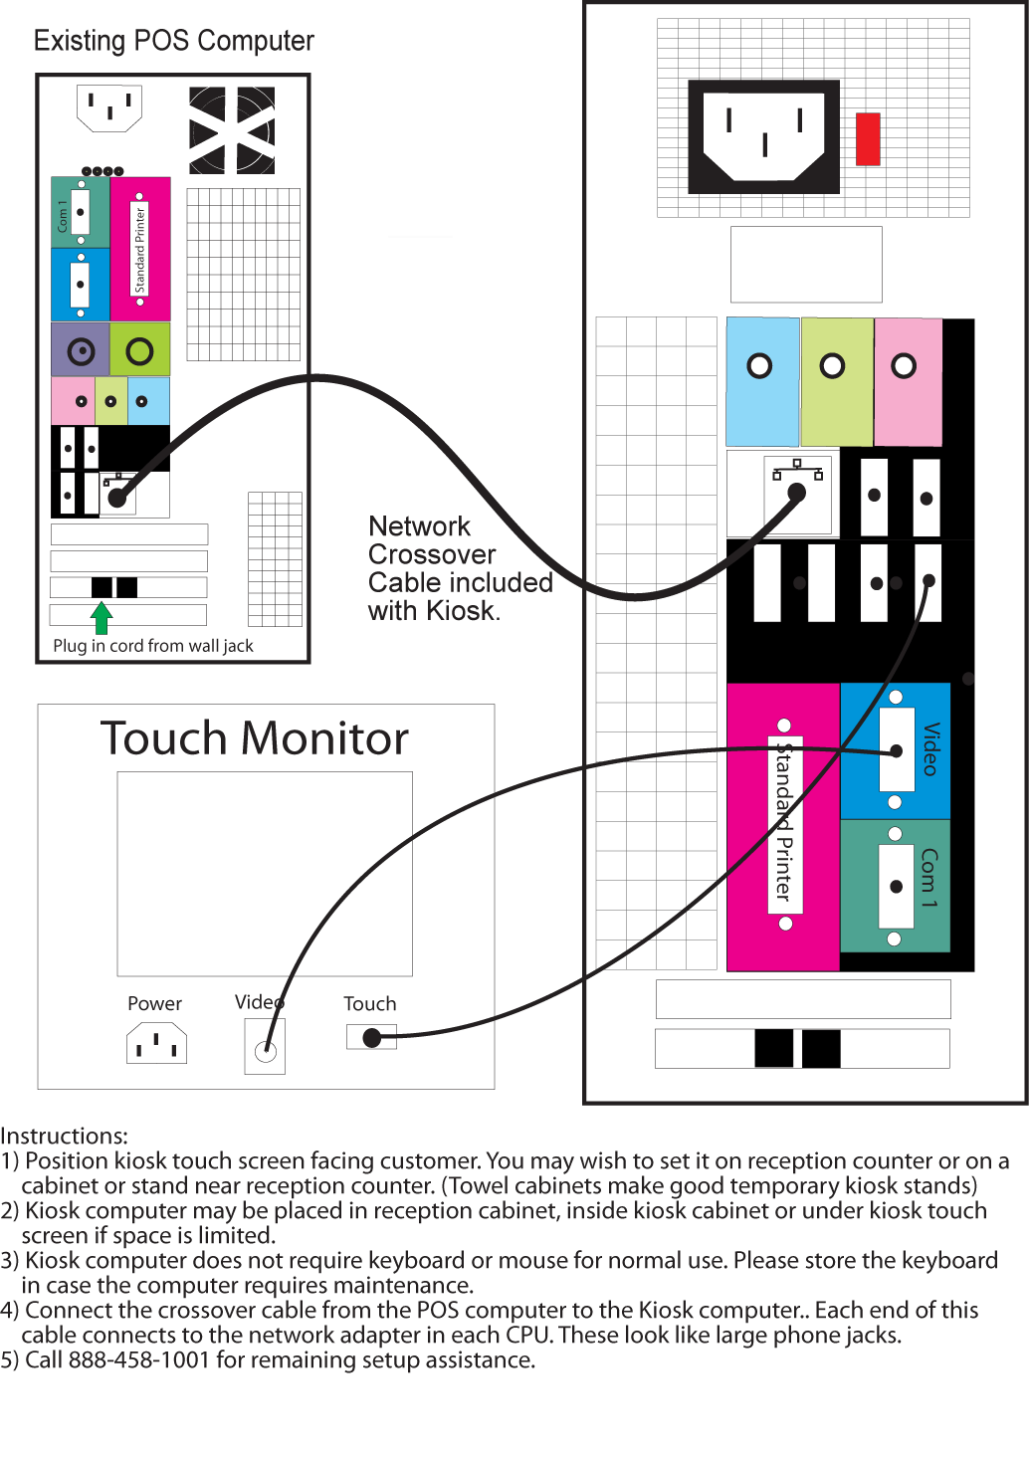
Kiosk Setup

To view the Kiosk, set the address to http://localhost/app/?controller=scheckin
There are two ways to enter the setup screen
- In SuperSalon go to Setup tab>Software Settings>Kiosk>Launch Kiosk Configuration
- Navigate to http://localhost/app/index.php?controller=scheckin&action=configuration

Configuring Static IP Addresses
- Go to Start>Control Panel
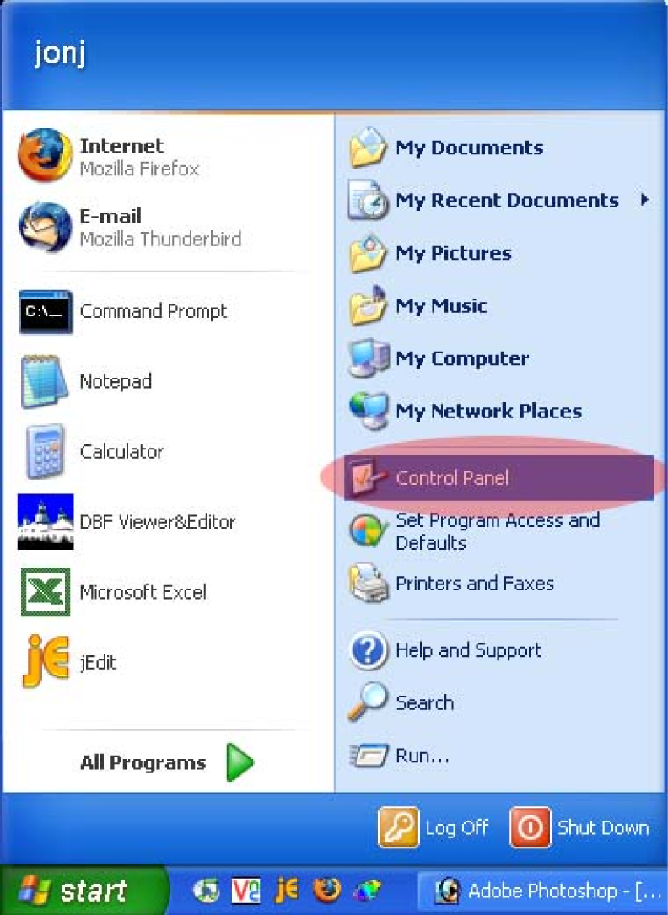
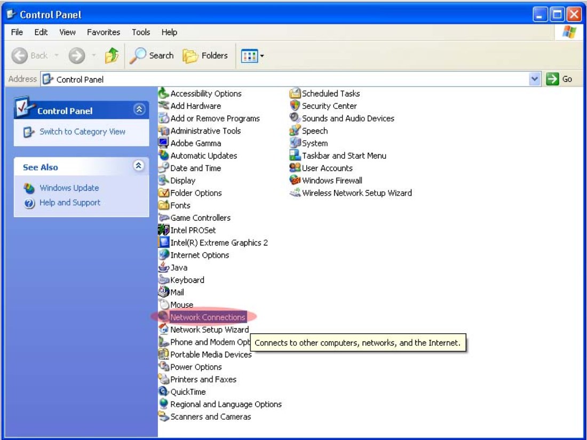
- Click on the Network Connections link
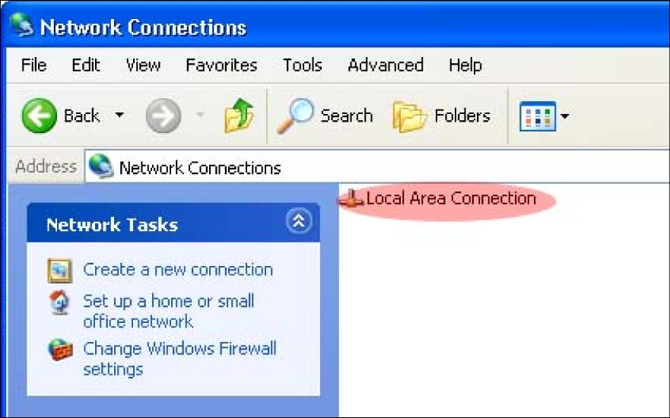
- You should see a Local Area Connections link

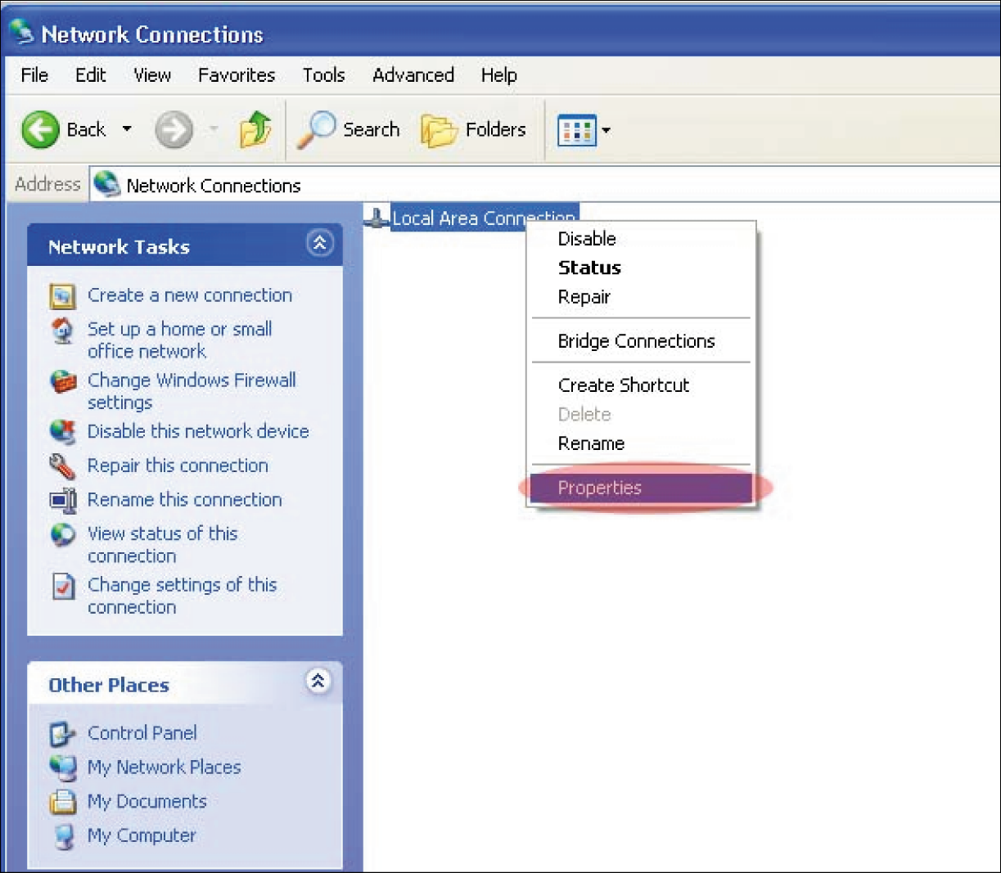
- Right click the link and select “Properties”

- You should see a connection properties box
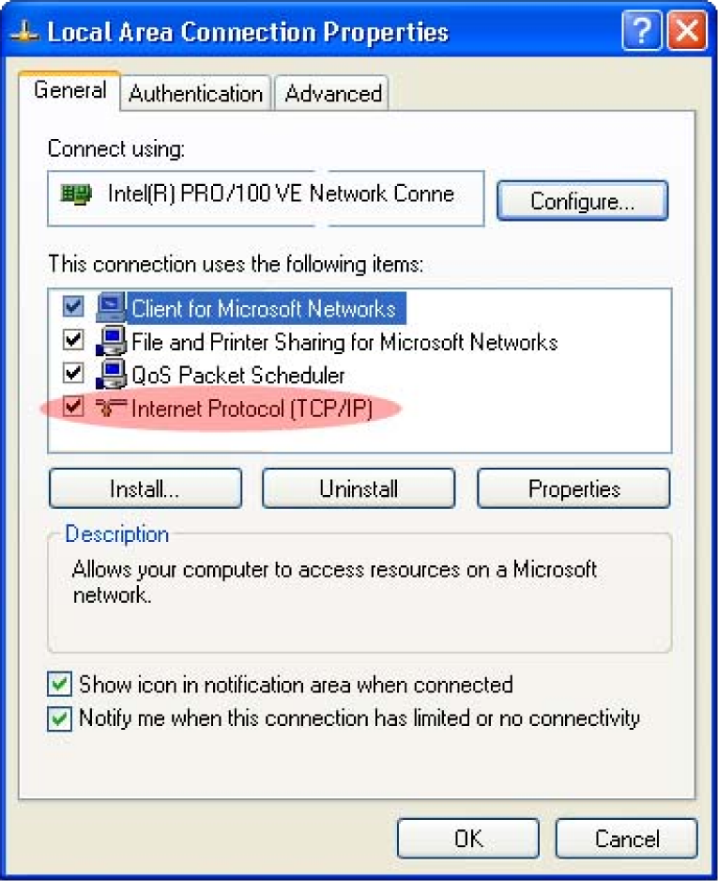
- Double click “Internet Protocol”

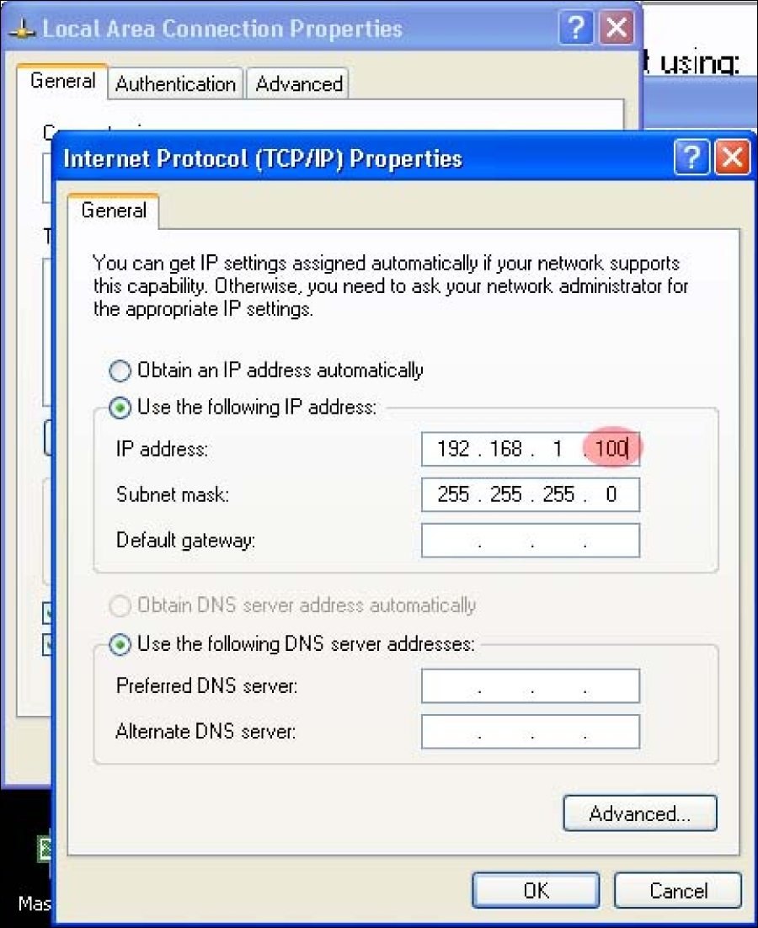
- At this point you should see windows similar to below

- Select “Use the following IP address”
- Input the numbers you see in the image for the “IP address” and “Subnet mask”
  - Note: The portion of the image highlighted in red needs to be a unique number for each system. This number should be between 100 and 200
- Once the information is input, click “Ok” on all of the open windows
- After you perform this task on both systems, they should be able to communicate with each other over a network

Complete Setup on Brand New Computer
Boot Process and Windows Setup
- Boot Process: Press any key until you get to your Windows screen
  - Follow through each screen
- Computer name – Name of Salon you are working with
  - Who will be using the computer? Salon
- Turn OFF Windows Firewall (Do not connect to the Internet until SuperSalon Firewall is installed
  - Control panel – Change to “Classic View”
  - Task Bar – Change to “Classic View”
  - Security Center – Firewall OFF
  - Change the way Security Center Alerts me Unclick Check Marks
  - Turn off automatic updates
  - Check time & date
- Right click on the bottom Tool Bar
  - Properties
  - Check all but “Quick Launch”
  - Classic View
  - Screen Resolution: Version3x 800x600/Version 4x and higher 1024x768
- Power Settings
  - Turn off monitor – After 2 hours
  - Hard Disk – Never
  - System Standby – Never
  - Hibernates – Never
- Delete games – Right click on games and delete
- Install ELO Touch Screen – Check USB port
  - Calibrate touch screen
  - Change mode tab – Click on touch

Install SuperSalon
- Always install the full version
- Components to install
  - SuperSalon and SS Extras
- Completing SuperSalon setup wizard
  - Unclick Run SuperSalon
Browser Settings
- Turn off Status Bar
  - View>Status Bar
- Turn off Bookmarks Toolbar
  - View>Toolbars>Bookmarks Toolbar
- Hide Navigation Toolbar (Address Bar)
  - View>Toolbars>Navigation Toolbar
SuperSalon Setup
- Create salon database in back-office
- Perform initial setup Admin Site
  - Go to the account, on the right side press “Initial Setup”
  - Select the account that you wish to copy. This will begin the process of copying all the information into the new account you are working with.
- Setup database name in local machine
  - Setup>Internet Setup>Office Upload
    - Assigned Store Name
      - Enter database name (example: US_CAIN90210_BB3)
    - Upload Address
      - Upload.supersalon.com
- Register salon software with back office
  - Admin Site
    - Go to the account and then the store
    - Go to the registration link and follow the steps
  - In the POS go to Setup Tab>Owner Password
    - Click “Recover Password”
    - Copy the Software Key at the top
  - In the Admin site select tools
    - Paste Software Key into the “Software key” field
  - A Registration Key will be generated – copy this key into the POS side for password changes
  - Click the hyperlink for “Complete the Registration”
  - Set the Owner Password to “Cut” unless otherwise instructed
  - Registration is complete
Update to current version
- Admin Site
  - Find the account and then the store
  - Navigate to “Update to Version” dropdown box and select the right version
  - Select the “Update store” button to save
- Perform an Upload on the POS computer
  - Manager Tab>Upload
- Version Is updated

Zebra Label Printers
Setup for Zebra 2824 USB
Zebra printer’s Windows Installation
- Install the drivers from the disk (Preferred) or download file by running the setup file (Located at ftp://rsdsuppo@rsdsupport.net/Beauty_First/06.Documentation/ZebraPrinterInfo/ZebraDriver.zip (Contact RSD support for password)
- The printer is the ZebraEPL LP2824
- Label size should be 1.2 x .85
- Make sure you select USB as the port during installation
- Everything else is default
- When finished copy the files onto the computer from the disk for later tech support troubleshooting. These are also available on the FTP link above.
Sharing the Zebra Printer
- To use the Zebra printer you must share the printer: In windows go to Start>Settings>Printers and Faxes
- Right click on the Zebra printer icon and select “sharing…” from the context menu
- This will take you to the Share tab of the Zebra Properties window. Select “Share this Printer”, Set the printer share name to “ZebraLP2”
Setting the Zebra Printer Port in the Properties Window
- In the Zebra printer Properties window, click on the Port tab.
- Select USB Port as your Option. Make sure the Zebra printer name is listed. This ensures your driver is installed properly. If no name is listed, reinstall. (See above for installation instructions)
- To send communication to the Zebra printer, click on the printer tab. Click Advanced. Click Tools.
- In the field named “Direct Command for Printer“ type “^default command” without quotes. Then click send.

Placing .bat File in Startup Folder
- Download the following .bat file and place into the C:/Supersalon directory. ftp://rsdsuppo@rsdsupport.net/Beauty_First/06.Documentation/ZebraPrinterInfo/zebraprinter.bat (Contact RSD support for password)
- Create a shortcut to this file and place the shortcut in the startup folder
Aligning the Labels and Printing a Test Page
- Load the labels according the manual or Quick reference guide ftp://rsdsuppo@rsdsupport.net/Beauty_First/06.Documentation/ZebraPrinterInfo/Zebra_LP2824_Quick_Reference_Guide.pdf
ftp://rsdsuppo@rsdsupport.net/Beauty_First/06.Documentation/ZebraPrinterInfo/Zebra_LP2824_Users_Guide.pdf (Contact RSD support for password)
- Turn printer off. Hold down the feed button. Turn the printer back on while holding the feed button. When the light blinks, let go of the feed button. This will print some words onto the labels.
- Press the feed button once more. This should print one more word and center the label.
- In windows, go to Start>Settings>Printers and Faxes. Right click on the Zebra icon and go to properties
- Click on the General tab
- Click “Print Test Page”, this sends a test page to the printer. The printer is now ready to print
SuperSalon Configuration
- Go to Setup>Label Printer
- Change the printer to the proper port (LPT1 if you used the USB configuration)
- In the command window enter “^@”. This will change the way the test button works. When you press test, it should make the power button blink on the printer if there is a proper connection.

Section 3 – Data Import

Mize Conversion Process
Information That Gets Imported from Mize ABE to SuperSalon
- Sales and transaction history
- Customer history
- Customer perm, color, and cut records
- ABE customer points
- Employees and timecards
Update the system you are working with to the most recent version of SuperSalon Update to current versionAsk the customer if there is another store owned by them they would like to bring SuperSalon data over from. If yes, you will need to perform an initial setup in the Admin site. Any data brought over from an initial setup will only be overwritten by the import if it is data the import brings in. If that data is not converted by the import, the system will not overwrite what was initially in the system. An example of this would be Commission plans, pay periods, or permissions.
Update the system to the “Import-Utilities” patch. Restart apache after using this patch.
- From the Command line
  - Net stop apache
  - Net start apache

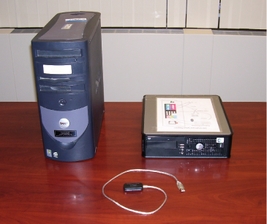
Retrieving data
Mize Abe directories from the original system need to be placed somewhere on the machine you are working with. It is suggested to use a flash USB thumb drive or an IDE to USB converter tool.
Figure 1 – Old system, new system and IDE to USB converter
Removing the Old Hard Drive
- Make sure the old system is disconnected from the power source
- Remove the PC’s cover and locate the hard drive
- Disconnect the power cable and IDE cable from the hard drive
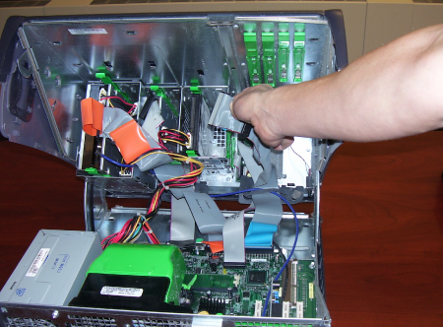
- Remove the hard drive from the computer. Some hard drives have fixing screws on each side of the hard drive that must be removed first
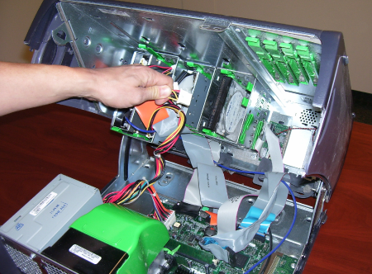
Hard drive
Power cable
IDE cable
Figure 2 - Power cable and hard drive
Figure 3 - IDE cable

Using an IDE to USB Converter Tool
- Connect the IDE adapter to the old hard drive
- Connect the power to the old hard drive
- Connect the adapter’s USB plug to the new PC’s USB socket
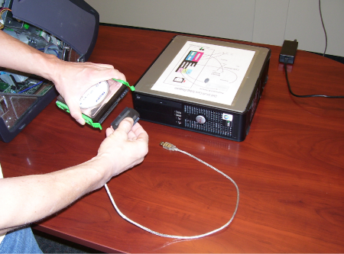
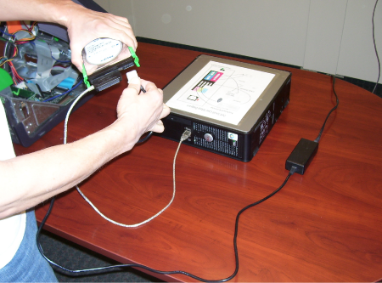
- Ensure the adapter is plugged into an electrical outlet
Figure 4 – Connect the IDE adapter
Figure 5 – Connect the power
Copy Files
- Copy the Abesta, Abesys, and Menu directories from the root directory of the old hard drive to the root directory of the new computer
- Disconnect the adapter
SuperSalon Data Import
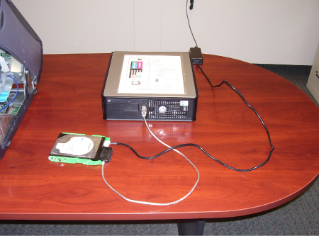
- Navigate to SuperSalon Setup Tab>Utilities>Import Data
Figure 6 – Connect to USB socket
  - Select Mize from the “Select Import” drop down list
  - In the “Import data from field” enter the path to the Abesys folder you copied from the original system
  - Select “Clear existing SuperSalon data”
  - Select “Setup Import Files”
  - Select the “Run Import” button
    - This process can take several minutes before you see any activity
Checking the Data
- Check that customers exist in the system and have history
- Customers have perm and color records in the system
- Product, services, and discounts appear in the system correctly
- Tickets are in the system and have service product and payment items on the them
- Run some reports in the system to confirm the financial data looks appropriate for two years past
- Edit the payment methods imported to display correct text
- Delete any time clock positions imported by Mize that should appear on the time clock
Perform a Full Upload
- Note: Do nothing in the system while it is uploading
- After the full upload is complete, verify the back office data looks the same as the data on the store
- Do a standard upload and confirm nothing drastic happened to the data after it is complete
- Register the system and continue with general setup of the POS

Guest Vision Conversion Process
- Ensure SuperSalon in on the correct version and initial setups have been done, if needed
- Through the admin site, download the patch called GVImport
- After the download completes, open up the file C:\SuperSalon\PHP\php.ini
- Find the line below and remove the ”;”
  - ;extension=php_mssql.dll
    - Making it look like
      - extension=php_mssql.dll
- Open up a command prompt and type “cmd”
  - Start>Run> cmd
- Execute the following commands
  - Net stop apache
  - Net start apache
- In SuperSalon go to Setup>Utilities and select the Import Data button
  - Select Guest Vision from the drop down list
  - Leave the default option as is in the Import Data From field
  - Available options
    - Clear Existing SuperSalon Data
      - This will delete everything in the system prior to the import starting
    - Setup Import Files
      - This will create the CSV files
      - Uncheck this only if the import has timed out and you are trying again
  - Once options are set as desired, press the Run Import button

Section 4 – Network/Remote Access

Broadband Setup Process
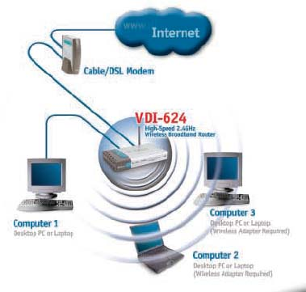
Most broadband setups involve two computers, a router, and a cable or DSL modem. Computers can be hardwired into the network or often they have wireless connectivity. Routers typically provide the computers plugged into it with the IP addresses automatically. Broadband Internet requires the VNC (Port 5900) and HTTP (Port 80) ports to be forwarded to the computer system so that we may still access it.
Figure 7 - Typical broadband setup
A typical broadband setup can look similar to the one below.
Step 1
- You will need to plug a cat5 cable from the computer systems ethernet adapter into one of the routers LAN Ethernet ports.
- Most ethernet cables are called patch or straight through cables. However, there is another type of cat5 cable called a crossover cable. Crossover cables are meant to hook two computers directly together. Patch or straight through cables are used for hooking routers and switches to computers.
- Note: Many routers and switches support the use of both types of cables. However, some of the older or cheaper models will use patch cables.
- Once all systems are plugged in, you will need to configure the router with the DSL setting of the users account.
- These settings are provided by the customers Internet service provider.
Step 2
- At this point you should confirm that the Internet connection is working.
- You will need to forward the VNC port and HTTP port from the router to their main SuperSalon system.
- After the Internet connection is working and VNC has been tested, the Internet setup is complete.

Port Forwarding/Backdoor Setup/VNC Setup
Check portforwarding.com for configuration information on specific routers.
To configure Bell South Routers
- The name of the program is Bell South FastAccess Internet Service
- The customer can access this address on their browser
  - For example http://192.1678.1.254/
  - This address will be for just that customer. You cannot pull it up on your browsers. Use their user name and password to access it. If the address is still listed in Internet Explorer, click on the drop down list in the address bar
- Click on Expert Mode on the left hand side
- Confirm by clicking “yes”, then enter
- Click “Configure” on the left hand side
- Click “NAT”
- Select VNC from the drop down list to enable it
- More information will be displayed

Logmein Setup
Step 1
- Go to http://www.logmein.com
- Once there, enter the email address and password of the account to which you want to add the computer or create a new account
- Type in the login information and click log me in
Step 2
Look for the link that reads “+Add Computer”
Add Computer link
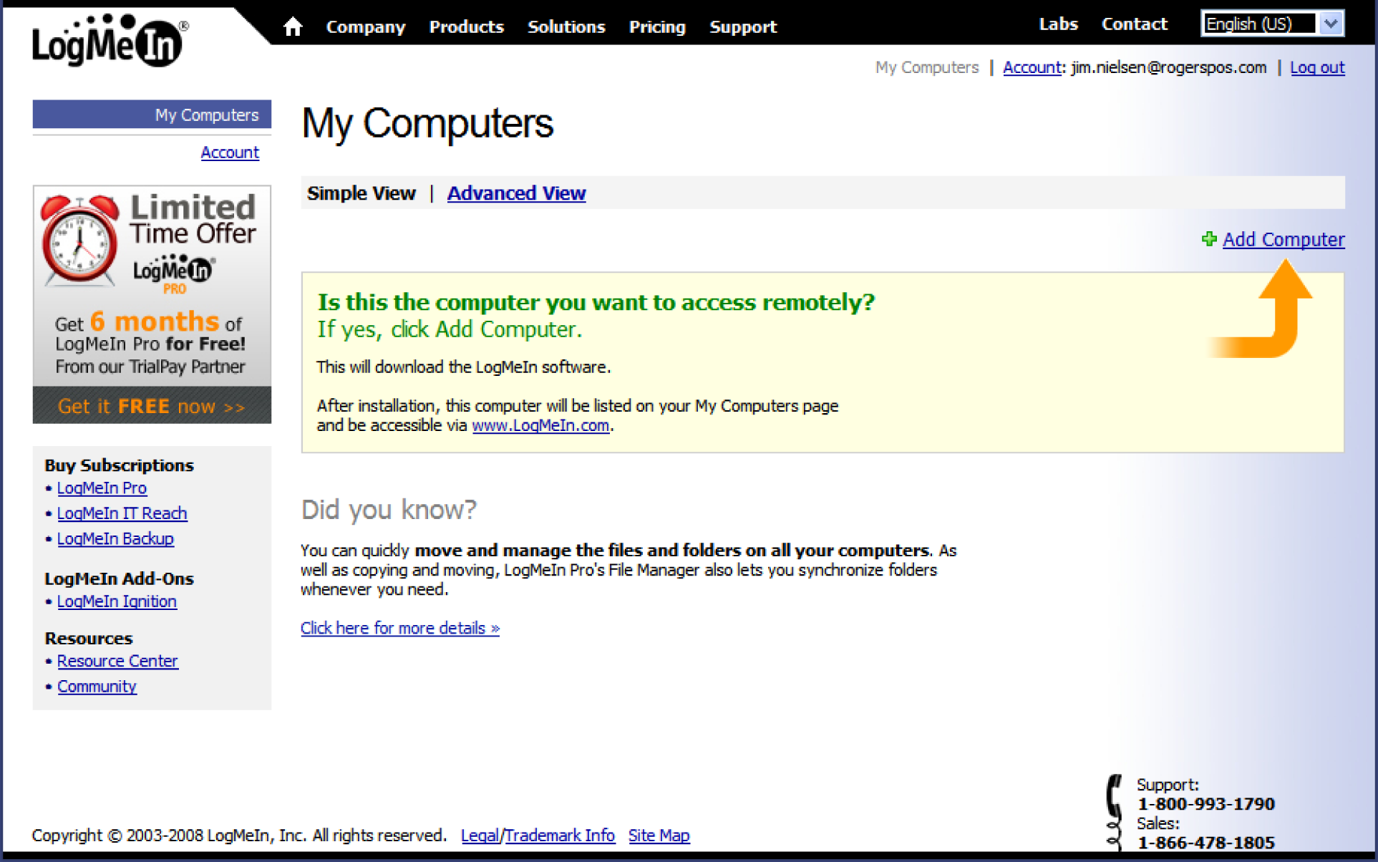
Figure 8 – Logmein add computer link

Step 3
The download process will start. You may or may not be prompted to run the utility, click run or install if asked.
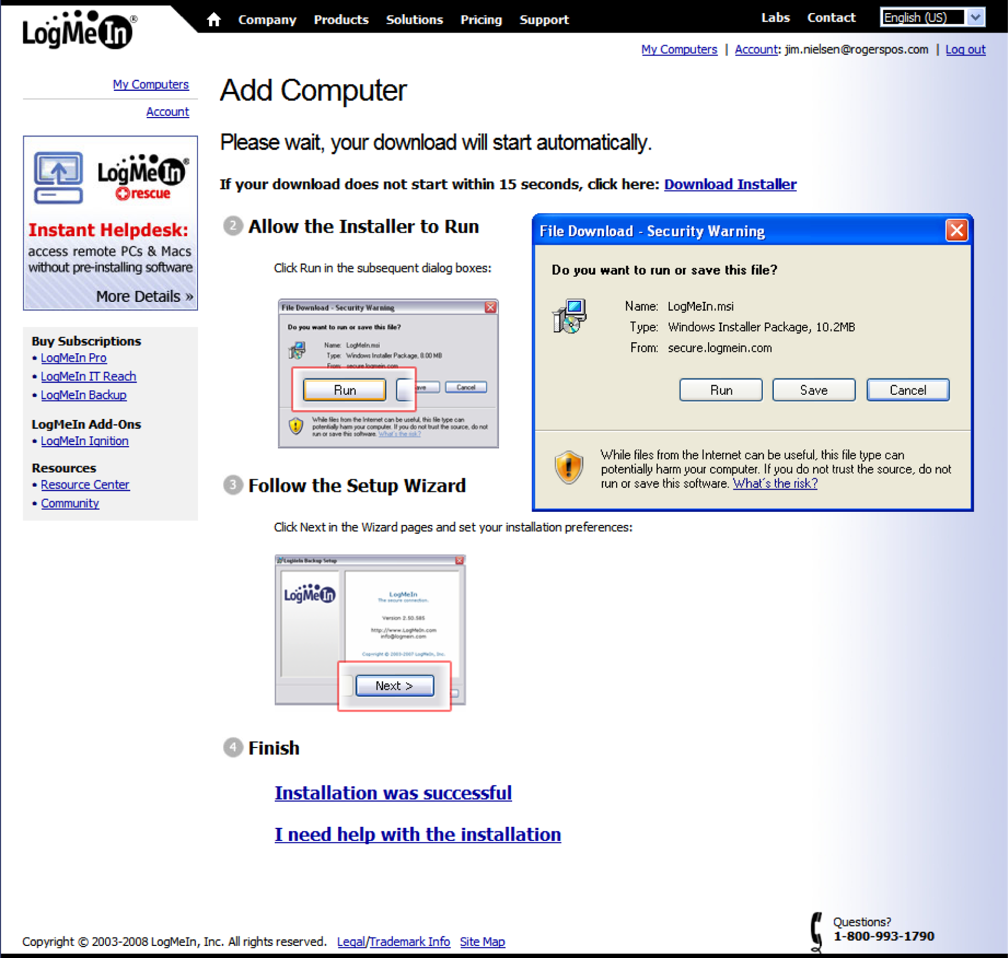
Figure 9 – Logmein installer

Step 4
Once the download has completed, the installation process will automatically begin.
- A Logmein title screen will appear, select Next
- Read the Terms of Agreement and click I Agree
- Under Software options, leave Typical selected and click “Next”
- Enter a brief description for the computer
- Click Next to install the program in the default folder
- Click Finish and log out of the Logmein web site
- The computer is now setup to be remotely accessed via www.logmein.com
  - To access the computer remotely go to www.logmein.com and log in using the email address an password you setup
  - On the My Computers page select the computer and you will be connected

Section 5 – PCCharge Installation and Setup

Payment Processor
Merchant Account Worksheet
To assist our customers in the setup of our PCCharge products, we’ve created this informational worksheet. Have a copy of this on-hand when you contact your credit card processor/merchant service provider to ensure that you have all the information required by PCCharge. We’ve included customer service numbers for the processing companies to aid you in obtaining your account information.
Alliance Data Systems, INC. – ADSI
ASDI Customer Service Number
- 972-348-5100
PCCharge Level 2 Support
- 866-261-1592
PCCharge Merchant Number
- 1-15-Character Merchant Number: _ _ _ _ _ _ _ _ _ _ _ _ _ _ _
PCCharge Extender Data
- 4-Digit Company Identifier: _ _ _ _
- 8-Digit Company Identifier: _ _ _ _ _ _ _ _
- 6-Digit Sequence Number: _ _ _ _ _ _

American Express—AMEX
AMEX customer service number
- 888-829-7302
- 800-222-3781
PCCharge Merchant Number
- 10-Digit Merchant (SE) Number: _ _ _ _ _ _ _ _ _ _
PCCharge Extended Data
- 2-Digit Terminal ID: 15
- 10-Digit Merchant (SE) Number: _ _ _ _ _ _ _ _ _ _
- 6-Digit Service ID (PCID): _ _ _ _ _ _
- User Name (PCID): _ _ _ _ _ _(Differs from FTP password
- System IP Address: 10.67.224.17
- System Port: 21
- Primary Authorization Phone Number: 1-800-874-0421
- Secondary Authorization Phone Number: 1-800-288-1022
AMEX FTP Account info
- FTP User Name: AMEXFESD
- FTP Password: golden1
- Settlement Phone Number 1-888-501-5232

Buypass, Inc. – BPAS
BPAS Customer Service Number
- 800-733-3322
- 800-238-7675
PCCharge Merchant Number
- 6-Digit Merchant Number: _ _ _ _ _ _
PCCharge Extended Data
- 3-Digit Currency Code (US = 840):_ _ _
- 3-Digit Device Number: _ _ _
- 2-Character Device Type: _ _
- 2-Digit State Code: _ _
If using TCP/IP EDSnet Lease Line or TCP/IP Pass Through connection
- Store ID: ________________
- Store Key: _________________

CardSystems (Formerly Maverick Processing Systems) – MVRK
MVRK Customer Service Number 800-704-4202
12-Digt merchant Number: _ _ _ _ _ _ _ _ _ _ _ _
PCCharge Extended Data
- 6-Digit BIN Number: _ _ _ _ _ _
- 4-Digit Store Number: _ _ _ _
- 4-Digit Terminal Number: _ _ _ _
- 6-Digit Chain Number: _ _ _ _ _ _
- 6-Digit Agent Number: _ _ _ _ _ _
- 3-Digit Currency Code (US = 840): _ _ _
- 3-Digit Country Code (US = 840): _ _ _
- 5-Digit City Code (Zip Code): _ _ _ _ _
- 2-Digit Language Code (US = 00): _ _
- 4-Digit Category Code (SIC, MCC): _ _ _ _
- 3-Digit Time Zone (Eastern = 705, Central = 706, Mountain = 707, Pacific = 708, Arizona = 707): _ _ _
If using TCP/IP Connection:
- DID:__________________________

Concord / EFS – CCRD
CCRD Customer Service Number
- 800-733-3322
- 800-238-7675
PCCharge Merchant Number
- 8-Digit Merchant Followed by 4-digit store number followed by 2-digit terminal
- ID:_ _ _ _ _ _ _ _
PCCharge Extended Data
If using TCP/IP connection
- Store ID: _________________
- Store Key: __________________

ECHO (formerly Electronic Clearing House ) – Echo
ECHO customer service number
- 800-233-0406
PCCharge Merchant number
- 10-Digit Terminal ID: _ _ _ _ _ _ _ _ _ _

FDMS Nashville /Envoy – FDCN
FDCN Customer Service Number
- 800-647-3722
PCCharge Merchant number
- 7-11-Digit Merchant Number Followed by 7-11-digit Terminal ID (NOTE YOU SOMETIMES NEED TO PUT 4 ZERO'S INFRONT OF THE MID AND 4 ZERO'S INFRONT OF THE TID, example: 08606066306930 to 0000086060600006306930) : _ _ _ _ _ _ _ _ _ _ _ _ _ _ _ _ _ _ _ _ _
PCCharge Extended Data
If using a TCP/IP connection
- Datawire ID: __________________________

FDMS North / CardNet (formerly Card Establishment Services) – CES
OUR TEST CREDIT CARDS DO NOT WORK WITH THIS PROCESSOR!!!!!!
CES Customer Service Number
- 800-346-3315
Better number, can assist in acquiring datawire ids
- 800-622-0482
PCCharge Merchant Number
- 12-Digit Merchant Number Followed by
- 6-Character Terminal ID: _ _ _ _ _ _ _ _ _ _ _ _ _ _ _ _ _ _
PCCharge Extended Data
- 6-Character Terminal ID: _ _ _ _ _ _
If using TCP/IP Connection:
- Datawire ID: _____________________

FDMS Omaha / FDR – FDC
FDC Customer Service Number
- 13-16-Digit Merchant Number: _ _ _ _ _ _ _ _ _ _ _ _ _ _ _ _
PCCharge Extended Data
- 4-Digit Device ID: _ _ _ _

FDMS South / NaBanco – NM
NM Customer Service Number
- 800-732-9195
PCCharge Merchant Number
- 9-10-Digit Merchant Number: _ _ _ _ _ _ _ _ _ _
PCCharge Extended Data
- 4-Digit Serial Number (authorization): _ _ _ _
- 9-10-Digit AMEX SE Number: _ _ _ _ _ _ _ _ _ _
- 10-Digit SE Discover Number: _ _ _ _ _ _ _ _ _ _
- 10-Digit JCB SE Number: _ _ _ _ _ _ _ _ _ _
- 10-Digit JAL SE Number: _ _ _ _ _ _ _ _ _ _
- 10-Digit Diners Club SE Number: _ _ _ _ _ _ _ _ _ _
- 10-Digit Carte Blanche SE Number: _ _ _ _ _ _ _ _ _ _
- 2-Digit Serial Number (Batch): _ _
- Qual Code: _______
- 2-Character State Code: _ _
- 3-Digit Country Code (US = 840 ): _ _ _
- 5-Digit ZIP Code: _ _ _ _ _
- 4-Digit Category Code: _ _ _ _
If using a First Data IPN Connection
- Datawire ID: ________________
- 2-Digit Serial Number (Same As Batch Serial Number)
If using TCP/IP Lease Line Connection:
- Primary Address: _______________________
- Port (For Primary Address):____
- Secondary Address: ______________________
- Port (For Secondary Address): ____

Fifth-Third Bank-St. Pete – BPS
FHAW Customer Service Number
- 8808-844-3172
PCCharge Merchant Data
- 4-Digit Bank ID: _ _ _ _
- 3-Digit Terminal ID: _ _ _
If using a TCP/IP Connection
- Primary Address: _______________________
- Port (For Primary Address): ____
- User Name: ____________
- Password: ____________

First Hawaiian – FHAW
FHAW Customer Service Number
- 808-844-3172
PCCharge Merchant Number
- 12-Digit Merchant Number: _ _ _ _ _ _ _ _ _ _ _ _
PCCharge Extended Data
- 7-11-Digit Primary (Batch Settlement Phone Number): _ (_ _ _) _ _ _ - _ _ _ _
- 7-11-Digit Secondary (Batch Settlement Phone Number): _ (_ _ _) _ _ _ - _ _ _ _
- Location Number: ___________
- 6-Digit Bin Number: _ _ _ _ _ _
- 4-Digit Store Number: _ _ _ _
- 4-Digit Terminal Number: _ _ _ _
- 6-Digit Chain Number: _ _ _ _ _ _
- 6-Digit Agent Number: _ _ _ _ _ _
- 3-Digit Currency Code (US = 840): _ _ _
- 3-Digit Country Code (US = 840): _ _ _
- 5-Digit City Code (Zip Code): _ _ _ _ _
- 2-Digit Language Code (US = 00): _ _
- 4-Digit Category Code (SIC, MCC): _ _ _ _
- 3-Digit Time Zone (Eastern = 705, Central = 706, Mountain = 707, Pacific = 708, Arizona = 707):_ _ _
- System Address: ___________________________
- System Port: _______

First Horizon (formerly First Tennessee Merchant Services) – FTMS
FTMS Customer Service Number
- 800-656-9405
- 800-333-8336
PCCharge Merchant Number
- 12-digit Merchant Number _ _ _ _ _ _ _ _ _ _ _ _
PCCharge Extended Data
- 7-11-Digit Primary (Batch Settlement Phone Number): _ (_ _ _) _ _ _ - _ _ _ _
- 7-11-Digit Secondary (Batch Settlement Phone Number): _ (_ _ _) _ _ _ - _ _ _ _
- Location Number: ___________
- 6-Digit Bin Number: _ _ _ _ _ _
- 4-Digit Store Number: _ _ _ _
- 4-Digit Terminal Number: _ _ _ _
- 6-Digit Chain Number: _ _ _ _ _ _
- 6-Digit Agent Number: _ _ _ _ _ _
- 3-Digit Currency Code (US = 840): _ _ _
- 3-Digit Country Code (US = 840): _ _ _
- 5-Digit City Code (Zip Code): _ _ _ _ _
- 2-Digit Language Code (US = 00): _ _
- 4-Digit Category Code (SIC, MCC): _ _ _ _
- 3-Digit Time Zone (Eastern = 705, Central = 706, Mountain = 707, Pacific = 708, Arizona = 707):_ _ _
If using a TCP/IP connection:
- System Address:__________________

Global Payments – Central (formerly MasterCard International) – MAPP
MAPP Customer Service Number
- 800-367-2638
PCCharge Merchant Number
- 1-15 – digit Merchant Number: _ _ _ _ _ _ _ _ _ _ _ _ _ _

Global Payments – East (formerly National Data Corporation) – NDC
NDC Customer Service Number
- 800-367-2638
PCCharge Merchant Number
- 1-15 – digit Merchant Number: _ _ _ _ _ _ _ _ _ _ _ _ _ _
PCCharge Extended Data
- 6-Digit Bank ID: _ _ _ _ _ _
- 3-Digit Merchant Type (SIC, Standard Industry Code): _ _ _

Lynk Systems, Inc. LYNK
Lynk Customer Service Number
- 800-859-5965
PCCharge Merchant Number
- 12-digit Merchant Number _ _ _ _ _ _ _ _ _ _ _ _
PCCharge Extended Data
- 7-11-Digit Primary (Batch Settlement Phone Number): _ (_ _ _) _ _ _ - _ _ _ _
- 7-11-Digit Secondary (Batch Settlement Phone Number): _ (_ _ _) _ _ _ - _ _ _ _
- Location Number: ___________
- 6-Digit Bin Number: _ _ _ _ _ _
- 4-Digit Store Number: _ _ _ _
- 4-Digit Terminal Number: _ _ _ _
- 6-Digit Chain Number: _ _ _ _ _ _
- 6-Digit Agent Number: _ _ _ _ _ _
- 3-Digit Currency Code (US = 840): _ _ _
- 3-Digit Country Code (US = 840): _ _ _
- 5-Digit City Code (Zip Code): _ _ _ _ _
- 2-Digit Language Code (US = 00): _ _
- 4-Digit Category Code (SIC, MCC): _ _ _ _
- 3-Digit Time Zone (Eastern = 705, Central = 706, Mountain = 707, Pacific = 708, Arizona = 707):_ _ _
If using a TCP/IP connection:
- System Address:__________________
- System Port:________________

Nova (formerly Nova Information Systems) – NOVA
Nova Customer Service Number
- 1-800-725-1243
PCCharge Merchant Number
- 3-16 -digit Terminal ID _ _ _ _ _ _ _ _ _ _ _ _ _ _ _ _ _
PCCharge Extended Data
- 6-Digit Bank Number: _ _ _ _ _ _

NPC (formerly National Processing Company) – NPC
NPC Customer Service Number
- 800-928-2583
PCCharge Merchant Number
- 12-digit Merchant Number _ _ _ _ _ _ _ _ _ _ _ _
PCCharge Extended Data
- 6-Digit Bin Number: _ _ _ _ _ _
- 4-Digit Store Number: _ _ _ _
- 4-Digit Terminal Number: _ _ _ _
- 6-Digit Chain Number: _ _ _ _ _ _
- 6-Digit Agent Number: _ _ _ _ _ _
- 3-Digit Currency Code (US = 840): _ _ _
- 3-Digit Country Code (US = 840): _ _ _
- 5-Digit City Code (Zip Code): _ _ _ _ _
- 2-Digit Language Code (US = 00): _ _
- 4-Digit Category Code (SIC, MCC): _ _ _ _
- 3-Digit Time Zone (Eastern = 705, Central = 706, Mountain = 707, Pacific = 708, Arizona = 707):_ _ _
- 7-11-Digit Primary (Batch Settlement Phone Number): _ (_ _ _) _ _ _ - _ _ _ _
- 7-11-Digit Secondary (Batch Settlement Phone Number): _ (_ _ _) _ _ _ - _ _ _ _
- Terminal ID: ___________

Paymentech (Formerly Gensar, Transnet) – GSAR
GSAR Customer Service Number
- 800-254-9556
PCCharge Merchant Number
- 12-Digit Merchant Number followed by 3-digit terminal: _ _ _ _ _ _ _ _ _ _ _ _
PCCharge Extended Data
- 4-Digit Client Number: _ _ _ _
If using a TCP/IP Connection:
- Primary Address: _______________________
- Port (For Primary Address): ____
- User Name: ____________
- Password: ____________
If using a TCP/IP Lease Line Connecting
- Primary Authorization Address: ____________________________________
- Port (For Primary Authorization Address: _______
- Secondary Authorization Address: __________________________________
- Port (For Secondary Authorization Address: _______
- Primary Settlement Address: ______________________
- Port (For Primary Settlement Address): _______
- Secondary Settlement Address: _____________________________________
- Port (For Secondary Settlement Address): _______

Royal Bank of Canada – RBOC
RBOC Customer Service number
- 800-268-8644
PCCharge Merchant Number
- 13-Digit Merchant Number: _ _ _ _ _ _ _ _ _ _ _ _ _
PCCharge Extended Data
- 8-Digit ECR Number: _ _ _ _ _ _ _ _

TSYS Acquiring Solutions (Formerly Vital Visa, before that; VisaNet) – VISA
Terminal processing unless otherwise stated
Visa Customer Service Number
- 800-847-2737
PCCharge Merchant Number
- 12-Digit Merchant Number: _ _ _ _ _ _ _ _ _ _ _ _ _ _ _
PCCharge Extended Data
- 7-11-Digit Primary (Batch settlement phone number): _ ( _ _ _ ) _ _ _ - _ _ _ _
- 7-11-Digit Secondary (Batch settlement phone number): _ ( _ _ _ ) _ _ _ - _ _ _ _
- Location Number: ____________
- 6-Digit BIN Number: _ _ _ _ _ _
- 4-Digit Store Number: _ _ _ _
- 4-Digit Terminal Number: _ _ _ _
- 6-Digit Chain Number: _ _ _ _ _ _
- 6-Digit Agent Number: _ _ _ _ _ _
- 3-Digit Currency Code (US = 840): _ _ _
- 3-Digit Country code ( US = 840): _ _ _
- 5-Digit City Code (ZIP Code): _ _ _ _ _
- 2-Digit Language Code (US = 00): _ _
- 4-Digit Category Code (SIC, MCC): _ _ _ _
- 3-Digit Time Zone (Eastern= 705, Central= 706, Mountain=707, Pacific= 708, Arizona=707):_ _ _
If using TCP/IP Connection
- System Address: _______________________
e.g. ssl.pgs.wcom.net/scripts/gateway.dll?transact Port: 443

PC Charge Serial Numbers
Please contact RSD Technical Support for PC Charge Serial Numbers
- Technical Support available Monday through Friday 6 am to 9:30 pm PST, Saturday 6 am to 7 pm PST, Sunday 7 am to 7 pm.
- Voice: 907-458-1001 or 888-458-1001
- Support Fax: 907-374-0977
- Email: support@rogerspos.com

PC Charge FAQ
- What should I do if I keep getting an error during a transaction?
- Which versions of PCCharge products are currently supported?
- Is there a charge for changing a merchant number?
- What should I know about modems?
- What should I do if I keep getting a result of Not Captured Connect Failure, No answer, or No dial tone?
- How do I edit my company's information in PCCharge?
- How do I check to see what transactions are currently authorized?
- I have a new computer. How do I move my PCCharge data over to the new computer?
- How can I make sure PCCharge is operating at top performance?
- What is the difference between PCCharge Pro and PCCharge Payment Server?
- What is the difference between PCCharge Pro and PCCharge Express?
- Will PCCharge Pro work with "xyz company's" software?
- Can VeriFone's PCCharge brand products be upgraded?
- Will I need to use a credit card terminal in conjunction with your software?
- What are the system requirements for VeriFone's PCCharge branded products?
- What should I do if I keep getting a result of INVALID TERMINAL ID?
- How do I know who my credit card processing company is?
- I can process Visa and MasterCard transactions, but I cannot process American Express or Discover cards?
- How do I change my PCCharge password?
- How do I make/edit a configuration disk?
- Why is my printer not printing receipts?
- Why can't I see the whole credit card number in my reports?
- How can I stop PCCharge from asking me if I want add a ticket number or address verification information when I process transactions?
- How can I process several transactions at once, or as a batch?
- What kind of encryption does PCCharge use when processing TCP/IP (Internet) transactions?
- How should I enter my company name in the Company Information window? Is the field case-sensitive?
- Can I run PCCharge in a Terminal Service environment?
- Can I run PCCharge through PC Anywhere or over a VPN?

- What should I do if I keep getting an error during a transaction?
  - Try restarting your computer and trying the transaction again
  - From the PCCharge Utilities menu, try running the Repair command and then the Compact command
  - Read through the PCCharge manual and help files thoroughly. Many problems can be solved by applying the information in the manual and the help files (The help files can be accessed from the Help | Contents menu in PCCharge.)
  - If you are having modem connection problems, please make sure that communications programs such as HyperTerminal or Dial-Up Networking are able to access your modem properly. Also, make sure that no communications or fax programs are running while trying to process transactions.
  - If these steps do not solve your problem, please contact technical support To maximize the effectiveness of your contact with technical support representatives, we ask that you have the following information included in your email or ready when you call:
    - Version of PCCharge you are using (select Help | About from PCCharge.)
    - Your credit card processing company and/or Merchant Service Provider.
    - Your merchant information (Terminal ID, Merchant ID, extended data, etc.)
    - Brand, model, and speed of the modem you are using.
    - Information on any 3rd party POS software (when applicable.)
    - The type of error you are getting:
      - Installation error
      - Modem/dialing problem
      - GPF (General Protection Fault) - please note the information that is displayed when the error occurs
    - If possible, step through the transaction and document the step that is causing the error.

- Which versions of PCCharge products are currently supported?
  - Annual support is available for versions 4.0 and later.
  - NOTICE: We will no longer be supporting versions of PCCharge earlier than 4.0. Versions earlier than 4.0 are legacy products, and were programmed prior to the advent of today's operating systems.

- Is there a charge for changing a merchant number?
  - There is no charge, provided that the customer has an active support contract. The merchant number is changed by means of a certain file that is emailed to the customer.

- What should I know about modems?
  - Your computer system must include a Hayes or compatible 300, 1200, or 2400 baud modem. The modem can be connected to either serial port 1, 2, 3, 4 (COM 1 - COM 4) of your system and must be connected to a standard analog phone jack.
  - VeriFone suggests that customers avoid "Win-modems" if at all possible. Win-modems are popular because of their low price, high speeds, and advanced compression techniques (which makes them ideal for connecting to the Internet.) Unfortunately, most Win-modems are incapable of non-compressed data transfer and the 300/1200 baud speeds that most financial networks require. Check with your modem manufacturer to see if your modem is capable of running without compression and can operate at these low speeds.
  - VeriFone has found that the following external non-Win-modems work well with most financial networks:
    - 3Com US Robotics 56k Faxmodem
    - Zoom 56k (older chipsets only)
  - VeriFone has found that the following internal non-Win-modem works well with most financial networks (but not in a Windows 2000 environment):
    - Actiontec PCI Pro (Model PC156019)
  - We have also found that older modems (pre 14.4 baud) and external modems work well with most financial networks.
  - If a modem can communicate using the Bell 212A protocol (1200 baud), it can almost always be made to successfully transmit transactions to any dial-up credit card processing company.
  - Modem troubleshooting:
    - It is not uncommon for a PC running Windows to run out of serial ports. There are only a limited number of IRQ numbers that devices such as serial mice and modems can use.
    - Factory IRQ setting most widely used for serial ports are:
    - COM1: Uses IRQ 4
    - COM2: Uses IRQ 3
    - COM3: Uses IRQ 4
    - COM4: Uses IRQ 3
    - Two devices cannot use the same IRQ at the same time. Therefore, if a pinpad is using COM1 (IRQ4), then COM3 cannot be used because it also uses IRQ4. Most Windows users who install modems set up the modem to use COM2, because other devices use COM1. However, some machines also have scanners, serial printers, or other devices that use COM2 or some other COM port. In this case, there may not be another COM port available. For customers who want to use more than two serial devices in Windows, it is recommended they install a serial port card which allows them to configure the COM ports to use different IRQs. Hardware conflicts are the most common problems customers have with PCs. An IRQ conflict is especially frustrating for novice computers users and an experienced technician may be required to solve these problems. In general, if programs such as HyperTerminal or Dial-Up Networking cannot access your modem, then PCCharge Pro will not be able to either. If this is the case, these problems will need to be resolved before PCCharge Pro will function properly.
  - High speed modems and Win-modems:
    - If you have a new modem that operates at 14.4, 28.8, 33.6 or 56 kbps, it is very likely you will need to modify the modem's initialization string to force it to connect at 300/1200 baud, disable data compression, and error correction features. This information is normally found in the modem's manual or by contacting the modem manufacturer. It is impossible for us to know all the methods necessary to disable these techniques with all of the different types of modems. Consequently, you may need to call your modem manufacturer and ask them, "How do I get my modem to act like a dumb 1200 baud Hayes modem?"

- What should I do if I keep getting a result of Not Captured Connect Failure, No answer, or No dial tone?
  - Make sure you have no other programs that are using the modem. If there are any running, shut them down and re-attempt the transaction.
  - Restart the computer. Re-attempt the transaction.
  - Click Setup | Modem (In PCCharge Express or Payment Server, click Setup | Hardware | Modem).
  - Click Detect Modem Setting. If that button is not shown, click Use Manual Modem Setup and you'll be taken to the correct window.
  - Make sure your modem is shown in the Modem box. Click OK on the Modem Setup window and re-attempt the transaction.
  - If the transaction still does not work, re-access that same modem setup window and change the modem shown in the Modem box to GS Special, Generic Fax/Modem, US Robotics 28.8, or Simple1. Click OK. Re-attempt the transaction using each of these modem types.
  - If the transaction still does not work, contact the PCCharge Technical Support Department at 1-877-659-8981.

- How do I edit my company's information in PCCharge?
  - Click Setup | Company (In PCCharge Express or Payment Server, click Setup | Merchant Setup | Setup Wizard. Continue clicking Next until you reach the Company Information window.)

- How do I check to see what transactions are currently authorized?
  - PCCharge Pro Terminal-based Processors:
    - Click Reports | Batch | Pre-Settle
    - Click OK.
    - This report will display what transactions have been authorized and are approved for settlement.
  - PCCharge Express and Payment Server Terminal-based Processors
    - There is no actual batch residing on your computer when using a Host-based processor; therefore, PCCharge can only show you what the processor has communicated as being approved.
    - Click Reports | Transactions | Credit Card Detail. Select Approved in the box labeled Status.
    - Click OK.
    - This report will display today's approved transactions.
    - Alternatively, your processor may be able to fax you a list of currently authorized transactions.
  - PCCharge Express and Payment Server Host-based Processors
    - There is no actual batch residing on your computer when using a Host-based processor; therefore, PCCharge can only show you what the processor has communicated as being approved.
    - Click Reports | Report Filter. Select the Credit Card Detail from the Report Type: drop-down list. Select Approved in the box labeled Status.
    - Click OK.
    - This report will display today's approved transactions.
    - Alternatively, your processor may be able to fax you a list of currently authorized transactions.

- I have a new computer. How do I move my PCCharge data over to the new computer?
  - You will need a formatted 3.5" floppy disk.
  - Click Utilities | Configuration Disk. Select Update/Create Config Disk. Click OK
  - Click Yes. Insert your formatted floppy disk and click OK. Click Open to start the process. Click OK and remove the disk when the process is complete.
  - Label the disk "PCCharge Configuration Disk".
  - Install PCCharge on your new computer, if you haven't already. Follow the standard installation instructions shown in your manual.
  - Start PCCharge on your new computer. Click Utilities | Configuration Disk. Select Restore from Config Disk. Click OK.
  - Click Yes. Insert floppy disk labeled "PCCharge Configuration Disk" and click OK. Click Open to start the process. Click OK and remove the disk when the process is complete.
  - PCCharge will shut down after the process is complete. All of your merchant account's information has been restored.
  - At this point, you can begin processing on your new computer using PCCharge. However, your customer/transaction history database has not been transferred to your computer. If you need/want to transfer your database to your new computer, continue with the following instructions.
  - To transfer your old database to your new computer, you'll either need a Zip disk, LAN connection, or some other means a transporting a large (>1.4meg) file from your old computer to your new computer.
  - The PCCharge database file is named pccw.mdb and can be found in your PCCharge directory.
    - The PCCharge Pro default directory is C:/Program Files/pccw.
    - The PCCharge Express default directory is C:/Program Files/Win-Charge.
    - The PCCharge Payment Server default directory is C:/Program Files/Active-Charge.
  - Use Windows Explorer (Start | Programs | Windows Explorer) or some other suitable program to copy this file from your old computer to your new computer.
  - After that's complete, start PCCharge on your new computer. PCCharge is now completely updated with all of your old information.

- How can I make sure PCCharge is operating at top performance?
  - To make sure PCCharge is operating at maximum capability, it's important to perform regular maintenance on your PCCharge database.
  - Click Utilities | Repair. Click OK when the process is complete.
  - Click Utilities | Compact. Click OK when the process is complete.
  - It's recommended that this process be repeated weekly.

- What is the difference between PCCharge Pro and PCCharge Payment Server?
  - PCCharge Pro is our single user and networkable award winning end user (merchant) product with Recurring and Installment Billing. PCCharge Payment Server is the payment processing engine used by software developers, ISP's and CSP's to integrate into their applications and web sites to provide a seamless eCommerce solution.
- What is the difference between PCCharge Pro and PCCharge Express?
  - PCCharge Express is a great entry level solution for any business that accepts credit cards. PCCharge Express does not support Recurring and Installment Billing and allows for only a single user and up to only 5 merchant numbers. PCCharge Express is a stand alone single computer solution and cannot be used in a server client environment.
  - PCCharge Pro provides capability for unlimited users and multi merchant licenses.
  - PCCharge Express does not support the eFraud neural network subscription service.

- Will PCCharge Pro work with "xyz company's" software?
  - Only if "xyz company" has integrated their product with PCCharge Pro software. Call our sales department (1-800-725-9264) to find out about a specific integration.

- Can VeriFone's PCCharge brand products be upgraded?
  - Yes, PCCharge may be upgraded any time. Contact the company that sold you your current version of PCCharge to obtain information on updating to the latest version of the software.

- Will I need to use a credit card terminal in conjunction with your software?
  - There is no need to have a credit card terminal with PCCharge. If a card swipe or PIN pad is needed, you may attach a card reader to your computer. Our software works with all major brands of peripherals.

- What are the system requirements for VeriFone's PCCharge branded products?
  - System Requirements
    - You must have the following:
      - PC with Microsoft® Windows 98, Windows NT, Windows 2000, Windows XP or Windows 2003 Server
      - 64 MB minimum of RAM, 256 MB preferred
      - 30 MB free space on hard drive, 100 MB recommended
      - Hayes compatible modem (capable of 1200 BPS or less) with an analog phone line OR an Internet connection
      - CD-ROM drive
      - Merchant Account
      - 400 mhz or higher processor
      - Microsoft® Internet Explorer v.6 or higher installed
      - Latest Microsoft service pack updates installed
    - The following are optional:
      - Track I & II reader
      - Check Reader/Scanner
      - Debit Card PIN pad
      - Windows compatible receipt printer
  - SSL Requirements
    - Depending on your payment processing company, connection type, and operating system, you may need to install some upgrades/enhancements to your operating system. Some processing companies are beginning to process transactions via SSL2 (a highly secure Internet protocol).

- What should I do if I keep getting a result of INVALID TERMINAL ID?
  - Access the Credit Card Company Setup window and very that your Merchant Number is correct. To do so, click Setup | Credit Card Company (In PCCharge Express or Payment Server, click Setup | Merchant Setup | Setup Wizard.) Contact your Merchant Service Provider to confirm that you have the correct merchant number.
  - In the same Credit Card Company Setup window, verify that you're using the correct phone numbers.
  - If all numbers are correct or you need to change your merchant number, contact the PCCharge Technical Support Department at 1-877-659-8981.

- How do I know who my credit card processing company is?
  - To find out which credit card processing company you're using, access the Credit Card Company Setup window and very that your Merchant Number is correct. To do so, click Setup | Credit Card Company (In PCCharge Express or Payment Server, click Setup | Merchant Setup | Setup Wizard.) Contact your Merchant Service Provider to confirm that you have the correct merchant number.

- I can process Visa and MasterCard transactions, but I cannot process American Express or Discover cards?
  - Your account may not be configured to accept that type of card. Contact your Merchant Services Provider and confirm that your account can process that type of card.

- How do I change my PCCharge password?
  - Access the Configure System/Preferences window. To do so, click Setup | Configure System (In PCCharge Express/Payment Server, click Setup | Preferences). You can edit your password from this window

- How do I make/edit a configuration disk?
  - Click Utilities | Configuration Disk. Select Update/Create Configuration Disk
  - Make sure a formatted 3.5" floppy disk in the drive and click OK.

- Why is my printer not printing receipts?
  - Click Setup | Printer | Receipt Printer (In PCCharge Express/Payment Server, click Setup | Hardware Setup | Printer | Receipt). Verify that the correct printer is selected.
  - If you're processing a Pre-Auth transaction, verify that the box labeled Print Receipts for Pre-Auths is checked.
  - Verify that the Number of Copies is set to one or more.

- Why can't I see the whole credit card number in my reports?
  - The credit card account numbers in PCCharge's reports are obscured for your protection and your customers' protection.
  - To obtain individual card numbers, determine the TROUTD of the transaction in question (shown in the PCCharge reports). Return to the main PCCharge screen. Click Utilities | Retrieve Account Number. Enter the TROUTD, click OK, and PCCharge will display that account number.

- How can I stop PCCharge from asking me if I want add a ticket number or address verification information when I process transactions?
  - Access the Configure System/Preferences window. To do so, click Setup | Configure System (In PCCharge Express/Payment Server, click Setup | Preferences).
  - Uncheck the box labeled Prompt for CPS 2000 qualifiers. Click OK.
  - You will no longer be prompted for the additional information.

- How can I process several transactions at once, or as a batch?
  - PCCharge Pro
    - Click File | New. This interface will allow you enter as many transactions as you need.
    - The far left column will allow you to specify the type of transaction you wish to perform
    - Check the bottom of the window for the transaction code key.
    - Scroll from left to right to enter all transaction information each line.
    - Click in next row to enter the information for the next transaction. Click OK when you're done.
    - Type in the name of your file in the File Name field and click Save.
    - To process the transactions you just saved, click File | Import. Select the file you saved. Click Open.
    - PCCharge will display the number of the transactions in the file and the balance. Click OK.
    - PCCharge will contact the credit card processing company and process the transactions.
  - PCCharge Express and Payment Server
    - Click the Process Offline button.
    - PCCharge will allow you to name the file in which your group of transactions will be stored. Enter a name of your choice and click the Open button.
    - Begin entering your transactions. Click the Process button after entering each. Note that PCCharge is not connecting to your payment processing company for each transaction.
    - After you're done entering transactions, click the Process Offline button again. PCCharge will close the file.
    - Click File | Import. If you have more than one merchant account, select the merchant account you want to use to process the transactions. Click the OK button.
    - Select the file containing the transactions you wish to process. Click the Open button.
    - PCCharge will display the number of the transactions in the file and the balance. Click OK.
    - PCCharge will contact the credit card processing company and process the transactions.

- What kind of encryption does PCCharge use when processing TCP/IP (Internet) transactions?
  - PCCharge uses SSL encryption to protect TCP/IP (Internet) transactions and merchant information from being recorded and used to make fraudulent transactions. The strength of the SSL encryptions depends on your Internet browser's capabilities. For example, Microsoft's Internet Explorer can support 128-bit SSL encryption. Thus, a computer processing TCP/IP transactions via PCCharge would be transmitting 128-bit SSL-encrypted transactions.
    - The following definition of SSL was taken from www.webopedia.com
  - SSL: Short for Secure Sockets Layer, a protocol developed by Netscape for transmitting private documents via the Internet. SSL works by using a public key to encrypt data that's transferred over the SSL connection. Both Netscape Navigator and Internet Explorer support SSL, and many Web sites use the protocol to obtain confidential user information, such as credit card numbers. By convention, Web pages that require an SSL connection start with https: instead of http:. Another protocol for transmitting data securely over the World Wide Web is Secure HTTP (S-HTTP). Whereas SSL creates a secure connection between a client and a server, over which any amount of data can be sent securely, S-HTTP is designed to transmit individual messages securely. SSL and S-HTTP, therefore, can be seen as complementary rather than competing technologies. Both protocols have been approved by the Internet Engineering Task Force (IETF) as a standard.

- How should I enter my company name in the Company Information window? Is the field case-sensitive?
  - Make sure that you enter exactly the same information into this window that your credit card processing company has on file. This information may or may not be case sensitive, depending on which credit card processing company you are using. Inconsistent information may cause transaction processing and/or end-of-day functions to fail with certain credit card processing companies. You should verify that your credit card processing company has the correct, most current company information.
    - Example: VisaNet/Vital generally requires that this information be entered using all capital letters.

- No, PCCharge is not supported in a Terminal Service environment.

- No, PCCharge is not supported when run through PC Anywhere or through a VPN.

Section 6 – Setting Up Gift Cards/Types

Creating an SVS Payment Method

Setup Tab → Payment Methods
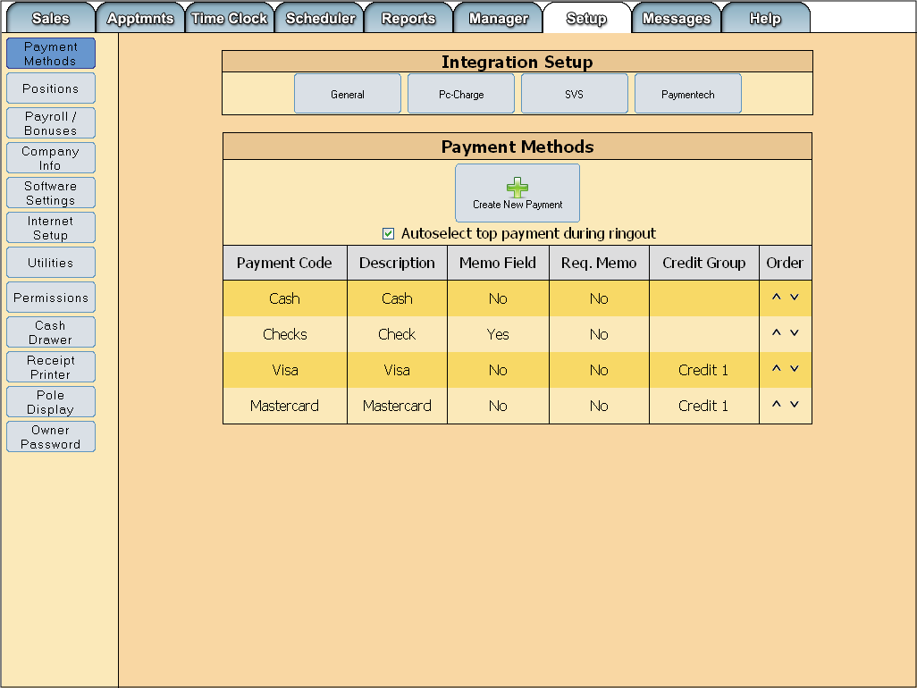
Select the Create New Payment button
Payment Methods button
Figure 10 - Payment Methods screen
From the setup tab select the Payment Methods button on the left. Then select the Create New Payment button

Creating an SVS Payment Method

Setup Tab → Payment Methods → Create New Payment
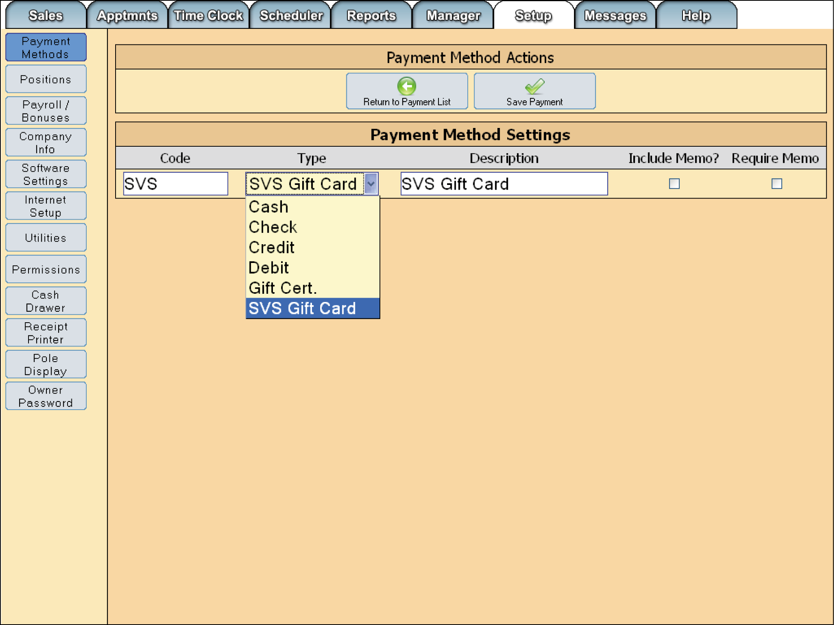
Enter the desired description for the payment method
Enter the desired code then choose SVS Gift Card from the drop down menu
Save your payment
Figure 11 - Payment Method settings
From the Payment Method Settings screen enter a code for the SVS payment method, then select “SVS Gift Card from the drop down menu under “Type”. Then enter a description. Be sure to save your payment when complete.

Setting Up SVS Gift Card Integration

Setup Tab → Payment Methods
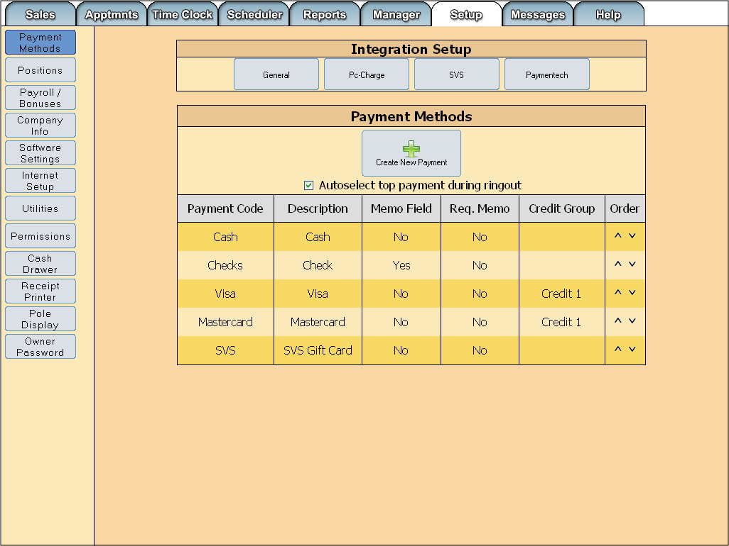
The new SVS payment method now shows in the list
Select the SVS button
Figure 12 - Integration Setup
After you have created the SVS payment method, it shows in the list. To enter your SVS settings select the SVS button.

Entering SVS Settings

Setup Tab → Payment Methods → SVS

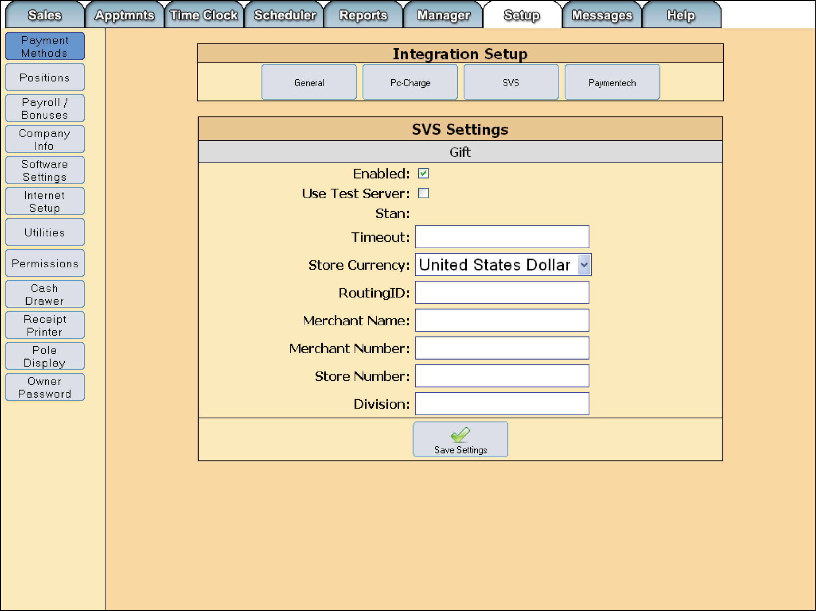
Test server must be unchecked
Save your settings
Figure 13 - SVS settings
- Make sure the box for Enabled is checked
- Test server box must be unchecked
- Enter 60 in the Timeout field
- Set the currency
- Enter the Routing ID (For Regis this will always be 6006496669000000000 in the US and 6006496672000000000 in Canada)
- Enter the Merchant Name (For Regis this will always be RGSUS in the US and RGSCA in Canada)
- Enter the Merchant Number (For Regis this will always be 066673in the US and 066674 in Canada)
- Enter the store number(For Regis, the number will be provided by Regis)
- Enter the Division (For Regis, the number will be provided by Regis)

Section 7 – Miscellaneous

Subject 1

Section 8 – FAQs/Troubleshooting

Peripheral Issues
Printer with flashing Error light
- Turn off the receipt printer.
- Open the receipt printer, check to make sure the paper roll is not empty.
- If the receipt printer roll is not empty, take the roll out, re-seat the roll of paper in the receipt printer, ensuring the paper feeds from underneath the roll, feed 2" through the top, and close the lid on top of the paper you've fed through.
- Turn the printer back on, if you are still receiving an error light, please call technical support.
Cash Drawer will not open automatically
- First check and ensure that the receipt printer does not have an error light, as this will cause the cash drawer not to open. If the printer does have an error light, please refer to the printer error light troubleshooting section, once the error light is resolved, the drawer should proceed to open normally.
- Verify that the cash drawer cable is connected to the receipt printer, near the end of the cable that plugs into receipt printer you should see a label that says "To Epson Printer", ensure that is the side plugged into the receipt printer.
- Ensure that under Setup > Cash Drawer, that the "Enable Cash Drawer" option is checked, as well as the "Connected Through Printer" option.
- Attempt to open the cash drawer by going to Sales > Open Till and then select Open Till again, to open the cash drawer. If these solutions do not resolve the problem, please contact technical support.
Pole Display not working and/or displaying random characters
- First, check the pole display settings under Setup > Pole Display, ensure that the "Enable Pole Display" option is enabled, the port is set correctly (typically Com1), and that the correct model of pole display is selected for the Device. From here test the pole display, if it is still not working proceed to step 2.
- If the pole display is not displaying anything, check to ensure that both the power cable, serial cable, and RJ45 cable are plugged in on each end. On the bottom of the pole display, the serial cable should be plugged into the serial port that says, "To Computer" or "To Com1". If the pole display still does not display anything, please contact technical support.
- If the pole display is displaying random characters, unplug the power from the back of the pole display, and plug it back in. If it continues to display these characters, please contact technical support.
Barcode Scanner not scanning properly
- Unplug/replug the USB cable, if that fails switch USB ports.
- If the problem continues to fail scan the default scanner settings barcode.
Card Reader
- If this is failing, you'll need to switch USB ports until it works.
- If all ports fail to get the reader working, please contact technical support.
Monitor Issues
Touch Screen – unresponsive
- Power touch screen off and on.
- Power computer off and on.
- If the screen is still failing to respond, recalibrate the touch screen.
- If the screen is still failing remove the plug from its current location (USB only) and put it in a different available slot, also check that both ends of the cable are plugged in firmly.
- Please there is still a problem, please contact technical support.
Blank Black Screen
- Power computer off and on.
- Verify video connections are secure.
- Verify the monitor is powered on.
Zebra Printer Issues
- Make sure the printer is powered on and you have a green glowing ring around the feed button. Also, make sure there are labels in the printer, and the USB cable is plugged into both the printer and computer.
- Make sure there are no print jobs waiting to be printed. Go to Start>Setting>Printers and faxes. Double click the Zebra Printer icon.
- Right click in the Print window and choose “Cancel all documents”.
- Make sure that you are dealing with a software bug before you uninstall.
Windows is Telling You it has Detected New Hardware after You have Installed Everything
If you have the drivers from the Disk
- Open the disk, or the file that the drivers are located in, and find the uninstall file (it is called “uninstall”) and run the file.
- Once the drivers have been successfully removed, remove the printer from the system by going to the “Printers and Faxes” menu, right click on the icon and select delete.
- If you can’t delete the printer from the system then it has print jobs in the queue. Double click the printer icon to open the list of print jobs, select all the jobs by dragging a box around them, then press the delete key.
- Go back to your drivers and reinstall them by running the setup file and following the normal installation instructions.
If you are using drivers from the Rogers Software FTP
- Reinstall the printer drivers by selecting the setup executable and select repair from the installation menus. This will repair the drives and allow you to skip the uninstall step.
- If you can’t reinstall the printer then it has print jobs in the queue. Doble click the printer icon to open the list of print jobs, select all the jobs by dragging a box around them, then press the delete key.
You are trying to install the printer drivers and you receive errors
- Make sure the printer is plugged in. If it is, try another USB port. The one you are using may be shorted out.
- Try downloading the software again, you may have a corrupted file. If you are using the drivers from the disk contact technical support about getting the drivers from the RSD support FTP.
To Manually Send USB to LPT1 Command
- Open up the command prompt by going to the Start menu, select “run”, then type in “cmd”, press OK.
- In the new black and white window, type “net use LPT1\\127.0.0.1\ZebraLP2/Persistent:YES”. This makes the USB think it is using LPT1.
You Can’t Print After You’ve Finished Setting Up the Printer
Note: On some versions o f4, you have to finalize before you can print the label, make sure it is finalized.
- Open up the command prompt by going to the Start menu, selecting “run” and typing “cmd”, then press OK.
- Type in “net use” and press enter, chances are it will say that the printer is unavailable, meaning it has lost its configuration from being unplugged, turned off, etc.
- Clear the old configuration by entering “net use /delete *” and when prompted type in “yes” to confirm then press enter.
- Re-enter the configuration that you did earlier during installation: “net use LPT1\\127.0.0.1\ZebraLP2/Persistent:YES”
- If you enter “net use” again it should show the printer as available now, by showing an “OK” status.
- Proceed to print a Windows Test Page.
You Can’t Enter a Net Use Configuration Command to Either Share the Printer or to Delete it
- Make sure there are no print jobs stuck in the printer. If so, you will need to delete them before the printer lets you do anything because the printer is “in use”. To do this: Go to Start menu, select Printers and Faxes (Possibly under Settings), double click on the printer, drag a box around the print jobs, and press the delete key.
- Make sure that the Windows share name is the same as the one you are entering in the net use configuration (“ZebraLP2”). To check what Windows thinks the share name is: From the Windows Start menu select “Printers and Faxes”. Right click on the printer and select “sharing…” from the context menu. The share name should be displayed.
- There might be old net configurations stored. Clear out any old net configurations you have added by typing “net use /delete *” and then try again.

Labels Printing Out, Off Center
The Zebra printers detect where the perforated edges are on the labels by using a sensor under the label feed. These are very sensitive sensors, and being in a hair salon they are probably covered with bits of hair, dust, moose, hairspray, etc.
- Lift the labels that are feeding out. Underneath them you should see a small hole cut into the bumpy plastic. See pic at ftp://rsdsuppo@rsdsupport.net/Beauty_First/06.Documentation/ZebraPrinterInfo/Zebra_MarkSensor.jpg ftp://rsdsuppo@rsdsupport.net/Beauty_First/06.Documentation/ZebraPrinterInfo/Zebra_Upper_Sensor.jpg (Contact RSD Support for password)
- Blow in the hole to clear out any dust, etc that might be blocking the sensors.
- If this still hasn’t fixed the labels from printing off center see “Aligning the Labels and Printing a Test Page”
Labels Printing a Barcode with No Description
- In SuperSalon go to Setup>Label Printers and select 2-(7pts-6pts). This is the preferred setting.
Zebra Printer Still Won’t Print Even After Reloading All Drivers
- Go to the products within an order and see if there are any special characters , like “@or&” in the description of that product. If so, delete, then re-save. Try to re-print, this should fix the problem.

Software Issues
Fatal Errors
- Click Setup
- Click Utilities
Only press the following buttons, wait for the buttons to reappear before clicking the next
- Click Check Database Structure
- Click Check Database for Errors
- Click Clear Session Variables
- Attempt to navigate to where you experienced the error message.
- Contact technical support if further assistance is needed.
Employee not appearing in waiting/servicing stylist selection screen
- Check if the employee is clocked in as the right position (receptionist/stylist/manager etc)
- Check if employee is set to 'Cuts Hair', this is in the employee setup area. (Manager > Employees)
- Check the Positions, make sure they are set to Track Production. (Setup>Positions)
Employee password not working
- Check to see if Caps Lock key is turned on, and if the password is alpha-numeric, also check to see if the Num Lock key is turned off.
- Reset the password in the employee setup area. (Manager>Employees)
- Make sure the employee permission group is authorized to access whichever area the employee is trying to access. (Setup>Permissions)
Owner password not working
- Check to see if Caps Lock key is turned on, and if the password is alpha-numeric, also check to see if the Num Lock key is turned off.
- Contact technical support to reset the password.
Can’t enter numbers anywhere
- Make sure the Num Lock key is on.
- If Num Lock key is on and you still can’t use the number pad to enter numbers, contact technical support.
The SuperSalon tabs have been replaced with a gray bar
- Move the pointer to the spot on the gray bar where the Sales tab normally appears.
- Press the right mouse button. A menu should appear.
- On the menu that appears, uncheck the option “Block images from localhost”
- Press the F5 key on keyboard. The tabs should be visible.

Upload Issues
DSL/Cable/Broadband
Unable to resolve iOffice server
- Find the DSL modem and router
- Unplug the power cable from the back of the modem and router.
- Keep modem and router unplugged for 30 seconds.
- Plug the modem and router back in and wait a minute
- Go to Manager Tab and click Upload. If the same error message appears, proceed to Step 6.
- Check the cables going to and from the DSL modem. (The phone line going to the modem and cables going from modem, router, and computer.
- If all cables appear to be connected, proceed to Step 8.
- Call the Internet Service Provider to check Internet connection.
Numbers between iOffice and Store not matching
- Find the days that the discrepancies are appearing.
- Go to Setup>Utilities>Upload Options (You will need access to the section. Most likely a manager will have this. If not, call technical support)
- Change the date range so that it includes the dates found in Step 1.
- Check the box next to the date fields and select submit.
- Go to Manager>Upload and let the upload completely run through.
- If you are still experiencing differences between the store and the iOffice contact technical support.
Credit Card Processing issues
DSL/Cable/Broadband
Unable to process credit cards
- Close out of SuperSalon using the ALT+F4 key combination.
- Open Internet Explorer, usually located in the start menu under Programs or All Programs.
- Load a webpage of your choosing, the recommend page is http://www.google.com because it is a fast loading page. On the page, run a quick search to verify have Internet access and are not just loading pages from your cache.
- If you cannot load a webpage, attempt to reset the modem by unplugging the power to it and plugging it back in.
- If, after resetting the modem, you still cannot access the Internet, call the Internet service provider and have them check the Internet connection.

Section 9 – Checklists
Subject 1

Help
We tried to make SuperSalon as easy as possible to use, but at times you may find you don’t understand the use of a certain feature.
If you are having trouble with the installation or use of SuperSalon, registered users of SuperSalon may obtain technical support by calling SuperSalon at one of the contacts below.
- Technical Support available Monday through Friday 6 am to 9:30 pm PST, Saturday 6 am to 7 pm PST, Sunday 7 am to 7 pm.
- Voice: 907-458-1001 or 888-458-1001
- Support Fax: 907-374-0977
- Email: support@rogerspos.com
- Internet: http://www.supersalon.com

Software License Agreement
THIS IS A LEGAL AGREEMENT BETWEEN YOU (EITHER AN INDIVIDUAL OR AN ENTITY) AND ROGERS SOFTWARE DEVELOPMENT INC. BY INSTALLING OR USING THE SUPERSALON POS SOFTWARE, (THE SOFTWARE) YOU ARE AGREEING TO BE BOUND BY AND TO THE TERMS AND CONDITIONS OF THIS LICENSE AGREEMENT. IF YOU SO NOT AGREE TO BE BOUND BY AND TO THE TERMS AND CONDITIONS OF THIS LICENSE AGREEMENT, RETURN PROMPTLY ANY SOFTWARE DISKS AND ACCOUMPANYING DOCUMENTATION TO ROGERS SOFTWARE DEVELOPMENT INC. AND DISCONTINUE USE OF THE SOFTWARE.
Grant of License.
- Subject to and in accordance with the terms and conditions of this License Agreement, Rogers Software Development Inc. grants you, and you accept, a limited, non-transferable license to use SuperSalon POS Software (the “Software”) and the Documentation only for the specific purposes set forth herein, and for no other purpose. The purpose for which the foregoing limited, non-transferable license is granted is to permit you to use the Software to assist you in retail sales and management on a single computer or a single network supporting no more than the permitted number of network users at one time.
Use Restrictions.
- Without enlarging in any way the scope of the limited license set forth above, you agree not to do any of the following:
  - Copy the Software for any purpose other than for backup purposes;
  - Copy the Documentation for any purpose;
  - Use the Software on or gain access from more than one machine at a time, nor install it in a fashion that makes it available for running on or access from more than one machine at a time unless, in conjunction with your purchase of a license to use the Software, you have paid local area network or wide area network concurrent user fees and any other charges imposed by Rogers Software Development inc. for such use or access. If you have paid such fees, then you agree not to allow more than the licensed number of users to use the Software at one time. (“More than one machine” includes, among other things, use on a local area or wide area network or a multi-use computer with several terminals;
  - Rent, Lease, license, sub-license, or assign the use of the Software to other;
  - Reverse engineer, decompile, or dissemble the Software;
  - Alter, modify, or adapt the Software.
Copyright.
- The copyright in the Software, in the date or test retrieved, display, or output by the Software and in the Documentation is owned by Rogers Software Development Inc. and is protected by the copyright laws of the United States of American and the laws of foreign countries pursuant to international treaties. Except as otherwise permitted by this License Agreement and the provisions of 17 U.S.C. Section 107 governing fair use, you may not copy, reproduce, distribute, or prepare derivative works based upon the Software or the Documentation, or otherwise engage in any other activities concerning the Software or the Documentation which infringe upon or violate the exclusive rights of Rogers Software Development inc.
Limited Warranty and Limitation of Remedies.
- Rogers Software Development Inc. warrants that the media on which the Software is delivered will be free from defects in material and workmanship for a period of ninety (90) days from the date of receipt by you. Your sole and exclusive remedy with respect to any defects shall be the right to return such materials. Rogers Software Development Inc.’s sole liability to you shall be the replacement of any diskette that is not free from defects in material and workmanship.
No Other Warranties.
- TO THE MAXIMUM EXTENT PERMITTED BY LAW, ROGERS SOFTWARE DEVELOPMENT INC.DISCLAIMS AL LWARRANTIES, EXPRESSED OR IMPLIED, INCLUDING WARRANTIES OR MERCHANTABILITY OR OF FITNESS FOR A PARTICULAR PURPOSE, OTHER THAN THOSE STATED IN PARAGRAPH 1. MOREOVER, OUR REMEDIES FOR BREACH OF THE LIMITED WARRANTY ARE LIMITED TO THAT STATED INPARAGRAPH 4. THIS LIMITATION EXCLUDES RECOVERY OR DAMAGES OF ANY KIND.
No Liability for Consequential Damages.
- TO THE MAXIMUM EXTENT PERMITTED BY LAW, IN NO EVENT SHALL ROGERS SOFTWARE DEVELOPMENT INC. OR ITS SUPPLIES BE LIABLE FOR ANY DAMAGES, WHETHER DIRECT OR INDIRECT, INCIDENTAL OR CONSEQUENTIAL, INCLUDING, WITHOUT LIMITATION, DAMAGES FOR LOSS OF BUSINESS, BUSINESS PROFITS, BUSINESS INTERRUPTION, BUSINESS INFORMATION, OR ANY OTHER PECUNIARY LOSS ARISING OUT OT OR THE INABILITY TO USE THE SOFTWARE, EVEN IF ROGERS SOFTWARE DEVELOPMENT INC. HAS BEEN ADVISED OF THE POSSIBILITY OF SUCH DAMAGES.
Professional Responsibility.
- You acknowledge that you are purchasing the licenses hereunder to assist you in your chosen profession and you further acknowledge that it is your responsibility to review the results suggested to you by the Software prior to their implementation.
Entire Agreement of the Parties.
- This License Agreement is the parties’ entire agreement. No representative of ROGERS SOFTWARE DEVELOPMENT INC. other than a corporate office is authorized to alter its terms, and an office may do so only in writing.
Governing Law.
- In case of any dispute, this License Agreement will be governed by the law of the State of Alaska. Copyright issues are an exception, as copyright is governed by the law of the United States.
No Assignment.
- The licenses granted pursuant to this License Agreement are personal to you, an under no circumstances may be assigned or transferred by you without ROGERS SOFTWARE DEVELOPMENT INC.’S prior written consent. Any attempted assignment or transfer shall be null and void and shall result in the immediate and automatic termination of the license granted under this License Agreement.

