HOW PASSING CRANES
INFLUENCE STACK OPERATIONS
IN A CONTAINER TERMINAL

A simulation study

In opdracht van XXXXXXXXXX

Margaret P. J. van Valkengoed
Business Mathematics & Informatics
Vrije Universiteit, Amsterdam
August, 2004

Supervisors:
TBA Nederland
Vulcanusweg 259a
2624 AV Delft
Tel. +31 (0)15 380 5775
Fax. +31 (0)15 380 5763
E-mail info@tba.nl
http://www.tba.nl

Ir. Yvo A. Saanen Pascal Bierhuizen
TBA Nederland TBA Nederland

Dr. Sandjai Bhulai Dr. Iris Vis
Vrije Universiteit Vrije Universiteit

prelude

Als laatste schrijf ik dan het voorwoord. In het Nederlands, mijn moedertaal, aangezien eenieder die betrokken is geweest bij de totstandkoming van deze afstudeerscriptie de Nederlandse taal machtig is en dit aan hen gewijd is. Want ja, zonder slag of stoot komt een afstudeeronderzoek niet voor elkaar. Daarom dank aan al diegenen die hebben bijgedragen aan het proces in wat voor vorm dan ook. Maar toch in het bijzonder zou ik willen bedanken:

Allereerst mijn begeleiders van beide zijden. Bij TBA wil ik Yvo bedanken voor de bondige doch kritische noot waardoor ik toch meestal weer een stap verder kwam. En voor zijn begrip voor mijn haat- liefdesverhouding met ‘mijn kranen’. Pascal voor alle ‘momentjes’ die hij voor me had die toch altijd weer uitliepen in een uur.
Mijn begeleider vanuit de VU, Sandjai Bhulai, wil ik bedanken voor zijn persoonlijke interesse… want ja, niet alles draait om kranen (echt niet Yvo!). En voor zijn onvoorwaardelijke begeleiderschap! (zoals een presentatie bijwonen net na aankomst uit de VS..)
Mijn tweede lezer, Iris Vis, bedank ik voor haar interesse toen ik haar vroeg op het laatste moment.

Ten tweede natuurlijk de rest van TBA, waarvan ik me toch echt een deel heb mogen voelen gedurende mijn stageperiode. Feike, wat had ik nou zonder jou (en je Star Wars poppetjes) gemoeten. Marijn, ik zal je geen honger meer bezorgen tijdens het blokje om. En Arjen, veel geluk met Jessica en mag ik over 4 jaar weer meedoen met de EK-pool? Klaas Pieter, bedank ik voor zijn keuze op mij bij de selectie, “toppertje!”.

Er zijn momenten dat je denkt dat er geen eind aan zal komen en juist op die momenten waren het mijn vrienden en familie die het tegendeel beweerden… DANKJEWEL! Ja, dankjewel voor alle steun en het getoonde vertrouwen in mijn kunnen.

En als laatste dank ik mijn ‘segunda tierra’. Je zon, bewoners, palmbomen en muziek kunnen wonderen verrichten. Gran Canaria, je bent heerlijk.

Margaret van Valkengoed
Augustus 2004

Executive summary

The growth of container transport will continue, which demands a further optimisation of container terminal operations. The storage yard (where the containers are located between arrival and departure) plays a great role in the container terminal and its functioning influences the terminal performance.
In this research we observe the high-density storage yard, consisting out of stacks, where each stack is served by two Rail Mounted Gantry Cranes. These cranes are able to quickly retrieve and store containers and are easy to automate. Using two cranes has the advantage that both waterside and landside of the stack can be served at the same time. But because they share the rails they hinder each other and each crane can only serve one particular side of the stack. Therefore a new configuration has been developed where one crane is bigger so it can pass the other crane when it has moved its trolley to the side. With this new configuration the cranes can serve both sides of the stack, which gives more flexibility in order assignment.
Subject of this research is the influence of the passing cranes configuration on the stack operations and performance compared to the no passing cranes configuration. Through dynamic simulation we gained insight in the stack performance and behaviour, and the possibilities of the new configuration.
First we obtained results for a single stack, isolated from the other terminal operations, using different assignment rules. We found very little difference in performance for the two different configurations.
Second we obtained results for an entire terminal where passing cranes were implemented, with AGVs transporting the containers between quay cranes and stack. We obtained results for terminal productivity and stack behaviour using different approaches in assignment. Compared to the no passing cranes we found the passing cranes, when the gain in flexibility is used, able to give a higher waterside performance.

Contents

prelude 2
Executive summary 3
1 Introduction 6
1.1 An introduction to container transport 6
1.2 Problem description 7
1.3 Problem approach 8
1.4 Outline 9
1.5 Research contribution 9
2 Container terminal characteristics 10
2.1 Containers 10
2.2 Container terminal processes 10
2.3 Decision making in container terminals 11
2.4 A further focus: the storage yard 12
2.5 Planning and performance of a container terminal 14
2.6 Stack planning characteristics 14
2.7 No passing vs passing 16
3 Literature and motivation approach 17
3.1 Literature review 17
3.2 Why this approach? 18
4 Description of simulation models 19
4.1 Stack operations 19
4.2 Crane operations 19
4.3 Order execution 20
4.4 Structure crane model 21
4.5 Interference of no passing cranes in the model 22
4.6 Passing cranes configuration 23
4.7 Conceptual model passing process 24
4.8 Implementation of passing in model 25
4.9 Validation of the model 26
4.10 Terminal configuration 26
4.11 Terminal operations in simulation model 26
5 Experiments and results 28
5.1 The isolated stack module 28
5.1.1 Assumptions for the isolated stack module 28
5.1.2 Order assignment 29
5.1.3 Output 30
5.1.4 Results 30
5.1.5 Extra experiment 34
5.2 Entire terminal operations 36
5.2.1 Model assumptions 36
5.2.2 Order assignment 37
5.2.3 Assignment concepts 38
5.2.4 Output 39
5.2.5 Results 39
5.2.6 Extra experiments 48
6 Concluding Remarks and further research 56
Bibliography 59
Appendices 60

Introduction

An introduction to container transport

From the fifties onwards the world economy experienced a strong growth. International division of labour increased and, in parallel, trade in and transport of (semi-) processed goods [2]. This new development asked for more transport facilities and shipping was a convenient answer. But the high labour costs on ships and in harbours became soon a bottleneck. Since all goods needed to be taken care of separately, unloading and loading were taking too much time and too much staff was needed on ships. For a less labour intensive way of handling the goods, standardisation of package in the form of containers was the solution. This concept of container had already been initiated in the United States of America, where trucks were developed of which chassis and container could be separated. On boarders from then on, only the containers had to be switched and not the cargo. To really have all the advantages of the standardisation, the introduction of the container could not go alone. Besides trucks all other forms of transport and transfer points involved had to be adapted to containers, like special designed vessels, trains, cranes, terminals etc. These changes demanded a large investment, which put up a barrier for most companies. But in the late fifties, the discovery of containers as an easy way of transporting military freight during the Vietnam War, gave containerisation the extra impulse it needed. After the large investments were done the costs of liner companies stabilized. The first container vessels were small ships, mostly with a carrying capacity of several hundred containers, and equipped with cranes to load and unload the vessels.
From the sixties onwards, container use expanded strongly. For example, between 1968 and 1974 the number of container transhipments got almost 10 times bigger from 150,000 TEU (Twenty foot Equivalent Unit, i.e., the 20 ft ISO-container) to 1,107,000 TEU in the largest European harbour, the Rotterdam harbour. Vessels became larger, cranes moved from the vessel to the quay and container terminals grew rapidly.

With containerisation the whole concept of transporting goods changed. No more individual treatment of goods but standardised processes. Logistics gained importance in the process chain of container handling.
With the introduction of ICT in the nineties and the continuous improvement and automation of container handling machinery, this process chain was re-designed and could be controlled more centrally. This made more efficient handling possible, which has increased throughputs of container terminals immensely. Nowadays numbers of throughput of large container terminals are in the range of 4 million TEU up to 25 million TEU. Vessels have a capacity of 400 TEU up to 8000 TEU or even more. Figure 1-1 shows the top 10 of container terminals based on throughput in TEUs in the year 2001 where in Figure 1-2 it is shown where they are located.

Top 10 world container ports
1 Hong Kong (China)  2 Singapore  3 Busan (South-Korea)  4 Kaohsiung (Taiwan)  5 Shanghai (China)  6 Rotterdam (The Netherlands)  7 Los Angeles (USA)  8 Shenzen (China)  9 Hamburg (Germany)  10 Long Beach (USA) | TEU (2001)  17,900,000  15,520,000  7,900,000  7,540,000  6,334,000  6,129,000  5,184,000  5,040,000  4,700,000  4,463,000
Figure 1-1: The top 10 world container ports, based on their throughputs in 2001
(Source: website Homepage European Combined Terminals (ECT))
Figure 1-2: Locations of top 10 container terminals in the world

Problem description

The growth of container transport will continue. Every major port is expected to double and possibly triple its cargo by 2020 [4]. Intercontinental vessels with a capacity of 8000 TEU are spotted already. These massive containerships and therefore the increasing number of containers to be handled, demand existing terminals to further optimise their terminal operations. To come to this optimisation, further automation of container handling operations and the use of Terminal Operating Systems (TOS) are subject to research, development and implementation.
Berthing time is costly and should be minimised, unloading and loading a ship should be done as efficient as possible. The bottleneck in waterside operations is that loading has to be done according to a strict load plan. This load plan is created in order not to have too many unnecessary moves in future destinations while meeting rules for safety for the ship too. Containers that are loaded mostly have their origin at the storage yard. This storage yard is divided into storage blocks where each block consists of several stacks. To be able to continue loading a ship, containers have to be delivered from stack in time on the berthing area. But at the same time unloaded containers and landside orders have to be taken care of. Clearly the performance of the stack yard plays a great role in the overall container terminal performance.
The scarcity of yard land in most container terminals, demand a high yard density. An alternative for high yard density that can be automated easily is the storage yard where the placing and retrieving of containers in stack is done by Rail Mounted Gantry Cranes (RMGCs). These cranes move over rails, and the width of the stack fits in between the legs of the crane. The RMGC can move over the whole length of the stack. The stack has on each end a transfer point where a container can be interchanged with a transport form.
To be able to serve both transfer points at the same time, a configuration used is stacks with two equally sized RMGCs. An inconvenience is that they share the rails and each RMGC is only able to serve one side. No flexibility in the assignment of landside and seaside orders is possible. Another inconvenience is that congestion and collisions have to be avoided which causes delays.
To try to overcome these inconveniences, a new configuration is developed. It is the combination of two cranes where one is smaller than the other one and both have their own rails. In this way, they are able to pass each other, when some conditions are met. A disadvantage is that they take more space. This configuration has been built in the CTA terminal in Hamburg, and the Kwangyang port in Korea is interested to do so too. Other terminals might follow if this new configuration will lead to a better performance. But very little is known about the actual influence of this new configuration on the performance of the stack yard. For that reason we are interested in answering the following question:

What is the influence of the passing cranes configuration on the performance of the stack yard compared to the no passing configuration?

Having a certain crane configuration, it is the assignment rules that define the planning of the stack yard. This concerns in what order the orders are done and by which crane. Especially for automated terminal processes these rules are necessary to perform in an efficient way, supporting the overall performance of the complete terminal. As explained, when having the passing cranes configuration, more flexibility is possible. For this reason the experimentation with new assignment rules is part of the research.

Problem approach

For this research dynamic simulation is used. Simulation is known as a powerful tool to gain insight in behaviour of dynamic processes. At TBA a simulation model of the no passing cranes configuration is present as well as a model for an entire terminal. To come to a simulation model for passing cranes, first the existing model for no passing cranes is studied. Then a control concept for passing cranes is developed and implemented.
To compare the productivity of the different crane configurations, we will observe two cases. The first case is the isolated stack module, where isolated means that no further attention is paid to the simultaneous processes at the terminal. A few ways of order assignment will be presented. Stacks with the two different crane configurations execute an exact same set of orders and a comparison is done based on productivity.
Second we observe an entire terminal where stacks are served by the passing crane configuration. To obtain an efficient stack yard operation, it should be synchronised with the other terminal operations. Some order assignment concepts in this matter are presented. Different scenarios are tested and a comparison is done for overall terminal performance, work distribution at the stack and truck service times are compared to the results of the terminal with no passing cranes.

Outline

Chapter 2 will give a further detailed description of the overall container terminal and stack yard characteristics. In chapter 3 a brief survey will be given on literature published on stack yard operations and a further motivation of the problem approach. Then a description of the crane operations and the way they are implemented in the existing and developed simulation models will be given in chapter 4. In chapter 5 the experiments and results for the cases of a single stack and a complete terminal will be discussed after which in chapter 6 conclusions are drawn and findings are summarised.

Research contribution

This research was done at TBA Nederland in Delft, The Netherlands. For a successful completion, TBA Nederland provided the hardware and software and the simulation models.
TBA Nederland is specialised in designing and developing advanced simulation models and emulation models of complex logistic processes. The mission of TBA Nederland is to solve the logistic problems of their customers and to support their design and implementation processes using state-of-the-art simulation and emulation models. Their projects range from baggage systems at airports to different production manufacturing systems, but their main expertise is container terminal processes. They have done projects for several terminals like the ECT terminal in Rotterdam, ACT terminal in Hamburg, and the Pyreus port in Greece.
(http://www.tba.nl/, 2004).

Container terminal characteristics

This section is meant to give insight in the research setting. The problems that arise in container terminals are discussed after which is focussed on the stack yard and the issues that matter in stack planning.

Containers

The International Standards Organisation (ISO) gave the following definition for a container:
“A freight container is an article of transport equipment intended to facilitate the carriage of goods by one or more modes of transport, without intermediate loading.”
ISO standardised the sizes of containers. Lengths are 20 feet (which is referred to as 1 TEU, about 6.1 meters) or 40 feet (which is referred to as 2 TEU). The width is fixed at 8 feet (2.4 m) and for the height the standard dimensions are 8’6 (2.6 m) or 9’6 feet (2.9 m). There still is a lot of diversity in containers within these standardised dimensions. This makes them usable for different types of freight.

Container terminal processes

Figure 2-1 shows a schematic representation of the processes taking place at a container terminal and how they are connected as a process line.
Figure 2-1: Processes involved transfers and transhipments in container terminals

We find the triggers of the processes in a container terminal on both ends of the process line, the in- and export of containers. On one side this is the arrival and departure of container vessels and on the other side departure and arrival of the other modalities like trains and external trucks. In between those two processes we find the stack yard where the container can stay for the time being in between being imported in and exported from the container terminal.

When a vessel berths at the dock the to be imported containers are unloaded according to the unload plan by the quay cranes. An inter-terminal transport vehicle delivers the container to a certain block, stack and lane where it is placed in stack by the stack equipment. If it is imported by one of the other transport modalities, comparable activities take place. A form of container handling equipment takes care of the unloading of the transport form after which it is transferred to the stack or vessel. In some container terminals external trucks are able to deliver the container at the stack yard themselves thus do not make use the inter-terminal transport.

When any form of transport comes to export a certain container, the stacking equipment is ordered to retrieve the container from its slot after which it will be transferred by the inter-terminal transport to the spot where it is loaded on the exporting transport form. If the export modality is a vessel, containers will be retrieved from stack according to the load plan of the quay crane. This load plan is determined in order to reduce unnecessary moves with unloading in upcoming destinations and for safety reasons of the vessel (e.g. stability, torsion). If the export modality is a truck, then in some terminals it will be able to pick up the container from the stack itself.

Decision making in container terminals

Within the above-described container terminal processes a lot of decisions have to be made. Vis [12] provides a classification of decision problems that arise at container terminals, namely strategic, tactical and operational decisions. They concern different issues on a different time-horizon.
With strategic decisions the overall setting of the container terminal is determined. Strategic decisions are on a long-term base and set the constraints for the tactical and operational decision-making. An example of a strategic decision is the types of container handling equipment used. For example, for inter terminal transport there is rather broad selection possible. There are two key issues in choices. First manned or unmanned (manual or automated). The second issue is whether it is able to pick up or drop the container by itself. If not, another type of equipment is needed to load or unload the transport form.
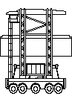
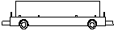
Figure 2-2: A straddle carrier (left) and an AGV (right)

The most common used manned inter-terminal transport form is the straddle carrier (SC), which is shown in Figure 2-2. It is able to pick and drop a container by itself. An unmanned inter-terminal transport form is the Automated Guided Vehicle (AGV), also shown in Figure 2-2. AGVs can be controlled centrally and follow pre-determined paths. An AGV is not able to pick up or drop a container by itself; it requires other material handling equipment for loading and unloading. To overcome this inconvenience the Automated Lifting Vehicle (ALV), which is able to do so, is under construction.
Other examples of strategic decisions are: physical layout of the terminal, stack configuration, etc.

By tactical decision-making a further determination according to the chosen strategy is done, by making the broad choices. These choices cover a time-horizon between a day up to months. Using the same example as before a tactical decision in this matter would be the determination of the number of inter-terminal transport vehicles necessary.

Operational decision-making is concerned with the practical implementation of executing the daily processes efficiently. This concerns the order in which the orders are carried out, how they are carried out and by what means. In this matter we see a lot of decisions possible. An operational decision in the former example of inter-terminal transport, is the decision what vehicle will carry out what order, and how its routed (when unmanned).
Other examples are the creation of the load- and unload plan of the vessels, the allocation of a container to a certain block, stack and slot, order assignment and priority rules etc.

Clearly all decisions made are supposed to contribute to the overall performance of the entire terminal. Where new terminals are built, strategic decisions are very important. But when looking at existing terminals, one pays more attention to the tactical and operational decision. Those are the ones that should be able to optimise performance within the existing setting. In practice, most concepts are developed with use of simulation or based on practical experience of decision makers. Vis [7] provides an overview of all the above-mentioned and many more problems for container terminals together with references to relevant literature.

A further focus: the storage yard

The storage yard of a container terminal has as function to provide space for the time staying in the terminal between being imported and exported again.
There are two main ways of storing containers: on chassis or piled up on the ground. Most terminals in Europe and Asia are dealing with a lack of space and use the latter ones. A negative side affect is that not all containers can be reached directly. When piled up on the ground there are mainly two alternative systems for storage and retrieval, SCs or stacking cranes. SCs are able to carry out both jobs of the stacking and transport, thus are flexible. But they are costly and need more space in the stack to operate. When stacking cranes carry out the stacking operations, storage yards are divided into storage blocks where each block consists of several stacks and one or more cranes serve each stack. Two forms of stacking cranes are known, the Rubber Tired Gantry Crane (RTGC) and the Rail Mounted Gantry Crane (RMGC). Figure 2-3 shows the passing configurations of RMGCs.
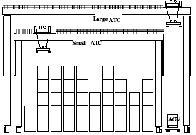
Figure 2-3: RMGCs, as in the passing configuration

The RTGC has the flexibility to change stack, but in practice this is time consuming and will not be done so often. Since they are harder to automate, they are less attractive for the terminals trying to further increase throughput through atomisation. In this research we only focus on automated terminals. Therefore from now on when referred to cranes, we refer to RMGCs.
Figure 2-4: Containers in stack

A stack served by cranes consists of rows (lengthwise), bays and tiers (height) as shown in Figure 2-4. A combination of these three coordinates creates a spot where a container can be located, called a slot. A slot fits a 20ft container, so a 40ft container takes two slots. The dimensions of stack served by cranes differ per terminal. But the order of magnitude one should think of is 30-60 bays length, 6-10 lanes wide and 4-5 tiers high. In meters, we are talking about 183-366 meters long, 15-24 meters wide and 10-13 meter high.
On both ends of the lanes, a number of transfer points is situated where the transfer of containers between crane and inter terminal transport takes place. One transfer point is situated on the waterside, the other on the landside. On the waterside transfer point containers delivered come from a vessel and pick-up orders have a vessel as destination. Containers delivered/picked-up on the landside transfer point, have their origin/destination at trucks, trains and barges. This research focuses on terminals where transport between QCs and stacks is done by AGVs as is done in automated terminals. External trucks, from now on called trucks, deliver and pick up containers at the landside transfer points.

Planning and performance of a container terminal

The planning of a container terminal concerns the individual planning of the different processes taking place. At the same time planning of these processes together has to lead to an optimisation of the performance of the entire terminal. But what is performance? To be able to define what performance means for container terminals, firstly we should look at its main function. Hekman [6] provides a definition for this main function of a container terminal:

“Container terminals are connecting points in the whole system of inter-modal container transport. The main function is to transfer or tranship containers correctly, promptly and safely between the different modes of transport connected to it.”

To achieve a good performance of a terminal, this function has to be carried out in the best possible way. How to deal with the enormous in- and outbound of containers, and carry out all forthcoming processes promptly is the key issue.
Berthing time of containerships in terminals is very costly. Berthing space is a problem for most terminals, and vessels want to spend the least time possible in each terminal. Therefore minimising berthing time and so optimising quay crane productivity is the key for good performance.
In this view the unload- and load plans of the QCs are the leading objects of terminal planning. All other activities on the waterside should be synchronised to these plans, in order to perform operations in an efficient way. Since most containers have their origin or destination at the stack yard, the well functioning of the stack yard influences the terminal performance for a great deal. Waterside operations tend to have priority, but on the other hand the landside operations cannot be forgotten. The time trucks spend delivering or picking up a container should be kept reasonable. Therefore the stack performance is determined by the waterside productivity and the truck service times together.

Stack planning characteristics

The stacking process consists of retrieving and placing of containers from/in stack. Each order, concerning the placement or retrieval of a container has its origin in an event at the landside or waterside. Not all containers are directly accessible for retrieval. In that case, the containers on top need to be replaced. These are called shuffle moves or rehandles.
The time window in which information is available about the order differs for the different events. For example at the landside, when a truck comes to pick up a container, this is only known when the truck shows up at the gate of the terminal. Then needed shuffle moves can only be done in the time the truck drives from the gate to the stack. At the waterside though, a retrieval order has its origin in the load plan, which is known in advance up to an hour ahead. This leaves a lot more time for shuffle moves to be carried out.
For unload orders, it has to be decided in what stack the container has to be stored. Depending on when this decision is made in the planning process, before being unloaded or as a real time decision, the time window of that order is determined.
Most terminals try to avoid shuffle moves by doing so called housekeeping moves. These are moves done within the stack during relatively quiet periods in order to have most containers that are known to leave reachable, preferably close to the transfer point from which they will leave.
As stated earlier, the unload- and load plans of the quay cranes are the leading objects of terminal planning. The assignment of the AGVs is done supporting these plans. When assigning orders to the stacking cranes, important is if the order is urgent according to the planning of the rest of the terminal. But in the same time we wish to carry out the movements within the stack in an efficient way, so to travel least as possible without carrying a container (empty travelling distance).
These two demands conflict in most cases and therefore ask for decision rules for assignment. Especially in terminals where AGVs are used, this is an important issue. Since they need another form of container handling equipment (like a stack crane or quay crane) to pick up the container or place the container synchronisation gains importance. Deadlocks can be easily provoked when assignment is not done properly.
An example: a crane is assigned to a loading order for a vessel. The order is not very urgent in matter of loading sequence in the load plan. But in terms of reducing empty travelling distance it is efficient to do it now.
In this situation the following two cases are possible:
The first case is that an AGV is assigned to come and pick up the container to free the crane so it can go do a new order. But then this AGV will be unavailable until the QC finally frees it, when it is this container’s turn.
The second case is that the AGV planning ignores the waiting crane and keeps on doing assignments according to the QC plans. This will keep an AGV free to do a more important order according to the QC plans, but will keep the crane blocked from doing any other order. When an urgent container is situated in this stack, it will be impossible to execute it until the crane is released from the container by an AGV.
Increasing the number of AGVs in the terminal can somehow give more room in the assignment. But disadvantages are that AGVs are costly. And having more AGVs, routing without collision and deadlocks gets more difficult and time consuming when travelling.
Another issue in stack planning using AGVs is the priority issue in pick up and retrieval orders. One could say that a pick up order is more important since this container has to arrive in time at the quay to be loaded by the QC. On the other hand, letting an AGV wait for being unloaded, keeps this AGV longer occupied, which delays the next order to which this AGV is assigned.
Using SCs provides some more flexibility in order assignment to cranes. The cranes and SCs can drop containers at the interchange zone; it functions as a temporary buffer. The same counts for buffer areas of the QCs, where the SCs and QCs can drop and pick up containers. But both areas have limitations in the number of containers that can be put, which has to be considered as well.

No passing vs passing

In the existing concept, where two cranes share the rails, dispatching of landside and waterside orders to the two cranes is done easily. In the case they cannot pass, one crane will be serving the landside and the other will be serving the waterside. Only shuffle moves have to be dispatched. The landside crane can support the waterside crane by moving containers closer to the waterside transfer point, these are called pre-positioning moves. In the new configuration though, both cranes are capable of reaching both transfer points, and therefore of processing any order. This needs further analysis in order to decide what crane is going to do what order.

Literature and motivation approach

A broad range of researches has been done on container terminal operations in order to improve efficiency. Though few focus on different crane concepts or operational rules for the stack yard. We will first give a brief literature review, after which a further explanation of the proposed research approach is given.

Literature review

Chin-I. Liu et al. [2], have developed a simulation model to simulate all the operations of the automated container terminal (ACT) in order to compare 4 different concepts by means of performance and costs. The concepts issued are a terminal where AGVs used in combination with stack yards served by one RMG, a terminal where a linear motor conveyance system is combined with stack yards served by one RMG, a terminal where AGVs used in combination with an overhead grid rail system of stacking and a terminal where AGVs used in combination with a stack and storage system with a rack structure. They found the AGV-RMG concept to be the most cost effective. This research concerns stacks served by one crane. For our research we are interested in the control concept used for the AGVs and cranes, but the paper does not describe how this is done.
Kozan [8] provides a comparison of analytical and simulation planning models of container terminals. He uses queuing theory in a simulation model to observe the effects of changing values for critical parameters and compares the results of the analytical and simulation approach. He finds very little difference in the results found for both methods. Operations are not simulated dynamically.
Kozan and Preston [9] provide a model where storage strategies and container handling schedules are determined in order to minimize berthing time. Therefore they want to minimise the sum of set up times and yard travel times, where the set up time defined as the time necessary to remove the containers on top of the desired container. Stacks are served by one crane.
Meersmans and Wagelmans [11] investigated the scheduling problem of AGVs in an automated container terminal. They used a beam search algorithm and proposed a way of using it in a dynamic setting. Results were compared with results of rules for dispatching, adjusted for this particular environment in order to avoid deadlocks. They found better performance for the beam search algorithm with the results of the beam search algorithm in the static environment as a benchmark. Only loading orders on the waterside are considered and stack planning is done according the AGV planning. Stacks are served by one crane.
Kim and Kim [7] discuss the problem of routing yard-side equipment by introducing heuristic algorithms to determine a pick-up schedule, minimizing the container handling time. However, containers are transferred at the side of the block and not at transfer points on the end. Which makes a great difference to travel times of the yard cranes compared to our configuration.
Vis [12] presents a model and heuristic for minimising empty travel distance for stack operations carried out by a SC or one crane. She considers the situation where the stack is isolated from other terminal operations.
Wang et al. [13] are the only ones that have conducted a simulation study for passing cranes. They suggest operational rules for crane dispatching and container allocation for automated container yards. They distinct two decision-making problems for dispatching: a role-separation rule (each crane serving one side) and a sequencing rule (First in First out concerning the AGVs and trucks or priority nearest order). Performance is measured in terms of number of containers handled per hour per stack. They found the best performance for the case where both cranes have a separated role, and sequencing is done according the nearest order principle. In their research approach no comparison is done with another crane configuration.

Why this approach?

Two types of approaches of a problem can be distinguished: analytical or simulation. When using an analytical approach, mostly the problem needs to be simplified to be able to formulate a mathematical model. Simulation models on the other hand are able to cover very complicated situations. Disadvantage of simulation is the increase of time and so costs to come to a working model. But since TBA is providing models to work with, this disadvantage of time is overcome. The provided models cover container terminal processes and crane operations in a very detailed manner, which will give us the opportunity to do a detailed comparison.
Almost all research, considering stacks served by cranes, considers stacks served by one crane. Travel times can be used concerning the distance only and heuristics can be used trying to minimise this travel time. Hindering of cranes is not an issue and crane control leads to no difficulty. We want to compare two configurations with two cranes per stack. Then travel times are not static anymore and collision avoidance in crane control becomes an issue. This can be covered in its full appearance only, when simulating the cranes dynamically as being done in the provided models.
Another thing we have seen in most research papers is that only a part of the terminal processes is considered. This simplification is needed to come to an optimisation of a certain process. To really know the stack performance, that has to deal with activities originating in all the different processes taking place in the terminal we choose to work with the full terminal operation on both landside and waterside. Performance optimisation then is difficult, so it will not be tried. But by using different approaches and heuristics, insight in the influence of the two different configurations on the stack performance and operations can be gained. This enables us to make a comparison and assess the new configuration.

Description of simulation models

First a further close-up is taken of the crane, its operation and how it is incorporated in the simulation model. This is followed by a description of the implementation of the model of the passing cranes. Then a description of the implementation of the main operations in the simulation model of the complete terminal is given.

Stack operations

Stack operations concern the retrieving of containers from stack and the storing of containers in stack. Carrying out these operations, four different types of moves are distinguished:

- Productive moves: moves where the container is directly moved from slot to transfer point or the other way around.
- Shuffle moves: moves where the container has been moved from one slot to another to give access to a container underneath it in the same pile.
- Housekeeping moves: moves performed in order to re-configurate the stack yard to facilitate less shuffles needed in the future.
- Pre-positioning moves: moves where a container is pre-positioned to a slot closer to its destination just before the actual productive move.

Housekeeping moves are mostly done in relatively quiet times. Pre-positioning moves are only done for the waterside orders and can be seen as way of supporting the waterside. For every single move a pick and drop position has been determined. Each position consists out of bay, lane and tier coordinates.

Crane operations

A crane consists of three parts (vehicles), namely gantry, trolley and spreader. Figure 4-1 shows a picture of a crane. The gantry is the biggest vehicle. It moves over the rails lengthwise, from bay to bay. The trolley is the vehicle that moves over the top of the gantry. We consider the crane where gantry and trolley can move simultaneously. The grabbing and dropping of a container is done by the spreader, which is connected to the trolley and can be lowered and hoisted. By positioning of gantry, trolley and spreader, any slot can be served.
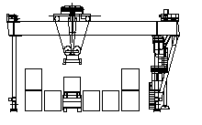
Figure 4-1: Crane in operation in stack.

Order execution

When executing an order, the crane has to perform a sequence of movements with the different vehicles, in order to reach the target positions and move in a safe way. To describe this process, we will give an example where a container is retrieved from stack and dropped at a transfer point:

- The spreader is brought to transport position, according to the stacking height of the stack.
- The trolley is brought to transport position that makes the crane in balance and gantry movement is started.
- Before the gantry reaches its target position (the bay where the container is located) the trolley is started, to move to its target position (the lane where the container is located).
- When these two movements have reached their destination, the spreader is dropped and hoisted consecutively after the container has been grabbed.
- When the spreader has reached its transport position, the trolley and gantry are brought in movement again; the trolley to transport position and the gantry to transfer point.
- Before the gantry reaches the transfer point, the trolley is started, to move to the position of the lane of the transfer point where the container should be dropped.
- When both gantry and trolley have reached their final positions, the spreader is lowered and drops the container.

At the start of executing an order the sequence of movements needed for that order is determined. To start a certain movement safely at the right moment, the model works with preconditions. Every single movement of a particular vehicle has a subset of different preconditions. A movement can only be started, when all preconditions are satisfied. The status of each precondition is registered in a table. The status of a precondition changes during execution of movements. For example, during a spreader movement, the status of precondition ‘spreader at transport height’ can change to true. If any vehicle was waiting for this precondition to be true, and it was the last precondition to be met, its movement will be started now. When a vehicle finishes a movement it tries to start the next movement of this vehicle. Depending on the status of the preconditions for this movement it will be decided if this is possible. If the preconditions are not satisfied yet, the vehicle is set to wait. An exception of the described pattern above in movements is when the trolley does not have to be positioned in the transport position. This is the case when the initial position of the gantry is located very close to the position of destination. Possibly moving the trolley over transport position will take more time than the complete gantry movement. In this case the trolley can move directly to the position of destination.

Structure crane model

Figure 4-2 shows the basic structure of the simulation model of the crane.

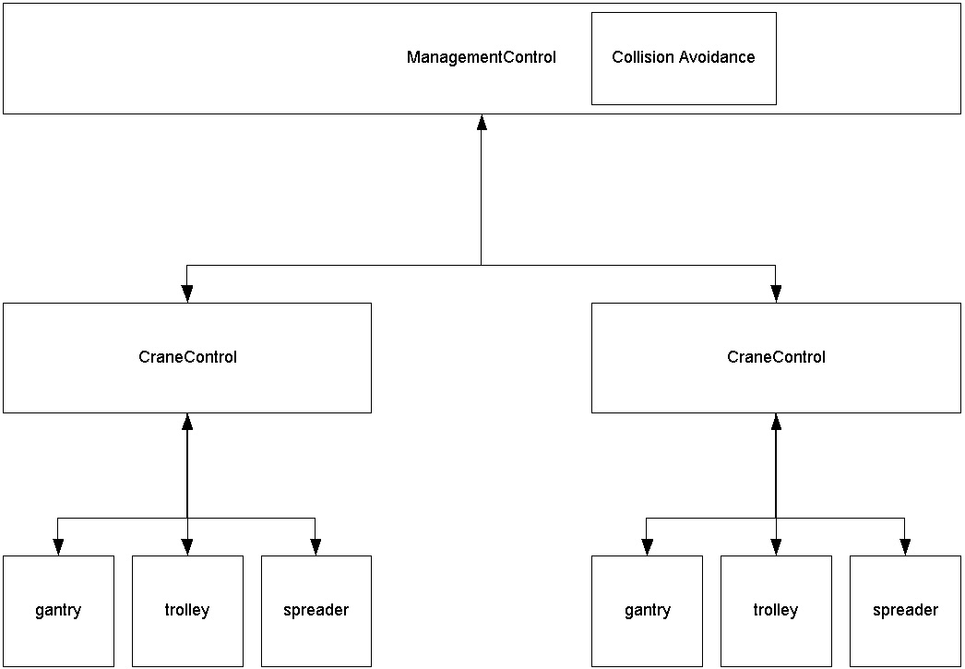
Figure 4-2: Structure of crane in simulation model.

On the highest level we find management control. This is where all methods and information is located that concern both cranes. This is where orders are assigned, cranes are started. When a crane has finished an order, the management control will be notified and all information will be updated. The module that provides collision avoidance of the two cranes is also located on this level because information on both cranes is needed for this. One level down the management control we find two instances of the crane control. On this level, the movements of the different vehicles are scheduled, started and the sequence of the movements is controlled. The three instances of the three vehicles gantry, spreader and trolley, are located on the lowest level. Each of them is responsible for executing its requested movements. For a further explanation on the functioning of the crane in model we refer to Appendix A.

Interference of no passing cranes in the model

For safety reasons a distance of 19 meters should always be kept between the two cranes. When an order threatens this safety distance when carrying out an order, collision has to be avoided. This is done through dynamic area claiming of which we will describe the basic concept.
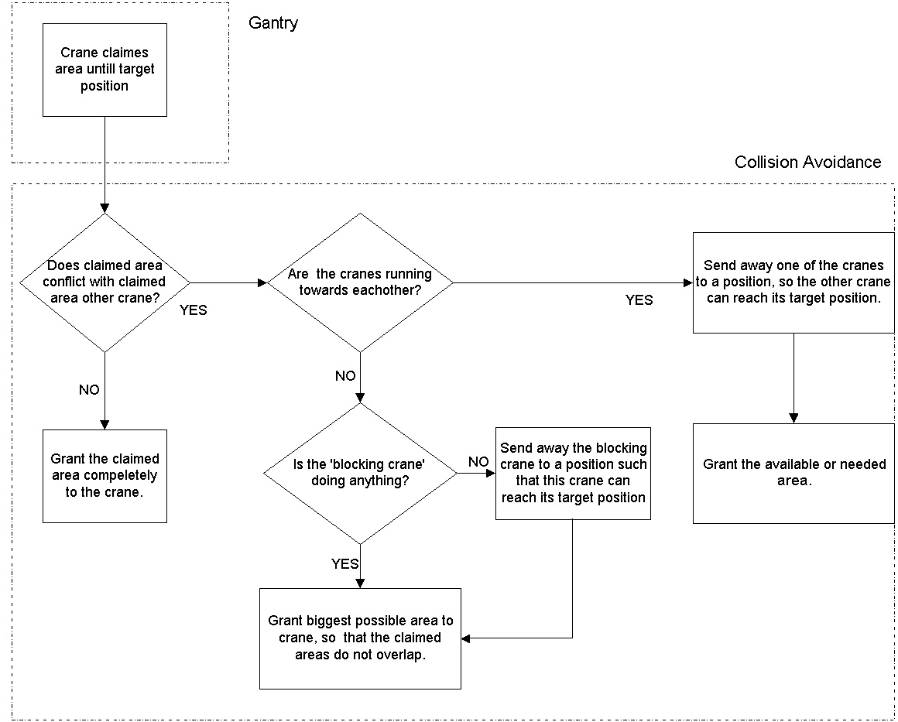
When a crane has claimed an area, it means that the other crane is not allowed to enter this area. The area is the space where the crane can move freely without colliding with the other crane. Of course no overlap is possible between claimed areas of different cranes. When standing still the claimed area of a crane has a minimal size of 19 meters, which is 9,5 meters on both sides of the central point of the crane, the safety distance. When a crane moves to another position in stack, it tries to claim a bigger area of the stack, ahead of it. Preferably it claims up to its target position. If the area, which it tries to claim, conflicts with the claimed area by the other crane, the claim fails. Depending on the state of the other crane, a decision is made according to the size of the area that it is granted.
Figure 4-3: Functioning of collision avoidance in model

Figure 4-3 shows a schematic representation of how this area claiming is managed in the collision avoidance module. When no conflict arises claiming the area, the whole claimed area is granted. If the areas conflict, and the two cranes are running towards each other, it means that the two target positions are located in such a way that not both cranes can reach them at the same time. In that case one of the two cranes needs to make space for the other one. Which one, depends mainly on the distances from their target position. The one closest to its target position gets priority over the other crane. If the claimed area conflicts, and the blocking crane is standing still and idle, it needs to make space for the coming crane. If it is busy hoisting or dropping a container, the crane simply needs to wait until it will start moving again. This area claiming is done repetitively during movement. At the moment the state of the other crane changes, like when the target position of the gantry is reached, the decision will be made according to the newly created situation.
According to the area that is granted to the crane, the so-called allowed position is determined, the furthest position to which the crane is allowed to move. Based on the current position is decided if the gantry needs to brake, can accelerate or if it keeps the same speed to reach the allowed position. During movement of a gantry the minimal size of the claimed area is the area needed to come to a stop. The maximum size is the complete area up to the target position. A further description is given in Appendix B

Passing cranes configuration

Figure 4-4 shows us a picture of the passing cranes configuration. There are a few differences in characteristics for the no passing configuration as compared to the passing configuration.

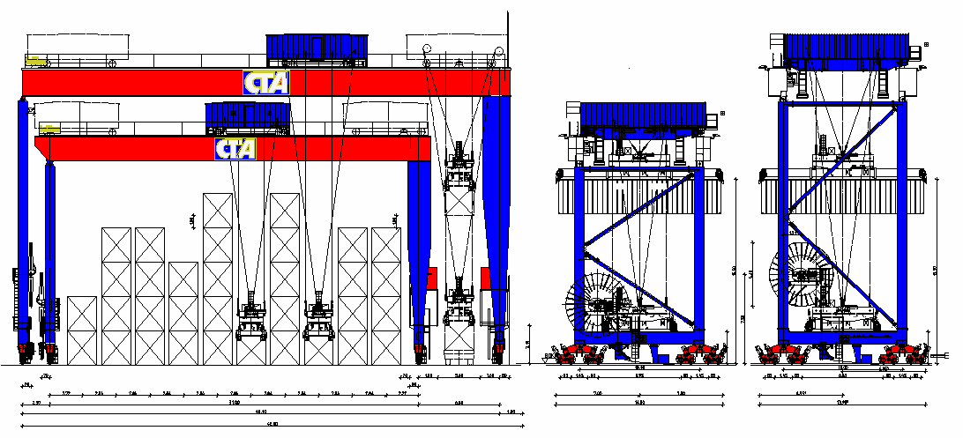
Figure 4-4: Passing cranes configuration

The smaller crane has the same characteristics as the cranes of the no passing configuration, only the large one is a little slower. The exact crane specifications are given in Appendix C. The transport position of the spreader is the same as compared to the smaller one. The cranes cannot pass each other under all conditions. Before a passing movement can be performed the trolley of the large crane needs to be moved to the far end side. Only when the trolley is in this position the large and small crane can pass without colliding. In the picture we see that the large crane is able to serve an AGV in the lane besides the block. This is not possible in the simulation model. So in the model this space is lost.

Conceptual model passing process

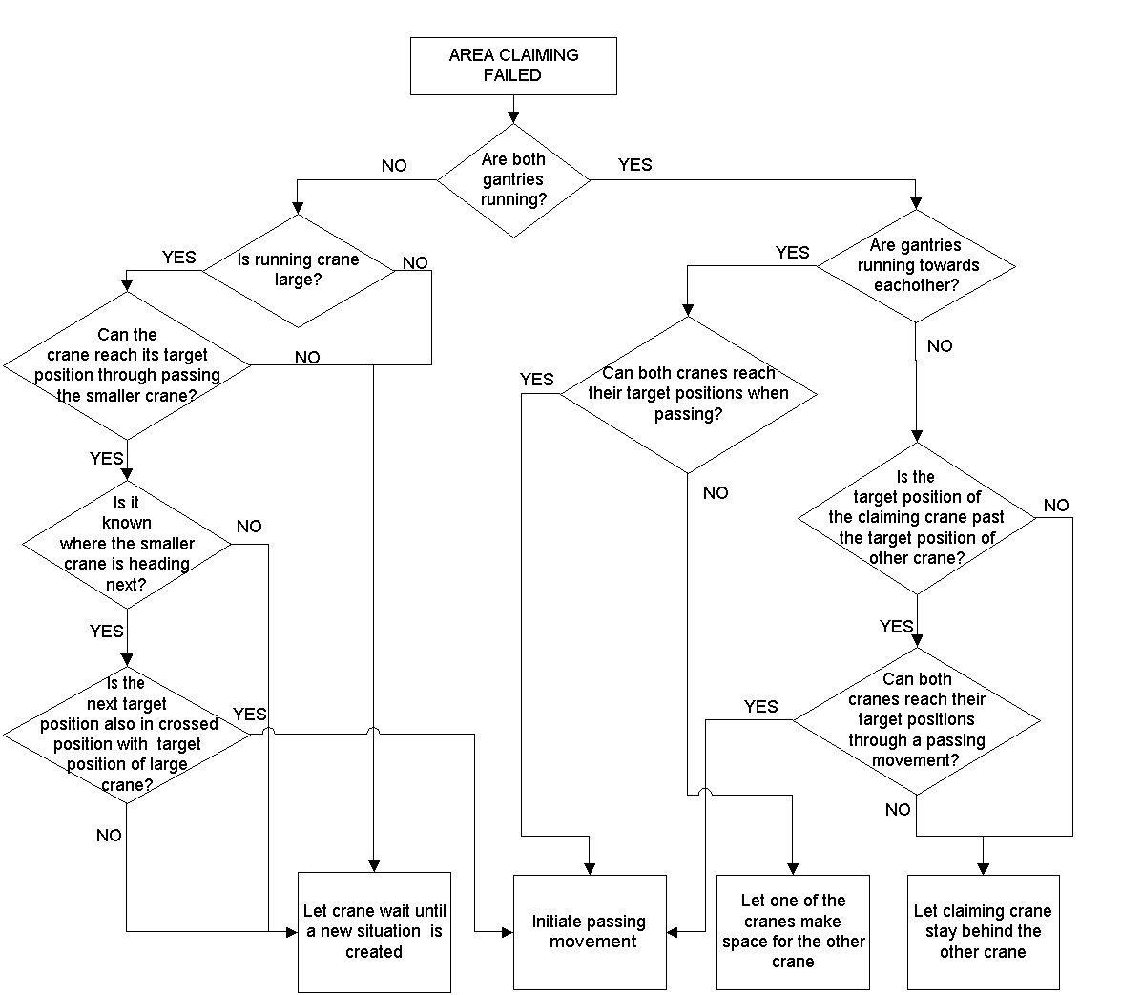
In the new model the cranes can pass each other. But when interference of the two cranes appears passing is not always an option. The situations where passing is not an option can be described in two cases. The first case is where it technically is not possible because some circumstances need to be met before passing can be initiated. E.g. when the large crane is busy on picking or dropping a container, the trolley cannot be brought to the side before it is finished. So then the smaller crane just has to wait. The second case is where passing strategically is not a good option because it causes even more interference. E.g. when the small crane will move away from the large crane when it has finished the drop or pick up movements, passing can be unnecessary and cause extra interference. The schedule in Figure 4-5 shows a flow diagram of the decisions made in the model for all different cases of interference (where the blocking crane is not idle).
Figure 4-5: Decision model of passing
We will walk through one decision path, to give some extra explanation on the choices made of the case where: the running crane is the large one and the small one is standing still and busy picking up or dropping a container. The first question is if the large crane is able to reach its target position by passing. When it is located too close to the position of the small crane the answer is negative. The large crane will have to wait until the small one starts moving again or becomes idle, and a new situation occurs. When passing does make it possible for the large crane to reach its target position, we first check if passing is worth the effort. First question is if we know where the small one is going to move after being done at that position. If it is going to a position, in which it will have to pass the large one again if we decided to let the large crane pass, we let the large one just wait. We know that the small one will move away within not too much time, and are saving two passing movements. If passing does not impose further obstruction, it will be initiated. When we do not know where the small one is going next, we let the large one wait as well. Soon, when the small one gets a new order or becomes idle, a new situation is created and a better decision can be made then.

Implementation of passing in model

The implementation of passing each other has been integrated into the collision avoidance module. As long as there has not been initiated a passing movement and the trolley is not located in the passing position, the same rule holds for the passing cranes as for the no passing cranes. A distance of 19 meters should be kept, and claimed areas cannot overlap.
When the passing movement is initiated, the trolley movement to the side position is scheduled. When the trolley reaches the passing position, the collision avoidance module starts working in a different way. The area(s) claimed by the crane(s) are granted even though they conflict, because this will not lead to a collision now. So (only) during the passing the claimed areas will overlap. In the meanwhile is measured if the cranes have crossed each other and if the distance between them has become 19 meters again. When this is detected, the trolley is sent back to the normal position and the collision avoidance module starts working in the normal way again.

This mechanism does not sound too complex. But because we are dealing with a dynamic simulation model, it is very sensitive to changes like the extra trolley move and. And because the model has not built from scratch by us it takes a lot of time and patience to be able to put a finger on the difficulty. After which the next step is finding a solution for the problem. An example of a problem that we found, and the solution for it, is:

The decision to initiate a passing movement is irreversible. This means that once a passing movement is initiated, it cannot be made undone anymore. This gives some extra preconditions for the two cranes. For example, the small crane is not allowed to move away while the large crane is passing it. Problems would occur if the small crane moves away and the large crane, reaching its target position, has not passed the small crane yet. The crane is waiting for a sign that the passing movement has been completed, which is not going to come. Therefore, to make sure the completion of the passing movement will occur, the small crane is locked at a certain position so it will not start moving until the large one has passed. This position is chosen in the best possible way, depending on the situation.

Validation of the model

The existing model for the no passing cranes configuration, on which the model with the passing cranes configuration is based, has been validated extensively over the past years. Two ways have been used to validate the new model.
First Em-plant provides a 2 dimensional model of the process. By observing the 2 dimensional model, operational errors and inaccuracies can be traced. The second way is observing the output data extensively. When relatively extreme measurements are found, errors and inaccuracies can be traced when running the model again with the exact same input.
Determination of the decision model as presented before, has been formulated after an extensive testing of the model. Through this testing we have seen that it is not possible to create a decision model that takes the best decision in all different cases. Sometimes passing causes more interference in the end than when you would have waited and the other way around. The model is structured in such way that a real-time decision is made which order to carry out next. This implies that until the current order is finished, the next target is not known which makes it impossible to take into account the future movements of the two cranes. Taking into account these circumstances, the decision model as presented performs reasonably well.

Terminal configuration

Obviously rail mounted gantry cranes serve the stack yard. The QCs for waterside operations are single hoisted. Trucks deliver and pick up containers on the stack yard themselves, so no intermediary form of transport is needed. Transport between quay and stack yard is done by AGVs.

Terminal operations in simulation model

Landside operations

On the landside pick up and delivery orders of truck are generated according to a distribution with an average number given per hour.
When a pick up order is generated, a random stack is chosen as pick up location. According to the stack distribution, the location of the container that needs to be retrieved is determined. When any container is located on top of this container, the necessary shuffle moves are determined including a new slot where to put away.
When a delivery order is generated, the destination stack is determined according to workload and occupation rate of the stack. A position in that stack is determined as close to the waterside transfer point as possible on a pile where no operation is scheduled yet. Only in busy times a possible closer position is chosen.
A landside order has its due time 15 minutes after the truck enters the terminal. So a landside order and its possible shuffles are scheduled 15 minutes before the truck shows up at the transfer point of the stack.

Waterside operations

On the waterside each quay crane can do a certain number of moves determined by a pre-specified average cycle time. One AGV can be served at the time. Next to the quay crane a buffer area is situated where AGVs can wait their turn to load or unload a container.
Loading and unloading orders are distributed equally. The work for a quay crane is scheduled in advance for at least half an hour up to several hours.
For loading orders the requested containers concern containers from stack, which have to be transported by an AGV to the quay before being loaded. A due time for an AGV to arrive at the stack and a start time for the crane to start the pick up move are determined according:

- The work plan of the QC
- The expected travel time of the AGV
- The expected pick up time of the crane

The possible shuffles that have to be done to be able to retrieve a container can be scheduled in the same time. If the configuration of the stack changes such that the shuffle(s) move(s) scheduled do not coincide with the current configuration, they will be changed or a possible extra shuffle is determined.
For unloading orders the destination of the container and thus of the AGV is only determined when the container has been put on the AGV. This is done according to terms as stack occupation rate and workload on the waterside of the stacks. Only then can this order be added to the order list of the stack.

In Appendix D a flowchart is given that presents the process of crane scheduling in the simulation model.

Experiments and results

The isolated stack module

We aim to gain insight in the influence of the new configuration with passing cranes. Therefore we present experiments for both configurations under equal circumstances. Part one presents an isolated stack module in order to assess the productivity of the crane configuration only, unlinked from other container terminal processes. Part two presents the case of the different configurations functioning within container terminal processes. We assess the configurations on their attained productivity levels considering different assignment rules expressed by the terminal productivity.

Assumptions for the isolated stack module
In the isolated stack module means that no attention to other terminal processes is paid. This means that the scheduling of orders is free from restrictions as for as the overall terminal planning. Both crane configurations will get the same initial list of orders to carry out. In this way we aim to observe the behaviour of the two crane configurations only. To be able to do so, the following decisions and assumptions have been made:

- On both landside and waterside there is a peak level in workload. At any point in time, a new order is available.
- Each retrieval or storage order applies to an individual container.
- A list of orders is a generated according to stack distributions for landside and waterside orders, which are developed at TBA based on experience. It represents the characteristics of both sides, e.g. there is about 25% shuffle moves at the landside since truck arrivals are not known much in prior. So shuffles cannot be avoided by housekeeping. On the waterside though, there are only 10% shuffle moves, which represents the housekeeping moves done when a vessel arrival is known. The majority of the retrieved containers is located close to the transfer point from which it leaves. Usually it is known from which side the container will leave when arriving, and allocation will be done according to this information when possible.
The types of moves represented in this list are productive moves, shuffle moves and pre-positioning moves. The portion of pre-positioning moves is small though, since they are normally only done by the landside crane when it has no landside orders. In peak hours at the landside this will not occur so often. We do not consider housekeeping moves, since they are normally not done during peak hours.
- Every container that appears in an order of the list is directly accessible. Every container that appears in a storage order of the list can be stored in that slot. Thus orders can be scheduled in any order.
- Each container retrieved or stored can be interchanged directly at the interchange zone, where no time is lost interchanging.
- Stack sizes are equal for both stack configurations and set to 40 TEU long, 8 containers wide and 4 containers high. Only 20ft (1 TEU) containers are used, thus 40 bay positions are available in each row.

Order assignment

As stated before order assignment considers the order in which orders are carried out and by which crane. For the configuration with no passing cranes, the question by which crane is determined by its initial position, waterside or landside, since they cannot change position. For the new configuration though the cranes can be unlinked from a transfer point, both cranes are able to serve both sides.
For determination of the order in which the cranes handle the orders different heuristics can be used. As stated before, there are two aspects that are important for stack operations. First important aspect is the due time, according to the planning schedule of the terminal. Second aspect is that orders should be carried out in an efficient way. Therefore we consider two straightforward rules, which are easy to implement representing the two different approaches. They should be able to give us some insight in the behaviour of the two configurations. The two rules used are:
- Nearest due time (ND). The order that comes first in the list is handled first.
- Nearest neighbour (NN). The order of which the pick up position is closest to the current position is handled first.
First rule represents the situation where due time has the leading role but no interest is paid to efficiency. The nearest neighbour heuristic searches for an efficient assignment by reducing empty travel distance. We do not wish to completely ignore due times when using the heuristic. Knowing the setting of the stack that would be rather unrealistic. Therefore the nearest order can only be determined from the first five orders. When the cranes are unlinked from the transfer points, the cranes can carry out orders from both waterside and landside. The set of possible orders is equally determined for both cranes, and therefore set to the ten for both cranes instead of five for each crane.

Output

The main output is the productivity level, expressed in moves per hour (mph).
But besides this we are interested in another aspect, namely the delays caused by interference. A delay is defined by the difference between the realised cycle time and the minimal cycle time needed to execute the order, based on the kinematics of the crane. Whenever a crane has to decelerate, come to a stop or even turn around in order to avoid collision with the other crane, a delay is caused. Clearly any delay is time loss and undesired as well because terminal planning is mostly based on predictions of handling time. Delays can hardly be predicted, and thus undermine this planning.

Results

Results for the assignment rules were computed using the simulation model as described in chapter 4. Figure 5-1 and 5-2 give the average productivity in moves per hour, found for experiments of 24 hours each of 10 replications. The standard deviations are given between brackets in Figure 5-2.

The differences found in productivity levels for the different configurations using the same assignment rule are small. When the nearest due time is used for the order assignment, the no passing cranes outperforms the passing cranes. With 50.2 moves per hour the productivity level for the passing cranes is 2.7% lower compared to the level found for the no passing configuration. For the nearest neighbour heuristic the difference becomes even smaller. The passing configuration is still outperformed by the no passing configuration. The passing cranes configuration reaches a productivity level 1% lower than the no passing cranes.

Figure 5-1: Stack productivity for different crane configurations using the different assignment rules

Stack productivity (moves per hour) | Nearest due-time | Nearest neighbour heuristic
No passing cranes | 51.6 (0.40) | 54.9 (0.56)
Passing cranes, each crane linked to one transfer point | 50.2 (0.46) | 54.3 (0.45)
Passing cranes unlinked from transfer points | 43.7 (0.36) | 47.6 (0.74)
Figure 5-2: Average productivity (standard deviation) of isolated stack with the different crane configurations using the different assignment rules

Remarkable is that unlinking the cranes from a transfer point gives a lot lower productivities. Even when the nearest neighbour heuristic is used we see a 5% lower result compared to the productivity of the linked passing cranes using the nearest due time rule. When we compare the linked and unlinked systems of the passing cranes where the nearest neighbour used, the productivity for the unlinked configuration is 12% lower than where the crane linked to a transfer point.
For both configurations the productivity increases using the nearest neighbour heuristic, with 6.4% for the no passing cranes, 8.1% for the linked passing cranes and 8.9% for the unlinked passing cranes. The increase is the highest for the unlinked cranes. Without using the nearest neighbour heuristic both cranes will move all over the stack all the time while carrying out orders. Understandably a rather high decrease of empty travel distances can be reached using the heuristic.
Figure 5-3 shows the averages found for the properties of delay in the different experiments. They can give us some more insight in the behaviour of productivity levels discussed before. When carrying out orders according to the earliest due-time rule, the average delay found for the no passing cranes is quite a bit lower (2.7 seconds) than for the linked passing cranes. This explains the higher productivity level found. The cranes suffer less delay thus more orders can be carried out.

 | Average delay properties
Crane configuration/ assignment rule | Delay per order (s) | Standard dev.(s) | Max. (s) | Orders delayed (%)
No passing cranes / ND | 5.7 | 21.0 | 239 | 11.0
Passing cranes, linked / ND | 8.4 | 22.0 | 190 | 18.0
Passing cranes, unlinked / ND | 16.6 | 27.6 | 210 | 41.7
No passing cranes / NN | 6.75 | 30.2 | 368 | 10.4
Passing cranes, linked / NN | 7.34 | 21.2 | 199 | 15.8
Passing cranes, unlinked / NN | 24.6 | 42.0 | 318 | 42.4
Figure 5-3: Average properties of delay for different crane configurations using the different assignment rules

The average maximum delay found for the no passing cranes is much higher. The percentage of orders delayed is higher for passing cranes in general, which can be explained by the fact that when the larger crane has passed the smaller one, passing has to be repeated to return to its transfer point. Only when the larger one is able to move its trolley to the side without having to slow down, no delay is caused, which in many cases is not the case. A lower maximum is found though. Observing the crane’s behaviour teaches that larger delays are mostly occurring when some serious hindering takes place, for which the passing cranes are not so sensitive, since they, in most cases, will be able to pass the hindering crane.
When the nearest neighbour heuristic is used for order assignment, the average properties of delay do not differ so much for the passing cranes as compared to the nearest due time rule; the average delay shows a slight decrease. For the no passing cranes though, both the maximum delay and standard deviation increase both with about 50%. This explains the decrease of the difference in the productivity levels. We presume that this increase is caused by the fact that with this assignment rule, when hindering occurs, the hindering crane will keep hindering because of processing an order located nearby.
To observe better the behaviour of the delays Figure 5-4 and Figure 5-5 present the delays that have occurred during two arbitrary simulation runs for the two configurations.

What we observe is that the delays are more spread out for the no passing cranes configuration as compared to the passing configuration especially when the nearest neighbour rule is used.

Figure 5-4: Delays measured during an arbitrary simulation run with the nearest due-time rule

Figure 5-5: Delays measured during an arbitrary simulation run, using the nearest neighbour rule

Rather extreme delays, between 100 and 300 seconds, are found for the no passing cranes. But a higher number of small delays is found for the passing cranes. These can be explained by the situation where the trolley movement of the larger crane to the passing position cannot be done during the gantry movement. This means that the gantry needs to slow down or even stop to finish the trolley movement, thus a delay for the gantry.

Extra experiment

Increased number possible orders for nearest neighbour.
As stated before, choosing the nearest neighbour out of 5 orders seems a rather small number. To see if increasing this number has a great influence on the results, we performed an experiment where the nearest order is chosen out of the first 6 orders. Figure 5-6 shows the results found for both cases.
Figure 5-6: Stack productivity using the nearest neighbour rule, selecting nearest of the first 5 or 6 orders

An increase in productivity levels can be seen for both configurations, although very small. The increase is 0.02% and 0.07% for the no passing and passing cranes respectively.

Stack productivity (moves per hour) | Nearest neighbour (5) | Nearest neighbour (6)
No passing cranes | 54.9 (0.39) | 55.0 (0.36)
Passing cranes, linked | 54.3 (0.45) | 54.7 (0.37)
Figure 5-7: Stack productivity (standard deviation)

The difference in productivity for the two different configurations increases.
From the properties in delay as shown in Figure 5-8, we observe that the average delay increases for the no passing cranes and decreases for the passing cranes which results in an equal average. The standard deviation for the no passing cranes increases again. The maximum delay on average has increased to 494 seconds.

 | Average properties delay
Crane configuration/ assignment rule | Delay per order (s) | Standard dev.(s) | Max. (s) | Orders delayed (%)
No passing cranes / NN (5) | 6.75 | 30.2 | 368 | 10.4
No passing cranes / NN (6) | 7.14 | 33.8 | 494 | 10.7
Passing cranes, linked / NN (5) | 7.34 | 21.2 | 199 | 15.8
Passing cranes, linked / NN (6) | 7.14 | 21.4 | 210 | 15.0
Figure 5-8: Average properties of delay using the nearest neighbour rule, selecting nearest of the first 5 or 6 orders

Entire terminal operations

We aim to assess the new configuration of passing cranes on their performance and behaviour. Within terminal operations performance is determined by the productivity of the QCs and at the same time the ability to reach acceptable service times for landside operations. In this part we will present some order assignment concepts developed for the passing cranes configurations and compare them for different aspects.

Model assumptions

Before we will further discuss the assignment concepts and experiments we will first present the assumptions and decisions made for the entire terminal model.

Operational assumptions:
- Every loading order for waterside, and pick up order on landside is located in the stack yard.
- Every container unloaded from a truck or a ship is placed in stack.
- The AGV assignment is done in such way, supporting the QCs load and unload plans.
- Loading a ship is done according to a fixed sequence.
- The cranes and AGVs are in operation all the time, no breakdowns occur.
- No housekeeping moves are done during the experiments. Since housekeeping moves are only done in quiet times and the experiments cover high workloads, they will not occur.
- A pre-positioning move is only done when no order could be processes from the order list. Only containers that are located over 9 bays from the waterside transfer point are considered for pre-positioning and moved to a bay closer to the transfer point.
- When a crane has started a particular move, productive, shuffle or pre-positioning, this move has to be finished. This means that a move cannot be interrupted; assignment is irreversible.
- The crane that starts initially on the waterside, crane 1, is the smaller crane. Crane 2 that starts initially on the landside is the larger crane. The smaller crane is faster and therefore chosen to be on the waterside.

Parameter specification:
- The stack yard consists of 8 stacks, each 10 wide, 40 TEU long and with a possible stacking height of 4 containers.
- Initial stacking filling rate is 70%. The initial stack is equal for all experiments.
- All transfer points at both ends of the stack contain 4 lanes for interchange with AGV or truck.
- Interchange between the crane and trucks takes 30 seconds. Between the crane and AGVs interchange takes 10 seconds.
- QCs have an average cycle time of 90 seconds.
- The ratio of pick up/delivery orders for trucks is 0.5.
- The ratio of load/unloading moves for the waterside is 0.5.

Order assignment

The problem of order assignment to the cranes within a stack operating in a terminal needs a different approach then we have seen before in the isolated stack. A few earlier mentioned aspects have to be taken into account now of which the most important is the loading sequence of containers at the QCs. But also the unloading orders on the waterside are important, because it frees an AGV to process a new order.
To come to an effective assignment and prevent deadlocks, a form of synchronisation to the planning of the AGVs that follows the sequence of QCs load plans, has to be done. To support this, first a selection of orders is made that can be considered as possible next order excluding the ones that should not be assigned yet. This is done according to the following rules:

- Only the load and unload orders on the waterside are considered that will be picked up or delivered within 10 minutes.
- When more than one order for a QC is available, only the order for that particular QC coming first in sequence is considered.
- A landside order is only considered when the truck has arrived.
- When there is an unload order arriving on the waterside, and all the loading orders for the waterside listed are not assigned yet to an AGV, no loading order may be done.
- If there is a loading order available that has been assigned to an AGV, no loading order is selected that is not assigned to an AGV.
- When a loading order still needs a shuffle to be done before it can be retrieved, only the first shuffle is selected.

Extra rule for the case that both cranes can serve the transfer point:
- When the other crane is doing a waterside order, this crane is only allowed to do a waterside order if the container of the other crane has been assigned to an AGV. Because only then it is certain that the transfer point will become free in a short while.
After this selection the following three cases are possible:

- When no order left to do: there is checked if a pre-positioning can be done.
- When only one order left: this order is processed.
- When more than one order left: one order needs to be chosen and assigned to the crane. This is done according the chosen assignment concept.

Assignment concepts

The assignment concepts are kept simple, to come to a quick implementation. We are not aiming for optimising the assignment, but to get some insight in the influence of different approaches of order assignment for passing cranes on the terminal performance. The following three assignment concepts have been implemented:

Linked cranes (linked DT)
In this concept the same approach is used for the assignment as is used for the no passing cranes in the existing model. Both cranes stay linked to a transfer point. Both cranes carry out the shuffle moves, but the landside crane has priority to do them. Main factors in assignment are due times. Decreasing empty travel distances is not tried.

Unlinked cranes (unlinked NN)
The second approach is to unlink the cranes from a transfer point, so they can serve both waterside and landside transfer points. This makes each order executable for each crane. To deploy the cranes in an efficient way though next to due times, empty travel distance is an important factor in assignment.

Waterside support (linked SUP)
In general, waterside moves are considered more important than landside moves. With the passing cranes configurations both cranes are able to execute waterside orders, but only one crane at the time. We consider a support concept where crane 1, stated as the initial waterside crane, will only do waterside orders, including waterside shuffle moves and crane 2, as stated the initial ‘landside crane’, has a supporting role on the waterside when no urgent landside orders are available. Only when an order is not very urgent in time, the empty travel distance becomes an important factor.

How the different concepts are expressed in the simulation model is explained in Appendix E.
To make a sound comparison the different assignment concepts are assessed using two different scenarios:

- The first scenario represents a regular but busy operation. There is a constant full maximum demand on the waterside of 40 moves on average per hour per QC. The demand on the landside for the 8 stacks consists of an average of 20 trucks per hour.
- The second scenario represents peak level, where demand on both waterside and landside of the stacks is high. QCs are set on a constant full demand of 40 moves on average per hour. The arrival rate on the landside is on average 80 trucks per hour.

The number of AGVs used has a large influence on the performance of the waterside operations. The more AGVs the more containers can be assigned and transported at the same time. They are expensive though and an increase of AGVs makes collision free routing harder. Therefore we have varied the number of AGVs between 4, 5 and 6 AGVs on average per QC for a further comparison.

Output

The main output is the terminal performance expressed in QC productivity (mph). In stack productivity the productive moves, express the containers that have been handled at the transfer points, and are therefore a direct translation of the QC productivity. But since the different systems, using the different crane configurations and assignment concepts handle the loads differently, we find it interesting to observe the work distribution within the stacks.

Results

All experiments are done under the same circumstances except for the order assignment for the cranes. Therefore the average results found are due to the different assignment concepts.
The results of experiments with the existing model for cranes that cannot pass are used as a benchmark. The results for the different assignment concepts for passing cranes are compared with this benchmark.
Each simulation run contains 8 hours of simulation. The first hour is used as start up time and thus is not considered in the results. For each experiment 8 runs are done from which the following average results are obtained.

Appendix F shows the view of the simulation model when running.

QC productivity

Figure 5-8 and 5-9 show the average QC utilisation and the net productivity levels achieved on average for the QCs for the low landside workload, Figure 5-10 and 5-11 for the high landside workload. Between brackets the standard deviations are given.
Figure 5-8: QC Utilisation with low landside workload

The differences found in performance are very small, but they show some tendencies. The passing cranes using the unlinked NN concept or linked SUP concept slightly outperform the no passing cranes independent of the number of AGVs available. They also outperform the linked DT concept independent of the number of AGVs. With an increasing number of AGVs, the productivity level rises for all concepts. With the maximum number of 6 AGVs, the unlinked NN concept outperforms the linked SUP concept. The linked DT concept performs the worst in productivity level achieved on average.

Net QC productivity  (Low landside workload) | Number of AGVs per QC
Net QC productivity  (Low landside workload) | 4 | 5 | 6
No passing | 30.7 (1.75) | 32.8 (0.91) | 35.3 (0.91)
Passing / linked DT | 29.8 (0.68) | 33.4 (1.25) | 34.5 (1.65)
Passing / unlinked NN | 30.8 (0.66) | 34.1 (1.04) | 36.6 (1.07)
Passing / linked SUP | 31.0 (0.84) | 34.6 (0.92) | 36.0 (0.81)
Figure 5-9: Net QC productivity with low landside workload
The differences found in productivity for the higher landside load scenario are small too.
Figure 5-10: QC Utilisation with high landside workload

The linked SUP concept comes across as the performing the best. Also in this scenario the passing cranes using the unlinked NN concept or linked SUP concept outperform the no passing cranes independent of the number of AGVs available. They also outperform the linked DT concept independent of the number of AGVs although the linked DT concept seems to perform slightly better, relatively to the other configurations, than in the scenario with the lower landside demand.

Net QC productivity  (High landside workload) | Number of AGVs per QC
Net QC productivity  (High landside workload) | 4 | 5 | 6
No passing | 28.2 (1.51) | 32.7 (1.35) | 34.0 (1.28)
Passing / linked DT | 29.0 (1.07) | 32.2 (1.56) | 34.6 (1.77)
Passing / unlinked NN | 29.8 (0.66) | 33.5 (1.07) | 35.0 (0.84)
Passing / linked SUP | 30.7 (1.09) | 33.8 (1.07) | 35.8 (0.81)
Figure 5-11: Net QC productivity with high landside workload

With this higher landside demand scenario, the unlinked NN concept does not outperform the linked SUP concept anymore, when having 6 AGVs. We expect that the high demands on both sides make the cranes travel a lot, which results in the relatively lower performance.
The standard deviations found are small. No real tendency can be found in the values.
Distribution of work within stacks.

The distribution of work within the stack is how the loads are handled (by which crane). In each configuration this is done differently. The presented results are the average numbers found when having 24 AGVs in the system, so when the maximum productivity is reached.
Figure 5-12: Stack productivity considered per crane under low landside workload

Figure 5-12 shows the productive moves, which determine the productivity of the stack. Indeed they show a direct translation of the QC performance in the waterside performance of the stacks. The differences per stack are small.

Productive moves per hour  (Low landside workload) | Stack side
Productive moves per hour  (Low landside workload) | Landside | Waterside
No passing | 2.6 | 17.8
Passing / linked DT | 2.4 | 17.2
Passing / unlinked NN | 2.5 | 18.5
Passing / linked SUP | 2.5 | 18.2
Figure 5-13: Productivity cranes per stack side

We see the landside crane gain in the passing linked SUP system (5 productive moves on the waterside average per hour) compared to the landside cranes of the no passing and linked NN systems. But the waterside crane has to give in on the productive moves. Therefore on the average, the total waterside moves do not differ so much.
Figure 5-14: Non productive moves carried out per crane

Then Figure 5-14 shows the rest of the moves carried out by the cranes, the non-productive moves. It shows for the linked configurations, the no passing cranes and linked DT concept for passing cranes, a lot of pre-positioning moves for the landside crane (crane 2). This is explained by the fact that the landside crane has a low workload and the only way to support the waterside doing a lot of pre-positioning. In the unlinked NN and linked SUP concepts both cranes together also perform a lot pre-positioning moves, which they still do when no productive move can be done on the waterside.
In Figure 5-15 we see the average work done, per crane in each system. It can be seen that in the unlinked NN concept and the linked SUP concept the workload can be much better spread out over the two cranes (landside crane can do more).
Figure 5-15: Distribution of moves in stack
The distribution in the productive moves for the higher landside workload looks familiar to
Figure 5-16: Stack productivity considered per crane under high landside workload

the one we have seen for the case with a low landside load. The higher landside load has led to a decrease in support of the landside crane to the waterside in the linked SUP concept. It is too busy to give much support.

Productive moves  (High landside workload) | Stack side
Productive moves  (High landside workload) | Landside | Waterside
No passing | 10.2 | 17.1
Passing / linked DT | 10.3 | 17.6
Passing / unlinked NN | 10.3 | 17.6
Passing / linked SUP | 10.0 | 18.0
Figure 5-17: Productivity cranes per stack side

In the distribution of the non-productive moves, as shown in Figure 5-18, we see an overall decrease in the number of pre-positioning moves compared to the low landside load scenario, especially for the cranes that are not linked to a transfer point. The cranes carry out more productive and rehandle moves for the landside, so that hardly any time is left to do any pre-positioning moves. The proportion pre-positioning moves for the landside crane of the linked systems is still bigger than for the other systems. For the other systems the pre-positioning has almost completely disappeared and is replaced by the extra number of productive moves and rehandles for the landside.
Figure 5-18: Non productive moves carried out per crane

With the higher workload on landside, the inequality in workload for the cranes has almost disappeared. Figure 5-19 shows that now in all the different systems the workload is divided quite equally over the two cranes.
Figure 5-19: Distribution of moves in stack
Truck service times

The truck service times, as shown in Figure 5-20 and Figure 5-21, show a few tendencies. Pick-up averages are higher than delivery averages, which can be explained by the extra time that is
Figure 5-20: Truck handling time averages, with a low landside workload
Figure 5-21: Truck handling time averages, with a high landside workload

caused by shuffle moves when they are not done yet at arrival of the truck. For all systems the averages rise with an increasing workload. An increase is seen for the passing cranes compared to the no passing configuration. The service times reached by the linked DT concept come closest to the service times of the no passing configuration. Landside operations seem to suffer when both cranes can serve both transfer points. But the average handling time is still within 5 minutes, which is very acceptable.

Extra experiments

To get more insight in the behaviour of the different systems, some extra experiments have been done. For these experiments we only present the results found for the stack performance, thus the QC productivity and truck handling times.

Increased workload
Terminals are dealing with an increase of containers to be handled. Although the workload we have used in the scenarios is seen as high, workload for stacks in the future is expected to increase. Therefore we have done an extra experiment to see how two different systems are able to deal with this increase. We present a comparison between the best performing passing cranes concept, the linked SUP concept, and the no passing cranes configuration.
Instead of 8 stacks, 7 stacks are simulated with the high workload on both water and landside. The initial stack filling is equal for both systems. The following results are obtained.

Figure 5-22: QC Utilisation with a higher workload
The passing cranes configuration again outperforms the no passing configuration on the waterside operations, with about the same rate. Figure 5-22 shows an about 4% better QC utilisation is reached. Figure 5-23 shows that compared to the lesser workload experiments, with 8 stacks, the QC productivity decreases, especially when the number of AGVs increases. Where 6 AGVs are used per QC the decrease is about one move per hour.

Net QC productivity | Number of AGVs per QC
Net QC productivity | 4 | 5 | 6
8 stacks
No passing | 28.2 (1.51) | 32.7 (1.35) | 34.0 (1.28)
Passing / linked SUP | 30.7 (1.09) | 33.8 (1.07) | 35.8 (0.81)
7 stacks
No passing | 28.4 (1.15) | 31.7 (1.45) | 32.9 (1.15)
Passing / linked SUP | 30.4 (1.13) | 33.0 (0.58) | 34.6 (0.78)
Figure 5-23: Net QC productivity for the increased and earlier workload

For the landside operations of the no passing configuration, the truck handling times show a very small increase compared to those found with the lower workload (see Figure 5-21). For the passing configuration though, the truck service times show a bigger increase. In more occasions the waterside will be supported which leads to a lesser service at the landside.
Figure 5-24 Truck handling time averages, with a higher landside workload

Stack surface
Most terminals in Asia and Europe are dealing with a lack of space. The passing cranes configuration takes more space in width (42.5 m) than the no passing configuration (36.0 m). Thus in terms of stacking surface, less stacks with the passing cranes configuration can be used compared to the no passing crane configuration. Therefore we present a comparison where the stack surface is taken into consideration. We present a comparison where 8 stacks (288 m) are used for the no passing cranes configuration and 7 stacks (297.5 m) for the passing cranes configuration with the linked SUP concept. We note that this is not completely a sound comparison. The resulting surfaces are not equally sized, and the number of AGVs per stack is different for the different stack configurations. Next to this, we consider the less stack capacity to be lost. However this can give us an idea in performance.
Figure 5-25 and 5-26 show the QC utilisations reached for the two different configurations under the different landside loads.
Figure 5-25: QC Utilisation when taking into account the stack surface, with a low landside workload

Figure 5-26: QC Utilisation when taking into account the stack surface, with a high landside workload

The passing cranes still achieve a higher performance on the waterside in most cases, even when dealing with the same workload with 14 cranes instead of 16. Only when having a lower landside load and 4 AGVs per QC this is not the case. The difference though, when performing better, has decreased.

Net QC productivity | Number of AGVs per QC
Net QC productivity | 4 | 5 | 6
(Low landside workload)
No passing (8 stacks) | 30.7 (1.75) | 32.8 (0.91) | 35.3 (0.91)
Passing / linked SUP (7 stacks) | 29.8 (1.13) | 33.6 (0.58) | 35.7 (0.78)
(High landside workload)
No passing (8 stacks) | 28.4 (1.15) | 31.7 (1.45) | 32.9 (1.15)
Passing / linked SUP (7 stacks) | 30.4 (1.13) | 33.0 (0.58) | 34.6 (0.78)

Figure 5-27: Net QC productivity when taking into account the stack surface

For the truck handling times, Figure 5-28 and 5-29 show the difference for the two configura
Figure 5-28: Truck handling time averages, with a low landside workload

tions, the difference has become bigger. The higher workload for the passing cranes, compared to the no passing configuration, is expressed in the higher handling times for the landside.

Figure5-29: Truck handling time averages, with a high landside workload
Large crane operating on the waterside instead of the landside

For the foregoing experiments we decided that the crane (initially) working on the landside, is the larger one. The larger crane is a bit slower than the smaller and therefore chosen to be working on the landside transfer point. To see if this decision has any influence on the stack performance, an extra experiment is done, where the waterside crane is the slower and bigger one and the landside crane the faster and smaller one. We consider that a possible difference will only be found when the cranes are linked to a transfer point. The following results are conducted using the linked SUP concept.
Figure 5-30: QC Utilisation for the two different combinations of cranes with a low landside workload
Figure 5-31: QC Utilisation for the two different combinations of cranes with a high landside workload

The differences found in waterside productivity are minimal. In general the combination that was used first, performs slightly better.

Net QC productivity | Number of AGVs per QC
Net QC productivity | 4 | 5 | 6
Low landside workload
Large crane on waterside | 31.0 (0.84) | 34.6 (0.92) | 36.0 (0.81)
Large crane on landside | 30.4 (1.81) | 34.3 (0.69) | 36.1 (0.56)
High landside workload
Large crane on waterside | 30.7 (1.09) | 33.8 (1.07) | 35.8 (0.81)
Large crane on landside | 30.9 (1.09) | 33.5 (0.69) | 35.5 (0.48)
Figure 5-32: Net QC productivity for the two different combinations of cranes with a high landside workload

In Figure 5-33 and 5-34 the truck handling times are shown. Again the differences are minimal for the both combinations. With the high landside workload, the handling times on average are even equal.

Figure 5-33: Truck handling time averages, with a low landside workload

Figure 5-34 Truck handling time averages, with a high landside workload

Concluding Remarks and further research

This research has been initiated to study the new configuration where cranes can pass each other. We started with the question:

What is the influence of the passing cranes configuration on the performance of the stack yard compared to the no passing configuration?

The results found through the simulation study, using the presented assignment rules, give rise to the following answers:

- The passing cranes configuration is performing slightly worse than the no passing configuration, when we observe the productivity of a stack independently from the other terminal operations. The difference is minimal though.
- With the passing cranes operating in the entire terminal an overall better performance on the waterside operations can be achieved. Then the landside handling time increases a bit.

Beside these answers, conducting the simulation study has given us further insight in the following operational issues:

- Since the trolley of the bigger crane needs to be brought to the side to be able to pass the other crane, in most cases time is lost when this movement cannot be carried out without disturbing the gantry movement. Therefore passing leads to an increase of small delays compared to the no passing cranes. The extreme delays that occur in the no passing configuration because of hindering of the two cranes decrease though.
- Passing cranes gain in flexibility, since both cranes are able to serve both sides. The assignment concepts for the stacks in the full terminal operations have shown that when using this flexibility, the system with passing cranes is better able to spread the workload over the two cranes. Workloads on the different transfer points fluctuate. In the no passing configuration the landside crane can only support the waterside by pre-positioning containers and doing the shuffles. In the passing configuration, as productive moves can be done by both cranes, the landside crane can give support in productive moves as well which makes the system with passing cranes able to support a higher workload on the waterside. For the landside operations though, this means that the former landside crane is not dedicated anymore to the landside only, which causes a bigger chance that the crane is occupied or has to come from far, which leads to a higher response time on average. The increase that we found in truck service times though, was around 1 minute only, which considering the time a truck spends in the terminal is not too much.
- Performance can be gained by decreasing the empty travel distance. Although the sequence of loading and arrivals of AGVs must be considered during assignment, there are cases that time can be spared through prioritising orders of which the pick up location is close to the current location of the crane. For the no passing cranes though, this can sometimes lead to an increase of hindering when the selecting of a close location makes that crane keep on hindering the other crane. With the passing cranes configuration in most cases this will be overcome by a passing the other crane.
- The concept where each crane is dedicated to a transfer point and the former landside crane gives support to the waterside crane when needed, performed best on average. From the moment the landside crane carries out productive moves for the waterside transfer point, hindering the waterside crane is insuperable working on the same area. But still an advantage is found in the resulting productivity. The disadvantage of hindering and so time-loss occurring clearly is overcome.
- The concept of unlinking the cranes, letting both cranes serve both transfer points, performed the worst in the isolated stack module. In the entire terminal operations though, good results were found. As stated before workloads on the transfer points are fluctuating, which was not the case in the isolated stack module. Especially when the average workload is much higher on one transfer point, the unlinked concept gives the opportunity of mutual support and decrease of travel distance. When the workloads on both transfer points are high on average, more travelling and passing has to be done, which causes more time-loss and a lesser performance.

We presume the following:

- A further gain in performance can be achieved elaborating on the assumed assignment concepts, when a better collaboration of the two cranes can be achieved. As modelled in the simulation model the decision to execute a certain order is done real-time for each crane individually. For the no passing configuration, where both cranes have their own individual source of orders to carry out, making this decision individually does not affect the performance really. But with the new passing configuration, where both cranes can draw on the same source of orders, the decision to carry out a certain order should take into account the other crane’s actions to come to a real collaboration. E.g., when the waterside crane is working on a loading order, should the landside crane then support the waterside by carrying out an urgent unload order and travel all way up to the waterside transfer point? When the waterside crane has soon its order finished, it will be at the transfer point already and it can do the unload order without loosing any time by travelling and the answer is no. On the other hand, if the waterside crane is still travelling to the pick up position of the container and if it is located far from the waterside transfer point, it could take quite some time before it will be able to do the unload order. Then it might be better to let the landside crane give some support, and the answer is yes. Taking a decision without considering at all the current status and position of the waterside crane does not lead to a full utilisation of the potential of collaboration.

There are few issues that we would like to propose for further research:
- Additional research should be done for crane assignment. The proposed assignment concepts have given us more insight in the impact of different approaches on the stack performance but do not cover the full potential of collaboration of the two cranes. E.g. further research could be carried out to see how the state and position of the other crane could be integrated in the assignment rules to further optimise the terminal performance.
- This study only focuses on terminal operations where transport between QCs and stack yard is done by AGVs. When this is done by another type of equipment that is able itself to put down or pick up a container by itself, a new situation occurs at the transfer points. Then the dependency between crane and vehicle disappears, which gives more freedom in order assignment. Further research should be conducted in assignment concepts for the passing cranes configuration in this terminal configuration, to see the effect on the terminal performance.
- The extra lane for AGVs to drive and interchange containers with the large crane has not been implemented in the model. The implementation of this extra interchange zone gives rise to questions like when to interchange at the waterside transfer point and when at the transfer lane. How to control efficiently cranes and AGVs.
- For the assignment of the no passing cranes, research could be done in the problem of prioritising moves. In the current assignment concept, the approach is to avoid hindering. We propose an approach where priority rules decide in case of hindering which crane gives way to the other crane. An idea could be to give priority to a productive move over housekeeping or pre-positioning moves.

Thus summarising the passing cranes configuration has advantages and disadvantages compared to the no passing configuration. The biggest advantage is flexibility in assignment, which results in better waterside performance. Also the passing cranes gain in reliability. Disadvantages are the complexity it gives to utilise the flexibility in an efficient way and the significant loss in stacking capacity. A cost-benefit analysis must be conducted to give insight on the financial aspects of the two crane configurations.

Bibliography

- Armadillo Marine Consultants, Containerisation, http://amchouston.home.att.net.
- Chin-I. L., Jula H., Ioannou P.A., Design, simulation and evaluation of automated container terminals, IEEE Transaction on intelligent transportation systems, vol.3, no.1, 2002
- Duinkerken M.B., Evers J.J.M, Ottjes J.A., A simulation model for integrating quay transport and stacking policies on automated container terminals, Proceedings of the 15th European Simulation Multiconference Prague June 2001.
- Egyedi T. M., The standardized container: Gateway technologies in cargo transportation, for the Helsinki Workshop on Standardisation and Transportation, Helsinki 1996.
- Hartmann S., A general framework for scheduling equipment and manpower at container terminals, preprint of an article to appear in OR Spectrum 26, 2004.
- Hekman J.A.C., Key design factors maritime container terminals, Master’s thesis, 2001.
- Kim K. Y., Kim K. H., Heuristic algorithms for routing yard-side equipment for minimizing loading times in container terminals, Naval Research Logistics, 50 (5), 498-514 (2003)
- Kozan, E. (1997b) Comparison of analytical and simulation planning models of seaport container terminals. Transportation Planning and Technology 20(3), 235-248.
- Kozan, E. and Preston, P. (1999) Genetic algorithms to schedule container transfers at multimodal terminals, International Transactions in Operational Research, 6.3, 311-329.
- Meersmans P.J.M., Dekker R., Operations research supports container handling, 2001.
- Meersmans, P.J.M., Wagelmans, A.P.M., Dynamic scheduling of handling equipment at automated container terminals, Econometric Institute Reports, 2001.
- Vis, I.F.A, Planning and control concepts for material handling systems, Ph. D. thesis, ERIM Ph. D. Series Research in Mangement 14, 2002.
- Wang S.J., Kim K.H., Park Y.M., Yang C.H., Bae J.W., A simulation study on operation rules for automated container yards, draft version, 2003.
- Zhang C., Wan Y., Liu J., Linn R.J., Dynamic crane deployment in container storage yards, Volume 36, Issue 6, Pages 537-555, 2002.

Appendices
Appendix A
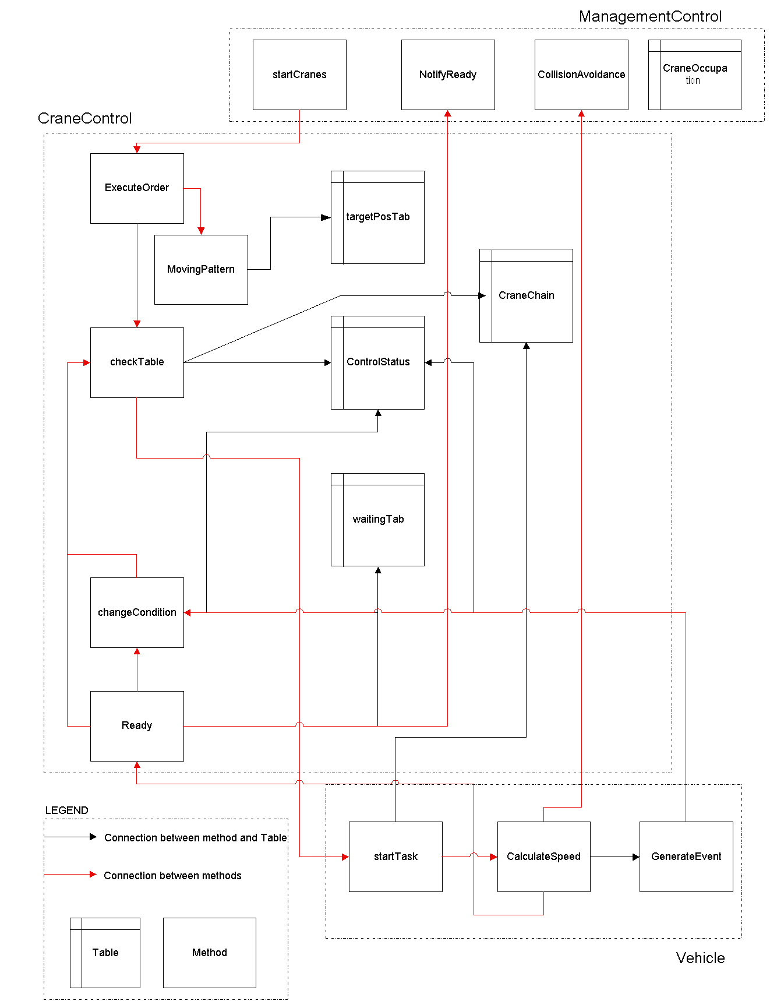
In Figure A-1 is the basic structure shown of the most important methods and table files as used in the crane model. Then a plain description how they function is given.

Figure A-1 Important methods and tables in crane model and their relations
When a crane is started in startCranes, through executeOrder the movingPattern is determined and written in table TargetPosTab. In this table each line consists of a description of a particular movement for a vehicle, listed in the order of execution. Each line (and so movement) contains a table where the preconditions of that particular movement are noted. To start the crane, for each vehicle checkTable is called, where is checked in table ControlStatus if all the preconditions for this particular action are fulfilled. If this is true, startTask of that vehicle is being called where a loop for CalculateSpeed is started that manages the movement of the vehicle dynamically. If it is not the case, the vehicle is set to wait in table WaitingTab. When the status of a precondition changes during movement, it is changed in the table ControlStatus through GenerateEvent . In changeCondition is checked if changing this precondition makes another movement of a waiting vehicle possible, which can be started by calling checkTable. When a movement is ready, through Ready the next movement of that vehicle is scheduled by calling checkTable. If the preconditions of that movement have not been satisfied yet, the vehicle is set to wait. Every time a vehicle is started is updated with which number of sequence, that belongs to a particular movement, the system is dealing. This sequence is registered in table CraneChain and enables the system to recognise movements and to control the sequence.

Appendix B

Full description of the functioning of collision avoidance in the crane model, with the two cranes called crane A and crane B.

- If crane B is moving towards crane A, and the claimed areas are in conflict, it means that it is not possible for both cranes to reach their target positions at the same time. One of the two cranes has to make space for the other crane so that it can reach its destination. If it needs to turn around for this, it will first get the area granted needed to stop. When this movement is finished, a new movement the other way will be started. If it can go on, it will get the area granted up until the front boundary of the granted area of the other crane.
Which crane gets priority, depends on the strategy used. The strategy formally used was first claims first, so the crane that claims an area first, will get it. The strategy we have implemented is to minimise the hindering, which means that the one, who loses the least time making space for the other, will do so.
- If crane B is moving in the same direction, and the claimed areas are in conflict, it means that crane A is ‘following’ crane B, and crane B is riding somewhere in between crane A and the target position of crane A. As long as crane A stays behind crane B there is no danger of collision. So it gets the area granted up until the back boundary of the claimed area of crane B.
- If crane B is standing still and busy, and the claimed areas are in conflict, it means that crane A can only move up until the position where crane B is standing and not any further. The granted area will be up until the back boundary of the granted area by crane B.
- If crane B is standing still and idle, and the claimed areas are in conflict, it means that crane B stands in the way. Crane B needs to make space for crane A so that it can reach its destination. The granted area will be up until the back boundary of the granted area by crane B. And a gantry movement for crane B will be started.

Appendix C

Figure C-1 and C-2 present the specifications of movement for the cranes as used in the models. As stated before the larger crane of the passing cranes configuration is slightly slower than the smaller crane. There is a difference of 0.5 ms in the maximum speed that it can reach.

 | Max. speed (ms) | Acceleration (ms⁻²) | Deceleration (ms⁻²)
Gantry | 4.0 | 0.35 | -0.35
Trolley | 1.0 | 0.35 | -0.3
Spreader | 1.0 | 0.45 | -0.35
Figure C-1: Specifications of movement of no passing crane and smaller crane in passing configuration

 | Max. speed (ms) | Acceleration (ms⁻²) | Deceleration (ms⁻²)
Gantry | 3.5 | 0.35 | -0.35
Trolley | 1.0 | 0.35 | -0.3
Spreader | 1.0 | 0.45 | -0.35
Figure C-2: Specifications of movement of bigger crane in passing configuration
Appendix D

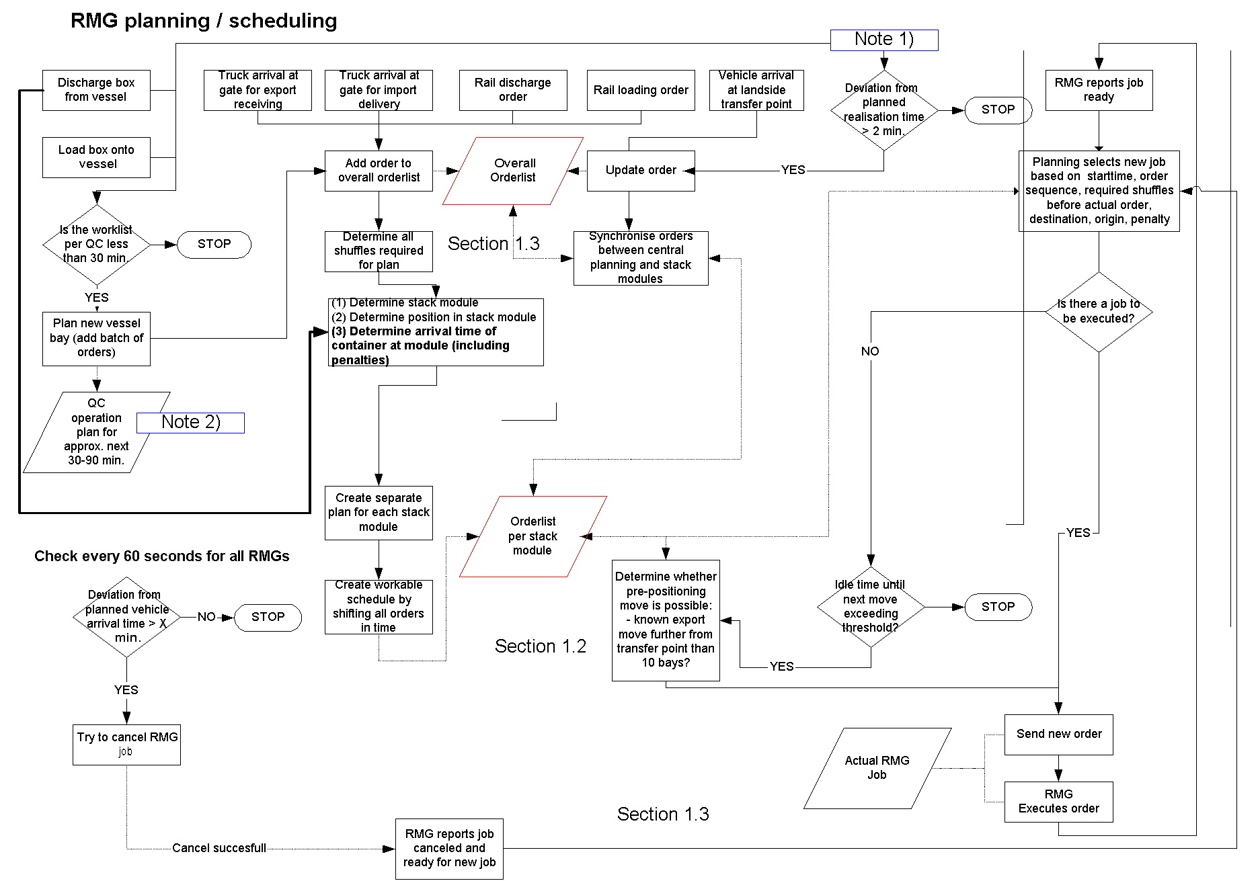
Figure D-1 presents a flow diagram for the crane scheduling as being done in entire terminal model.

Figure D-1: The RMG-planning in the entire terminal simulation model.
Appendix E

Implementation assignment concepts in simulation model

To implement the assignment concepts the same basic structure is used, expressed in Figure E-1, which is a score and penalty system. Every executable order, resulting from the selection, is scored and the order that has the highest score is assigned to the crane. Scoring is done regarding three issues:

- Urgency: concerning the due time of the order. The urgency score is set to the difference in due time and the actual time.
- Progress: concerning the state of the vehicles (AGV or truck) picking up or bringing the container. E.g., when the vehicle is arriving or waiting at the TP already, there is a progress score given to this order.
- Distance: concerning the distance between the current position of the crane and the pick up location of the scored order. The further away, the higher the penalty will be.
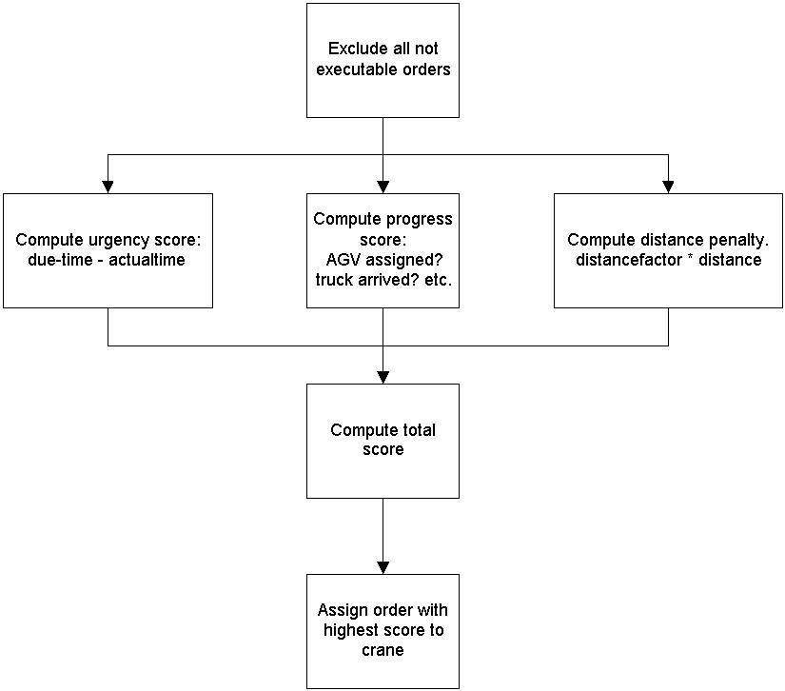

Figure E-1: The selection process of order.

In the linked cranes (linked DT) concept the score is purely obtained from urgency and progress score. In the unlinked cranes (unlinked NN) concept all three issues are scored. The distance factor is high, which gives the distance importance. In the waterside support (linked SUP) also all three issues are used. To make the landside crane do the landside orders, the progress score on the landside is high. The distance factor is only higher, for not so urgent orders.
Appendix F

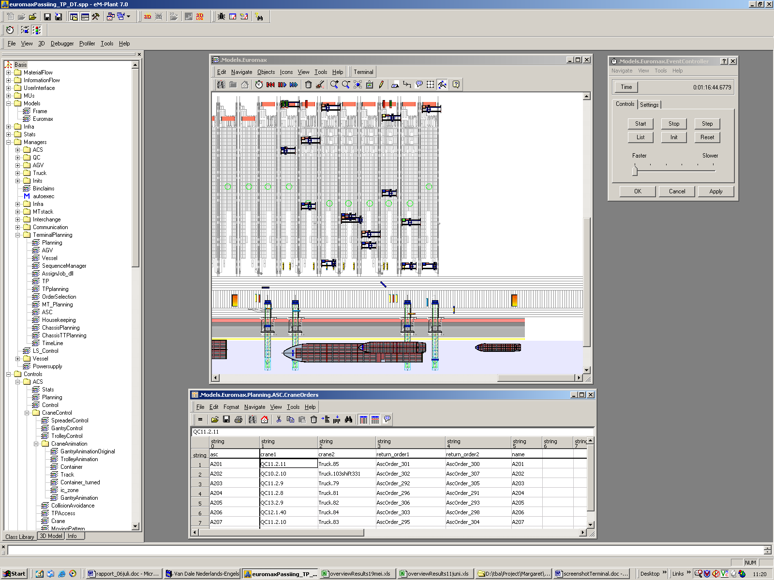
Figure F-1 shows the 2-dimensional view of the entire terminal operations while the simulation model is running.

Figure F-1: The view of the entire terminal simulation model

A small deviation was found for the minimal time computed from the realised minimal time in the model. This deviation ranged from 3 seconds shorter to 3 seconds faster on an average cycle time of 70 seconds. Therefore, since we are more interested in the longer delays anyway, a delay is defined only as a delay when bigger than 3 seconds. Delays smaller than this value are considered not to be a delay but a deviation in measurement and considered zero for further computation.

