Department of Rehabilitation and Physiotherapy, Chair of Rehabilitation, Physiology and Balneotherapy, Medical University of Lublin
Zakład Rehabilitacji i Fizjoterapii Katedry Rehabilitacji, Fizjoterapii i Balneoterapii Uniwersytetu Medycznego w Lublinie
Teresa Stawińska, Ilona Stolarz, Piotr Majcher, Anna Kozak
Overloading syndrome of the lower part
of the vertebral column
in administration workers from Janów Lubelski province
Zespół przeciążeniowy dolnego odcinka kręgosłupa
u pracowników administracji z powiatu janowskiego
Along with the progress of civilisation, there is a marked increase in leisure-time sedentary behaviour. Added to this, the position of the vertebral column during work is often forced, and mental and physical load overlap and recur. Different aspects of everyday life also cause disturbance of balance in muscle tension, as well as loads which decrease tissue adaptation, and can contribute to overloading syndrome of the vertebral column [6, 16].
Pathologies in the lower part of the spine stem from a combination of various causes and adverse conditions. Additional decrease in tissue adaptation is associated with hidden hormonal and metabolic disorders, such as diabetes, underactive thyroid gland, RA, insufficient physical activity, hyperactivity, disturbances of biomechanical balance and stress [1]. Innate abnormalities and effects of aging can also affect the spine, as well as acute or chronic injuries, neoplastic diseases and inflammation [2]. Despite such a large number of causes of pain in the vertebral column, by far the most common is a form of overload, and various clinical presentations of pain syndromes are simply periods or stages of the same disease, at different levels of advancement [21].
The percentage of people suffering from lumbar pains is increasing, due to civilisational changes and higher standards of living [6]. It is estimated that approx. 80-90% of adults suffer from pains of spinal origin [7]. According to research, in Poland sacral pains affect 72% of the population before the age of 40, and 66% of men and 30% of women after 40 [8].

Chronic overload is a longstanding chain of causes and effects which have a clearly adverse effect on the quality of health [2]. Each of the specialised tissue structures in the vertebral column can be the point of origin for sacral pain [2]. The essence of the disease is progressive overload, multi-stage wear and wear on the components of the motion segment of the spine, which is further accelerated by applying a load in excess of their strength [6]. As the pathology progresses, disorders can involve structures within the motion segment, and cause secondary changes of different intensity in the neighbouring or distant organs, depending on the stage and rate of the primary damage [2, 8, 12, 15].
Pain-related limitations imposed by the disease process affect professional, social, cultural and family life, and they contribute to an inferiority complex concerning relations in these areas. The complex is characterised by discomfort, dissatisfaction, inability to deal with pain, and even depression [17, 7].
Epidemic incidence and multitude of risks resulting from sacral pain syndrome caused by overloading make it a health problem on a global scale, as well as causing a huge socio-economic burden Pain in the vertebral column causes more frequent visits to the doctor's, a greater number of surgical procedures and hospital admissions. Studies indicate that costs of the disease are often generated by sickness absence and early retirement or receiving disability allowances by people suffering from pain [24].
Therefore, it is necessary to popularise prophylactic and educational activities, as well as to support the development of rehabilitation and treatment methods for spinal pain syndromes, in the form of comprehensive therapy [13]. It is paramount to develop certain habits, proper ergonomics of work and leisure, considering the health of the vertebral column [23], and physical activity should be treated as a first line therapeutic method, allowing limiting the use of other, more expensive methods.
In this light, monitoring the influence of professional work on the overloading syndrome of the vertebral column takes on special importance. The need to consider various factors at work in a studied population seems substantial in monitoring the frequency of spinal pain syndromes. Therefore, analysis of correlations and links between the occurrence of pain syndromes in a studied population and selected factors, as well as establishing influence those factors have on the incidence and the risk of development of the overload disease of the vertebral column is an important issue, and is the aim of this study.

Material and Methods
Analysis of the incidence of overload disease concerning the lumbar-sacral part of the vertebral column was conducted in three randomly selected gmina offices in the janowski province. Due to a random selection of the studied group, it can be assumed that work conditions of this population correspond to those of other administration employees in this province. The study was conducted on the basis of a written consent from a town or village mayor of a given office. All employees had given their oral consent to participate in the study. All the employees from the three selected community offices were involved in the study.
In general, the study involved a group of 103 public administration employees. Both manual and office workers participated in the research. The employees were aged 18 to 60 years old. The study group consisted of 74 women (72%) and 29 men (28%).
To estimate the frequency of spinal pain syndromes a questionnaire technique was used, and utilised as a research tool the original, own questionnaire form.
The questionnaire consisted of a demographic part and a short set of questions. The demographic part included standard data necessary for analytic and statistical purposes, such as age, gender and place of residence. The questions concerned the nature of professional work, incidence of pain syndromes in the lower part of the vertebral column, frequency of pain, and characteristics of the condition. The study group were also asked about their physical activity.
Anthropometric research was conducted as well, including body weight and height (using standard scales and doctor's stadiometers) Measurement of body weight was conducted without shoes or outerwear, and the results were rounded to 1 kg (values 0.01-0.50 were rounded down, and 0.51-0.99 rounded up). The height measurement was conducted without shoes, and the results were presented with an accuracy to 1 cm.
To assess the frequency of excessive weight and obesity, apart from the questionnaire, which was the main research tool, and the medical apparatus mentioned, the Body Mass Index (BMI) was used. BMI, or Quetelet index, is calculated according to the formula: BMI = body weight [kg] / height [m²]. According to the World Health Organisation (WHO), the proper values for adults are 18.5-24.9 kg/m². Values between 25.0-29.9 kg/m² mean excessive weight. Obesity is indicated by a body mass index exceeding 30.0 kg/m².
The study results were analysed with the use of Excel and Statistica 6.0 software. To estimate relations between individual factors and work conditions and the incidence of pain syndromes in the administration employees the chi² test was used. The level of significance < 0.05 was considered statistically significant.

Results
The study group was divided into employees suffering from spinal pain syndromes and those without any pain symptoms. On the basis of the research conducted, pain syndrome of the lower part of the vertebral column was found in 67% of the study population. Within this group 47% have very frequent or frequent pains, and 53% report periodic pains.

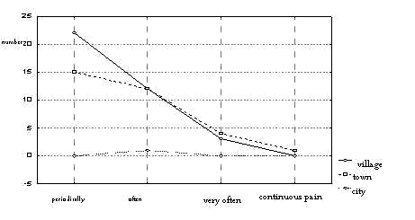

Chart 1 Frequency of incidence of pain syndromes in the lower part of the vertebral column

Most subjects, however, describe the pain as mild - 39 subjects (56%). 27 subjects (38%) suffer from severe symptoms. Severe pain was reported by 4 respondents (6%).

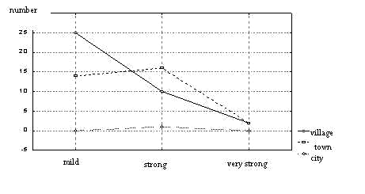

Chart 2 Pain intensity

A strong tendency is found for incidence of spinal pain syndromes in women, compared to men. As much as 70% of the studied women (52 women) suffer from pain symptoms. The problem affects 59% of men involved in the study (17 respondents). However, the study was not statistically dependent, due to the smaller study population of men (p = 0.263).

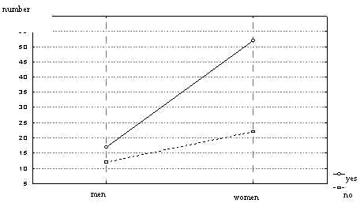

Chart 3 Relation between incidence of sacral pain and gender

The most numerous group with spinal pain were employees aged 40-49 years old - 21 subjects (30%) and employees aged 50-60 years old - 19 subjects (28%); 17 (25%) employees with pains were 30-39 years old, and 12 (17%) respondents with pain symptoms were 18-29 years old.

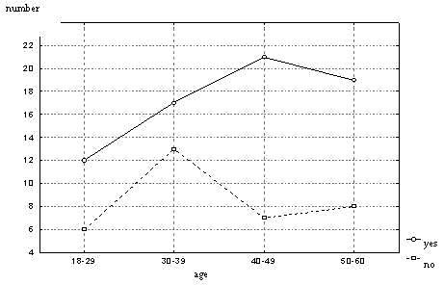

Chart 4 Age and spinal pain symptoms

Moreover, the frequency of incidence of spinal pain syndromes in public administration employees was analysed considering two social groups: employees living in towns and those living in the country. There is a larger tendency for the studied phenomenon in the group with a rural background; the pain symptoms affect 73% (36%) of subjects from rural areas. Employees reporting sacral pains and living in towns constituted 60% (32 subjects) of the urban group.

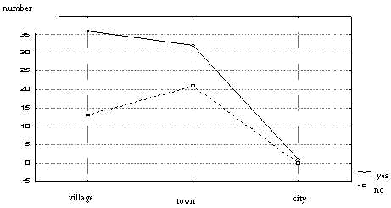

Chart 5 Place of residence and the frequency of incidence of sacral pain

Additionally, for the purpose of analysis and statistical comparison, the study population was divided according to the character of their work. Among 95 office workers, 61 respondents (64%) reported lumbar pains. The manual workers group was considerably smaller; however, the study found that pain symptoms affected 100% of subjects in this group, i.e. 8 respondents.
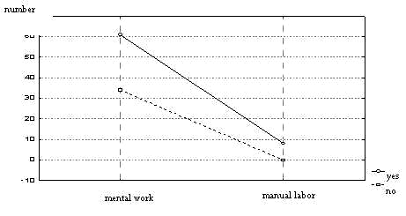

Chart 6 Character of professional work

In most cases subjects performed sedentary work - 92 subjects (89%). 6 subjects (6%) performed work which required mainly walking, 2 subjects (2%) had work that was both sedentary and required walking, and the remaining 3 subjects (3%) performed other kinds of work, involving lifting or a more intensive form. Nevertheless, this relation was not indicated in the correlation assessment with the chi² test.
Subjects involved in the study could link rather precisely the incidence of pain with its assumed cause. Most of them point to professional load, related to prolonged body position or inadequate work station set-up (6 subjects/6%). Pain symptoms in the lower part of the vertebral column in the study population are essentially related to the sitting position in 47 subjects (46%) employed in public administration. A large group of 15 subjects (15%) also look for causes in extra-occupational factors, and individuals - in other factors. There is also a high correlation between the studied characteristic, and the place of residence, p = 0.0006 (p < 0.05).

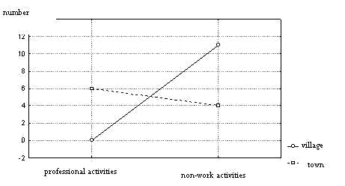

Chart 7 Assumed cause of pain

This factor is revealed in answers to the question about intensification of pain symptoms during performance of professional duties. In 36 (35%) of subjects involved in the study the pain increases at work, and 34 subjects (33%) report sacral pain regardless of performing professional tasks. There is no correlation of this characteristic between designated social groups and the frequency of incidence of the problem (place of residence p = 0.507 and gender p = 0.482; p > 0.05).

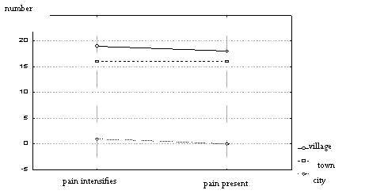

Chart 8 Level of pain intensity during performance of professional duties, with division according to the place of residence

It is shocking that 79 (77%) of subjects involved in the study spend their leisure time in a passive way, often in a sitting position, watching television or using a computer. Only 24 subjects (23%) spend their leisure time in an active way.
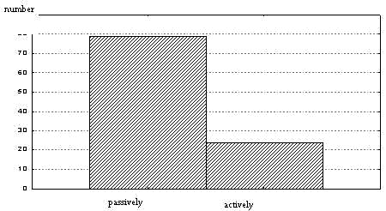

Chart 9 Ways of spending leisure time

The above data is reflected in a strong correlation as a factor pre-disposing the incidence of pain syndromes in the lumbar-sacral part of the vertebral column, p = 0.003 (p < 0.05). The data is also reflected in the question about undertaking physical activity. Theoretically, 17 subjects (17%) engage in some form of physical activity every day, 7 subjects (7%) do it systematically. In other cases, physical activity is irregular (43 subjects/42%) or very rare (23 subjects/22%), and 13 subjects (13%) do not engage in any form of physical activity.

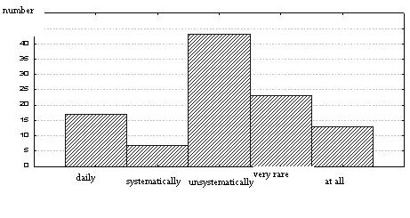

Chart 10 Physical activity of the study group

An anthropometric study was also conducted in order to present relations between body mass of the subjects and the frequency of incidence of pain symptoms. The results on the basis of BMI index calculated individually for each subject involved in the study were statistically insignificant, p = 0.225 (p > 0.05), although an increase tendency was found for pain incidence related to incorrect body mass of the subjects under study.

Table I Body mass and frequency of sacral pain
BMI code | Spinal pain | No spinal pain | Total
Underweight | 2 | 2 | 4
Norm | 26 | 19 | 45
Excessive weight | 26 | 9 | 35
Obesity | 15 | 4 | 19
Total | 69 | 34 | 103

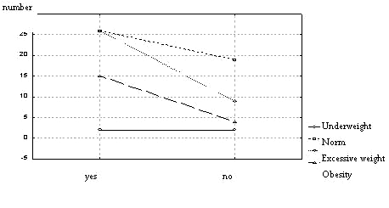

Chart 11 Body mass and frequency of sacral pain

Description of the results of own study

Spinal pains, due to their common occurrence, have reached epidemic proportions. On the basis of the research conducted, pain syndrome of the lower part of the vertebral column was found in 69 (67%) subjects in the study population.
Many authors in their works also mention the problem of an increasingly common incidence of pain syndromes of the lower part of the vertebral column in society [17, 19]. It is estimated that in the USA approximately 80% of the adult population suffers from back pain symptoms, and in Switzerland that problem affects 65% of adults. 40% to 50% of Germans report frequent or chronic spinal pains [10]. According to research, in Poland sacral pains affect 72% of the population before the age of 40, and 66% of men and 30% of women after 40 [8]. Research conducted by Jankowska et al. on a random number of volunteers indicates the scope of the problem. As many as 70.2% complained about sacral pains, where the pain affected the lumbar or lumbar-sacral spine in 76% [11].
The seriousness and scope of the problem is emphasised by the frequency of pain symptoms incidence. In the group under the study, chronic or very frequent pain was reported by 8% of subjects, frequent pain syndromes affect 24% of subjects, and in 36% the pain is periodic.
The frequency of pain is also presented by Kujawa et al.: periodic pain symptoms affected 6.7% of subjects under study, frequent - 39.5% of the studied subjects, very frequent - 51.4%, and chronic pain affected 2.4% of subjects involved in the study [14]. Among 1000 subjects examined by Hans et al. 19% reported pains once or twice a week, and 29% of subjects involved in the study suffered from pains several times a month [10]. In 64% of midwives involved in the study pain afflictions in the musculoskeletal system occur at least once a month, and in 38% at least once a week. They are an everyday problem for 5% of respondents, 3-5 times a week for 14%, and 1-2 a week for 19% [3].
Most subjects, however, describe the pain as mild – 38% subjects. 26% of subjects suffer from severe symptoms. Very strong pain affects 4% of the studied subjects. Markedly strong pain is reported by subjects from an urban environment.
Among other professional groups the level of pain intensity also varies, the most common being usually mild pain symptoms. For instance, in a group of physical therapists reporting an incidence of sacral pain, over a half (70%) described the pain as mild, 28% described the pain as strong, and only 3% described it as very strong [18].
A strong tendency is found for the incidence of spinal pain syndromes in women, compared to men. As many as 70% of women suffer from pain symptoms. The problem affects 59% of men involved in the study. However, the study was not statistically dependent, due to the smaller study population of men.
Depa et al. also presents an estimation of the frequency of lumbar pain incidence according to gender, and they find pain syndromes in 76% of women and 68% of men [8].
It appears that the frequency of pain symptoms increases with age, but no statistically significant difference was found between the frequency of incidence of spinal pain and age of the study group. The most numerous group with spinal pain were employees aged 40-49 years old - 30% and employees aged 50-60 years old - 28%; 25% of employees with pains were 30-39 years old, and 17% of respondents with pain symptoms were 18-29 years old. Research conducted in Bydgoszcz show similar results: pain in the lumbar-sacral spine affected 47% of patients aged 40-60 years old, 30% of patients older than 60, and 23% of those aged 20-40 years old.
Among 95 office workers, 64% reported lumbar pains. The manual workers group was considerably less numerous; however, the study found that pain symptoms affected 100% of subjects in this group, i.e. 8 respondents, who constituted only 8% of the study population. The study results confirm that overload disease affects manual workers more often than office workers. In this case the relation is confirmed also by analysis of the correlation between the incidence of spinal pain syndromes and the kind of occupation, which reveals a statistical significance. However, the significance may result merely on the group size. In most cases subjects performed sedentary work - 89%. 6% of subjects performed work which required mainly walking, 2% had work that was both sedentary and required walking, and the remaining 3% performed other kinds of work, involving lifting or a more intensive form. Nevertheless, this relation was not indicated in the correlation assessment with the chi² test.
Grochmal reports that pains in the lower part of the vertebral column due to overload in professional work usually affect people, who have to lift heavy things at work. Magoza noticed that lumbar pains are reported also by people who do not have to deal with loads at work, but they remain for longer periods in a sitting position, or are leaning forward [8]. Among causes of spinal pains in the group studied by Jankowska et al. degenerative processes dominated (45%), and in 19% overload associated with forced body position; in other cases the cause was not found [11].
Subjects involved in the study could link rather precisely the incidence of pain with its assumed cause. Most of them point to professional load, related to prolonged body position or inadequate work station set-up. Pain symptoms in the lower part of the vertebral column in the study population are essentially related to the sitting position in 46% of subjects. A large group consisting of 15% of subjects also look for causes in extra-occupational factors, and individuals - in other factors. In 35% of subjects involved in the study the pain increases at work, and 33% of subjects report sacral pain regardless of performing professional tasks.
Pain symptoms in the lumbar spine of nurses under study were associated with their job, since in 39% of women the pain increased at work, and in 31% it was present also without performing occupational duties. Over 69% of nurses mention forced prolonged body position as the reason for pain intensification [22]. The midwives studied associate the occurrence of pain and its intensification mostly with a forced position during work (43%). 12% of the subjects see a relation between pains in the lumbar-sacral spine to combining professional activity with extra-occupational[3].
Causes and conditions of spinal load can vary and do not need to be related to professional work. Therefore, the analysis included also assessment of physical activity outside of work, as well as body build characteristics of respondents.
As many 77% of subjects involved in the study spend their leisure time in a passive way, often in a sitting position, watching television or using a computer. Only 23% spend their leisure time in an active way. The above data is reflected in a strong correlation as a factor pre-disposing the incidence of pain syndromes in the lumbar-sacral part of the vertebral column. Theoretically, 17% of subjects engage in some form of physical activity every day, 7% do it systematically. In other cases, physical activity is irregular (42%) or very rare (22%), and 13% do not engage in any form of physical activity.
Similar observations can be found in the study involving 80 patients treated for pain syndromes of the lower part of the vertebral column in the Rehabilitation Clinic in the Medical University of Poznań. None of the subjects did any sports or physical exercises regularly [8]. Research by Bilski et al. shows that 57% of subjects undertake recreational physical activity [3]. Data concerning physical activity in adults reveals inactivity on an epidemic scale. Nearly 70% of adults in USA either do not engage in any physical activity, or it is insufficient [5]. In the research by Ćwirlej et al. subjects with sacral pain described their lifestyle mostly as sedentary, inactive (40%) or moderately active (40%). Only 20% led active lifestyle [7]. As many as 77.5% of patients of a medical centre from Toruń evaluated their activity as poor. 22.5% of patients described it as medium, and there were no patients with high activity [20].
An anthropometric study was also conducted in order to present relations between body mass of the subjects and the frequency of incidence of pain symptoms. The results were statistically insignificant, although an increase tendency was found for pain incidence related to incorrect body mass of the study subjects.
On the basis of the calculated BMI index, body mass of midwives was compared. In 60.7% it was within the norm, 23.4% had excessive weight, obesity was found in 6.5%, and 9.3% were underweight [3]. A study involving mainly subjects from the rural environment, conducted in Iwonicz Zdrój concluded that spinal function can be impaired due to excessive weight. Among subjects suffering from spinal pains only 39.3% had correct body weight, 47.3% had excessive weight, and 14.3% were obese [25].
Summing up, it is important to remember that none of the studied factors related to lifestyle affect somatic development directly; their influence is only indirect, since factors in the general situation, such as the character of professional work and limited physical activity of an individual, influence certain elements of lifestyle and life conditions, which directly impinge on the biological aspect of the development of the body.

Conclusions
- Overload disease of the vertebral column in the study group is worrying, and it is close to standards in highly developed countries.
- Overload changes in the administration employees result from many factors, which are caused by both physical load due to professional work, and overload due to civilisational and cultural changes experienced by society.
- Passive spending of leisure time by administration employees should be superseded by regular physical activity, which needs to become a part of their lifestyle.

Summary
Overload disease of the vertebral column is a reflection of deep civilisational changes.
The aim of this study was to estimate the frequency of incidence of lumbar-sacral spine pain syndromes in the study group, considering different factors which determine their occurrence.
The questionnaire and anthropomotoric study involved 103 administration employees in the janowskie province. The study results were analysed with the use of Excel and Statistica 6.0 software.
Pain syndrome of the lower part of the vertebral column was found in 67% of the study population.
Spinal pain syndromes in the study population result from different factors simultaneously at work, which can cause risks in the form of functional and structural changes in the body.

References
- Bączkiewicz M., i wsp.: Dolegliwości kończyn górnych u osób pracujących przy komputerze a zaburzenia czynnościowe kręgosłupa szyjnego. Fizjoterapia Polska. 2006, 1, (4), 6, 58-66.
- Bielińska M.: Ocena skuteczności leczenia fizjoterapeutycznego chorych ambulatoryjnych z zespołami bólowymi odcinka szyjnego kręgosłupa. Kwartalnik Ortopedyczny. 2008, 2, 173 – 183.
- Bilski B., Kandefer W.: Uwarunkowania obciążeń układu ruchu i ich konsekwencje zdrowotne w wybranej populacji położnych. Medycyna Pracy. 2007, 58, (1), 7-12.
- Brzosko M., i wsp.: Bóle pleców i absencja chorobowa z tego powodu. Medycyna pracy. 1997, XLVIII, 4, 393-398.
- Chakravarthy M. V., i wsp.: Spoczywający na lekarzu pierwszego kontaktu obowiązek zalecania aktywności fizycznej pacjentom prowadzącym mało aktywny tryb życia, w celu zmniejszenia ryzyka chorób przewlekłych. Rehabilitacja Medyczna. 2002, 6, 4, 45-52.
- Ćwirlej A., i wsp.: Masaż klasyczny w terapii bólów krzyża. Medycyna Manualna. 2005, 9, (3/4), 7-11.
- Ćwirlej A., i wsp.: Problem rehabilitacji pacjentów z przewlekłym bólem dolnego odcinka kręgosłupa. Przegląd Medyczny Uniwersytetu Rzeszowskiego. 2007, 4, 355-359.
- Depa A., Drużbicki M.: Ocena częstości występowania zespołów bólowych lędźwiowego odcinka kręgosłupa w zależności od charakteru wykonywanej pracy. Przegląd Medyczny Uniwersytetu Rzeszowskiego. 2008, 1, 34 –41.
- Górecki A., i wsp.: Zasady postępowania diagnostyczno-leczniczego w bólach pleców. Ortopedia Traumatologia Rehabilitacja. 2004, 2, 6, 137-140.
- Hans L., i wsp.: Leczenie bólu w niemieckiej i polskiej ochronie zdrowia. Zdrowie Publiczne. 2008, 118, (2), 210-215.
- Jankowska E., i wsp.: Wykorzystanie magnetostymulacji w terapii zespołów bólowych narządu ruchu (badania własne). Acta Bio-Optica et Informatica Media. 2000, 6, 29-33.
- Kiwerski J.: Zmiany zwyrodnieniowo-przeciążeniowe kręgosłupa. W: Kiwerski J.: Schorzenia i urazy kręgosłupa. Wydawnictwo Lekarskie PZWL, Warszawa 2001, 137-149.
- Korab D., i wsp.: Rehabilitacja w zespołach bólowych dolnego odcinka kręgosłupa – zasady postępowania. Zamojskie Studia i Materiały. 2004, 6, 2, 65-72.
- Kujawa J., i wsp.: Ocena skuteczności przeciwbólowej biostymulacji laserowej skojarzonej z kinezyterapią u chorych z zespołem bólowym dolnego odcinka kręgosłupa. Medycyna Manualna. 1999, 3, (3-4), 41-45.
- Kwolek A., i wsp.: Rehabilitacja w zespołach bólowych dolnego odcinka kręgosłupa – zasady postępowania. Postępy Rehabilitacji. 2004, XVIII, 3, 27-31.
- Lesiak A.: Mechanika stawów. W: Małdyk E., Wagner T.: Patomorfologia stawów. Warszawa. PZWL 1991 23-33.
- Lisiński P., Małgowska M.: Jakość życia a zespół bólowy kręgosłupa na tle przeciążeniowym. Chirurgia Narządów Ruchu i Ortopedia Polska. 2005, 70, (5), 361-365.
- Lisiński P., Samborski W.: Bóle kręgosłupa lędźwiowego w grupie zawodowej fizjoterapeutów. Balneologia Polska. 2006, XLVIII, 3, 156-160.
- Łukowicz M., i wsp.: Czynniki socjo-zdrowotne i ich wpływ na bóle kręgosłupa. W: Bury P., Czajkowska-Ziobrowska D.: Edukacja bez granic – mimo barier: przestrzeń tworzenia. Poznań. Wydawnictwo Wyższej Szkoły Bezpieczeństwa 2008, 325-332.
- Łukowicz M., i wsp.: Efekt włączenia sonoterapii do postępowania kinezyterapeutycznego w zespołach bólowych odcinka lędźwiowego kręgosłupa. Acta Bio-Optica et Informatica Media. 2009, 1,15, 40-43.
- Molas A., i wsp.: Fizjoterapia w zespołach bólowych dolnego odcinka kręgosłupa. Zamojskie Studia i Materiały. 2004, 6 , 2 , 93-97.
- Rok S., i wsp..: Ocena skuteczności ćwiczeń leczniczych w dolegliwościach bólowych dolnego odcinka kręgosłupa u pielęgniarek. Medycyna Pracy. 2005, 56, (3), 235 – 239.
- Stodolny J.: Choroba przeciążeniowa kręgosłupa. Epidemia naszych czasów, Wydawnictwo ZL NATURA Kielce 1999.
- Smolińska B., i wsp.: Nowoczesna rehabilitacja w schorzeniach kręgosłupa odcinka krzyżowo-lędźwiowego ludzi czynnych zawodowo – wybrane metody, jako odpowiedź na wzrastającą absencję w pracy spowodowaną bólami krzyża. Medycyna Pracy. 2004, 55, (5), 439-443.
- Szczygielska-Majewska M., i wsp.: Zapotrzebowanie na edukację w zakresie prozdrowotnym stylu życia osób z dolegliwościami bólowymi kręgosłupa. Annales Universitatis Mariae Curie-Skłodowska Lublin-Polonia. 2005 LX, XVI, 531, 355-358.

Abstract
The overloading of vertebral column syndrome reflects the changes in contemporary civilisation. The aim of the article is to define the frequency of pain syndrome of the vertebral column, especially in its lower parts. The research was conducted on 103 administration workers from the Janów Lubelski province and analyzed using the Exel and Statistica 6.0 programmes. Pain syndrome of the lower part of vertebral column was observed in 67 per cent of the people examined. The pain syndrome of the vertebral column stems from a variety of factors which may lead to different disorders such as changes in the functional or structural body system.

Streszczenie
Choroba przeciążeniowa kręgosłupa jest odzwierciedleniem głębokich przemian cywilizacyjnych. Powtarzające i nakładające się obciążenia psychiczne i fizyczne działają niekorzystnie na kręgosłup współczesnego społeczeństwa. Celem pracy było określenie częstości występowania zespołów bólowych lędźwiowo-krzyżo-wego odcinka kręgosłupa w badanej grupie z uwzględnieniem czynników determinujących ich powstawanie. Badaniami ankietowymi oraz antropomotorycznymi objęto 103 pracowników administracji powiatu janowskiego. Wyniki badań analizowano w programie Exell oraz Statistica 6.0. Zespół bólowy dolnego odcinka kręgosłupa stwierdzono u 67% badanej populacji. W tym bardzo częste lub częste bóle krzyża odczuwa 47%, a u 53 % badanych ból ten występuje okresowo. Zespoły bólowe kręgosłupa w badanej populacji wynikają z jednoczesnego działania wielu czynników, które mogą nieść ze sobą zagrożenia w postaci zmian czynnościowych i strukturalnych organizmu.

Artykuł zawiera 29670 znaków ze spacjami + grafika

