




USDA FOREST SERVICE
INTERMOUNTAIN REGION, R4

Natural Resources Specialist

GS-0401-11

Dixie National Forest

Pine Valley Ranger District
196 E, Tabernacle St #38
St. George, UT
Phone: (435) 652-3100 Fax: (435) 652-3191

A vacancy announcement to fill a Natural Resources Specialist (Recreation) GS-0401-11 will be posted on the USAJOBS website, http://www.usajobs.gov in the near future. This is a professional recreation position located on the Pine Valley Ranger District of the Dixie National Forest.

This notification is being circulated to inform prospective applicants of this exciting opportunity and to determine interest in the position.

About the position:
The Natural Resource Specialist administers all aspects of the Pine Valley Ranger District recreation program, including:
Pine Valley Visitor Center (Heritage Center) and Interagency Visitor Center: coordination with Interagency management, Dixie Arizona Strip Interpretative Association liason.
Developed and dispersed recreation sites: Pine Valley Recreation Area, Oakgrove campground, Honey Comb Rocks Campground, concessionaire administrator, canyoneering management.
Travel Management: OHV program oversight. Motorized Travel Planning and Implementation.
Trails Program: Non-motorized and motorized trails.
Recreation Special Uses: Recreation events and coordination with Special Use Permit Administrator.
Interpretative Services: events, booths, education, outreach, product development, signs.
Scenery management
Wilderness areas: Pine Valley and Cottonwood Forest Wilderness areas.
Facilities programs: oversight of district recreation and administrative site maintenance budgets and implementation of work.
Coordination with local government officials
In addition, this position is the district lead for minerals, with some duties in the special use program. Specifically, the incumbent is responsible for: implementation and administration of annual work plans and budget; development of short and long range plans and/or programs of work; evaluation of the impacts of various proposals on the recreation resources (NEPA); planning and oversight of the construction and maintenance of all projects within the fields described above; developing and writing grant applications; developing, strengthening, and coordinating the volunteer and partnership program; seasonal employment hiring; and all aspects of supervising a staff of 3 full time permanent employees, seasonal crew and a small volunteer crew.

The incumbent develops annual work plans for recreation operation and maintenance programs. Completes rehabilitation work on existing facilities and plans for modifications or additions to recreation areas. Determines type, amount, and location of work to be accomplished under each program. Projects the cost of each program based on staffing, equipment and supply needs. Administers the Heritage Center in cooperation with an interpretive association, including personnel, volunteers and facilities. Interagency coordination and supervision of Visitor Center Manager to ensure operations meeting Interagency Management needs. Administers all aspects of the trail program. Plans and directs the care and policy of non-motorized and motorized trails. Participates in decisions as part of the unit management team. Supervises 3 subordinates at various grade levels, assigning, directing, and reviewing work, plans, schedules, and coordinates work and solves difficult technical problems. Carries out established personnel functions and practices.

The tour of duty will be full time permanent, 40 hours per week

Telework: Eligible

Qualification Requirements:

Those who are interested must meet the qualification requirements for the GS-0401 series that is covered by the Professional and Scientific Standards. The OPM Qualification Standards Handbook Manual is available for the review at any federal personnel office OR on the Internet at http://www.opm.gov/policy-data-oversight/classification-qualifications/general-schedule-qualification-standards/#url=Group-Standards. Applicants must have one year of specialized experience at the next lower level (GS09). Specialized experience is that which has equipped the applicant with the particular knowledge, skills, and abilities to perform successfully the duties of the position that is typically in or related to the work of the position to be filled. Basic Requirements are:
- Degree: biological sciences, agriculture, natural resource management, chemistry, or related disciplines appropriate to the position.
OR
- Combination of education and experience: Courses equivalent to a major plus appropriate experience or additional education.

Location:
The incumbent’s duty station will be St. George, Utah.

Salary:
The grade level GS-11 salary starts at $58,562.00 per annum.

Supervisor:
The supervisor of the position will be the District Ranger, Joe Rechsteiner. For questions regarding the position he can be contacted at 435-652-3101, or by email at jrechsteiner@fs.fed.us
If interested please complete and submit the Outreach Notice Form which is attached to the end of this document and email to: Catherine Carlile at ccarlile@fs.fed.us or mail to: Pine Valley R.D. Attn: C. Carlile, 196 E. Tabernacle St. #38, St. George, UT.

About The Dixie National Forest
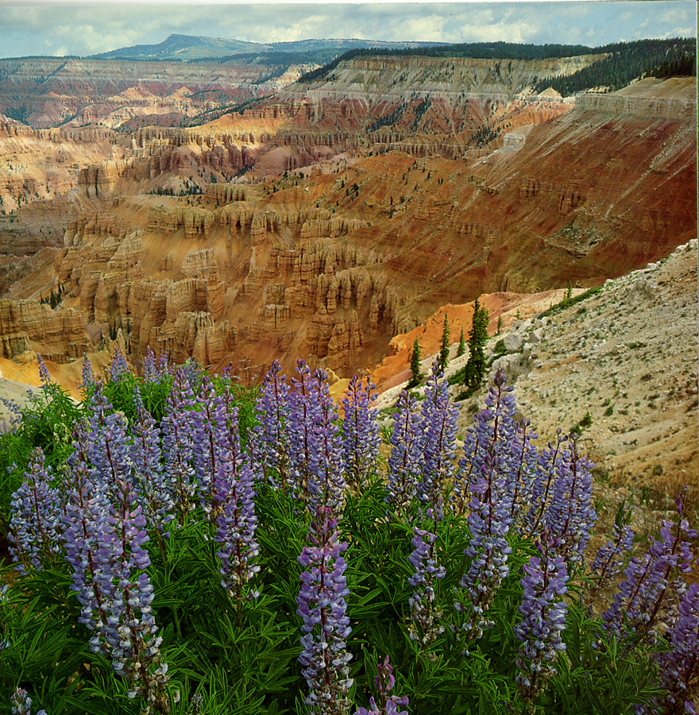
The Dixie National Forest occupies almost two million acres and stretches about 170 miles across southern Utah. The Forest straddles the divide between the Great Basin and the Colorado River. Elevations vary between 2,800 feet near St. George to 11,322 feet at Blue Bell Knoll on Boulder Mountain. Comprising the southern rim of the Great Basin above the Colorado River, the Dixie is loved for its spectacular scenery, from high mountain meadows and lakes to multicolored cliffs and steep-walled gorges. Vegetation on the Dixie changes from sparse, desert plants at the lower elevations to stands of low-growing pinion Pine and juniper dominating the mid-elevations. At higher elevations, aspen and conifers such as pine, spruce and fir predominate.
Cedar Breaks National Monument

The headquarters of the Dixie National Forest is the Supervisor's Office in Cedar City. The Forest has four Ranger Districts; they are located in St. George, Cedar City, Panguitch, and Escalante. The Dixie employs about 125 permanent employees and between 100 and 150 seasonal employees.

Camping facilities are available across the Forest, and in three National Parks and two National Monuments adjacent to the Forest. The scenic beauty for which the national parks were established prevails over much of the Dixie. The Dixie has three designated wilderness areas.

About St. George.

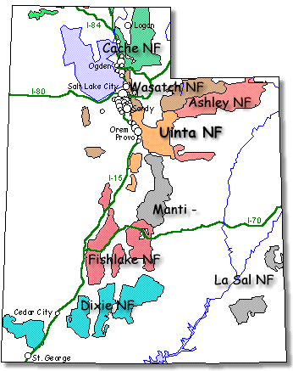
Located in the Southeastern corner of Utah, the City of St. George is known as Utah’s Dixie. Mild winter weather, beautiful red rock scenery and many recreational opportunities make it very attractive to residents and visitors. The area is experiencing rapid growth with the population increasing from about 10,000 in the 1960’s to nearly 145,000 today in the St George metropolitan area. Many retirees have come for the desert climate and easy lifestyle. St. George is the Spring Break destination for many Utah high school students.

Climate - St. George lies in the high desert at an elevation of 2800 feet. The climate is semi-arid with about 8-inches of precipitation annually from rains usually occurring in the early spring and in late summer. Temperatures for the summer months are 95-101, but the low humidity makes it livable. Communities, such as Pine Valley, Central, and Enterprise exist nearby, and can be great alternatives if one whishes to live in a cooler climate.

Housing – St. George and the nearby cities of Santa Clara, Ivins, Washington, Hurricane, Enterprise, and other communities of Southern Washington County offer a variety of sizes, styles and a price to suit most buyer or renter needs. The housing market is active with many new developments at the present time. Based on the 2014 housing sale prices, the average sales price of a home in Washington County was $275,00..

Health Care – Full service medical facilities are available within the St. George area. The new Dixie Regional Medical Center opened late 2003. The new facility, with over 140 patient beds and 8 operating rooms, provides a high level of health services, including open heart surgery, cancer treatment, and other advanced care.

Several health centers, clinics, family practice, same day surgical services, specialty treatment centers and home health services are located throughout the St George area.
Also, many provider choices for dental care, optical care, hearing centers, and specialty medical services are available locally.

Schools – Washington County School District public education enrollment is over 25,000 students. There are 23 elementary schools, 5 middle schools, and 6 high schools. Remedial and gifted student programs are offered within the district. A few elementary and middle schools are on year-round schedules, high schools are on a traditional August-May schedule. Statistics show a 98% graduation rate with 82% of high school graduates planning to continue higher education. One fully accredited charter high school for the performing arts is located in nearby Ivins.
Dixie State College is located in St. George with a present enrollment of 8,000 students. Four-year bachelor degrees are offered in business, accounting, biology, computer & information systems, communications, criminal justice, dental hygiene, nursing, English , and elementary education. Associate degree programs are offered in the arts, sciences, business, pre-engineering, and science in criminal justice. Career courses in automotive, health sciences, graphic communications, marketing, and visual technology. Advanced 4-year and master’s degrees, accessed through Southern Utah University and Utah State University, are available at Dixie State College.

Churches – Approximately 90% of the area population are members of the Church of Jesus Christ of Latter Day Saints. Other denominations: Assembly of God, Baptist, Southern Baptist, Catholic, Christian Science, Church of Christ, Episcopal, Jehovah’s Witnesses, Lutheran, Presbyterian, Seventh-day Adventist, United Methodist, Unity, Harvest Christian Assembly, and a non-denominational Bible Church.

Shopping / Business - There are numerous banks and financial institutions, a good business selection, shopping malls, smaller craft shops, boutiques and unique stores available to the shopper. Several local and chain grocery stores are located though out the towns. Gas stations with mini-marts are plentiful.

Eating/Dining out - A great variety of wonderful restaurants, smorgasbord, ethnic dining and most fast food chain eateries are represented.

Leisure Activities - More than we can name. There are several special annual events such as: St George’s First Night, Art Festivals, Marathon, Huntsman World Senior Games, and the Dixie Round-Up. Other events include the Washington County Fair, Parade of Homes, Santa Clara Swiss Days, Enterprise Corn Festival, Hurricane Easter Car Show, DSC Invitational Art Show & Junior College Rotary Bowl to name just a few. You are just two hours from Las Vegas or a mere 35 miles takes you across the border to Mesquite NV to enjoy their gaming resorts. Winter snow activities on Cedar Mountain and skiing at Brian Head ski resort are within a two-hour drive.

Golfing is high on the list of activities. Per capita, there are more courses in St George than anywhere else in the country. With nine public courses and one private golf club, all set in picturesque sites, it is often described as a “golfer’s paradise”

Other outdoor activities include walking or biking along more than 30 miles of paved trails that connect parks, desert areas and town center, enjoying any of the 25 local parks, swimming at the family aquatic center or other public pools, visiting the beautiful nearby National Parks and State Parks, playing ball on the many ball fields, recreating at the family fun center, recreation and fitness centers or take in a movie at one of the five movie theatre complexes. Enjoy boating and water sports at Quail Reservoir, Sand Hollow, and Gunlock Reservoir.

Hunting, camping, hiking, fishing and mountain biking are all available to experience. Several Forest Service campgrounds are located on the west side of the Pine Valley Mountain for a cooling summer retreat. An equestrian campground provides a convenience to horseman for exploring the District’s 195 miles of trails, including many miles within the 50,000-acre Pine Valley Wilderness area. More information can be obtained at the Interagency Information Center, 345 West Riverside Dr. St. George, UT 84770.

For information about St. George area, visit the Washington County web page at http://www.washco.state.ut.

Outreach Notice Form
Natural Resources Specialist
GS-0401-11
If interested please respond no later than February 18^{th,} 2015

If you are interested in this position, and wish to have the website vacancy announcement faxed or mailed to you, please complete this form, fax, mail or email to ccarlile@fs.fed.us or by mail Catherine Carlile – Support Services Spec, Pine Valley Ranger District, 196 E Tabernacle St #38, St George, Utah 84770, or fax to (435) 652-3191. You may phone 435-652-3100 for additional information.

Yes, I’m interested in the Natural Resources Specialist position and would like to receive a copy of the Vacancy Announcement.

NAME: ___________________________________________________________________

E-MAIL ADDRESS: _________________________________________________________

MAILING ADDRESS: ________________________________________________________________ _________

_____________________________________________________________ _________

TELEPHONE NUMBER: ______________________________________________________

AGENCY EMPLOYED WITH: _____USFS _____ BLM _____ OTHER____

TYPE OF APPOINTMENT: _____PERMANENT _____ TEMPORARY ______ TERM

______ VRA _____ PWD ______ OTHER

CURRENT REGION/FOREST/DISTRICT: _________________________________________

CURRENT SERIES AND GRADE: ______________________________________ ______

CURRENT POSITION TITLE: ___________________________________________________

IF NOT A CURRENT PERMANENT (CAREER OR CAREER CONDITIONAL) EMPLOYEE
ARE YOU ELIGIBLE TO BE HIRED UNDER ANY OF THE FOLLOWING SPECIAL
AUTHORITIES:

______ PERSON WITH DISABILITIES
______ VETERANS READJUSTMENT
______ DISABLED VETERANS W/30% COMPENSABLE DISABILITY
______ VETERANS EMPLOYMENT OPPORTUNITIES ACT OF 1998
______ FORMER PEACE CORPS VOLUNTEER
______ PATHWAYS PROGRAM
______ OTHER _____________________________________________________________

Thank you for your interest in this opportunity!

