Supplier AdvantageTM
A Solution for all Suppliers

Enterprise Systems Group (ESG)

Dell White Paper

By Scott Cairney, Cactus Internet

Pierre Deschamps, Cactus Internet

Jean-Yves Martineau, Cactus Internet

Richard Hou, Dell Computer Corporation

Mike Owens, Dell Computer Corporation



Contents

Overview 3
Sell-Side E-Commerce: Supplier Enablement 3
Catalog Publishing 6
Customizing Supplier AdvantageTM for Catalog Publishing 6
Designing a Catalog Solution 7
BizTalk Configuration for Catalog Publishing 8
Documents 9
Supplier Managed Catalogs 11
Supporting Supplier Managed Catalogs 11
Web Site Configuration – Supplier Advantage TM Artifacts 11
Order Reception and Fulfillment 13
Document Receipt Overview 13
Payment Processing 15
Support for B2B Transactions 15
Integration with Microsoft Commerce Server 2000 16
Sizing the Solution 18
Small implementations – Business Jumpstart 18
Medium Configuration – Volume B2B 21
Large Configuration– Enterprise Integration 24
Additional Deployment Considerations 27
Completing the Enablement 29

Table of Figures
Figure 1 - Supplier Enablement Overview 4
Figure 2 - Catalog Publishing Architecture 8
Figure 3 - Order Reception Flow 13
Figure 4: Acuraci Architecture 16
Figure 5: Two-Server Reference Architecture 19
Figure 6: Three-Server Reference Architecture 20
Figure 7: "Volume B2B" Reference Architecture 22
Figure 8: "Enterprise Solution" Reference Architecture 25
Figure 9: "Enterprise Solution" with Security Layers 28

Section 1

Overview

Business-to-business (B2B) e-commerce has been touted as the next big thing. In the excitement and hurry to implement B2B solutions, companies run the risk of losing track of key business fundamentals. Yet business-to-business e-commerce is simply about buyers and suppliers connecting online and conducting everyday business. The electronic exchange of information between the two players has not been easy; in fact, it’s been an impediment to enabling true e-commerce. Companies require a solution that enables them to interact with trading partners of all shapes and sizes, easily, seamlessly and reliably. Suppliers of all sizes need to be able to publish their offerings, receive electronic orders and get paid for it; in essence, they need a means to electronically enable their business.

Sell-Side E-Commerce: Supplier Enablement

Supplier Enablement is about helping suppliers accelerate their adoption of e-commerce technology. Getting suppliers connected and trading online is essential not only for buyers to realize the promise of operational efficiency gains, reduced procurement costs and improved employee productivity, but also for suppliers to maintain and increase their relative competitive advantage.
The supplier enablement process begins with the supplier making their offering, be it products or services, available to the buyer. This concept is quite generic and can be accomplished in several ways: catalog publishing and/or supplier managed catalogs.

Catalog publishing is performed by transforming the commerce catalog into an industry standard message format, and then transmitting this data electronically to the buy-side system. In marketplace scenarios, when suppliers provides their catalog to an e-marketplace or to a buy-side system, control of the presentation and content lies in the hands of whoever is operating that system.

Oftentimes, this situation has the adverse effect of reducing the buying decision to price and SKU, limiting the effect of the supplier’s brand and value-added relationship with the buyer. This sometimes unwanted situation could be overcome by the use of supplier-managed catalogs. Essentially, supplier managed catalogs are a mechanism for enabling the buy side application to leverage the supplier’s own presentation of the offering.

Once a buyer completes a requisition, it will normally go through a validation and approval process within the buyer’s organization. Once approved, the requisition becomes a purchase order and must be sent to the supplier. To date, only EDI-enabled companies have been able to reap the benefits of the full cycle of e-commerce. For most companies, the last step in an e-commerce transaction results in a non-electronic medium such as printing a check. This robs companies of most of the potential savings to be gained in electronic commerce.

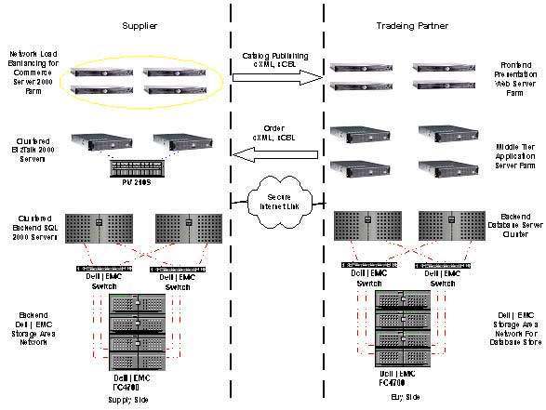

Figure 1: Supplier Enablement Overview

The business solution described above is one that will meet the needs of most suppliers. Dell and Cactus have worked together with Microsoft to build Supplier Advantage, a solution framework for delivering this business solution. Supplier Advantage is based on industry standard products such as Microsoft SQL Server 2000, Microsoft Commerce Server 2000, Microsoft BizTalk Server 2000, Microsoft BizTalk Accelerator for Suppliers, and Cactus Acuraci™ Financial Transactions Platform. This solution supports the concept of supplier managed catalogs, which allow the supplier to attract buyers to a supplier-controlled commerce site where they will be presented with a personalized buying experience complete with customized product listings and pricing. Supplier Advantage is capable of receiving orders in any of three widely adopted industry standard formats and is designed such that it can be extended to support custom formats quite easily.
This purpose of this paper is to describe how Supplier Advantage can help organizations:

- Make their product(s) available to their buying community through the catalog publishing process.
- Help ensure brand equity through robust catalog management capabilities.
- Conduct complete (order, fulfillment, payment) electronic transactions with their business partners.

Section 2

Catalog Publishing

Catalog publishing is the art of making a product or service offering available to the community of trading partners. A great deal of thought is required to properly design a catalog that is to be published to these trading partners. For instance, depending on the destination of the catalog one may wish to include details such as industry standard codes that completely and accurately describes the products being presented. For other trading partners, using the supplier managed catalog features may be the best method to insure the supplier’s brand recognition and reputation are exploited to their fullest. Another very important item to work out is the structure of the catalog. The catalog must be the designed in a manner that is conducive to mapping to various other protocols such as xCBL, cXML, or any proprietary protocol defined by a specific trading relationship. The structure should also be extendable for the future addition of trading partners, and it should be compatible with the desired look and feel of any potential retail commerce site that accompanies the business-to-business solution.

Customizing Supplier Advantage for Catalog Publishing

The Supplier Advantage solution comes complete with maps and document definitions that can greatly accelerate an organization’s catalog-publishing endeavor. However, these maps and documents will have to be modified to match the chosen catalog format. To make the transition from the default catalog format to a custom catalog format as simple as possible it is suggested that organizations reuse the base element names used in the default maps. This way, when the default document definition is replaced with a custom document definition, the bulk of the mapping work will remain. The only additional work required will be to map additional data from the organization’s catalog into either existing protocol elements or, depending on the implementation of the buy side application, map data into proprietary or special use elements such as the cXML extrinsic elements.

The standard fieldname and descriptions used by the Supplier Advantage solution are as follows:

Product
- Prodid, the identifier of the product
- Manufacturer, the name of the manufacturer
- ManufacturerPartID, the part id as defined by the manufacturer
- Classification, ISBN number, USNPSC or some Proprietary ID of some sort
- ClassificationDomain, descriptor of the classification
- Product_name, name of the product
- Producturl, URL of a page describing the product in detail
- RemotelyConfigurable Boolean yes/no if the product is remotely configurable
- Unit_of_measure, a mandatory item indicating the units by which the product is to be sold, i.e.: each, foot, pound

Product Variant
- Listprice, price of the item
- SKU, stock keeping unit, the identification of a particular variant

Designing a Catalog Solution

In order to craft the best catalog solution one should analyze and select the most natural way of representing the offering. Once all the information items are represented in the catalog schema we begin reducing the schema to its simplest form, meaning fewest hierarchical levels, by using techniques very similar to those of database design. For instance, each level of data should contain one and only one piece of information that identifies uniquely all other data defined in that level. Additionally all data contained in that level should relate directly to the unique identifier. The reason for reducing the level of hierarchy is simple: it greatly reduces the complexity of mapping the catalog to either industry standard protocols or proprietary protocols.

One exception to the above method would be the particular case where a solution is being designed to support one and only one protocol. Furthermore, a conscious decision not to support additional protocols may have been taken. In this case, rather than normalizing the catalog, we would more likely define a catalog structure that appears much like the document the protocol defines for catalog messaging.

Once the structure of the catalog is defined, the maps must be created. The Supplier Advantage solution comes complete with working maps intended as a starting point. Using tools supplied with the Supplier Advantage solution, organizations can extract the document definition of the Commerce Server catalog. With that definition loaded into the BizTalk Server repository, the provided map can be loaded into the BizTalk Mapper. Replacing the source definition will not cause lost links because we have properly defined the elements that the Supplier Advantage solution is expecting. Maintaining these elements is not necessary, but makes the creation of the map much simpler.

Completion of the map from this point forward depends on the data one wishes to present to the trading partner. Often mapping of the industry standards codes such as ISBN, UNSPSC or others adds a great deal of value and make the products easier to find from within the buy side applications.

BizTalk Configuration for Catalog Publishing

Once complete, the map is added to the catalog publishing transformation channel. BizTalk is used for both the transformation and the transportation of the catalog; the following diagram is an overview of the catalog publishing architecture configuration:

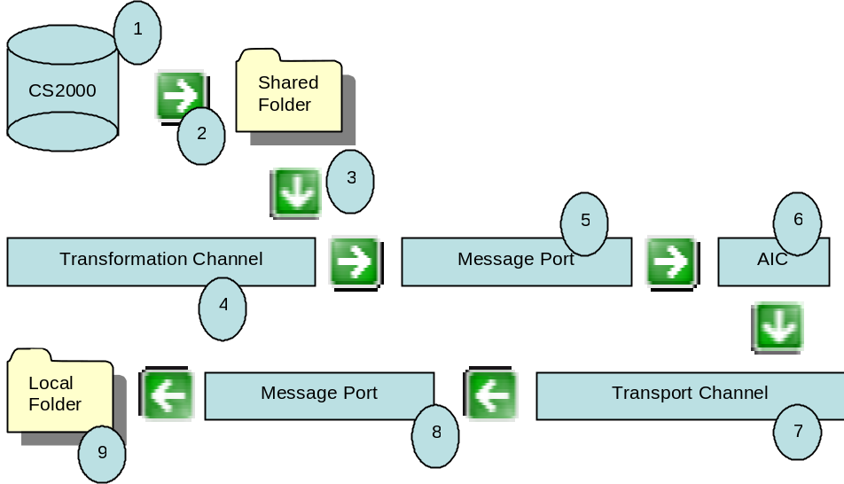

Figure 2: Catalog Publishing Architecture

Description of steps in the catalog publishing architecture

- The catalog or product offering is stored in Commerce Server. This allows use of Commerce Server as a retail site server as well as providing the supplier with a strong offering of tools aimed at the management of the product offering.
- A user triggers the catalog publishing process. When the user requests that a catalog be published, the Commerce Server catalog library is used to export the catalog in an element centric XML document. This document is placed in a shared folder on the BizTalk Server machine. In order to perform the save to a remote machine, a domain account with appropriate permissions on both machines is used.
  - One item to note here is the filename given to the exported catalog. The filename will contain a timestamp as well as an extension that defines the requested transformation. For instance if the trading partner is to receive a cXML catalog the filename will appear as <timestamp>
- A BizTalk Receive function will collect the document and pass it to transport channel.
- The transformation channel is responsible for the creation of the cXML or xCBL catalog document. If the incoming document is a version 1.5 Commerce Server catalog document, the map defined above will perform an XML transformation and produce either a cXML Index document or a xCBL catalog document. One item of note here is that depending on the variant configuration of the source Commerce Server catalog, the BizTalk Mapper may or may not be used. Occasionally, when multiple variants are present, the map produced by the BizTalk Mapper must be modified manually with a text editor to properly loop through variants.
- The transformation message port is static and will pass the document off to a BizTalk Application Integration Component.
- The Application Integration Component out of the box simply reads a BizTalk Framework envelope that contains the name of the transport channel and submits the document with the envelope removed to this channel. This component however has been designed for extension. For instance, additional manipulation of the document may be performed at this stage. Additional information may be added, some unnecessary data can be removed, etc.
- The transport channel performs no transformation to the document; however it may be configured to override the default message port with envelope information possibly placed in the AIC component described in step 6. Additionally, an outgoing document may be signed with the addition of a certificate. Normally there will be one transport channel for each protocol used by each trading partner.
- Since many trading partners such as Commerce One and Ariba do not necessary accept catalogs posted to them via HTML the standard configuration of the transport message port simply writes the catalog document to the file system where it can then be manually uploaded to a web page at a later time.
- The default folder that will contain the catalog document ready for transport is:
  - Program Files\Microsoft BizTalk Accelerator For Suppliers\Data\Catalog\<protocol>.

Documents

CS2000 Catalog Version 1.5
Microsoft added an additional XML catalog document format in service pack 1 of Commerce Server 2000, . This format is element-centric as opposed to the attribute-centric version 1.0 document format. The main elements of the version 1.5 documents are the CatalogSchema and Catalog. The CatalogSchema element contains the specification for the definition of the catalog structure. This definition is encapsulated into three main nodes: AttributeDefinition, Property and Definition. AttributeDefinition defines an attribute that can be used to describe an aspect of a property, such as its “display name.” This allows additional attributes to be defined on fields on top of the built in ones: name, maxSize, and defaultValue. The Property element defines the customized properties configured to describe products and categories. These categories and products have these properties assigned to them via the Definition element that groups such properties in such a way as to completely describe a given category or product.

The Catalog Element is used to describe the content of the catalog. This content is organized into Category and Product where the Product element describes the individual products and services offered and the Category element is used to group the products.

Section 3

Supplier Managed Catalogs

Supplier-managed catalogs are a feature of the Supplier Advantage solution geared at maintaining the supplier’s identity, brand recognition, etc., from the perspective of the buy side application. Supplier managed catalog functionality is possible thanks to industry standard protocol defined messages such as Ariba Punchout, Commerce One RoundTrip and Clarus Tap Out. The main difference in protocols is the product level punchout support that is available with Ariba Punchout vs. the catalog level remote shopping supported by Tap Out and RoundTrip.

Supporting Supplier Managed Catalogs

There are two phases to implementing supplier-managed catalogs. The first is the configuration of catalog data and the second is the modifications that need to be brought to the website pages. Supplier managed catalogs, interestingly enough, only affect the Commerce Server catalog in one area; specifically the RemotelyConfigurable attribute that by default exists in the catalog. This attribute is specifically created to support the Ariba product level Punchout scenario. Configuration of Round Trip or Tap Out shopping is done during the registration phase with your trading partner.

Web Site Configuration – Supplier Advantage Artifacts

Supplier Advantage comes out of the box with a commerce website ready to support remote shopping. Since the likelihood that the particular site in question differs from the Microsoft standard retail solution site is quite high, the AFS package ships with an SDK section containing the code files required to modify existing sites. In order to modify an existing site, the following web pages should be added or modified.

Added
- OCIAccept.asp, the page that will accept the OCI form post.
- Punchout.asp, the page that will receive and handle the punchout setup request.
- RemoteBasket.asp, the basket page displayed when in a remote session.
- RemoteBasketNav.asp, determines the proper page to render during remote shopping sessions.
- include\std_remotebasket_lib.asp, the utility page used by the ASF remote shopping functionality.
- FormPostRemoteBasket.asp, builds and posts the protocol-specific XML document that terminates a remote shopping session.

Modified
- Basket.asp, modified to redirect to remoteBasket.asp when in a remote session.

Section 4

Order Reception and Fulfillment

Order reception and fulfillment is the heart of the business-to-business system. This topic will cover how to receive order XML documents and manage them within the Commerce Server site. When a new trading relationship is created, the trading partner is provided with a URL to which they will send purchase orders. The Supplier Advantage solution will receive purchase orders as cXML 1.1, cXML 1.2 and xCBL 3.0 documents.

Document Receipt Overview

Figure 3 is an overview of process flow for receiving a document:

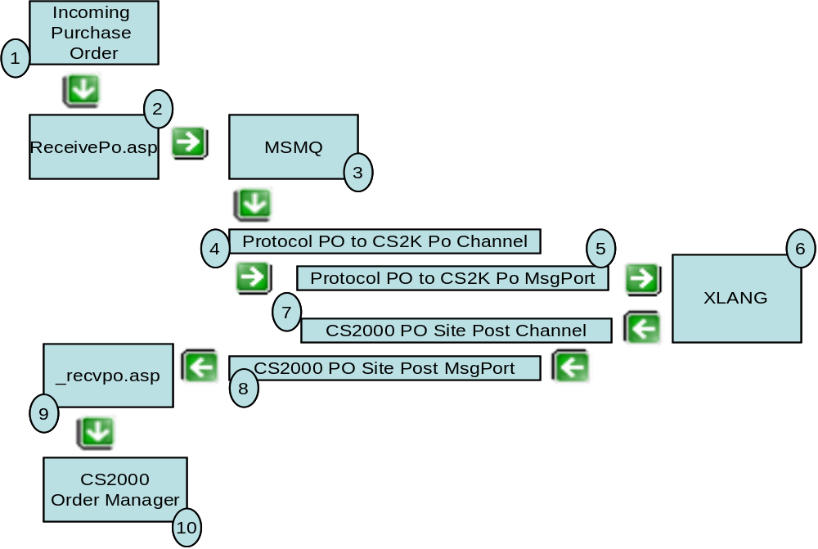

Figure 3: Order Reception Flow

Description of steps in the order reception architecture
- The order reception URL is one item of information that is given to the trading partner during the supplier registration phase. The trading partner will post order documents to that URL using HTTP as well as supplying query string information in the following format:
  - ?TP=<Trading Partner>&Protocol=cXML1.1
Note that the trading partner name must match exactly with the trading partner name configured in the BizDesk.
- The ReceivePO.asp page receives all messages, regardless of protocol. ReceivePO.asp will place the Order in a message queue. The Name of the message queue is defined by the protocol used.
- BizTalk Receive functions, specific for each protocol, monitor the queues, and when a message is present it is collected and passed to a transformation channel.
- The Transformation channel’s purpose is to transform the order into a CS2000 common format.
- The formatted order is now passed from the message port to a BizTalk XLANG Schedule.
- This schedule is available for expansion of the business rules related to order reception and fulfillment. At the completion of the schedule the document is returned to a BizTalk transport channel.
- The BizDesk transport channel does not perform any transformation but is used over a simple HTTP post from the XLANG schedule because it allows for the BizTalk’s ability to retry, suspend and log issues relating to the post back to the site.
- The transport message port allows for dynamic configuration of the site name. All Supplier Advantage sites come with an _recvpo.asp page that accept CS2000 Standard order formatted orders.
- The _recvpo.asp page expects to receive the Commerce Server common format order document and will interpret the document, create any organization and address information necessary to link to the document , and then save the order to the order group manager of Commerce Server 2000.
- The order can then be manipulated with a special BizDesk modules geared to orders received from trading partners. In addition to order management, the reporting and analytics modules of the BizDesk allow for custom modifications to be made allowing for sophisticated reporting on the performance of B2B trading channels.

Section 5

Payment Processing

As mentioned in the introduction, full-cycle e-commerce is only possible when organizations are able to move beyond traditional paper-based means of processing payments, and they are able to fully integrate an electronic payment solution into overall B2B process – a solution that to date has been available only with EDI. To respond to this complex business need, Acuraci was developed from a global treasury perspective and provides centralized administrative tools and reporting capabilities to companies without access to EDI infrastructures. Acuraci provides a reliable and scalable Internet payment solution that enables organizations to implement and manage multi-merchant and multi point-of-sale environments (including Call Centers, Internet Commerce Stores and Brick & Mortar operations).

Support for B2B Transactions
As discussed above, most B2B transactions rely on standard XML-based protocols such as cXML or xCBL. Acuraci uses XML natively throughout and provides support for several B2B XML implementations through its BizTalk Server 2000 Orchestration Component. Financial transaction information is extracted from a variety of documents and processed accordingly. Not only can it authorize and settle credit card transactions in various designated currencies, but it can also process more business-oriented forms of payment such as purchasing-cards and direct transfers.

Financial transactions may be processed in real time, in batches and/or may be processed by means of a pre-authorized schedule. All administrative functions (including void and refund) are available via web-based tools as well as through the Microsoft Commerce Server 2000 BizDesk or directly through an extensive API.

Acuraci uses 128-bit encryption, MD5 hashing, RSA public/private keys and message signing to help ensure the integrity of each transaction. In addition, Acuraci helps minimize the risks associated with “person-not-present” transactions, and with the help of its extended connectivity, Acuraci also provides access to 16 recognized credit card issuers worldwide. Benefiting from a data pool of 50 billion credit card transactions to date, clients will minimize their risk of encountering fraudulent activities and will consequently lower their charge-back occurrences and related penalty fees.

Integration with Microsoft Commerce Server 2000

Acuraci provides seamless integration with the Microsoft Commerce Server 2000 platform by making full use of the BizDesk, the pipeline, and other resources. Its complete BizDesk module enables Business Managers to execute transactions in addition to providing access to all administrative functions as well as summary and detailed data reports. Acuraci also provides IT management functions through an MMC snap-in. IT administrators are able to install, configure and test merchant configurations prior to switching the solution to “live mode.”

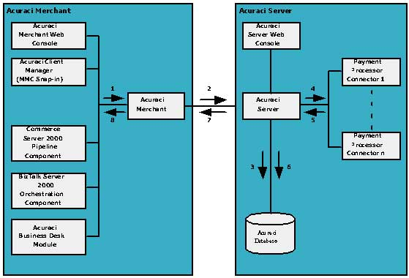
Figure 4: Acuraci Architecture

Description of steps in the settlement of a financial transaction:
- Acuraci Merchant receives the order from the CS2K pipeline or from the BTS2K Orchestration Component. Other interfaces such as the Acuraci Business Desk Module and the Acuraci Merchant Web Console can also access the functionality of Acuraci such as placing and managing orders.
- Acuraci Merchant packages, encrypts and sends the request to the Acuraci Server. Information between the Acuraci Merchant and Acuraci Server is transmitted using 128-bit encryption to help ensure secure communications. Messages are also signed and hashed so that only trusted Acuraci Merchants can send requests to the Acuraci Server.
- Once the request is received, it is decrypted and unpackaged. Acuraci Server then validates the content of the request, checks permissions and applies relevant business rules.
- Acuraci Server sends the transaction to the appropriate Payment Processor. The Acuraci architecture allows for the support of different Payment Processor Connectors. Merchant settings determine which Payment Processor will process the transaction. The choice of Payment Processor best suited for a Merchant will depend on the currency types to support, the country where the Merchant’s financial institution is located, the type of transaction to perform (e.g., credit card, e-check, purchase cards), etc.
- Acuraci Server receives confirmation from the Payment Processor.
- Acuraci Server logs the result to the Acuraci Database. Transactions are logged to the Acuraci Database throughout their life cycle to in order to provide audit capabilities and generate comprehensive reports like transaction status, activity summary, statistics, etc.
- Acuraci Server packages the confirmation message, encrypts it and sends it back to the Acuraci Merchant.
- Acuraci Merchant forwards the transaction result to the component that initiated the request.

Section 6

Sizing the Solution

While this paper has addressed the logical system architecture of a supplier enablement solution based on Supplier Advantage, it has not yet touched on the physical system architecture. Supplier Advantage is based on an evolutionary framework consisting of a set of successive reference architectures that allow the solution to scale with the needs of the business. While every organization will have its own unique business requirements, these reference architectures help to provide a starting point for implementation. We have also worked to reduce the complexity of management while providing a robust and extendable application environment. The deployment models discussed here will include three scenarios: Small Organization, Medium Organization and Enterprise Organization. These reference architectures help to provide a starting point to decide which deployment model is suitable for an organization’s environment.

Small implementations – Business Jumpstart

Architecture Overview
For small implementations, Supplier Advantage has a reference architecture called the “Business Jumpstart.” This configuration is ideal for smaller businesses with a requirement for five or fewer trading partner integrations or a larger business that is interested in conducting a pilot or proof of concept implementation. The configuration consists of two or three PowerEdgeTM 1550 servers. For a small organization with no need to scale, the two-server configuration is ideal. The three-server configuration is designed for organizations planning on scaling the solution beyond the initial implementation.

Right-sizing your Solution
The “Business Jumpstart” solution is designed for environments with the following characteristics:
- 1-5,000 items in their catalog
- Between 1-5 integration partners with catalogs published to each partner
- Up to 100,000 transactions per day
- 2,500 concurrent users
- ~25 ASP pages per second

Two-Server Reference Architecture
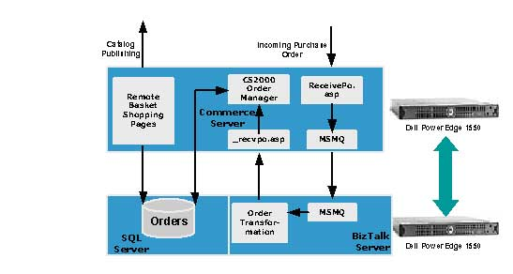
Figure 5: Two-Server Reference Architecture

Server #1:
PowerEdgeTM 1550:
Processors: Pentium III 933MHz w/256K Cache, Dual Processor
Memory: 2GB SDRAM
Primary Controller: PERC3-DCL RAID Card w/64MB Cache 1 Int/1 Ext Channel
1st Hard Drive: 18GB Ultra3, 1 IN, 10K RPM, SCSI Hard Drive
2nd Hard Drive: 18GB Ultra3, 1 IN, 10K RPM, SCSI Hard Drive
3rd Hard Drive: 18GB Ultra3, 1 IN, 10K RPM, SCSI Hard Drive
Network Adapter: Dual On-Board NICS
Diskette Drive: 3.5 Inch, 1.44MB Floppy Drive
CD ROM: 24X IDE CD ROM
Operating System: Windows 2000 Advanced Server
Application(s): SQL Server 2000 Standard, BizTalk Server Standard and BizTalk Accelerator for Suppliers
Server #2:
PowerEdgeTM 1550:
Processors: Pentium III 933MHz w/256K Cache, Single Processor
Memory: 1GB SDRAM
Primary Controller: PERC3-DCL RAID Card w/64MB Cache 1 Int/1 Ext Channel
1st Hard Drive: 18GB Ultra3, 1 IN, 10K RPM, SCSI Hard Drive
2nd Hard Drive: 18GB Ultra3, 1 IN, 10K RPM, SCSI Hard Drive
3rd Hard Drive: 18GB Ultra3, 1 IN, 10K RPM, SCSI Hard Drive
Network Adapter: Dual On-Board NICS
Diskette Drive: 3.5 Inch, 1.44MB Floppy Drive
CD ROM: 24X IDE CD ROM
Operating System: Windows 2000 Advanced Server
Application(s): Commerce Server 2000 and BizTalk Accelerator for Suppliers

Three-Server Reference Architecture
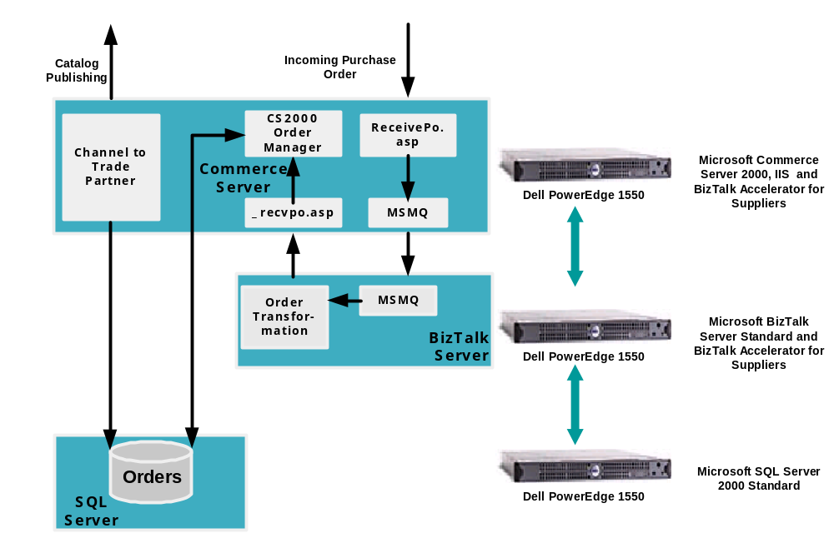

Figure 6: Three-Server Reference Architecture

Figure 6 illustrates a 3-tier implementation of the “Business Jumpstart” solution. We have placed the applications upon different tiers to allow for component-level redundancy and future scalability into a larger environment.

Server #1:
PowerEdgeTM 1550:
Processors: Pentium III 933MHz w/256K Cache, Single Processor
Memory: 1GB SDRAM
Primary Controller: PERC3-DCL RAID Card w/64MB Cache 1 Int/1 Ext Channel
1st Hard Drive: 18GB Ultra3, 1 IN, 10K RPM, SCSI Hard Drive
2nd Hard Drive: 18GB Ultra3, 1 IN, 10K RPM, SCSI Hard Drive
3rd Hard Drive: 18GB Ultra3, 1 IN, 10K RPM, SCSI Hard Drive
Network Adapter: Dual On-Board NICS
Diskette Drive: 3.5 Inch, 1.44MB Floppy Drive
CD ROM: 24X IDE CD ROM
Operating System: Windows 2000 Advanced Server
Application(s): SQL Server 2000 Standard

Server #2:
PowerEdgeTM 1550:
Processors: Pentium III 933MHz w/256K Cache, Single Processor
Memory: 1GB SDRAM
Primary Controller: PERC3-DCL RAID Card w/64MB Cache 1 Int/1 Ext Channel
1st Hard Drive: 18GB Ultra3, 1 IN, 10K RPM, SCSI Hard Drive
2nd Hard Drive: 18GB Ultra3, 1 IN, 10K RPM, SCSI Hard Drive
3rd Hard Drive: 18GB Ultra3, 1 IN, 10K RPM, SCSI Hard Drive
Network Adapter: Dual On-Board NICS
Diskette Drive: 3.5 Inch, 1.44MB Floppy Drive
CD ROM: 24X IDE CD ROM
Operating System: Windows 2000 Advanced Server
Application(s): Commerce Server 2000 and BizTalk Accelerator for Suppliers

Server #3:
PowerEdgeTM 1550:
Processors: Pentium III 933MHz w/256K Cache, Single Processor
Memory: 1GB SDRAM
Primary Controller: PERC3-DCL RAID Card w/64MB Cache 1 Int/1 Ext Channel
1st Hard Drive: 18GB Ultra3, 1 IN, 10K RPM, SCSI Hard Drive
2nd Hard Drive: 18GB Ultra3, 1 IN, 10K RPM, SCSI Hard Drive
3rd Hard Drive: 18GB Ultra3, 1 IN, 10K RPM, SCSI Hard Drive
Network Adapter: Dual On-Board NICS
Diskette Drive: 3.5 Inch, 1.44MB Floppy Drive
CD ROM: 24X IDE CD ROM
Operating System: Windows 2000 Advanced Server
Application(s): BizTalk Server 2000 Standard and BizTalk Accelerator for Suppliers

Medium Configuration – Volume B2B

Architecture Overview
For mid-sized implementations, Supplier Advantage has a reference architecture called the “Volume B2B.” This configuration is ideal for businesses with a requirement to integrate with multiple business partners and applications. The configuration consists of two PowerEdge™ 1550 servers, one PowerEdge™ 2550 server, and one PowerEdge™ 6450 server. Additionally, if there is a need for high availability, the PowerEdge 6450 server can be clustered with a Dell™|EMC® FC5300 storage solution for use as shared storage.

Right-sizing your Solution
The “Volume B2B” solution is designed for environments with the following characteristics:
- 5,000-10,000 items in their catalog
- Between 5-10 integration partners with catalogs published to each partner
- 1 Back-end integration requirement to an ERP/CRM system
- Up to 1 million transactions per day
- 5,000 concurrent users
- ~75 ASP pages per second

“Volume B2B” Reference Architecture
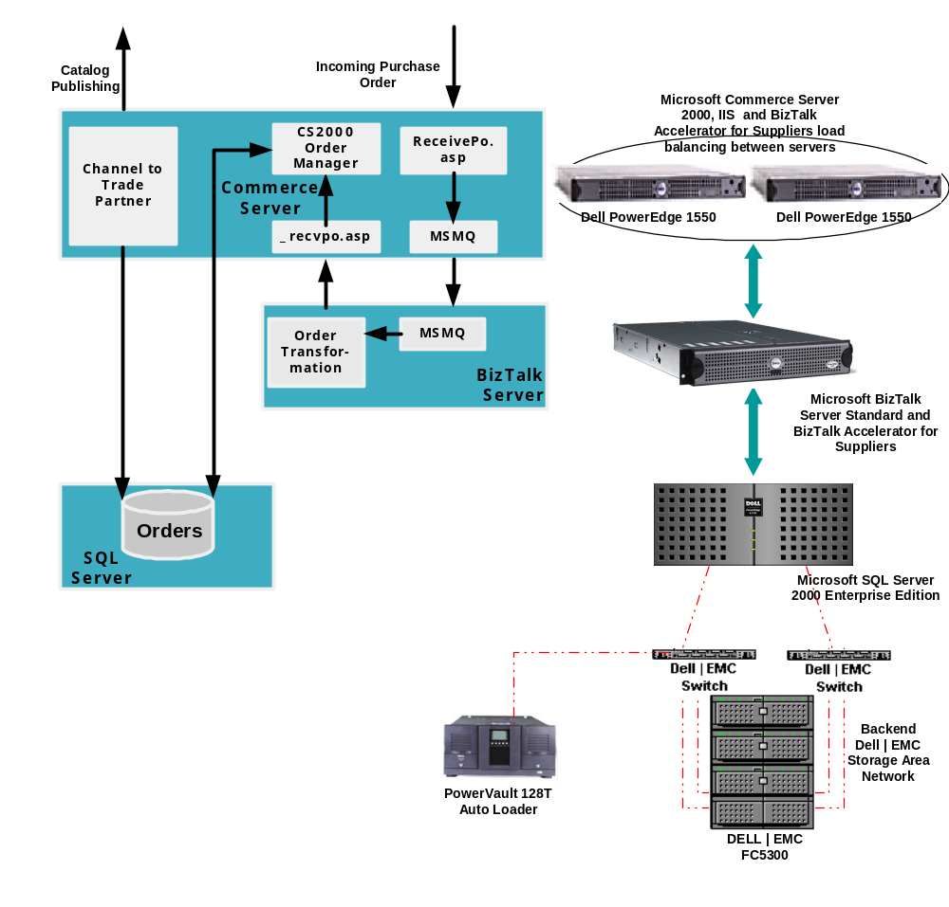
Figure 7: "Volume B2B" Reference Architecture

Servers #1 & #2 (Load-Balanced):
PowerEdgeTM 1550:
Processors: Pentium III 933MHz w/256K Cache, Dual Processor
Memory: 2GB SDRAM
Primary Controller: PERC3-DCL RAID Card w/64MB Cache 1 Int/1 Ext Channel
1st Hard Drive: 18GB Ultra3, 1 IN, 10K RPM, SCSI Hard Drive
2nd Hard Drive: 18GB Ultra3, 1 IN, 10K RPM, SCSI Hard Drive
3rd Hard Drive: 18GB Ultra3, 1 IN, 10K RPM, SCSI Hard Drive
Network Adapter: Dual On-Board NICS
Diskette Drive: 3.5 Inch, 1.44MB Floppy Drive
CD ROM: 24X IDE CD ROM
Operating System: Windows 2000 Advanced Server
Application(s): Commerce Server 2000 (Load-Balanced), BizTalk Accelerator for Suppliers

Server #3:
PowerEdgeTM 2550:
Processors: Pentium III 1.26GHZ w/512K Cache, Dual Processors
Memory: 2GB SDRAM, 133MHz, 2X1GB DIMMs
Primary Controller: Dual-Channel On-board RAID Controller 128MB Cache (2-Int Channels)
1st Hard Drive: 18 GB 1" Ultra3 (Ultra160) SCSI 10K RPM Hot Plug Hard Drive
2nd Hard Drive: 18 GB 1" Ultra3 (Ultra160) SCSI 10K RPM Hot Plug Hard Drive
3rd Hard Drive: 18 GB 1" Ultra3 (Ultra160) SCSI 10K RPM Hot Plug Hard Drive
Hard Drive Backplane: 4 Bay (1x4) Hot Plug Hard Drive Backplane
Hard Drive Configuration: On-Board SCSI, Drives 1-5 connected to on-board SCSI
Network Adapter: One integrated 10/100 and one integrated 10/100/1000 NICs
Operating System: Windows 2000 Advanced Server with 25 Client Licenses
Diskette Drive: 1.44MB Diskette Drive
CDROM or DVD ROM: 24X IDE Internal CD ROM Drive
Power Supply Kits: Dual Redundant 330 Watt Power Supplies
Remote Management: Dell Remote Assistant Card w/ 56K Modem
Application(s): BizTalk Server 2000 Enterprise or Standard (Dependant on number of trading partners)

Server #4:
PowerEdgeTM 6450:
Processors: Pentium III Xeon 700MHz w/1M Cache, Dual Processor
Memory: 2GB SDRAM
Primary Controller: PERC3/DC-Dual Channel Add-in RAID Card 128MB Cache (1-Int/1-Ext Channel)
First Hard Drive: 18GB 1" Ultra3 SCSI 10K RPM Hard Drive
Second Hard Drive: 18GB 1" Ultra3 SCSI 10K RPM Hard Drive
Third Hard Drive: 18GB 1" SCSI Hard Drive,10K RPM
Fourth Hard Drive: 18GB 1" SCSI Hard Drive,10K RPM
Network Adapter: Two Intel Pro 100+ NICs w/Adaptive Load Balancing and Adapter Fault Tolerance
Operating System: Windows 2000 Advanced Server
Diskette Drive: 3.5", 1.44MB Floppy Drive
CDROM: 24X IDE CD ROM
Tape Backup Unit: PowerVault 120T or PowerVault 130T for DLT technology, or PowerVault 128T for either DLT or LTO, or PowerVault136T for LTO technology. Based on different Service Level Agreements (SLA), different products can be used for different performance.
Remote Management: Dell Remote Assistant Card 2.0
Application(s): SQL Server 2000 Enterprise Edition
Optional Storage Array – Dell|EMC² FC5300 with up to 1.8TB of storage capacity

Large Configuration– Enterprise Integration

Architecture Overview
For large implementations, Supplier Advantage has a reference architecture called the “Enterprise Integration.” This configuration is ideal for businesses with large transaction volumes and a requirement to integrate multiple business partners and applications. The configuration consists of four PowerEdge 1550 servers, two PowerEdge 2550 servers, three PowerEdge 6450 servers, and one Dell|EMC FC5300 storage solution for use as shared storage.

Right-sizing your Solution
The “Enterprise Integration” solution is designed for environments with the following characteristics:
- Catalogs larger than 10,000 items
- 10 or more integration partners with catalogs published to each partner
- Several back-end integration requirement to ERP/CRM systems
- Greater than 1 million transactions per day
- 10,000 Concurrent Users
- ~150 ASP pages per second

“Enterprise Integration” Reference Architecture
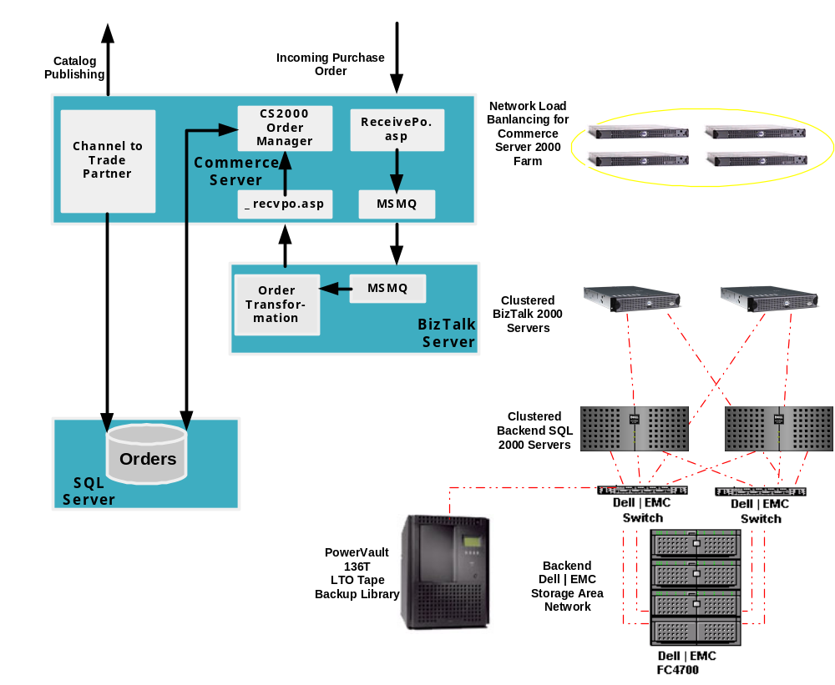

Figure 8: "Enterprise Solution" Reference Architecture [Label of Figure 8 should be on same page as Figure.]

Servers #1, #2, #3, and #4 (Load-Balanced):
PowerEdgeTM 1550:
Processors: Pentium III 933MHz w/256K Cache, Dual Processor
Memory: 2GB SDRAM
Primary Controller: PERC3-DCL RAID Card w/64MB Cache 1 Int/1 Ext Channel
1st Hard Drive: 18GB Ultra3, 1 IN, 10K RPM, SCSI Hard Drive
2nd Hard Drive: 18GB Ultra3, 1 IN, 10K RPM, SCSI Hard Drive
3rd Hard Drive: 18GB Ultra3, 1 IN, 10K RPM, SCSI Hard Drive
Network Adapter: Dual On-Board NICS
Diskette Drive: 3.5 Inch, 1.44MB Floppy Drive
CD ROM: 24X IDE CD ROM
Operating System: Windows 2000 Advanced Server
Application(s): Commerce Server 2000 (Load-Balanced), BizTalk Accelerator for Suppliers

Server #5 & #6 (Clustered with shared Dell | EMC Storage Area Network (SAN)):
PowerEdgeTM 2550:
Processors: Pentium III 1.26GHZ w/512K Cache, Dual Processors
Memory: 2GB SDRAM, 133MHz, 2X1GB DIMMs
Primary Controller: Dual-Channel On-board RAID Controller 128MB Cache (2-Int Channels)
1st Hard Drive: 18 GB 1" Ultra3 (Ultra160) SCSI 10K RPM Hot Plug Hard Drive
2nd Hard Drive: 18 GB 1" Ultra3 (Ultra160) SCSI 10K RPM Hot Plug Hard Drive
3rd Hard Drive: 18 GB 1" Ultra3 (Ultra160) SCSI 10K RPM Hot Plug Hard Drive
Hard Drive Backplane: 4 Bay (1x4) Hot Plug Hard Drive Backplane
Hard Drive Configuration: On-Board SCSI, Drives 1-5 connected to on-board SCSI
Network Adapter: One integrated 10/100 and one integrated 10/100/1000 NICs
Operating System: Windows 2000 Advanced Server with 25 Client Licenses
Diskette Drive: 1.44MB Diskette Drive
CDROM or DVD ROM: 24X IDE Internal CD ROM Drive
Power Supply Kits: Dual Redundant 330 Watt Power Supplies
Remote Management: Dell Remote Assistant Card w/ 56K Modem
Application(s): BizTalk Server 2000 Enterprise

Server #7, #8, #9 (Clustered with Dell | EMC Fibre-channel Storage Area Network):
PowerEdgeTM 6450:
Processors: Pentium III Xeon 700MHz w/1M Cache, Quad Processor
Memory: 4GB SDRAM
Primary Controller: PERC3/DC-Dual Channel Add-in RAID Card 128MB Cache (1-Int/1-Ext Channel)
First Hard Drive: 18GB 1" Ultra3 SCSI 10K RPM Hard Drive
Second Hard Drive: 18GB 1" Ultra3 SCSI 10K RPM Hard Drive
Third Hard Drive: 18GB 1" SCSI Hard Drive,10K RPM
Fourth Hard Drive: 18GB 1" SCSI Hard Drive,10K RPM
Network Adapter: Two Intel Pro 100+ NICs w/Adaptive Load Balancing and Adapter Fault Tolerance
FC-AL HBAs: Two Emulex Host Bus Adapter (HBA) card for redundancy.
Operating System: Windows 2000 Advanced Server
Diskette Drive: 3.5", 1.44MB Floppy Drive
CDROM: 24X IDE CD ROM
Remote Management: Dell Remote Assistant Card 2.0
Application(s): SQL Server 2000 Enterprise Edition
The Dell|EMC FC4500 supports up to 7.3TB of storage. Data storage can by expanded by upgrading the Dell | EMC FC4500 storage solution into three Dell | EMC FC4700 models; the Dell | EMC FC4700 can scale up to 8.4TB. The Dell | EMC FC4700 also provides Remote Synchronous Mirroring and SnapShot for Disaster recovery and Online backup. All Dell | EMC products support dual processors, dual fans, dual standby power supplies, and dual Fibre Channel HBAs. The Dell | EMC FC4700 has 4 functioning Fibre Channel adapters to access the drives. With dual Intel Pentium III processors on each Storage Processor, FC4700 can support 50,000 IOPS and move data at up to 360MB/Sec.

Section 7

Additional Deployment Considerations

One additional component that organizations need to factor in when designing an environment is security. When analyzing the security needs, organizations, should consider a Firewall solution such as Microsoft Internet Security Accelerator. Regardless of the size of the implementation, a common thread in any implementation is that organizations will be sharing data with each other via an electronic link, and it is imperative that this data remain secure. To ensure the data security, most organizations employ two separate firewall layers:
- The first layer should consist of a firewall separating the Public Internet from the front-end web servers. Since these front-end web servers have the greatest potential exposure to external hackers, etc., this is the most dangerous and volatile environment, and security precautions are critical. In the case of Supplier Advantage, these web-layer described above is represented by the servers in the Commerce Server 2000 Farm.
- The second layer should consist of a firewall to isolate the back-end of the web servers from the organization’s Intranet, and in this layer an organization will configure relevant ports to allow (or deny) access to the Internet. This creates a “DMZ” or Demilitarized Zone out of the web farm to help isolate critical data in back-end systems from potential attacks. In the Supplier Advantage solution, the Commerce Server Farm sits in the DMZ, and transmits data to and from the back-end BizTalk and SQL servers using HTTP through port 80.

This design allows organizations to scale their web and their application layers independently without sacrificing security. Figure 9 illustrates the “Enterprise Solution” complete with the firewall layer included.

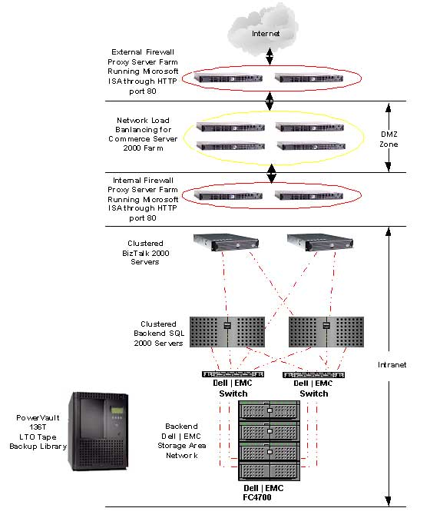
Figure 9: "Enterprise Solution" with Security Layers

Section 8

Completing the Enablement

Supplier Advantage provides a solution that to enables suppliers to complete round trip B2B transactions with their business partners using several pre-configured integration points. Through the use of BizTalk Server, a supplier can reap the full benefit of the workflow, document transformation, document messaging, and routing capabilities; BizTalk also provides and extendable platform to perform integrations with virtually any existing line of business systems. Additionally, the Supplier Advantage solution exposes XLANG schedules and code segments intended expressly for the purpose of integration. This is helpful because in many cases additional custom integration is recommended to fully complete the solution. This integration often comes in the form of integration to back end ERP systems. In an ERP integrated scenario, product/service offerings, inventory, customer and vendor profiles as well as the order management capability, are all controlled by the ERP system leveraging Commerce Server as an interface to the Internet. Another potential integration requirement is with Customer Resource Management (CRM) applications where the personalization of the remotely managed catalogs is controlled by the CRM application making a truly complete customer interaction for both the buyer and seller.

Supplier Advantage is a solution for organizations looking to electronically enable their businesses and expand their trading relationships to many diverse partners over the Internet. Supplier Advantage provides an evolutionary framework that leverages the best practices of Dell and the expertise of Cactus, all on the Microsoft .NET platform. We know that the implementation of any business-to-business solution is anything but trivial; however, Supplier Advantage is geared at making such an implementation as painless as possible. Supplier Advantage offers organizations a set of pre-packaged server solutions to fit their needs, and it provides the facilities for the delivery of additional services. Whether these services are aimed at customizing the messaging protocol, integrating the solution to a line of business system, or simply designing the most scaleable and adaptable catalog structure, Dell, Cactus and Microsoft have the expertise and experience to help organizations make the best use of their business-to-business investment.

For more information send an email to dotnet@dell.com or visit:
http://www.dell.com/SupplierEnablement
http://www.cactus.ca/solutions/default_e.asp
http://www.microsoft.com/solutions/msse

Dell, PowerEdge, and PowerVault are trademarks of Dell Computer Corporation. EMC is a registered trademark of EMC Corporation. Microsoft is a registered trademark of Microsoft Corporation. Other trademarks and trade names may be used in this document to refer to either the entities claiming the marks and names or their products. Dell disclaims proprietary interest in the marks and names of others.

©Copyright 2002 Dell Computer Corporation. All rights reserved. Reproduction in any manner whatsoever without the express written permission of Dell Computer Corporation is strictly forbidden. For more information, contact Dell. Dell cannot be responsible for errors in typography or photography.

Information in this document is subject to change without notice. The content is provided as is, without express or implied warranties of any kind.

The Acuraci Financial Transactions Platform (pronounced “accuracy”) enables businesses to settle electronic transactions online, through a variety of methods, such as: credit cards, corporate procurement cards, electronic funds transfers and e-cheques. Acuraci allows customers to process and settle transactions in 128 currencies, making this an excellent solution for mid-tier sell-side and buy-side e-commerce in the market.
This schema can be extended to include other attributes to accommodate the unique requirements of each supplier.
For more information on cXML Catalogs, see http://www.cXML.org . For more information on xCBL Catalogs, see http://www.xCBL.org .
Note that if the default maps are used in the way described in the Catalog Publishing section of this paper, then use only lower case ‘yes’ or ‘no’ values in this attribute. Any other values will cause the map to fail.
The Accuraci Server is certified by several payment processors in the United States and Canada.
The Acuraci Server and the Acuraci Database normally reside behind firewalls to protect the computer itself from intruders and hackers.
For detailed information on how to install and configure these solutions, Microsoft offers several in-depth guides at http://msdn.microsoft.com/downloads/default.asp?URL=/code/sample.asp?url=/MSDN-FILES/027/001/784/msdncompositedoc.xml

