1. Project Background and Scope

Gambling is one of the world’s oldest hobbies. A practical issue is how to facilitate gamblers and entertain them without them needing travel thousands of miles to Las Vegas, for instance. This motivated our team to develop an Internet casino that will offer gamblers a casino experience that will satisfy all of their needs and allow them to play real casino games from anywhere around the world

The purpose of this document is to specify, visualize, construct, and document the artifacts of an e-Casino project. The document will act as a baseline for the design and analysis of the e-Casino application. The intended audience for this document consists of all business and technical stakeholders and the members of the e-Casino application team.

The goal of the e-Casino project is to identify, design and implement e-Casino application. Phase 1 will implement two casino games. One of which will be a dice game “craps” and the other is a card game of “black jack”. Future project phases will implement additional games. It must allow web users to register and subsequently to gamble. In addition, it must be secure and be able to support millions of customers at any one moment.

- Development Approach

The technology of Object-Oriented Analysis and Design (OOA/D) has been applied for the e-Casino application software design. The Unified Modeling Language (UML) is used as the standard notation for modeling. The overall design process is carried on using an iterative development throughout all phases of design.

The overall lifecycle activity starts with capturing requirements, identifying actors for the e-Casino system, and defining the objective for the system. Next is to figure a system level of use case diagram. Based upon the requirements and gambling rules, a scenario in a system level is narrated to describe details what the system must provide to the actors. The sequence diagram is then developed accordingly.

By analyzing and elaborating use case model, a further concrete scenario is developed with a more detailed event flow and user interfaces related definitions associated with. At this level, objects for the system are defined to incorporate into the sequence diagram. The guideline of GRASP patterns is used to establish the relationship among classes to realize low coupling and high cohesion. This in turn examines the scenario and adds necessary missing events to the use case.

All attributes and operations defined in the class diagram are assigned to the classes based upon the requirements and events in the sequence diagram. Their sufficiency is evaluated by a real world object diagram, which is basically described by a snapshot of series states. Each object can be further detected with a state chart diagram that illustrates the interesting events & states and shows the lifecycle of an object. Furthermore, how a series of states change crossing object boundary in the system is described in the activity diagram.

With the consideration of software modularity, a component diagram is designed to encapsulate classes with performing a same type of tasks. The overall system scope of implementation details is described with the deployment diagram that essentially illustrates the deployment of components defined in the component diagram and processing nodes communicated through interfaces.

- Use Case Model

The use case model for the e-Casino can be established based upon the system’s requirements, functionality, and environment. They are illustrated in the following.

  - Requirements:
- The e-Casino system must be web-based that allows gamblers to register and subsequently gamble via Internet.
- It should support blackjack and craps.
- It must be secure.
- It should eventually be scalable to entertain millions of gamblers at any given moment.
- It should be able to keep track of, to provide, and to update user’s information.
- It should be able to handle user’s account transaction and cash in & out.

  - Actors:
- Gambler.
- Billing System.
- System Administrator.
- Authorization Service.

  - Purpose and interests:

- Gamblers want fast, secured entry, no payment errors, and games are easy to play. They can get help as needed such as, password request.
- Billing System wants fast and accurate transaction.
- System Administrator needs to insure secured entry and to provide help for user needs.
- Authorization Service provides accurate authorization requests in a correct format, and checks for authorization every time the credit card is used.

  - Use case diagram:

Figure 1 depicts the system level of the use case diagram that represents the interaction between actors and the e-Casino system, including,

- A gambler can play blackjack.
- A gambler can play craps.
- The authorization Service does validating credit card information and checking credit limit.
- The billing system serves making payment and updating user’s account balance.
- The system administrator is responsible for processing any user request.

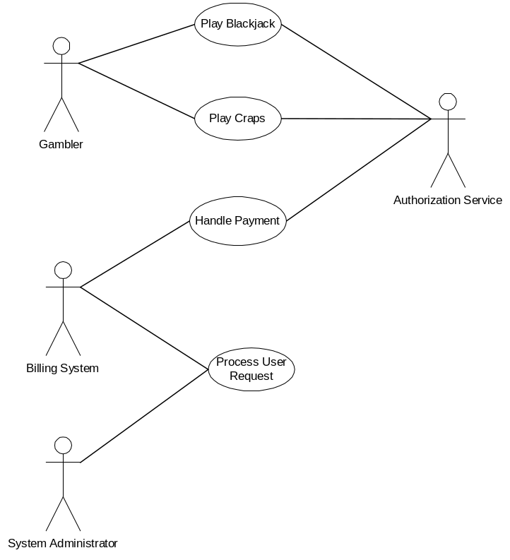

Figure 1 Use case diagram for e-Casino.

  - Essential use case scenarios:

Based upon the functionality, requirements, and the goal of the e-Casino system, an essential use case narrative can be described as follows.

- Gamblers link to the URL and register for a user account.
- The system generates username & password and emails them to the gamblers.
- Gamblers login to the system using their username and password.
- The system authenticates the login by checking the validity of username and password.
- Gamblers select blackjack or craps to play.
- Gamblers can also update their personal information such as, password and credit card.
- Gamblers play blackjack.
- Gamblers exchange for chips.
- The system checks gamblers’ account balance to make sure that the cash in the account is sufficient.
- Gamblers bet then start a new game.
- The system serves two cards for both the gamblers and dealer.
- Gamblers may win if they have blackjack but the dealer doesn’t, lose if the dealer has blackjack but the gamblers don’t, or even if both the dealer and gamblers have blackjack at the same time.
- Gamblers select “hit”.
- The system serves another card to the gamblers.
- Gamblers lose if it causes busted, the total point is greater than 21.
- Gamblers select “split”.
- The system serves two cards to each of split cards.
- Gamblers select “double down”.
- The system serves only one more card. The gamblers lose if it is busted.
- Gamblers select “stand”.
- The system adds cards to the dealer until the total point is greater than 16.
- Gamblers win if their total point is less than or equal to 21, and greater than dealer’s point or dealer is busted, lose if they are busted or their total point is less than dealer’s point, or even if both gamblers and the dealer have equal point.
- Gamblers can restart the game at any time.
- Gamblers can only play one kind of game, blackjack or craps, at a time.
- Gamblers can cash in and out.
- Gamblers can exchange from cash to chips and chips to cash.
- The system updates cash and chips into account balances.
- The system can store, update, and retrieve user’s information from databases.
- Gamblers play craps.
- Gamblers roll dices.
- Gamblers put down chips for bets.
- The system determines if gamblers lose or win.
- Gamblers can change betting at any time.
- Gamblers get help for password.
- The system searches gamblers’ password based upon the information provided by gamblers.
- The system notifies gamblers’ password if it is found. Otherwise, asks gamblers to re-register or input correct information again.

  - System sequence diagram:

In order to examine and realize the essential use case scenario in 3.5, a sequence diagram in a system level has been established. As shown in Figure 2.1 and 2.2, the event flow in the system sequence diagram is mapping with the functionality in the use case scenario.
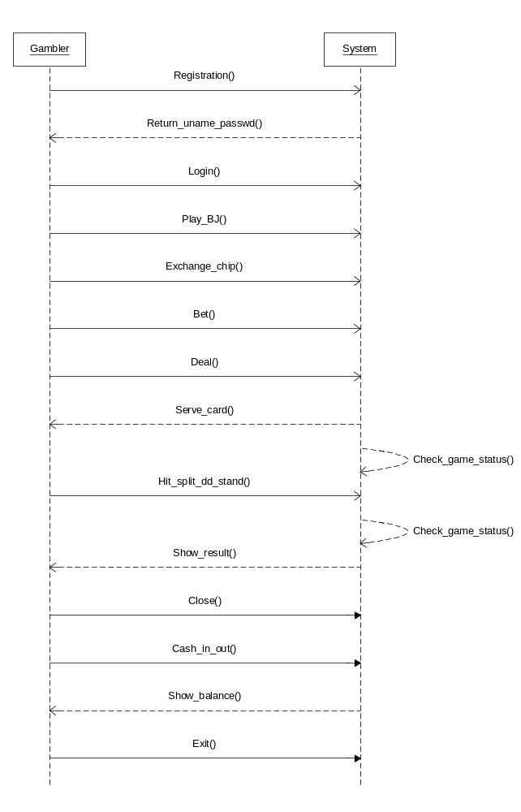
Figure 2.1 System sequence diagram of blackjack.

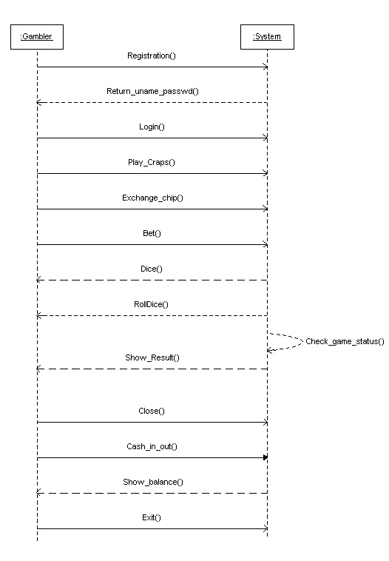
Figure 2.2 System sequence diagram of craps

- Object-Oriented Analysis

In a deep understanding of the system use case, a further decomposition of the system use case through process analysis and elaboration into a number of sub-use cases. This is a very important step to break down a high level functionality into more detailed and self-contained objects.

  - Real use case scenarios:

1) Name: Register
Actor: Gambler
Purpose: Gamblers link to URL of e-Casino and wants to register.
Preconditions: Gamblers are a first time players. The system uses SSL communication.
Main scenarios:
  - Type URL: the main page of e-Casino pops up, which allows gamblers to register.
  - Gamblers click the registration button/link. A page pops up with requested information entries for gamblers to input.
  - Gamblers enter requested Information: name, email address, phone number, type of a credit card used, number on the credit card, and expiration date.
  - Gamblers submit registration request.
  - The system validates input and credit card information.
  - The system generates username and password, and emails them to the registering users.
  - The system stores submitted information into databases.
Post-condition: Gamblers received their username and password.
Extension: Gamblers registered already (or already a member).
Exception: The registration is rejected.
- Gamblers provide invalid credit card information and/or insufficient request information.
- Credit card company signals invalid information.

2) Name: Login
Actor: Gambler
Purpose: Gamblers want to play games.
Precondition: Gamblers are registered and authenticated.
Main scenario:
- Gamblers click the Member Login button/Link, a page pops up asking for username and password.
- Gamblers type username and password.
- Gamblers click on login to submit username and password to the system.
Extension:
- Member forgot password.
- Gamblers click on “Get Help”, a page pops up asking for name, username, and email address.
- Gamblers enter all requested information.
- Gamblers submit request.
- Gamblers receive the password.
- Gamblers want to update account after login, such as, change password and credit card.
Post-condition: Gamblers successfully enters into the e-Casino.
Exception: Login is invalid: <<Update Account>>
- Gamblers entered invalid username/password. The system signals gambler by sending a warning message. Gamblers are asked to enter username and password again.

3) Name: Update Account
Actor: Gambler
Purpose: Change password and/or credit card information.
Precondition: Gamblers were successfully Login.
Main scenarios:
- Gamblers request to view information on their accounts.
- Gamblers click update information.
- Gamblers enter new password.
- Gamblers add another credit card or change existing credit card information.
- Gamblers submit new changes.
- Submitted information is added or updated into databases.
Post-condition: information was updated.
Exception: the new password is not in the correct format. New credit card information is not valid.

- Name: Login Validation
Actor: Authorization Service.
Purpose: Validate login for checking correct username and password. Also provides help for gamblers as needed.
Precondition: Gamblers were successfully registered.
Main scenarios:
- The system gets gamblers’ records from databases based on the username and password input by the gamblers.
- The system checks input username and password to see if they are existing in the databases or not. If yes, it links to Authorization Service to validate credit card information obtained from gamblers’ profile.
- If the information is correct, Gamblers are allowed to play games. Otherwise, a message is returned to notify input failure.
Extension: Gamblers forgot password: <<Update Account>>
- The system asks gamblers to submit username, name, and email address.
- The system gets information from databases and compares them.
- If the data matches with the information input by the gamblers, the system sends a message with the password to the gamblers.
Post-condition: Gamblers login or got help.
Exception: Gamblers forgot password: Gamblers either provide name, address, email, credit card number, and expiration date to register again, or request for password for login.

5) Name: Play Black Jack
Actor: Gambler.
Purpose: to play Black Jack.
Precondition: Gamblers were successfully login.
Main scenarios:
- Gamblers start the game
- Gamblers click “Buy Chips”. A page pops up to allow gamblers to exchange money for chips.
- Gamblers enter amount of cash for chips.
- Gamblers bet and start the game.
- The system deal two cards for gamblers and the dealer with one of them facing up.
- Gamblers select “Hit” for asking another card if sum of points on the existing two cards are still less than 21.
- Gamblers repeat step 5-f) as long as sum of points on all cards is less than or equal to 21.
- Gamblers click “Stay” to stop serving cards.
- Gamblers win if sum of points is greater than sum of points on dealer’s cards, and loss if sum of points on gambler’s cards is less than sum of points on dealer’s cards.
- Gamblers start a new game: gamblers repeat steps 5-a) – 5-h).
- Gamblers quit playing Black Jack.
- Gamblers receive their chip and account balances.
- Gamblers want cash out.
- Billing System transacts account balance and bills gamblers.
- Gamblers log off system.
Extensions:
- Gamblers want to split if 2 cards are identical:
  - The system deals two cards to each of the split cards.
  - Gamblers are allowed to split as many as they want.
  - Games are proceeded with regular rules.
- Gamblers wants to double down:
  - Gamblers double the bet. The system will serve only one more card to gamblers.
- Gamblers want to buy insurance:
  - Gamblers place another ½ of the bet if the dealer’s face-up card is an Ace.
  - The dealer takes the amount of insurance immediately.
  - If the dealer has Black Jack, the gamblers do not lose their bet and the game is over. Otherwise, the game resumes with the regular rules.
- Gamblers have Black Jack that sum of points on the first 2 cards is 21. Gamblers win.
- Gamblers lose if sum of the total points is greater than 21 (busted).
Post-condition: Gamblers won or lost.
Exception: Gamblers do not have enough money (credit cards are over limit):
- Billing Service notifies gamblers.
- Game is suspended.

6) Name: Play Craps
Actor: Gambler.
Purpose: to play Craps
Preconditions: 1) Gamblers were successfully login.
2) Gamblers must be rollers.
Main scenarios:
- Gamblers select the game
- Gamblers want to exchange for chips.
- Gamblers enter amount of cash and obtain the same amount of chips.
- Gambler places bet according to the following rules
- Place a bet on a pass area and roll the dices
  - If getting 7 or 11, gamblers win.
  - If getting 2, 3, or12, gamblers lose.
  - If getting 1, 4, 5, 6, 8, 9, and 10, gamblers get a point.
  - If getting 7, gamblers lose
  - If not equal to 7, gamblers win.
- Place a bet on “Don’t Pass” area and roll the dices
  - If getting 7 and 11, gamblers lose.
  - If getting 2 and 3, gamblers win.
  - If getting 12, it is standing by.
- Place a bet on a “Come Area” (play once the point is established) and roll the dices
  - If getting 7 or 11, gamblers win.
  - If getting 2, 3, and 12, gamblers lose.
  - If getting 1, 4, 5, 6, 8, 9, and 10, gamblers get a point.
    - If getting 7, gamblers lose.
    - If not getting 7, gamblers win.
- Gamblers place bet on a “Filed Area” and roll the dices
  - Bet that 2, 3, 4, 9, 10, and 12 is rolled before 5, 6, 7, or 8.
  - Lose if not getting 5, 6, 7, or 8.
- Any seven - bet that the next roll would be a 7 - pay 4 to 1
- Any eleven - bet that the next roll would be an 11.
- Any two - bet that the next roll would be a 2.
- Any three - bet that the next roll would be a 3
- Any twelve - bet that the next roll would be a 12.
- Results are displayed.
- Gamblers select to quit out of the game.
- Account balance is updated.

7) Name: Data Process.
Actor: Authorization Service
Purpose: Manipulate and retrieve data
Precondition: Gamblers were registered and successfully login.
Main scenarios:
- Gambler’s username, password, personal and credit cards information should be stored in databases after gambler’s registration is submitted and validated.
- Authorization Service gets credit card information and authenticates its number, type, and expiration date.
- The system gets information from the databases to validate gambler’s username and password every time when gamblers login.
- System administrator provides help information based on gambler’s name and username stored in the databases.
- Authorization Service checks gambler’s credit limit after validating gambler’s credit card information.
- System administrator updates databases and tracks gambler actions when gambling sessions are active.
- System administrator notifies Billing System for any gambler action to exit games or if any session is abnormally terminated.
Post-condition: data was manipulated.
Exception: Data not found.

8) Name: Payment
Actor: Billing System
Purpose: calculates total, makes credit card transaction, requests authentication, gets credit limit, and presents receipts.
Precondition: Gamblers entered correct credit card information, and were successfully login.
Main scenarios:
- Billing System records chip exchanged.
- Billing System gets data from the database, including gambler’s name, address, phone number, credit limit, present amount of win/lose.
- Billing System signals gamblers if available money exceeds total limit.
- Billing System calculates total balance when gamblers quit game.
- Billing System makes/receives payment:
  - Billing System requests validation.
  - Credit amount of win/lose to gamblers’ credit card.
  - Billing System asks gamblers for credit payment.
  - Billing System receives from and/or bills gamblers.
Extension: Billing System receives warning notices from Authorization Service:
- Billing System sends a message to the gambler.
- Billing System can suspend any game in process.
Post-condition: Billing System successfully transacted balance.
Exception: Database is down: Billing System stores credit update and processes update when the database is up.

9) Name: Chip Exchanger
Actor: Gambler, Billing System.
Purpose: exchange from chips to money, and money to chips.
Main scenarios:
- When Gamblers select “Buy Chips”, a window pops up to ask gamblers to enter amount of cash for chips.
- Gamblers click “Exchange”.
- The system gives the same amount of chips to gamblers.
- The system updates the gambler’s account balance in the database.
Post-condition: Exchanger was successfully, and gamblers got chips.
Exception: Chip Exchanger is temporarily out of service (maintenance).

10) Name: Credit Validation
Actor: Authorization Service
Purpose: check credit limit, expiration date, and validate credit card holder.
Precondition: Gambler provided credit card information when registered, or Billing Service wants to validate credit card.
Main scenarios:
- Authorization Service verifies gambler’s name, credit card number, type of credit card, and expiration date.
- If the credit card is valid, Authorization Service gets credit limit and available credit for system uses.
Post-condition: credit card was validated.
Exception:
- Invalid Credit Card information: Authorization Service sends a message to notify the system.
- Expiration date is wrong: Authorization Service sends a message to notify the system.
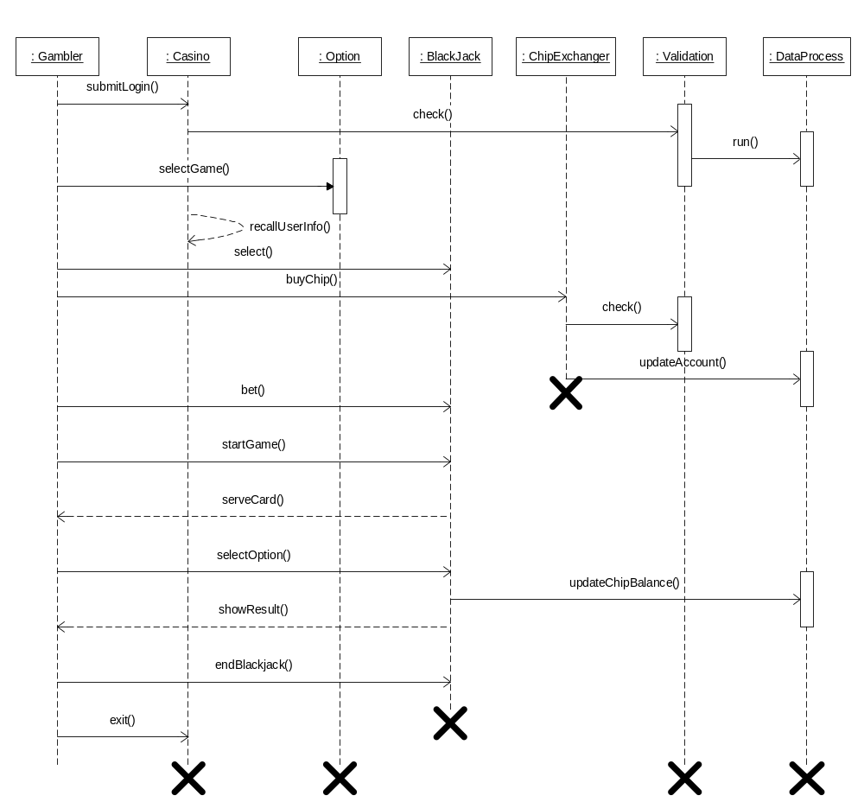
Figure 3.1 Sequence diagram for blackjack
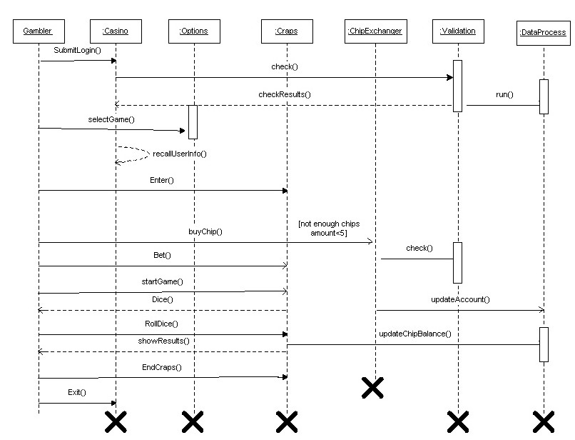
Figure 3.2 Sequence diagram for craps

  - Object-based sequence diagram:

As an example, the following shows a sequence diagram (Figure 3) for playing blackjack. The diagram gives an object-oriented representation with time series associated event flow, object activation, lifetime of an object. It also shows the interaction between an actor and the system, as well as the interaction among the internal system objects.

- Design Model

By investigating the requirements, related rules, and constraints, four diagrams including class, object, state chart, and activity have been developed to satisfy design requirements.

  - Class diagram:

By parsing requirement information from use cases in 3.1 along with collecting operations according to the object-based sequence diagram, a class diagram is created as shown in Figure 4.

Ten classes have been modeled in the class diagram. Their functionality and relationship are illustrated below.

- Casino is a control class in the e-Casino system, which has three operations to interact with other classes. i) Operation login is used to pass parameters username and password input by users for checking the existence of a user record in the database through classes Validation and DataProcess. If it exists, the login invokes class Option. ii) Operation register is used to activate class Registration. iii) Operation getHelp is for users to request help, for instance, password.

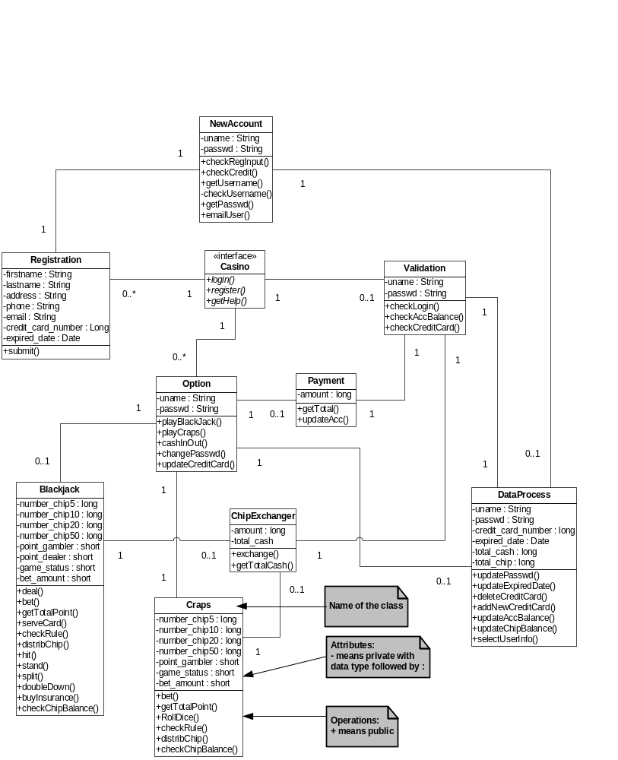

Figure 4 Class diagram for e-Casino.

- Class Registration is to be invoked by class Casino if a new user need to register for gambling. Only one operation submit is used to invoke class NewAccount and to pass user inputs to it.
- Class NewAccount is associated with class Registration. Its operations include i) checkRegInput which is to validate all necessary input by users. If OK, go next. Otherwise, pop up a message to notify users for more requested information; ii) checkCredit which is used to link the Credit Card Authorization Service for credit card validation; iii) getUsername used to auto-generate username which should be created initially by the initial of first name followed by the full last name. After that, it calls checkusername to check the initialized username from the database to make sure that the username is unique. If it exists in the database, add number to its suffix and go through the same process until the username is generated; iv) checkUsername which is used to check if the username exists in the database or not. It will invoke class DataProcess; v) getPasswd used to generate a password randomly for users; vi) emailUser used to send generated username and password to any registering user.
- Option is a central class associated with class Casino. Its operations include i) playBlackjack used to invoke class Blackjack; ii) playCraps used to invoke class Craps; iii) cashInOut used to invoke class Payment; iv) changePasswd used to invoke class DataProcess which does updating the password.
- Blackjack is the class encapsulating all rules for playing game. Its operations includes i) deal which is to restart a game; ii) bet used to put down amount of chips for gambling; iii) getTotalPoint used to sum of the total points for users and the dealer; iv) serveCard which used to generate a card randomly; v) checkRule used to determine who is a winner; vi) distribChip used to auto-change the number in 5, 10, 20, and 50 dollar’s chips, which should facilitate users for betting whatever amount they want; vi) hit used to request another card; vii) stand used to stop serving cards; viii) split used to split a pair of card and put down same amount of chips for one of the split cards; ix) doubleDown used to double amount of chips for bet, which only one more card is serving to the gambler; x) buyInsurance used in the case of whenever the dealer has a Ace facing up, gamblers can put down a half of their bet as buying insurance. No matter whether the dealer is blackjack or not, the gamblers is losing the amount for insurance. If the dealer is blackjack, the game is over. Otherwise, the game continues with a regular rule; xi) checkChipBalance used to check how many chips a gambler left. If it is zero, invoke class ChipExchanger.
- Class Craps is for playing craps. Its operations are very similar to those in class Blackjack, except for the rollDice that is to randomly generate dice number.
- The purpose of class ChipExchanger is to provide functionality for chip exchanger. It invokes class Validation to check user’s account balance to make sure that the account has enough cash for cash transaction. Its operations include i) exchange used to exchange cash to chips or chips to cash; ii) getTotalCash used to calculate the total cash in a specific account.
- Class Payment is to handle cash in and out. It invokes class Validation to check and update user’s account information. Its operations include i) getTotal which is used to total cash in a specific account; ii) updateAcc used to update user account after cash in and/or out.
- Class Validation is designed for validating user’s information by invoking class DataProcess to view, add, and update user’s information in the databases. Its operations include i) checkLogin used to validate username and password input by gambler for logon; ii) checkAccBalance used for getting a specific account balance and to make sure that a gambler has enough cash for chip exchanger; iii) checkCreditCard used to link to Credit Card Authorization Service for credit card validation.
- Class DataProcess is to connect to databases and retrieve user’s information. Its operations include i) updatePasswd used to change password requested by gamblers; ii) UpdateExpiredDate used to update credit card expiration date if it need be changed; iii) deleteCreditCard used to delete a credit card information if it is no longer to be used; iv) addNewCreditCard used to add a new credit card; v) updateAccBalance used to update a specific account balance whenever any chip exchanger or cash in & out is proceeded; vi) updateChipBalance used to update chip balance; vii) selectUserInfo used to retrieve user’s information.

  - Object diagram:

Object diagram, which is a instance of the class diagram, show a snapshot of the state of the system at one time. Figure 5 gives a real world state reflecting the class diagram depicted above for a blackjack gambling process.

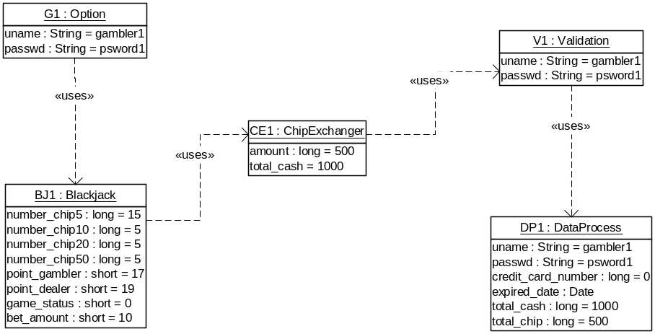

Figure 5 Object diagram for playing blackjack.

  - State chart diagram:

Figure 6.1 shows a state chart diagram for playing a balckjack, which provides the sequence of three states, ServingCard, MakingSelection, and GettingGameStatus. Their transitions are shown as arrows, labeled with their events.
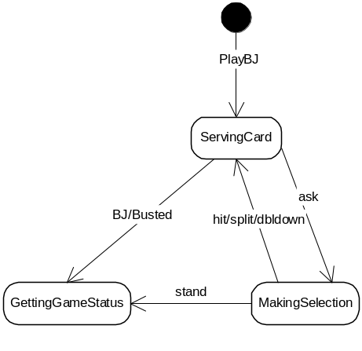

Figure 6.1 State chart diagram for playing blackjack

Figure 6.2 shows a state chart diagram for playing a craps, which specifies the sequence of seven states, Checking, Play, Bet, Roll Dice, Game Status, Quitting and Buying Chips. Their transitions are shown as arrows, labeled with their events.

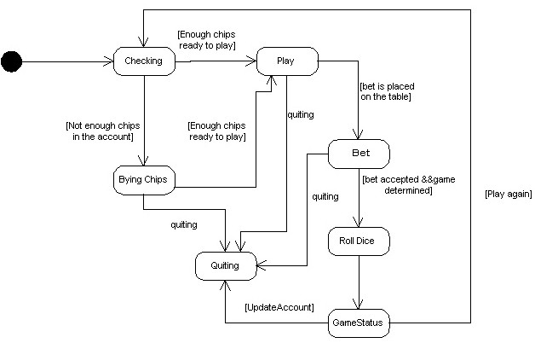
Figure 6.2 State chart diagram for playing craps

  - Activity diagram:

Figure 7 depicts an activity diagram for playing blackjack. It contains two objects, a gambler against the dealer, partitioning the activity states into groups. In this diagram, transitions cross objects with a time sequence from top down. Note that there are a fork and join in the dealer object representing that state “Serve Card” can directly trigger state “Check Game” or invokes state “Choose Option” then activates state “Check Game”.

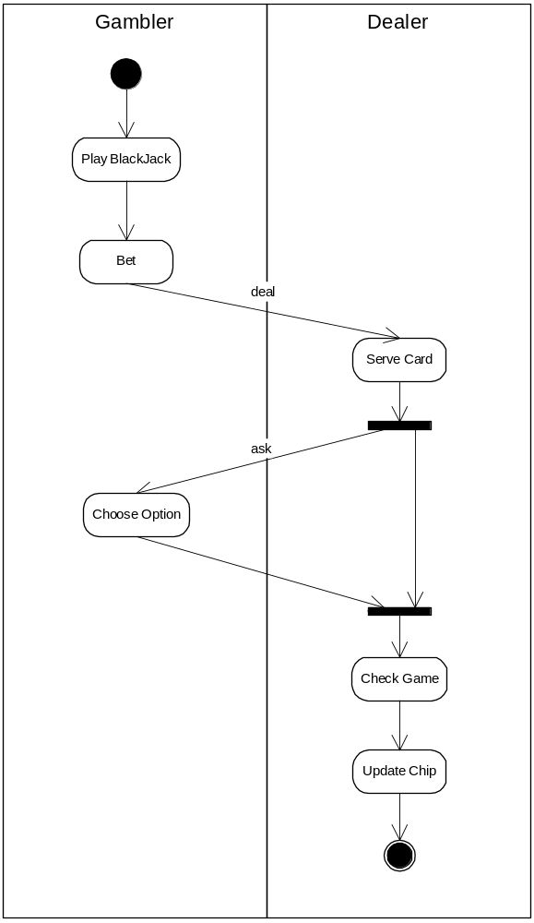

Figure 7 Activity diagram for playing blackjack.

- Deployment Model

The following two diagrams have been created to view the system topology, communications, and mapping with classes to components and components to processing nodes for deployment.

  - Component diagram

By taking maintainability and scalability into consideration, the component diagram has been designed to group class(es) into a number of deployable and replaceable parts of the system, as shown in Figure 8.

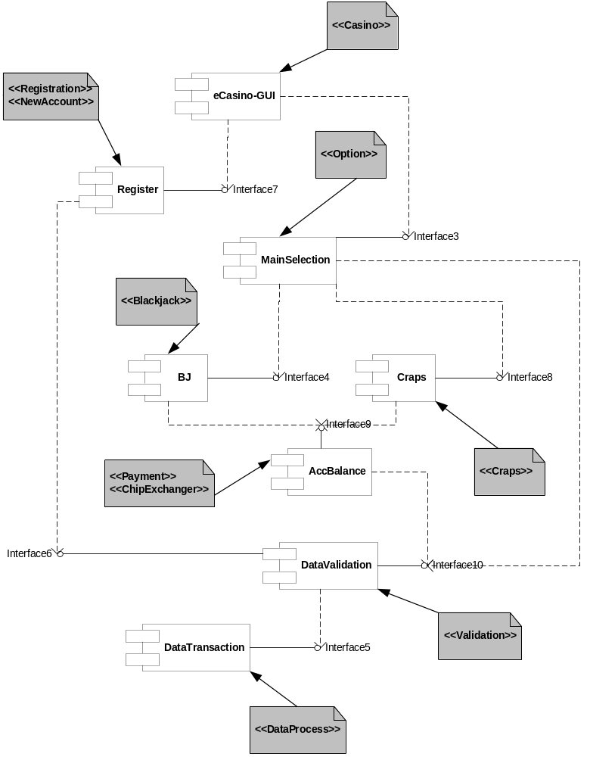

Figure 8 Component diagram for e-Casino.
In the diagram, some components are not too often to be changed, for instance, register, while others may need to be changed quite frequently. This will eventually benefit the system to extend new types of games to the system and to increase volume of gambling by breaking them down into more sub-processing nodes.

  - Deployment diagram

Figure 9 shows the deployment diagram for the e-Casino system. Since it is web-based, the Client processing node requires an instance of browser for navigation. All components designed in the component diagram are encapsulated into the web server node in which an interface from the e-Casino_GUI component will serve as an entry point marshaling with the client-processing node, and the DataTransaction component will point to the interface exposed from the database node for retrieving and manipulating data.

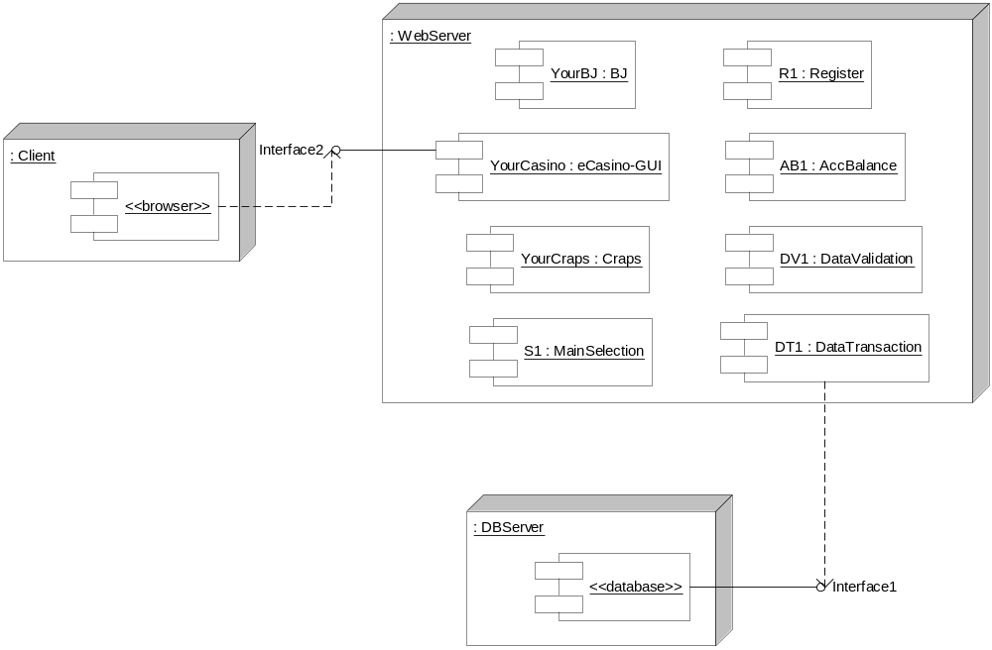

Figure 9 Deployment diagram for e-Casino

