
Indirect Tax Reference Model Version 2.0
Working Draft 07
26 October 2007
URIs:
This Version:
http://docs.oasis-open.org/tax/indirect/taxxml-indirect_tax-2.0-reference_model-wd-07.html
http://docs.oasis-open.org/tax/indirect/taxxml-indirect_tax-2.0-reference_model-wd-07.doc
http://docs.oasis-open.org/tax/indirect/taxxml-indirect_tax-2.0-reference_model-wd-07.pdf
Previous Version:
http://docs.oasis-open.org/tax/indirect/taxxml-indirect_tax_ref_model-1.0-spec-wd-10.html
http://docs.oasis-open.org/tax/indirect/taxxml-indirect_tax_ref_model-1.0-spec-wd-10.doc
http://docs.oasis-open.org/tax/indirect/taxxml-indirect_tax_ref_model-1.0-spec-wd-10.pdf
Latest Version:
http://docs.oasis-open.org/tax/indirect/taxxml-indirect_tax-2.0-reference_model-wd-07.html
http://docs.oasis-open.org/tax/indirect/taxxml-indirect_tax-2.0-reference_model-wd-07.doc
http://docs.oasis-open.org/tax/indirect/taxxml-indirect_tax-2.0-reference_model-wd-07.pdf
Technical Committee:
OASIS Tax XML TC
Chair(s):
Harm Jan van Burg, Netherlands Tax and Customs Administration
Susan Smoter, US IRS, Internet Development Service
Editor(s):
John Glaubitz, Vertex Inc, Member, OASIS Tax XML TC Technical Analysis Sub-Committee
Andy Greener, HMRC, Chair, OASIS Tax XML TC Technical Analysis Sub-Committee
Andrew Webber, CRA, Member, OASIS Tax XML TC Technical Analysis Sub-Committee
Related work:
This specification replaces or supercedes:
- Indirect Tax Reference Model Version 1.0
Status:
This document was last revised or approved by the Tax XML Technical Committee on the above date. The level of approval is also listed above. Check the “Latest Version” location noted above for possible later revisions of this document.
Technical Committee members should send comments on this specification to the Technical Committee’s email list. Others should send comments to the Technical Committee by using the “Send A Comment” button on the Technical Committee’s web page at http://www.oasis-open.org/committees/tax/.
For information on whether any patents have been disclosed that may be essential to implementing this specification, and any offers of patent licensing terms, please refer to the Intellectual Property Rights section of the Technical Committee web page (http://www.oasis-open.org/committees/tax/ipr.php.
The non-normative errata page for this specification is located at http://www.oasis-open.org/committees/tax/.
Notices
Copyright © OASIS® 2007. All Rights Reserved.
All capitalized terms in the following text have the meanings assigned to them in the OASIS Intellectual Property Rights Policy (the "OASIS IPR Policy"). The full Policy may be found at the OASIS website.
This document and translations of it may be copied and furnished to others, and derivative works that comment on or otherwise explain it or assist in its implementation may be prepared, copied, published, and distributed, in whole or in part, without restriction of any kind, provided that the above copyright notice and this section are included on all such copies and derivative works. However, this document itself may not be modified in any way, including by removing the copyright notice or references to OASIS, except as needed for the purpose of developing any document or deliverable produced by an OASIS Technical Committee (in which case the rules applicable to copyrights, as set forth in the OASIS IPR Policy, must be followed) or as required to translate it into languages other than English.
The limited permissions granted above are perpetual and will not be revoked by OASIS or its successors or assigns.
This document and the information contained herein is provided on an "AS IS" basis and OASIS DISCLAIMS ALL WARRANTIES, EXPRESS OR IMPLIED, INCLUDING BUT NOT LIMITED TO ANY WARRANTY THAT THE USE OF THE INFORMATION HEREIN WILL NOT INFRINGE ANY OWNERSHIP RIGHTS OR ANY IMPLIED WARRANTIES OF MERCHANTABILITY OR FITNESS FOR A PARTICULAR PURPOSE.
OASIS requests that any OASIS Party or any other party that believes it has patent claims that would necessarily be infringed by implementations of this OASIS Committee Specification or OASIS Standard, to notify OASIS TC Administrator and provide an indication of its willingness to grant patent licenses to such patent claims in a manner consistent with the IPR Mode of the OASIS Technical Committee that produced this specification.
OASIS invites any party to contact the OASIS TC Administrator if it is aware of a claim of ownership of any patent claims that would necessarily be infringed by implementations of this specification by a patent holder that is not willing to provide a license to such patent claims in a manner consistent with the IPR Mode of the OASIS Technical Committee that produced this specification. OASIS may include such claims on its website, but disclaims any obligation to do so.
OASIS takes no position regarding the validity or scope of any intellectual property or other rights that might be claimed to pertain to the implementation or use of the technology described in this document or the extent to which any license under such rights might or might not be available; neither does it represent that it has made any effort to identify any such rights. Information on OASIS' procedures with respect to rights in any document or deliverable produced by an OASIS Technical Committee can be found on the OASIS website. Copies of claims of rights made available for publication and any assurances of licenses to be made available, or the result of an attempt made to obtain a general license or permission for the use of such proprietary rights by implementers or users of this OASIS Committee Specification or OASIS Standard, can be obtained from the OASIS TC Administrator. OASIS makes no representation that any information or list of intellectual property rights will at any time be complete, or that any claims in such list are, in fact, Essential Claims.
The name "OASIS" is a trademark of OASIS, the owner and developer of this specification, and should be used only to refer to the organization and its official outputs. OASIS welcomes reference to, and implementation and use of, specifications, while reserving the right to enforce its marks against misleading uses. Please see http://www.oasis-open.org/who/trademark.php for above guidance.
Conventions
Actors, Roles, Messages, and Processes are highlighted in Capitalized Italics.
The primary notations used to describe the reference model are Unified Modeling Language (UML) class diagrams and a form of UML process diagrams.
Table of Contents
1 Introduction 8
1.1 Definitions 8
1.2 Scope 9
1.3 How to read this document 10
2 Use-Case Overview 11
3 Indirect Tax Process Models 13
3.1 Core-Model Processes 14
3.1.1 Billing Process 14
3.1.2 Fulfilment Process 17
3.1.3 Ordering Process 19
3.1.4 Payment Notification Process 20
3.1.5 Quotation Process 21
3.1.6 Self Billing Process 23
3.2 Extension-Model Processes 26
3.2.1 Customs Evidence Process 26
3.2.2 Drawback/Refund/Rebate Process 28
3.2.3 Export Clearance Process 30
3.2.4 Import Clearance Process 32
3.2.5 Movement of Duty Suspended Goods in Transit or Removal to Home Use Process 34
3.2.6 Receipt of Duty Suspended Goods in Transit Within a Customs Union Process 36
3.2.7 Shipment Declaration Process 37
4 Actors and Roles 38
4.1 Customer 38
4.1.1 Buyer 38
4.1.2 Debtor 38
4.1.3 Importer 38
4.1.4 Recipient 38
4.2 Customs/Revenue Agency 38
4.2.1 Place of Receipt Customs 39
4.2.2 Place of Supply Customs 39
4.3 Supplier 39
4.3.1 Despatcher 39
4.3.2 Exporter 39
4.3.3 Seller 39
4.3.4 Creditor 39
5 Indirect Tax Documents (Messages): Descriptions and Class Models 40
5.1 Conventions for Class Models 40
5.2 Core-Model Documents (Messages) 41
5.2.1 Account Response 41
5.2.2 Credit Note 42
5.2.3 Debit Note 44
5.2.4 Invoice 45
5.2.5 Order 48
5.2.6 Quotation 49
5.2.7 Quotation Request 51
5.2.8 Self Billed Credit Note 52
5.2.9 Self Billed Invoice 53
5.3 Extension-Model Documents (Messages) 54
5.3.1 Customs Evidence 55
5.3.2 Drawback Claim 56
5.3.3 Export Declaration 58
5.3.4 Import Declaration 59
5.3.5 Removal from Duty Suspension Declaration 61
5.3.6 Transit Declaration 62
5.3.7 Vessel Arrival Input 63
6 Indirect Tax Class Models (Shared Components) 66
6.1 Basic Components 66
6.1.1 Allocated Prepayment 66
6.1.2 Customs Procedure 66
6.1.3 Document Reference 66
6.1.4 Jurisdiction 67
6.1.5 Jurisdiction Currency Tax 67
6.1.6 Note 67
6.1.7 Price Adjustment 68
6.2 Aggregate Components 68
6.2.1 Address 68
6.2.2 Endorsement 70
6.2.3 Exemption Certificate 70
6.2.4 Item 71
6.2.5 Line Item 72
6.2.6 Line Item Tax 73
6.2.7 Location 74
6.2.8 Party 75
6.2.9 Shipment 77
6.2.10 Shipment Line 78
6.2.11 Shipment Line Tax 80
6.2.12 Tax 81
6.2.13 Tax Registration 83
6.2.14 Tax Total 83
7 Glossary 85
8 Process/Message Cross-Reference 93
9 Process/Actor/Role Cross-Reference 95
10 Actor/Role/Message Cross-Reference 96
Appendix: Alignment with Other Specifications 98
Universal Business Language (“UBL”) 98
A. Acknowledgements 99
B. Revision History 100

Table of Figures
Figure 1: Use-Case Overview 11
Figure 2: Billing Process Model 14
Figure 3: Fulfilment Process Model 17
Figure 4: Ordering Process Model 19
Figure 5: Payment Notification Process Model 20
Figure 6: Quotation Process Model 21
Figure 7: Self Billing Process Model 23
Figure 8: Customs Evidence Process Model 26
Figure 9: Drawback/Refund/Rebate Process Model 28
Figure 10: Export Clearance Process Model 30
Figure 11: Import Clearance Process Model 32
Figure 12: Movement of Duty Suspended Goods in Transit or Removal to Home Use Process Model 34
Figure 13: Receipt of Duty Suspended Goods in Transit Within a Customs Union Process Model 36
Figure 14: Shipment Declaration Process Model 37
Figure 15: Account Response Class Model 41
Figure 16: Credit Note Class Model 43
Figure 17: Debit Note Class Model 44
Figure 18: Invoice Class Model 46
Figure 19: Order Class Model 48
Figure 20: Quotation Class Model 50
Figure 21: Quotation Request Class Model 51
Figure 22: Self Billed Credit Note Class Model 52
Figure 23: Self Billed Invoice Class Model 53
Figure 24: Certificate of Origin Class Model 55
Figure 25: Drawback Claim Class Model 57
Figure 26: Export Declaration Class Model 58
Figure 27: Import Declaration Class Model 60
Figure 28: Removal from Duty Suspension Declaration Class Model 61
Figure 29: Transit Declaration Class Model 62
Figure 30: Vessel Arrival Input Class Model 64
Figure 31: Allocated Prepayment Class Model 66
Figure 32: Customs Procedure Class Model 66
Figure 33: Document Reference Class Model 66
Figure 34: Jurisdiction Class Model 67
Figure 35: Jurisdiction Currency Tax Class Model 67
Figure 36: Note Class Model 67
Figure 37: Price Adjustment Class Model 68
Figure 38: Address Class Model 69
Figure 39: Endorsement Class Model 70
Figure 40: Exemption Certificate Class Model 71
Figure 41: Item Class Model 71
Figure 42: Line Item Class Model 72
Figure 43: Line Item Tax Class Model 74
Figure 44: Location Class Model 75
Figure 45: Party Class Model 76
Figure 46: Shipment Class Model 77
Figure 47: Shipment Line Class Model 79
Figure 48: Shipment Line Tax Class Model 81
Figure 49: Tax Class Model 82
Figure 50: Tax Registration Class Model 83
Figure 51: Tax Total Class Model 84

Introduction
The purpose of this document is to present a model of the tax related information contained within the Messages exchanged between the participants involved in a business transaction, the primary purpose of which is not tax-related, but which may be subject to the imposition of an indirect tax. This model is intended to serve as a reference for any effort to analyze the related Messages (documents) of an implementation to verify that the indirect tax implications are adequately addressed, and as input to any effort to define Message-oriented specifications involving indirect taxation.
The model is the result of extensive business analysis conducted by the participants of the OASIS Tax XML Technical Analysis Sub-Committee, comprising indirect taxation experts from both industry and government tax authorities, and has been validated against the varied requirements of the European Union VAT regulations, the United States state sales tax regulations, the Canadian GST/HST regulations, and the Canadian Excise Duty and Tax domestic environment relevant requirements. In the EU, there is a core framework for VAT and for customs duties, although each Member State has its own variations. For Excise duties, the balance between core framework and Member State practice is even further skewed towards Member State practice.
Transactional Messages contain information used to determine the tax and/or duty compliance liabilities. These liabilities are based on who participates in the transaction, what goods or services are involved in the transaction; where the aspects of the transaction take place; when the transaction occurs; and what type of transaction is involved. The tax and/or duty compliance liabilities are not necessarily determined solely from the Message data itself; however the data needs to be sufficient to be interpreted for tax determination and/or to identify the relevant master data appropriate to a transaction in a transmitting or a receiving party’s system(s).
For example, a transaction Message may include one or more addresses to be used to identify how aspects of the transaction are to be processed, such as where to send the goods or services ordered. From a tax point of view, what’s important is to identify in which tax Jurisdiction(s) these aspects of the transaction take place, or are deemed to take place; and the rules of which Jurisdiction(s) will apply to the tax and/or duty treatment of the transaction.
While the reference model aims to define the tax and/or duty information, and the tax and/or duty relevant business information that would be required in any jurisdiction, not everything in the model is applicable in every jurisdiction.

Definitions
The term “Indirect Tax” is shorthand for indirect tax procedures and information items. By indirect tax we therefore mean taxation procedures and information items applied to any business or financial transaction whose primary purpose is not tax-related.
This definition covers such examples as procedures and information items directly connected with excise duties and taxes, customs duties, VAT, GST/HST, sales tax and use taxes. It includes interactions between the transacting parties and tax administrations relating to the reporting of taxes or duties collected or reclaimed in the context of a single transaction. However, it excludes periodic reporting and remittance – reporting and remittance are primarily tax-oriented functions and therefore fall outside our transaction-oriented model.
Direct tax and indirect tax reporting and remittance involve transactions primarily about tax and require tax specific transaction types, whereas indirect tax will involve tax-oriented procedures and information items that are incorporated into e-commerce systems and transaction templates. This distinction also rules out any registration transactions, as well as ancillary transactions involving such things as applications for Exemption Certificates (though interactions where Exemption Certificates are referenced in a transaction are within the scope of the definition).
The terms Two-Party and Three-Party have been introduced to distinguish two important viewpoints on the Reference Model.
The former describes a restricted view of the model that includes the Supplier and Customer parties, but excludes the Customs Agency Party. It assumes that a transaction takes place within a single Jurisdiction where there is no active involvement of the tax administration. The Two-Party model involves a sequence of discrete interactions between a Supplier and a Customer, each one acting in a variety of Roles.
The latter describes a complete view of the model that includes the Customs Agency Party in addition to the Supplier and Customer Parties (hence three-party). It assumes that the Supplier and Customer are located in separate Jurisdictions and that a transaction takes place across the boundary between their respective Jurisdictions, thus involving one or two Customs Agencies. The Three-Party model involves a sequence of discrete interactions between a Supplier, a Customer and a Customs Agency, each one acting in a variety of Roles. Although each interaction may only involve two of the three Parties, the overall transaction involves all three.

Scope
The scope of the Indirect Tax Reference Model is limited to e-commerce transactions that involve any kind of indirection taxation, as well as associated transaction-related interactions between any of the parties.
Version 1 of the model (described in version 1.0 of this document) was restricted to indirect taxes applied to transactions between two parties; a Supplier and a Customer, or their representatives (typical e-commerce or supply chain transactions within a single Jurisdiction). This is designated the Core or Two-Party Model.
Version 2 of the model (described in version 2.0 of this document) expands the model to cover indirect taxes such as excise duties, excise taxes and customs duties relating to intermediaries or third parties (over and above the principal participants). This is designated the Extension or Three-Party Model.
The overall model is intended to be international in scope. However, the tax knowledge that supported the development of the model is based on the knowledge and experiences of the committee’s members which are primarily directed toward:
- European Union VAT regulations;
- European Union customs duty regulations as implemented in the UK;
- UK Excise duties;
- United States state sales tax regulations; and
- Canadian GST/HST regulations;
- Canadian Excise Duty and Tax domestic environment regulations.
Other jurisdictions may have additional information requirements or variations on the intention and use of the information presented in the model.

How to read this document
The Indirect Tax Reference Model presented in this document can be viewed in one of two ways, as described above in the definitions. The structure of the document makes it easy for those interested only in the Core or Two-Party model to concentrate on Processes, Actors, Roles and Messages that are relevant to a core (two-party) transaction. The Use-Case Overview diagram in Section 2 neatly encapsulates the distinction – the two-party model Processes, Actors and Roles occupy the central yellow-shaded area, and everything outside that shaded area is irrelevant. Sections 3, 4 and 5 of the document are similarly structured to make it easy to ignore non-core Processes, Actors and Messages.
Readers interested in the full three-party extended model should ignore the diagrammatic and structural divisions and regard Sections 3, 4 and 5 as homogeneous.

Use-Case Overview
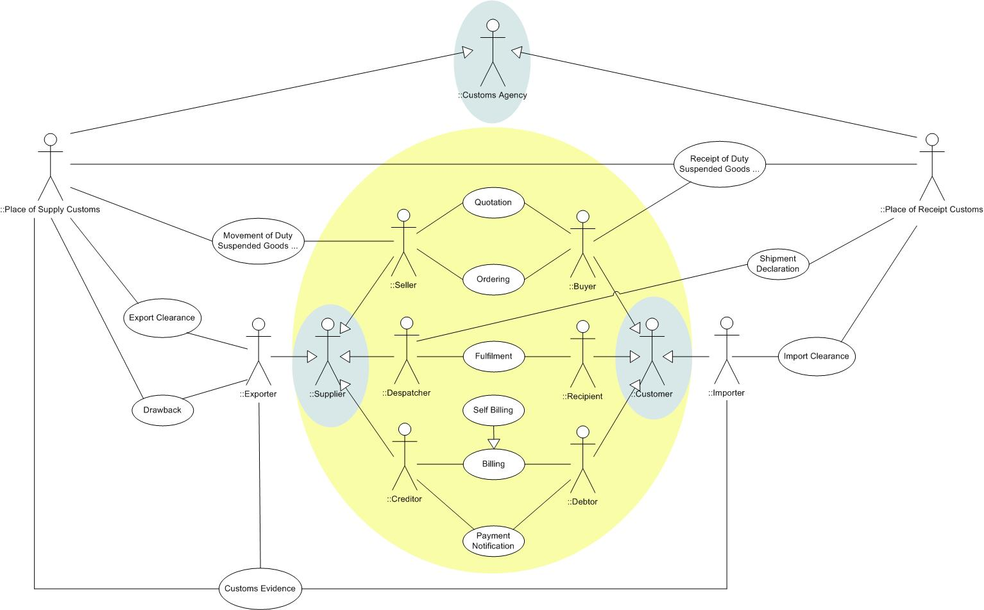
Figure 1: Use-Case Overview
There are two categories of use-case included in Figure 1 above:
Those that take place between Supplier and Customer, or their representatives, and do not involve a government agency (typical e-commerce or supply chain transactions within a single Jurisdiction), viz.:
- Quotation;
- Ordering;
- Fulfilment;
- Billing (of which “Self Billing” is represented as a specialisation); and
- Payment Notification.
that are highlighted in yellow and have been termed Core or Two-Party for purposes of this document.
Those involving Customs/Revenue Agencies, viz.:
- Movement of Duty Suspended Goods in Transit or Removal to Home Use
- Export Clearance;
- Drawback;
- Customs Evidence;
- Receipt of Duty Suspended Goods in Transit Within a Customs Union
- Shipment Declaration; and
- Import Clearance;
that fall outside the highlighted area and have been termed Extension or Three-Party for purposes of this document.
The Roles in Figure 1 are mainly specialisations of the core Supplier and Customer Actors as defined in Section 4. The exception to this is the Customs Agency, used, where appropriate, as a general term for a Government organisation carrying out a regulatory role in respect of an indirect tax (and particularly a duty relevant) transaction. The two Roles Place of Supply Customs and Place of Receipt Customs are specialisations of the Customs Agency Actor.
The three principal Actors are highlighted separately. Note that use-case participation is with reference to the various Roles that these Actors play, and not directly with the Actors themselves – within a use-case Process Model an Actor is always operating in one specific Role.

Indirect Tax Process Models
Process Models identify the Processes that need to be performed by the participants involved in a transaction to accomplish their purpose. The models will describe the Message types communicated between participants in the course of the identified Processes.
The focus of this model is the information that is exchanged between the participants in a transaction of goods and/or services. Several Processes and tasks may be necessary for the completion of the transaction as well as several information exchanges (interactions).
The primary concerns are:
- The Processes, and where necessary sub-Processes, that involve the determination and handling of the taxes incurred as a consequence of the transaction; and
- The information that supports these Processes.
The Process Models have been grouped into two categories: Core-Model or Two-Party Model Processes, in which a Customs or other government agency is not an Actor taking any Role; and Extension-Model or Three-Party Model Processes, in which one or more Customs or other government agencies is an Actor.
Each Process equates to a use-case as identified in Section 2 above.
Sub-Process steps shaded green are involved in the determination of tax; Messages (documents) shaded green carry tax-relevant information. In the text, Process Models, Roles and Messages (documents) are indicated in italics.

Core-Model Processes

Billing Process
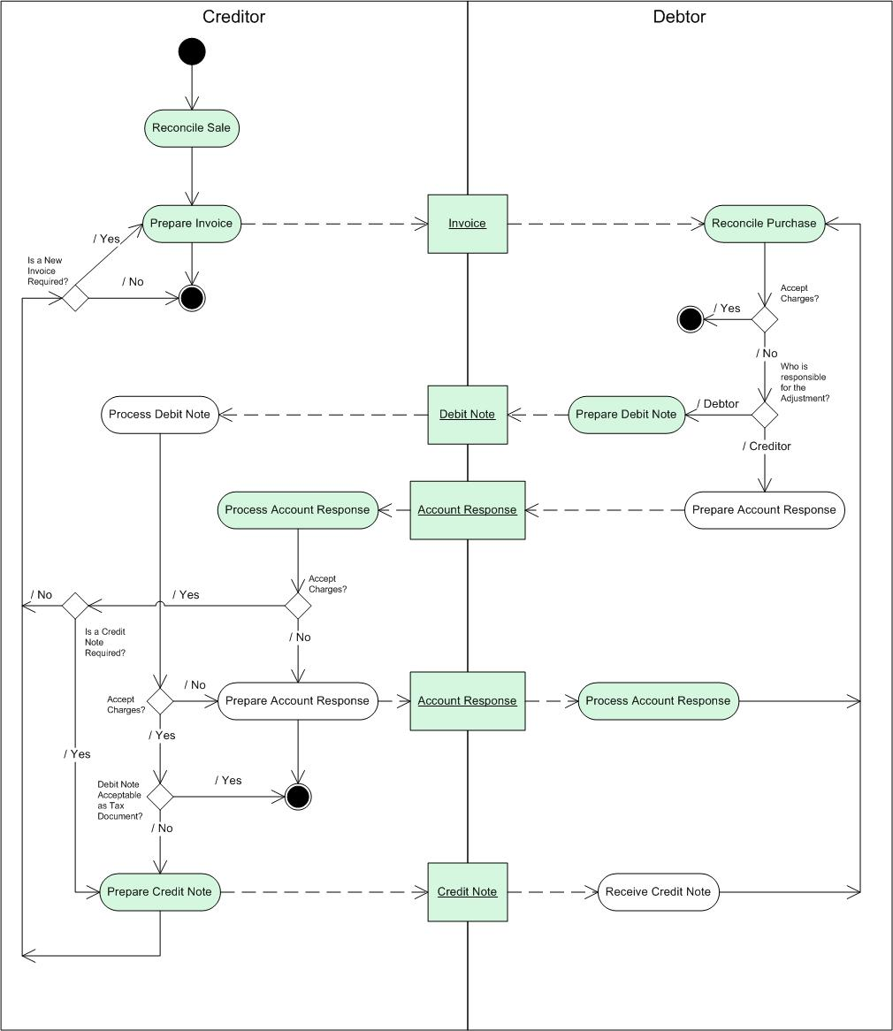
Figure 2: Billing Process Model
The Billing Process Model set out in Figure 2Error: Reference source not found represents the steps taken by each Role and the Messages (documents) exchanged between those Roles.
- The Creditor reconciles the sale, likely based on reconciling the Receipt Advice with the Purchase Order and potentially other criteria, such as acknowledgement by the Recipient of satisfactory Fulfilment (see Section 3.1.2).
- Based on the reconciled sale, the Creditor prepares an Invoice, which is sent to the Debtor.
- The Debtor reconciles the purchase, likely to be based on reconciling the matched Purchase Order with the received Invoice and potentially other criteria such as evidence of the service being performed to or the goods being of the required quality.
- If the Debtor accepts the charges shown in the Invoice, the Process ends as the Invoice will in due course become due for payment.
- If the Debtor does not accept the charges shown in the Invoice, the action taken depends on whether the Debtor or the Creditor is responsible for preparing the record of the adjustment.
- If the Debtor does not accept the charges shown in the Invoice and the Debtor is responsible for preparing the record of the adjustment, the Debtor prepares a Debit Note.
- On receipt of the Debit Note, the Creditor determines the acceptability of the adjusted charges shown in the Debit Note.
- If the Creditor does not accept the adjusted charges shown in the Debit Note, the Creditor prepares and sends to the Debtor an Account Response Message indicating their non-acceptance.
- On receipt of the Account Response, the Debtor again reconciles the purchase, including the Account Response in the reconciliation.
- If the Debtor does not accept the charges shown in the Invoice and the Creditor is responsible for preparing the record of the adjustment; the Debtor prepares and sends to the Creditor an Account Response indicating non-acceptance of the charges in the Invoice.
- If the Creditor does not accept the Debtor’s proposed adjustment as shown in the Account Response, the Creditor prepares and sends to the Debtor another Account Response, which the Debtor uses in a further reconciliation of the purchase.
- If the Creditor does accept the Debtor’s proposed adjustment as shown in the Account Response, then, the Process depends on whether a Credit Note is required.
- If the Creditor has received a Debit Note Message and accepts the adjusted charges shown therein, the Process depends on whether a Debit Note is acceptable to the Jurisdiction in question as a tax document to support the adjustment in the taxable value of the supply, or whether a Credit Note is required.
- If a Debit Note is acceptable as a tax document, the Process ends, the Creditor and the Debtor have agreed on the value of the supply and the Invoice will in due course become due for payment by the Debtor.
- If the Jurisdiction in question insists on a Credit Note to provide evidence of the changed value of the supply for tax evidence purposes, the Creditor prepares and sends to the Debtor a Credit Note Message, which the Debtor uses in a further reconciliation of the purchase.
The Model makes no attempt to represent:
- The precise nature of the reconciliation between the Receipt and the Order;
- the matched Order and the Invoice;
- Any tolerances involved; or
- Any interaction by telephone, e-mail or otherwise between the Debtor and the Creditor to resolve questions about the Invoice, Debit Note, Credit Note or Account Responses.

Messages used in the Process:
- Invoice
- Debit Note
- Account Response
- Credit Note
[Note that Message(s) in bold are considered to have a tax implication and are described in Section 5]

Roles included in the Process:
- Creditor
- Debtor

Fulfilment Process
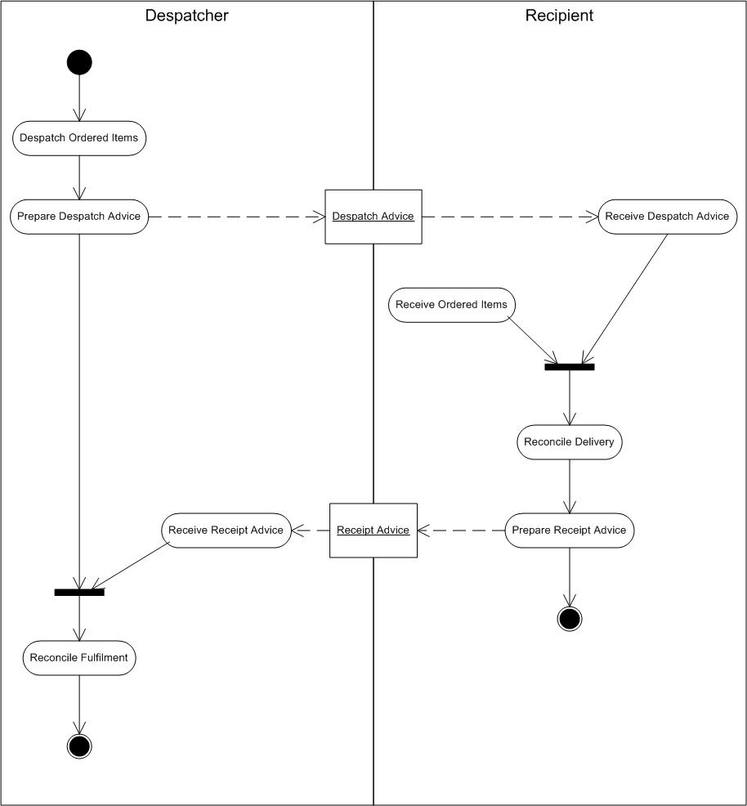
Figure 3: Fulfilment Process Model
The Fulfilment Process Model set out in Figure 3 represents the steps taken by each Role and the Messages (documents) exchanged between those Roles.
- At the appropriate point in the Despatcher’s business Process(es), the Despatcher records despatch of the ordered Items and sends a Despatch Advice Message to the Recipient.
- The Recipient records receipt of the ordered Items.
- The Recipient reconciles the recorded receipt with the Despatch Advice received from the Despatcher.
- The Recipient prepares a Receipt Advice and sends a Receipt Advice Message to the Despatcher.
- The Despatcher reconciles the Receipt Advice with the Despatch Advice.
The Model makes no attempt to represent:
- Physical despatch of the goods by the Despatcher;
- Physical receipt of the goods by the Recipient; or
- The document against which the Recipient receives the goods;
nor of any interaction by telephone, e-mail or otherwise between the Recipient and the Despatcher to resolve questions about the Despatch Advice or the Receipt Advice.

Messages used in the Process:
- Despatch Advice
- Receipt Advice

Roles included in the Process:
- Despatcher
- Recipient

Ordering Process
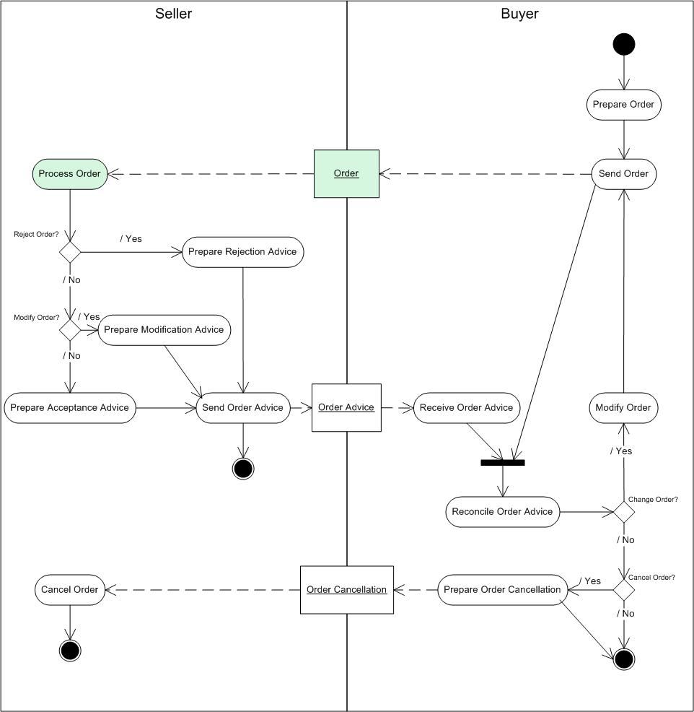
Figure 4: Ordering Process Model
The Ordering Process Model set out in Figure 4 represents the steps taken by each Role and the Messages (documents) exchanged between those Roles.
- The Buyer prepares the Order and sends it to the Seller.
- The Seller processes the Order.
- If the Seller rejects the Order, the Seller prepares an Order Advice informing the Buyer of rejection.
- If the Seller wishes to modify the Order, the Seller prepares an Order Advice indicating the modification.
- If the Seller accepts the Order, the Seller prepares an Order Advice accepting the Order.
- The Buyer reconciles the Seller’s Order Advice with the Order originally sent to the Seller.
- If the either the Buyer or Seller has modified the Order, then following reconciliation, the Buyer sends the modified Order to the Seller.
- If the Buyer decides to cancel the Order as a result of the reconciliation, an Order Cancellation is sent to the Seller.
- The Seller cancels the Order on receipt of the Order Cancellation.
The Model makes no attempt to represent:
- Availability checking;
- Agreed delivery dates;
- Agreed receipt dates; or
- Any interaction by telephone, e-mail or otherwise between the Buyer and the Seller to resol ve questions about the Order, the Order Advice or the Order Cancellation.

Messages used in the Process:
- Order
- Order Advice
- Order Cancellation
[Note that Message(s) in bold are considered to have a tax implication and are described in Section 5]

Roles included in the Process:
- Seller
- Buyer

Payment Notification Process
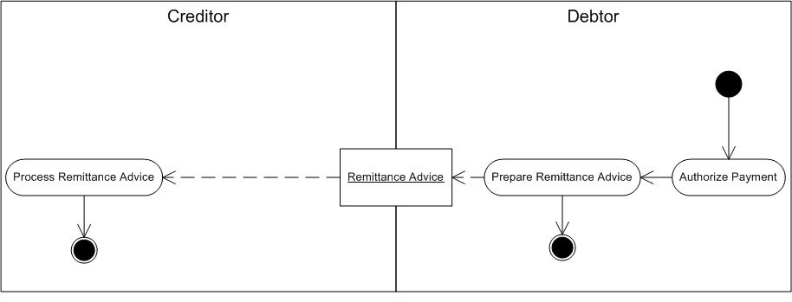
Figure 5: Payment Notification Process Model
The Payment Notification Process Model set out in Figure 5 represents the steps taken by each Role and the Messages (documents) exchanged between those Roles. As there are no steps or Messages considered to have tax implications, it is not described further.

Messages used in the Process:
- Remittance Advice

Roles included in the Process:
- Creditor
- Debtor

Quotation Process
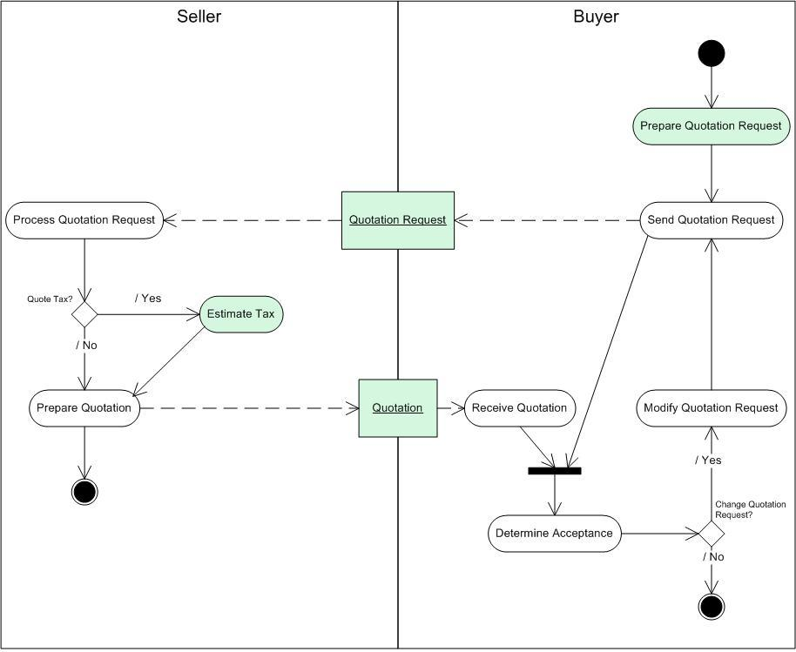
Figure 6: Quotation Process Model
The Quotation Process Model set out in Figure 6 represents the steps take by each Role and the Messages (documents) exchanged between those Roles.
- The Buyer produces a Quotation Request. The Seller receives the Quotation Request and determines whether the Quotation is required to be tax and/or duty inclusive or exclusive.
- If the Quotation is required to be tax and/or duty inclusive, the Seller estimates the tax and/or duty that will be due at the time the supply takes place, based on the best information available at the time. It must be recognised that the tax and/or duty figure(s) estimated at this point may not be accurate.
- The Seller sends the Quotation to the Buyer. The Buyer validates the received Quotation as compared to the Quotation Request.
- If the Seller did not accept the terms of the Quotation Request, the Buyer can either amend the terms of the Quotation Request, or can terminate the Process.
- If the Buyer decides to change the terms of the Quotation Request, the amended Quotation Request is sent to the Seller for re-consideration.
The Model makes no attempt to represent:
- Requirement determination;
- Supplier selection;
- Sourcing by the Buyer; or
- Any interaction by telephone, e-mail or otherwise between the Buyer and the Seller to resolve questions about the Quotation Request.

Messages used in the Process:
- Quotation Request
- Quotation
[Note that Message(s) in bold are considered to have a tax implication and are described in Section 5]

Roles included in the Process:
- Seller
- Buyer

Self Billing Process
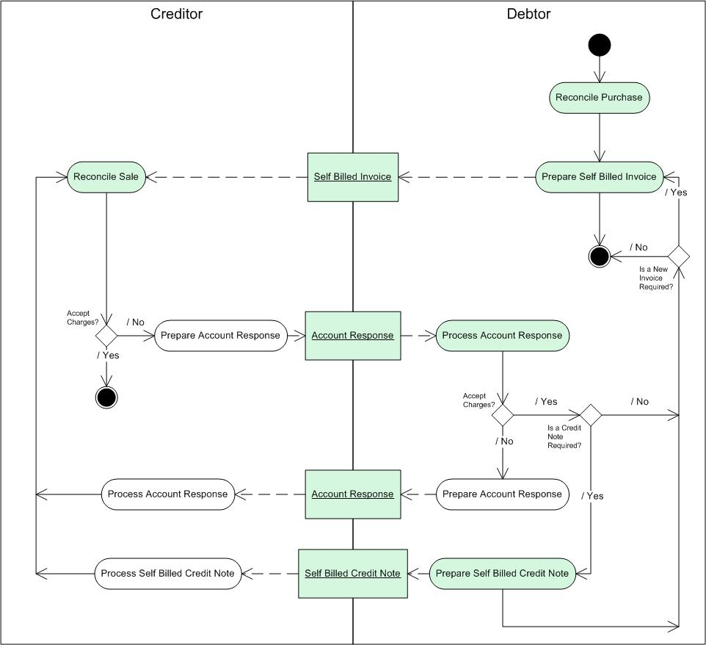
Figure 7: Self Billing Process Model
The Self Billing Process Model set out in Figure 7 represents the steps taken by each Role and the Messages (documents) exchanged between those Roles.
- In the Self Billing Process (a.k.a. Evaluated Receipts Settlement) the Creditor determines the tax amount to be deducted in respect of the supply received and uses a Self Billed Invoice to advise the Debtor of the amount of tax for which the Debtor must account to the responsible tax administration.
- Self Billing transactions are often the result of electronic Processes whereby the Buyer submits an Order to the Seller who ships goods upon acceptance of the Order (see Section 3.1.3). The Creditor then processes payment of the amount based on the Order terms. As the Debtor-issued Self Billed Invoice represents the supply, the Creditor issues no Invoice.
- The Debtor must remit indirect tax with the payment based on the tax requirements of the competent Jurisdiction(s). The Debtor’s system will calculate the indirect tax as it would have been calculated if the Creditor had issued an Invoice.
- In the context of the Process Model, the Process is realised as follows:
- At the appropriate point in the Debtor’s business Process, the Debtor prepares a Self Billed Invoice based on the quantity of goods or the extent of the service received from the Seller (the Process used to determine this value is not illustrated in this Reference Model as it has no direct tax implication).
- The Debtor sends the Self Billed Invoice to the Creditor. The Self Billed Invoice can accompany the payment, but is more likely to quantify the payment anticipated as being remitted at a later date.
- The use of Self Billing implies either a significant degree of trust in the relationship; or that the Buyer is the more powerful Party in the relationship.
- In a commercial sense, the circumstances and terms of a Self Billing arrangement are likely to be tightly regulated. In a UK VAT context, the contract between the Buyer and the Seller will either have to include, or be supported by, a VAT relevant “self billing agreement”. The agreement will confirm that the tax Invoice for supplies covered will be issued by the Debtor; that the Creditor will not issue a tax Invoice for supplies covered; and that the Creditor will inform the Debtor of any changes in his VAT registration status.
- In the VAT environments of other EU Member States, VAT relevant control over the Process is enforced by explicit acceptance of the Debtor’s Self Billed Invoice being required, rather than by the creation of a VAT relevant self billing agreement.
- On receipt of the Self Billed Invoice, the Creditor reconciles it with his record of the supply. If the Creditor accepts the charges shown on/in the Self Billed Invoice, the Process ends and the Creditor awaits the Debtor’s remittance.
- If the Creditor does not agree with the charges shown on/in the Self Billed Invoice, the Creditor prepares (and sends to the Debtor) an Account Response.
- On receipt of the Account Response, the Debtor determines whether the effect on the charges shown on/in the Self Billed Invoice which would result is acceptable.
- If the Debtor does not accept the amendment to the charges, the Debtor prepares (and sends to the Creditor) a further Account Response. The Creditor performs a further reconciliation of the sale.
- If the Debtor accepts the adjusted charges, the Process depends on whether the Debtor must account for an increase or a decrease in the charges shown on/in the original Self Billed Invoice.
- If the Debtor must account for a reduction in the price, the Debtor prepares (and sends to the Creditor) a Self Billed Credit Note. On receipt of the Self Billed Credit Note, the Creditor performs another reconciliation of the sale.
- If the Debtor must account for an increase in the price, then the Debtor prepares (and sends to the Creditor) an additional Self Billed Invoice, whereupon the Creditor performs another reconciliation of the sale.
A Self Billed Credit Note performs fundamentally the same function as a Debit Note (the Debtor provides an accounting document that notifies the Creditor of a reduction in the price). The term Self Billed Credit Note is used in the model to avoid problems potentially caused where a Jurisdiction does not recognise a Debit Note as a tax document and would “normally” insist on a Credit Note being prepared as the tax document to formalise the effect of the Debit Note. In a self billing environment, where the Debtor is responsible for creating the accounting documents, insisting on the Creditor creating a Credit Note to reflect the Debtor’s Debit Note would be inconsistent with a self billing environment.
The Model makes no attempt to represent:
- the precise nature of the reconciliation between the Receipt and the Order which give rise to the Self Billed Invoice; or
- any interaction by telephone, e-mail or any other means between the Debtor and the Creditor about:
  - the Self Billed Invoice;
  - any Account Response; or
  - Self Billed Credit Note.
In a VAT environment, the fundamental difference between the Evaluated Receipts Settlement/Self Billing and the more “normal” business models is that in ERS/Self Billing, the Debtor (who is responsible for the issue of the tax Invoice), determines how much input tax he will deduct in respect of the supply received and uses a Self Billed Tax Invoice to advise the Creditor how much output tax the Creditor is required to account for in respect of the supply.
There are risks associated with self billing such as the chance that the Creditor will treat the Self Billed Invoice as a purchase Invoice and add the VAT on it to the input tax which he recovers from the tax administration – leading to a double tax loss. As an example of a means to counteract this, the United Kingdom requires that the Debtor endorse a paper Self Billed Invoice to the effect that “THE VAT SHOWN IS YOUR OUTPUT TAX PAYABLE TO <the U.K. tax administration>”. In an electronic invoicing environment, the UK recognizes that the inclusion of a text string in an electronic Invoice would not be effective and either system or procedural controls have to be implemented to prevent a Self Billed Tax Invoice being treated as a purchase Invoice by the Creditor.
The other major risk in respect of self billing in a VAT environment is that the Creditor will issue his own tax Invoice for a supply for which the Debtor also issues a Self Billed Tax Invoice. Although the Creditor is unlikely to account for the output tax twice, it is considered much more likely that the Debtor would reclaim from the tax authority both the input tax shown on the Creditor’s tax Invoice and the input tax shown on the Self Billed Tax Invoice.

Messages used in the Process:
- Self Billed Invoice
- Account Response
- Self Billed Credit Note
[Note that Message(s) in bold are considered to have a tax implication and are described in Section 5]

Roles included in the Process:
- Creditor
- Debtor

Extension-Model Processes

Customs Evidence Process
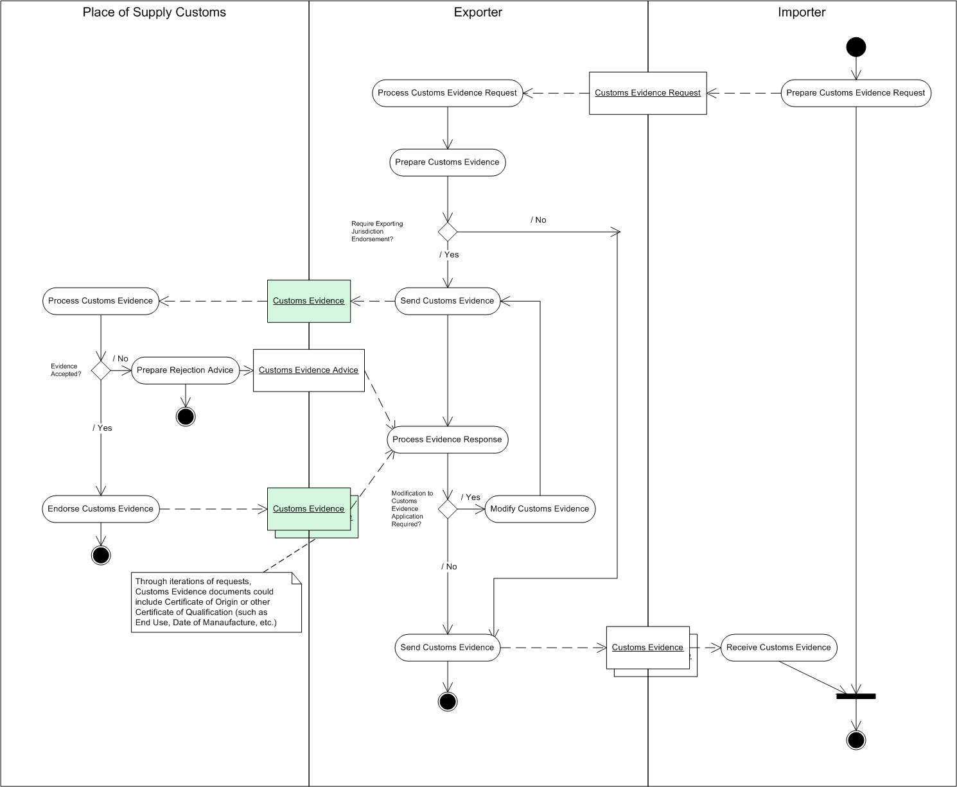
Figure 8: Customs Evidence Process Model
The Customs Evidence Process Model set out in Figure 8 represents the steps take by each Role and the Messages (documents) exchanged between those Roles.
In addition to the requirement to submit import and export entries, further evidence may be required from the exporting country to prove the origin, value or quality of the goods, and/or a licence to authorise their movement. The requirement for additional evidence is primarily defined by the nature of the goods, the country of origin and their intended use.
- Importer requests the required Customs Evidence from the Exporter.
- If the Exporter is authorised to self-certificate:
  - The Customs Evidence is prepared and issued to the Importer
- If the Customs Evidence has to be endorsed or approved by Place of Supply Customs:
  - A request is made to Place of Supply Customs.
  - Place of Supply Customs validate the request.
  - Place of Supply Customs issue the Customs Evidence to the Exporter.
- The Exporter issues the Customs Evidence to the Importer.

Messages used in the Process:
- Customs Evidence Request
- Customs Evidence Advice
- Customs Evidence
[Note that Message(s) in bold are considered to have a tax implication and are described in Section 5]

Roles included in the Process:
- Place of Supply Customs
- Exporter
- Importer

Drawback/Refund/Rebate Process
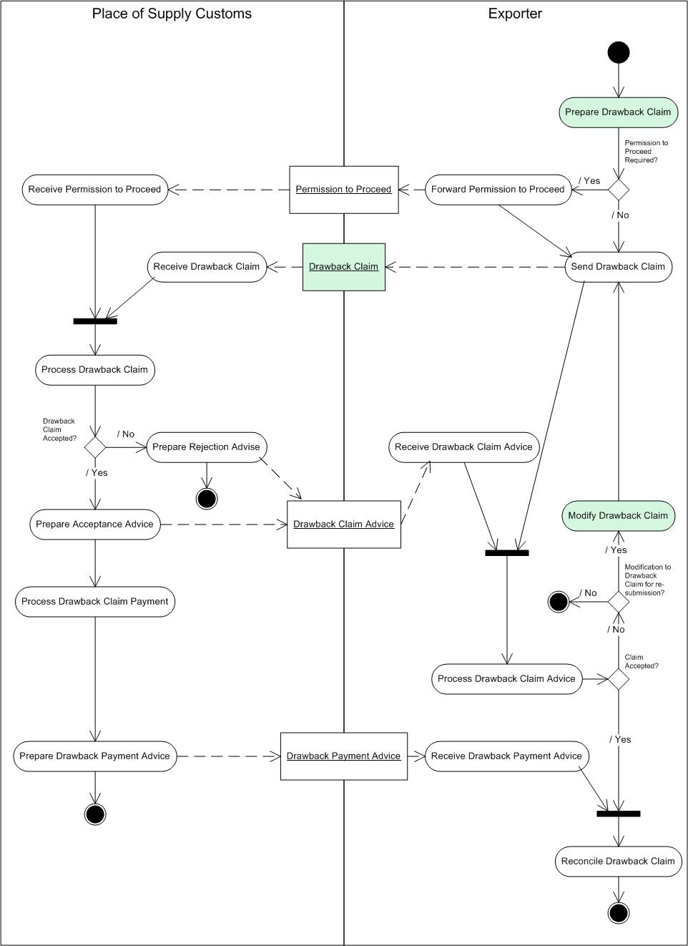
Figure 9: Drawback/Refund/Rebate Process Model
The Drawback Process Model set out in Figure 9 represents the steps take by each Role and the Messages (documents) exchanged between those Roles.
- If an Exporter exports goods on which customs duty or taxes have previously been paid or secured, or these goods are damaged or destroyed prior to the export, it may be possible to claim ‘drawback’ to recover the payment or release the payment security when the goods are exported.
- Exporter receives from Place of Supply Customs a Permission to Proceed with the export of the goods.
- Exporter submits a Drawback Claim to Place of Supply Customs.
- Place of Supply Customs validate the claim and issue the Payment Advice.
Note that there can be different duty and tax collection mechanisms in different jurisdictions. For example, in the Canadian Excise Duty and Tax domestic environment, pursuant to the Excise Tax Act and the Excise Act, 2001, which is administered by the Canada Revenue Agency, Drawbacks are no longer used. Excise Duties are returned to the taxpayer through a Refund process, and Excise Taxes through either a Refund or Rebate process.

Messages used in the Process:
- Permission To Proceed
- Drawback Claim
- Drawback Claim Advice
- Drawback Payment Advice
[Note that Message(s) in bold are considered to have a tax implication and are described in Section 5]

Roles included in the Process:
- Place of Supply Customs
- Exporter

Export Clearance Process
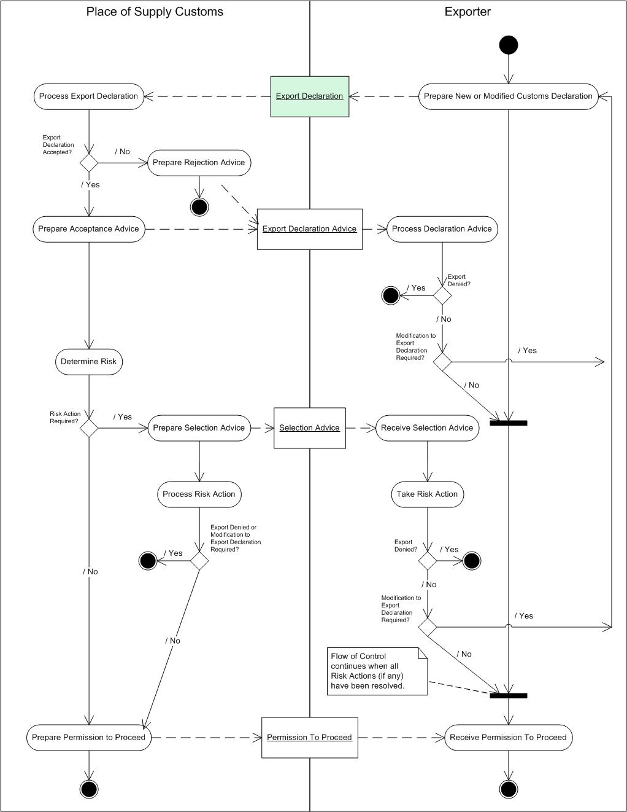
Figure 10: Export Clearance Process Model
The Export Clearance Process Model set out in Figure 10 represents the steps take by each Role and the Messages (documents) exchanged between those Roles.
In addition to the requirement to submit an Export Declaration, the Exporter may be required to provide a licence to authorise the movement. This is dependent on the nature of the goods and their destination. A licence may be required, for example, to export military equipment, antiquities and works of art, or pursuant to a specific regulation, for example the Canada - U.S. Softwood Lumber Agreement. Simplified Procedures may be available to authorised Exporters that enable them to submit a simplified declaration to have the goods released quickly by Place of Supply Customs provided they commit to submit a full Export Declaration within a prescribed timescale.
- An Exporter, or the approved agent, confirms to Place of Supply Customs that the goods are available for inspection and submits an Export Declaration.
- Place of Supply Customs validate the Export Declaration to ensure that it is complete and includes any supporting evidence that is required.
- Place of Supply Customs use risk parameters to determine whether a physical examination of the goods is required.
- Following satisfactory completion of these Processes, Permission to Proceed is granted and the goods can be exported.

Messages used in the Process:
- Export Declaration
- Export Declaration Advice
- Selection Advice
- Permission To Proceed
[Note that Message(s) in bold are considered to have a tax implication and are described in Section 5]

Roles included in the Process:
- Place of Supply Customs
- Exporter

Import Clearance Process
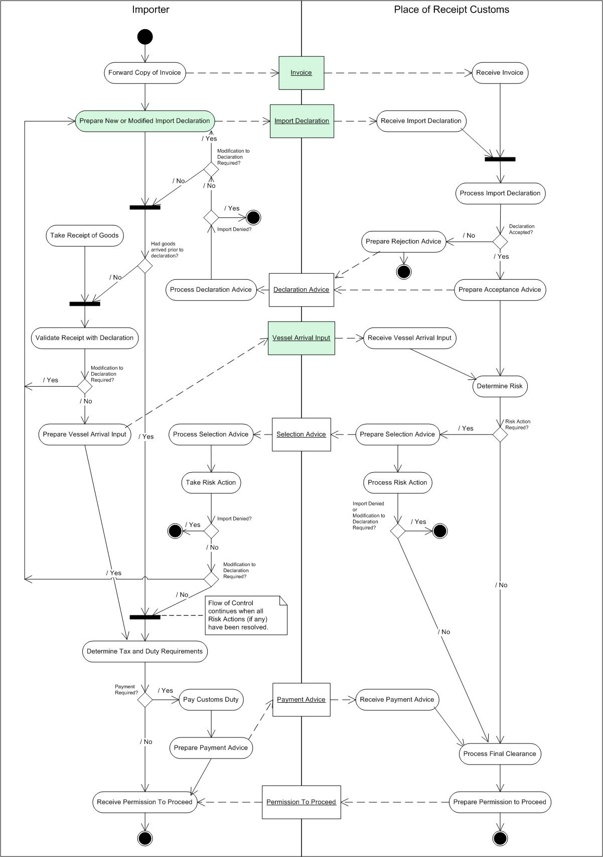
Figure 11: Import Clearance Process Model
The Import Clearance Process Model set out in Figure 11 represents the steps take by each Role and the Messages (documents) exchanged between those Roles.
In addition to the requirement to submit an Import Declaration, the Importer may be required to provide further evidence to prove the origin, value or quality of the goods, and/or a licence to authorise their movement. Physical presentation of the document may not always be required, but the relevant reference numbers must be recorded on the Import Declaration. Some of this evidence, such as a Certificate of Origin, has to be supplied from the exporting country, while other certificates and licences are provided within the importing country. Simplified Procedures may be available to authorised Importers that enable them to submit a simplified declaration to get the goods quickly released by Customs provided they commit to submit a full Import Declaration within a prescribed timescale. Before the import can be released by Customs, the Importer must either pay any taxes and duties due, or make a commitment to pay them unless the goods are released under duty suspension to authorised persons operating at authorised sites, such as customs warehouses, where the goods remain subject to customs controls.
- An Importer, or the approved agent, submits an import entry with supporting documentation. This will normally include an Invoice.
- Place of Receipt Customs validate the declaration to ensure that it is complete and includes any supporting evidence that is required.
- Arrival of the vessel is advised to Place of Receipt Customs
- Place of Receipt Customs use risk parameters to determine whether physical examination of the goods is required.
- Place of Receipt Customs secure payment of any duties that are due.
- Following satisfactory completion of these Processes, Permission to Proceed is granted and the goods can be removed from the place of entry.

Messages used in the Process:
- Invoice
- Import Declaration
- Declaration Advice
- Vessel Arrival Input
- Selection Advice
- Payment Advice
- Permission To Proceed
[Note that Message(s) in bold are considered to have a tax implication and are described in Section 5]

Roles included in the Process:
- Importer
- Place of Receipt Customs

Movement of Duty Suspended Goods in Transit or Removal to Home Use Process
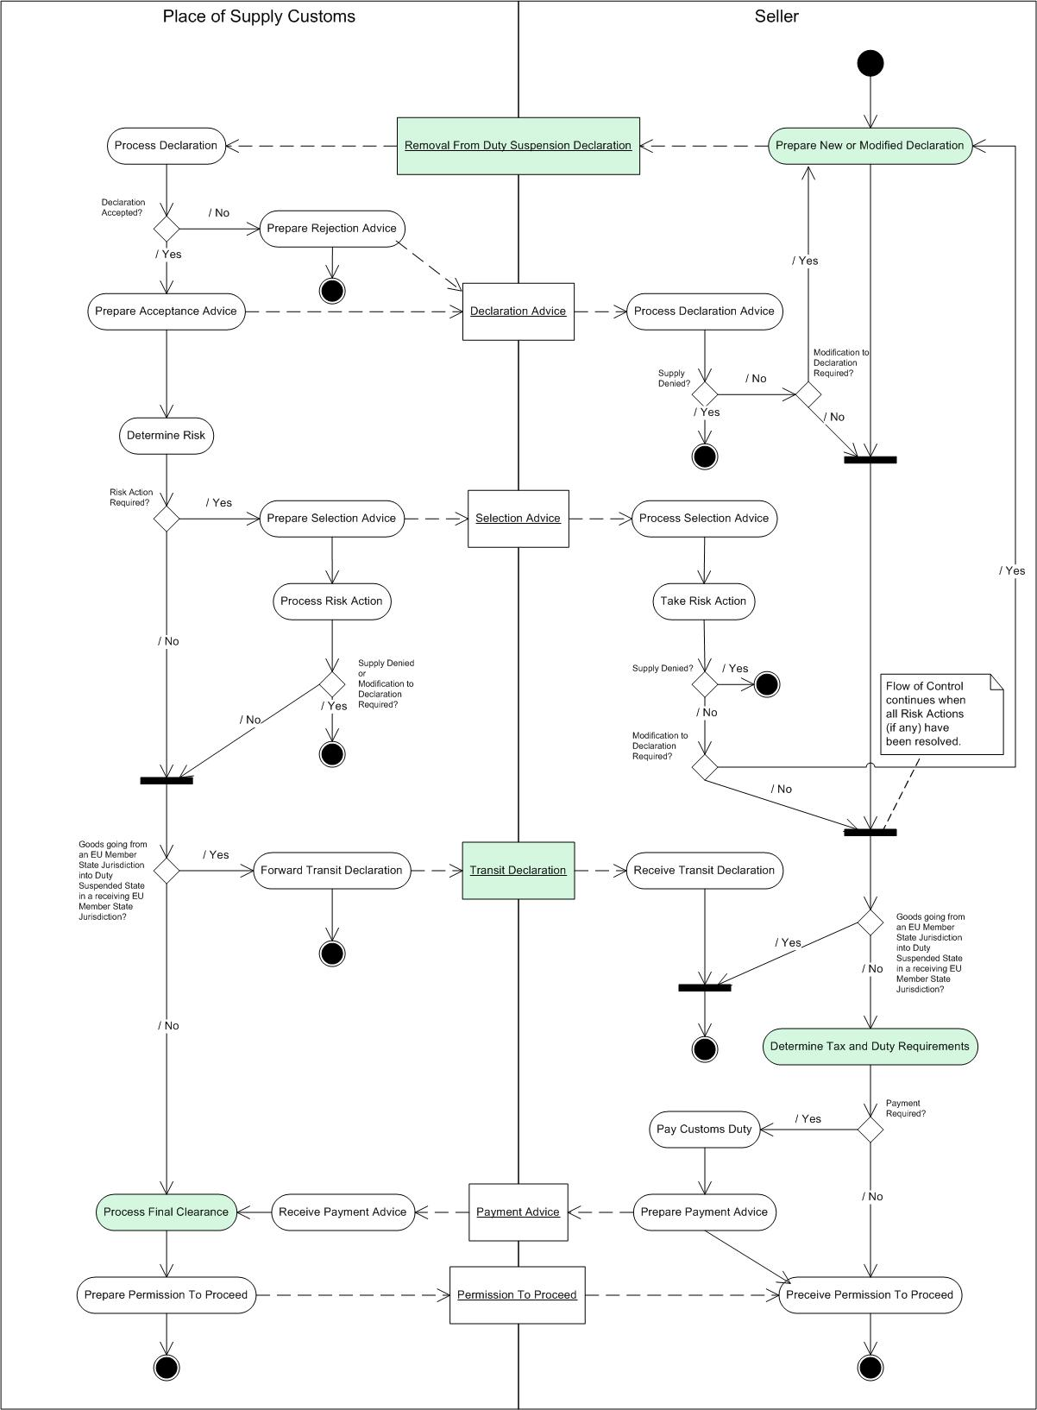
Figure 12: Movement of Duty Suspended Goods in Transit or Removal to Home Use Process Model
The Movement of Duty Suspended Goods in Transit or Removal to Home Use Model set out in Figure 12 represents the steps take by each Role and the Messages (documents) exchanged between those Roles.
Duty suspended goods may be transferred between authorised persons and sites without payment of any duties or taxes that may be due (Transit), or they can be released from customs control by submission of a customs declaration and payment. Within the EU, a computerised system is used to control the transit of goods whereby the Seller enters details of the consignment and receives an electronic authorisation from Place of Supply Customs to authorise the movement. When the goods arrive at the destination the Buyer enters the details of the goods received. Place of Supply Customs validates the movement and issues unloading permission [see Section 3.2.6 “Receipt of Duty Suspended Goods in Transit Within a Customs Union”].
- The Seller submits a declaration to remove goods in Transit.
- Place of Supply Customs validate the declaration and use risk parameters to determine whether a physical examination of the goods is required.
- If Place of Supply Customs accept the request then the Transit documents are approved, if not then either the transfer is cancelled or the required changes are made, alternatively, a declaration is made to release the goods from Place of Supply Customs control.
- If the goods are being released from Place of Supply Customs control, then any duties and taxes due must be secured by Place of Supply Customs prior to their release.
- Place of Supply Customs issue the Seller with Permission to Proceed.
The owner of duty suspended goods may choose to remove them from customs control without making a sale. This requires submission of a declaration to Place of Supply Customs and payment of any duties or taxes that are due, and may be done in anticipation of increases in duty and tax rates or to perform Processes on the goods that are not permitted whilst they are duty suspended or to make use of the goods within the business.
Messages used in the Process:
- Removal from Duty Suspension Declaration
- Declaration Advice
- Selection Advice
- Payment Advice
- Transit Declaration
- Permission To Proceed
[Note that Message(s) in bold are considered to have a tax implication and are described in Section 5]

Roles included in the Process:
- Place of Supply Customs
- Seller

Receipt of Duty Suspended Goods in Transit Within a Customs Union Process
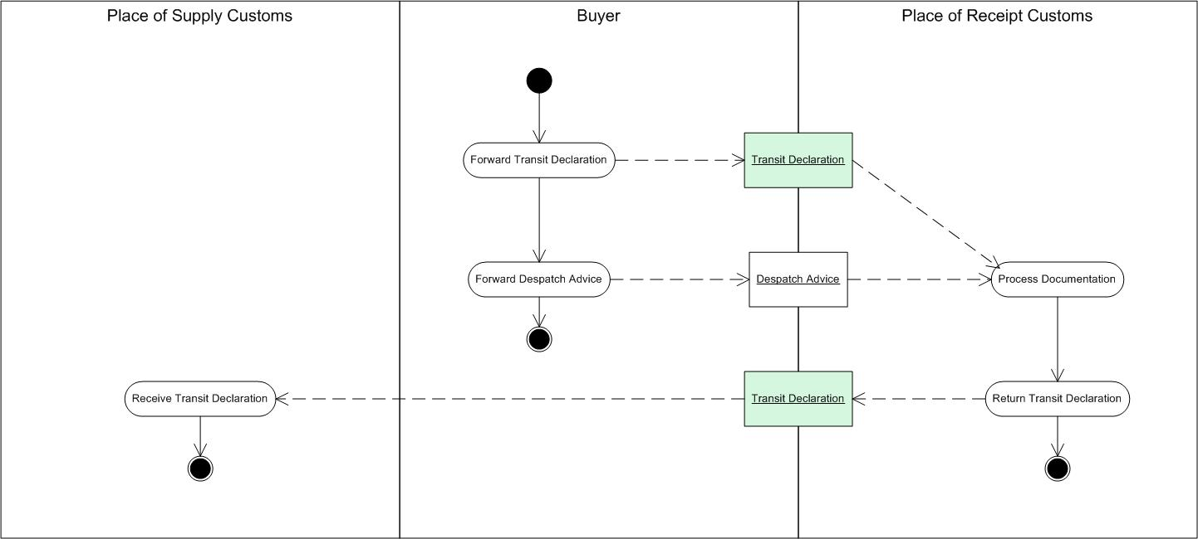
Figure 13: Receipt of Duty Suspended Goods in Transit Within a Customs Union Process Model
The Receipt of Duty Suspended Goods in Transit Within a Customs Union Process Model set out in Figure 13 represents the steps take by each Role and the Messages (documents) exchanged between those Roles.
Goods may be transferred within a Customs Union without payment of any duties or taxes that may be due. These transfers are controlled using prescribed documents to confirm receipt of the goods at the destination.
- Buyer receives the goods together with the customs documents and validates that the correct goods have been received.

Messages used in the Process:
- Transit Declaration
- Despatch Advice
[Note that Message(s) in bold are considered to have a tax implication and are described in Section 5]

Roles included in the Process:
- Place of Supply Customs
- Buyer
- Place of Receipt Customs

Shipment Declaration Process
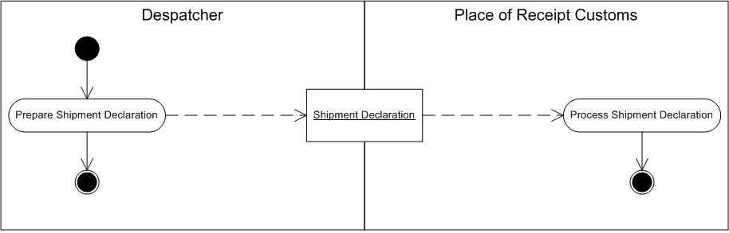
Figure 14: Shipment Declaration Process Model
The Shipment Declaration Process Model set out in Figure 14 represents the steps take by each Role and the Messages (documents) exchanged between those Roles.
- Despatcher advises Place of Receipt Customs that the Shipment has departed.
- Place of Receipt Customs update the status of the Shipment.

Messages used in the Process:
- Shipment Declaration

Roles included in the Process:
- Despatcher
- Place of Receipt Customs

Actors and Roles
The information relative to a participant in a transaction that involves elements that describe the identity of the individual or organization involved in the transaction and the Role that the Actor plays. From a tax perspective, the participant information may identify a categorization of an Actor that has non-standard tax implications and will identify the participant to the tax authorities for appropriate tax reporting.
An Actor may assume one or more Roles or specialisations in the various activities they participate in relative to a transaction.
This document describes those Roles that participate in the Process Models (Section 3). Roles that only appear in the Class Models (Section 5) are considered not to have tax-specific significance and have not been described in this document. These Roles are: Carrier, Consignee, Consolidator, Deconsolidator, Endorser, Issuer, and Producer.

Customer
In this Reference Model, an Actor which does not appear in any Process models. Roles include Buyer, Recipient, Debtor, and Importer.

Buyer
A Role of the Customer in a transaction that is the requisitioner of the goods or services for a monetary consideration from a Seller.
Alternate terms include: Consumer, Purchaser, and Order Point

Debtor
A Role of the Customer in a transaction who owes the monetary consideration for the supply of goods or services to the Creditor.
Alternate terms include: Payer

Importer
A Role of the Customer in a transaction whose function is to undertake the import of goods from another customs Jurisdiction.

Recipient
A Role of the Customer in a transaction that is receiving the delivery of goods or services.
Alternate terms include: Ship-To Party

Customs/Revenue Agency
In this Reference Model, an Actor which does not appear in any Process models. Roles or specialisations include Place of Supply Customs and Place of Receipt Customs.

Place of Receipt Customs
A Role of the Customs/Revenue Agency in a three-party transaction that fulfils the obligations of the tax administration that provides jurisdiction for the Importer or Buyer.
Alternate terms include: Port of Discharge Customs, Port of Destination Customs, Place of Entry Customs

Place of Supply Customs
A Role of the Customs/Revenue Agency in a three-party transaction that fulfils the obligations of the tax administration that provides Jurisdiction for the Exporter or Seller.
Alternate terms include: Port of Loading Customs, Place of Exit Customs

Supplier
In this Reference Model, an Actor which does not appear in any Process models. Roles include Seller, Despatcher, Creditor, and Exporter.

Despatcher
A Role of the Supplier in a transaction that is providing for the delivery of goods from their point of origin and the performance of services.
Alternate terms include: Shipper, Despatch Point

Exporter
A Role of the Supplier in a transaction whose function is to undertake the export of goods to another customs Jurisdiction.

Seller
A Role of the Supplier in a transaction that has agreed to receive monetary consideration for the provision of the goods or services to a Buyer.
Alternate terms include: Vendor, Sales Point

Creditor
A Role of the Supplier in a transaction who is owed the monetary consideration for the supply of goods or services to the Debtor.
Alternate terms include: Payee

Indirect Tax Documents (Messages): Descriptions and Class Models
The Messages that are communicated between the participants in a transaction contain the information required to support the Processes to achieve an intended result.
A document is the vehicle for the exchange of information between the parties engaged in a business Process.
The information contained in the document includes elements that describe the overall business exchange, elements that describe the details of the Items (goods and/or services) involved in the transaction, and the tax implications of each of those Item details.
From a tax point of view, the information in the messages is to facilitate those Processes that involve complete, accurate and timely compliance with any tax implications of the sale.
Tax consequences may arise at various points in the transaction. The accuracy of the determination is dependent on the completeness of the transaction details provided.
The key elements of the information provided to determine the appropriate tax consequences are those that sufficiently identify:
- Participant
- Item (Goods or Services)
- Location
- Time
- Transaction Type
At the level of the overall transaction, this movement or exchange can be described as a business arrangement between two participants where they assume the Roles of Supplier and Customer. Parties involved in the details of the transaction may assume additional Roles.

Conventions for Class Models
The class attribute names follow the UN/CEFACT Name and Design Rules for element names in a conceptual UML model.
- Element, attribute and type names MUST be composed of words in the English language, using the primary English spellings provided in the Oxford English Dictionary
Upper camel case (UCC) MUST be used for naming of elements and types.
Note: UpperCamelCase is a naming convention in which a name is formed of multiple words that are joined together as a single word with the first letter of each of the multiple words – including the first word for upper camel case - capitalized within the new word that forms the name.
- Element, attribute and type names MUST be in singular form unless the concept itself is plural.
- Element, attribute and type names MUST be drawn from the following character set: a-z and A-Z.
- Element, attribute and type names constructed from dictionary entry names MUST NOT include periods (full stops), spaces, or other separators; or characters not allowed by W3C XML 1.0 for XML names.
- Element, attribute and type names MUST NOT use acronyms, abbreviations, or other word truncations, except those included in the UN/CEFACT controlled vocabulary or listed in Appendix C [of the UN/CEFACT XML Naming and Design Rules].
Note: Currently the approved acronyms and abbreviations in Appendix C include:
- ID – Identifier
- URI – Uniform Resource Identifier
Acronyms MUST appear in all upper case for all element declarations and type definitions

Core-Model Documents (Messages)
In the Core-Model Process Models, a number of specific Messages have been identified: Credit Note, Debit Note, Despatch Advice, Invoice, Order, Order Response, Quotation, Quotation Request, Receipt Advice, Remittance Advice, Self Billed Credit Note, and Self Billed Tax Invoice. Not all Message types will necessarily be utilized for a given transaction.
These Messages all revolve around the information that describes a sales transaction between the participants. Each Message type is specific to the Process it is intended to facilitate, although many of the Messages involved in the sales Process contain similar information that only varies in those elements related to the stage of the overall Process.
Note: Of the document types listed below, only the Invoice has tax implications in the Canadian GST/HST environment.

Account Response

Account Response Description
The Account Response is sent either by the Buyer or the Seller to inform on discrepancies in the Billing Process that will require another invoicing document raising (Credit Note, Debit Note). An Account Response could be raised after any invoicing document (Invoice, Credit Note, Debit Note). [From http://ec.europa.eu/idabc/servlets/Doc?id=22200]

Account Response Class Model
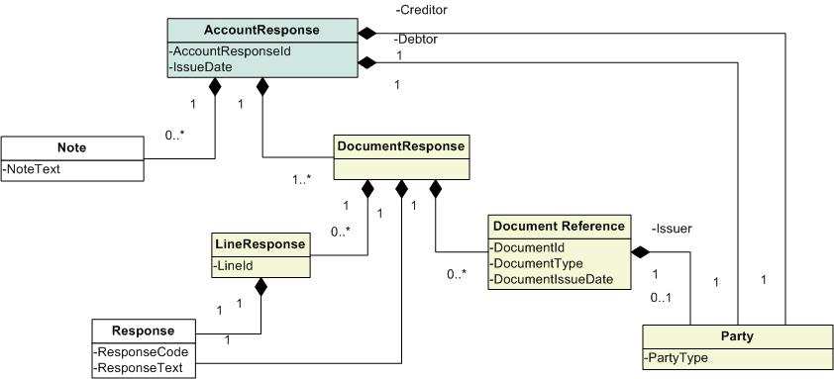
Figure 15: Account Response Class Model
Account Response Attributes:
- Account Response ID – A unique identifier for the Account Response document, assigned by the originator.
- Issue Date – The date of issue of the Account Response, assigned by the originator.
Related Classes:
- Document Response – The response details associated with a particular referenced document.
- Line Response – A reference to a particular line in a document that has a response associated to it.
- Document Reference – A reference to a document that is the subject of the Account Response.
- Response – The response that is associated to a document or a specific line in a document.
- Note – Additional text attached to the Account Response.
- Creditor→Party – A Party (see Section 6.2.8) associated with the Account Response in the Role of a Creditor (see Section 4.3.4).
- Debtor→Party - A Party (see Section 6.2.8) associated with the Account Response in the Role of a Debtor (see Section 4.1.2).
- Issuer→Party - A Party (see Section 6.2.8) associated with the Account Response in the Role of an Issuer.

Credit Note

Credit Note Description
A Credit Note is sent from the Supplier to the Customer. The purpose of the Credit Note is to provide a means to record the reduction in the value that the Customer owes to the Supplier (and the reason for the reduction).
A Credit Note is a monetary instrument issued by a Seller that allows a Buyer to purchase an Item or service from that Seller on a future date. Credit Notes may be issued by a Seller as a goodwill gesture to a Buyer who wishes to return previously purchased merchandise (instead of cash repayment) in circumstances where the original sales agreement did not include an explicit refund policy for returned Items. In such circumstances, a Credit Note of value equal to the price of the returned Item is usually issued allowing the Buyer to exchange his purchase for other Items available with the sale. [From http://en.wikipedia.org/wiki/Credit_note]

Credit Note Class Model
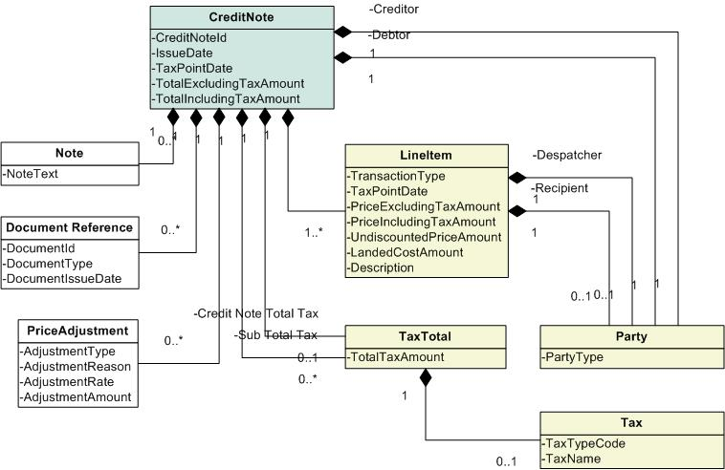
Figure 16: Credit Note Class Model
Credit Note Attributes:
- Credit Note ID – A unique identifier for the Credit Note document, assigned by the originator.
- Issue Date – The date of issue of the Credit Note, assigned by the originator.
- Tax Point Date – The date on which determination of tax is based.
- Total Excluding Tax Amount - The total price for all transaction lines in the Credit Note excluding the tax amount incurred.
- Total Including Tax Amount - The total price for all transaction lines in the Credit Note including the tax amount incurred.
Related Classes:
- Document Reference – A reference to a document that supports the Credit Note.
- Note – Additional text attached to the Credit Note.
- Creditor→Party – A Party (see Section 6.2.8) associated with the Credit Note in the Role of a Creditor (see Section 4.3.4).
- Debtor→Party - A Party (see Section 6.2.8) associated with the Credit Note in the Role of a Debtor (see Section 4.1.2).
- Despatcher→Party – A Party (see Section 6.2.8) associated with the Credit Note in the Role of a Despatcher (see Section 4.3.1).
- Recipient→Party - A Party (see Section 6.2.8) associated with the Credit Note in the Role of a Recipient (see Section 4.1.4).
- Credit Note Total Tax→Tax Total – The sum total of all taxes associated with the Credit Note.
- Sub Total Tax→Tax Total – The sum of taxes associated with a Credit Note by Tax Type.
- Line Item – A Line Item that is included in the Credit Note.
- Price Adjustment – Prices may include one or more discounts or surcharges that adjust the final price to the Debtor.
- Tax – A levy that may be imposed in a Jurisdiction (see Section 6.2.12).

Debit Note

Debit Note Description
A Debit Note is sent from the Customer to the Supplier. The purpose of the Debit Note is to provide a means to record the reduction in the value that the Customer owes to the Supplier (and the reason for the reduction). A Debit Note obviates the need for the Supplier to create a Credit Note.
Note: In an EU VAT environment, the Debit Note must contain all the details required on a tax Invoice as well as a reference to the Invoice in connection with which the Debit Note was issued if the Debit Note is to be treated as a tax document and is to obviate the requirement for the Supplier to issue a Credit Note

Debit Note Class Model
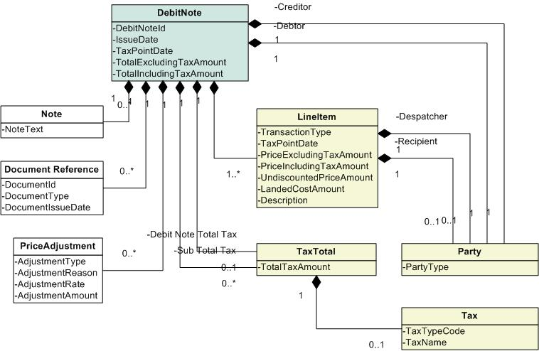
Figure 17: Debit Note Class Model
Debit Note Attributes:
- Debit Note ID – A unique identifier for the Debit Note document, assigned by the originator.
- Issue Date – The date of issue of the Debit Note, assigned by the originator.
- Tax Point Date – The date on which determination of tax is based.
- Total Excluding Tax Amount - - The total price for all transaction lines in the Debit Note excluding the tax amount incurred.
- Total Including Tax Amount - The total price for all transaction lines in the Debit Note including the tax amount incurred.
Related Classes:
- Document Reference – A reference to a document that supports the Debit Note.
- Note – Additional text attached to the Debit Note.
- Creditor→Party – A Party (see Section 6.2.8) associated with the Debit Note in the Role of a Creditor (see Section 4.3.4).
- Debtor→Party - A Party (see Section 6.2.8) associated with the Debit Note in the Role of a Debtor (see Section 4.1.2).
- Despatcher→Party – A Party (see Section 6.2.8) associated with the Debit Note in the Role of a Despatcher (see Section 4.3.1).
- Recipient→Party - A Party (see Section 6.2.8) associated with the Debit Note in the Role of a Recipient (see Section 4.1.4).
- Debit Note Total Tax→Tax Total – The sum total of all taxes associated with the Debit Note.
- Sub Total Tax→Tax Total – The sum of taxes associated with a Debit Note by Tax Type.
- Line Item – A Line Item that is included in the Debit Note.
- Price Adjustment – Prices may include one or more discounts or surcharges that adjust the final price to the Debtor.
- Tax – A levy that may be imposed in a Jurisdiction (see Section 6.2.12).

Invoice

Invoice Description
An Invoice is sent from the Supplier to the Customer to request payment for goods delivered or services performed.
The Invoice is normally issued on the basis of one despatch event triggering one Invoice. An Invoice may also be issued for pre-payment on a whole or partial basis. The possibilities are: (1) Prepayment Invoice (payment expected); (2) Pro-forma Invoice (pre advice, payment not expected); (3) Normal Invoice, on despatch for despatched Items; (4) Invoice after return of Receipt Advice. The Invoice only contains the information that is necessary for invoicing purposes. It does not reiterate any information already established in the Order, Order Change, Order Response, Despatch Advice, or Receipt Advice that is not necessary when invoicing. If necessary, the Invoice refers to the Order, Despatch Advice or Receipt Advice by a Reference for those documents... [From http://xml.coverpages.org/ni2004-04-30-b.html]
Note: In an EU VAT environment, an Invoice sent from a Supplier to a Customer would be accepted as a tax Invoice provided it includes all the minimum requirements to be included in a tax Invoice laid down in the EU invoicing directive and supporting [EU Member State] National legislation.

Invoice Class Model
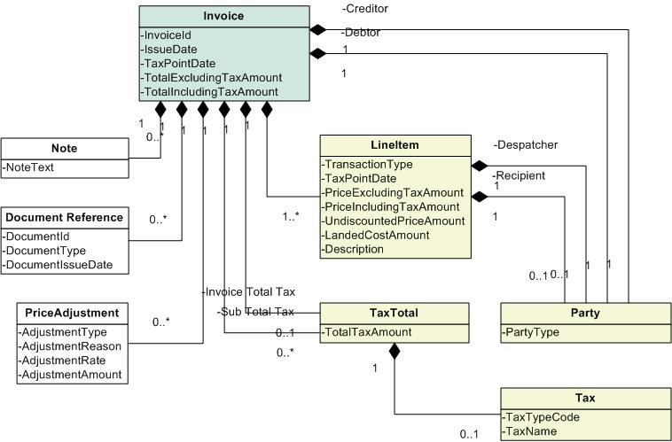
Figure 18: Invoice Class Model
Invoice Attributes:
- Invoice ID – A unique identifier for the Invoice document, assigned by the originator.
- Issue Date – The date of issue of the Invoice, assigned by the originator.
- Tax Point Date – The date on which determination of tax is based.
- Total Excluding Tax Amount – The total price for all transaction lines in the Invoice excluding the tax amount incurred.
- Total Including Tax Amount– The total price for all transaction lines in the Invoice including the tax amount incurred.
Note: The EU invoicing directive specifies that the gross value of the Invoice excluding tax and the total tax on the Invoice should be transmitted as part of the Invoice; it does not allow these values to be calculated, by the Customer, based on line values – if the Customer’s calculation gave a different result to the Supplier’s calculation this would destroy the integrity of the tax and result in differences between the amount of tax accounted for by the Supplier and the tax recovered by the Customer.
Related Classes:
- Document Reference – A reference to a document that supports the Invoice.
- Note – Additional text attached to the Invoice.
- Creditor→Party – A Party (see Section 6.2.8) associated with the Invoice in the Role of a Creditor (see Section 4.3.4).
- Debtor→Party - A Party (see Section 6.2.8) associated with the Invoice in the Role of a Debtor (see Section 4.1.2).
- Despatcher→Party – A Party (see Section 6.2.8) associated with the Invoice in the Role of a Despatcher (see Section 4.3.1).
- Recipient→Party - A Party (see Section 6.2.8) associated with the Invoice in the Role of a Recipient (see Section 4.1.4).
- Invoice Total Tax→Tax Total – The sum total of all taxes associated with the Invoice.
- Sub Total Tax→Tax Total – The sum of taxes associated with an Invoice by Tax Type.
- Line Item – A Line Item that is included in the Invoice.
- Price Adjustment – Prices may include one or more discounts or surcharges that adjust the final price to the Debtor.
- Tax – A levy that may be imposed in a Jurisdiction (see Section 6.2.12).
Note: In the Canadian GST/HST environment, minimum information requirements to be included in an Invoice are dependent on the total value of the Invoice, as follows:

Information required | Total sale under $30 | Total sale $30 to $149.99 | Total sale $150 or more
Your business or trading name, or your intermediary’s name (person with whom you have an agreement to help you supply your goods or services) | X | X | X
Invoice date or, if you do not issue an invoice, the date the GST/HST is paid or payable | X | X | X
Total amount paid or payable | X | X | X
An indication of the total amount of GST/HST charged or that the amount paid or payable for each taxable supply (other than zero-rated supplies) includes GST/HST at the applicable rate. |  | X | X
When you supply items taxable at the GST rate and the HST rate, an indication of which items are taxed at the GST rate and which are taxed at the HST rate. |  | X | X
Your Business Number or your intermediary’s Business Number (registrant with whom you have an agreement to help you supply your goods or services) |  | X | X
The buyer’s name or trading name or the name of their authorized agent or representative |  |  | X
A brief description of the goods or services |  |  | X
Terms of payment |  |  | X

Order

Order Description
An Order is sent by the Customer to inform the Supplier that the Customer wishes to purchase goods or services for a specified cost, along with instructions for delivery and special tax considerations. It is a promise to buy. Variants may support cancellation or revision of the Order either in content (Items ordered or quantity of Items) and/or in terms of fulfillment (changed delivery details, required by date, etc.).
May specify allowance and charge instructions (e.g. freight, documentation, etc.) that identify the type of charge and who pays which charges. The Order can be placed 'on account' against a trading credit account held by the Seller, or against a credit/debit card account, or a direct debit agreement. The Order allows for an overall currency defining a default for all pricing and also a specific currency to be used for Invoicing. Within an Order, additional currencies can be specified both for individual Item pricing and for any allowances or charges. Trade discount may be specified at the Order level. The Buyer may not know the trade discount, in which case it is not specified. This makes a detailed response from the Seller necessary. The Order may specify delivery terms and constraints that apply for the delivery Location in relation to the following information that would normally not appear until the Despatch Advice. [From http://xml.coverpages.org/ni2004-04-30-b.html]

Order Class Model
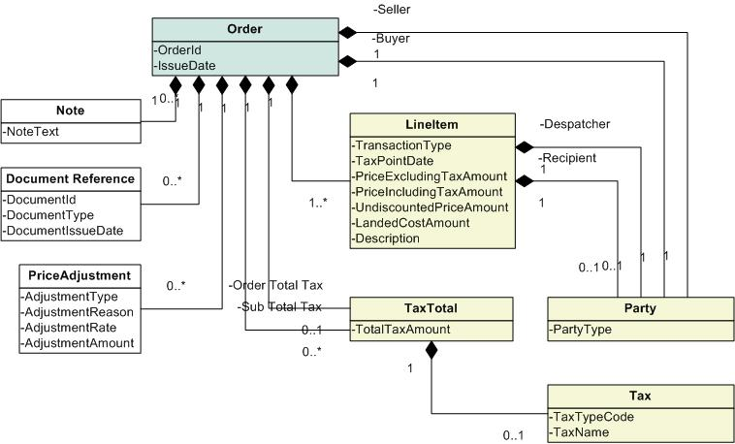
Figure 19: Order Class Model
Order Attributes:
- Order ID – A unique identifier for the Order document, assigned by the originator.
- Issue Date – The date of issue of the Order, assigned by the originator.
Related Classes:
- Document Reference – A reference to a document that supports the Order.
- Note – Additional text attached to the Order.
- Seller→Party – A Party (see Section 6.2.8) associated with the Order in the Role of a Seller (see section 4.3.3).
- Buyer→Party - A Party (see Section 6.2.8) associated with the Order in the Role of a Buyer (see section 4.1.1).
- Despatcher→Party – A Party (see Section 6.2.8) associated with the Order in the Role of a Despatcher (see Section 4.3.1).
- Recipient→Party - A Party (see Section 6.2.8) associated with the Order in the Role of a Recipient (see Section 4.1.4).
- Order Total Tax→Tax Total – The sum total of all taxes associated with the Order.
- Sub Total Tax→Tax Total – The sum of taxes associated with an Order by Tax Type.
- Line Item – A Line Item that is included in the Order.
- Price Adjustment – Prices may include one or more discounts or surcharges that adjust the final price to the Debtor.
- Tax – A levy that may be imposed in a Jurisdiction (see Section 6.2.12).

Quotation

Quotation Description
A Quotation is sent by the Supplier to the Customer to inform the Customer of the terms and conditions under which the Supplier is willing or able to supply goods or services.
A Quotation is also used as the response document from the Supplier when the Customer has purchased directly from the Supplier’s web site (also known as ‘punch out’).
A document to specify pricing and availability information about goods or services. The document which, with a view to concluding a contract, sets out the conditions under which the goods are offered. [From http://docs.oasis-open.org/ubl/os-UBL-2.0/UBL-2.0.html]

Quotation Class Model
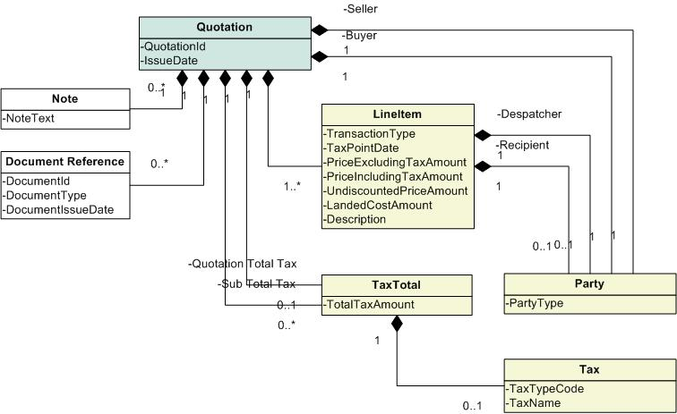
Figure 20: Quotation Class Model
Quotation Attributes:
- Quotation ID – A unique identifier for the Quotation document, assigned by the originator.
- Issue Date – The date of issue of the Quotation, assigned by the originator.
Related Classes:
- Document Reference – A reference to a document that supports the Quotation.
- Note – Additional text attached to the Quotation.
- Seller→Party – A Party (see Section 6.2.8) associated with the Quotation in the Role of a Seller (see Section 4.3.3).
- Buyer→Party - A Party (see Section 6.2.8) associated with the Quotation in the Role of a Buyer (see Section 4.1.1).
- Despatcher→Party – A Party (see Section 6.2.8) associated with the Quotation in the Role of a Despatcher (see Section 4.3.1).
- Recipient→Party - A Party (see Section 6.2.8) associated with the Quotation in the Role of a Recipient (see Section 4.1.4).
- Line Item – A Line Item that is included in the Quotation.
- Quotation Total Tax→Tax Total – The sum total of all taxes associated with the Quotation.
- Sub Total Tax→Tax Total – The sum of taxes associated with an Quotation by Tax Type.
- Tax – A levy that may be imposed in a Jurisdiction (see Section 6.2.12).

Quotation Request

Quotation Request Description
A Quotation Request is a request by a potential Customer to the Supplier to quote the terms and conditions under which the Supplier is willing to supply specific goods or services.
A Quotation Request is a document to request pricing and availability information about goods or services. The document may request a quote on specified goods or services. [From http://docs.oasis-open.org/ubl/os-UBL-2.0/UBL-2.0.html]

Quotation Request Class Model
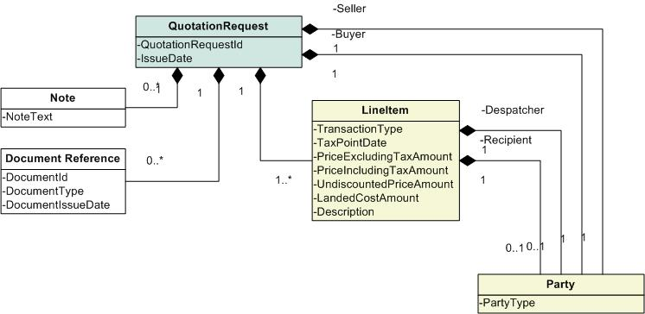
Figure 21: Quotation Request Class Model
Quotation Request Attributes:
- Quotation Request ID – A unique identifier for the Quotation Request document, assigned by the originator.
- Issue Date - The date of issue of the Quotation Request, assigned by the originator.
Related Classes:
- Document Reference – A reference to a document that supports the Quotation Request.
- Note – Additional text attached to the Quotation Request.
- Seller→Party – A Party (see Section 6.2.8) associated with the Quotation Request in the Role of a Seller (see Section 4.3.3).
- Buyer→Party - A Party (see Section 6.2.8) associated with the Quotation Request in the Role of a Buyer (see Section 4.1.1).
- Despatcher→Party – A Party (see Section 6.2.8) associated with the Quotation Request in the Role of a Despatcher (see Section 4.3.1).
- Recipient→Party - A Party (see Section 6.2.8) associated with the Quotation Request in the Role of a Recipient (see Section 4.1.4).
- Line Item – A Line Item that is included in the Quotation Request.

Self Billed Credit Note

Self Billed Credit Note Description
In an ERS/Self Billed environment, the Customer is in a position to prepare the Credit Note, in the same way as he is in a position to prepare the Invoice. A Self Billed Credit Note effectively fulfils the same function, as would a Debit Note.

Self Billed Credit Note Class Model
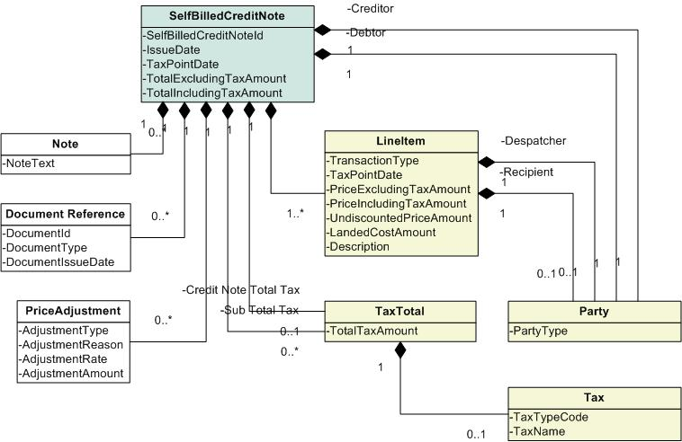
Figure 22: Self Billed Credit Note Class Model
Self Billed Credit Note Attributes:
- Self Billed Credit Note ID – A unique identifier for the Self Billed Credit Note document, assigned by the originator.
- Issue Date – The date of issue of the Self Billed Credit Note, assigned by the originator.
- Tax Point Date – The date on which determination of tax is based.
- Total Excluding Tax Amount - The total price for all transaction lines in the Self Billed Credit Note excluding the tax amount incurred.
- Total Including Tax Amount – The total price for all transaction lines in the Self Billed Credit Note including the tax amount incurred.
Related Classes:
- Document Reference – A reference to a document that supports the Self Billed Credit Note.
- Note – Additional text attached to the Self Billed Credit Note.
- Creditor→Party – A Party (see Section 6.2.8) associated with the Self Billed Credit Note in the Role of a Creditor (see Section 4.3.4).
- Debtor→Party - A Party (see Section 6.2.8) associated with the Self Billed Credit Note in the Role of a Debtor (see Section 4.1.2).
- Despatcher→Party – A Party (see Section 6.2.8) associated with the Self Billed Credit Note in the Role of a Despatcher (see Section 4.3.1).
- Recipient→Party - A Party (see Section 6.2.8) associated with the Self Billed Credit Note in the Role of a Recipient (see Section 4.1.4).
- Credit Note Total Tax→Tax Total – The sum total of all taxes associated with the Self Billed Credit Note.
- Sub Total Tax→Tax Total – The sum of taxes associated with the Self Billed Credit Note by Tax Type.
- Line Item – A Line Item that is included in the Self Billed Credit Note.
- Price Adjustment – Prices may include one or more discounts or surcharges that adjust the final price to the Debtor.
- Tax – A levy that may be imposed in a Jurisdiction (see Section 6.2.12).

Self Billed Invoice

Self Billed Invoice Description
A Self Billed Invoice is sent by the Customer to the Supplier, obviating the need for an Invoice as described above.

Self Billed Invoice Class Model
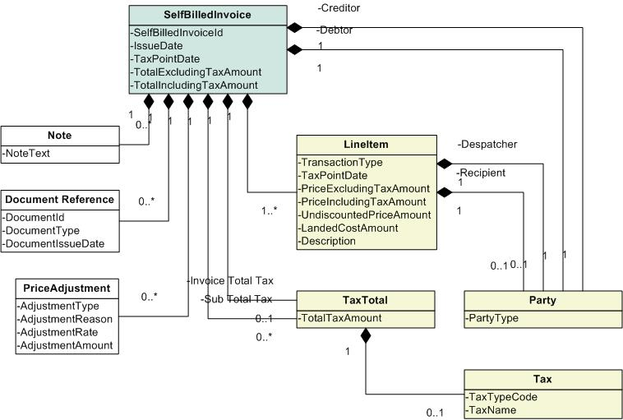
Figure 23: Self Billed Invoice Class Model
Self Billed Invoice Attributes:
- Self Billed Invoice ID – A unique identifier for the Self Billed Invoice document, assigned by the originator (the Customer in this case).
- Issue Date – The date of issue of the Self Billed Invoice, assigned by the originator (the Customer in this case).
- Tax Point Date – The date on which determination of tax is based.
- Total Excluding Tax Amount – The total price for all transaction lines in the Self Billed Invoice excluding the tax amount incurred.
- Total Including Tax Amount– The total price for all transaction lines in the Self Billed Invoice including the tax amount incurred.
Related Classes:
- Document Reference – A reference to a document that supports the Self Billed Invoice.
- Note – Additional text attached to the Self Billed Invoice.
- Creditor→Party – A Party (see Section 6.2.8) associated with the Self Billed Invoice in the Role of a Creditor (see Section 4.3.4).
- Debtor→Party - A Party (see Section 6.2.8) associated with the Self Billed Invoice in the Role of a Debtor (see Section 4.1.2).
- Despatcher→Party – A Party (see Section 6.2.8) associated with the Self Billed Invoice in the Role of a Despatcher (see Section 4.3.1).
- Recipient→Party - A Party (see Section 6.2.8) associated with the Self Billed Invoice in the Role of a Recipient (see Section 4.1.4).
- Invoice Total Tax→Tax Total – The sum total of all taxes associated with the Self Billed Invoice.
- Sub Total Tax→Tax Total – The sum of taxes associated with the Self Billed Invoice by Tax Type.
- Line Item – A Line Item that is included in the Self Billed Invoice.
- Price Adjustment – Prices may include one or more discounts or surcharges that adjust the final price to the Debtor.
- Tax – A levy that may be imposed in a Jurisdiction (see Section 6.2.12).

Extension-Model Documents (Messages)
In the Extension-Model Process Models, a number of specific Messages have been identified: Customs Evidence, Customs Evidence Application, Drawback Claim, Export Declaration, Import Declaration, Single Administrative Document, and Vessel Arrival Input. Not all Message types will necessarily be utilized for a given transaction.
These Messages all revolve around the information that is exchanged between participants in a sales transaction and one or more government tax agencies. Each Message type is specific to the Process it is intended to facilitate.
For each Message, the associated information items are listed, and described where there is a specialized meaning associated with the item. Items have not been defined when their meaning is considered to be generally known and accepted, and no specialized meaning is implied.

Customs Evidence

Customs Evidence Description
Documentation required by Customs to support a claim to a relief from Customs duty, a reduced rate of Customs duty or eligibility for admission to a particular customs regime. This analysis has focussed on Certificate of Origin as the most common example of Customs Evidence. Whilst this example relates to evidence of origin, other evidence may be required from a range of different agencies depending on the nature of the goods. This will vary across Jurisdictions and can include, for example, phytosanitary and animal health certificates.

Certificate of Origin Class Model
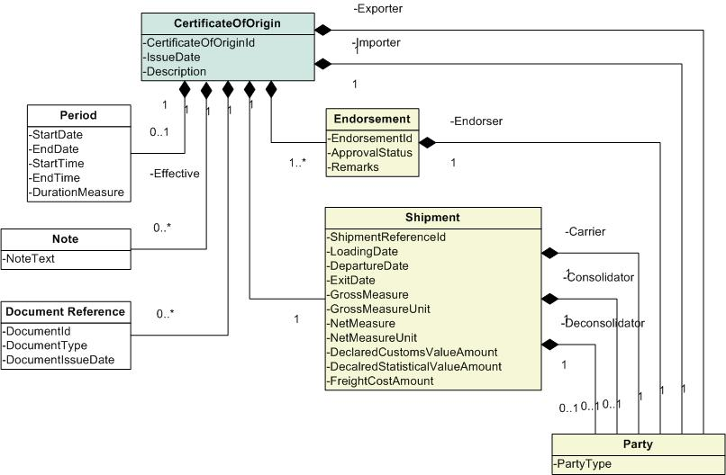
Figure 24: Certificate of Origin Class Model
Certificate of Origin Attributes:
- Certificate of Origin ID – A unique identifier for the Certificate of Origin document, assigned by the originator.
- Issue Date – The date of issue of the Certificate of Origin, assigned by the originator.
- Description – A textual description of the nature and purpose of the Certificate of Origin.
Related Classes:
- Document Reference – A reference to a document that supports the Certificate of Origin.
- Note – Additional text attached to the Certificate of Origin.
- Exporter→Party – A Party (see Section 6.2.8) associated with the Certificate of Origin in the Role of an Exporter (see Section 4.3.2).
- Importer→Party - A Party (see Section 6.2.8) associated with the Certificate of Origin in the Role of an Importer (see Section 4.1.3).
- Endorser→Party - A Party (see Section 6.2.8) associated with the Certificate of Origin in the Role of an Endorser.
- Carrier→Party - A Party (see Section 6.2.8) associated with the Certificate of Origin in the Role of a Carrier.
- Consolidator→Party - A Party (see Section 6.2.8) associated with the Certificate of Origin in the Role of a Consolidator.
- Deconsolidator→Party - A Party (see Section 6.2.8) associated with the Certificate of Origin in the Role of a Deconsolidator.
- Shipment – The details of the Shipment that is covered by the Certificate of Origin.
- Effective→Period – The period of time that the Certificate of Origin is in effect.
- Endorsement – An Endorsement of the validity of a Certificate of Origin.

Drawback Claim

Drawback Claim Description
In the UK, goods on which relief from duty could be claimed provided that the goods were exported during a defined period following their import for a specific purpose could either be claimed by importing the goods to a duty suspended regime, or by paying the duty at import and reclaiming it at export. The latter procedure is referred to as drawback. Other Jurisdictions use the same term but with slightly different connotations.

Drawback Claim Class Model
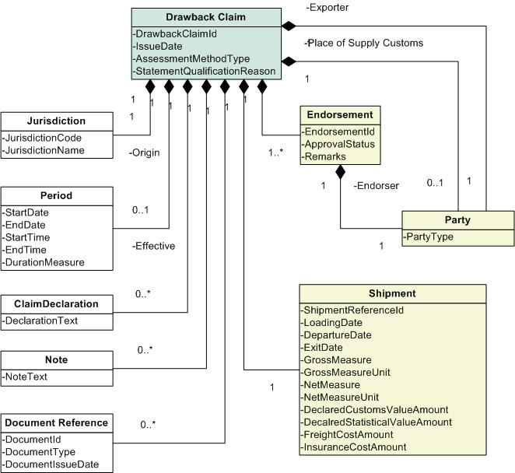
Figure 25: Drawback Claim Class Model
Drawback Claim Attributes:
- Drawback Claim ID – A unique identifier for the Drawback Claim document, assigned by the originator.
- Issue Date – The date of issue of the Drawback Claim, assigned by the originator.
- Assessment Method Type – The method used to calculate the amount of claim of Drawback. For example, the methods used for Australian Drawback include Shipment by Shipment, Representative Shipment and Imputation.
- Statement Qualification Reason - The reason that a claimant may use to qualify the statements presented in a claim in the case that the claimant is uncertain about the information included in the claim, or that the claimant has omitted of information from the claim, and considers that as a result the claim may be false or misleading in a material particular.
Related Classes:
- Document Reference – A reference to a document that supports the Drawback Claim.
- Note – Additional text attached to the Drawback Claim.
- Claim Declaration – Text explaining and supporting the endorsement of the Drawback Claim.
- Exporter→Party – A Party (see Section 6.2.8) associated with the Drawback Claim in the Role of an Exporter (see Section 4.3.2).
- Place of Supply Customs→Party - A Party (see Section 6.2.8) associated with the Drawback Claim in the Role of a Place of Supply Customs (see Section 4.2.2).
- Endorser→Party - A Party (see Section 6.2.8) associated with the Drawback Claim in the Role of an Endorser.
- Shipment – The details of the Shipment that is covered by the Drawback Claim.
- Effective→Period – The period of time that the Drawback Claim is in effect.
- Origin→Jurisdiction – The Jurisdiction (usually the country) where the goods specified in the Drawback Claim originated.
- Endorsement – An Endorsement of the validity of a Drawback Claim.

Export Declaration

Export Declaration Description
The act whereby a person indicates in the prescribed form and manner a wish to place goods under a given customs export procedure.

Export Declaration Class Model
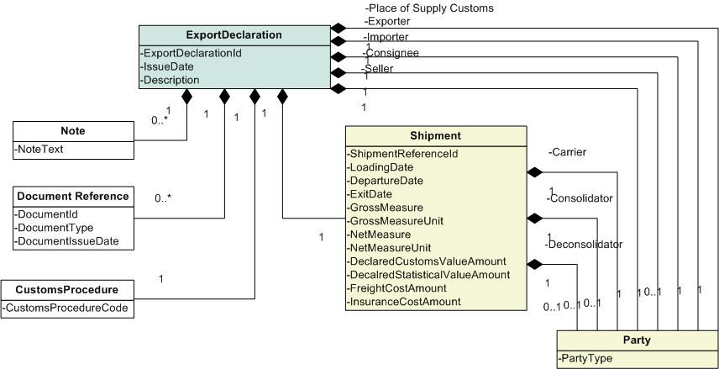
Figure 26: Export Declaration Class Model
Export Declaration Attributes:
- Export Declaration ID – A unique identifier for the Export Declaration document, assigned by the originator.
- Issue Date – The date of issue of the Export Declaration, assigned by the originator.
- Description – A textual description of the nature and purpose of the Export Declaration.
Related Classes:
- Customs Procedure - The Customs Procedure that is to be followed for the Export of the Shipment.
- Document Reference – A reference to a document that supports the Export Declaration.
- Note – Additional text attached to the Export Declaration.
- Exporter→Party – A Party (see Section 6.2.8) associated with the Export Declaration in the Role of an Exporter (see Section 4.3.2).
- Importer→Party - A Party (see Section 6.2.8) associated with the Export Declaration in the Role of an Importer (see Section 4.1.3).
- Consignee→Party – A Party (see Section 6.2.8) associated with the Export Declaration in the Role of a Consignee.
- Seller→Party – A Party (see Section 6.2.8) associated with the Export Declaration in the Role of a Seller (see Section 4.3.3).
- Place of Supply Customs→Party - A Party (see Section 6.2.8) associated with the Export Declaration in the Role of a Place of Supply Customs (see Section 4.2.2).
- Carrier→Party - A Party (see Section 6.2.8) associated with the Export Declaration in the Role of a Carrier.
- Consolidator→Party - A Party (see Section 6.2.8) associated with the Export Declaration in the Role of a Consolidator.
- Deconsolidator→Party - A Party (see Section 6.2.8) associated with the Export Declaration in the Role of a Deconsolidator.
- Shipment – The details of the Shipment that is covered by the Export Declaration.

Import Declaration

Import Declaration Description
The act whereby a person indicates in the prescribed form and manner a wish to place goods under a given Customs Procedure. [From http://eur-lex.europa.eu/LexUriServ/site/en/consleg/1992/R/01992R2913-20001219-en.pdf]

Import Declaration Class Model
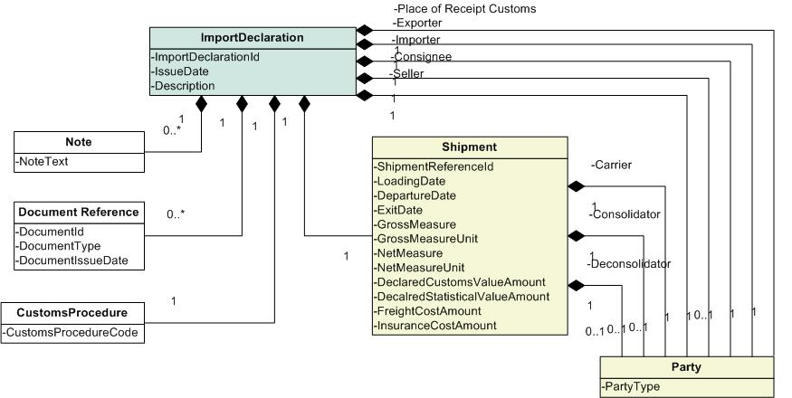
Figure 27: Import Declaration Class Model
Import Declaration Attributes:
- Import Declaration ID – A unique identifier for the Import Declaration document, assigned by the originator.
- Issue Date – The date of issue of the Import Declaration, assigned by the originator.
- Description – A textual description of the nature and purpose of the Import Declaration.
Related Classes:
- Customs Procedure – The Customs Procedure that is to be followed for the Import of the Shipment.
- Document Reference – A reference to a document that supports the Import Declaration.
- Note – Additional text attached to the Import Declaration.
- Exporter→Party – A Party (see Section 6.2.8) associated with the Import Declaration in the Role of an Exporter (see Section 4.3.2).
- Importer→Party – A Party (see Section 6.2.8) associated with the Import Declaration in the Role of an Importer (see Section 4.3.2).
- Consignee→Party – A Party (see Section 6.2.8) associated with the Import Declaration in the Role of a Consignee.
- Seller→Party – A Party (see Section 6.2.8) associated with the Import Declaration in the Role of a Seller (see Section 4.3.3).
- Place of Receipt Customs→Party - A Party (see Section 6.2.8) associated with the Import Declaration in the Role of a Place of Receipt Customs (see Section 4.2.1).
- Carrier→Party - A Party (see Section 6.2.8) associated with the Import Declaration in the Role of a Carrier.
- Consolidator→Party - A Party (see Section 6.2.8) associated with the Import Declaration in the Role of a Consolidator.
- Deconsolidator→Party - A Party (see Section 6.2.8) associated with the Import Declaration in the Role of a Deconsolidator.
- Shipment – The details of the Shipment that is covered by the Import Declaration.

Removal from Duty Suspension Declaration

Removal from Duty Suspension Declaration Description
The act whereby a person indicates in the prescribed form and manner a wish to remove goods from a given customs duty suspended procedure.

Removal from Duty Suspension Declaration Class Model
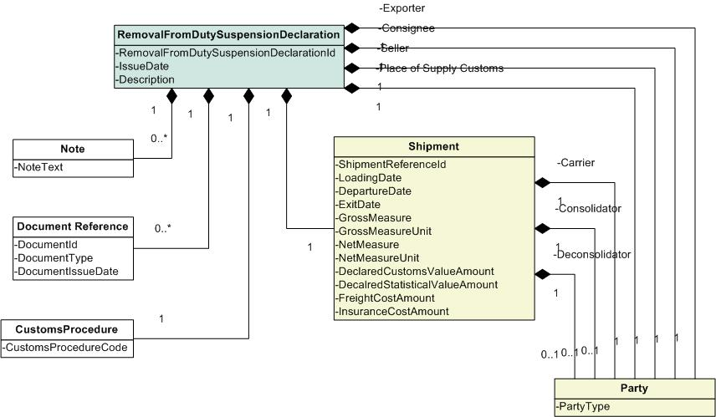
Figure 28: Removal from Duty Suspension Declaration Class Model
Removal From Duty Suspension Declaration Attributes:
- Removal From Duty Suspension Declaration ID – A unique identifier for the Removal from Duty Suspension Declaration document, assigned by the originator.
- Issue Date – The date of issue of the Removal from Duty Suspension Declaration, assigned by the originator.
- Description – A textual description of the nature and purpose of the Removal from Duty Suspension Declaration.
Related Classes:
- Customs Procedure – The Customs Procedure that is to be followed for the Removal from Duty Suspension of the Shipment.
- Document Reference – A reference to a document that has supports the Removal from Duty Suspension Declaration.
- Note – Additional text attached to the Removal from Duty Suspension Declaration.
- Exporter→Party – A Party (see Section 6.2.8) associated with the Removal from Duty Suspension Declaration in the Role of an Exporter (see Section 4.3.2).
- Consignee→Party – A Party (see Section 6.2.8) associated with the Removal from Duty Suspension Declaration in the Role of a Consignee.
- Seller→Party – A Party (see Section 6.2.8) associated with the Removal from Duty Suspension Declaration in the Role of a Seller (see Section 4.3.3).
- Place of Supply Customs→Party - A Party (see Section 6.2.8) associated with the Removal from Duty Suspension Declaration in the Role of a Place of Supply Customs (see Section 4.2.2).
- Carrier→Party - A Party (see Section 6.2.8) associated with the Removal from Duty Suspension Declaration in the Role of a Carrier.
- Consolidator→Party - A Party (see Section 6.2.8) associated with the Removal from Duty Suspension Declaration in the Role of a Consolidator.
- Deconsolidator→Party - A Party (see Section 6.2.8) associated with the Removal from Duty Suspension Declaration in the Role of a Deconsolidator.
- Shipment – The details of the Shipment that is covered by the Removal from Duty Suspension Declaration.

Transit Declaration

Transit Declaration Description
A declaration used to control the act of moving duty suspended goods without payment of any duties or charges that may be due.

Transit Declaration Class Model
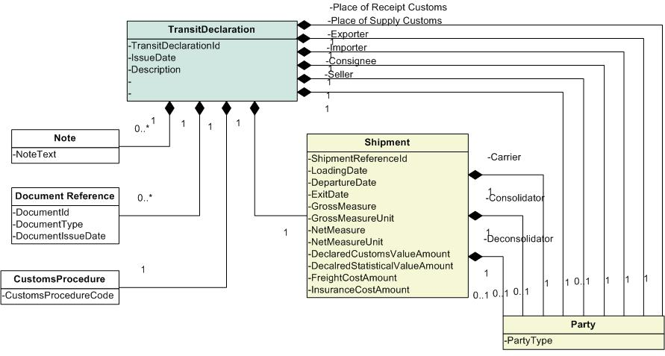
Figure 29: Transit Declaration Class Model
Transit Declaration Attributes:
- Transit Declaration ID – A unique identifier for the Transit Declaration document, assigned by the originator.
- Issue Date – The date of issue of the Transit Declaration, assigned by the originator.
- Description – A textual description of the nature and purpose of the Transit Declaration.
Related Classes:
- Customs Procedure – The Customs Procedure that is to be followed for the Import of the Shipment.
- Document Reference – A reference to a document that has supports the Transit Declaration.
- Note – Additional text attached to the Transit Declaration.
- Exporter→Party – A Party (see Section 6.2.8) associated with the Transit Declaration in the Role of an Exporter (see Section 4.3.2).
- Importer→Party – A Party (see Section 6.2.8) associated with the Transit Declaration in the Role of an Importer (see Section 4.3.2).
- Consignee→Party – A Party (see Section 6.2.8) associated with the Transit Declaration in the Role of a Consignee.
- Seller→Party – A Party (see Section 6.2.8) associated with the Transit Declaration in the Role of a Seller (see Section 4.3.3).
- Place of Supply Customs→Party - A Party (see Section 6.2.8) associated with the Transit Declaration in the Role of a Place of Supply Customs (see Section 4.2.2).
- Place of Receipt Customs→Party - A Party (see Section 6.2.8) associated with the Transit Declaration in the Role of a Place of Receipt Customs (see Section 4.2.2).
- Carrier→Party - A Party (see Section 6.2.8) associated with the Removal from Duty Suspension Declaration in the Role of a Carrier.
- Consolidator→Party - A Party (see Section 6.2.8) associated with the Removal from Duty Suspension Declaration in the Role of a Consolidator.
- Deconsolidator→Party - A Party (see Section 6.2.8) associated with the Removal from Duty Suspension Declaration in the Role of a Deconsolidator.
- Shipment – The details of the Shipment that is covered by the Transit Declaration.

Vessel Arrival Input

Vessel Arrival Input Description
Input to customs computer system indicating that vessel has arrived. Pre arrival declarations for goods in that vessel will be reprocessed at this point – the goods have now arrived so the declaration has legal force. Any goods on the vessel for which a pre arrival declaration has not been made will require to be declared to customs using post arrival procedures.

Vessel Arrival Input Class Model
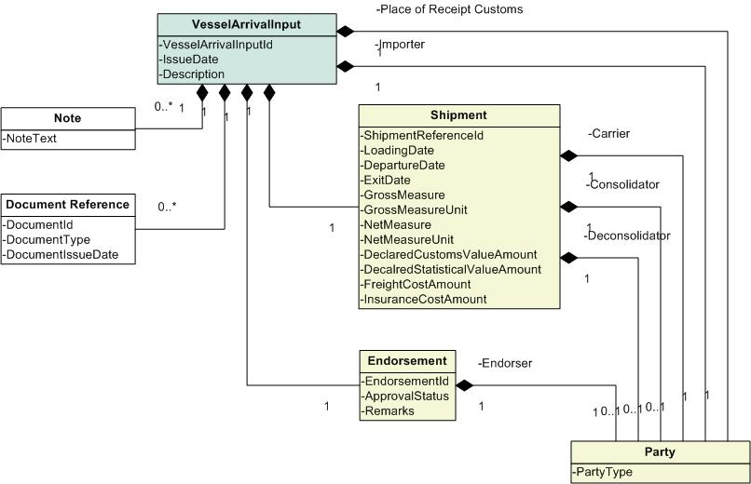
Figure 30: Vessel Arrival Input Class Model
Vessel Arrival Input Attributes:
- Vessel Arrival Input ID – A unique identifier for the Vessel Arrival Input document, assigned by the originator.
- Issue Date – The date of issue of the Vessel Arrival Input, assigned by the originator.
- Description - A textual description of the nature and purpose of the Vessel Arrival Input.
Related Classes:
- Document Reference – A reference to a document that supports the Vessel Arrival Input.
- Note – Additional text attached to the Vessel Arrival Input.
- Importer→Party – A Party (see Section 6.2.8) associated with the Vessel Arrival Input in the Role of an Importer (see Section 4.1.3).
- Place of Receipt Customs→Party - A Party (see Section 6.2.8) associated with the Vessel Arrival Input in the Role of a Place of Receipt Customs (see Section 4.2.1).
- Endorser→Party - A Party (see Section 6.2.8) associated with the Vessel Arrival Input in the Role of an Endorser.
- Carrier→Party - A Party (see Section 6.2.8) associated with the Vessel Arrival Input in the Role of a Carrier.
- Consolidator→Party - A Party (see Section 6.2.8) associated with the Vessel Arrival Input in the Role of a Consolidator.
- Deconsolidator→Party - A Party (see Section 6.2.8) associated with the Vessel Arrival Input in the Role of a Deconsolidator.
- Endorsement – An Endorsement of the validity of a Vessel Arrival Input.
- Shipment – The details of the Shipment that is covered by the Vessel Arrival Input.

Indirect Tax Class Models (Shared Components)
The Messages that are communicated between the transaction participants have an associated set of information items that can be described in a class model. This section describes components that are shared by more than one class model. Class models at the level of a particular document (Message) are included with that document’s description in the previous section.
For the purpose of this reference model, information items that may be provided by the Messages to facilitate the sales Process but are not specific to tax compliance may not be covered.

Basic Components
A Basic Component is a class of data that may be used in the composition of another class structure but does not have a composition structure itself.

Allocated Prepayment
An Allocated Prepayment is an amount that has been paid in advance.
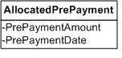
Figure 31: Allocated Prepayment Class Model
Allocated Prepayment Attributes:
- Pre Payment Amount – The amount of a payment that is applied.
- Pre Payment Date – The date that the payment was received by the Creditor.

Customs Procedure
A Customs Procedure is used to identify the customs regime of a shipment and thereby defines what documents and information are required for the goods to be cleared by customs. If duties or taxes are due, it also defines whether they are to be paid immediately, paid on deposit or suspended.
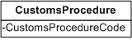
Figure 32: Customs Procedure Class Model
Customs Procedure Attributes:
- Customs Procedure Code – A code used to identify a specific Customs Procedure.

Document Reference
A Document Reference is an association from the document in the Message to another relevant document.
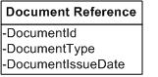
Figure 33: Document Reference Class Model
Document Reference Attributes:
- Document ID – An identifier of the document being referenced.
- Document Type – The type of document being referenced.
- Document Issue Date – The date on which the referenced document was issued.

Jurisdiction
A Jurisdiction is a geopolitical area or areas for which a legal authority is responsible. A Jurisdiction could be a country, state, county, city, district, or other geopolitical entity. The sub type, country, is specified to highlight its significance in certain tax related relationships.
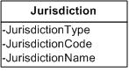
Figure 34: Jurisdiction Class Model
Jurisdiction Attributes:
- Jurisdiction Type – The type of Jurisdiction such as Country, State, Province, County, City, etc.
- Jurisdiction Code – A code that identifies a Jurisdiction.
- Jurisdiction Name – A name that identifies a Jurisdiction.

Jurisdiction Currency Tax
It is a requirement of certain tax authorities that the tax amount be expressed in the currency of the Jurisdiction in which the tax is applied. In the case that this currency is different from the primary currency of the document, the tax amount will need to be additionally carried in that currency.
Note: In such a case it may also be necessary to provide the exchange rate and date for the amounts shown. The exchange rate information is attached to the Document (see 4.2 Document (Message) Information) in which the tax amount is stated since exchange rates will commonly apply to all converted amounts in a document. The currency of the monetary amount itself is assumed to be an attribute of the amount.
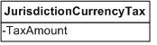
Figure 35: Jurisdiction Currency Tax Class Model
Jurisdiction Currency Tax Attributes:
- Tax Amount – The amount of tax expressed in the currency of the local Jurisdiction.

Note
A Note is additional text attached to a document.
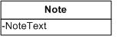
Figure 36: Note Class Model
Note Attributes:
- Note Text – The text that comprises the Note on the document.

Price Adjustment
Prices may include one or more discounts or surcharges that adjust the final price to the Debtor.
The Price Adjustment details the difference between the final price and the original base price. These details may be required for tax reporting or for commercial reasons. An adjustment may apply to an individual line item or to the whole transaction or both. Multiple adjustments may also apply to either. The adjustment may be specified as either a percentage to be applied against the price or a set amount.
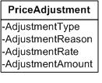
Figure 37: Price Adjustment Class Model
Price Adjustment Attributes:
- Adjustment Type – The type of adjustment applied such as a discount or surcharge.
- Adjustment Reason – The reason that the adjustment is applied.
- Adjustment Rate – The percentage of the price that is to determine the adjustment.
- Adjustment Amount – The amount of the adjustment.

Aggregate Components
An Aggregate Component is a class of data that may be used in the composition of another class structure and has a composition structure itself.

Address
An Address is a series of data values that is used for the purpose of delivering mail. For the purposes of tax processing, an Address is commonly used as a means of establishing the Location of a residence or place of business within a Jurisdiction (see Section 6.2.7).
The detailed structure of an Address has been considered out of scope since there can be a significant number of formats. For the purposes of the model it is sufficient to recognize the requirement for an Address.
What is presented here is one such structure based on the OASIS CIQ specification. This structure has been designed with the intent to support all possible formats for Addresses internationally. The definitions below are based on the CIQ 2.0 documentation.
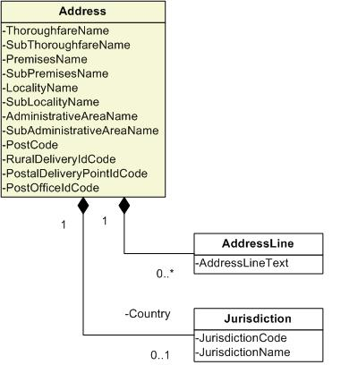
Figure 38: Address Class Model
Address Attributes:
- Thoroughfare Name – Name of the access route along which buildings are located, such as street, road, channel, crescent, avenue, etc. This also includes canals/banks on which houses/boat houses are located where people live.
- Sub Thoroughfare Name – Another thoroughfare that is required to uniquely identify the Location, such as an access route, intersection, corner, adjacent, boundary, etc.
- Premises Name – Name of the premises which is a landmark place which has a main Address such as large mail user (e.g. airport, hospital, university) or could be a building (e.g. apartment, house) or a building or complex of buildings (e.g. an apartment complex or shopping centre) or even a vacant land (e.g. lot). A premises can have many sub-addresses such as apartments in a building having its own Addresses or buildings within an airport having its own Addresses including its own thoroughfares.
- Sub Premises Name – Examples of sub-premises are apartments and suites in buildings, shops in malls, etc., or sub-addresses in a landmark place such as airports, military bases, hospitals, etc. Some countries have blocks within blocks.
- Locality Name – Name of a locality which is a named densely populated area (a place) such as town, village, suburb, etc.
- Sub Locality Name – Name of a locality that is smaller and is contained within the boundaries of its parent locality. Note that not all localities have sub locality. For example, many areas within a locality where each area is a sub locality.
- Administrative Area Name – Name of the top-level area division in the country, such as state, district, province, island, region, etc. Note that some countries do not have this.
- Sub Administrative Area Name – The next level down division of the area, e.g. state/county, province/reservation. Note that not all countries have a sub administrative area.
- Post Code – A container for a single free text or structured post code. Note that not all countries have post codes.
- Rural Delivery ID Code – A code for postal-specific delivery identifier for remote communities. Note that not all countries have rural delivery.
- Postal Delivery Point ID Code – Final mail delivery point where the mail is dropped off for recipients to pick them up directly, e.g. PO Box, private bag, pigeon hole, free mail numbers, etc.
- Post Office ID Code – A delivery point where all mails are delivered and the post man picks up the mails and delivers it to the recipients. Examples are a rural post office where post is delivered, a post office containing post office boxes/personal mail boxes. Note that not all countries have post office. Can be used to represent overseas military Addresses also along with postal delivery point.
Related Classes:
- Address Line – Container for free text Address elements where Address elements are not parsed.
  - Address Line Text – Free format Address representation. An Address can have more than one line. The order of the address lines must be preserved.
- Country→Jurisdiction – The Jurisdiction that represents the country identified in the Address (see Section 6.1.4).

Endorsement
An Endorsement is a validation by the Endorser that a document has met required criteria.
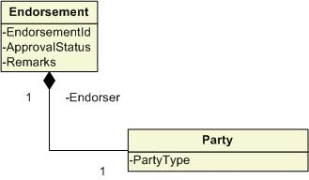
Figure 39: Endorsement Class Model
Endorsement Attributes:
- Endorsement ID – An identifier of the Endorsement.
- Approval Status – An identification of the status of the Endorsement for approval.
- Remarks – Any textual remarks that may need to accompany the Endorsement.
Related Classes:
- Endorser→Party - A Party (see Section 6.2.8) associated with the Endorsement in the Role of an Endorser.

Exemption Certificate
An Exemption Certificate is a certificate that, when provided by the Customer and accepted in “good faith” by the Supplier, allows for the elimination of tax on a transaction or series of transactions. The Supplier would retain any compliance requirement such as reporting the exempted transactions.
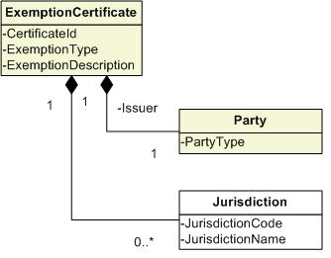
Figure 40: Exemption Certificate Class Model
Exemption Certificate Attributes:
  - Certificate ID – An identifier assigned to the certificate by the certificate issuer.
  - Exemption Type – The type of certificate represented such as an exemption or direct pay permit.
  - Exemption Description – A textual description of the purpose and use of the certificate.
Related Classes:
- Issuer→Party – The Party that issued the Exemption Certificate (see Section 6.2.8).
- Jurisdiction – The Jurisdiction in which the exemption applies (see Section 6.1.4).

Item
An Item is a product or service that may be the object of a transaction between parties.
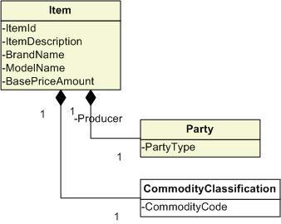
Figure 41: Item Class Model
Item Attributes:
- Item ID – A number or code that identifies an Item.
- Item Description – A description that identifies the nature of an Item.
- Brand Name – A name used by the Producer to identify the Item, typically for marketing purposes.
- Model Name – A name that identifies the specific model of the Item under the Brand.
- Base Price Amount – The standard price for an Item before discounts.
Related Classes:
- Producer→Party – The Party that produced the Item (see Section 6.2.8).
- Commodity Classification – A classification of the Item as a commodity that may have a specific tax treatment associated with it in some circumstances.

Line Item
A transaction is further specified by the Line Items associated with the event. A Line Item is a component of a transaction that involves the details for one of the Items (goods or services) involved.
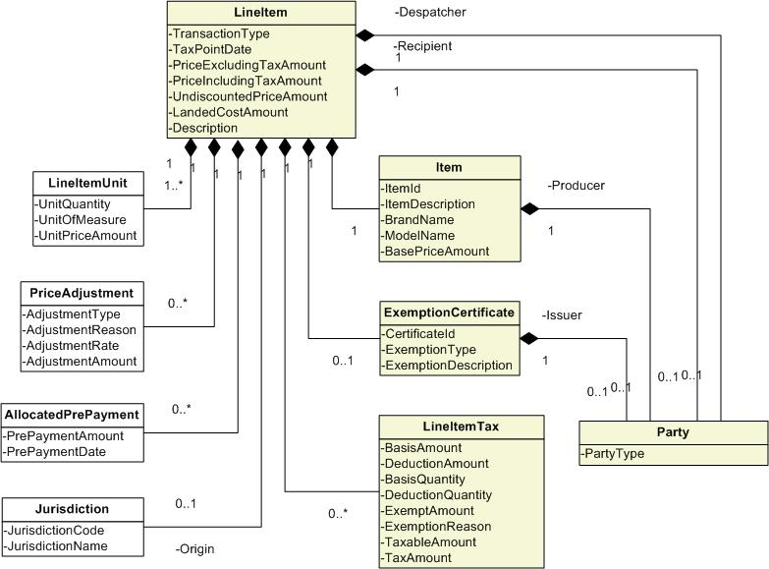
Figure 42: Line Item Class Model
Line Item Attributes:
- Transaction Type – An identifier of the type of transaction that occurred such as a sale, rental, asset movement, inventory removal, etc.
- Tax Point Date – The date on which the determination of the tax liability is based.
- Price Excluding Tax Amount – the price established for the Line Item excluding any associated tax amounts.
- Price Including Tax Amount – the price established for the Line Item including the associated tax amounts.
- Undiscounted Price Amount – the price established for the Line Item prior to any discount amounts being applied.
- Landed Cost Amount - Total expense of receiving goods at place of retail sale, including retail purchase price, transportation costs, duties, value added taxes, excise tax and other taxes. In implementations, this is likely to be a derived value which will vary by jurisdiction. Since the Reference Model does not cover all possible implementations, this is intended to highlight the requirement for these elements.
- Description – A textual description of the circumstances involved in the Line Item including the goods or services provided.
Note: In an EU VAT environment, the description on the line should be sufficient to identify the goods or services supplied, although for a supply of goods it is allowable to use a code to identify products provided the code can be readily checked against a full description at both the Supplier’s and the Customer’s premises.
Related Classes:
- Despatcher→Party – The Party that is providing for the delivery of goods from their point of origin and the performance of services specified in the Line Item (see Section 6.2.8).
- Recipient→Party – The Party that receives the goods or services specified in the Line Item (see Section 6.2.8).
- Producer→Party – The Party that produced the goods or services specified in the Line Item (see Section 6.2.8).
- Issuer→Party – The Party that issued the Exemption Certificate that refers to the goods or services specified in the Line Item (see Section 6.2.8).
- Item – The good or service specified by the Line Item.
- Exemption Certificate – A certificate, or reference to a certificate, that confirms an exemption held by the Customer that may be applied to the Line Item.
- Line Item Unit – The unit price and quantity of the Item transacted in a LineItem expressed in a specific Unit of Measure, required for tax and statistical declarations.
- Unit Quantity - The quantity of the item expressed in the Unit of Measure
- Unit of Measure - The Unit of Measure in which the quantity is expressed.
- Unit Price Amount - The price of the item per Unit of Measure.
- Price Adjustment – The amount of an adjustment applied to the price of the specified Line Item.
- Allocated Pre Payment – An amount that has been paid in advance against a particular Line Item.
- Origin→Jurisdiction – The Jurisdiction (usually the country) where the goods specified in the Line Item originated.
- Line Item Tax - A tax that is incurred for the Line Item.

Line Item Tax
For each Line Item the circumstances of the event may give rise to a tax liability in one or more of the Jurisdictions that encompass the Locations that play a particular Role. Multiple taxes may be incurred for a single Line Item.
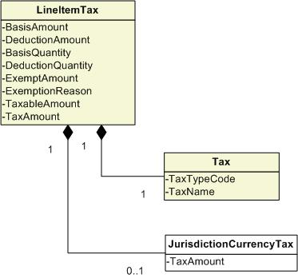
Figure 43: Line Item Tax Class Model
Line Item Tax Attributes:
- Basis Amount – The base amount on which tax is to be calculated.
- Deduction Amount – An amount subtracted from the gross or basis amount to reduce the amount subject to tax.
- Basis Quantity -- The base quantity on which tax is to be calculated.
- Deduction Quantity -- A quantity subtracted from the gross or basis quantity to reduce the quantity subject to tax.
- Exempt Amount – The amount of the basis that is determined to be exempt from taxes.
- Exemption Reason – The reason that the exemption applies to a particular tax. This could be a code and/or text.
- Taxable Amount – The net amount of the basis after adjustments, exclusions and exemptions against which the tax rate will be applied.
- Tax Amount – The amount of tax calculated against the taxable amount.
Note: In the Canadian GST/HST environment, tax is not calculated on individual Line Items. Tax is calculated at the Invoice level, although different tax rates may apply to different Line Items.
Related Classes:
- Tax – A levy that may be imposed in a Jurisdiction (see Section 6.2.12).
- Jurisdiction Currency Tax - The tax amount expressed in the currency of the Jurisdiction in which the tax is applied, in the case that this currency is different from the primary currency of the document.

Location
The Location information in a transaction describes the identity of the Locations where aspects of the events surrounding the transaction occur. From a tax perspective, the requirement for Location information is to identify the Jurisdictions within the boundaries of which the Location is situated.
Commonly, a Location in a transaction is identified by a postal Address. However, other means of identifying a Location are available and may be supplied in addition or instead of a postal Address such as a coordinate system (e.g. latitude and longitude) or other identifiers (e.g. Global Location Numbers [GLNs]). Alternate means of identifying a Location may be necessary in instances where a postal Address is not available at a Location (such as an off-shore oil rig).
Standards for the representation of Addresses as well as various coordinate systems and other identifiers are outside the scope of this reference model. For the purposes of the model it is sufficient to recognize the requirement for an Address without defining further detail. The definitions for the Location Coordinate attributes below are based on CIQ 2.0 documentation.
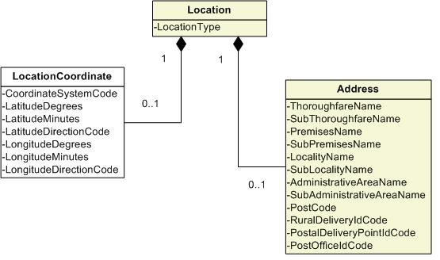
Figure 44: Location Class Model
Location Attributes:
- Location Type – Indicates an Address or a geographic Location.
Related Classes:
- Address – An Address used to identify a Location (see Section 6.2.1).
- Location Coordinate – Address Location Coordinates (Geocoding) Information
  - Coordinate System Code – Identifier for the location system used.
  - Latitude Degrees – Measure of the latitude in degrees.
  - Latitude Minutes – Measure of the latitude in minutes.
  - Latitude Direction Code – The direction of latitude measurement offset from the equator.
  - Longitude Degrees – Measure of the longitude in degrees.
  - Longitude Minutes – Measure of the longitude in minutes.
  - Longitude Direction Code – The direction of longitude measurement offset from the meridian.

Party
A Party is an individual, group or organization having a Role in a business function or activity. A Party may assume one or more Roles in the various activities they participate in such as Supplier, Customer, agent, tax authority, etc.
A Government Agency is a type of Party that acts as an organization having authority to administer rules and regulations within the Jurisdiction(s) in their domain. As a Party, the Government Agency would inherit any appropriate attributes and relationships such as an Address.
A Tax Authority is a Role that may be assumed by a Government Agency in the context of tax compliance and reporting.
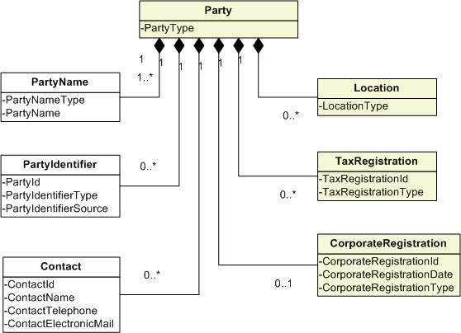
Figure 45: Party Class Model
Party Attributes:
- Party Type – The type of Party represented such as an individual (Person), Corporation, Tax Authority, Sole Proprietorship, Partnership, etc.
Related Classes:
- Location – Place at which the Party is located in the tax-relevant context of the transaction.
- Tax Registration – A Tax Registration held by the Party.
- Corporate Registration – Information regarding the registration of a Party as a Corporate Entity.
- Corporate Registration ID – The identification code assigned to the Corporate Entity.
- Corporate Registration Type – The type of registration issued.
- Party Name - The full name of the Party.
- Party Name Type – The type of name being represented, such as Legal Name, DBA Name, Standard Abbreviation, etc.
- Party Name – The full name of the Party for the specified name type.
Note: Standards for the representation of Party name are outside the scope of this reference model. For the purposes of the model it is sufficient to recognize the requirement for a name without defining further detail.
- Party Identifier – A code that identifies the Party.
- Party ID – The identification code assigned to the Party.
- Party Identifier Type – The type of identification code assigned to the Party.
- Party Identifier Source - The source agency that issued the identification code.
- Contact – A Contact is an individual with whom communication related to the specified Party may be facilitated.
- Contact ID – An identification code assigned to a Contact.
- Contact Name – The full name of the Contact.
- Contact Telephone - A telephone number that can be used to communicate with the Contact.
- Contact Electronic Mail - An electronic mail address that can be used to communicate with the Contact.

Shipment
Freight tendered to a carrier by one consignor at one piece at one time for delivery to one consignee at one place on one bill of lading.
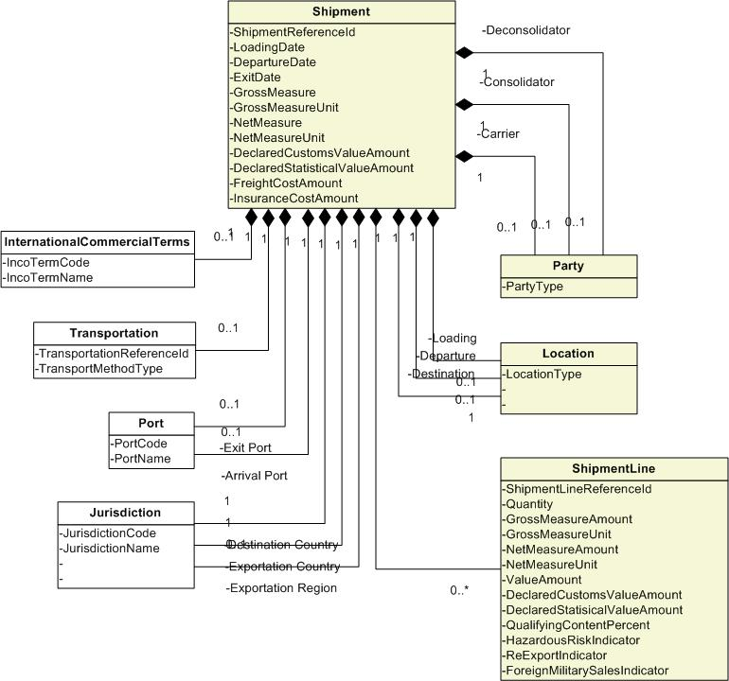
Figure 46: Shipment Class Model
Shipment Attributes:
- Shipment Reference ID – A unique identifier for the Shipment, assigned by the Shipper.
- Loading Date – The date on which the goods were loaded onto the transport.
- Departure Date – The date on which the transport left the port.
- Exit Date – The date on which the transport exited the country of origin.
- Gross Measure – The full weight of a Shipment, including goods and packaging.
- Gross Measure Unit – The unit of measure in which the gross measure is stated.
- Net Measure – Weight of the goods only which does not include their packing.
- Net Measure Unit – The unit of measure in which the net measure is stated.
- Declared Customs Value Amount – The value on which ad valorem customs duties are calculated.
- Declared Statistical Value Amount – The value required for statistical purposes. The cost elements that make up the statistical value may vary from those used to calculate the customs value on which duty and charges are calculated.
- Freight Cost Amount – The amount of the freight cost for the Shipment.
- Insurance Cost Amount – The amount of the insurance cost for the Shipment.
Related Classes:
- Deconsolidator→Party - The Party that takes a consolidated Shipment and breaks it down into individual Shipments for onward delivery.
- Consolidator→Party – The Party that performs the procedure carried out as part of a contract to transport the goods whereby a number of small consignments are loaded together to form a single, larger Shipment.
- Carrier→Party – The Party that transports the Shipment.
- Loading→Location – The Location at which the Shipment was loaded onto the transport.
- Departure→Location – The Location from which the Shipment leaves port.
- Destination→Location – The Location at which the Shipment is destined to arrive.
- Shipment Line - Line level detail of the goods included in the Shipment.
- International Commercial Terms – The recognized abbreviation for the International Chamber of Commerce Terms of Sale that are associated with the Shipment.
  - Inco Term Code – A code that identifies a specific INCO Term.
  - Inco Term Name – A name that describes a specific INCO Term.
- Transportation – Information regarding the transportation used for the Shipment.
  - Transportation Reference ID – An identifier that references the specific voyage on which the Shipment is transported.
  - Transport Method Type – The type of transportation method used for the Shipment.
- Port – The port from which the Shipment departed.
  - Port Code – A code that identifies a specific Port.
  - Port Name – The name of a Port.
- Destination Country→Jurisdiction – The Jurisdiction that represents the Country for which the Shipment is destined.
- Exportation Country→Jurisdiction – The Jurisdiction that represents the Country from which the Shipment is exported.
- Exportation Region→Jurisdiction – The Jurisdiction that represents the Region from which the Shipment is exported.

Shipment Line
A Shipment is further specified by the associated Shipment Lines. A Shipment Line is a component of a Shipment that involves the details for one of the Items involved.
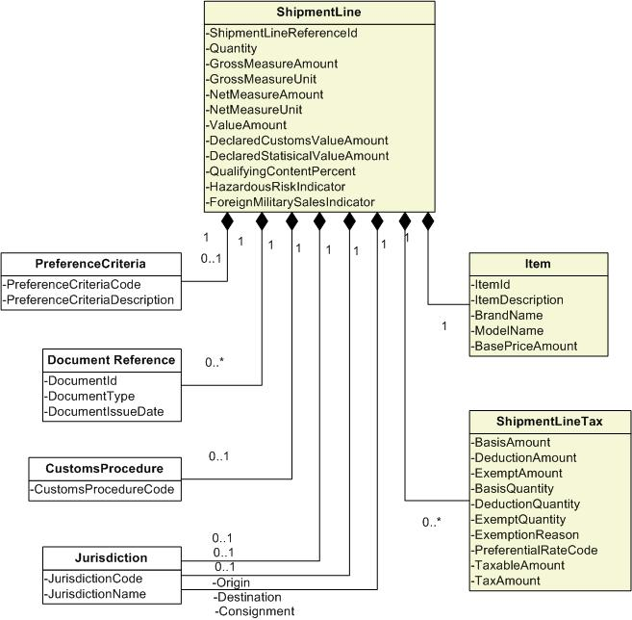
Figure 47: Shipment Line Class Model
Shipment Line Attributes:
- Shipment Line Reference ID – An identifier that may be used to reference a particular Shipment Line.
- Quantity – The quantity of goods included in the Shipment Line.
- Gross Measure Amount – The full weight of a Shipment Line, including goods and packaging
- Gross Measure Unit – The unit of measure in which the gross measure is stated
- Net Measure Amount – Weight of the goods only which does not include their packing.
- Net Measure Unit – The unit of measure in which the net measure is stated.
- Value Amount – The Invoice line value.
- Declared Customs Value Amount – The value on which ad valorem customs duties are calculated.
- Declared Statistical Value Amount – The value required for statistical purposes. The cost elements that make up the statistical value may vary from those used to calculate the customs value on which duty and charges are calculated.
- Qualifying Content Percent – The percentage content of the goods being imported that must come from a particular Jurisdiction (usually a country) to satisfy the origin rules. This will usually be based on value but other criteria may also be used.
- Hazardous Risk Indicator – An indicator that the goods identified in the Shipment Line have been designated as posing a hazardous risk.
- Foreign Military Sales Indicator – An indicator that the goods identified in the Shipment Line are designated as a Sale to a foreign military.
Related Classes:
- Item – The Item of Goods identified by the Shipment Line.
- Shipment Line Tax – The tax associated with the Shipment Line.
- Preference Criteria – Preferential trade agreements may exist between Jurisdictions whereby reduced or zero rates of duty can be applied to imported goods. The Preference Criteria may limit these preferential rates to particular goods that meet specific origin rules, and may also require the goods to be transported direct from the exporting Jurisdiction.
  - Preference Criteria Code – The preference code used to define any reduced rate of duty being claimed. The code may relate to a General Preference or to a reduced rate based on the economic development status of the Jurisdiction (usually the country) of origin. Preferential rates may be limited to specific products.
  - Preference Criteria Description – The description associated with the Preference Criteria Code.
- Document Reference – A reference to a document that is related to the Shipment Line.
- Customs Procedure – The procedure that is to be followed by Place of Supply Customs or Place of Receipt Customs for the actions related to the Shipment Line.
- Origin→Jurisdiction – The Jurisdiction of origin of the goods described in the Shipment Line.
- Consignment→Jurisdiction – The Jurisdiction from which the goods described in the Shipment Line were consigned.
- Destination→Jurisdiction – The Jurisdiction to which the goods described in the Shipment Line are destined.

Shipment Line Tax
For each Shipment Line (see Section 6.2.10) the circumstances of the event may give rise to a tax liability in one or more of the Jurisdictions that encompass the Locations that play a particular Role. Multiple taxes may be incurred for a single Shipment Line.
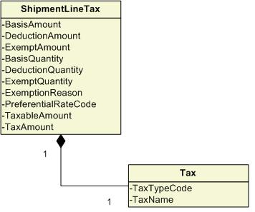
Figure 48: Shipment Line Tax Class Model
Shipment Line Tax Attributes:
- Basis Amount - The value of the items in a Shipment Line which is used as a basis for determining tax.
- Deduction Amount – An amount subtracted from the gross or basis amount to reduce the amount subject to tax.
- Exempt Amount – The amount of the basis that is determined to be exempt from taxes.
- Basis Quantity – The base quantity on which tax is to be calculated.
- Deduction Quantity – A quantity subtracted from the gross or basis quantity to reduce the quantity subject to tax.
- Exempt Quantity - A quantity subtracted from the gross or basis quantity to reduce the quantity subject to tax as a result of an exemption.
- Exemption Reason - A quantity subtracted from the gross or basis quantity to reduce the quantity subject to tax as a result of an exemption.
- Preferential Rate Code - A code that identifies a preferential rate applied to a specific Line Item.
- Taxable Amount - The net amount of the basis after adjustments, exclusions and exemptions against which the tax rate will be applied.
- Tax Amount – The amount of tax calculated against the taxable amount.
Related Classes:
- Tax - A levy that may be imposed in a Jurisdiction (see Section 6.2.12).

Tax
A Tax is a levy that may be imposed in a Jurisdiction. A Tax is applicable within a specific Jurisdiction and may optionally be applicable for a specific Item tax category. The Tax to be applied may be structured in various ways such as a simple rate, a flat amount, an amount per number of units, or a rate within a tiered range of values.

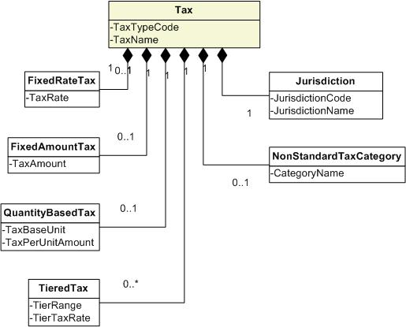
Figure 49: Tax Class Model
Tax Attributes:
- Tax Type Code – A reference to the tax code that specifies the conditions of the Tax.
- Tax Name – A name that describes a Tax.
Related Classes:
- Fixed Rate Tax – A tax rate that is fixed regardless of the cost or quantity of the goods and services involved in a transaction.
  - Tax Rate – The rate that is set for a Fixed Rate Tax.
- Fixed Amount Tax – An amount of Tax that is incurred regardless of the cost or quantity of the goods and services involved in a transaction.
  - Tax Amount – The amount that is set for a Fixed Amount Tax.
- Quantity Based Tax – An amount of Tax that varies according to the quantity of goods and services involved in a transaction.
  - Tax Base Unit – The Quantity Unit for which a set amount of Tax is assessed.
  - Tax Per Unit Amount – The amount of Tax that is assessed for the given quantity unit.
- Tiered Tax – A rate of Tax that varies according to a level of the taxable basis within a set of defined ranges.
  - Tier Range – The range of taxable amounts that define the rate of Tax to apply.
  - Tier Tax Rate – The tax rate that applies within a specified range of taxable amounts.
- Non Standard Tax Category – Identifies a Tax as one that is not the standard for the specified Jurisdiction.
  - Category Name – A name that identifies a Tax category
- Jurisdiction – The Jurisdiction in which the Tax is applied.
  - Jurisdiction Code – A code that identifies a Jurisdiction.
  - Jurisdiction Name – A name that identifies a Jurisdiction.

Tax Registration
Tax Registration contains the information regarding the registration of a company or individual with an issuing Tax Authority for the tax consequences raised within a Jurisdiction.

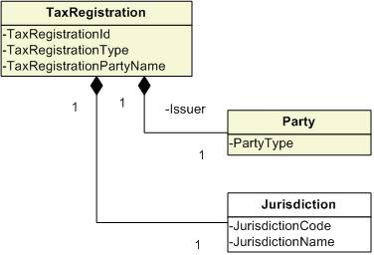
Figure 50: Tax Registration Class Model
Tax Registration Attributes:
- Tax Registration ID – An identifier of a unique Party (person or organization) allocated by an authority (Tax Authority) as a registered Party or person (taxpayer).
- Tax Registration Type – The type of Tax Registration that the Party holds. The types of registration that may need to be represented could be numerous. A brief list of registration types could include:
  - Tax File Number - Australia
  - Social Insurance Number – Canada (individual)
  - Business Number – Canada (organization and individual)
  - Social Security Number – United States (individual)
  - Tax Identification Number – United States (organization)
  - Tax Identification Number – Europe
- Tax Registration Party Name – The name under which the Party was registered (this may be different than the Party Legal Name).
Related Classes:
- Issuer→Party – The Party that issued the Tax Registration (see Section 6.2.8).
- Jurisdiction – The Jurisdiction in which the Tax Registration applies (see Section 6.1.4).

Tax Total
In some documents, the calculated total of taxes must be explicitly carried rather than derived from the tax details. Totals may be expressed for the document as a whole or as sub totals by type. The tax details are derived at the line item.
Note: This structure only carries the total of the calculated tax amount since this was all that was required to be explicit at the document level according to those tax authorities consulted. Other amounts that may be totalled such as exemption or taxable amounts may be included as requirements dictate.

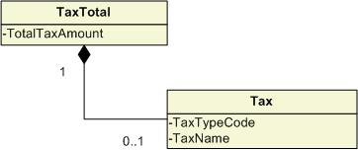
Figure 51: Tax Total Class Model
Tax Total Attributes:
- Total Tax Amount – The total amount of all taxes within a document or of a specific tax type for all transaction lines in a document.
Related Classes:
- Tax – A tax that may be specified for the Tax Total. This will be used to differentiate a tax total amount if it represents a sub total for a document. The tax carries the details of the tax imposed including the tax name, tax rate and taxing jurisdiction.

Glossary
Term | Similar Terms | Juris-dictions | Definitions (various sources)
Accounting Basis |  |  | Method of calculating amounts subject to income tax and VAT. In respect of VAT, tax would be computed as a percentage levy on the excess of sales over purchases.  [from Tax_Terms_English 2004-03-12 (OECD)]
Acquisition |  | EU | An “import” from one European Union state to another is known as an acquisition, reflecting the fact that there are no national barriers within the Community.  Instead of having to pay import VAT to achieve clearance of the goods at the point of entry into the Member State, the acquirer will account for VAT (acquisition tax) due on the acquisition of the goods as part of his normal VAT accounting (via his usual VAT return). The acquisition tax will therefore usually be paid and reclaimed on the same VAT return (some EU Member States require a one month delay between accounting for the acquisition tax and reclaiming it). This accounting process is known as the “postponed accounting” system.  [from TaxXML_Vocabulary ("Tax XML BASC Vocabulary")]
Acquisition Date |  | EU | The date on which an asset is purchased or obtained. The date on which ownership is transferred into the name of the purchaser.  [from TaxXML_Vocabulary ("Tax XML BASC Vocabulary")]
Ad Valorem Tax |  |  | A tax on goods or property expressed as a percentage of the sales price or assessed value. E.g. VAT, Sales tax  [from Tax_Terms_English 2004-03-12 (OECD)]
Advance Pricing Arrangement (APA) |  |  | An arrangement that determines, in advance of controlled transactions, an appropriate set of criteria (e.g. method, comparables and appropriate adjustments thereto, critical assumptions as to future events) for the determination of the transfer pricing for those transactions over a fixed period of time.  [from Tax_Terms_English 2004-03-12 (OECD)]
Commodity Tax |  |  | Tax based on a selective number of commodities. It corresponds in nature to excise duties on the sale of commodities, usually imposed at the importation of goods or sale by domestic manufacturers.  [from IBFD International Tax Glossary]
Consumers Use Tax |  |  | A tax liability that is imposed on the storage, use, consumption and sometimes distribution of property or services. Consumer use taxes typically arise when the seller that provides the goods or services is not registered to bill and collect the tax in a taxing jurisdiction. Use tax is complimentary to sales tax and is accrued (self-imposed) by a business. Consumers use tax applies to the following:  1) Purchases from out-of-state vendors, which are not responsible for sales tax, for use within the state;  2) Items removed from inventory for a business’s own use;  3) When property is brought into one jurisdiction from another (asset movement); and  4) When a service is performed in one jurisdiction but the benefit received is in another jurisdiction.  [from TaxXML_Vocabulary (“Tax XML BASC Vocabulary”)]
Consumption Tax |  |  | Tax generally intended to fall on the ultimate consumption of goods and services. E.g. VAT, Sales Tax  [from Tax_Terms_English 2004-03-12 (OECD)]
Cost |  |  | Purchase price paid for goods or services or the value of the exchange for which goods or services are given.  [derived from Tax_Terms_English 2004-03-12 (OECD)]
Delivery |  |  | Transfer of goods or an interest in goods from one person to another.  [from Tax_Terms_English 2004-03-12 (OECD)]
Despatch |  | EU | An “export” from one European Union Member State to another is known as a despatch. Although despatches can be zero rated, there are additional conditions which must be met before the despatch can be zero rated: the supplier has to show his customer’s EU VAT registration number on the sale invoice, and the goods must be used by the acquirer for his business purposes.  Where goods are despatched to other EU Member States and the supplier does not have his customer’s VAT number (for example, because the customer is a non-taxable person) he must charge VAT even though the goods have left the supplier’s country. This type of transaction is known as “distance selling” and, to avoid an imbalance in intra-EU trade, if a supplier’s distance sales to a country exceed a specified value in euros, the supplier must register for VAT in that country.  It should be noted that a despatch in one EU Member State would give rise to an acquisition in the recipient EU Member State.  [from TaxXML_Vocabulary (“Tax XML BASC Vocabulary”)]
Direct Cost |  |  | Cost identified with a particular transaction, such as raw materials, components and goods, wages and other processing expenses.  [from Tax_Terms_English 2004-03-12 (OECD)]
Direct Pay Permit |  | US | Customers holding Direct Pay permits do not pay any sales tax to their suppliers. Rather, the permit holders assume the full responsibility for determining which of their purchases are taxable and which are exempt, and remit any tax that may be due directly to the jurisdiction. Upon receiving a valid direct payment certificate, a supplier is relieved of all responsibility for collecting tax from the permit holder.  [from TaxXML_Vocabulary (“Tax XML BASC Vocabulary”)]
Discount |  |  | For VAT and other sales tax purposes, discounts (e.g. reduced prices, allowances made at the settlement of accounts by way of deduction from the amount payable (e.g. for paying promptly or in cash), allowances made to bankers or others for advancing money upon bills before they become due, etc.) usually reduce the taxable base, thus resulting in a decrease of the tax amount due.  [derived from IBFD International Tax Glossary]
Environmental Tax |  |  | Tax imposed for environmental reasons, e.g. to provide an incentive to reduce certain emissions to an optimal level or taxes on environmentally harmful products.  [from Tax_Terms_English 2004-03-12 (OECD)]
Evaluated Receipts Settlement  (see Section 3.1.6) | Self Billing,  Payment on Receipt |  | Sometimes Evaluated Receipts Settlement is used as a synonym for Self Billing. In other contexts, Evaluated Receipts Settlement is described as “automatically” settling (i.e. paying) goods receipts from suppliers. In these circumstances the supplier issues a “shipping notification” or “delivery note” to the customer, which notifies the customer of what he can expect to receive. When the goods receipt occurs, if it matches to the customer’s purchase order and the supplier’s “shipping notification” or “delivery note”, the payment will be made automatically without any document being generated which acts as an invoice. Exception handling procedures have to be implemented for instances where the goods receipt does not match.  In a VAT or Goods & Services Tax environment the absence of any document which acts an invoice would render this “automated” Evaluated Receipts Settlement process non compliant with tax requirements.
Exempt goods/service |  |  | A good or service that is exempt from GST/HST and against which the vendor cannot claim ITCs.  [from CRA RC4022 General Information for GST/HST Registrants guide]
Exempt With Credit |  | EU | In some Member States within the European Union (EU) there is an allowance for certain goods or services to be “free” of VAT, but for tax on expenses to be recoverable. In the UK this is achieved by designating a tax rate of 0% applicable to certain items. These “zero-rated” supplies are considered taxable supplies, but no VAT is actually charged to the customer. These supplies include books and newspapers, children’s clothes, food, transport services and exports. Some other Member States designate such zero-rated supplies as “exempt with credit”.  [from TaxXML_Vocabulary (“Tax XML BASC Vocabulary”)]
Exemption |  |  | A sale of tangible personal property or service, which would normally be taxable, but based on how the TPP or service is used, and/or who uses or sells the TPP or service, is not subject to tax. Or a special kind of tax rule which defines a situation in which no tax is required.  [from TaxXML_Vocabulary (“Tax XML BASC Vocabulary”)]
Extended Price |  |  | The amount that is arrived at by multiplying the price of an item by the quantity of items. For example, an item sells for $10 and a buyer purchases 10 of these items, the extended price is $100 ($10 X 10). This amount is the basis for the calculation of taxes.  [from TaxXML_Vocabulary (“Tax XML BASC Vocabulary”)]
First Nations Goods and Services Tax (FNGST) |  | CA | A version of the GST/HST calculated on the full range of products upon a First Nations reserve that has entered into the appropriate agreement with the Department of Finance and enacted the required by-laws upon the reserve.  [from CRA RC4072 First Nations Tax guide]
First Nations Tax (FNT) |  | CA | A tax on the sale of listed products (tobacco, fuel, and alcohol) on some First Nations reserves. The First Nation must enter into an agreement with the Department of Finance and enact the necessary by-laws on the reserve.  [from CRA RC4072 First Nations Tax guide]
Goods And Services Tax |  |  | VAT style multi-stage sales tax levied on purchasers (and lessees). Suppliers (and lessors) are generally responsible for collection.  [from Tax_Terms_English 2004-03-12 (OECD)]
Harmonized Sales Tax (HST) |  | CA | Three participating provinces, Nova Scotia, Newfoundland and Labrador, and New Brunswick, harmonised their provincial sales tax with GST to create the harmonised sales tax (HST). HST has the same basic operating rules as GST and applies at a single rate of 15% on the same base of goods that are taxable at 7% under the GST.  [from CRA RC4022 General Information for GST/HST Registrants guide]
Hidden Tax |  |  | Indirect tax paid by the customer without his knowledge.  [from Tax_Terms_English 2004-03-12 (OECD)]
Input Tax | Input Credit | EU | Term used in connection with VAT to denote the tax embodied in purchases made by a trader or entrepreneur who will usually be able to obtain a credit for the tax that his suppliers have paid on the goods supplied to him which form his “inputs”.  [from Tax_Terms_English 2004-03-12 (OECD)]
Input Tax Credit (ITC) |  | CA | The means for recovering the GST/HST paid or owing on the purchases and expenses related to a registrant’s commercial activities.  [from CRA RC4022 General Information for GST/HST Registrants guide]
Inventory Removal |  |  | Items withdrawn from inventory and used by the taxpayer in an internal taxable use and not in the tax-exempt manner for which they were originally purchased. Example: A calculator is removed from inventory to be used by an employee. The company originally purchased the calculator for resale and without paying tax.  [from TaxXML_Vocabulary (“Tax XML BASC Vocabulary”)]
Invoice Basis |  | EU | Method of applying VAT to the price at which the goods or service are invoiced, with a deduction for the tax (if any) charged at previous stages.  [from Tax_Terms_English 2004-03-12 (OECD)]
Landed Cost |  |  | Term used in relation to the importation of goods which means the sum total of the cost of the goods concerned, the amount of customs duties levied on those goods and the expense incurred (freight, insurance, etc) in unloading them.  [from Tax_Terms_English 2004-03-12 (OECD)]
Nontaxable |  |  | A type of deduction. Applies to the sale of tangible personal property or service that is not taxed because the item sold is not included in the class of taxable items defined in the taxing jurisdiction’s statute.  [from TaxXML_Vocabulary (“Tax XML BASC Vocabulary”)]
Option To Be Taxed |  | EU | In the VAT context, a VAT exempt entrepreneur sometimes can claim to be subject to VAT, the advantage being that to be entitled to his input tax against his output tax.  [from Tax_Terms_English 2004-03-12 (OECD)]
Order Acceptance Location |  |  | The location where a supplier approves a sales transaction or accepts a contract. This location may be used to determine the appropriate taxing jurisdiction.  [from TaxXML_Vocabulary (“Tax XML BASC Vocabulary”)]
Order Taken Location |  |  | The location where the order or contract is received, worked on or taken by a salesperson. This location may be used to determine the appropriate taxing jurisdiction.  [from TaxXML_Vocabulary (“Tax XML BASC Vocabulary”)]
Output Tax |  | EU | Term used in connection with VAT to denote the tax payable on the sales of goods or services by those who are subject to the tax and in contrast to the input tax for which a credit will be available.  [from Tax_Terms_English 2004-03-12 (OECD)]
Place Of Supply | Situs | EU | It provides an indication of where VAT is due and who is liable to account for VAT. The rule for determining place of supply is different for goods and for services. And there are situs exceptions for both goods and for services.  General Rules for Place of Supply:  - VAT is charged in the country where the goods are physically located when allocated to the customer. VAT is charged in the country where the service is consumed.  [derived from TaxXML_Vocabulary (“Tax XML BASC Vocabulary”)]
Pro Rata Rule | Partial Exemption | EU | Under most VAT systems, input tax is deductible to the extent that it relates to the making of taxable supplies. VAT registered persons are required to attribute input tax as far as possible to taxable and exempt supplies. Any input tax which cannot be directly attributed must be pro rata’d based on a proportion representative of the balance of taxable and exempt supplies made by the VAT registered person. The fraction of the non-attributable input tax that reflects the proportion of taxable supplies is deductible as input tax, while the fraction of the non-attributable input tax that represents the proportion of exempt supplies is not deductible as input tax.
Punch Out |  |  | The “punch-out” technique provides a mechanism to extend the catalogue content available to a requisitioner. When the requisitioner selects items provided by a ‘punch-out’ supplier, the requisitioner is automatically redirected to the supplier's web site where he/she can browse the supplier’s catalogue. After selecting the required items on the supplier’s site, the requisitioner is returned to his/her “own” system to complete the requisition.  For approved requisitions, an order is automatically generated and sent to the supplier's web site so that the order can be processed and the goods despatched.  The great advantage of this method is that it avoids the maintenance overhead of suppliers sending electronic details of their catalogue to the buying organisation, which then loads it onto its buy-side system. This is particularly relevant where the catalogue content changes frequently, or where the supplier offers configuration options on their products (e.g. computer hardware suppliers that provide on-line configuration for PCs).
Retail Sales Tax |  |  | Single-stage tax on the sale of goods to ultimate customers, whether by retailers or other traders.  [from Tax_Terms_English 2004-03-12 (OECD)]
Reverse Charge |  | EU | In the European Union (EU), for the purchase of certain services from outside the country in which he is registered for VAT, the customer is required to make a VAT adjustment to both his output and input tax figures (based on the VAT rate applicable in the Member State in which he is registered for VAT).  The mechanism by which this is achieved is:  - The customer accounts for output tax VAT at the appropriate rate as though he had sold the service to himself at the value which he paid for it.  - The customer calculates VAT at the appropriate rate as though he had purchased the service from a supplier in the country in which he is registered for VAT at the value which he paid for it. The customer is only allowed to deduct as input tax that proportion of this VAT which he would have been able to deduct if he had purchased the service from a supplier in the country in which he is registered for VAT.
Sales Tax |  |  | Tax imposed as a percentage of the price of goods (and sometimes services). The tax is generally paid by the customer but the supplier is responsible for collecting and remitting the tax to the tax authorities.  [from Tax_Terms_English 2004-03-12 (OECD)]
Self-Assessment |  | CA | The purchaser calculates the GST/HST, or FNGST owing on a taxable good or land they purchased but upon which no tax was calculated and remits it to CRA along with the appropriate return form (GST59, GST/HST Return for Imported Taxable Supplies; GST60, GST/HST Return for Acquisition of Real Property; GST489, Return for Self-Assessment of the Provincial Portion of the Harmonized Sales Tax (HST); GST531, Return for Self-Assessment of the First Nations Goods and Services Tax (FNGST))  [from CRA RC4022 General Information for GST/HST Registrants guide]
Self Billing  (see Section 3.1.6) | Evaluated Receipts Settlement,  Payment on Receipt |  | This is a process whereby a customer “invoices” or “bills” himself, in the name and on behalf of his supplier and provides a supplier with a copy of the “self billed invoice”. Where a customer knows what was ordered from a specific supplier, what prices were agreed and what was actually delivered, there is no real business need for an invoice to be issued by the supplier, before paying what is due. The requirement for a self billed invoice is primarily that of taxes like VAT and Goods and Services Tax, to record that the correct amount of tax was deducted by the customer in respect of the supply and to inform the supplier of the amount of VAT which the customer has claimed from the tax authority and for which the supplier will be required to amount to the tax authority.  Legal provisions for self billing vary from jurisdiction to jurisdiction. Some jurisdictions encourage self billing, others allow self billing only within certain restrictions and some jurisdictions refuse to allow self billing at all.  Some jurisdictions do not allow self billing, but allow “pre notification” where the customer informs the supplier what the invoice should contain and the supplier prepares the invoice accordingly.
Situs |  |  | The locations for which a taxing jurisdiction has the right to tax transactions or more commonly, the location of a specific transaction.  [from TaxXML_Vocabulary (“Tax XML BASC Vocabulary”)]
Taxable Base | Tax Base |  | The thing or amount on which the tax rate is applied. The taxable base is represented as a bottom-line amount, taking into consideration all possible deductions, losses and personal allowances.  [derived from IBFD International Tax Glossary]
Taxable Event |  |  | Term used to define an occurrence which affects the liability of a person to tax.  [from Tax_Terms_English 2004-03-12 (OECD)]
Trade-In Allowance |  |  | The amount by which the supplier reduces the sale price of a property in return for the property of the customer. This does not affect the customer’s basis in the property purchased.  [from TaxGlossary ]
Transaction Taxes |  |  | Tax that uses a specific type of transaction as its object, e.g. sales tax, immovable property transfer tax, etc.  [from Tax_Terms_English 2004-03-12 (OECD)]
Transfer Tax |  |  | Tax levied on the transfer of goods and rights, e.g. purchase and/or sale of securities and immovable property.  [from Tax_Terms_English 2004-03-12 (OECD)]
Triangulation |  | EU | This is a scenario developed by the European Union (EU) to simplify the Value Added Tax (VAT) collection process when suppliers are in different member states.  Conditions of Triangulation  - Must only be three parties involved, two suppliers to one purchaser.  - All parties must be registered for VAT in the EU.  - All parties must be in separate EU member states, for example supplier (A) in Germany, supplier (B) in France, and customer (C) in Austria.  Triangulation Flow  - Supplier (A) ships goods directly to the customer (C). (Physical Flow)  - Supplier (A) bills supplier (B) and then (B) bills (C) (Invoice Flow)  - Supplier (A) zero rates the supply and C accounts for Acquisition VAT (Tax Flow)  [from TaxXML_Vocabulary (“Tax XML BASC Vocabulary”)]
Use Tax |  |  | Tax on goods which are used within the taxing jurisdiction although the goods were purchased in another jurisdiction  [from Tax_Terms_English 2004-03-12 (OECD)]
Value Added Tax (VAT) |  |  | Specific type of turnover tax levied at each stage in the production and distribution process. Although VAT ultimately bears on individual consumption of goods or services, liability for VAT is on the supplier of goods or services. VAT normally utilizes a system of tax credits to place the ultimate and real burden of the tax on the final consumer and to relieve the intermediaries of any final tax cost.  [from Tax_Terms_English 2004-03-12 (OECD)]
Zero Rate |  | EU | The term is used in relation to VAT, where the rate of tax which is in principle levied but at a rate of 0% so that in effect no tax is payable, but will result in refunds of input tax credits.  [from Tax_Terms_English 2004-03-12 (OECD)]
Zero-rated goods/service |  |  | A good or service that is taxed at the rate of 0% and against which the vendor may claim ITCs.  [from CRA RC4022 General Information for GST/HST Registrants guide]

Process/Message Cross-Reference
Message  (those described in Section 5 highlighted in bold; those appearing in “Core” processes highlighted in yellow) | Process  (“Core” processes highlighted in yellow)
 | Billing | Customs Evidence | Drawback/ Refund/ Rebate | Export Clearance | Fulfilment | Import Clearance | Movement of Duty Suspended Goods in Transit or Removal to Home Use | Ordering | Payment Notifica-tion | Quotation | Receipt of Duty Suspended Goods in Transit Within a Customs Union | Self Billing | Shipment Declara-tion
Account Response |  |  |  |  |  |  |  |  |  |  |  | 
Credit Note | 
Customs Evidence |  | 
Customs Evidence Advice |  | 
Customs Evidence Request |  | 
Debit Note | 
Declaration Advice |  |  |  |  |  |  | 
Despatch Advice |  |  |  |  |  |  |  |  |  |  | 
Drawback Claim |  |  | 
Drawback Claim Advice |  |  | 
Drawback Payment Advice |  |  | 
Export Declaration |  |  |  | 
Export Declaration Advice |  |  |  | 
Import Declaration |  |  |  |  |  | 
Invoice |  |  |  |  |  | 
Order |  |  |  |  |  |  |  | 
Order Advice |  |  |  |  |  |  |  | 
Order Cancellation |  |  |  |  |  |  |  | 
Payment Advice |  |  |  |  |  |  | 
Permission to Proceed |  |  |  |  |  |  | 
Quotation |  |  |  |  |  |  |  |  |  | 
Quotation Request |  |  |  |  |  |  |  |  |  | 
Receipt Advice |  |  |  |  | 
Remittance Advice |  |  |  |  |  |  |  |  | 
Removal from Duty Suspension Declaration |  |  |  |  |  |  | 
Selection Advice |  |  |  |  |  |  | 
Self Billed Credit Note |  |  |  |  |  |  |  |  |  |  |  | 
Self Billed Invoice |  |  |  |  |  |  |  |  |  |  |  | 
Shipment Declaration |  |  |  |  |  |  |  |  |  |  |  |  | 
Transit Declaration |  |  |  |  |  |  |  |  |  |  | 
Vessel Arrival Input |  |  |  |  |  | 

Process/Actor/Role Cross-Reference
Actor/Role  (those appearing in “Core” processes highlighted in yellow) | Process  (“Core” processes highlighted in yellow)
 | Billing | Customs Evidence | Drawback/Refund/ Rebate | Export Clearance | Fulfilment | Import Clearance | Movement of Duty Suspended Goods in Transit or Removal to Home Use | Ordering | Payment Notifica-tion | Quotation | Receipt of Duty Suspended Goods in Transit Within a Customs Union | Self Billing | Shipment Declara-tion
Seller |  |  |  |  |  |  |  |  |  | 
Despatcher |  |  |  |  |  |  |  |  |  |  |  |  | 
Creditor |  |  |  |  |  |  |  |  |  |  |  | 
Exporter |  |  |  | 
Buyer |  |  |  |  |  |  |  |  |  |  | 
Recipient |  |  |  |  | 
Debtor |  |  |  |  |  |  |  |  |  |  |  | 
Importer |  |  |  |  |  | 
Place of Supply Customs |  |  |  |  |  |  |  |  |  |  | 
Place of Receipt Customs |  |  |  |  |  |  |  |  |  |  |  |  | 

Actor/Role/Message Cross-Reference
Message  (those described in Section 5 highlighted in bold; those appearing in “Core” processes highlighted in yellow) | Actor/Role  (those appearing in “Core” processes highlighted in yellow)
 | Seller | Despatcher | Creditor | Exporter | Buyer | Recipient | Debtor | Importer | Place of Supply Customs | Place of Receipt Customs
Account Response |  |  |  |  |  |  | 
Credit Note |  |  |  |  |  |  | 
Customs Evidence |  |  |  |  |  |  |  |  | 
Customs Evidence Advice |  |  |  |  |  |  |  |  | 
Customs Evidence Request |  |  |  |  |  |  |  | 
Debit Note |  |  |  |  |  |  | 
Declaration Advice |  |  |  |  |  |  |  |  |  | 
Despatch Advice |  |  |  |  |  |  |  |  |  | 
Drawback Claim |  |  |  |  |  |  |  |  | 
Drawback Claim Advice |  |  |  |  |  |  |  |  | 
Drawback Payment Advice |  |  |  |  |  |  |  |  | 
Export Declaration |  |  |  |  |  |  |  |  | 
Export Declaration Advice |  |  |  |  |  |  |  |  | 
Import Declaration |  |  |  |  |  |  |  |  |  | 
Invoice |  |  |  |  |  |  |  |  |  | 
Order |  |  |  |  | 
Order Advice |  |  |  |  | 
Order Cancellation |  |  |  |  | 
Payment Advice |  |  |  |  |  |  |  |  |  | 
Permission to Proceed |  |  |  |  |  |  |  |  |  | 
Quotation |  |  |  |  | 
Quotation Request |  |  |  |  | 
Receipt Advice |  |  |  |  |  | 
Remittance Advice |  |  |  |  |  |  | 
Removal from Duty Suspension Declaration |  |  |  |  |  |  |  |  | 
Selection Advice |  |  |  |  |  |  |  |  |  | 
Self Billed Credit Note |  |  |  |  |  |  | 
Self Billed Invoice |  |  |  |  |  |  | 
Shipment Declaration |  |  |  |  |  |  |  |  |  | 
Transit Declaration |  |  |  |  |  |  |  |  |  | 
Vessel Arrival Input |  |  |  |  |  |  |  |  |  | 

Appendix: Alignment with Other Specifications

Universal Business Language (“UBL”)
Version 1 of the OASIS Tax XML TC Indirect Tax Reference Model was aligned to Version 1 of the UBL standard.
Development of version 2 has not included alignment with changes between UBL v1 and UBL v2. An initial comparison has identified terms that appear synonymous (see table below); however a more detailed analysis is required before a decision to align those terms and concepts can be taken.

Tax XML TC term | UBL TC term | Alternative term
Account Response | Application Response | Dispute Note
Payment Advice | Remittance Advice
Debtor | Accounting Customer Party
Creditor | Accounting Supplier Party
Transit Declaration | Forward Instruction (?)
Quotation Request | Request for Quotation
Price Adjustment | Allowance Charge
Table 1 – Potential synonyms between Indirect Tax Reference Model v2 and UBL v2
- Acknowledgements
The following individuals have participated in the creation of this specification and are gratefully acknowledged:
Participants:
Dave Chambers, HMRC, Member, OASIS Tax XML TC Technical Analysis Sub-Committee
John Glaubitz, Vertex Inc, Member, OASIS Tax XML TC Technical Analysis Sub-Committee
Andy Greener, HMRC, Chair, OASIS Tax XML TC Technical Analysis Sub-Committee
Geraint Richards, HMRC, Member, OASIS Tax XML TC Technical Analysis Sub-Committee
Michael Roytman, Vertex Inc, Member, OASIS Tax XML TC
Sylvia Webb, GEFEG Inc, Member, OASIS Tax XML TC
Andrew Webber, CRA, Member, OASIS Tax XML TC Technical Analysis Sub-Committee

- Revision History
Revision | Date | Editor | Changes Made
1.0 | 11 May 2005 | John Glaubitz | Initial Version of Model (2-Party)
2.0 | 26 Oct 2007 | John Glaubitz  Andy Greener  Andrew Webber | Revised Version of Model (3-Party)

The only exceptions to this in the scope of this model are in the Movement of Duty Suspended Goods in Transit or Removal to Home Use process and the Drawback process, where the Customer and the Supplier may well be in the same jurisdiction, or where there is no Customer as a result of withdrawal to home use or destruction of the goods by the owner (Supplier).
A single transaction may comprise a sequence of discrete interactions between the transacting parties.
Source for Customs definitions: US Maritime Administration Glossary of Shipping Terms (http://www.marad.dot.gov/Publications/05%20reports/Glossary.final.pdf)

