MASARYK UNIVERSITY
FACULTY OF INFORMATICS



Managing External Resources
In Multicultural Environment

MASTER THESIS

Bc. Matúš Kominka

Brno, 2010
Declaration
Hereby I declare that this paper is my original authorial work, which I have worked out by my own. All sources, references and literature used or excerpted during elaboration of this work are properly cited and listed in complete reference to the due source.
Bc. Matúš Kominka

Advisor: RNDr. Zdenko Staníček, Ph.D.
Acknowledgement
I would like to thank RNDr. Zdenko Staníček, the advisor of my master thesis, for his valuable comments, suggestions and time he spent helping me with this work. I would like to thank Peter Foldy and Anton Cpin for their support during my work in JTE Company and my parents for supporting my university studies.
Abstract
Globalization of our world takes round to business a new concept. More and more big companies are opening branches all over the world with mixture of employees from different nations therefore they create multicultural environment. Hiring a full time employee for a short term job is not always the best choice for a company with limited resources. Especially during the economic crisis when most of the companies stopped their recruitments, the one choice to use more resources could be freelancers. Freelancer is external employee of the company underlying to another category then regular employee and therefore requires different management approach especially in multicultural environment.
This work provides a summary and experience of my internship in service oriented company as a manager of external resources. The 6 months internship is part of SSME studying program curriculum. It also deals with the concept of multicultural environment and globalization in business focused on managing teams of freelancers. The main output is the layout of online system for managing external resources according my practice on real projects in localization specialized company. It also involves a conceptual model of mentioned system with entities and relationship definition.

Keywords
team work, culture, interim project, SSME, freelancer, JOSER, external resources, managing team, multicultural environment, localization, conceptual model
Contents
1. Introduction 6
2. Interim Project 7
2.1 Project Background 7
2.2 Customer 7
2.3 Project Goals 8
2.4 Roles and Responsibilities 8
2.5 Team 9
2.6 Project Anatomy 9
2.7 Managing the Project 11
2.8 Important Aspects 11
2.9 Results 12
2.10 Analysis 12
2.11 Lessons Learned 12
3. Multicultural Environment 13
3.1 Possible Problems in Multicultural Environment 15
3.2 Dealing with Multicultural Problems 17
3.3 Multicultural Teamwork 19
3.4 Global Leadership Competences 21
3.5 Multicultural Communication Tips 22
4. Managing Teams 24
4.1 Types of Teams 24
4.2 Building a Team 25
4.3 The Team and its Leader 26
4.4 A Model for Team Effectiveness 27
5. Internal vs. External Employees 30
5.1 Hiring a Freelancer 31
5.2 Managing Freelancers 32
6. JOSER 35
6.1 Functionality of the System 37
6.2 Conceptual Model 45
7. Conclusion 50
Bibliography 51

Introduction
The internationalization of business, creation of a "global village" and similar influences remind us that a science of organizations and management is incomplete without the integration of concepts of culture, interdependence, and self-awareness. No longer is it appropriate to discuss organizational activities and employee actions without incorporating a more comprehensive view of where such activities take place. Not only must we include an immediate social context, but we must deal with the international and cultural aspects of the social world as well. More than ever, understanding of employee action requires knowledge of how action is related to the environment in which it is embedded.
As a student of SSME program I have attended many useful and interesting courses during my master study and all of these courses were taught for one main purpose: “To form SSME student to so called T-Shape professional with ability to apply himself into modern world.” Important part of SSME curriculum was an internship in service providing company to gain some practical skills.
This thesis focuses mainly on managing projects using teams of people from different cultures and mostly on teams of external employees. It is based on experience gained during my Interim project in Jonckers Translation and Engineering, which is multinational localization company. I have worked as project team manager on several projects and had a chance to manage teams of 8 to 40 people. During my activity in this company I have learned many new things, but also figured out some stuff, which could be done a lot better. I had my best effort to capture my experience to my master thesis.
The first chapter summarizes my Interim project in Jonckers TE describing my actual work there and it is based on IPMA project report standards. Next chapters are focused on some theory about multicultural team and team management itself with addition of my personal opinions and experience followed by differences between internal and external employees. I had a chance to try managing team of internals, but mostly externals, so next chapter captures some techniques and practices for working with freelancers. Managing the external resources is no easy thing, but it can be facilitated using proper information system. In the company I worked in we used many techniques, but none of them was the right one. The last chapter describes the possible functionality and features of hypothetic online system for managing externals supplemented by its conceptual model with domain definition.

Interim Project
We live now in a world focused on services and service economy. The key to successful business is to have satisfied customers. The customer demands the highest quality for the least cost. Good service is therefore one that provides what customer wants while ensuring a reasonable profit for the provider.
Quality was therefore the main criterion for establishing the project in which I officially participated from 1-st of the August 2009 until the end of the year 2009. The main purpose of the project was coordination of assigned localization project within the customer’s company. It involved cooperation with project managers, who communicated with external parties. The main project elements were recruitment for the assigned project, preparation and conduct of training and taking over responsibility for developing the project team. The main task was to carry out a project for a client with assigned team in the pre-agreed time and with the best quality.
The following chapter describing my internship and it is significantly influenced by customer requirement about not mentioning specific data, names of clients and also no detailed description of work processes. Therefore only superficially summarizes my work on the project without providing sensitive information. The structure of this chapter is based on IPMA requirements for project report.

Project Background
During my time in the client’s company I had gained experience from several different positions by working for various departments. I started four years ago as a freelance desktop publishing assistant, where I got familiar with quality control and basic DTP tools. Later, I became the DTP specialist working on DTP processing of the entire project. My experience was needed in the department of testing, where we were started the localization of electronic manuals using my skills from DTP, and gradually I gained the position of a QA Test Leader. I was coordinating the group of testers with responsibility for the quality of their output. Forasmuch as I went through all of the technically oriented positions, and I was experienced with the majority of internal processes, it was a chance for me to move forward. And then the position of Project Team Manager was offered to me so I took it.
Project Team Manager (PTM) was newly created position responsible for managing the project with focus on quality. It includes responsibility for the entire project, with the exception of financial issues like budgeting and invoicing, which remained in the responsibility of project manager. PTM should be familiar with the entire localization process and sub-processes and be able to present these skills to the team of people to subordinates and also coordinate the whole team.

Customer
Jonckers Translation & Engineering is a multinational localization company with headquarters in Brussels and branch offices in the Czech Republic, Great Britain, Germany, Italy, Japan, China, Hong Kong, Vietnam, Korea and the USA. It was founded in 1994 and in 15 passed years of operation on the market has gained significantly strong position and many clients from the IT industry. The company offers full localization services, whether software products, or documentation, manuals and handbooks or websites, including translation, processing and testing of the ordered product.
Organization of the customer's business is strongly influenced by the fact that top management is located in Brussels and the individual branches are controlled by Operation Managers with limited competence. Most of the strategic decisions therefore come from the head office and all branches have to follow. The basic motto of the company is: "If you think you can, you can ..." and it is also the rule used in planning of some projects, where "no" is not admittable answer for clients.
Reporting is preformed through regular meetings with supervisors, mostly at the beginning of the week. At the end of each week, everyone should make a report for the past week, with estimated work for next week. On the report’s basis and the workload of individual employees the future allocation of work is planned.

Project Goals
Project Team Manager‘s duty during the running of the project is a collaboration with the project manager and work actively with the assigned team to gain or deepen his experience with leadership and managing the project team. One of the objectives is the benefits to the customer in the form of a qualified workforce, utilizing previous experience from other departments.
The main objective was to ensure the highest quality on running projects at the customer using external resources to minimize costs. The objective was to raise the client's final benchmark at least in 0.5 point. The clients expect unchanged or even improved quality, but the customer decided to reduce the cost of eligible projects, and so use external rather than internal employees. For selected projects were hired more than 30 new workers without any previous experience in localization. There were mostly students of lower classes from Brno‘s universities. That’s why the Project Team Manager was needed to be responsible for managing a team of such freelancers with preservation of quality and compliance achieving required productivity and also to manage whole the project on time.
Side goal, but still important one was to prepare documentation for each of processes and formulation of some kind of handbook for further use. This objective, as it was the side one, could be performed only for the time of lower workload, because commercial projects have priority over internal ones.

Roles and Responsibilities
My task has been for most assigned projects for the clients more or less the same. I started a new project with analysis and evaluation client‘s requirements associated with participation on negotiations with representatives of the client company (if it was necessary). This was followed by assistance in project planning, schedule creation and identification of major milestones. Important task was the preparation of guidelines for external translators to meet client‘s requests to be easy to understand and so avoid potential misinterpretation of requirements. Despite efforts in some cases there were still certain misunderstandings from translators.
My main responsibility was creation a team of trained technical personnel for processing and testing of concurrent projects and cooperation with other divisions on related projects. I was responsible for coordinating the project team on running projects, work assignation and dealing with potential problems. Almost all decisions were in my competence without dealing with higher management, which significantly speed up the whole process. My work also included the occasional technical work on single projects, if it was necessary. In addition, I was performing productivity and quality review of work and produce periodic reports for supervisors. At the end of the projects I supervised the testing process and finishing work. This was followed by verification of deliverables and delivery of the project to client associated with the final assessment with the project manager. Evaluation led to post-mortem examination of the document for client comments and suggestions for improvement for future projects.

Team
The project team consisted mostly of an external resources hired based on job interview which I had led. Interview was based on simple test created for specific project, then some translation exercises and conversation in English. Those who reach the limit, usually 80% were added in the database of external staff and if needed they are called for individual projects.
For each project the first analysis determined the number of people needed for each phase and that leads to preliminary resource planning. Ideally, the experienced people were used on similar projects, but I worked mostly with students and their availability was rather limited. It was therefore difficult to plan each day to cover needed capacity. At the same time all team members have to be trained and familiar with latest information. As a student myself, during my school duties, I had to had a back-up representative to perform the necessary tasks in the time of my absence and after my return report me all issues.
Ongoing planning of human resources has always been done a week ahead according the availability of individual team members. In case of some sudden changes an operative steps were needed to be performed. Workers were called to work mostly day in advance via e-mail, where necessary even in the very same day by telephone. On the basis of their willingness to come to work according their filled availability a special attendance bonus could be awarded to their regular hourly rate.

Project Anatomy
During my job in localization company I worked on many different projects, but there were some activities, which were same for mostly all of them:

Agreement with the Client
In the initial phase of the project the sales department is dealing with the client, contacts me or my colleges for preliminary analysis and the approximate cost calculation of the entire project. On the basis of our analysis the draft budget is drawn up and the contract is concluded with the client.

Analysis of the English source Files
The most projects are localized from English to languages required by client. Before the actual localization a detailed analysis of the source files is necessary to determine possible recycling rate of translation based on previous projects.

Translation Process
After analysis and processing requests from client the text extracted from source files is transformed to special bilingual xml files using the recycled translation to get partly translated texts. These are sent along with instructions to translators for translation of untranslated segments/strings and full proofread. During this phase, other files such as images, animations and other elements of the translated material are processed under the supervision of the project team manager.

Translations Handling
This phase varies considerably by type of localized project. First it is necessary to clean up files from the translators from English strings to get translated files. They are either used in the program component of software product, integrated into the html/xml structure or imported to the DTP template. A translation process is usually responsibility of one person or a small team when needed to minimize the possibility of issues. But even this does not guarantee 100% perfection, therefore additional checks are required.

Linguistic QA (Quality Assurance)
Some clients require a specific translation formats and translations of certain names exactly according reference materials. Although these requirements were interpreted to the translators, they had not always understood them correctly or even very often they had decided to ignore or overlooked in some parts of the text. These shortcomings should be spotted during the linguistic check performed by trained testers carried under the supervision of an experienced person. All spotted issues are implemented to translated files and send to translators to be checked again.

Interim Review
This stage usually occurs in about third quarter of the project duration. It is a continuous check of translated parts of the project on the client‘s side. By this event, it is necessary to have all the files in the highest quality possible in order to send them for a check to the client. After this, client‘s observations and insights are delivered to us, which we either accept or justify why this is so as it is. Relevant comments are implemented in translation files, but more relevant comments were spotted during interim review, the lower the final mark we get in benchmark.

Final Testing
After all files are checked and corrected a process of finalization follows. That involves the final compilation, upload to the server or just PDF files preparation. Before submitting the files they have to be narrowly tested. A team of testers goes through all the localized languages according the test cases elaborated mostly by PTM by given instructions. All languages are compared with English source files and they should be in line with them.

Sign Off Process and Final Delivery
Once the project is after testing phase with all spotted issues corrected all languages are sent to client to sign-off. This can be called as the final check on client’s side and if no issues are found during this phase, project is considered to be successfully delivered.

Project Evaluation
After successful completion of the project (during my involvement with the projects all of them were successfully completed in given deadline) a final assessment of whole project follows up to highlight the accomplishments and also reasoning of possible problems. A post-mortem document is based on this assessment, which is mostly discussed during a personal meeting with the client.

Managing the Project
The method of managing individual projects was dependent on the type and size of the particular project. For small projects I have performed all the activities myself, without the need for delegating work to others. Sometimes I managed a small approximately 10-member team, which requires detailed planning, allocation of work and project oversight. For really big projects, which involves more than 40 people it was necessary to establish a hierarchy and divide responsibilities among the various roles of other team members. If the right people were selected for each task, the process was virtually seamless and by successful delegation of work I got time for more important activities.
I went through a progressive development mode of governance of individual projects. For large projects it is the most difficult to be in touch with the entire team and also to keep all team members informed about current changes and the most common problems. After various attempts through query logs, issue trackers and other instruments for tracking spotted issues and problems, I realized that none of them is really helping. So as the best solution I had chosen to use English source files as reference material for all languages. Since all languages are based on same source files, thus they should all be the same as the English so during checking of every language is the source file with added comments used as a reference file for all team members. The best solution is to mark all information, instruction and problem areas right there, whether it is a PDF document, or screenshots of the application with comments. Thus it is possible to continuously add to the instructions and the team remains informed about all of them.
There is one area which still needs further improvement. It is the actual planning of human resources (mostly the external ones). It is necessary to establish a new online system for monitoring the availability and assigning individuals to actual projects. The system should also include the brief description of each part-timer (with which is experienced, on what work fits...) to help other team leaders to choose appropriate resources for particular project.

Important Aspects
The output quality was the main importance for all projects, which I was involved in. The entire localization process can be done without mentioned checks as it can be seen in some manuals for some device or machines. But customer‘s satisfaction is associated with client‘s satisfaction and so quality is so important and increases the prestige of the whole company or brand. It is something that is not worth saving because it could lead to loss of important clients, and some thoughtless short-term cost reduction could dramatically reduce the profits in the future.
My big effort on several projects was to enforce the creation of specialized teams for specific client‘s projects. This would save time for apprenticeship training for workers and significantly improve the quality and productivity. It did not meet with understanding of the management of the customer’s company. They were concerned about the overloading of certain workers, and especially the acquisition of a sense of their unavoidability. Their concern was keeping the contrary, which "everyone knows everything" and so everyone can be replaced. In some phases of the project it caused considerable problems when some people were just not good for the some job and their results were bad. Unfortunately, just after these highlighted problems the management agreed with my ideas of specialized teams with occasional use of uninterested staff.

Results
The conclusion of the whole project was tied to the results of individual projects for different clients and the implications of the required documentation. The main success of the project was to increase the marks in the client’s evaluation in some projects, even on 1.6 points. The initial average 3.2 was increased to 4.8 points from maximum 5 and the customer's company was moved to first place in the client’s vendor evaluation.
Another success was managing 3 projects simultaneously in a very short period of time. This was possible only because of already mentioned establishment of specialized teams and improved quality control, but it brought need to work overtime and during weekends, but we all follow through to a successful conclusion.
The secondary goal in the creation of process documentation was fulfilled after the finishing of the interim project. Due to the time demands of commercial projects all internal projects were postponed to a later party. The mentioned documentation can not be disclosed as it is property of the customer.

Analysis
One of the most critical factors was limited availability of part-timers and the associated need for complex human resource planning for each day separately. The biggest problem occurs during the exam period, when usually there is a lot of work and also limited number of available students. This problem could minimize the above-mentioned system for the management of external resources.
Another issue for some projects was a slight decrease in productivity caused by the involvement of inexperienced people into the process. This decline was therefore defensible in front of the management and was not considered as a failure.
One of the achievements was establishing of corporate e-mail accounts for all freelancers, which greatly facilitated inter-team communication. For monitoring of individual workers the domain accounts with a unique login were also created for all externals.

Lessons Learned
The most valuable experience for me was working in a multicultural environment and a chance to try to cooperate with other branches, especially those in Asia. I saw how different people perceive different responsibilities, timeframe and focus on quality. I gained real experience with managing the projects and teams and also practiced my communication skills.

Multicultural Environment
Culture is a fascinating concept. It has so many applications, whether between nations, organizations, or people. Communicating effectively across cultures, negotiating on a global scale, and conducting international business are always challenging. To thrive, and in many cases to survive, in the 21st century, individuals and institutions must incorporate cultural sensitivity and skills into their relations, strategies, and structures. Inability to deal with differences or diversity in human cultures is a sign of weakness and obsolescence in persons and groups. [1]
During the last century, many Western nations and companies have successfully competed on a global scale through their use of new technological advances. Many other Eastern nations have recently managed to expand their global business through acquiring the West’s basic technologies and by manufacturing products at reduced prices. In the 21st century, however, new technology and lower prices will no longer be the sole competitive edges. Western technology will be quickly acquired by other countries and lower prices will be attained through enhanced productivity and automation. As a result, a new competitive edge to successful global business is needed: cultural competency. Cultural competency is what future global business managers will need to supplement both technological advances and price reductions.
Multiculturalism presents us with a paradox because it requires us to look at how we are the same and how we are different at very same time. The multicultural perspective is one of the most important ideas in this century because it emphasizes both the ways that we are each unique and the ways that we share parts of our identity with others. Alternative views of culture have made three serious mistakes:
1. The "malting pot" metaphor made the mistake of overemphasizing the ways we are the same and ignoring differences. This has usually resulted in the more powerful groups imposing their perspectives on everybody else.
2. The overemphasis of differences has resulted in stereotyped and disconnected "special interest" cultural groups in an exclusionary perspective while ignoring the common ground of shared interests that makes the welfare of each group important to each other group.
3. The assumption that anyone must select either a universalist or a particularist viewpoint has resulted in a false choice, because both are important to defining the cultural context accurately and comprehensively. A universalist perspective represents an all-embracing, all-reaching perspective. A particularist perspective represents adherence to one particular interest or system. Each cultural perspective is unique, but each perspective also shares overlapping features with each other group like overlapping fish scales. [4]
According study of Markus & Kitayama from 1991 there is a model which provides a linkage among key individual and team characteristics in multicultural environment. This model consists of both process and content features across several levels of analysis. It is intended to capture the key features of multinational teams in relation to environmental and personnel features. It has a number of general features. At a structural level, the model contains both process and contextual features occurring at an individual, team, and organizational level of analysis. The overarching structure of the model links the individual and group elements through specific processes. For example, roles enacted by individuals within a team collectively may create fractionation within the team. Role-making and role-taking is a fundamental action of individuals when exposed to a social structure. It is through the action of creating roles for oneself that fractionation and differentiation within a team may occur at a team level.
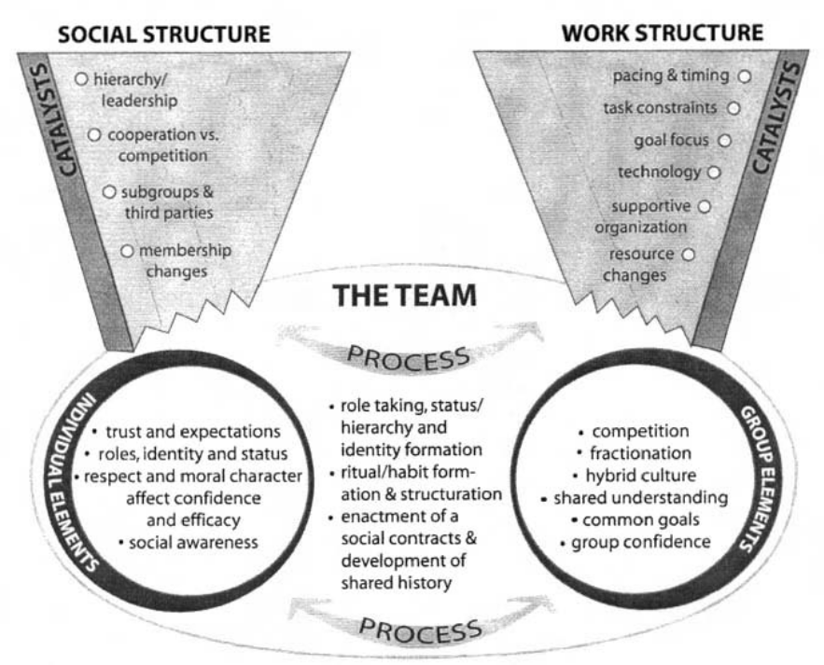
Figure 3.1: Model of Multinational Team Theory [4]

Possible Problems in Multicultural Environment
Multicultural environment often generate frustrating management dilemmas. Cultural differences can create substantial obstacles to effective teamwork—but these may be subtle and difficult to recognize until significant damage has already been done. Usually managers may create more problems than they resolve by intervening. The challenge in managing multicultural teams effectively is to recognize underlying cultural causes of conflict, and to intervene in ways that both get the team back on track and empower its members to deal with future challenges themselves.
According Jeanne Brett the wrong kind of managerial intervention may sideline valuable members who should be participating or, worse, create resistance, resulting in poor team performance. Not talking about respecting differing national standards for doing business, such as accounting practices but referring to day-to-day working problems among team members that can keep multicultural teams from realizing the very gains they were set up to harvest, such as knowledge of different product markets and culturally sensitive customer service.
The cultural challenges are manageable if managers and team members choose the right strategy and avoid imposing single culture-based approaches on multicultural situations.

Direct versus Indirect Communication
Communication in Western cultures is typically direct and explicit. The meaning is on the surface, and a listener doesn’t have to know much about the context or the speaker to interpret it. This is not true in many other cultures, where meaning is embedded in the way the message is presented. For example, Western negotiators get crucial information about the other party’s preferences and priorities by asking direct questions, such as “Do you prefer option A or option B?” In cultures that use indirect communication, negotiators may have to infer preferences and priorities from changes—or the lack of them—in the other party’s settlement proposal. In cross-cultural negotiations, the non-Westerner can understand the direct communications of the Westerner, but the Westerner has difficulty understanding the indirect communications of the non-Westerner.
The differences between direct and indirect communication can cause serious damage to relationships when team projects run into problems. Communication challenges create barriers to effective teamwork by reducing information sharing, creating interpersonal conflict, or both.

Trouble with Accents and Fluency
Although the language of international business is English, misunderstandings or deep frustration may occur because of nonnative speakers’ accents, lack of fluency, or problems with translation or usage. These may also influence perceptions of status or competence. Nonfluent team members may well be the most expert on the team, but their difficulty communicating knowledge makes it hard for the team to recognize and utilize their expertise. If teammates become frustrated or impatient with a lack of fluency, interpersonal conflicts can arise. Nonnative speakers may become less motivated to contribute, or anxious about their performance evaluations and future career prospects.

Differing Attitudes toward Hierarchy and Authority
A challenge inherent in multicultural teamwork is that by design, teams have a rather flat structure. But team members from some cultures, in which people are treated differently according to their status in an organization, are uncomfortable on flat teams. If they defer to higher-status team members, their behavior will be seen as appropriate when most of the team comes from a hierarchical culture; but they may damage their stature and credibility—and even face humiliation—if most of the team comes from an egalitarian culture. When, as a result of differing cultural norms, team members believe they’ve been treated disrespectfully, the whole project can blow up.

Conflicting Norms for Decision Making
Cultures differ enormously when it comes to decision making—particularly, how quickly decisions should be made and how much analysis is required beforehand. Not surprisingly, U.S. managers like to make decisions very quickly and with relatively little analysis by comparison with managers from other countries. Managers from other cultures may, for example, decline to share information until they understand the full scope of a project. But they have learned that they can’t simply ignore the desire of their American counterparts to make decisions quickly. What to do? The best solution seems to be to make minor concessions on process—to learn to adjust to and even respect another approach to decision making. [8]
During my job I have been a witness of problems especially with communication and cooperation with the office in Vietnam. Whole Hanoi office was created with vision of minimizing the costs, but in East Asia there is a problem with qualified work force. The only criterion during hiring employees was basic level of English, what is just not enough for IT related company.
Their attitude to work was completely different, quality very poor and they could not stand critique. It may originate from their indirect communication and whole different life style. They felt ashamed, their morale came down and it is very hard to assign them any work. So there is only one way how to work with them. Even if they did something wrong, I had to praise them for “good work”, but gave them some examples, what could be done “differently”. After that they did improve a little bit, but still it was way worse then average student in Brno.
Another difference I have seen in their problem solving and attitude to any issue. If there was anything they did not know how to proceed, they just stopped doing anything and waiting for advice. The expected reaction would be that they go on doing anything else, but the reality was completely different. They have to be handled differently and that is the only key how to cooperate with them.
There was also some experiment, when two Vietnamese employees came to Brno to learn from us. It was almost impossible to teach them anything not only because of low level of their English, but also because of different view on the problem. For example we were making localization of English manual and I told him to mark words in the text, which should not be translated, like Windows® or Macintosh®. And they did mark all words they understand with explanation that when they do understand them, anyone can, so there is no need to translate them. After a year working in localization, they still had not got the whole purpose. There were many situations like that during their stay in Brno, but I tried my best, to teach them at least something, they can use.

Dealing with Multicultural Problems
There are four known strategies for dealing with multicultural problems: adaptation (acknowledging cultural gaps openly and working around them), structural intervention (changing the shape of the team), managerial intervention (setting norms early or bringing in a higher-level manager), and exit (removing a team member when other options have failed).
Representative  problems | Enabling Situational Conditions | Strategy | Complicating  Factors
Conflict arises from  decision-making differences | Team members can attribute a challenge to culture rather than personality | Adaptation | Team members must be  exceptionally aware
Misunderstanding or  stonewalling arises from  communication differences | Higher-level managers are not available or the team would be embarrassed to involve them | Adaptation | Negotiating a common  understanding takes time
The team is affected by  emotional tensions relating to fluency issues or prejudice | The team can be subdivided to mix cultures or expertise | Structural Intervention | If team members aren’t  carefully distributed, subgroups can strengthen preexisting differences
Team members are inhibited by perceived status  differences among teammates | Tasks can be subdivided | Structural Intervention | Subgroup solutions have to fit back together
Violations of hierarchy have resulted in loss of face | The problem has produced a high level of emotion | Managerial Intervention | The team becomes overly dependent on the manager
An absence of ground rules is causing conflict | The team has reached  a stalemate | Managerial Intervention | Team members may be  sidelined or resistant
An absence of ground rules is causing conflict | A higher-level manager is able and willing to intervene | Managerial Intervention | Team members may be  sidelined or resistant
A team member cannot  adjust to the challenge at hand and has become unable to contribute to the project | The team is permanent rather than temporary | Exit | Talent and training costs are lost
 | Emotions are beyond the point of intervention | Exit | Talent and training costs are lost
 | Too much face has been lost | Exit | Talent and training costs are lost

Table 3.1: Four Strategies [8]
There is no one right way to deal with a particular kind of multicultural problem; identifying the type of challenge is only the first step. The more crucial step is assessing the circumstances—or “enabling situational conditions”—under which the team is working. For example, does the project allow any flexibility for change, or do deadlines make that impossible? Are there additional resources available that might be tapped? Is the team permanent or temporary? Does the team’s manager have the autonomy to make a decision about changing the team in some way? Once the situational conditions have been analyzed, the team’s leader can identify an appropriate response. [8]

Adaptation
Some teams find ways to work with or around the challenges they face, adapting practices or attitudes without making changes to the group’s membership or assignments. Adaptation works when team members are willing to acknowledge and name their cultural differences and to assume responsibility for figuring out how to live with them. It’s often the best possible approach to a problem, because it typically involves less managerial time than other strategies; and because team members participate in solving the problem themselves, they learn from the process. When team members have this mind-set, they can be creative about protecting their own substantive differences while acceding to the processes of others.

Structural Intervention
A structural intervention is a deliberate reorganization or reassignment designed to reduce interpersonal friction or to remove a source of conflict for one or more groups. This approach can be extremely effective when obvious subgroups demarcate the team (for example, headquarters versus national subsidiaries) or if team members are proud, defensive, threatened, or clinging to negative stereotypes of one another.

Managerial Intervention
When a manager behaves like an arbitrator or a judge, making a final decision without team involvement, neither the manager nor the team gains much insight into why the team has stalemated. But it is possible for team members to use managerial intervention effectively to sort out problems.

Exit
Possibly because many of the teams are project based, leaving the team is an infrequent strategy for managing challenges. In short-term situations, unhappy team members often just waited out the project. When teams are permanent, producing products or services, the exit of one or more members is a strategy of last resort, but it is used—either voluntarily or after a formal request from management. Exit is likely when emotions are running high and too much face had been lost on both sides to salvage the situation.

Multicultural Teamwork
Multicultural teams have become very common in recent years. With cross border mobility becoming much easier the number of people moving from one country to another has grown significantly. This has also led to more people from different cultural and ethnic backgrounds intermarrying. Their children could be born and grow up in different countries and have hybrid cultural identities. Globalization and the advances in communication and transportation technology have reduced trade barriers and increased interaction among people.
Is global homogeneity a feasible and desirable vision? Philosophically this would be very questionable. This would be immediately equated with suppression of differences and diversity, which are inalienable human rights. It can be argued that it would destroy cultures and diminish creativity. There are enough instances in human history e.g., the fate of the Native Americans or the Conquistador actions in South America, where one culture has by force exterminated other cultures. Then there are scores of other examples where aspects of cultures have blended through interaction e.g., India and the United States. Thus living with and managing diversity has become the central theme of this century.
Many studies have in fact shown that diversity in human capital actually leads to increased creativity and efficiency in many cases. Studies have also shown that the failure to successfully integrate diverse workforces has negative implications for organizational performance. The skills needed for managing with people from diverse backgrounds at work or outside the workplace can be very different because in the workplace we are in our work roles and there are many external constraints to our behavior. Many people actually spend more time awake with their colleagues than with their spouse and children. So any problems arising in this area will definitely spill over onto the private life. [7]

National Culture
There are ample theories and much research into how national cultures affect team behavior. Ger Hofstede's Culture's Consequences (1980) and Cultures and Organizations (1991) are two examples. National culture has many dimensions like orientation to time, style of communication, personal space, competitiveness and worldview. Generally we are dealing also with stereotypes and cultural biases here. Regional and personal life experience or character traits can override these ascribed 'national' culture traits. In real life this means that an Italian team member can be a shy, quite person or a German can be hopeless with timetables.

Corporate Culture
Corporate culture is very closely related to the functional culture and it is a result of a historical process where the founder and successive leaders have left their marks. A large multinational organization is bound to have a more structured, hierarchic and bureaucratic approach to running its affairs while an Internet web design company with 5 young creative artists would be an entirely different environment.

Nature of the Industry
Coal miners, web designers and international bankers would seem to come from different worlds. Dress, language, etiquette, unwritten codes of behavior, accepted practice and skills needed on the job vary to a great extent in different industries. It is of vital importance that the industry, the organization or the environment allows team members to display a sense of pride in one's professional identity.

Stage of Team Development
If the team is just recently formed with no history or experience, the rules of the game have to be learned by everyone. If the team has a history of performing efficiently, new entrants can rely on established practice and older members to teach them the skills required. The stage of development of the team member also plays a great role here. If the team is in the formation stage, the rules of the game are still being negotiated and people are learning their own roles. The 'veteran' team member has carved a secure role for himself while the new entrant has to struggle.

Personal Attributes
Last but not least are all the other factors like personality, competence profile, the individual's own life experience, expectations of rewards, acknowledgment and satisfaction from working in the team as well as previous history of team working.
The first three factors are static factors, which mean that their characteristics cannot be easily changed by individual action. Team members or even the whole team cannot change the national culture. Individuals, teams and organizations have to learn to adapt to them. In fact the efficiency of the team is directly correlated to how well this adaptation has been achieved. But intervention can greatly affect the last two factors of Stages of Team Development and Personal Attributes. A team can accelerate its progress from formation stage to the stage of maturity and an individual can change personal attributes by acquiring new competences.
Superior sustainable team performance can be achieved only if team members learn to take into account dimensions of organizational culture and those of national culture like orientation to time, style of communication, personal space, competitiveness and worldview. Only when these have been successfully adapted to their working practices to reflect the team members' background realities can teams actually see the added value that multicultural teams bring. [7]
As a project team manager I used to have team consisting usually members of more then four nationalities. Czechs and Slovaks are so similar, that I did not consider them as different cultures, even though there are some chasms in the natures of these nations. More different approach I have spotted in collaboration with Irish, Bulgarian or Argentinean colleges but the biggest surprise was Chinese and Vietnamese employees. That was a huge national culture mixture I have ever worked with.
Mixing of other mentioned cultures was not so obvious in my team, but also some of them can be mentioned. The stage of development acts big role, when I was starting big challenging project with 40 people and 38 of them was completely new in the team. Later from this big horde of people I have formed an experienced team of 10 people who were the core of all teams for next projects.
Working with students from different faculties or even from different universities I gained an experience with multi-nature-of-industry-cultural team. It needs completely different approach to manage IT-people then philosophers, linguist or even medical students. Once I had in my team a girl studying medicine, who asked me all around the questions about possible injuries caused by working with computer. This was also one of other reasons why she did not stay in team for a long. But that was the time, when recruitment was performed by our HR department. Later, seeing the sample of people hired by HR, I started doing job interviews myself and succeed to create very good and strong team.

Global Leadership Competences
The competencies required for effective global leadership, whether domestically in a multicultural environment or abroad, are very similar. Z. Aycan in 1997 summarized key global leadership competencies based on several sources as:
- in-depth business and technical knowledge;
- managerial competency;
- ability to cope with uncertainties and conflicts;
- willingness and ability to embrace and integrate multiple perspectives;
- communication effectiveness;
- competence in developing and maintaining good interpersonal relations;
- willingness and commitment to succeed;
- ability to motivate and develop people with potential;
- ability and willingness to learn from experience;
- competence in playing the role of a change agent.
Global competencies are required for business success, but determining which competences are most important is really difficult. There is often a temptation to begin training of employees without proper analysis of their instructional needs and background. The key factor of good leader in multicultural interactions is to be globally literate. "To be globally literate means seeing, thinking, acting, and mobilizing in culturally mindful ways. It is the sum of the attitudes, beliefs, knowledge, skills, and behaviors needed for success in today's multicultural, global economy" (Rosen & Digh, 2001, p.74). This key factor can be also captured by four main competencies:
  - Personal literacy (understanding and valuing oneself)
  - Social literacy (engaging and challenging other people)
  - Business literacy (focusing and mobilizing one's organization)
  - Cultural literacy (valuing and leveraging cultural differences)
All of these competencies are both interrelated and interdependent. Together they form the foundation for the next literacy. How each of these illiteracies is expressed depends on the culture in which the leader is working, living, and conducting business. [4]
For a leader to be successful is to be aware of important cultural dimensions and understand how these dimensions can influence his working relationship with others from dissimilar cultures. Here follows the most actual review of skill requirements and competencies for successful executives in global environment by Adler from 2002:
- ability to employ cultural sensitivity and diplomacy;
- ability to foster relationships that create respect for all parties;
- ability to communicate clearly;
- ability to solve cultural problems synergistically;
- ability to negotiate across cultures.

Multicultural Communication Tips
A large part of cultural literacy depends upon communicating in a way that effectively gets the message across to all team members, while excluding no one and offending no one due to unintended cultural misunderstandings.
According American Management Association (AMA) there are some language and communication rules for particular benefit to managers of culturally diverse teams:
- Simplify your message by using less complex sentence structures and vocabulary.
- Never shout to be understood.
- Define the meaning of critical technical words and acronyms.
- Avoid non-standard abbreviations, such as “U R” for “you are.”
- Be patient and try to follow team members' ideas and logic, which may be different from yours.
- Ask people to repeat once, maybe twice, if you do not understand them. If that does not work, ask them to say it in a different manner.
- Remain cool and composed, even when you have made a mistake that results in embarrassment for you or when you feel embarrassed by others (in most cases, they did not mean to embarrass you).
- When you feel strong emotions about something said or done by someone who comes from a culturally different background than you do, clarify their meanings and intentions before you express your emotions.
- If you cannot think of any positive interpretation of someone else's actions or words, chances are you are missing something. Clarify with the person or with someone who has experience in dealing with similar cultural groups.
- Adapt your space requirements to those of your counterparts whenever possible. You can judge someone's comfort zone by the distance to which they extend their hand when shaking hands.
- When someone does or says something that seems weird and/or wrong, give him/her the benefit of the doubt. Ask yourself: “How else could I interpret these words or actions?”
- Communicate important messages via several different media to ensure that they are received. Make sure that all the messages are consistent.

Tips for Native English Speakers
- Avoid “isn't it?” questions. Because this way of formulating questions does not exist in many other languages, it can be confusing for non-native English speakers. For example, to the question, “You are coming, aren't you?” they may answer, “Yes” (I am coming) or “No” (I am coming), depending on how they interpret the question.
- Ask the person if he/she wants help with finding words that might convey their meaning.
- If you do not understand a word, ask the person to spell it, write it down, use a synonym or say the word in his/her native language and have someone else translate, if possible.
- Try to involve non-native English speakers, particularly during brainstorming sessions, by asking explicitly for their input.
- If you receive a voice mail message that you do not understand, ask another non-native English speaker from the same linguistic background to listen to it and “translate” for you.
- In continuous meetings, provide some break time so that non-native English speakers can take a rest from the concentration required to follow the conversation.
- Avoid scheduling presentations by non-native English speakers at the end of the day, when fatigue may affect their English speaking skills.
- Consider providing ESL courses to the non-native English speakers on your staff or team.
- Offer to proofread non-native English speakers' documents or presentations.
- Slow down your delivery and clearly articulate each word. Avoid contractions that are difficult for non-native English speakers to understand (i.e., “gonna,” “wanna”).
- In face-to-face meetings, face the people to whom you speak.

Tips for Non-native English Speakers
- If you do not mind people suggesting words so that you can communicate more quickly, say so.
- Try to participate in discussions, especially brainstorming sessions, even if you feel uncomfortable.
- If your organization offers ESL courses, take them, even if your English is already functional. Courses designed to help you modify your accent to make it more understandable by native English speakers can be particularly beneficial.
- Keep a dictionary handy and make sure the words you use mean what you think they mean.
- Ask a native English speaker for help with your documents, presentations and even sensitive e-mails or phone calls, if necessary.
- Before calling someone, think of what you want to say and look up any words that you are unsure of. If you must leave a voice mail message, compose the message on paper, and then read it into the phone.
- Make sure you know and use appropriately the technical words that people in your field use. Find a native English speaker who will take the time to discuss this with you; use sketches, diagrams and pictures to ensure that you understand correctly. Use the terms repeatedly until they become second nature.
- Do not attempt to use slang and idiomatic expressions until you are quite comfortable with the language. Using these incorrectly or in the wrong situation can backfire.
In essay by Robert Rosen "Becoming a Culturally Literate Leader in a Global World" (from the book Partnering, the New Face of Leadership, AMACOM 2003), the author explains why today's managers must implement strategies that foster better cooperation among members of a culturally diverse workforce: “Corporate survival and prosperity increasingly depend on our ability to interact and manage people of different cultures, locally, regionally, nationally and globally. Today, everyone is part of the global marketplace, even though many companies don't yet realize that fact.” He continues, “To thrive, all leaders must adopt a global-centric approach to business. They must develop a multicultural perspective, an international knowledge base and a global imagination—in other words, cultural literacy.” [6]

Managing Teams
Why do teams emerge, or why do we create teams? Human beings have been working together and learning to cooperate since the dawn of time. Cooperation and working together are considered valuable in and of themselves, but also they result in efficiency and satisfaction that may not be possible otherwise. In addition to efficiency there is a bigger consideration that leads to the emergence and creation of teams. This consideration has to do with the sense of individual and collective satisfaction, achievement, and learning that occurs as individuals combine their efforts to achieve team and organizational goals. These variables directly and indirectly strengthen team processes and outcomes.
The successful completion of tasks, projects, and missions in community, organizational, and larger arenas of human’s interactions requires a certain degree of interdependence and relationship building among a group of individuals. In that sense one can argue that when a number of people in some kind of an informal or formal organization regularly interact and depend upon each other to accomplish desired outcomes, they are working as a team. [5]
Bailey and Cohen in 1997 examined a large set of team definitions. Following this comprehensive review, they proposed the following definition of teams:
A team is a collection of individuals who are interdependent in their tasks, who share responsibility for outcomes, who see themselves and are seen by others as an intact social entity, embedded in one or more larger social systems and who manage their relationships across organizational boundaries.

Types of Teams
Several typologies have been offered in last years to categorize teams. The latest is from already mentioned Baily and Cohen from 1997 which includes formal and informal teams, task forces, committees, self-managed team and virtual teams. But in many cases the features attributed to a certain type of team may overlap with another team type.

Formal Teams
They are the building blocks of organizations. The formal team has a high level of boundary spanning in that it may operate across departments within organizations. It has a more rigid organizational structure, as team members tend to have distinct roles and the workload is distributed accordingly. Formal teams may be set up to address particular tasks that the organization seeks to accomplish within a specific time period. Their members have a high degree of interdependence and both the process and performance are integral to the success of the whole team.

Informal Teams
Teams which meet to solve specific problems and their membership may change with the task that the team seeks to accomplish. Informal teams thus have a high level of boundary spanning, similar to that of formal ones. However, members of informal teams have a lower level of interdependence consistent with a less-rigid organizational structure. An informal group might be formed in a micro-credit organization to understand and offer some suggestions about motivational and turnover issues among its employees.

Task Forces
Teams organized for specific project generally managed by the organization that initiated them. The task force has a great deal of interdependence between members and a strong emphasis on performance and timetables.

Committee
It is similar to task force in that it is focused on specific project for a discrete period of time. A committee can be a group of people who are formally delegated to perform a task or formed to take action on a matter without the explicit involvement of the organization its members belong to. It can have different levels of member interdependence and varying degrees of autonomy from the member’s organizations.

Self-managed Teams
They are teams with greatest level of autonomy from the organization and strong emphasis on performance. Self-managed teams combine aspects of formal and informal teams, since they are inaugurated by the organization’s management but take on the responsibility for the management of their own. Most decision-making authority is turned over to a group that works interdependently in order to accomplish an assigned task.

Virtual Teams
They are formed and joined electronically, with negligible face-to-face contact. Although virtual teams are not necessarily as autonomous as self-managed ones, team members have a high degree of autonomy. They are less interdependent due to the nature of virtual communications and the multiplicity of organizations that can be involved.
Virtual teams are characterized by a permeable boundary between organizations, facilitated by networking. They have advantage of spreading the workload among long-distance players. However, the challenges present for non-virtual teams can be enhanced for virtual teams. These challenges are likely to be overcome with increased experience and the use of continually improved technologies. Both self-managed and virtual teams are increasingly common team types for organizations, and ongoing research that examines the complexities of these team types can help us learn how t make them more effective. [5]

Building a Team
There are many ways of building a team and almost all of them, indirectly, draw on certain mechanisms in human nature. The traditional military technique for team-building, for instance, involved putting group of people through all sorts of shared and demanding experiences. Being cold, hungry, exhausted and having to struggle simply to survive establishes a common understanding between the people who are sharing experience which is reinforced if actually getting through the experience demands co-operation and teamwork. Although some approaches to team-building involve similar types of experience, usually based around outdoor activities, others take a somewhat gentler approach. The goal is to ensure that the members of the team get to know one another very well in a rather less drastic manner.
Above all else, building a team involves developing a strong and positive sense of “belonging”. Unless the team member can identify with one another – can see their team as “us” rather than just a collection of individuals – a team can’t possibly work. The reason for this lies deep in human nature. We are social animals and we evolved in close-knit groups of families and tribes. We feel most secure when we are co-operating with others and when we are with people that we feel to be friends and allies. We work best and most inventively, when we feel secure. So the task of building a team involves creating conditions in which people will begin to perceive the team members as “us” – as belonging to the same unit and identifying with it. [10]
From my experience, it is very important to realize, which team is to be build. Building team made of internal employees of the company, which has the presumption to be a long term unit, or building team for one particular project made external resources or the combination of these two. Each of these mentioned teams requires a special strategy to pick the right people able to cooperate each other and most important to be effective.

The Team and its Leader
In a fully operative team, each individual member is contributing to the whole and so to single out the leader as the person responsible for the team’s success would be to distort the picture by ignoring the importance of every other member of the team. Yet, on the other hand, a team without a leader can easily become directionless and diverted from its main goals and purposes.
The team’s achievements result from a combination of different factors. Without capable and committed team members – whether these exist beforehand or whether they develop their capabilities as part of the team – a team has no chance of working effectively. Equally, without a supportive management, a team has very little chance of success. So the team leader is a powerful determinant of the likely success of the team. A leader who is apathetic, ineffectual, openly cynical, or interpersonally hostile isn’t likely to be able to maintain a positive, forward-looking team. But on the other hand, nor is a leader who is dictatorial and dominating. The essence of a positive working team is that each individual can contribute to it, so the team benefits from the total skills and abilities of its members. A team leader who creates a working atmosphere in which that can happen – even if it means actually standing back and handling responsibility to others from time to time – is likely to contribute a great deal to the success of the team. [11]
The team can have two types of leader, whether the formal or informal one. The best is when both types are combined into one single person. That was an idea, I was trying to follow and once I got the team assigned, which made me a formal leader I put all my effort to become also informal leader of my team. I see a basic difference between these two words as the one has to be respect and recognized, because he is a supervisor and the second is followed by the people because of their free will.

A Model for Team Effectiveness
A number of theorists have put forward models conceptualizing what makes teams effective. It is a difficult task to build a model that captures complex behavioral and psychological phenomena, such as teamwork and team effectiveness, in a comprehensive and meaningful manner. In addition to adequately representing behavioral and psychological dynamics at the team level, such models need to include higher-level variables connected to organizational and societal dynamics. However, despite these difficulties it is important to develop such models to inform theory building and practice. Based on observation of Offerman and Spiros from 2001 a new model was created in 2008 by Aqeel Tirmizi attempting to integrate the comprehensive existing knowledge about teamwork and processes through a usable framework facilitating transfer to practice. This model on Figure 4.1 represents the factors that affect team effectiveness. Its components are societal/institutional factors, organizational factors, team factors (structure, membership and processes), team climate, and team effectiveness criteria.
Overall, the model proposes that team structure, membership, and processes determine team effectiveness. The model further asserts that the relationship between team effectiveness and team-level factors is mediated by the level of the trust, cohesion, efficacy, and commitment that are present in a team, labeled as team climate in the model. In addition, team effectiveness and its team-level determinants are impacted by variables in the organizational and societal contexts. [5]
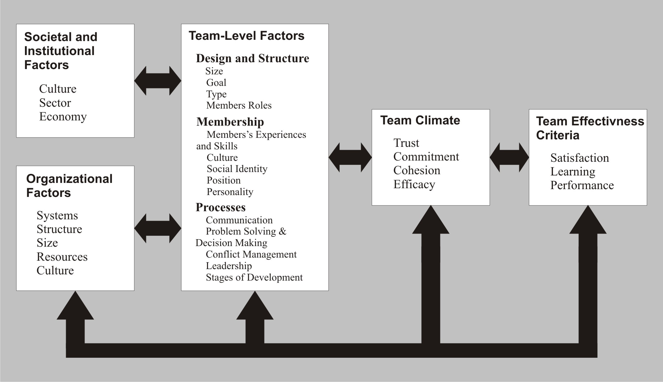
Figure 4.1: Multicultural Team Effectiveness Model [5]

Societal and Institutional Factors
The multicultural teams are embedded in one or more larger social systems. One such system is culture or national culture. Schein in 1985 defined culture as the assumptions, values, and artifacts that are shared by the members of a group (society). In addition to culture, other macro-level variables such as the sector of work (development, education), industry (high technology, manufacturing), etc., may play some role in impacting the nature and effectiveness of teams in a certain context.

Organizational Factors
Team achievement, to a large extent, depends upon the resources and authority required to complete the assignment successfully. A number of organizational arrangements play a key role in this area. These arrangements include systems such as compensation, performance management, and training and development; structural arrangements that help create and maintain teams; and organizational culture that promotes and encourages teamwork.

Team-Level Factors
They can be divided into three subcategories: team design and structure, membership and processes. Here follows the brief description of each of them:
Team design and structure elements include team size, goal, type, and member composition. Team size is an important variable as it plays role in management of team dynamics and if not managed properly could negatively affect the team’s performance. The size is defined by the nature and complexity of the task to be performed. It also depends upon resources available. In some teams the size may not be constant, but depend upon the progress of the task and the availability of the resources.
According to Gardenswartz and Rowe (2003), team goals are the means to articulate and translate the overall mission. Collective understanding and clarity around team goals is crucial for a team’s success. This can be a problem in multicultural teams due to the variety of expectations, individual goals, and backgrounds that members bring to the team.
Team membership variables include team members’ experiences and skills, cultural background, social identity (issues such as class, race, gender, and ethnicity) and individual aspects of personality and intelligence. At the team level the variable of social identity, personality and culture intersects in complex ways. These intersections may be seen as a tri-lens, which ay exist as overlapping personal, social, and collective identities that members bring to a multicultural team.
Team processes include a number of important areas such as communication, problem solving and decision making, conflict management, stashes of development, and leadership. All of these processes play an extremely important role in the working and effectiveness of multicultural teams.

Team Climate
The areas of trust, commitment, cohesion, and efficacy have received some much-deserved attention in the literature. They are considered as mediating variables linking the team-level factors and the effectiveness criteria. The model indicates that the team and higher-level factors determine the team climate. The resulting climate not only plays a role in team effectiveness, but could also impact team processes and higher-level variables.

Team Effectiveness Criteria
Over the years, the theory of multicultural teams has recognized the importance of multiple effectiveness criteria when considering team success. In addition to productivity and performance, team members’ satisfaction and learning are now considered integral to understanding the team’s effectiveness. The model explicitly recognizes that in addition to performance and productivity, individual and collective sense of satisfaction and learning is integral to judging a team’s success. They can also contribute to strengthening teamwork.
Consideration of mentioned aspects can help team leader and manager to form an effective team. But the model is not enough to achieve that. There are some rules, but they can never be applied to anyone and there is no manual to become a good leader and not anyone can become one. It is all about attitude, experience and ability to understand other people supplemented by some experience and theory can also help. Sometimes a man can have all of that but he finds himself in such stern environment, that he has to start over and adapt to specific people to be able to cooperate with them. The other choice, more drastic one is to get rid of such a people, but it depends on situation as it was already mentioned before.

Internal vs. External Employees
Employment is a contract between two parties, one being the employer and the other being the employee. An employee may be defined as: "A person in the service of another under any contract of hire, express or implied, oral or written, where the employer has the power or right to control and direct the employee in the material details of how the work is to be performed." (Black's Law Dictionary, page 471, 1979)
Most individuals attain the status of regular employee after a job interview with a company. If the individual is determined to be a satisfactory fit for the position, he or she is given an official offer of employment within that company for a defined starting salary and position. This individual then has all the rights and privileges of an internal employee, which may include medical benefits and vacation days. The relationship between a corporation and its employees is usually handled through the human resources department, which handles the incorporation of new hires, and the disbursement of any benefits which the employee may be entitled, or any grievances that employee may have. [16]
It is the nature of any small or medium business that it has to fluctuate in size to meet the demands of seasonally larger projects. Freelancers or external resources are a great way to ramp up productivity without committing to long term internal employees. Hiring an internal employee could be very expensive with all additional benefits. On the other hand a freelancer gets a simple contract for given short time and some hour rate with no extra costs.
Few industries rely on the contribution of freelancers as much as the unwieldy universe known as marketing communications, graphic arts, and also localization business. Agencies use freelancers, small shops use freelancers, even freelancers use freelancers. It's a virtual world…
So why hire a freelancer or any other external resource in a first place? Hiring freelancer means that company gets the finished product it needs without incurring the costs of hiring a new employee or dealing with agency fees. It means no need to pay the cost of hiring and training an employee, provide health and social insurance, medical benefits, vacation or provide valuable office space. It also means to be treated like a client instead of having to act like a boss. It is a possibility to reinvigorate the company with fresh ideas on a project-by-project basis and find the right expertise for every job. It's the easiest (and often the cheapest) way to bring a talented, experienced team player into the company.
The tricky situation comes, when the biggest motivation of using freelancers is save some money. There are many skillful and experienced individuals who could be perfect for the job, but they would possibly cost even more then regular employee. That’s why sometimes it is profitable to spend some money on training inexperienced individuals and after that get qualified labor force for minimal expenses. It depends on the type of work which needs to be done, but it is a possible way.

Hiring a Freelancer
Before hiring a freelancer or make him our “new best friend”, according Eric J. Adams there are six questions to ask a potential freelancer and demand the answers [15].
1. Who will be doing the work?
This question is in the place when hiring freelancer using other freelancers. It might seem obvious, but the answer isn't always straightforward. Is the freelancer simply brokering a deal without our knowledge or subcontracting some of the work to less experienced freelancers? It is good to make sure to get the top-of-the-line professional to pay for, and so to speak directly to the person who will actually sit down to do the work. The best choice, if possible, is to hire directly that person without middleman.
2. What's your availability?
When he can start and how many hours per week he can spent at work? How long will it take him to respond to the potential feedback and when can be expected the finished work? These are all variations of the same question, and it's important to know up front if, for example, a freelancer having five jobs lined up before he can get to work or he's working another job and can only respond to urgent emails only after hours. Or most common the freelancer is a student with some school schedule he needs to follow and also some exam period when he requires more time for learning.
3. What are your payment terms?
No matter how good the relationship is, it helps everybody to spell out the terms of the contract explicitly. Are you buying all rights? How many revisions are included? How will you deal with project changes midstream? What if a deadline is missed? There are also the questions for multiple contracts. Easiest way is to offer single contract to each freelancer for specific work with given payout date and all conditions.
4. Do you have the technical and collaborative skills necessary?
If hiring a freelancer, we usually want someone who can get up to speed quickly. The point of outsourcing is to save the organization time and money, not to invest weeks walking someone through the basics. That is why the students of some IT programs were very suitable for positions in our company. They did not have to been explained how to use computer and they also understand easily how to use some specialized software. We had some efforts to use students of other faculties, especially faculty of arts for linguistic checks, but the results were worse then expected. But I still think they were worth a try.
5. Can I talk to former clients?
A reputable freelancer will be happy to provide you with a list of names and numbers to call. They are mostly really expensive and using them is suitable only if we truly need them. Then call them and find out the good and not-so-good. Sometimes hiring one expensive and many cheap can also be a solution how to save the money. The one most experienced can relegate his knowledge to whole team and we then obtain efficient team for minimal expenses, what would always please the higher management.
6. Can you show me samples of relevant work?
The operative work here is "relevant." Someone who comes by way of recommendation might have been great for the job completed but not for the work, which needs to be done. The next thing is to explore the freelancer's capabilities and its relevance to company. This is the option used in time critical projects, when the results are needed as soon as possible. In most cases with preparatory planning to save some money is better to hire inexperienced freelancers for less salary and train them on specific project before its very launch. This alternative not only save money, but minimize the risk of pretentious individuals, who think they know everything and do anything without asking the manager. It can leads to problems and possible crash of entire projects. On the other hand people mannered by the company would most probably follow the rules and procedures.
These questions are not the only part of the job interview, they can only help us to make a picture about the person sitting in front of us. It depends on the work we are planning to hire him for, but mostly there is some test to examine his qualification on specific position. Working in multicultural environment, the English is also important to have and it can be proved by some grammatical test or just face to face conversation. It depends if written or spoken form of English is required.

Managing Freelancers
It's pretty much a no-brainer to say that the management techniques you may use with full-time staff will not be as effective with creative freelancers. This is not to imply that freelancers are any less professional, hard working, or receptive to management than their salaried equivalents. Simply their work styles differ vastly and therefore require different management styles to handle them. Some freelancers can be difficult to manage, but there are some techniques which I recognized very useful during my job and they can help to handle it:
Know their schedule
One of the main reasons freelancers freelance is they like the freedom of not having a rigid schedule. In our case, they have some school commitments, so they can perform full-time job. Also, some freelancers are nocturnal, preferring to churn out work while the rest of us are sleeping. Freelancers will often have schedules that don’t line up with the traditional nine-to-five workday the rest of us are used to. It is important to find out their availability up front so we can plan around their schedule. And let them know they will have to be flexible as well, and may have to forego sleeping in one day to make that afternoon meeting. [14]
Verify their reliability
Good freelancers are difficult to find. Reliability is one of the most important qualities a freelancer can have. The last thing wanted for a project is to fizzle because the freelancer has gone. The project should be high on the freelancer’s priority list, and it is necessary to do anything possible to incentive them, otherwise, the project could get dropped because a freelancer made a last minute decision to spend the week in Alps—which once really happened, but fortunately the deadline was not so critical.
Require them to track their time
A manager is on the hook to the client, not the freelancer. This involves for not only managing freelancers, but paying them as well. Regardless of how the pay cycles work, accurate and timely payments are important to keep both the client and the freelancer happy. It is easy to get stuck in a situation where the freelancer is demanding payment while the client has yet to cut a check, so it is best to prevent such a situation. Since most freelancers work on an hourly basis, they are required to track their time, and they are paid based on this data. This system takes care of getting the freelancer paid, and also includes the data to justify expenses to the client. The more data we have, the less questions and problems are with the billing. The best solution is to use special system for tracking hours spent on specific project with particular tasks. Mentioned system could also take care about schedule by summarization of availability of each freelancer to help with planning single projects.
Provide them with all information needed
Once they start working on the project, they need to be trained and informed about the whole process. During the project they have to have access to all instructions and reference materials and also follow the instruction of their leader. The best practice is to use experienced freelancers for longer terms on more similar projects. They require a less training; they are faster and more reliable. The perfect way would be to have specialized team of freelancers for each specific type of project. Unfortunately the project pipeline is usually not continuously exhausted and therefore it is not enough work for all team members, which causes, that some very efficient individuals finds something else or switch to full-time position. Then a new people need to be hired and it starts all over again with training, learning the processes…
Focus on product not process
Feel free to give explicit parameters on the end product you desire, but give freelancers flexibility of how they work within those parameters. There are some given processes but the work will be more interesting for them, if they would feel more independent. The best result could be achieved by just letting freelancers use their creativity and expertise with some fundamental information and advices to get their work done.
Offer them possibility to mature and to gain new experience
It is useful to have highly specialized team of freelancers, but there is a risk of loosing them because of monotonous everyday work. The key to retain good freelancer is to enlarge his scope and give him a chance to learn new things. As long he considers his work as replenished, he would work more hard and reliably. And the benefit for the company is the potential future employee with all required training.
Be a corporate guide
Every office has its own corporate mindset, and freelancers usually come in as outsiders. Explaining what's important to the company and why can help the freelancer do a better job. If they're working onsite, give them a little "new-employee" tour. They would feel more like part of a team and also part of the company. If working offsite, provide the essential information they'll need to get work done properly and paid swiftly.
Evaluate them by regular feedbacks
Working as freelancers their commitment to the company would be still lesser than the internal employees. So they have to know, that the company has an overview of their activities, skills, experience and attitude to work. They need to be admired for good work, but also reprove for causing problems or not meeting the requirements. As a conclusion of such feedbacks could be some motivational salary increases or just single-shot bonus if desired. A little bit of competitivity among freelancers could be very helpful, but it can not outgrow to envy and jealousy. It is important to be very cautious with awarding the bonuses to freelancers not to overreach the limit granted for internal employees. They should always be a priority when considering the satisfaction of team members.
Be careful about the employee-friend line
Working everyday with the team of freelancers leads to becoming a very good friends or sworn enemies. The second one usually leads to sacking of particular individual or possible crash of entire project. It is good, when all team members are also good friends, but it can be a difficult situation for their leader or manager. Everyone makes mistakes and if something like that happens, he or she has to take consequences whether he is a friend or not. It is all about the proper attitude and characters of the people. Someone can undertake criticism worse than another, but the friends should not be prioritized above others. That could also leads to envy among team members.
These are only couple of techniques and principles how to make work with freelancers easier. They can not be applied on all people on all projects, but with combination of tips and policies from previous chapters an operating and effective team can be acquired. It has worked for me on many various projects on which I had more than satisfactory results with my team. There are no strict guidelines for this subject or guaranteed guide how to handle any situation and each leader and manager has to choose his own way with hope, that it will be the good one.

JOSER
Most of big or small companies are part of “the modern business” which involves using computers and internet. With using of computers comes a need for information system, which would make the run of the company easier and smoother. An Information System (IS) is any combination of information technology and people's activities using that technology to support operations, management, and decision-making. [20] In a very broad sense, the term information system is frequently used to refer to the interaction between people, algorithmic processes, data and technology. In this sense, the term is used to refer not only to the information and communication technology (ICT) an organization uses, but also to the way in which people interact with this technology in support of business processes. Alter argues for an information system as a special type of work system. A work system is a system in which humans and/or machines perform work using resources (including ICT) to produce specific products and/or services for customers. An information system is a work system whose activities are devoted to processing (capturing, transmitting, storing, retrieving, manipulating and displaying) information. [21]
As such, information systems inter-relate with data systems on the one hand and activity systems on the other. An information system is a form of communication system in which data represent and are processed as a form of social memory. An information system can also be considered a semi-formal language which supports human decision making and action. This chapter is not about an information system in general. The companies mostly have their own IS, which they are using and they have got used to it. There are various types of systems for handling accounting, employees, projects, etc, but there is one thing, which is not so common for many companies, so in most systems it is not supported. The missing feature is the one, which would allow managing external resources or freelancers. They need different method from the one using by internals. In the company I worked for, we were using special system called JOTS (Jonckers Online Time Sheet) for tracking time spent on the projects. This system was operational, but not even close to the level we would need. There were many features missing and the only useful functionality was tracking time spent of various project and creating a simple report. It could be enough for 10 or 15 people, but we had 80 people in our database and planning a project with them was a nightmare. That inspires me to an idea about already mentioned online system especially designed for externals with working name JOSER (Jonckers Online System for External Resources). It is only theoretical system, which has not been implemented yet due lack of the resources. The following pages describe required functionality of such a system enriched by screenshots prepared to illustrate some features. Even though system is now only a proposal, it would be very helpful for companies using external resources to implement something similar in the future.
The first important requirement for this system is to be accessible through internet to all users. Sometimes on Friday is everyone in a hurry to get home and very often forgets to fill in the time sheet. It would be very stiff to come back to work during weekend so it is better to do it via internet from home. In case of external resources is this accessibility even more vital to be able to track time or fill their availability even if they are not present at work. All they need to do is type the address to internet browser and log in to the system (illustrated on Figure 6.1).
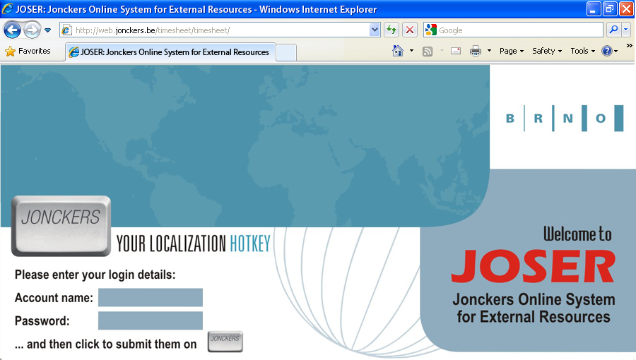
Figure 6.1: Login Page

Every user should have assigned unique account name and the password which has to be changed after first login to the system. Each account represents one of the three roles in the system which different rights for specific tasks:
PM (Project Manager)
PM is a specific role inside the system with all rights but using necessarily only few features. So there are two modes available. In basic mode user can only generate reports according entered parameters and create new projects in the system. After switching to full mode there are all features available but they are mostly used only by Project Team Manager.
PTM (Project Team Manager)
It is a role with similar rights as PM, but the user can not create project, so he can not be considered as the owner of project itself. PM just assign him to specific project an after that he gets all the rights to tasks related. His main responsibility is to allocate needed resources, summon them to work and then verify their time sheets.
FL (Freelancer)
User with the limited rights and the only responsibility to fill his availability and track the time spent on given projects. He also can generate an informative report of his worked hours and the money which should be paid to him according his hour rate.

Functionality of the System
Implementation of system like JOSER could be quite expensive concernment and the fact that it is only for external resources would not help to persuade management to approve its realization. Consequently to minimize the cost I shaped a system using combination of Google Calendar and Google Docs. Basically with proper use of these two features or something similar, we can get a system for minimal expenses. Following section describes possible functionality of proposed information system.

Freelancer
After successful login into the system there are three options available for this role. The first thing to get some work after passing the recruitment tests the user has to fill in his availability on Availability page (illustrated on Figure 6.2). It can be displayed for whole month, or specific week or even a day to fill exact time when the user is available. At first, all days are colored to gray as blank. Then the user can use green, yellow or red to mark the days which he is available whole day, only in specific time (time specification is required), or not available at all. Availability for entire week has to be filled a week advance and it should be obligatory. According colored days the user can be assigned to some project by Project Team Manager. Once the user is assigned, the color of specific days is changed to one assigned with specific project and e-mail notification is sent to his e-mail address.
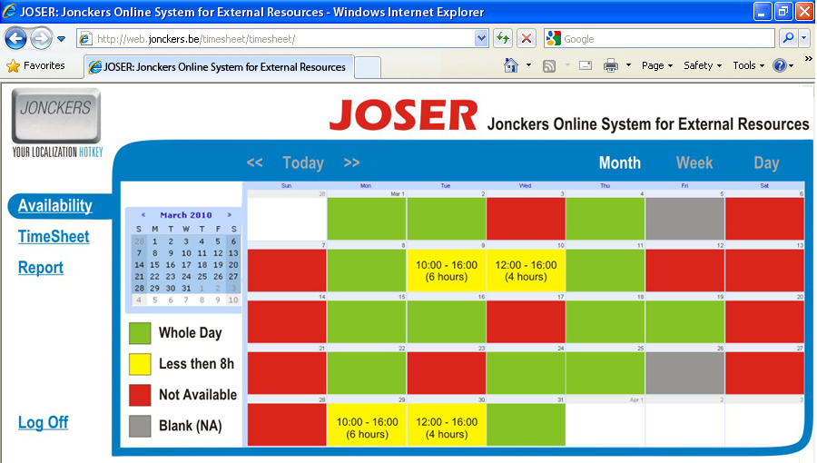
Figure 6.2: Availability Page (Freelancer)

After the freelancer spent some time at work he has to track it in the system under TimeSheet option. Again the user can choose to display entire week or specific day. The most useful in this case is week view with all days, tasks and hours spend on them (illustrated on Figure 6.3). The user can choose the project using drop-down menu with the list of all projects he is assigned to. Then using another drop-down menu select particular task and enter how many minutes he spent on that activity. After that, the time sheet should be saved by clicking on the Save option. Once it is saved, all values are refreshed and total hours per week are displayed on the bottom of the screen. At the end of the week after filling all time spent on all projects the timesheet needs to be submitted. After submitting it waits for Project Team Manager for accepting or rejecting. Once the time sheet is submitted it can not be changed. The only way is to ask Project Team Manager or Project Manager to reject it.
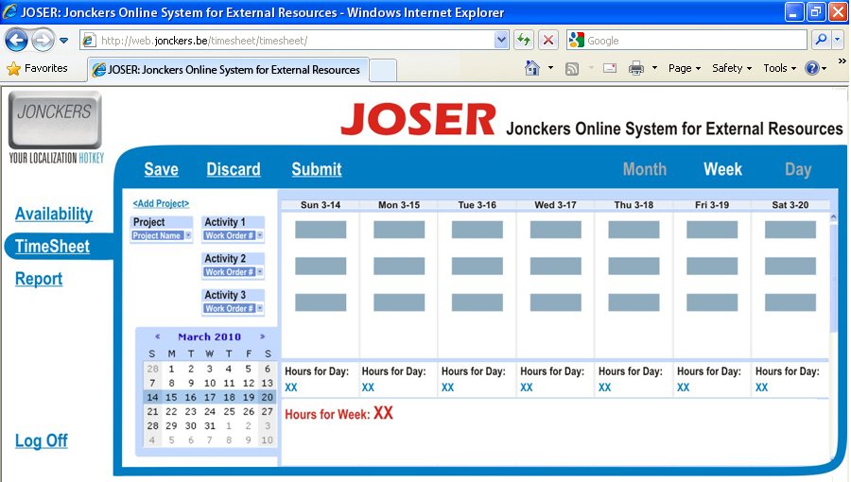
Figure 6.3: TimeSheet Page (Freelancer)

The last option in Freelancer’s mode is Report page. Here a simple informative report can be generated for given period and published as PDF file or XLS spreadsheet with required values. In this mode user can choose time period, specify the project or activity and enter his hour rate to get theoretical financial valuation of his work (illustrated on Figure 6.4).
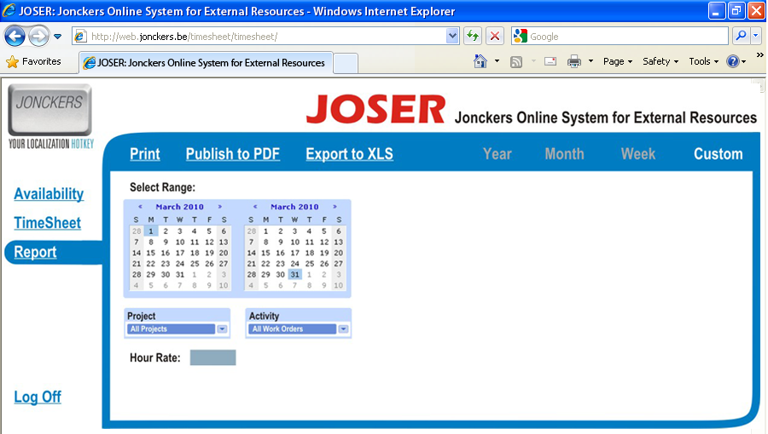
Figure 6.4: Report Page (Freelancer)

Project Team Manager
There are some additional features available for this role. User needs some special functionality to be able to manage people and also to have a summary of all freelancers. The good system should provide list of available externals, inspectional list of worked hours with ability to reject suspicious entries. Project Team Manager also needs to create and modify user accounts for freelancers and work with projects and work orders (specific activities on project).
The first option here is also Availability page, but with a little bit different features (illustrated on Figure 6.5). There is a list of all active freelancers with their availability for specific day, week or month. Even if they are available, they can be already assigned to some another project, so they can not be used. That’s why it is useful to use filter tool to show only free people with green cells. They can be then assigned to desired project by changing their color of cells according project color (except the basic ones). If there is anyone without filled availability, they are mostly considered to be unavailable. Sometimes in urgent cases a special request can be sent via system to e-mail address of selected people with unknown availability to fill it as soon as possible.
The main feature of this option is assigning specific freelancers to actual project with calculation of hours, they can spend at work according their availability. Once they are assigned to project, system sends them notification when they should come to office and who they are about to work for. In case of more assigned hours as needed, some freelancers can be dismissed from the project. Dismissing from the project is also followed by notification to freelancer.
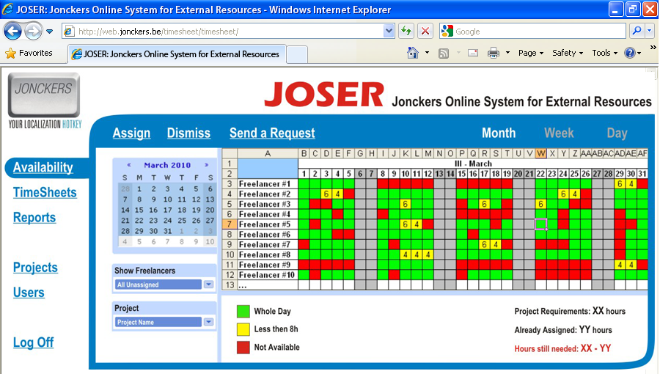
Figure 6.5: Availability Page (Project Team Manager)

The second option TimeSheets is similar to basic one but it shows more time sheets of the specific freelancers (illustrated on Figure 6.6). This feature is important for approval or rejection of the hours reported by external resources. The good practice is to require freelancers to track all time for last week till Friday midnight so all time sheets can be revised on Monday morning. In basic view there is only list of filtered freelancers and hours reported for each day. The list can be filtered by users with submitted or uncommitted time sheets or by specific projects. Using the check tool in front of the name the freelancer can be selected and clicking on Detail option the entire time sheet of selected user can be displayed with all tracked activities.
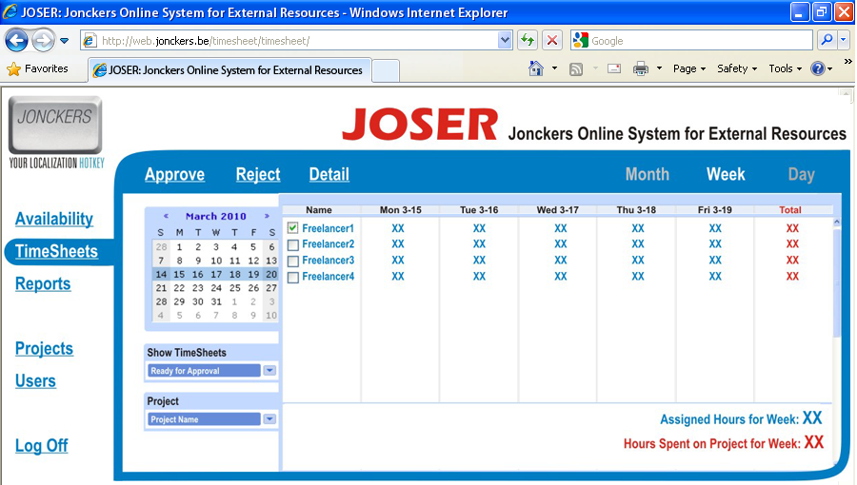
Figure 6.6: TimeSheets Page (Project Team Manager)
It is also important to check if the hours reported did not overrun the plan and also if entered values correspond with availability of the freelancers. Someone with availability of 20 hours could hardly work 40 hours on the project. Such a timesheets are suspicious and need to be reviewed. Each Project Team Manager can approve or reject only hours spent on his projects in case, that freelancers worked on more projects in one week.
The third option for this role is almost same as for freelancers with the same name Reports (illustrated on Figure 6.7). The only difference is ability create report of more users according given criteria. The report can be generated for particular user, project or activity in given time period or just a report of tracked hours in current month. It can also be saved as PDF file or XLS spreadsheet. This export can be used by accounting department to calculate payouts for freelancers.
There are two more options available for PTM to handle projects and users in the system. The first one is dedicated to managing projects and work orders so it is expanded to three other options. Project Team Manager is unable to create new projects, but he should be able to edit and modify existing projects. When choosing Edit Project, he can choose desired one from the list of projects he is assigned to by Project Manager.
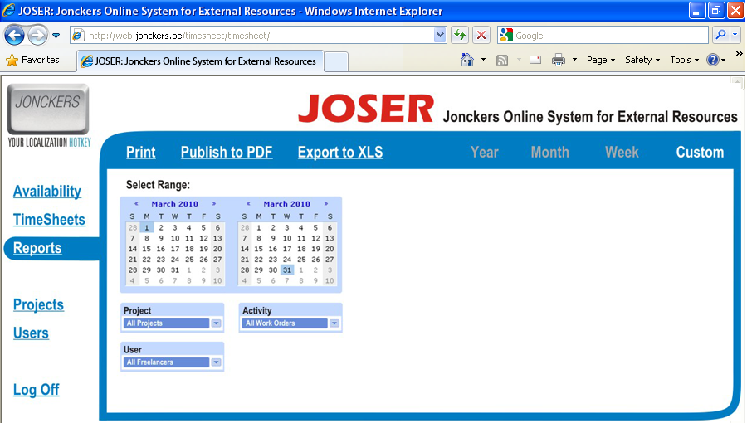
Figure 6.7: Reports Page (Project Team Manager)

The main responsibility of PTM is to create work orders for assigned projects for tracking time to specific activities (illustrated on Figure 6.8). The work order is created for certain project, which can be selected using drop-down menu. Once the project is selected, the system provides basic information about project manager, project team manager and agreed deadline. The work order details have to be filled in next step. The last option is the check tool to mark word order as active or already finished. The user can also modify existing work orders after clicking on option Edit WO and choosing actual one from presented list.
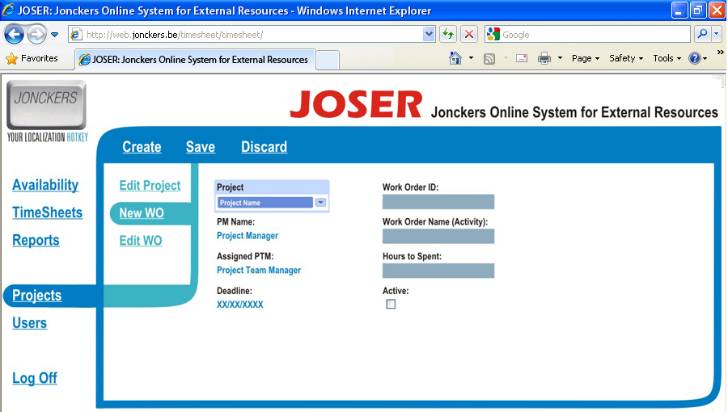
Figure 6.8: Projects -> New WO Page (Project Team Manager)

The last option is intended for managing users with three expansion features. Once the new freelancer is hired to the company, he or she has to be added to the system using option New User (illustrated on Figure 6.9). The first step to create a user is assigning him a role using list in drop-down menu. The next is to grant him a unique account name with temporary password, which should be changed after first login to the system. Very important are also contact details and arrangement to specific department. For Project Team Manager can be also very useful to have a photograph of each freelancer to recognize them easily when they come to work. The rest of the fields are to be filled later with some feedback on user’s work, his experience and skills. The system also automatically stores information about projects and activities the user had been assigned to. This additional information can be very helpful during choosing the team for specific project. The second option under this category enables modify existing users and adding useful information to their profile. The last feature can generate list of users according preferred criteria with desired information.
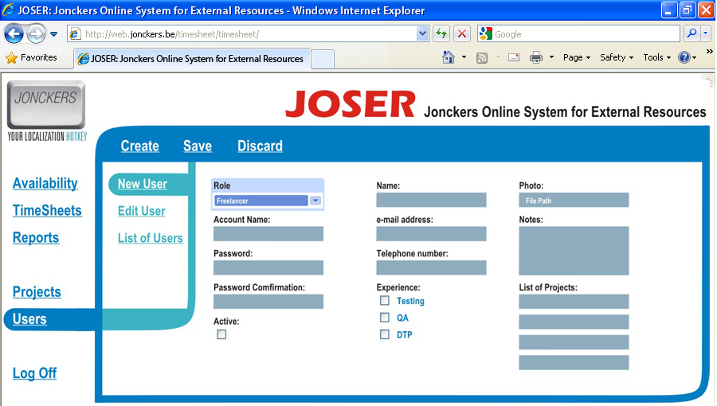
Figure 6.9: Users -> New User Page (Project Team Manager)

Project Manager
Project Manager is the strongest role with unlimited rights inside the system. As mentioned before, he has all options available, but usually he needs only two of them. That is why there are two modes available for this role. In Full Mode he has same options as Project Team Manager extended by ability to create new projects. This special option is consequently present in both modes under the Project section. Creating a new project involves assigning project manager (mostly himself) and project team manager to the new project with unique ID and name (illustrated on Figure 6.10). The project is mostly done for specific customer or in case of internal project, the customer is company itself. The important information is also the cost center from which all expenses will be paid. The last field on this page is deadline which represents the date of delivery project to the customer. The project also can be active, if it is running or inactive, if it is already finished or canceled.
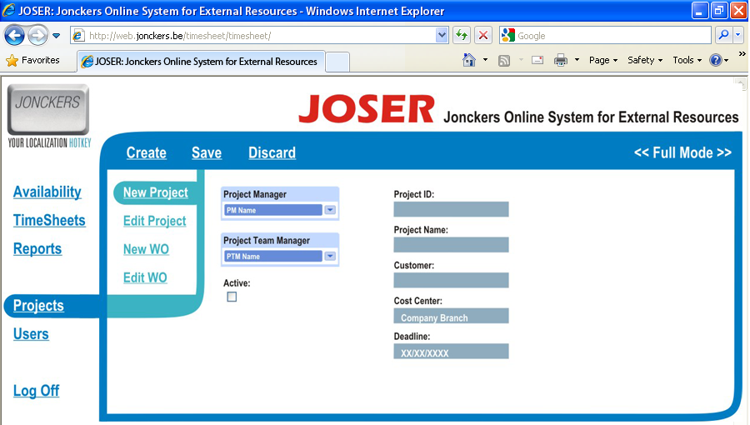
Figure 6.10: Projects -> New Project Page (Project Manager – Full Mode)
In the basic mode, when the Full Mode option is inactive, there are only two main options available. Reports page is virtually same as the one for Project Team Manager for generating reports. Under the Projects section there are only two options present with same functionality as in Full Mode. The second one provides the list of projects with additional information filtered by desired parameters with ability to modify, delete or close selected project (illustrated on Figure 6.11).
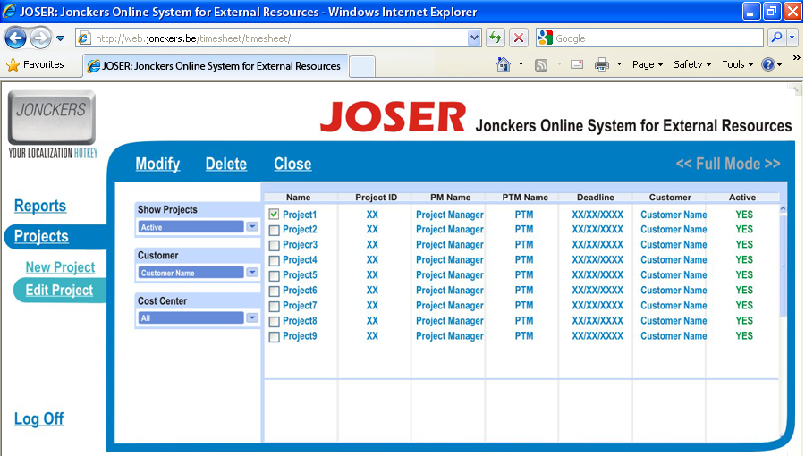
Figure 6.11: Projects -> Edit Project Page (Project Manager – Basic Mode)
These are just the basic features, which should be present in the system for external resources. Using such a system in multicultural environment may require localization to several languages. Even though English is used as communication languages in many companies, possibility to have system more intelligible for all users would be positive. The language bar with all supported languages could be placed on top right corner of the each page, which would help not only non English speakers to take their bearings easier, but also to give a chance for people speaking various languages to learn some useful words in language of their coworkers.
The best way to summarize functionality of the proposed system is use-case diagram with all roles and activities present inside the system (illustrated on Figure 6.12).
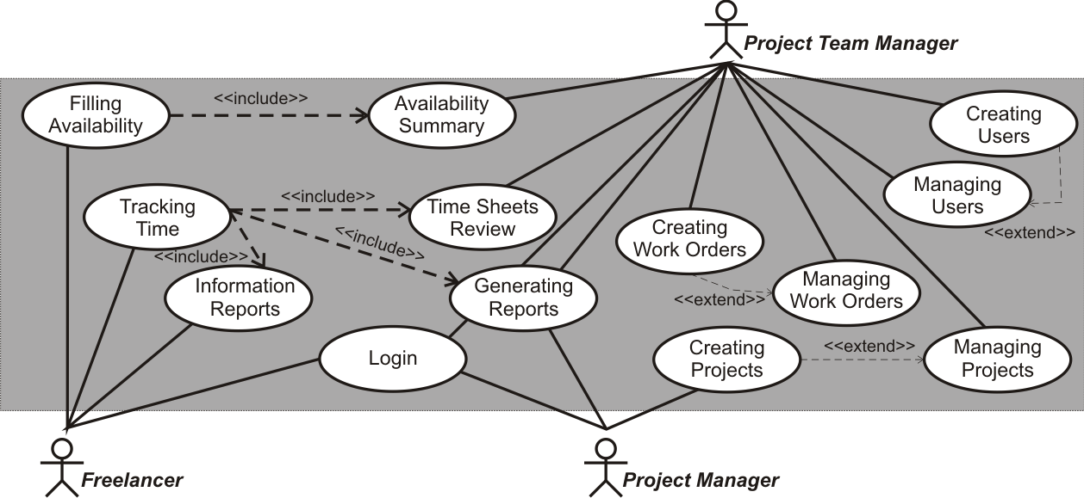
Figure 6.12: JOSER: Use-Case Diagram

Conceptual Model
The system design is not only about its proposed functionality and layout, but also about function relationships between its components and data structures. A conceptual model of the system was designed to identify objects and also to define correlative relations. It consists of domain description, entity relationship diagram and the formal definition of entities and relationships. The model can be used before system implementation for full data model creation, so it has to cover all useful features of information system.

Domain Description
Considered information system covers only small part of the big domain related to localization company Jonckers TE. JOSER is intended exclusively for external resources also called as freelancers and the pertinent activities. There are three types of user roles with different rights and responsibilities in the system. Each login to the system is reported to user log with user name and time of the login.
The main term of this domain is project, which is handled for specific client. The client can be company itself for internal projects or more frequent another company with commercial projects. Each project is performed under specific company branch, which is responsible for allocating financial resources so it tends also as cost center for given project with responsibility for payouts.
Once the project is ordered by client a project managers takes all responsibility for its running. It also involves creating project in the JOSER, but only if some freelancers are needed for it. Created project is characterized by its unique ID and project name. It is associated with customer and cost center and also there is project team manager assigned to the project. His main responsibility at the first stages is to create work orders which represent specific activities performed on the project. They are used by freelancers to track the time spent on various tasks.
After hiring a freelancer, new user account is created in the system by project team manager. Then freelancer is assigned with user name and password and has to fill in his availability for every day of current month for planning purposes. Availability is recorded to calendar for each day. According reported availability the freelancer can be assigned to specific projects. All time spent on various activities of each project has to be tracked in time sheets under relevant work order. From the data reported in time sheets the reports for specific time period can be generated by the system. This feature is mostly used at the end of the month for payouts purposes and also after finishing the project for invoicing the client. This functionality is not covered by the system for external resources and should be handled by company information system.
These are the main features of the information system which are the most vital and the reason why it should be implemented in the first place. There are still many extensions which can improve the system, but the most important is to start with proposed ones and then adding other modules.

Entity Relationship Diagram
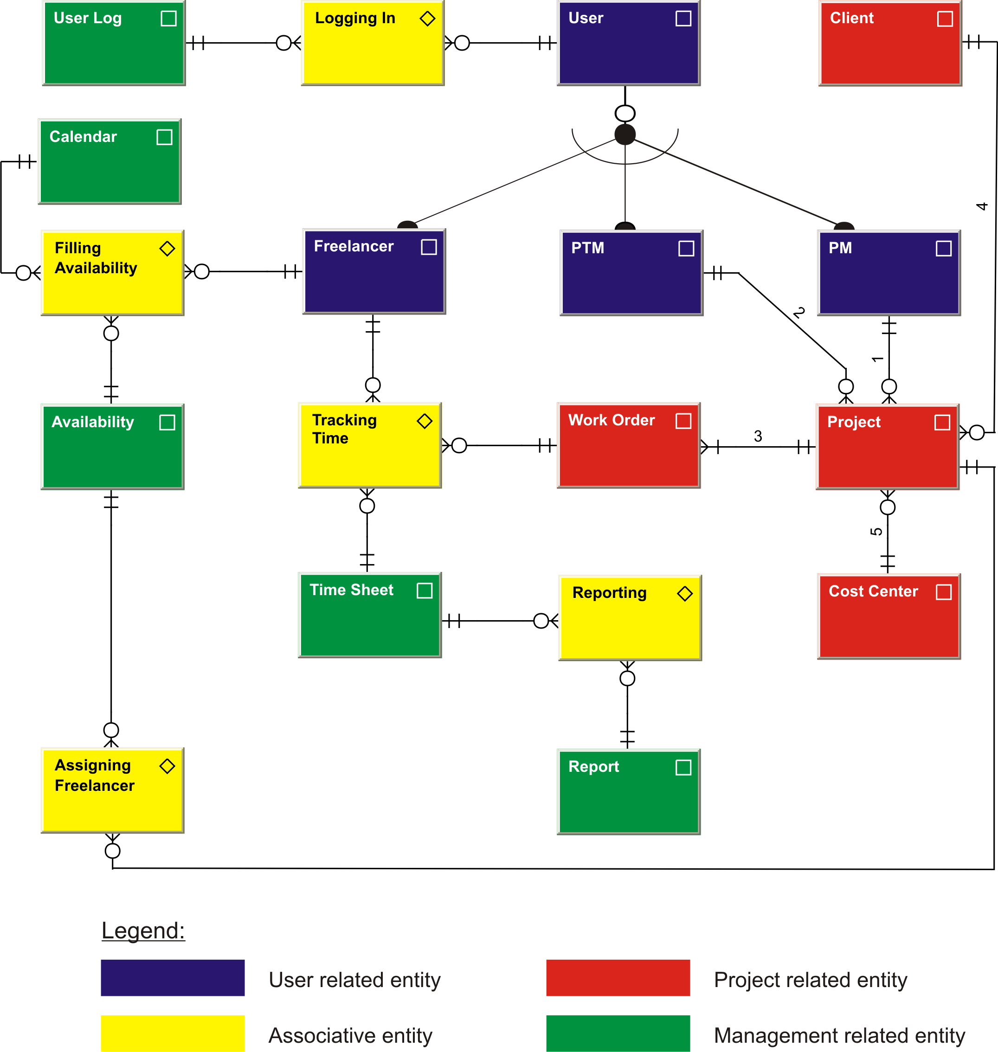

Figure 6.13: JOSER: Entity Relationship Diagram

Entities
Name: User
Type: Kernel
Description: An object of the type (#User) is every person using the system with assigned user account, unique ID and password which allows him to authenticate to system services
Name: Freelancer
Type: Kernel
Description: An object of the type (#Freelancer) is every user authorized with basic rights, who is an external employee of the company with special contract participating on assigned projects
Name: PTM (Project Team Manager)
Type: Kernel
Description: An object of the type (#PTM) is every user with specific rights for managing users on assigned projects
Name: PM (Project Manager)
Type: Kernel
Description: An object of the type (#PM) is every user with full rights inside the system who must be an internal employee of the company in charge of planning, organizing, and managing resources to bring about the successful completion of specific project goals and objectives
Name: Client
Type: Kernel
Description: An object of the type (#Client) is every personal or corporate entity ordering any project performed by the company
Name: Cost Center
Type: Kernel
Description: An object of the type (#Cost Center) is every branch of the company which is in charge of any project provided by the company
Name: Project
Type: Kernel
Description: An object of the type (#Project) is every unique temporary endeavor, having a defined beginning and end, undertaken to meet specific goals and objectives, usually to bring about beneficial change or added value to client
Name: Work Order
Type: Kernel
Description: An object of the type (#Work Order) is every activity performed on specific project with unique identification and name
Name: User Log
Type: Kernel
Description: An object of the type (#User Log) is every list generated by the systems with specific information about users and times when their logged into the system
Name: Calendar
Type: Kernel
Description: An object of the type (#Calendar) is every system of organizing days for commercial or administrative purposes by giving names to periods of time, typically days, weeks, months, and years
Name: Availability
Type: Kernel
Description: An object of the type (#Availability) is every notation inside the system reported by freelancer about his possibilities to participate on some work for the company
Name: Time Sheet
Type: Kernel
Description: An object of the type (#Time Sheet) is every record inside the system with amount of freelancer’s time spent on each job or activity
Name: Report
Type: Kernel
Description: An object of the type (#Report) is every informative document generated by the system from the data stored by all users during some time period
Name: Logging In
Type: Associative
Description: An object of the type (#Logging In) is every representation of the relationship between (#User) and (#User Log) with meaning:
A notation (#User Log) generated from information about logging user (#User) in some time (Time). / 0,1:0,M
Name: Filling Availability
Type: Associative
Description: An object of the type (#Filling Availability) is every representation of the relationship among (#Freelancer), (#Calendar) and (#Availability) with meaning:
A record (#Availability) reported by given freelancer (#Freelancer) in the given calendar (#Calendar). / 0,1:0,M
Name: Tracking Time
Type: Associative
Description: An object of the type (#Tracking Time) is every representation of the relationship among (#Freelancer), (#Work Order) and (#Time Sheet) with meaning:
A record (#Time Sheet) submitted by given freelancer (#Freelancer) with amount of minutes (Minutes) spent on given activity (#Work Order). / 0,1:0,1
Name: Reporting
Type: Associative
Description: An object of the type (#Reporting) is every representation of the relationship between (#Time Sheet) and (#Report) with meaning:
A report (#Report) generated according tracked hours (#Time Sheet) during given time period (Time). / 0,1:0,M
Name: Assigning Freelancer
Type: Associative
Description: An object of the type (#Assigning Freelancer) is every representation of the relationship between (#Freelancer) and (#Project) with meaning:
A freelancers (#Freelancer)-s assigned to given project (#Project) for given time period (Time). / 0,M:0,1
A project (#Project) planned to be performed by given (#Freelancer) in given time period (Time). / 0,1:0,M

Relationships
1: Projects (#Project)-s created by the given project manager (#PM). / 0,M:1,1
2: Project team manager (#PTM) assigned to the given project (#Project). / 1,1:0,M
3: Activities (#Work Orders)-s performed within the given project (#Project). / 1,M:1,1
4: Projects (#Project)-s ordered by the given client (#Client). / 0,M:1,1
5: Projects (#Project)-s handled by the given company branch (#Cost Center). / 0:M:1,1
All mentioned definitions of entities and relationships refer to ERD diagram on Figure 6.13. They define the meaning of entity names and also explain the number identifications of the relationships between entities.
The JOSER was primarily proposed as system to manage freelancers and their activities, but why it should be his only feature. Freelancers are mostly used on projects, which require team work, so the good system could support also this matter. System could be later extended with environment similar to Google Wave with shared work space so the users would be able to share information and possible problems. The whole system could be used as some form of issue tracker. JOSER would be then important component of everyday work with users logged in and solving together all the problems. It could also help on projects running simultaneously on various branches over the world for communication between participants. There are many possibilities how improving such a system and they can be evolving in the future.

Conclusion
The primary topic of the whole work comes from interim project in localization company Jonckers Translation and Engineering where I have worked as project team manager. The work has dealt with efficient teamwork and managing teams in the environment with people from various nations and cultures. The main focus was on external resources also called freelancers, who require little bit different approach then classic employees. It can be also be perceived as a summary of my experience gained during my internship supplemented by some theoretical concept about the topic.
The main output should be an abstract of known practices from multiple resources about teams and team work, nationalities and cultures and also leadership and people management. It also offers a predesign of specialized online system to facilitate working with freelancers. The functionality of such a system can be applied in many project oriented companies using external resources, brigadiers or freelancers. There is one thing they have all in common. They are not full-time available like classic employees and the companies do not use them every day. That requires composite planning of work and tricky supervision over the team. Proposed system called JOSER is designed exactly to solve this problem with availability planning, time tracking and user administration. The work only describes system’s functionality and possible layout. It does not involve its implementation and provided screenshots are just a demonstrative samples. Conceptual model, which should be intelligible to any data modeling experienced implementer could be used for the potential implementation of the system. With formal definition of entities and relationships the risk of misinterpreting any information in the model should be minimized.
During my studies of Service Science, Management and Engineering at Faculty of informatics I have learnt a lot about work with people, service economy, project management and soft skills which I had a chance to use in praxis during my internship. These two years gave me much information and experience which I hope I will be able to use in my future career.

Bibliography
[1] Elashmawi, Farid: Competing Globally: Mastering Multicultural Management and Negotiations, Butterworth-Heinemann, 2001, ISBN 0-87719-371-1
[2] Earley, P. Christopher and Gibson, Cristina B.: Multinational Work Teams - A New Perspective, Psychology Press, 2002, ISBN 0-8058-3464-8
[3] Lewis, James: Mastering Project Management: Applying Advanced Concepts to Systems Thinking, Control & Evaluation, Resource Allocation, McGraw-Hill, 2007, ISBN 978-0071462914
[4] Dr. Connerley, Mary L. and Pedersen, Paul B.: Leadership in a Diverse and Multicultural Environment: Developing Awareness, Knowledge, and Skills, Sage Publications, 2005, ISBN 978-0761988601
[5] Halverson, Claire B. and Tirmizi, S. Aqeel: Effective Multicultural Teams: Theory and Practice (Advances in Group Decision and Negotiation), Springer, 2008, ISBN 978-1402086977
[6] Lifland, Shari: Managing Multicultural Teams for Peak Performance, AMA, 2005
[7] Sinha, Rana: Key Factors of Multicultural Team Management & Leadership, Dot-Connect, 2010
[8] Brett, Jeanne with Behfar, Kristin and Kern, Mary C.: Managing Multicultural Teams, Harvard Business Review, 2006, document available (April 2010) at URL:
<http://michaelmyers.biz/materials/managing-multicultural-teams.pdf >
[9] Cox, Taylor: Creating the Multicultural Organization: A Strategy for Capturing the Power of Diversity, John Wiley & Sons, Inc., 2001, ISBN 978-0787955847
[10] Hayes, Nicky: Managing Teams: A Strategy for Success, Cengage Learning Business Press, 2001, ISBN 978-1861527820
[11] Holpp, Lawrence: Managing teams, The McGraw-Hill Companies, Inc., 1999,
ISBN 0-07-071865-2
[12] Morris, Peter & Pinto, Jeffrey K.: The Wiley Guide to Project Organization and Project Management Competencies, John Wiley & Sons, Inc., 2007, ISBN 978-0-470-22633-4
[13] Gennard, John & Judge, Graham: Employee relations, Chartered Institute of Personel and Development, 2005, ISBN 1843980630
[14] Reeve, John: Managing Freelancers, Project Management Tips for Managing Freelancers, document available (April 2010) at URL: <http://www.myintervals.com/blog/2009/01/29/project-management-tips-on-managing-freelancers/>
[15] Adams, Eric J.: The Art of Business: Care and Feeding of Freelancers, 2004, CreativePro.com, document available (April 2010) at URL: <http://www.creativepro.com/article/the-art-of-business-care-and-feeding-of-freelancers>
[16] Wikipedia: Employment, document available (April 2010) at URL:
<http://en.wikipedia.org/wiki/Employment>
[17] Whatmore, John: Releasing Creativity: How Leaders Can Develop Creative Potential in Their Teams, Kogan Page, 1999, ISBN 978-0749430108
[18] Keynes, John Maynard: The General Theory of Employment, Interest and Money, CreateSpace, 2009, ISBN 978-1448671854
[19] Chapman, Elwood N.: Managing Part-Time Employees (Better Management Skills), Kogan Page, 1994, ISBN 978-0749414320
[20] Wikipedia: Information system, document available (April 2010) at URL:
<http://en.wikipedia.org/wiki/Information_system>
[21] Alter, Steven: Information Systems: Foundation of E-Business, Prentice Hall, 2002,
ISBN 978-0130617736
[22] Google Calendar: Overview, document available (April 2010) at URL:
<http://www.google.com/googlecalendar/overview.html>
[23] Google Docs: Tour, document available (April 2010) at URL: <http://www.google.com/google-d-s/tour1.html>

