
New Image Technology
CheckINN Card™ Training Guide
Table of Contents
Program Overview 3
Benefits! 3
PAY 30% TO 50% LESS FOR HOTEL ROOMS 3
EASILY FIND HOTELS 4
SLEEP WHEN YOU NEED TO, DAY OR NIGHT 4
EASILY ORGANIZE YOUR HOTEL EXPENSES FOR TAXES 4
How It Will Be Marketed! 4
Radio 4
Direct Mail 5
New Image Technology’s Role 7
How CheckINN Card Works: 8
Program Enrollment: Telephone & Web 8
Program Enrollment: Telephone & Web 9
Method 1 – Web at www.checkinncard.com 9
Temporary Card Option – Direct Mail Only 10
Web Enrollment: Step 1 - Welcome 10
Web Enrollment: Step 2 - Enrollment 11
Web Enrollment: Step 3 - Confirmation 13
Method 2 – Telephone Enrollment 14
Telephone Enrollment: Step 1 – Call Center CheckINN Card Internet Login 14
Telephone Enrollment: Step 2 – Customer Setup 15
Telephone Enrollment: Step 3 - Enrollment 16
Telephone Enrollment: Step 4 - Confirmation 18
CLC Traveler Support Center Services (888) 545-9391 19
Hotel Check-In Support 19
Hotel Directory Assistance 19
CLCResTM Hotel Reservation Service 19

Program Overview
Corporate Lodging Consultants, Inc. provides customized lodging programs to more than 250 corporations throughout North America. Through its sophisticated transaction processing technology and the purchasing leverage of seven million rooms at 11,500 hotels, CLC delivers both unmatched savings and comprehensive solutions that include rate negotiation, electronic auditing, consolidated billing and flexible reporting services. If travel is a critical component of your business, CLC can reduce the cost of your lodging program, with less effort and increased traveler satisfaction.
Now the purchasing power previously available to large companies is available to small companies and independent business owners as well. The same great rates negotiated by CLC for big companies are being made available to small businesses through CheckINN Card – CLC’s newest lodging program.

Benefits!
The key CheckINN Card benefits are as follows:

PAY 30% TO 50% LESS FOR HOTEL ROOMS
• Deeply discounted rates are available at over 5,000 hotels.
• Corporate Lodging negotiates lower hotel rates using its volume purchasing power
• Present a CheckINN card to qualify for the deeply discounted rate
• The deeply discounted hotel rate, tax and a modest transaction fee will appear on your credit card

EASILY FIND HOTELS
• Easily find hotels using Directory Assistance, www.checkinncard.com or a printed directory.
• Get maps and directions with a CLC*Web account at www.checkinncard.com
• Obtain maps and interactive directions on your CLC*Web account.

SLEEP WHEN YOU NEED TO, DAY OR NIGHT
• No more worrying about check out time.
• Check out up to 24 hours after you check in and pay for one day

EASILY ORGANIZE YOUR HOTEL EXPENSES FOR TAXES
• All hotel expenses will be reflected on your CLC*Web account at www.checkinncard.com

How It Will Be Marketed!
CLC will be running ads on satellite radio and sending direct mail to generate inbound calls to sign up for CheckINN Card. The mailings and radio are targeted at the small, independent business person who drives for a living such as independent owner-operator truck drivers and manufacturers reps.

Radio
To hear the radio ad, click here.

Direct Mail
Here is a copy of the direct mail letter.

New Image Technology’s Role
NIT’s part in the program is to provide support and sign up assistance for the callers. Potential customers will call and your job is to help them understand how the CheckINN Card program can benefit them.

It is our job is to promote the CheckINN Card program and get them to enroll.


How CheckINN Card Works:
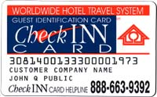
When the customer enrolls in the CheckINN Card program, they will receive a CLC CheckINNTM card in a week to ten days just like all of our other customers. They are also required to provide us credit card to keep on file for billing purposes.
When traveling, the CheckINN Card customer will present their CheckINN card at the front desk to get the CLC rate, and the hotel will direct bill us just like any other CLC customer.
When CLC receives the bill from the hotel, CLC will charge the room rate, tax and a transaction fee to their credit card. Then we process payment to the hotel and the transaction cycle starts all over again.

Customer checks into a hotel using his CLC card.
Hotel bills CLC for the stay.
CLC charges the Customer’s Credit card for the room rate & our fee.
CLC pays the hotel.
Customer Signs up for a CLC CheckINN Card account and receives a CheckINN Card.

Program Enrollment: Telephone & Web
There are two ways a customer can enroll in the CLC CheckINN Card program.

Method 1 – Web at www.checkinncard.com
- The customer can respond to the URL cited in the radio ad or on the direct mail letter.
- Upon typing in and navigating to the address above in step 1, they will be presented with a CheckINN Card welcome page.
- To start the sign up process all they have to do is click on the “enroll” button which will take them to the enrollment form. They will need to supply the following information:
- User name for their CLC*web log in.
- Password they would like to use.
- Shipping address for their card and program info.
- Billing address (if different from the shipping address).
- A valid credit card for billing purposes. (required)
- After supplying the required information they must “agree” to our program terms by clicking the “agree” check box at the bottom of the screen.
- To complete the enrollment process they simply click on the “Submit” button.
- After Clicking on the Submit button, they will receive a temporary “voucher” which they can present to a hotel to begin saving immediately. They will also receive an e-mail confirmation with instructions on how they can begin using the CLC program before their CheckINN Card arrives. Their CheckINN Card will arrive in 7 to 10 days.

Temporary Card Option – Direct Mail Only
Prospective customers receiving the direct mail piece will also view a screen which shows them their “Activation Code”. The Activation Code should be hand written in the space indicated on their Temporary card. | 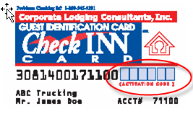

Web Enrollment: Step 1 - Welcome
Online Enrollment in the CheckINN Card program is easy!  It begins with the customer logging onto www.checkinncard.com  This will bring them to the CheckINN Card program home page.  Here they will find information about CLC and the CheckINN Card program.  It also gives them the answers to many frequently asked questions (FAQ’s).  To start the enrollment process all they need to do is click on the “Enroll Now” button. | 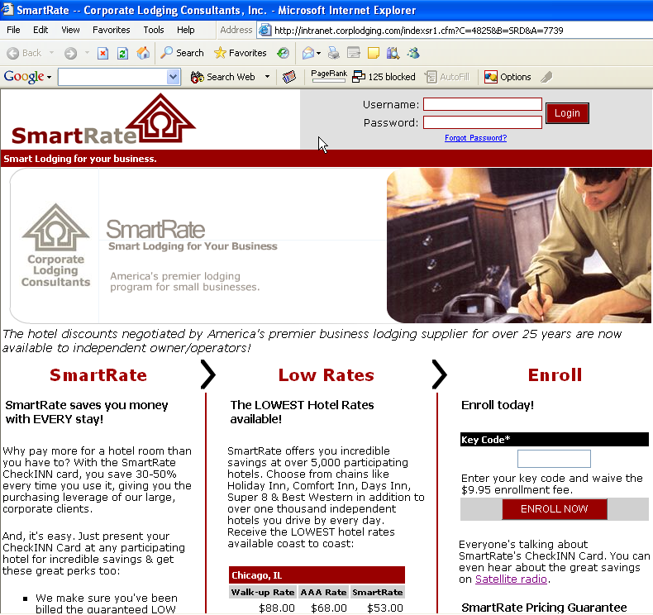

Web Enrollment: Step 2 - Enrollment
What You Kneed To Know | CheckINN Card Enrollment Screen
Web Enrollment in the CheckINN Card program is easy!  All fields with an * are required.  Create User Account:  Every CheckINN Card member receives a web account. This is where the customer will specify his/her web username and password.  Notes:  Every member receives a web account, even if they don’t plan to use it. Remind them to select a user name and password they can remember. They can change their password once their account is set up.  Contact Information:  The customer will need to provide us with all of their contact information including a shipping and billing address.  Notes:  A billing address is only required when it is different than the shipping address.  The shipping/billing address must match the billing address for the credit card they are using. If it does not they will receive an error message.  At this point the customer is required to provide us with a credit card. The credit card will be charged a 1-time enrollment fee and it will also be used for our billing process. | The $9.95 enrollment fee is waived if they enter a key code during enrollment.  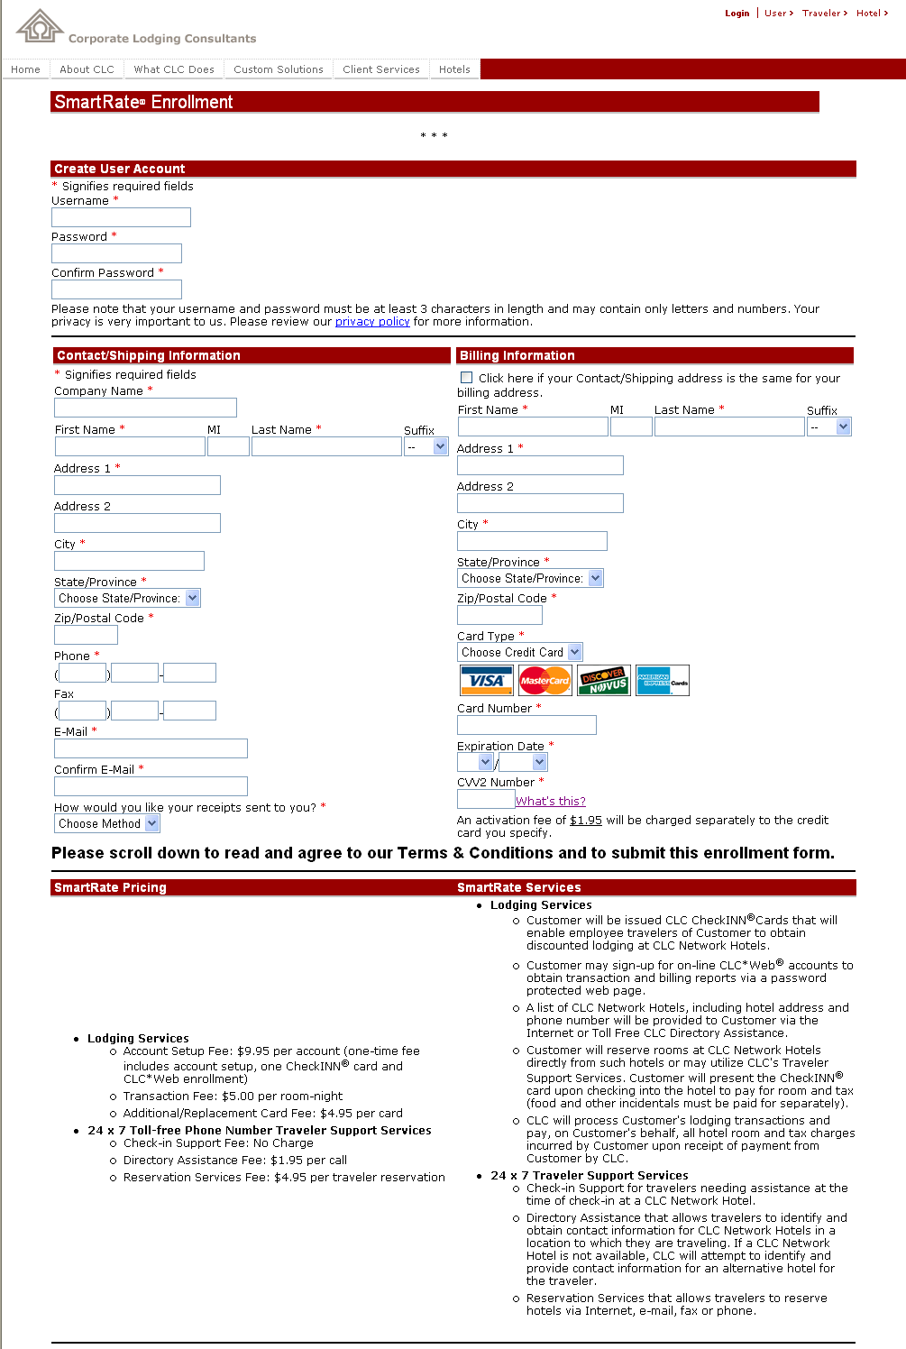
Web Enrollment: Step 2 - Enrollment (cont’d)
What You Kneed To Know | CheckINN Card Enrollment Screen
Online Enrollment process continued:  Terms and Conditions:  After completing the personal information section the customer must scroll down and view the program Terms and Conditions.  After reviewing the Terms and Conditions they must select “I Agree” and will then finish the process by clicking on the “Submit” button. | 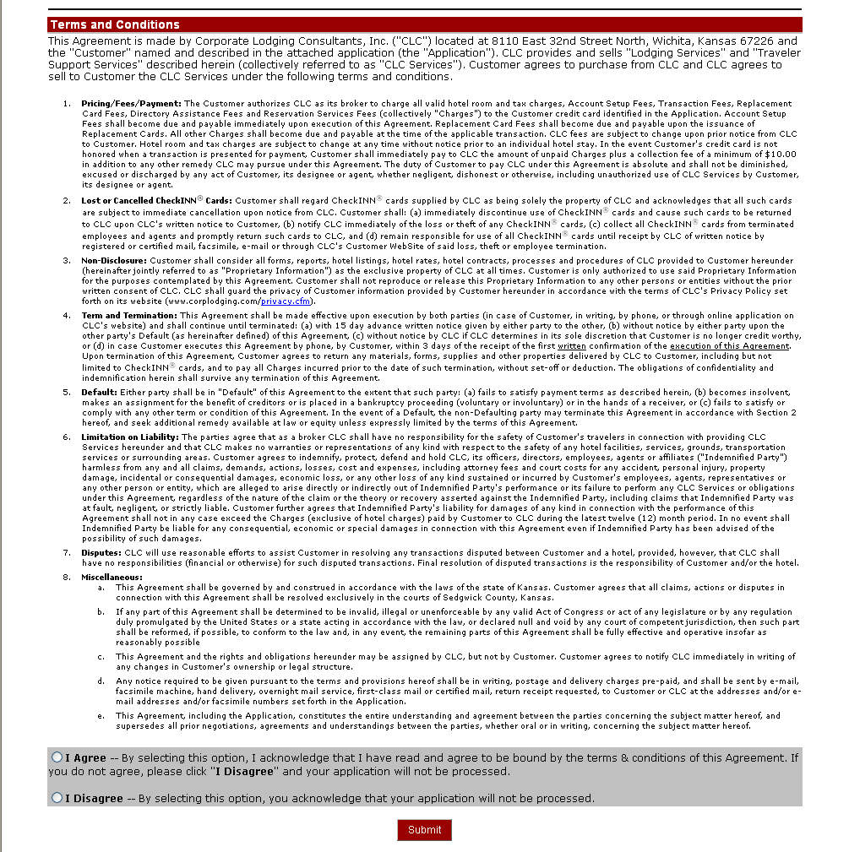

Web Enrollment: Step 3 - Confirmation
What You Kneed To Know | CheckINN Card Enrollment Screen
nline Enrollment Confirmation Screen:  When the enrollment process is complete the customer will receive this confirmation screen.  It explains how the customer can begin using the CLC SmarteRate program even before they receive their card.  The bottom half of the screen is a printable CLC voucher that has an image of their actual CLC Card. The image is complete with company name, cardholder name and CLC number.  They should be able to print this document and use the voucher at any approved CLC hotel.  There are specific instructions for the hotel explaining how to manually bill us for the stay.  The customer will also receive e-mail with the same information so they can print it and use as often as they need until their actual card arrives. | 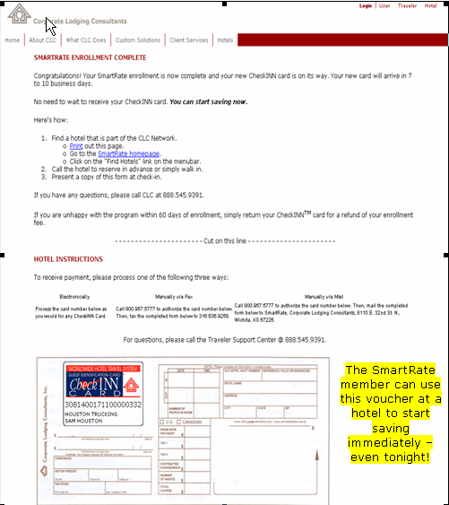

Method 2 – Telephone Enrollment
The customer responds to a radio ad or direct mail solicitation and requests program information and enrollment.
We then have the opportunity to promote the program by:
- Explaining who CLC is.
- Explain how CheckINN Card works.
- Sell the benefits they will receive by being a CLC CheckINN Card customer.
- Answer any of their questions.
Enroll them in the program using the same setup process as above but we will do it for them using the CLC site at www.corplodging.com
Once enrolled we welcome them as a CheckINN Card Customer
Explain how to begin using program

Telephone Enrollment: Step 1 – Call Center CheckINN Card Internet Login
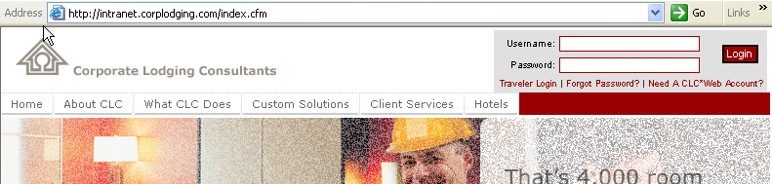
The telephone enrollment process begins by logging on to the CLC website at www.corplodging.com. Your login and password will be assigned by an administrator.

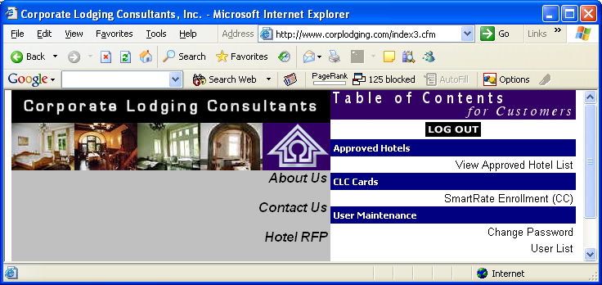Once you have logged into the Intranet site, you will need to click on “CheckINN Card Enrollment (CC)” which is listed under the CLC Cards heading.

Telephone Enrollment: Step 2 – Customer Setup
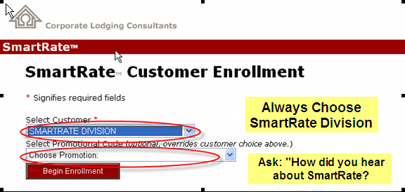
Always choose the CheckINN Card Division.
Ask the caller if they have a Key Code. If they choose a Key Code, the typical $9.95 enrollment fee will be waived.

Telephone Enrollment: Step 3 - Enrollment
What You Kneed To Know | CheckINN Card Enrollment Screen
Telephone enrollment is almost identical to Web enrollment, except that the CSR is completing the form for the future customer.  All fields with an * are required.  Create User Account:  All cardholders receive a free CLC*Web account (even if they don’t have Internet access). Ask the customer for a User Name (it should be something they can remember). Next ask them to make up a password. You will need to enter it twice for verification. Explain to the customer this is just for the purpose of creating their web account. Note: The customer can change this password at any time by logging on to www.checkinncard.com.  Contact Information:  Next you will verify and input the customers contact information.  At this point you will need to get a credit card from the customer. The credit card will be charged a 1-time activation fee (free if the CSR entered a Key Code earlier) and it will also be used for our billing process.  Notes: A billing address is only required when it is different than the shipping address.  Click “No E-Mail Address” if the customer does not have one. | 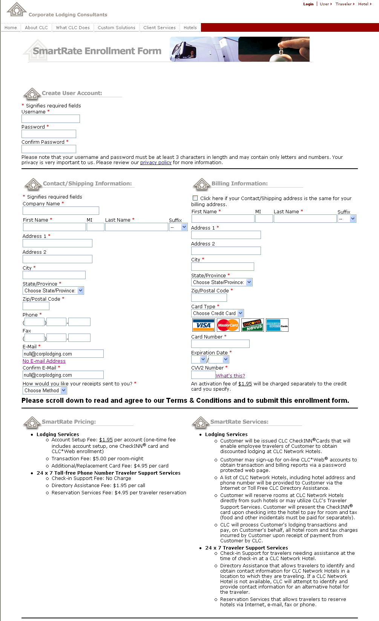
Telephone Enrollment: Step 3 - Enrollment (cont’d)
What You Kneed To Know | CheckINN Card Enrollment Screen
Telephone Enrollment process continued:

Terms and Conditions:

You do not need to read the terms and conditions to the customer, simply explain that “as with any program there are Terms & Conditions that apply”. They will receive a copy of the Terms and Conditions in the mail with their cards. If they have any questions they can contact us.

After completing the personal information section you will need to scroll down to the bottom of the page and select “I Agree” to the program Terms and Conditions.

To process the enrollment you will then need to click “Submit” to complete the enrollment process and receive the confirmation.

Telephone Enrollment: Step 4 - Confirmation
What You Kneed To Know | CheckINN Card Confirmation Screen
Enrollment Confirmation Screen:  When the enrollment process is completed you will see this screen.  It confirms the account set up process was completed properly.  It also includes instructions for the customer on how they can begin using the program even before their card arrives.  The bottom half of the screen is a printable CLC voucher that is pre-populated with an image of what their actual card will look like and it has their account number on it.  If the customer supplied an e-mail address they will automatically receive a copy of this info. You can also print it and fax it to them.  If the customer does not have access to either e-mail or fax machine they will have to wait until they receive their card in the mail to begin using the program. | 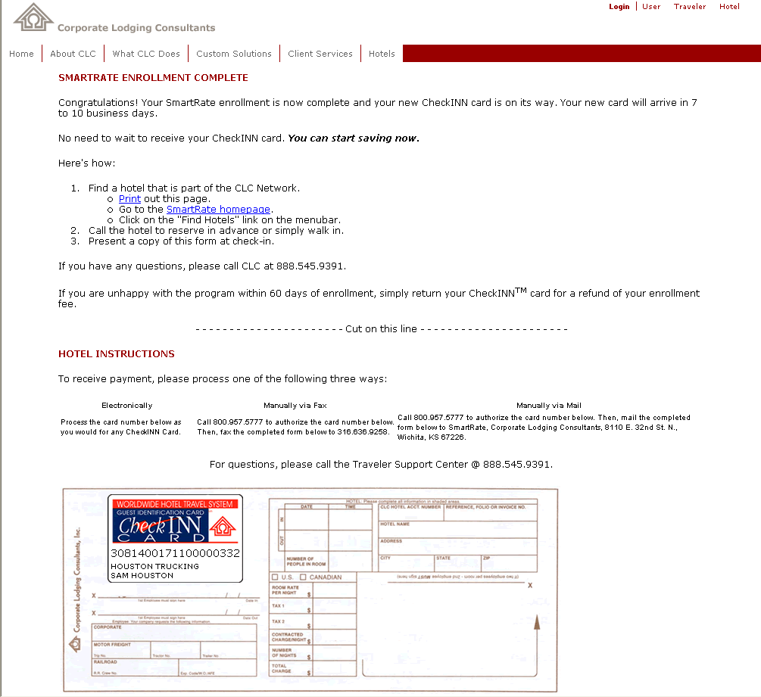

CLC Traveler Support Center Services (888) 545-9391

Hotel Check-In Support
CLC will provide toll Free, 24/7 Operator Assistance to help Travelers if they encounter problems while checking into a CLC preferred hotel. If questions or problems arise during check-in, the traveler or the hotel desk clerk may call Corporate Lodging’s Traveler Support Center and speak directly to a Customer Service Agent. In most cases the question can be answered or the problem resolved during this phone call.
This service is provided at no charge to all CLC customers.

Hotel Directory Assistance
Toll free, 24/7 Hotel Directory Assistance is available to all CheckINN Card customers. The CSR will provide the caller a listing of the nearest hotels along with the phone numbers. The caller can then contact the hotel directly and make his or her own reservation.
A service charge of $1.95 per call will apply.

CLCResTM Hotel Reservation Service
Toll free, 24/7 Reservation Assistance is available to all CheckINN Card customers.
Our reservation service can be used on an occasional, as needed emergency basis or as the standard operating procedure for every hotel reservation.
A service charge of $4.95 per individual traveler reservation will apply.

