

Travel technology assignment

Hanna Schroderus

POMO16/ M1D2
28.4.2016

Sisällys
1 Expedia.fi products and services 1
2 Visuality 1
3 User-friendliness 1
4 Security 2
5 Information on website 2
6 Interactivity& customer target group 2
7 Sources 3

Expedia.fi products and services
I did my evaluation about a booking website www.expedia.fi. Threw it you can book hotels, flights, package holidays and rent cars. If you change the language to English it automatically transfers you to expedia.com which has also an option to book cruises and activities.

Visuality
The first thing that I noticed when entering the page was that the visual side of the page is not very appealing. There is just too much text for the head page and the background picture looks very unprofessional because of its bad quality. Colors blue,white and yellow are not really smartly mixed together and they look a little bit cheap in my opinion. The amount of banners and advertisement is huge and disturbing. All in all the visual site of the page does not increase any sort of ”travel fever”.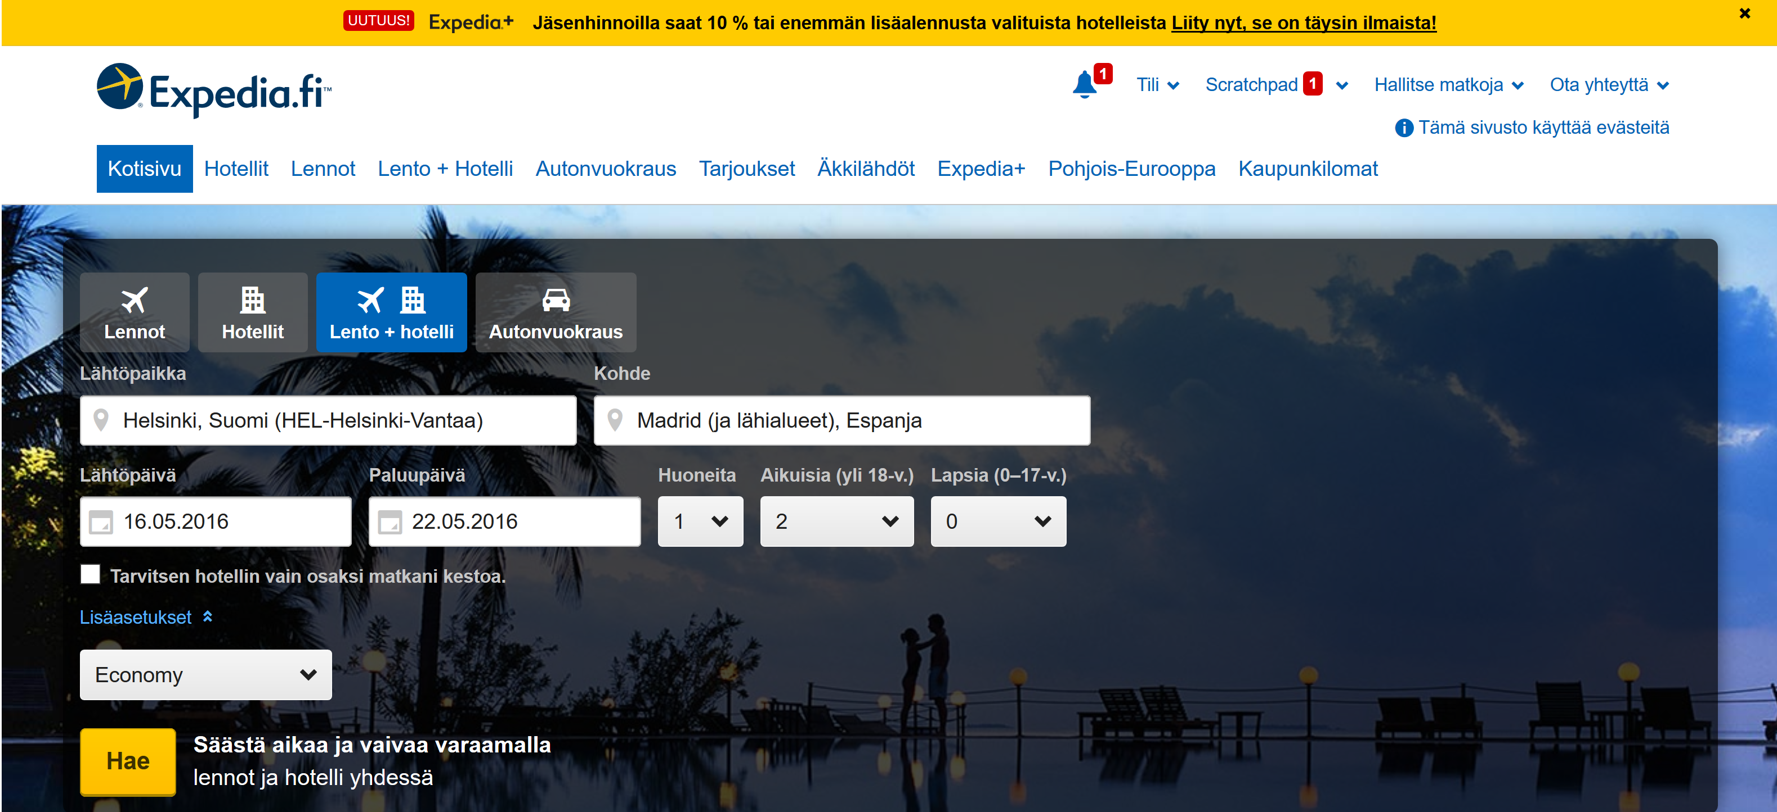
Picture 1. Visual layout of Expedia.fi

User-friendliness
To test the user friendliness I tried to book a one week holiday from Helsinki to Madrid. It was easy to find a hotel if you knew exactly where you are planning to go to, but in the front page there was no tempting offers if you do not have a holiday in mind. Website was downloading everything extremily slowly, but it might be because of my not so good internet connection as well. Once deciding your destination you could sort out the hotels based on price, popularity, number or stars etc. What I found quite disturbing was the banners ” Join us now and get 25% off the price” and the ”only 1 room left BOOK NOW” text next to some of the hotels (Picture 1), as it made me feel like I have to rush the decision.

Picture 2. Banners in the website disturbing the booking
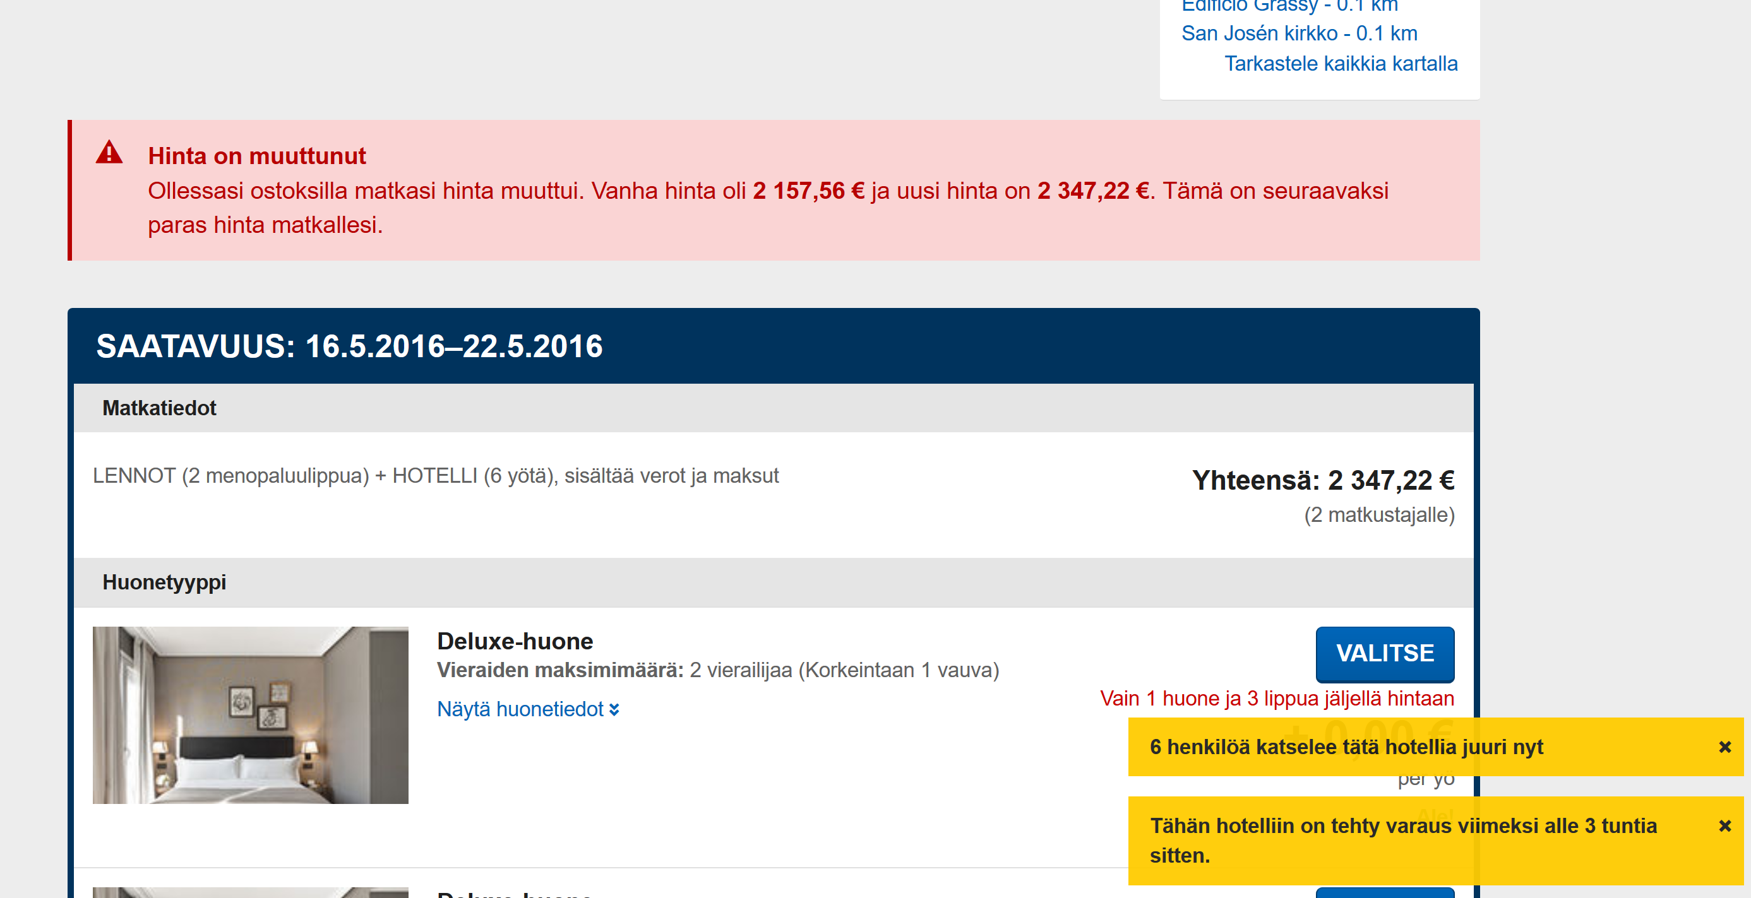

Security
Because there was so much advertisement, webpage did not feel safe for me. The prices kept on changing all the time which made me feel suspicious; are they going to change also while booking&paying? While booking the trip the site asked for my credit card number and expiry date. That was the longest I could go without booking the trip. There was a document about safety issues attached and also a contact number, which made me feel more trusting towards the booking.

Information on website
Constantly rising banners and sponsored advertisement were really annoying and took attention from the more important things. When going throw the hotel options you could see the distance from the airport, but actually the website never informed the name of the airport. The hotel info was not good enough for me to book a hotelroom straight from Expedia without trying to find the hotels own website first. There was customer feedback about the hotel but with only positive comments checked by Expedia first. There were no links to TripAdvisor (only a logo you could not click on) or the hotels own website.

Interactivity& customer target group
It was hard to figure out the main customer target group of this website, because there was such a variety of accommodation types from very expensive 5 star hotels to very weird cheaper boutique hotels somewhere further from the centrum. Based on the ”Quick booking discounts” I would say Expedia is ment for those who know where they are going and need to book a trip really fast. The prices change all the time so you need to be ready to book instantly if you want something little bit cheaper.
There was no ”Chat” service but a phone number which you could contact from Monday to Friday between 8.30‒17.30 . Based on my own experience I feel that specially young people would be booking a holiday later than 5pm or during the weekends, so I found it weird that they do not have any customer service (chat) during those late hours.

Sources
https://www.expedia.fi/

Picture 1&2. Screenshots from https://www.expedia.fi/

