TABLE OF CONTENTS

Travel Tips 3-5

Request for Travel Approval/Cash Advance/Prepaid Registration 6-7

Travel Expense Claim (CSUSM.262) 8-9

Excess Travel Advance Repayment 10

Online Resources 11

FORMS INCLUDED IN THIS HANDBOOK ARE FOR DEMONSTRATION ONLY.

YOU CAN ACCESS THE ACTUAL FORMS ONLINE AT:

http://www.csusm.edu/travel

TRAVEL TIPS
Refer travel related questions to the Travel Desk at x4466 or email traveldesk@csusm.edu.

- Effective April 1, 2011 the Travel Desk will process claims as follows:
  - Review and audit claims to ensure compliance with the Chancellor’s Office policy

  - Email the travel claim preparer, the traveler, and the approving authority IF there are errors

  - Return the claim to the travel preparer for correction if necessary *

*Please note that this last step could delay payment of your claim, so careful review before submission is recommended.

- Approvals/Authorizations
- Please see the President’s “Approval of Travel Memorandum” dated 12/1/2008 for appropriate approval authority. http://www.csusm.edu/travel/EO688travelapproval120108.pdf

- A “green” Request for Travel/Prepaid Registration/Cash Advance is used to authorize any travel, travel advances and/or registration over $100.This is a trip specific form and is REQUIRED to be completed and signed before the trip arrangements are made.

- The “green” Request for Travel/Prepaid Registration/Cash Advance must be signed by the traveler, the traveler’s supervisor and someone who has fiscal authority for the dept id# and the fund #. It must also be signed by the final approving authority dependent on whether the travel is in state, out of state or out of country. (See Memo in A. above)

- The Travel Expense Claim Form (262) must be signed by the traveler, the traveler’s supervisor and an authorized signer for the dept id# and if appropriate for the fund #.

- American Express for travel expenses.
- It is strongly suggested that all permanent employees who travel on business apply for an American Express Corporate Card, to be used exclusively for University business travel.This also gives you the additional insurance protection for rental cars through contracted vendors. Please be aware that you MUST sign up to receive your statements electronically. You will not have the option of receiving them through any other method.

- To apply for the American Express Travel card please follow the application process that can be found on the Travel website. http://www.csusm.edu/travel/information/amex.html

- Anyone considered a permanent employee of CSUSM is eligible to apply for a card.

- Any pre approved travel related expenses that have a University business purpose can be charged to the card.

- Transportation
- The CSU will reimburse costs for all pre approved and reasonable transportation expenses when traveling on University business.

- When opting to drive instead of fly, the traveler will be reimbursed for the lesser of the two expenses and must provide documentation showing what the flight would have cost as well as a written explanation of why that choice was made.

- The Chancellor’s Office has set the 2011 mileage reimbursement rate at 50 cents a mile.

- You MUST provide the actual original receipt. It should have a $0 balance due or it should show the exact amount that was charged to your credit card. An itinerary or confirmation will not be accepted as a receipt.

- Please see the Travel website for car rental instructions and information. http://www.csusm.edu/travel/carrentals.html

- Please note that you will not be reimbursed for any additional insurance.

AGENCY | PHONE NUMBER | CORPORATE ID
Enterprise | (916) 487-3100 | NACA050  Pin # CSU
Alamo | (800) 608-7514 | 191259
National | (800) 608-7514 | 5400321

- The contracted rates include $500,000.00 liability insurance and full collision damage waivers for the rented vehicles. Use of contract car rental agencies not only protects the state, but the state employee as well.

- Note: The only recognized form of payment to receive the state rate is the American Express Government Card.

V. Meals
A. Effective April 1, 2011meals are now reimbursed based on
“actual cost”. Receipts are REQUIRED for any meal costing over $25 and
RECOMMENDED for all costs being reimbursed.
The maximum daily allowance for meals is $55.00
For detailed examples of how this should be claimed, please refer to the “$55
example” which you can find as a hyperlink on the travel website.(Insert when posted)

B. Meals can be claimed for a trip lasting less than 24 hours under the following conditions; The approving authority can allow breakfast and dinner expenses if travel begins before 7am and/or extends beyond 6pm. The amount must be considered a reasonable expense and incurred as a result of University business. These expenses will be reported to Payroll as a taxable item by the travel desk.

C. Lunch will no longer be reimbursed under any circumstances for a trip lasting less than 24 hours.

- Incidentals
- Effective April 1, 2011 incidentals are now reimbursed based on “actual cost”. Receipts are not required but are recommended.

- Incidentals can be claimed for each 24 hour portion of a trip lasting more than 24 hours.
They will be reimbursed on “actual costs” UP to $7 per each 24 hour period.

VII. Lodging
- Lodging will be reimbursed based on an “actual cost” basis unless traveling internationally. If a traveler stays with a friend or relative, the purchase of a hospitality gift is allowed. One gift per trip, up to $75.00 with an original receipt. No alcohol/no cash/no gift cards allowed.

- Reasonable expenses for lodging based on actual costs will be reimbursed after approval by the approving authority.

- The Hotel/Motel Transient Occupancy Tax Waiver Form can be located on the travel website www.csusm.edu/travel and is an optional form at the discretion of the hotel.

VIII. Reporting travel expenses
- Once trip is complete, please submit all original receipts and approved Travel Expense Claim Form (CSUSM.262) within 30 days after the trip. Please allow 10 working days to receive payment from the date Accounts Payable receives your claim.

- For any cost OVER $25 a detailed receipt is required. It is recommended that all receipts be kept in a “receipt envelope” during your travels to avoid any unanswered questions.

- If there is anything out of the ordinary about your trip please provide documentation.

IX. International Travel
- Travelers to foreign destinations will receive a fixed amount per diem for lodging, meals and incidentals in accordance with the Federal Maximum Travel Per Diem Allowance for Foreign Areas published by the U.S. Department of Defense and may be found at:
http://www.defensetravel.dod.mil/site/perdiemCalc.cfm
Receipts will not be required for reimbursement.

- You may incorporate personal travel with business travel under certain conditions. There may be tax implications. Please review the Chancellor’s Office Policy and Procedure at the following link for detailed information on all international travel.
http://www.calstate.edu/icsuam/sections/3000/Travel_Procedures_G-001_Final.doc

REQUEST FOR TRAVEL APPROVAL/PREPAID REGISTRATION AND/OR CASH ADVANCE FORM
PRINT IN GREEN
____________________________________________________________________________
Form available online at http://www.csusm.edu/travel
The Request for Travel Approval/Prepaid Registration and/or Cash Advance Form serves three (3) purposes.
- To authorize travel and all related expenses
- To authorize prepaid registration be paid directly by the Travel Desk
- To authorize a cash advance be paid by the Travel Desk

This form MUST be completed and signed by the responsible approving authority then submitted to the business manager before making any travel arrangements.

TRAVEL EXPENSE CLAIM FORM(CSUSM.262)

Form available online at http://www.csusm.edu/travel

PURPOSE
The Travel Expense Claim (CSUSM.262) form’s purpose is to reimburse an employee for expenses incurred during time of travel for University related business.

Travel Claims Forms must be completed and submitted within 30 days from the first date of travel. Please allow 10 working days from the date the Travel Desk received the completed claim to receive payment.

TRAVEL EXPENSE CLAIM (CSUSM.262) INSTRUCTIONS

EXCESS TRAVEL ADVANCE REPAYMENT

What is the procedure when an employee needs to return an excess travel advance?
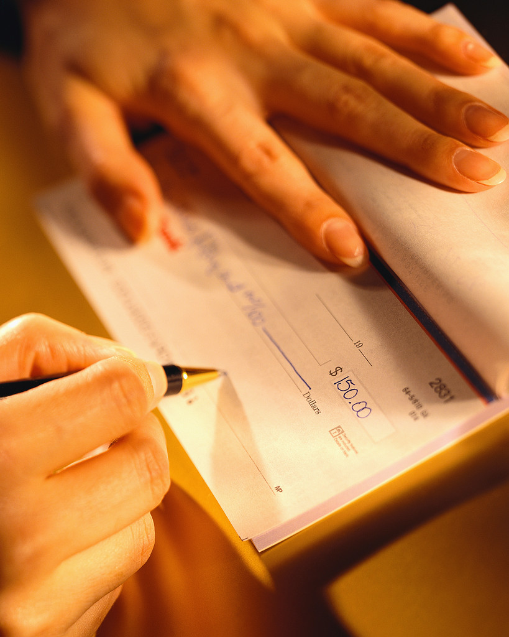

Example:
Advance- 500.00
Actual Expense- 450.00
Balance due to University- $50.00

      - The employee is to issue a check payable to Cal State San Marcos for the amount owed and submit it to their Business Manager immediately upon the traveler’s return.

      - The Business Manager then completes the Deposit Form available at http://www.csusm.edu/fas/fasforms.html
        - Use detail code PTAP
        - Chartfield String- 107801, fund 49901.
        - The Travel Desk will then complete the transaction to move the expense to the designated chartfield string.

      - The original Deposit Form and check is then submitted to University Cashiers to credit the appropriate account.

      - A copy of the Deposit Form (stamped by University Cashiers) and copy of employee’s check is then attached to the Final Travel Expense Claim and forwarded to the Travel Desk.

NOTE: Any excess advance must be submitted immediately upon the completion of travel. It is important that you estimate your travel expenses as accurately as possible.

All travel related forms can be accessed online at -
http://www.csusm.edu/travel

ONLINE RESOURCES

    - CSU Travel Policy and Procedure-
http://www.calstate.edu/icsuam/sections/index.shtml

- Airlines- State contracted
  - American, Jet Blue, United Airlines, and US Air
- Recommended travel booking website www.farecast.com
- Car Rentals- State approved companies
  - Enterprise Rent A Car/Leasing- www.pickenterprise.com
  - Alamo Rent A Car, Inc.- www.goalamo.com
  - National Rental Car System, Inc.- www.nationalcar.com
- Driving Directions/Mapping
  - MapQuest- www.mapquest.com
  - Expedia- www.maps.expedia.com
  - Yahoo- http://maps.yahoo.com/
- International Travel Currency Converters
  - Online Currency Calculator- www.currencycalculator.com
  - The Universal Currency Converter- www.xe.net/ucc
  - Exchange Rates- www.x-rates.com

    - Vehicle Request from Facility Department-
  - www.csusm.edu/facilities/AutomotiveCarForm.htm
    - Authorization to Use Privately Owned Vehicle on State Business (STD.261)-
  - http://www.csusm.edu/police/images/std261.pdf
- Travel Related forms
  - http://www.csusm.edu/travel

