Phi Sigma Kappa


Treasurer’s Manual
TABLE OF CONTENTS

HOW TO BE A SUCCESSFUL TREASURER 4
PRACTICAL TIPS ON FINANCIAL OPERATIONS 5
RESPONSIBILITIES 9
USING AN ACCOUNTS RECEIVABLE LEDGER 10
USING RECEIPTS 11
ACCOUNTS RECEIVABLE 12
DISCOUNT INCENTIVE PLAN 12
PENALTY INCENTIVE PLAN 12
ALUMNI CENTERED ACCOUNTS RECEIVABLE PROGRAM 14
DELINQUENT ACCOUNTS OWED BY ALUMNI 17
USING OUTSIDE FINANCIAL MANAGEMENT SERVICES 18
COLLECTING RENT 19
BUDGETING - FINANCIAL MANAGEMENT 20
HOW TO USE THE PHI SIGMA KAPPA BUDGET TEMPLATE 22
CHAPTER TAXES 25
What Form Does the Chapter Have to File? 25
When Do I Need to File? 26
Other Information You Will Need. 26
FINANCIAL DEALINGS WITH THE GRAND CHAPTER 27
Budgeting For and Explanation of Grand Chapter Fees 27
Fees and Dates Summary Timeline 29
Invoices 30
Monthly Statements 31
ASSOCIATE AND INITIATE REPORTING PROCEDURES 33
Associate Reporting 33
Initiate Reporting 34
OTHER FINANCIAL MATTERS 35
Making Payments to the Grand Chapter 35
Credit Balances 35
Non-Sufficient Funds 36
LIABILITY INSURANCE 37
How to Reduce your Premium 37
TRAINING YOUR SUCCESSOR 38
Financial Continuity 38
Electing and Training the Assistant Treasurer 38
TREASURER’S CHECKLIST 41
APPENDIX 43
INDIVIDUAL HOUSING CONTRACT 44
PROMISSORY NOTE 50
FINANCIAL OBLIGATION CONTRACT 52
SAMPLE COLLECTION LETTERS 53
Phi Sigma Kappa Insurance Premium Allocation Guidelines 55

INTRODUCTION

Congratulations on your election to the office of treasurer. You have been trusted with a very important responsibility, that of maintaining the financial stability of your chapter.

No office is more important than that of the treasurer. The financial operations and stability of the chapter is in your hands. It is a well-known fact that financially weak chapters have difficulty attracting good members, with the result that there is accompanying weakness in scholarship, campus activities, and social prestige. A good Phi Sigma Kappa chapter always has sound financial operation.

This manual will give you the tools to establish a sound fiscal plan for your chapter. Included in the appendices of the manual are a variety of sample resources, including a housing contract and promissory notes that you can use to better manage your chapter’s finances.

On assuming office, the treasurer should do the following things:

1. Acquaint himself with the laws of the Fraternity as they relate to finances.

2. Insist that his predecessor turn over to him a balanced set of books, a reconciled bank account and a balanced cash account.

3. Get in touch with the chapter’s accountant, financial adviser, or the person supervising the chapter’s finances.

4. Get in touch with the Grand Chapter to ensure the chapter is in good financial standing.

5. Provide the bank with the signatures of the president and himself and whatever document is required to show that they are the duly authorized officers to sign for the chapter.

6. Secure as much assistance as possible from his predecessor during the first month’s operations.

7. Have an assistant treasurer appointed who can help him with the routine work.

HOW TO BE A SUCCESSFUL TREASURER

1. Never let the work accumulate until the end of the month. Do a little every day and the workload will be much lighter.

2. Deposit collections in the bank promptly. It is dangerous to keep large sums of money on hand, and checks may become uncollectible. Whatever system of bookkeeping is used, all receipts must be deposited and always deposit all cash on hand on the last day of each month.

3. Give a receipt (made in duplicate) for every item of cash received.

4. Do not pay out money without proper authorization from the president and checking with the person in charge of a department, such as the steward, social chairman, recruitment chairman, etc. Take a firm stand against purchases being made by officers and members without the sanction of the treasurer.

5. See that members’ accounts are collected promptly. An aggressive policy here will pay dividends. Remember that a chapter can soon find itself in serious financial difficulty if members’ accounts are not paid promptly. (See the section later in the manual concerning accounts receivable.)

6. Pay the chapter’s bills promptly. Establish a good credit record.

7. Have the books balanced promptly at the end of the month. If an accountant is employed, turn all records over to them promptly.

8. Adopt an active rather than a passive role in the financial management of the chapter. Be on the alert to guard the treasury, eliminate waste and extravagance and safeguard the chapter’s property. This will require cooperation with the other officers.

9. Show no favoritism. A good treasurer cannot have a double set of standards, one for the “good guys” and one for the “bad guys.”

PRACTICAL TIPS ON FINANCIAL OPERATIONS

Who contracts for services or goods?
For chapters with a house, within the budgeted allocation the house manager is responsible for purchasing supplies and minor tools and contracting for minor repairs. The steward is responsible for the purchase of boarding club provisions, kitchen utensils and other supplies unless such authority has been granted to a housemother in which instance the steward would periodically check the activities.

On general chapter needs, it would be the secretary who would order necessary chapter forms and supplies and on the social front, it would be the social chairman who contracted for services and goods in connection with the social program. In like manner, if the purchases of ritual equipment were provided in the budget, the sentinel would be responsible, the recruitment chairman for recruitmenting expenses, etc.

In all instances, however, the treasurer, with the support of the Executive Committee, is the guardian of the chapter’s funds, and he is charged, by virtue of his office, with the responsibility for the disbursement of funds within the limitations of the chapter budget.

No member or officer not specifically authorized has the right to make any purchase or contract for any service in the name of the chapter, and should he do so, the chapter would be perfectly within its rights to invoke a proper penalty upon him.

Who pays the bills?
The treasurer is responsible for the payment of all bills. In order to safeguard his own position and also to observe the laws of the Fraternity, however, he should have a co-signer for every check drawn on the chapter account. Such co-signer shall always be the president or, by chapter approval, a financial adviser if the chapter operates with such an advisory system. All large accounts should be paid by check or chapter credit card. Only minor disbursements should be made out of a separate petty cash fund.

Keep accurate records.
Not only the chapter records but also the records given to members in the form of invoices and receipts are important. A sloppy treasurer who keeps inaccurate or insufficient records could easily embarrass many members of the chapter if, in later years, inaccurate records should fall into the hands of others and it appeared they had uncollected receivables.

Make sure that you are bonded.
Bonding protects both you and the chapter in the event of any question regarding the integrity of your records. Bonding makes sure the chapter is insured in case money is stolen from a chapter bank account. Any member with the ability to sign checks should be bonded. If you are not bonded, contact your alumni or a local bonding agent (many insurance companies provide this service).

Handling bounced checks.
When a member bounces a check, give him the benefit of the doubt only once. He’ll insist the bank made a mistake. Thereafter, impose a bounced check charge (don’t call it a fine) for every bad check.

What about fines?
Probably the weakest form of punishment, but sometimes the only alternative. To be effective, a fine must first fill these conditions:

- It should be timely. Require payment within 48 hours. If it’s on next month’s bill, it won’t hurt so much as it will now (especially if their parents pay the monthly bill).

- It should be large enough to be a genuine punishment. Ten or twenty dollars will drive the point home.

- Pre-set fines, to be effective, must serve as a real deterrent and should not be after the fact. All members should be aware of what offenses receive fines and what the amounts of the fines are.

When to raise dues.
First, when you work up a budget that doesn’t balance and you’ve cut estimated expenses as far as you can. Secondly, you should raise board and room charges every time the college raises these rates for the dormitories. Keep your rates competitive with the dormitories and other fraternities, but don’t sell “cheap fraternity.” Actually, charges that are average or slightly higher than the average can be used as a stronger selling point than being the “cheapest fraternity on campus.” It costs a little more to go first class.

Charge a Parlor Fee.
If you have a chapter house, members living out use the living room, chapter room, recreation room and other common rooms and should be charged a parlor fee (over and above dues) for the use of these facilities.

Take your discounts.
Some suppliers will offer a discount if the bill is paid within 10- 15 days. Check each statement and take all discounts. They add up. Conversely, all suppliers add a charge if a bill is not paid within 30 days. Pay your bills as soon as you receive them.

List of Suppliers.
Make up a list of suppliers, with addresses and phone numbers and keep it handy. Limit purchases to as few suppliers as possible and where you can get the best deals. Shop around and compare prices.

Purchase in Quantity.
Discounts are always available in quantity lots. Find out where the price breaks are and buy supplies in large quantities.

Reconcile the Bank Statement Every Month.
It takes only a few minutes.

Ordering Supplies.
Order supplies from the International Headquarters Office. A price list of supplies and manuals can be obtained from the International Headquarters Office.

You are on the Executive Committee.
As treasurer, you are automatically on the Executive Committee of the chapter. Therefore, familiarize yourself with the duties of the Executive Committee.

Do not Destroy Voided Checks.
All checks should be pre-numbered, and you must account for every one. If a mistake is made on a check, write VOID across the check and the check stub; tear off the signature portion of the check and destroy it; staple the voided check opposite the corresponding check stub.

Use of Purchase Orders.
Some chapters require that everyone making a purchase for the chapter have a purchase order signed by the treasurer. Purchase orders are recommended.

Here is a List of Other Tips to Save the Chapter Money.

- Search out capital improvements that will reduce other costs such as heating, maintenance and insurance.
- Insulate the attic and basement.
- Re-caulk the storm windows and doors. If you cannot afford storm windows and doors, then invest in heavy plastic sheeting to put over screens and screen doors.
- Line draperies with thermal material and close them at night.
- Keep the thermostat at 68 degrees. Every one degree it is lowered saves 3% in fuel costs.
- Turn off the heat in rooms which are not used during the day.
- If you have a fireplace, keep the flue closed when not in use. Heat loss also occurs when a fireplace is in use.
- Have the furnace serviced once a year and change the filters frequently.
- Keep hallway and stairwell doors closed to prevent drafts and heat loss.
- Install closers on doors or encourage members to close doors when they enter and leave the house.
- Ask brothers to bring extra blankets, not electric blankets.
- Discourage refrigerators and air conditioners in individual rooms. They cost between $10 and $35 per month to operate.
- Shut off heat and water heaters over vacations (be sure to drain water pipes). Alternatively, lower thermostats to 55 degrees, no less.
- Turn off the refrigerator and leave the door open.
- Reduce outdoor lighting.
- One 100-watt light bulb sheds more light than three 40-watt bulbs and uses one-third less energy.
- Keep showers brief.
- Keep refrigerators between 38 and 40 degrees Fahrenheit.
- Turn off stereos, televisions and lights when not in use.
- Wash clothes in warm or cold water instead of hot.
- Put two bricks in the tanks of all toilets. Each brick will displace about one quart of water.
- Try to find an alumnus to do financial consulting rather than paying for the services of an accountant.
- Utilize university facilities.
- Pay bills on time to avoid interest charges.
- Install coin-operated washing machines.
- Encourage brothers to do as much repair work as possible. Professionals are costly, especially Physical Plant services at your University or College.
- Eliminate linen service.
- Take turns waiting on tables and performing house duties.
- Use room deposits to cover damages.
- Don’t compensate chapter officers.

RESPONSIBILITIES

As treasurer of the undergraduate chapter, it is your responsibility to keep complete books of account except in cases where financial management is in the hands of a professional accountant, alumni financial adviser, or an alumni board of control. Your duties and responsibilities are:

1. The treasurer shall collect all dues and fees and pay all verified obligations of the chapter.

2. The treasurer shall use an adequate accounting system, or a system required by the college or university at which the chapter is located.

3. The treasurer is required to furnish reports of the financial condition of the chapter at each chapter meeting and send all necessary reports to the International Headquarters Office, as required by the Grand Chapter Bylaws. The record shall be subject to inspection by any member of the chapter at all times.

4. The treasurer shall see that the financial records of the chapter are properly audited at least annually and preferably at least once each semester or quarter.

5. It is the chapter treasurer’s responsibility to see that associate and initiate fees are sent to the International Headquarters immediately following association and initiation. The inductor may assist with collection of these fees, however, it is the treasurer’s responsibility to send the fees. Colony treasurers are responsible for immediate payment of associate fees following Ritual of Association. Never use associate or initiate fees to pay other chapter bills. This is fraud and the paying member can pursue legal action against you and the chapter if his payment is misused.

6. The treasurer must see that no member is permitted to become delinquent in his payment to the chapter. Payments must be prompt. He must also see that no man is put through the Third Degree Ritual if he still owes money to the chapter or the Grand Chapter.

7. The treasurer must see that committees and committee chairmen operate within the approved budget.

8. The treasurer shall also be responsible for the following tax information:

a. Completing and filing the Internal Revenue Service Form 990 - RETURN OF ORGANIZATIONS EXEMPT FROM INCOME TAX - as required by the U.S. Treasury Department.

b. Reporting and paying Social Security Taxes to the U.S. Treasury Department; also income taxes withheld, where applicable.

c. Reporting and paying State Unemployment Compensation to the appropriate state agency, where applicable.

9. The treasurer shall be thoroughly familiar with the Rituals and the part he plays within.

USING AN ACCOUNTS RECEIVABLE LEDGER

An accounts receivable ledger contains all of the information on one individual member’s account with the chapter. By maintaining this form, the treasurer has an up-to-date record of all monies owed the chapter.

Entries are made into the member’s account each time he is charged for dues, assessments, etc. An entry is also made in the credit column each time the member pays the chapter any money on his account. Following is an example of a member’s A/R ledger.

Name | Joseph Barrett
School Address | 123 College Ave., Amherst, MA
Cell Phone | 555-555-1873
Home Address | 123 Main St., Emporia, KS
Home Phone | 555-555-1910
Date | Description | Debit (charges) | Credit (payments) | Balance
September 1, 2006 | Liability Insurance | $200.00 |  | $200.00
September 1, 2006 | Fall Dues | $300.00 |  | $500.00
September 8, 2006 | payment - check # 1034 |  | $200.00 | $300.00
September 15, 2006 | payment - check # 1036 |  | $300.00 | $0.00
October 20, 2006 | Homecoming | $50.00 |  | $50.00
September 6, 2006 | payment - cash |  | $50.00 | $0.00

1. Dues, fines, assessments, etc. constitute money that the member owes the chapter. These are referred to as CHARGES and are placed in the DEBIT column.

2. All CHARGES are ADDED to the account BALANCE.

3. The account BALANCE is the total money owed to the chapter by the member.

4. Anytime the member pays the treasurer any money this is called a CREDIT.

5. All CREDITS are SUBTRACTED from the account BALANCE.

6. EVERY TIME a member pays the treasurer money, the member receives a receipt for the same amount.

These accounts receivable forms are invaluable since they are used to determine how much money is owed to the chapter by any individual at any given time. As soon as a new member is associated, a page for him should be set up in the accounts receivable ledger. Every charge and payment should be entered immediately. Failure to keep this ledger current will cause confusion and could cost the chapter considerable loss of revenue. You can easily create a ledger like the one above in a spreadsheet, or purchase a ledger book from an office supply store.

USING RECEIPTS

The purpose of using receipts is threefold. First, it provides both the chapter and the member with a written record of his payment to the chapter. Secondly, the copies of the receipts can be used when preparing the budget for next term. Finally, it can also be used to verify the credits to members’ accounts in your accounts receivable ledger. You can pick up a simple receipt book at just about any office supply store.

Be sure and write clearly on the receipt form. Indicate what the money was for and sign your name. The first copy of the receipt is on perforated paper. This copy is to be torn out and given to the member who made the payment. The second copy is to be kept as the chapter’s record. Also, the brother should retain his copy as proof of payment. Should an error occur or dispute in payment arise, cross-checking against the receipts, you should be able to locate the reason for the discrepancy.

The following rules apply when keeping the receipt book:

1. Every time money (from anyone) is received by the treasurer, whether by cash or by check, a receipt is written out.

2. Be sure to fill out all of the information requested on the form, write clearly, and SIGN your name.

3. The top copy is torn out and given to the member making the payment.

4. The bottom copy is retained for the chapter’s records.

5. NEVER accept cash without giving a receipt.

ACCOUNTS RECEIVABLE

Accounts receivable is the total money owed to the chapter or colony by alumni, initiates, or associate members. Many chapters have experienced problems with the collection of dues. First, we will show how to prevent the problem, and then we’ll discuss how to cure present problems with collections.

A key to collections is communication. The treasurer must keep the chapter aware of the financial situation and be willing to make himself available to all brothers for questions. It is your responsibility to make delinquent brothers aware of their debt and keep good documentation of all warnings you send them.

A chapter can, with relative ease, prevent most problems with the collection of dues, but, once a trend of not paying catches hold, it will cripple or kill the chapter. Chapters are encouraged to adopt one of the following plans for the collection of dues, have it written down into the by-laws, and enforced strictly.

DISCOUNT INCENTIVE PLAN

1. At the beginning of the term (semester, quarter, etc.) each member is billed for the total amount of dues for the term.
2. A deadline is set for the payment of dues for the term in full. (A typical deadline used is the end of the third week of the term.)
3. All members who pay all of their dues by the deadline will receive a deduction of a certain amount. For example, if dues are $300 per term, then members paying before the deadline would receive a $20 discount.

Any member who cannot pay all of his dues by the deadline will be required to make an initial payment of one-third of his dues prior to the deadline. The remaining two-thirds will be divided into two equal installment payments due at the first of the next two months.

Example: Joe is a member of a chapter whose dues are $300 a semester. He pays the treasurer $280 before the end of the third week of the semester. (He received a $20 discount for paying on time.)
Example: Fred is a member of a chapter whose dues are $300 per semester. He works to go to school and cannot afford to pay all of his dues at once. He pays the treasurer $100 (one-third) before the end of the first three weeks of the semester. He pays $100 again at the first of the next month and again at the first of the following month, for a total of $300.

PENALTY INCENTIVE PLAN

1. At the beginning of the term each member is billed for the total amount of dues for the term.

2. A deadline is set for the payment of the dues for the term in full.

3. Any member who is unable to pay all of his dues by the deadline will be fined a certain amount.
4. The total amount (dues plus fine) will be divided into three equal payments. The first payment will be due at the same time that is set for full payments as listed above. The remaining two payments will be paid at the first of each of the next two months.

Example: Joe is a member of a chapter whose dues are $300 per semester. He pays the treasurer the $300 in full before the end of the third week of the semester.
Example: Fred is a member of a chapter whose dues are $300 per semester. He cannot pay all of his dues at once, so the Treasurer adds a $15 penalty to his account. (Total now owed is $315.) He pays one-third ($105) before the end of the third week of classes and pays $105 at the first of each of the next two months, for a total of $315.

Phi Sigma Kappa chapters throughout the country have proven that the discount incentive and penalty incentive plans are two reliable methods of handling accounts receivable. Both offer some type of encouragement to the member to pay his dues early and on time.

Chapters that do not have houses DO NOT need to bill dues on a monthly rate. This only quadruples the effort needed to collect dues. Payment of the entire term’s dues in full at the beginning of the term is simply easier to enforce, can be afforded by most members, and ensures that most of the term’s income will be in the bank as soon as possible.

Still, a few of the members may at some time fall behind in paying the dues. This is caused by the following:
1. Failure to properly educate members on the importance of financial responsibility.
2. Failure of the officers to enforce the penalties for non-payment of dues.

Every chapter should have rules defining the penalties for not paying dues. Most often these penalties include all of the following:
1. He cannot play in intramural sports.
2. He cannot attend social functions.
3. He cannot vote at meetings.
4. He cannot run for office.
5. He cannot be a Big Brother.

The following is a list of some methods used for the collection of delinquent accounts from members:

1. He may be asked to stand at a chapter meeting and explain why he has not paid.
2. He may be required to appear before the Finance Committee.
3. His parents may be advised immediately by letter.
4. Some or all of his privileges as a member may be suspended.
5. He may be required to sign a promissory note.
6. The chapter may institute an Alumni Centered Accounts Receivable Program (see below).
7. In some instances, the university may withhold members’ grades, class schedules, transcripts, etc.
8. Vote may be held for removal of his membership in the Fraternity.

ALUMNI CENTERED ACCOUNTS RECEIVABLE PROGRAM

Note: Even if you don’t have an alumni base to use, this process can still work. Do not disregard it solely because you do not have alumni support.

Step 1 Talk to alumni - they must be willing to support this program because they are the mainstay of the program. They must be willing to work at this. If you cannot get their assistance or do not have an active alumni association you can still run this system within the chapter.
Step 1a - Get the chapter to admit there is a problem.

Step 2 Housing Contracts - Each brother living in the house (or non-brother) must sign a contract with the alumni, not the chapter, if possible. (The alumni corporation has more clout.) In addition, the contract should contain a figure that includes room, board, social fees and whatever other normal fees are charged during the year. The contract should also spell out the fact that half of the yearly amount is due on or before the first day of the semester (or one-third for quarters).

Step 3 Budget - In order to set your yearly and semesterly (quarterly) cost, a full year’s budget must be set up. Your first term budget must be followed exactly. Following term budgets must be reviewed before those terms begin in detail using the last term’s figures as a guide. Allow for some increasing costs during the year.

Step 4 Payment and Enforcement - Each term’s payment must be made on or before the first day of the term. The alumni should be there to enforce this. (But the undergraduate chapter has to support the need for the program.) In the fall (best time to start this program is the fall) no one should be allowed to move in without paying.

Step 5 Presentation of Program to Chapter – Of course, it is easier to present this plan to a chapter with accounts receivable problems. It takes the collection burden (most of it, anyway) off of the chapter treasurer. It is a great plan if the chapter now uses monthly billings or separates out social dues in those bills. One major source of chapter problems (internal) has always been money and the need for one brother to hassle another brother for it. Also, the need to impart onto a brother (hopefully through the membership education program) what his financial responsibilities are and why he must keep up his end of the bargain. Brotherhood has responsibilities as well as benefits. There are a myriad of reasons to go to this system, depending on the chapter. But the alumni, Executive Council, and adviser should present this to the chapter in the winter and spring with reminders in the summer. In the presentation, a financial statement along with easy to understand pie charts, graphs, etc. should be employed. Cash flow statements can be extremely helpful in showing brothers that the first part of the year (insurance perhaps) can be more expensive than say November or April. Monthly bills spread income evenly (if paid on time and we all know they are not) and monthly expenses are not even, therefore, creating some bad months.

Some more points to bring up in your presentation include the fact that if a member lived in university housing, he would have to pay his term bill at the beginning of the term. The Fraternity can’t afford to continue to be a lending institution, which is exactly what you are when bills are paid haphazardly. You aren’t even paid interest. Remember, a fraternity chapter is a business. You incur bills, you have to pay them. Your creditors could care less about brotherhood. Remember that next time a brother gives you that line. Also remember that by not paying dues that brother is weakening the chapter for his own personal gain. What does that say about his character and brotherhood?

What about exceptions? A review board should be setup. If a brother can’t pay up front you should have him appear before this board (mostly alumni if possible). Be prepared to present to him every possible avenue for him to pursue for money. Examples are the Phi Sigma Kappa Foundation (scholarships), federal loans, state loans, university loans or grants, school scholarships, local foundations, etc. Contact your school’s grant and aid office for help in preparing that list. If a brother is to, say, receive grant money in October for instance, you can make an exception with him. But make him sign a promissory note at that meeting. Not later. You can afford a few exceptions, but they must be under circumstances in which the exception is necessary.

Step 6 Follow-up - This program does work. Many of our successful chapters use it. However, once your presentation is made, the battle has just begun. It won’t be tough if you did your homework thoroughly before your presentation and then professionally and seriously made that presentation.

Several weeks after your original presentation return to a chapter meeting (alumni) to answer any questions that any of the brothers might have. The biggest reason, though, is to remind them of the program and of the fact that you are serious.

About two months before finals begin for spring term, return again with contract in hand for next year. Have them signed that night by the guys that know they are returning next fall. Set up appointments with the guys who say they are going to have problems meeting your requirements. The president of the chapter should remind the guys in between your visits and announce your (alumni) attendance at this meeting. By the end of school you should know who will be back in school in the fall with signed contracts. You should also know who needs to be contacted in the summer about signing contracts. (Schedule when to contact and by whom.)

Now, you’ve got signed contracts on everybody and it is summer. A letter should go to each parent in May or June explaining your program and the fact that the brothers were informed months ago. (Including a list of alternatives for money). If the chapter will be having a summer meeting, this should again be on the agenda. Stress no money, no move-in unless those prior arrangements have been made. By now they should realize you are serious! The week or perhaps two weeks before move-in time, a reminder would be appropriate.

Step 7 Move-in Day - When the day arrives for moving in, the alumni and the Executive Council should be there. Make sure you have a list of every time this was discussed last year, over the summer, mailing dates as well as copies of mailings and handouts. There is no reason why anyone should show up without a check. If one does, make an example of him. Send him home to get it. It has been done before. If home is too far away, send him to an ATM to get cash and tell him to purchase a money order. If you make exceptions, they will all lose respect for you and your program.

Step 8 What if there are no alumni?
- Must use contracts.
- Set up same way - just no alumni - use your chapter adviser more
- When it comes time to move in the entire executive board must be present and must all make a firm stance together to not allow the individual to move in until he has paid.

Step 9 What if the chapter does not have a house?
Instead of housing contracts each member should be required to sign a promissory note.
The note should outline when all payments are due and what they are for. Outline the penalties for not fulfilling the obligation in the note.
The first should be a suspension from chapter functions. At this time it would be appropriate to send a letter to the individual’s parents informing them of the situation and that if payment is not made by a set deadline the chapter will be forced to send the individual to a collection agency. The parents should already be aware of the promissory note since you informed them of it over the summer and likely will make sure that member pays as they will not want to see his credit affected.
If these measures fail you should follow through and send the member to a collection agency. This is certainly a difficult step to take but this member was made aware of the consequences and was given multiple opportunities to amend the situation. You are teaching him that he will be held responsible for his actions and it will make him a better person in the long run. See the appendix for information on how to use a collection agency.
Many chapters will expel financially delinquent members. This is certainly a strong incentive to pay, however when the time comes to make this decision you must be prepared to follow through and you must hold all members to the same standards. Do not play favorites.

Final Points:

1. Chapter must support the program. A well-presented program will take care of that.
2. Get alumni in town involved in this. Also, find an alumnus who is respected by the chapter to present and be at the door when members move in or find a hard-nosed individual who will make the chapter toe the line. Can’t do this with softies!
3. Always be positive. This is a positive approach.

Should the chapter be unable to collect or to make arrangements for the payment of the account, or if the chapter is having severe problems with collections, then contact the International Headquarters for help as soon as possible. It may be necessary to pursue this debt via a collection agency.

DELINQUENT ACCOUNTS OWED BY ALUMNI

Many chapters have on their books delinquent accounts owed by alumni. Obviously an effort should be made to reduce this outstanding indebtedness. However, if the chapter has allowed a member to carry a debt with a chapter even after he has graduated these funds will be very difficult to collect. You should not allow this to happen. When new members see a brother graduate without ever having paid his debt they will believe that they can get away with this as well. Keep in mind that members who are becoming or have become an alumnus can still be expelled from the fraternity.

The following are steps that the chapter can take to attempt to recover unpaid alumni accounts:

1. A letter should be written to each supposedly delinquent member asking for verification of the amount, which chapter records indicate he owes.

2. Then, the best procedure is to write a very friendly letter to each delinquent asking him to work out a plan for paying the debt on a monthly basis. Remember, correspondence should be of the friendliest personal nature.

3. Where no reply is received to such a letter, the next step is to enlist the aid of alumni from his class or who live in his locality in an effort to make an equitable arrangement.

4. If still no reply, take more drastic action:
a. Enlist help of the International Headquarters
b. Publish amount owed by alumnus in chapter newsletter
c. Start proceedings for suspension from the chapter and expulsion from the Fraternity. Make sure the delinquent is advised of these actions.

USING OUTSIDE FINANCIAL MANAGEMENT SERVICES

The Grand Chapter recommends all chapters to use Omega Financial: www.omegafi.com

COLLECTING RENT

For those chapters that have houses, the single largest source of income for the chapter is rent paid by the members and associates who live in the chapter house. Failing to collect the rent is likewise the quickest way for the chapter to get into debt. Therefore, it is most important for the chapter to have a strict policy for the payment of rent, and this policy must be enforced.

Members should be encouraged to pay all of the rent at the beginning of the semester or term. Both the discount incentive and penalty incentive plans (previously discussed) can be used to encourage members to pay their rent in advance.

In developing the chapter’s policy for rent payment, the following should serve as a guideline: The chapter’s policy for rent payment should be similar to that used by the school by students living in the dorms. Most schools require the following:
1. A deposit paid in advance to reserve the room.
2. A signed contract from the student.
3. The balance of rent paid at the beginning of the term.
4. Payment for any and all damages.

Members moving into the house for the first time should pay a deposit which serves two purposes. First it reserves a room for him. Second, the deposit is used to pay for any damages that occur for which he is responsible. When the member graduates or moves out of the house, the balance of his deposit (less any damage charges) is refunded to him.

Signing a housing contract (a sample housing contract can be found in the appendix) is a legal and binding action that ensures the chapter that the member plans to live in the house. The housing contract also legally obligates that member to pay the rent on time. The use of a housing contract (lease agreement) protects both the chapter and the member.

Due to the considerable expense involved in operating a chapter house the treasurer cannot afford for members to be late paying their rent. As a result, it is imperative that the rent be collected in advance if possible. Since most schools require dorm rent to be paid at the beginning of a term, the chapter should expect no less. Living in the chapter house is a privilege - not an opportunity to use the chapter as a credit agency.

If you do decide to collect rent on a monthly basis (although it is not recommended) make sure that you have a set day in place and you stay firm on expected payment by this date. If a payment is more than a week late charge a $50 late fee. If a member refuses to pay his rent you must evict him. Giving any one member special treatment is not fair to rest of the brothers in your chapter.

Damages will occur in any chapter house. If the member has pre-paid a damage deposit before he moves in, it will be simple for the treasurer to collect for any mishaps that do occur. Collecting for damages from the member without using the pre-paid deposit system is an unnecessary hassle. Additionally the damage deposit acts as an incentive to prevent a lot of the accidents that can happen.

BUDGETING - FINANCIAL MANAGEMENT

The most important tool in the management of expenses is the budget. A budget is an intelligent estimate of the chapter’s income and expenses for the school year. It is a financial plan of action, and every Phi Sigma Kappa chapter must have a budget.

1. At the end of every term a good chapter expects to consider and approve a budget which will provide funds for the term ahead. The necessities (fixed expenses) must be provided for. The variable expense items may be provided for to the extent that the Fraternity is willing to provide additional income. Examples of necessary fixed expense items are: rent, utilities, labor, maintenance and repairs, kitchen costs, recruitment, chapter publications, dues to the Grand Chapter, IFC dues, etc. Examples of variable costs are: social functions, recreational supplies and equipment, charitable donations, or events such as homecoming, Founders’ Day, etc.

2. Budgets can be simple or complex, depending on the nature of operations of the chapter. Therefore, it is advisable to work out a budget with a Budget Committee composed of the Executive Committee, the assistant treasurer, the chapter adviser, etc.

Whenever possible, the chapter adviser should serve as chairman of this committee, the proper functioning of which can guarantee a much greater degree of chapter efficiency and responsibility. Given an adviser with a thorough knowledge or keen interest in chapter finances, the Budget Committee can do much to make the chapter’s operation smooth. The adviser, through virtue of his experience and maturity, should be looked to for help in suggesting wise expenditures, allocating funds properly, blocking wasteful practices, and useless outlays of chapter funds, and planning intelligent operation in the light of existing conditions. Proper functioning of this committee is the biggest single step in the direction of smooth chapter operation.

3. A fundamental principle in budgeting is to ESTIMATE INCOME LOW and ESTIMATE EXPENSES HIGH. Start with the expenditures made last year for the various categories of operations. Then add additional amounts for any other items which you or the chapter anticipates will be necessary, and subtract amounts for unnecessary expenditures. Be sure to allow for increases in the costs of food, payrolls, utilities, etc. which have been caused by inflation. It is usually necessary to budget a 10 percent increase per year to cover inflationary tendencies.

4. Now analyze your sources of income which include dues, fines, parlor fees, etc. Some members live at the house and eat at the house. Some may live out of the house, but eat at the house. Some may neither live nor eat at the house, but use the house facilities for recreation and social functions. Therefore, those who live at the house should pay room rent in relation to the costs for that area of operations. Those eating at the house should pay in relation to the costs of maintaining the kitchen and dining room. All members should pay dues to cover the cost of general fraternity operations in connection with campus and social activities, liability insurance, recruitment, Grand Chapter dues, etc. When estimating income, be sure to include an estimate of uncollectible amounts. Also, be sure to realize when your income is received. Many chapters plan for all their money to come in at the beginning of the quarter when it actually comes in throughout the quarter. This can cripple a fraternity.

5. Budgets must be realistic. All of the elaborate computations and good intentions in the world will not alter a situation where anticipated income does not equal or exceed expense. When the expense totals add up to an amount exceeding actual income, there is a choice to be made. The Fraternity must either eliminate some of the expense by cutting back on variable expense items or it must increase the charges to individual members. It is appropriate to note that good recruiting results will bring an immediate increase in income. Good fraternity education and scholarship will extend it, because they are necessary for initiation and continued association with the Fraternity.

6. Once the budget is approved, the treasurer must then set up a system to monitor expenses throughout the year and to continually compare these expenses to the budget. A system for monitoring expenses is outlined later in this section of the manual.

7. The officers and members must be aware that once the budget is approved, the chapter cannot vote to spend money for items not listed in the budget without also providing for additional income through an assessment, an increase in dues, or another source of additional income like fundraising. Likewise, the chapter cannot vote to spend more money for an area than the total listed in the budget without increasing one of the sources of income by at least the same amount.

8. A characteristic of a successful and well-managed chapter of Phi Sigma Kappa is the use of a budget and expense monitoring. These two items are easy to prepare and maintain and their use will greatly ensure the continued financial stability of the chapter.

CHAPTER TAXES - 990 WAYS TO FILE YOUR IRS FORM

Like most national fraternities, Phi Sigma Kappa is a tax-exempt organization. However, this exemption is not based solely on being a non-profit organization, but is also based on other factors. The IRS has a special classification for fraternities and sororities. Consequently, there are specific tax laws and regulations that apply to these groups that you should be familiar with. A general explanation follows, but it is not intended to be definitive or all inclusive. We recommend you seek the help of a CPA if you have specific questions or problems.

What Form Does the Chapter Have to File?

Form 990 or 990-EZ

There are a number of different classifications that determine which form(s) should be used and to what extent. Regulations and procedures are confusing and complicated, so the advice of a CPA is strongly recommended. There are a few “rules of thumb,” however, that you should be familiar with.

If the chapter has annual gross receipts (total amount of funds collected in a year BEFORE expenses) greater than $25,000 must file form 990.

If the chapter’s gross receipts are greater than $25,000 but less than $100,000 and the chapter has less than $250,000 in total assets, then the chapter can choose to file the short form version of the 990, form 990-EZ.

If the chapter’s gross receipts are less than $25,000, the chapter does not have to file a return with the IRS, however, some states require that you always file regardless of whether gross receipts are less than $25,000. Check with a local CPA to determine if this is required in your state.

Form 990-T

If over $1000 of the chapter’s receipts are from “unrelated business income” the chapter must file form 990-T in addition to the 990 or 990-EZ.

Unrelated business income includes all gross receipts EXCEPT “dues, fees, charges or amounts paid by members, as consideration for providing members or their guests, goods, facilities or service in furtherance of the social, educational or fraternal purpose for which the fraternity was organized.” Examples of income that belong in this category include interest from savings accounts, revenue gained from renting rooms to non-members, etc. This type of income is taxable.

A chapter may be entitled to deduct a portion of the expenses directly incurred to produce the unrelated business income reported on the 990-T. It is impossible to be more specific without knowing the particular facts involved.

A way to avoid paying tax and filing the 990-T is to set aside or use the income from non-members in excess of $1,000 for scholarships, student loans or reduction of loans on the chapter house. Some technicalities are involved here, so check with your CPA for more details.

You can locate form 990, 990-EZ and 990-T as well as detailed instructions for each from on the IRS website at, http://www.irs.gov/formspubs/index.html

When Do I Need to File?

The form is due 4 1/2 months after the close of your fiscal year. The Grand Chapter’s and in turn your chapter’s fiscal year does not coincide with calendar year but instead coincides with the school year. Your chapter’s fiscal year begins on July 1 and ends on June 30. This would mean that your chapter must file by November 15th.

The penalty for not filing or filing improperly is a fine of $10 per day up to $5,000 for the person(s) responsible for the filing. Also a fine imposed on the organization of $20 per day up to the lesser of $10,000 or 5% of gross receipts.

Other Information You Will Need.

Organization Type

The Grand Chapter and its undergraduate chapters are classified under the tax exempt organization type for social clubs. The IRS code for this organization type is 501 (c) 7.

Group Exemption Number

The Grand Chapter of Phi Sigma Kappa and its member chapters are covered under a blanket tax-exempt ruling and have the group exemption number 0258. Please note, however, that this number only applies to the local chapters and the Grand Chapter. It does not include a local housing corporation, alumni club or foundation. These groups should file for their own exemption under Section 501(C) 7 of the Internal Revenue Service Code.

Employer Identification Number (EIN)

There is another number, in addition to the group exemption number, that your chapter needs to have. It is called the “Employer Identification Number” or EIN and is analogous to an individual’s social security number. It is also sometimes referred to as a tax ID number. Unless your chapter was just recently chartered you likely already have an EIN. If you are not sure of your chapter’s EIN, or if your chapter has an EIN, contact the International Headquarters. If your local chapter does not have a EIN, apply for one using form SS-4, which can be found on the IRS website.

The group exemption number, the EIN and the organization type are important to you because they are required on IRS Form 990 and 990-EZ.

FINANCIAL DEALINGS WITH THE GRAND CHAPTER

Budgeting For and Explanation of Grand Chapter Fees

The following are Grand Chapter fees and dues that should be included in your annual chapter budget. Please remember that although these are the current fees, the Grand Chapter fees are subject to change at anytime. As with anything you’re budgeting, always pad the numbers to leave yourself some room for possible increases. A 5% to 10% increase is recommended for any questionable budgeted item. At the end of the year you want to tell the chapter, all the bills are paid and the chapter has a surplus. You don’t want to tell them; sorry our bills were more than I budgeted for so we are canceling the formal.

FALL SEMESTER

Insurance (billed from and paid directly to the insurance company) - due October 15 – the average chapter premium varies greatly per chapter based on the Premium Allocation Plan (found in the appendix).

Be aware of your chapter size as insurance is billed per man. A large increase or decrease in chapter size will greatly change your overall insurance bill. Also make sure you check with the Grand Chapter to make sure your roster is correct. This can be done at Leadership School in the summer or you can request a roster at anytime by contacting the IHQ staff. After August 15, you will NOT be able to make any further changes to your roster for insurance purposes.

Fraternity insurance rates can be very volatile, but for the most part increase every year as it is a very high risk market for the insurer. You should always budget for an annual increase in insurance. A minimum budgeted increase of 8% to 10% is recommended.
Make sure you understand the Premium Allocation Plan. If you are not aware of the details of the plan you could be costing your chapter a lot of money.
If you would like more specific information about your chapter’s insurance billing, contact the International Headquarters.

Fall Census (CEN on invoices and statements) - due October 15 - $50 x number of men in chapter + $150 conclave assessment + $60 convention assessment.
Sometimes it’s easier to explain the $210 as a “fixed chapter census fee.”
The conclave and convention assessments are not the same as registration fees.
Colonies are not responsible for the per-man census, but they still must pay the $210.

Conclave Registration (CLV on invoices and statements) - due November 15 - $600

SPRING SEMESTER

Spring assessments-Due February 15th-+ $150 conclave assessment + $60 convention assessment.

Spring Census (CEN on invoices and statements) - due March 15 - $50 x number of men in chapter
Leadership School or Convention Registration (LSS or CONV on invoices and statements) - due May 15 – up to $350

Leadership School is held every year and is held in Indianapolis on even numbered years, i.e. 2006, 2008, 2010

Convention is held in conjunction with Leadership School in odd years, i.e. 2007, 2009, 2011, and is held in a different city throughout the country alternating between the Western, Central and Eastern U.S.

YEAR ROUND FEES

Associate Fees (ASC on invoices and statements) - due 1 week after Association - $79 per associate

You should not have to budget for associate fees because they should be paid by the new members PRIOR TO ASSOCIATION.

Association should take place as soon as the university allows the new member education period to begin.

Initiate Fees (INI on invoices and statements) - due 1 week after Initiation - $290 per initiate
You should not have to budget for initiate fees because they should be paid by the new members PRIOR TO INITIATION.

Associate and Initiate fees are where most chapters get themselves into financial trouble. You should be collecting these fees directly from the new members BEFORE they go through association and initiation. If they don't pay, they don't get initiated, it's very simple to enforce. Failure to submit associate and initiate fees directly to the Grand Chapter and use of these fees for other expenses constitutes fraud. A new member can take legal action against you and the chapter if you fail to submit his associate fees to the Grand Chapter promptly.

For any further questions regarding budgeting and/or Grand Chapter fees and dues please contact the International Headquarters at 317-573-5420.

Fees and Dates Summary Timeline

Note: Amounts and dates are subject to change at anytime. The following timeline should be used as a reference to determine when chapter dues should be collected. For definite dues dates and amounts contact the International Headquarters.

October 15 – Liability Insurance Due – amount varies by chapter and is paid directly to the insurance company

October 15 – Fall Census Fees Due – $50 per man + $210 per chapter

December 15 – Conclave Registration Due – $100 per man for 6 required delegates ($600 total)

March 15 – Assessments $210 per chapter

March 15 – Spring Census Fees Due – $50 per man +

April 15 – Leadership School or Convention Registration Due - up to $350 per man for 3 required delegates

7 Days after Association – Associate Fees ($79)

7 Days after Initiation – Initiate Fees ($290)

Notice that the chapter will have several large bills due in the month of October. It is again recommended that if possible you make the members’ dues to the chapter due at the return of the school year instead of on a monthly basis. You are going to need a lot of cash on hand early in the year. Offer incentives for early payment, if necessary.
INVOICES AND MONTHLY STATEMENTS

Invoices

For every billing placed on your chapter account, you will receive an invoice. You should send payment for an invoice as soon as you receive it. The longer you wait to pay it, the more likely you are to forget about it. Each invoice will list the quantity of items charged to your account, the item’s description, individual price and the total amount due. All invoices are due for payment within thirty days of the invoice date. A finance charge of 18% APY will be added to items 30 days past due of the invoice date. If you have any questions concerning an invoice, please call the International Headquarters for an explanation of charges. Following is an example of a Grand Chapter invoice.

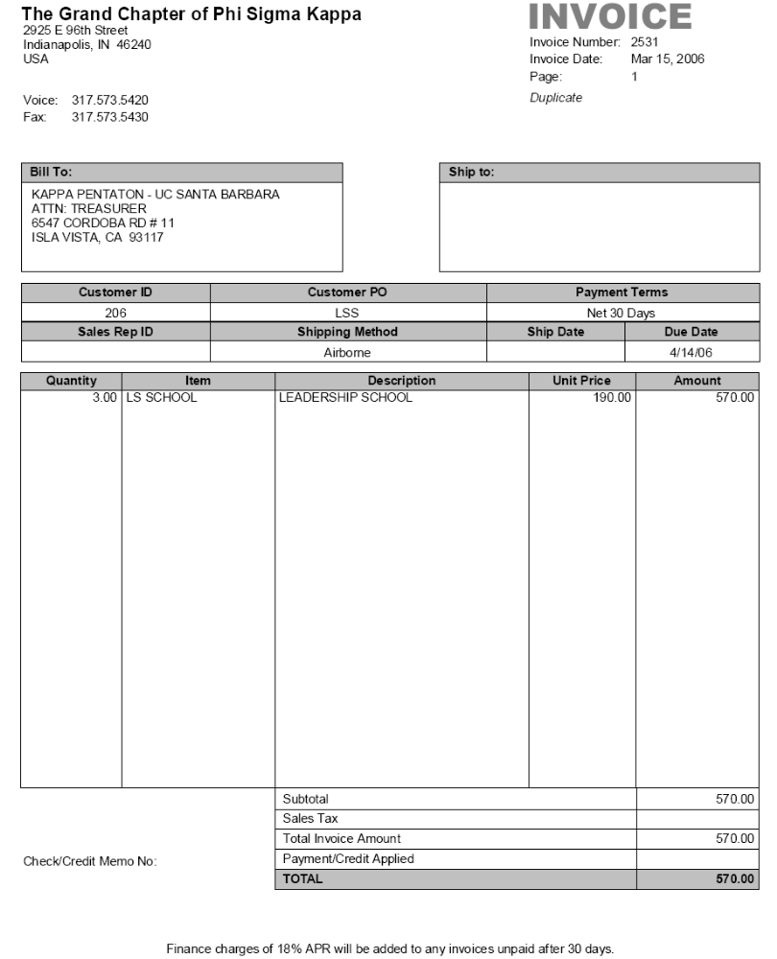

ASSOCIATE AND INITIATE REPORTING PROCEDURES

Associate Reporting

Reporting of Associates
(For Chapters and Colonies)

Instructions for Creating Associates
on Officer Portal

**Only the President, Treasurer, Secretary, and Inductor

may create and report associates**

Steps to create and report associates:
- Login to officer portal: http://officerportal.phisigmakappa.org/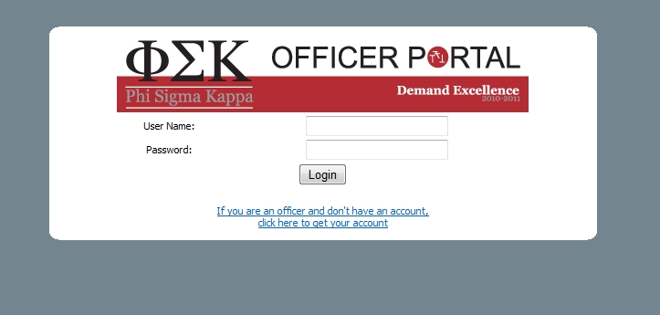

- Click on: ‘Members’ on the left hand side of the screen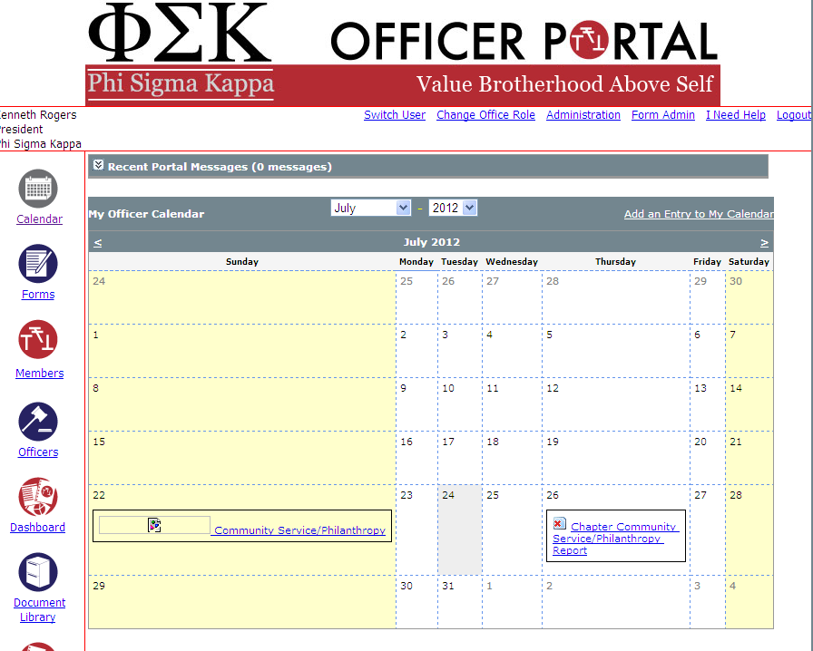

- Under membership changes click ‘Report New Associates’

- 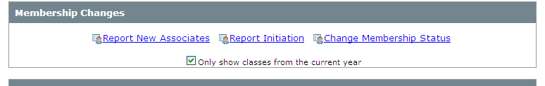

- Click Enter a New Associate Member
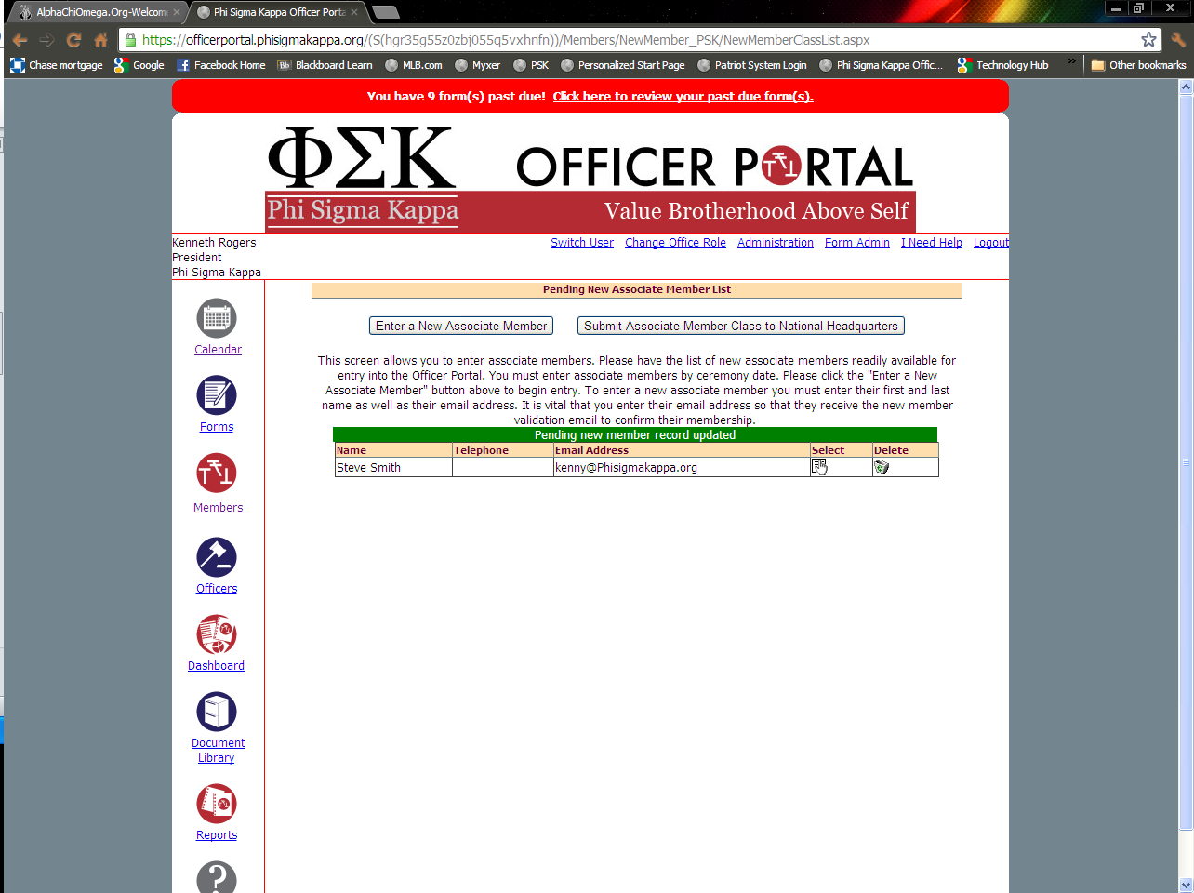

- Select the  icon for each row and fill out the information (See Step 6).

  - If you need to delete a person, click the trash can icon
  - If you need to add additional people, click Enter a New Associate Member
8. Click the Submit Associate Member Class to National Headquarters button
9. Enter the Date of Association and click Submit Associate Member Class to National Headquarters button:
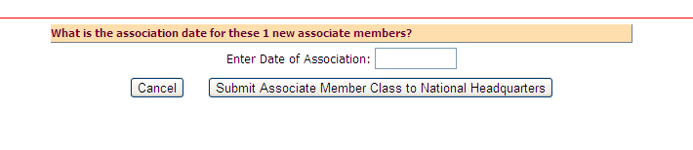
10. After submitting the system will automatically create an invoice and send it to OmegaFi. You may also print for chapter records.
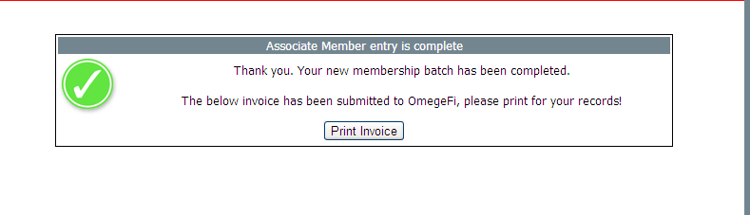

This invoice will have all the charges for your new associate class that the chapter is required to pay
      - You have 4 options for payment:
        - Pay through OmegaFi (preferred)
        - Pay online at www.phisigmakappa.org
        - Send a check or money order and the invoice to: 2925 E. 96th Street | Indianapolis | IN | 46240
        - Call the headquarters at 888-846-6851 and pay over the phone by check or credit card.

What is in a brotherhood kit? The brotherhood kit contains the following items: the Associate Member Pin, a copy of the Hills and a Star, a copy of the Creed and Cardinal Principles, a crest decal, risk management policies, the Brotherhood Examination, and a letter of welcome from the Executive Director.

I. Association:
A. Mandates
1. The Secretary must ascertain from the college/university, or Interfraternity Council, or other relevant group that the candidate is eligible for membership in Phi Sigma Kappa.

- Phi Sigma Kappa policy states that the chapter is to maintain a grade point average above the all male average at the host institution. It is suggested that the chapter choose its candidates accordingly.

B. Ordering materials
1. To assure that Associate Pins and Brotherhood Kits are present at the time of the Ritual of Association, it is recommended that information and monies be relayed prior to the ritual date. Once payment and associate cards are received the Grand Chapter will ship the stated materials to the chapter within 5 business days.

2. Recruitment Orders: faxing associate cards and calling with a credit card will expedite the process. Overnight shipping is acceptable; the extra shipping costs will be transferred to the chapter.

3. It is the policy of the Grand Chapter that inventory of any kind may not be sent without prior payment or authorization.
Initiate Reporting

Reporting for Initiates
(for Chapters only)

Instructions for Creating Initiates
on Officer Portal

**Only the President, Secretary, and Inductor

may create and report Intitates**

Steps to create and report initiates:
- One of the above officers must log into the Officer Portal

- Click on the ‘Members’ icon on the left side of the screen:

- Under membership changes, click create new initiate batch

Provide the following information:
  - Specify the term: fall or spring
  - Specify the current year
  - Specify the initiation date (XX/XX/XXXX)
  - Click create initiate batch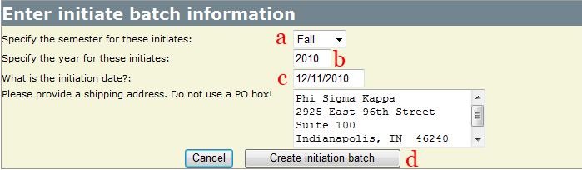

- Verify the following:
      - Initiation date
      - Click on the following icons for each row below the edit column
      - Check the box for the member you wish to initiate
      - Click the Initiate The Selected Men once you have checked all members to include.
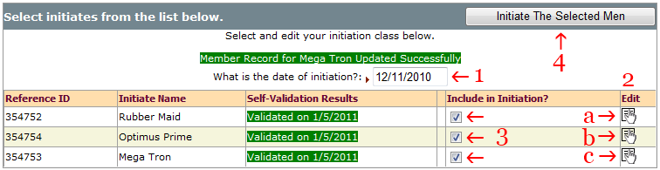

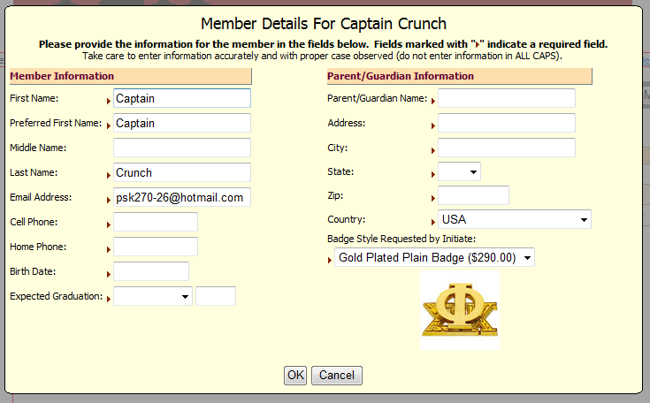
Enter all information. Make sure each initiate has all the required filed filled in, and then click ‘ok’

      - Click on the boxes below Include in Initiation?
- If there, is no box next to an associates name click the link to Resend Validation Link and have the associates validate themselves in the email sent to them.
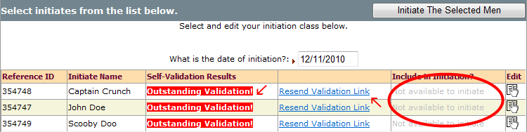
- Please be aware that we cannot initiate an associate until they validate through the email.

      - Click “Initiate The Selected Men”

- Reorder the list of initiates to match the desired roll number order by clicking on the box next to the associate you would like to change and dragging his name to the correct spot in the order (1). When finished, click the "Submit these initiates in this order" button to submit your list of members in order of initiation. (2)
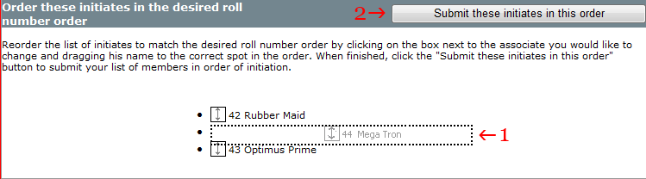

- Submitting the batch will automatically create an invoice which is automatically sent to OmegaFi, you may also print
  - This invoice will have all the charges for your new initiate class that the chapter is required to pay
  - You have 4 options for payment
    - Pay through OmegaFi (preferred)
    - Pay online at http://www.phisigmakappa.org
    - Send a check with the invoice
    - Call headquarters at 888-846-6851 and pay over the phone by check or credit card.

OTHER FINANCIAL MATTERS

Making Payments to the Grand Chapter

There are three ways that a chapter can pay their Grand Chapter bills:
Mail a check to the Grand Chapter. Make the check out to Phi Sigma Kappa Fraternity and mail it to:
Phi Sigma Kappa IHQ
2925 East 96th Street
Indianapolis, IN 46240
Whenever you send a check make sure you include a note stating what the payment is for.

Make a credit card payment by phone. Contact the International Headquarters by phone at 317-573-5420, and state that you would like to make a payment on the chapter’s account using a credit card. Have the credit card number, expiration date, and the name on the card ready.

3. Make a credit card payment electronically. You can pay your chapter bill online using a credit card by going to the following link, https://www.phisigmakappa.org/?action=chapters_paybill. You can also access this section through the main page by visiting, www.phisigmakappa.org, clicking on the chapters section and choosing “pay my bill”. You can also request to be emailed a current copy of your chapter’s financial statement in this section.

Credit Balances

In the past, a number of chapter treasurers have not understood the concept of a credit balance. Hopefully, this section will answer all questions.

A credit balance on the chapter account indicates an overpayment or a credit issued to the chapter. For example, an invoice was paid for the amount of $50 on the twenty-sixth of the month. The treasurer forgets to record the payment and amount. When he receives his monthly statement, the payment has not been posted because the check was not received until the third of the following month. The statement is for all invoices and payment received before the end of the month. The treasurer, having forgotten to record the payment, issues another check for $50 to pay the invoice. He has now overpaid the chapter account.

When this second check is received, if there are other unpaid invoices on the chapter account, the payment will be applied to one of them. If, however, the chapter has a zero balance on its account, the extra payment will be applied to the account in the form of a credit. The treasurer will then receive either a credit invoice (memo) or the next monthly statement will indicate a credit balance.

A credit balance will be shown on a statement or invoice in one of the following ways:
-50.00 or (50.00)

If you receive an invoice or statement in which the total amount due is shown in one of the two ways listed above, DO NOT PAY THE INVOICE OR STATEMENT. Paying the amount only increases the credit balance.

If you have a question regarding credit balances, or receive a credit invoice and are not sure what to do with it, please call the International Headquarters.

Non-Sufficient Funds

Occasionally, chapters will send a check for payment which does not clear with the bank. If this happens the Grand Chapter will place the amount of the check back on the chapter’s account and contact the treasurer (if possible). An additional non-sufficient funds charge of $35 will be billed to the chapter account.

LIABILITY INSURANCE

“Insurance Bill”…The two words that undergraduate members hate to hear most. Your liability insurance bill is likely one of, if not the largest bill, the chapter pays all year. No one likes paying it, and everyone thinks the cost is ridiculous. Unfortunately, whether we like it or not, insurance is a necessary evil in today’s fraternity world. We live in an era where lawsuits are filed everyday, and fraternities are at high risk.

In addition, just about every college and university in the country is not going to allow your chapter to operate without at least $1 million in liability coverage. The fact is, the insurance bill isn’t going away and as treasurer it is your responsibility to collect the appropriate funds and make the payment.

- This payment is NOT made to the Grand Chapter. The check should be made out to HRH/ Kirklin & Co. and sent directly to their offices at:
By U.S. Mail: By FedEx, UPS, DHL, etc:
PO Box 540637 12231 Emmet St., Ste. #5
Omaha, NE 68154 or Omaha, NE 68154

- Payment should be made on time and in full. The insurance company assesses a $500 late charge on any late payment.

- Your chapter cannot and will not operate without insurance coverage. If a chapter does not make its liability insurance premium payment they will be denied coverage and will be put on immediate suspension. If the situation is not corrected, the chapter will be closed.

How to Reduce your Premium

The amount per man for your liability insurance is affected by your chapter operations. Each chapter begins with a base rate that is adjusted by the Premium Allocation Guidelines (see appendix). There is a good chance your chapter could lower your insurance premium and not be taking advantage of it.

For example, you can lower your cost by simply making sure your bills are paid on time. Chapters that are in good financial standing with the Grand Chapter receive a discount on their insurance premium. Likewise, not paying your bill on time is going to cost the chapter additional funds. Chapters that are carrying an overdue balance will receive a penalty on their insurance premium. Just one more reason why it pays to stay current with your dues to the Grand Chapter.

To see all the penalties and discounts possible make sure you review the Premium Allocation Guidelines in the appendix. As chapter treasurer it is your responsibility to make sure your chapter is paying the lowest possible insurance premium.

TRAINING YOUR SUCCESSOR

Financial Continuity

To provide for continuity in financial matters and thus sound chapter management, the proper training of your successor is critical. At the time a treasurer is elected, those interested in becoming the assistant treasurer should come forward. After some time, an assistant treasurer should be appointed to act as the treasurer’s understudy, and it should be understood that this understudy will be the sole nominee for the respective position for which he is to be trained when the succeeding election is held. This should assure the election of a man to the position of treasurer who is well versed in the work and who has proven his capability for the job.

Electing and Training the Assistant Treasurer

Step One: Search
The treasurer begins the search for an assistant treasurer during his first semester in office. Several announcements are made to determine if any members are interested in the job. The treasurer should seek out individuals who he believes will make a good assistant. Discussion of the office is established with the interested members. Everyone must understand that a failure to come forward may preclude them from a decision to run for treasurer at a later date.

Every interested member should have the opportunity to enter the training program. This is not the step at which the treasurer makes a value decision about who may or may not make a good treasurer.

Step Two: Study
The training program should be designed to give a good representation of the position and to identify who can handle the job.
The treasurer at this time will gather all prospective treasurers together and begin the following study program.

- A brief talk about what it is like to be treasurer
  - Position Description
  - Goals
  - Responsibilities
- Everyone receives a copy of the treasurer’s manual
- The final step in the “Study Stage”
  - Bank Accounts
  - Bookkeeping
  - Administrative Duties
  - Collections
  - Insurance
  - Budgeting
  - Paying Bills
  - Taxes

Step Three: Assuming Workload
This stage should begin the second month during the treasurer’s term. The treasurer should make his final call for members interested in the office. A member who comes forward at this point will have to do some catch-up work on step two.

The treasurer should gather the prospective treasurers together and review what they have done. The treasurer should answer questions and address any concerns. He should place special emphasis on the responsibility and time commitment involved with the position.

Now the treasurer will begin to delegate the workload. All prospective candidates should work on and complete financial reports from the beginning. This allows the treasurer to discover difficulties and explain the functions of the financial report. Other responsibilities are delegated and rotated among the candidates --- i.e., issuing bills, collection of payment, etc.

The treasurer should then observe the work of the prospective treasurers. He should give each candidate an honest evaluation of his performance. If there is hesitation about one’s ability to handle the job, the matter should be honestly and openly discussed. Increasing an individual's workload is a good way to find out how he will handle the job.

Step Four: Election of the Assistant Treasurer
The assistant treasurer is an elected position. He should be elected early in the current treasurer’s second semester in office. In reality you are electing your next treasurer a semester ahead of time, but he will not be installed in office until it is time for the current treasurer to step down.

The treasurer should give the chapter his honest evaluation of the qualifications of all the candidates. If an individual is clearly unqualified, he should inform the chapter of this fact. In the event an individual runs for assistant treasurer and he has not participated in the preliminary training program, the treasurer should explain to the chapter how this could cause problems (unless the individual has previous experience that can take the place of the preliminary training).

Step Five: Transition
This step begins following the election of the assistant treasurer. The treasurer should work closely with this individual. The assistant treasurer should be incorporated into all facets of the treasurer’s work and responsibility, and workload should gradually be shifted to the assistant treasurer. The assistant treasurer should also review step two. Information and responsibility should not be transferred so fast that the assistant treasurer cannot absorb what is happening. A majority of the treasurer’s responsibility should be turned over to the assistant treasurer by the time the regular chapter election occurs.

Step Six: Post Election Training
A new treasurer encounters many issues that are unfamiliar and for which the solution may be uncertain. In this case, the former treasurer should continue working closely with the new treasurer to help when an issue arises.

The former treasurer may now serve as an advisor, no longer the final decision-maker. The former treasurer, however, should continue to perform on a regular basis many of the training tasks. A former treasurer has a responsibility to make sure that the new treasurer knows what needs to be done and is doing it correctly. Likewise, a treasurer must be willing to listen to the advice of a former treasurer and to go to him for help when it is needed.

The goal of the training program is to prepare the treasurer-elect to handle the job of the chapter treasurer. This goal cannot be accomplished if the outgoing treasurer does everything and makes all the decisions for the incoming treasurer. The treasurer-elect should learn to think for himself and come up with the answers to chapter financial issues.

TREASURER’S CHECKLIST

1. Did you completely review the office with the out-going treasurer?

2. Do you have an accurate record keeping system?

3. Are you working under a budget at the present time?

4. Is it a feasible budget and are you following it?

5. Does your chapter have a budget committee?

6. Is your chapter income adequate to meet your expenses? (Always underestimate income and overestimate expense by at least ten percent.)

7. Are your financial bylaws updated and workable?

8. Do you have a finance committee to handle any violations of the financial bylaws of the chapter and to help establish and enforce all policies affecting finances in the chapter?

9. Have all live-in members signed housing contracts?

10. Do you have promissory notes on all accounts?

11. Have you sent statements and or bills to delinquent alumni?

12. Have you followed all possible legal actions on people refusing to pay bills?

13. Were the books audited at the time of your installation in office?

14. Have you made the necessary changes to all checking accounts so that your signature and the current president’s signature are required on each check?

15. Do you authorize all purchases?

16. Do you issue receipts for all payments (especially needed when being paid in cash)?

17. Are your bills standardized, coming out at the same time each month and due at the same time?

18. Do you prepare individual members’ bills from your worksheet?

19. Are advanced payments encouraged?

20. Do you prepare weekly status reports for the chapter meetings?

21. Are you up-to-date on loan payments, housing corporation payments, and accounts with merchants in the community?

22. Do you have adequate insurance on the house, and does it reflect a current assessment of the property?

23. Do you prepare weekly status reports for the chapter meetings?

24. Do you or your alumni have any type of savings program to fall back on in case of an emergency?

25. Is excess money deposited in a savings account and drawing interest?

26. Does the chapter file an annual 990 form with the IRS?

27. Do you have a supply of all forms and know when and how to fill them out?

28. Are all associates or initiates reported and paid on time to the Grand Chapter?

29. Do members make associate or initiate fee payments out directly to the Grand Chapter?

30. Do you have an assistant to help with time consuming duties?

31. Do you have records on wholesalers and retailers where the chapter buys, including whether or not they have given good service in the past?

32. Do you have an up-to-date materials price list and order forms in your possession?

33. Are these materials ordered ahead of time and are the order forms utilized?

34. Have you collected a damage deposit from each member? Is it kept in a separate savings account so it won’t be spent?

APPENDIX

Individual Housing Contract

Promissory Note

Financial Obligations Contract

Sample Collection Letters

Insurance Premium Allocation Guidelines

INDIVIDUAL HOUSING CONTRACT

Student’s Name
(First Name) (Middle Name) (Last Name)

Student’s Home Address
(Number & Street) (City) (State) (Zip)

Student’s Home Phone Number ( )

Student’s Social Security Number_________________________________

Contract Term (check as applicable):

Fall Term Spring Term Academic Year

Security Deposit Amount: $

Term Charges: $

FOR GOOD AND VALUABLE CONSIDERATION, (Name of chapter) (hereinafter referred to as the “Chapter”) of Phi Sigma Kappa Fraternity (hereinafter referred to as the “Fraternity”), the Student named above (which student is hereinafter referred to as the “Individual”) and the individual’s undersigned parent(s) or legal guardian(s) do hereby mutually covenant and agree as follows:

1. Residence in Chapter House; Membership Status. The Chapter shall furnish room (and board) to the Individual in the chapter house occupied by the Chapter at (chapter address) during the portion(s) of the academic year specified above of the (name of University) (hereinafter referred to as the “University”). The Individual shall reside in the chapter house and take board therein during such period subject to the terms and conditions of this Contract. The Individual understands and agrees that residency in the chapter house is limited to members in good standing with the Fraternity who are regularly enrolled students at the University. If the Individual named above fails to comply with this Contract or his status as a member of the Fraternity or regularly enrolled student terminates for any reason, this Contract may be terminated as provided in Section 17.

2. House Corporation. The Chapter leases the chapter house from (legal name of facility corporation) (hereinafter referred to as the “House Corporation”). The Individual and the Chapter grant rights to the House Corporation hereunder which are essential terms of the Chapter House Lease Agreement and are hereby incorporated by reference and made a part of this House & Use of House Contract. The Individual agrees to abide by the terms of the Chapter House Lease Agreement.

- Enforcement. The Individual agrees that each of the Chapter and the House Corporation has the right and standing, in its own name and on its own behalf, to enforce this Contract, including, without limitation, the right to bring actions to enforce the terms of this Contract, to collect amounts due from the Individual hereunder including Chapter and Fraternity charges and to terminate this Contract.

- No Agency; Joint Obligation. None of the Chapter, the Individual or his/her guests is a subordinate or agent of the House Corporation or the Fraternity and none of them shall, at any time, represent themselves as such. The Chapter is an unincorporated association comprised of its members, including the Individual. As a member of the Chapter, the Individual is jointly responsible and liable for and guarantees (on an equal basis with other members of the Chapter) the performance of the Chapter’s obligations to the House Corporation and the Fraternity.

- Other Services. The Chapter shall provide to the Individual such services as are customarily furnished by the Chapter to residents of its chapter house, subject to this Contract; the bylaws, standing rules and policies of the Fraternity; and rules and regulations of the Chapter. So long as he is a member in good standing of the Fraternity, the Individual shall also be entitled to all other benefits of membership in the Fraternity.

6. Charges; Payment. In consideration for room, board and the services described in the first sentence of Section 5, the Individual shall pay to the Chapter the applicable term charges specified above for each semester during the term of this Contract. The Fall Term charges shall be paid (in two equal installments on August 1 and October 1). The Spring Term charges shall be paid (in two equal installments on December 1 and February 1). The Individual shall pay for the membership benefits described in the second sentence of Section 5 and any charges assessed under Section 12 when and as billed by the Chapter or the Fraternity.

7. Security Deposit. The Individual shall pay to the Chapter upon execution of this Contract a security deposit in the sum specified above. The deposit may be applied to remedy any default of the Individual under the terms and conditions of this Contract and shall be refunded upon the Individual’s full performance of his/her obligations under this Contract.

8. Room Assignment; Public Areas; Guests. This Contract is for living space in the chapter house and not for any particular room. The Chapter reserves the right to assign the Individual named above to a room and to change his room assignment according to Chapter policies. The Individual named above shall be permitted to use the public areas of the chapter house and to invite and host guests at the chapter house; provided that all guests shall be subject to and abide by the terms of this Contract to the same extent as the Individual, the Individual shall take all steps necessary to assure that his guests abide by this Contract and the Individual shall be financially responsible for any claims, damages, losses, expenses or liabilities arising out of the acts or omissions of his/her guests.

9. Occupancy. The chapter house shall be available for occupancy (from the third Sunday before the beginning of Fall Term to the end of Spring Term final examinations; provided, however, that the house will be closed from the end of Fall Term final examinations to the second Sunday before the beginning of Spring Term and during Spring Vacation).

10. Board. Board shall be available from the first day of (classes) (workweek) through the last day of (classes) each term. Board shall consist of (ten) meals per week, to be served on the days and at the times determined by the Chapter, subject to the approval of the House Corporation. No meals will be served on University holidays or during vacations. The Chapter shall not be responsible for meals not served for reasons beyond its control.

11. Residential Use; Compliance with Legal and other Requirements. The Individual shall use the chapter house only for residential purposes, and neither the Individual nor his guests shall use his room or any other portion of the chapter house property for any purpose or in any manner which violates the law or constitutes a nuisance. The Individual and his guests shall at all times comply with all local, state, and federal laws, ordinances and regulations; rules, regulations and policies of the Chapter, the House Corporation, the University and any insurer of the Chapter, House Corporation or Fraternity; and Fraternity Standards.

12. Care of Property. The Individual shall take good care of the chapter house and its furniture, furnishings and equipment, shall keep them in a neat, clean and orderly condition, shall suffer and permit no waste to be committed in or upon them, and shall make no alterations or additions to the premises without the prior written consent of the Chapter and the House Corporation. The Chapter and the House Corporation may charge the Individual for any special services which either of them provides, or any special costs which either of them incurs, in connection with the Individual’s use or misuse of the chapter house or Chapter or House Corporation property. Upon the expiration or other termination of this Contract, the Individual shall promptly upon request of the Chapter or the House Corporation remove his/her personal property from the chapter house and shall peaceable surrender possession of the premises and property in clean condition and good repair, ordinary wear and tear resulting from careful usage alone excepted. After surrender of possession by the Individual, the Chapter and House Corporation shall have the right to dispose of any personal property left by the Individual in or on the chapter house premises, and the Chapter and House Corporation shall not be responsible to the Individual to account for the disposition of such property. The Individual shall not affix any items to the doors of his/her room. The Individual shall not drive any nails or screws into the woodwork, walls, or ceilings of his/her room and shall be responsible for any damage caused by items affixed thereto.

13. Rules. The Individual named above and his guests shall, in addition to complying with the provisions of Section 11 of this Contract, observe the following rules: (a) no animals or pets whatsoever shall be brought or kept on the chapter house property, (b) access to or use of the roof is prohibited, (c) tampering with or disabling any life safety system or devise is prohibited, (d) flammables, bicycles and motorcycles shall be stored outside in designated areas, (e) the possession of firearms or other weapons on the chapter house property is prohibited, (f) the use of burning candles in the chapter house is prohibited, and (g) the use or possession of alcohol or illegal substances is prohibited on the chapter house property.

14. Right of Inspection. The Individual agrees that the House Corporation may, and the House Corporation reserves the right to, enter the Individual’s room without prior notice for the purpose of inspecting the room and its contents to ascertain compliance with the terms of this Contract, to assure the safety of occupants of the chapter house and to make such repairs, alterations, additions, and improvements as the House Corporation may deem necessary or desirable.

- Insurance. The Chapter, the House Corporation and the Fraternity, and their respective officers, directors, employees, and agents shall not be responsible for any injury, loss, or damage to the Individual or the Individual’s property resulting from fire, theft, or other cause. The Individual agrees that she alone is responsible for securing personal insurance protection against such things as accident, sickness, injury or death, damage to or loss of their property and legal liability imposed on him for damage to persons or property. The Individual is expected to insure any property that she brings onto the chapter house premises against the risk of loss or damage, and proof of insurance may be required as a condition of occupancy. The Individual agrees, provided such agreement does not invalidate any policy of insurance, that in the event of a claim against his for injury to persons or damage to property, insurance coverage, if any, under any policy of insurance secured or maintained by the Chapter, the House Corporation or the Fraternity shall specifically be excess of and shall not contribute with any insurance otherwise available to the Individual. The Individual further agrees, provided such agreement does not invalidate any policy of insurance, that in the event his property is damaged or destroyed or she is injured, and his loss is covered by insurance maintained by or for the benefit of the Individual, she hereby waives any rights of recovery or subrogation against the Chapter, the House Corporation or the Fraternity.

16. Indemnification. The Individual acknowledges and agrees that she is responsible and liable for his personal actions and those of his guests and invitees, including, but not limited to, negligent or intentional acts, errors or omissions. The Individual agrees to defend, hold harmless and indemnify the Chapter, the House Corporation and the Fraternity, and their respective officers, agents, employees and volunteers, from and against any claims, damages, costs or expenses, including attorney’s fees, financial loss, or any loss or damage to property or for injury or death to any person, arising in any way out of the acts or omissions of the Individual or his guests, including, but not limited to, negligent or intentional acts, errors and omissions, or any breach of this Contract by the Individual, his/her guests, invitees or agents.

17. Termination. The Chapter or the House Corporation may terminate this Contract if the chapter house becomes uninhabitable by reason of fire, windstorm, or other similar catastrophe. The Chapter or the House Corporation may elect to cancel or terminate this Contract and take possession of the Individual’s room, upon ten days written notice of such election, if the Individual fails to comply with any of the terms and conditions of this Contract (including a loss of membership). In such event, the Individual shall remain obligated in accordance with this Contract for all charges for the remainder of the term of this Contract, as well as any losses, damages or expenses incurred by reason of his default, including, without limitation, costs and expenses incurred to recover possession of the Individual’s room or to collect any amounts due from the Individual.

18. Amendment; Assignment. This Contract shall not be amended except in a writing signed by all of the parties with the written consent of the House Corporation. The Individual shall not sell or assign this Contract without the prior written consent of the Chapter and its House Corporation. No modification of this Contract shall be effective unless it is made in writing and is signed by the Individual, the Chapter, and its House Corporation.

19. Liability of Parent/Guardian. The undersigned parent(s) or legal guardian(s) shall be jointly and severally liable for the Individual’s full and faithful performance of the terms and conditions of this Contract.

20. Governing Law. This Contract is made with reference to and shall be construed in accordance with the laws of the (State of_______) in which state it shall be performed by the parties. Any action arising under the terms and conditions of this Contract may be brought in any local, state or federal court located in the (County of __________), (State of _________), having jurisdiction of the subject matter, and the undersigned parties hereby consent that any such court shall have personal jurisdiction over them with respect to any such action.

IN WITNESS WHEREOF, the Chapter, the Individual, and the Individual’s undersigned parent(s) or legal guardian(s) have caused this Contract to be executed as of the ____ day of ______, 2___.

(NAME OF CHAPTER) OF
PHI SIGMA KAPPA FRATERNITY

By President: _____________________________________________________

By Treasurer: ___________________________________________________

INDIVIDUAL: ______________________________________________________

PARENT OR GUARDIAN: _________________________________________

Parent/Guardian Information (Please Print)

Name(s)

Home Address(es)
(Number & Street) (City) (State) (Zip)

(Number & Street) (City) (State) (Zip)
Home Telephone Number(s) ( ) ( )

Work Telephone Number(s) ( ) ( )

PROMISSORY NOTE

Amount: $ Date:

FOR VALUE RECEIVED, I {name of individual } (hereinafter the Maker) promises to pay to {name of chapter or alumni association } of Phi Sigma Kappa (hereinafter the Holder), located at {street address }, in the city of {city }, in the state of {state}, the principal sum of {amount spelled out } United States Dollars (USD${number amount}) (hereinafter the Principal). Principal shall be payable according to the following schedule:

$ due , 20
$ due , 20
$ due , 20
$ due , 20

If any amounts payable hereunder are not paid within five (5) business days of their respective due dates then, (A) thereafter such amounts shall bear interest at the annual rate of eighteen percent (18%), and (B) the Holder shall have the right to accelerate the indebtedness evidenced by this Note and seek by all available legal remedies recovery of such entire sum, together with its cost of collections including attorneys’ fees and legal expenses. This note may be pre-paid in whole, or in part, without penalties.

This Promissory Note is given by the Maker and accepted by the Holder hereof pursuant to a transaction contracted , negotiated, and consummated in {State }, and shall be governed by and construed in accordance with the laws of the State of {State }.

This Note shall be binding upon the Maker. Neither this Note, nor any rights hereunder, shall be pledged, assigned, sold, transferred, or otherwise encumbered by without written consent of the Holder.

Continued on Next Page.

Executed on behalf of the Maker
This _____ day of , 20

BY: ____________________________
(Maker Signature)

____________________________
(Printed Name)

____________________________
(Chapter President or Treasurer)

____________________________
(House Corp. President or Advisor)

STATE OF )
) SS:
COUNTY OF )

Before me, a Notary Public, in and for said County and State, personally appeared __________________________ (chapter president) and _________________________ (chapter treasurer), who acknowledged the execution of this document as President and Treasurer of Beta Pentaton Chapter of Phi Sigma Kappa.

___________________________________
Notary Public

My commission expires: Residing in __________________ County
___________________

FINANCIAL OBLIGATION CONTRACT

I, {name of member/ associate} fully understand that by signing this contract, I vouch for my indebtedness to the {chapter name} Chapter of Phi Sigma Kappa Fraternity in the amount of {amount spelled out } United States Dollars (USD${number amount}).

This amount is made up of:

Associate Fee: $ payable on , 20
Initiate Fee: $ payable on , 20
Membership Dues: $ payable on , 20
Insurance Dues: $ payable on , 20
Room: $ payable on , 20
Board: $ payable on , 20
Etc: $ payable on , 20
Etc: $ payable on , 20
Etc: $ payable on , 20

I understand that payment of $ is due on , 20 unless alternative arrangements are made in writing with the {chapter name} Chapter Treasurer. If I do not pay by , 20 , I forfeit my right to membership in Phi Sigma Kappa, and the chapter has the right to pursue collection of funds owed by use of a collection agency and/or small claims court. I also understand that the {chapter name} Chapter of Phi Sigma Kappa may proceed with my expulsion from the fraternity if this financial obligation is not met. Of these obligations, I am fully aware and sign on my own free will.

Executed on this _____ day of , 20

____________________________
(Member Signature)

____________________________
(Printed Name)

____________________________
(Chapter President or Treasurer)

____________________________
(House Corp. President or Advisor)

SAMPLE COLLECTION LETTERS
Letter 1:
Dear Brother:

Your Chapter bill dated (date) is now considered past due. As Chapter Treasurer, I have the unpleasant task of having to write on behalf of Phi Sigma Kappa regarding your overdue account. According to our records, as of today you have an overdue balance of $_____________.

I would appreciate it if you could enclose a check payable to Phi Sigma Kappa Fraternity in that amount and return it in the enclosed envelope prior to ___________. If you are not able to pay the entire amount at one time, I would be happy to help arrange a suitable payment schedule so the entire amount may be paid off as soon as possible.

I know you will meet your responsibility and will settle the matter quickly. If you have any questions or would like to arrange a payment plan, please contact me at (contact information).
Fraternally,
[Name]
Chapter Treasurer

Letter 2:
Dear Brother:

On (date), I wrote to you concerning your past due account of $__________, asking for payment. As yet we have not received any response from you; therefore you have been placed on suspension until payment is received.

The chapter needs to collect this outstanding balance. If you do not immediately satisfy your obligation in full, your name and the amount owed will be forwarded to a collection agency for collection. Our intent is to use all possible means of legal action to collect on this money.

If you have any questions as to the amount due or making payment on your bill, please do not hesitate to contact me at [phone #], or the (president, advisor, alumni board president) at [phone #].

Thank you for your immediate attention.
Fraternally,
[Name]
Chapter Treasurer

Letter 3:
Dear Brother:

I, on behalf of the chapter have been requested to approach you regarding your outstanding account.

According to chapter records, as of today you have an overdue balance of $___________. As you may recall, you received two letters from the treasurer of the chapter stating the overdue amount.

There is no reason for a member of our chapter after receiving two collection letters to still have a delinquent account.

The overdue account needs to be rectified immediately. This can be done by enclosing a check payable to Phi Sigma Kappa Fraternity in the said amount, and returned in the enclosed envelope prior to ________________. If you are not able to pay the entire amount at one time, I would be happy to help arrange a suitable payment schedule so the entire amount may be paid off as soon as possible. I can be contacted at (contact information).

I sincerely hope we can remedy this situation. Please settle this matter, as quickly as possible or legal action to collect on this money will be taken.

Fraternally
[Name]
Chapter Advisor/ Alumni President

Letter 4:
Dear Brother:

Three letters have already been sent to you requesting the payment of your debt of ________________. To date, no satisfactory reply has been received from you.

We will be obligated to take legal action to collect this amount due the chapter unless we receive your remittance by __________________ (One week from the date of the letter), at the latest.

We feel that we have dealt with you both courteously and patiently, but we cannot continue to carry your obligation. This will be your last opportunity to satisfy your financial obligation in full without facing legal repercussions.

Fraternally,
[Name]
Treasurer/ Advisor/ Alumni President

If there is no response at this point you should send the account to a collection agency.

Phi Sigma Kappa Insurance Premium Allocation Guidelines

All Discounts and Additions will be applied only to the Insurance Premiums.

Discounts

- Alcohol-Free Housing: -10%
Those chapters that have elected or been required to become alcohol-free will receive a discount of 10%. Chapters must submit written notice to the Grand Chapter of their status by July 1 to receive the discount.

- No Housing: -10%
Those chapters with no formal housing will receive a 10% discount.

- Outstanding Chapters: -5%
Those chapters receiving the Herbert Brown Outstanding Chapter Award at Leadership School will receive a 5% discount.

- Automatic Colony Discount: -20%
All colonies receive an automatic 20% discount.

- Attendance at Leadership School or General Convention: up to -15%
Chapters who are represented at the Shonk Leadership School or a General Convention will receive a discount in their liability premium according to the following table:
3 delegates, -10% 4+ delegates, -15%
      - Delegates whose registration is paid for by the Grand Chapter or Foundation do not count towards the total number registered for their chapter (i.e. Zillgitt Institute Delegates)

- Increase in Number of Initiates: up to -5%
Chapters will receive a 1% discount for each new member (up to a maximum 5% discount) they initiate above the last year’s initiate total for their chapter.

- Increase in Chapter Size: up to -5%
Chapters who have increased their chapter census from the prior year will receive a 1% discount for each man increase (up to a maximum 5% discount) over the previous year’s figure. Census figures will be derived from the fall insurance billings.

- Outstanding Financial Chapter: -5%
Those chapters carrying a $0.00 balance or a credit balance with the Grand Chapter on August 31, 2006 will receive a 5% discount. Chapters with open payment plans are not eligible to receive this discount.

- Installed Sprinkler System: -10%
Chapters living in housing that is 100% sprinkled in living and common areas (not including attic or basement, unless inhabited) will receive a discount of 10%. This does not apply to those chapters with no housing.

Additions

- Phi Sigma Kappa Risk Management Policy Violations: see below
1. Should a chapter/colony have violated any of the Alcohol or Drug Policies (#1-13) during the fiscal year, a 10% penalty will be applied for each policy violated, up to a maximum penalty of 20% per incident, as determined by the Grand Council.
2. Should a chapter/colony have violated the hazing policy (as described in the Risk Management Policies) during the fiscal year, a 10% penalty will be applied, as determined by the Grand Council.
3. Should a chapter/colony have violated any risk management policy during the fiscal year, they may forfeit any discounts received upon a subjective review by the Grand Council or Director of Finance and Administration.

- Lack of attendance at Leadership School or General Convention: +5%
Educational sessions at these annual meetings focus directly on Phi Sigma Kappa Risk Management Policies and Practices. Failure to have delegates of your chapter attending these sessions indicates that the chapter is not receiving the same risk management education as other chapters and therefore is at a higher level of risk.

- Lack of attendance at Regional Conclaves: +5%
Educational sessions at these annual meetings focus directly on Phi Sigma Kappa Risk Management Policies and Practices. Failure to have delegates of your chapter attending these sessions indicates that the chapter is not receiving the same risk management education as other chapters and therefore is at a higher level of risk.

- Not Participating in Fall and Spring Risk Awareness Weeks: +5% (for each)
If a chapter fails to participate in Fall and Spring Risk Awareness Weeks, it will be assumed that the chapter has not educated its members on the Grand Chapter’s risk management policies and practices. Therefore, the chapter would be considered to have a higher level of risk. Chapters would receive credit for participating by returning the completed certification forms by the deadlines.

- Financially Delinquent Chapter: up to +20%
Any chapter with a past due balance (defined as any balance greater than $100 over 31 days past the date of the original posting) as of June 30th will receive an addition according to the following table.
Chapter Balance | % Increase
$100 - $499 | 5%
$500 - $999 | 7%
$1000 - $1499 | 10%
$1500 - $1999 | 13%
$2000 - $2499 | 15%
$2500 - $2999 | 17%
$3000+ | 20%
Chapters that are on payment plans (defined as chapters that have signed a promissory note and have had a balance transferred to a ‘399’ account) will not have their payment plan balance susceptible to the above increases. If, however, they have fallen behind on their designated payments, the total amount of past due payments will be added to their current account balance and this number will be used to calculate the addition.

- Failing to Respond to Chapter House Life Safety/Loss Control Recommendations: see below
The penalties listed in the table below would apply to those chapters failing to respond to the recommendations from the on-site inspections (performed last fall). The inspection program has placed chapters into one of the three categories defined below:
- Good Ranking – None or only minor recommendations
- Needs Improvement Ranking – Several or major recommendations
- Poor Ranking – Numerous and major recommendations

Response Scale Rating
Good Needs Improvement Poor
Complete Response……………………………0% 0% 0%
Partial Response………………………………+3% +5% +10%
No Response………………………………….+10% +25% +35%

- Claims History: up to +35%
Chapters with insurance claims in the previous 5 years will receive an addition according to the following table:
One Claim: Closed with no payment 0%
Open or Closed with payment or reserve <$3500 +5%
Open or Closed with payment or reserve of $3500-$10,000 +10%
Open or Closed with payment or reserve >$10,000 +25%

Two Claims: Closed with no payment +3%
Open or Closed with payments and reserves <$3500 +10%
Open or Closed with payments and reserves of $3500-$10,000 +25%
Open or Closed with payments and reserves >$10,000 +30%

Three Claims: Closed with no payment +5%
Open or Closed with payments and reserves <$3500 +15%
Open or Closed with payments and reserves of $3500-$10,000 +30%
Open or Closed with payments and reserves >$10,000 +35%

