The unbearable costs of sprawl
On top of the soaring costs of crumbling infrastructure, health impacts and ecological damage, we must now add the global economic crisis itself – triggered by the unsustainable economic patterns of sprawling American suburbs. But new solutions are emerging to re-structure a generation of vibrant, successful neighborhoods.

A Policy White Paper by:
Michael Mehaffy , Sustasis Foundation, Portland, OR
Galina Tachieva, Congress for the New Urbanism “Sprawl Retrofit Initiative”
Laurence Qamar, DPZ Cascadia Group
Mary Vogel, PlanGreen

With contributions from
John Holtzclaw, The Sierra Club
Christopher Leinberger, The Brookings Institution

Introduction: Converging forces and the end of “Business as Usual”

History records that the sprawling American suburbs were Ground Zero of the global financial crisis of 2008-2010. It was here that millions of American homebuyers used unsustainable financial means to buy far-out homes in artificially cheap, “drive ‘til you qualify” suburbs. Buyers drove increasingly farther away from jobs and services, to increasingly remote, car-dependent enclaves that offered apparently cheaper homes - at least, until the true costs of transportation, furnishing and home heating and cooling were factored in. This set the stage for financial disaster.

Many of these homes were bought with adjustable-rate mortgages, artificially lowered for an initial period after sales (and with hefty commissions for agents and brokers). Homebuyers had to wager that their incomes would rise, or they would be able to sell their homes for more money later, to cover any shortfall. Worse, many of these same homeowners took out second mortgages, sometimes on top of car loans for low fuel efficiency cars, high-interest credit card balances, and other mounting debts.

Adding to this precarious situation, in 2007, a convergence of rising energy prices, mortgage interest re-adjustments, and a normal cyclical recession, triggered a wave of mortgage defaults. Because these instruments were no less highly leveraged, the defaults quickly cascaded into a wider series of defaults by mortgage companies, banks -- and ultimately, governments around the world.

It’s clear in retrospect that we had built a global financial house of cards. And this “house” was much like the American suburban domicile: over-reliant on high consumption, artificially low initial costs, heavily leveraged with staggering debt -- and therefore, unable to withstand relatively ordinary economic shocks. In the parlance of systems theory, this was not, to say the least, a resilient system.

As Christopher Leinberger of the Brookings Institution reports, “what we face today is not just a cyclical housing problem, but a structural one as well.” Over the past decade, he writes in The Atlantic (June 2010), most house building occurred in the heavily auto-dependent suburban fringe, “in large part because that’s where houses could be built most easily and quickly. But now that the bubble has popped, we can clearly see that underlying demand in these areas is extremely weak, and oversupply is massive.”

This was the acute crisis of 2008-2010. But it was, in a sense, the “warning shot” of a much broader convergence of forces that is likely to cause even deeper damage to the world’s economy in the future, if the underlying problems are not addressed. We can describe these converging forces as follows:

- Continued precipitous rises in energy costs. The fuel of suburban expansion, and of other forms of rapid and non-resilient growth, has been historically cheap energy fueled by abundant petroleum – an era that is coming to an end. As demand continually exceeds remaining supplies, the price of oil – and of other fuels traded within global energy markets – is likely to continue to increase, sometimes dramatically. This is likely to place even more financial stress on outer, car-dependent suburbs with large, energy-demanding homes – and on the economies that continue to rely upon this suburban pattern of consumption to fuel economic growth.
- Declining revenues available for continued infrastructure operation and maintenance. Local governments have been able to sustain the increasing cost of operating and maintaining sprawling infrastructure with higher system development charges on new development – but that “pyramid” scheme has shown its vulnerability in the current recession, as the funding from new development has dried up. The result, combined with other financial stresses from lost revenues and investments, has been financially catastrophic for many local governments.
- Restricted credit markets. The easy credit that made this scheme possible has given way to a new era of tight credit, making it all the more difficult to sustain existing sprawl developments and mitigate their negative impacts -- and that puts new developments in an even more precarious situation.

THE CHALLENGE: Rising costs of obsolete sprawl

Added to these external converging forces, we can expect the internal costs of sprawl to continue to grow, placing even further stresses on the finances of governments and homeowners alike. They can be summarized:

- Infrastructure and maintenance. Many older sprawling subdivisions are now entering critical periods of infrastructure maintenance, at a time when governments are even less able to cope with these soaring costs. As energy prices rise, so to do operating and maintenance costs – placing even more stresses on financially strapped governments.
- Physical health and its associated costs. Soaring rates of obesity and diabetes have been linked by the US Centers for Disease Control and other researchers to a car-dependent, “drive-through” suburban lifestyle – one that affords little opportunity for walking or other forms of healthy living. Suburban environments have also been linked to rising rates of asthma and other respiratory disease. All of these increased rates of disease translate into higher health costs, at a time when the cost of health care is already a serious strain on recovering economies.
- Environmental damage, including climate change. The long-term economic impacts of environmental damage caused by sprawling, high-emissions development, including climate change, have been assessed by many entities including insurance company research departments and others. The loss of so-called “ecosystem services” – such as purification of water and air – could total many billions of dollars. The impact of climate change on agriculture alone, in the form of droughts, heat waves and the like, could be globally catastrophic, both economically and socially. Other well-understood impacts include loss of arable land, destruction of important species habitats, and loss of regional quality of life amenities.

THE OPPORTUNITY: Recycling a readily available resource

These impacts illustrate that sprawling suburban developments at present carry unacceptable costs – yet it would be equally unacceptable, from a resource efficiency point of view, to abandon these regions altogether. A more desirable outcome would be to find ways to re-structure these regions into denser, more walkable, more vibrant neighborhoods, using a series of infill and re-structuring techniques. This is of course only consistent with the principle of recycling resources that are readily available for re-use, instead of perpetuating a “throwaway” approach.

It should be stressed that these strategies must not come at the expense of revitalizing inner-city areas, which often hold out the best opportunity for more sustainable urban development. Rather, this is a “both-and” approach that sees opportunities to do both as part of a combined strategy for more sustainable regional development.

Fortunately, just such strategies and tools are indeed emerging – and they hold great promise for a “new beginning” for sprawling suburban neighborhoods.

We can summarize the key principles of such approaches as follows:

Principle 1: Many of the ingredients are there, but in the wrong place. Sprawling suburbs often have jobs, housing, recreation, and talented and able populations – all the ingredients of a sustainable urban environment - but they are poorly organized, and often in the wrong numbers.

Principle 2: The wasted space is a resource. Under-used right of way is available for transit. Over-large lots can allow accessory dwellings or live-work facilities. Excessive parking lots often make excellent infill sites. Reconfigurations of poorly organized, car-dependent commercial developments can often produce surprisingly elegant plans (see illustration).

Principle 3: Make it pay (by adding customers). Many suburban sites suffer from the diseconomies of low-density development. Put simply, they lack the customer base to support quality development. By adding customers for vibrant, well-designed new centers, suburbs can support more attractive commercial and civic amenities. If managed correctly, the process can become a “virtuous circle” – the additional customers support higher-quality development, which attracts additional customers, and so on.

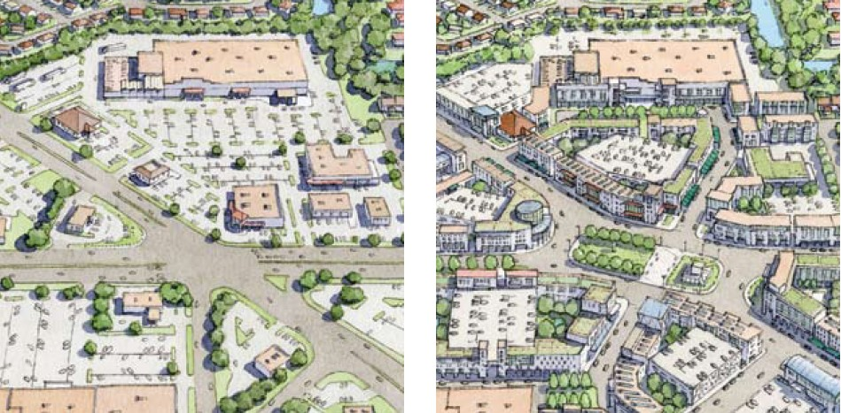
Before-and-after of a typical retrofit for a sprawling “strip mall” district into a vibrant mixed-use town center. (Galina Tachieva, from The Sprawl Repair Manual)

THE ROADBLOCKS: Some misconceptions about urban and suburban development.

Effective policy reform on suburban redevelopment is often obstructed by well-meaning residents who fear the negative consequences of new development. This is not irrational: so much new development has in fact been chaotic, poorly organized, and downright ugly, that residents have good reason to be concerned. But these same residents are vulnerable to several key myths about suburban development

Myth 1: More density is always unpleasant. On the contrary, less density can be quite unpleasant, because it can mean less economic support for desirable services and businesses, less ability to walk, and a more open, fragmented environment. Often a low-density development can mean less privacy than a well-designed development at a higher density.

Myth 2: The suburbs are about getting out of congestion, and into the open, quieter countryside. In fact, history has demonstrated that the suburbs are about bringing congestion and noise with you – and indeed, increasing congestion, as a consequence of increased dependence on cars for increasingly long trips, and channeling them onto a few highways. A rural lifestyle is the right one for some Americans – but too many Americans thought they were getting a rural lifestyle in the suburbs, when what they got was the worst of both worlds: isolation, and traffic jams.

Myth 3: New infill development is always ugly, and degrades the quality of the neighborhood. Unfortunately, this can be true – but it need not be. If citizens become pro-active stewards of development, and hold policy leaders, architects and developers accountable for the livable quality of development, then history shows that such infill development can add enormously neighborhood quality. Indeed, the greatest cities in the world were built from just such well-planned, beautifully designed infill development.

THE MEANS: Tools and policy recommendations

As noted above, an exciting array of policy tools and strategies is coming to the fore today. An exhaustive account of these is beyond the scope of this paper, but more information can be found in the references below. But we can summarize the strategies as follows:

- Add new design tools and strategies. A growing toolkit of design types and strategies is becoming available in both “proprietary” and “shareware” formats. New “sprawl retrofit” strategies are emerging, and offering elegant new ideas for turning ugly, poorly used suburban sites into vibrant, successful centers. Public, private and NGO entities are working together to pioneer new mechanisms and tools, like tax-increment financing, community land trusts, and many others.
- Remove the old codes and barriers; add new code tools. Many of the most beautiful, sustainable neighborhoods in human history would be illegal under today’s common zoning codes. They need to be scrapped, and replaced with a new generation of codes that allow much more flexible development, in a way that supports walking, transit, and a good distribution of amenities.
- Add new incentives and funding mechanisms. The mantra of sustainable development advocates today is, “make it pencil.” Good development will not happen if it cannot be supported economically. Sometimes, that means adding customers. Sometimes that means “priming the pump” by creating incentives and financial tools that can support good development through the early periods, when the economic return is most challenging. And sometimes, that means making unsustainable development pay its true cost, so that it does not have an artificial competitive advantage over good-quality sustainable development.

Today, the voices of “business as usual” continue to sing an old song. The sprawling suburbs are the American dream; the American way of life is “non-negotiable;” we can go back to the vision of the 1950s and 1960s, and all glide around effortlessly in gleaming automobiles, in a drive-through utopia. Our economy, too, can go back to what it was. We now see that illusion for what it was, and we are now facing the unbearable costs.

But the future need not be a grim time of sacrifice. Most of us are aware that we were not getting very much for our prodigious (and wasteful) expenditures of money and resources, and we are eager to return to the pleasures of life that are still everywhere around us – and do not cost the Earth in the bargain. We can see ready examples from urban environments where a lower-carbon way of life, for example, certainly does not translate into a lower quality of life. On the contrary, the evidence shows that a higher quality of life can be had in the bargain – one with more diversity of options, more urbanity, richer experiences.

Our economy, too, might benefit by focusing more upon those things that renew and sustain rather than those that destroy and extinguish. It does seem that we have little choice: for the present crisis reminds us that we simply can no longer afford to go on in the old sprawling ways.

* * *

APPENDIX I

From Sprawl to Complete Communities
From Galina Tachieva, the Sprawl Repair Manual

Sprawl is a pattern of growth characterized by an abundance of congested highways, strip shopping centers, big boxes, office parks, and gated cul-de-sac subdivisions – all separated from each other in isolated, single-use pods (figure 1-1). This land-use pattern is typically found in suburban areas, but also affects our cities, and is central to our wasteful use of water, energy, land, and time spent in traffic. Sprawl has been linked to increased air and water pollution,
greenhouse gas emissions, loss of open space and natural habitat, and the exponential increase in new infrastructure costs. Social problems related to the lack of diversity have been attributed to sprawl, and health problems such as obesity to its auto-dependence.

In contrast, complete communities have a mix of uses and are walkable, with many of a person’s daily needs – shops, offices, transit, civic and recreational places – within a short distance of home. They are compact, so they consume less open space and enable multiple modes of transportation, including bicycles, cars, and mass transit. A wide variety of building types provides options to residents and businesses, encouraging diversity in population. This mix of uses, public spaces, transportation, and population makes complete communities economically, socially, and environmentally sustainable.

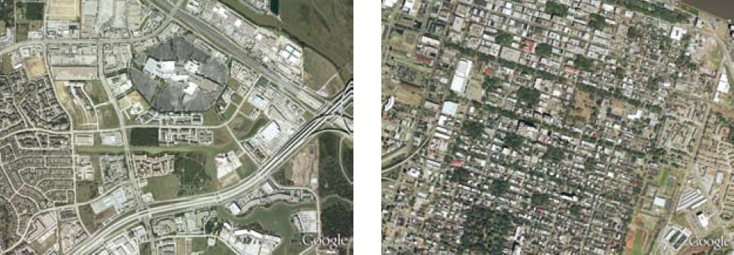
Left, a heavily car-dependent area of sprawl, with many fragmented street segments. Right, a neighborhood with a street grid pattern, which is much more walkable. Uses are distributed throughout the neighborhood.

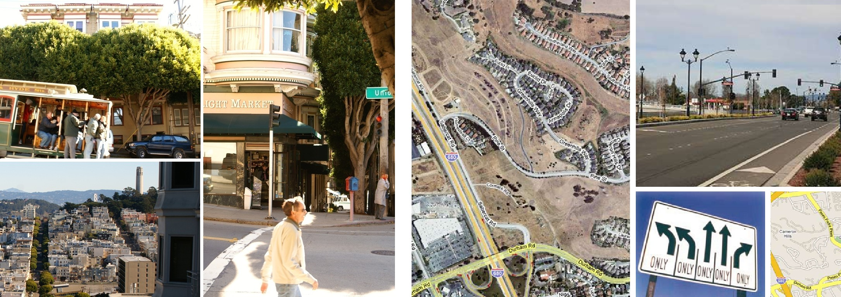
Left, images from a mixed-use, walkable, transit-oriented neighborhood of San Francisco. Right, images from a neighborhood across the bay, with the same climate, economy, government and other factors. Studies show that the energy use and carbon emissions per capita in such neighborhoods is dramatically higher. (From Mehaffy et al., “The Factors of Urban Morphology in Greenhouse Gas Emissions.”)

The promise of suburbia has been eroding for decades, but reached a critical point with the mortgage meltdown of 2008. A record number of homes went into foreclosure and entire subdivisions and commercial developments began to fail. Yet the expanse of sprawl represents a vast investment, and cannot be simply abandoned or demolished. Pragmatism demands the reclamation of sprawl through redevelopment that introduces mixed uses and transportation options. It must be acknowledged, however, that portions of sprawl may remain in their current state, while others may devolve, reverting to agriculture or nature. The design and regulatory strategies and incentives shown here are intended for the places that are best suited to be urbanized because of location or existing investment.

The history and consequences of suburban development, specifically sprawl, are well documented. Numerous books articulate the trajectory of sprawl within its historical context – from the Federal Housing Administration’s mortgages for new construction, the subsidies of the interstate highway system, and the tax laws allowing accelerated depreciation of commercial development, to the evolution of Euclidean zoning’s separation of uses and the cultural mandate for separation by race. Recent publications put forward the need to redevelop sprawl and what specifically should be repaired; among these are Greyfields into Gold- elds and Malls into Main Streets, reports by the Congress for the New Urbanism. Retrofitting Suburbia: Urban Design Solutions for Redesigning Suburbs, by Ellen Dunham-Jones and June Williamson, explains why we need to retrofit sprawl and documents successful examples of retrofits through illuminating and comprehensive analysis.

The Sprawl Repair Manual seeks to expand the literature as a guide that illustrates how to repair the full range of suburban conditions, demonstrating a step-by-step design process for the creation of more sustainable communities. This is a framework for designing the interventions, incorporating them into the regulatory system, and implementing them with permitting strategies and financial incentives.

The proposed approach addresses a range of scales from the region down to the community, street, block, and building. The method identifies deficiencies in typical elements of sprawl, and determines the best remedial techniques for those deficiencies. Also included are recommendations for regulatory and economic incentives.

Lessons learned from history guide this methodology. Rather than the instant and total overhaul of communities, as promoted so destructively in American cities half a century ago, this is a guide for incremental and opportunistic improvement.

APPENDIX II

“Here comes the neighborhood”
Excerpt from Atlantic Monthly, June 2010
By Christopher Leinberger

As Zillow’s satellite maps begin to indicate, what we face today is not just a cyclical
housing problem, but a structural one as well. Over the past decade, most house building occurred on the suburban fringe, in large part because that’s where houses could be built most
easily and quickly. But now that the bubble has popped, we can clearly see that underlying demand in these areas is extremely weak, and oversupply is massive.

Nationwide, houses on the exurban fringes are now generally priced below the cost of the materials that went into building them. That’s usually the first step in the creation of a slum. Owners have no financial incentive to invest in their houses if they will not get that investment back upon resale. Developers have no financial incentive to build in those areas either….

Yet the creation of new, attractive urban spaces is slow and difficult, and becomes all but impossible without substantial new infrastructure. Most of all, it relies on good transit options— especially rail links—around which walkable neighborhoods can develop. Rail, biking, and walking infrastructure is the backbone of urban development, and as a country we’ve for the most part neglected to build it in recent decades, in favor of new roads for new suburbs farther and farther away from metropolitan hubs. To support growth in the next decade, we need to change that dynamic—and nourish our walkable urban spaces and neighborhoods. Complicating matters, in these cash-strapped times we need to find a way to do so on the cheap.

Read the full article at www.theatlantic.com

--------------------------------------------------------------------------
REFERENCES

Dunham-Jones, E. (2008)Retrofitting Suburbia: Urban Design Solutions for Redesigning
Suburbs. John Wiley & Sons
Ewing, R. (1994). "Characteristics, Causes, and Effects of Sprawl: A Literature
Review." Environmental and Urban Issues 21(2): 1-15.
Leinberger, Christopher (2010). “Here comes the neighborhood.” The Atlantic, June 2010.
Holtzclaw, J., R. Clear, et al. (2002). "Location Efficiency: Neighborhood and Socioeconomic
Characteristics Determine Auto Ownership and Use – Studies in Chicago, Los Angeles and San Francisco." Transportation Planning and Technology 25: 1-27.
Mehaffy, Michael et al. (2009) “The factors of urban morphology in greenhouse gas emissions.”
IOP Conference Series: Earth and Environmental Science 6:11, 9
Steil, L. et al., “Growing Sustainable Suburbs: An Incremental Strategy for Reconstructing
Sprawl” (chapter), in Haas, T. (2008) New Urbanism and Beyond. Rizolli.
Tachieva, Galina. The Sprawl Repair Manual. Island Press (Washington D.C.), July, 2010

333 S. State Street, Lake Oswego, Oregon 97034. michael.mehaffy@gmail.com
Galina@dpz.com
l.qamar@comcast.net
mary@plangreen.net
john.holtzclaw@sierraclub.org
cleinberger@brookings.edu

